Contents

1. SAABHC0001 6

2. SAABHC0002 8

3. SAABHC0003 10

4. SAABHC0004 12

5. SAABHC0005 14

6. SAABHC0006 16

7. SAAEYB0002 18

8. SAAEYB0003 20

9. SAAEYB0004 22

10. SAAEYB0005 24

11. SAAEYB0006 26

12. SAAEYB0007 28

13. SAAEYB0008 30

14. SAAEYB0009 32

15. SAAEYB0010 34

16. SAAEYB0011 36

17. SAAEYB0012 38

18. SAAEYB0013 40

19. SAAEYB0021 42

20. SAAEYB0022 44

21. SAAEYB0023 46

22. SAAEYB0024 48

23. SAAEYB0025 50

24. SAAEYB0026 52

25. SAAEYB0027 54

26. SAAEYB0028 56

27. SAAEYB0029 58

28. SAAEYB0030 60

29. SAAEYB0031 62

30. SAAEYB0032 64

31. SAAEYB0033 66

32. SAAFLB0003 68

33. SAAFLB0004 70

34. SAAFLB0005 72

35. SAAFLB0006 74

36. SAAFLB0007 76

37. SAAFLB0008 78

38. SAAFLB0030 80

39. SAAFLB0031 82

40. SAAGAW0001 84

41. SAAGAW0002 86

42. SAAGAW0003 88

43. SAAGAW0004 90

44. SAAGAW0005 92

45. SAAGAW0006 94

46. SAAGAW0007 96

47. SAAGAW0008 98

48. SAAGVD0001 100

49. SAAGVD0002 102

50. SAAGVD0003 104

51. SAAGVD0004 106

52. SAAKAN0001 108

53. SAAKAN0002 110

54. SAAKAN0003 112

55. SAAKAN0004 114

56. SAAKAN0005 116

57. SAAKAN0006 118

58. SAAKAN0007 120

59. SAAKAN0008 122

60. SAAKAN0009 124

61. SAAKAN0010 126

62. SAAKAN0012 128

63. SAAMDD0007 130

64. SAAMDD0008 132

65. SAAMDD0009 134

66. SAAMDD0010 136

67. SAAMDD0011 138

68. SAANUL0001 140

69. SAANUL0002 142

70. SAANUL0003 144

71. SAANUL0004 146

72. SAARIV0001 148

73. SAARIV0002 150

74. SAARIV0003 152

75. SAARIV0004 154

76. SAARIV0005 156

77. SAARIV0006 158

78. SAARIV0007 160

79. SAARIV0008 162

80. SAARIV0009 164

81. SAASTP0001 166

82. SAASTP0002 168

83. SAASTP0003 170

84. SAASTP0004 172

85. SAASTP0005 174

86. SAASTP0006 176

87. SAASTP0007 178

88. SAASTP0008 180

89. SAASTP0009 182

90. SAASTP0010 184

91. SAASTP0011 186

92. SAASTP0012 188

93. SAASTP0013 190

94. SAASTP0014 192

95. SAASTP0015 194

96. SAASTP0016 196

97. SAASTP0017 198

98. SAASTP0018 200

99. SAASTP0019 202

100. SAASTP0020 204

101. SAASTP0021 206

102. SAASTP0022 208

103. SAASTP0023 210

104. SAASTP0024 212

105. SAASTP0025 214

106. SAASTP0026 216

107. SAASTP0027 218

108. SAASTP0028 220

109. SAASTP0029 222

110. SAASTP0030 224

111. SAASTP0031 226

112. SAASTP0032 228

113. SAASTP0033 230

114. SAASTP0034 232

115. SASMDD0001 234

116. SASMDD0002 236

117. SASMDD0003 238

118. SASMDD0004 240

119. SASMDD0005 242

120. SASMDD0006 244

121. SASMDD0008 246

122. SASMDD0009 248

123. SASMDD0011 250

124. SASMDD0012 252

125. SASMDD0013 254

126. SASMDD0014 256

127. SASMDD0016 258

128. SASMDD0017 260

129. SASMDD0018 262

130. SASRIV0001 264

131. SASRIV0002 266

132. SATEYB0001 268

133. SATEYB0002 270

134. SATFLB0001 272

135. SATFLB0002 274

136. SATFLB0003 276

137. SATFLB0004 278

138. SATFLB0005 280

139. SATFLB0006 282

140. SATFLB0008 284

141. SATFLB0009 286

142. SATFLB0010 288

143. SATFLB0011 290

144. SATFLB0013 292

145. SATFLB0015 294

146. SATFLB0016 296

147. SATFLB0017 298

148. SATFLB0018 300

149. SATFLB0019 302

150. SATFLB0020 304

151. SATFLB0021 306

152. SATFLB0022 308

153. SATFLB0023 310

154. SATFLB0024 312

155. SATFLB0025 314

156. SATFLB0026 316

157. SATFLB0027 318

158. SATFLB0028 320

159. SATKAN0001 322

160. SATKAN0002 324

161. SATKAN0003 326

162. SATKAN0004 328

163. SATSTP0001 330

164. SATSTP0002 332

165. SATSTP0003 334

166. SATSTP0004 336

167. SATSTP0005 338

168. SATSTP0006 340

169. SATSTP0007 342

170. SATSTP0008 344

# SAABHC0001

| Min. | 1st Qu. | Median | Mean | 3rd Qu. | Max. |
| --- | --- | --- | --- | --- | --- |
| 0 | 6.415047 | 8.215452 | 8.681953 | 10.28242 | 30.80287 |

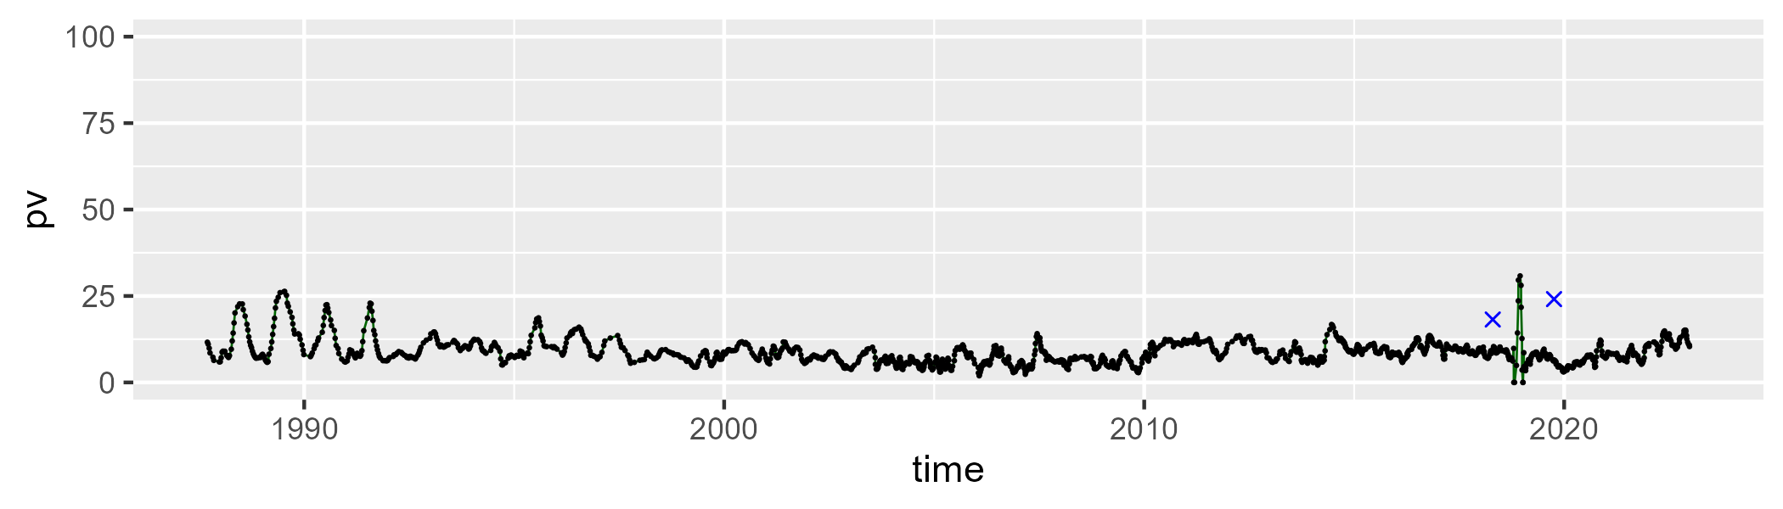

| Min. | 1st Qu. | Median | Mean | 3rd Qu. | Max. |
| --- | --- | --- | --- | --- | --- |
| 22.28026 | 32.85506 | 35.01345 | 35.10196 | 37.33688 | 49.48668 |

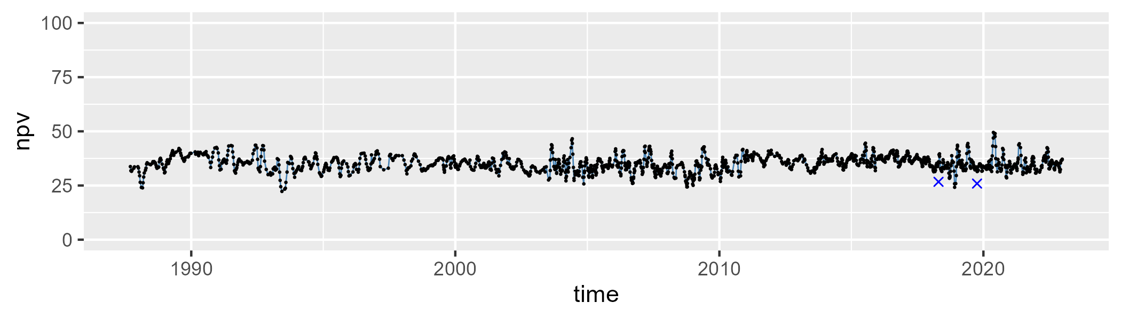

| Min. | 1st Qu. | Median | Mean | 3rd Qu. | Max. |
| --- | --- | --- | --- | --- | --- |
| 30.39852 | 51.81865 | 54.84429 | 54.65859 | 58.08081 | 68.26435 |

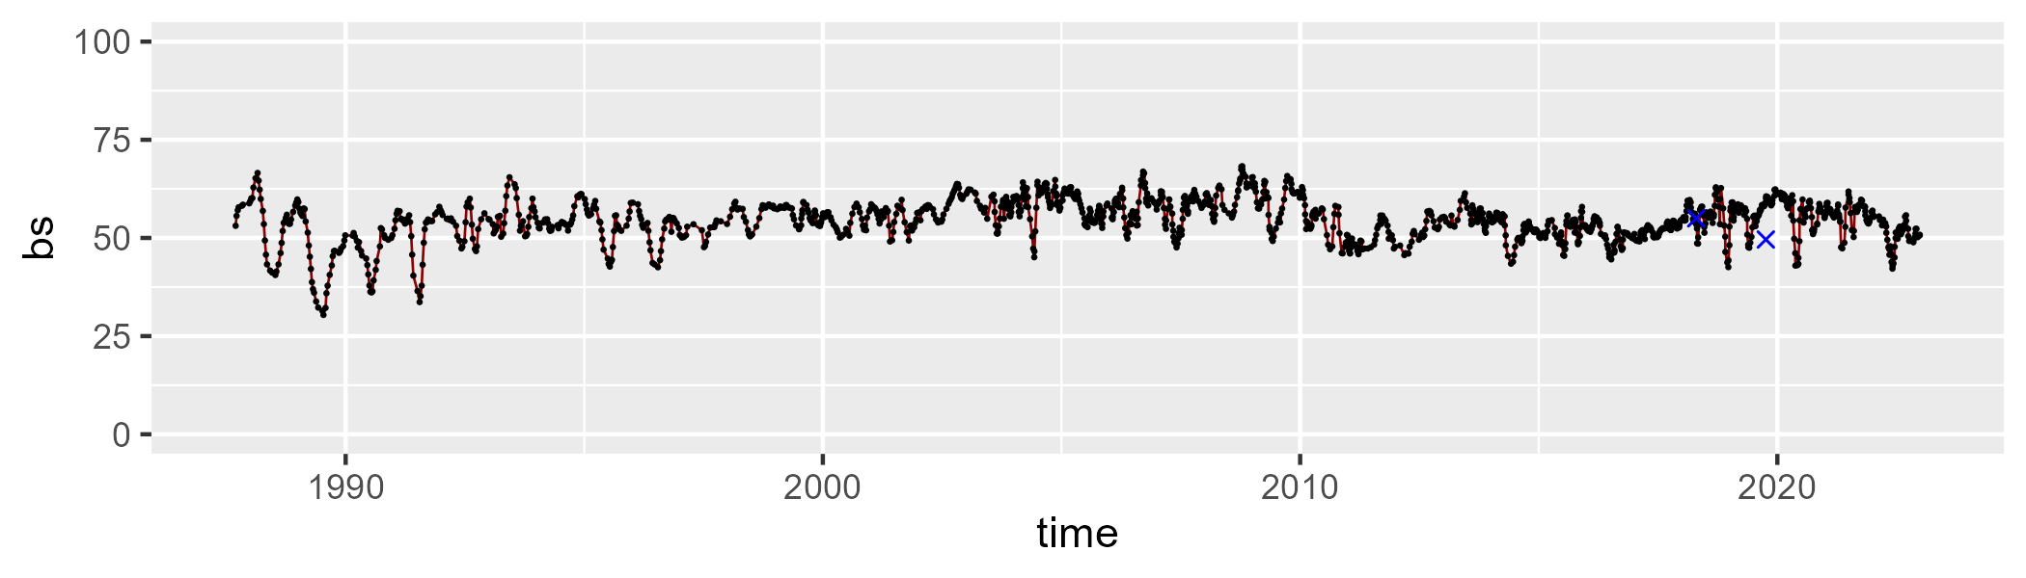

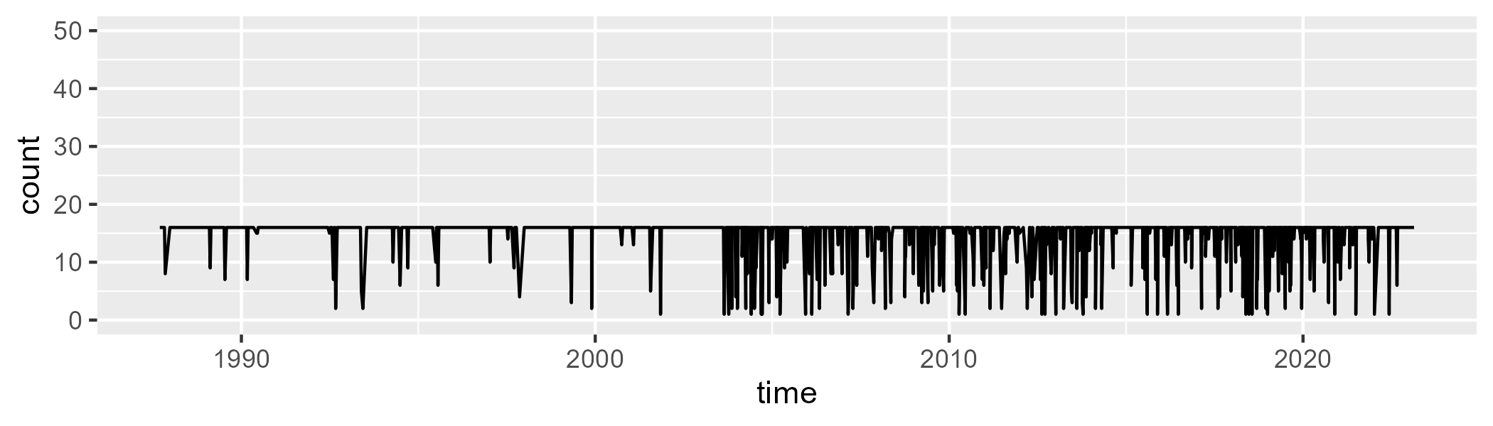

Min. : 1.00 1st Qu.:16.00 Median :16.00 Mean :14.81 3rd Qu.:16.00 Max. :16.00

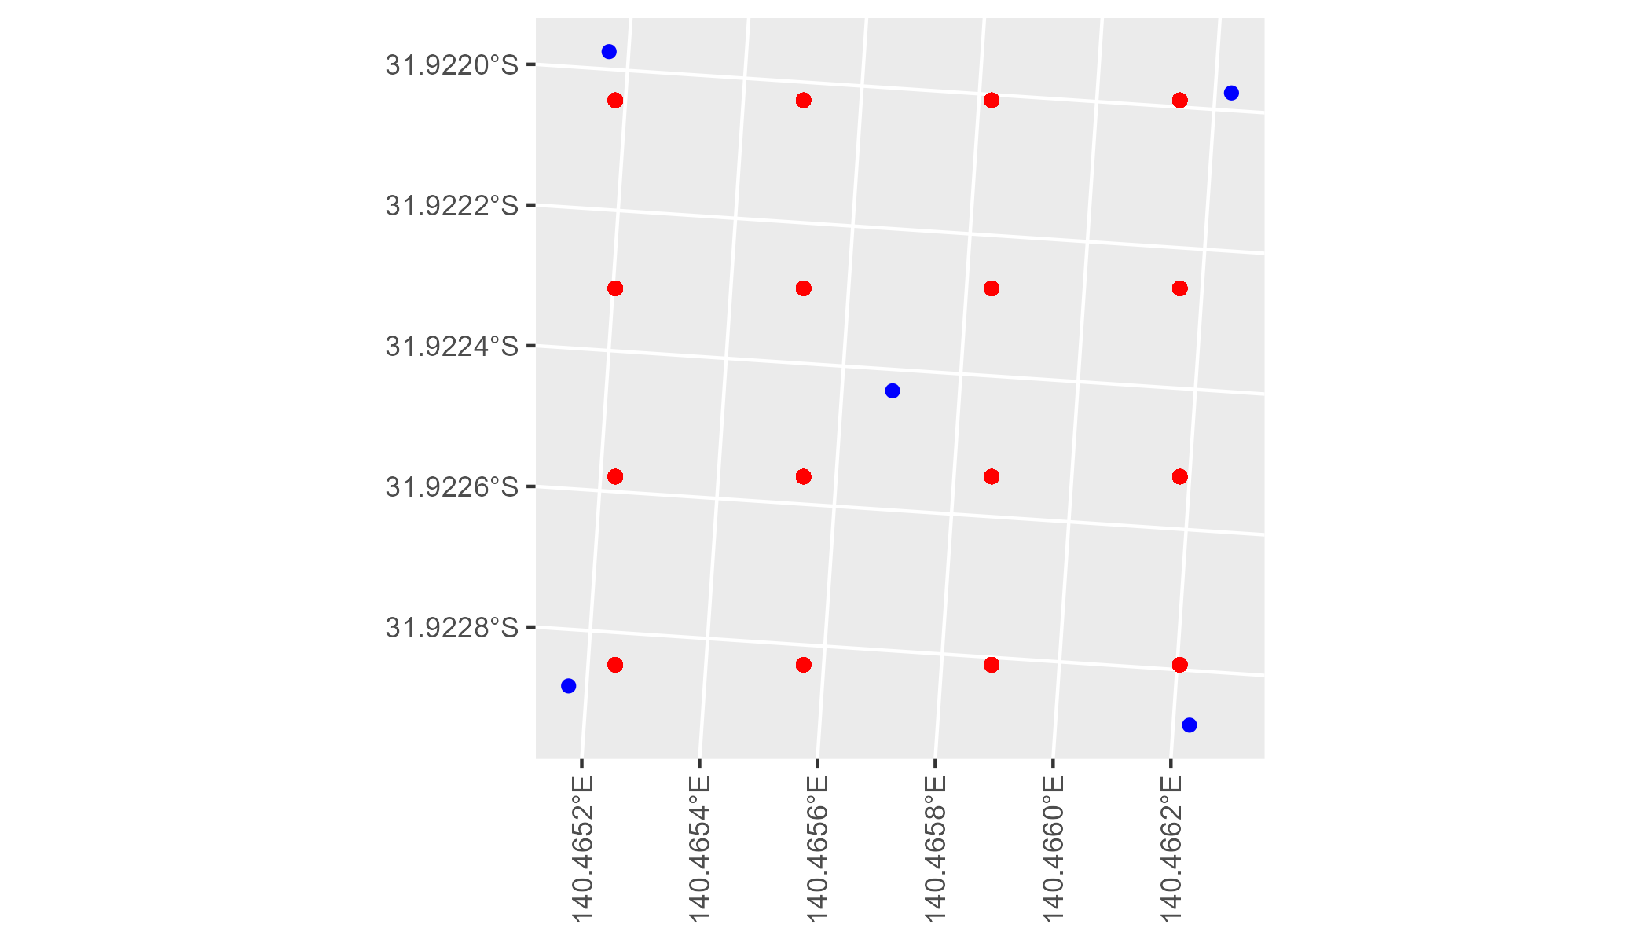

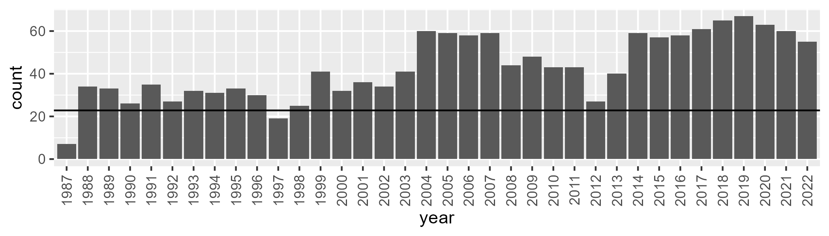

Number of samples: 1542

# SAABHC0002

| Min. | 1st Qu. | Median | Mean | 3rd Qu. | Max. |
| --- | --- | --- | --- | --- | --- |
| 3.136932 | 6.592985 | 8.593901 | 8.997275 | 10.77091 | 24.02156 |

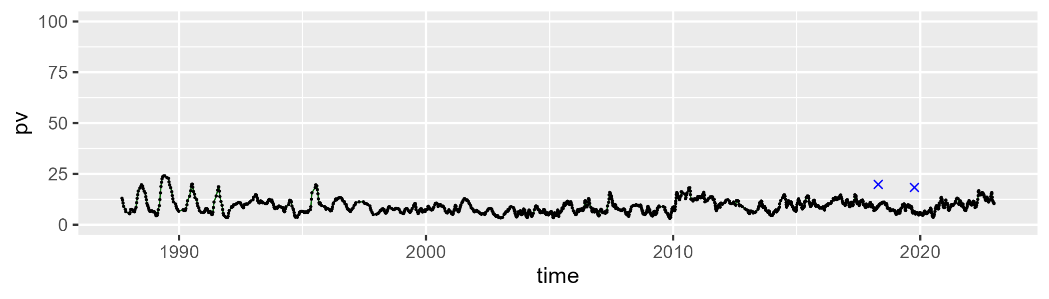

| Min. | 1st Qu. | Median | Mean | 3rd Qu. | Max. |
| --- | --- | --- | --- | --- | --- |
| 13.61384 | 24.31013 | 27.55112 | 27.53106 | 30.47286 | 43.27439 |

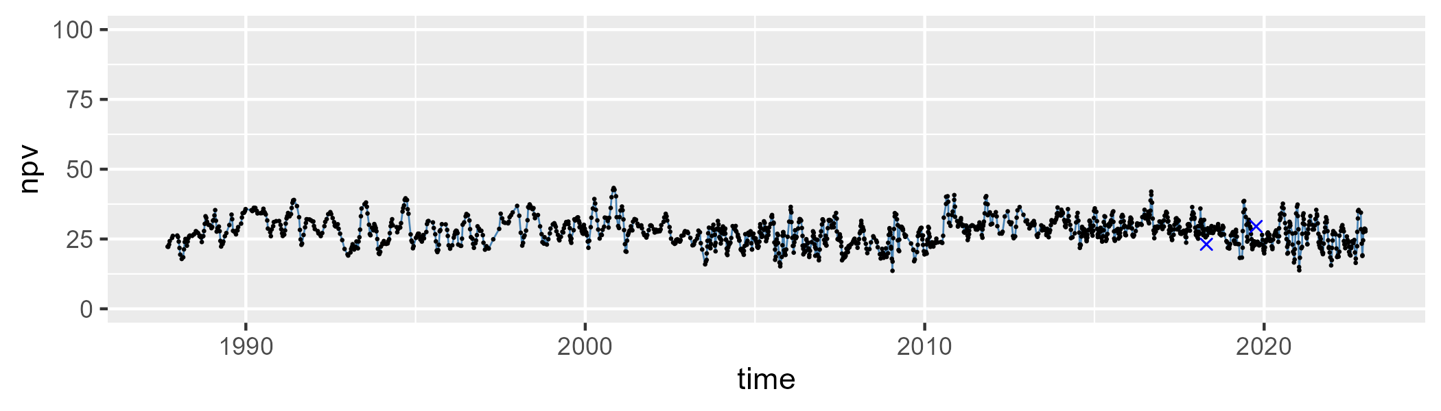

| Min. | 1st Qu. | Median | Mean | 3rd Qu. | Max. |
| --- | --- | --- | --- | --- | --- |
| 40.09464 | 58.4299 | 61.93835 | 61.91054 | 66.0791 | 77.65194 |

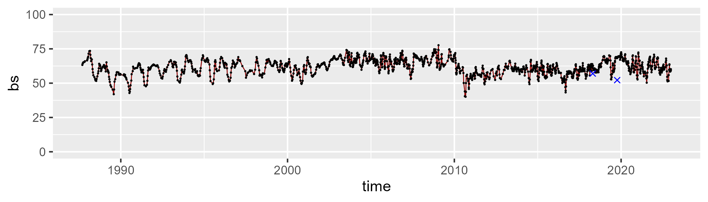

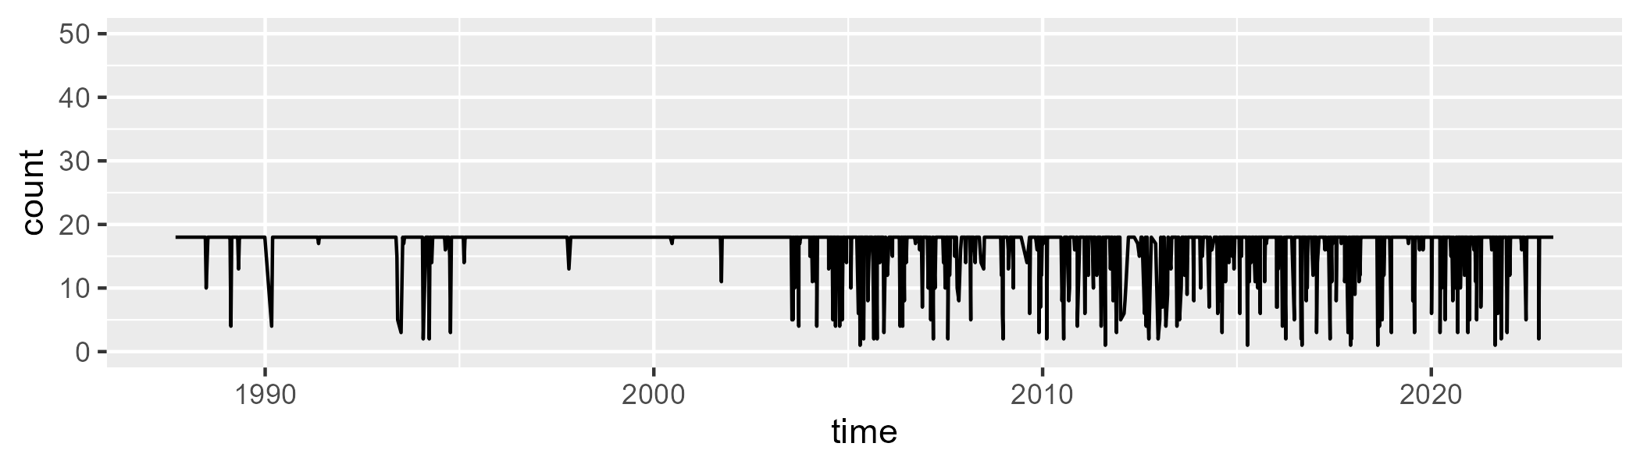

Min. : 1.0 1st Qu.:18.0 Median :18.0 Mean :16.7 3rd Qu.:18.0 Max. :18.0

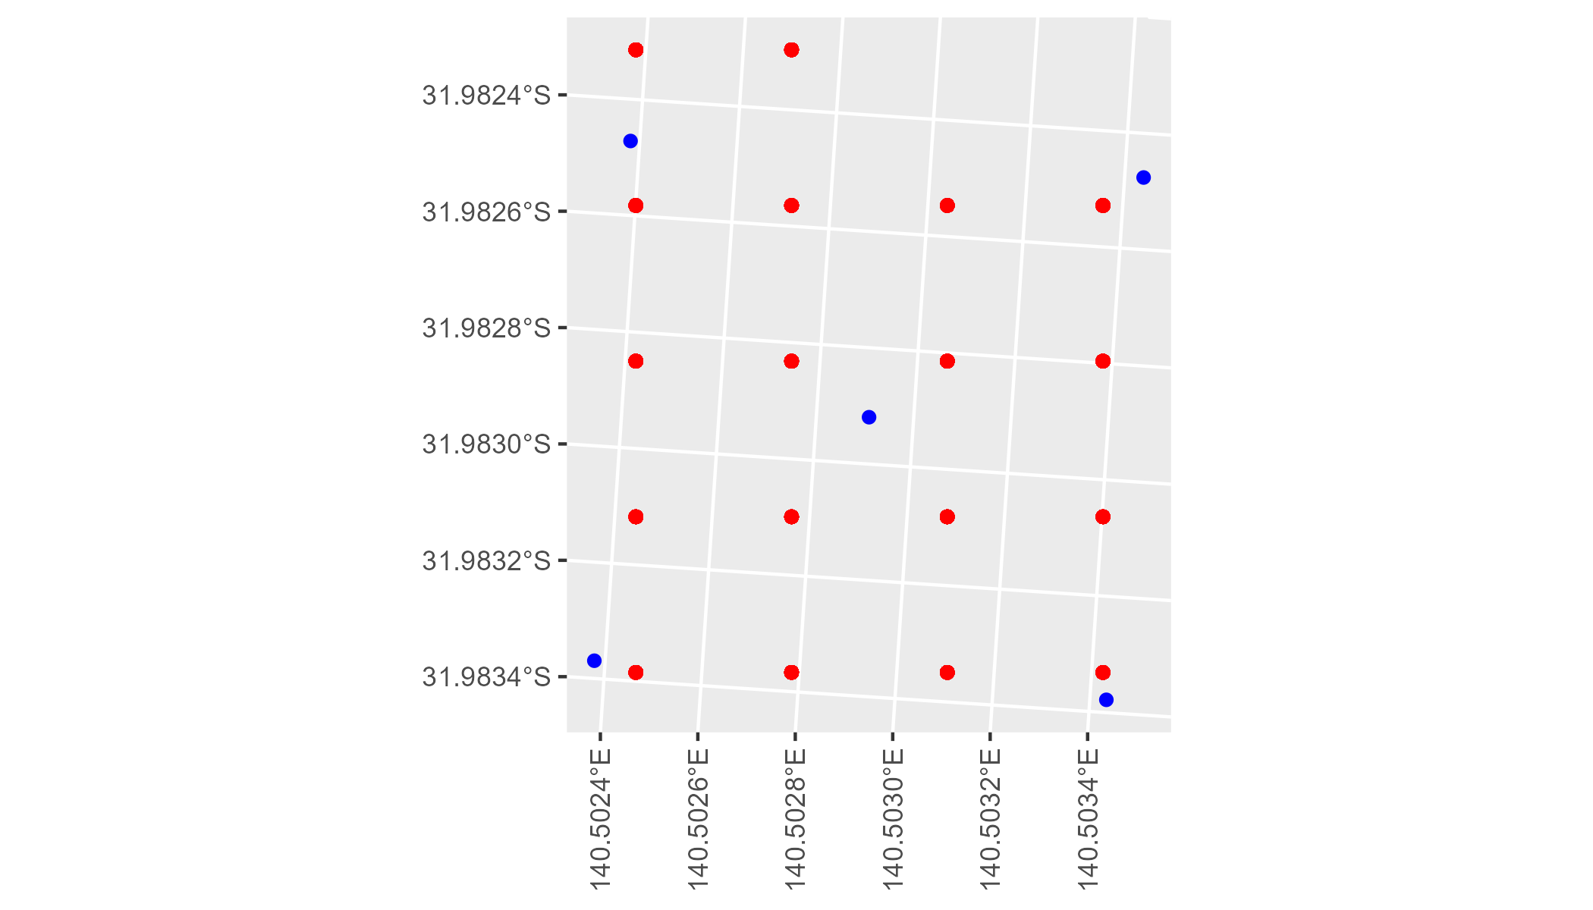

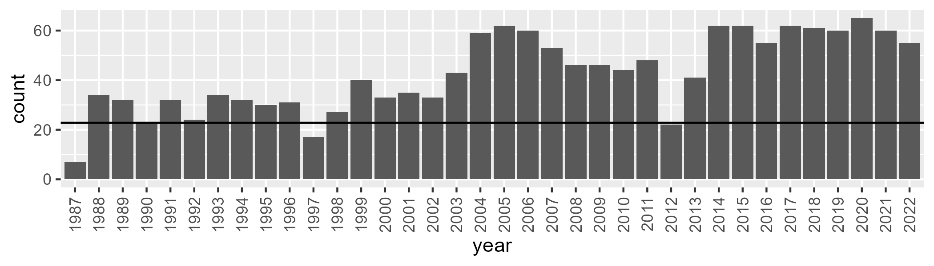

Number of samples: 1530

# SAABHC0003

| Min. | 1st Qu. | Median | Mean | 3rd Qu. | Max. |
| --- | --- | --- | --- | --- | --- |
| 0 | 2.146078 | 5.223661 | 7.4448 | 10.6046 | 39.6851 |

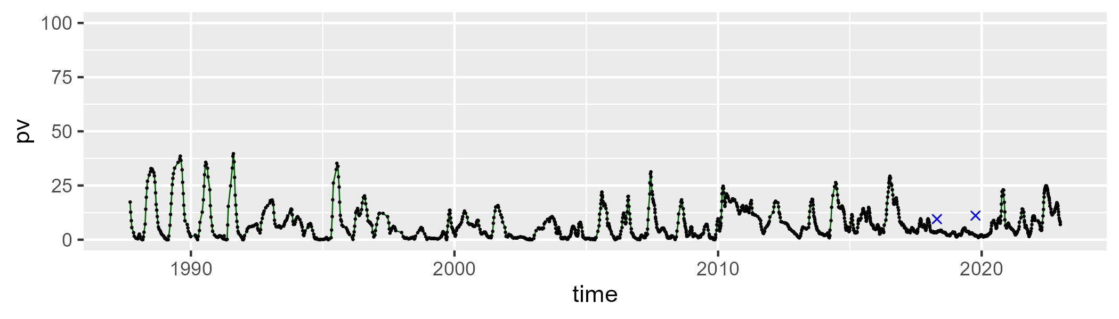

| Min. | 1st Qu. | Median | Mean | 3rd Qu. | Max. |
| --- | --- | --- | --- | --- | --- |
| 22.2493 | 34.70073 | 38.63798 | 38.41665 | 41.63389 | 57.91747 |

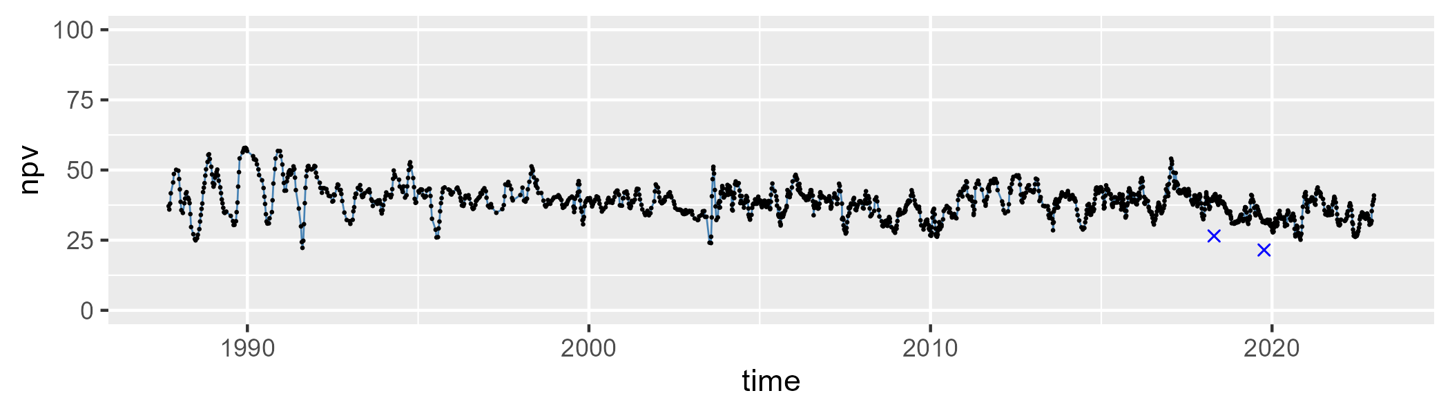

| Min. | 1st Qu. | Median | Mean | 3rd Qu. | Max. |
| --- | --- | --- | --- | --- | --- |
| 29.42362 | 48.68662 | 52.92599 | 52.69905 | 57.03975 | 69.06572 |

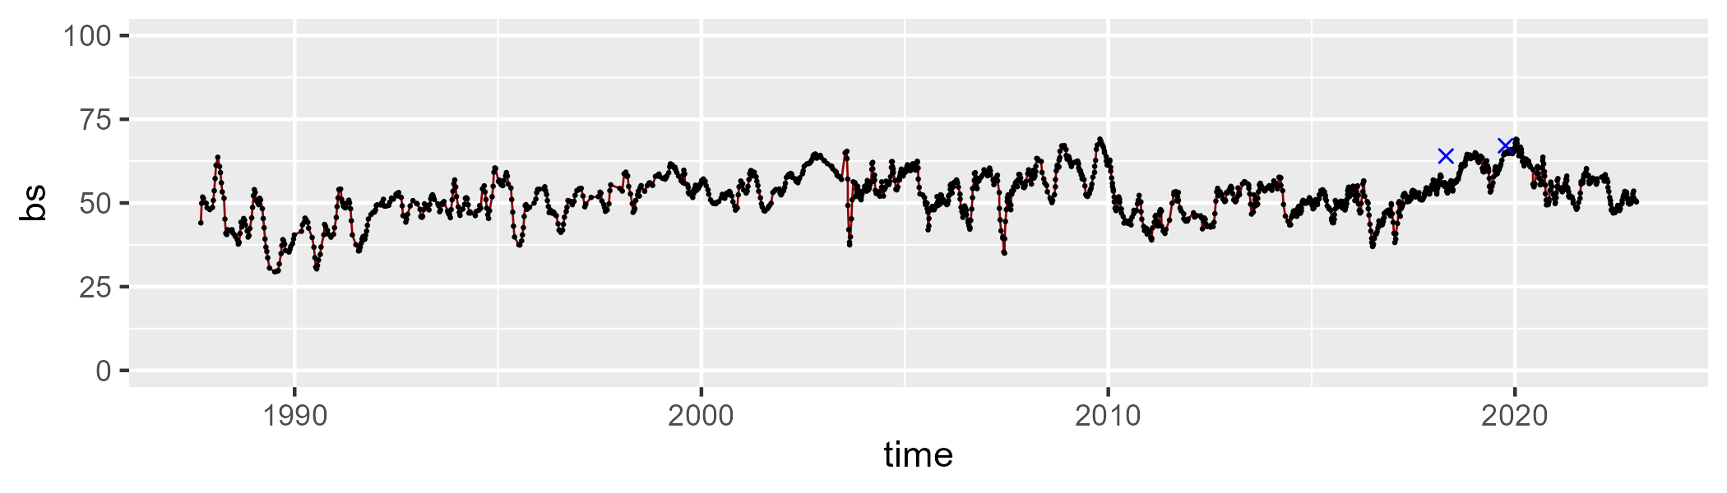

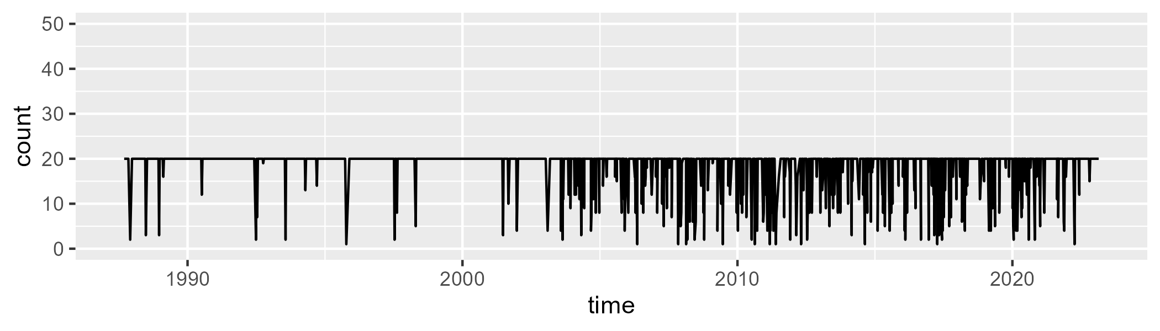

Min. : 1.00 1st Qu.:20.00 Median :20.00 Mean :18.41 3rd Qu.:20.00 Max. :20.00

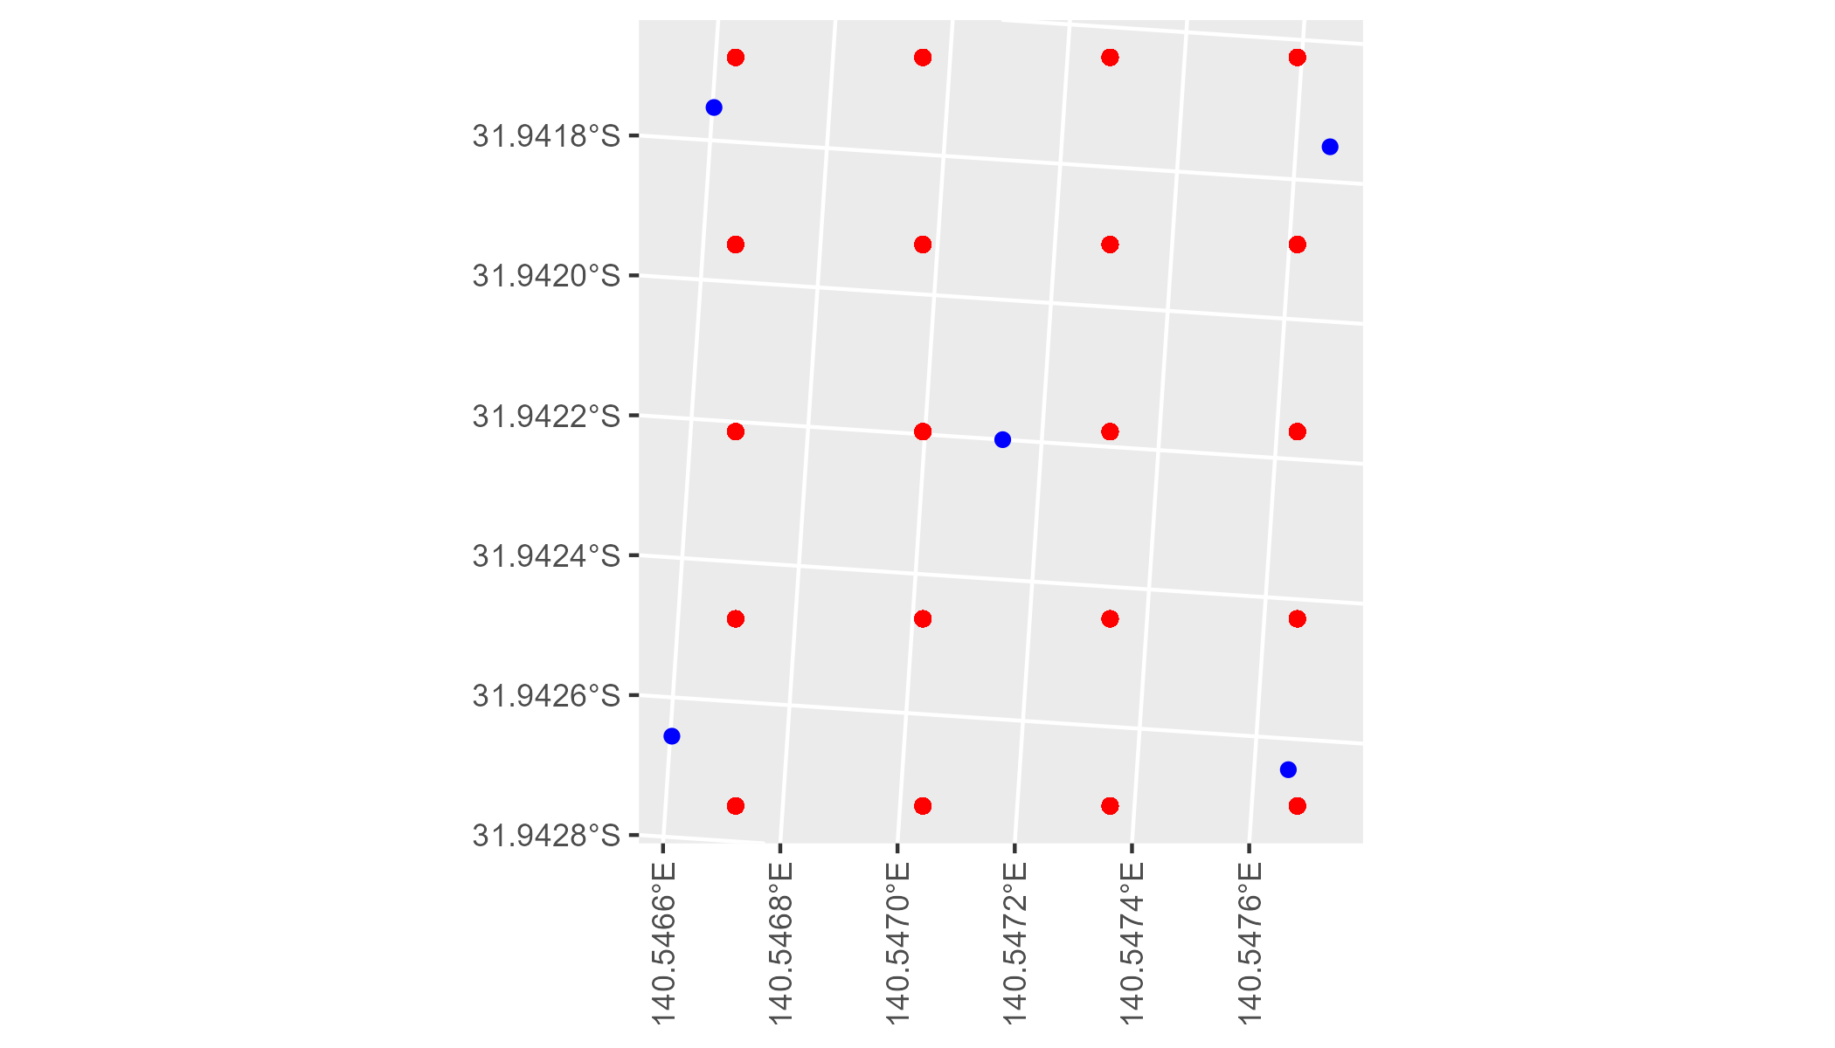

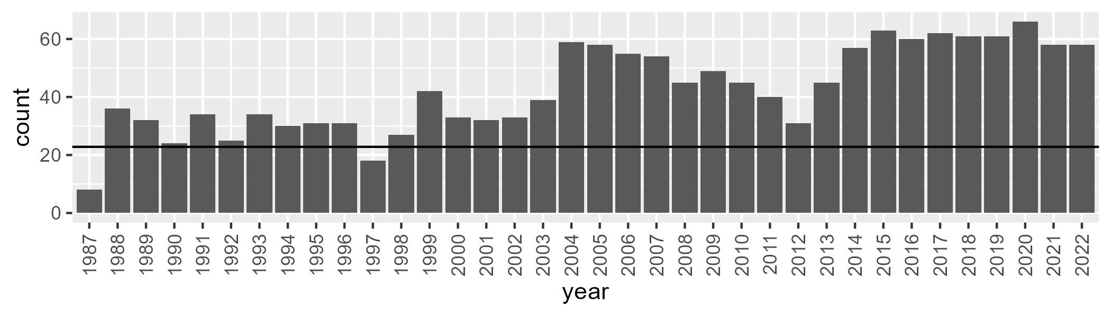

Number of samples: 1536

# SAABHC0004

| Min. | 1st Qu. | Median | Mean | 3rd Qu. | Max. |
| --- | --- | --- | --- | --- | --- |
| 6.960339 | 21.45481 | 27.00733 | 28.31862 | 34.17855 | 57.13557 |

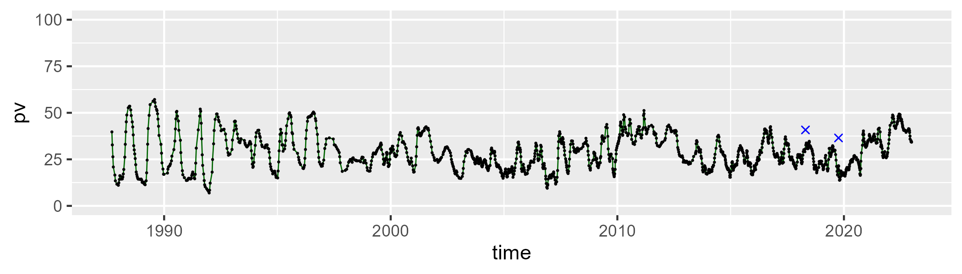

| Min. | 1st Qu. | Median | Mean | 3rd Qu. | Max. |
| --- | --- | --- | --- | --- | --- |
| 15.58156 | 34.32413 | 38.93089 | 38.7157 | 42.4582 | 57.92072 |

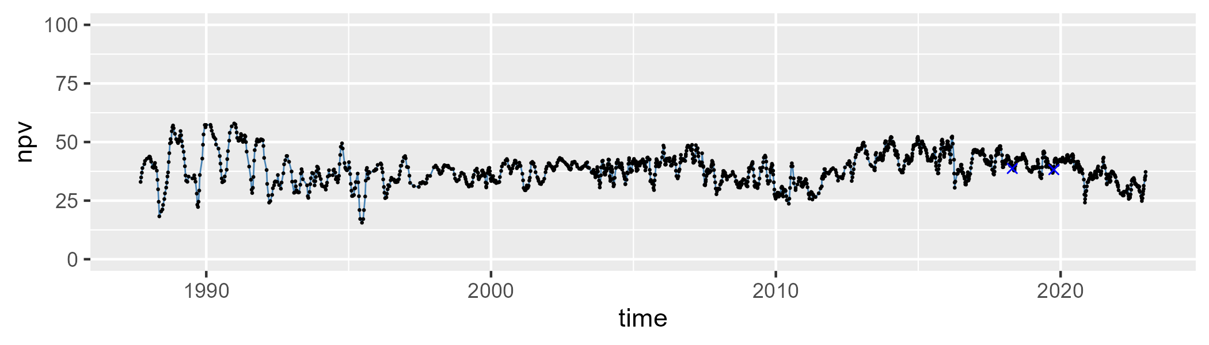

| Min. | 1st Qu. | Median | Mean | 3rd Qu. | Max. |
| --- | --- | --- | --- | --- | --- |
| 5.532655 | 26.75266 | 31.4783 | 31.4516 | 36.61186 | 48.4479 |

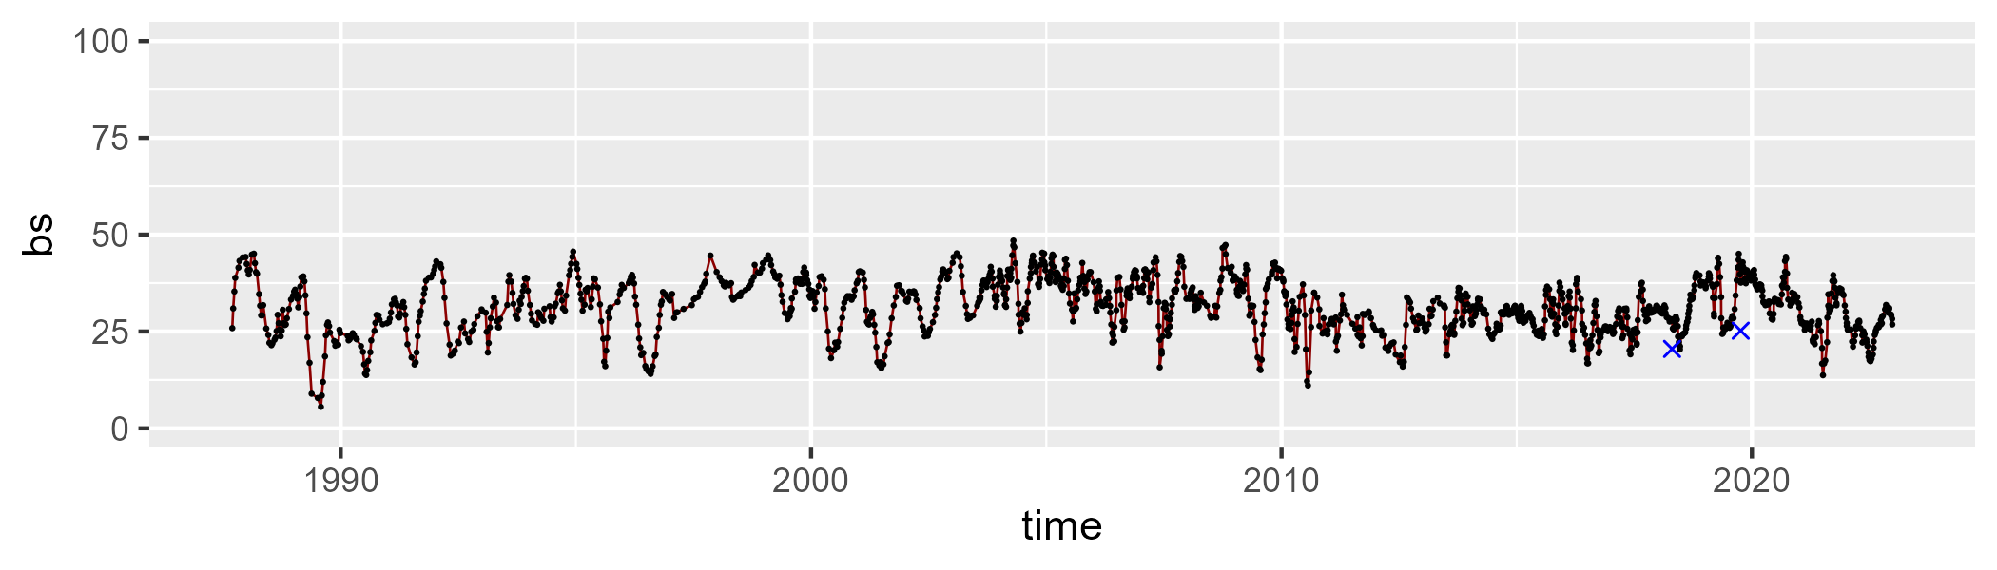

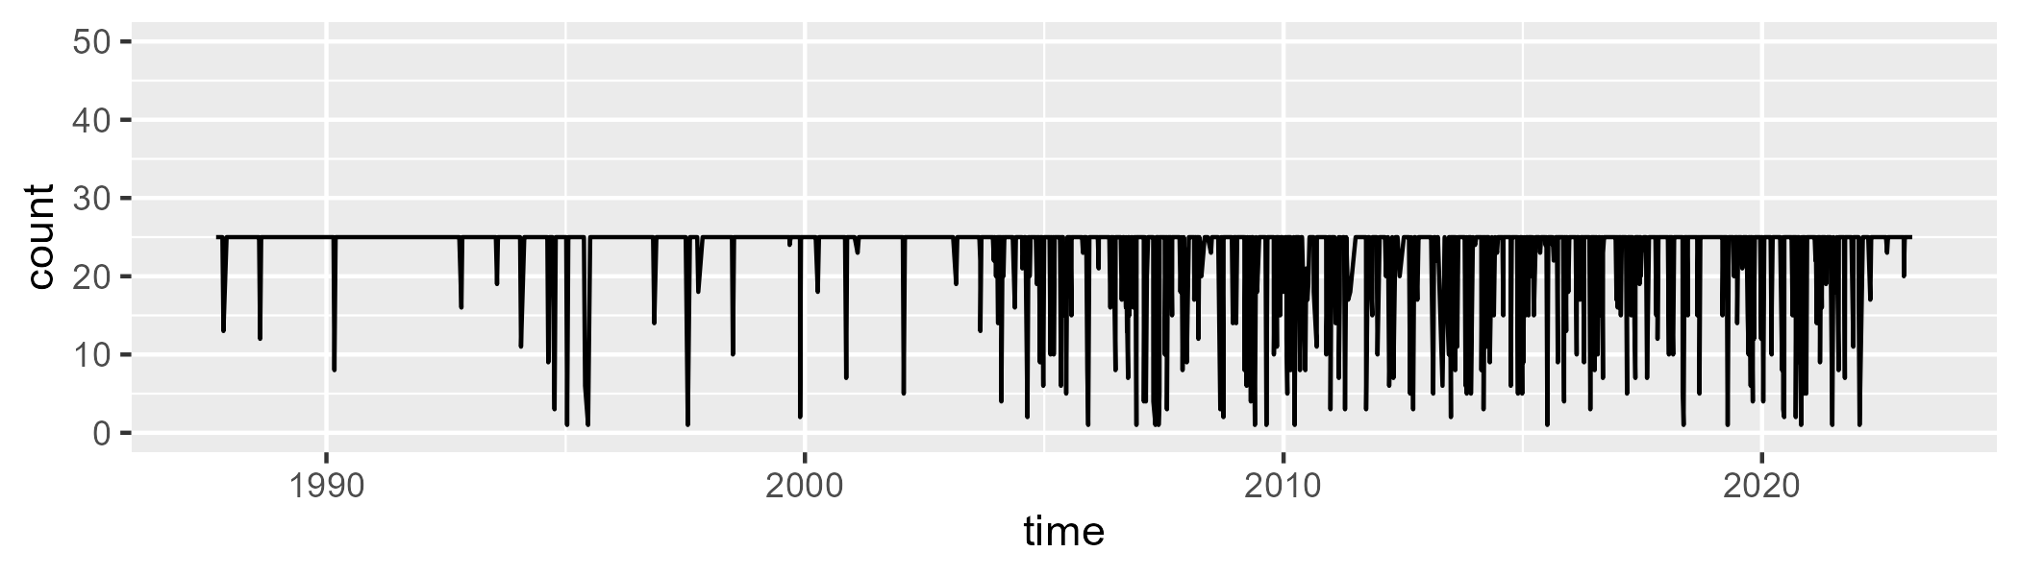

Min. : 1.0 1st Qu.:25.0 Median :25.0 Mean :22.9 3rd Qu.:25.0 Max. :25.0

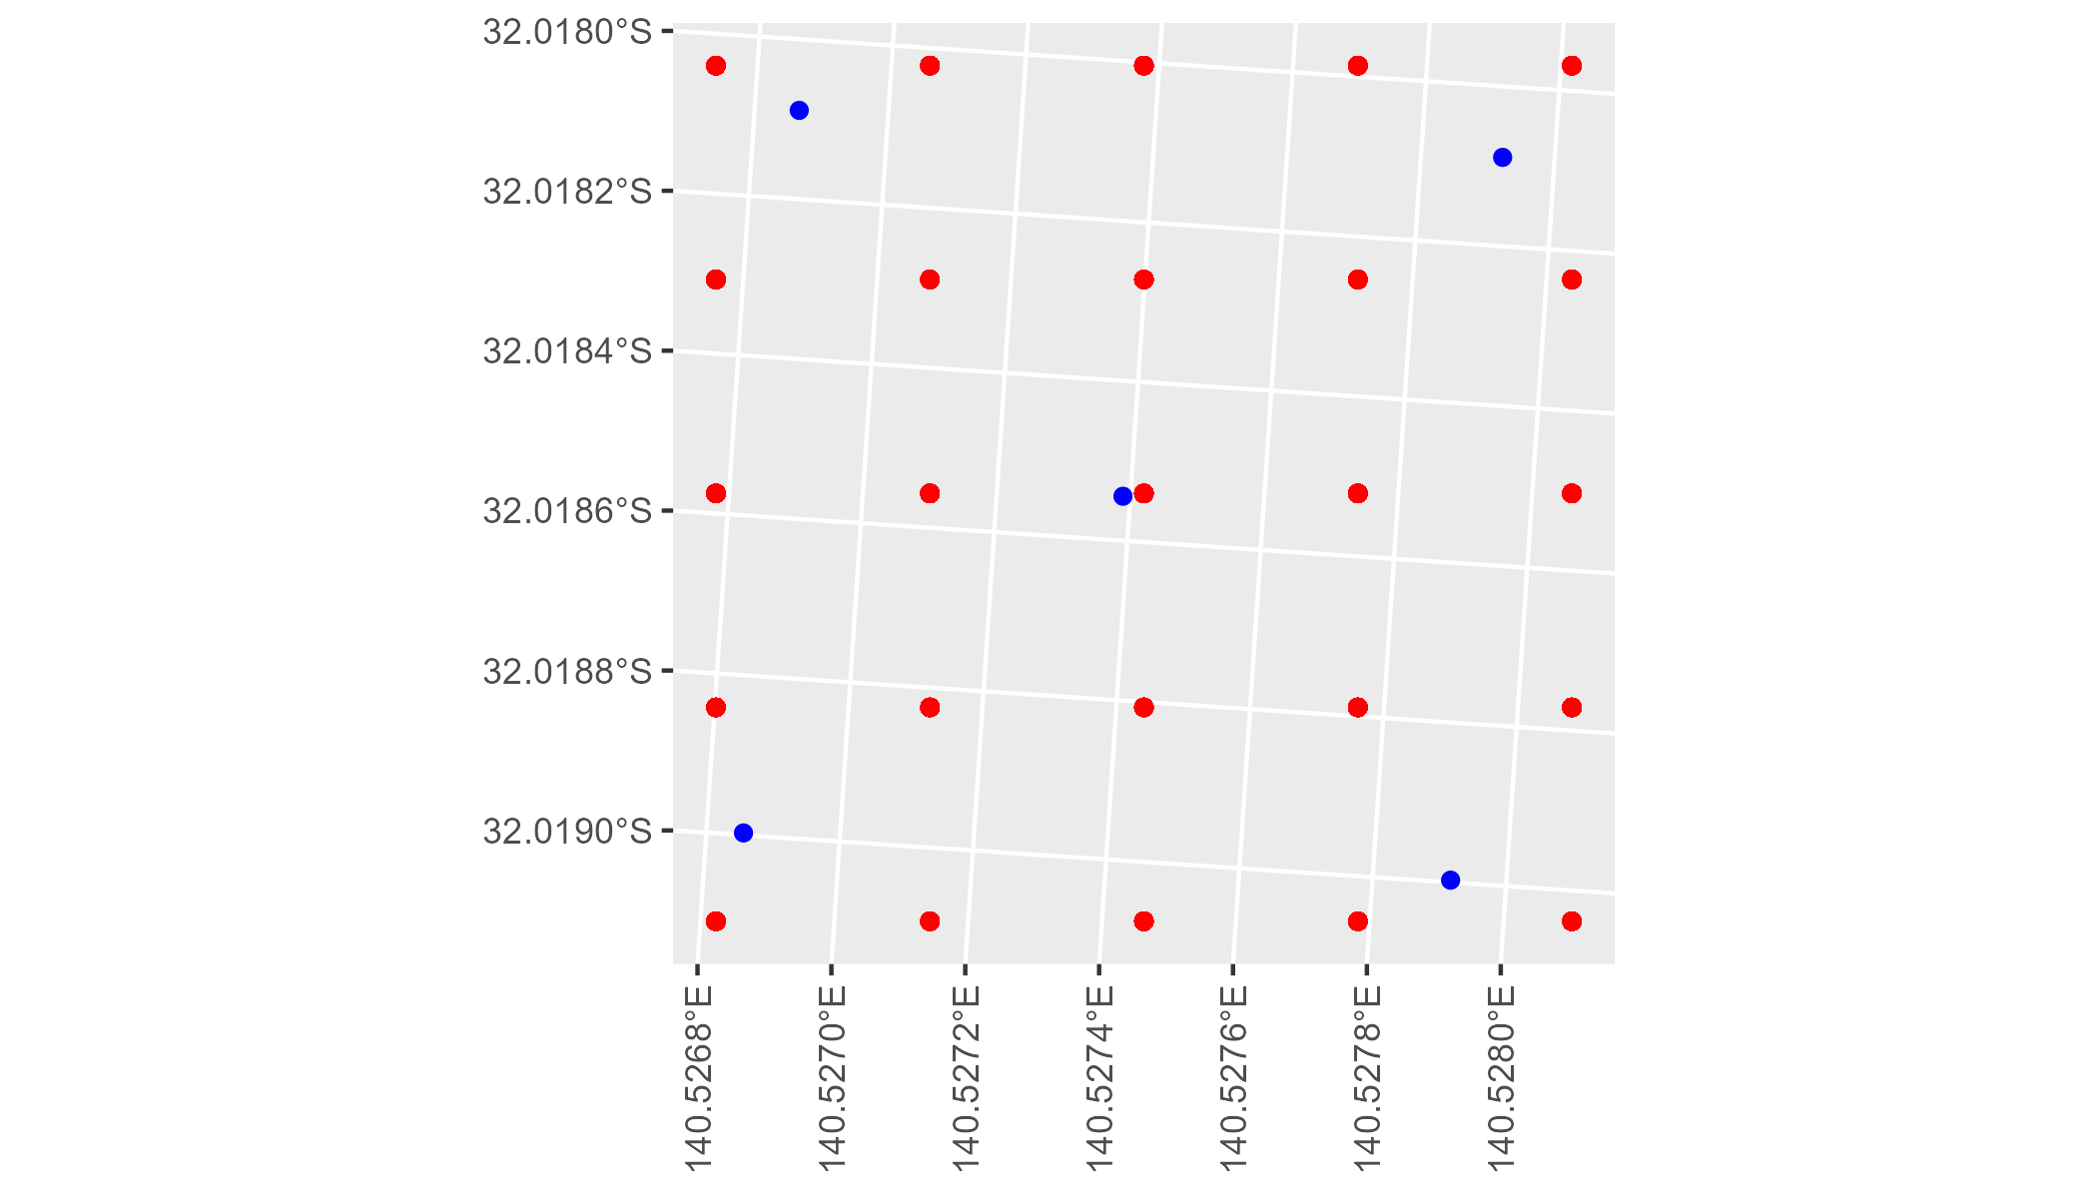

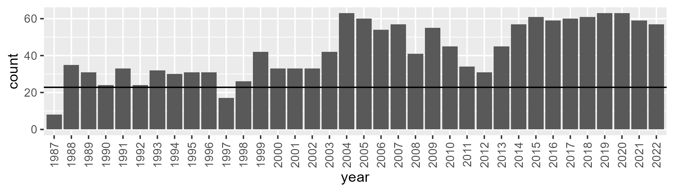

Number of samples: 1530

# SAABHC0005

| Min. | 1st Qu. | Median | Mean | 3rd Qu. | Max. |
| --- | --- | --- | --- | --- | --- |
| 0 | 1.83428 | 4.394289 | 7.978834 | 11.61069 | 51.37564 |

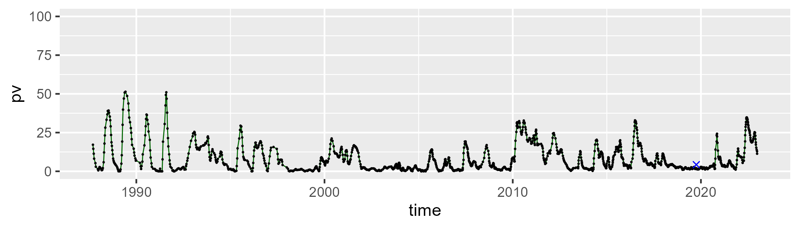

| Min. | 1st Qu. | Median | Mean | 3rd Qu. | Max. |
| --- | --- | --- | --- | --- | --- |
| 13.19858 | 27.04044 | 33.66195 | 34.27166 | 40.10062 | 64.08863 |

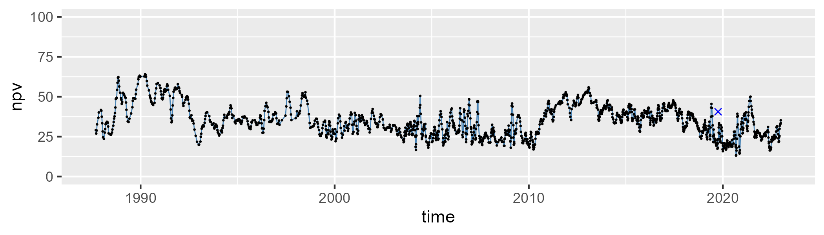

| Min. | 1st Qu. | Median | Mean | 3rd Qu. | Max. |
| --- | --- | --- | --- | --- | --- |
| 10.49821 | 48.61577 | 56.67933 | 56.24303 | 66.32129 | 80.25765 |

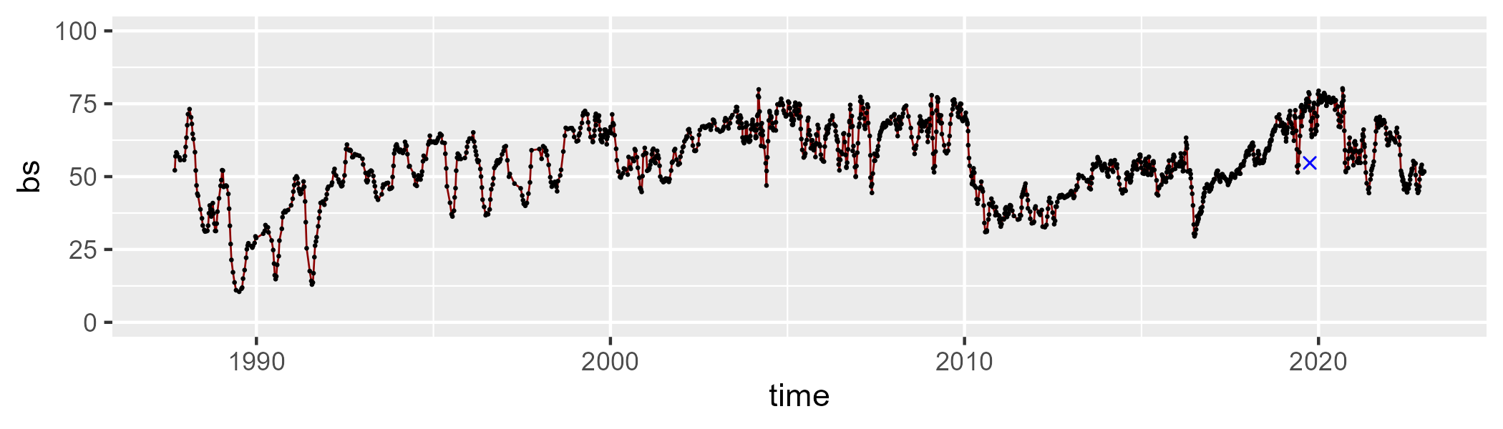

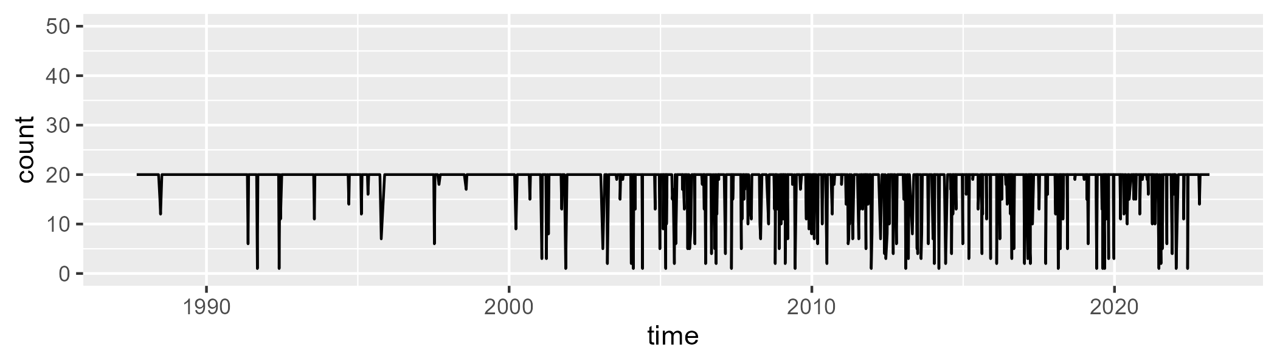

Min. : 1.00 1st Qu.:20.00 Median :20.00 Mean :18.57 3rd Qu.:20.00 Max. :20.00

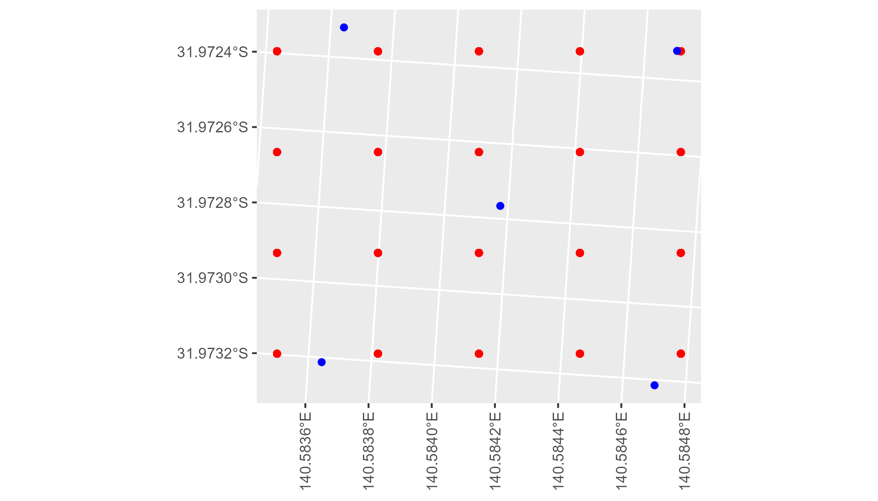

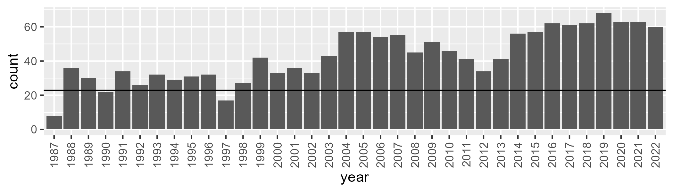

Number of samples: 1544

# SAABHC0006

| Min. | 1st Qu. | Median | Mean | 3rd Qu. | Max. |
| --- | --- | --- | --- | --- | --- |
| 0 | 1.696656 | 3.5632 | 6.780941 | 9.07503 | 54.40417 |

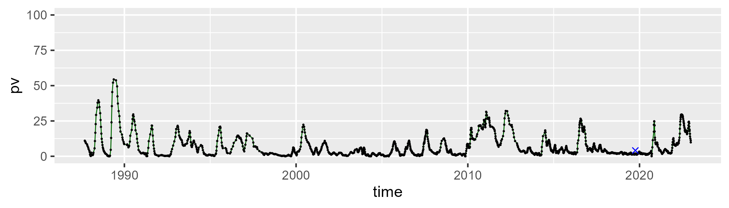

| Min. | 1st Qu. | Median | Mean | 3rd Qu. | Max. |
| --- | --- | --- | --- | --- | --- |
| 13.01217 | 29.78044 | 35.65734 | 36.79882 | 43.27022 | 69.98507 |

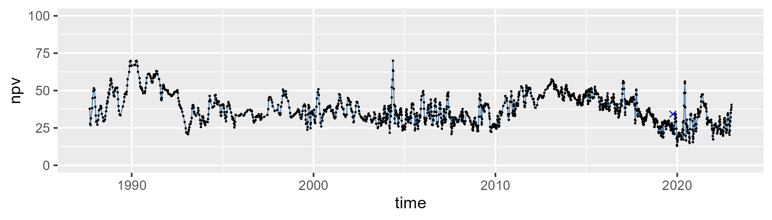

| Min. | 1st Qu. | Median | Mean | 3rd Qu. | Max. |
| --- | --- | --- | --- | --- | --- |
| 5.593653 | 47.94611 | 56.5429 | 54.90971 | 63.93424 | 81.87847 |

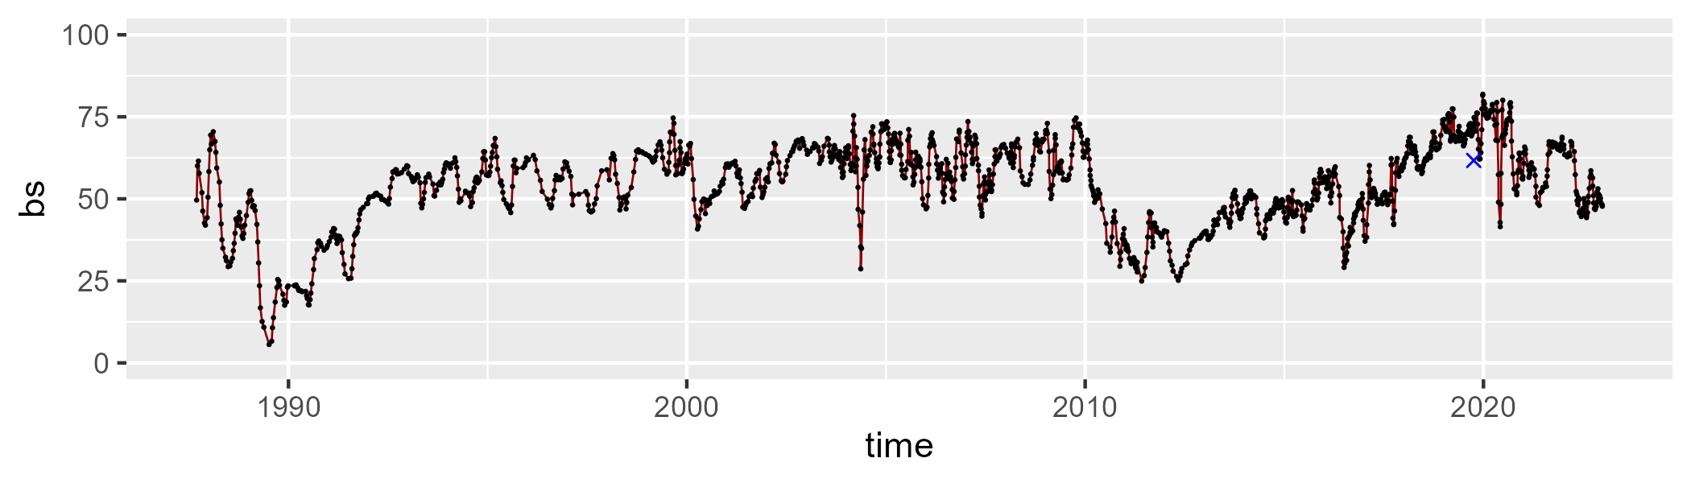

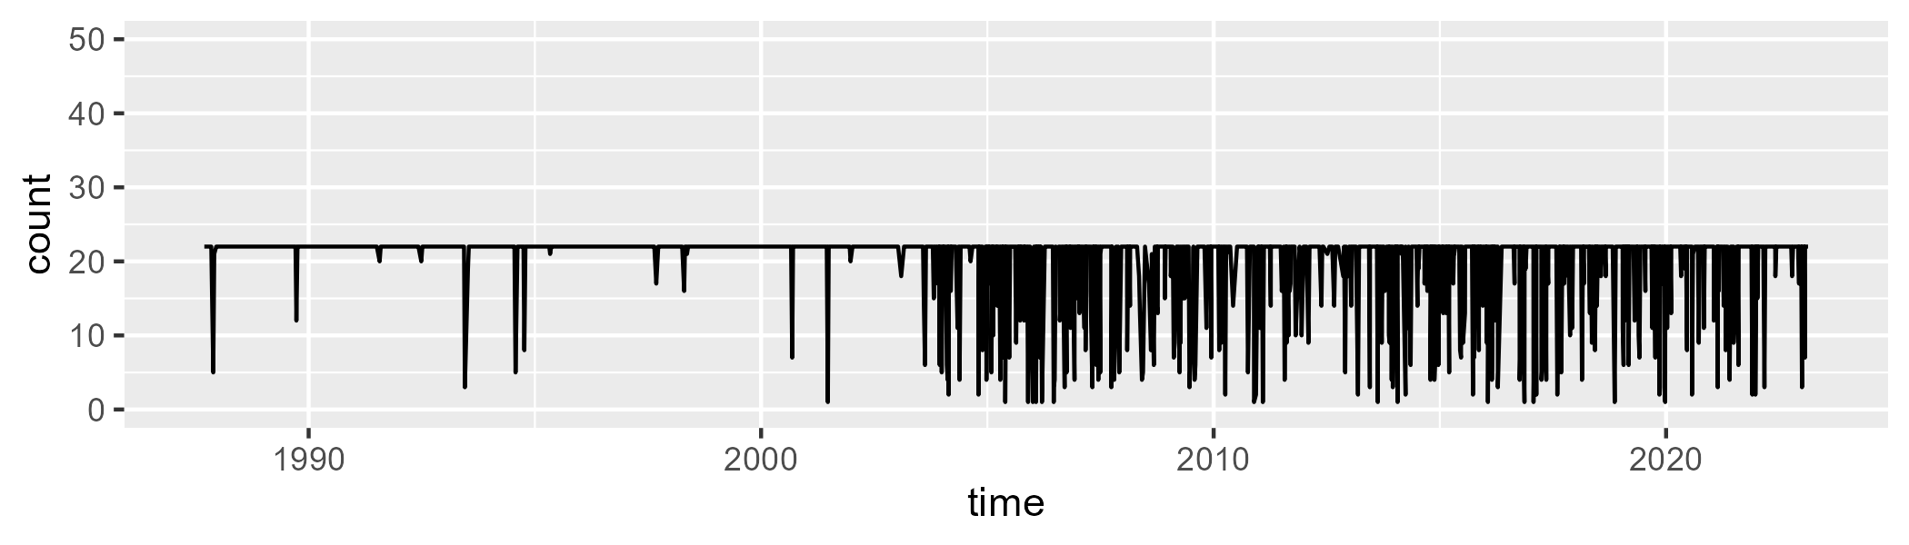

Min. : 1.00 1st Qu.:22.00 Median :22.00 Mean :20.05 3rd Qu.:22.00 Max. :22.00

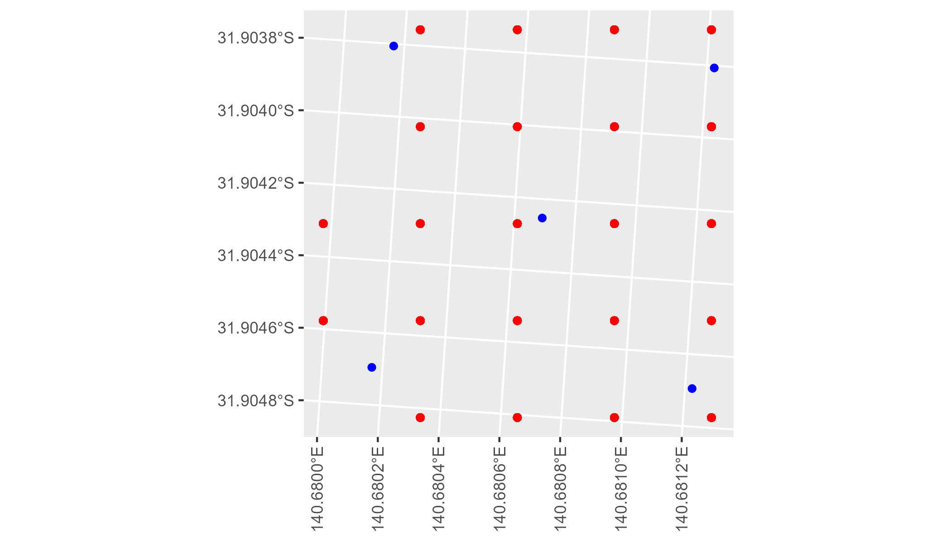

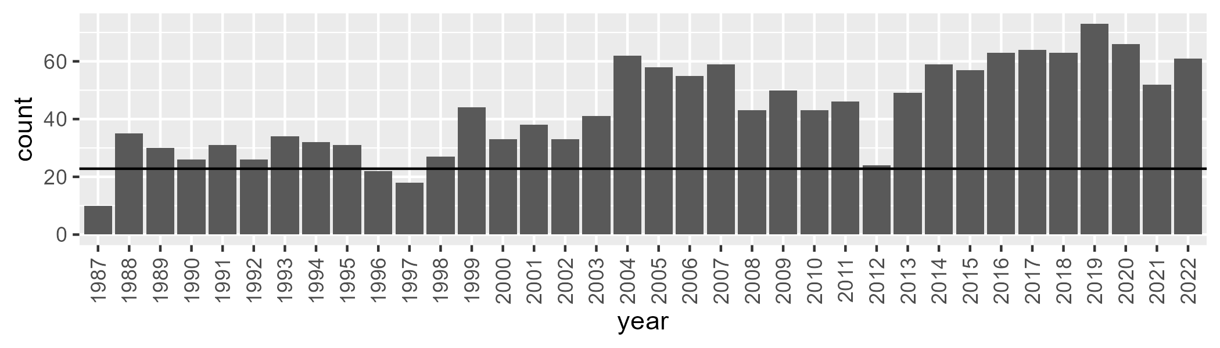

Number of samples: 1558

# SAAEYB0002

| Min. | 1st Qu. | Median | Mean | 3rd Qu. | Max. |
| --- | --- | --- | --- | --- | --- |
| 17.2183 | 31.78108 | 35.17445 | 35.10082 | 38.32265 | 48.69624 |

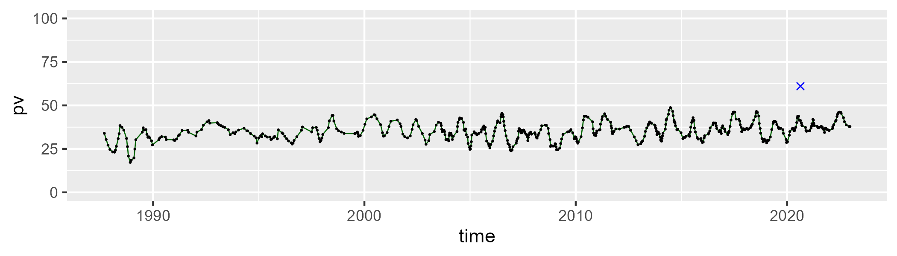

| Min. | 1st Qu. | Median | Mean | 3rd Qu. | Max. |
| --- | --- | --- | --- | --- | --- |
| 35.26217 | 45.28941 | 48.02745 | 48.37816 | 51.35252 | 62.62246 |

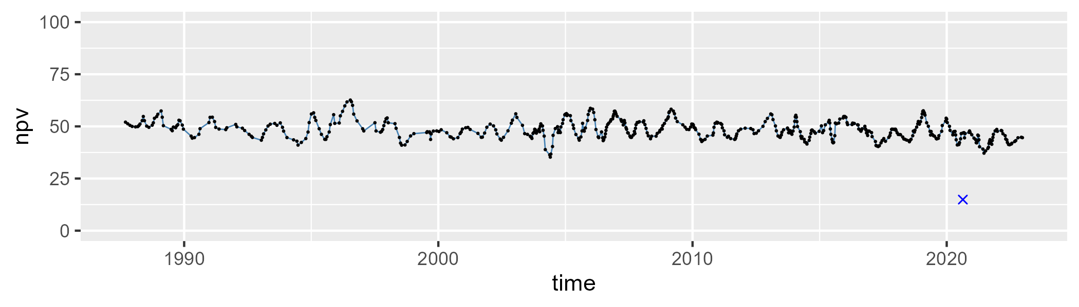

| Min. | 1st Qu. | Median | Mean | 3rd Qu. | Max. |
| --- | --- | --- | --- | --- | --- |
| 7.26834 | 12.66801 | 15.17412 | 15.27428 | 17.46329 | 27.71814 |

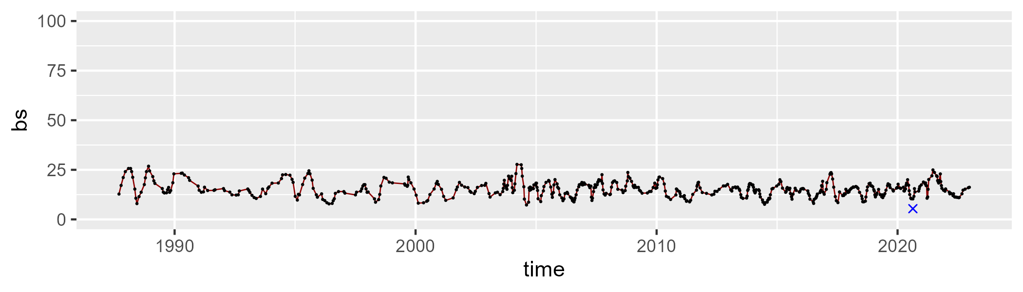

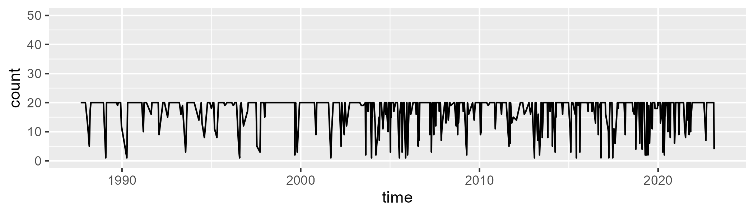

Min. : 1.00 1st Qu.:17.00 Median :20.00 Mean :17.14 3rd Qu.:20.00 Max. :20.00

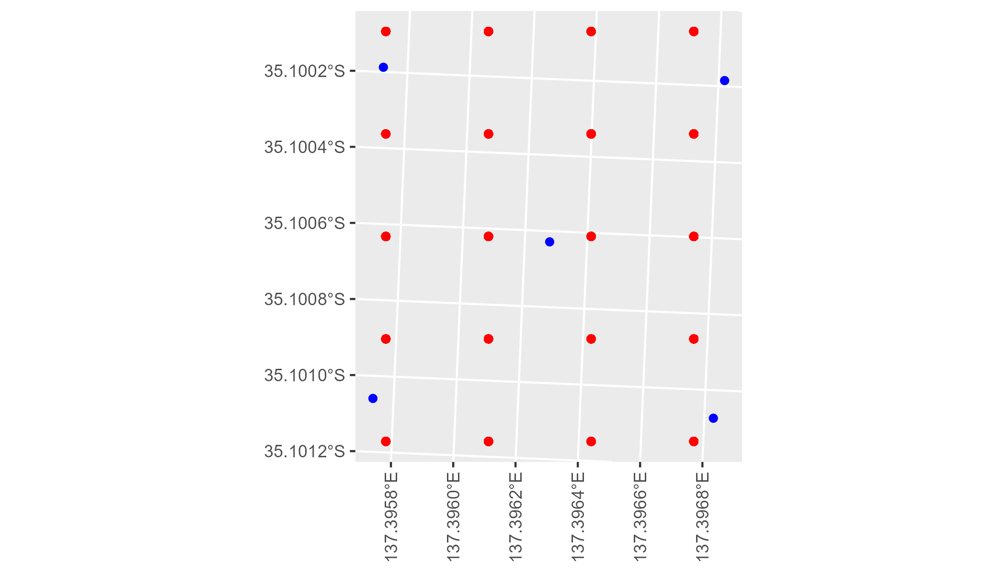

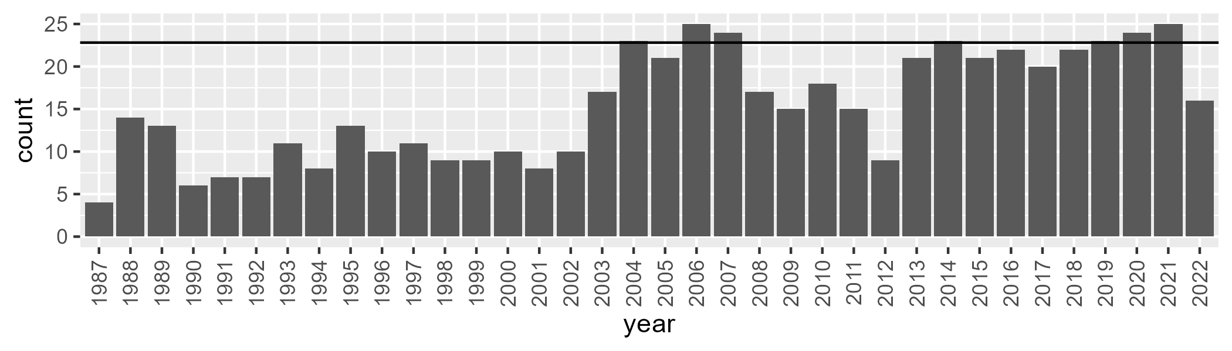

Number of samples: 551

# SAAEYB0003

| Min. | 1st Qu. | Median | Mean | 3rd Qu. | Max. |
| --- | --- | --- | --- | --- | --- |
| 31.82834 | 41.48844 | 44.97859 | 45.48757 | 49.28078 | 62.79438 |

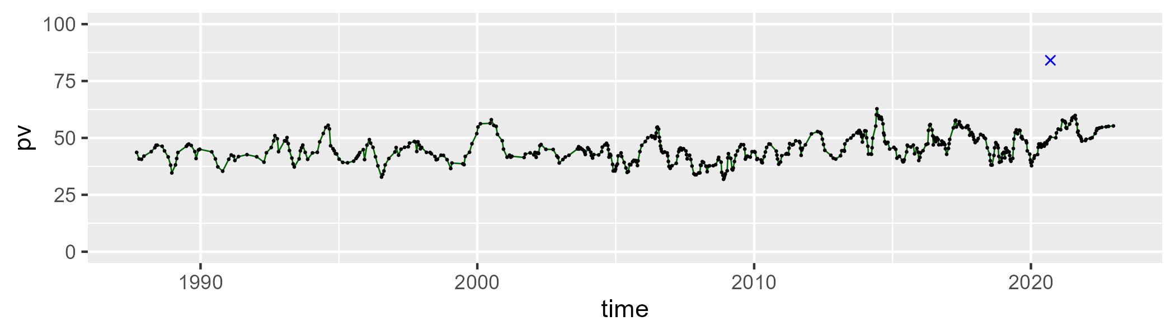

| Min. | 1st Qu. | Median | Mean | 3rd Qu. | Max. |
| --- | --- | --- | --- | --- | --- |
| 24.33824 | 36.77731 | 42.25155 | 42.3332 | 48.26657 | 57.4946 |

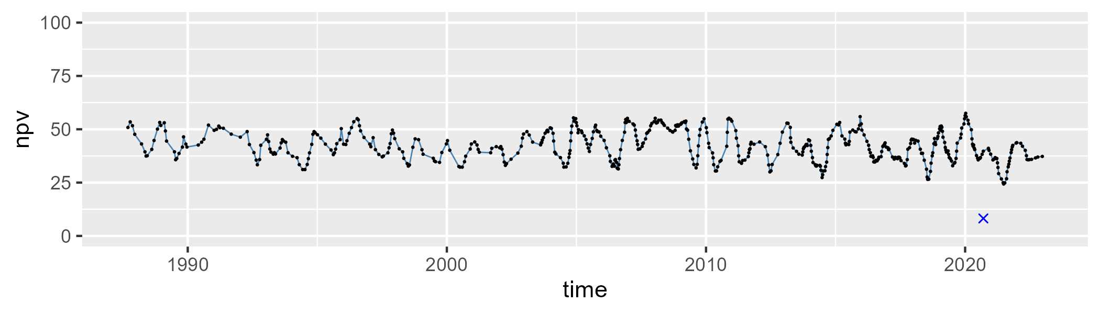

| Min. | 1st Qu. | Median | Mean | 3rd Qu. | Max. |
| --- | --- | --- | --- | --- | --- |
| 0 | 6.907114 | 10.10723 | 10.87201 | 14.38395 | 34.09047 |

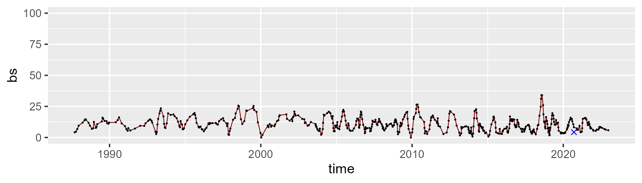

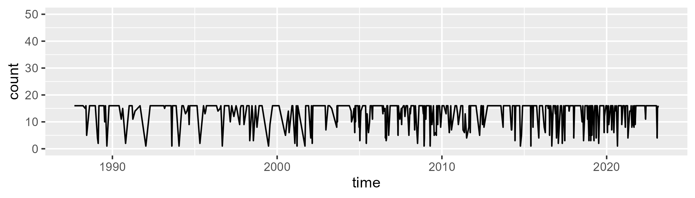

Min. : 1.00 1st Qu.:12.50 Median :16.00 Mean :13.42 3rd Qu.:16.00 Max. :16.00

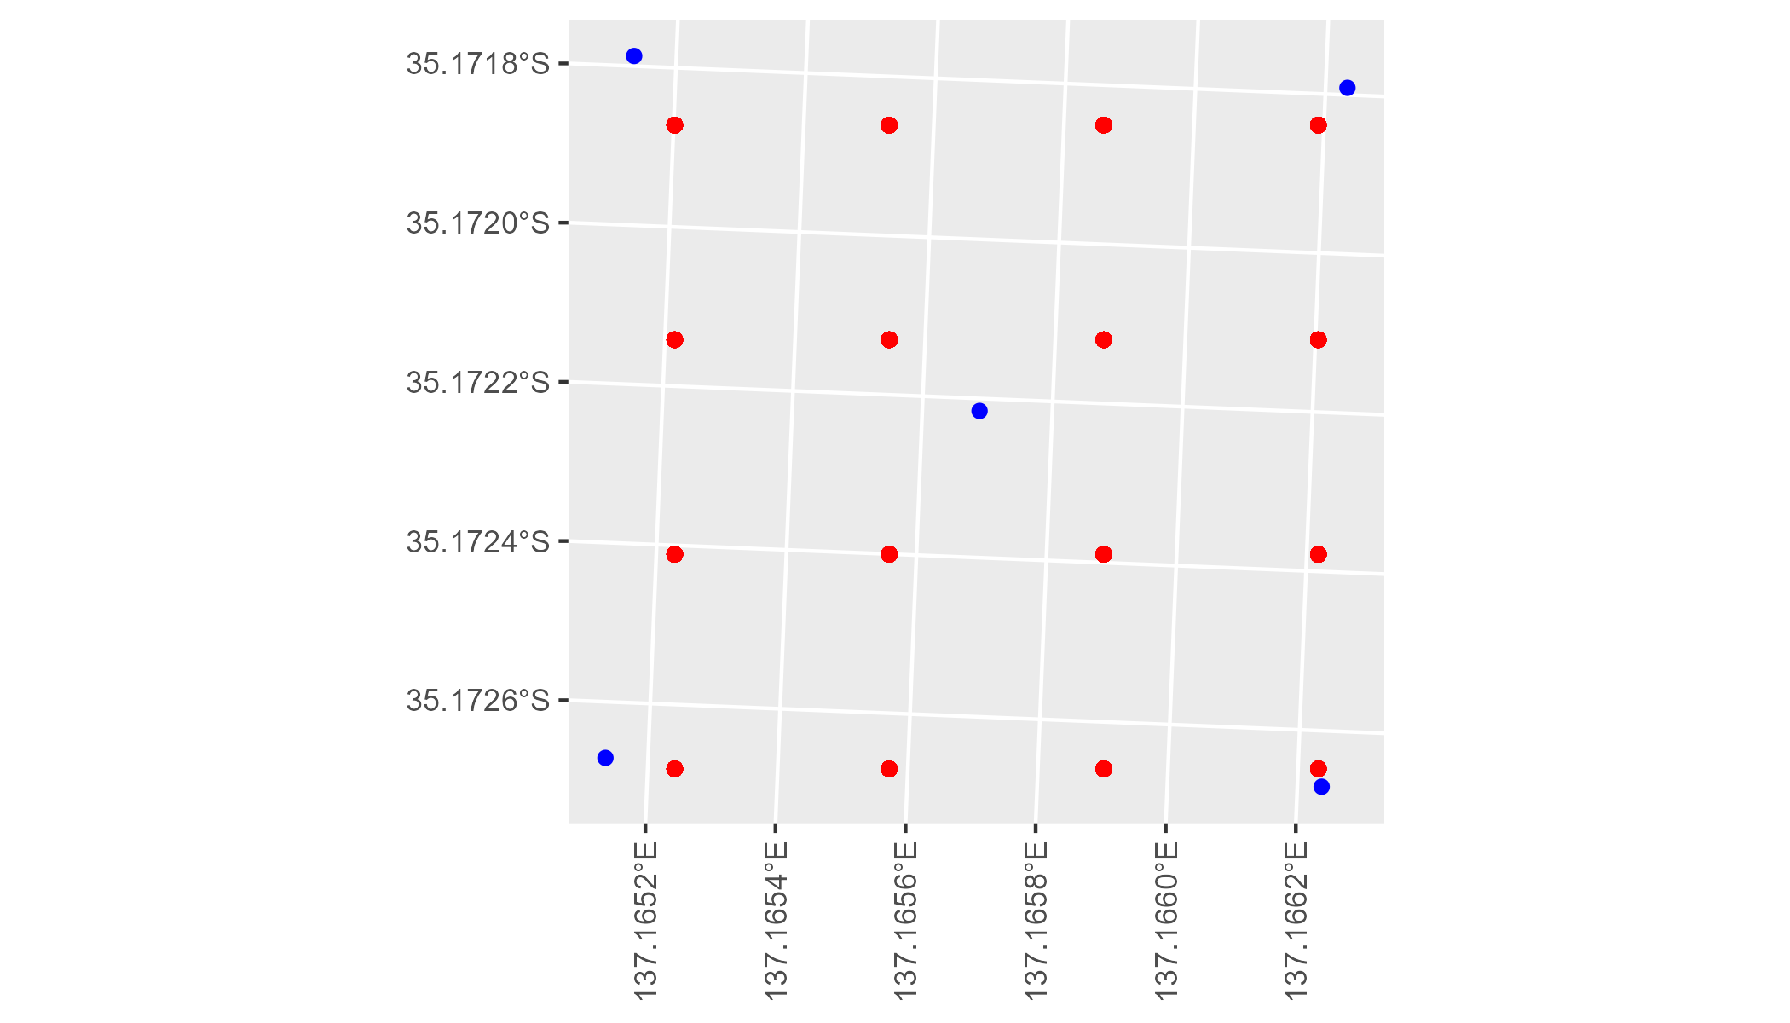

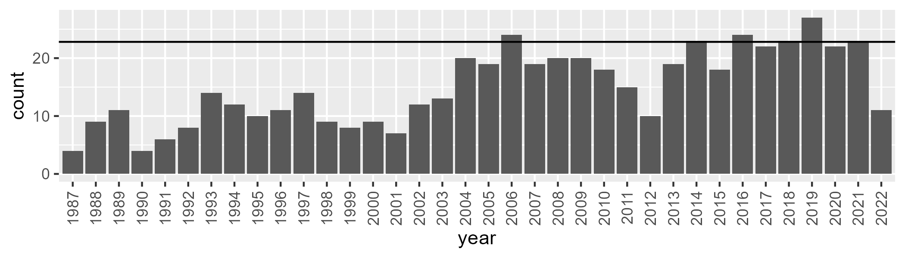

Number of samples: 538

# SAAEYB0004

| Min. | 1st Qu. | Median | Mean | 3rd Qu. | Max. |
| --- | --- | --- | --- | --- | --- |
| 29.24557 | 40.59096 | 44.08747 | 43.75444 | 47.15061 | 54.86642 |

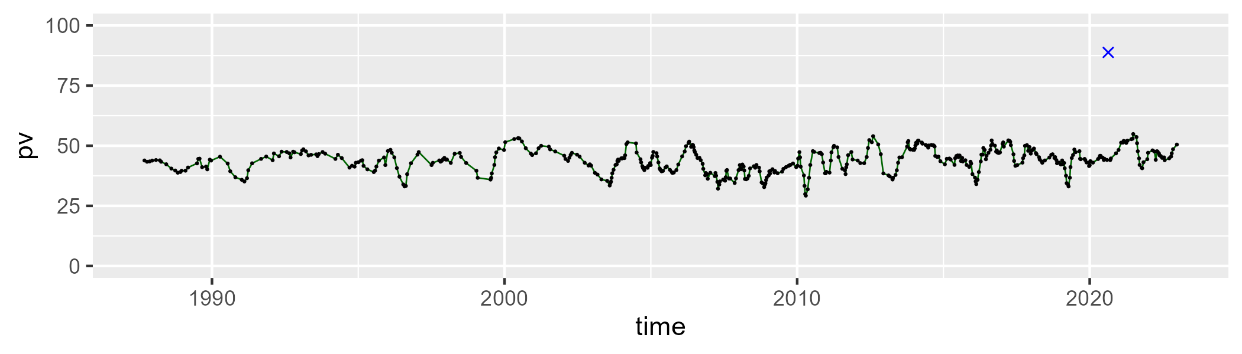

| Min. | 1st Qu. | Median | Mean | 3rd Qu. | Max. |
| --- | --- | --- | --- | --- | --- |
| 26.38698 | 38.48029 | 42.33853 | 42.37249 | 46.51704 | 55.31322 |

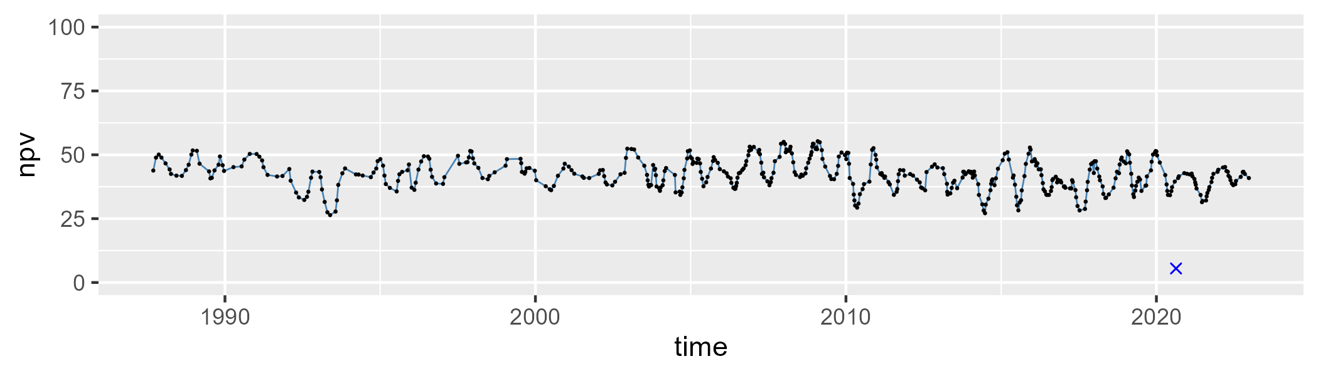

| Min. | 1st Qu. | Median | Mean | 3rd Qu. | Max. |
| --- | --- | --- | --- | --- | --- |
| 0.3033878 | 8.045726 | 11.71802 | 12.59327 | 15.92074 | 39.50177 |

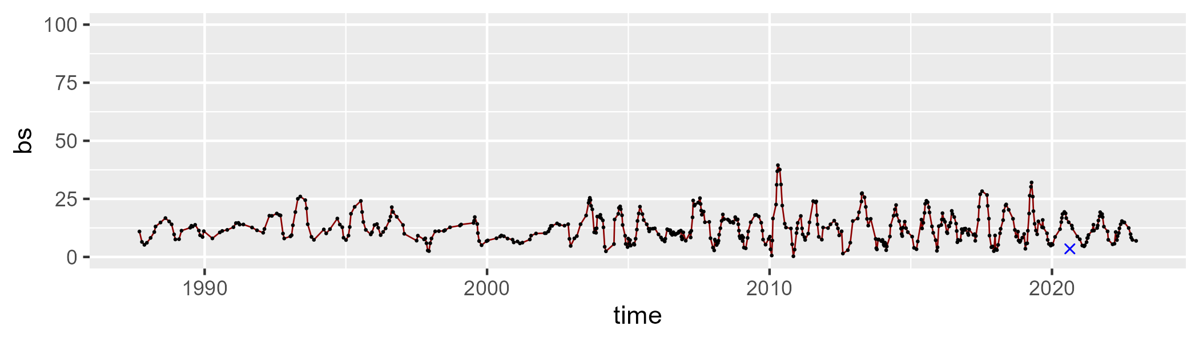

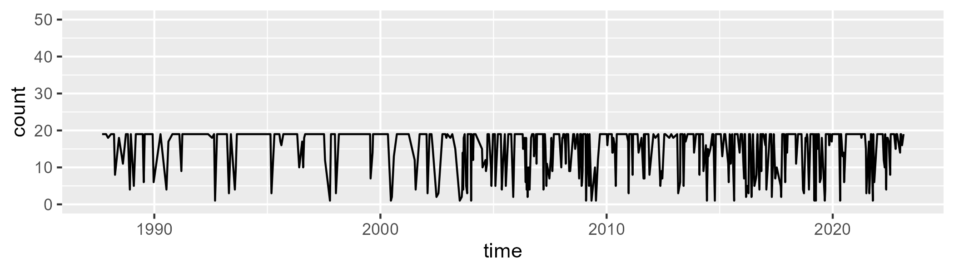

Min. : 1.0 1st Qu.:12.0 Median :19.0 Mean :15.2 3rd Qu.:19.0 Max. :19.0

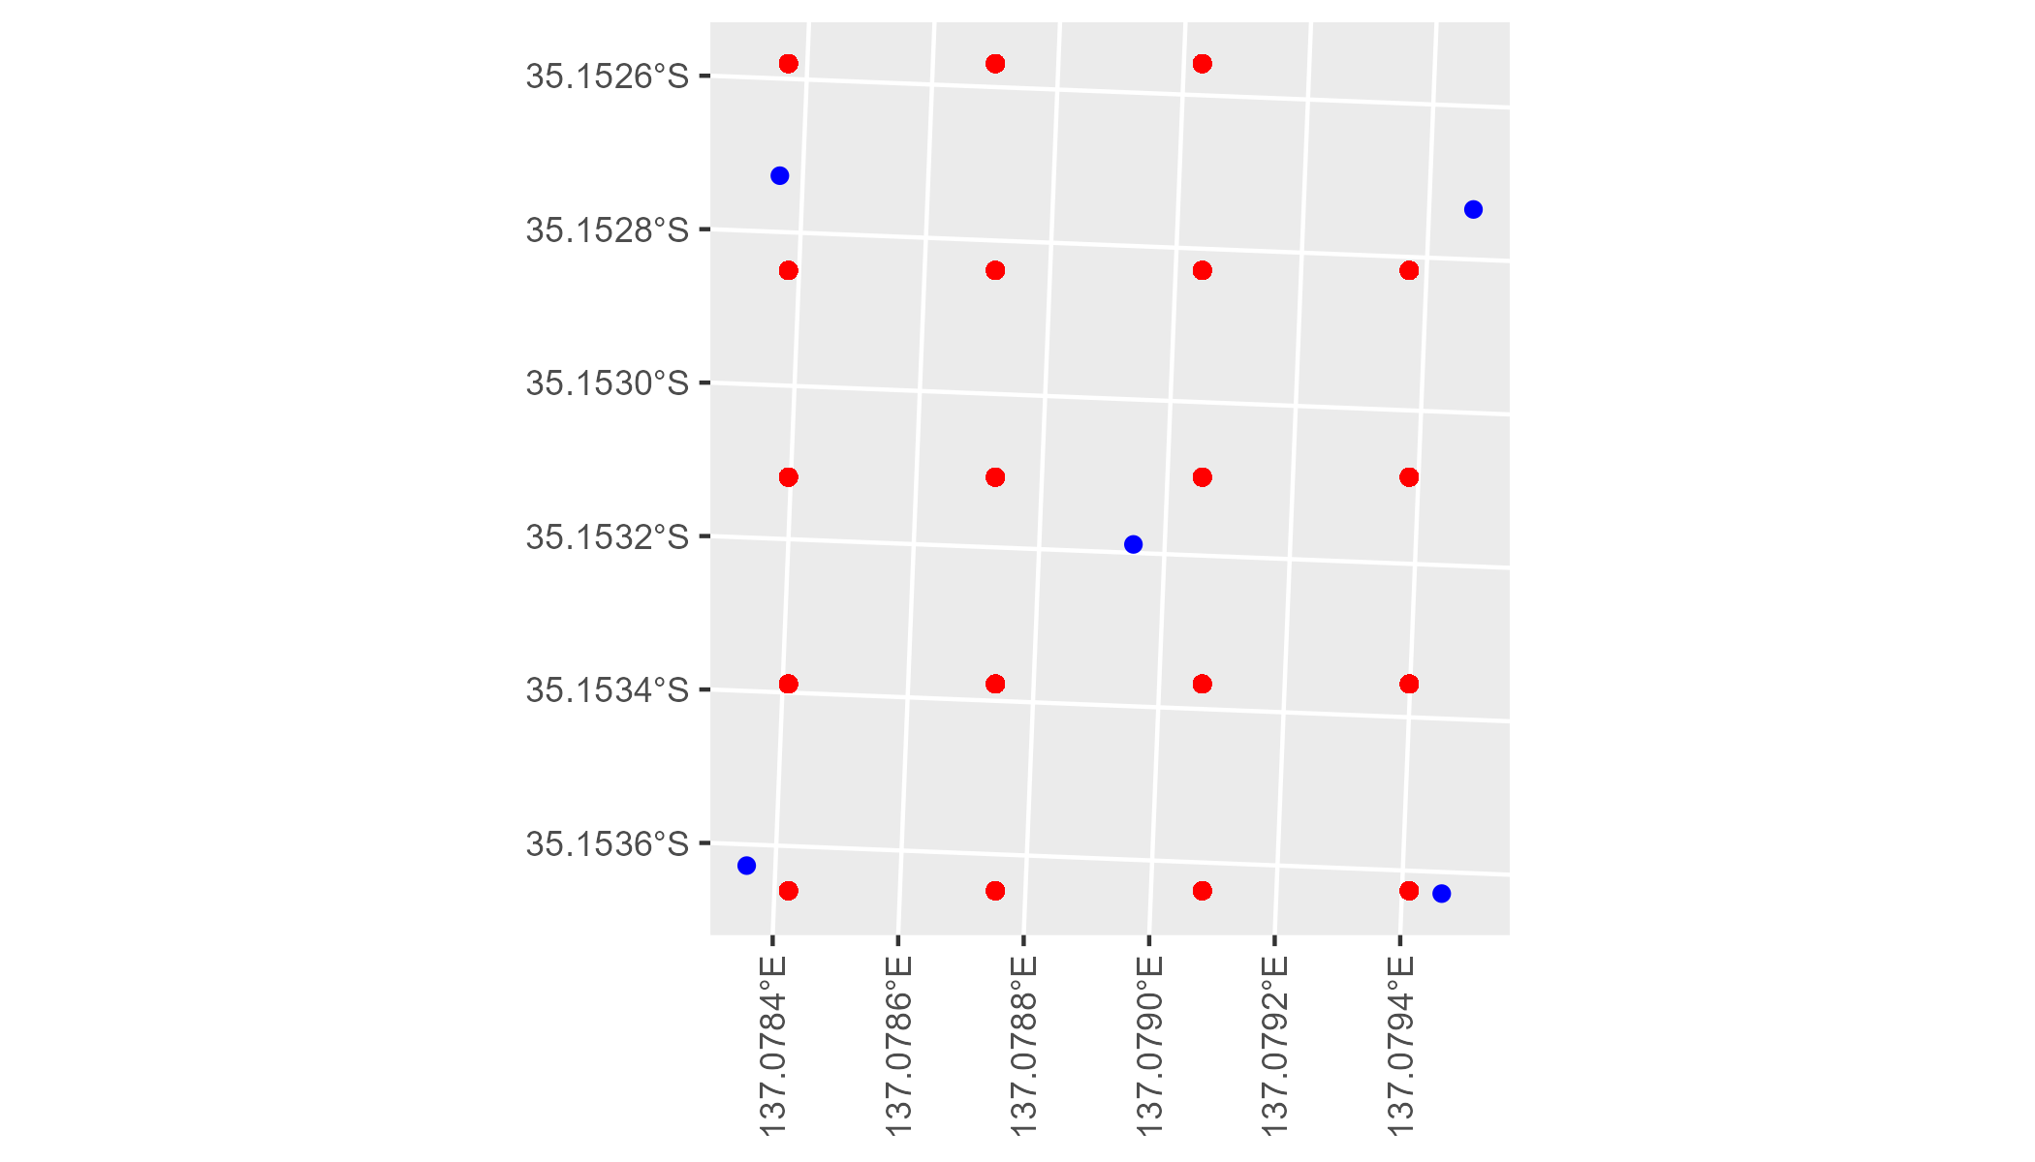

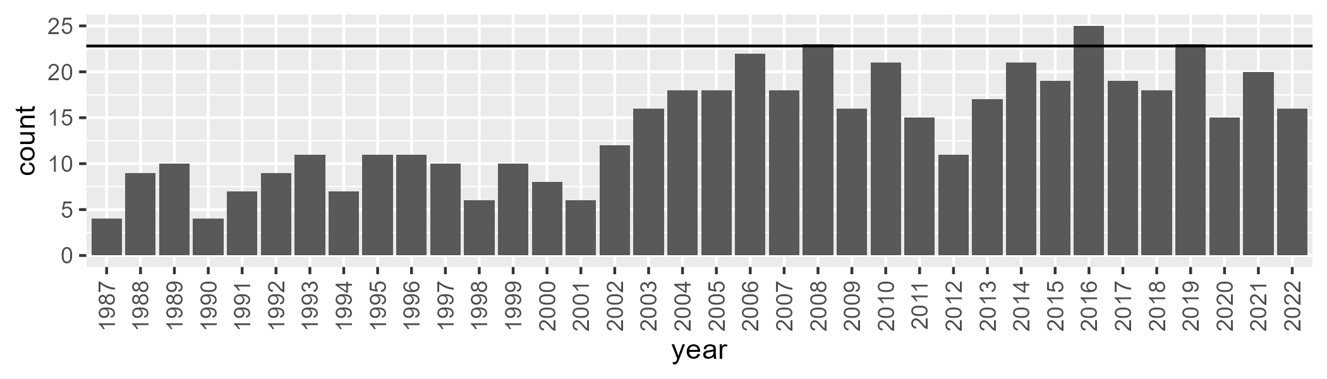

Number of samples: 506

# SAAEYB0005

| Min. | 1st Qu. | Median | Mean | 3rd Qu. | Max. |
| --- | --- | --- | --- | --- | --- |
| 25.04237 | 39.17754 | 42.77231 | 43.10013 | 47.34837 | 56.11252 |

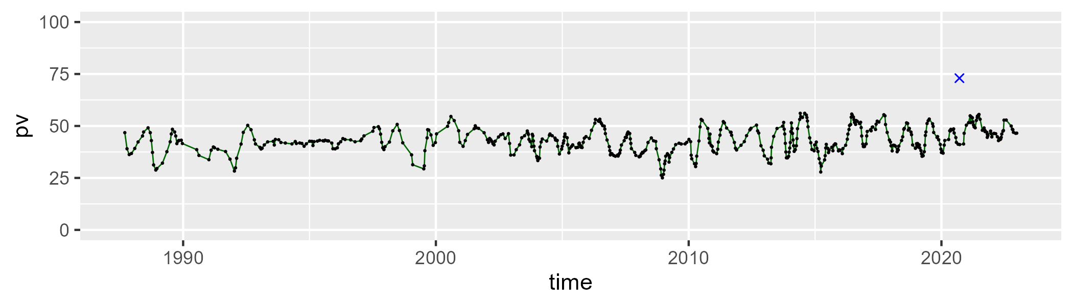

| Min. | 1st Qu. | Median | Mean | 3rd Qu. | Max. |
| --- | --- | --- | --- | --- | --- |
| 25.59697 | 40.60606 | 47.04485 | 46.07439 | 51.77573 | 61.47862 |

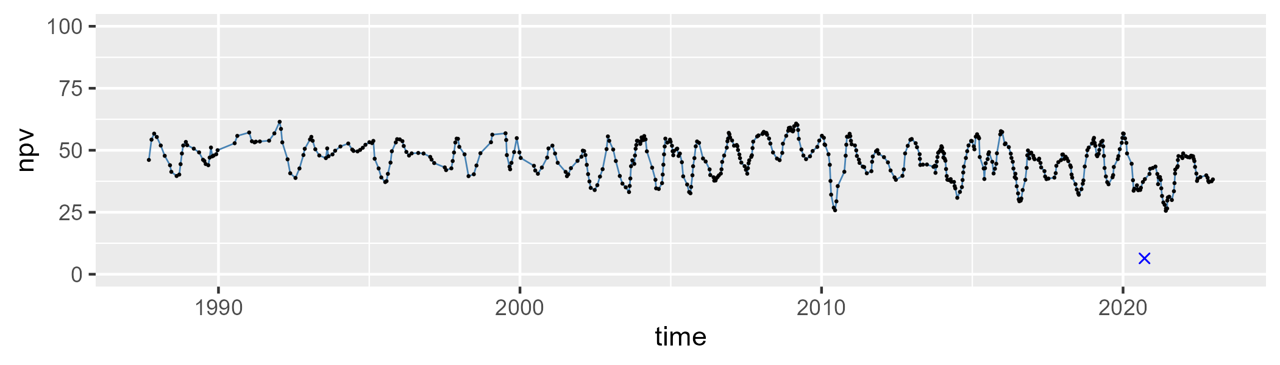

| Min. | 1st Qu. | Median | Mean | 3rd Qu. | Max. |
| --- | --- | --- | --- | --- | --- |
| 0 | 6.043235 | 8.304643 | 9.642884 | 12.15936 | 33.22381 |

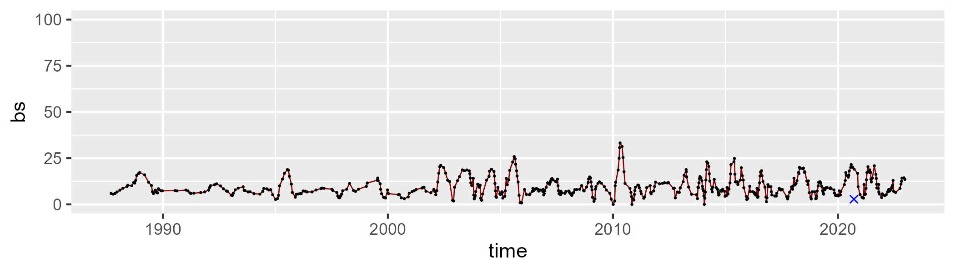

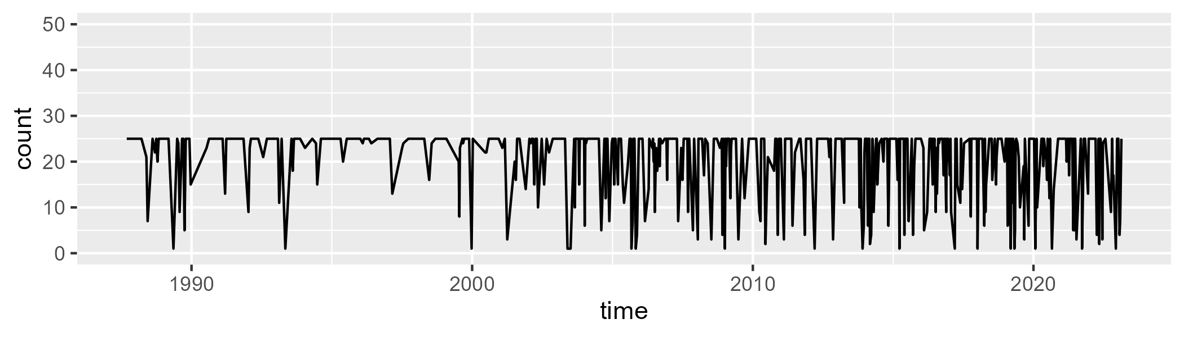

Min. : 1.00 1st Qu.:18.50 Median :25.00 Mean :20.56 3rd Qu.:25.00 Max. :25.00

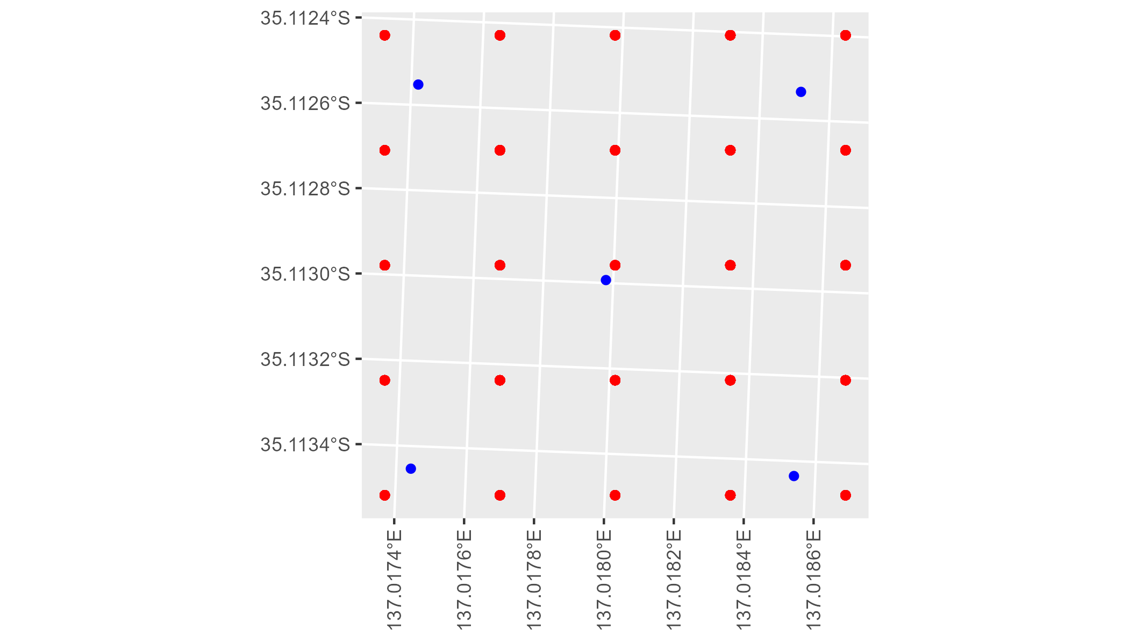

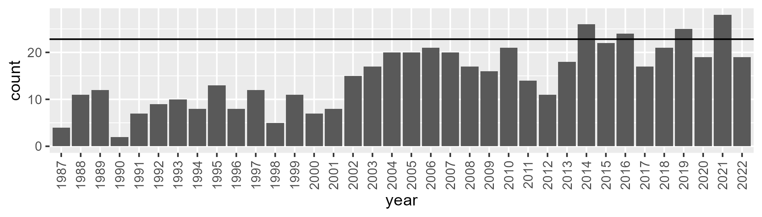

Number of samples: 538

# SAAEYB0006

| Min. | 1st Qu. | Median | Mean | 3rd Qu. | Max. |
| --- | --- | --- | --- | --- | --- |
| 30.7707 | 40.12718 | 43.79405 | 43.67056 | 47.51456 | 58.80338 |

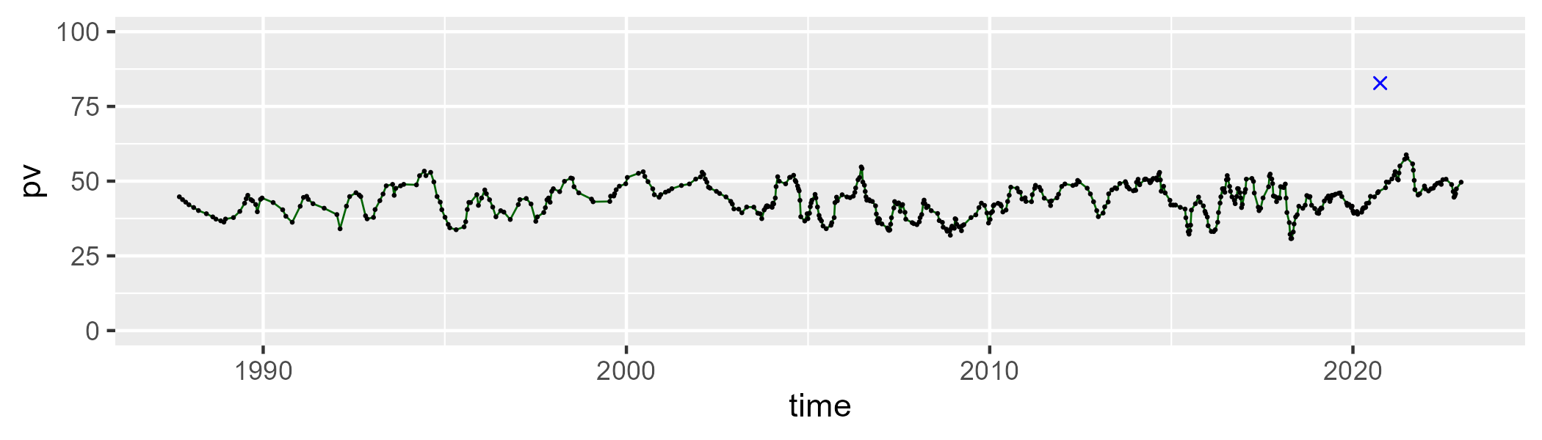

| Min. | 1st Qu. | Median | Mean | 3rd Qu. | Max. |
| --- | --- | --- | --- | --- | --- |
| 19.49547 | 39.26484 | 43.48803 | 43.28847 | 48.1799 | 60.42161 |

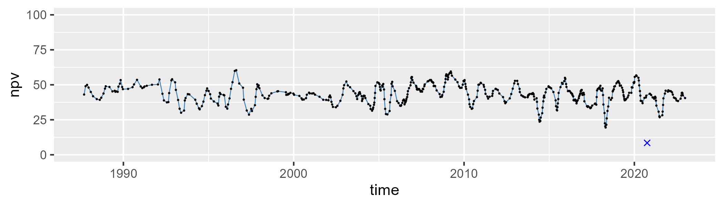

| Min. | 1st Qu. | Median | Mean | 3rd Qu. | Max. |
| --- | --- | --- | --- | --- | --- |
| 0 | 7.490781 | 9.781959 | 11.76831 | 14.41543 | 48.65201 |

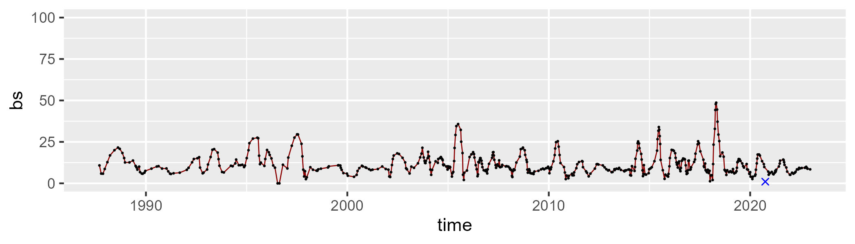

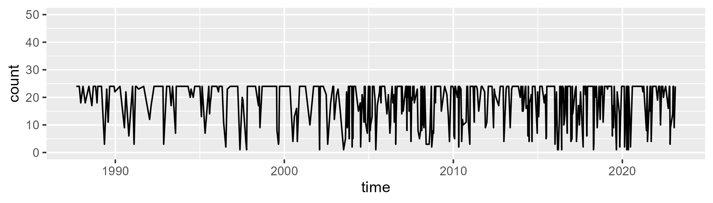

Min. : 1.0 1st Qu.:14.0 Median :24.0 Mean :18.8 3rd Qu.:24.0 Max. :24.0

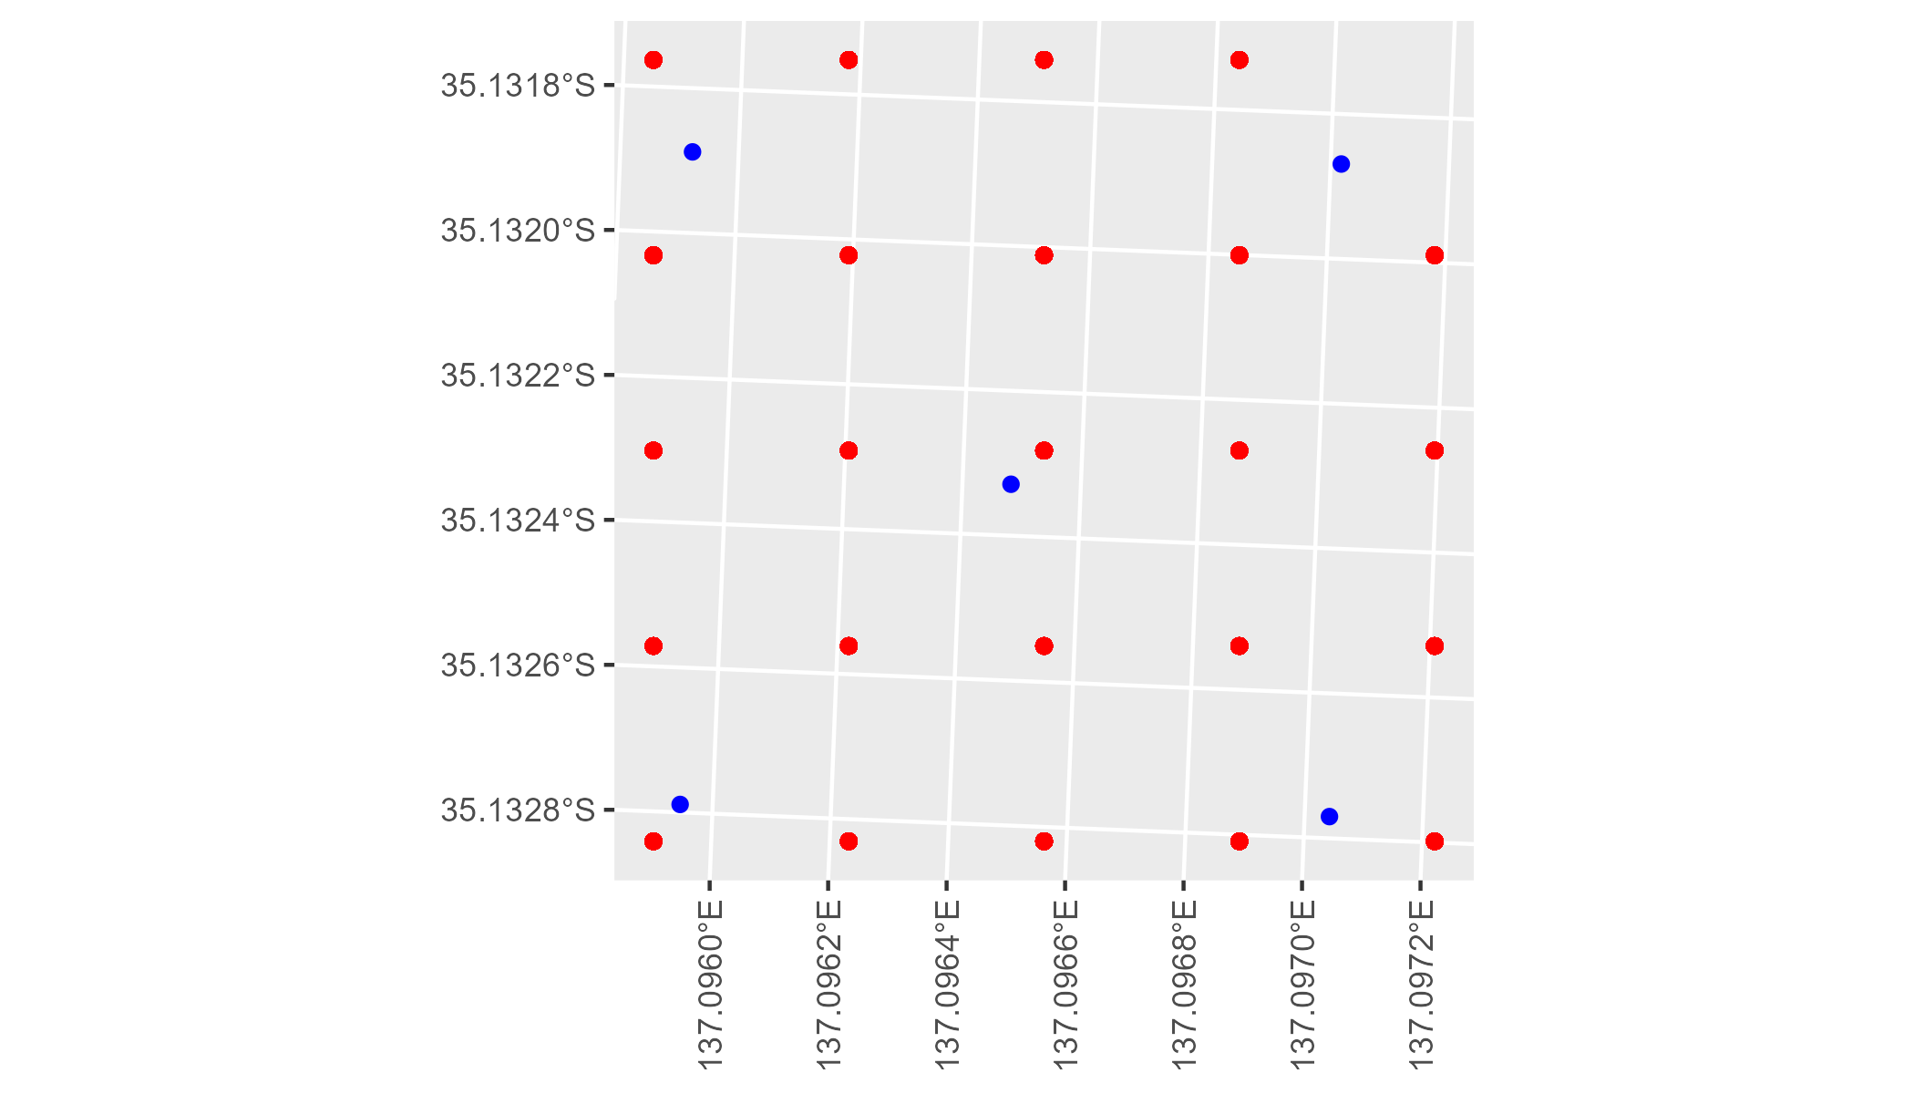

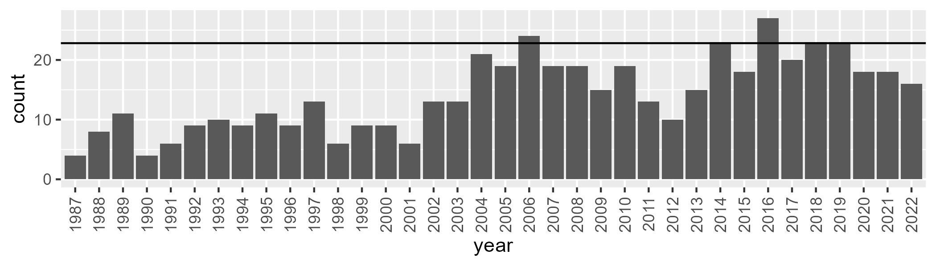

Number of samples: 510

# SAAEYB0007

| Min. | 1st Qu. | Median | Mean | 3rd Qu. | Max. |
| --- | --- | --- | --- | --- | --- |
| 22.68006 | 36.95238 | 40.28018 | 40.43895 | 43.81431 | 53.78393 |

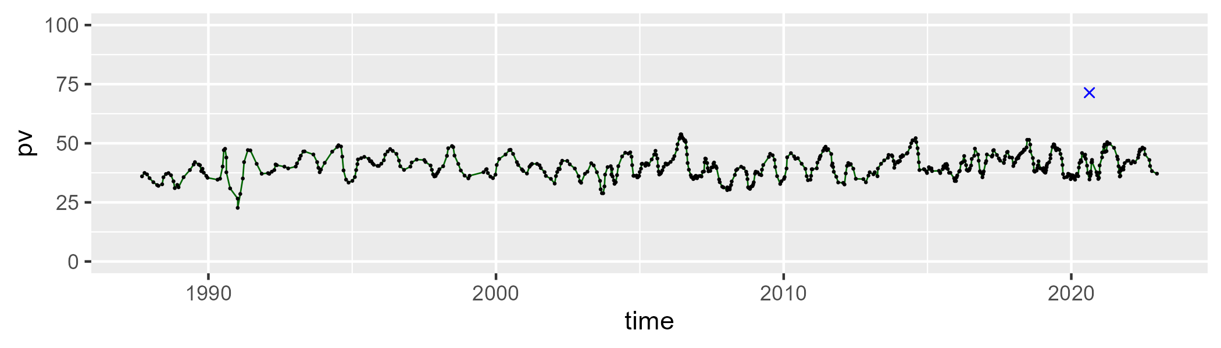

| Min. | 1st Qu. | Median | Mean | 3rd Qu. | Max. |
| --- | --- | --- | --- | --- | --- |
| 26.03542 | 39.97652 | 44.08692 | 43.67676 | 47.16068 | 57.73006 |

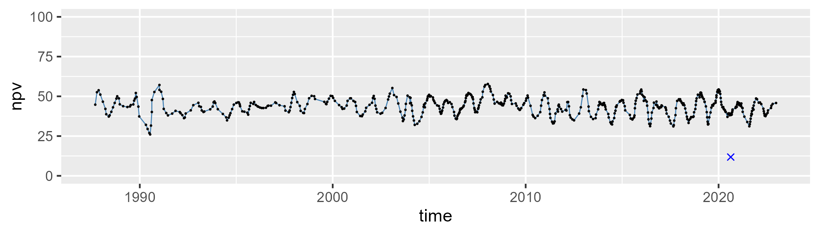

| Min. | 1st Qu. | Median | Mean | 3rd Qu. | Max. |
| --- | --- | --- | --- | --- | --- |
| 4.700734 | 10.78965 | 13.45137 | 14.59276 | 17.81045 | 34.37297 |

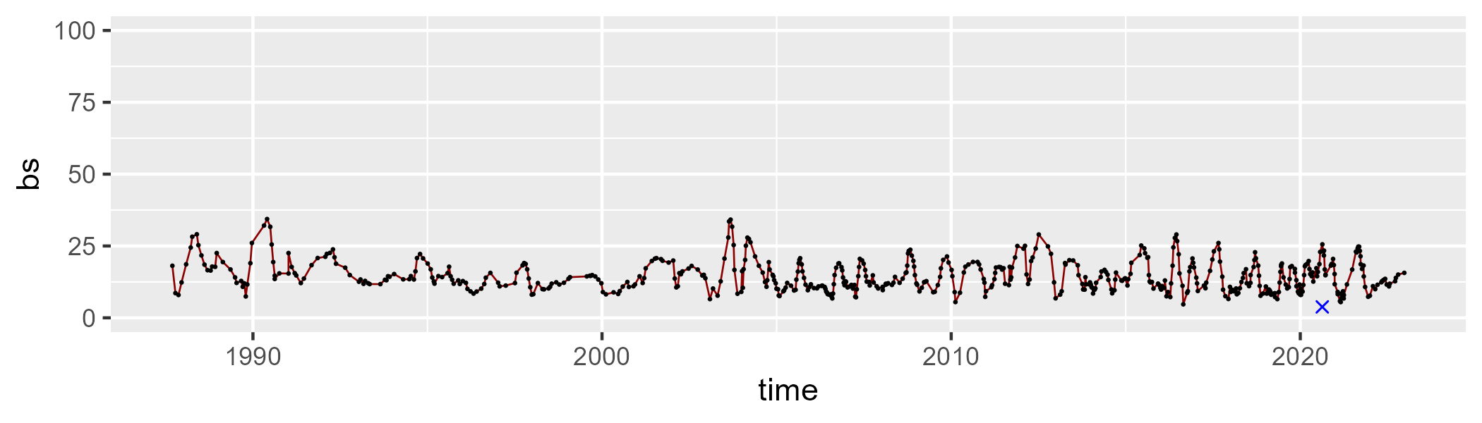

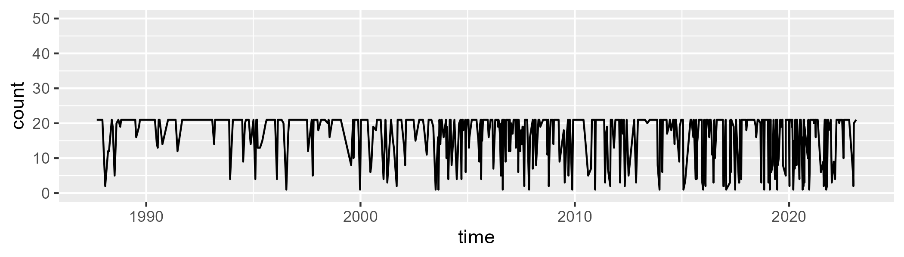

Min. : 1.00 1st Qu.:14.00 Median :21.00 Mean :16.83 3rd Qu.:21.00 Max. :21.00

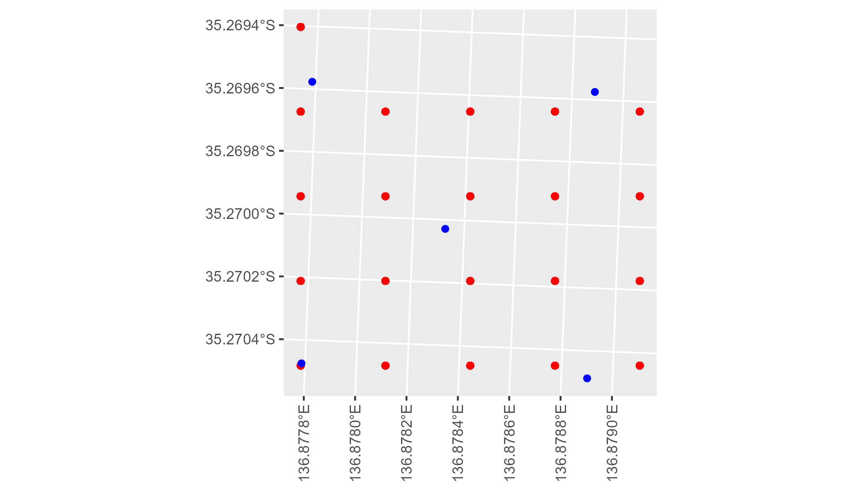

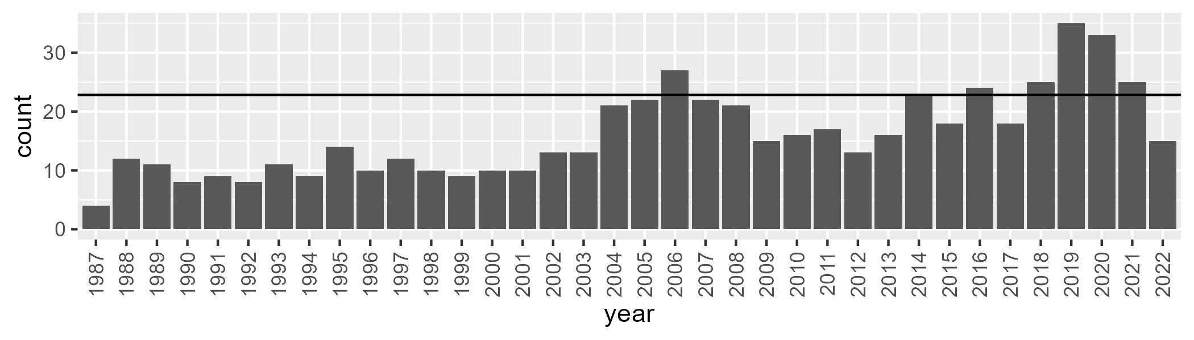

Number of samples: 579

# SAAEYB0008

| Min. | 1st Qu. | Median | Mean | 3rd Qu. | Max. |
| --- | --- | --- | --- | --- | --- |
| 24.45806 | 41.64331 | 45.05653 | 44.41422 | 48.12378 | 57.7214 |

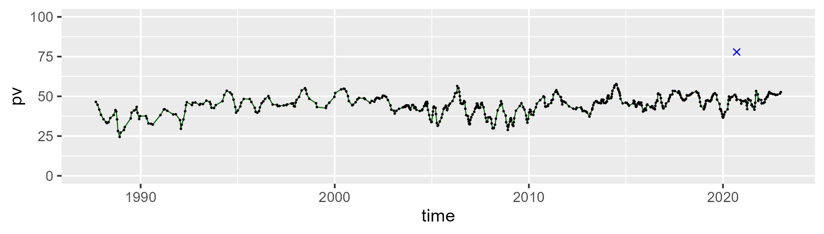

| Min. | 1st Qu. | Median | Mean | 3rd Qu. | Max. |
| --- | --- | --- | --- | --- | --- |
| 24.70799 | 39.28361 | 43.30127 | 43.77201 | 48.35712 | 64.34384 |

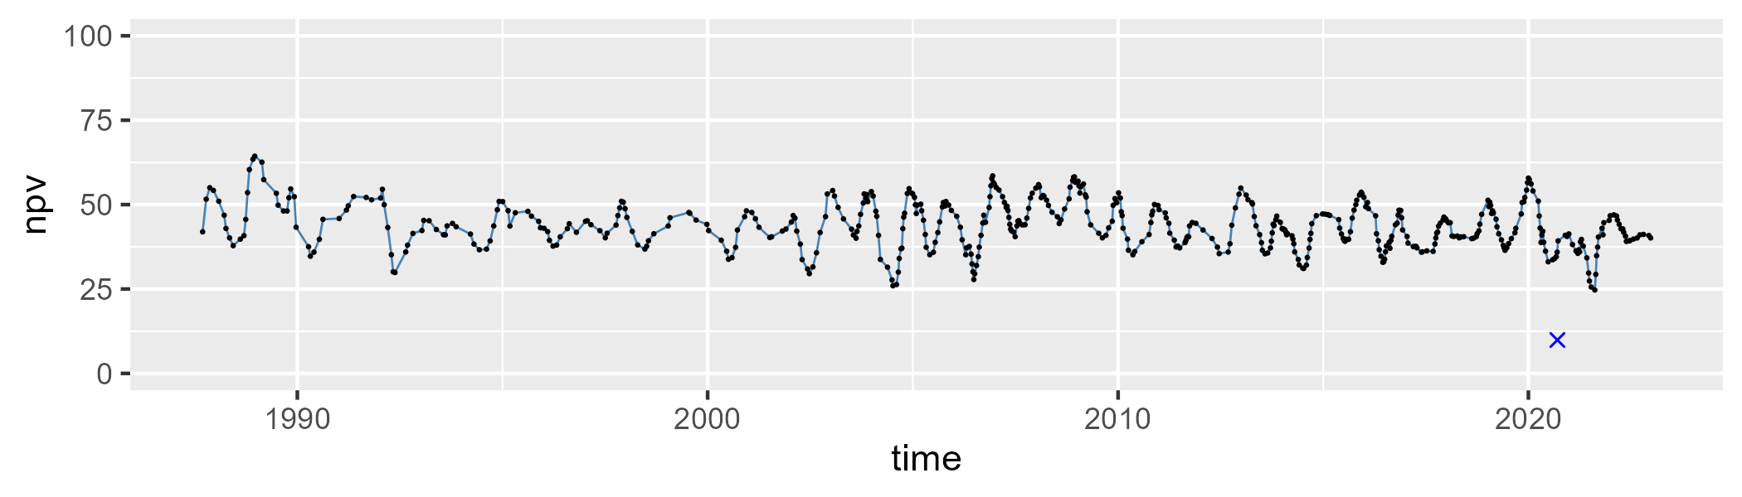

| Min. | 1st Qu. | Median | Mean | 3rd Qu. | Max. |
| --- | --- | --- | --- | --- | --- |
| 0.4692535 | 6.343832 | 8.982455 | 10.51737 | 13.36086 | 32.16437 |

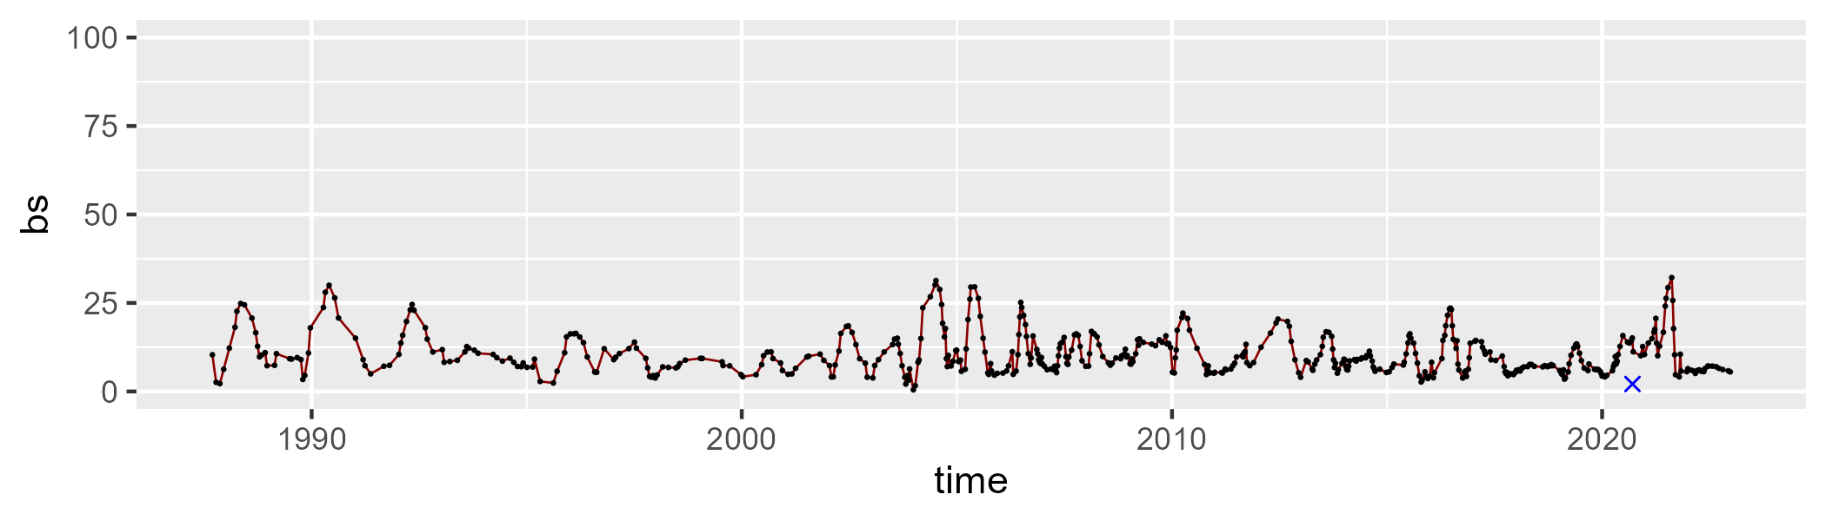

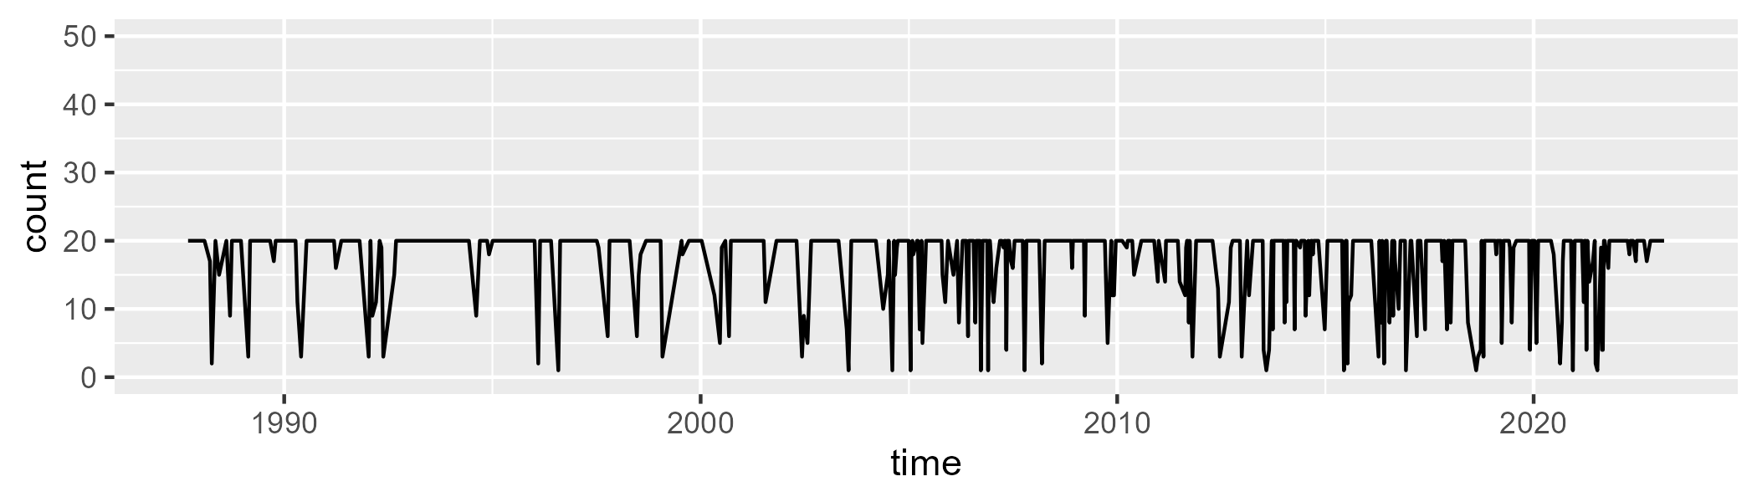

Min. : 1.00 1st Qu.:18.00 Median :20.00 Mean :17.16 3rd Qu.:20.00 Max. :20.00

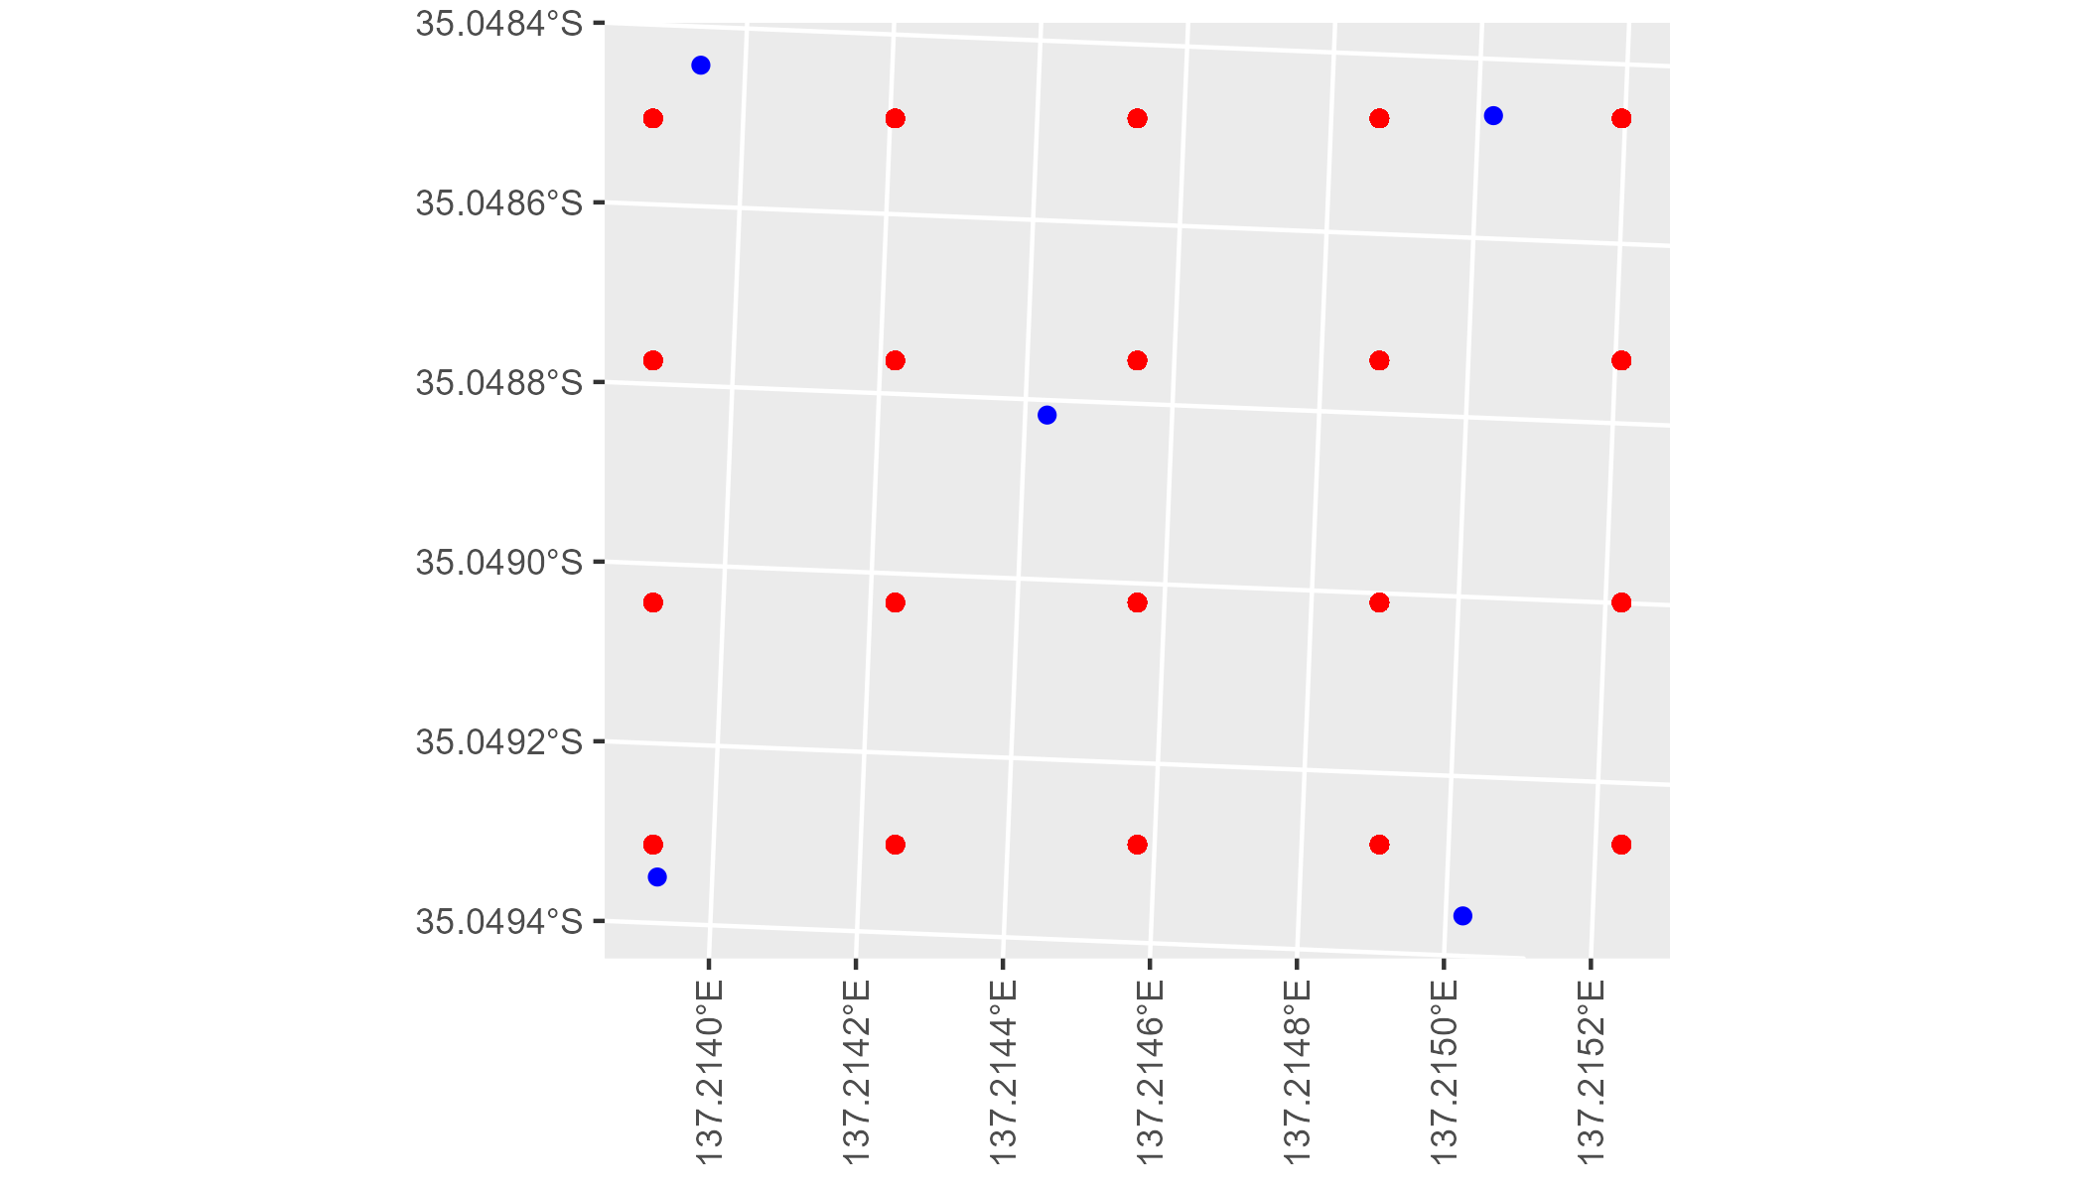

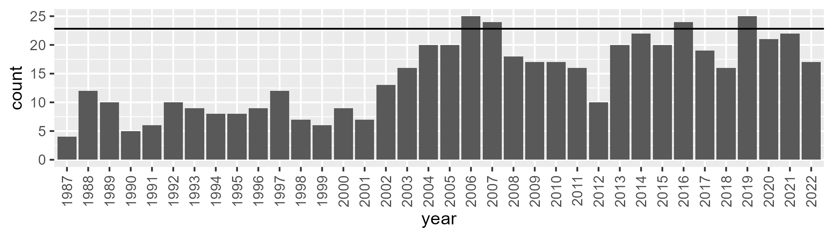

Number of samples: 524

# SAAEYB0009

| Min. | 1st Qu. | Median | Mean | 3rd Qu. | Max. |
| --- | --- | --- | --- | --- | --- |
| 28.55558 | 39.69584 | 42.86649 | 42.94209 | 46.17535 | 56.16046 |

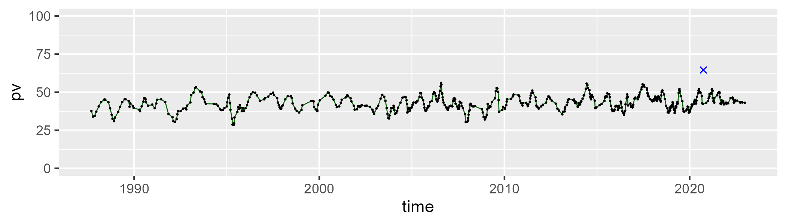

| Min. | 1st Qu. | Median | Mean | 3rd Qu. | Max. |
| --- | --- | --- | --- | --- | --- |
| 28.11279 | 37.94434 | 43.27592 | 42.75837 | 47.30211 | 55.77892 |

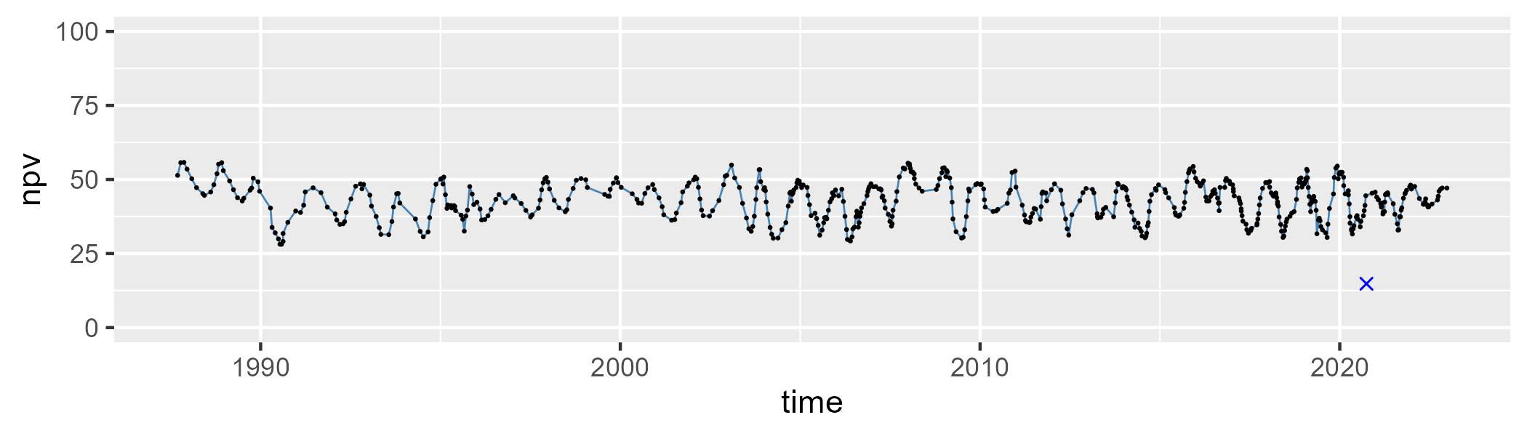

| Min. | 1st Qu. | Median | Mean | 3rd Qu. | Max. |
| --- | --- | --- | --- | --- | --- |
| 1.834913 | 8.990343 | 11.63736 | 12.98546 | 15.54561 | 33.6874 |

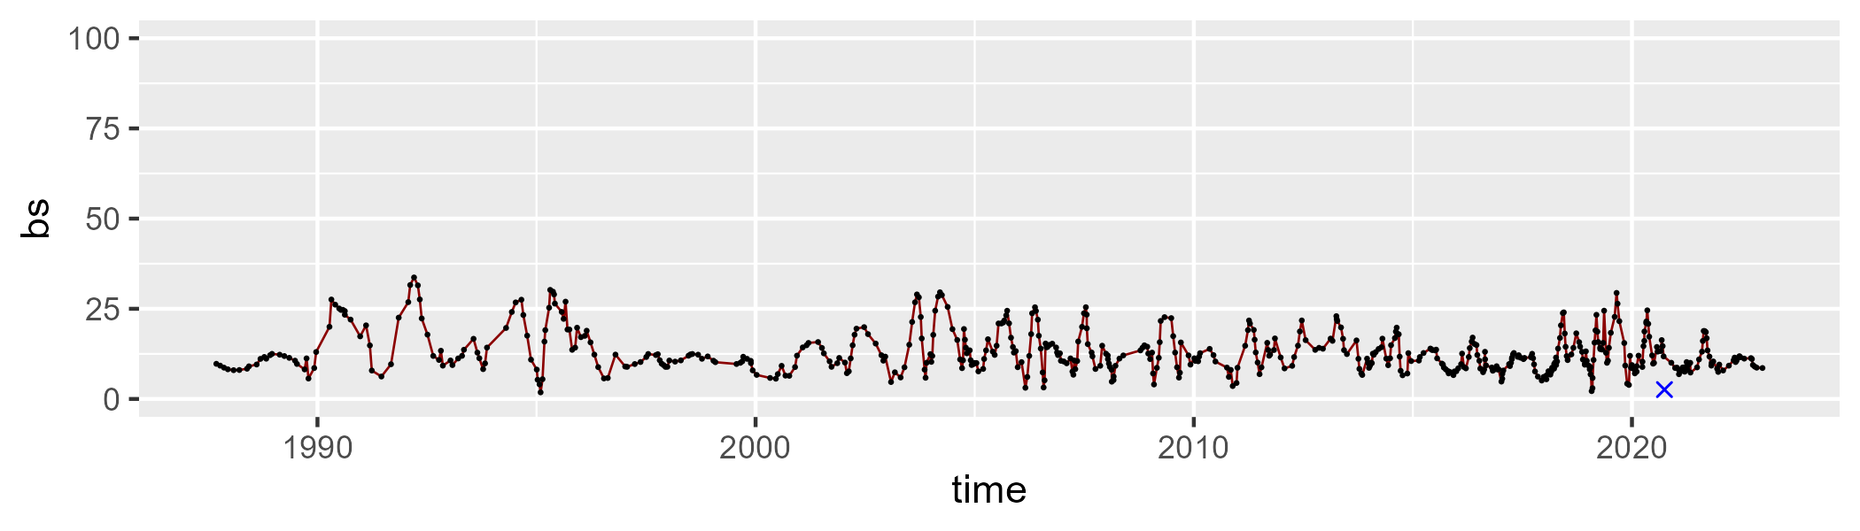

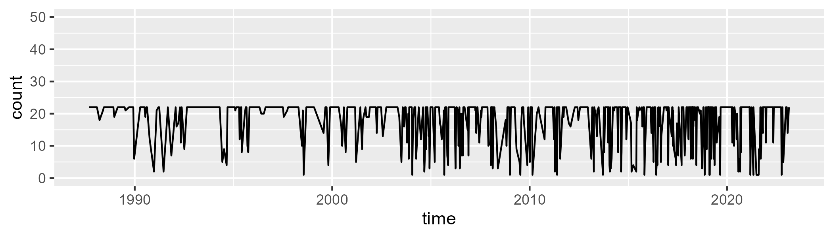

Min. : 1.00 1st Qu.:15.00 Median :22.00 Mean :17.79 3rd Qu.:22.00 Max. :22.00

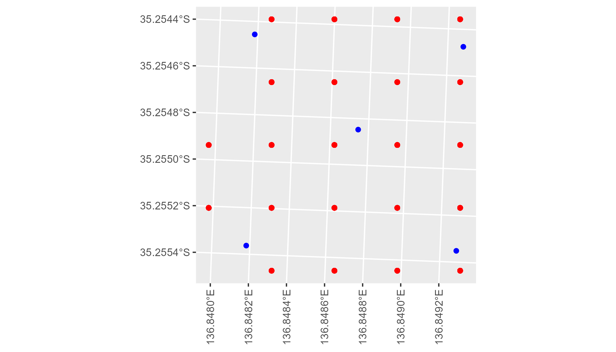

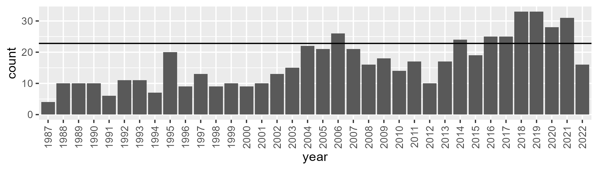

Number of samples: 593

# SAAEYB0010

| Min. | 1st Qu. | Median | Mean | 3rd Qu. | Max. |
| --- | --- | --- | --- | --- | --- |
| 28.35138 | 38.46787 | 42.13036 | 42.39119 | 45.82517 | 56.24298 |

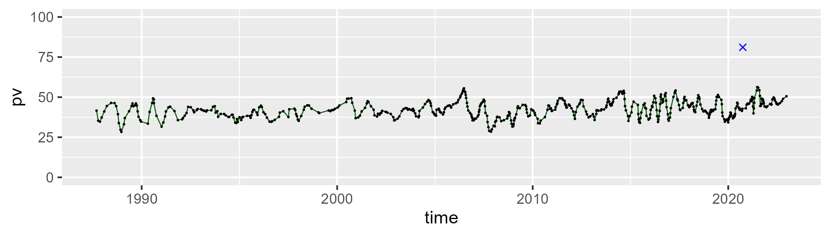

| Min. | 1st Qu. | Median | Mean | 3rd Qu. | Max. |
| --- | --- | --- | --- | --- | --- |
| 25.44713 | 39.63952 | 44.69265 | 44.35742 | 49.18818 | 60.59894 |

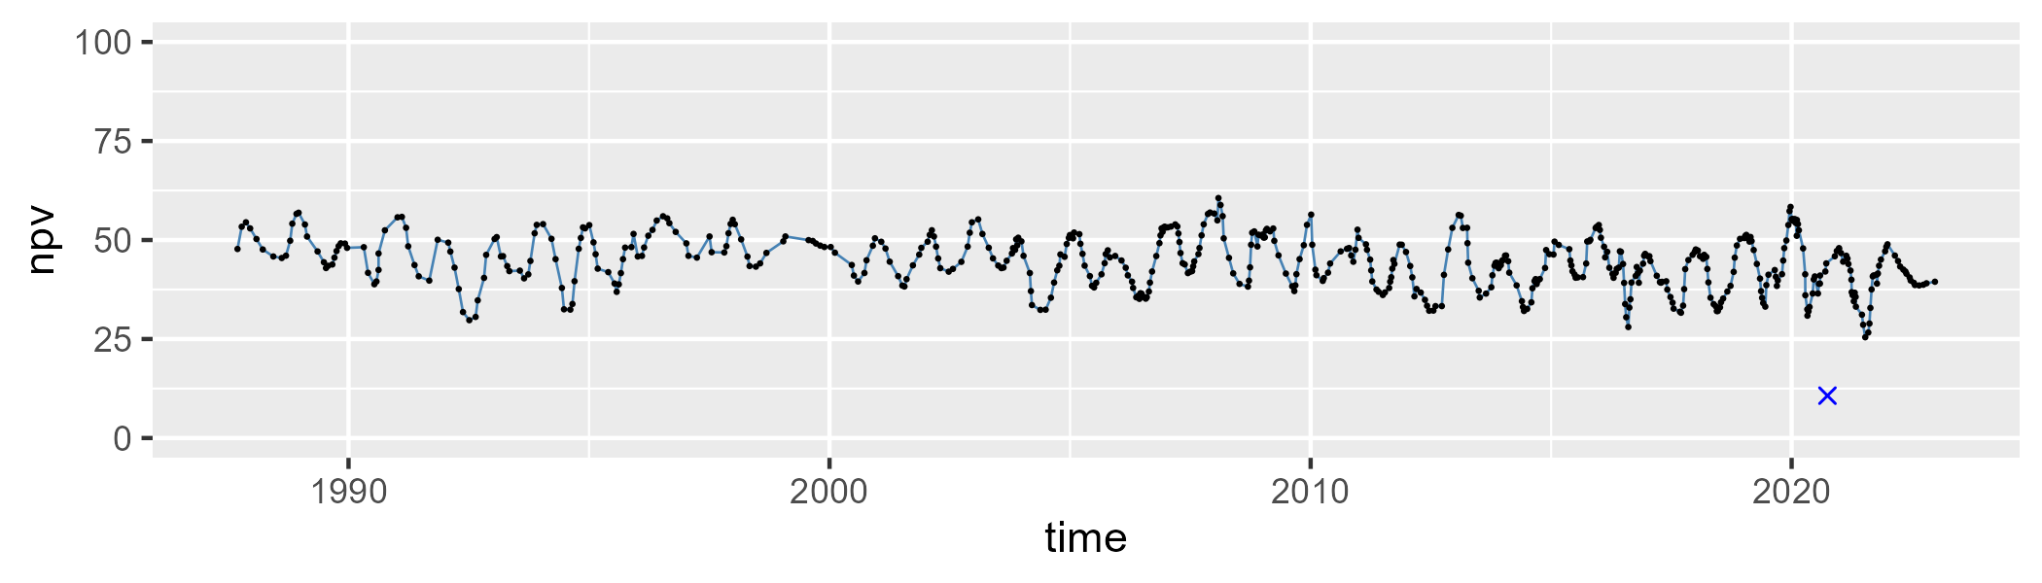

| Min. | 1st Qu. | Median | Mean | 3rd Qu. | Max. |
| --- | --- | --- | --- | --- | --- |
| 0.9118145 | 7.948829 | 10.88818 | 11.99533 | 15.29125 | 29.45143 |

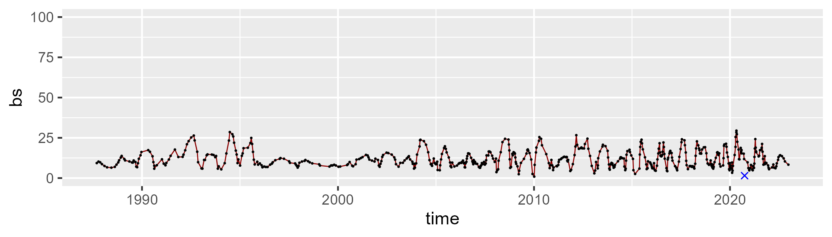

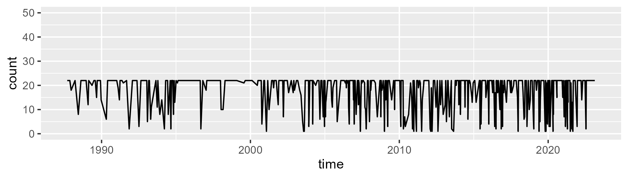

Min. : 1.00 1st Qu.:15.00 Median :22.00 Mean :17.87 3rd Qu.:22.00 Max. :22.00

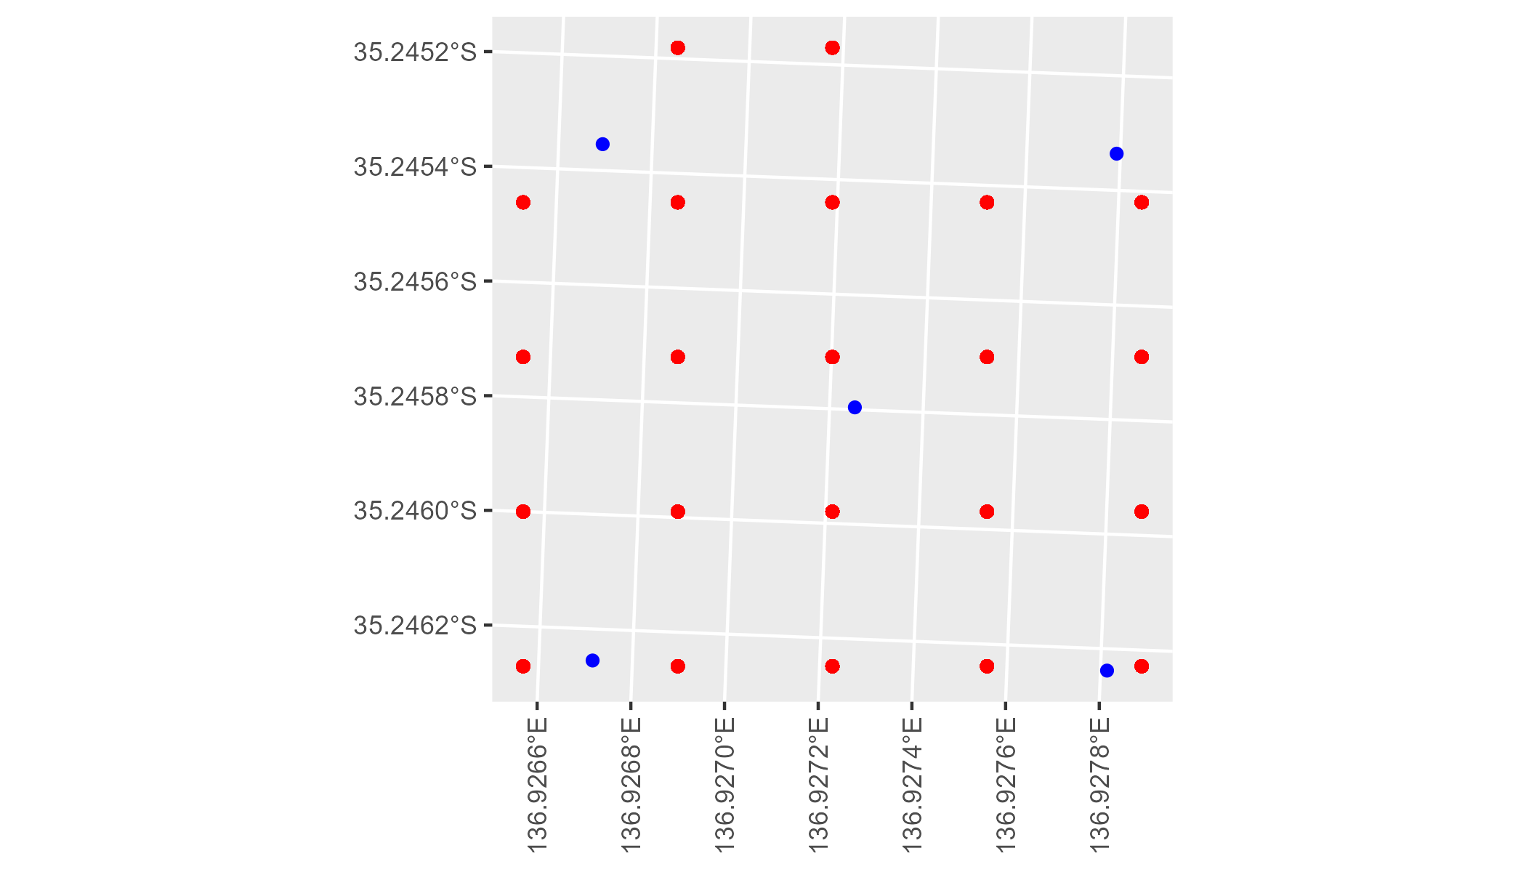

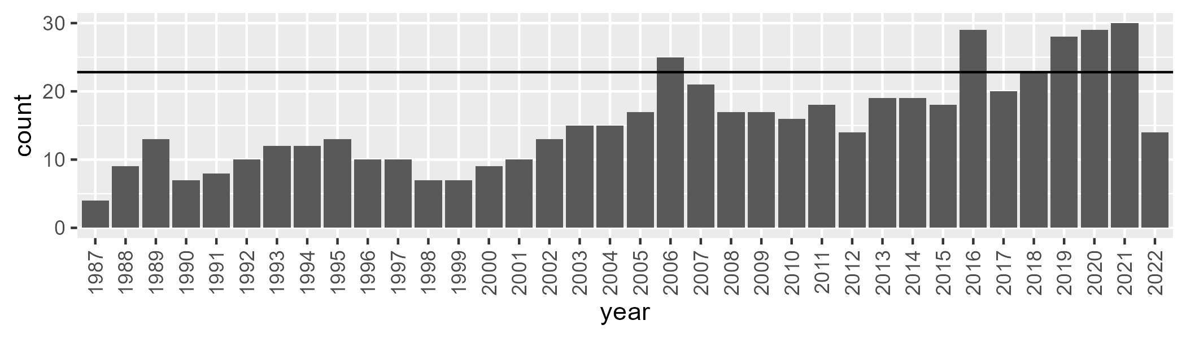

Number of samples: 558

# SAAEYB0011

| Min. | 1st Qu. | Median | Mean | 3rd Qu. | Max. |
| --- | --- | --- | --- | --- | --- |
| 35.61223 | 43.58292 | 46.41815 | 46.64959 | 50.07764 | 59.66362 |

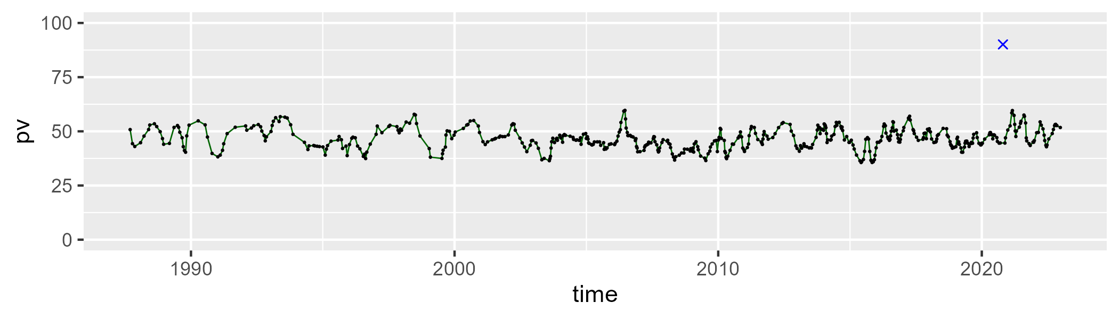

| Min. | 1st Qu. | Median | Mean | 3rd Qu. | Max. |
| --- | --- | --- | --- | --- | --- |
| 15.93738 | 35.94755 | 40.42941 | 40.07673 | 44.7427 | 55.1848 |

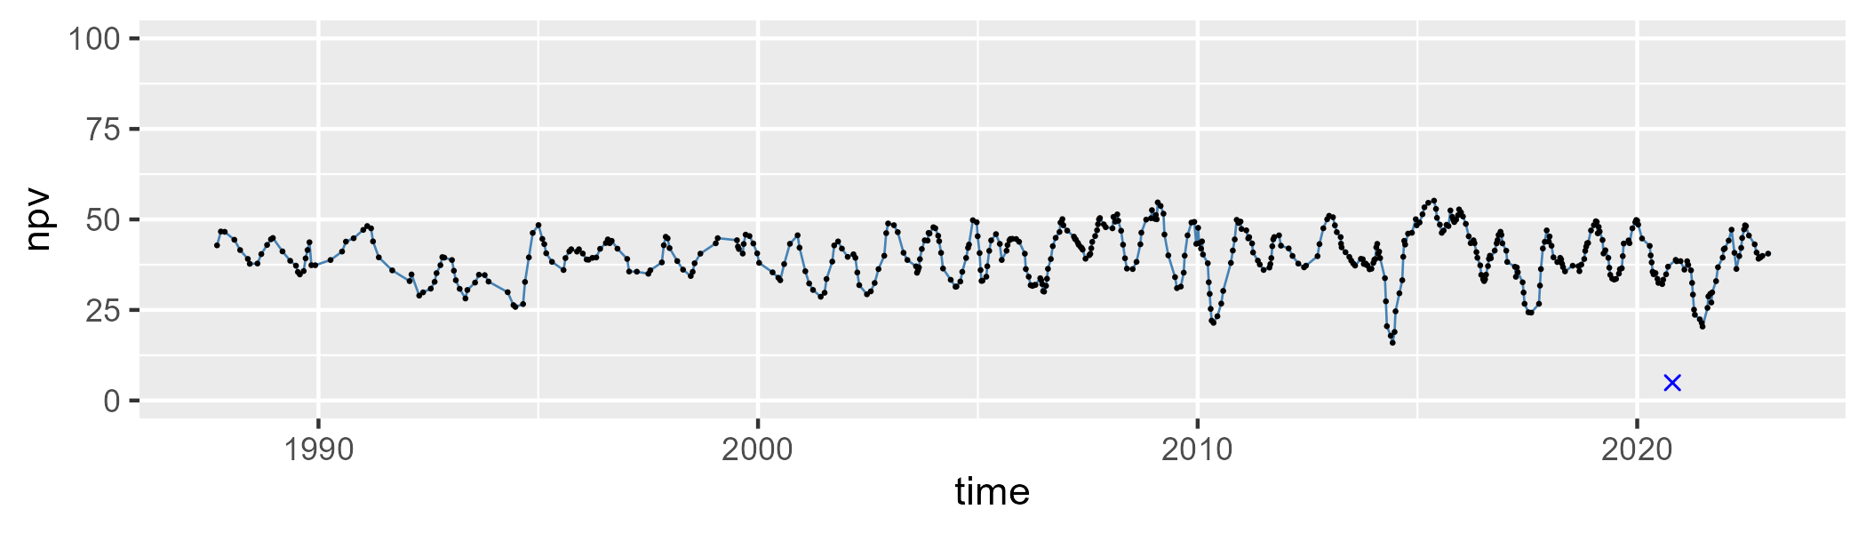

| Min. | 1st Qu. | Median | Mean | 3rd Qu. | Max. |
| --- | --- | --- | --- | --- | --- |
| 0 | 6.85824 | 10.98961 | 11.98595 | 15.56932 | 39.88808 |

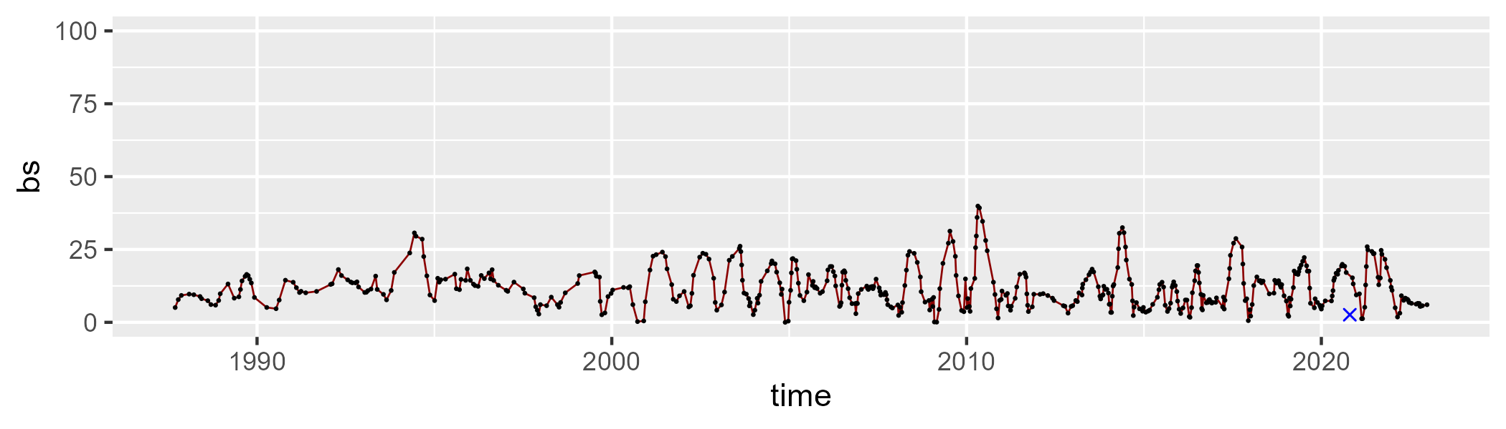

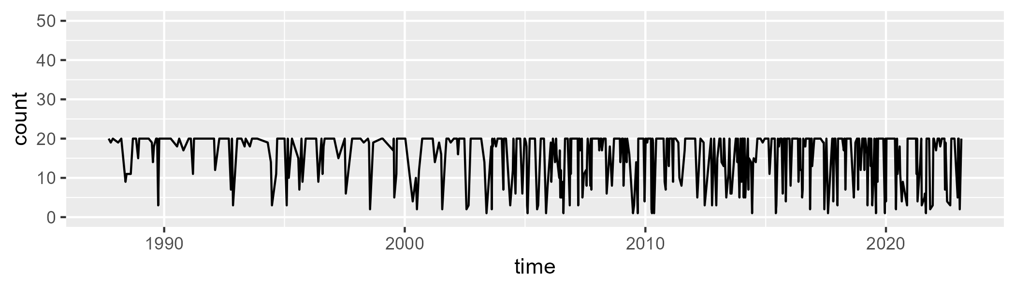

Min. : 1.00 1st Qu.:12.00 Median :20.00 Mean :15.86 3rd Qu.:20.00 Max. :20.00

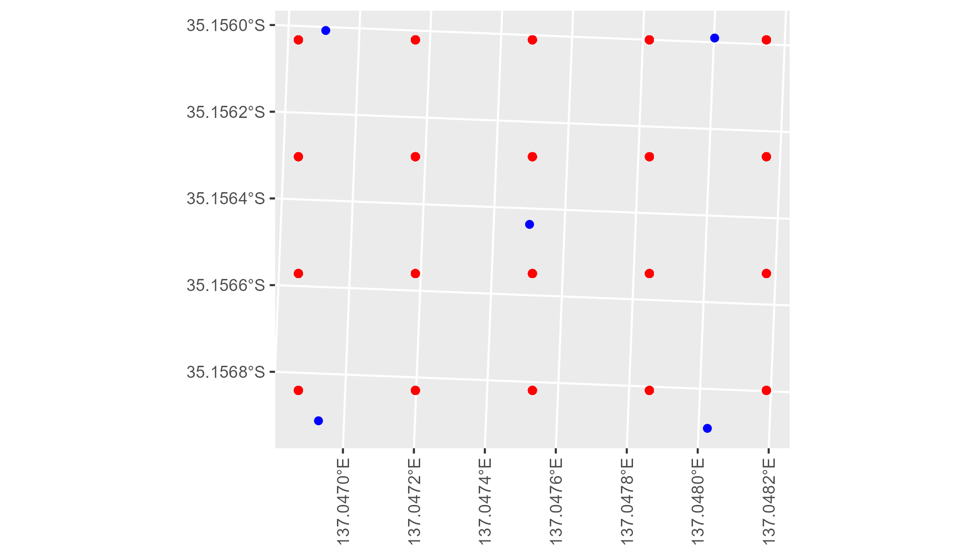

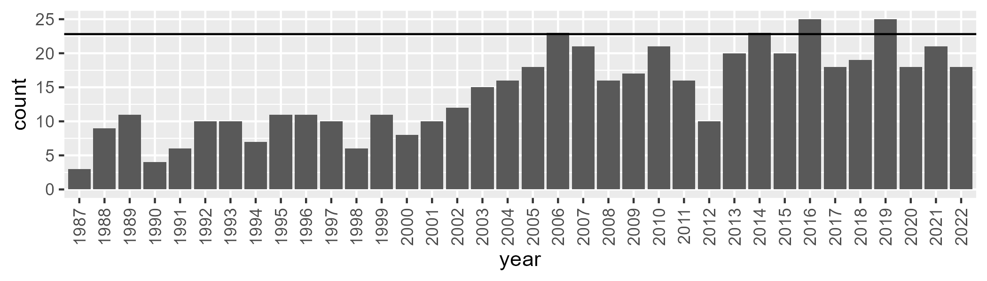

Number of samples: 519

# SAAEYB0012

| Min. | 1st Qu. | Median | Mean | 3rd Qu. | Max. |
| --- | --- | --- | --- | --- | --- |
| 29.64294 | 39.4085 | 43.04572 | 43.15529 | 46.45187 | 56.79871 |

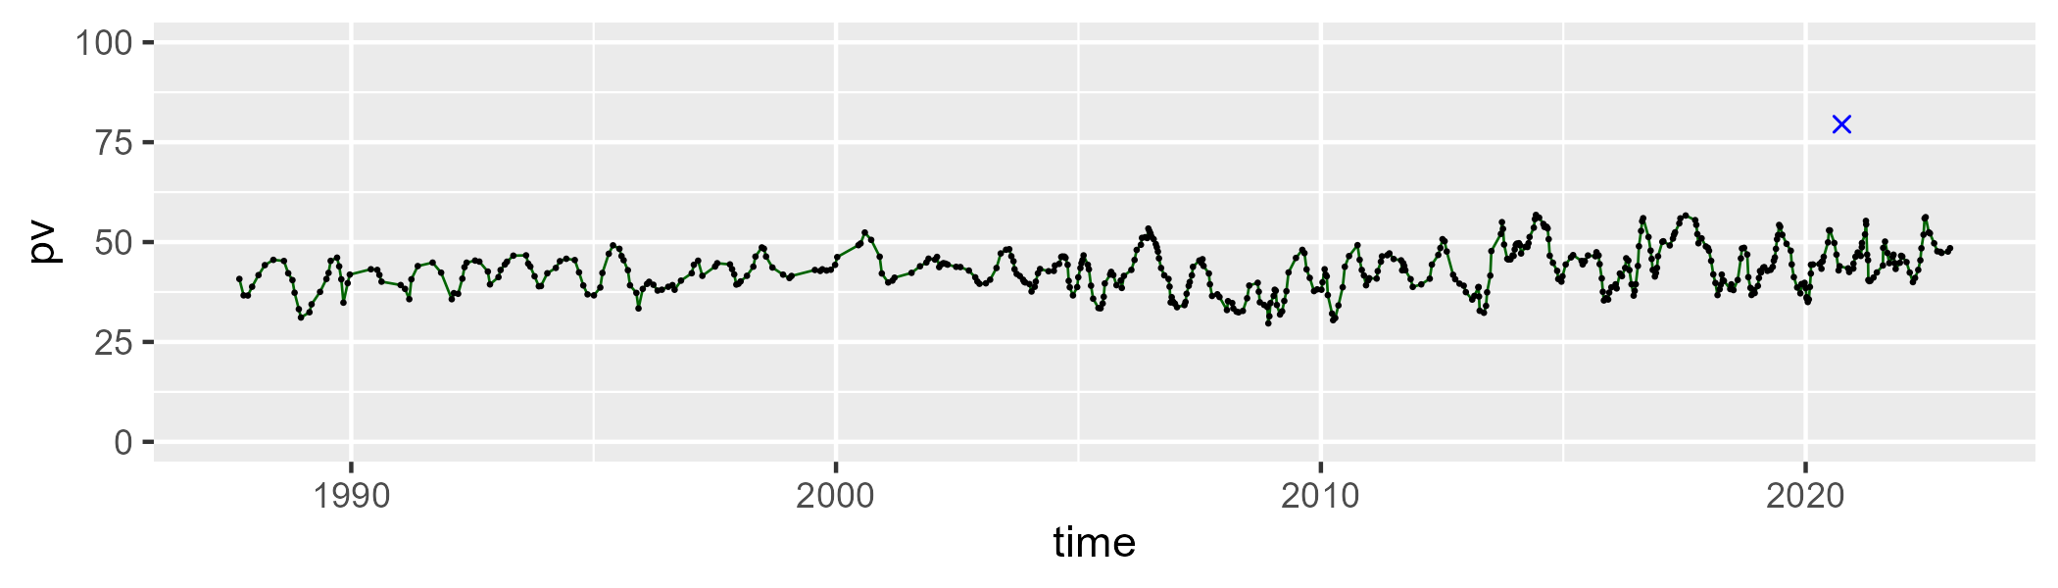

| Min. | 1st Qu. | Median | Mean | 3rd Qu. | Max. |
| --- | --- | --- | --- | --- | --- |
| 26.95661 | 40.26545 | 45.18877 | 44.61608 | 49.59567 | 59.53157 |

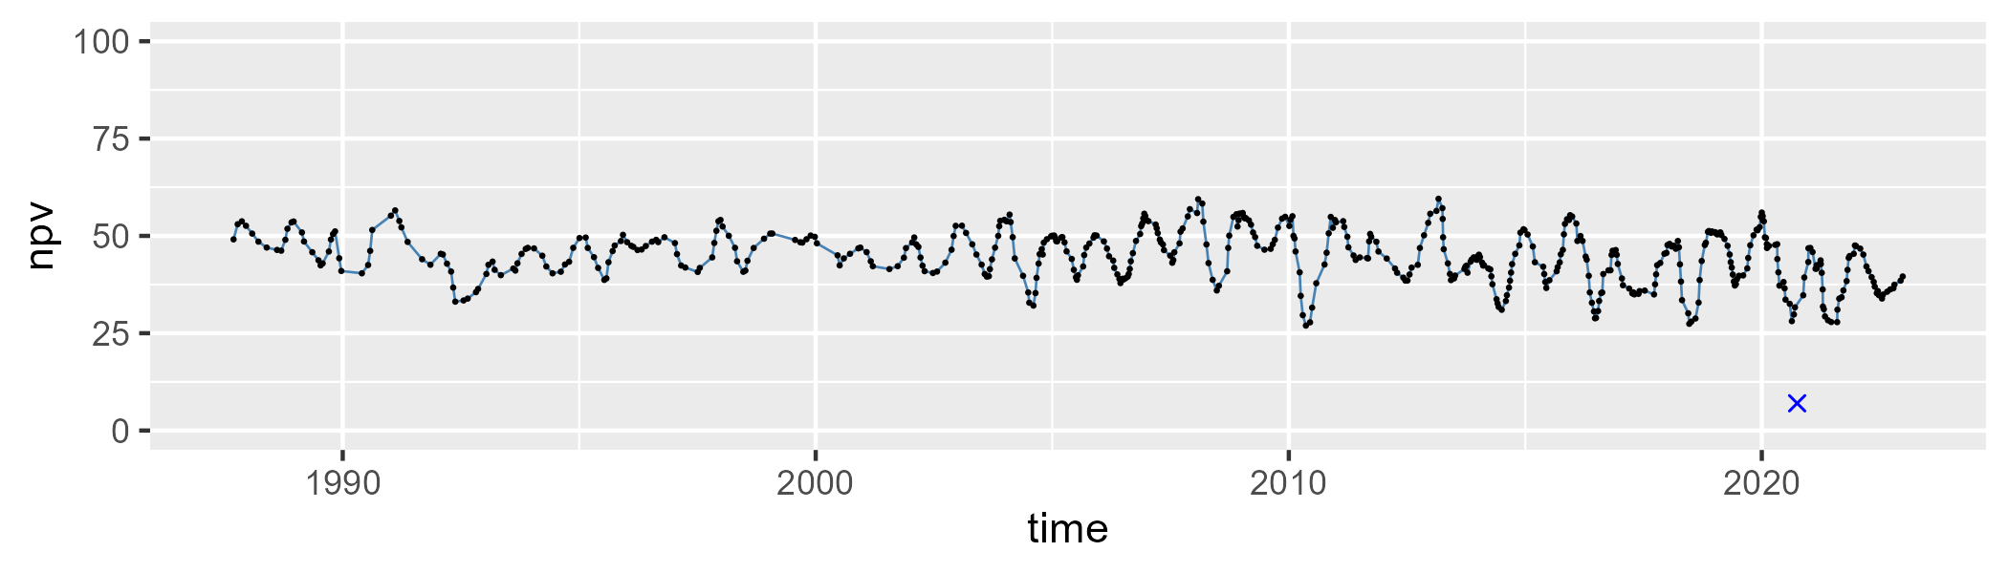

| Min. | 1st Qu. | Median | Mean | 3rd Qu. | Max. |
| --- | --- | --- | --- | --- | --- |
| 0 | 7.156283 | 9.62797 | 10.99008 | 13.11299 | 38.47333 |

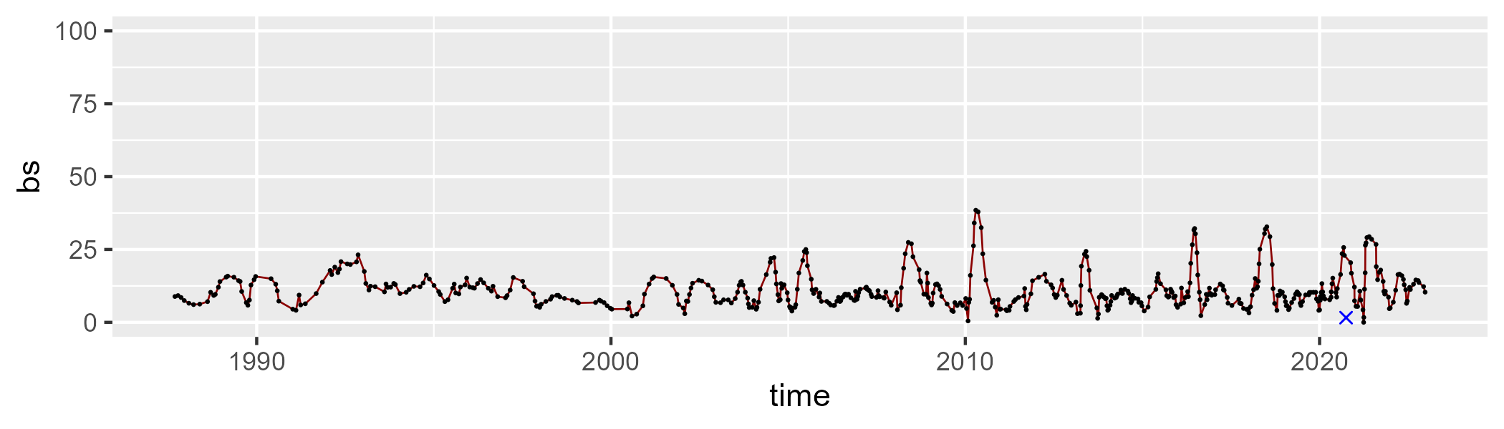

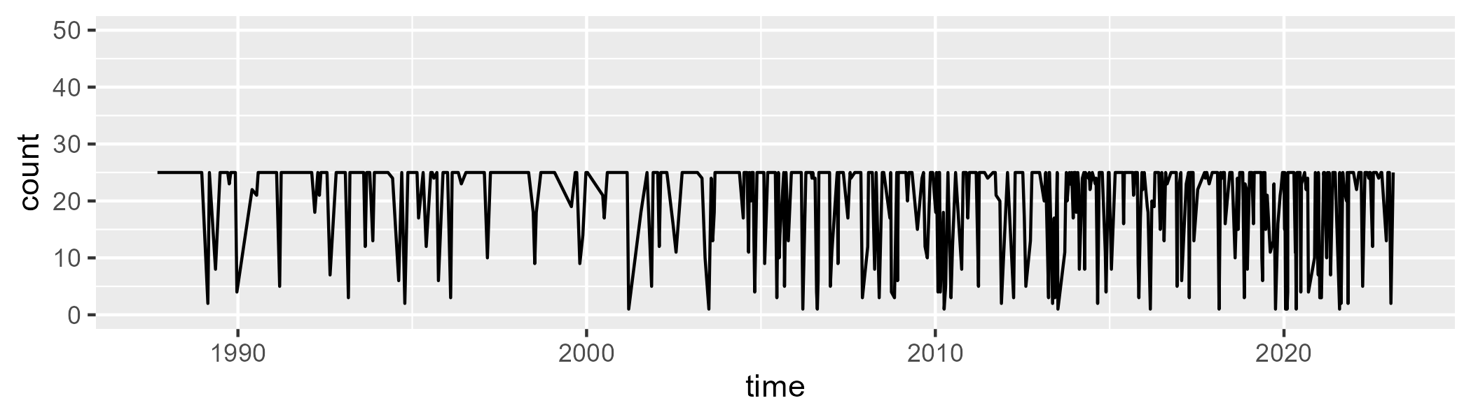

Min. : 1.00 1st Qu.:18.00 Median :25.00 Mean :20.44 3rd Qu.:25.00 Max. :25.00

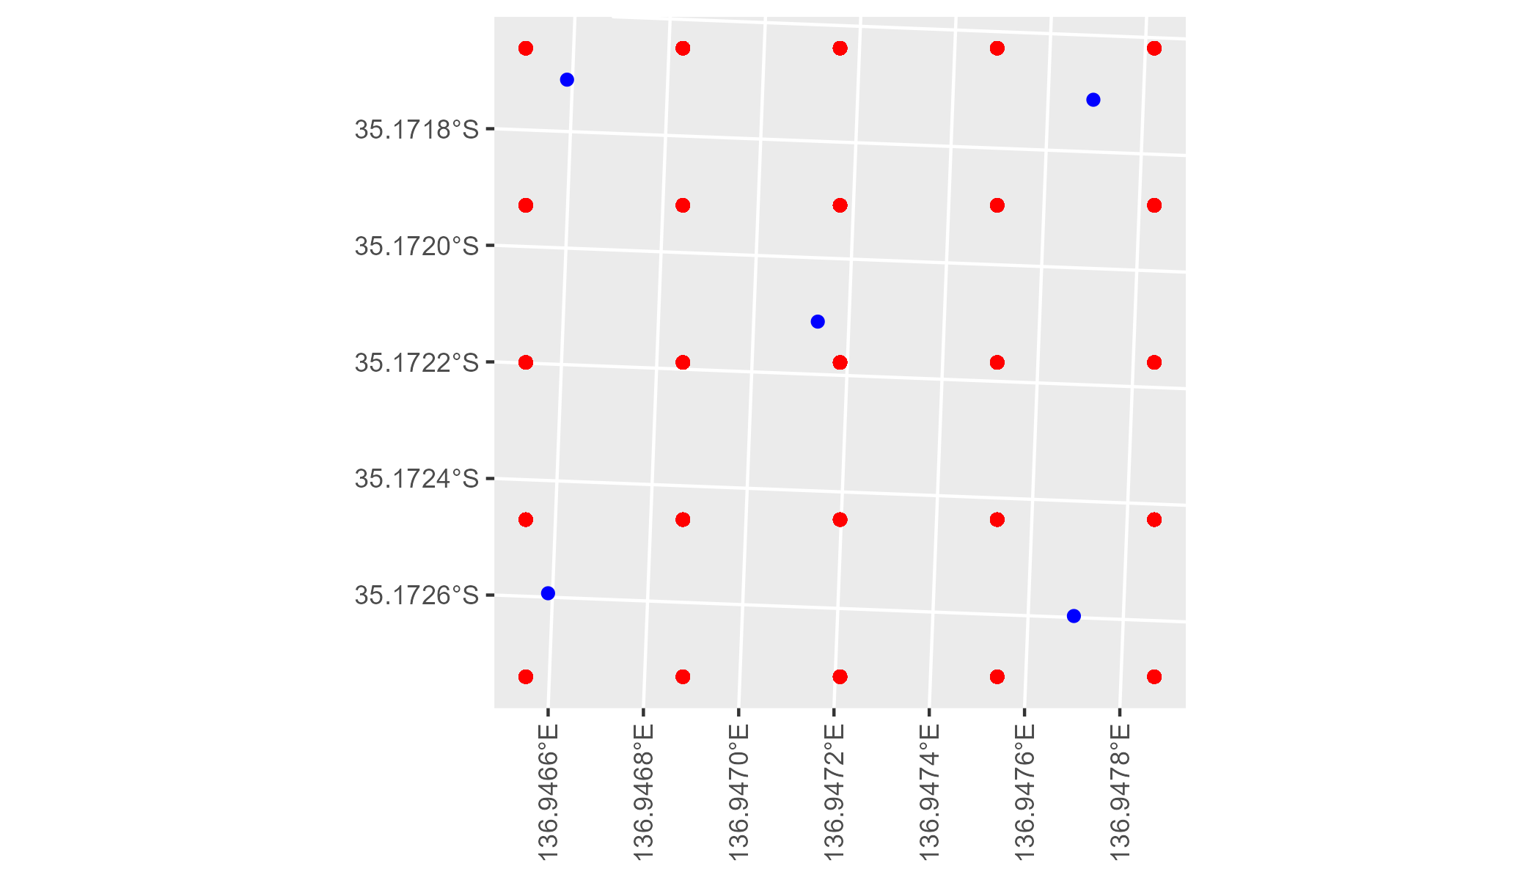

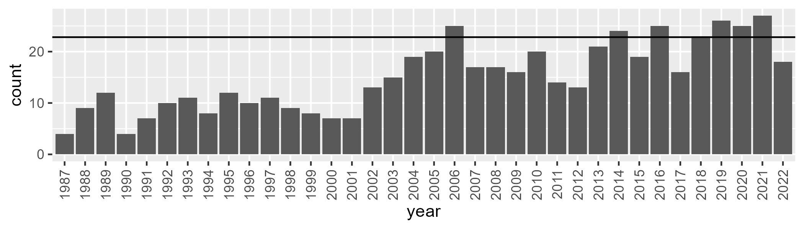

Number of samples: 542

# SAAEYB0013

| Min. | 1st Qu. | Median | Mean | 3rd Qu. | Max. |
| --- | --- | --- | --- | --- | --- |
| 28.68195 | 40.42008 | 44.29549 | 44.01244 | 47.45516 | 53.75357 |

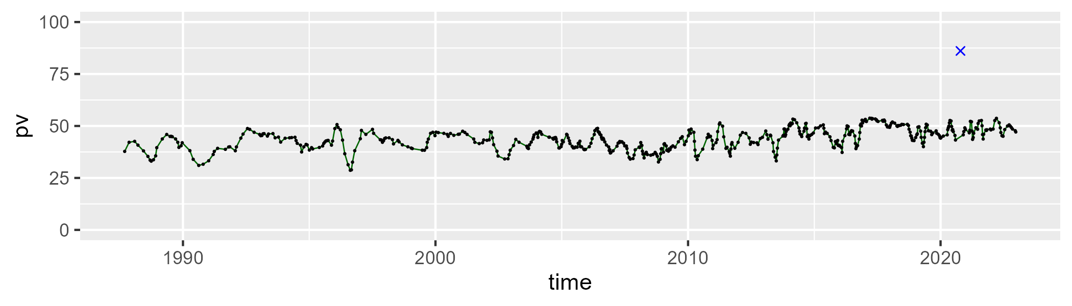

| Min. | 1st Qu. | Median | Mean | 3rd Qu. | Max. |
| --- | --- | --- | --- | --- | --- |
| 21.20233 | 38.23405 | 42.94527 | 42.5271 | 47.49456 | 56.09308 |

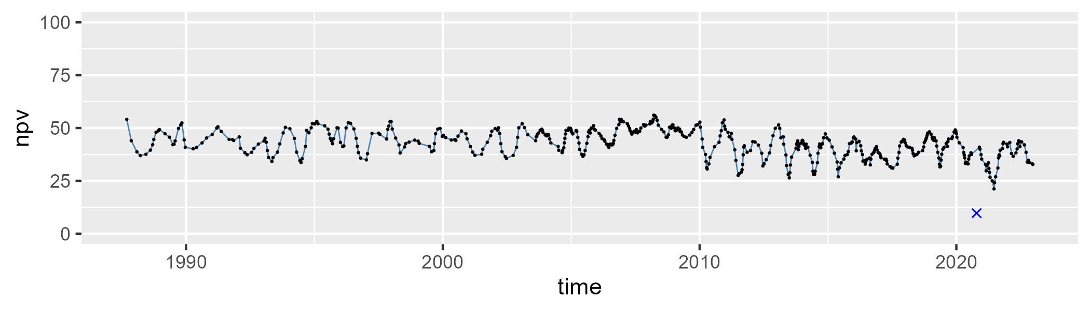

| Min. | 1st Qu. | Median | Mean | 3rd Qu. | Max. |
| --- | --- | --- | --- | --- | --- |
| 0 | 7.534438 | 10.64178 | 12.19789 | 15.56459 | 38.9584 |

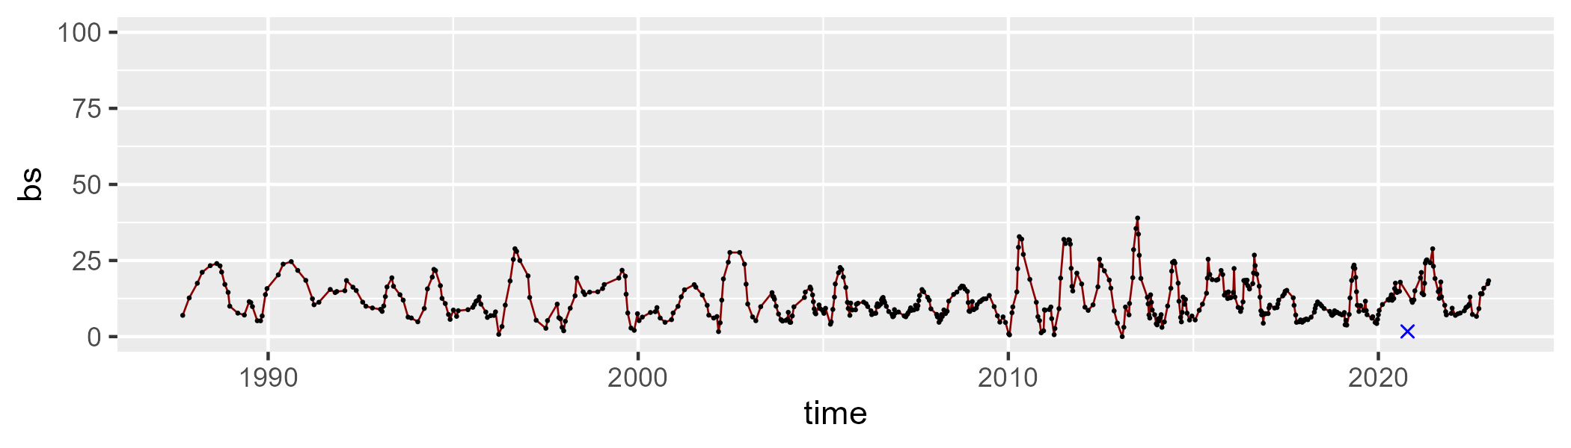

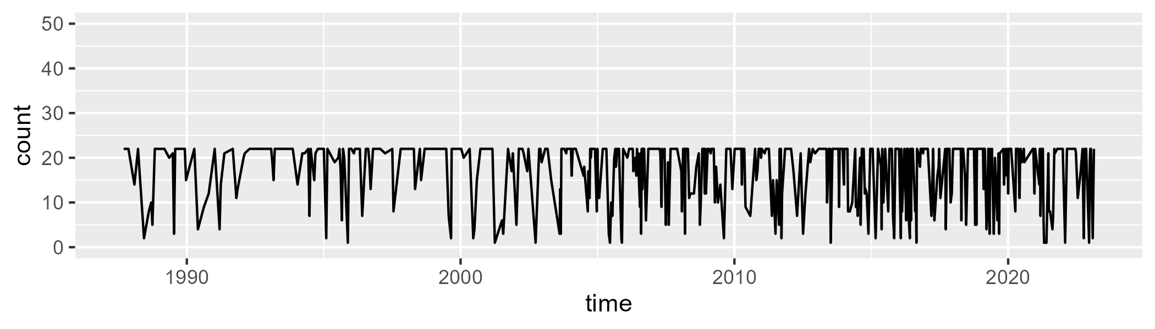

Min. : 1.00 1st Qu.:13.00 Median :22.00 Mean :17.39 3rd Qu.:22.00 Max. :22.00

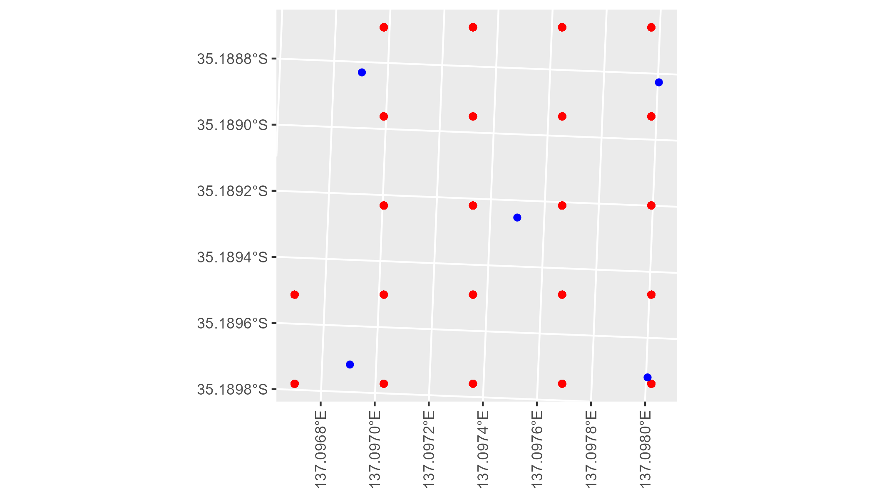

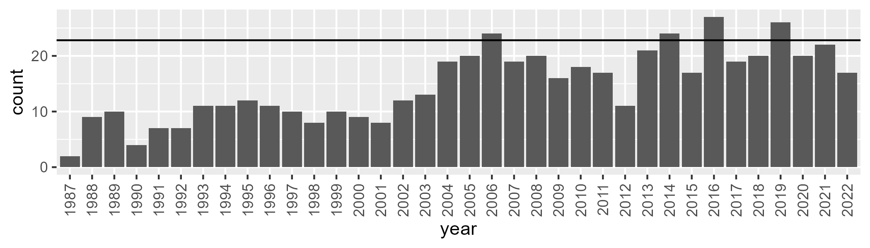

Number of samples: 531

# SAAEYB0021

| Min. | 1st Qu. | Median | Mean | 3rd Qu. | Max. |
| --- | --- | --- | --- | --- | --- |
| 0 | 22.94081 | 28.82653 | 27.84698 | 34.08097 | 46.49499 |

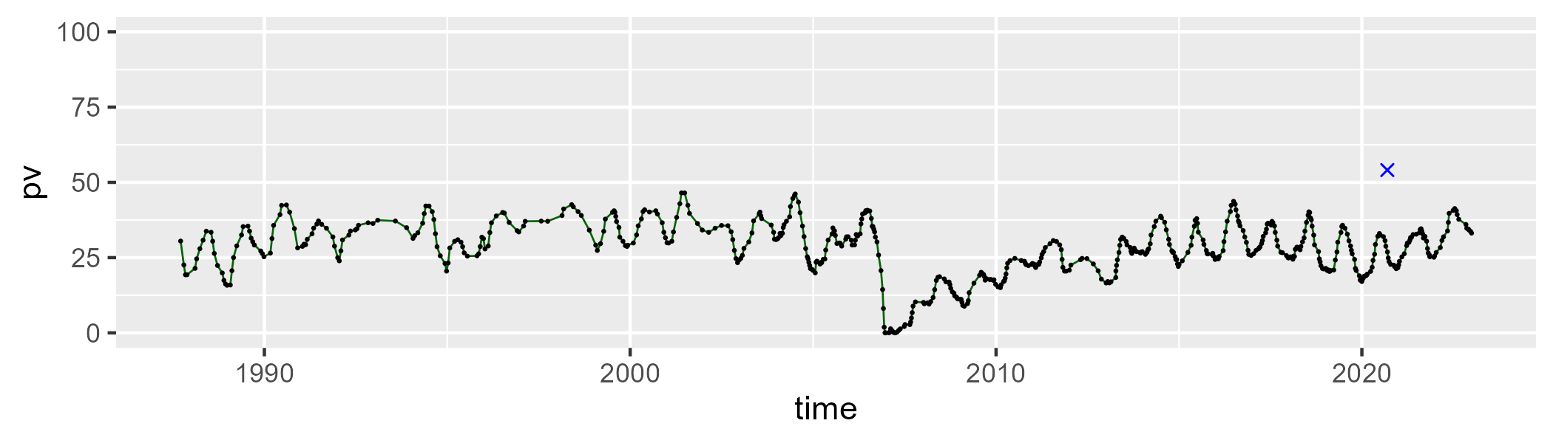

| Min. | 1st Qu. | Median | Mean | 3rd Qu. | Max. |
| --- | --- | --- | --- | --- | --- |
| 0 | 36.5209 | 46.03248 | 41.49858 | 50.68878 | 66.82422 |

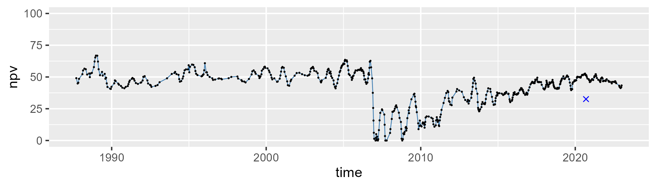

| Min. | 1st Qu. | Median | Mean | 3rd Qu. | Max. |
| --- | --- | --- | --- | --- | --- |
| 4.986206 | 13.94271 | 21.88086 | 29.45771 | 36.07415 | 101.4643 |

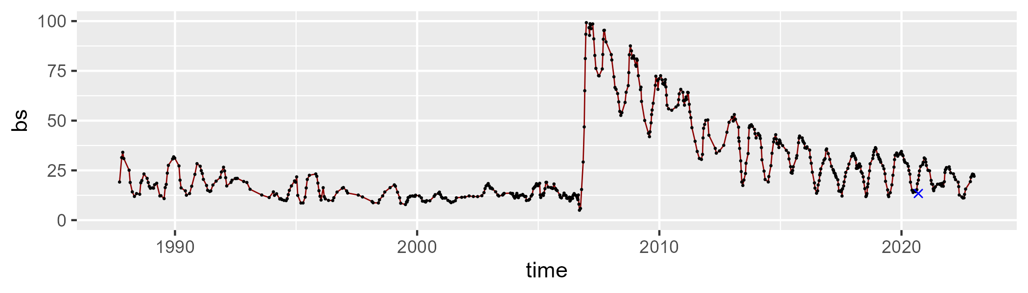

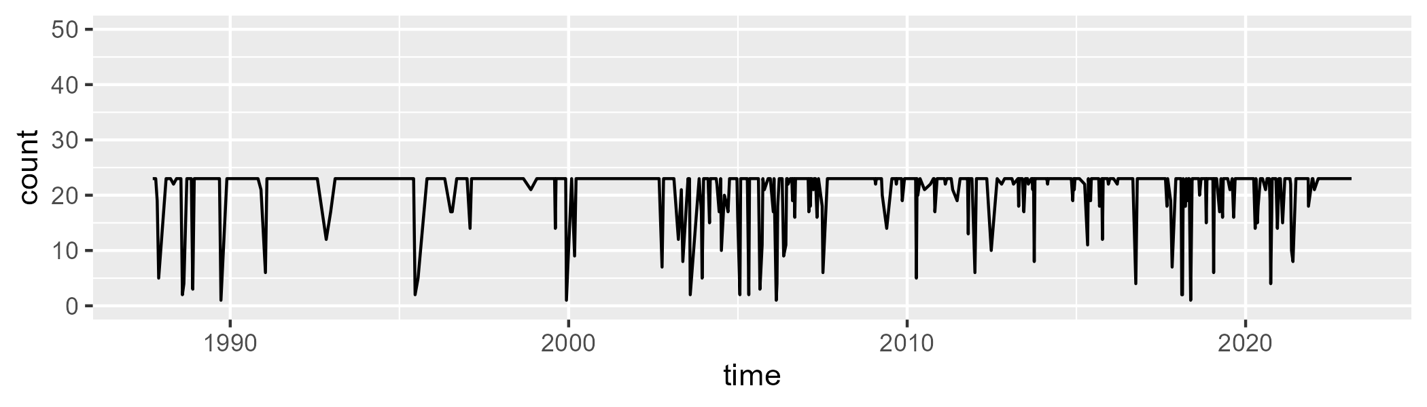

Min. : 1.00 1st Qu.:23.00 Median :23.00 Mean :21.28 3rd Qu.:23.00 Max. :23.00

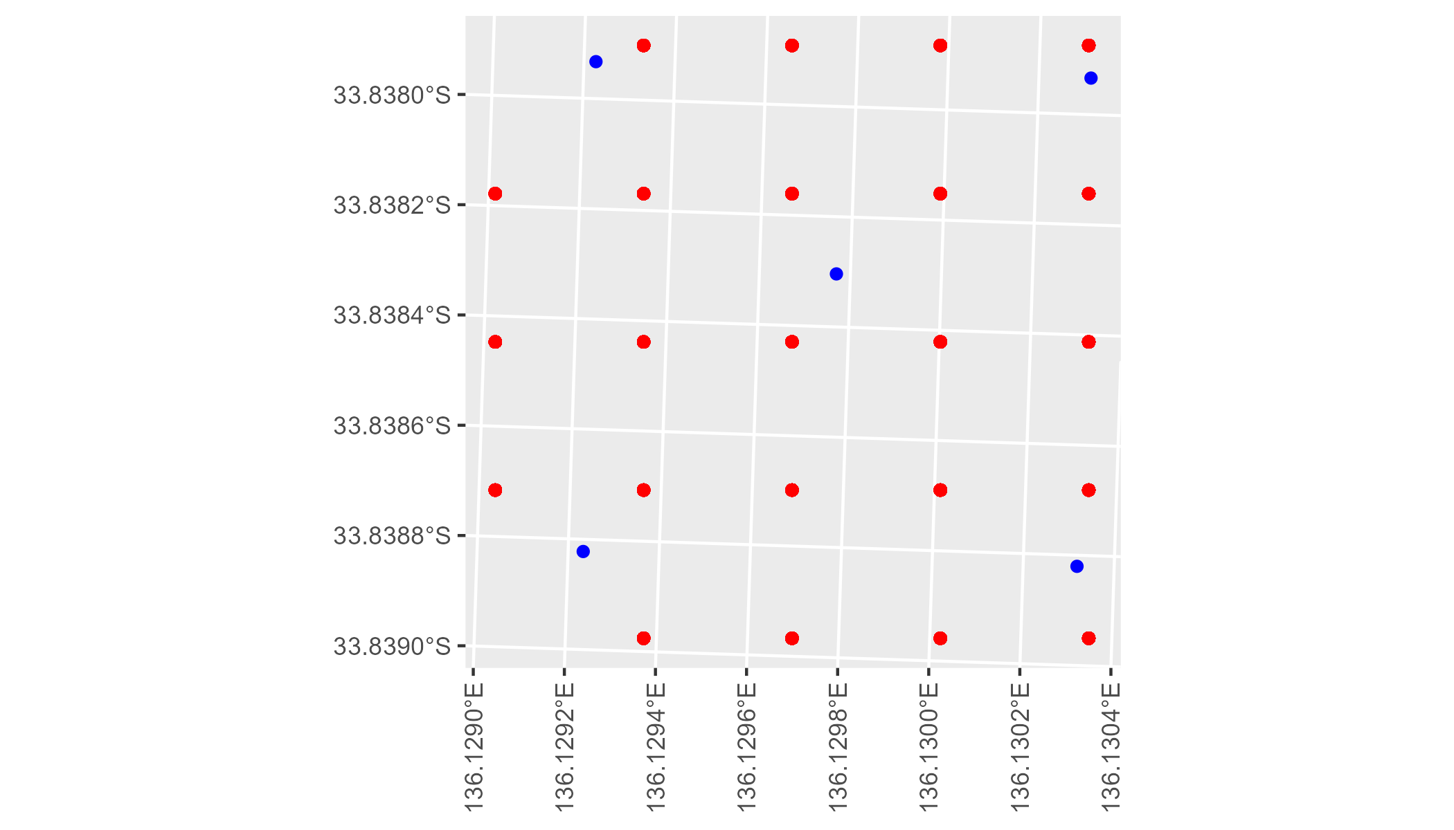

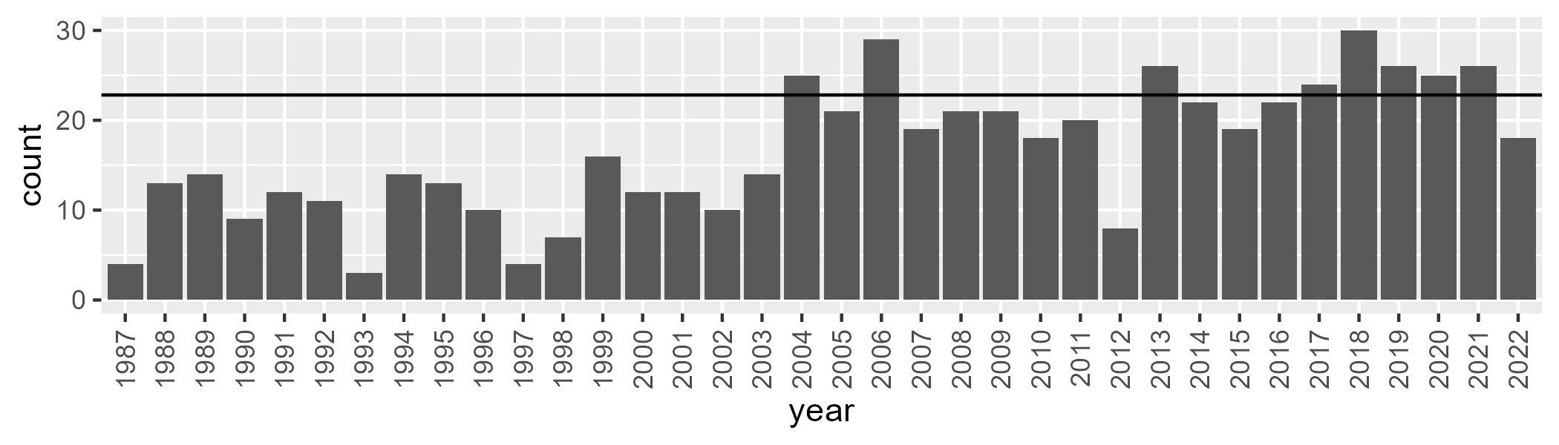

Number of samples: 598

# SAAEYB0022

| Min. | 1st Qu. | Median | Mean | 3rd Qu. | Max. |
| --- | --- | --- | --- | --- | --- |
| 13.01826 | 25.57993 | 29.67957 | 29.76265 | 34.03757 | 45.21809 |

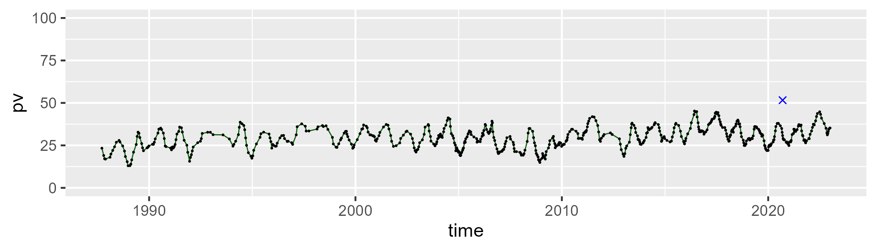

| Min. | 1st Qu. | Median | Mean | 3rd Qu. | Max. |
| --- | --- | --- | --- | --- | --- |
| 32.28158 | 47.84353 | 51.10809 | 51.00112 | 54.54099 | 68.55247 |

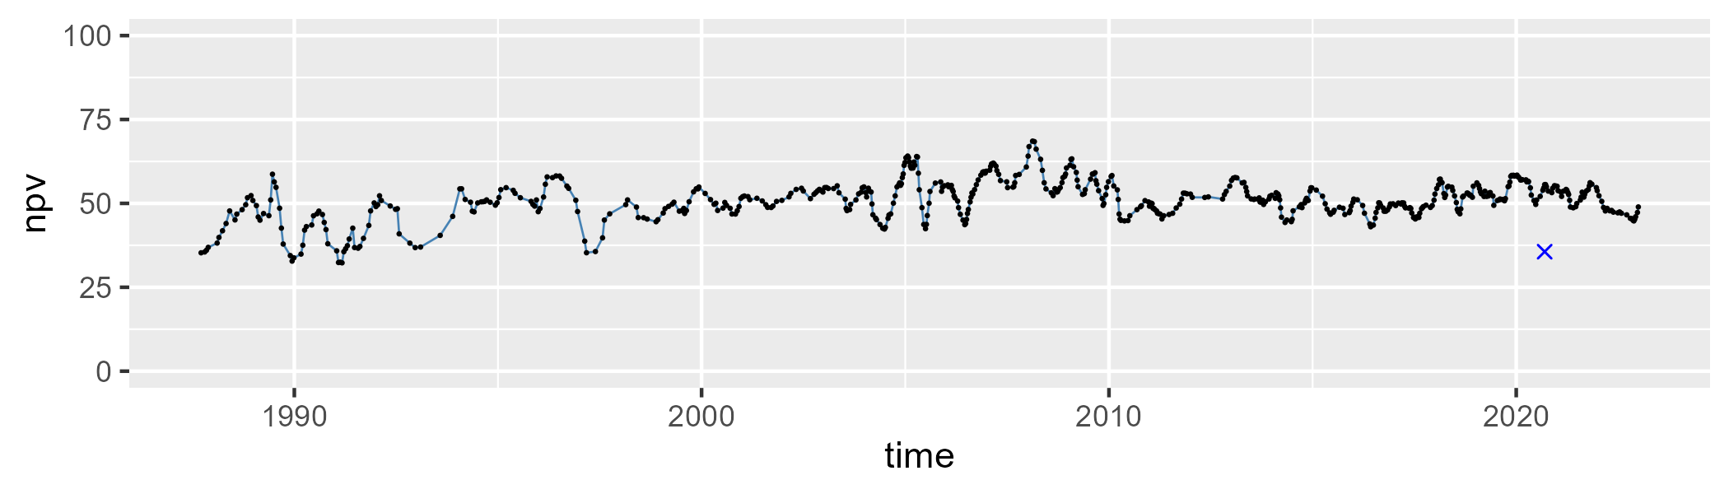

| Min. | 1st Qu. | Median | Mean | 3rd Qu. | Max. |
| --- | --- | --- | --- | --- | --- |
| 6.555568 | 13.69251 | 17.03875 | 17.99869 | 20.59022 | 45.73999 |

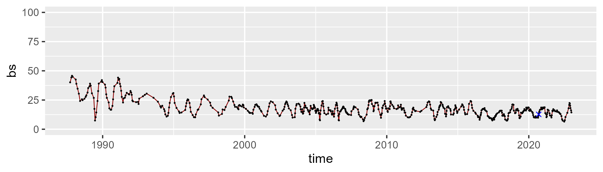

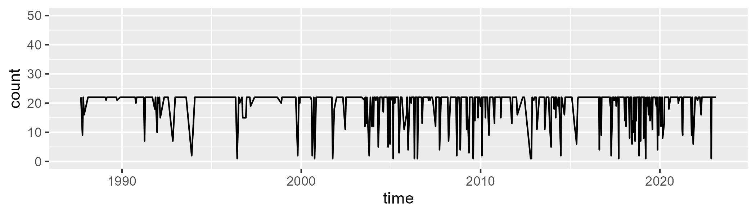

Min. : 1.00 1st Qu.:22.00 Median :22.00 Mean :19.79 3rd Qu.:22.00 Max. :22.00

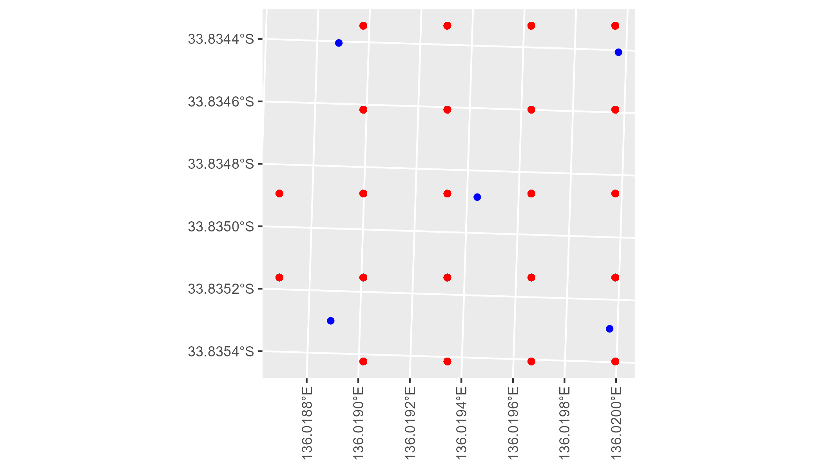

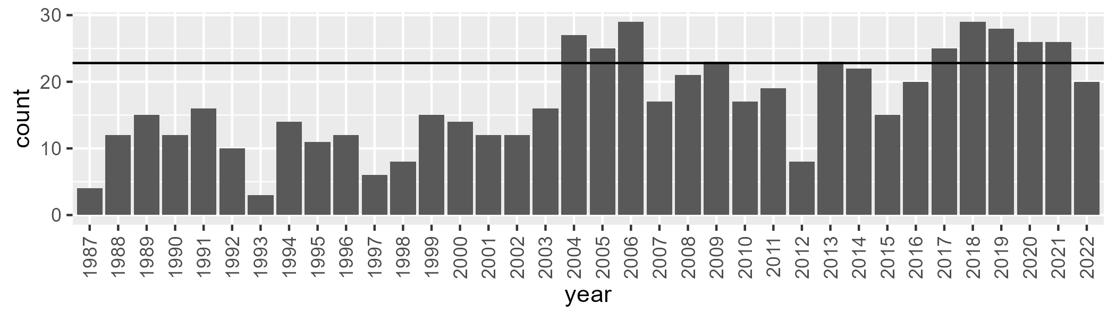

Number of samples: 612

# SAAEYB0023

| Min. | 1st Qu. | Median | Mean | 3rd Qu. | Max. |
| --- | --- | --- | --- | --- | --- |
| 0 | 21.35123 | 26.44172 | 25.38022 | 31.00563 | 43.29021 |

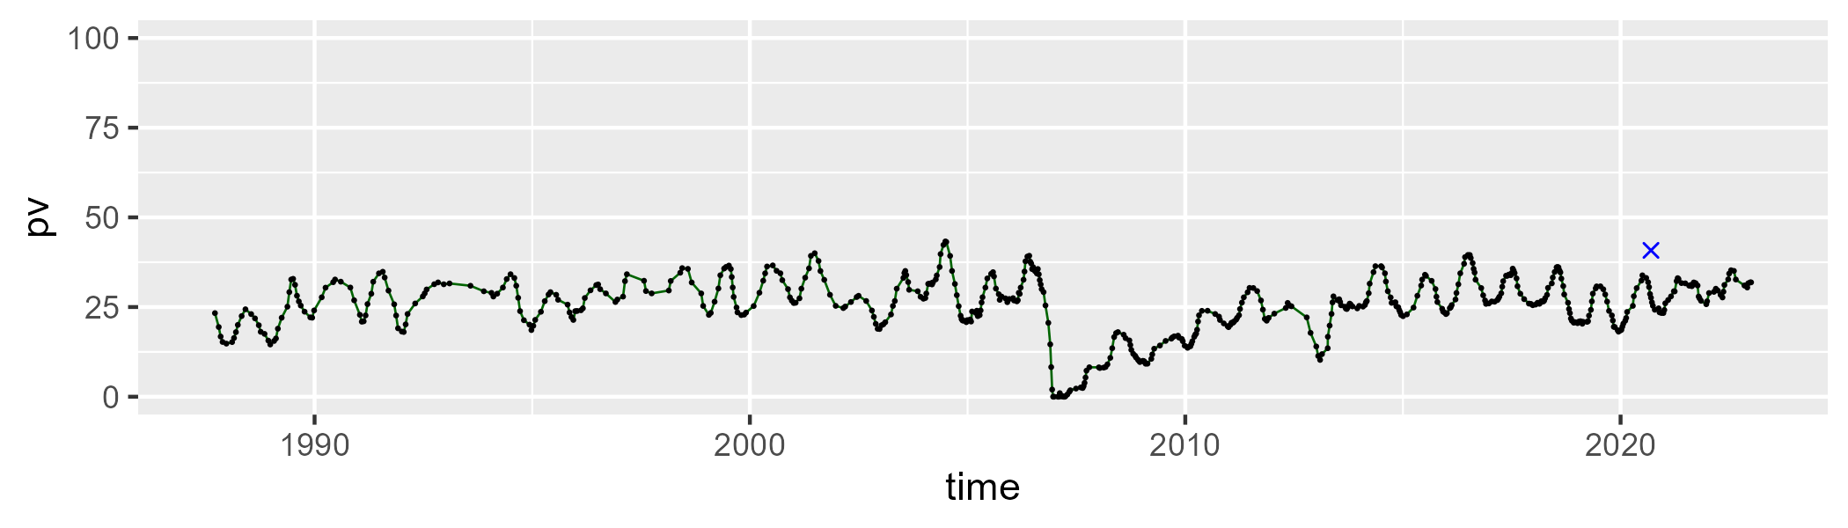

| Min. | 1st Qu. | Median | Mean | 3rd Qu. | Max. |
| --- | --- | --- | --- | --- | --- |
| 0 | 27.33807 | 34.03518 | 32.18382 | 40.58301 | 51.00399 |

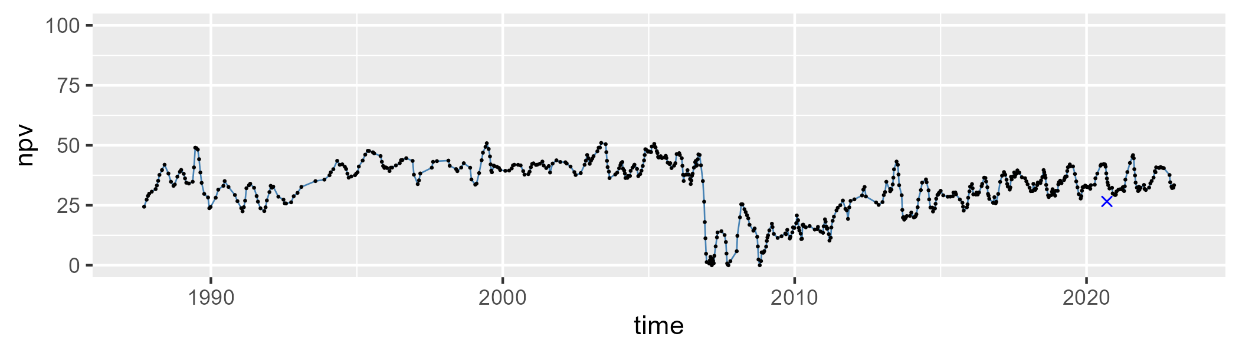

| Min. | 1st Qu. | Median | Mean | 3rd Qu. | Max. |
| --- | --- | --- | --- | --- | --- |
| 11.96636 | 28.47557 | 36.77172 | 41.19166 | 47.39114 | 99.72242 |

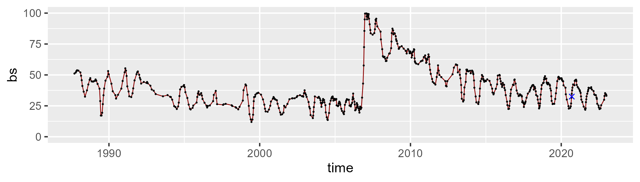

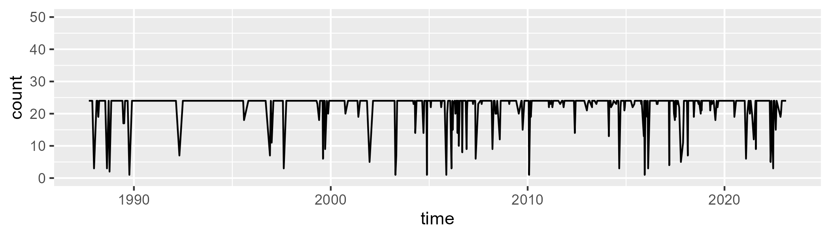

Min. : 1.00 1st Qu.:24.00 Median :24.00 Mean :22.44 3rd Qu.:24.00 Max. :24.00

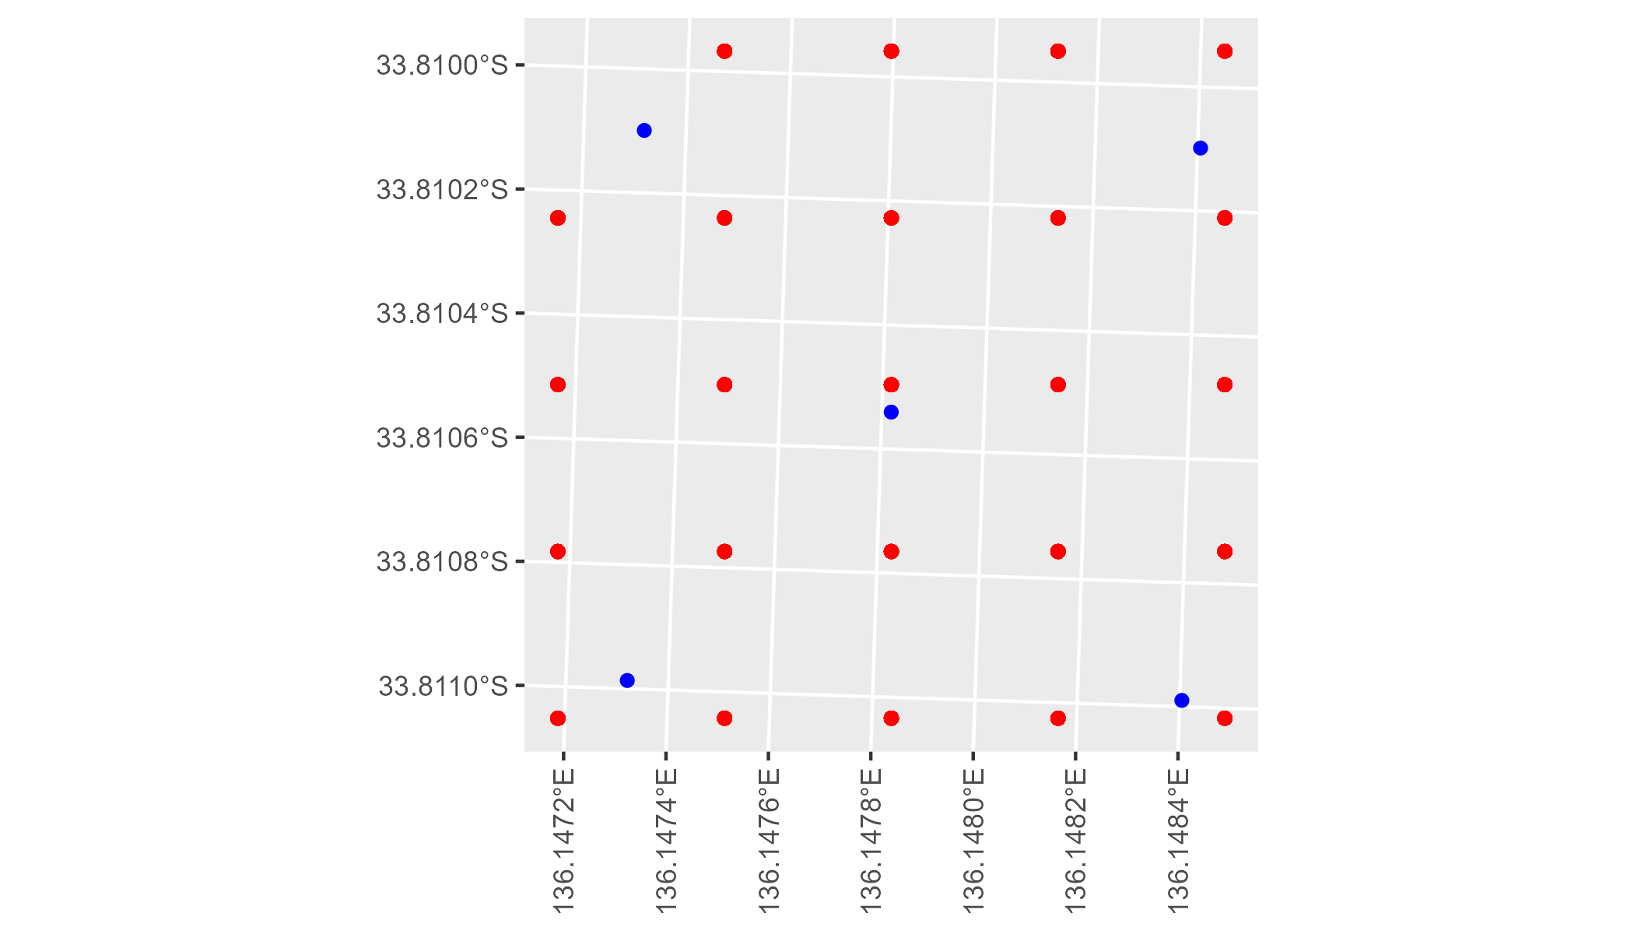

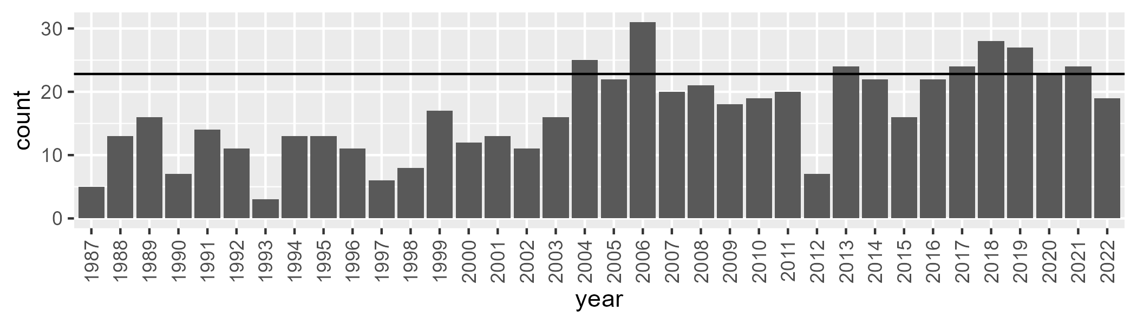

Number of samples: 601

# SAAEYB0024

| Min. | 1st Qu. | Median | Mean | 3rd Qu. | Max. |
| --- | --- | --- | --- | --- | --- |
| 0 | 22.94211 | 28.17449 | 27.58603 | 32.54564 | 46.25264 |

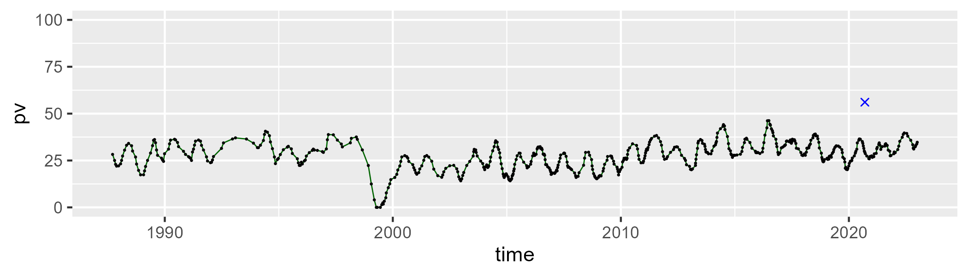

| Min. | 1st Qu. | Median | Mean | 3rd Qu. | Max. |
| --- | --- | --- | --- | --- | --- |
| 0 | 30.46162 | 36.22805 | 35.26555 | 41.76057 | 54.85198 |

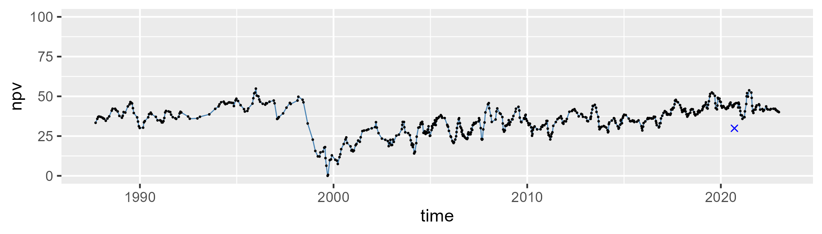

| Min. | 1st Qu. | Median | Mean | 3rd Qu. | Max. |
| --- | --- | --- | --- | --- | --- |
| 12.18151 | 25.55478 | 33.75927 | 35.89671 | 43.57951 | 94.27179 |

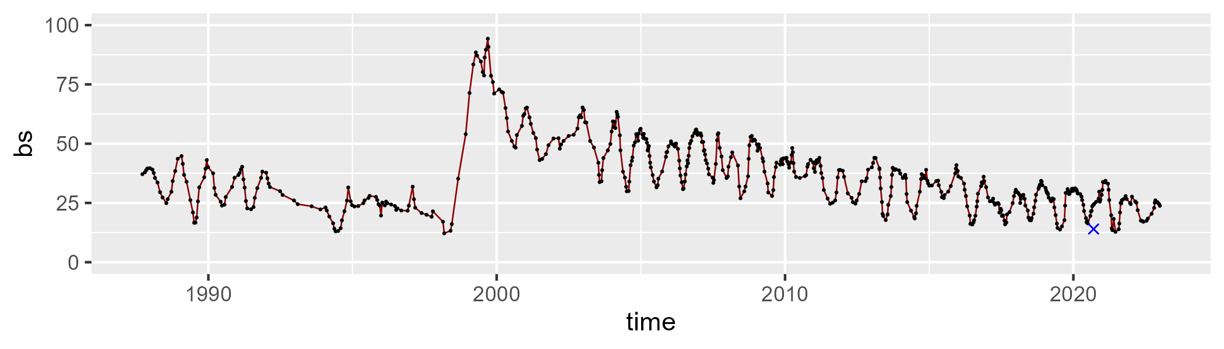

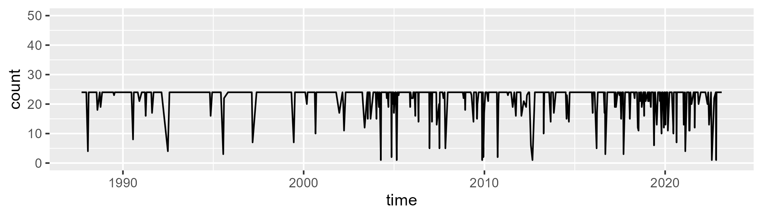

Min. : 1.00 1st Qu.:24.00 Median :24.00 Mean :22.14 3rd Qu.:24.00 Max. :24.00

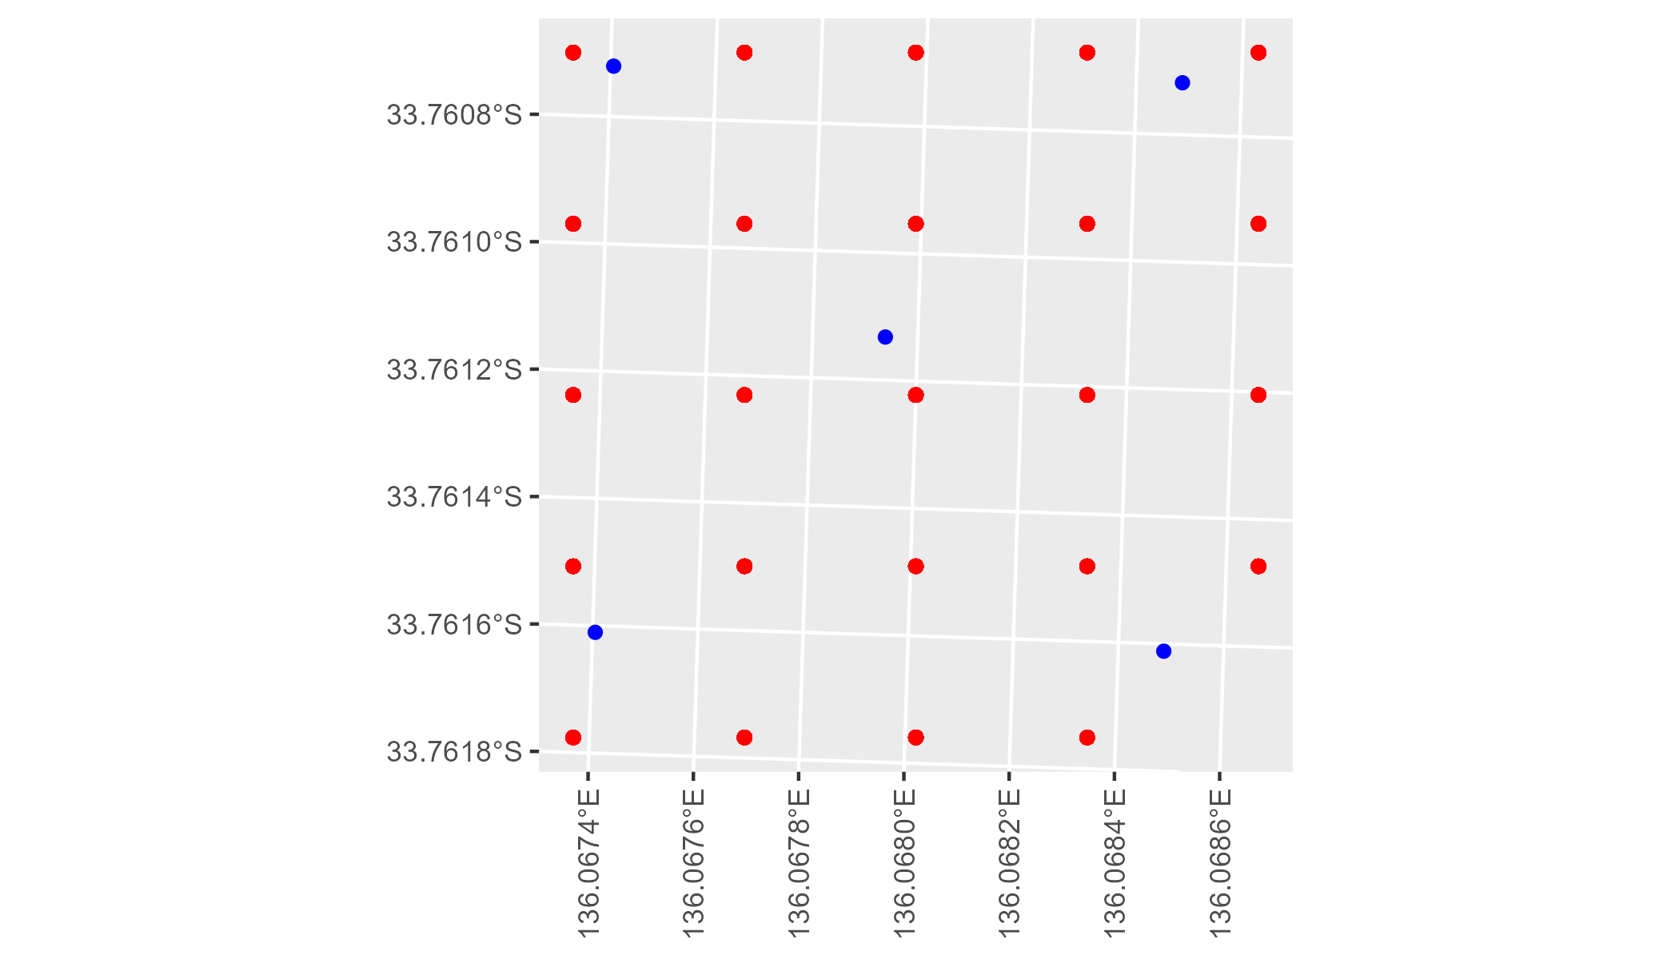

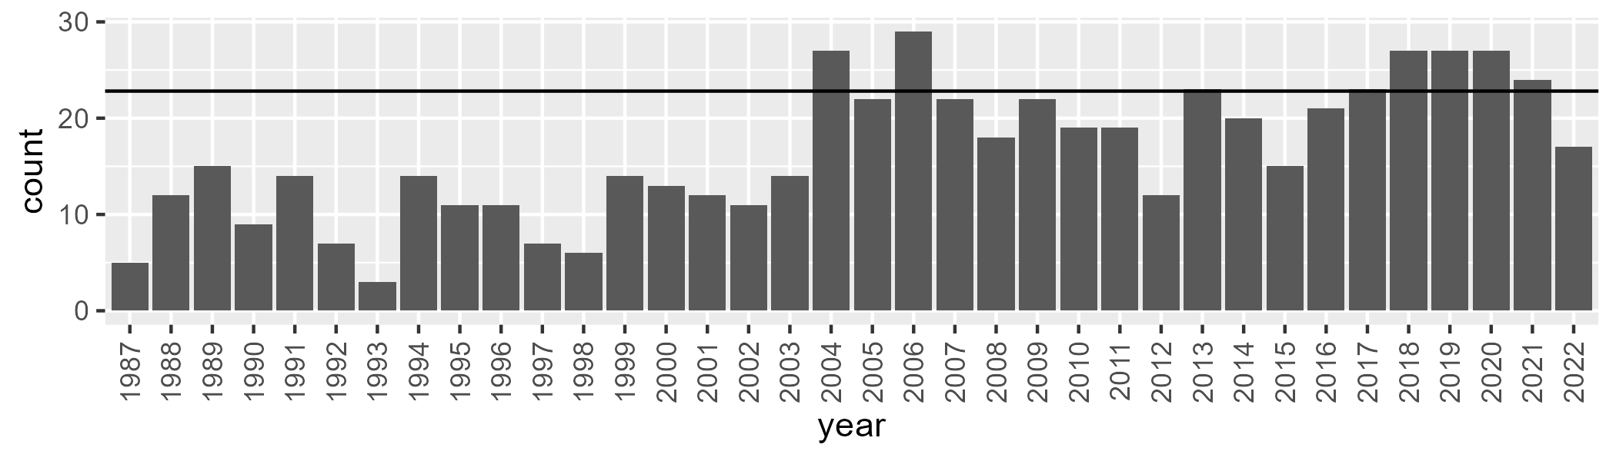

Number of samples: 592

# SAAEYB0025

| Min. | 1st Qu. | Median | Mean | 3rd Qu. | Max. |
| --- | --- | --- | --- | --- | --- |
| 24.50652 | 36.4862 | 40.48081 | 40.06591 | 43.9071 | 53.89344 |

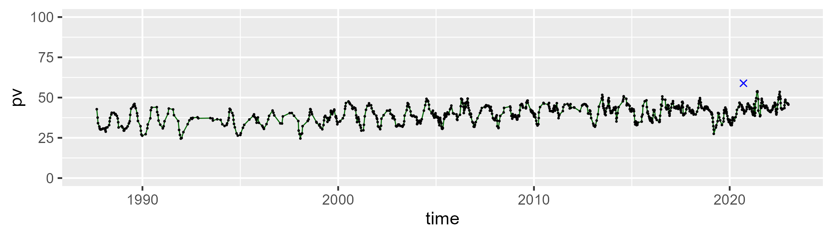

| Min. | 1st Qu. | Median | Mean | 3rd Qu. | Max. |
| --- | --- | --- | --- | --- | --- |
| 26.01014 | 43.79469 | 47.80989 | 47.76777 | 51.98868 | 62.63957 |

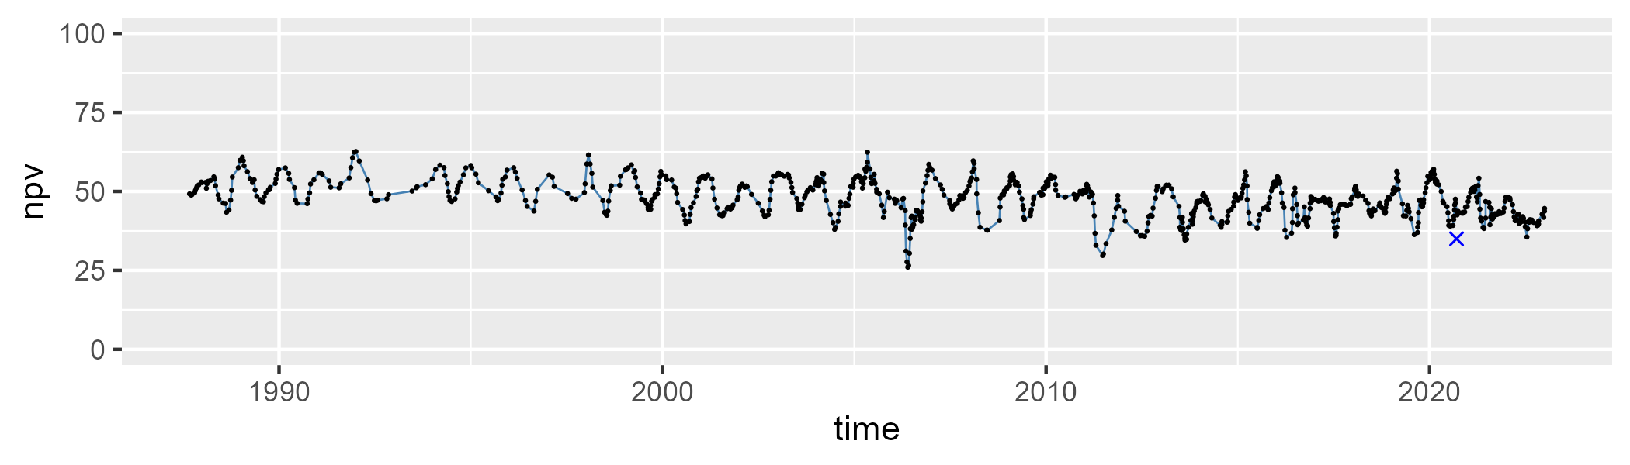

| Min. | 1st Qu. | Median | Mean | 3rd Qu. | Max. |
| --- | --- | --- | --- | --- | --- |
| 0.1993094 | 8.336169 | 10.24983 | 10.98805 | 12.88341 | 32.26271 |

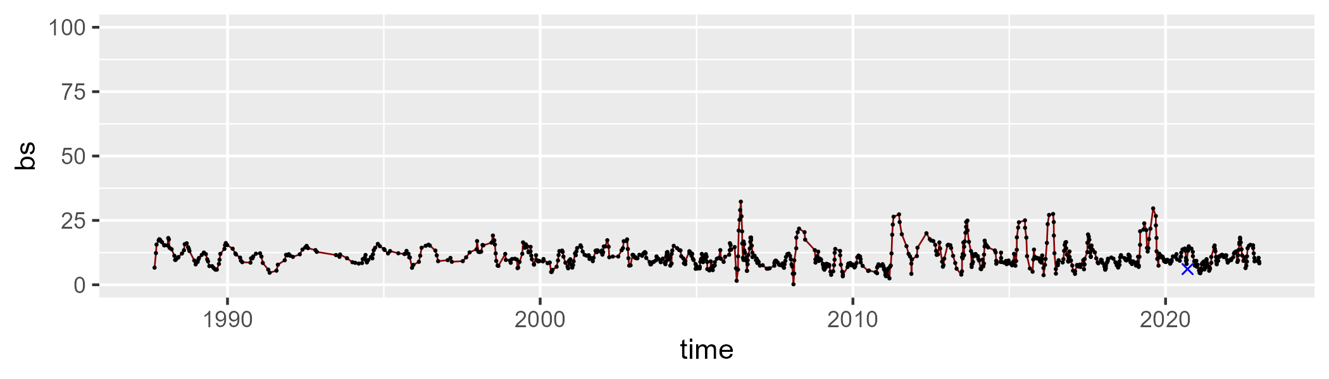

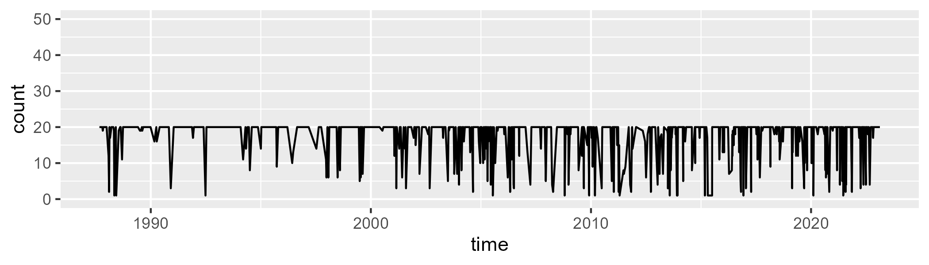

Min. : 1.00 1st Qu.:20.00 Median :20.00 Mean :17.62 3rd Qu.:20.00 Max. :20.00

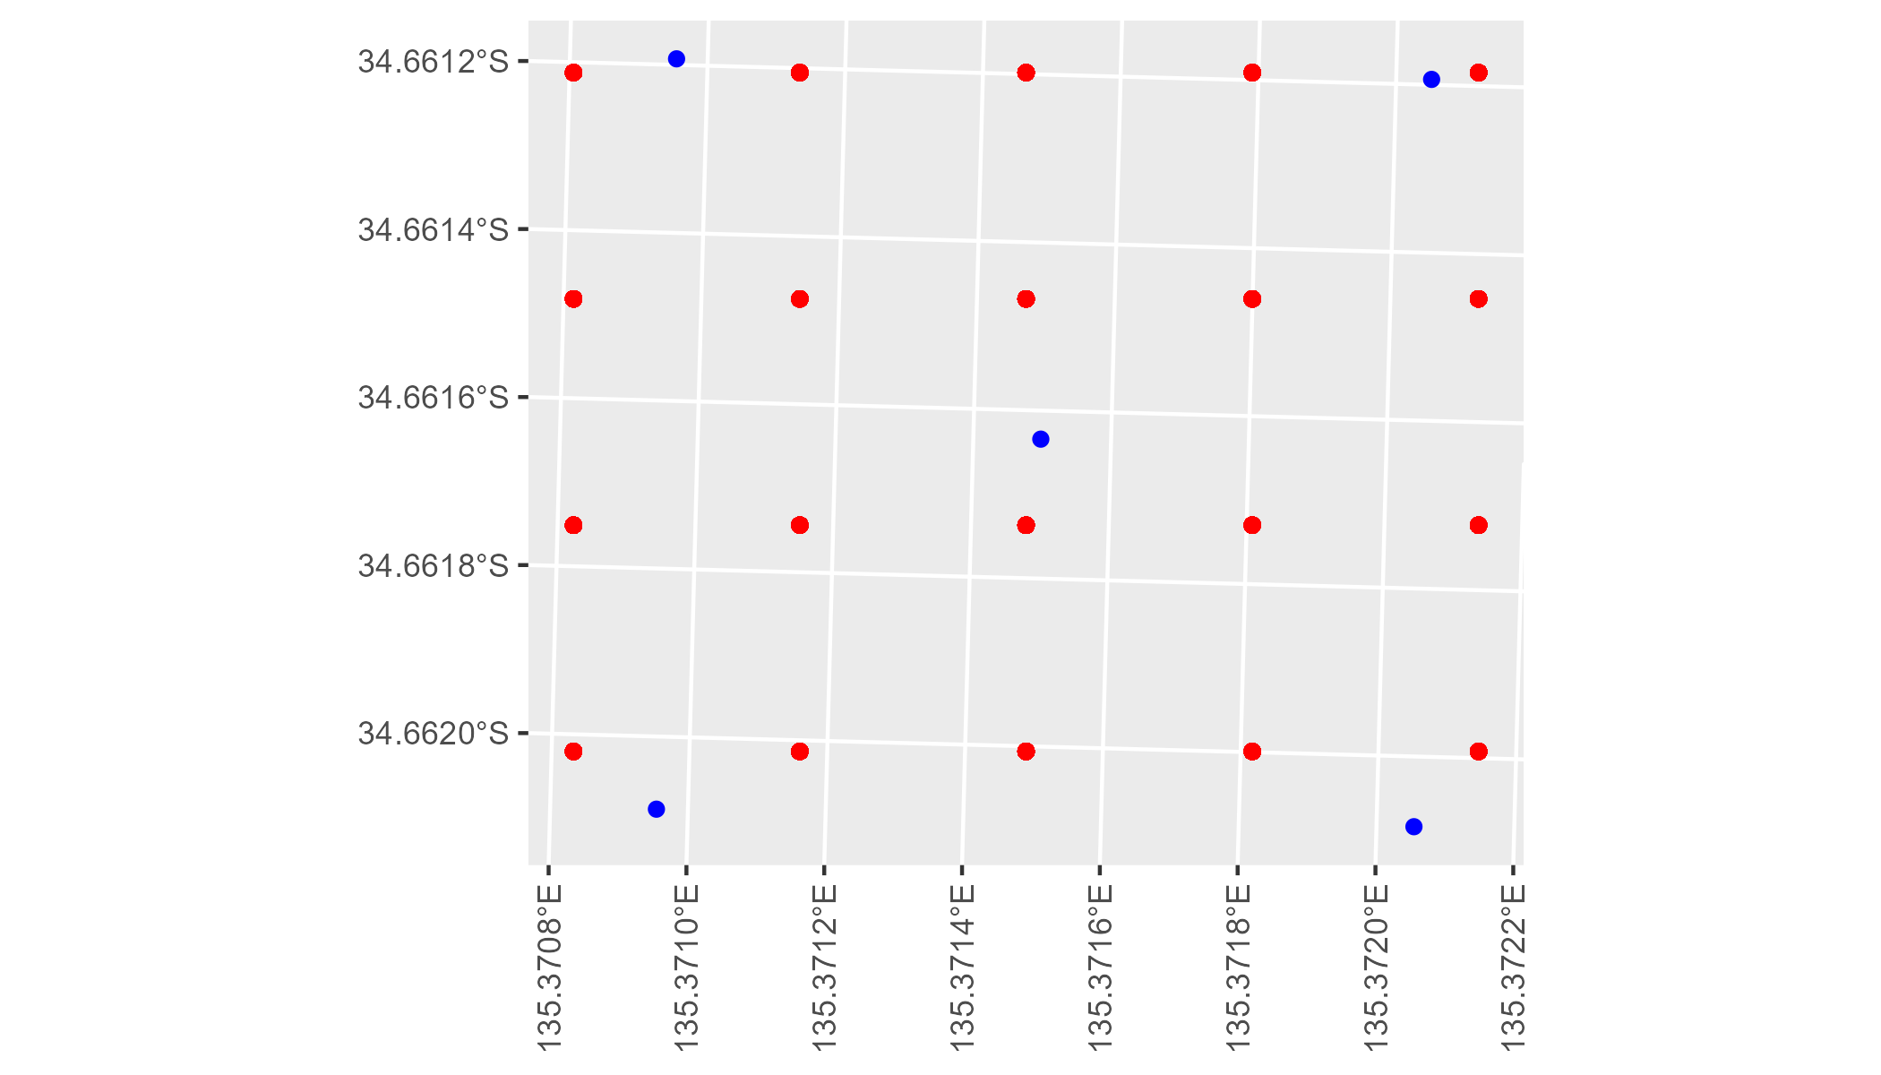

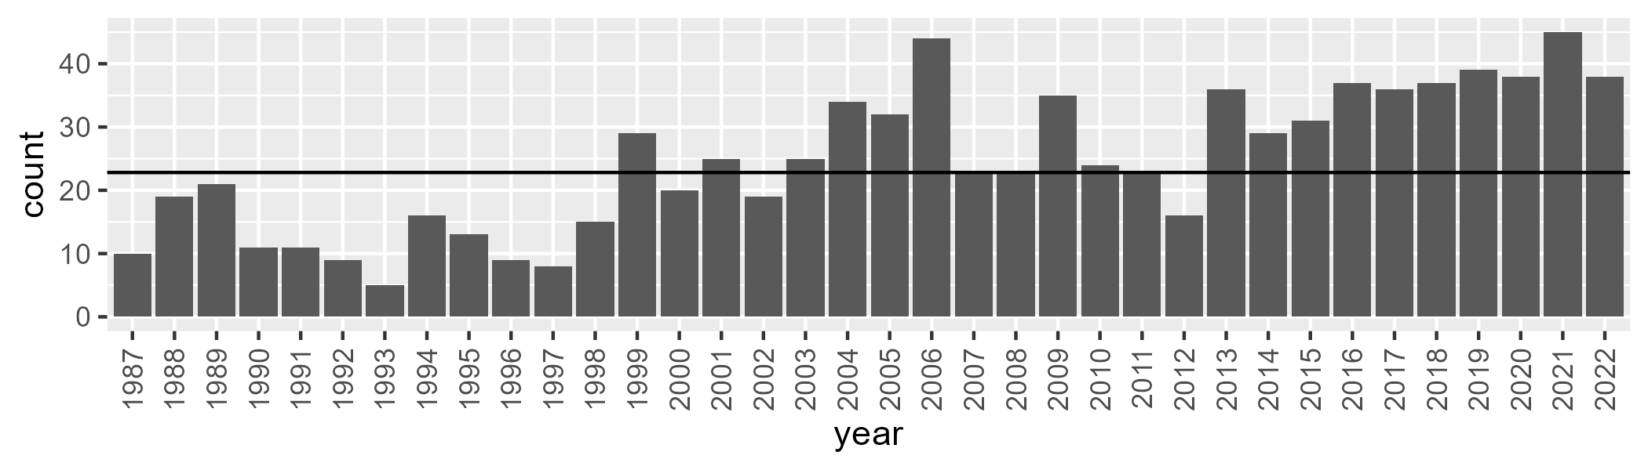

Number of samples: 885

# SAAEYB0026

| Min. | 1st Qu. | Median | Mean | 3rd Qu. | Max. |
| --- | --- | --- | --- | --- | --- |
| 2.702466 | 35.20828 | 41.41365 | 40.3191 | 46.33428 | 58.84909 |

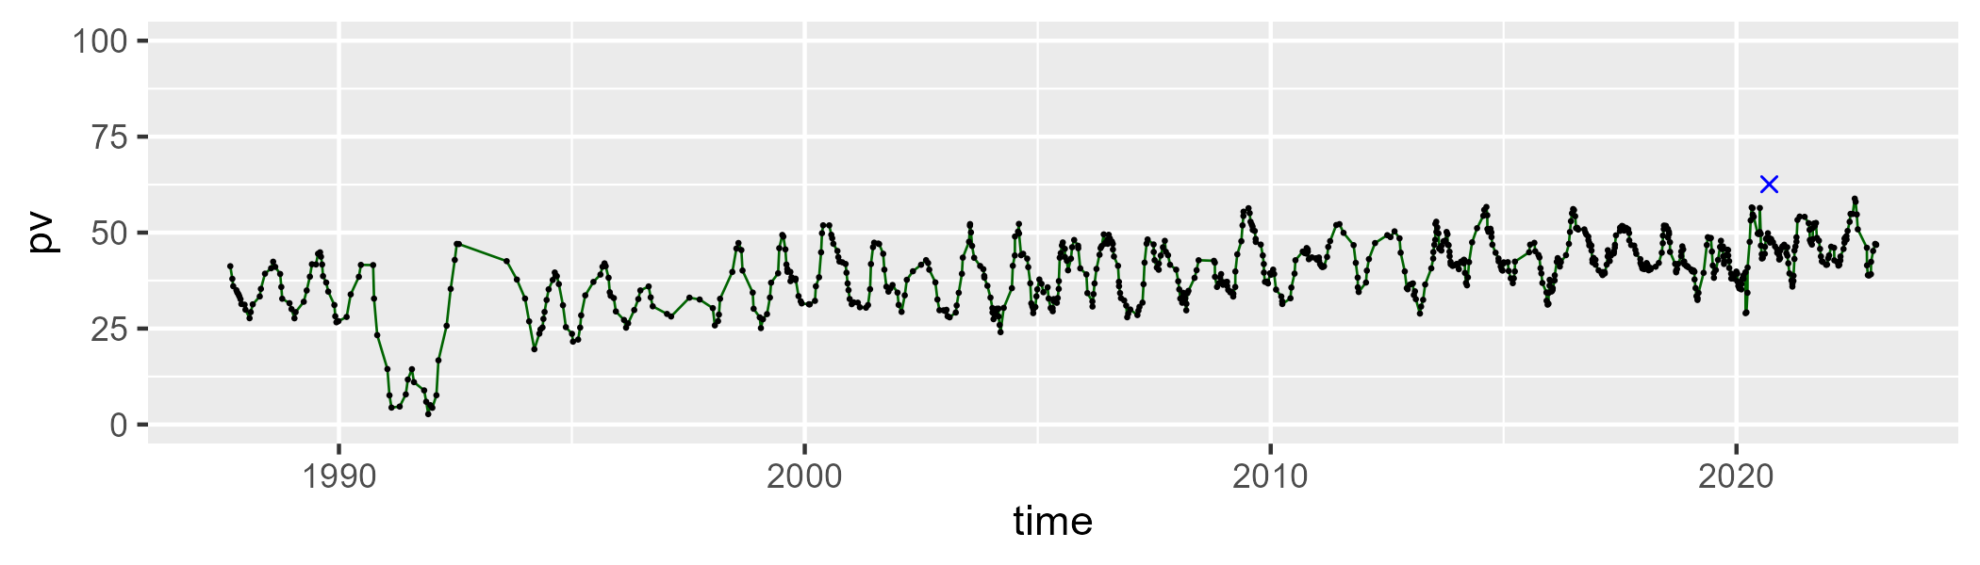

| Min. | 1st Qu. | Median | Mean | 3rd Qu. | Max. |
| --- | --- | --- | --- | --- | --- |
| 28.06666 | 40.38891 | 45.19809 | 45.24928 | 50.23074 | 65.04792 |

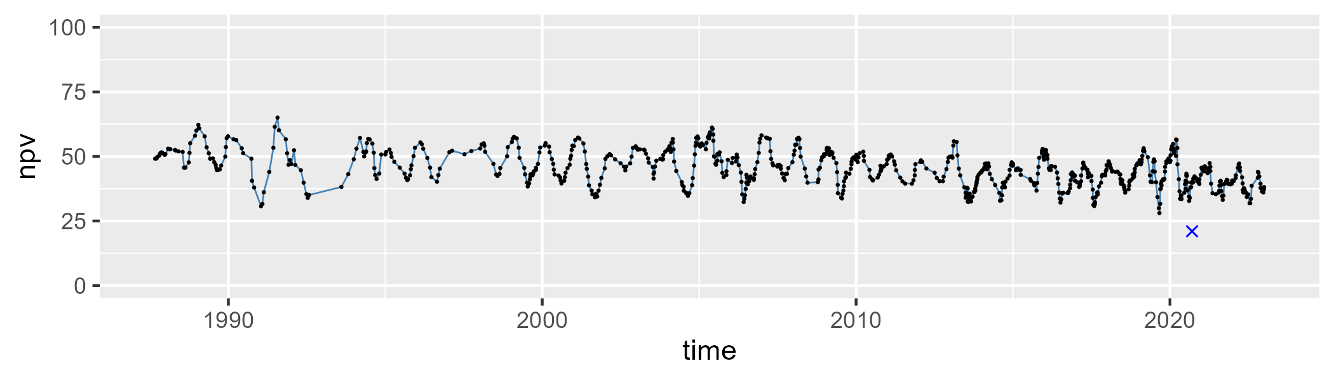

| Min. | 1st Qu. | Median | Mean | 3rd Qu. | Max. |
| --- | --- | --- | --- | --- | --- |
| 2.95136 | 9.812393 | 12.09682 | 13.21079 | 15.60036 | 59.71917 |

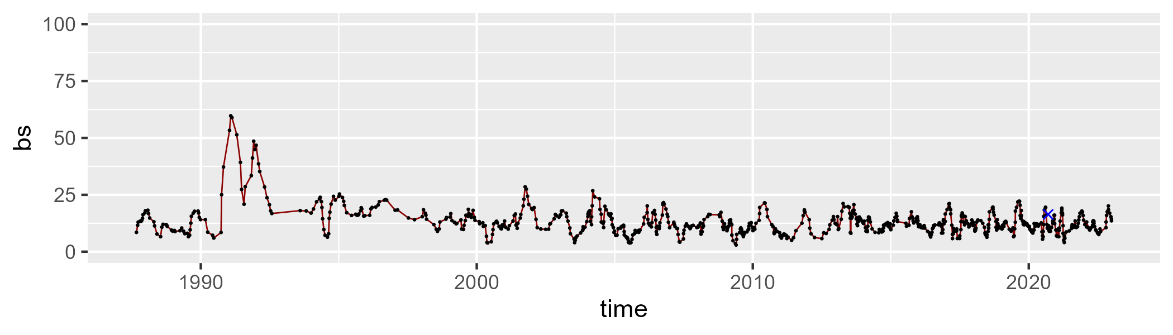

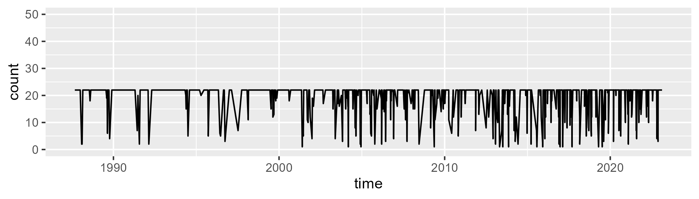

Min. : 1.00 1st Qu.:22.00 Median :22.00 Mean :19.32 3rd Qu.:22.00 Max. :22.00

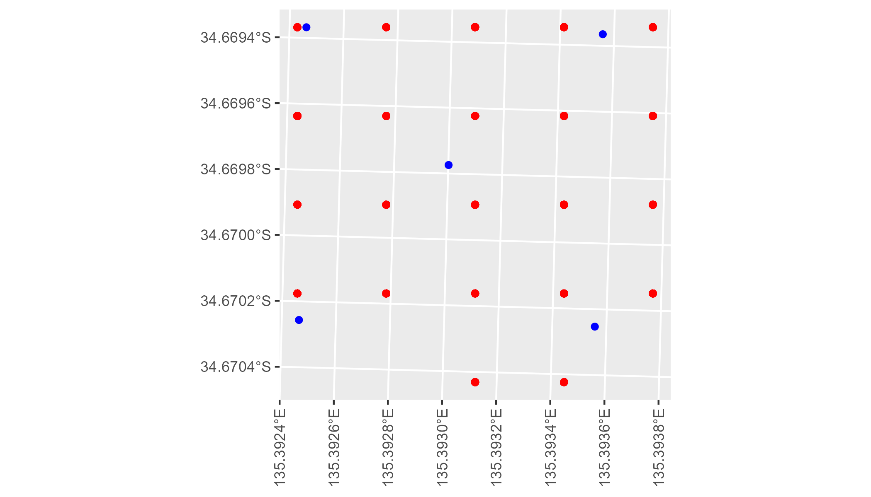

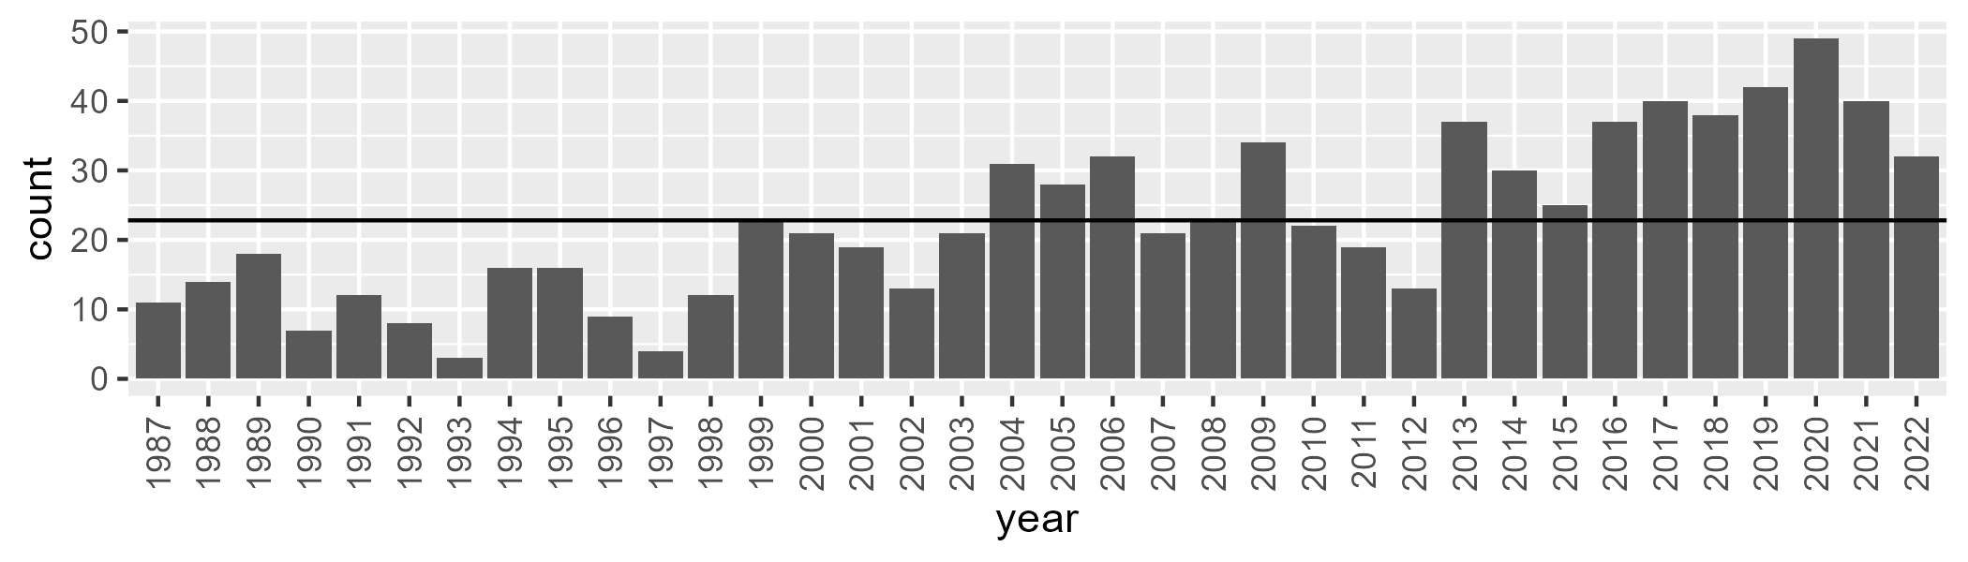

Number of samples: 820

# SAAEYB0027

| Min. | 1st Qu. | Median | Mean | 3rd Qu. | Max. |
| --- | --- | --- | --- | --- | --- |
| 0 | 39.76284 | 43.22421 | 42.63625 | 46.19839 | 60.28601 |

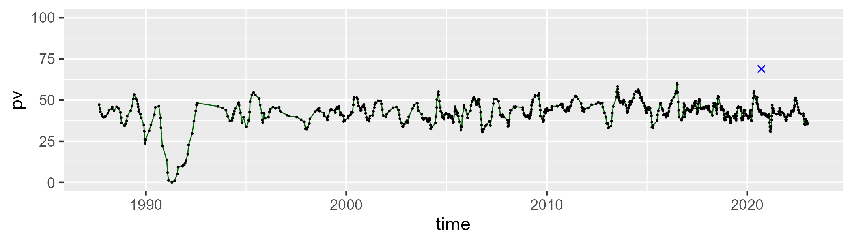

| Min. | 1st Qu. | Median | Mean | 3rd Qu. | Max. |
| --- | --- | --- | --- | --- | --- |
| 17.19562 | 35.65742 | 39.72156 | 39.61767 | 42.87899 | 63.64794 |

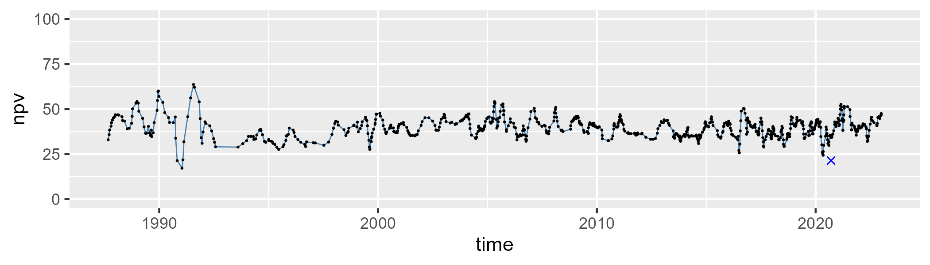

| Min. | 1st Qu. | Median | Mean | 3rd Qu. | Max. |
| --- | --- | --- | --- | --- | --- |
| 3.582626 | 13.02605 | 15.30052 | 16.37974 | 18.35991 | 70.23109 |

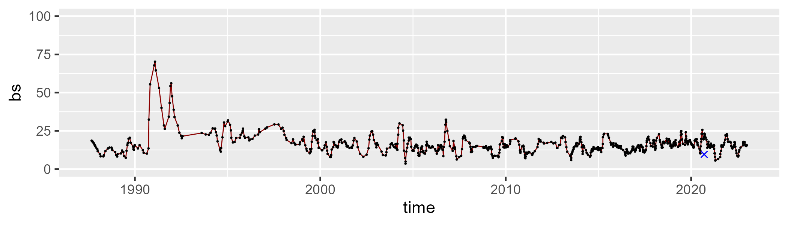

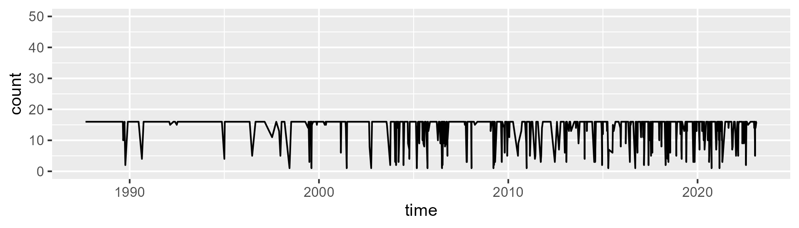

Min. : 1.00 1st Qu.:16.00 Median :16.00 Mean :14.22 3rd Qu.:16.00 Max. :16.00

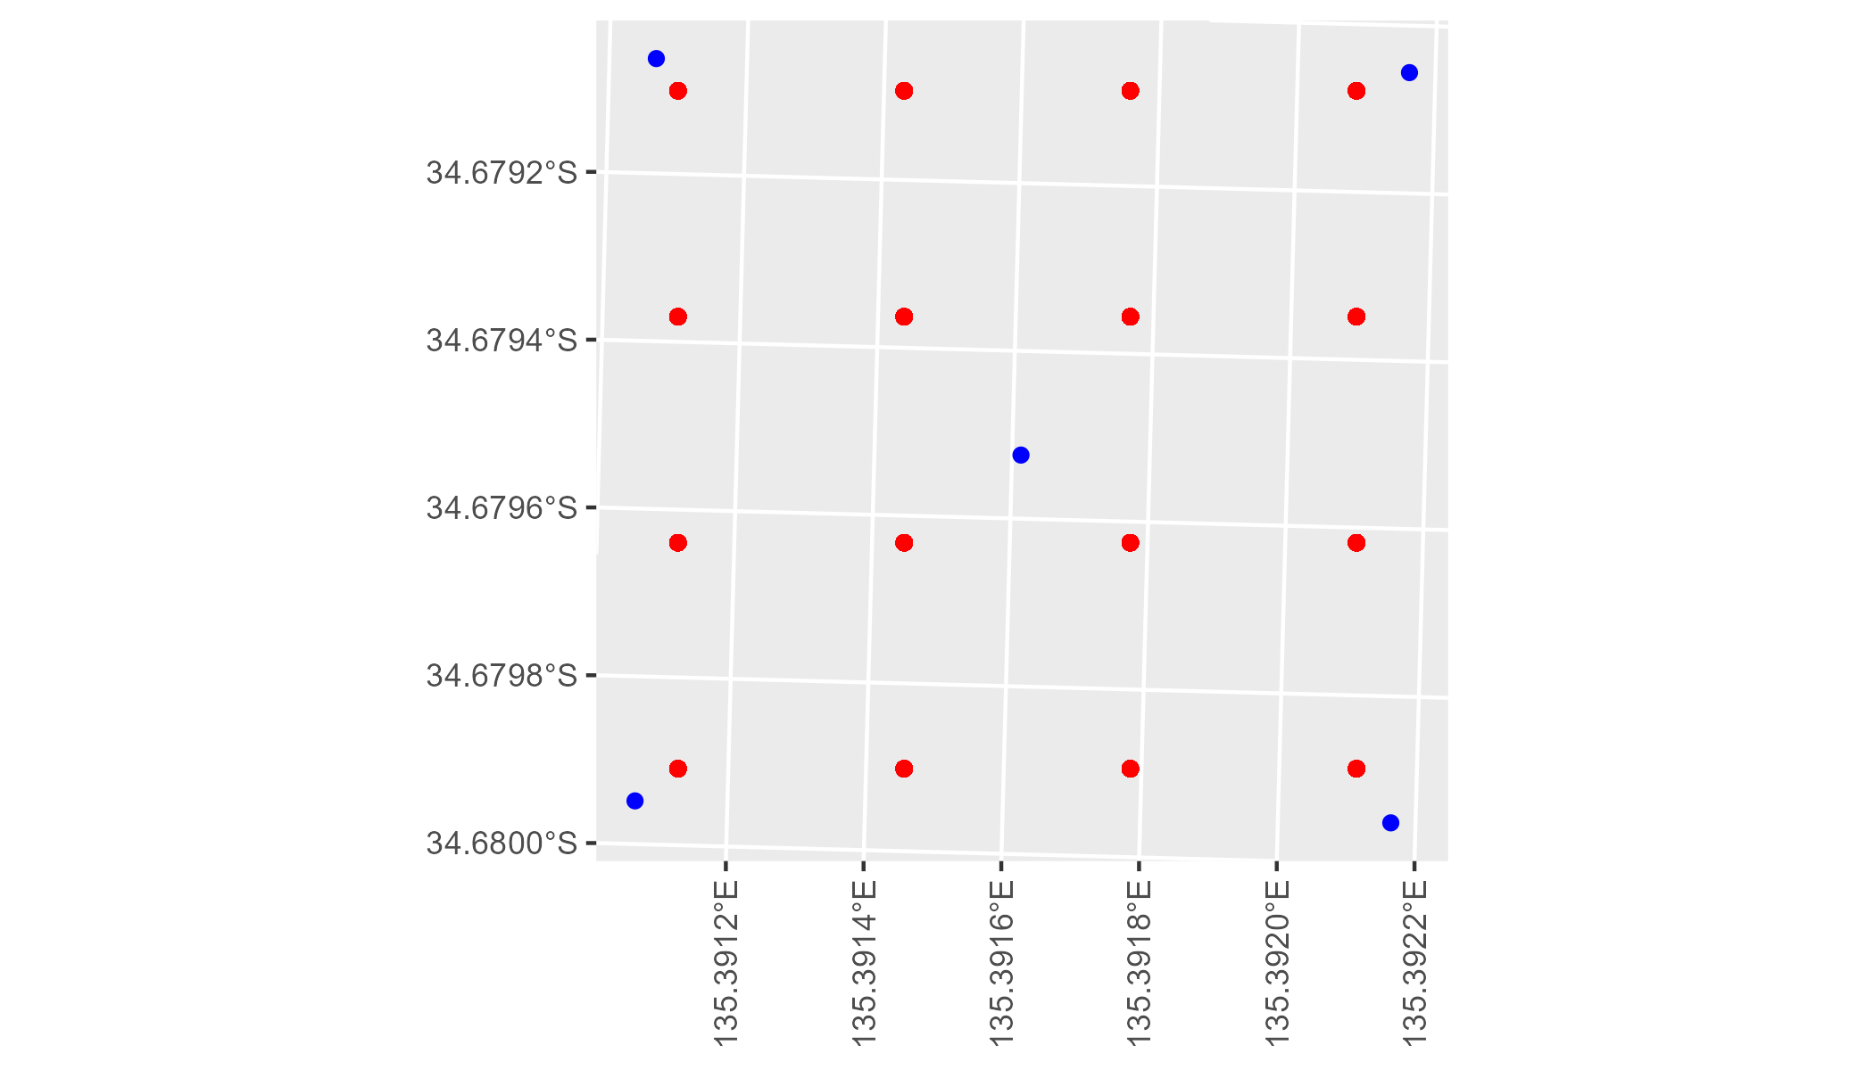

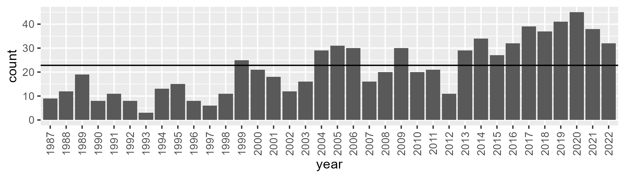

Number of samples: 777

# SAAEYB0028

| Min. | 1st Qu. | Median | Mean | 3rd Qu. | Max. |
| --- | --- | --- | --- | --- | --- |
| 0 | 1.526322 | 4.109436 | 4.514343 | 6.426543 | 29.12515 |

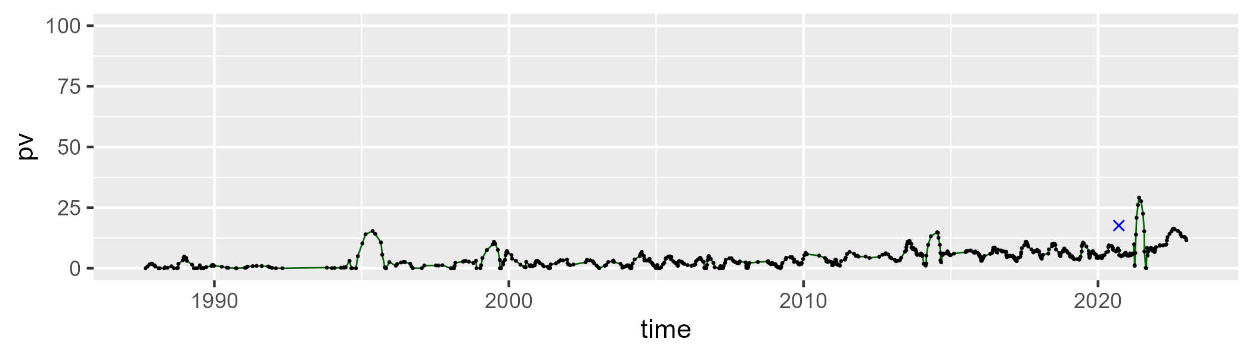

| Min. | 1st Qu. | Median | Mean | 3rd Qu. | Max. |
| --- | --- | --- | --- | --- | --- |
| 62.87147 | 82.04563 | 88.089 | 87.53045 | 93.97011 | 102.8821 |

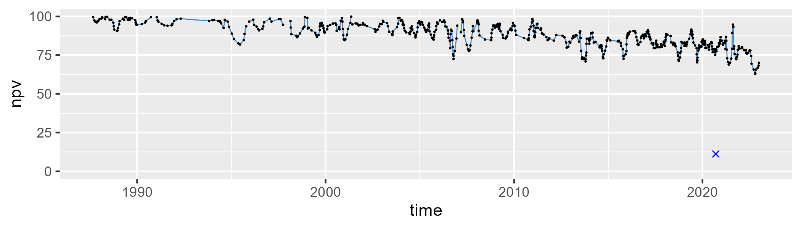

| Min. | 1st Qu. | Median | Mean | 3rd Qu. | Max. |
| --- | --- | --- | --- | --- | --- |
| 0 | 2.488572 | 5.847183 | 6.66956 | 9.941127 | 23.47632 |

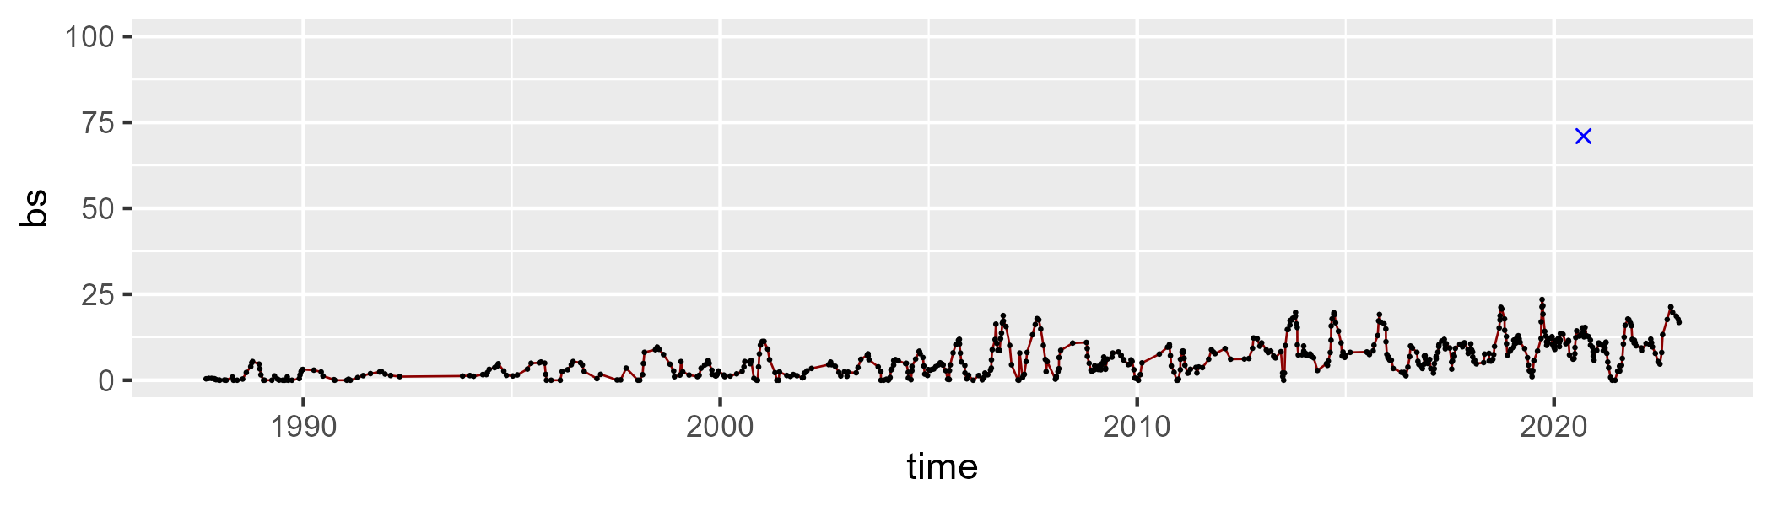

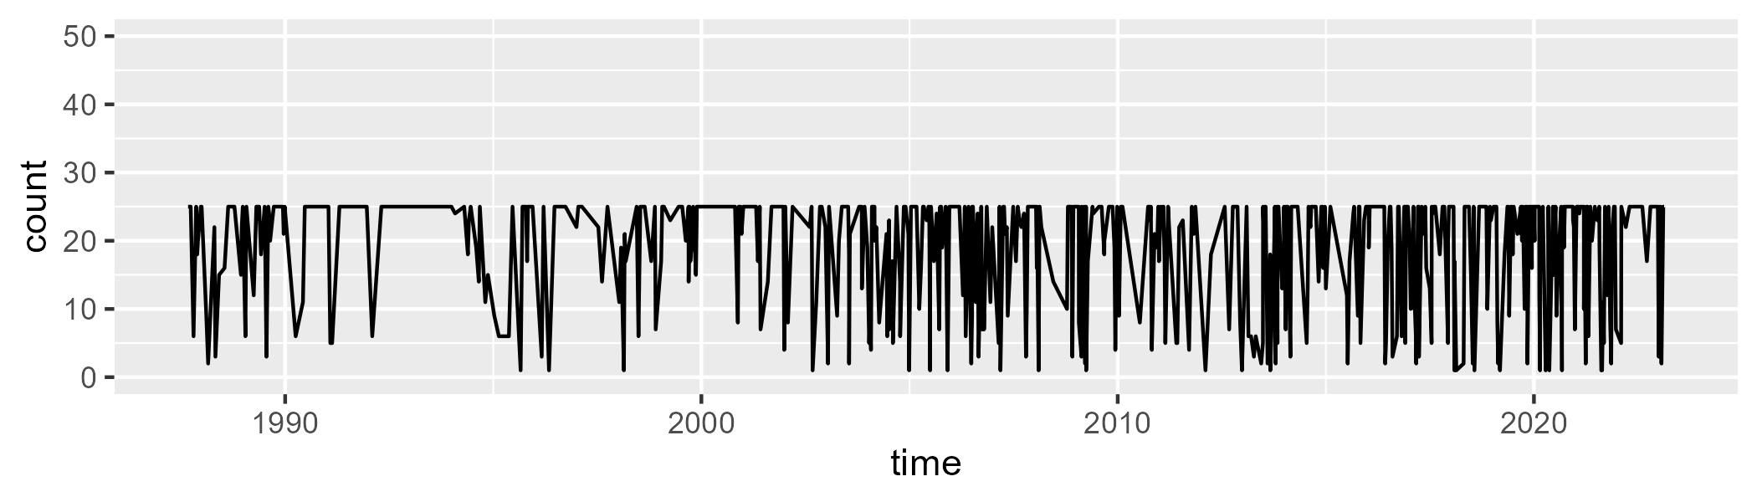

Min. : 1.00 1st Qu.:13.50 Median :25.00 Mean :18.96 3rd Qu.:25.00 Max. :25.00

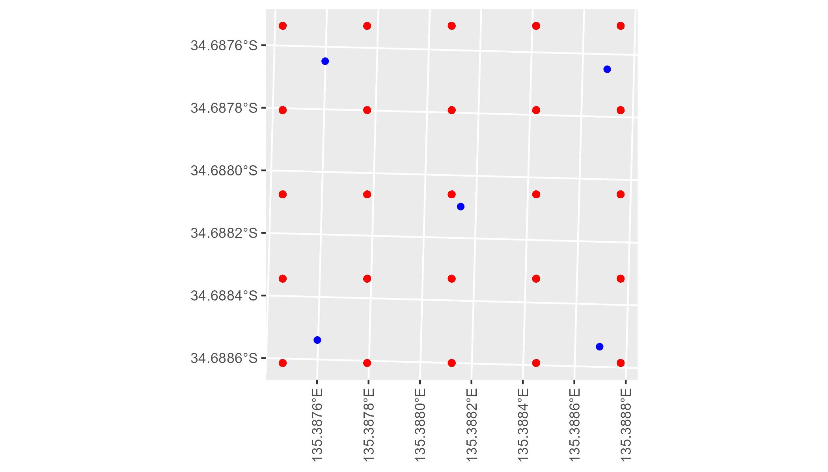

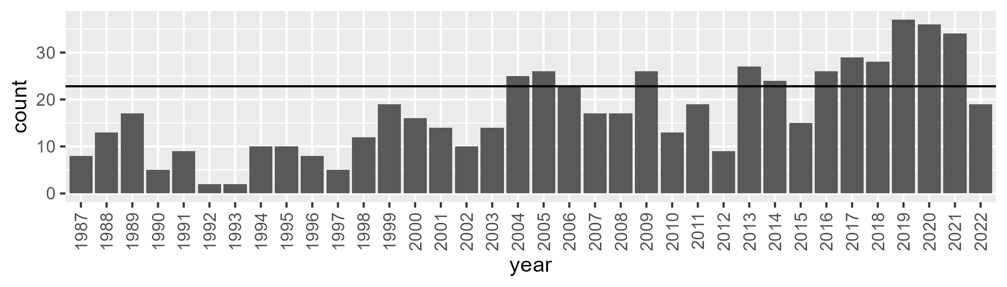

Number of samples: 624

# SAAEYB0029

| Min. | 1st Qu. | Median | Mean | 3rd Qu. | Max. |
| --- | --- | --- | --- | --- | --- |
| 0 | 18.03809 | 21.54672 | 21.417 | 25.06793 | 36.82641 |

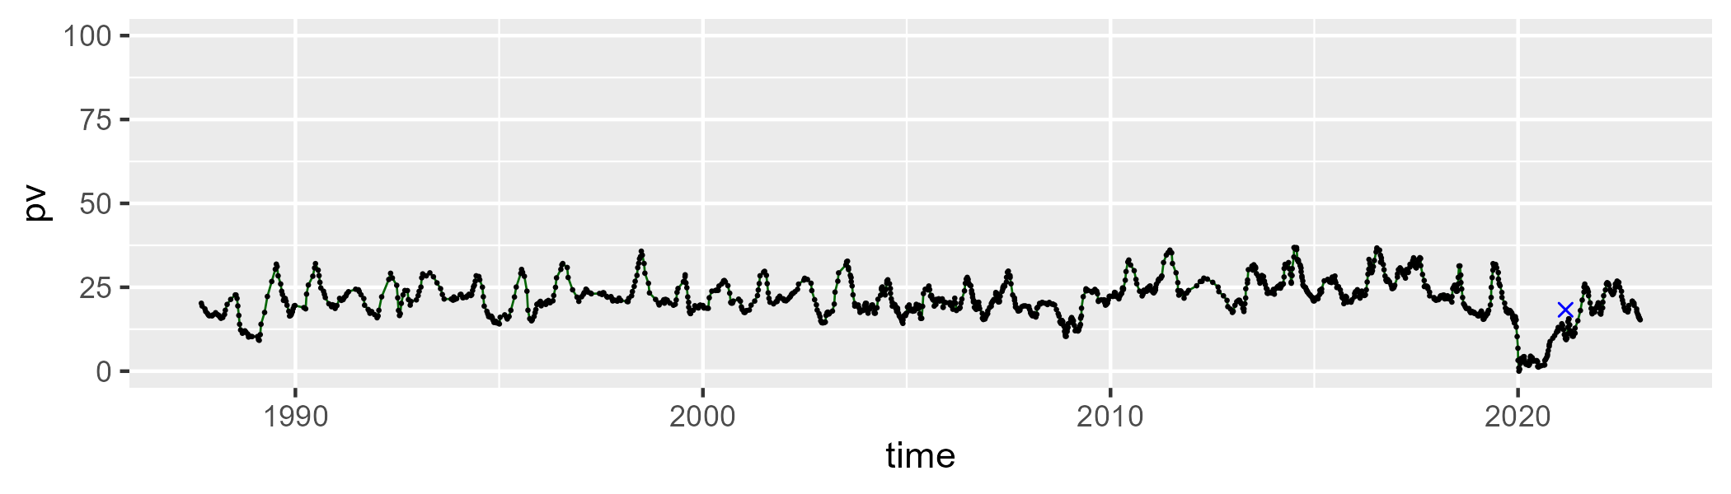

| Min. | 1st Qu. | Median | Mean | 3rd Qu. | Max. |
| --- | --- | --- | --- | --- | --- |
| 22.33236 | 50.01991 | 53.19661 | 51.61889 | 55.50805 | 66.9328 |

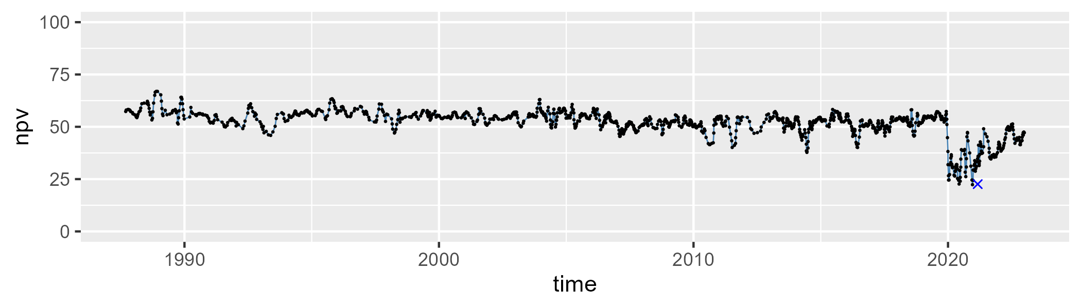

| Min. | 1st Qu. | Median | Mean | 3rd Qu. | Max. |
| --- | --- | --- | --- | --- | --- |
| 8.650892 | 20.35372 | 23.66938 | 25.70368 | 27.65838 | 73.65573 |

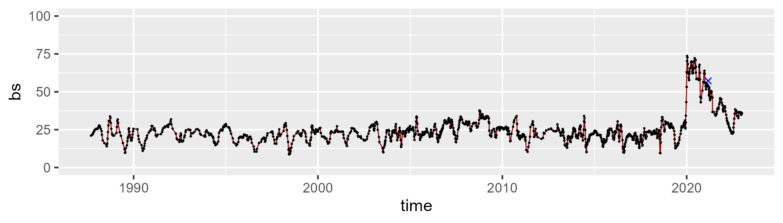

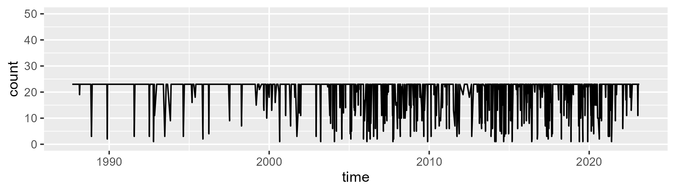

Min. : 1.00 1st Qu.:23.00 Median :23.00 Mean :20.38 3rd Qu.:23.00 Max. :23.00

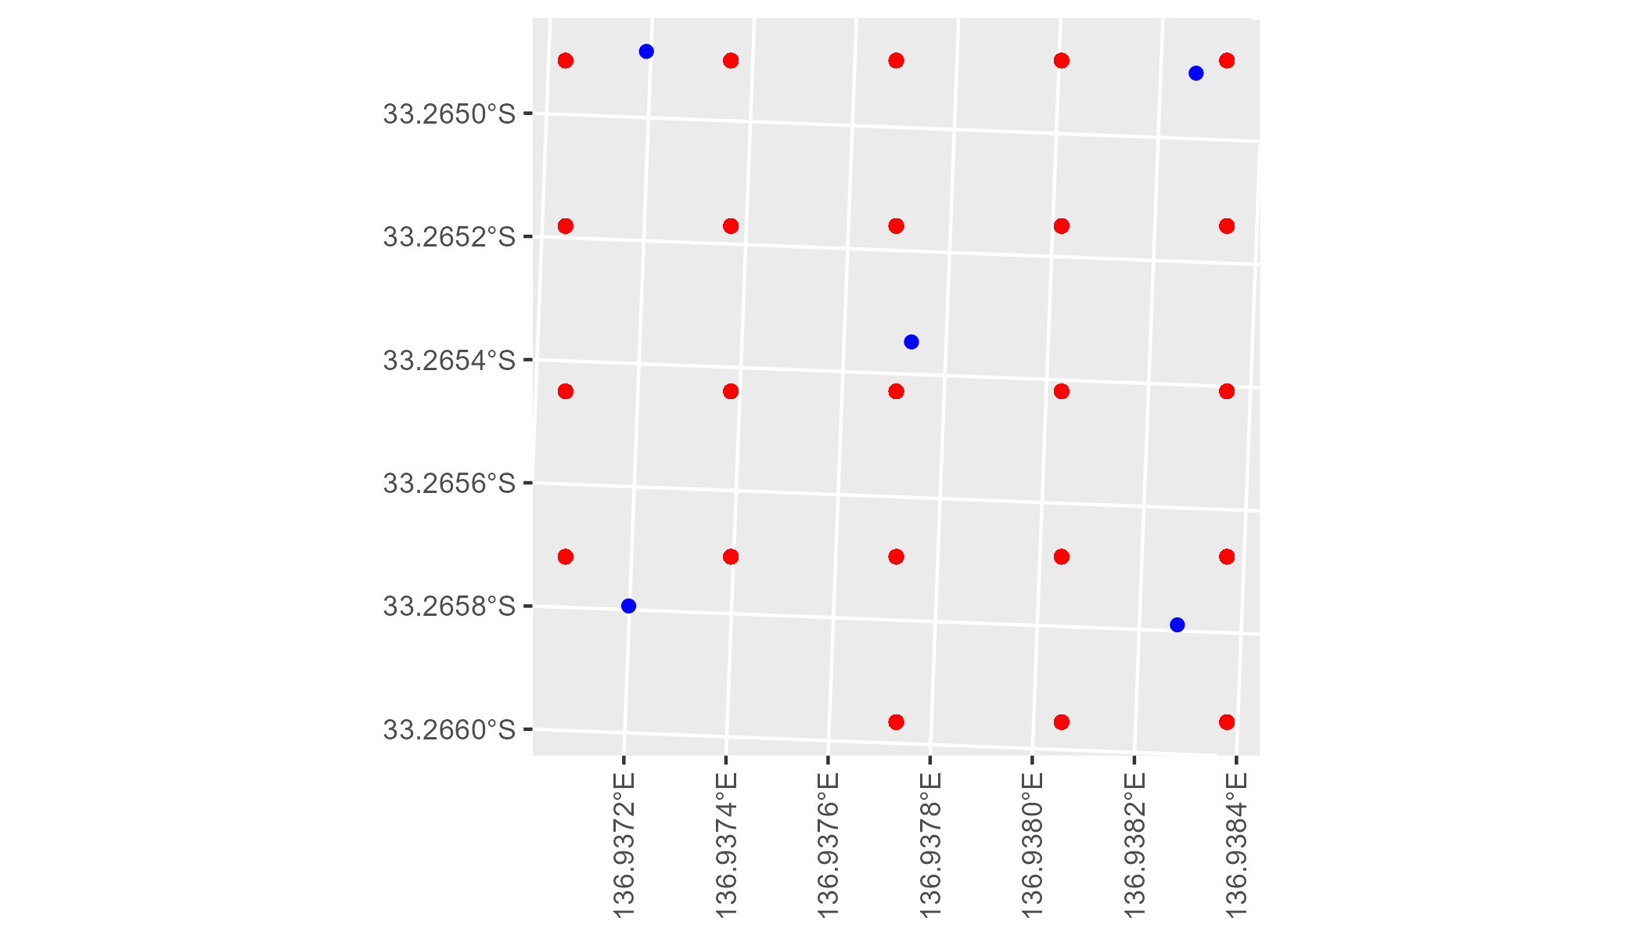

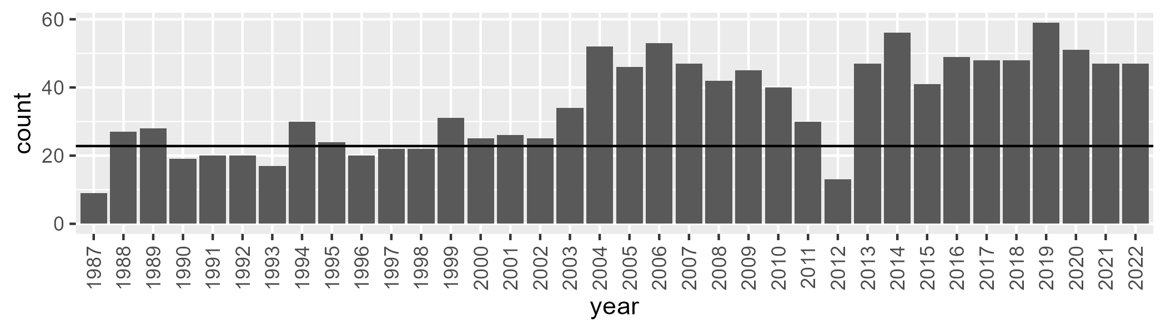

Number of samples: 1260

# SAAEYB0030

| Min. | 1st Qu. | Median | Mean | 3rd Qu. | Max. |
| --- | --- | --- | --- | --- | --- |
| 13.03489 | 22.47031 | 26.44891 | 26.52692 | 30.21802 | 41.37322 |

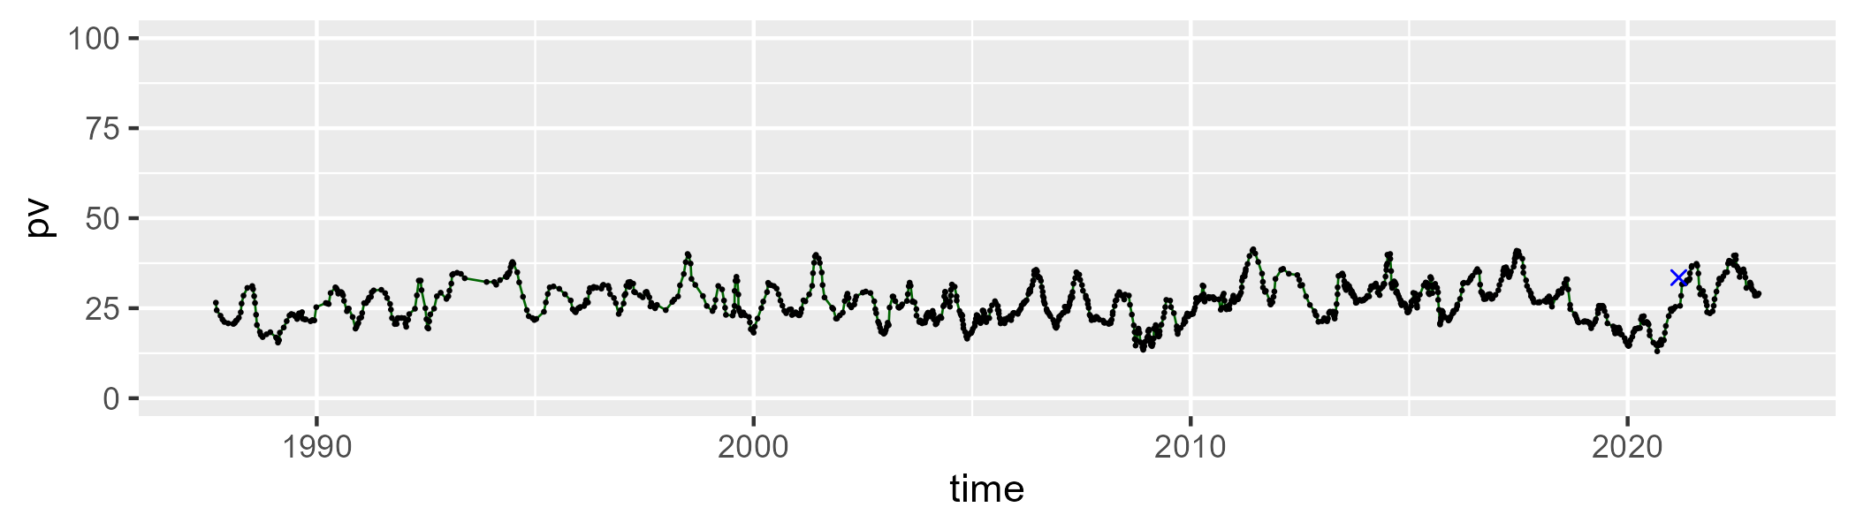

| Min. | 1st Qu. | Median | Mean | 3rd Qu. | Max. |
| --- | --- | --- | --- | --- | --- |
| 31.20013 | 48.70633 | 50.79974 | 50.33082 | 52.57243 | 65.81983 |

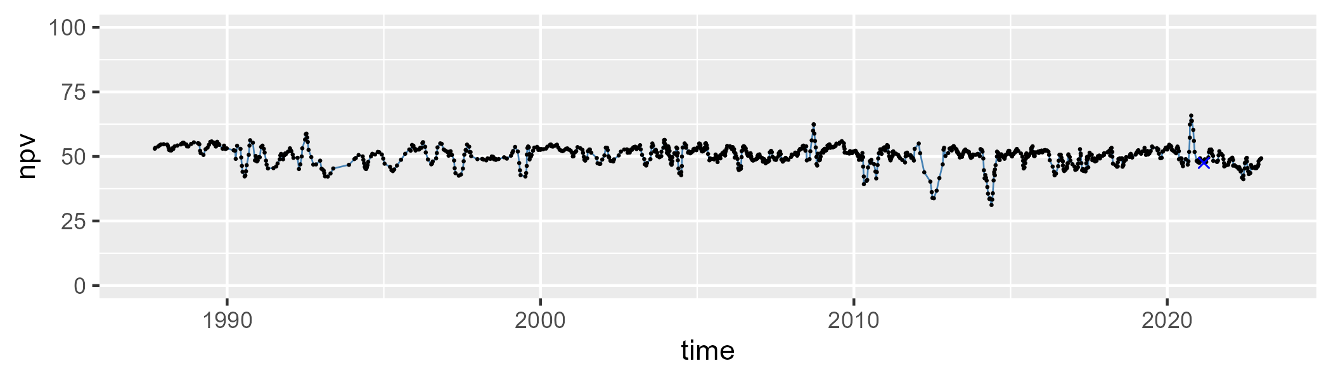

| Min. | 1st Qu. | Median | Mean | 3rd Qu. | Max. |
| --- | --- | --- | --- | --- | --- |
| 7.32428 | 18.65733 | 22.11508 | 21.9208 | 25.43805 | 37.63575 |

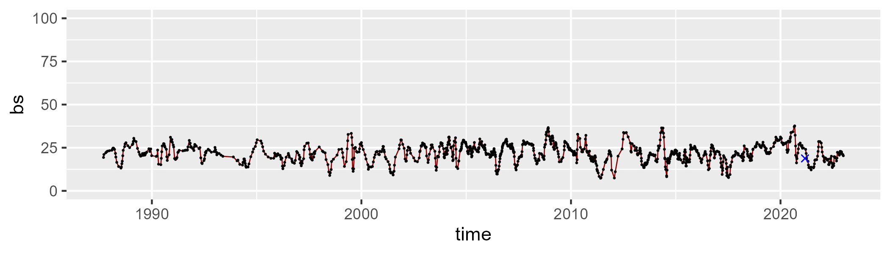

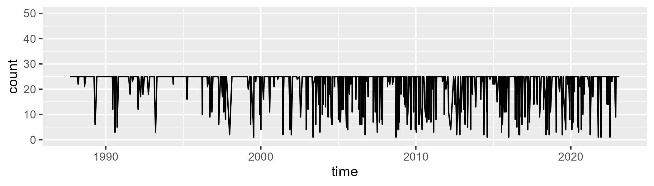

Min. : 1.0 1st Qu.:25.0 Median :25.0 Mean :22.2 3rd Qu.:25.0 Max. :25.0

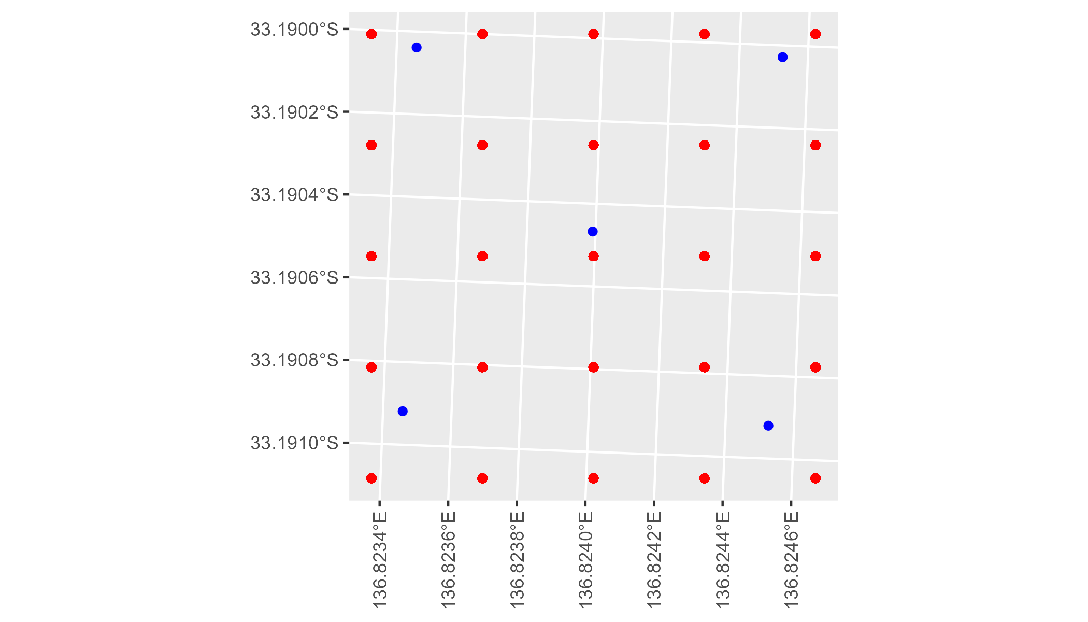

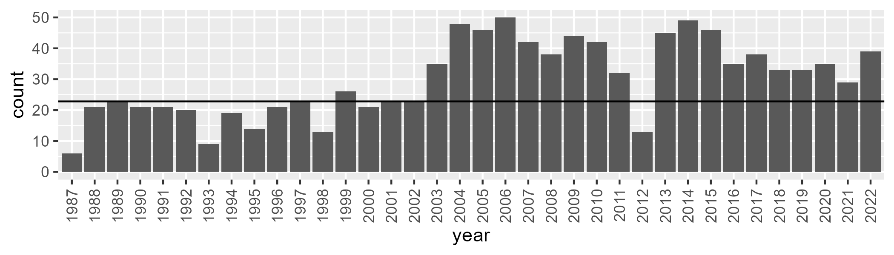

Number of samples: 1076

# SAAEYB0031

| Min. | 1st Qu. | Median | Mean | 3rd Qu. | Max. |
| --- | --- | --- | --- | --- | --- |
| 14.22177 | 22.64652 | 26.34339 | 26.55123 | 30.0503 | 41.17204 |

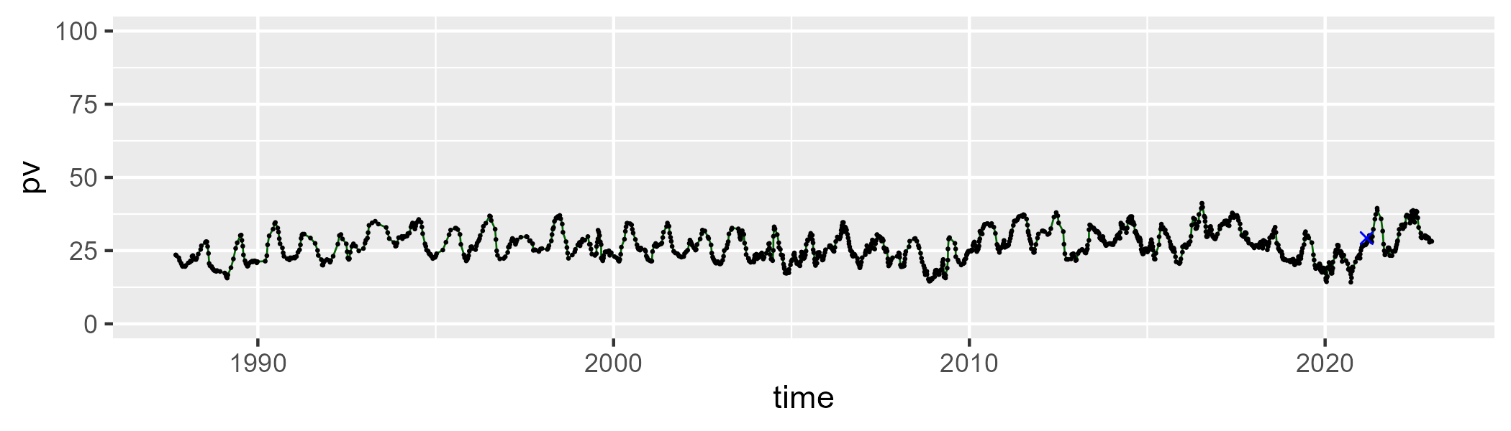

| Min. | 1st Qu. | Median | Mean | 3rd Qu. | Max. |
| --- | --- | --- | --- | --- | --- |
| 36.62113 | 47.10352 | 49.36288 | 48.93185 | 51.25342 | 60.5137 |

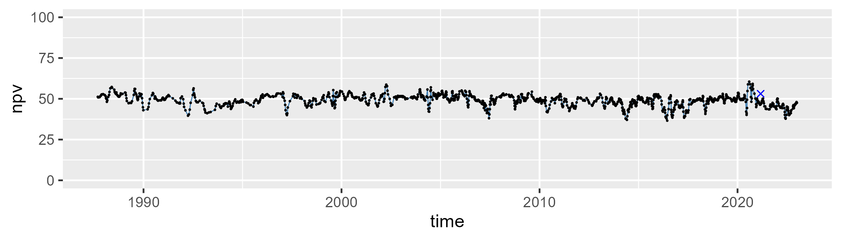

| Min. | 1st Qu. | Median | Mean | 3rd Qu. | Max. |
| --- | --- | --- | --- | --- | --- |
| 7.363846 | 20.0638 | 23.23269 | 23.25128 | 26.66814 | 38.01261 |

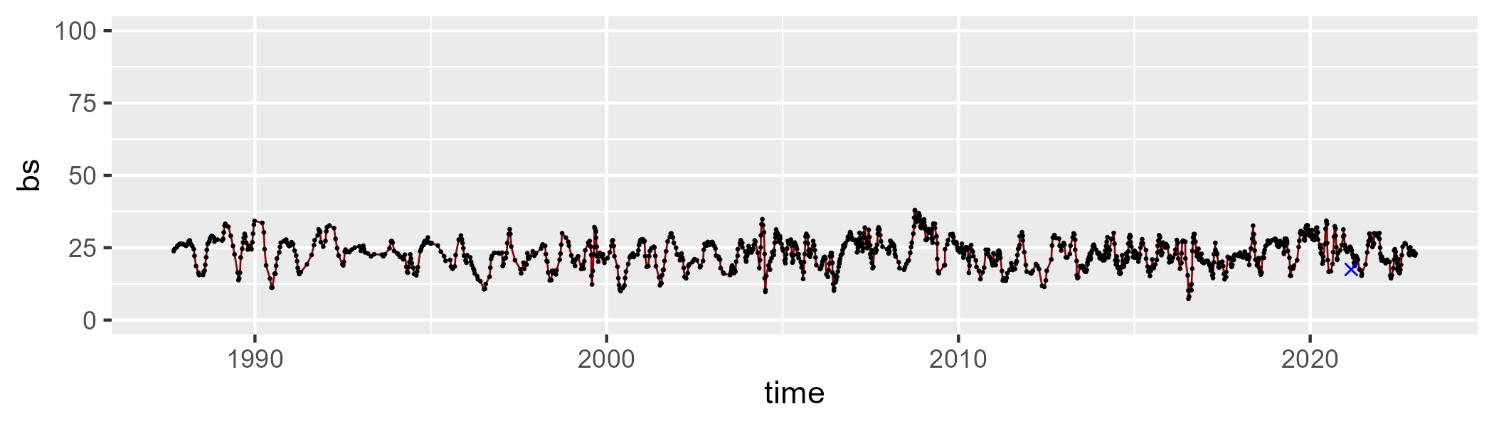

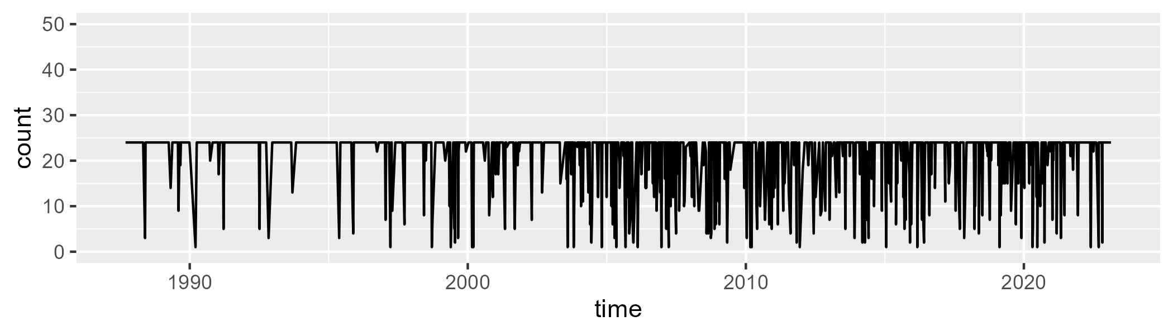

Min. : 1.00 1st Qu.:24.00 Median :24.00 Mean :21.28 3rd Qu.:24.00 Max. :24.00

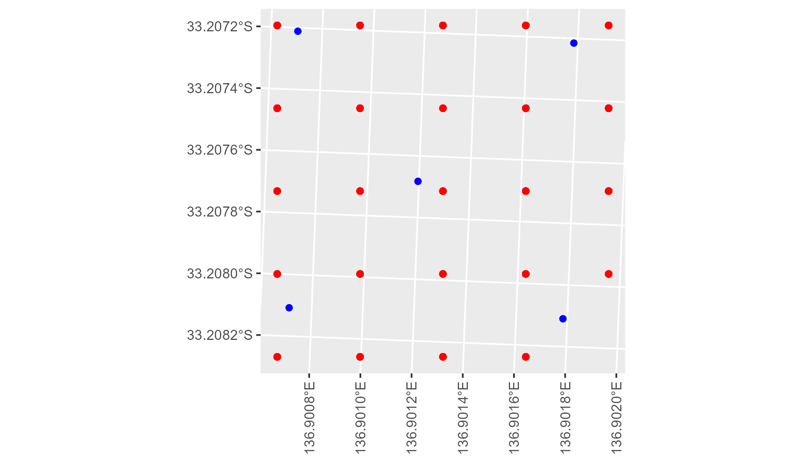

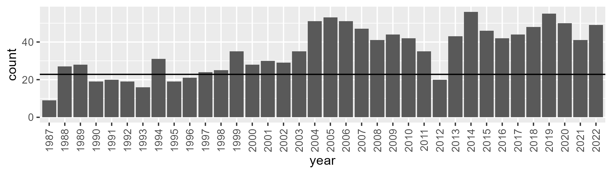

Number of samples: 1273

# SAAEYB0032

| Min. | 1st Qu. | Median | Mean | 3rd Qu. | Max. |
| --- | --- | --- | --- | --- | --- |
| 4.065281 | 20.77629 | 24.91647 | 24.59303 | 28.64579 | 41.08739 |

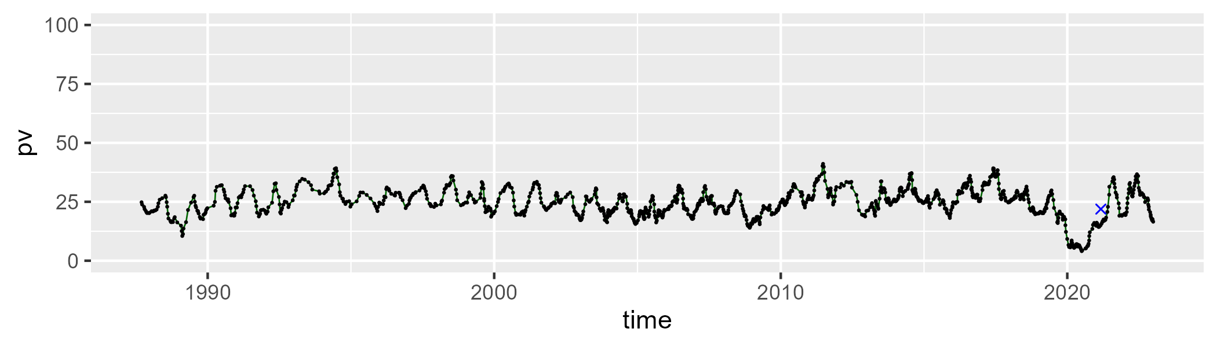

| Min. | 1st Qu. | Median | Mean | 3rd Qu. | Max. |
| --- | --- | --- | --- | --- | --- |
| 33.62014 | 49.06827 | 51.36982 | 50.78139 | 53.16601 | 62.21628 |

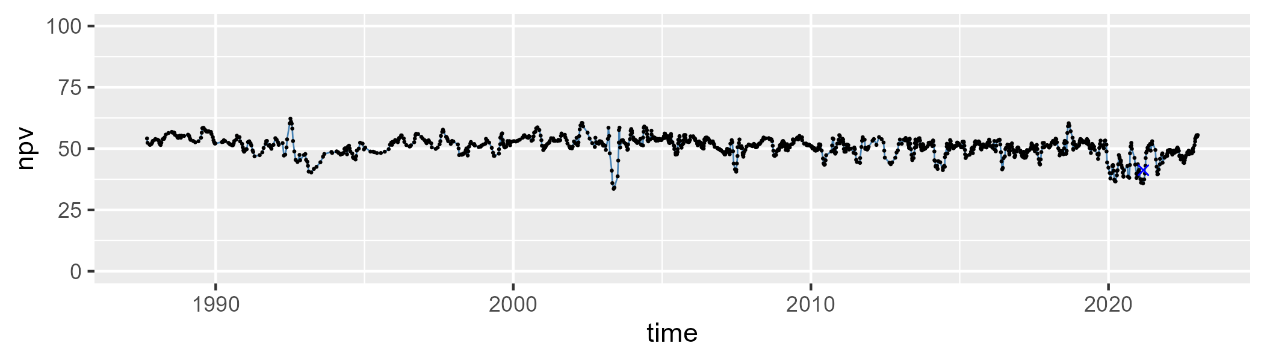

| Min. | 1st Qu. | Median | Mean | 3rd Qu. | Max. |
| --- | --- | --- | --- | --- | --- |
| 7.55908 | 19.37153 | 22.93016 | 23.40551 | 26.29065 | 56.21574 |

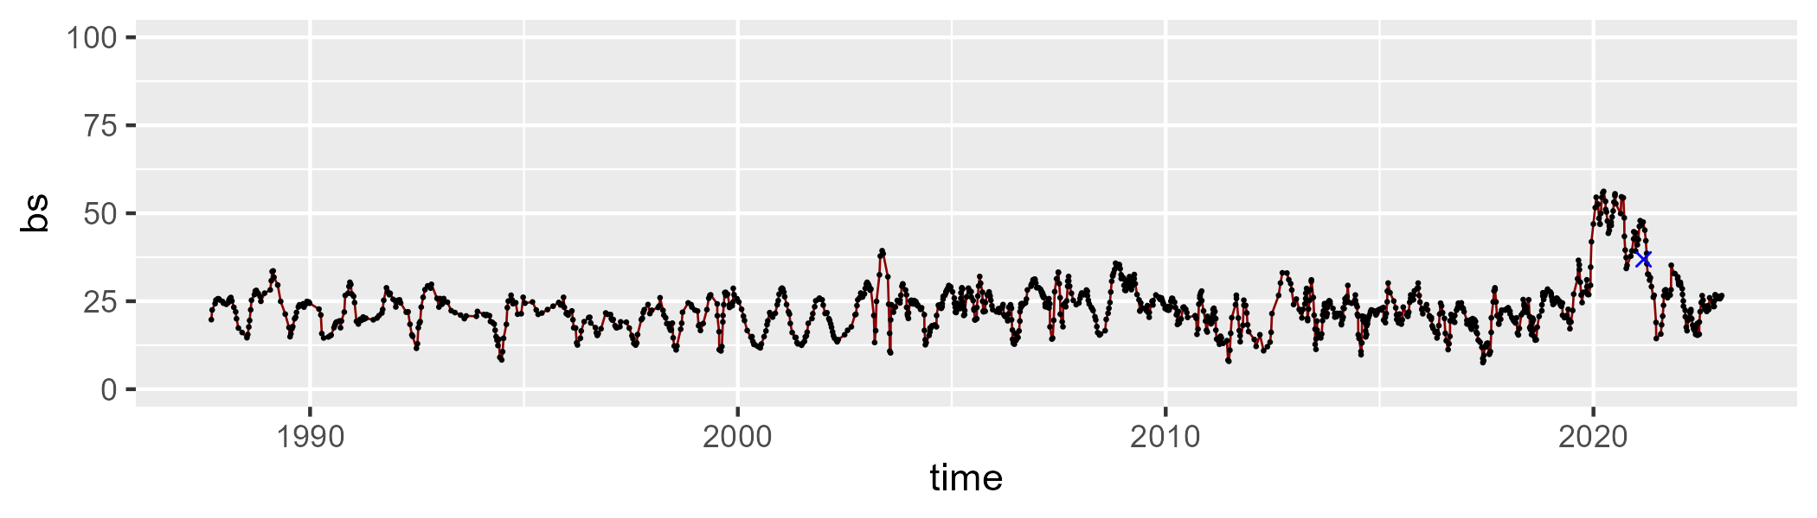

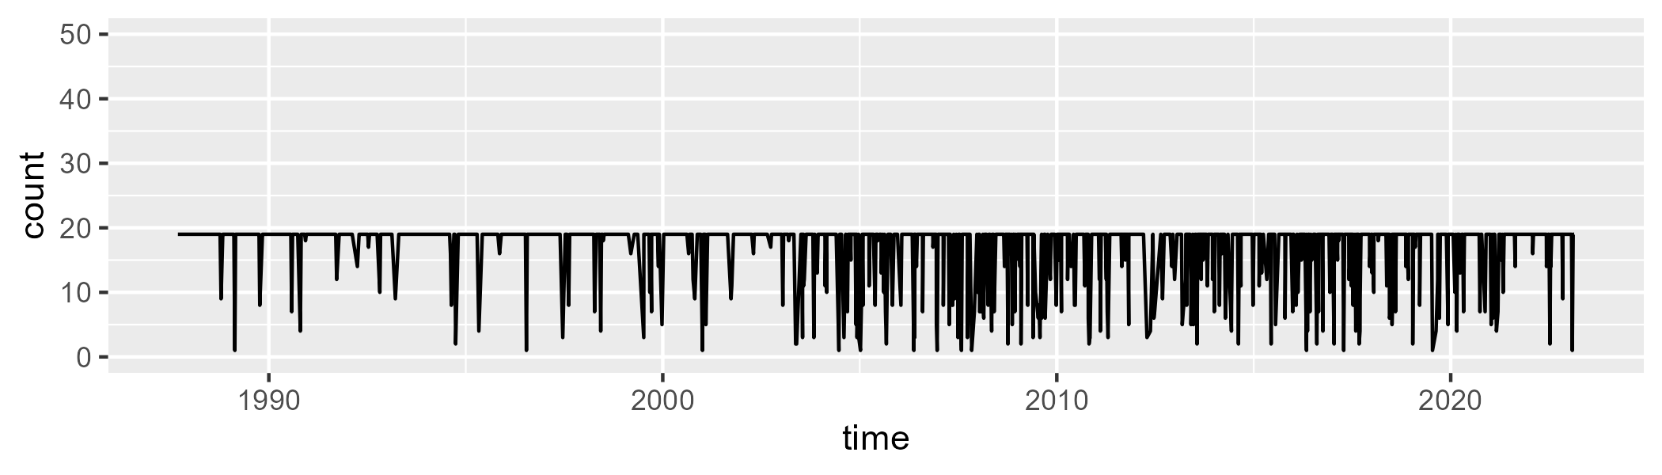

Min. : 1.00 1st Qu.:19.00 Median :19.00 Mean :16.96 3rd Qu.:19.00 Max. :19.00

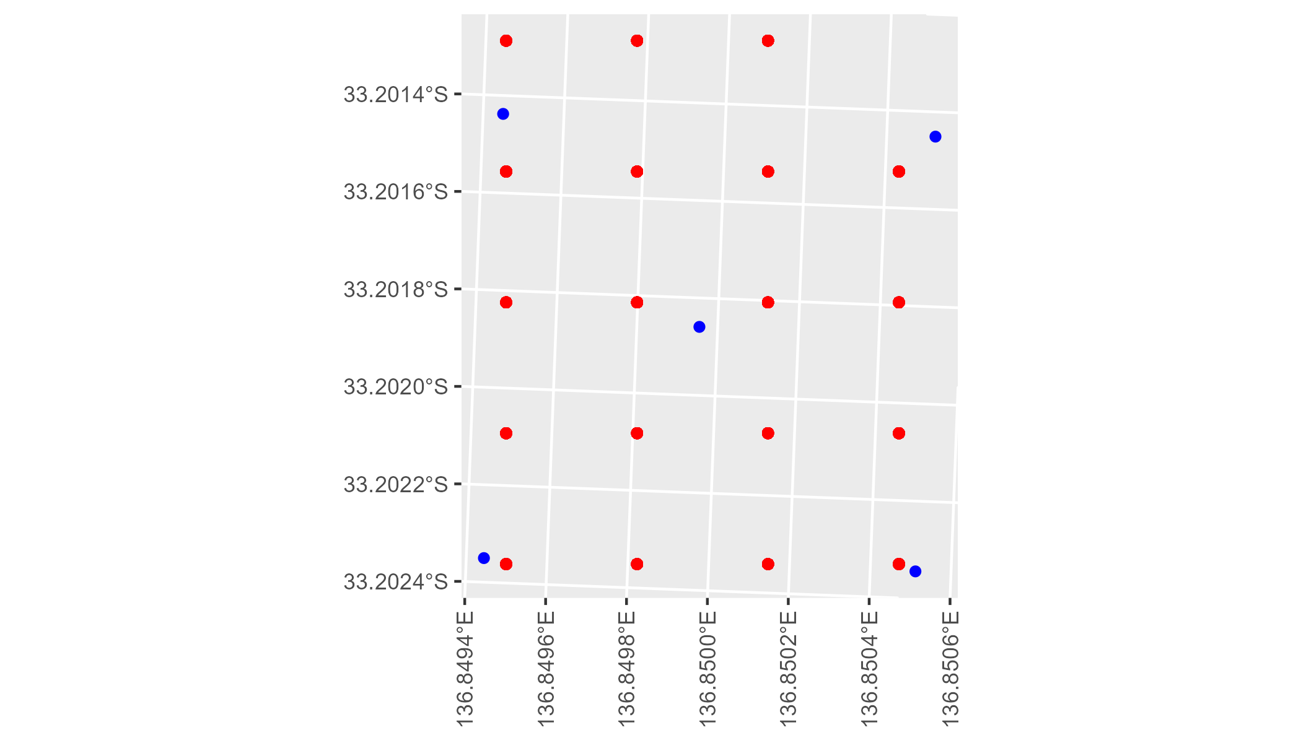

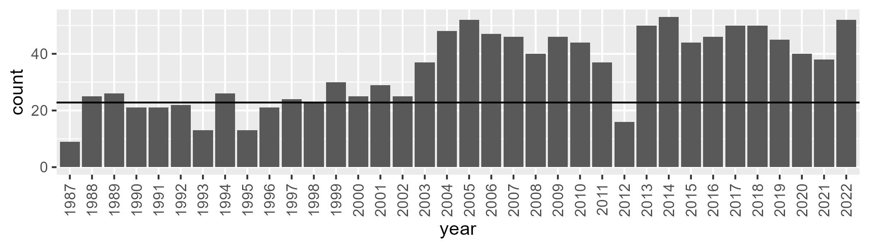

Number of samples: 1234

# SAAEYB0033

| Min. | 1st Qu. | Median | Mean | 3rd Qu. | Max. |
| --- | --- | --- | --- | --- | --- |
| 18.92434 | 27.31685 | 31.14874 | 31.38431 | 35.44856 | 47.32067 |

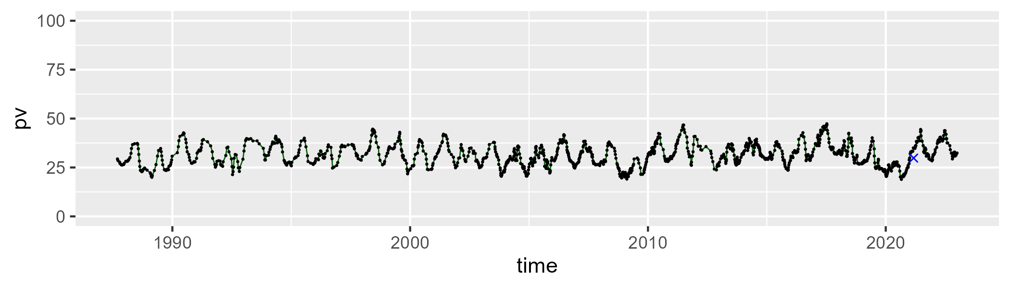

| Min. | 1st Qu. | Median | Mean | 3rd Qu. | Max. |
| --- | --- | --- | --- | --- | --- |
| 35.12927 | 48.85723 | 51.18261 | 50.53114 | 52.79183 | 65.64908 |

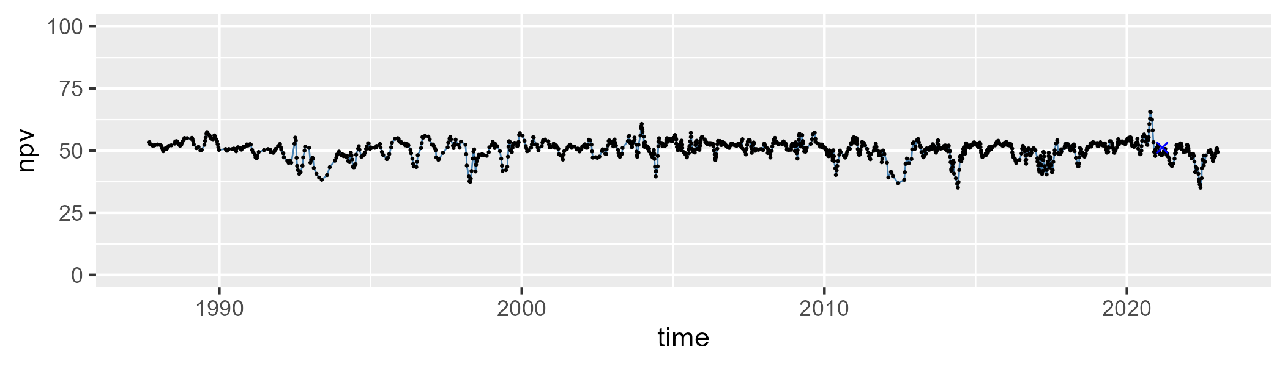

| Min. | 1st Qu. | Median | Mean | 3rd Qu. | Max. |
| --- | --- | --- | --- | --- | --- |
| 3.2297 | 13.65974 | 17.01015 | 16.94137 | 20.2801 | 32.86595 |

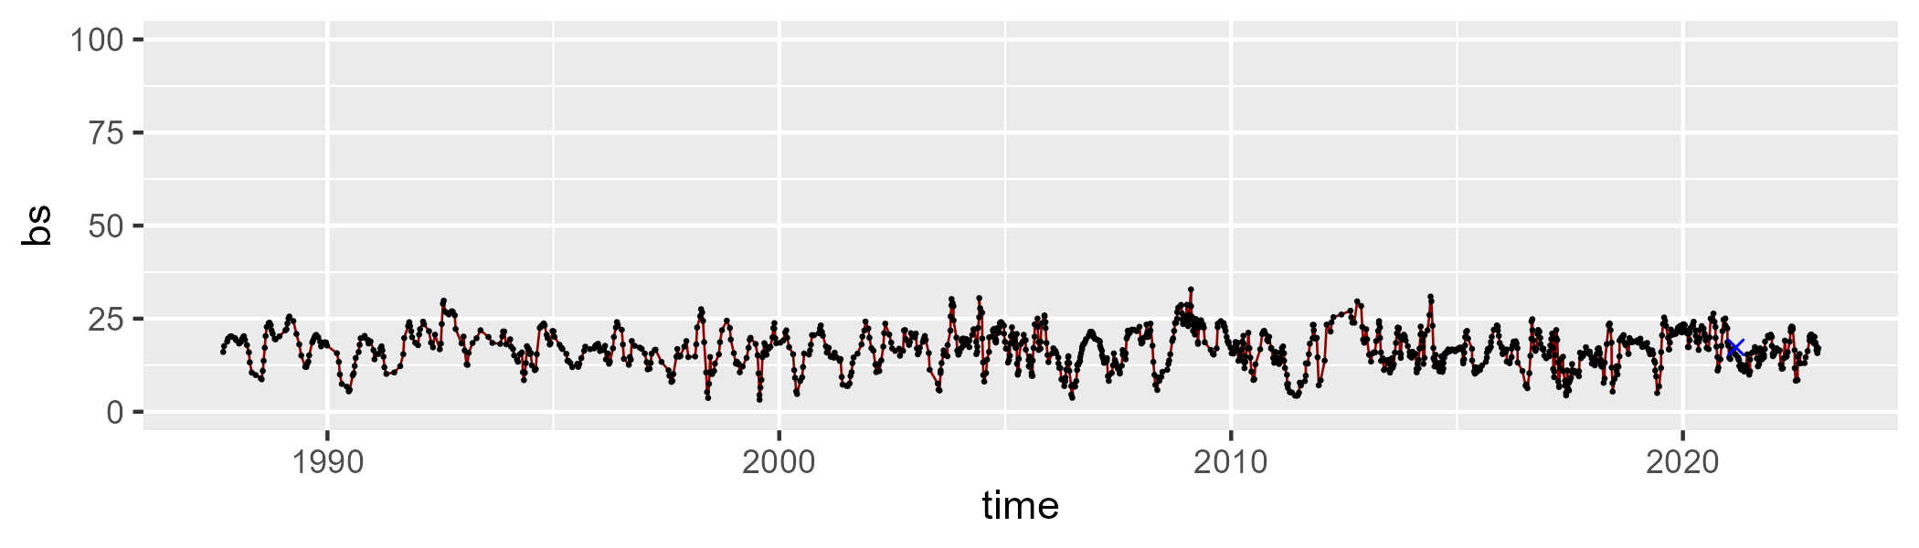

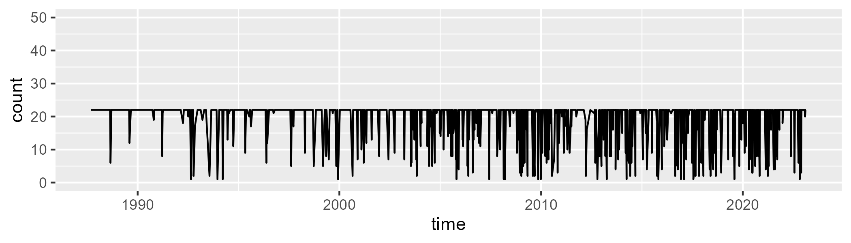

Min. : 1.0 1st Qu.:22.0 Median :22.0 Mean :19.6 3rd Qu.:22.0 Max. :22.0

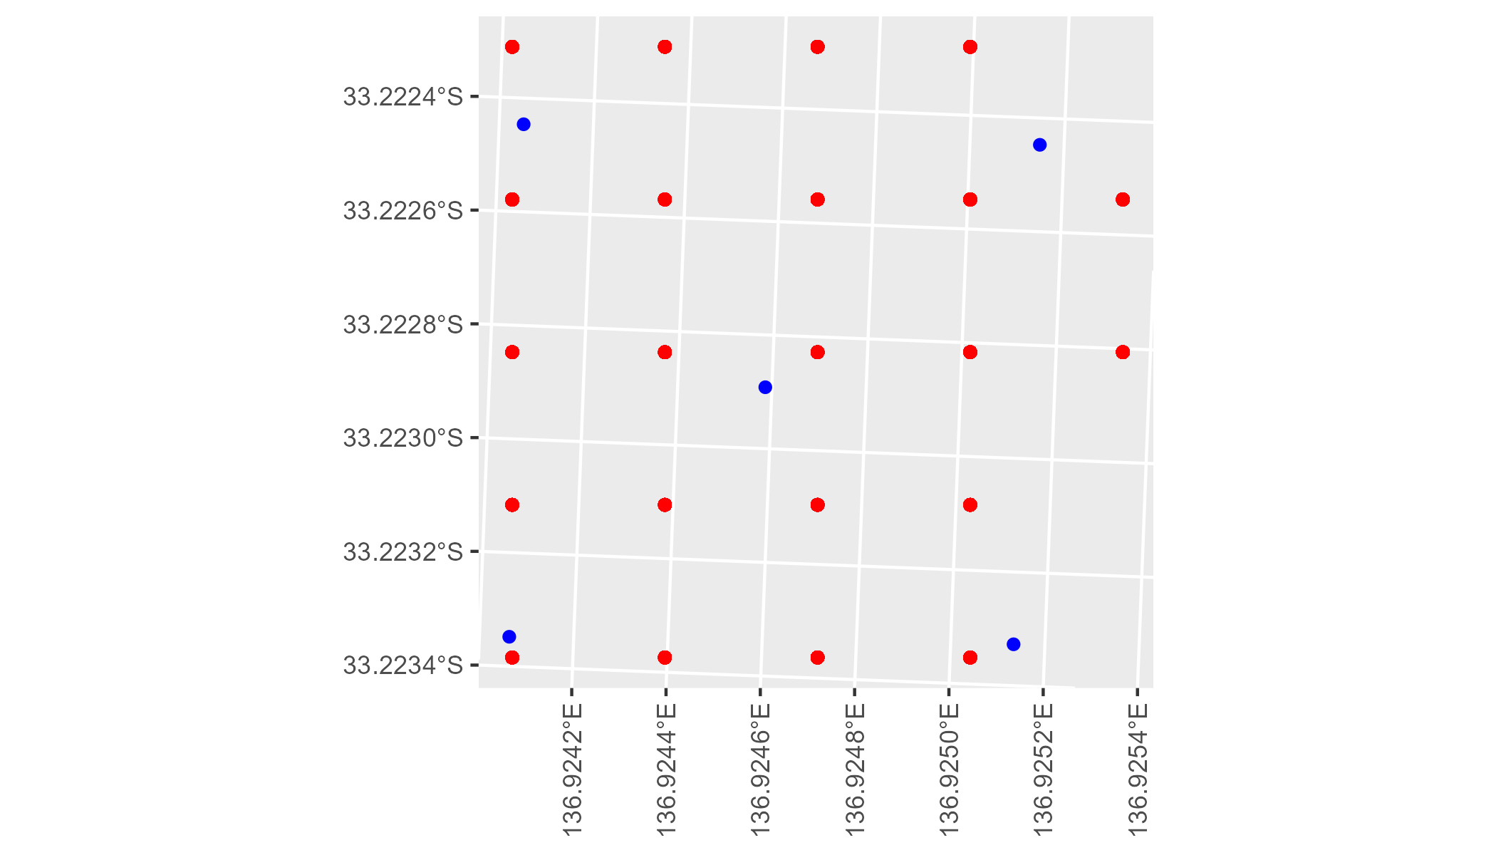

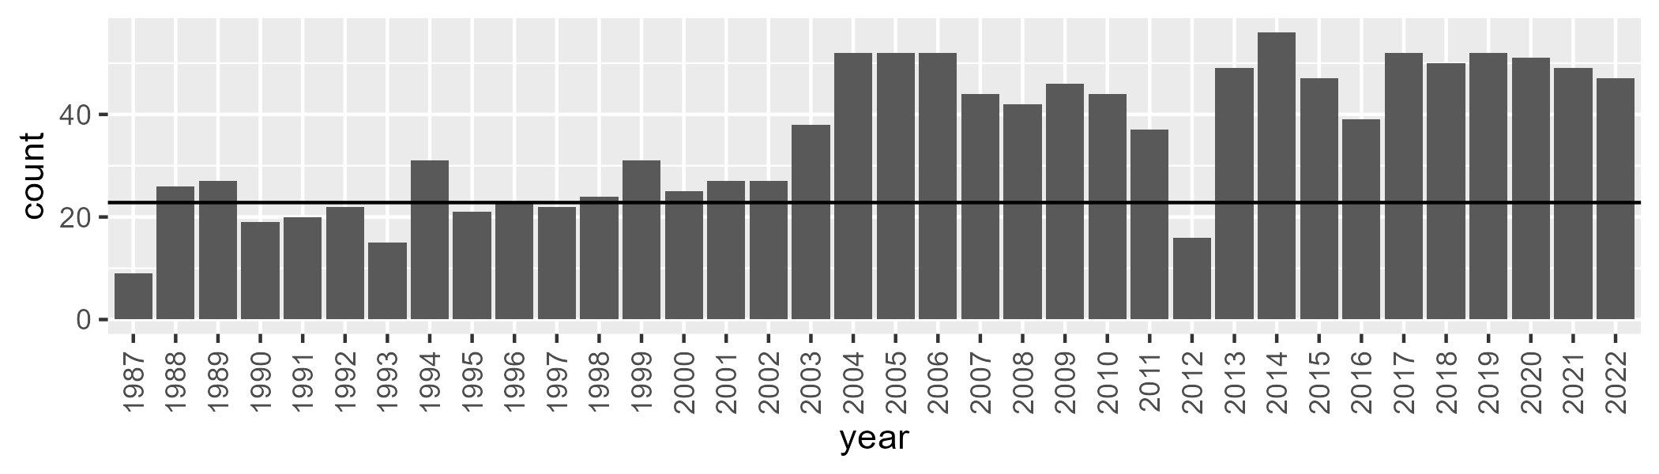

Number of samples: 1284

# SAAFLB0003

| Min. | 1st Qu. | Median | Mean | 3rd Qu. | Max. |
| --- | --- | --- | --- | --- | --- |
| 29.43394 | 46.36485 | 52.01611 | 51.31513 | 56.27566 | 67.33875 |

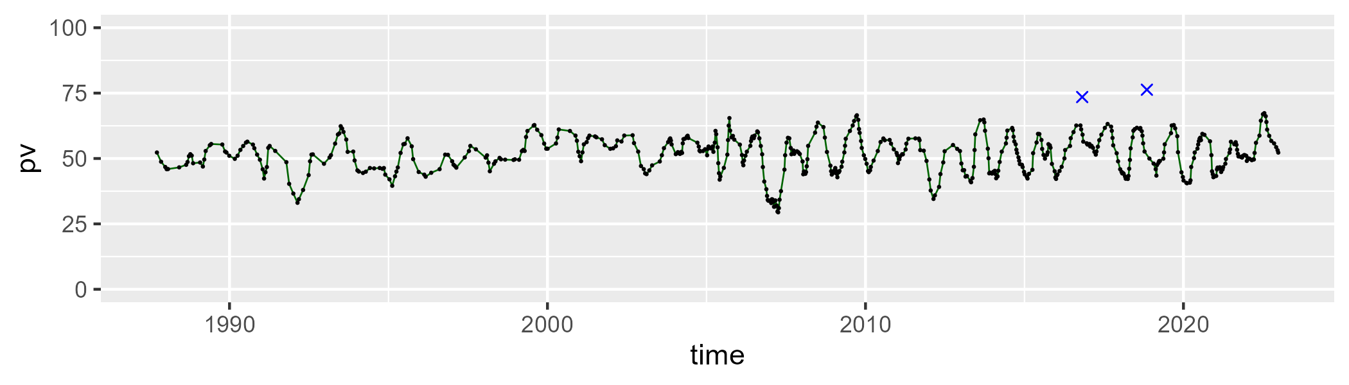

| Min. | 1st Qu. | Median | Mean | 3rd Qu. | Max. |
| --- | --- | --- | --- | --- | --- |
| 13.54817 | 33.80886 | 38.58889 | 38.33769 | 43.60478 | 59.32884 |

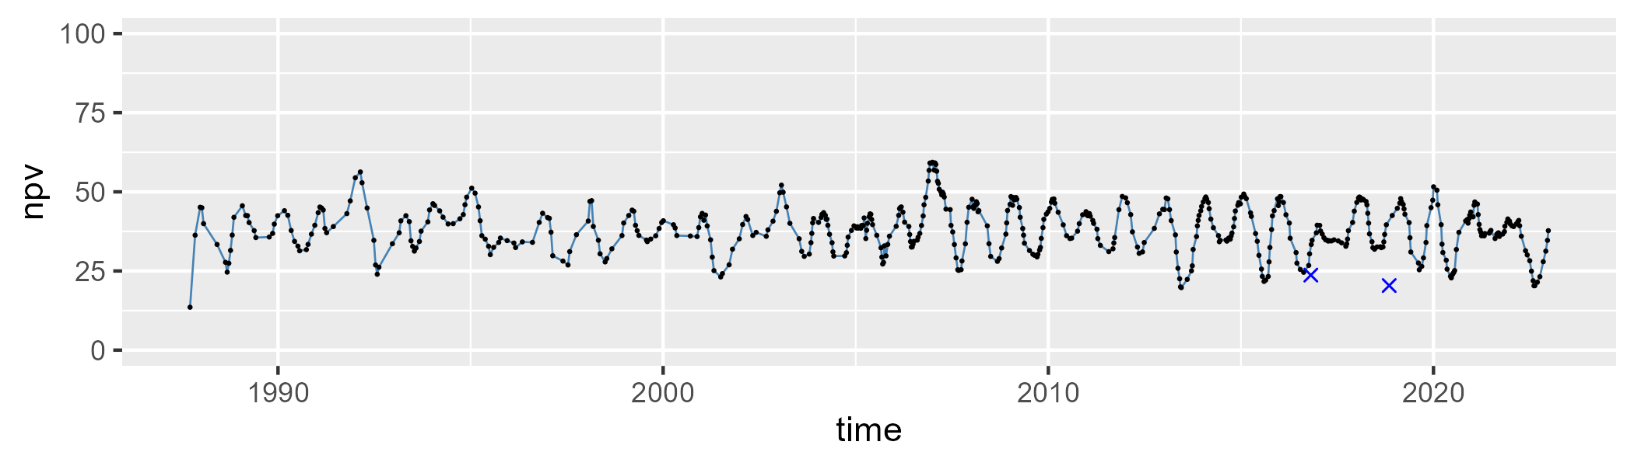

| Min. | 1st Qu. | Median | Mean | 3rd Qu. | Max. |
| --- | --- | --- | --- | --- | --- |
| 0 | 5.300733 | 7.487027 | 8.891917 | 11.22898 | 33.19836 |

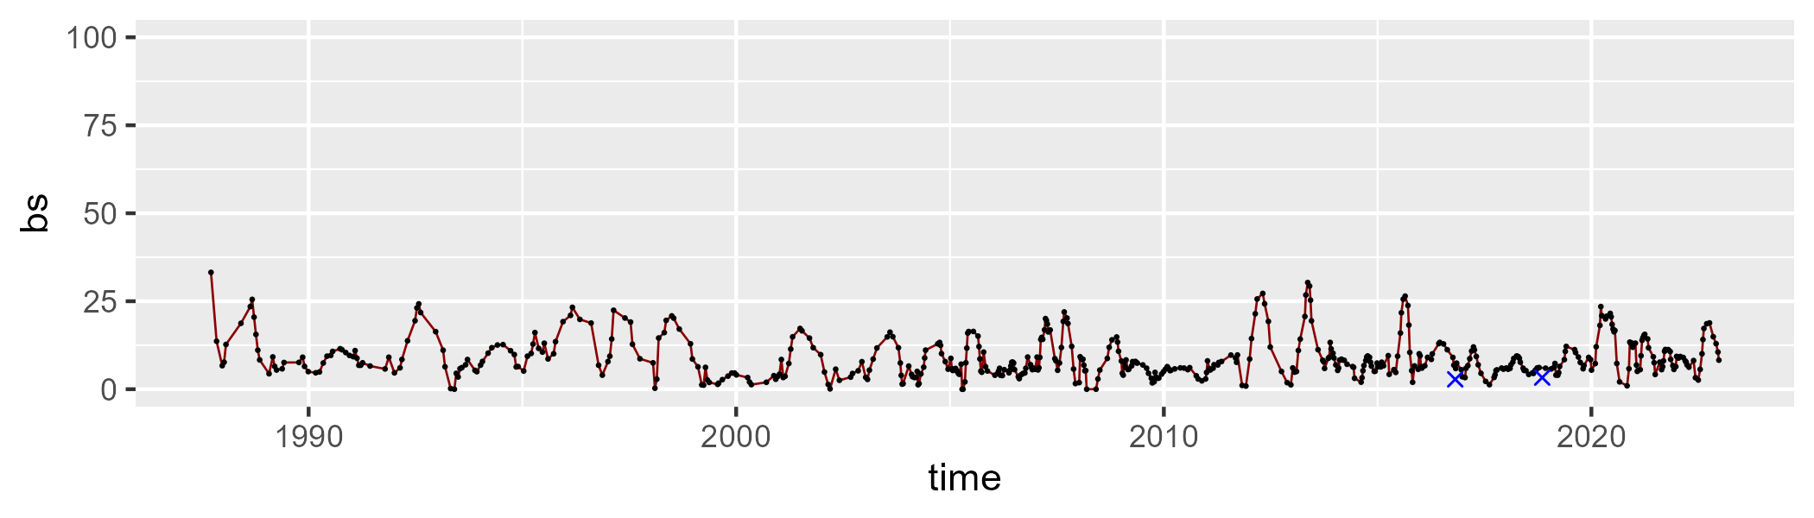

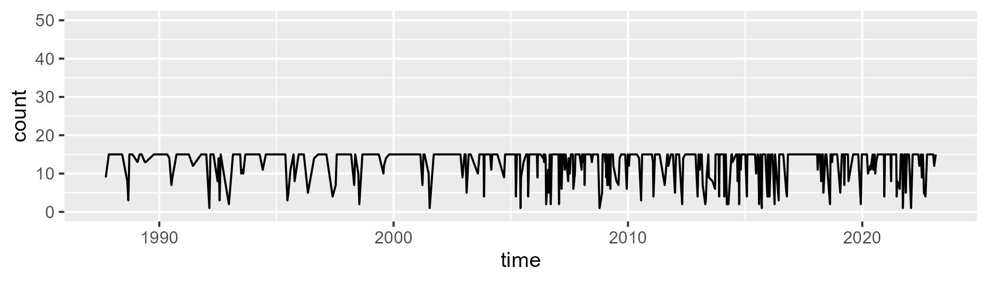

Min. : 1.00 1st Qu.:13.00 Median :15.00 Mean :12.98 3rd Qu.:15.00 Max. :15.00

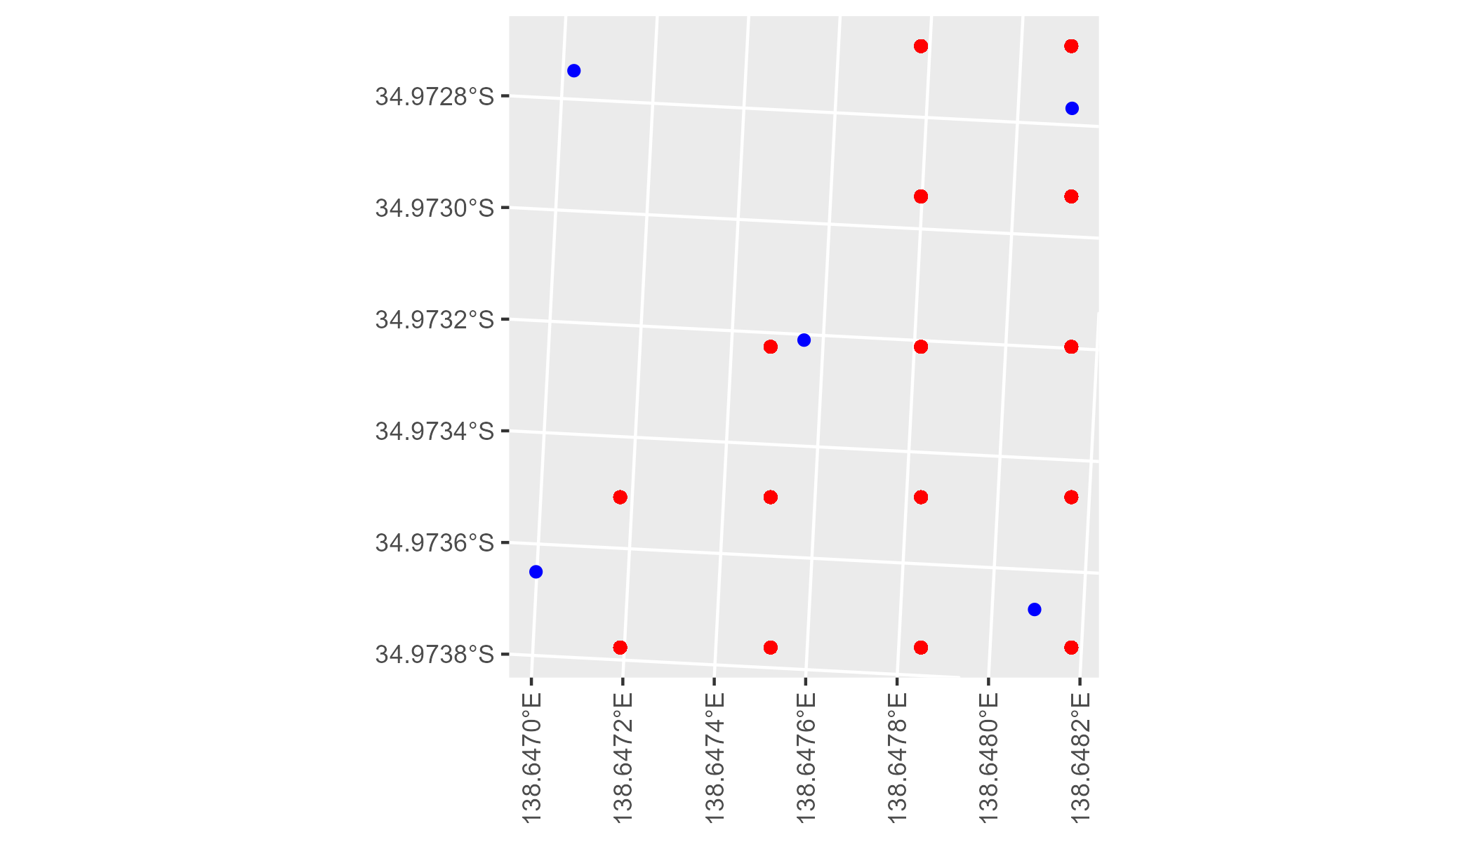

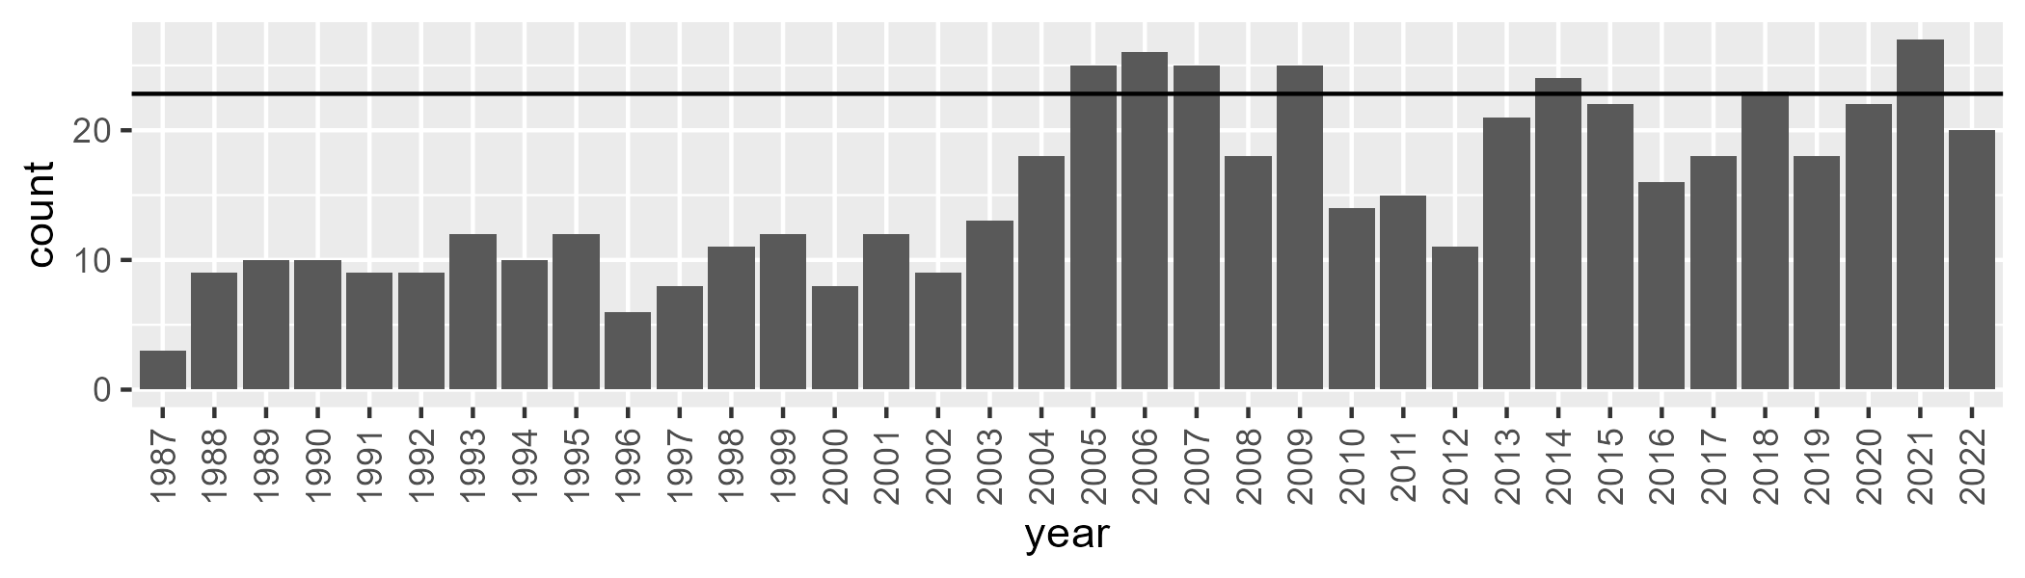

Number of samples: 551

# SAAFLB0004

| Min. | 1st Qu. | Median | Mean | 3rd Qu. | Max. |
| --- | --- | --- | --- | --- | --- |
| 28.95337 | 41.52882 | 45.94256 | 46.0209 | 50.93469 | 62.2836 |

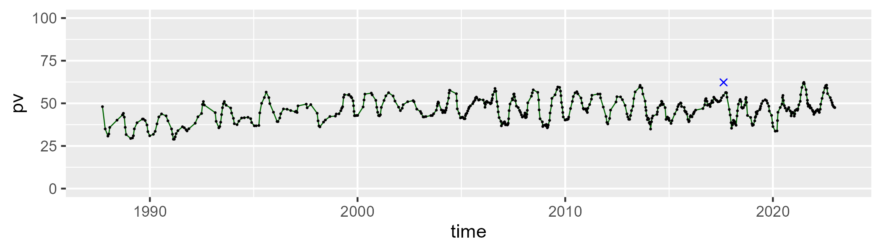

| Min. | 1st Qu. | Median | Mean | 3rd Qu. | Max. |
| --- | --- | --- | --- | --- | --- |
| 24.74214 | 38.69978 | 43.77844 | 43.01583 | 47.84348 | 56.16565 |

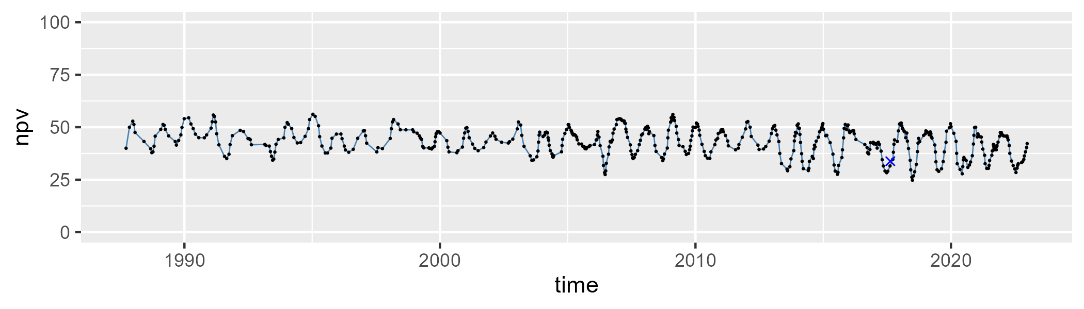

| Min. | 1st Qu. | Median | Mean | 3rd Qu. | Max. |
| --- | --- | --- | --- | --- | --- |
| 0 | 6.208445 | 8.307352 | 9.695192 | 12.19834 | 28.23514 |

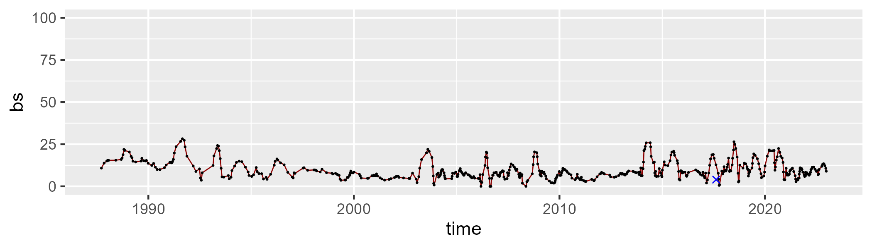

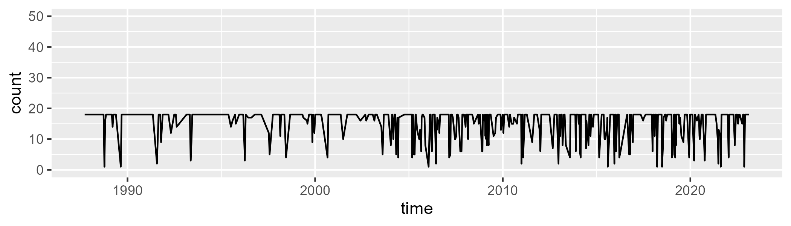

Min. : 1.00 1st Qu.:15.75 Median :18.00 Mean :15.53 3rd Qu.:18.00 Max. :18.00

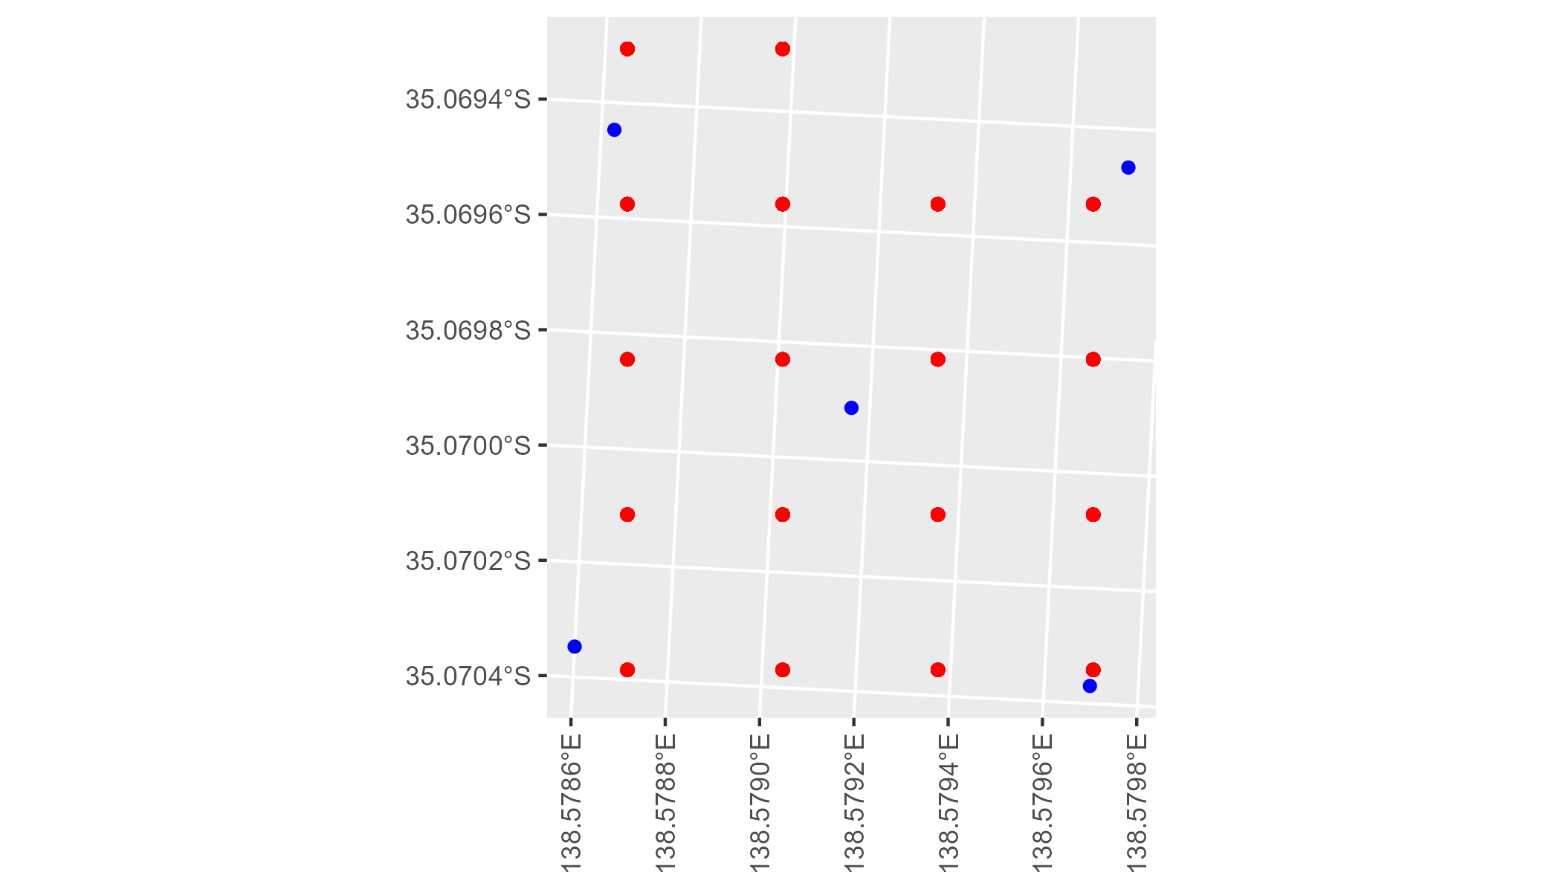

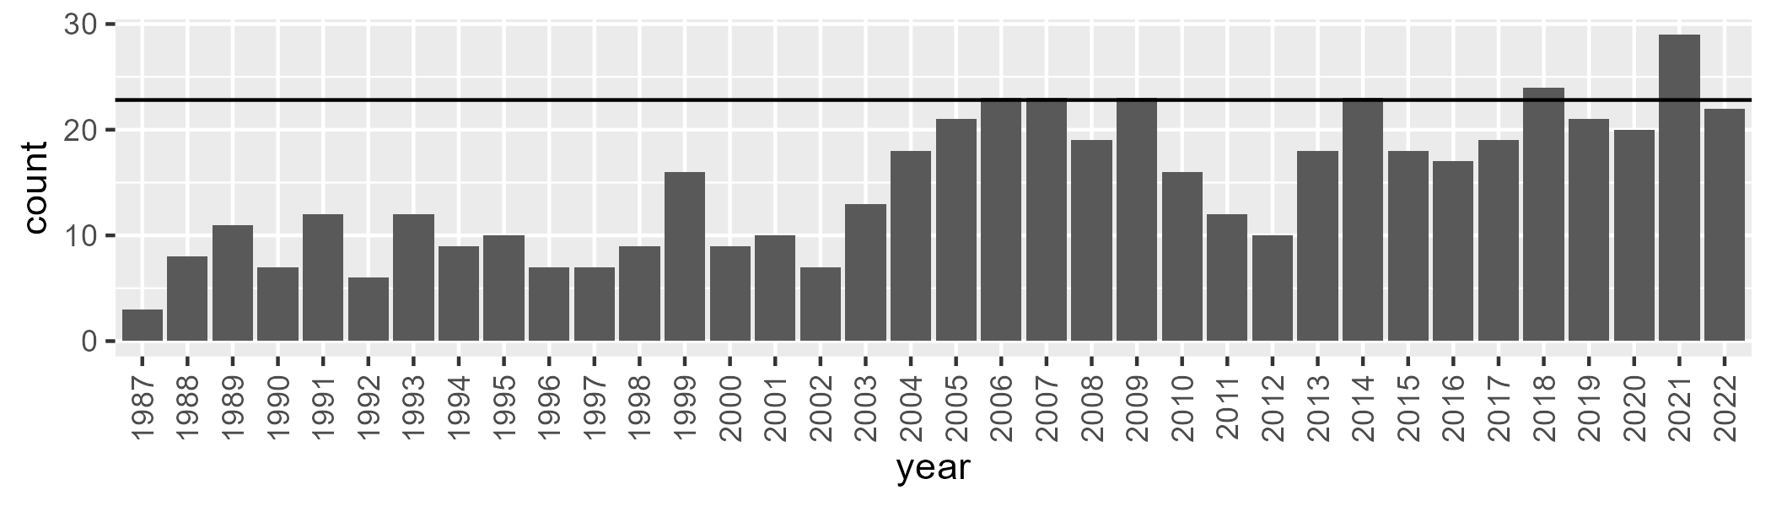

Number of samples: 532

# SAAFLB0005

| Min. | 1st Qu. | Median | Mean | 3rd Qu. | Max. |
| --- | --- | --- | --- | --- | --- |
| 0.8009678 | 29.46796 | 37.03869 | 36.37218 | 43.04783 | 59.88539 |

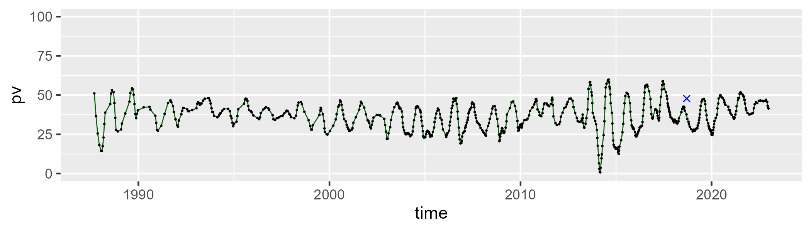

| Min. | 1st Qu. | Median | Mean | 3rd Qu. | Max. |
| --- | --- | --- | --- | --- | --- |
| 21.38096 | 38.99972 | 45.16752 | 44.91098 | 51.65099 | 70.49218 |

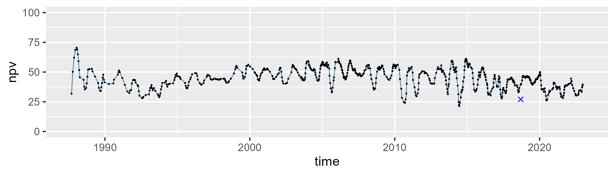

| Min. | 1st Qu. | Median | Mean | 3rd Qu. | Max. |
| --- | --- | --- | --- | --- | --- |
| 3.595376 | 13.64202 | 17.08939 | 17.42843 | 20.80104 | 47.48742 |

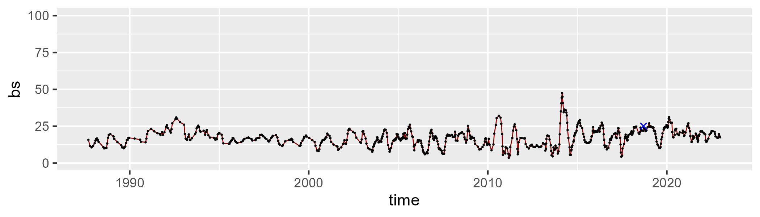

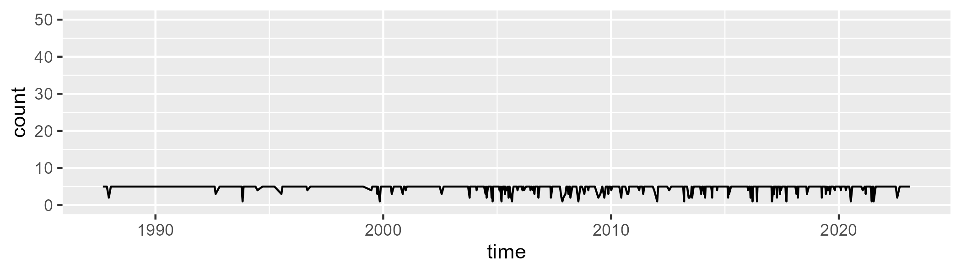

Min. :1.000 1st Qu.:5.000 Median :5.000 Mean :4.667 3rd Qu.:5.000 Max. :5.000

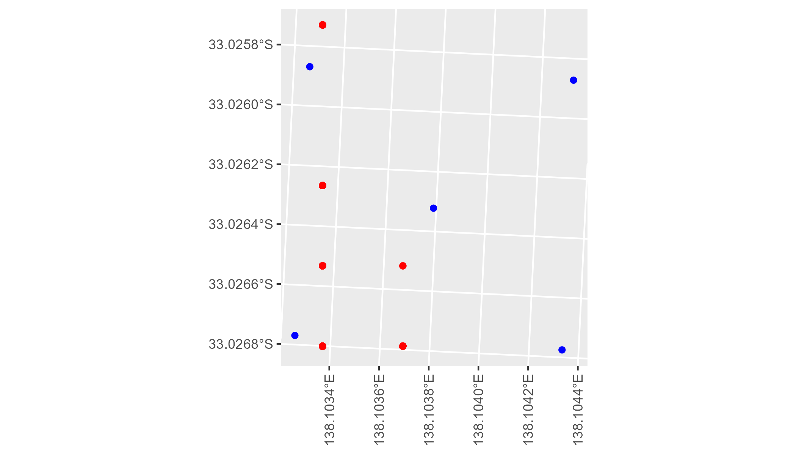

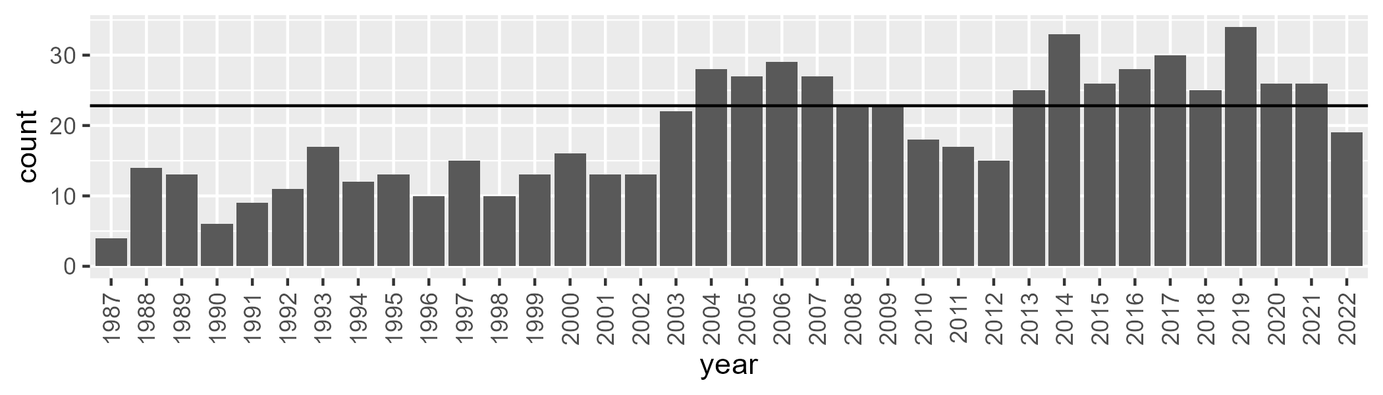

Number of samples: 690

# SAAFLB0006

| Min. | 1st Qu. | Median | Mean | 3rd Qu. | Max. |
| --- | --- | --- | --- | --- | --- |
| 20.45536 | 43.49396 | 46.77698 | 45.98445 | 49.56035 | 60.31468 |

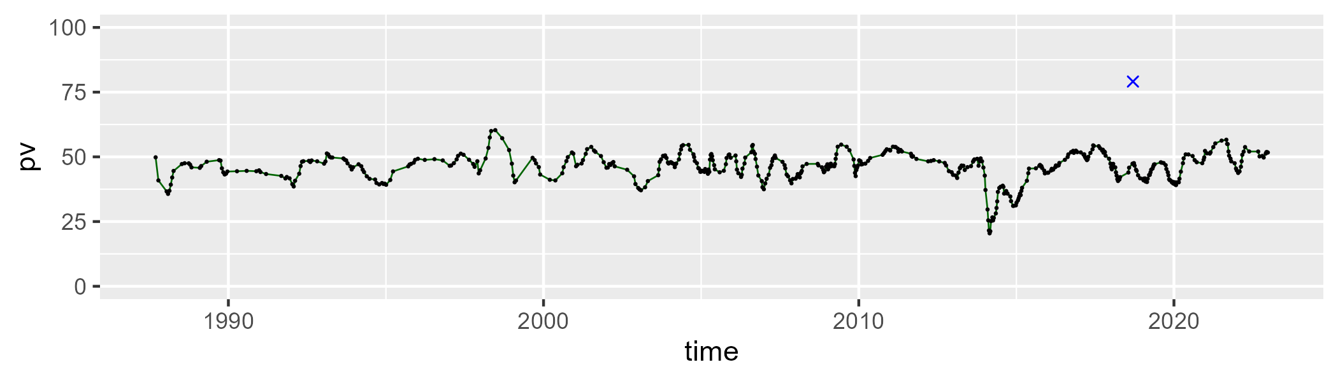

| Min. | 1st Qu. | Median | Mean | 3rd Qu. | Max. |
| --- | --- | --- | --- | --- | --- |
| 24.34599 | 39.23339 | 42.07148 | 41.40019 | 44.04473 | 53.06011 |

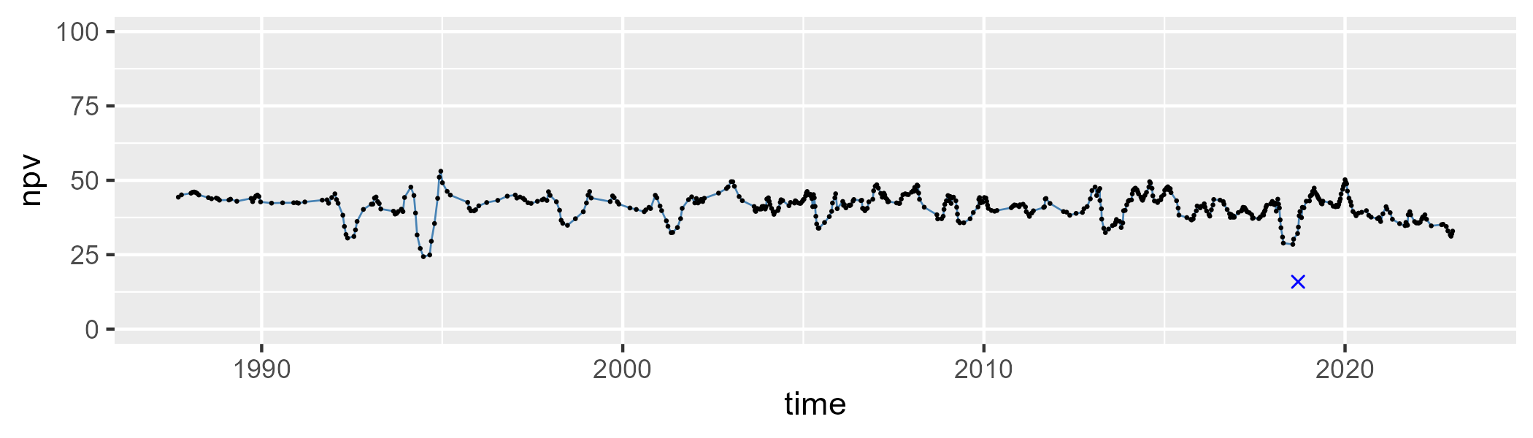

| Min. | 1st Qu. | Median | Mean | 3rd Qu. | Max. |
| --- | --- | --- | --- | --- | --- |
| 1.049121 | 7.822106 | 10.42211 | 11.21932 | 13.69716 | 32.80395 |

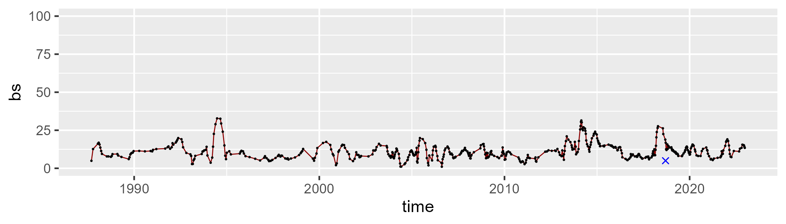

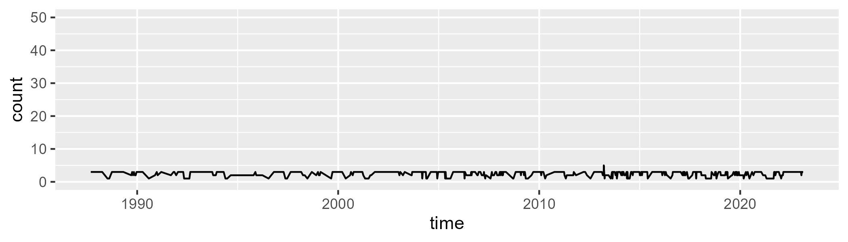

Min. :1.000 1st Qu.:2.000 Median :3.000 Mean :2.492 3rd Qu.:3.000 Max. :5.000

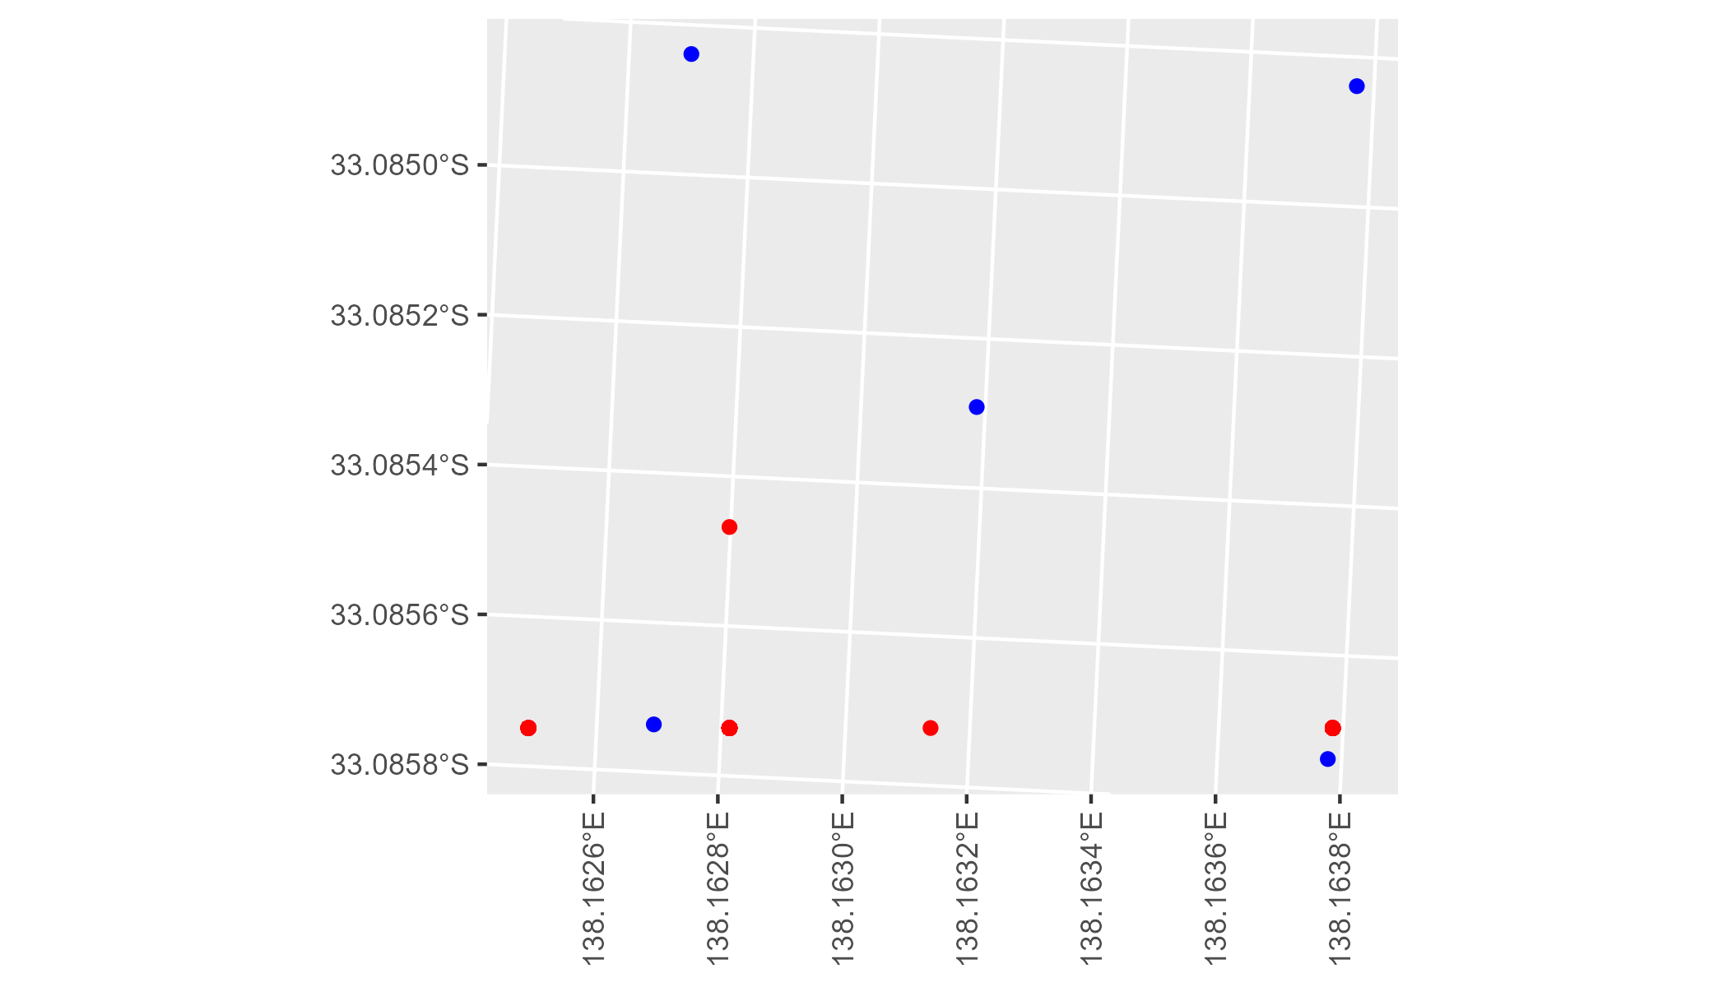

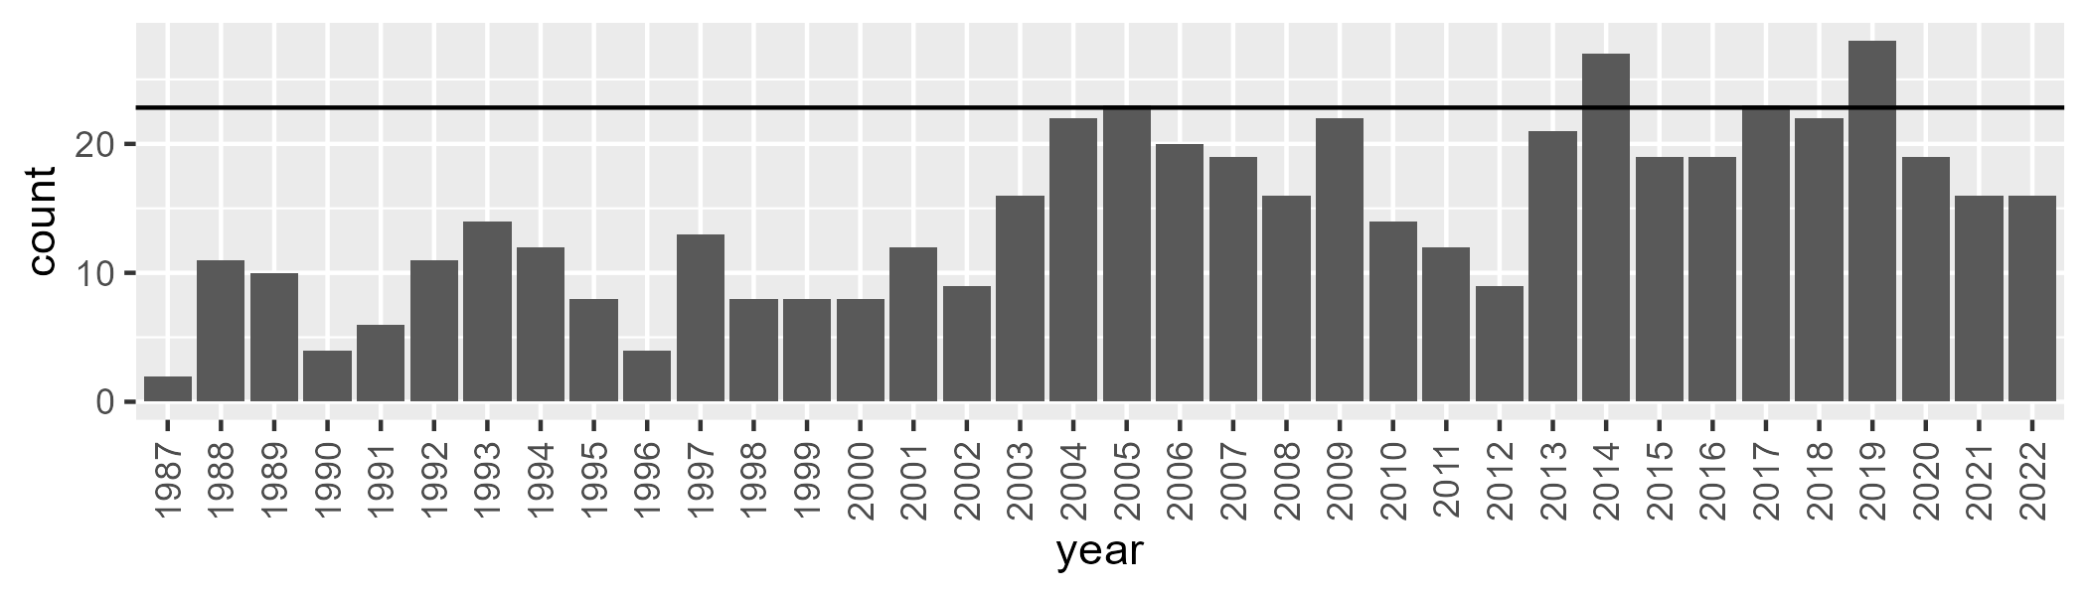

Number of samples: 523

# SAAFLB0007

| Min. | 1st Qu. | Median | Mean | 3rd Qu. | Max. |
| --- | --- | --- | --- | --- | --- |
| 0.6289931 | 6.41834 | 8.879018 | 11.83619 | 14.61251 | 44.60279 |

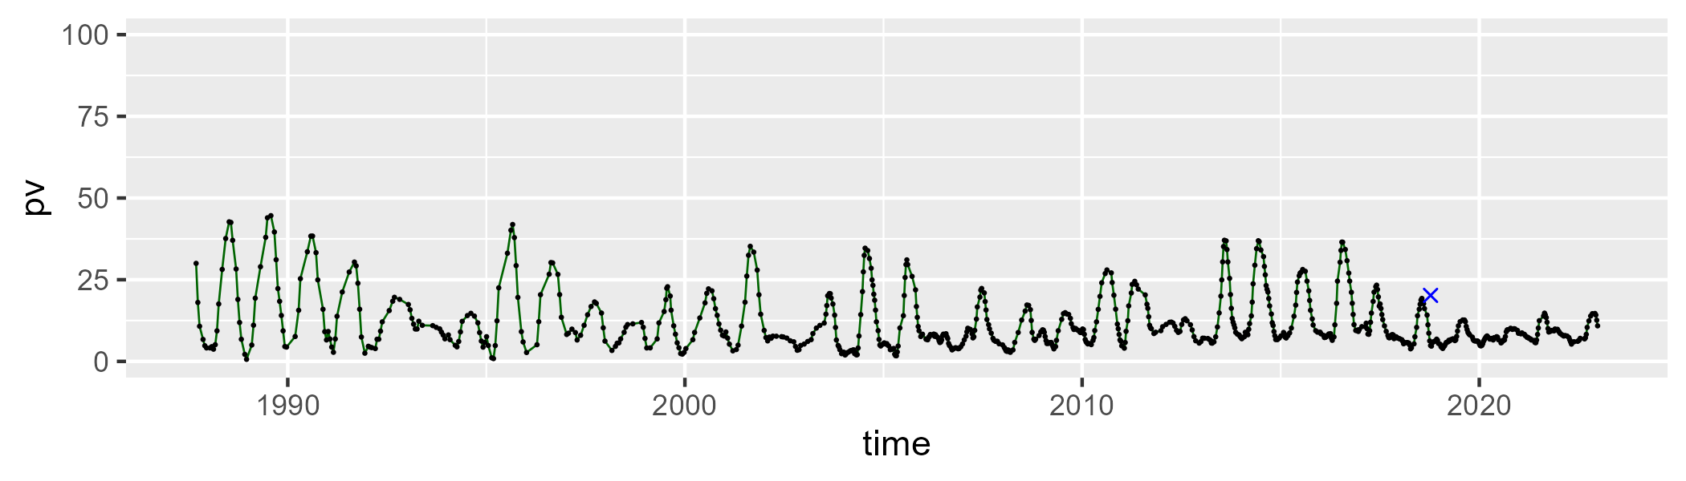

| Min. | 1st Qu. | Median | Mean | 3rd Qu. | Max. |
| --- | --- | --- | --- | --- | --- |
| 15.43157 | 26.58256 | 32.67703 | 32.56129 | 37.92877 | 56.91683 |

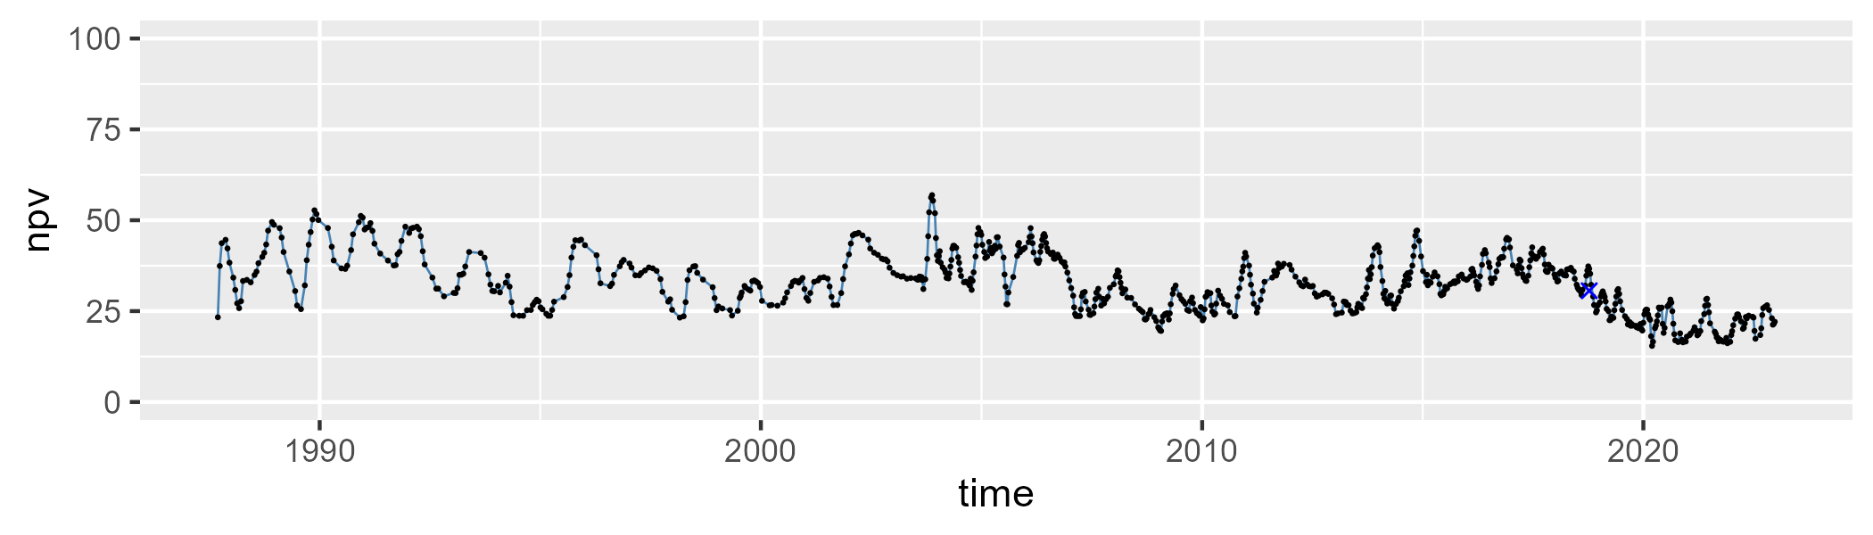

| Min. | 1st Qu. | Median | Mean | 3rd Qu. | Max. |
| --- | --- | --- | --- | --- | --- |
| 20.13296 | 46.63602 | 54.33321 | 54.05041 | 63.207 | 75.00324 |

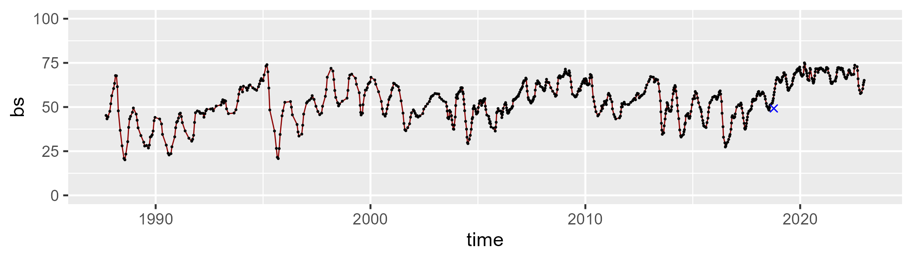

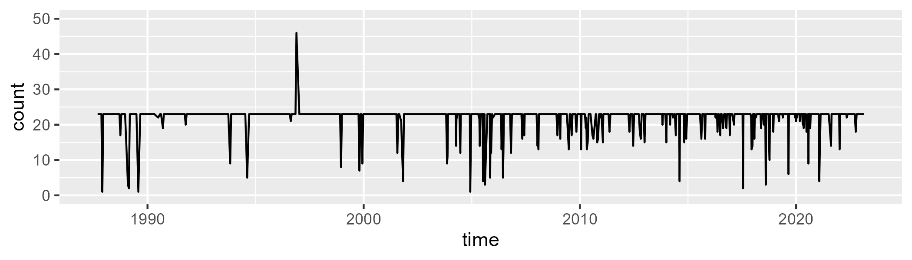

Min. : 1.00 1st Qu.:23.00 Median :23.00 Mean :21.91 3rd Qu.:23.00 Max. :46.00

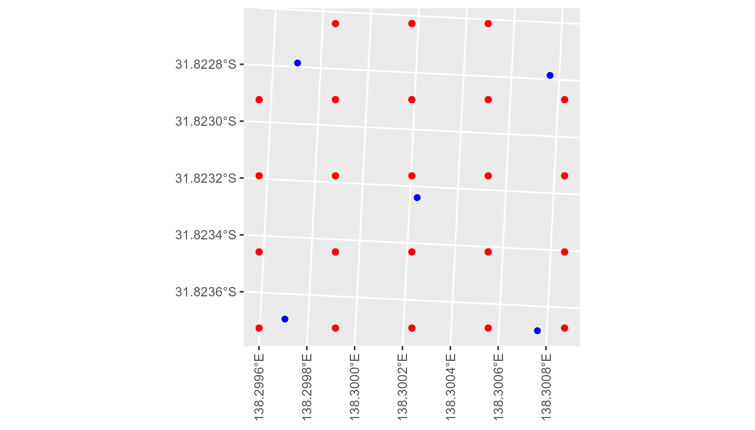

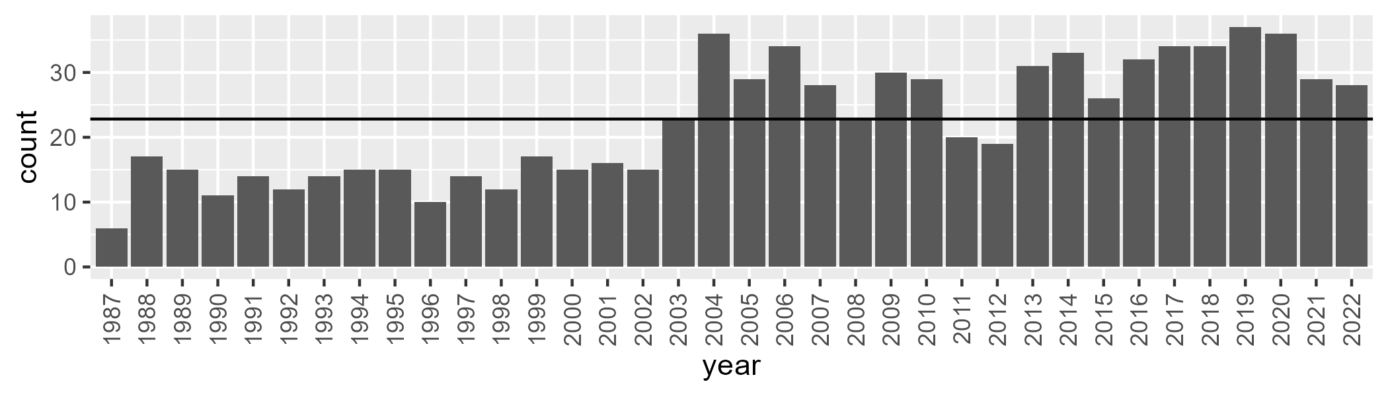

Number of samples: 809

# SAAFLB0008

| Min. | 1st Qu. | Median | Mean | 3rd Qu. | Max. |
| --- | --- | --- | --- | --- | --- |
| 9.149902 | 14.51794 | 17.39675 | 17.71155 | 20.82161 | 28.17828 |

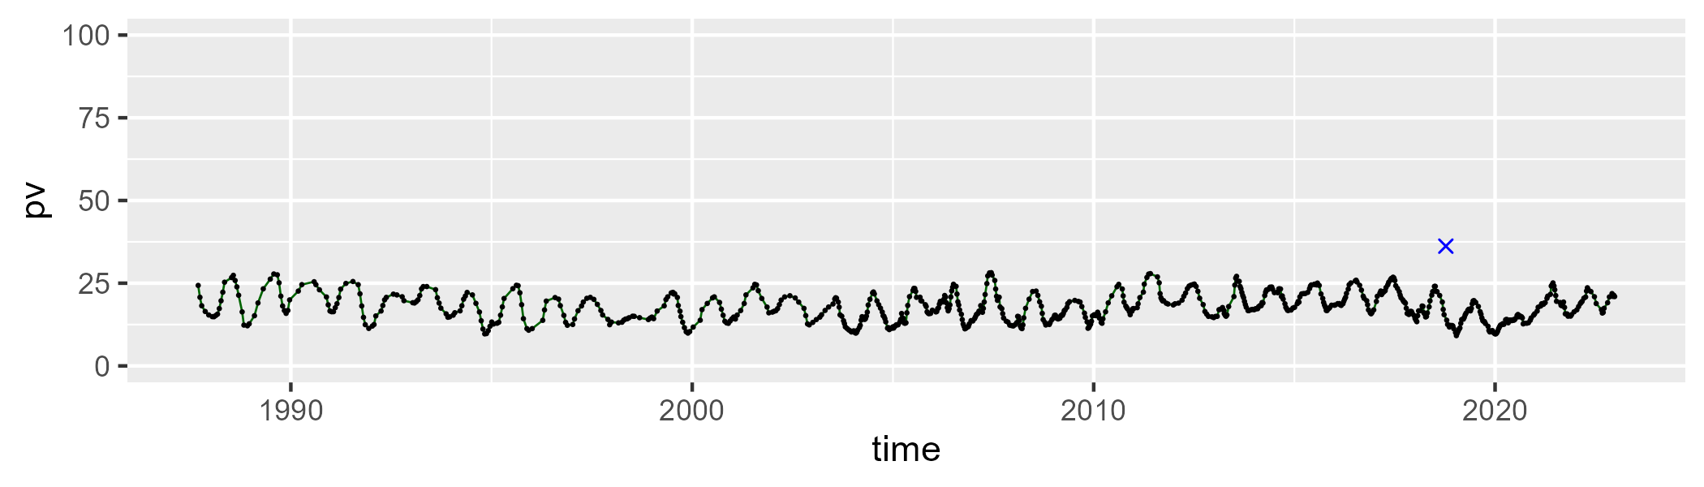

| Min. | 1st Qu. | Median | Mean | 3rd Qu. | Max. |
| --- | --- | --- | --- | --- | --- |
| 36.7171 | 42.56119 | 44.33578 | 44.48049 | 46.3985 | 54.68432 |

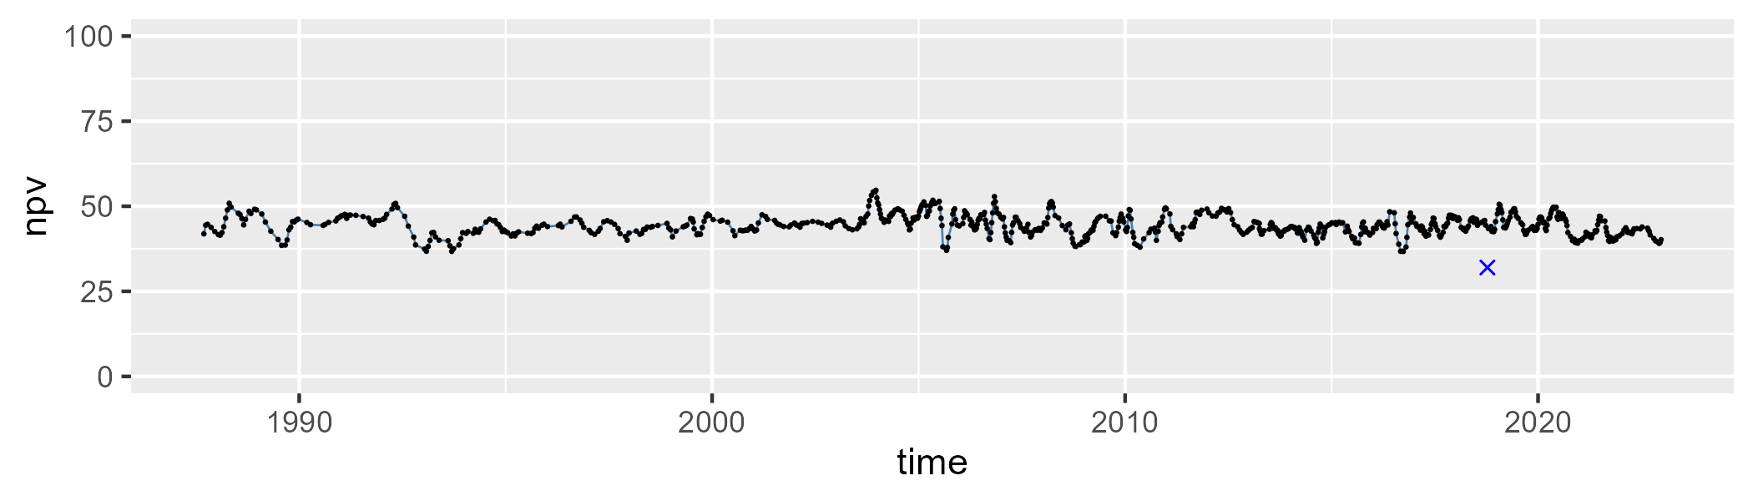

| Min. | 1st Qu. | Median | Mean | 3rd Qu. | Max. |
| --- | --- | --- | --- | --- | --- |
| 23.68269 | 33.3269 | 36.46553 | 36.41495 | 39.97221 | 48.04902 |

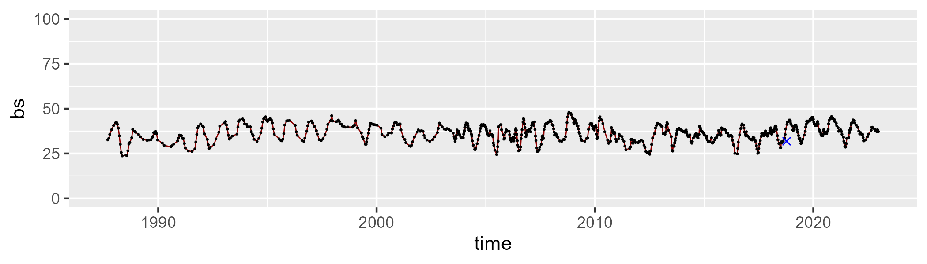

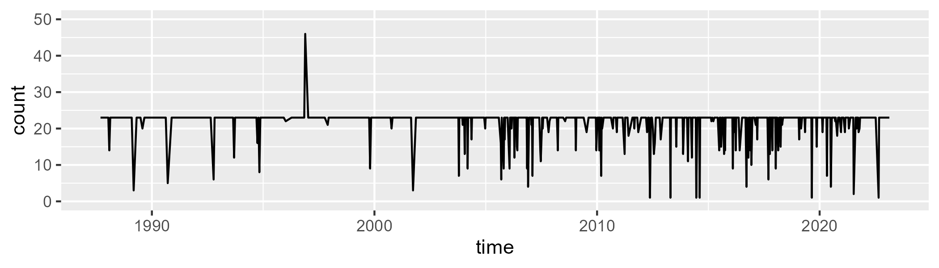

Min. : 1.00 1st Qu.:23.00 Median :23.00 Mean :21.82 3rd Qu.:23.00 Max. :46.00

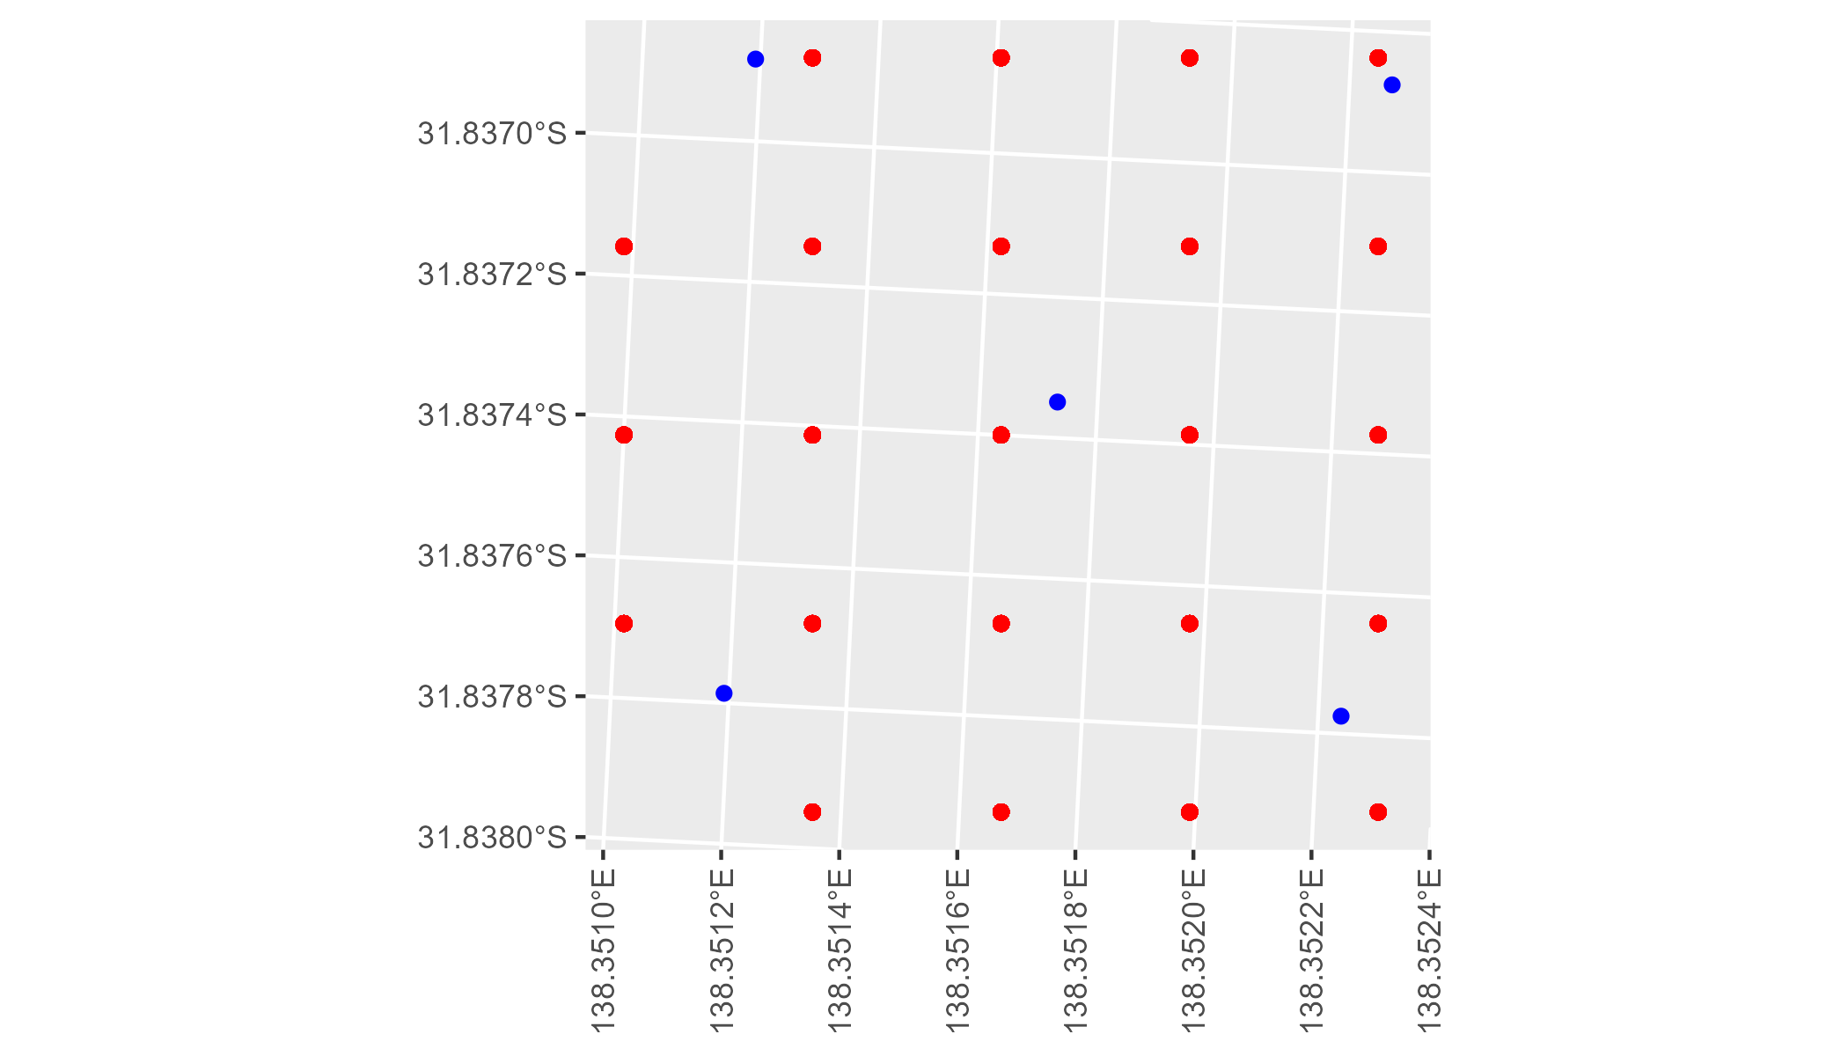

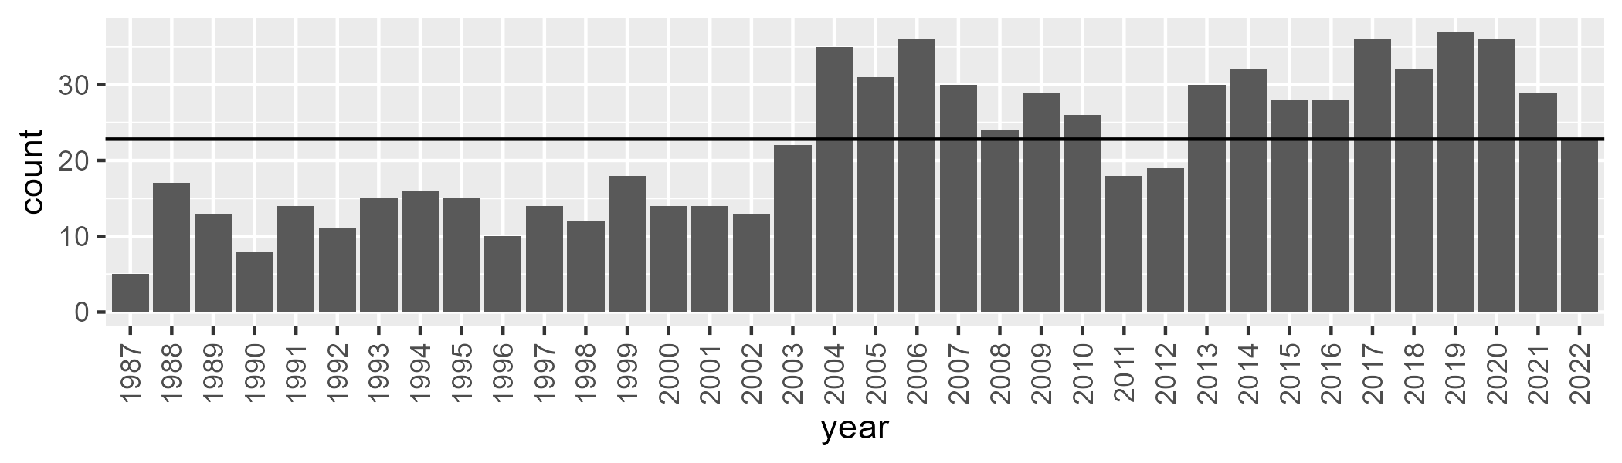

Number of samples: 790

# SAAFLB0030

| Min. | 1st Qu. | Median | Mean | 3rd Qu. | Max. |
| --- | --- | --- | --- | --- | --- |
| 0 | 0.2511544 | 1.243049 | 2.227347 | 2.896209 | 17.66978 |

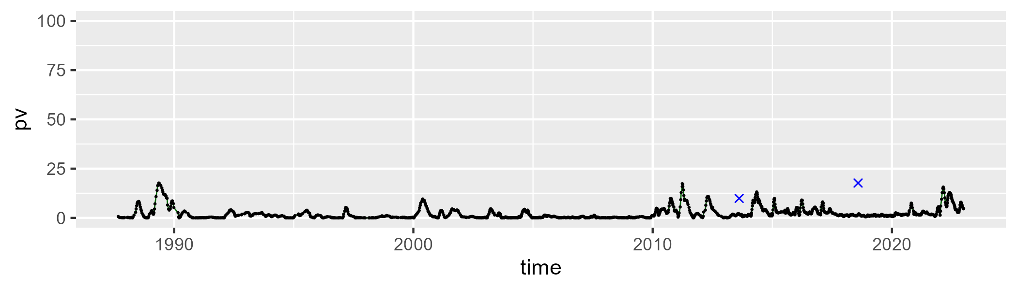

| Min. | 1st Qu. | Median | Mean | 3rd Qu. | Max. |
| --- | --- | --- | --- | --- | --- |
| 16.80305 | 27.38781 | 30.71884 | 31.06125 | 34.65637 | 52.39197 |

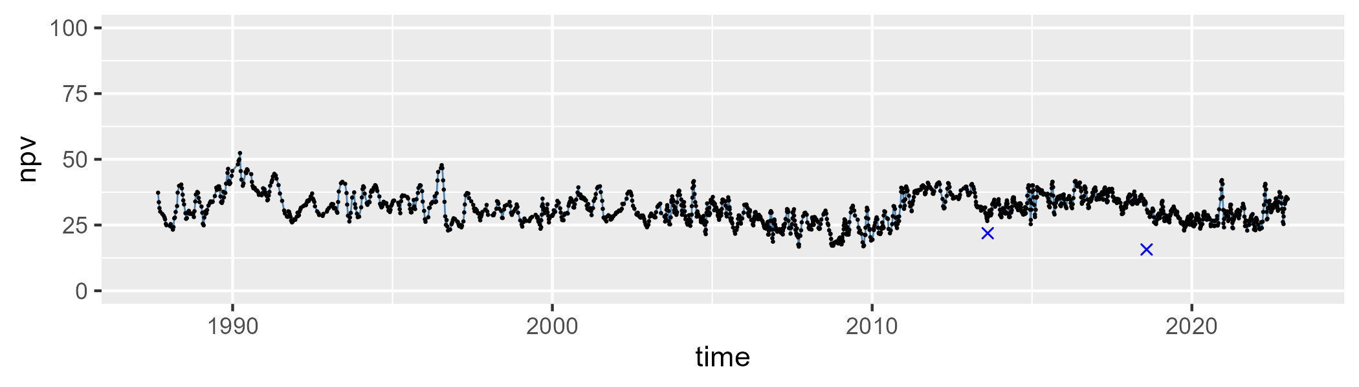

| Min. | 1st Qu. | Median | Mean | 3rd Qu. | Max. |
| --- | --- | --- | --- | --- | --- |
| 44.20289 | 60.76702 | 65.96595 | 65.37095 | 69.97365 | 82.08184 |

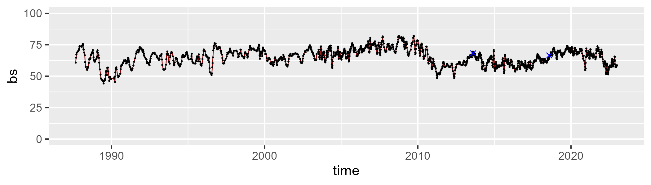

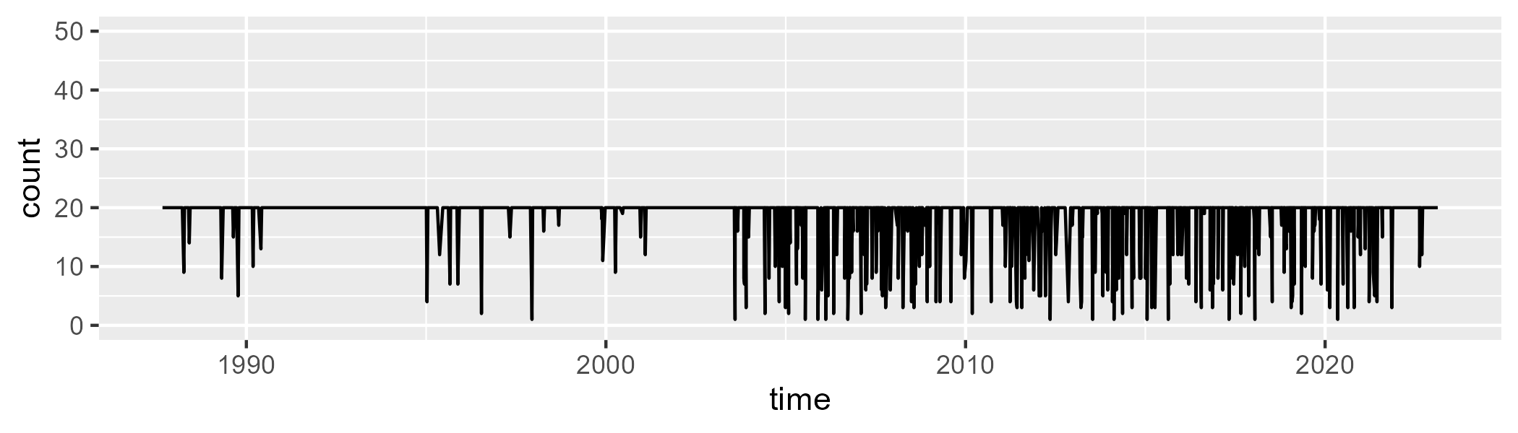

Min. : 1.00 1st Qu.:20.00 Median :20.00 Mean :18.51 3rd Qu.:20.00 Max. :20.00

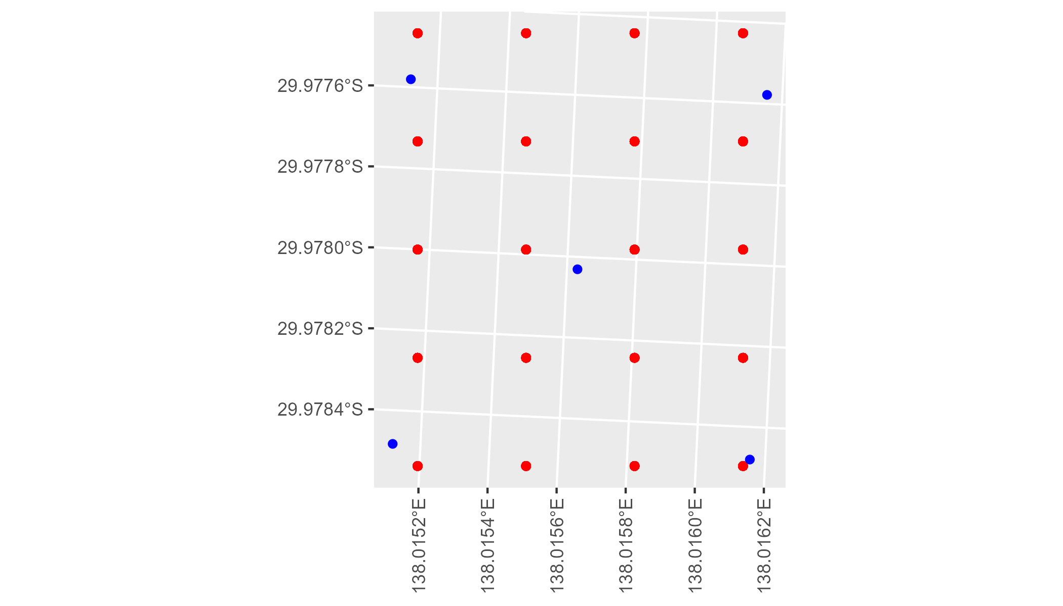

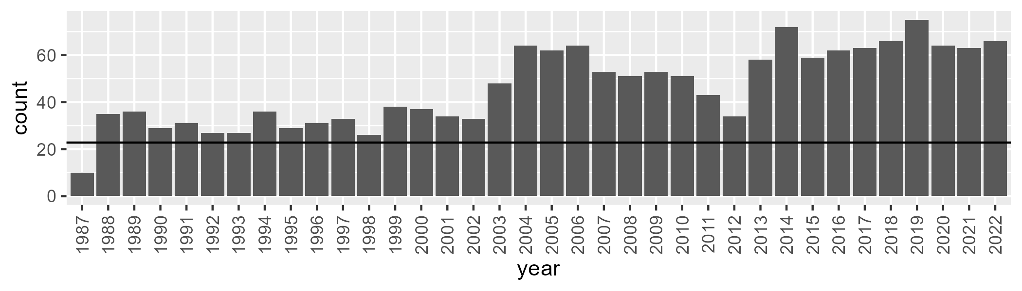

Number of samples: 1663

# SAAFLB0031

| Min. | 1st Qu. | Median | Mean | 3rd Qu. | Max. |
| --- | --- | --- | --- | --- | --- |
| 0 | 0.1268548 | 1.022752 | 1.804016 | 2.145588 | 16.70537 |

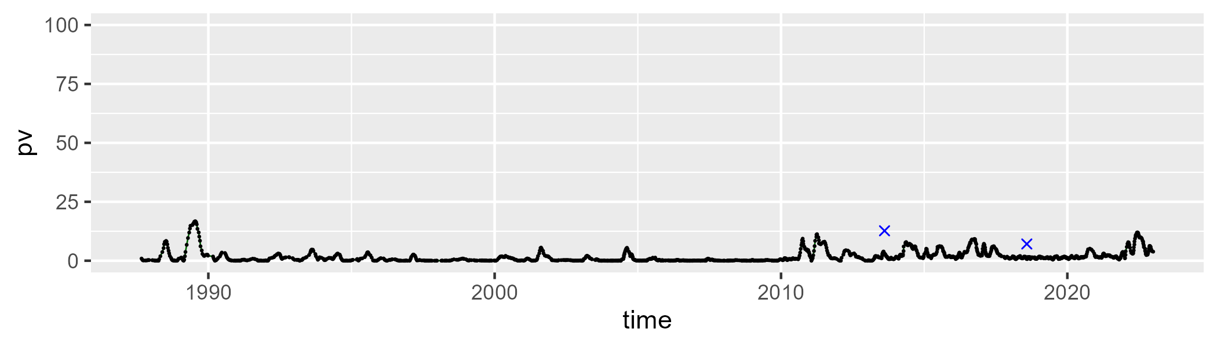

| Min. | 1st Qu. | Median | Mean | 3rd Qu. | Max. |
| --- | --- | --- | --- | --- | --- |
| 21.71103 | 30.30392 | 32.6728 | 32.85512 | 35.31765 | 50.9849 |

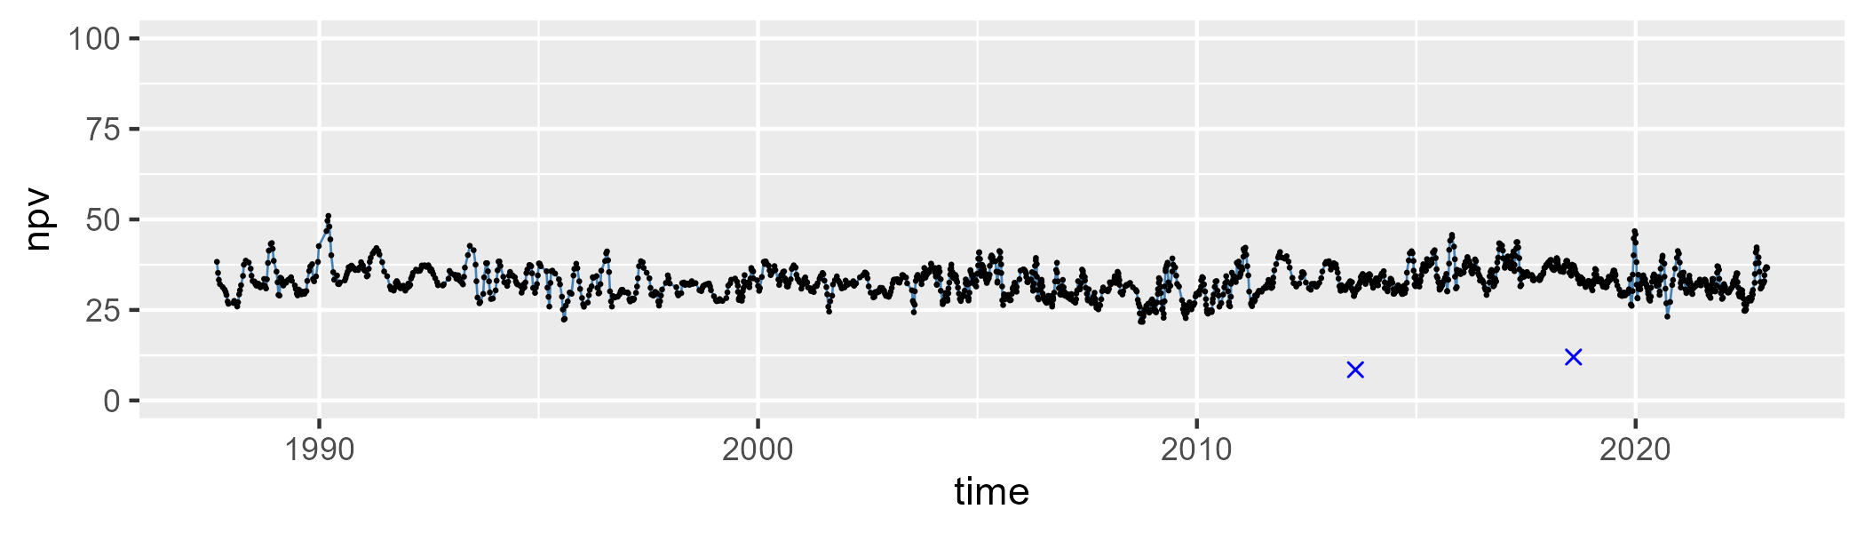

| Min. | 1st Qu. | Median | Mean | 3rd Qu. | Max. |
| --- | --- | --- | --- | --- | --- |
| 47.43388 | 61.1365 | 64.07871 | 64.07895 | 67.04733 | 77.39148 |

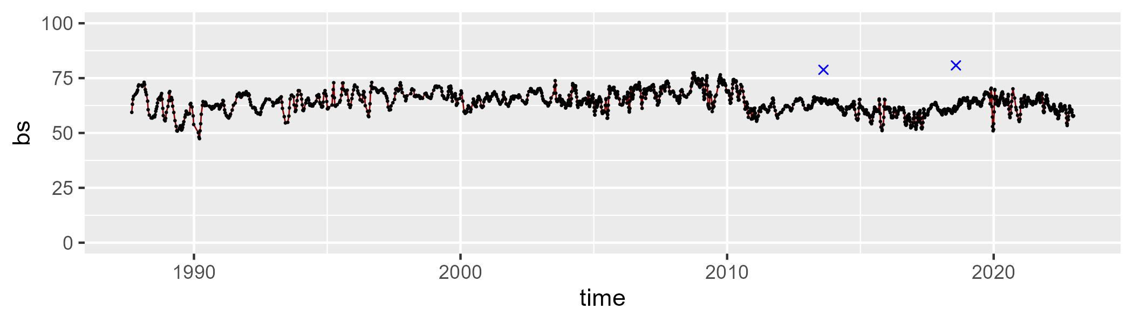

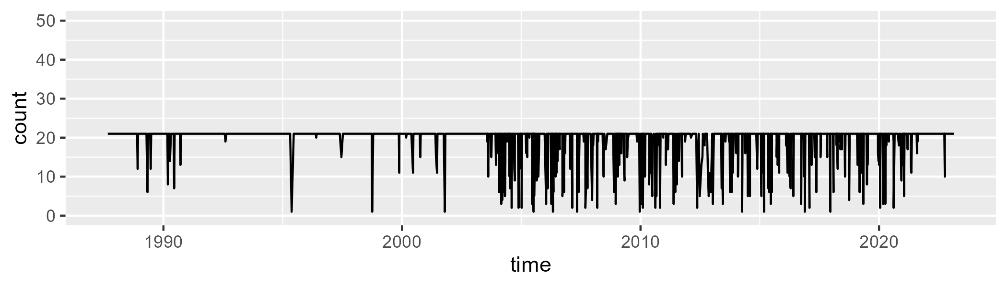

Min. : 1.00 1st Qu.:21.00 Median :21.00 Mean :19.62 3rd Qu.:21.00 Max. :21.00

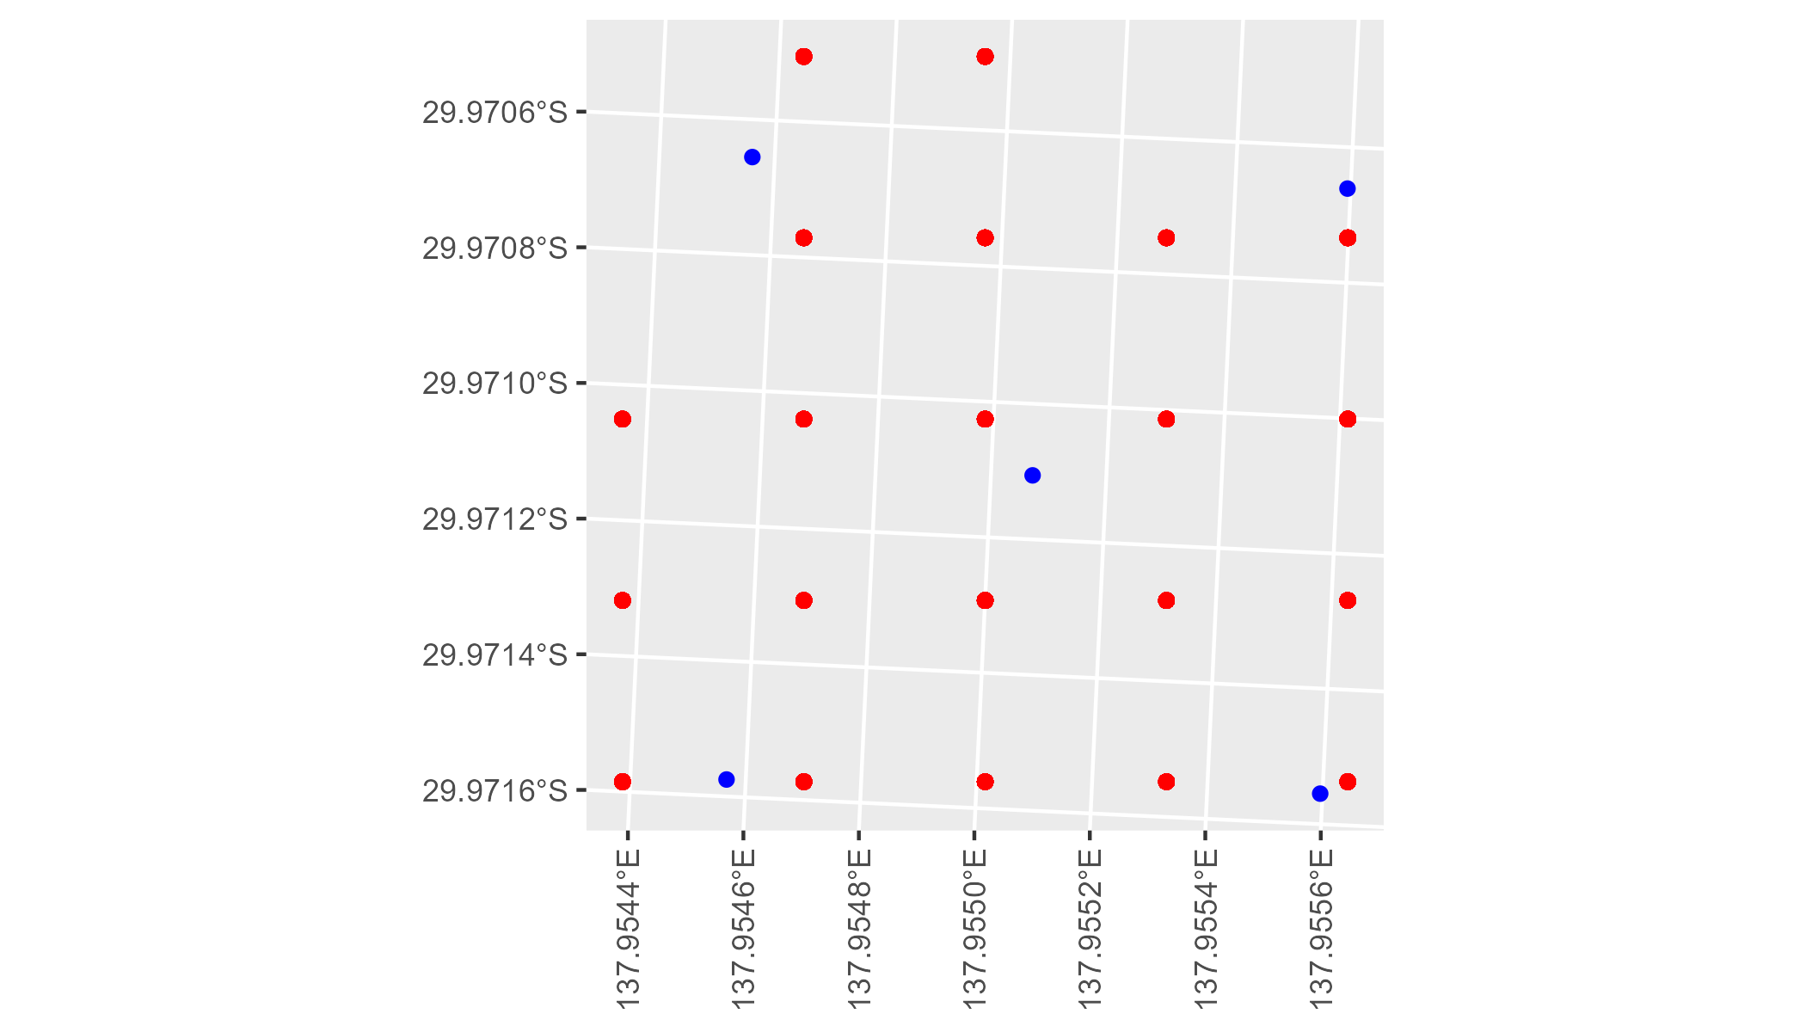

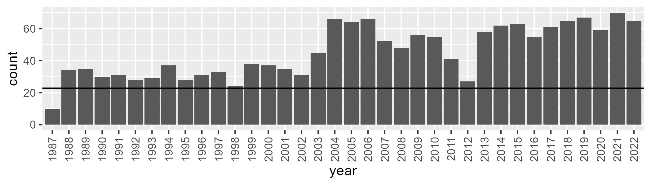

Number of samples: 1636

# SAAGAW0001

| Min. | 1st Qu. | Median | Mean | 3rd Qu. | Max. |
| --- | --- | --- | --- | --- | --- |
| 7.81793 | 15.99378 | 18.94975 | 19.54163 | 22.51644 | 38.05368 |

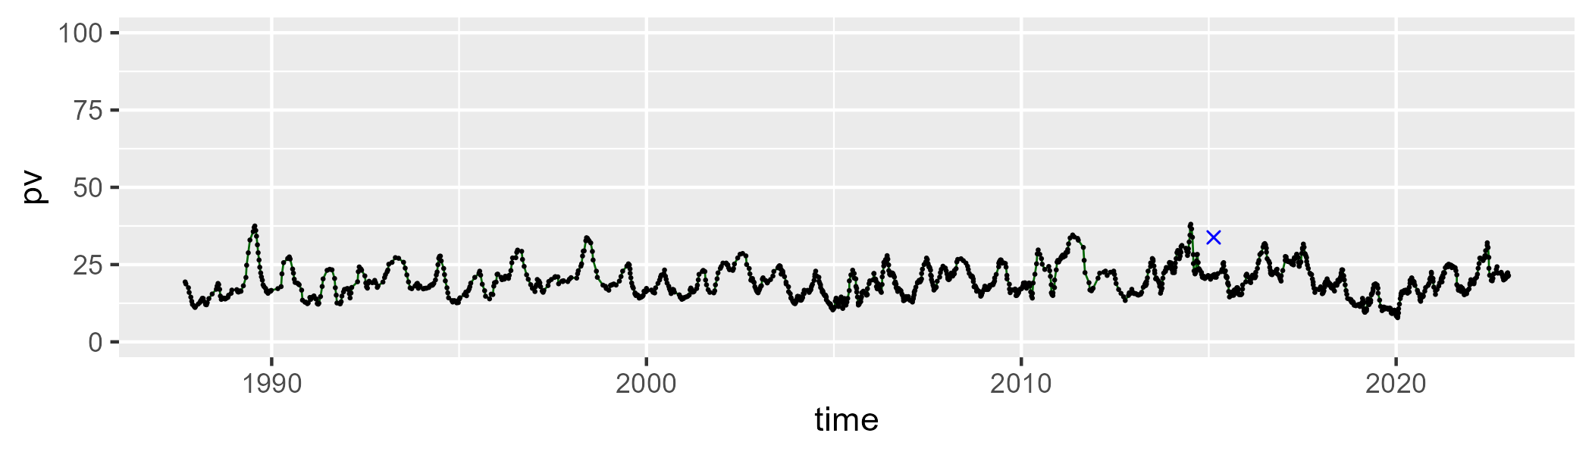

| Min. | 1st Qu. | Median | Mean | 3rd Qu. | Max. |
| --- | --- | --- | --- | --- | --- |
| 34.14305 | 46.95985 | 49.11095 | 48.84605 | 51.16507 | 64.52183 |

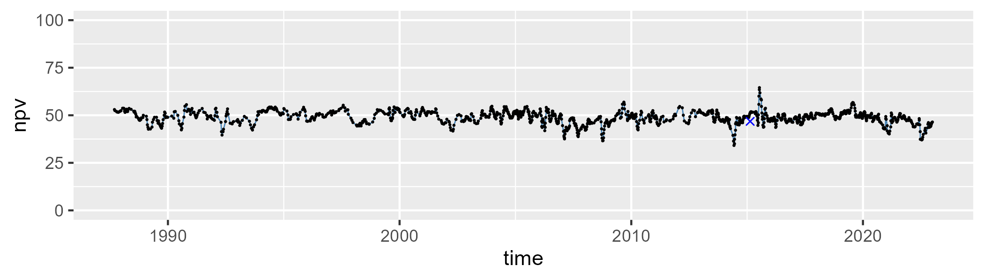

| Min. | 1st Qu. | Median | Mean | 3rd Qu. | Max. |
| --- | --- | --- | --- | --- | --- |
| 13.29194 | 26.85637 | 30.80159 | 30.30953 | 33.93679 | 46.96902 |

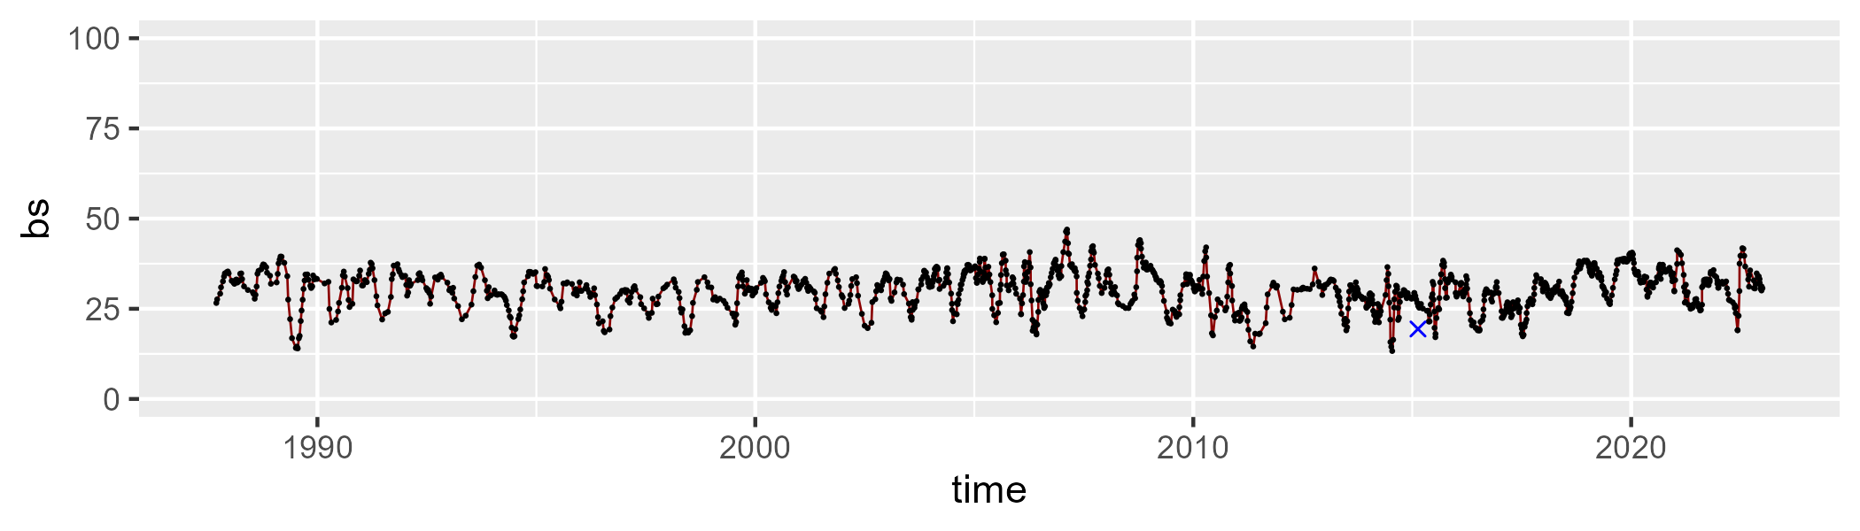

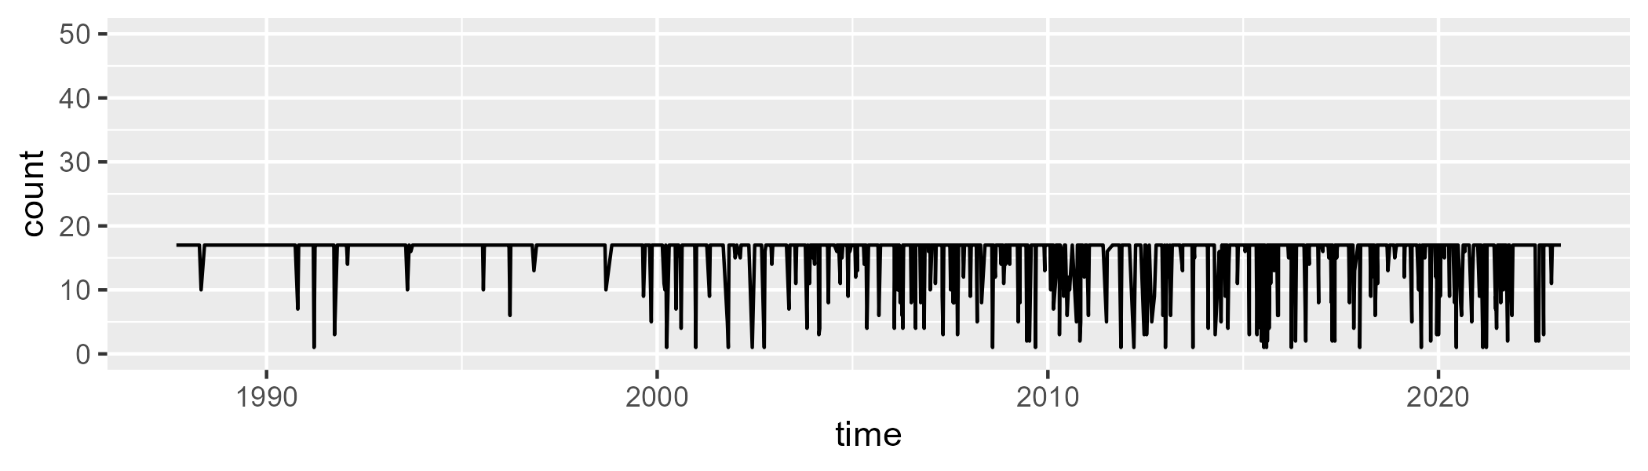

Min. : 1.00 1st Qu.:17.00 Median :17.00 Mean :15.64 3rd Qu.:17.00 Max. :17.00

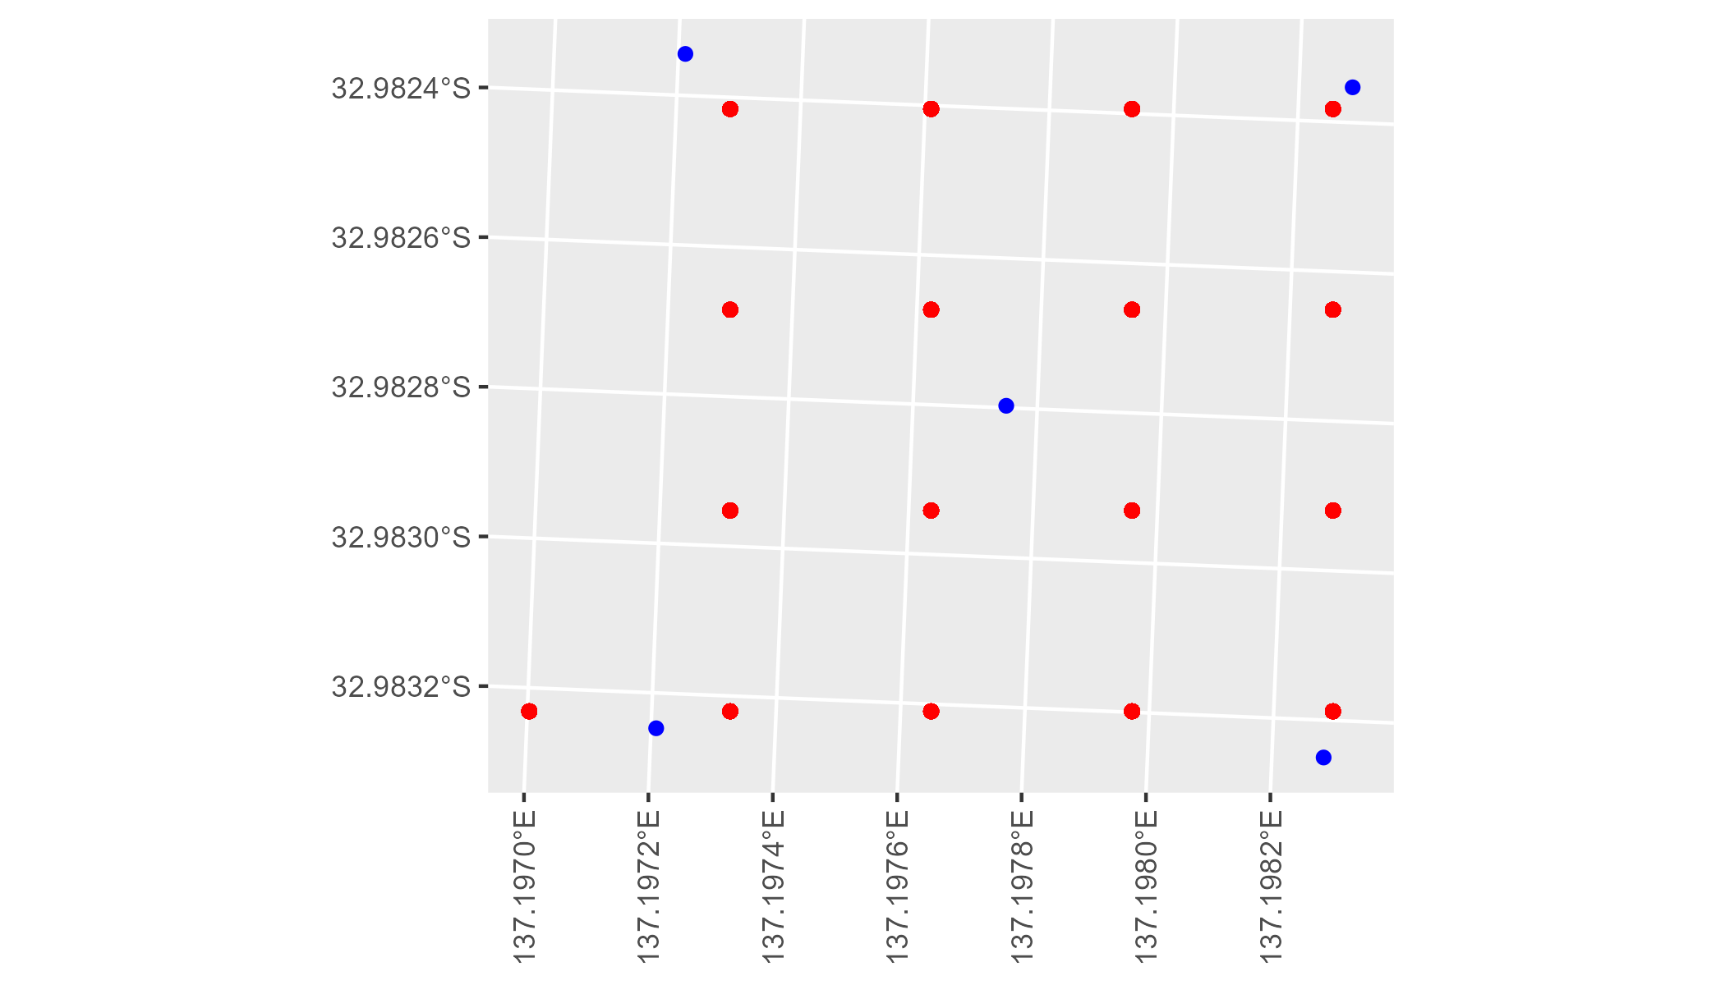

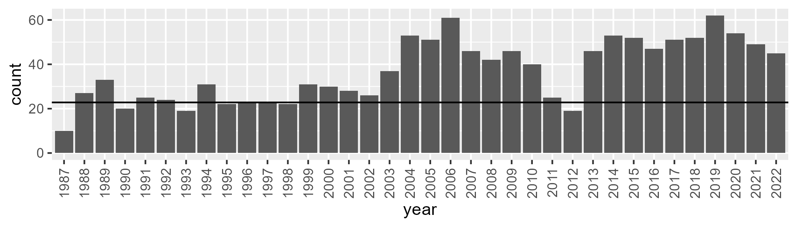

Number of samples: 1325

# SAAGAW0002

| Min. | 1st Qu. | Median | Mean | 3rd Qu. | Max. |
| --- | --- | --- | --- | --- | --- |
| 2.682014 | 6.980218 | 10.37154 | 12.10493 | 15.3487 | 42.15503 |

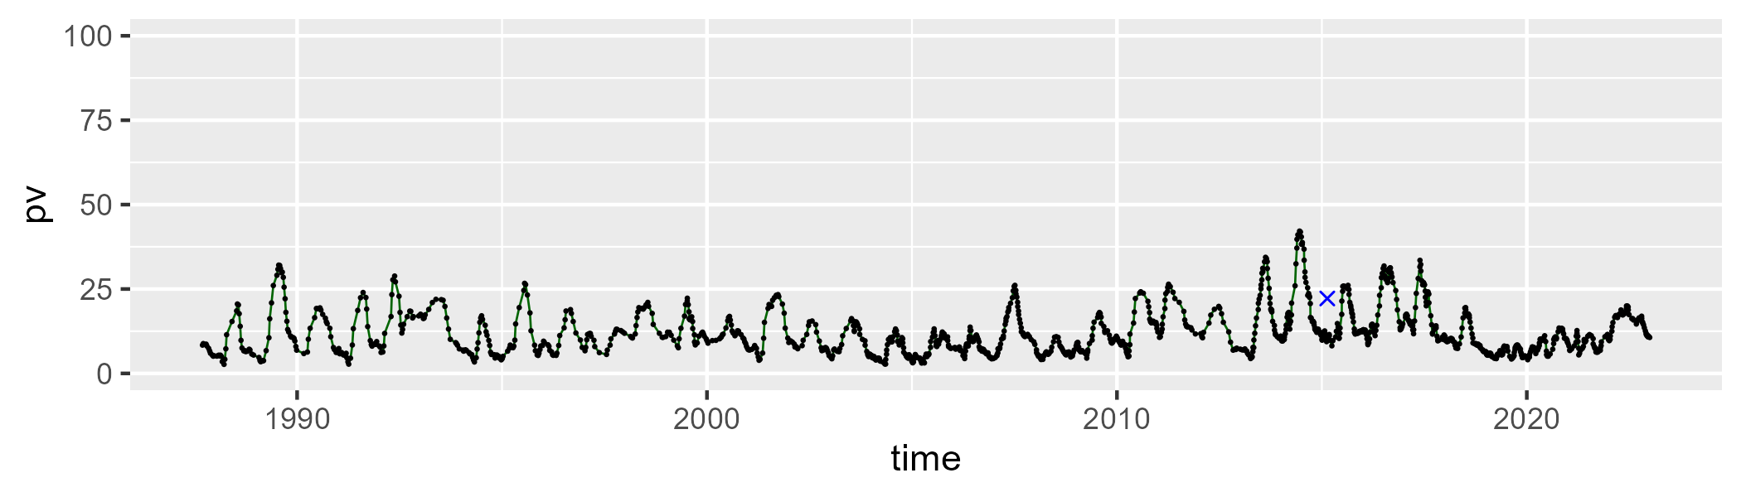

| Min. | 1st Qu. | Median | Mean | 3rd Qu. | Max. |
| --- | --- | --- | --- | --- | --- |
| 27.67566 | 41.18422 | 45.63034 | 45.65467 | 49.92367 | 67.03703 |

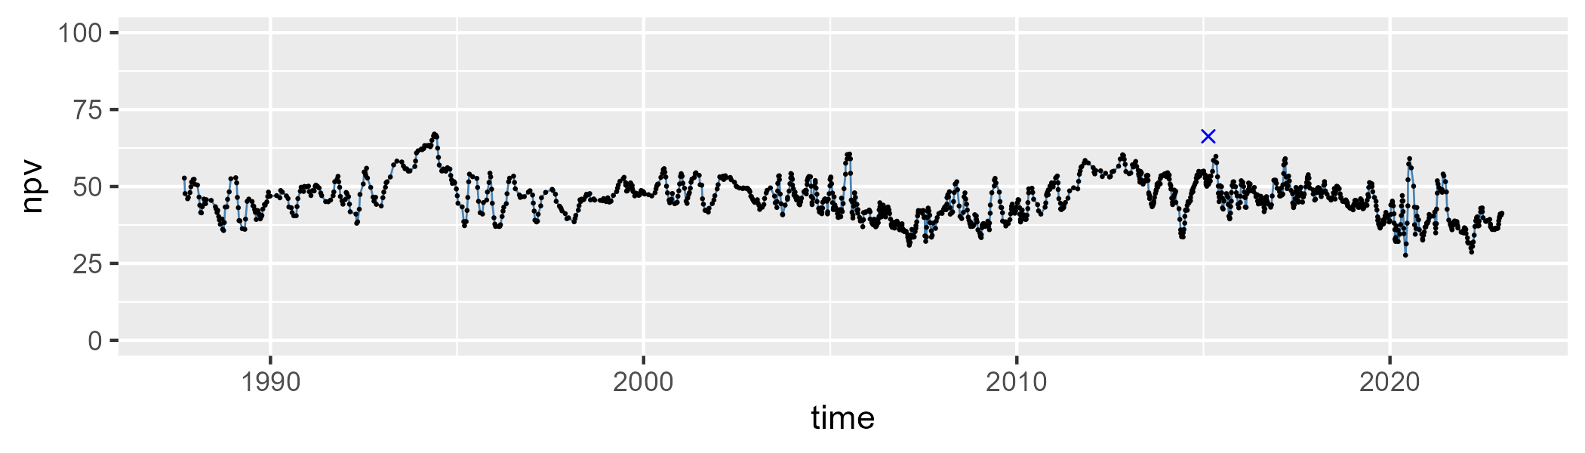

| Min. | 1st Qu. | Median | Mean | 3rd Qu. | Max. |
| --- | --- | --- | --- | --- | --- |
| 17.41125 | 33.83422 | 41.54564 | 40.81669 | 48.21473 | 60.2888 |

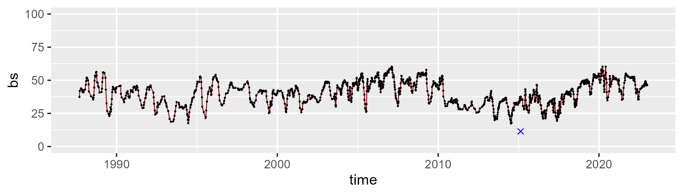

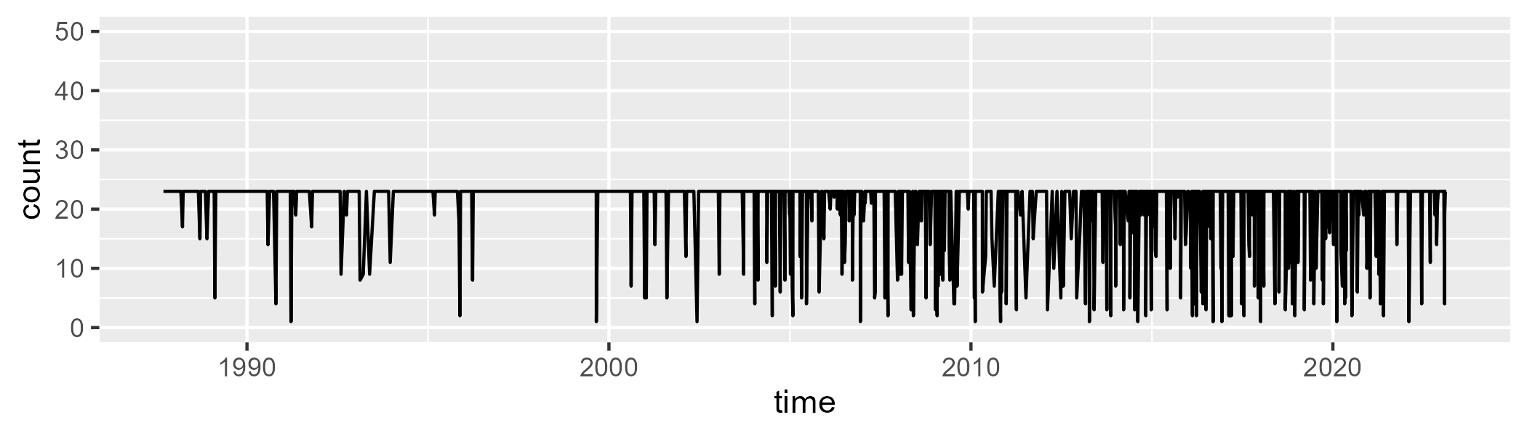

Min. : 1.00 1st Qu.:23.00 Median :23.00 Mean :20.78 3rd Qu.:23.00 Max. :23.00

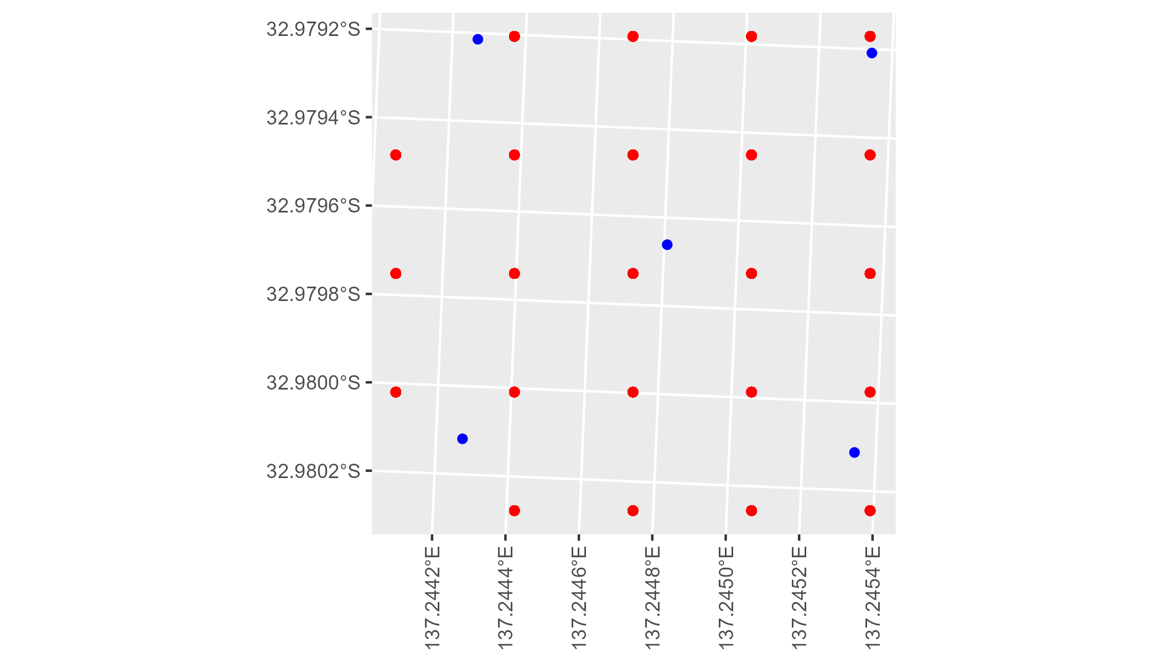

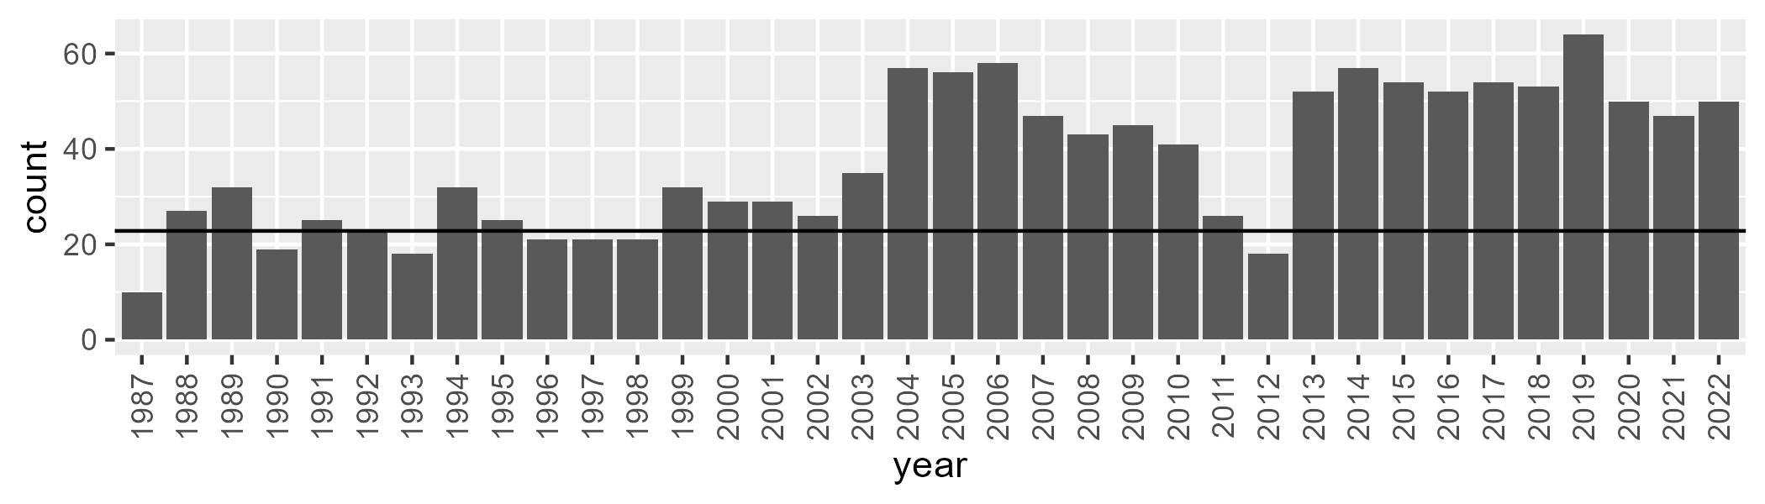

Number of samples: 1349

# SAAGAW0003

| Min. | 1st Qu. | Median | Mean | 3rd Qu. | Max. |
| --- | --- | --- | --- | --- | --- |
| 7.515595 | 15.16254 | 18.43717 | 18.52763 | 21.30944 | 31.26998 |

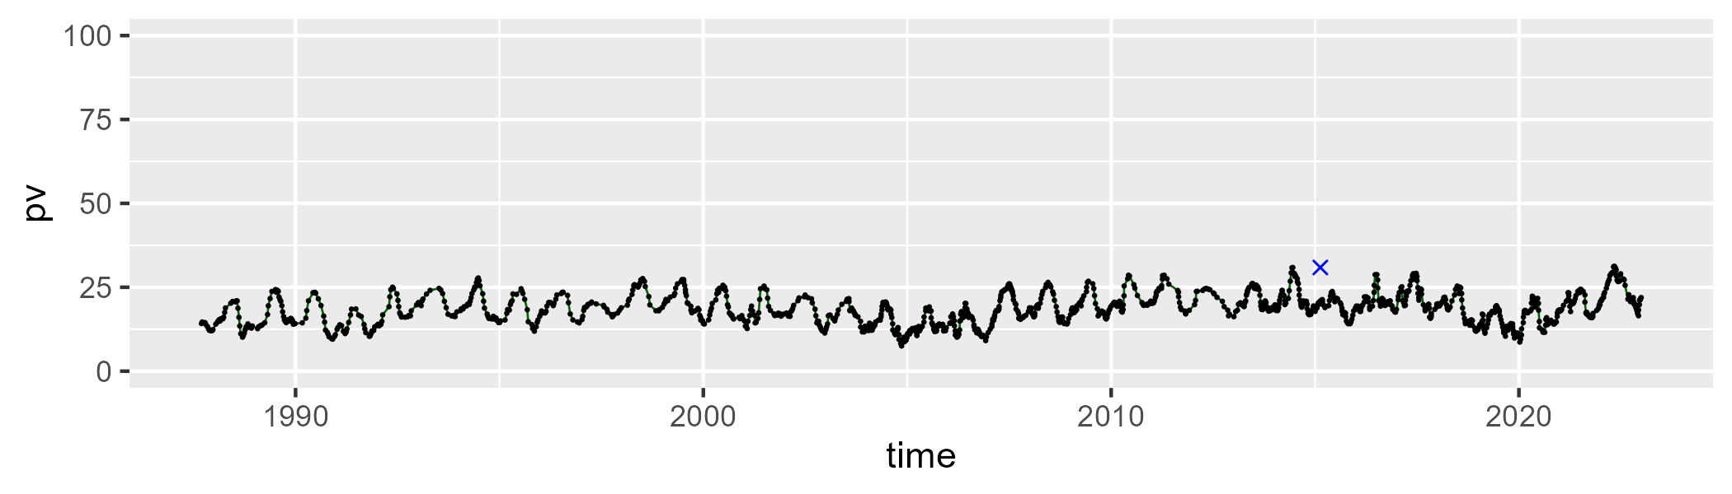

| Min. | 1st Qu. | Median | Mean | 3rd Qu. | Max. |
| --- | --- | --- | --- | --- | --- |
| 35.57972 | 46.31458 | 48.31883 | 48.06673 | 50.03113 | 55.82033 |

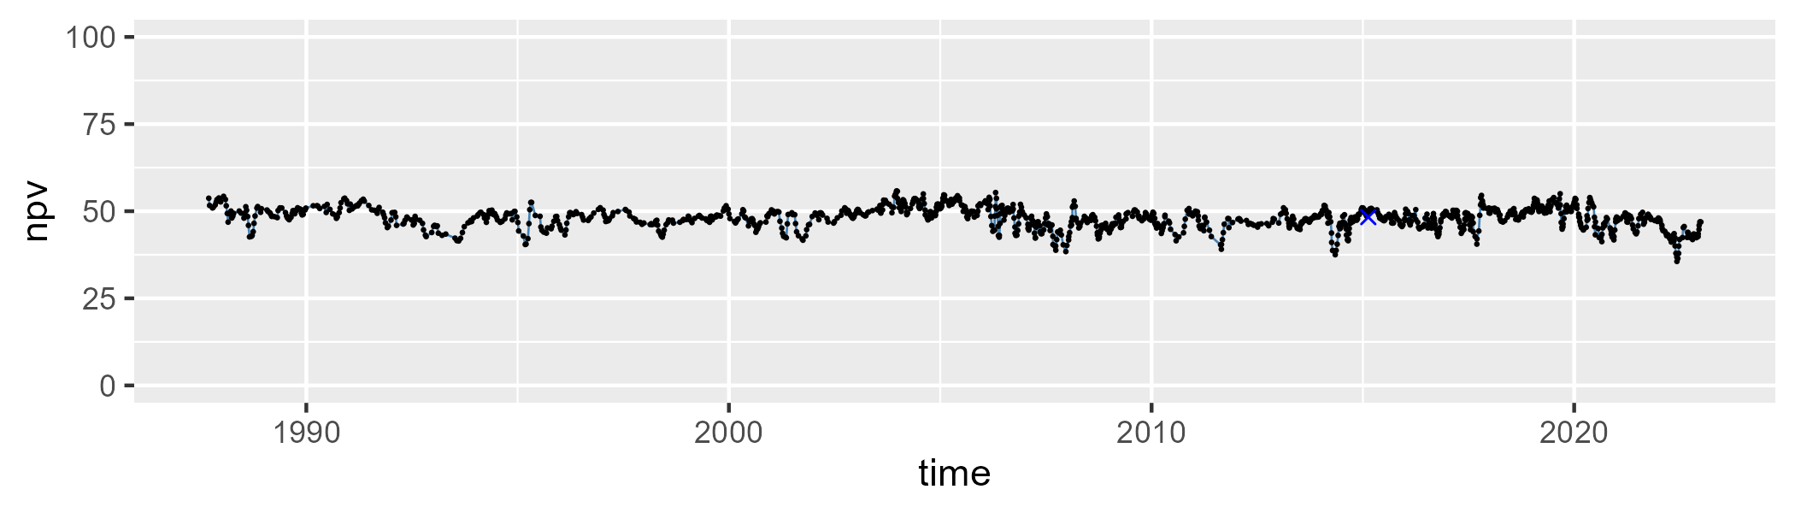

| Min. | 1st Qu. | Median | Mean | 3rd Qu. | Max. |
| --- | --- | --- | --- | --- | --- |
| 20.10092 | 28.96908 | 32.15994 | 32.06476 | 35.14172 | 45.7816 |

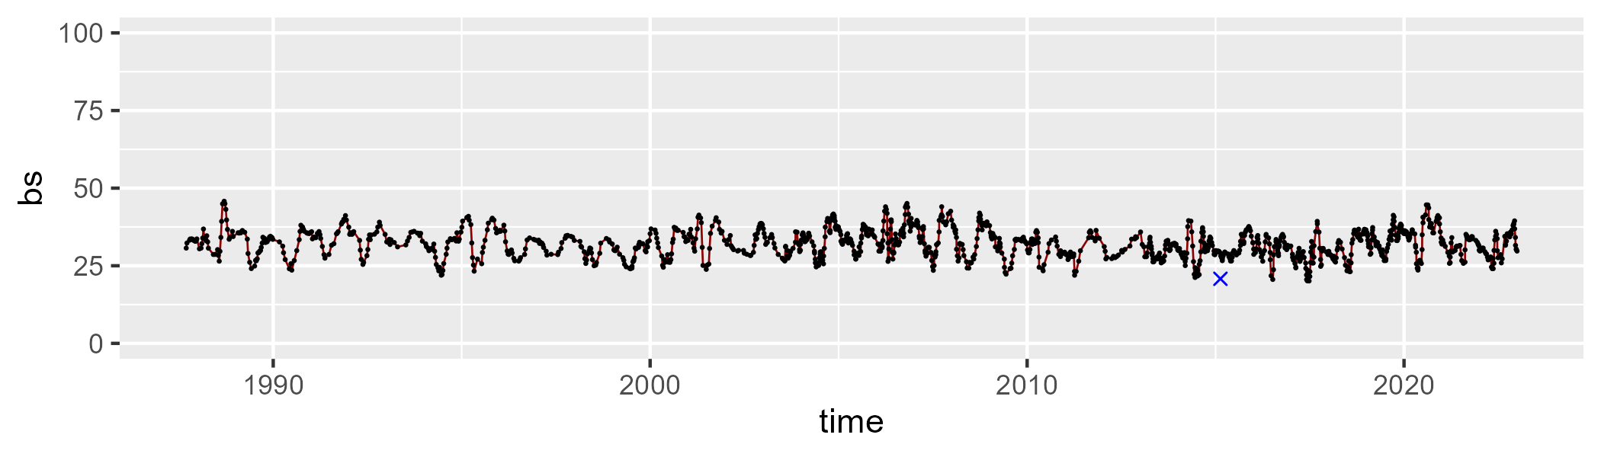

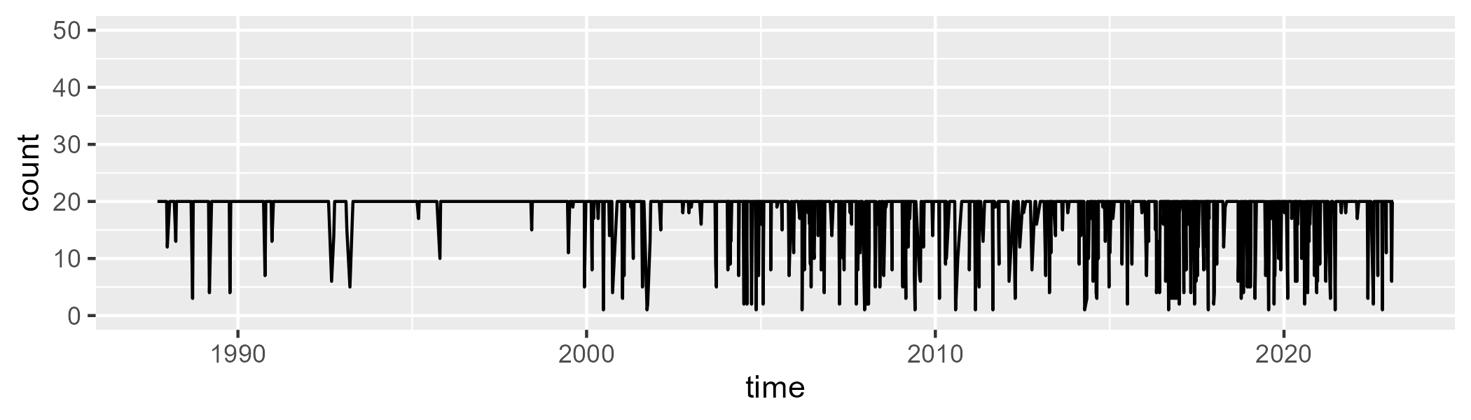

Min. : 1.00 1st Qu.:20.00 Median :20.00 Mean :18.16 3rd Qu.:20.00 Max. :20.00

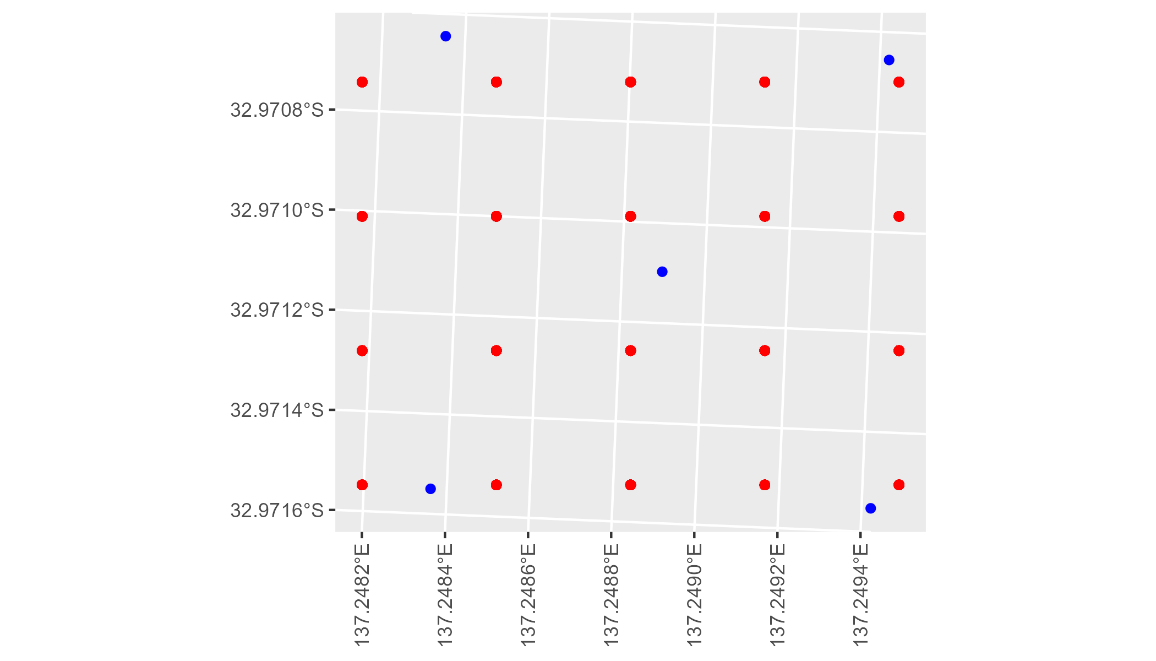

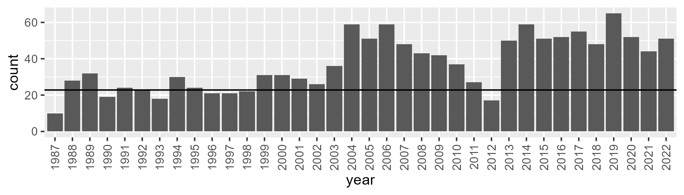

Number of samples: 1335

# SAAGAW0004

| Min. | 1st Qu. | Median | Mean | 3rd Qu. | Max. |
| --- | --- | --- | --- | --- | --- |
| 1.997549 | 6.64951 | 8.159758 | 8.646789 | 10.36993 | 19.47863 |

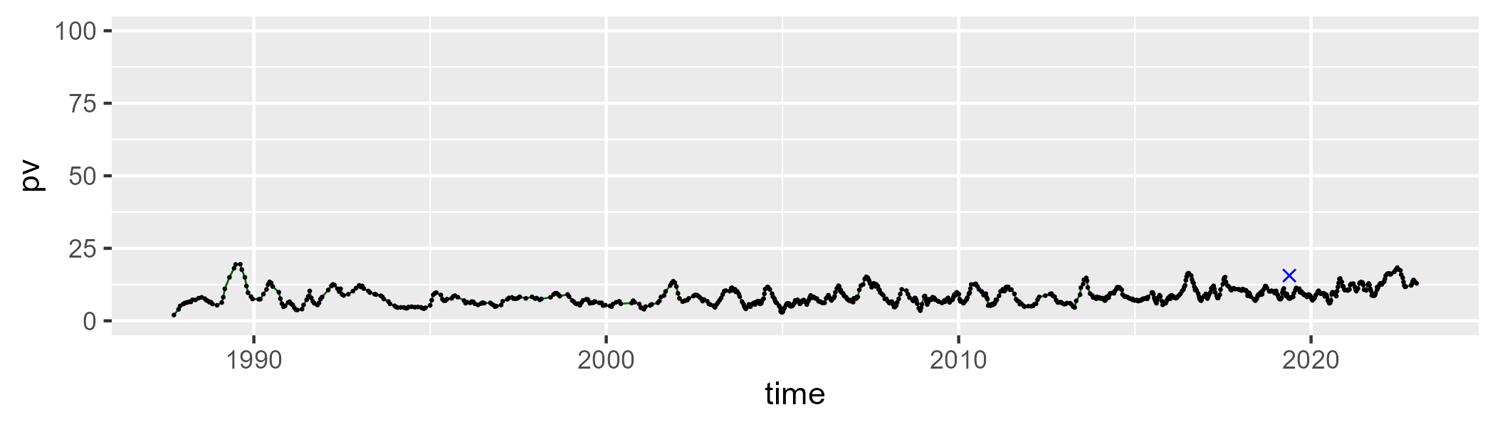

| Min. | 1st Qu. | Median | Mean | 3rd Qu. | Max. |
| --- | --- | --- | --- | --- | --- |
| 7.822248 | 18.35769 | 22.85043 | 23.70074 | 28.25241 | 56.71657 |

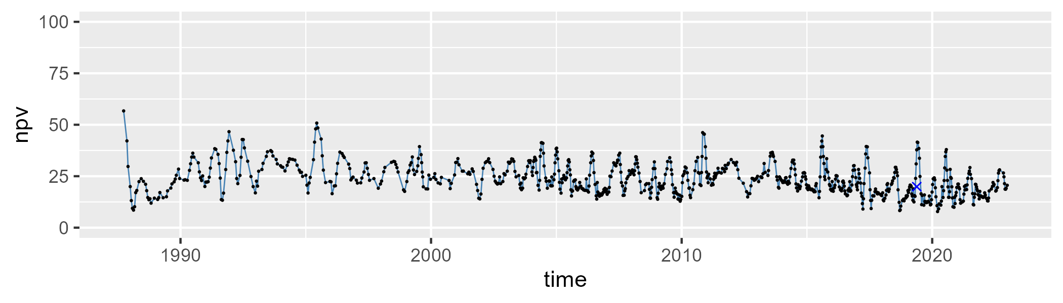

| Min. | 1st Qu. | Median | Mean | 3rd Qu. | Max. |
| --- | --- | --- | --- | --- | --- |
| 40.02931 | 61.91615 | 67.18335 | 66.10461 | 70.86514 | 83.69441 |

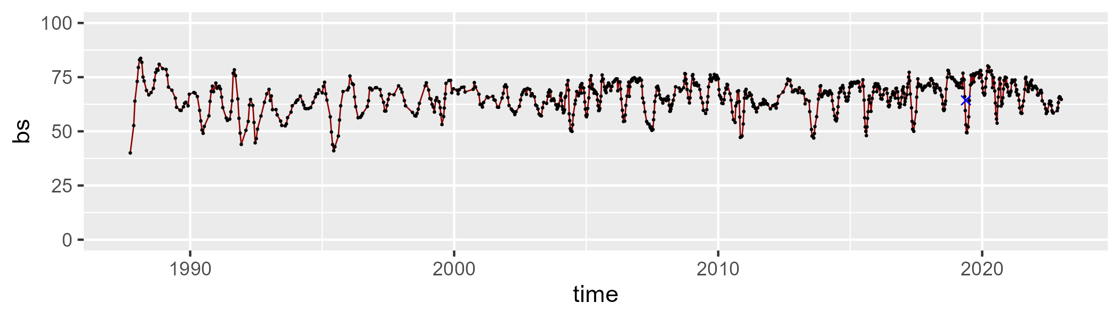

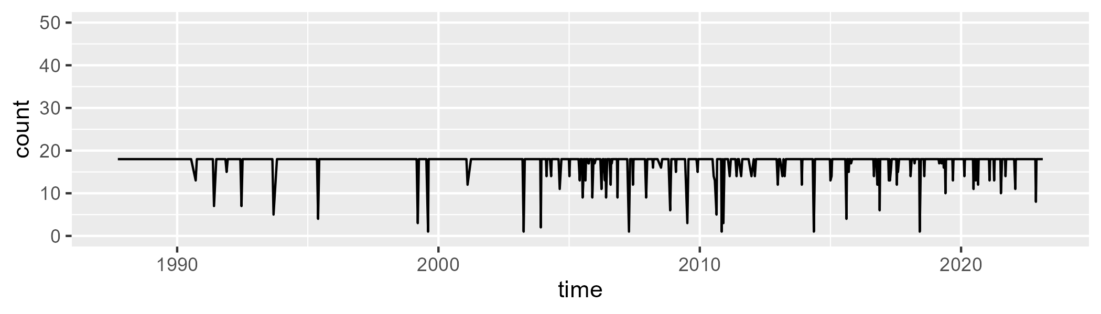

Min. : 1.00 1st Qu.:18.00 Median :18.00 Mean :17.31 3rd Qu.:18.00 Max. :18.00

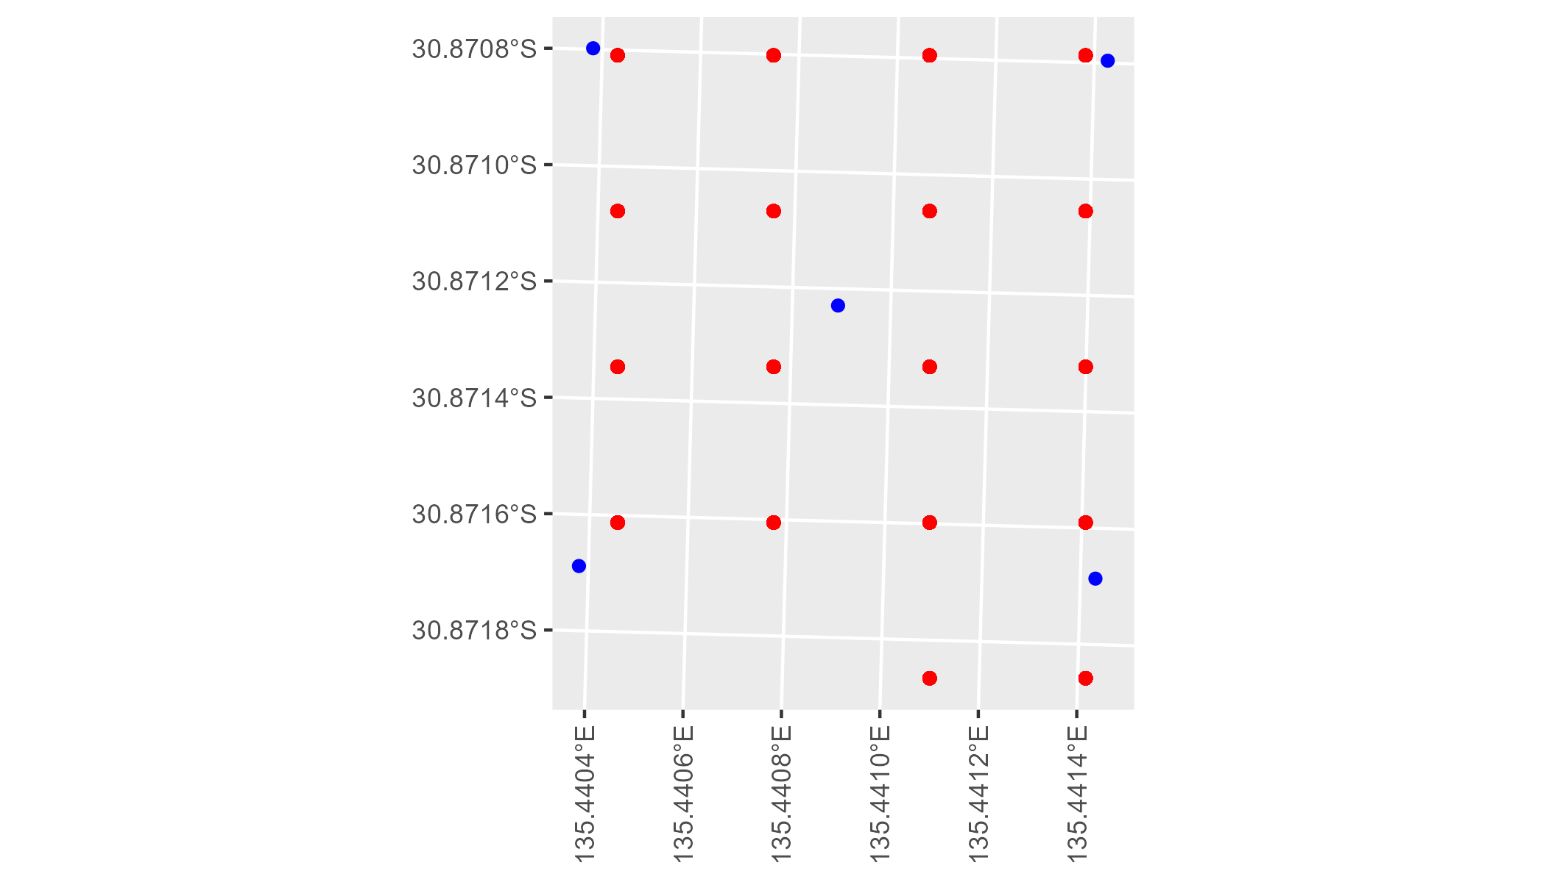

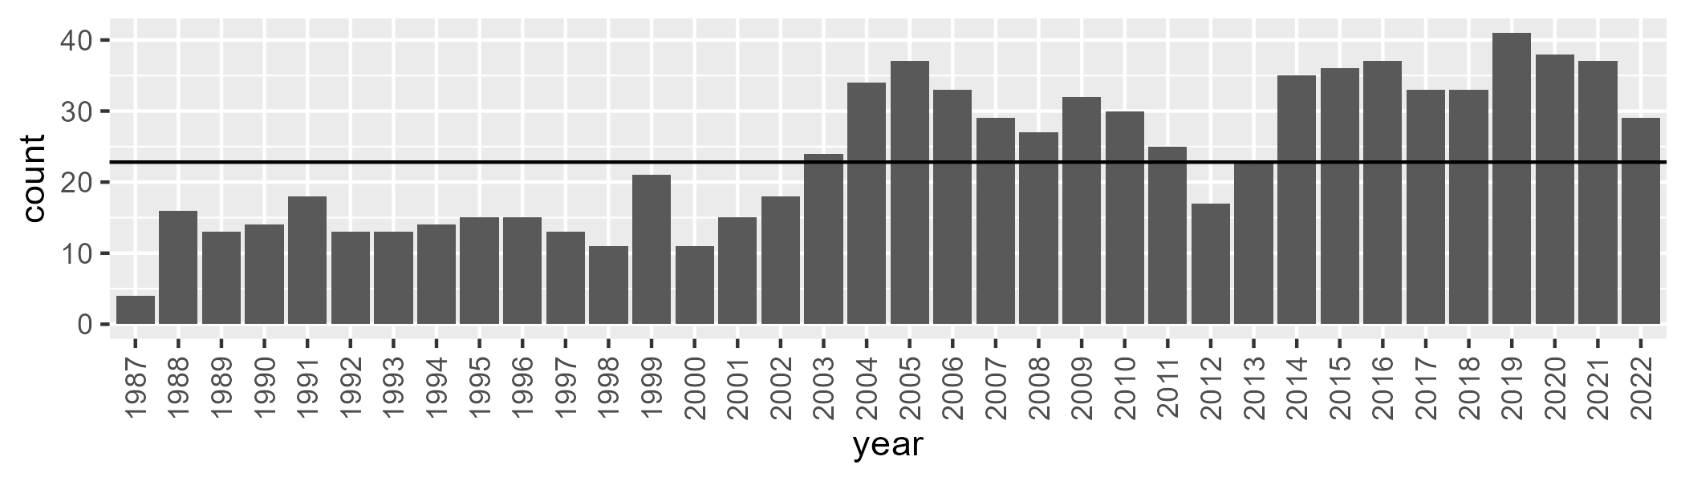

Number of samples: 854

# SAAGAW0005

| Min. | 1st Qu. | Median | Mean | 3rd Qu. | Max. |
| --- | --- | --- | --- | --- | --- |
| 0 | 0.6403661 | 1.849982 | 3.584572 | 4.652403 | 34.99424 |

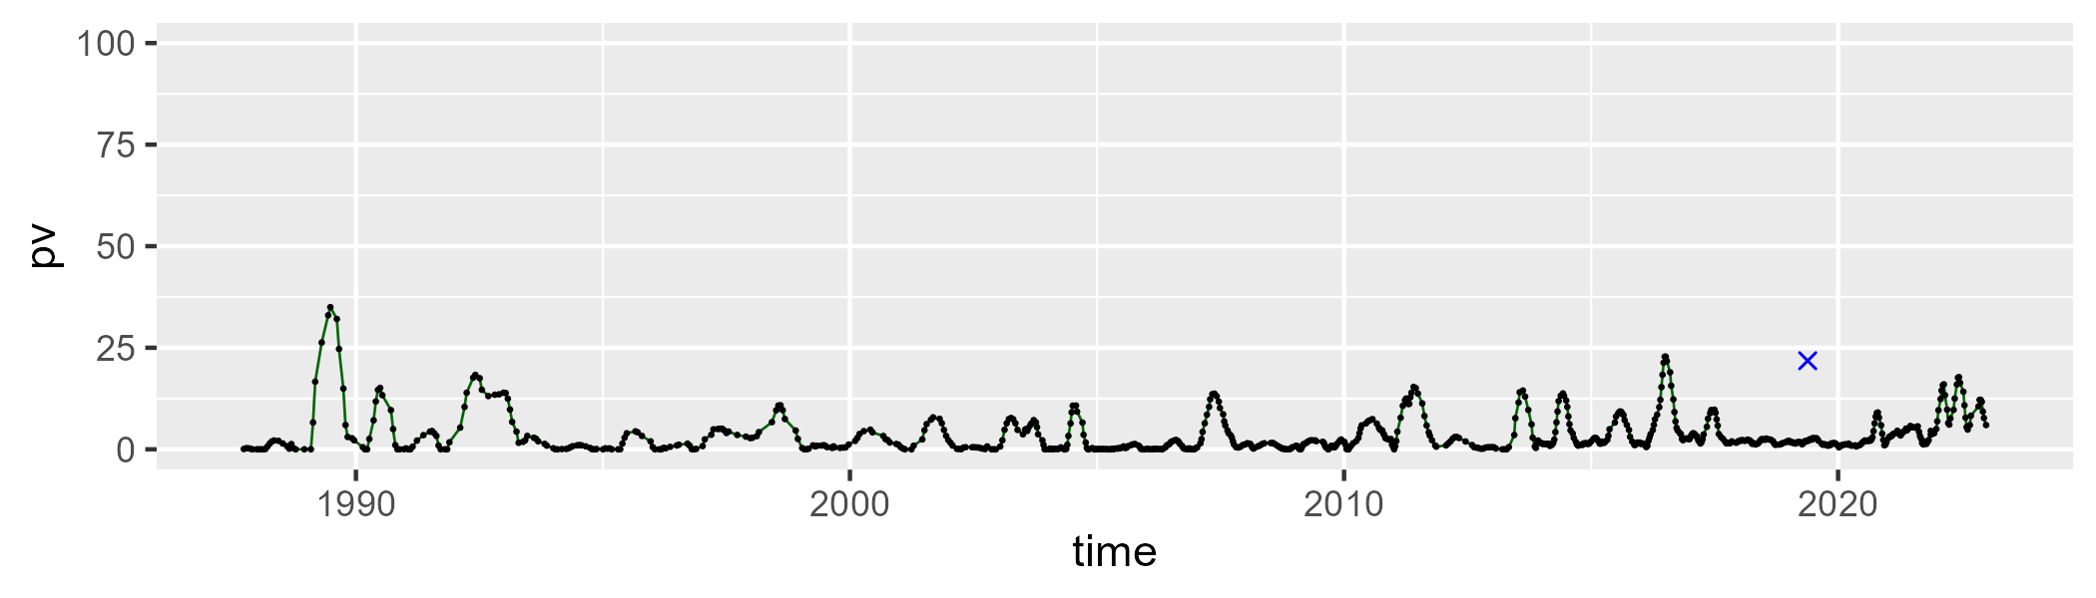

| Min. | 1st Qu. | Median | Mean | 3rd Qu. | Max. |
| --- | --- | --- | --- | --- | --- |
| 39.44023 | 51.71073 | 54.08531 | 54.29583 | 56.43238 | 77.15353 |

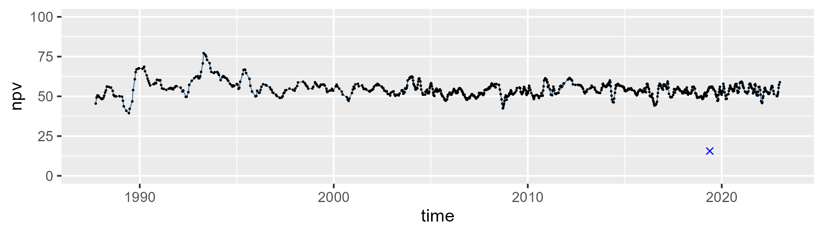

| Min. | 1st Qu. | Median | Mean | 3rd Qu. | Max. |
| --- | --- | --- | --- | --- | --- |
| 19.5681 | 38.22963 | 41.50493 | 40.9156 | 44.60465 | 56.07312 |

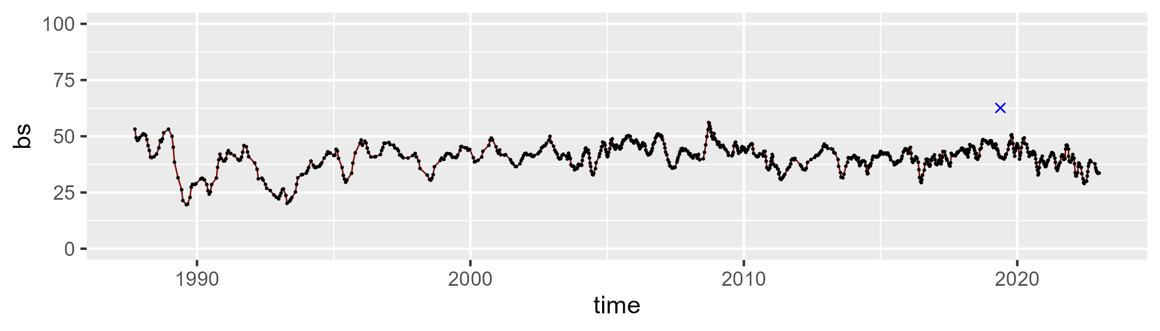

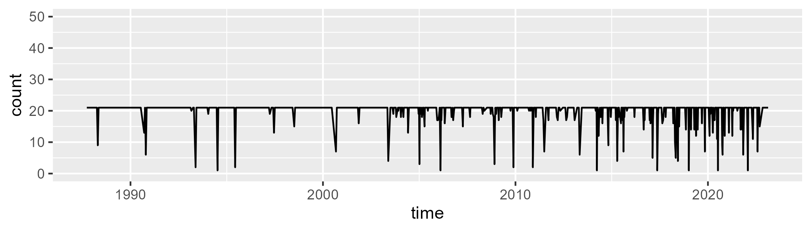

Min. : 1.00 1st Qu.:21.00 Median :21.00 Mean :19.92 3rd Qu.:21.00 Max. :21.00

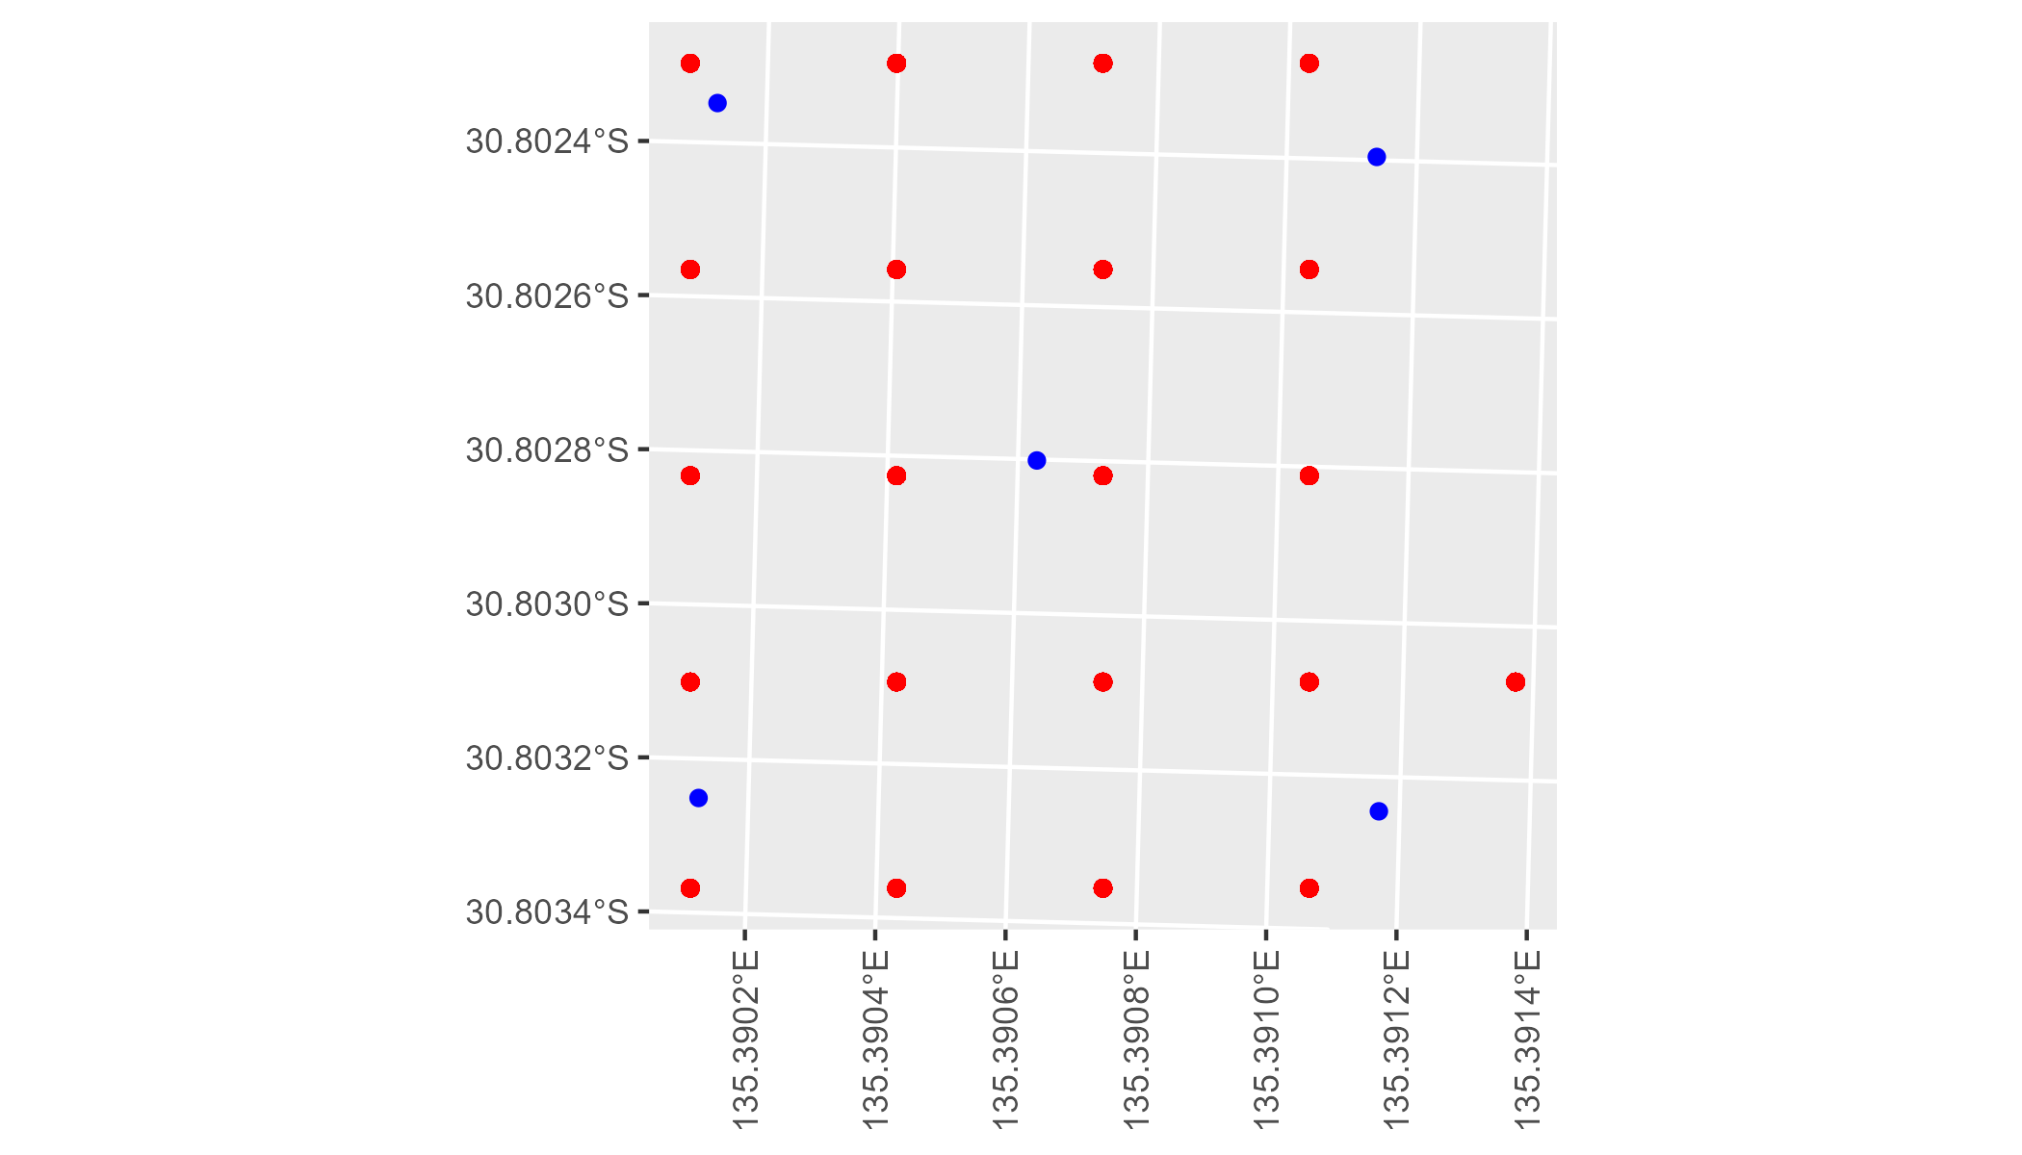

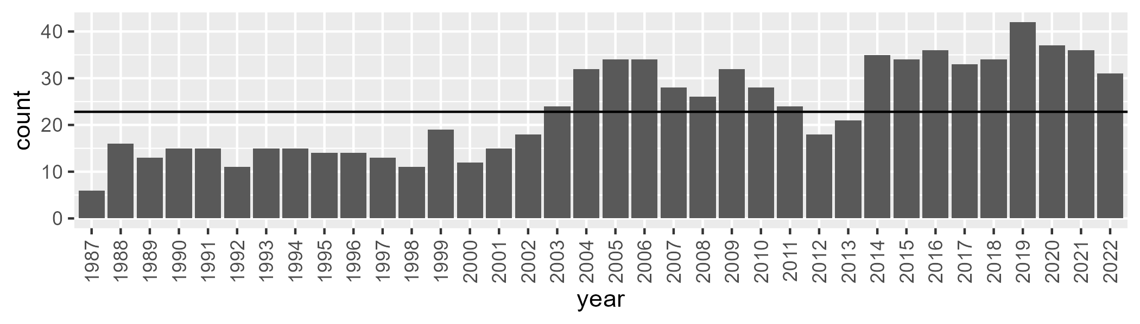

Number of samples: 841

# SAAGAW0006

| Min. | 1st Qu. | Median | Mean | 3rd Qu. | Max. |
| --- | --- | --- | --- | --- | --- |
| 0 | 6.987591 | 9.402638 | 10.49264 | 12.97489 | 31.97988 |

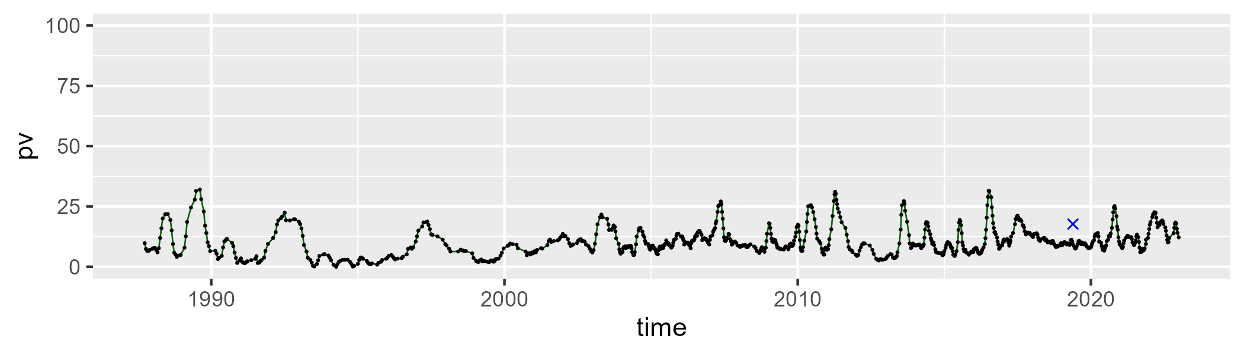

| Min. | 1st Qu. | Median | Mean | 3rd Qu. | Max. |
| --- | --- | --- | --- | --- | --- |
| 14.92326 | 28.96698 | 33.85361 | 34.24779 | 39.29638 | 64.7275 |

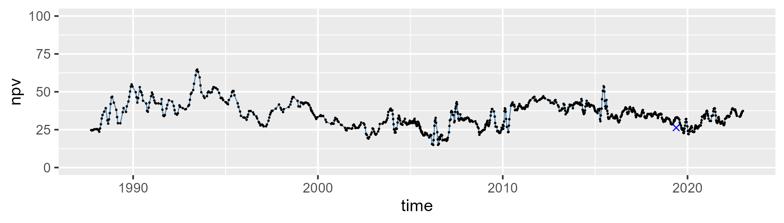

| Min. | 1st Qu. | Median | Mean | 3rd Qu. | Max. |
| --- | --- | --- | --- | --- | --- |
| 26.36217 | 48.30951 | 54.37267 | 53.72993 | 60.30669 | 73.84851 |

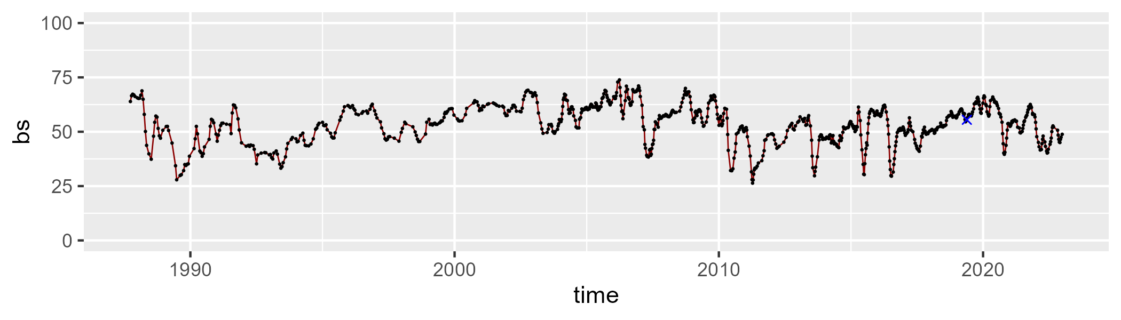

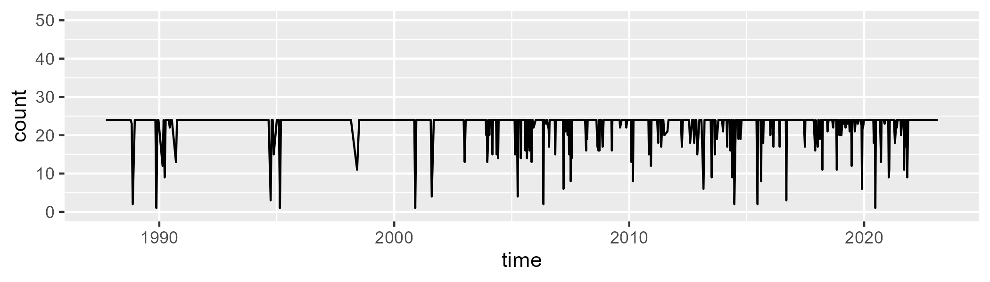

Min. : 1.00 1st Qu.:24.00 Median :24.00 Mean :22.81 3rd Qu.:24.00 Max. :24.00

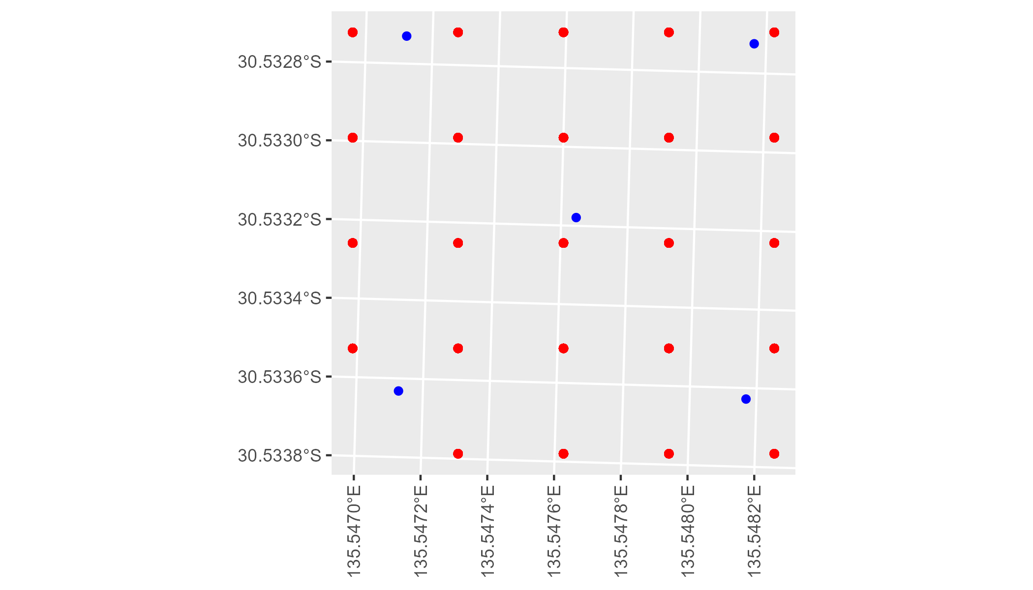

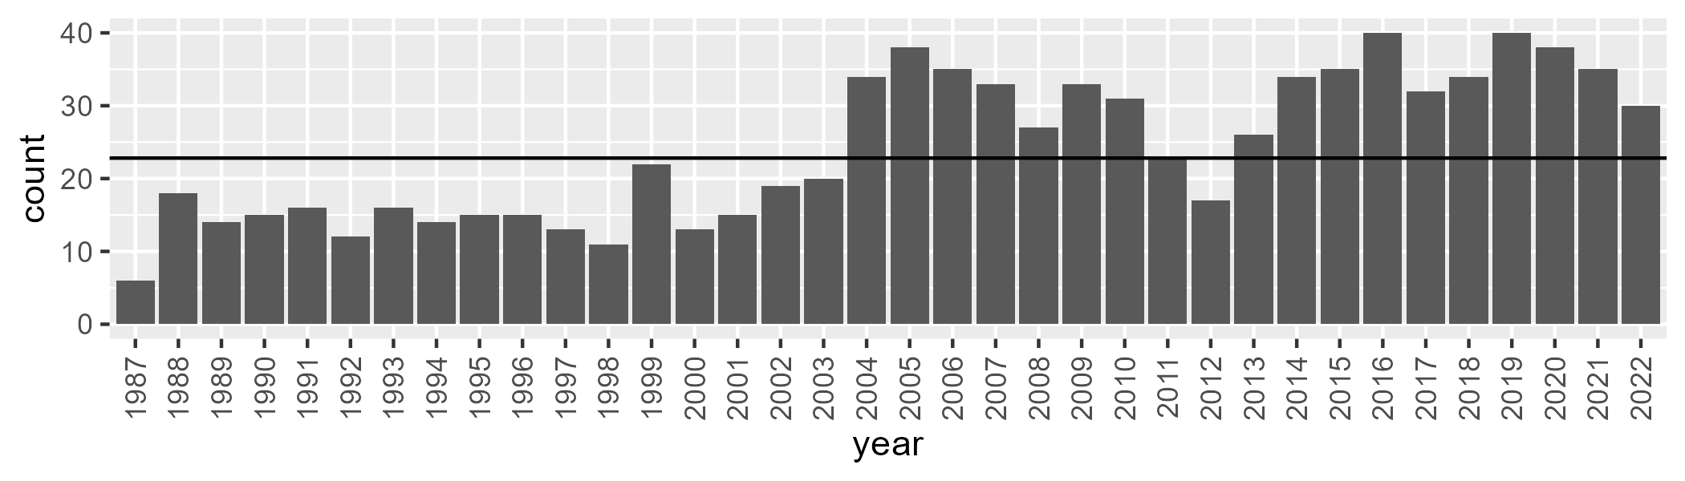

Number of samples: 869

# SAAGAW0007

| Min. | 1st Qu. | Median | Mean | 3rd Qu. | Max. |
| --- | --- | --- | --- | --- | --- |
| 2.718244 | 7.407228 | 9.031327 | 9.582273 | 11.30138 | 27.03857 |

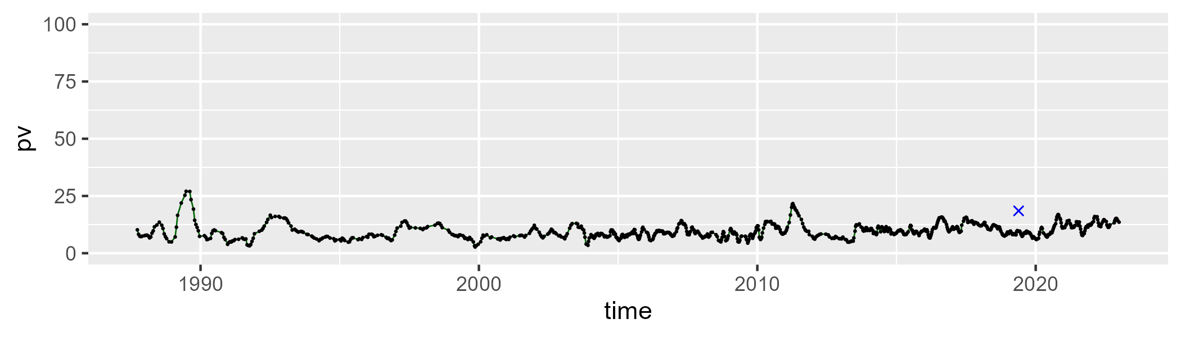

| Min. | 1st Qu. | Median | Mean | 3rd Qu. | Max. |
| --- | --- | --- | --- | --- | --- |
| 14.82116 | 25.14712 | 28.40224 | 28.63128 | 31.79512 | 49.4057 |

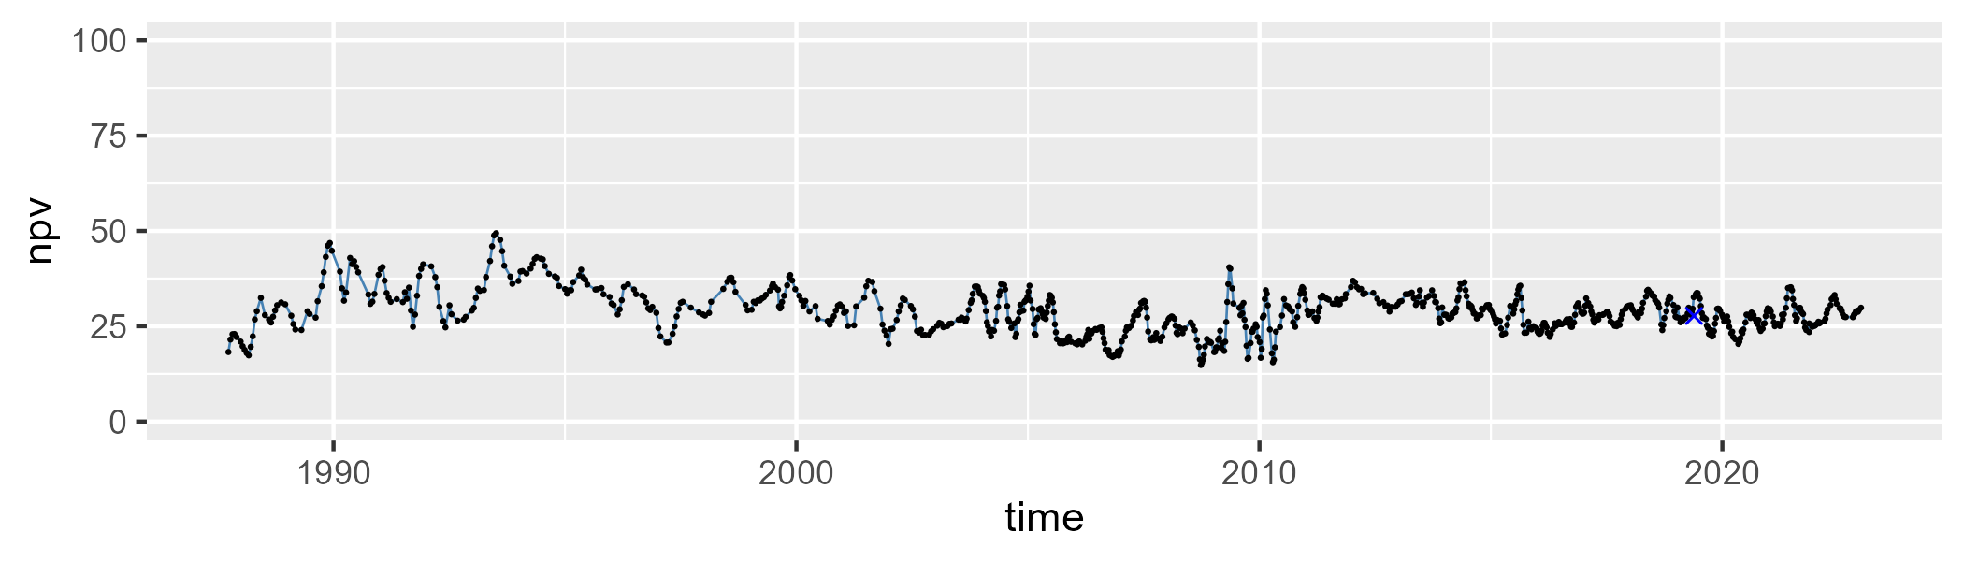

| Min. | 1st Qu. | Median | Mean | 3rd Qu. | Max. |
| --- | --- | --- | --- | --- | --- |
| 39.90002 | 56.76981 | 59.99226 | 60.19671 | 64.07853 | 76.78219 |

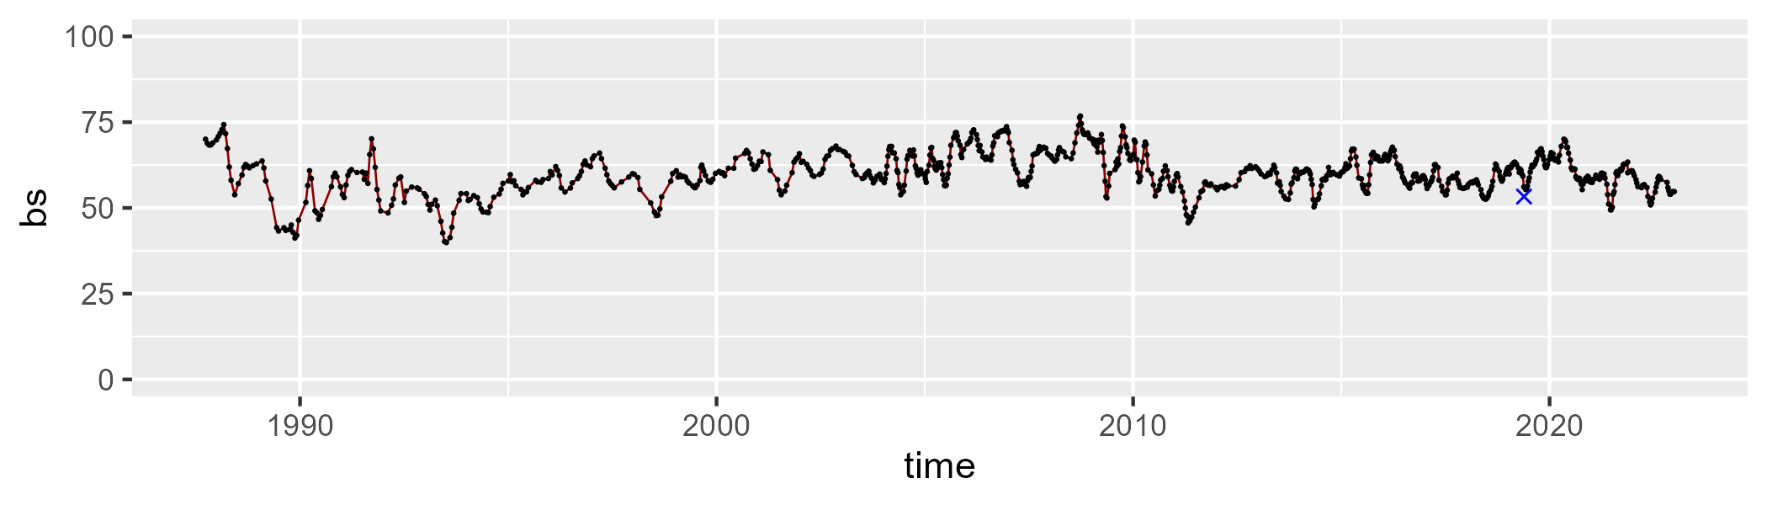

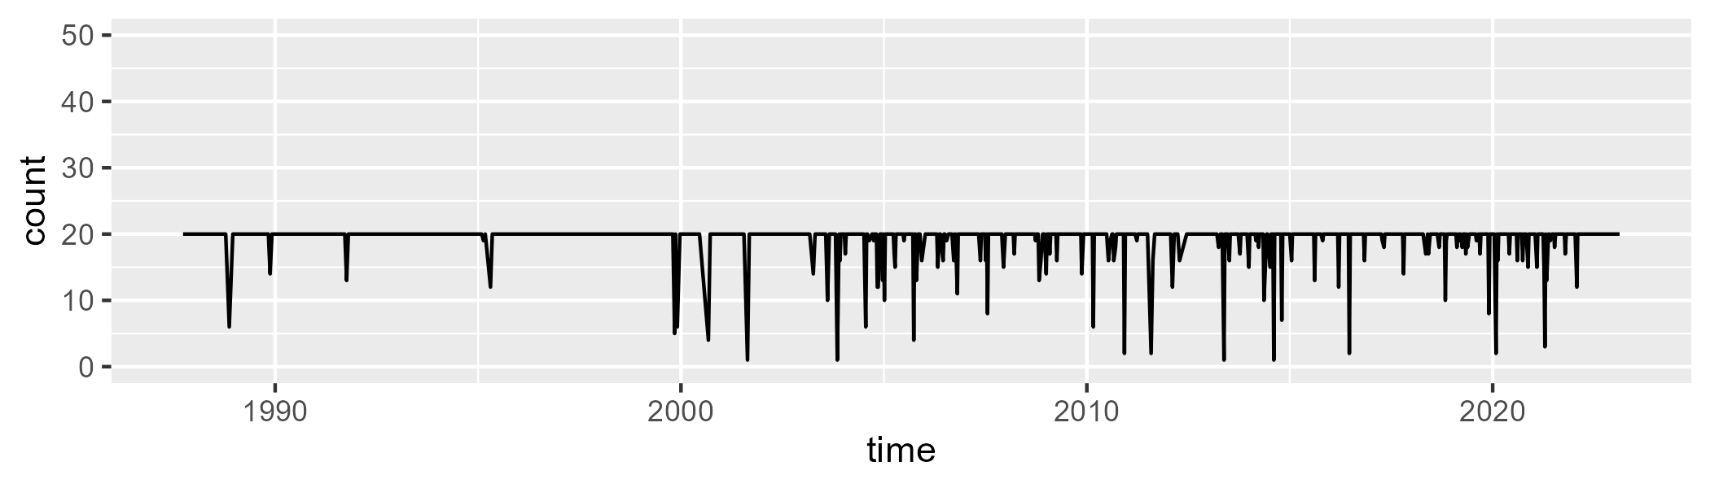

Min. : 1.00 1st Qu.:20.00 Median :20.00 Mean :19.26 3rd Qu.:20.00 Max. :20.00

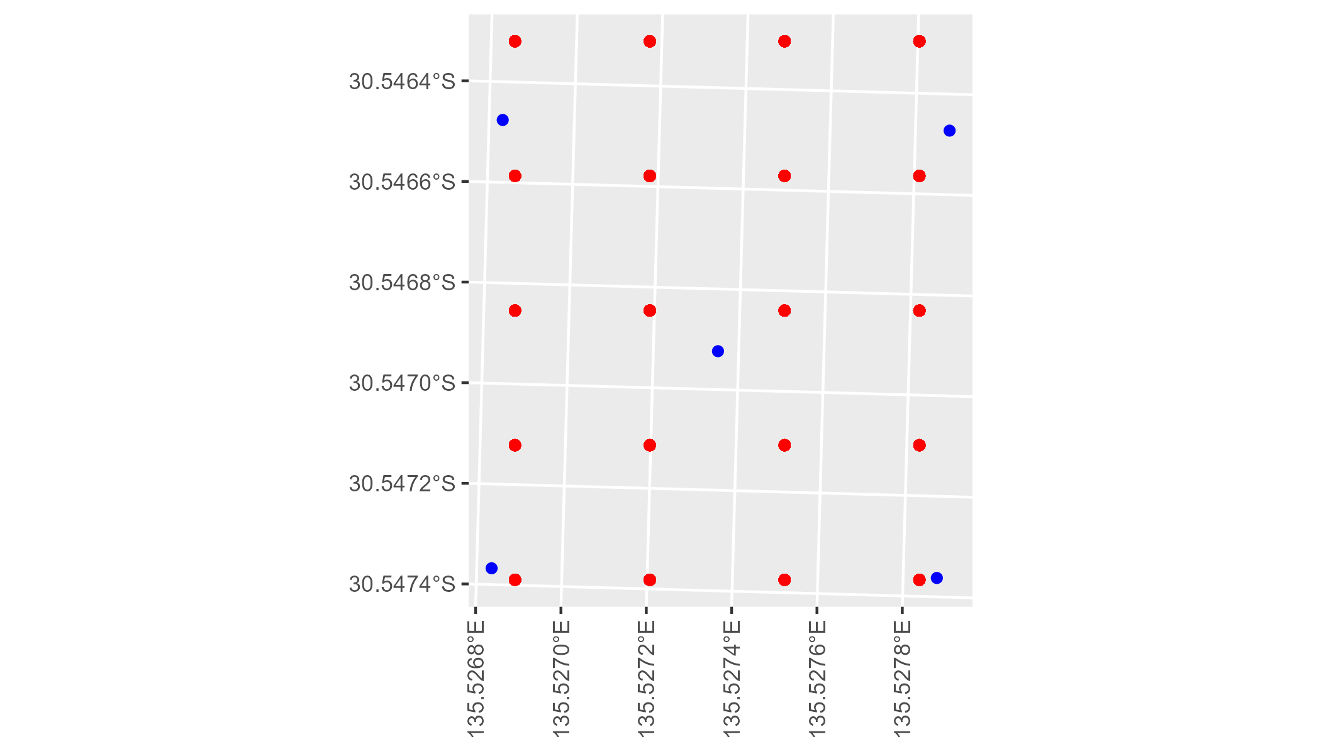

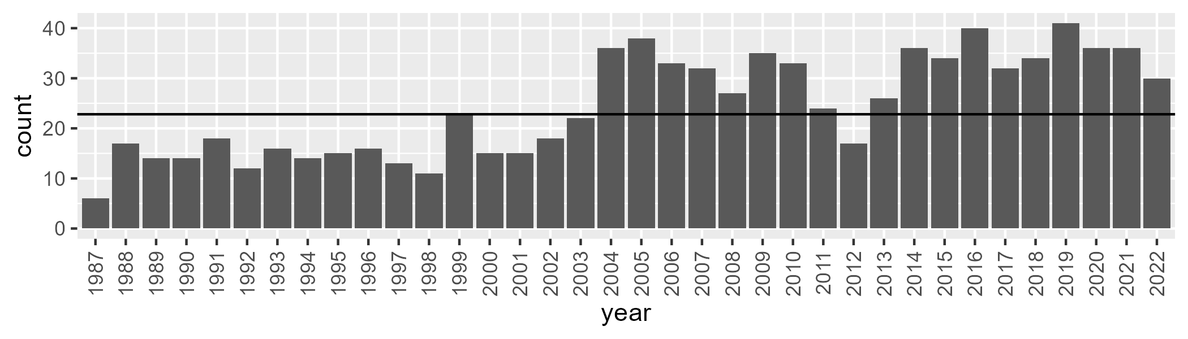

Number of samples: 879

# SAAGAW0008

| Min. | 1st Qu. | Median | Mean | 3rd Qu. | Max. |
| --- | --- | --- | --- | --- | --- |
| 0 | 2.193871 | 3.24961 | 3.861396 | 5.267483 | 10.64506 |

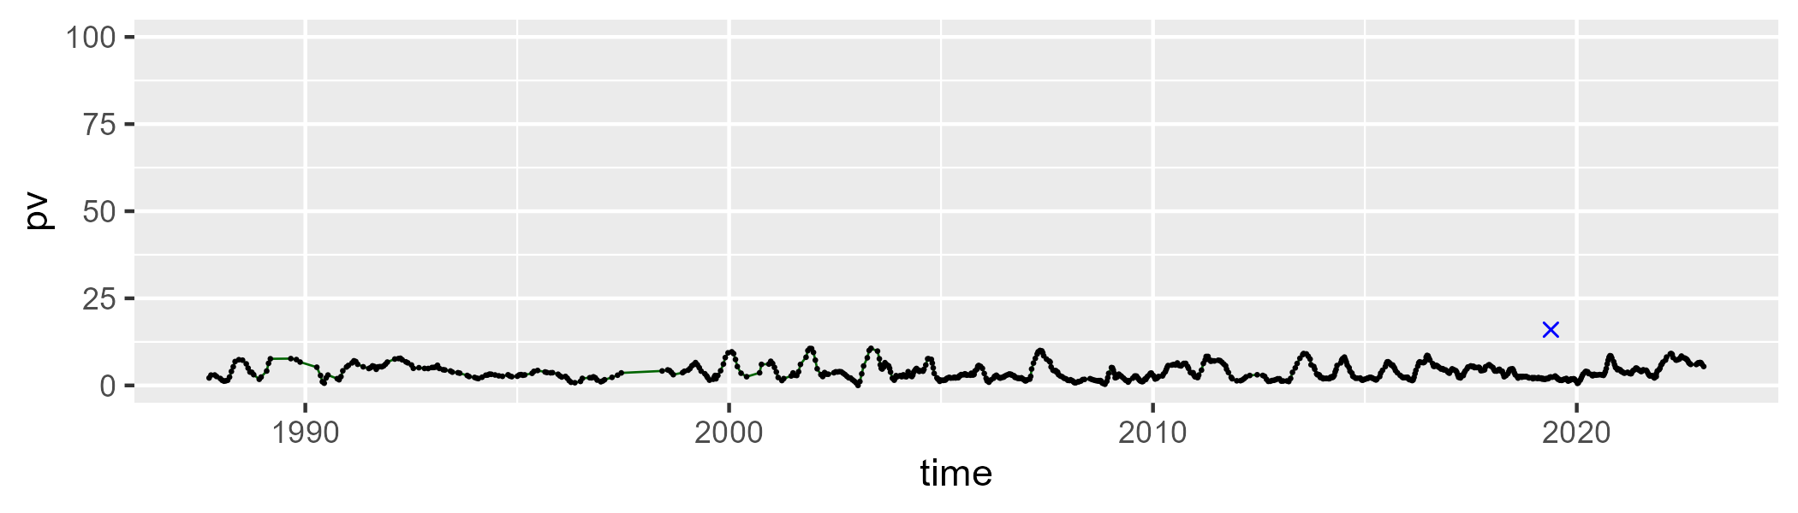

| Min. | 1st Qu. | Median | Mean | 3rd Qu. | Max. |
| --- | --- | --- | --- | --- | --- |
| 24.75081 | 53.92043 | 58.52853 | 58.74283 | 63.61737 | 92.24692 |

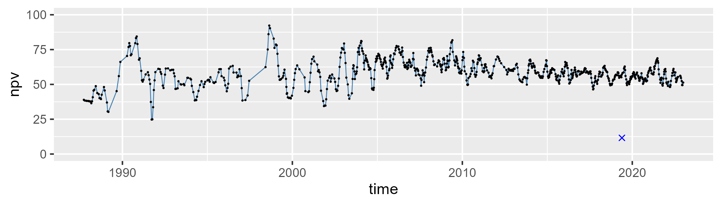

| Min. | 1st Qu. | Median | Mean | 3rd Qu. | Max. |
| --- | --- | --- | --- | --- | --- |
| 3.481763 | 31.72655 | 36.21675 | 36.40664 | 40.9872 | 69.0817 |

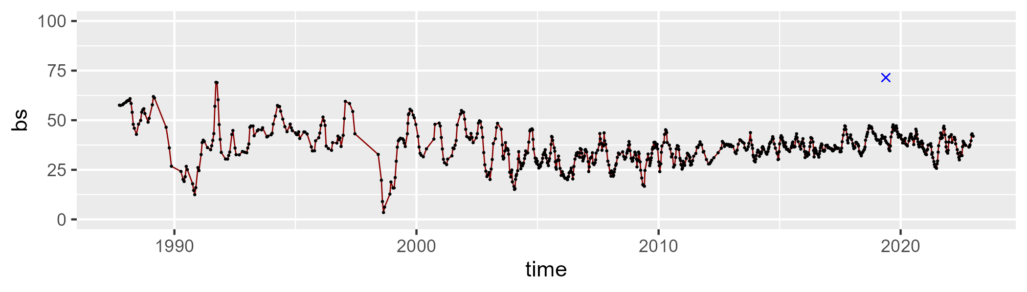

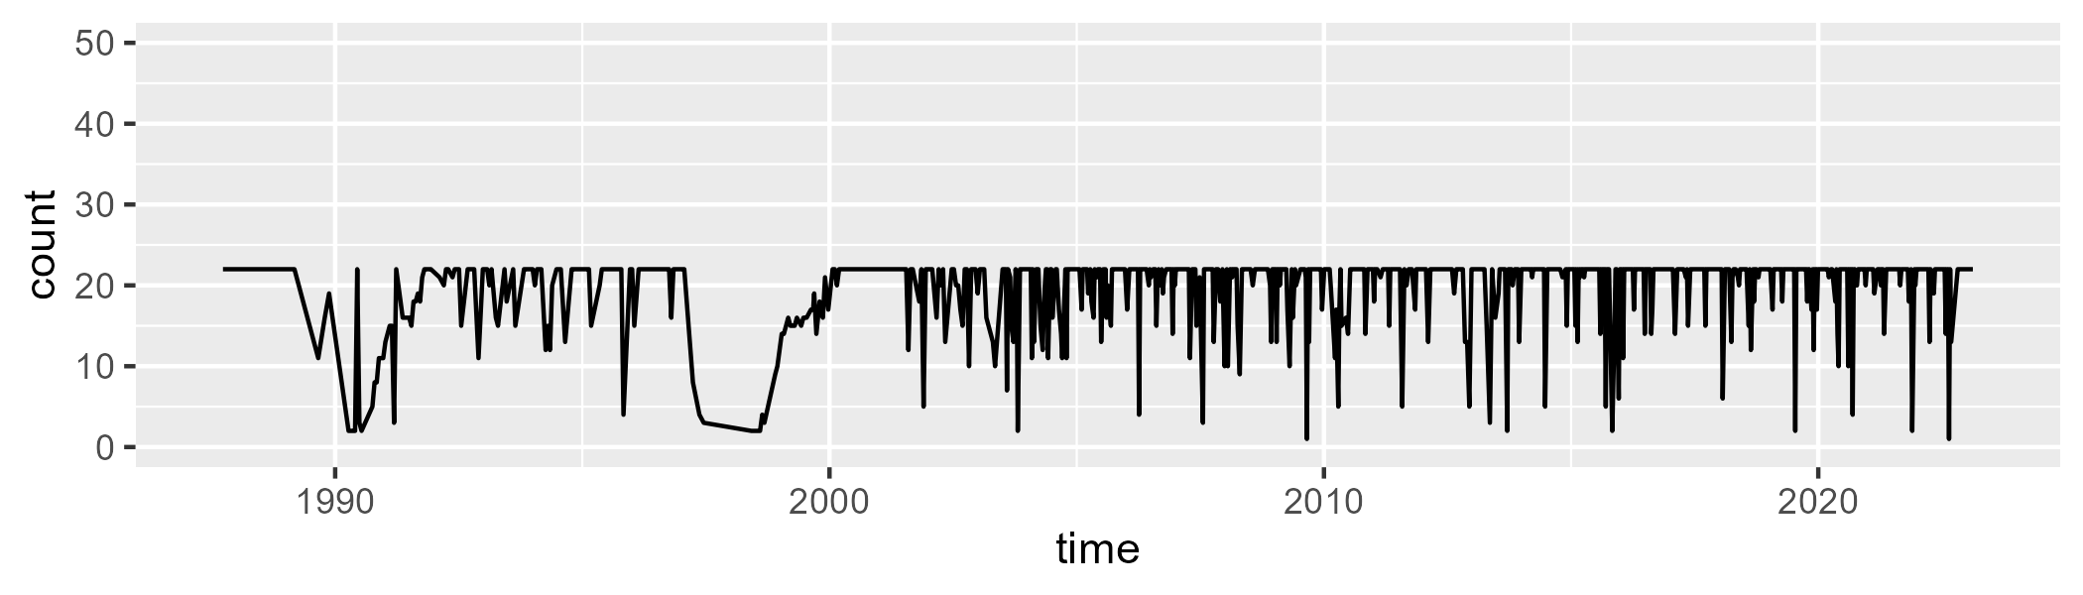

Min. : 1.00 1st Qu.:20.00 Median :22.00 Mean :19.72 3rd Qu.:22.00 Max. :22.00

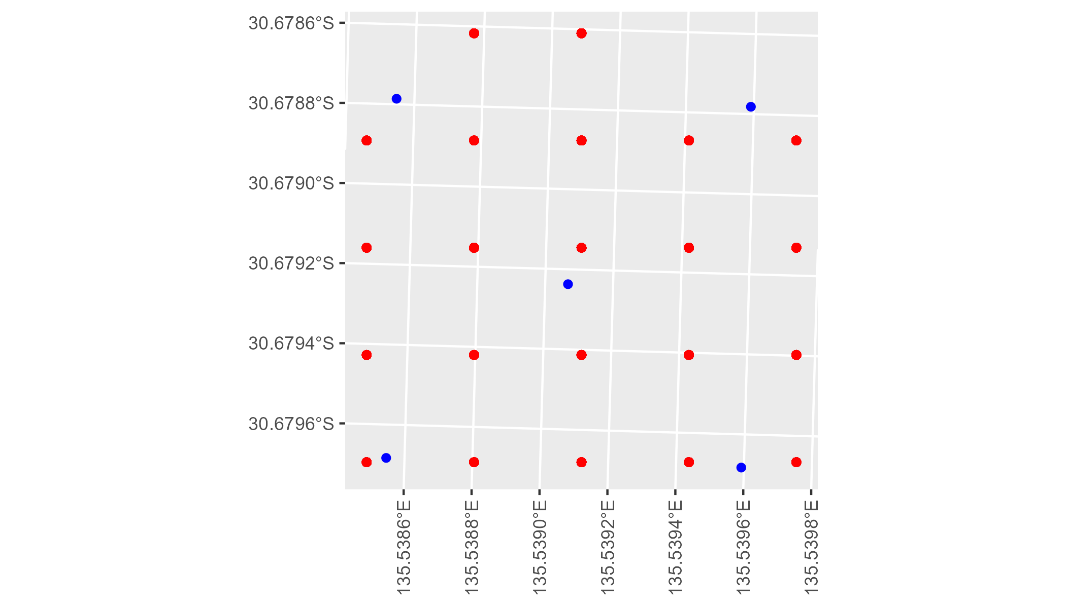

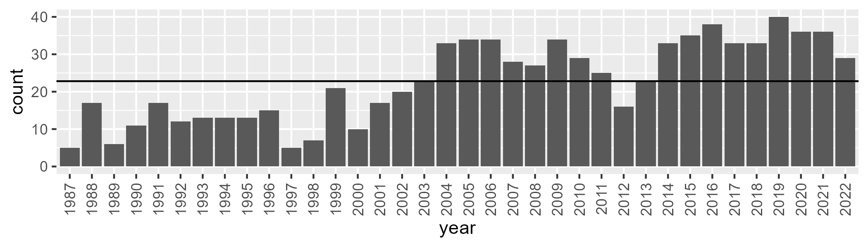

Number of samples: 821

# SAAGVD0001

| Min. | 1st Qu. | Median | Mean | 3rd Qu. | Max. |
| --- | --- | --- | --- | --- | --- |
| 0 | 3.641645 | 6.075837 | 7.251144 | 9.065017 | 29.56471 |

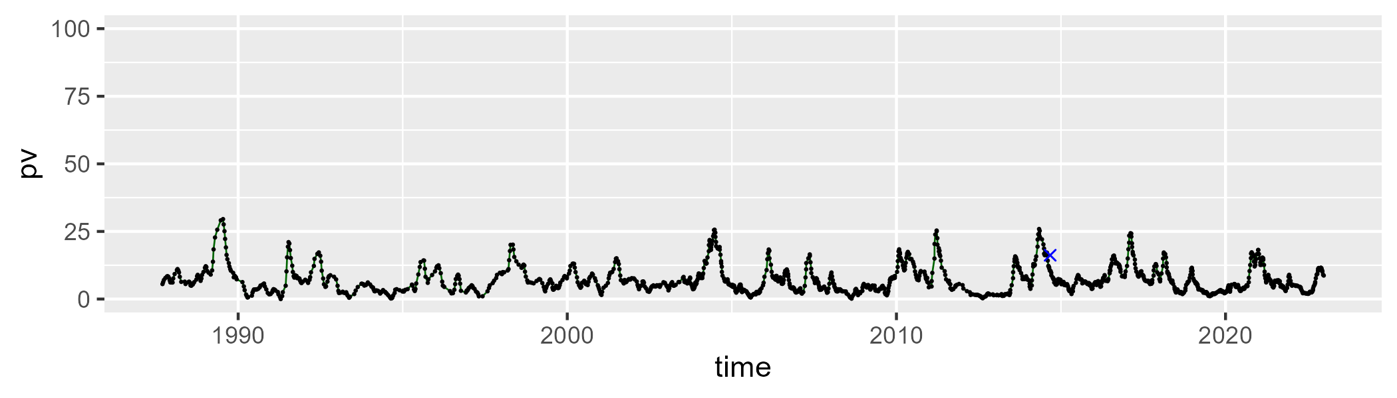

| Min. | 1st Qu. | Median | Mean | 3rd Qu. | Max. |
| --- | --- | --- | --- | --- | --- |
| 7.439685 | 33.62519 | 39.61528 | 38.71711 | 44.2015 | 60.63238 |

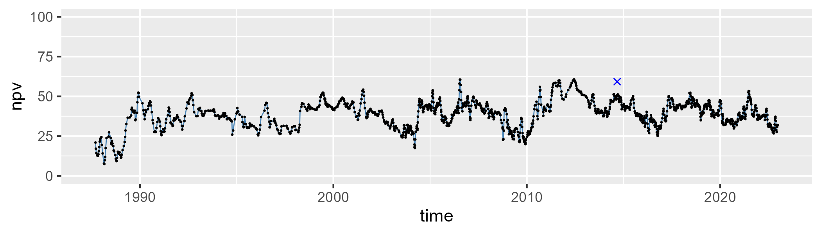

| Min. | 1st Qu. | Median | Mean | 3rd Qu. | Max. |
| --- | --- | --- | --- | --- | --- |
| 25.60605 | 46.85874 | 52.42241 | 52.5573 | 58.74993 | 80.65255 |

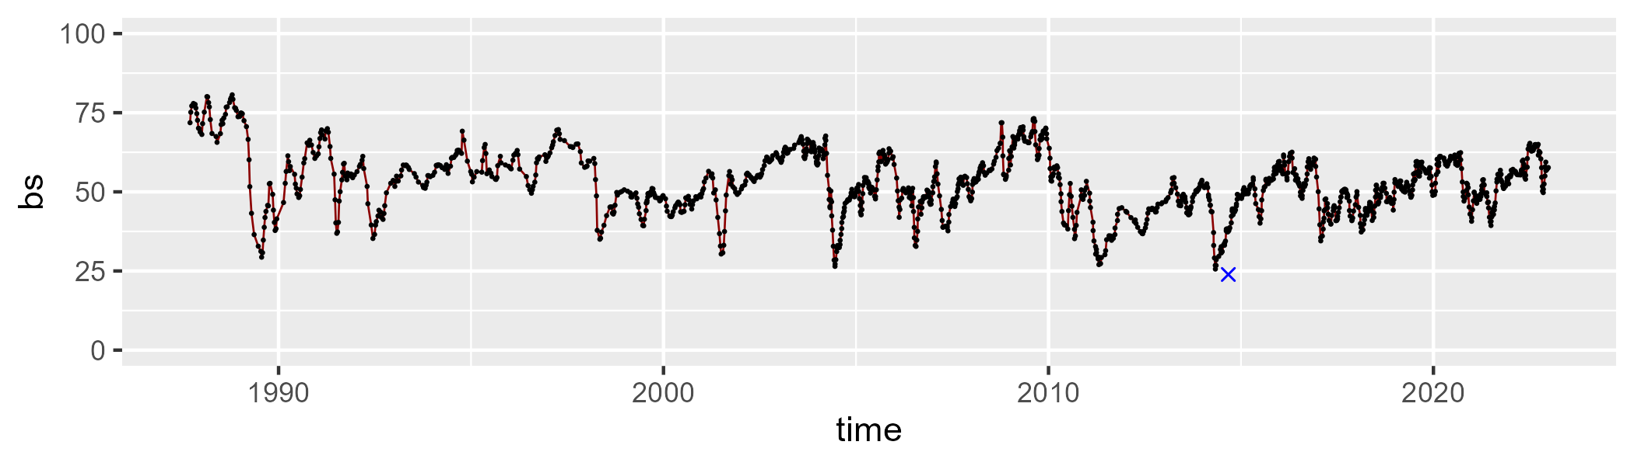

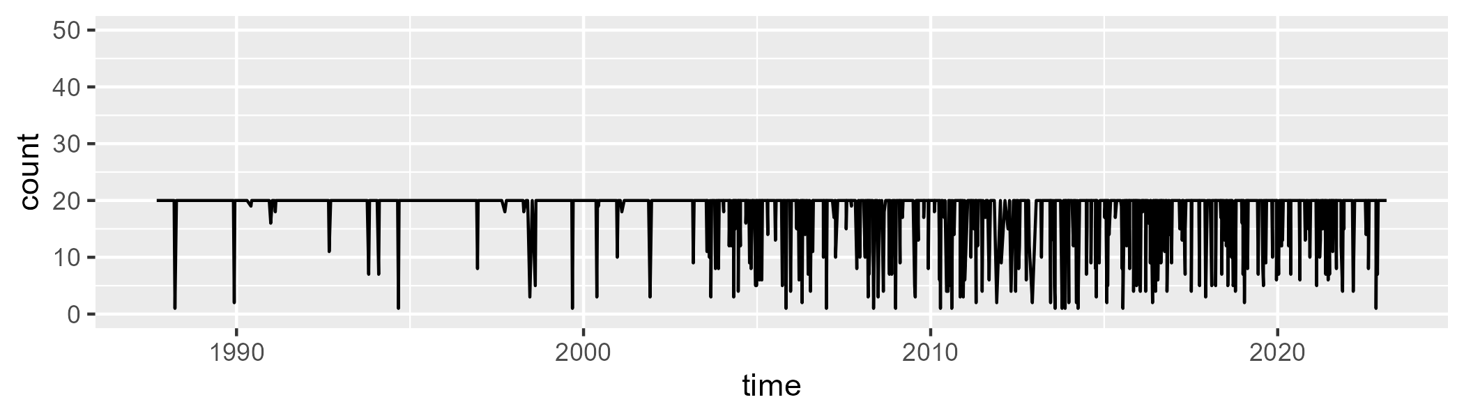

Min. : 1.00 1st Qu.:20.00 Median :20.00 Mean :18.32 3rd Qu.:20.00 Max. :20.00

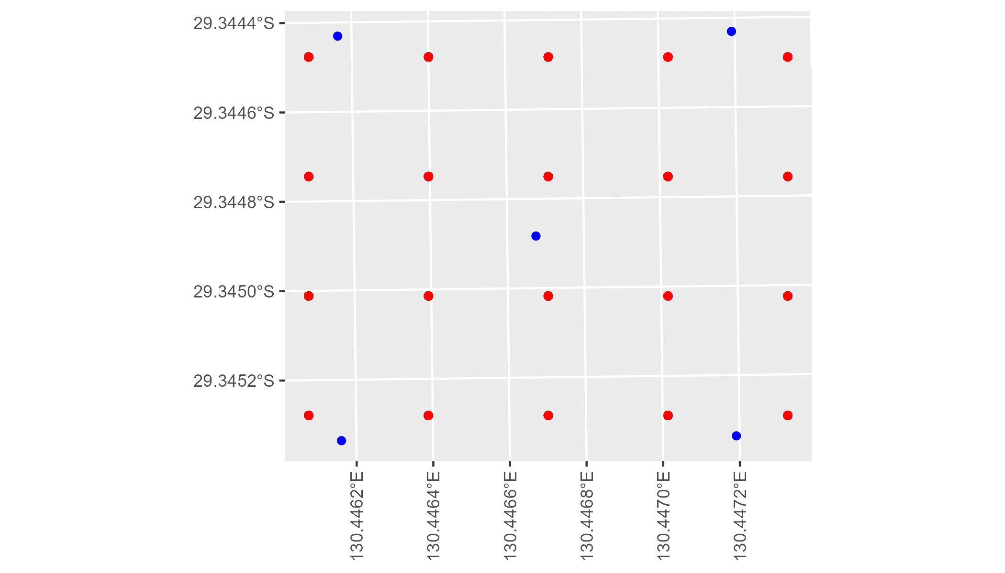

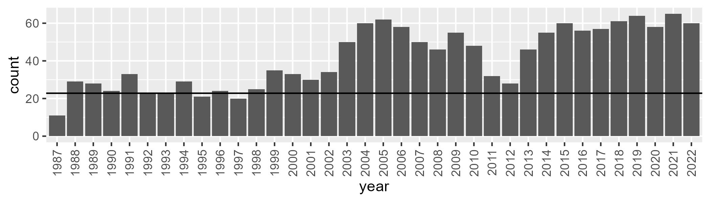

Number of samples: 1493

# SAAGVD0002

| Min. | 1st Qu. | Median | Mean | 3rd Qu. | Max. |
| --- | --- | --- | --- | --- | --- |
| 0.3024809 | 4.428244 | 6.675292 | 7.656504 | 9.651325 | 30.02757 |

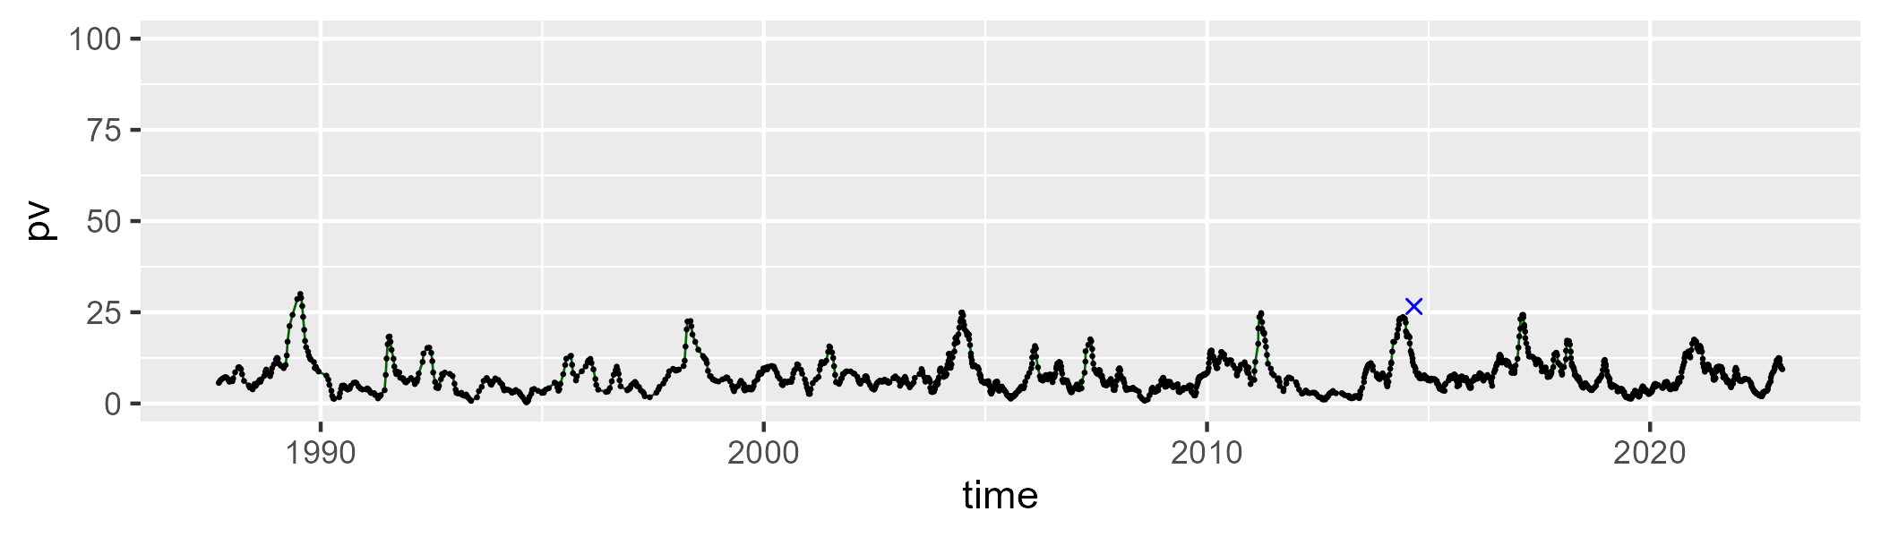

| Min. | 1st Qu. | Median | Mean | 3rd Qu. | Max. |
| --- | --- | --- | --- | --- | --- |
| 6.274432 | 32.51374 | 37.72862 | 37.22566 | 42.2699 | 58.28133 |

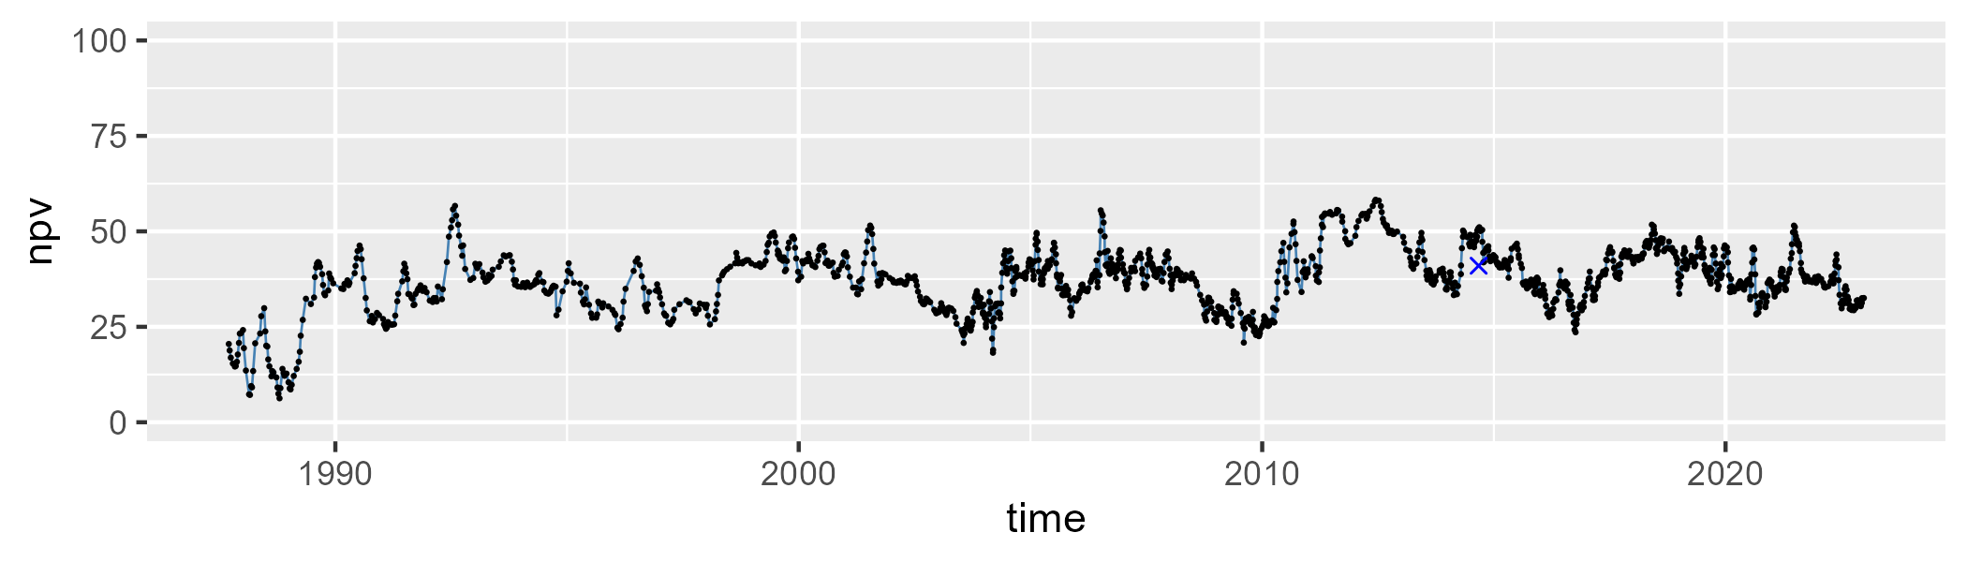

| Min. | 1st Qu. | Median | Mean | 3rd Qu. | Max. |
| --- | --- | --- | --- | --- | --- |
| 25.45732 | 48.26702 | 53.49974 | 53.62067 | 58.93815 | 83.64264 |

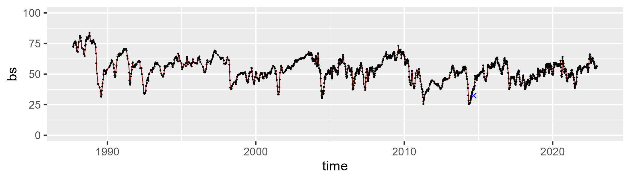

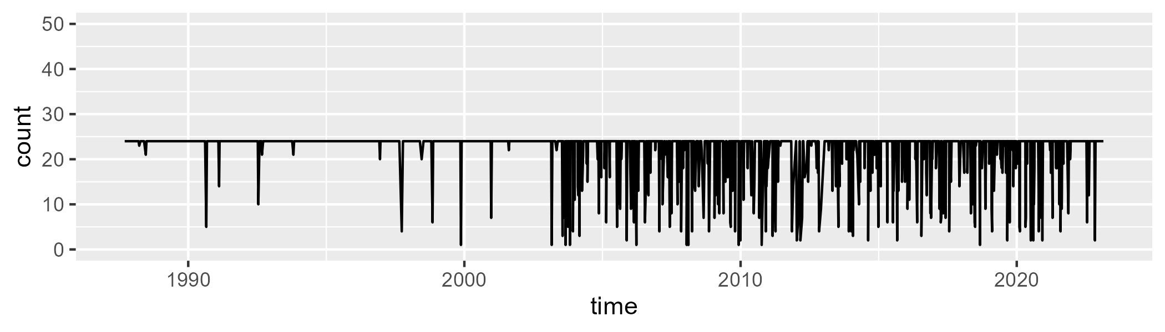

Min. : 1.00 1st Qu.:24.00 Median :24.00 Mean :22.07 3rd Qu.:24.00 Max. :24.00

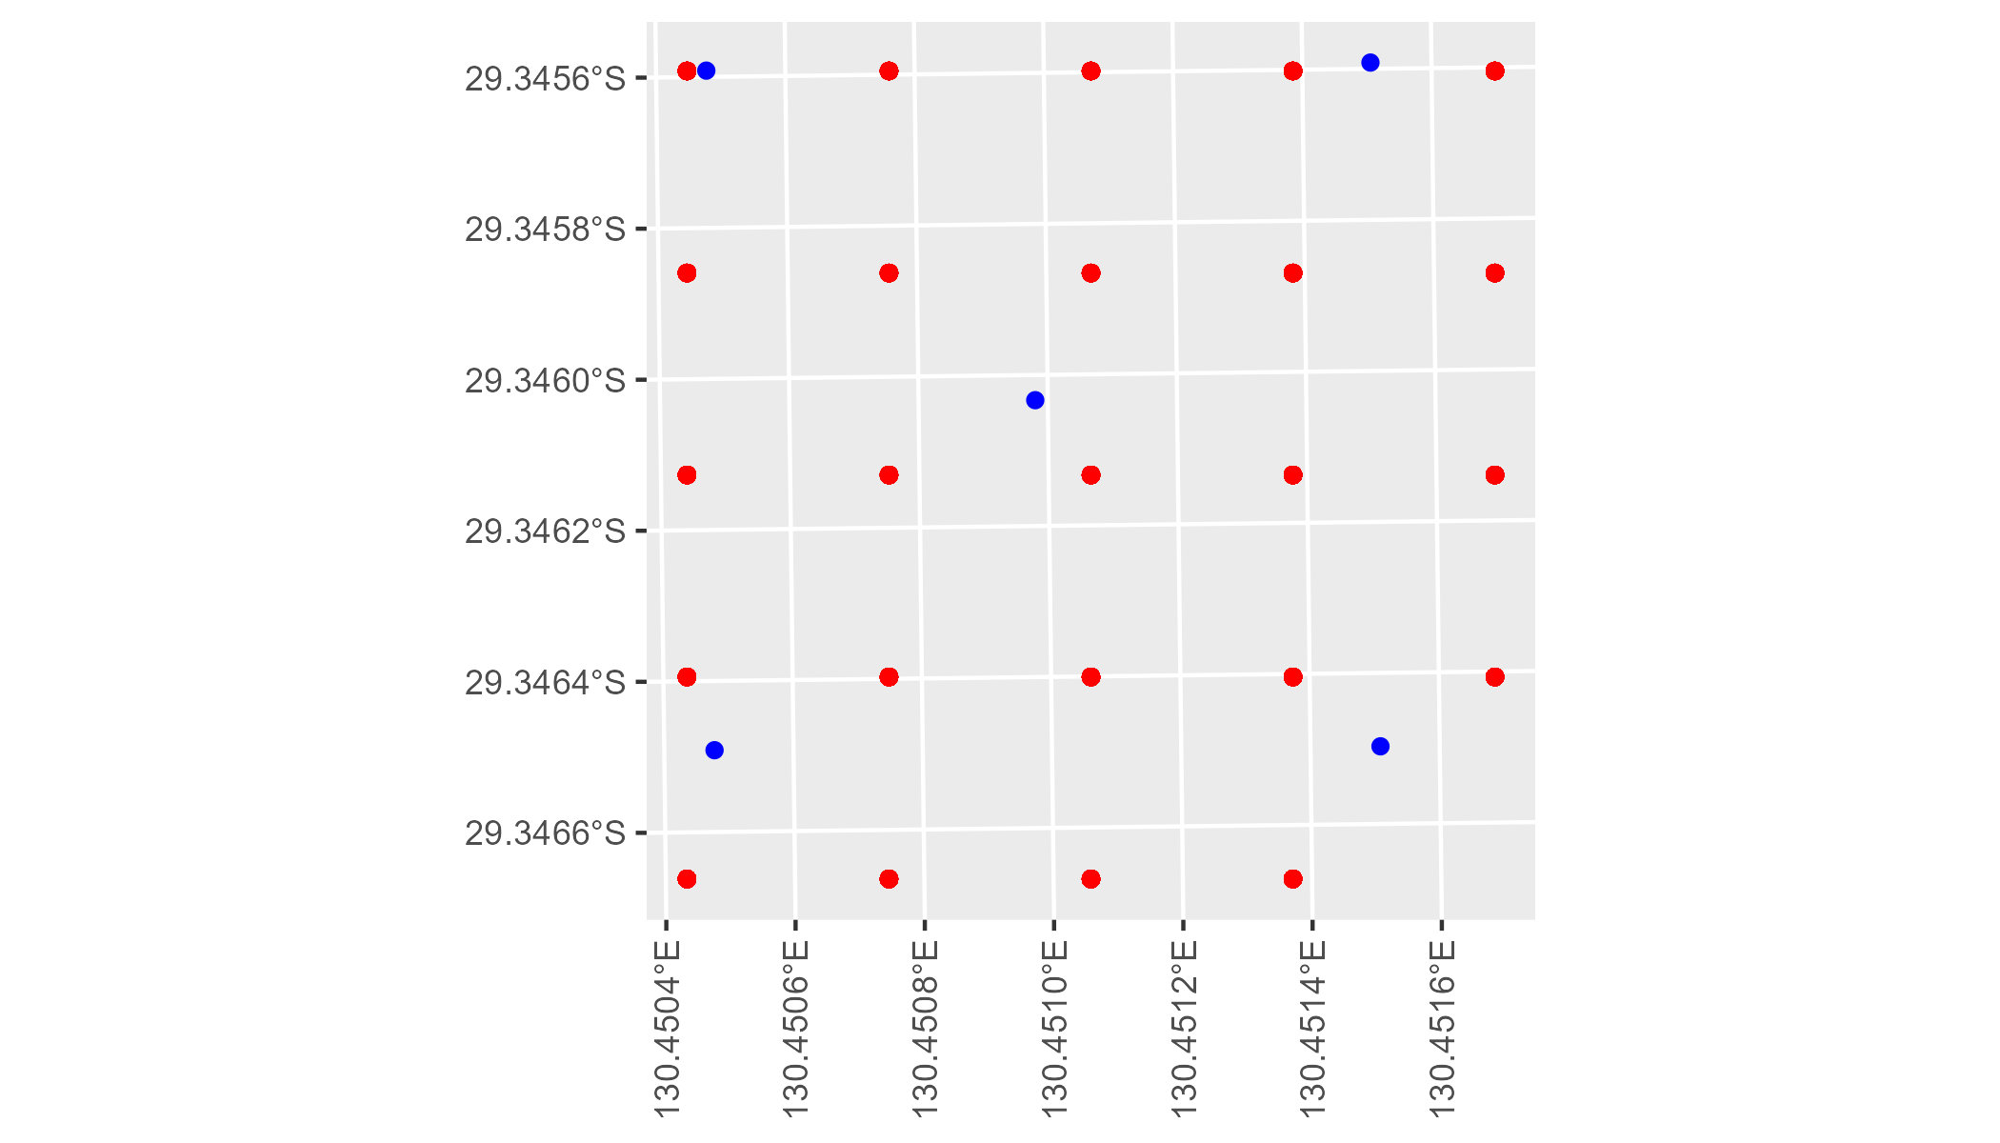

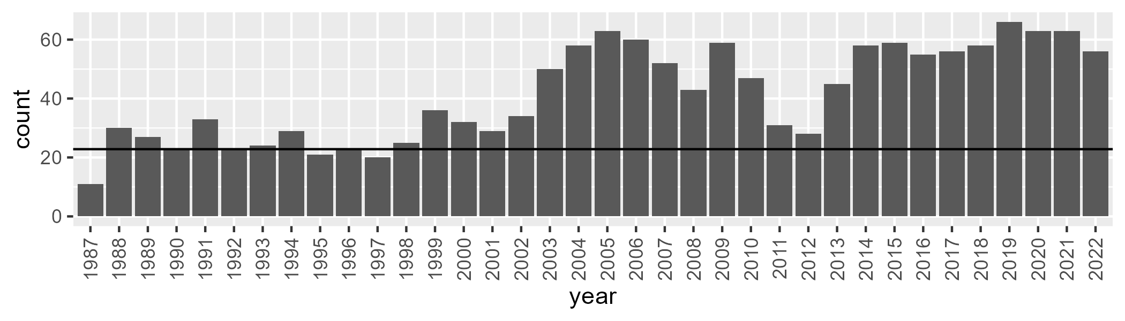

Number of samples: 1490

# SAAGVD0003

| Min. | 1st Qu. | Median | Mean | 3rd Qu. | Max. |
| --- | --- | --- | --- | --- | --- |
| 0 | 3.542516 | 6.627758 | 10.19706 | 14.24527 | 47.25733 |

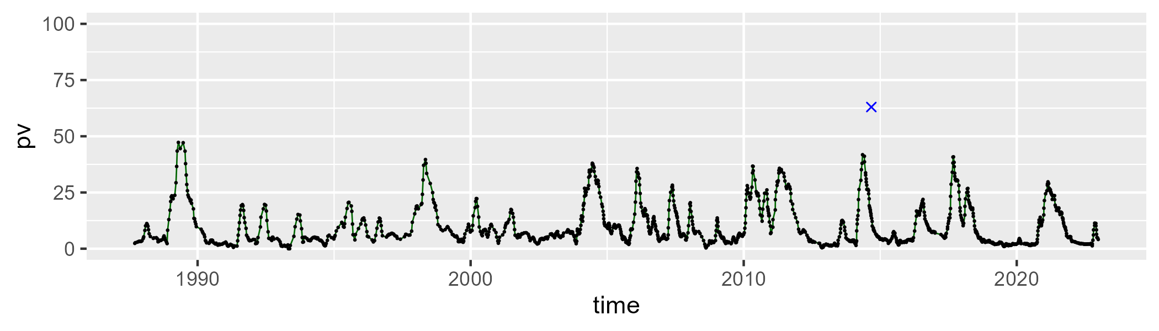

| Min. | 1st Qu. | Median | Mean | 3rd Qu. | Max. |
| --- | --- | --- | --- | --- | --- |
| 24.73116 | 40.82719 | 46.07526 | 45.89859 | 51.00845 | 69.96432 |

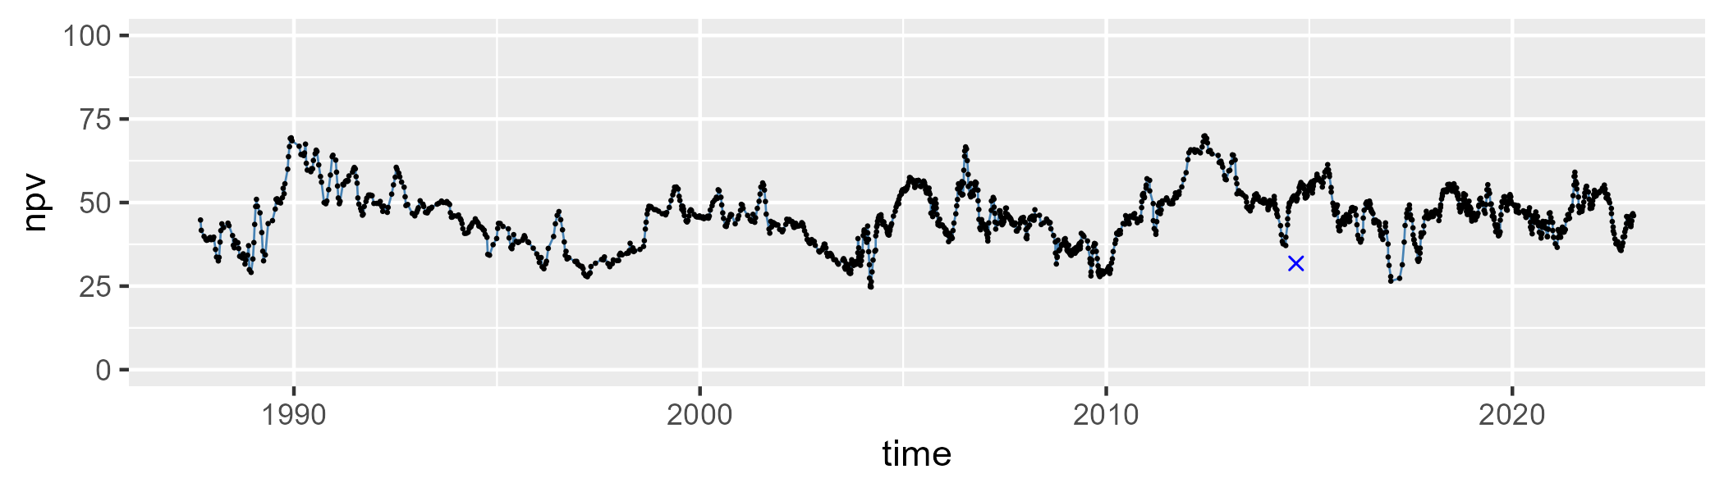

| Min. | 1st Qu. | Median | Mean | 3rd Qu. | Max. |
| --- | --- | --- | --- | --- | --- |
| 7.026189 | 34.33725 | 43.74915 | 42.51653 | 50.48032 | 65.51521 |

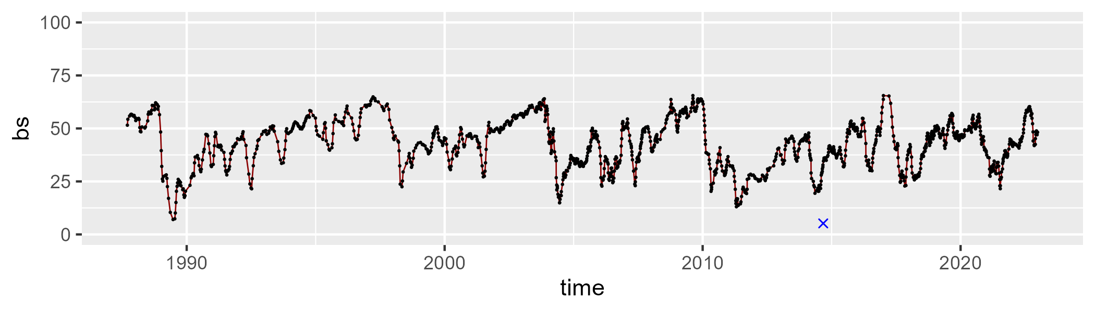

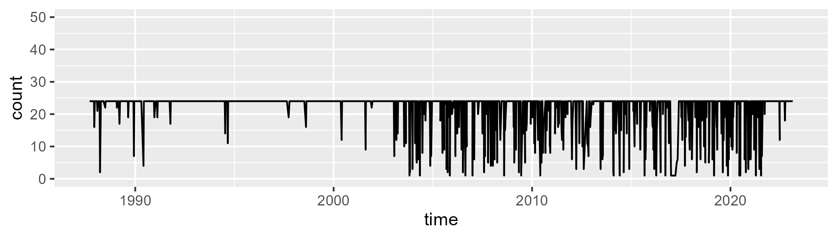

Min. : 1.00 1st Qu.:24.00 Median :24.00 Mean :21.92 3rd Qu.:24.00 Max. :24.00

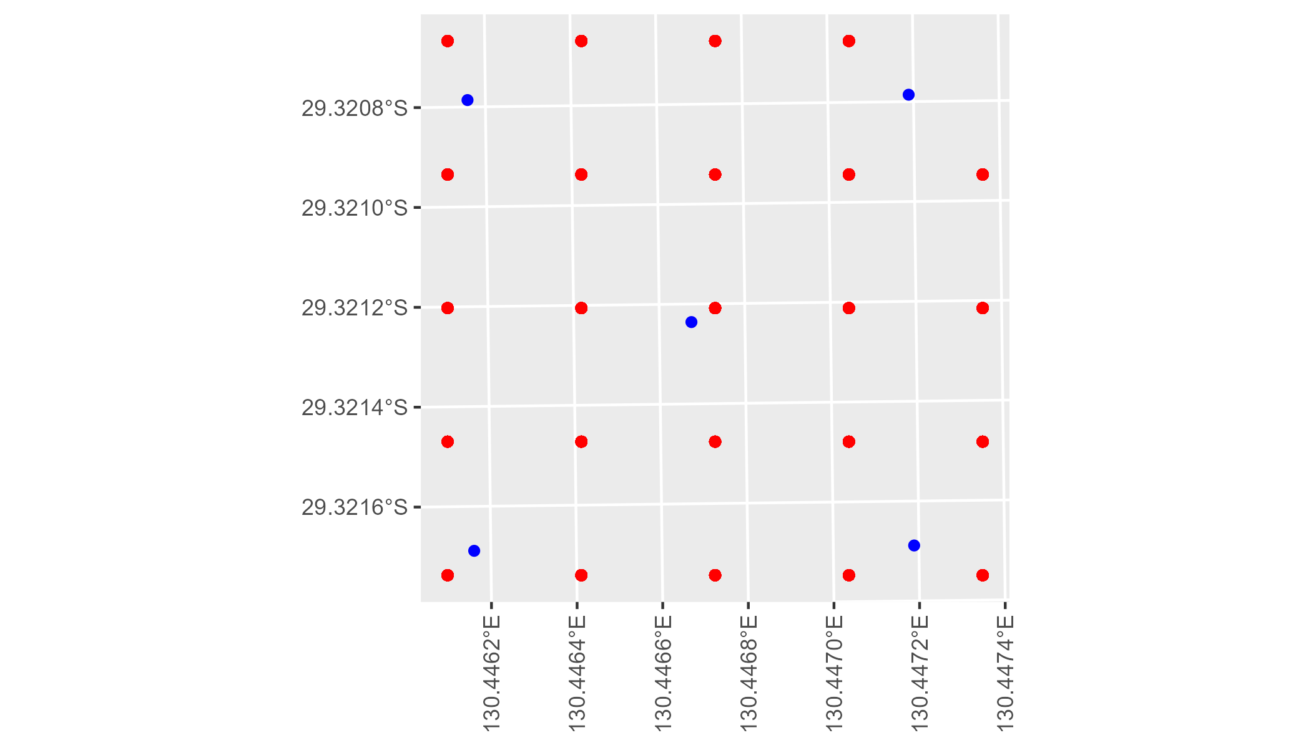

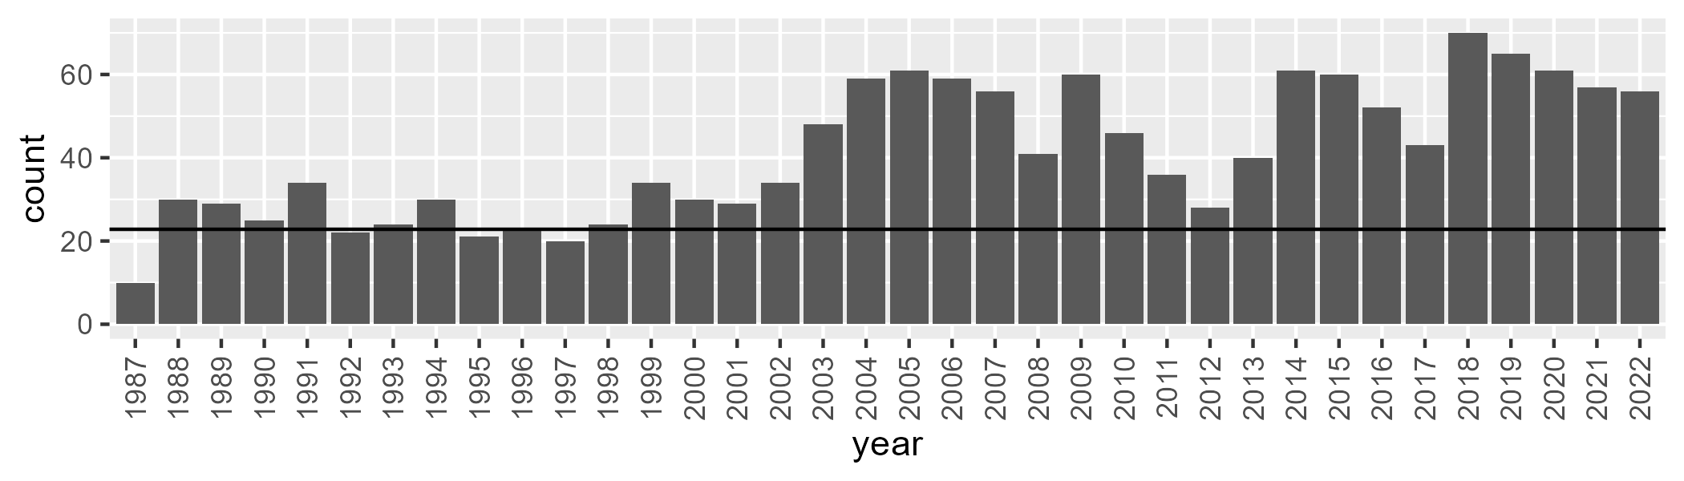

Number of samples: 1478

# SAAGVD0004

| Min. | 1st Qu. | Median | Mean | 3rd Qu. | Max. |
| --- | --- | --- | --- | --- | --- |
| 0 | 6.782308 | 9.675085 | 10.44187 | 13.00674 | 29.64816 |

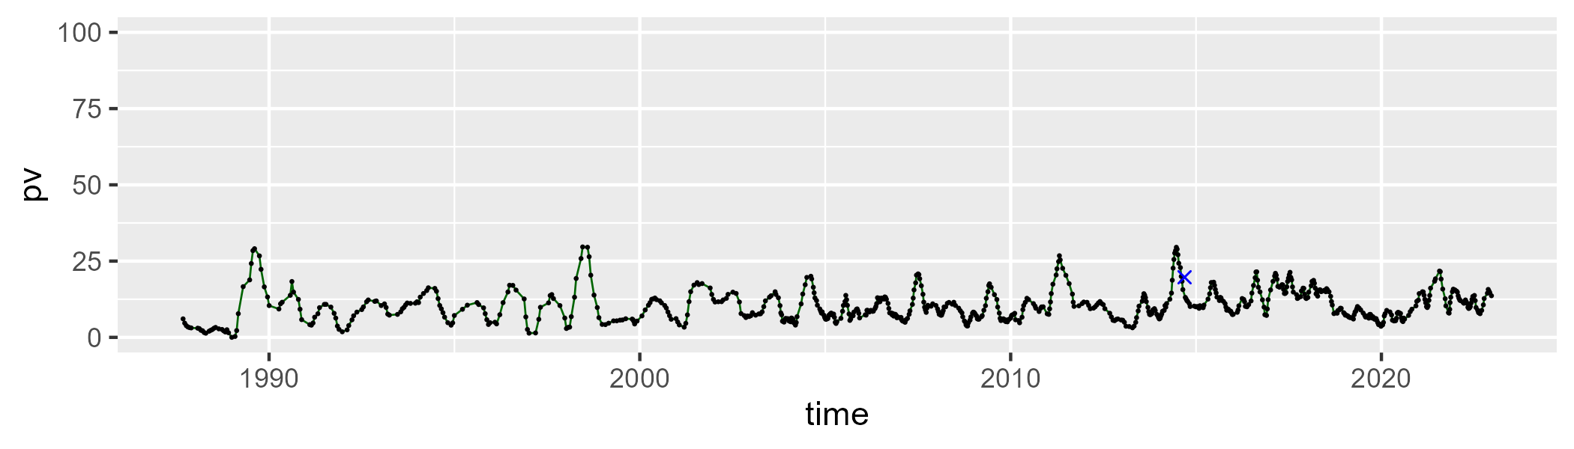

| Min. | 1st Qu. | Median | Mean | 3rd Qu. | Max. |
| --- | --- | --- | --- | --- | --- |
| 41.51322 | 47.8701 | 50.47476 | 50.95268 | 53.249 | 67.4497 |

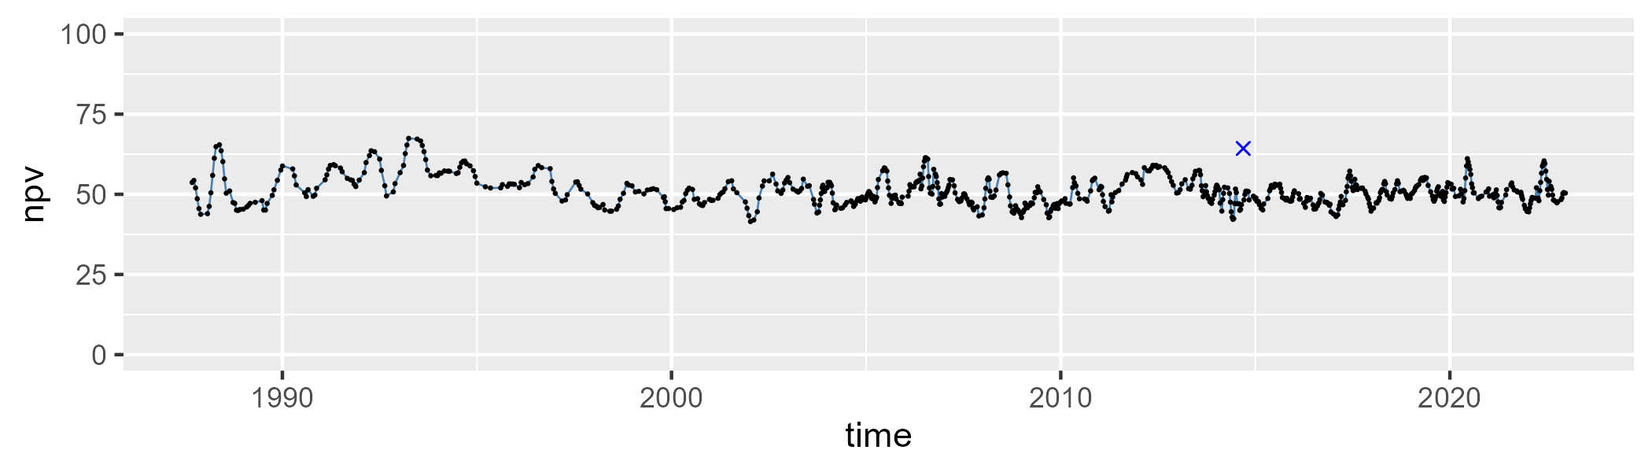

| Min. | 1st Qu. | Median | Mean | 3rd Qu. | Max. |
| --- | --- | --- | --- | --- | --- |
| 18.22188 | 32.69454 | 37.96516 | 37.23044 | 41.70025 | 53.88677 |

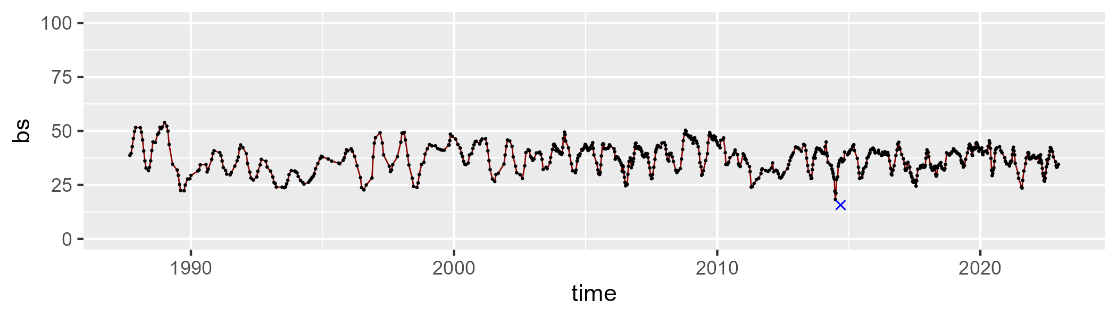

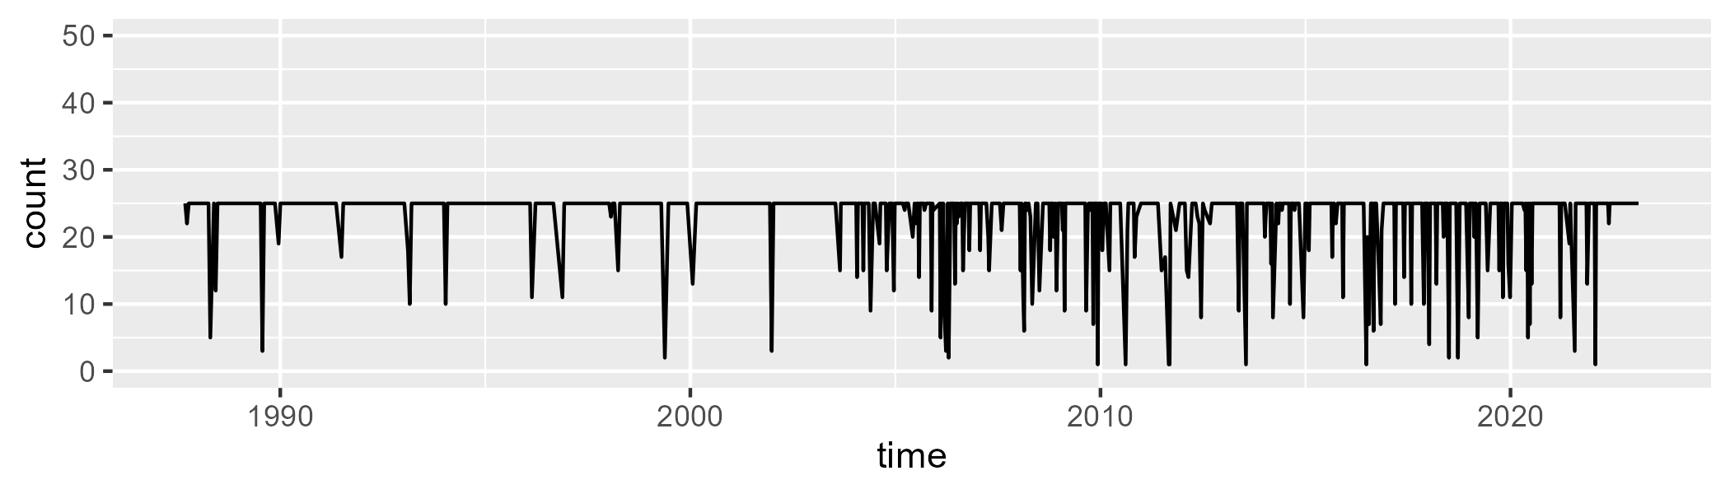

Min. : 1.00 1st Qu.:25.00 Median :25.00 Mean :23.14 3rd Qu.:25.00 Max. :25.00

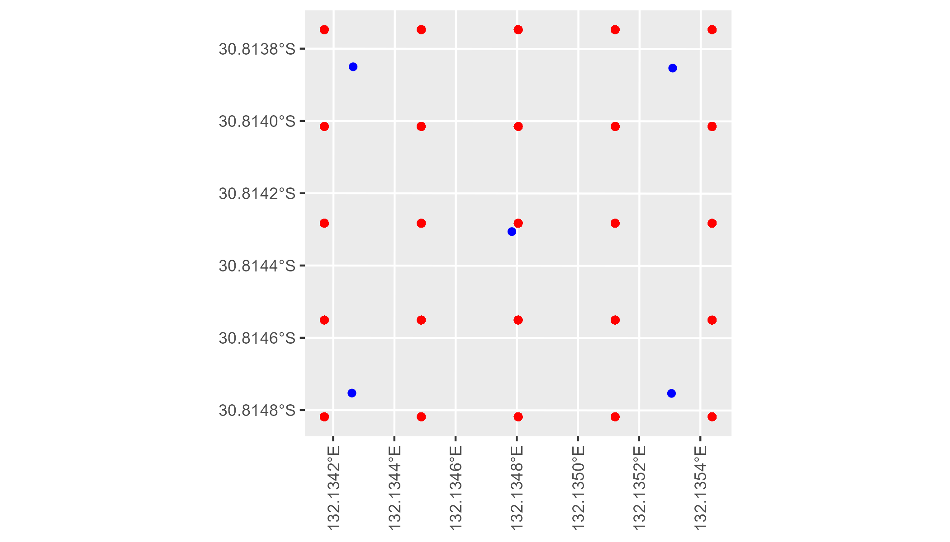

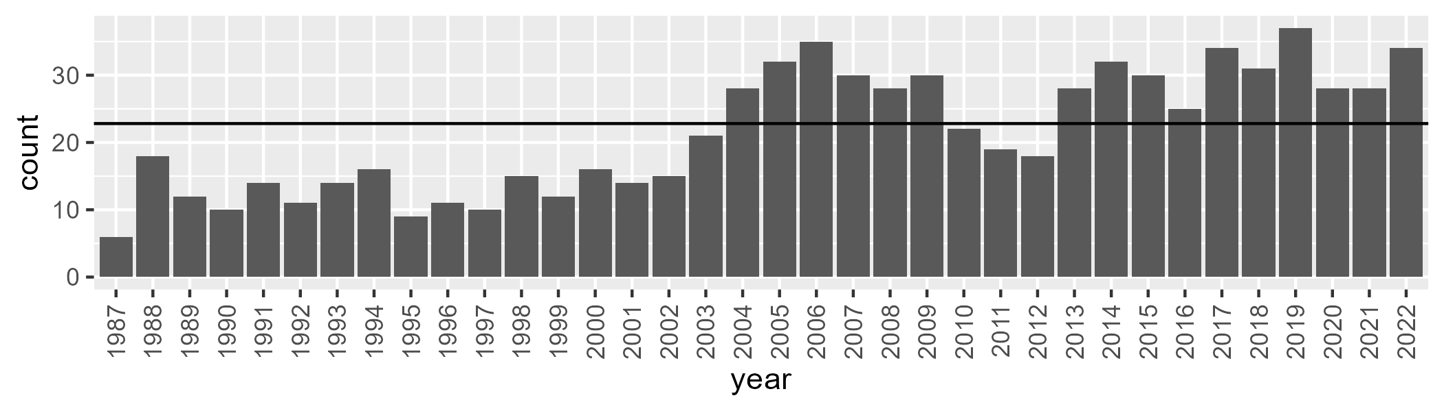

Number of samples: 773

# SAAKAN0001

| Min. | 1st Qu. | Median | Mean | 3rd Qu. | Max. |
| --- | --- | --- | --- | --- | --- |
| 31.71225 | 45.36631 | 49.898 | 49.18033 | 52.71961 | 67.2973 |

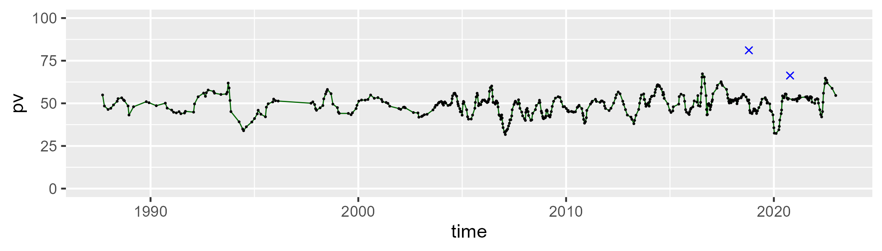

| Min. | 1st Qu. | Median | Mean | 3rd Qu. | Max. |
| --- | --- | --- | --- | --- | --- |
| 18.58124 | 34.41357 | 38.49089 | 38.17017 | 42.01231 | 59.32287 |

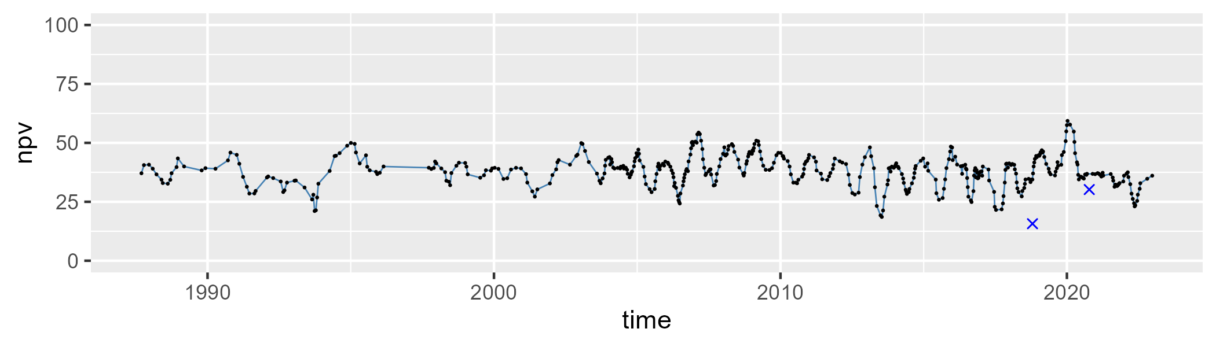

| Min. | 1st Qu. | Median | Mean | 3rd Qu. | Max. |
| --- | --- | --- | --- | --- | --- |
| 0.8512923 | 7.900403 | 10.3456 | 11.29158 | 13.8031 | 32.39284 |

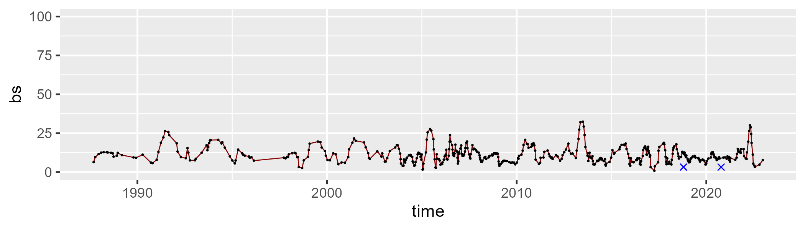

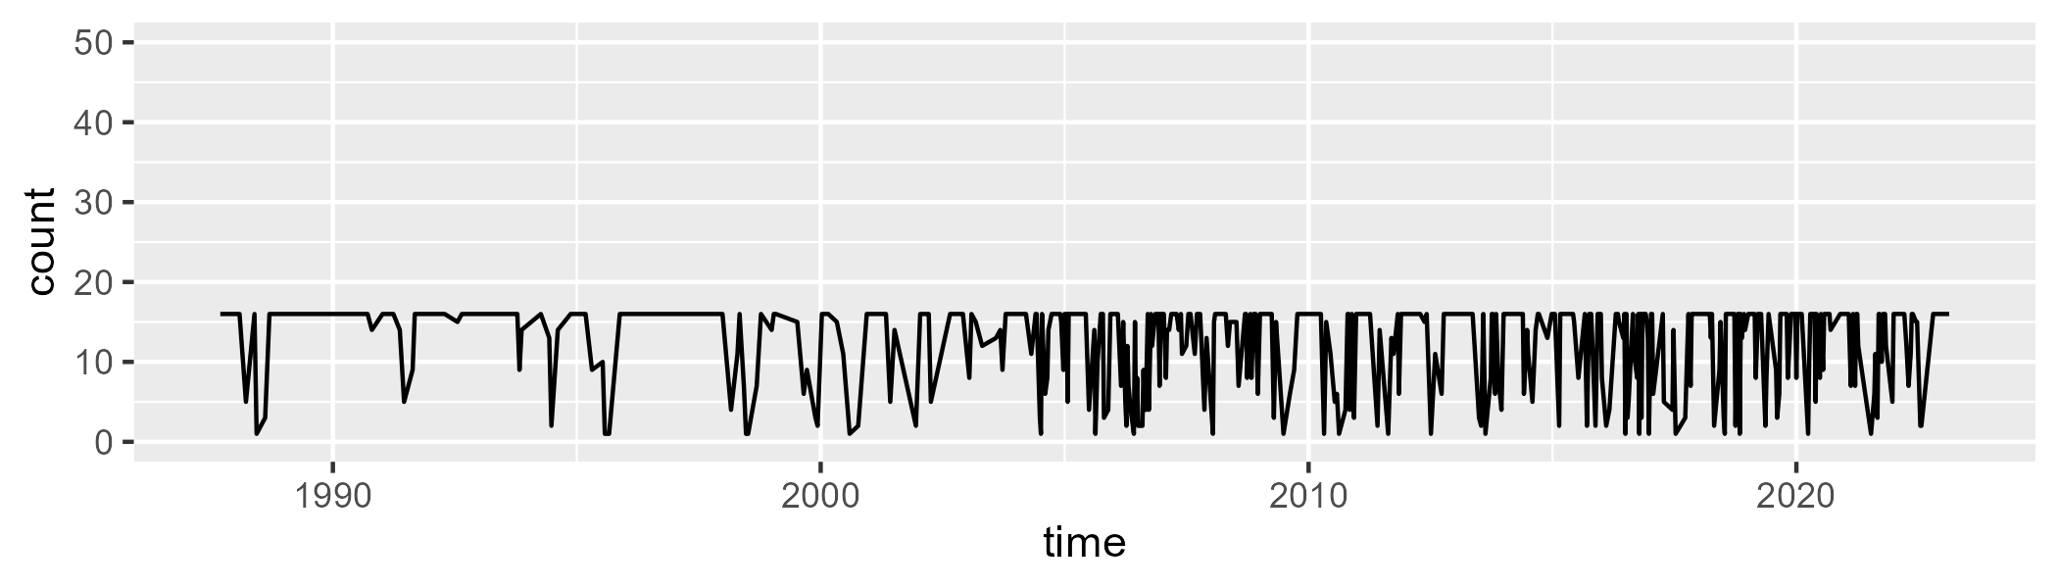

Min. : 1.0 1st Qu.: 8.0 Median :16.0 Mean :12.4 3rd Qu.:16.0 Max. :16.0

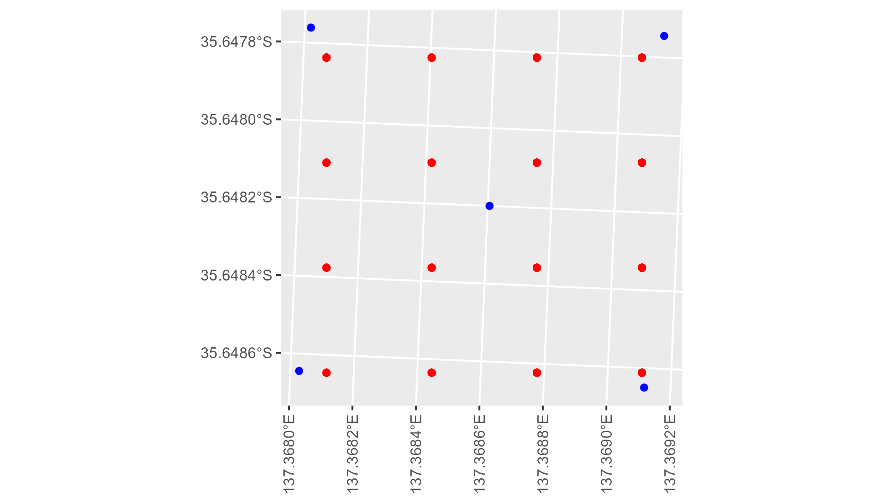

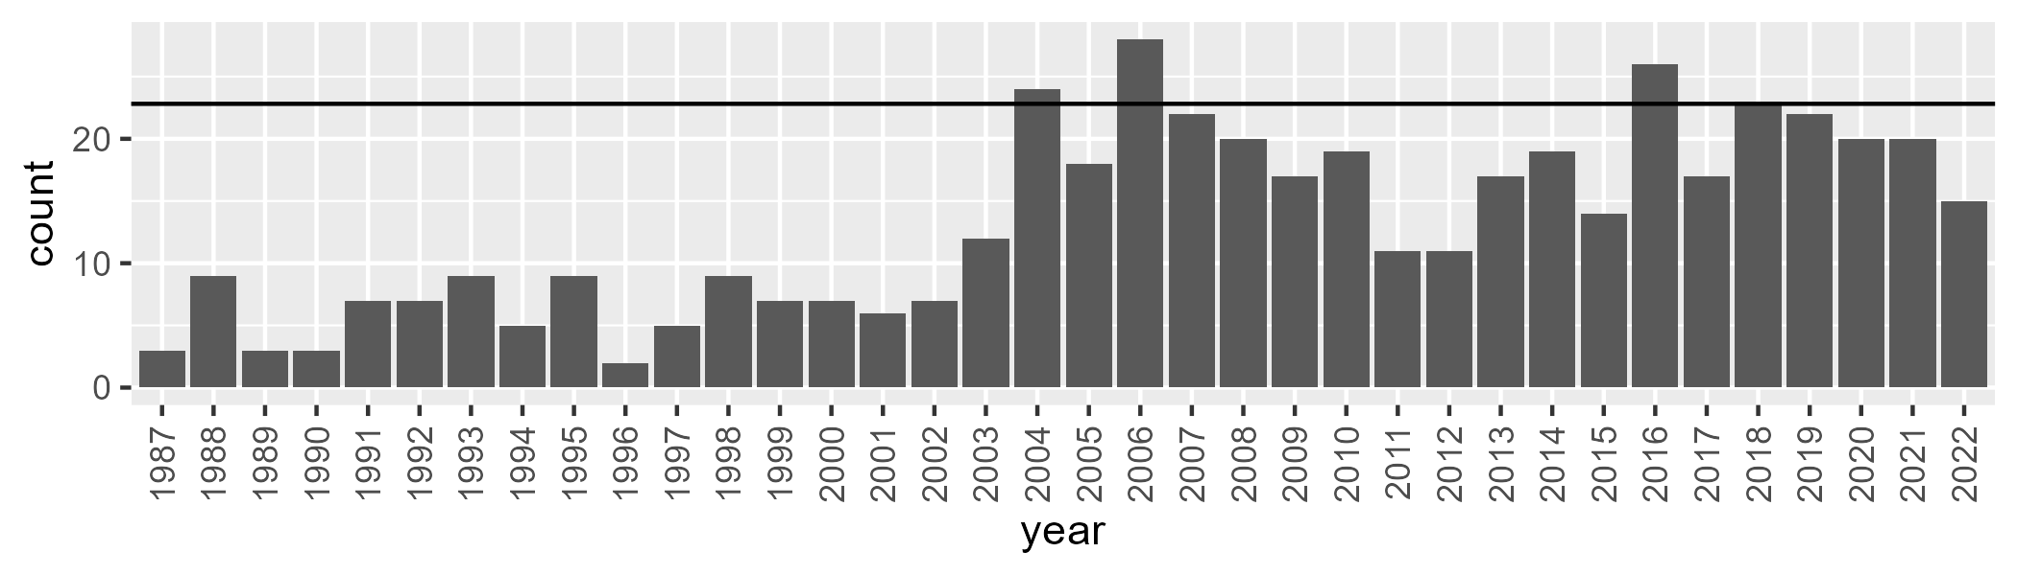

Number of samples: 473

# SAAKAN0002

| Min. | 1st Qu. | Median | Mean | 3rd Qu. | Max. |
| --- | --- | --- | --- | --- | --- |
| 4.972175 | 48.97061 | 52.86471 | 50.96394 | 56.22522 | 69.40232 |

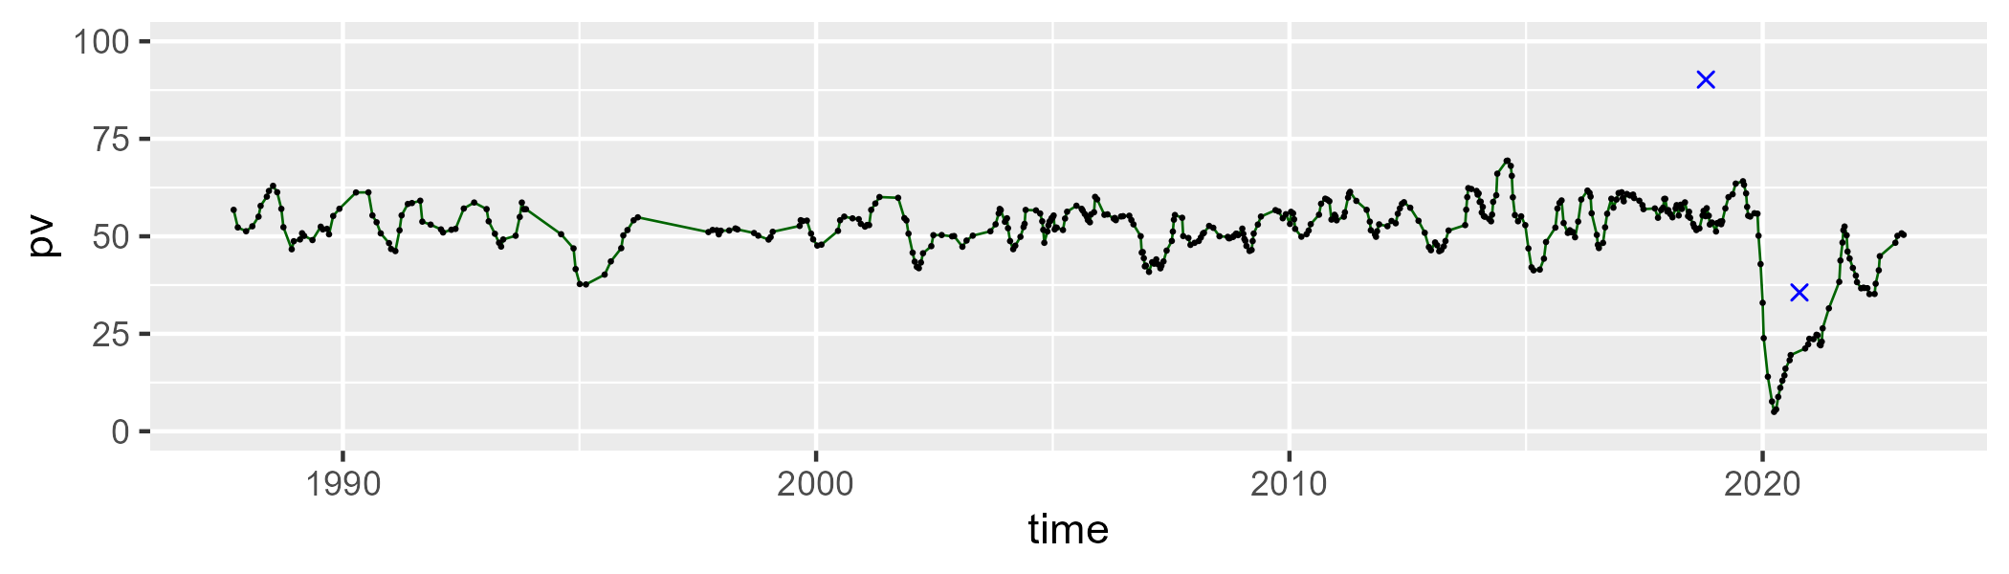

| Min. | 1st Qu. | Median | Mean | 3rd Qu. | Max. |
| --- | --- | --- | --- | --- | --- |
| 22.37528 | 31.86962 | 36.01256 | 36.20761 | 39.36698 | 58.24418 |

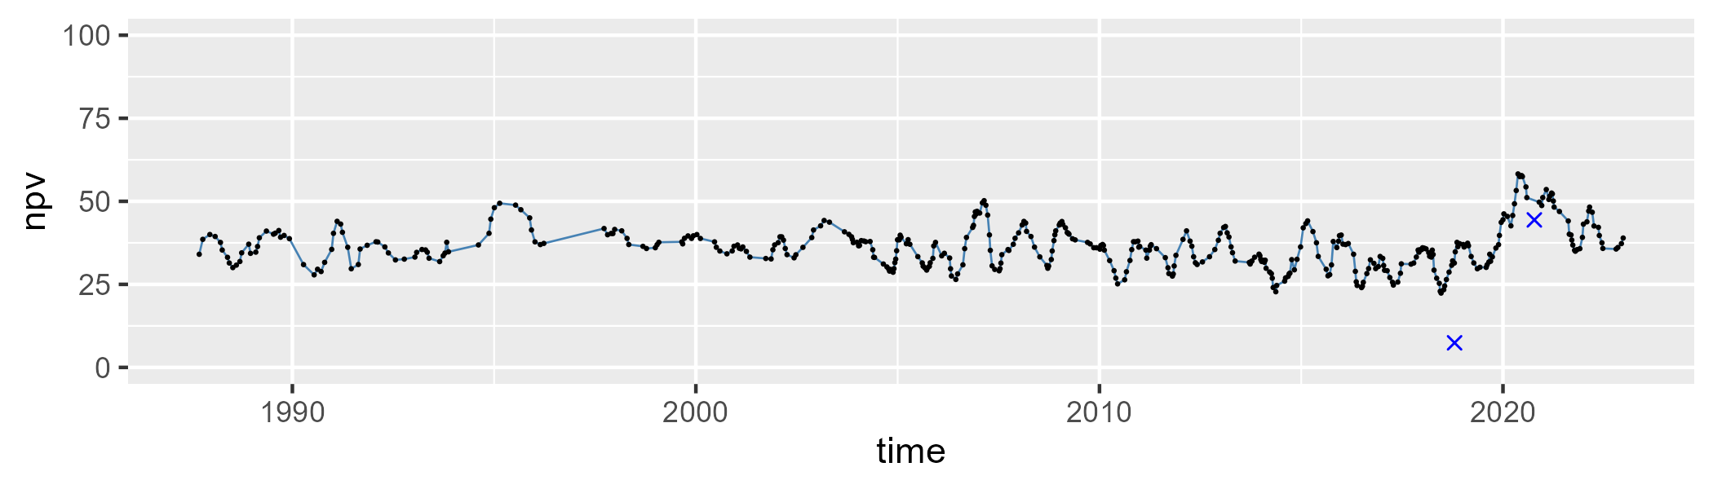

| Min. | 1st Qu. | Median | Mean | 3rd Qu. | Max. |
| --- | --- | --- | --- | --- | --- |
| 0.4217493 | 7.028038 | 9.849227 | 11.43017 | 14.5498 | 48.09662 |

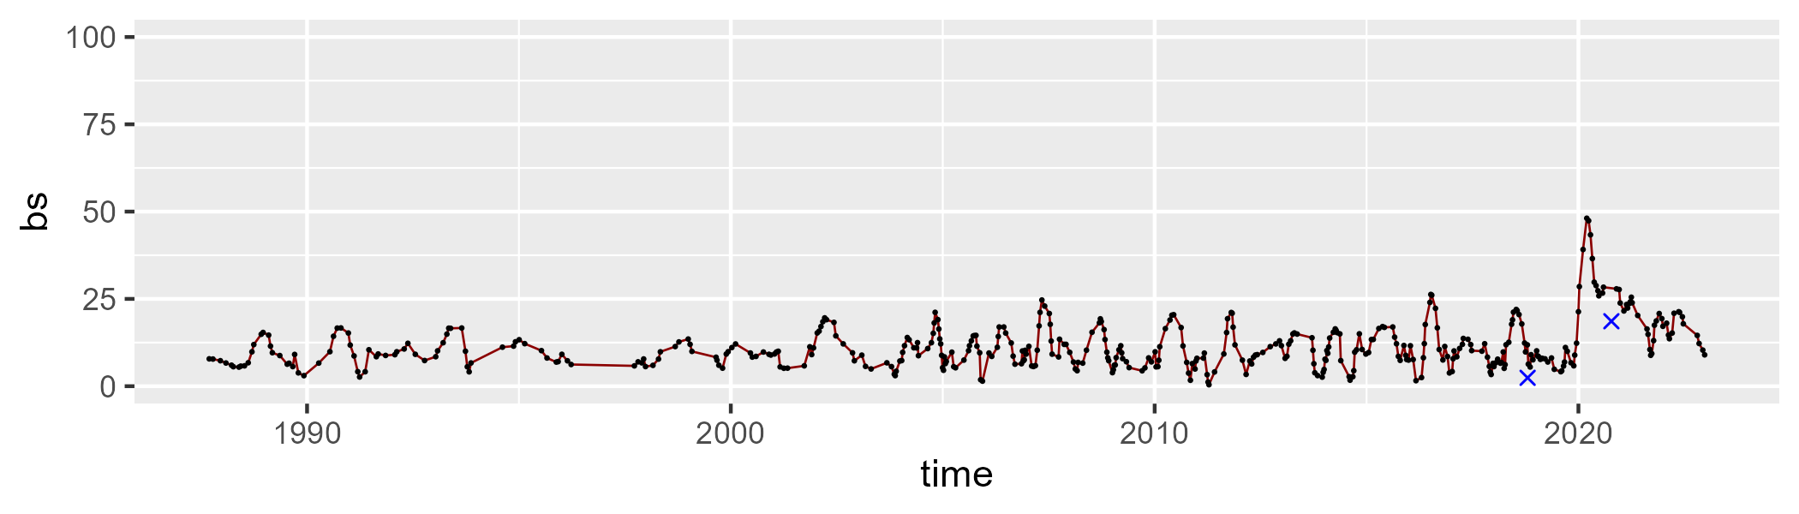

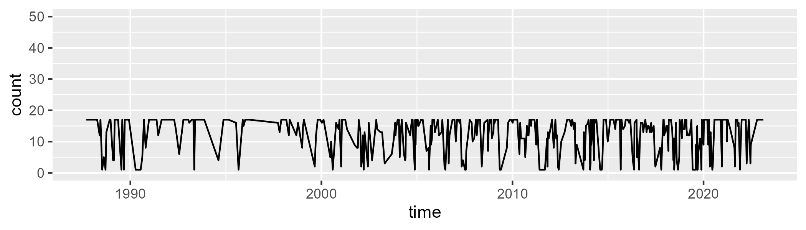

Min. : 1.00 1st Qu.: 9.00 Median :16.00 Mean :12.52 3rd Qu.:17.00 Max. :17.00

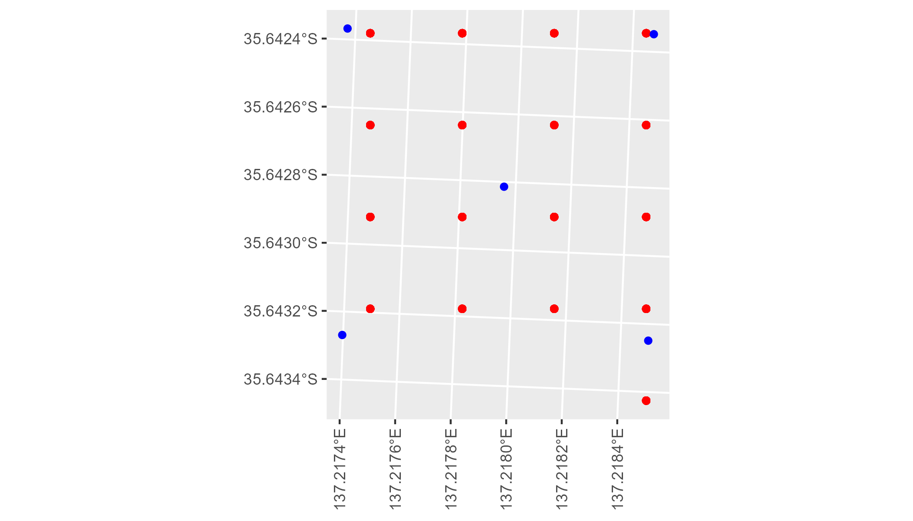

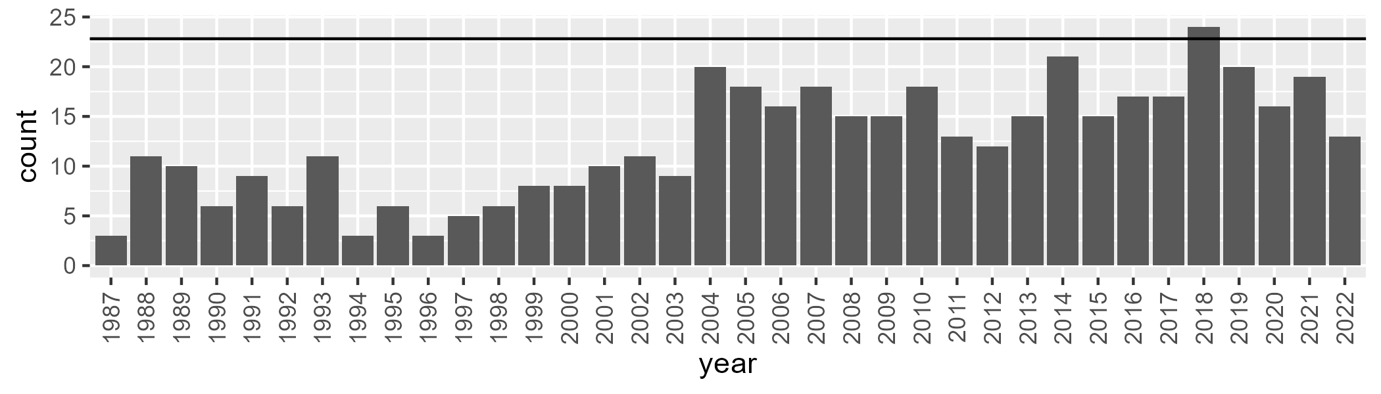

Number of samples: 447

# SAAKAN0003

| Min. | 1st Qu. | Median | Mean | 3rd Qu. | Max. |
| --- | --- | --- | --- | --- | --- |
| 5.388396 | 52.67119 | 56.45233 | 55.09009 | 60.14387 | 71.2549 |

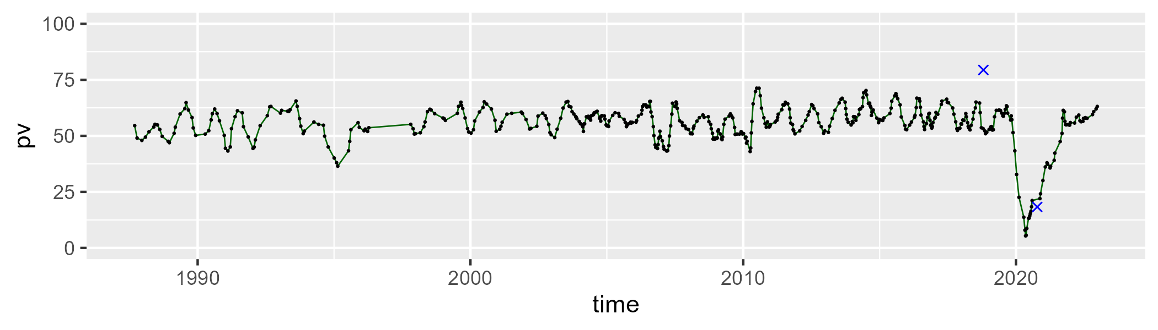

| Min. | 1st Qu. | Median | Mean | 3rd Qu. | Max. |
| --- | --- | --- | --- | --- | --- |
| 19.13899 | 29.99002 | 33.95263 | 34.14866 | 37.76893 | 58.23562 |

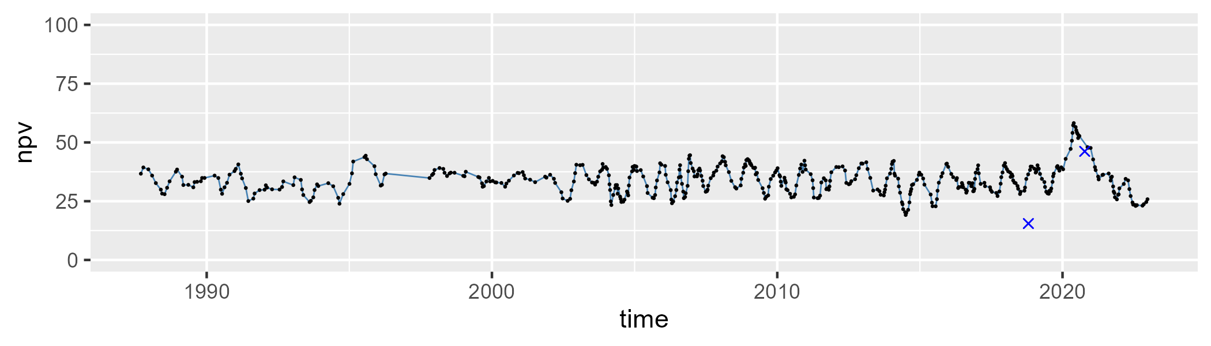

| Min. | 1st Qu. | Median | Mean | 3rd Qu. | Max. |
| --- | --- | --- | --- | --- | --- |
| 0 | 4.614592 | 8.017417 | 9.440988 | 12.94373 | 40.03925 |

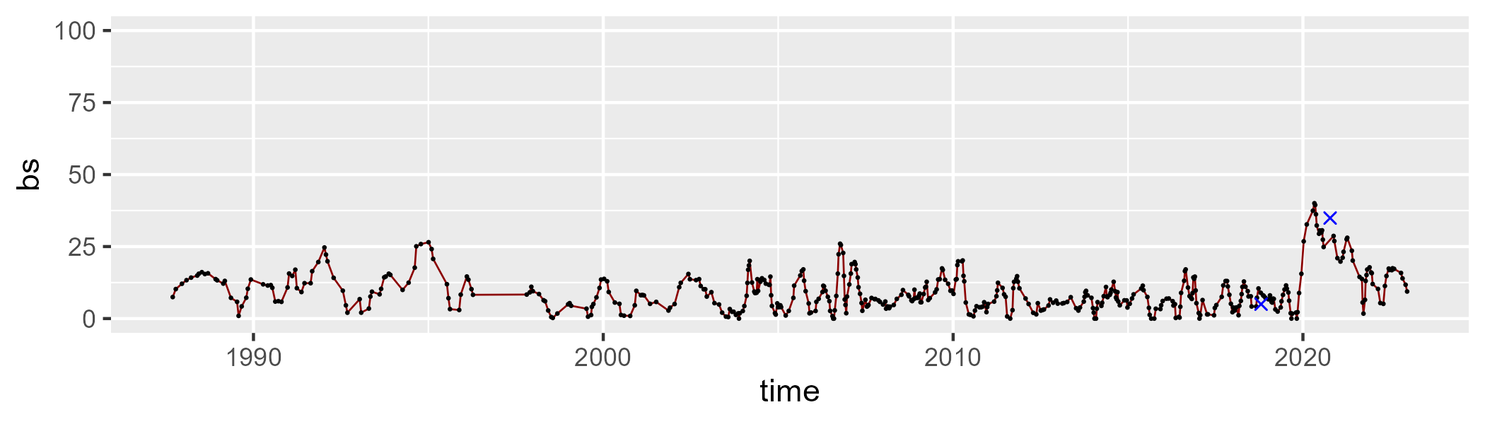

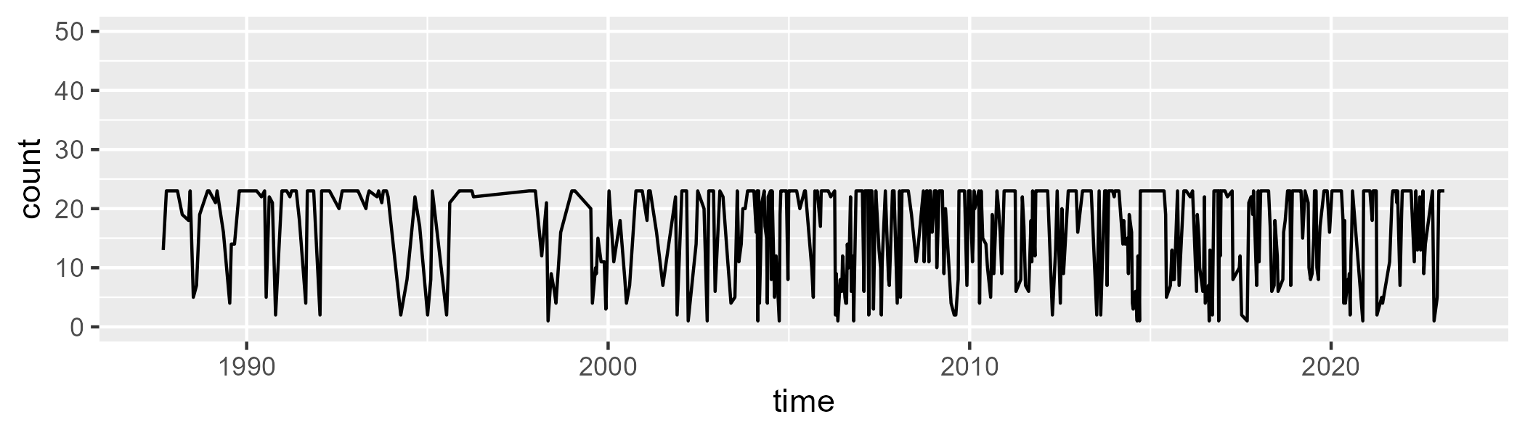

Min. : 1.00 1st Qu.:10.00 Median :22.00 Mean :16.75 3rd Qu.:23.00 Max. :23.00

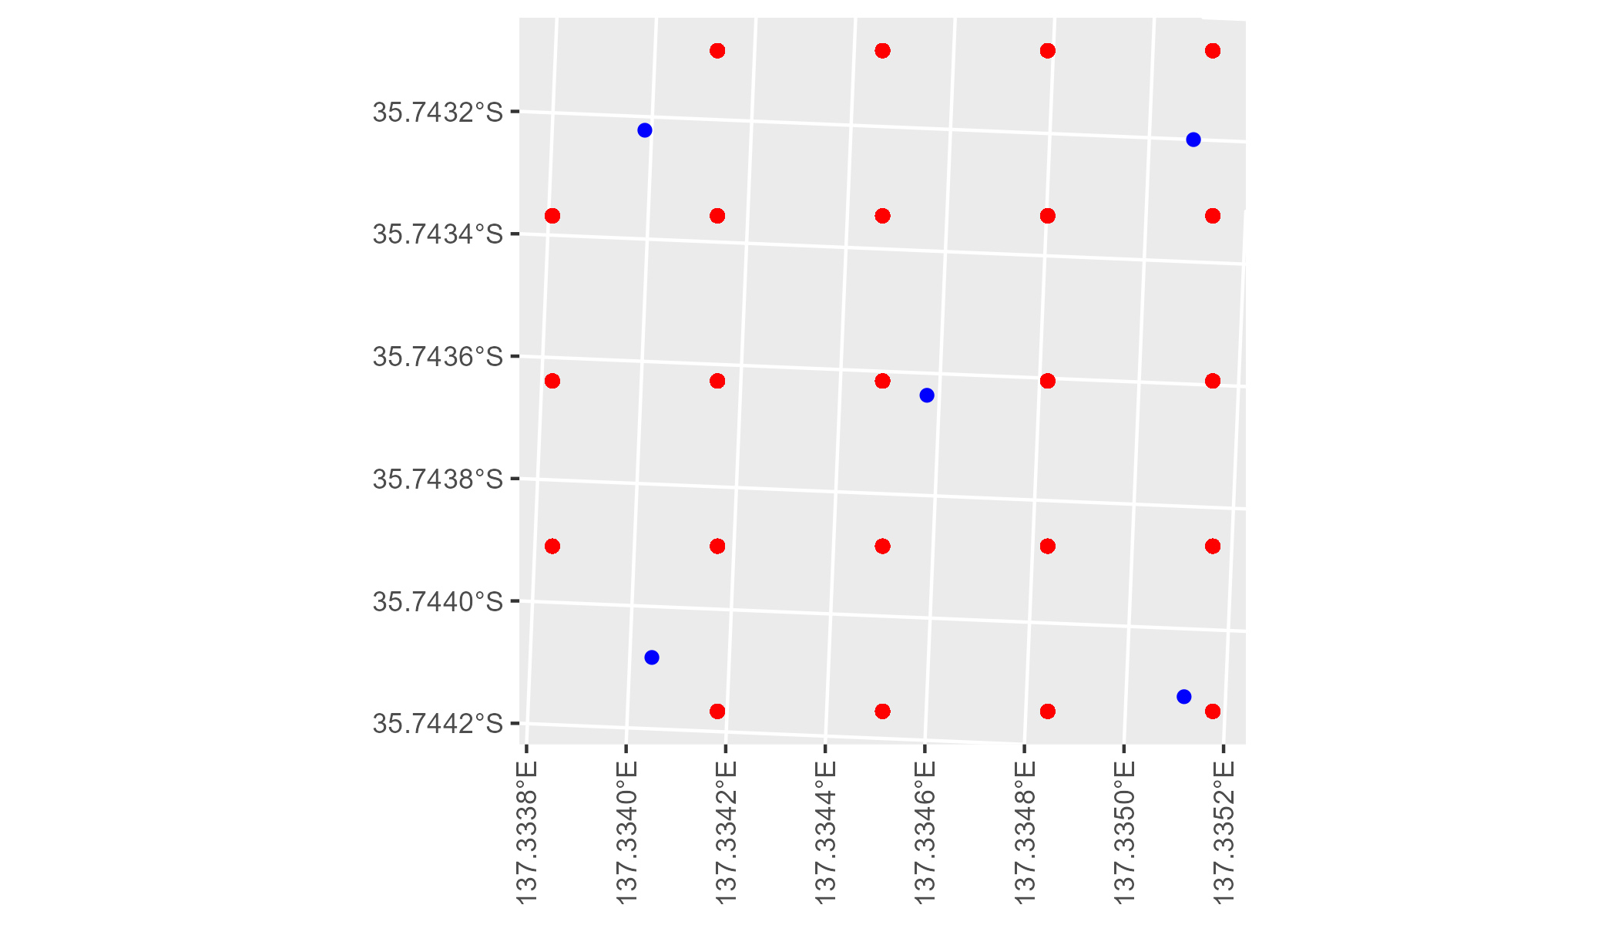

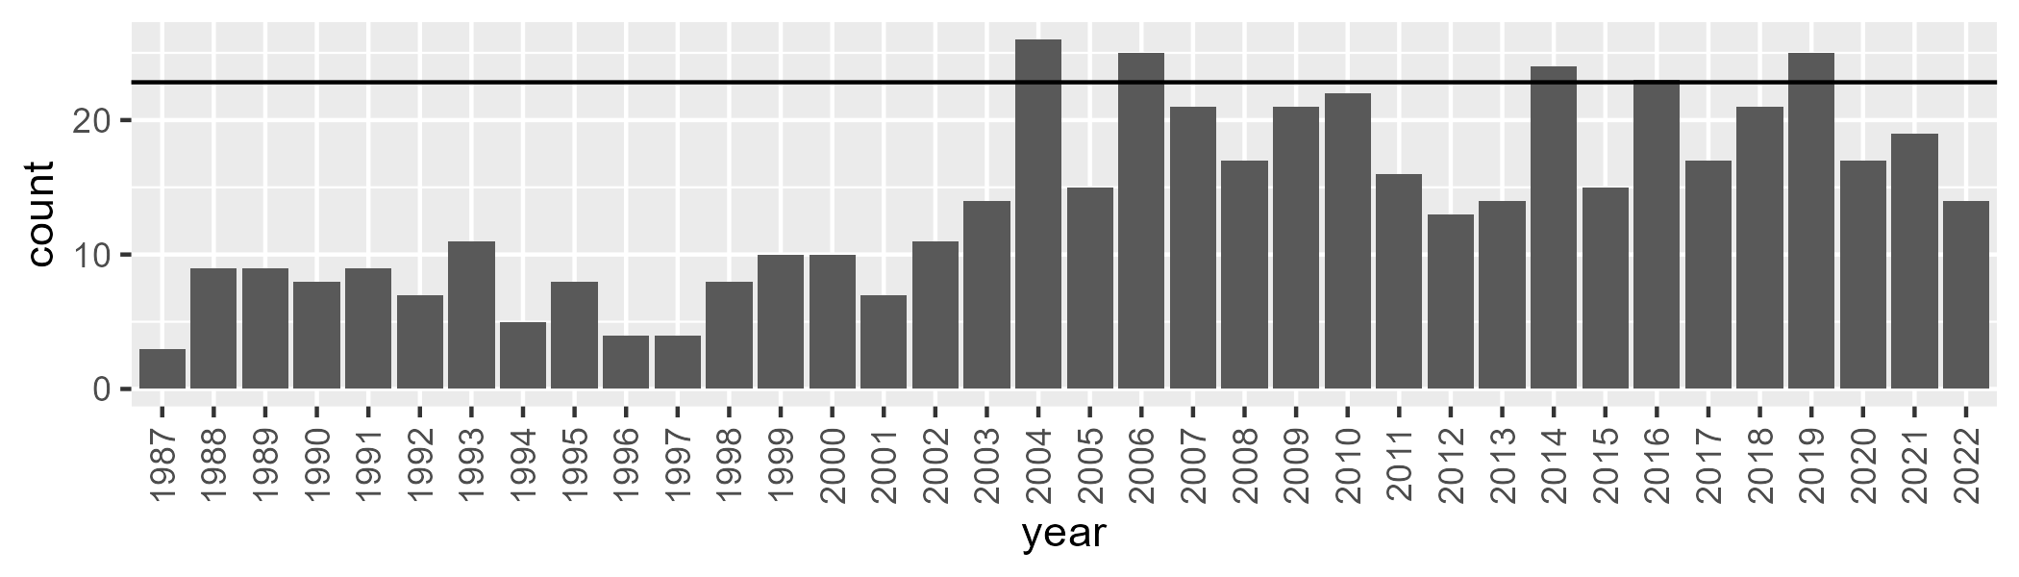

Number of samples: 502

# SAAKAN0004

| Min. | 1st Qu. | Median | Mean | 3rd Qu. | Max. |
| --- | --- | --- | --- | --- | --- |
| 0 | 36.44009 | 49.76357 | 45.33037 | 55.41083 | 67.46794 |

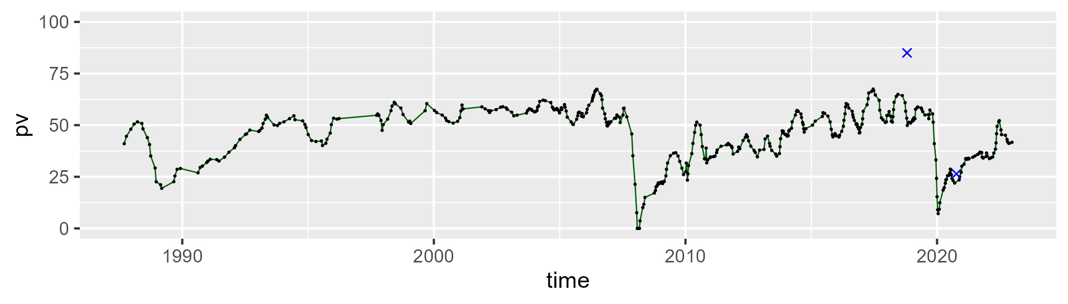

| Min. | 1st Qu. | Median | Mean | 3rd Qu. | Max. |
| --- | --- | --- | --- | --- | --- |
| 5.827853 | 28.58698 | 33.86195 | 33.05555 | 37.83347 | 52.34296 |

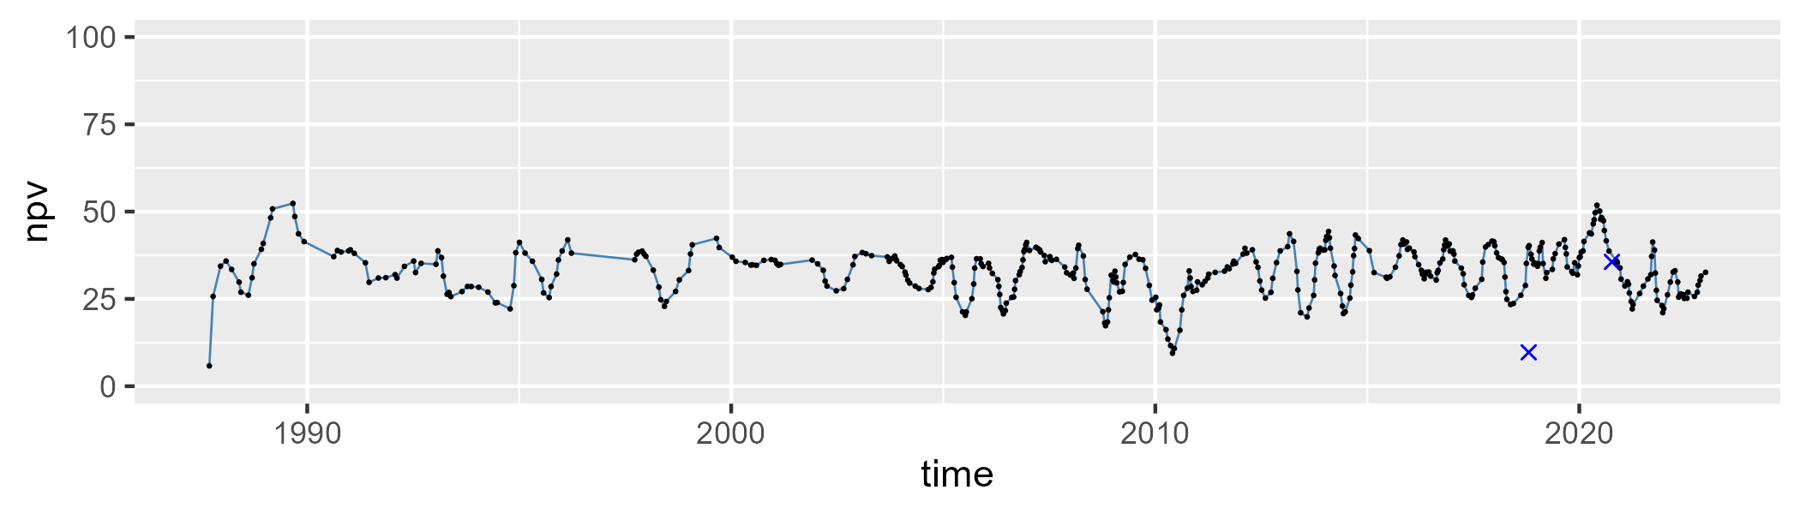

| Min. | 1st Qu. | Median | Mean | 3rd Qu. | Max. |
| --- | --- | --- | --- | --- | --- |
| 0 | 8.670754 | 14.84649 | 20.26671 | 29.31947 | 69.26197 |

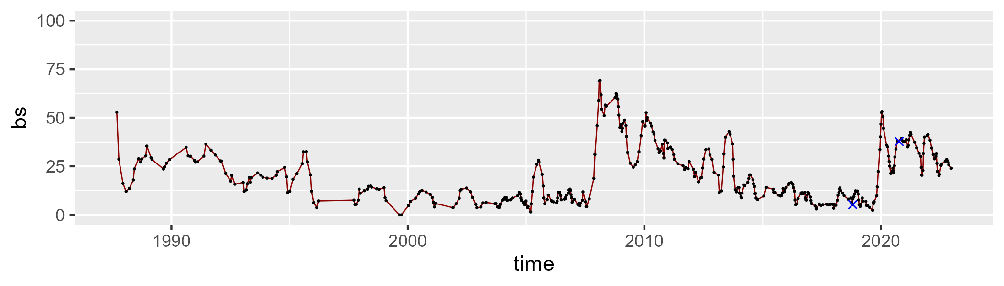

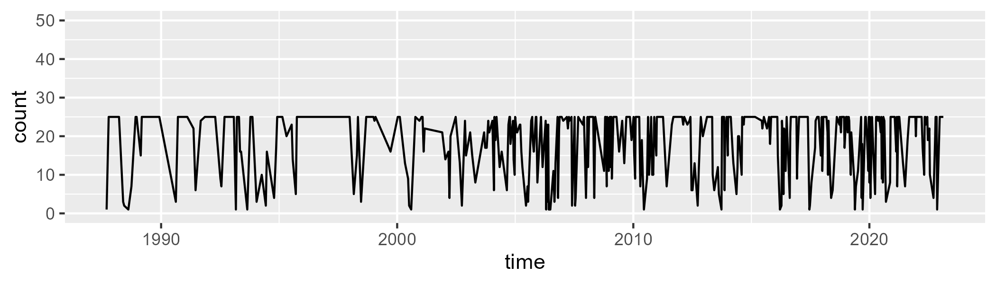

Min. : 1.00 1st Qu.:12.00 Median :24.00 Mean :18.82 3rd Qu.:25.00 Max. :25.00

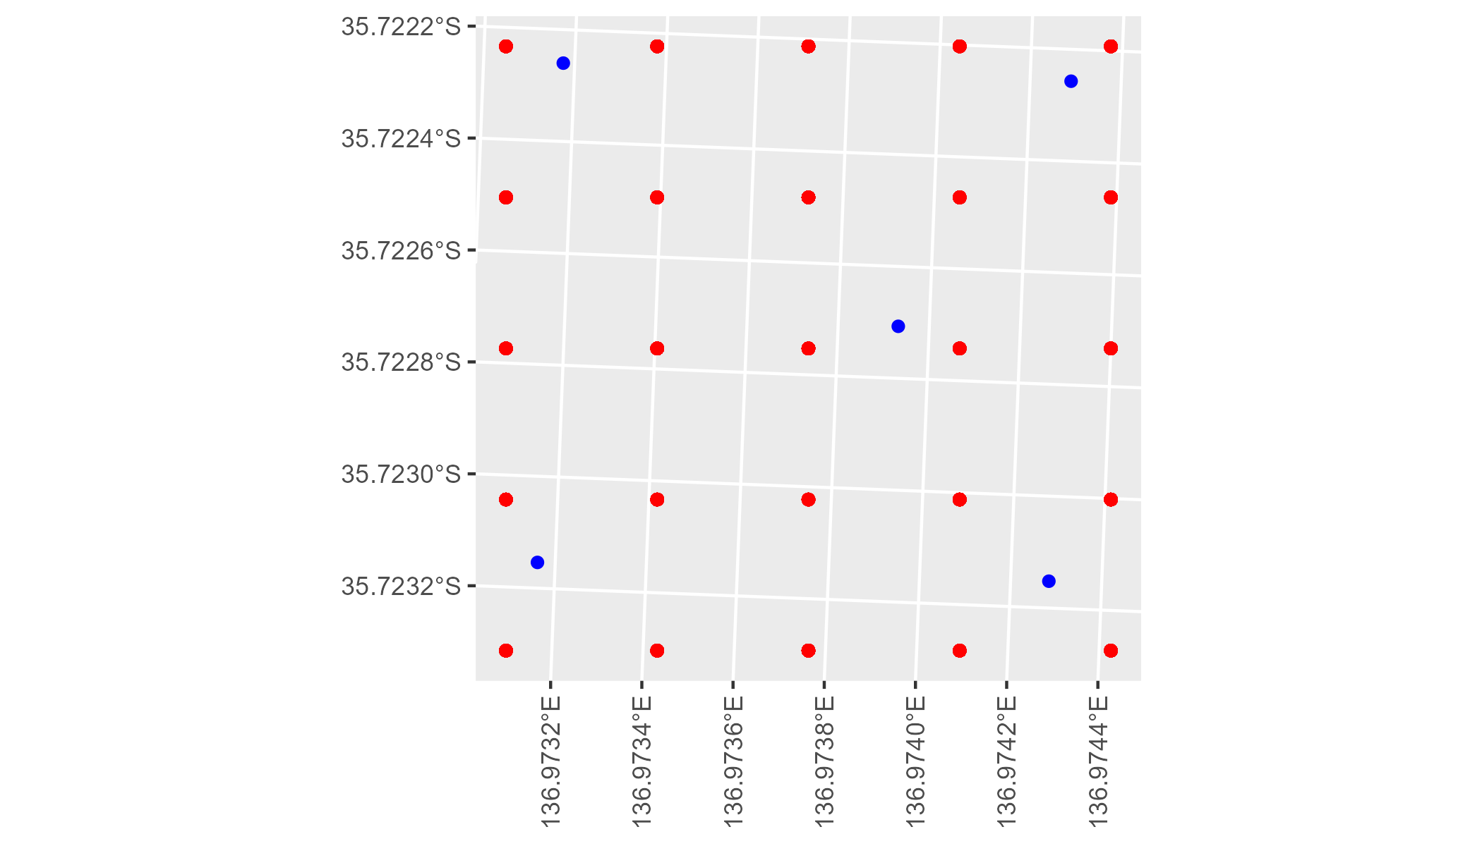

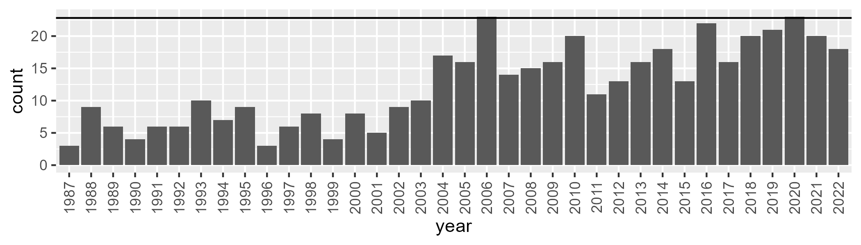

Number of samples: 445

# SAAKAN0005

| Min. | 1st Qu. | Median | Mean | 3rd Qu. | Max. |
| --- | --- | --- | --- | --- | --- |
| 0 | 36.31891 | 49.24719 | 44.15206 | 54.35133 | 65.86098 |

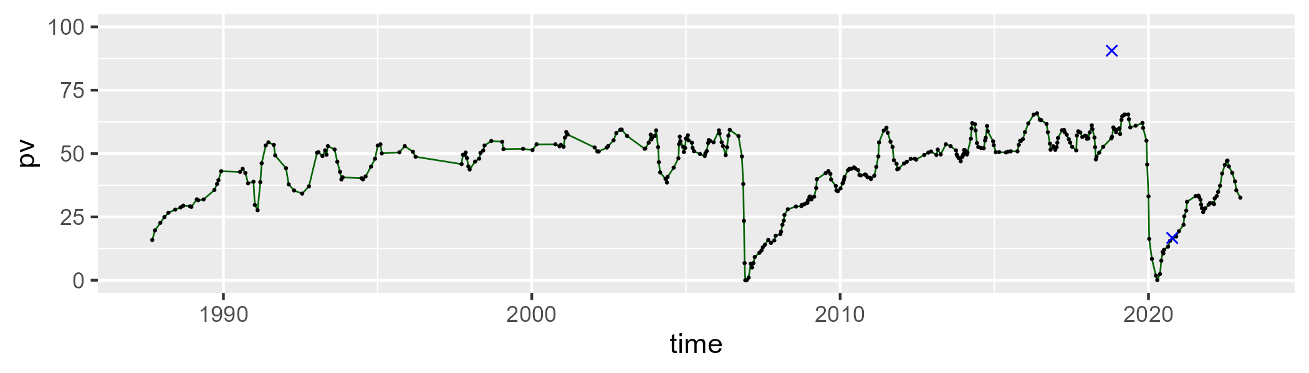

| Min. | 1st Qu. | Median | Mean | 3rd Qu. | Max. |
| --- | --- | --- | --- | --- | --- |
| 16.73797 | 29.76195 | 35.505 | 35.69479 | 40.99752 | 58.96951 |

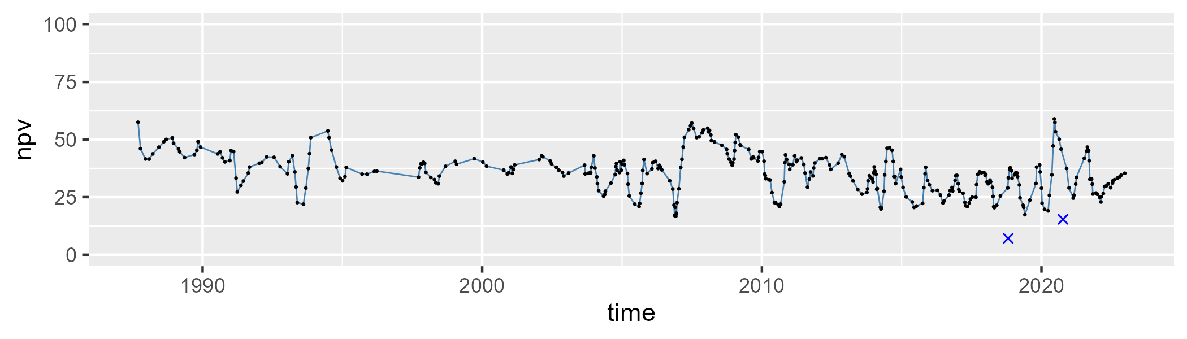

| Min. | 1st Qu. | Median | Mean | 3rd Qu. | Max. |
| --- | --- | --- | --- | --- | --- |
| 0 | 8.85577 | 16.64168 | 18.96169 | 24.91213 | 84.62261 |

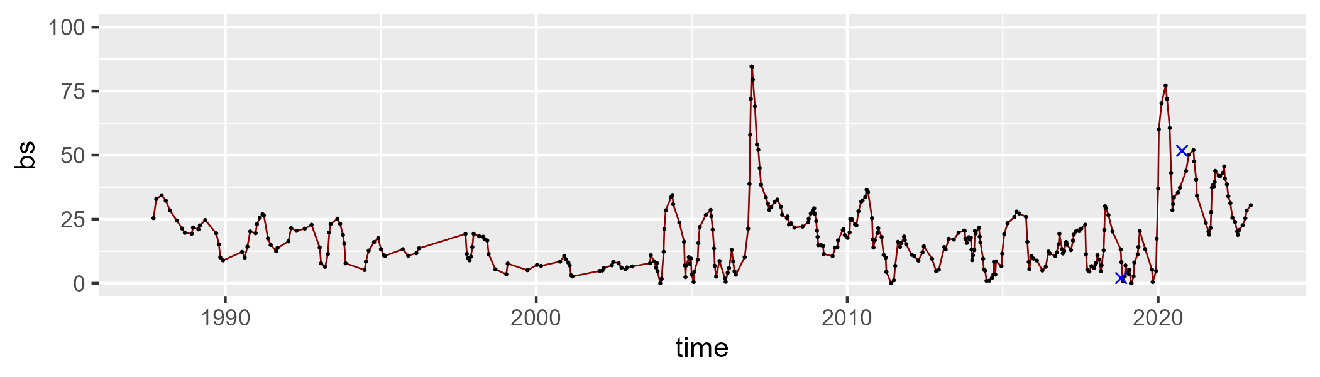

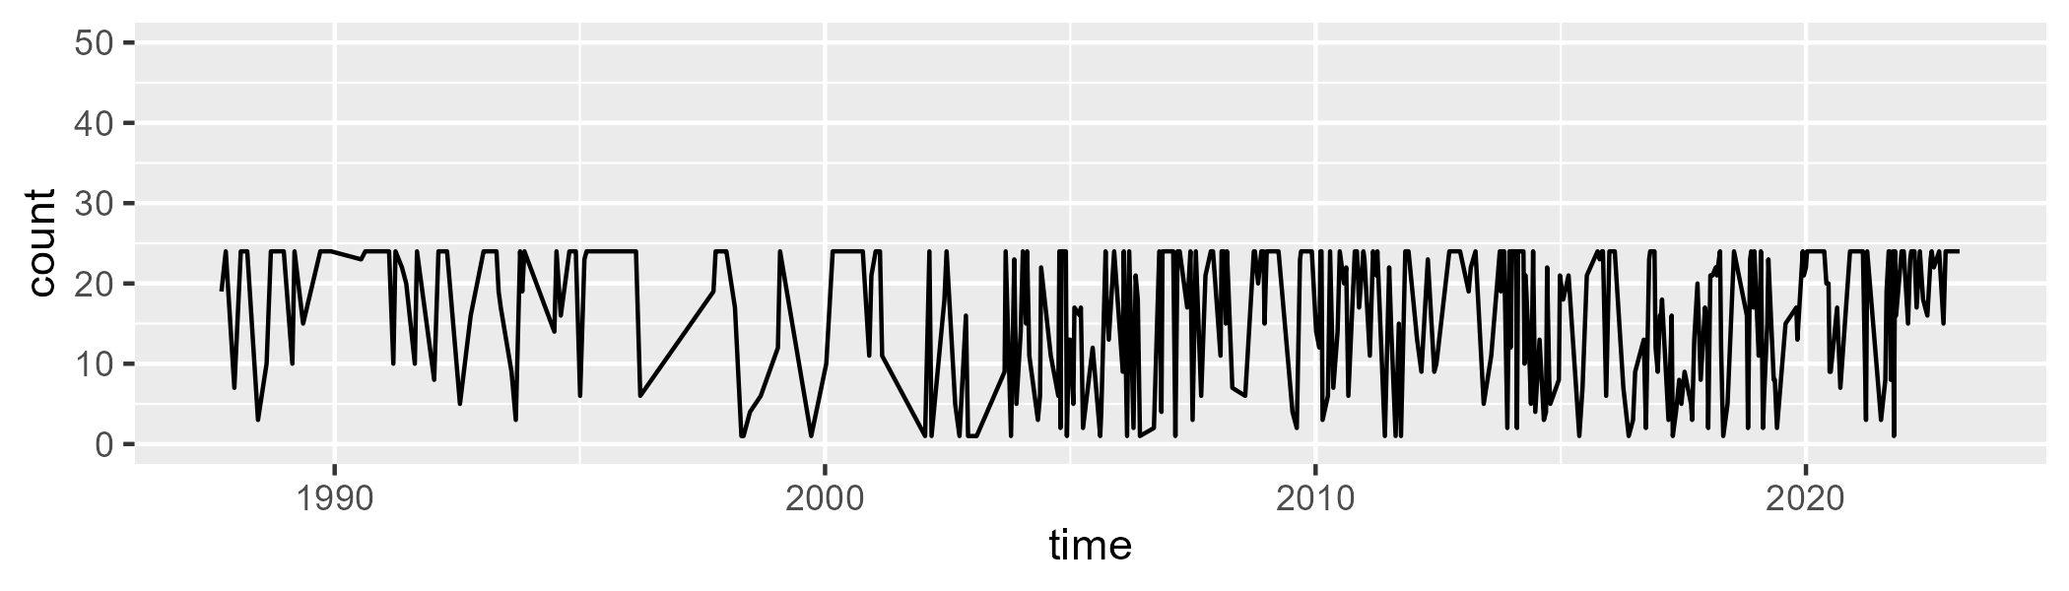

Min. : 1.00 1st Qu.: 9.00 Median :21.00 Mean :16.52 3rd Qu.:24.00 Max. :24.00

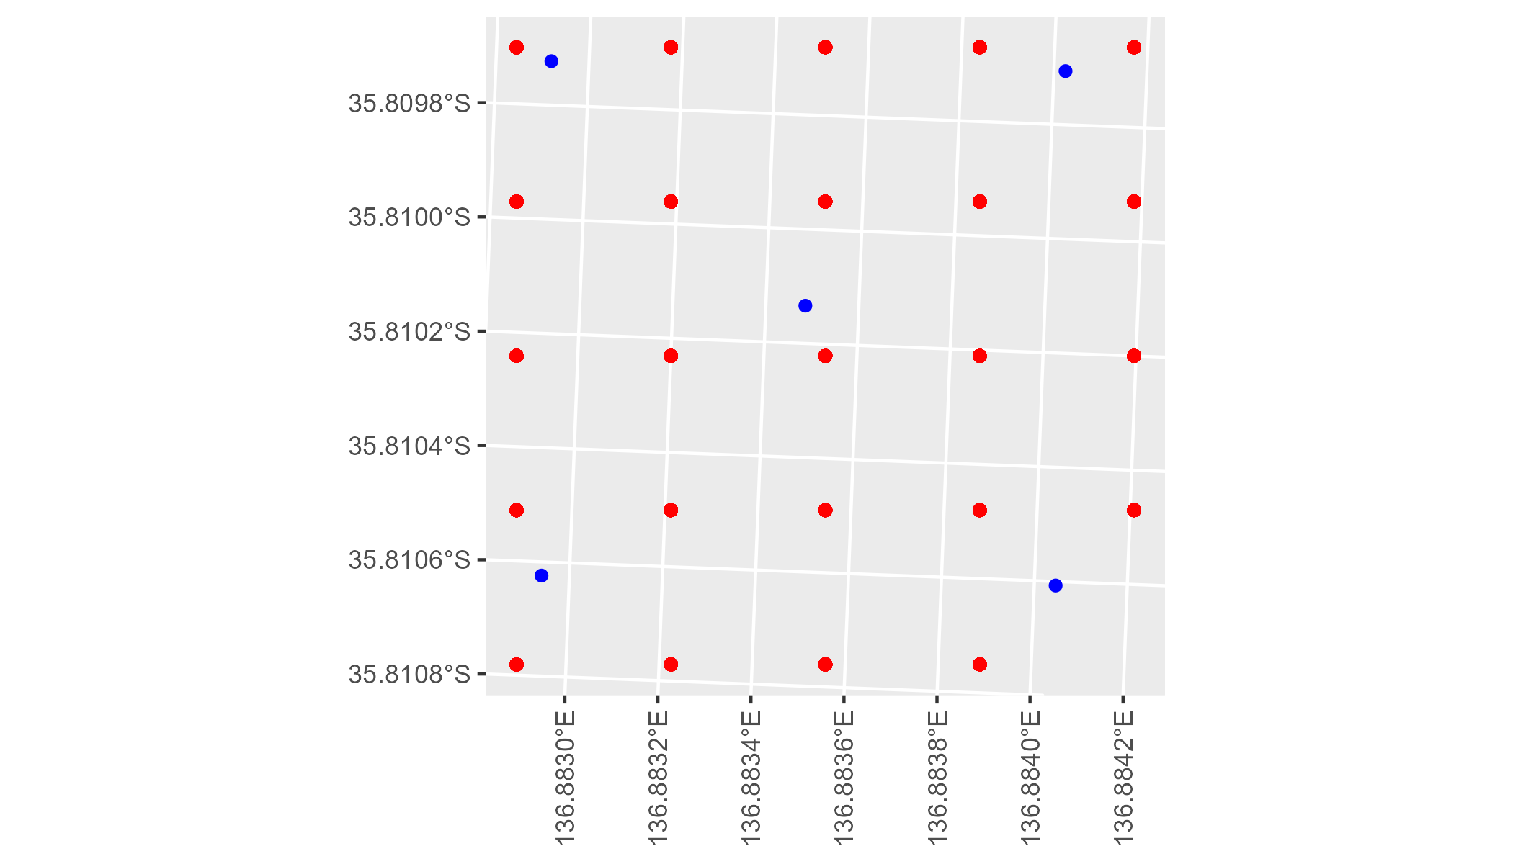

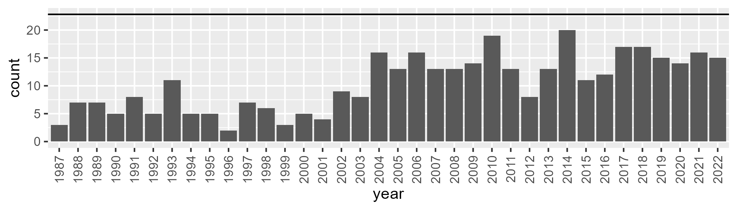

Number of samples: 375

# SAAKAN0006

| Min. | 1st Qu. | Median | Mean | 3rd Qu. | Max. |
| --- | --- | --- | --- | --- | --- |
| 0 | 37.85469 | 42.28472 | 40.27195 | 45.62806 | 53.86447 |

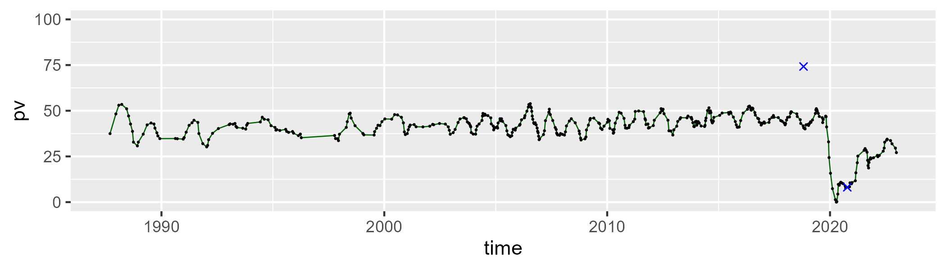

| Min. | 1st Qu. | Median | Mean | 3rd Qu. | Max. |
| --- | --- | --- | --- | --- | --- |
| 13.78501 | 40.56416 | 45.58841 | 44.78362 | 50.30331 | 64.70835 |

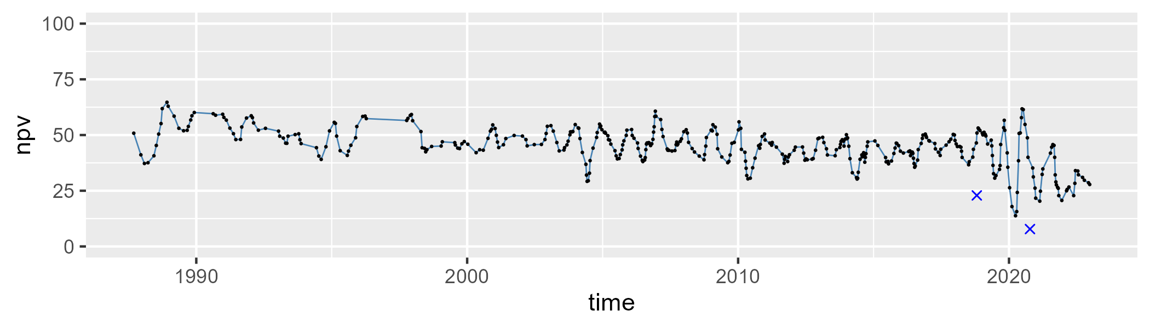

| Min. | 1st Qu. | Median | Mean | 3rd Qu. | Max. |
| --- | --- | --- | --- | --- | --- |
| 0 | 6.466921 | 9.277561 | 13.8352 | 15.06364 | 82.50922 |

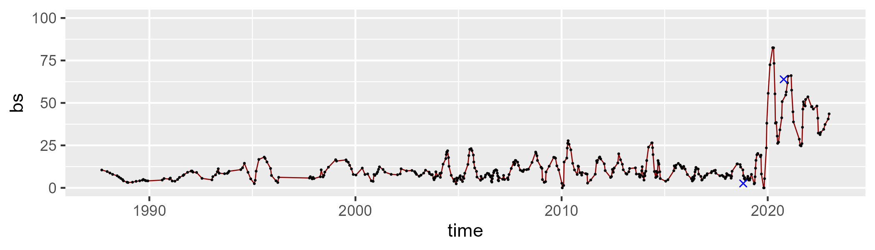

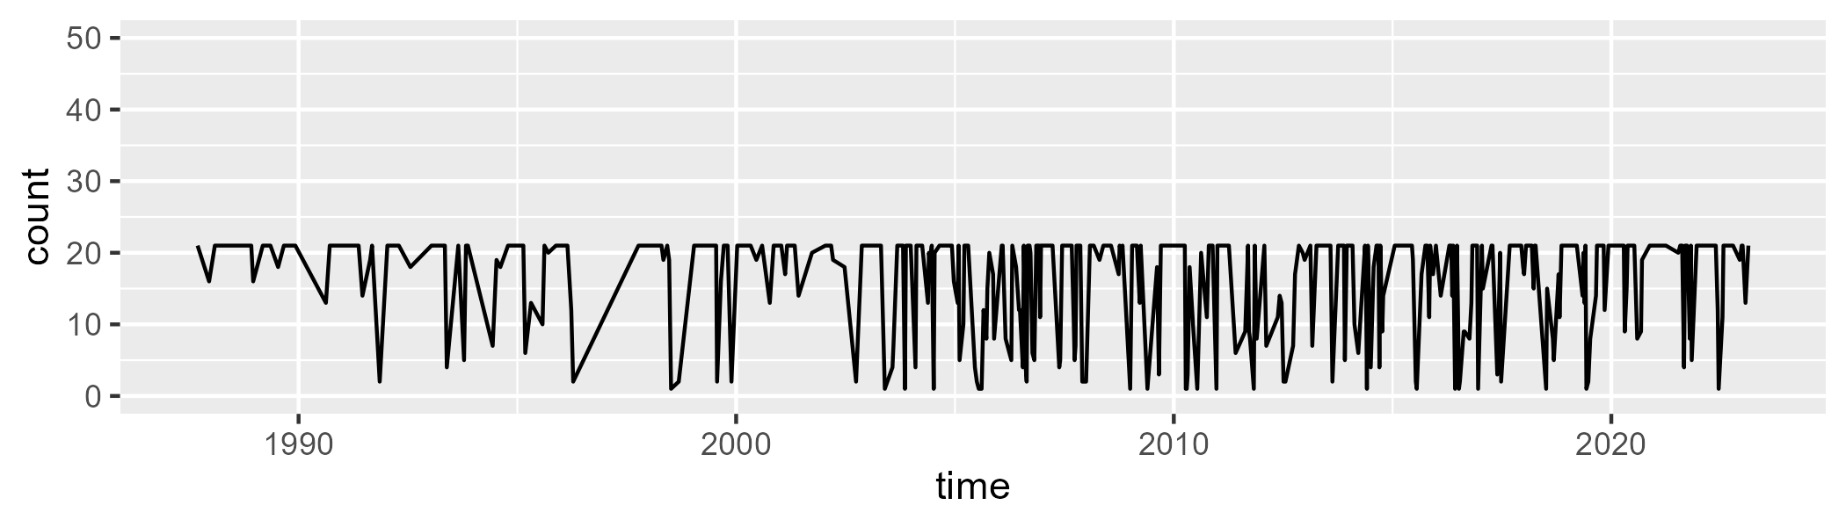

Min. : 1.00 1st Qu.:12.00 Median :21.00 Mean :16.31 3rd Qu.:21.00 Max. :21.00

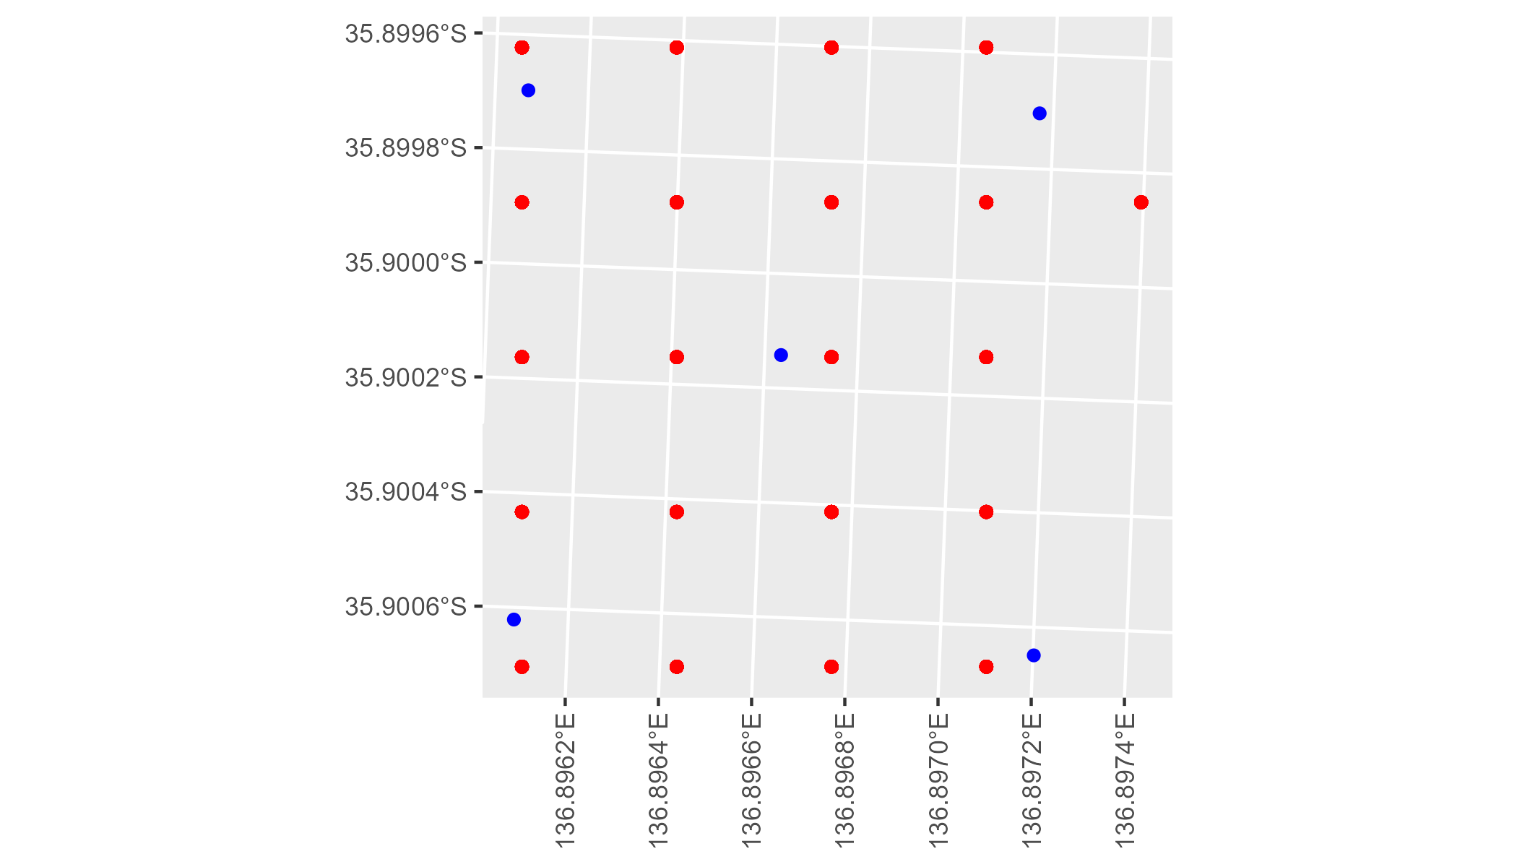

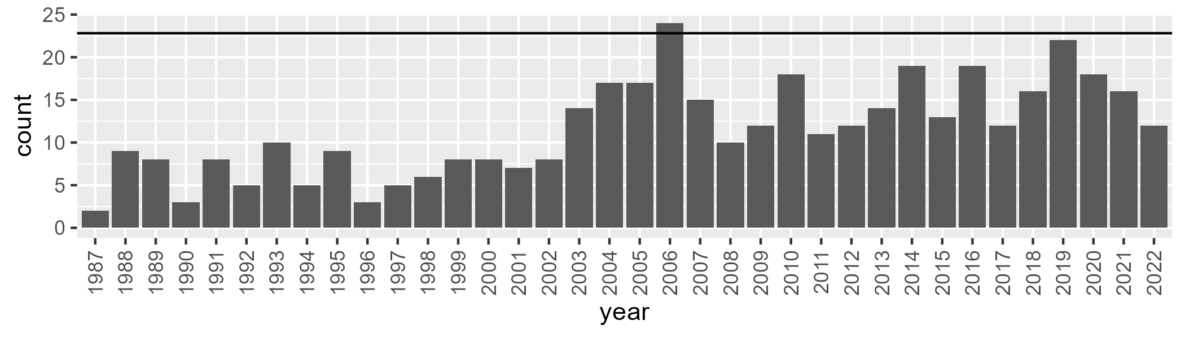

Number of samples: 415

# SAAKAN0007

| Min. | 1st Qu. | Median | Mean | 3rd Qu. | Max. |
| --- | --- | --- | --- | --- | --- |
| 0 | 40.28635 | 51.51141 | 47.00943 | 56.28609 | 68.6114 |

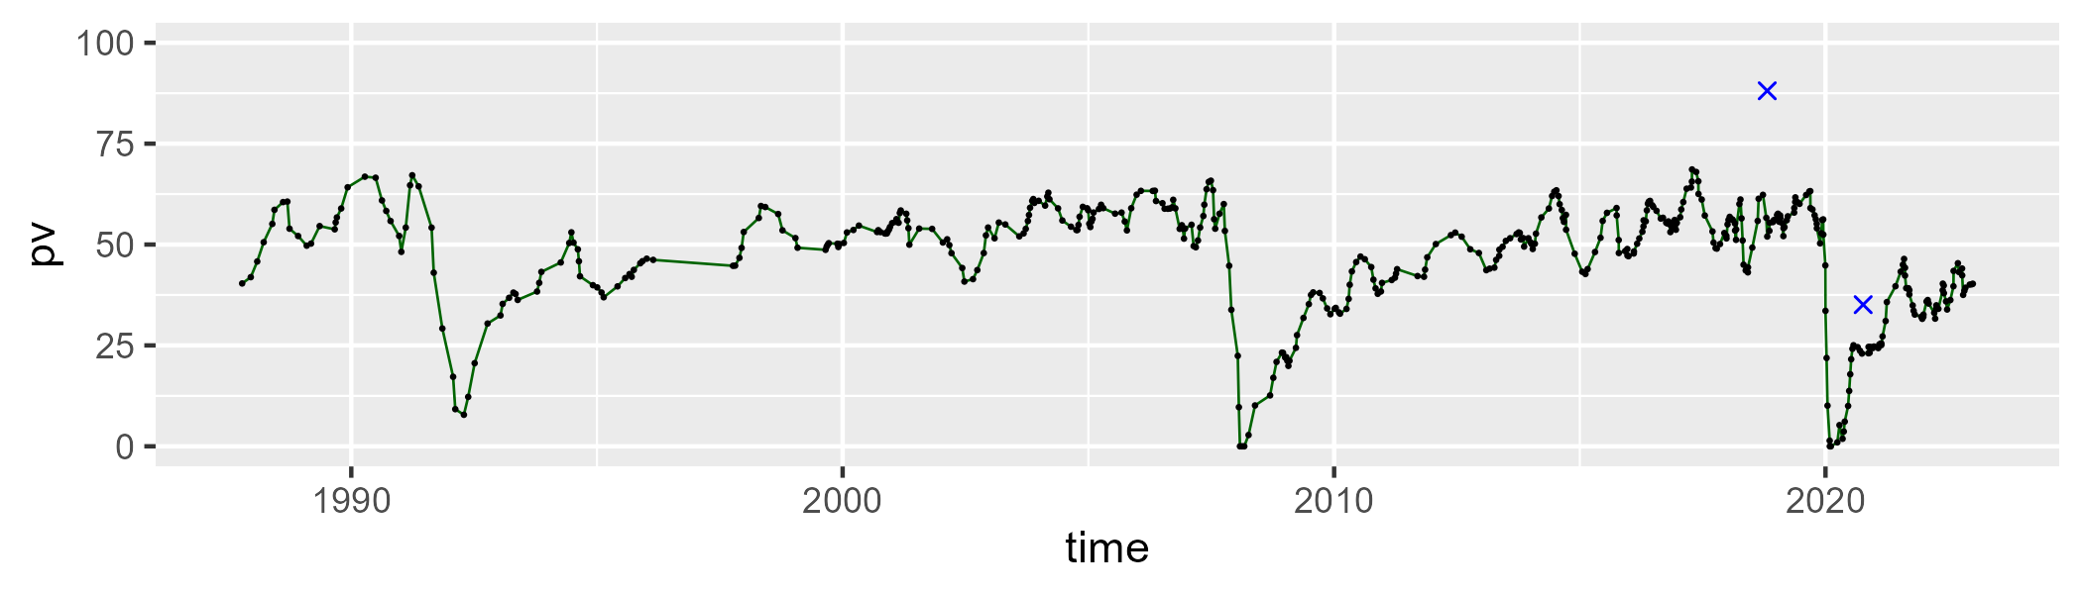

| Min. | 1st Qu. | Median | Mean | 3rd Qu. | Max. |
| --- | --- | --- | --- | --- | --- |
| 15.19964 | 27.10616 | 32.35522 | 32.11017 | 35.69786 | 63.80653 |

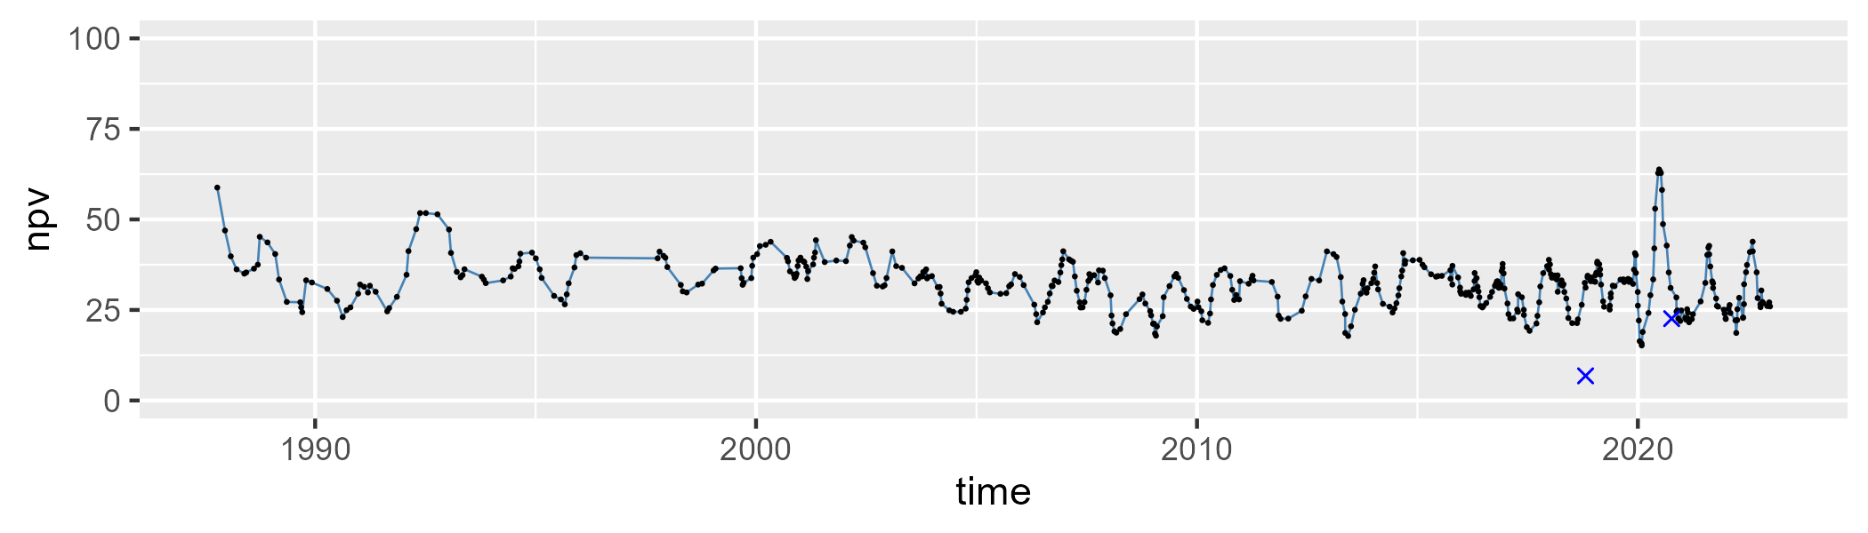

| Min. | 1st Qu. | Median | Mean | 3rd Qu. | Max. |
| --- | --- | --- | --- | --- | --- |
| 0 | 8.744325 | 14.26707 | 19.50466 | 26.54098 | 85.29895 |

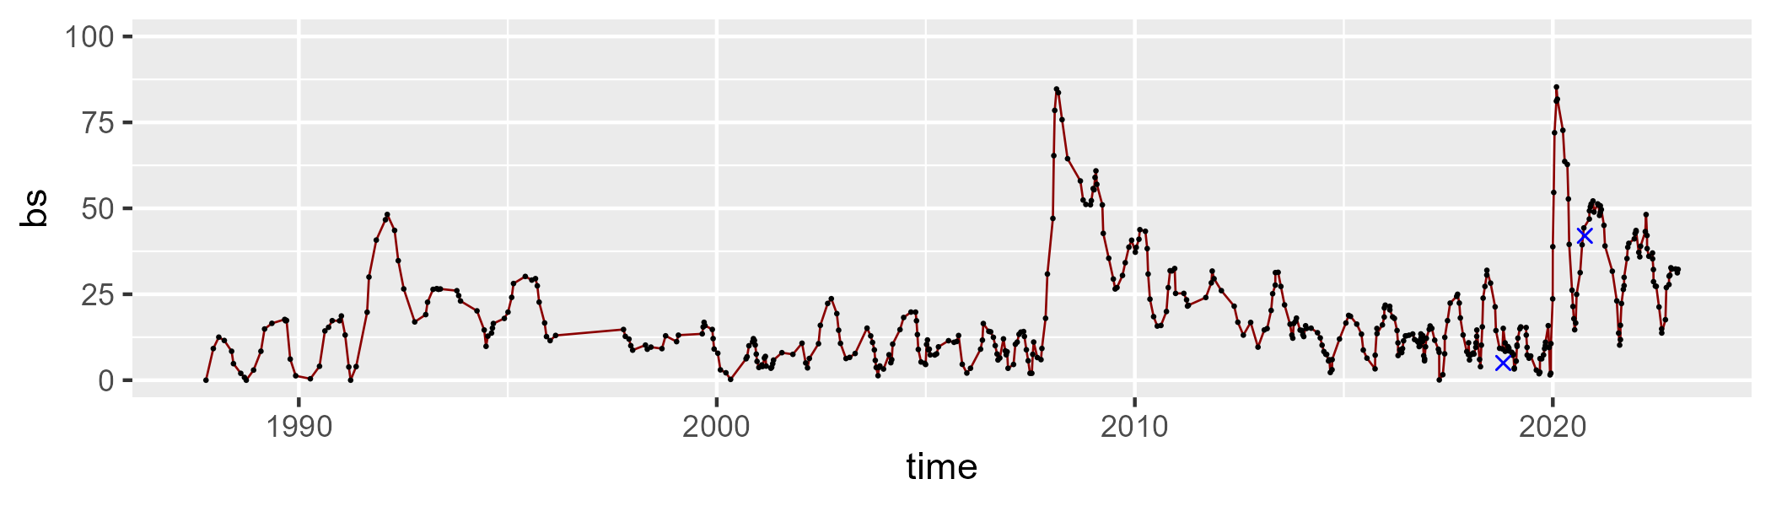

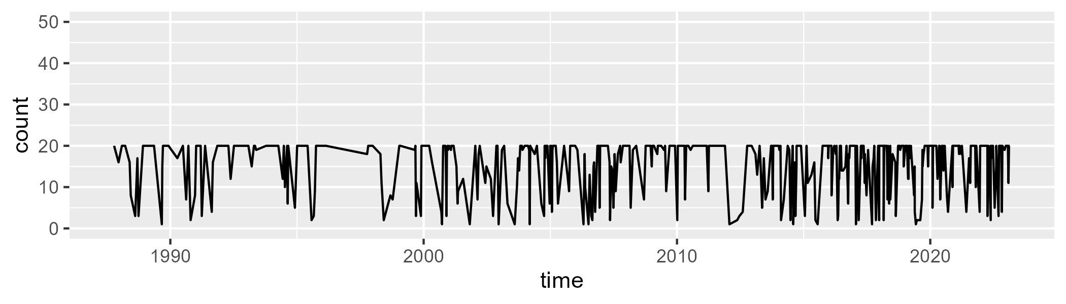

Min. : 1.00 1st Qu.:12.00 Median :20.00 Mean :15.79 3rd Qu.:20.00 Max. :20.00

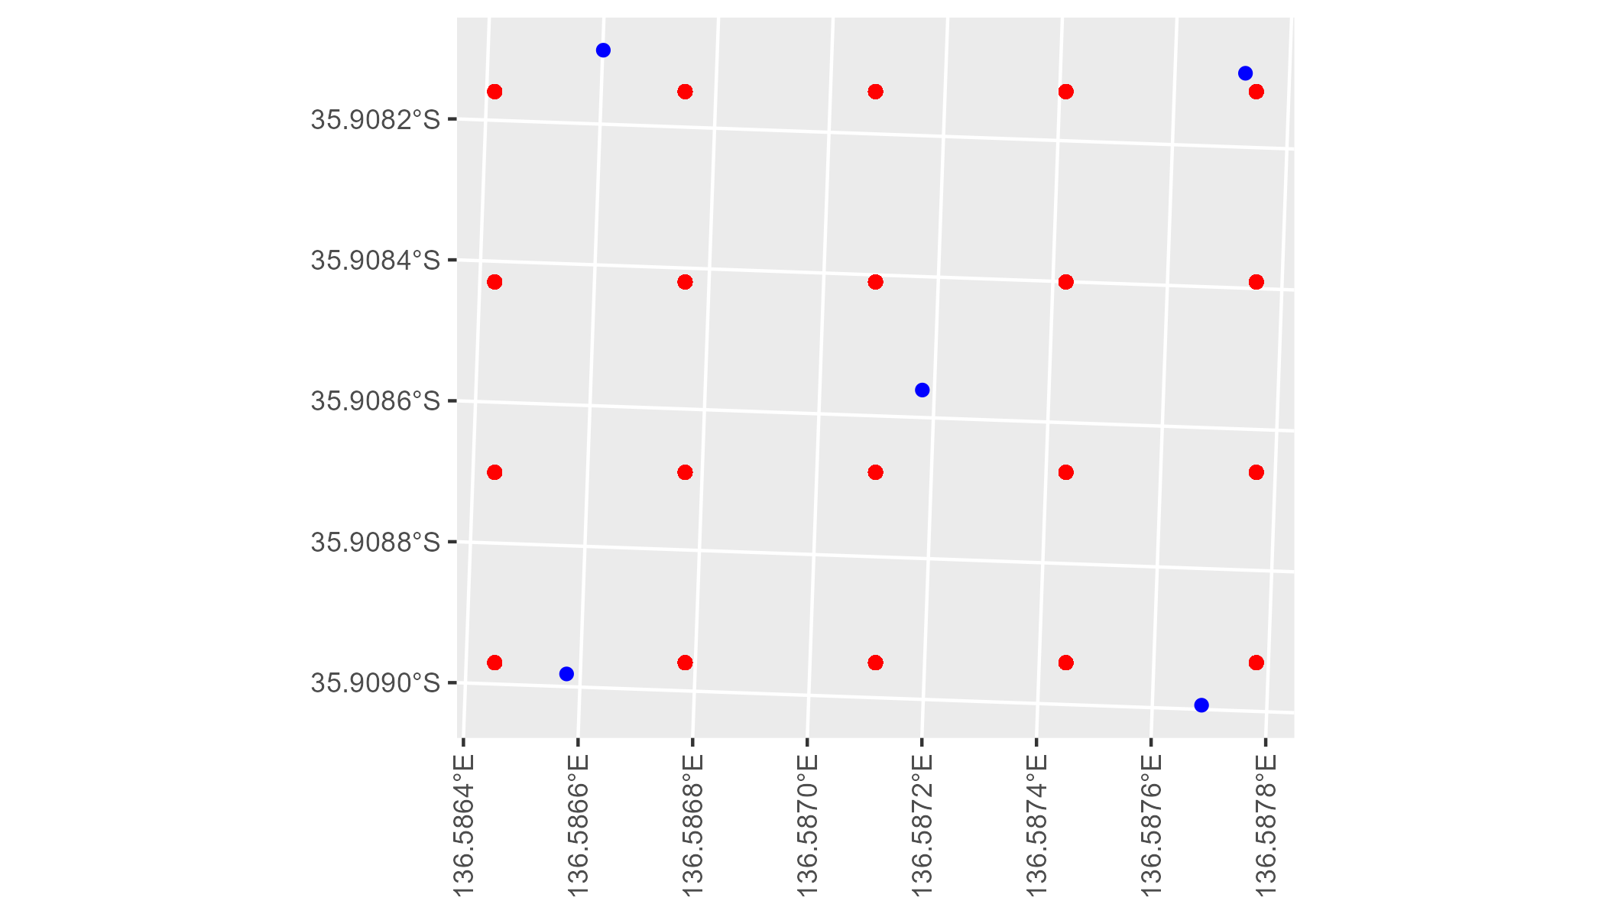

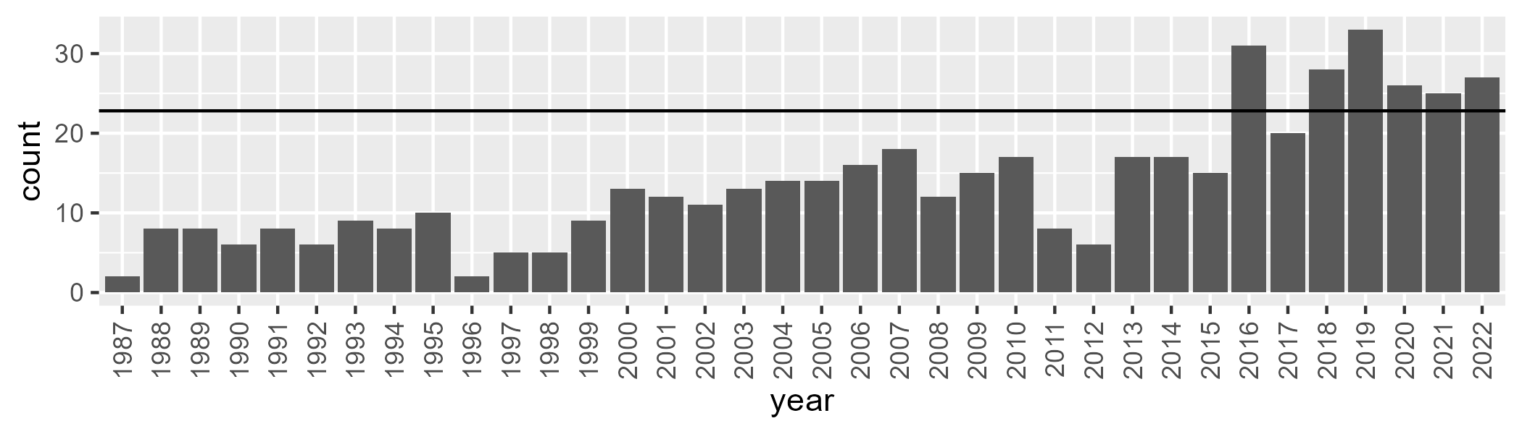

Number of samples: 494

# SAAKAN0008

| Min. | 1st Qu. | Median | Mean | 3rd Qu. | Max. |
| --- | --- | --- | --- | --- | --- |
| 14.78735 | 44.51147 | 48.31469 | 47.7573 | 52.04728 | 61.8907 |

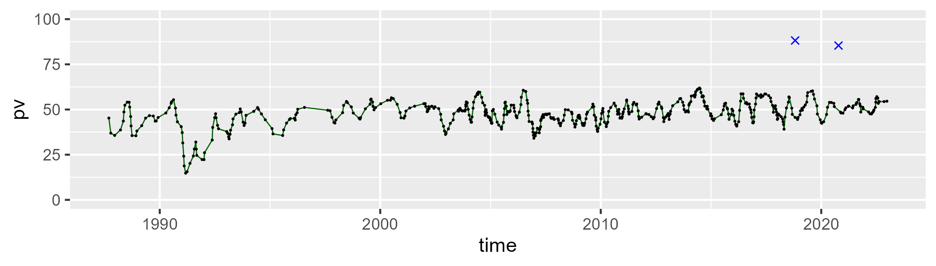

| Min. | 1st Qu. | Median | Mean | 3rd Qu. | Max. |
| --- | --- | --- | --- | --- | --- |
| 23.65752 | 36.58342 | 40.72918 | 40.64459 | 44.532 | 55.34057 |

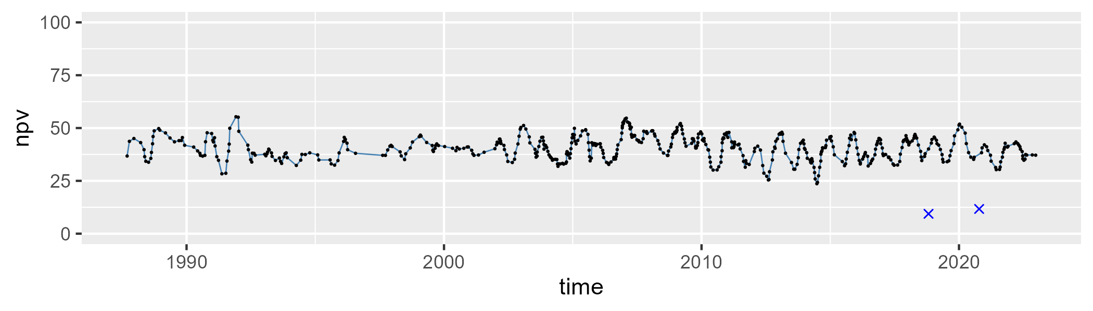

| Min. | 1st Qu. | Median | Mean | 3rd Qu. | Max. |
| --- | --- | --- | --- | --- | --- |
| 0.4667954 | 6.154808 | 8.644011 | 10.31351 | 12.66143 | 50.31962 |

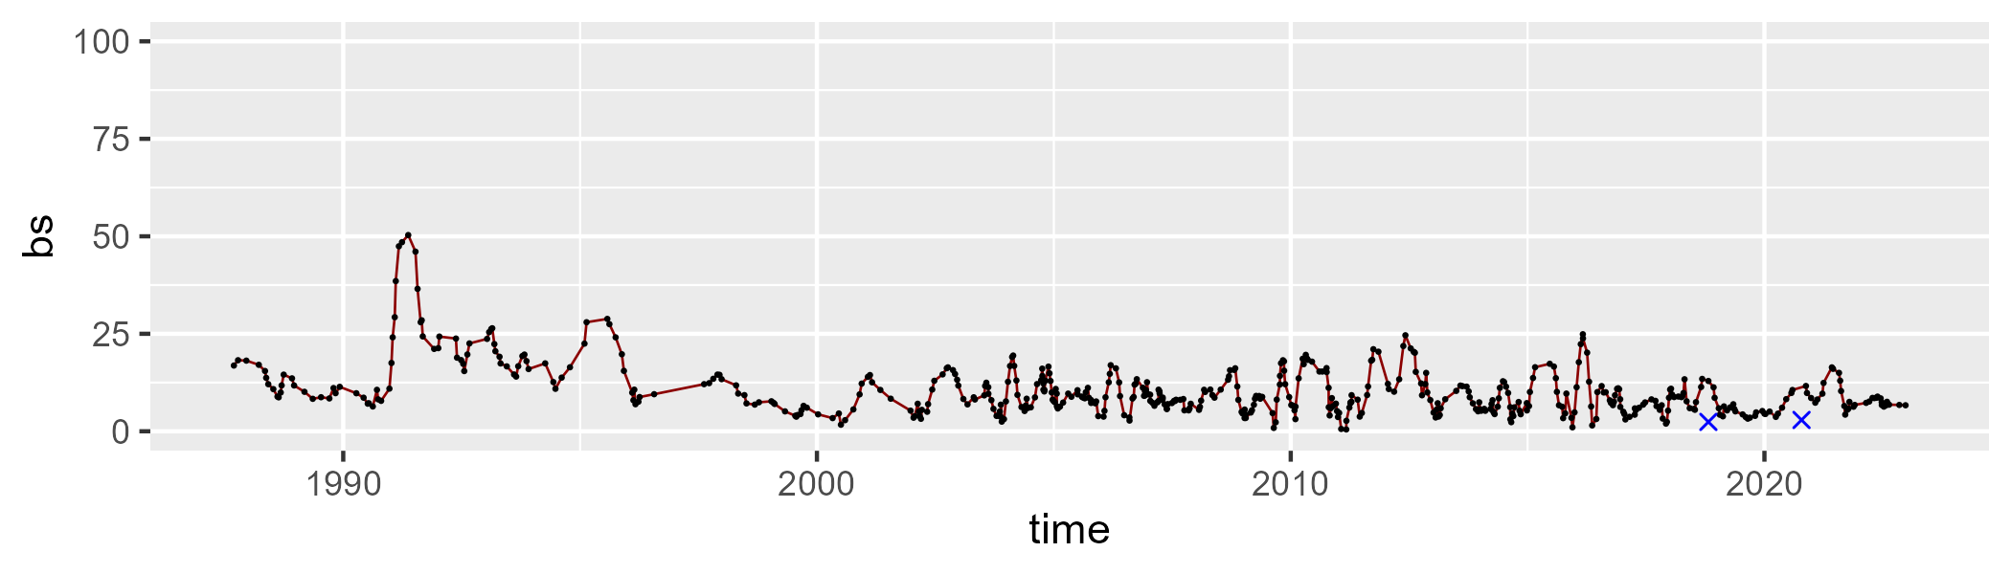

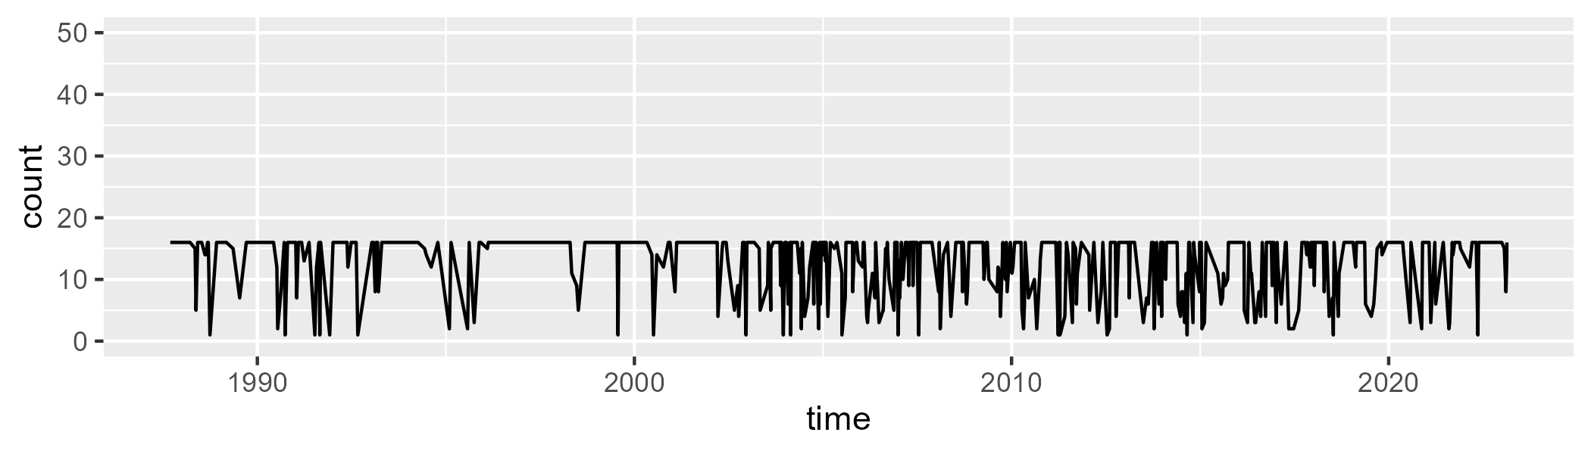

Min. : 1.00 1st Qu.:10.00 Median :16.00 Mean :12.72 3rd Qu.:16.00 Max. :16.00

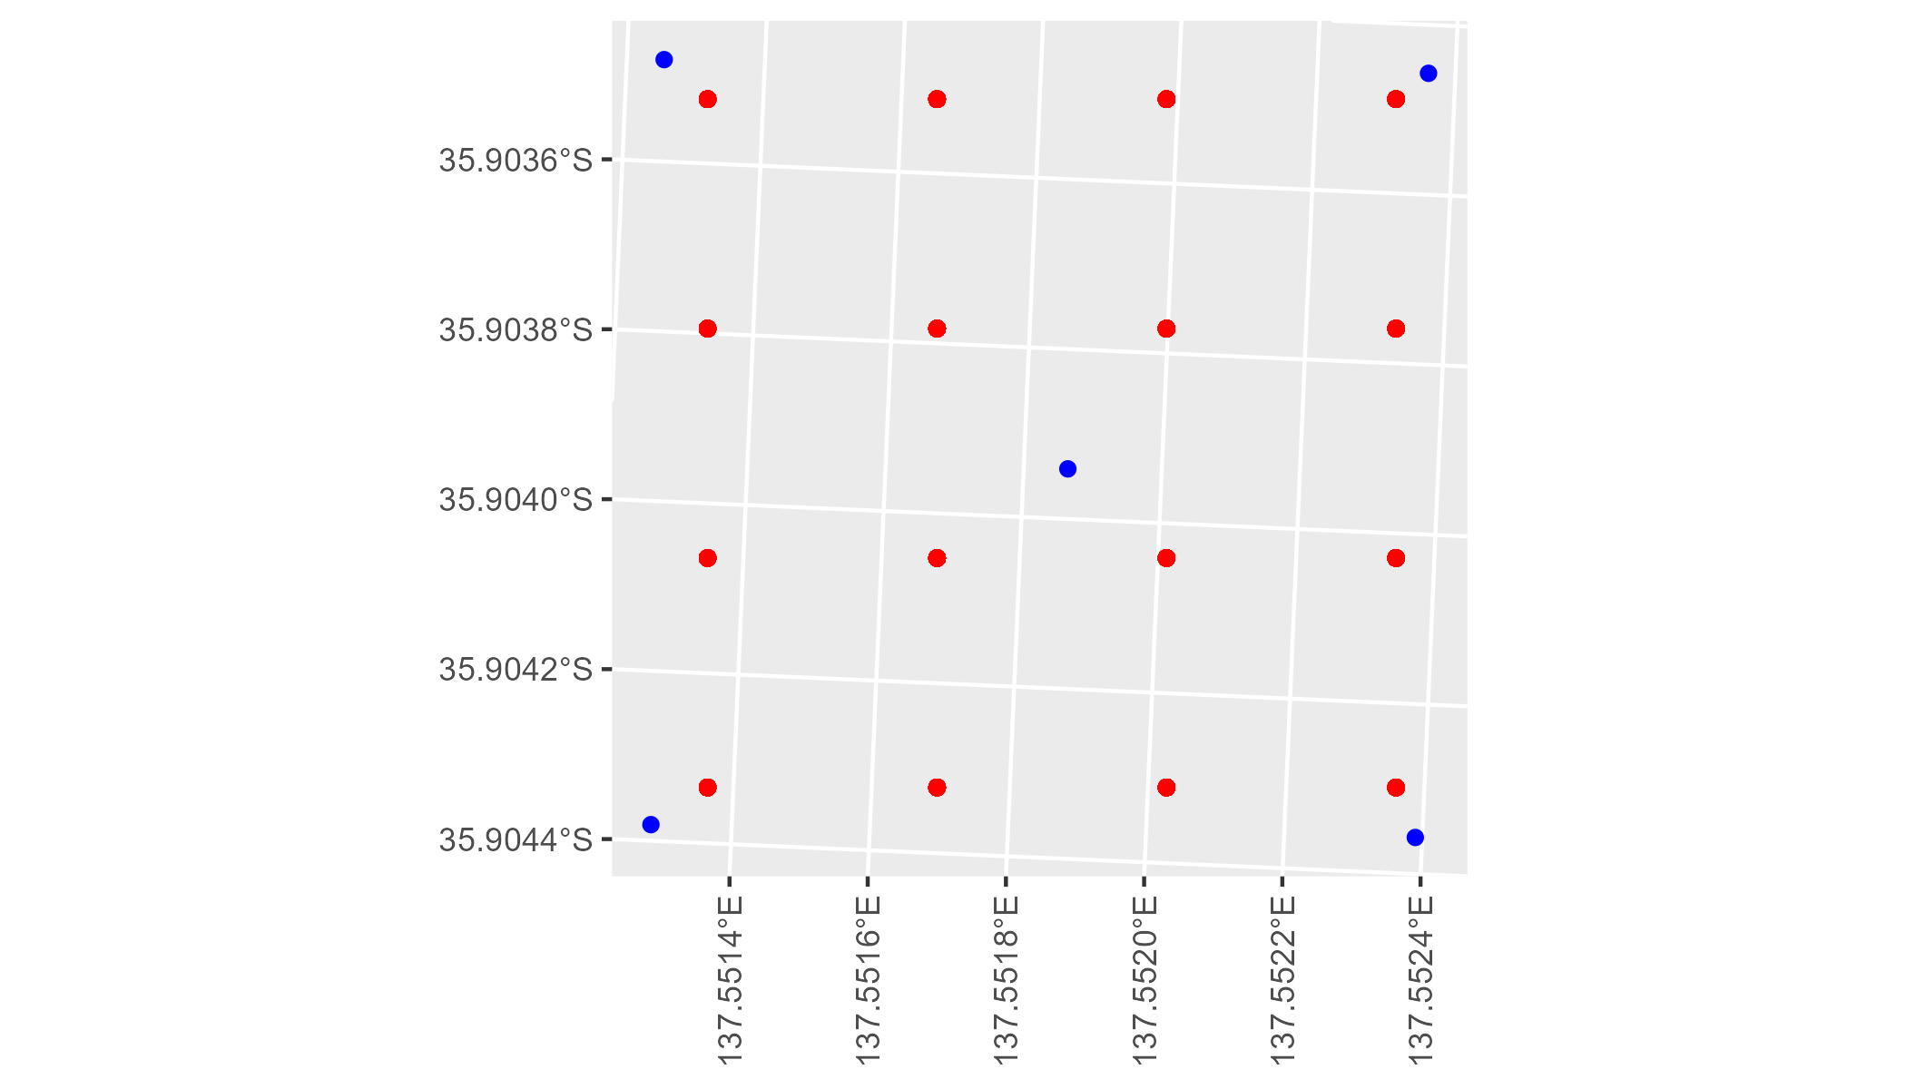

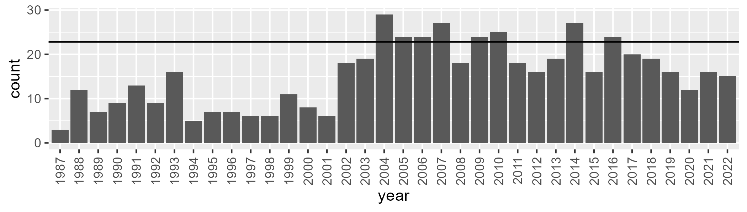

Number of samples: 551

# SAAKAN0009

| Min. | 1st Qu. | Median | Mean | 3rd Qu. | Max. |
| --- | --- | --- | --- | --- | --- |
| 0 | 42.84847 | 46.88538 | 44.60843 | 49.80794 | 66.25567 |

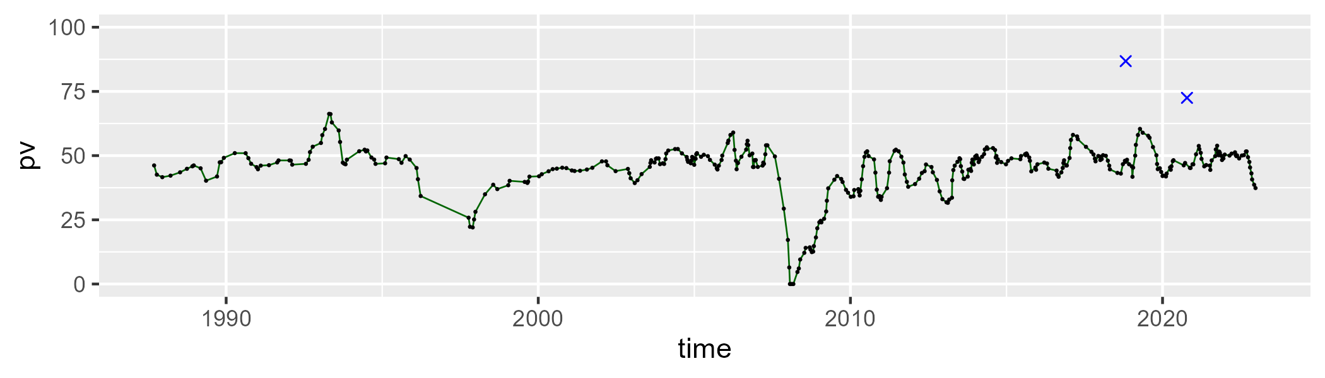

| Min. | 1st Qu. | Median | Mean | 3rd Qu. | Max. |
| --- | --- | --- | --- | --- | --- |
| 12.69869 | 29.25918 | 35.42177 | 34.92887 | 40.59296 | 54.434 |

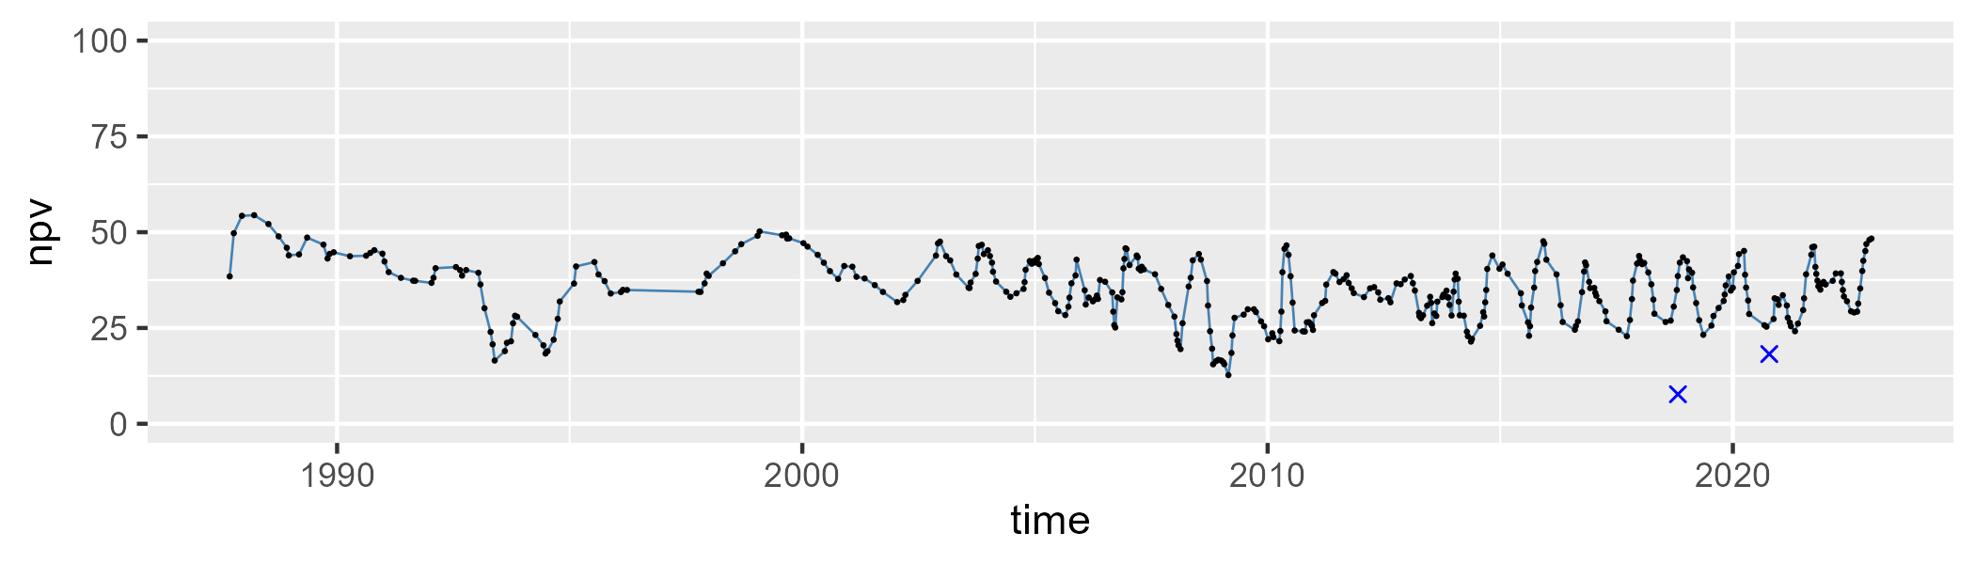

| Min. | 1st Qu. | Median | Mean | 3rd Qu. | Max. |
| --- | --- | --- | --- | --- | --- |
| 0 | 10.19517 | 15.73308 | 19.20438 | 23.43569 | 83.12676 |

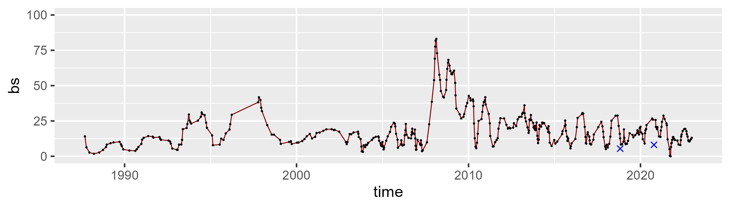

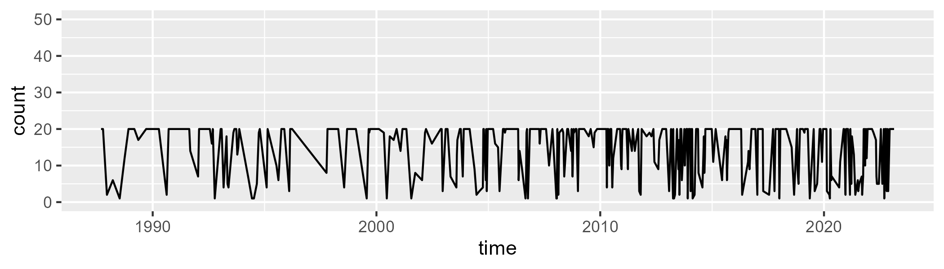

Min. : 1.00 1st Qu.: 9.00 Median :20.00 Mean :14.92 3rd Qu.:20.00 Max. :20.00

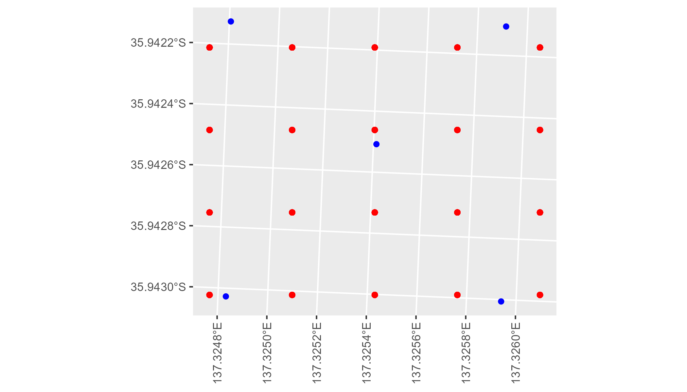

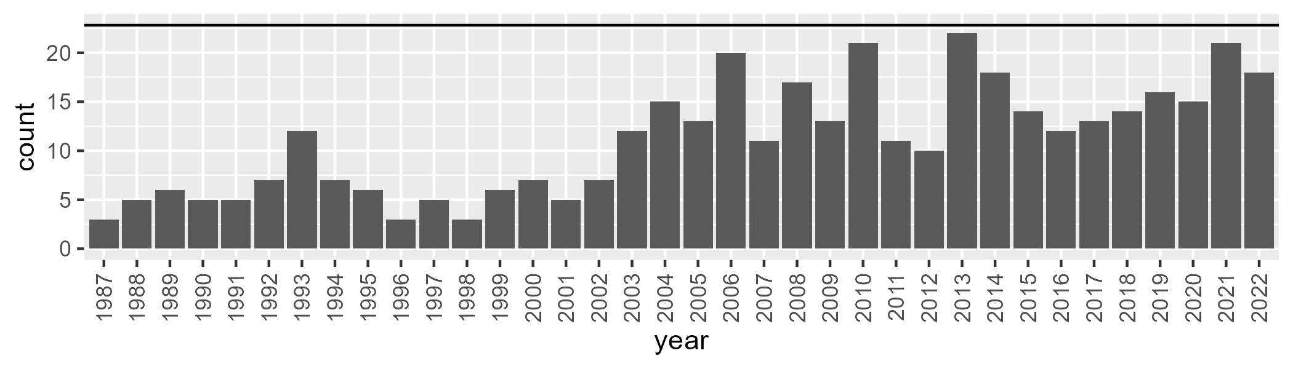

Number of samples: 398

# SAAKAN0010

| Min. | 1st Qu. | Median | Mean | 3rd Qu. | Max. |
| --- | --- | --- | --- | --- | --- |
| 10.84838 | 44.72365 | 50.4978 | 48.53151 | 54.31616 | 70.87068 |

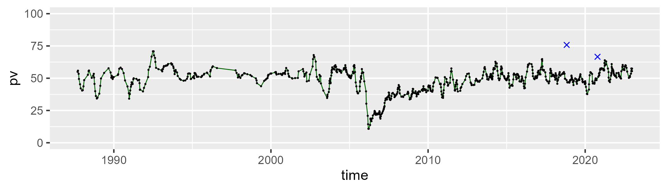

| Min. | 1st Qu. | Median | Mean | 3rd Qu. | Max. |
| --- | --- | --- | --- | --- | --- |
| 9.981196 | 29.84356 | 35.37915 | 35.51 | 40.4144 | 66.09666 |

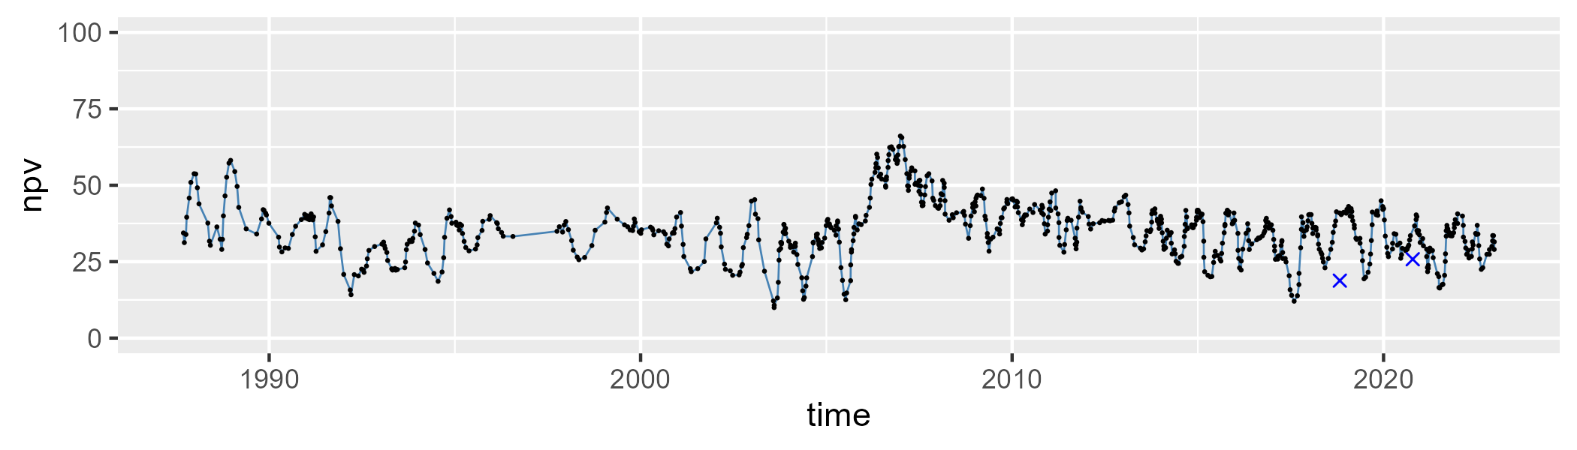

| Min. | 1st Qu. | Median | Mean | 3rd Qu. | Max. |
| --- | --- | --- | --- | --- | --- |
| 0 | 8.854681 | 12.39451 | 14.60599 | 19.11763 | 53.42554 |

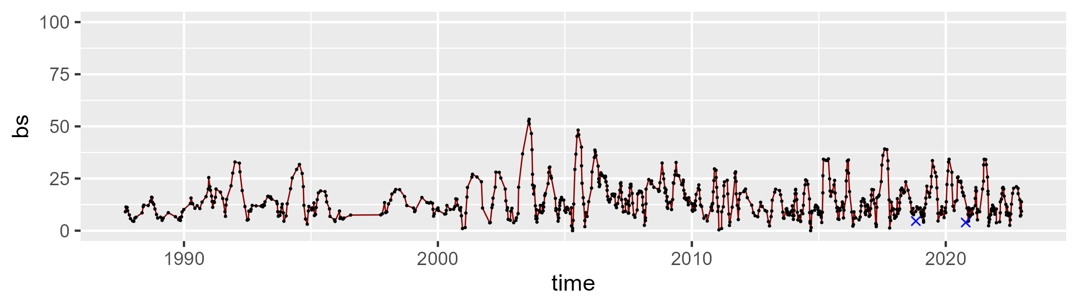

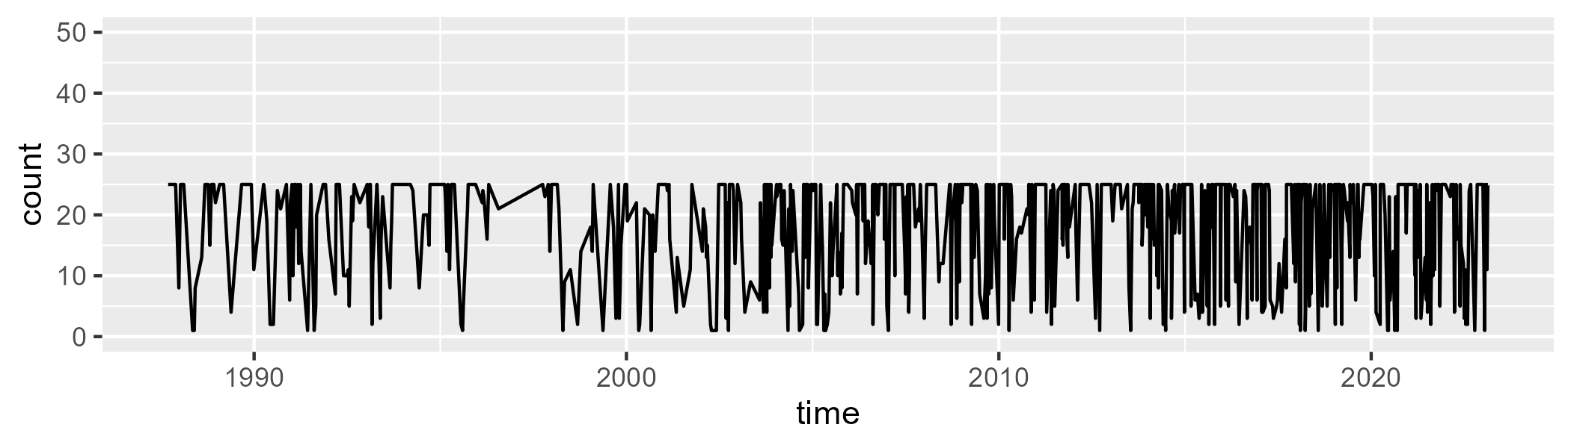

Min. : 1.00 1st Qu.:12.00 Median :24.00 Mean :18.47 3rd Qu.:25.00 Max. :25.00

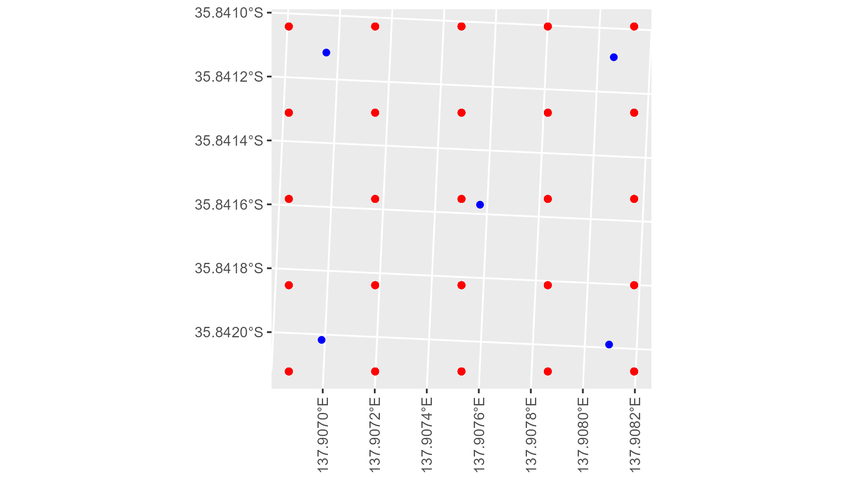

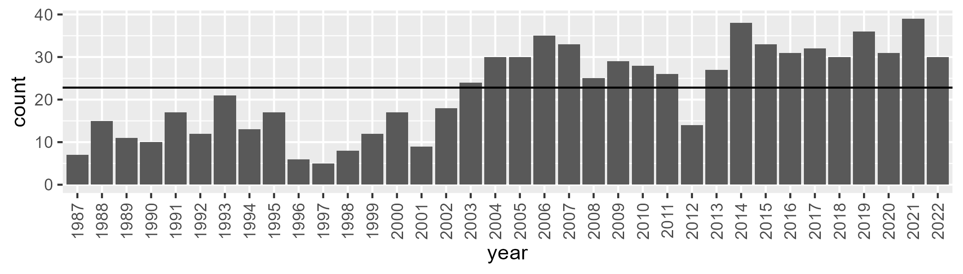

Number of samples: 799

# SAAKAN0012

| Min. | 1st Qu. | Median | Mean | 3rd Qu. | Max. |
| --- | --- | --- | --- | --- | --- |
| 29.30403 | 46.16748 | 49.35 | 49.14512 | 52.4148 | 65.45783 |

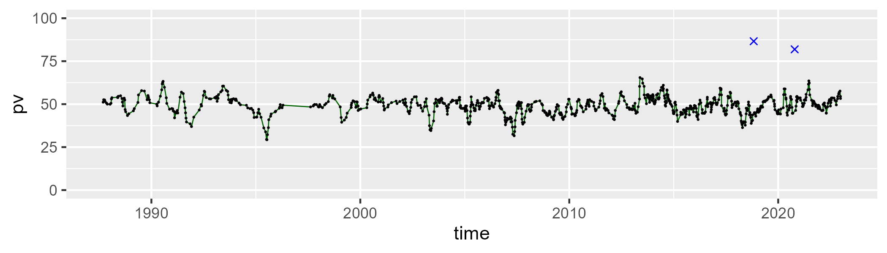

| Min. | 1st Qu. | Median | Mean | 3rd Qu. | Max. |
| --- | --- | --- | --- | --- | --- |
| 14.34847 | 29.16943 | 32.51487 | 32.8788 | 36.737 | 50.5429 |

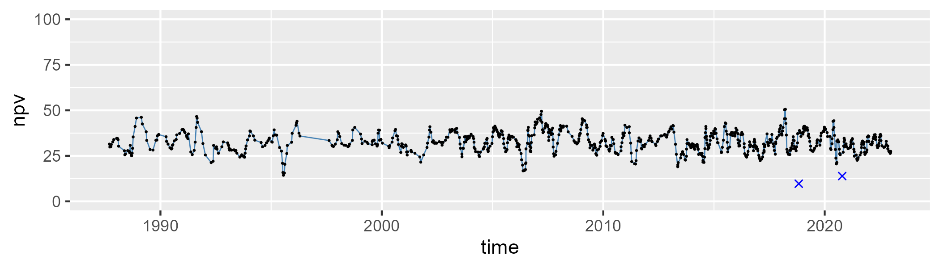

| Min. | 1st Qu. | Median | Mean | 3rd Qu. | Max. |
| --- | --- | --- | --- | --- | --- |
| 1.965731 | 12.20364 | 15.78604 | 16.69665 | 20.23154 | 54.52182 |

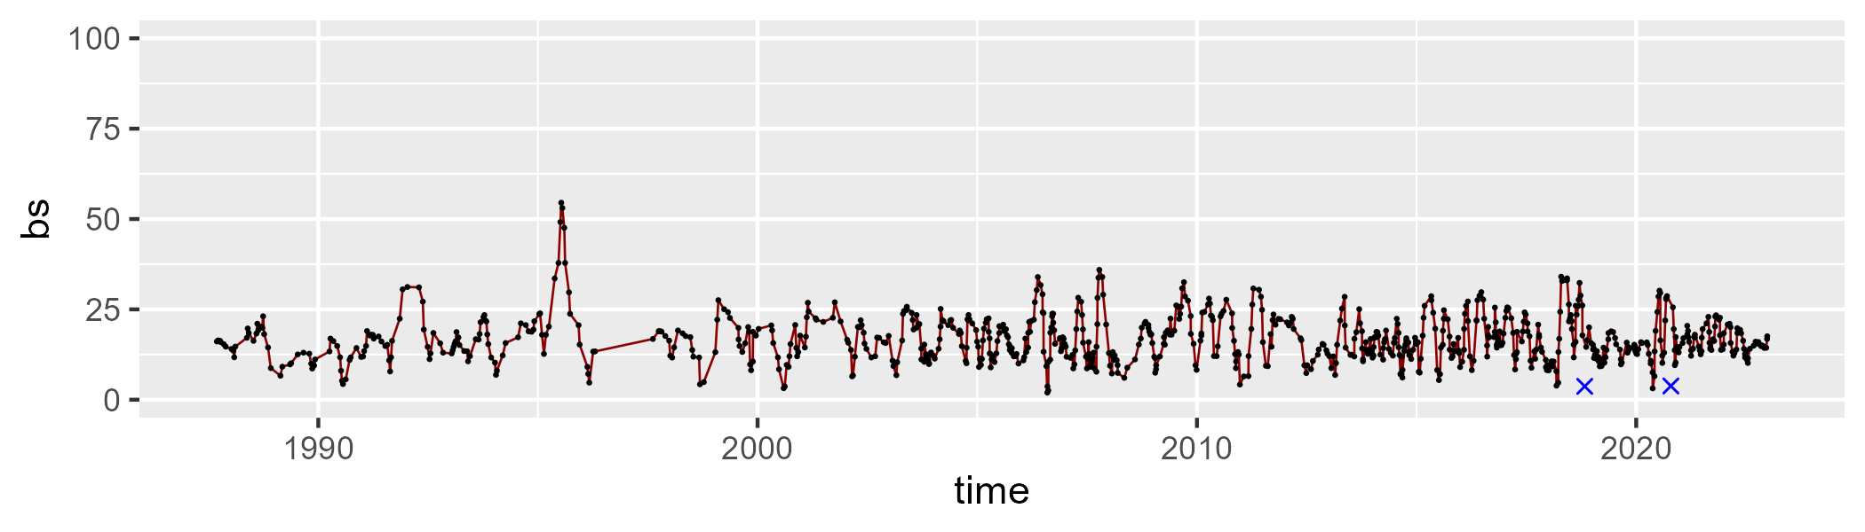

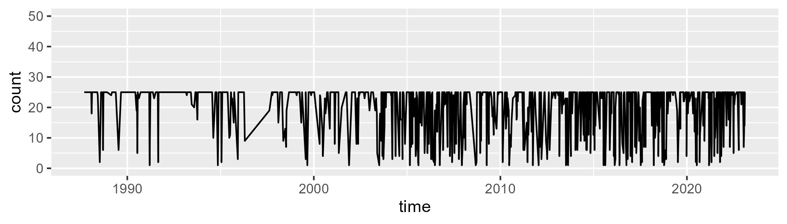

Min. : 1.00 1st Qu.:17.00 Median :25.00 Mean :19.95 3rd Qu.:25.00 Max. :25.00

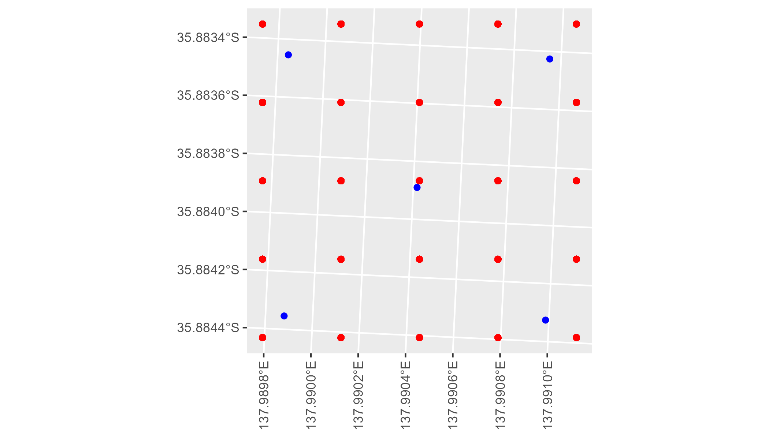

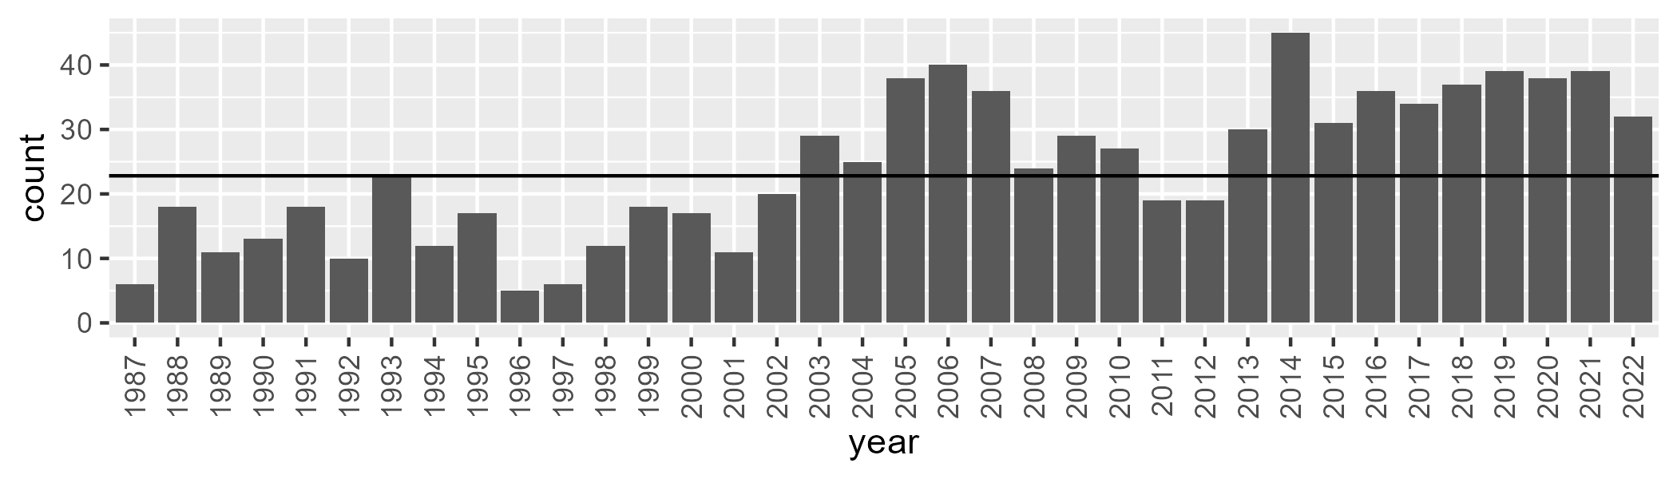

Number of samples: 864

# SAAMDD0007

| Min. | 1st Qu. | Median | Mean | 3rd Qu. | Max. |
| --- | --- | --- | --- | --- | --- |
| 1.495519 | 9.860876 | 15.2523 | 20.09048 | 29.60332 | 60.44404 |

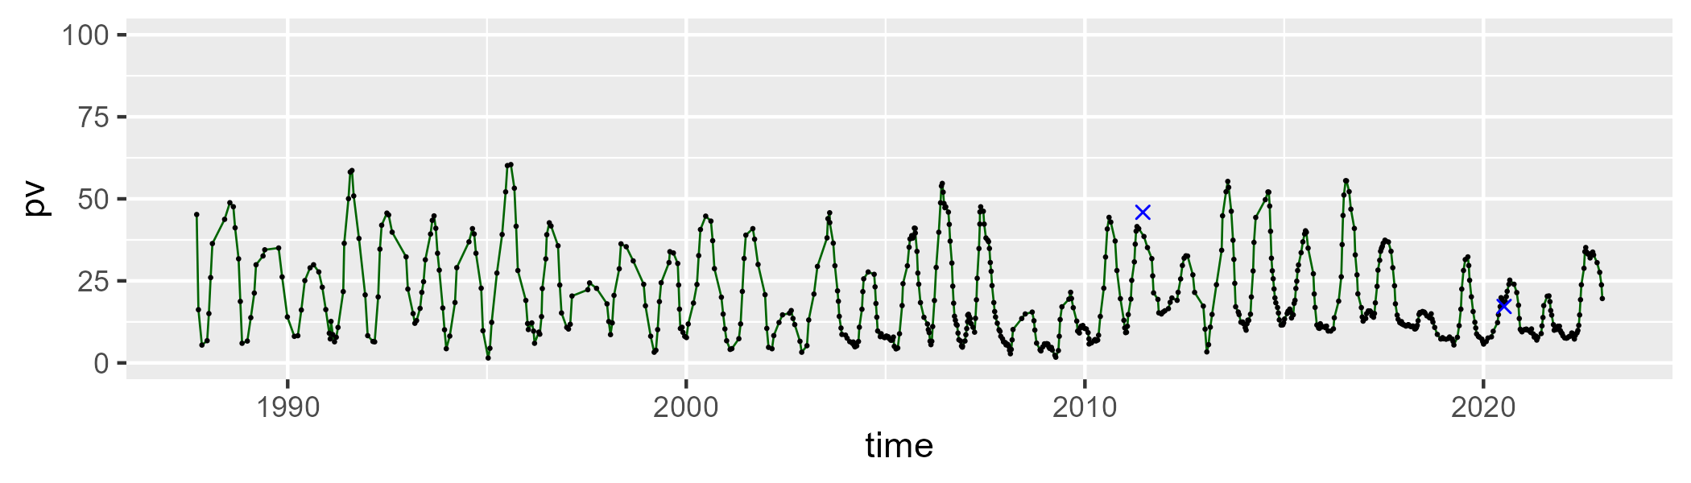

| Min. | 1st Qu. | Median | Mean | 3rd Qu. | Max. |
| --- | --- | --- | --- | --- | --- |
| 24.2 | 43.10252 | 49.91419 | 50.91573 | 58.13286 | 81.83473 |

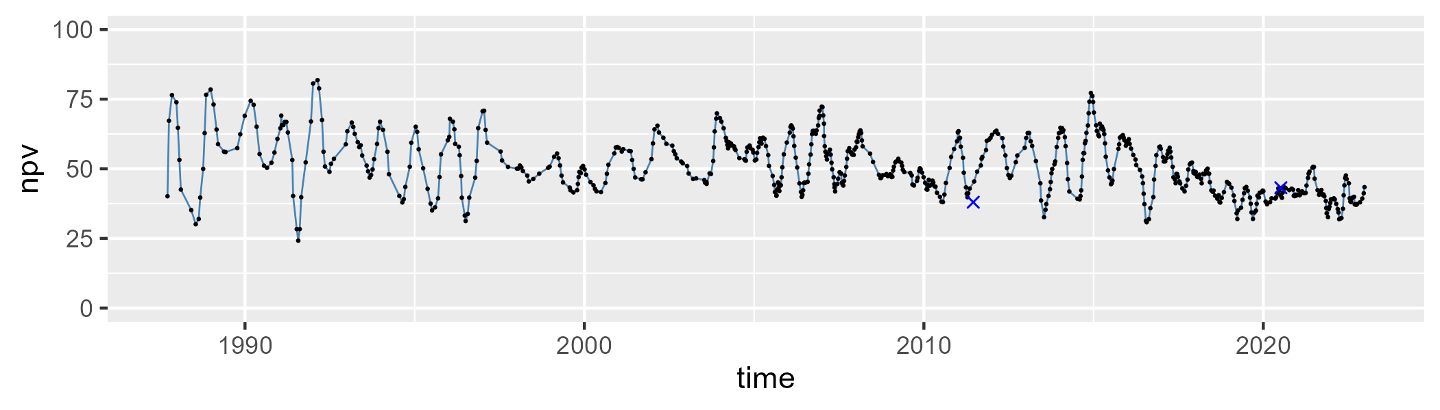

| Min. | 1st Qu. | Median | Mean | 3rd Qu. | Max. |
| --- | --- | --- | --- | --- | --- |
| 2.063985 | 18.64304 | 25.90774 | 27.64178 | 35.95934 | 59.79999 |

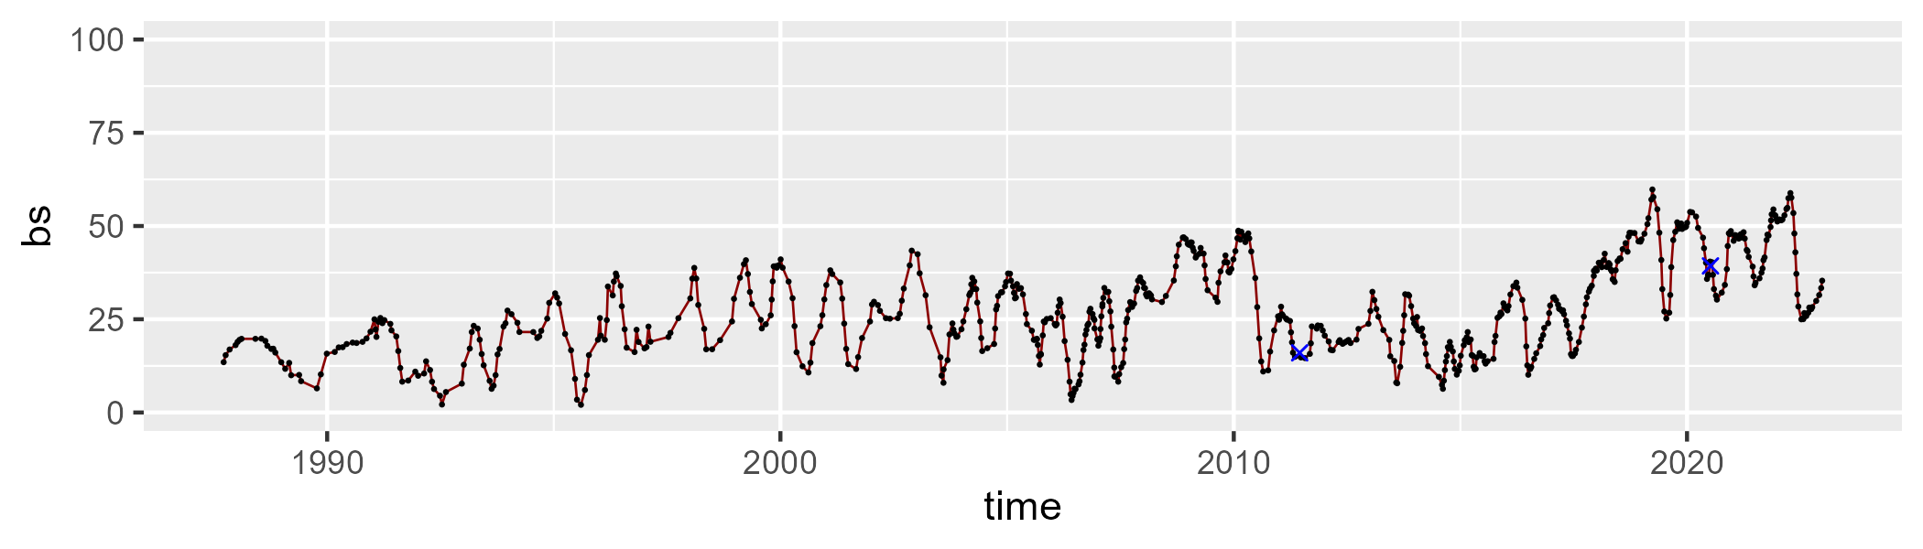

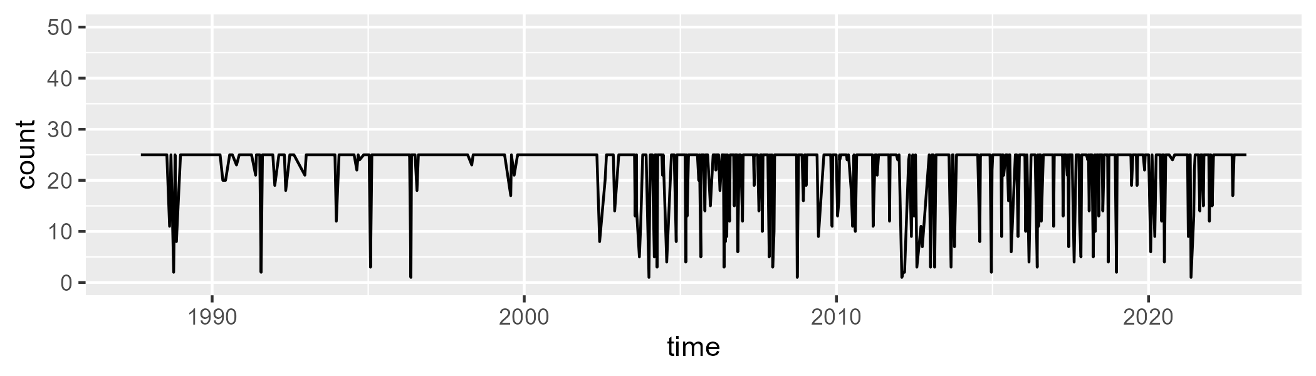

Min. : 1.00 1st Qu.:25.00 Median :25.00 Mean :22.53 3rd Qu.:25.00 Max. :25.00

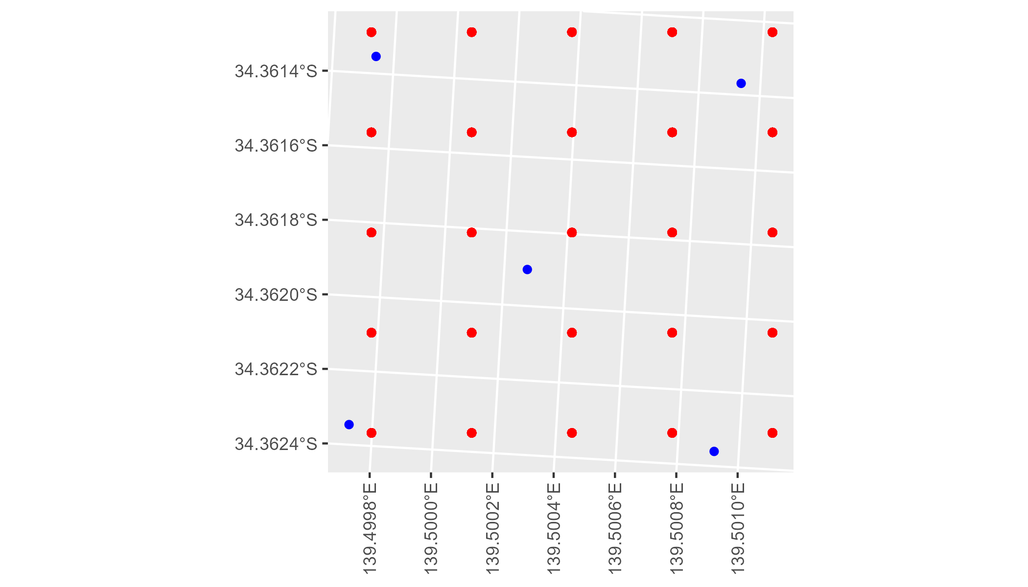

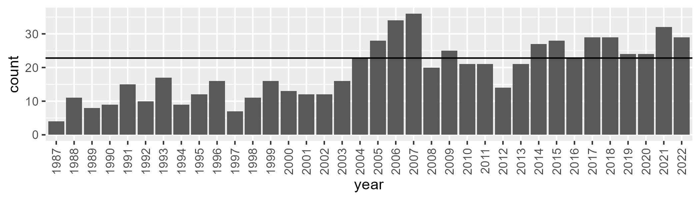

Number of samples: 686

# SAAMDD0008

| Min. | 1st Qu. | Median | Mean | 3rd Qu. | Max. |
| --- | --- | --- | --- | --- | --- |
| 25.19917 | 34.53034 | 37.63239 | 38.00361 | 41.40859 | 53.25488 |

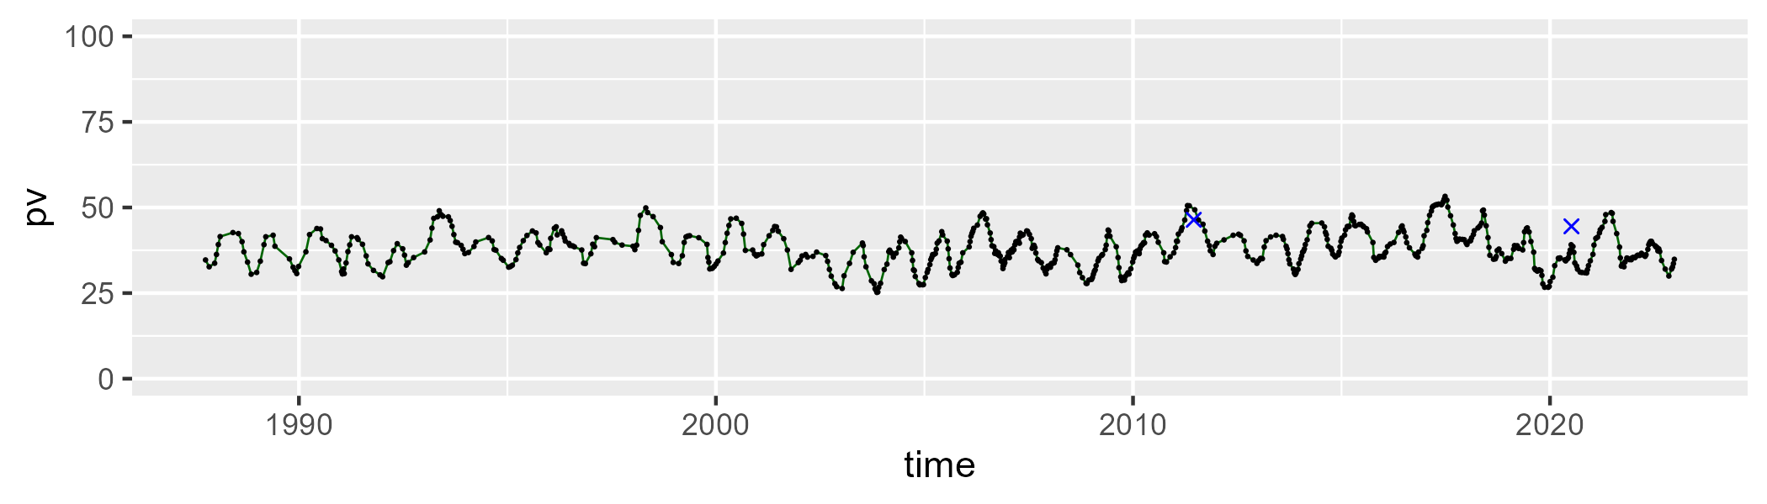

| Min. | 1st Qu. | Median | Mean | 3rd Qu. | Max. |
| --- | --- | --- | --- | --- | --- |
| 35.00088 | 45.3835 | 48.17971 | 47.67203 | 50.48504 | 54.97927 |

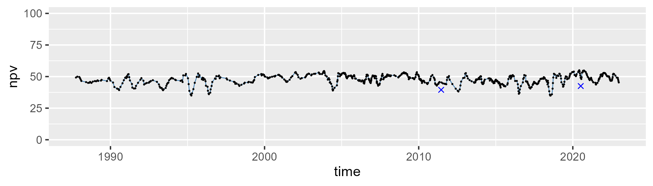

| Min. | 1st Qu. | Median | Mean | 3rd Qu. | Max. |
| --- | --- | --- | --- | --- | --- |
| 0 | 10.20934 | 12.76815 | 13.08735 | 16.04574 | 28.22079 |

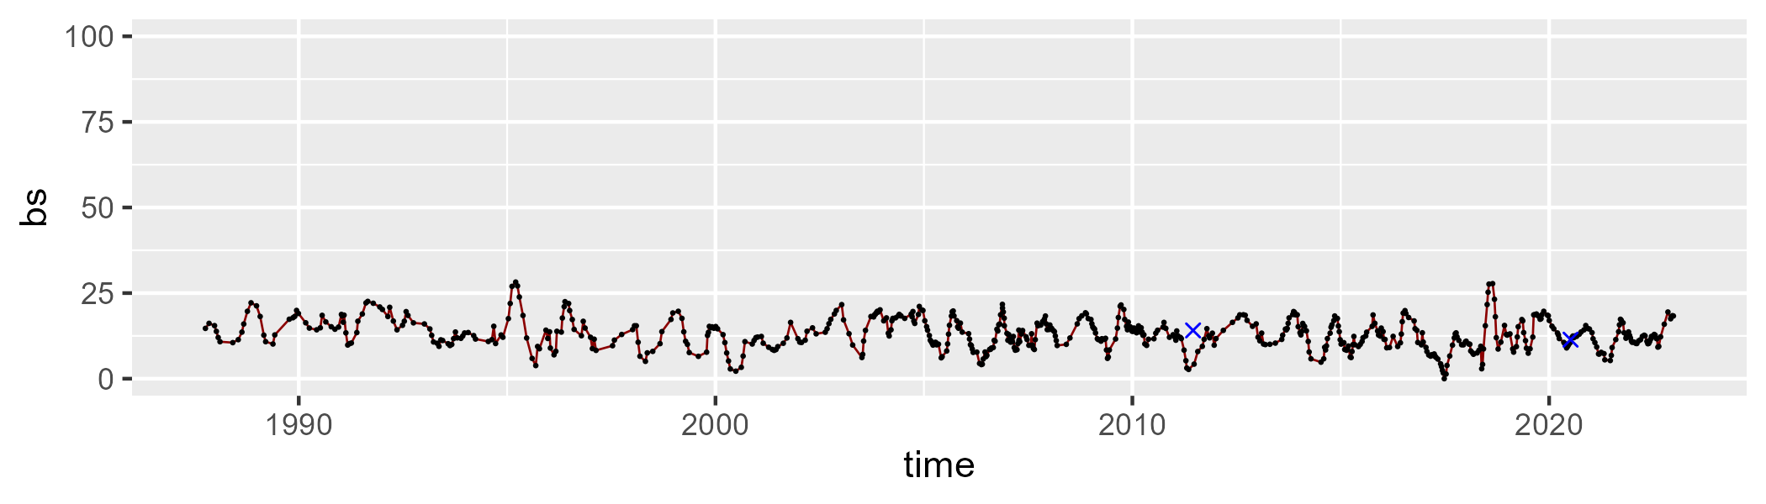

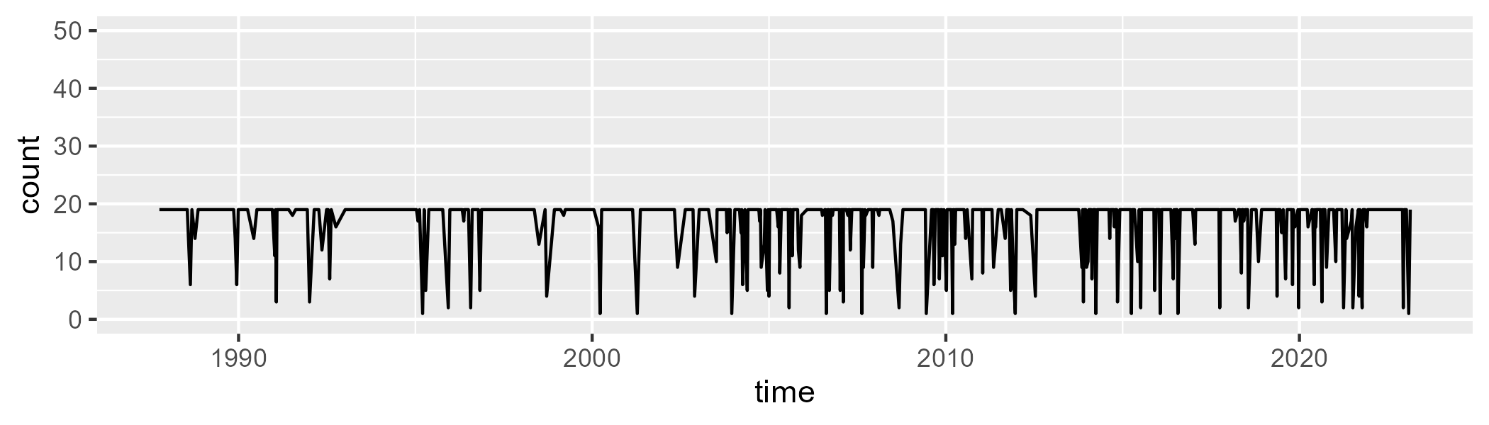

Min. : 1.00 1st Qu.:19.00 Median :19.00 Mean :17.03 3rd Qu.:19.00 Max. :19.00

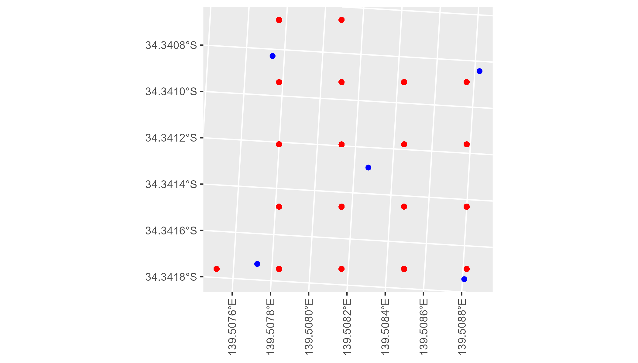

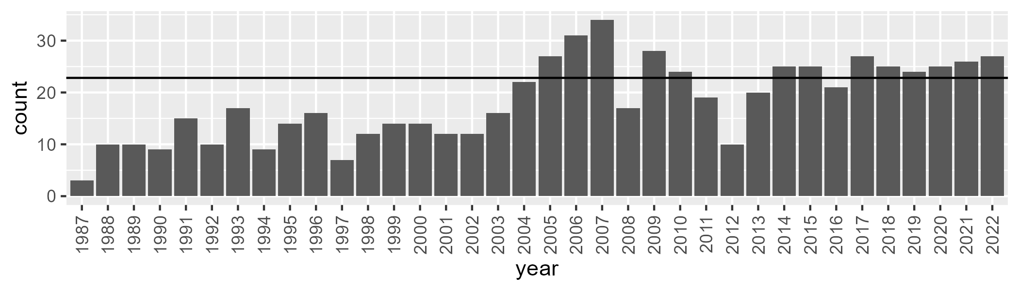

Number of samples: 657

# SAAMDD0009

| Min. | 1st Qu. | Median | Mean | 3rd Qu. | Max. |
| --- | --- | --- | --- | --- | --- |
| 5.871657 | 14.69211 | 20.84485 | 23.49467 | 30.3104 | 57.5018 |

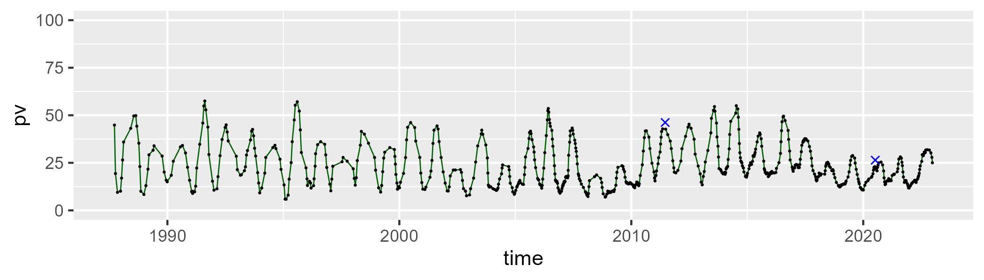

| Min. | 1st Qu. | Median | Mean | 3rd Qu. | Max. |
| --- | --- | --- | --- | --- | --- |
| 23.86793 | 41.46741 | 45.92183 | 46.80836 | 52.07304 | 70.86695 |

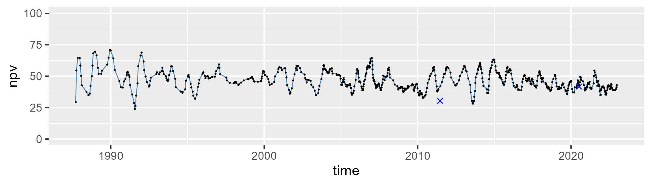

| Min. | 1st Qu. | Median | Mean | 3rd Qu. | Max. |
| --- | --- | --- | --- | --- | --- |
| 4.882914 | 19.8996 | 27.86684 | 28.35015 | 35.87323 | 52.07881 |

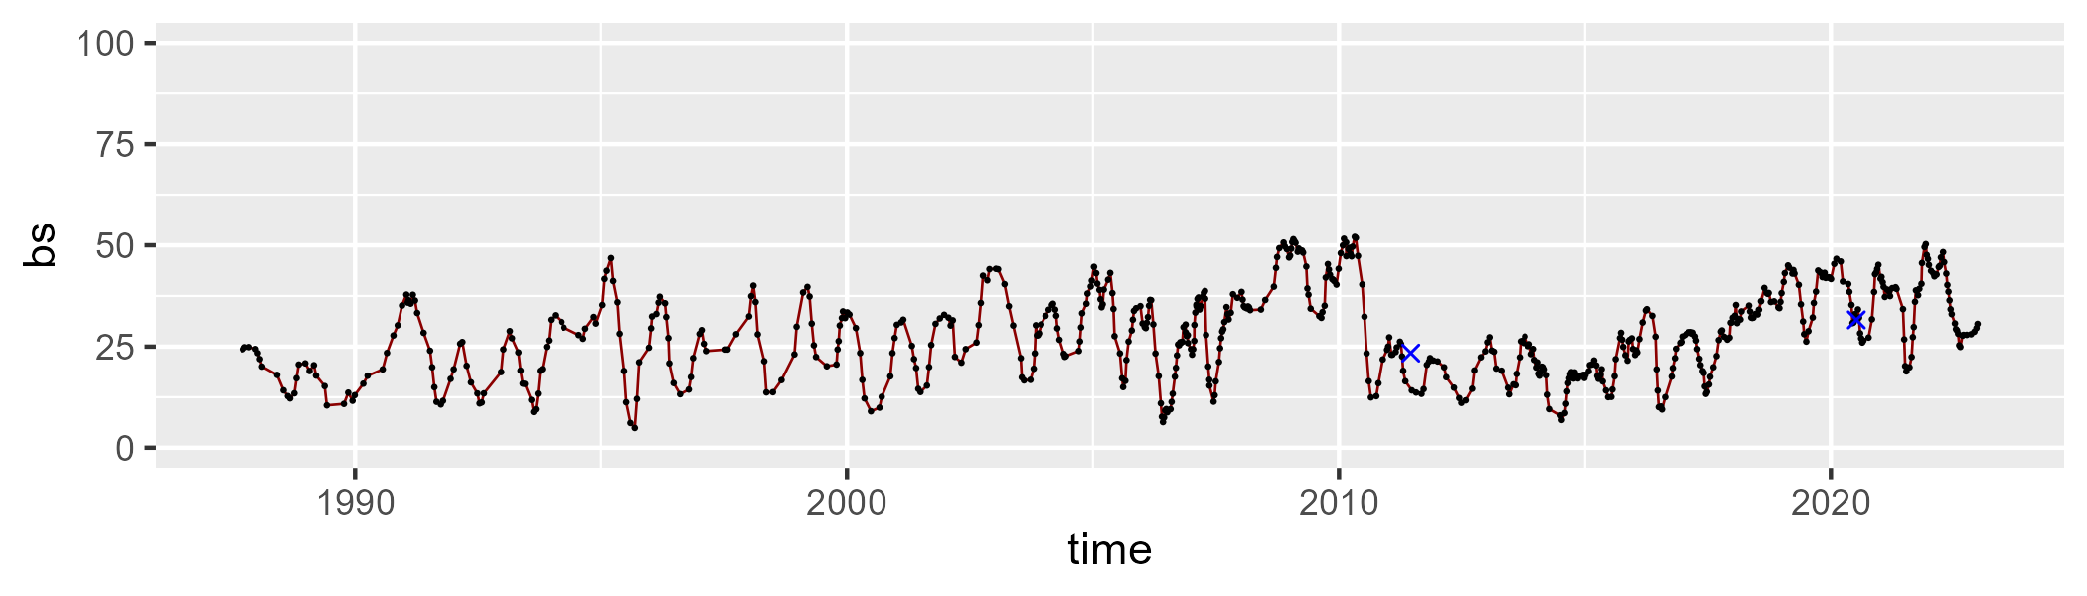

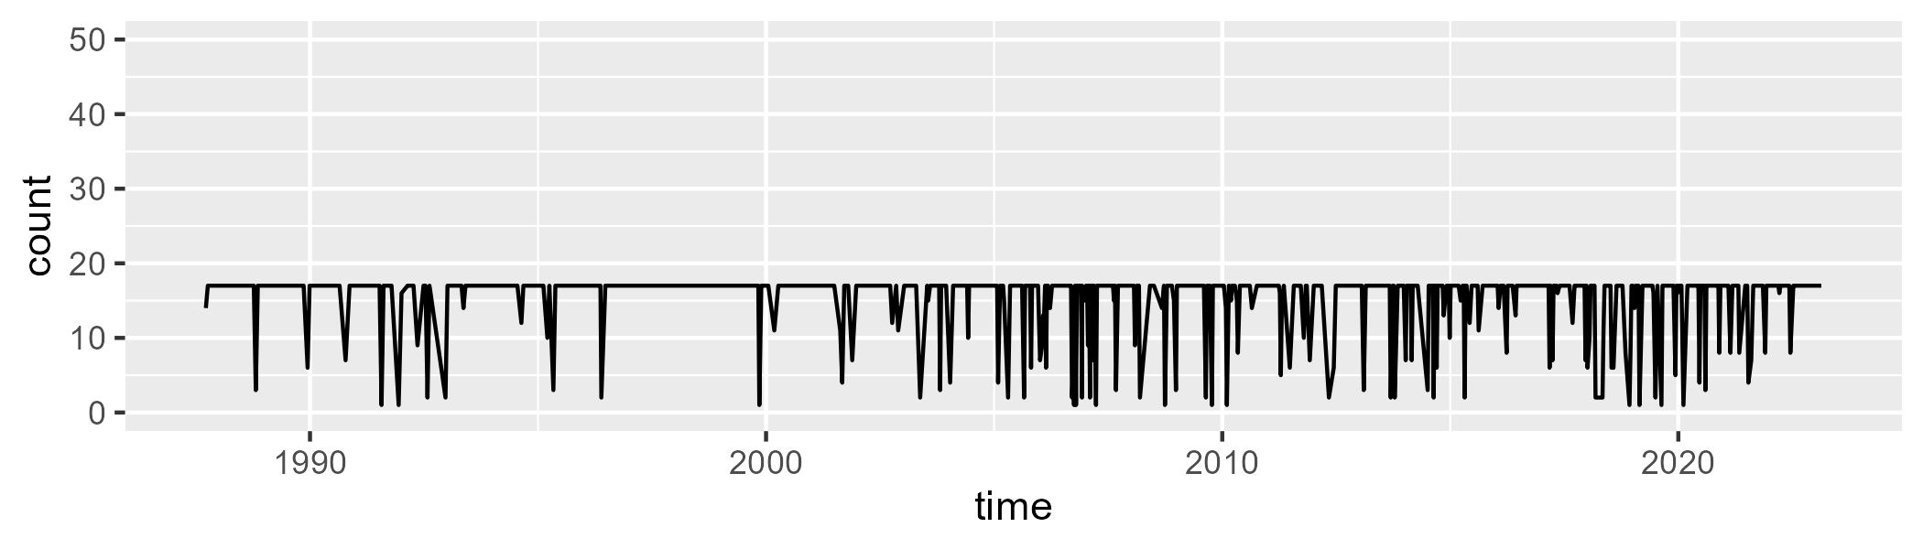

Min. : 1.00 1st Qu.:17.00 Median :17.00 Mean :15.24 3rd Qu.:17.00 Max. :17.00

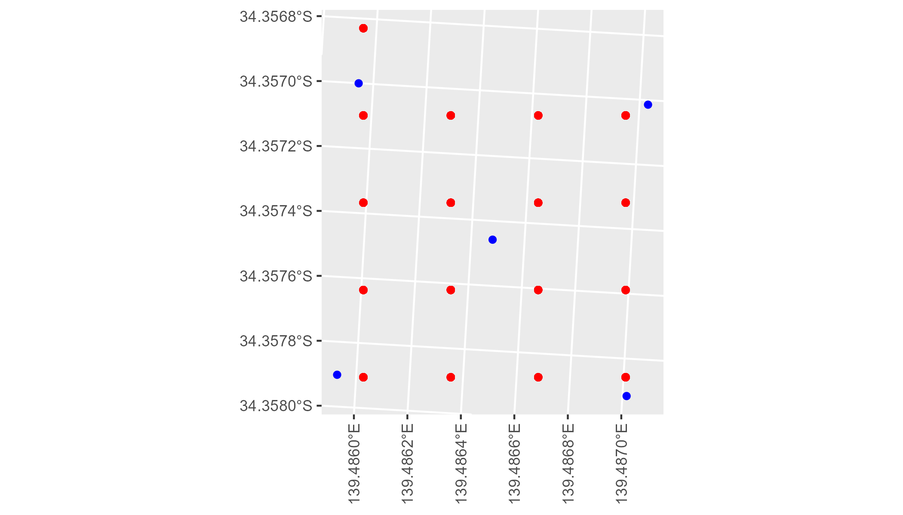

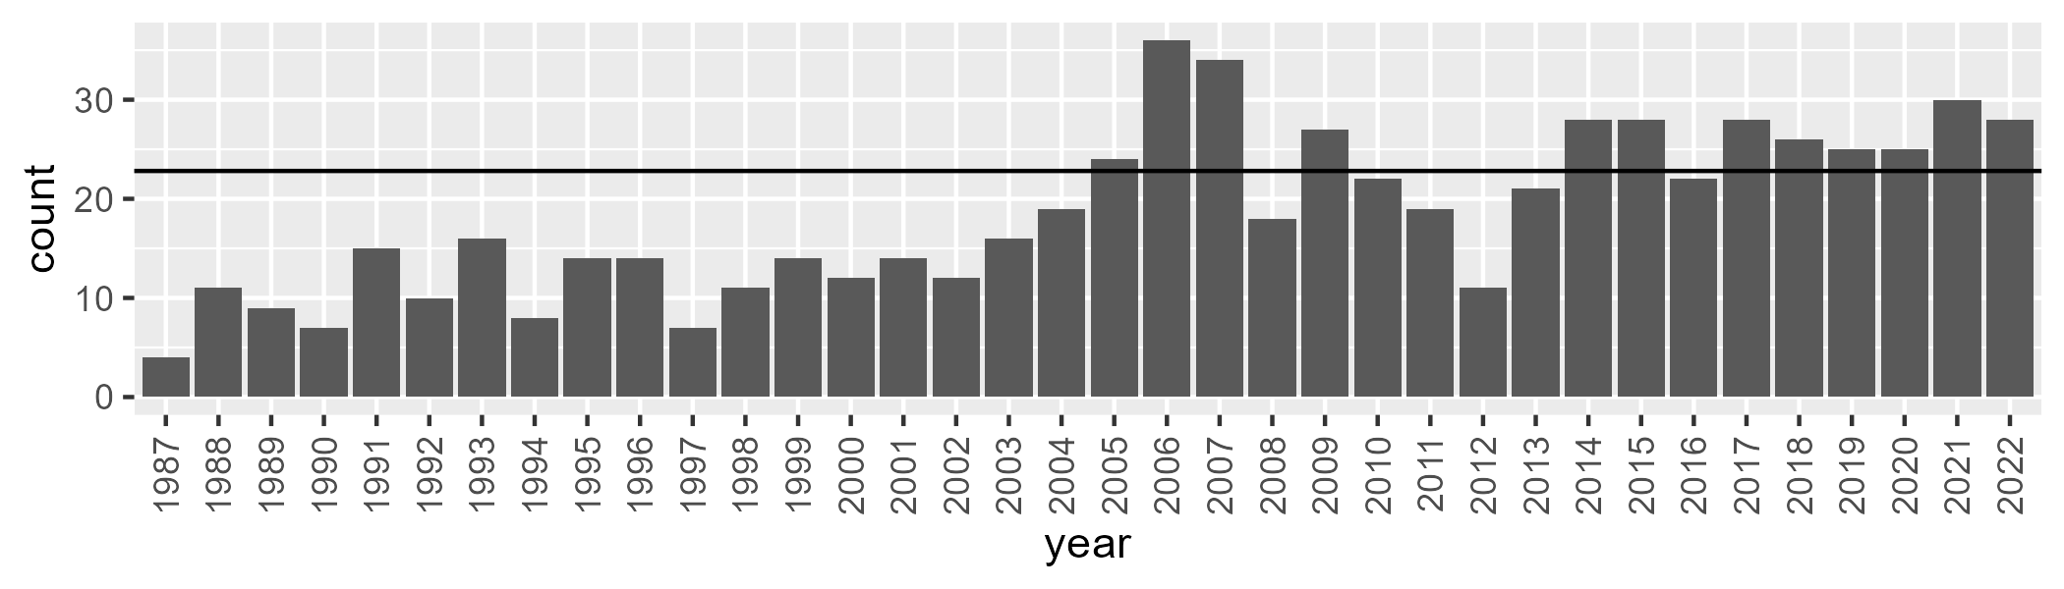

Number of samples: 665

# SAAMDD0010

| Min. | 1st Qu. | Median | Mean | 3rd Qu. | Max. |
| --- | --- | --- | --- | --- | --- |
| 15.99468 | 24.81836 | 27.78778 | 28.22164 | 31.35342 | 41.70789 |

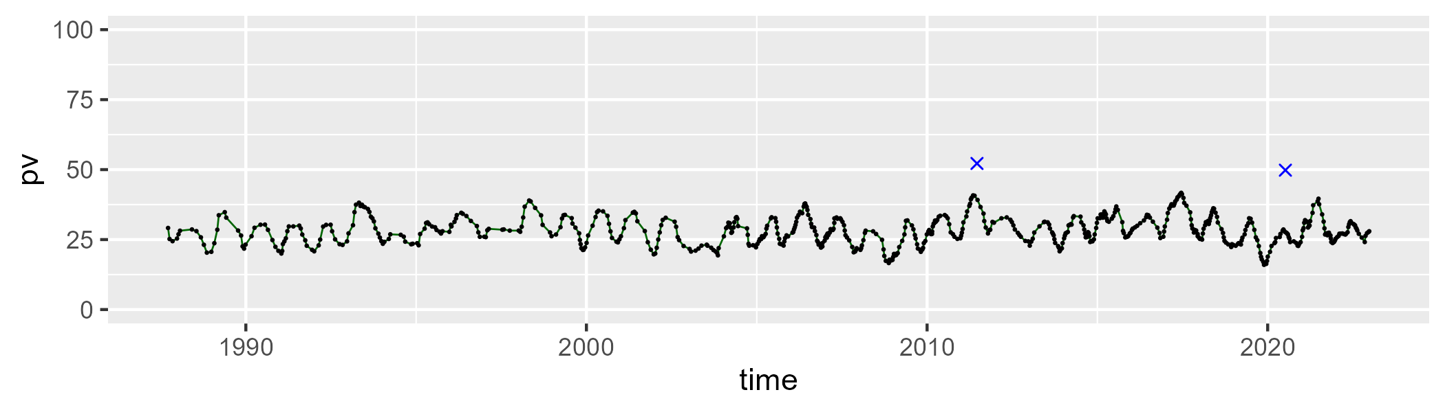

| Min. | 1st Qu. | Median | Mean | 3rd Qu. | Max. |
| --- | --- | --- | --- | --- | --- |
| 36.72799 | 47.3905 | 49.45157 | 49.15176 | 51.18865 | 60.98174 |

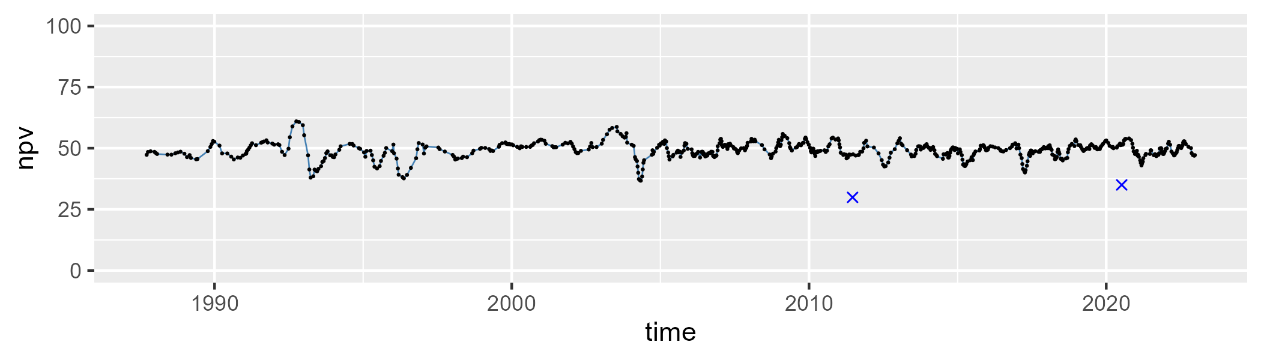

| Min. | 1st Qu. | Median | Mean | 3rd Qu. | Max. |
| --- | --- | --- | --- | --- | --- |
| 7.908091 | 18.76678 | 21.43708 | 21.34767 | 24.14143 | 33.55215 |

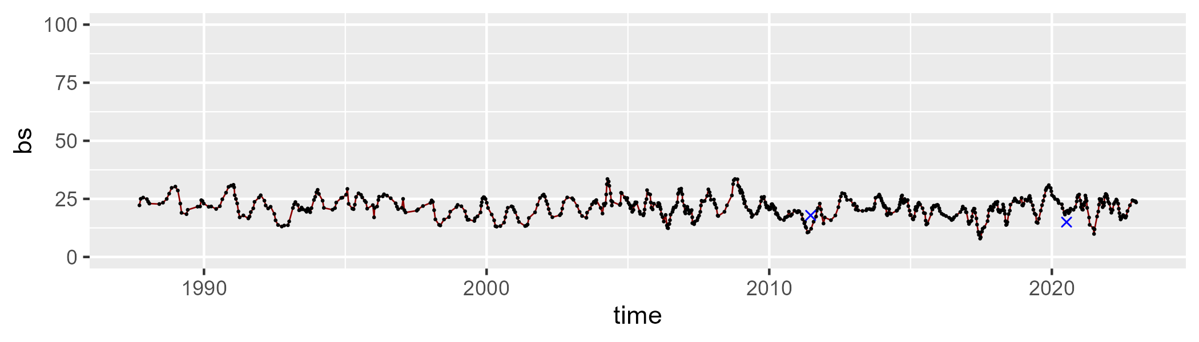

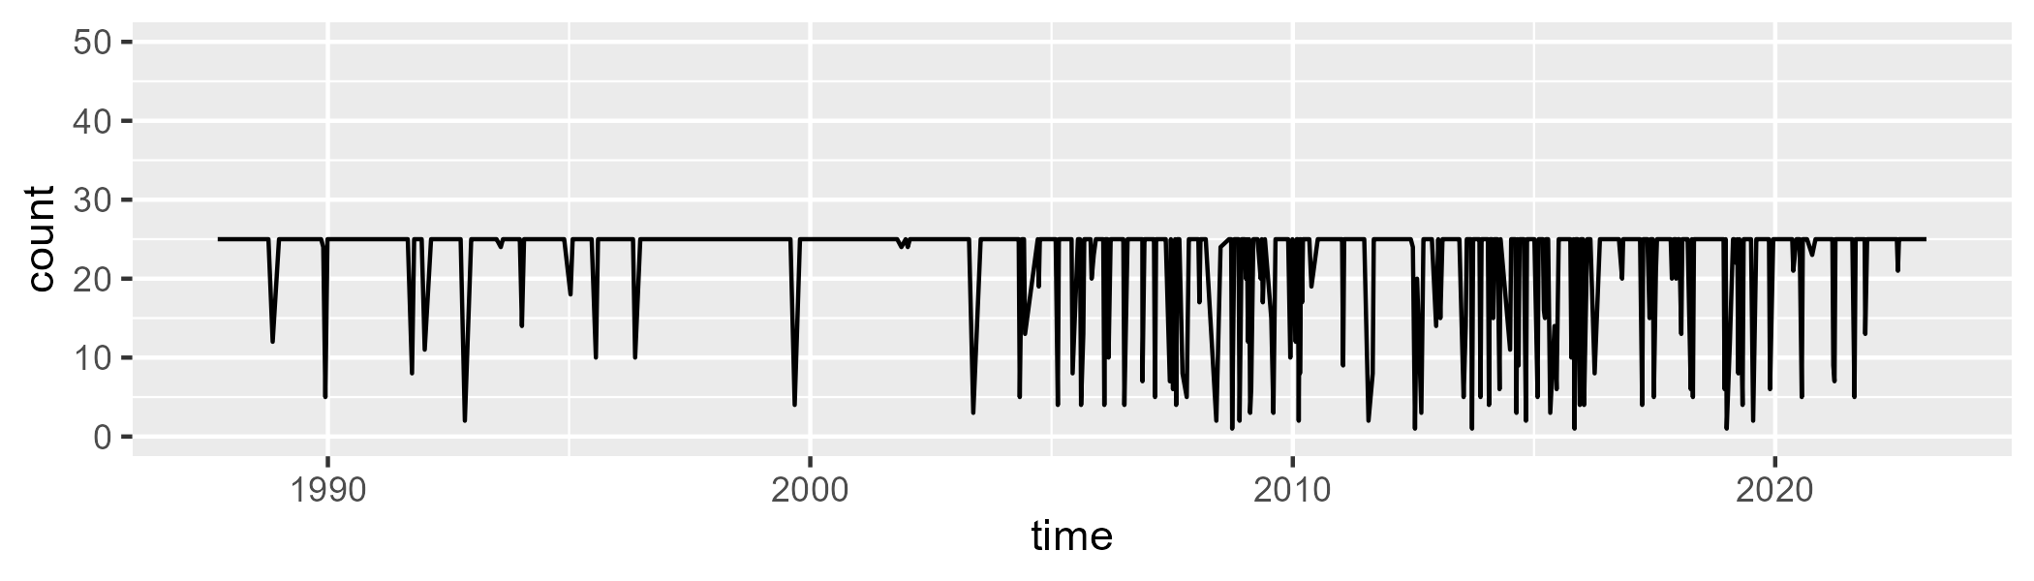

Min. : 1.00 1st Qu.:25.00 Median :25.00 Mean :22.56 3rd Qu.:25.00 Max. :25.00

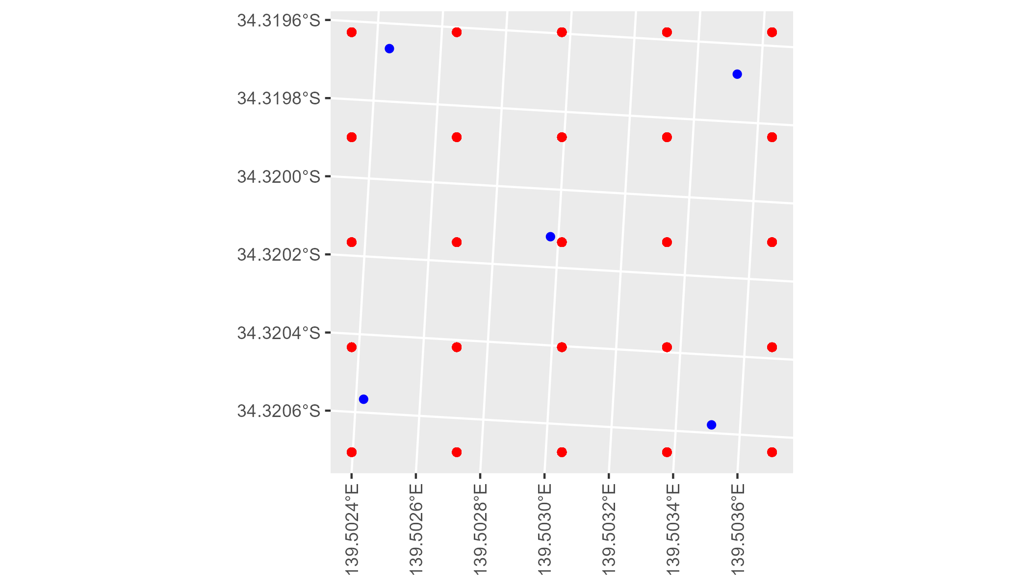

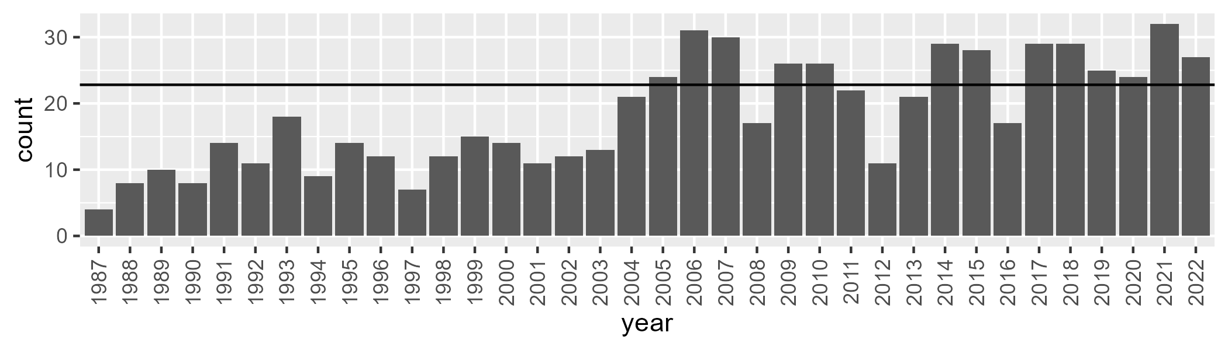

Number of samples: 661

# SAAMDD0011

| Min. | 1st Qu. | Median | Mean | 3rd Qu. | Max. |
| --- | --- | --- | --- | --- | --- |
| 9.26349 | 19.65781 | 26.02337 | 26.8859 | 33.05142 | 53.8142 |

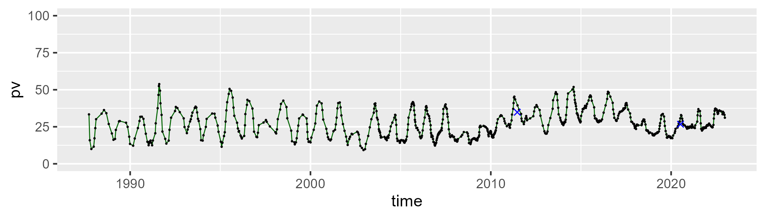

| Min. | 1st Qu. | Median | Mean | 3rd Qu. | Max. |
| --- | --- | --- | --- | --- | --- |
| 29.60961 | 47.03928 | 49.64252 | 49.73053 | 52.26188 | 61.4728 |

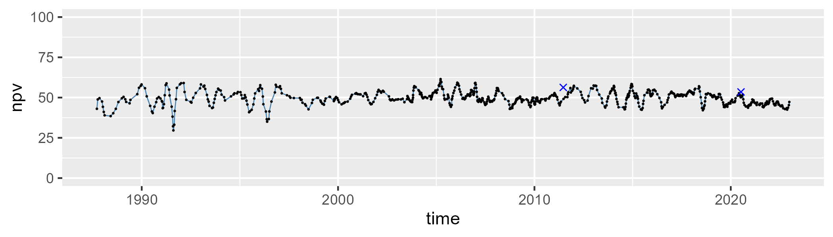

| Min. | 1st Qu. | Median | Mean | 3rd Qu. | Max. |
| --- | --- | --- | --- | --- | --- |
| 4.186807 | 15.46176 | 22.10536 | 22.11267 | 28.61146 | 41.85086 |

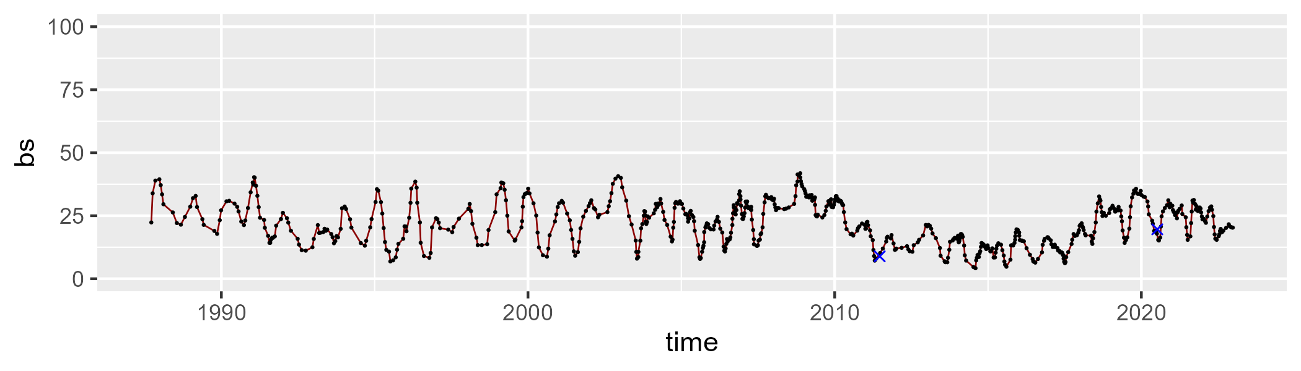

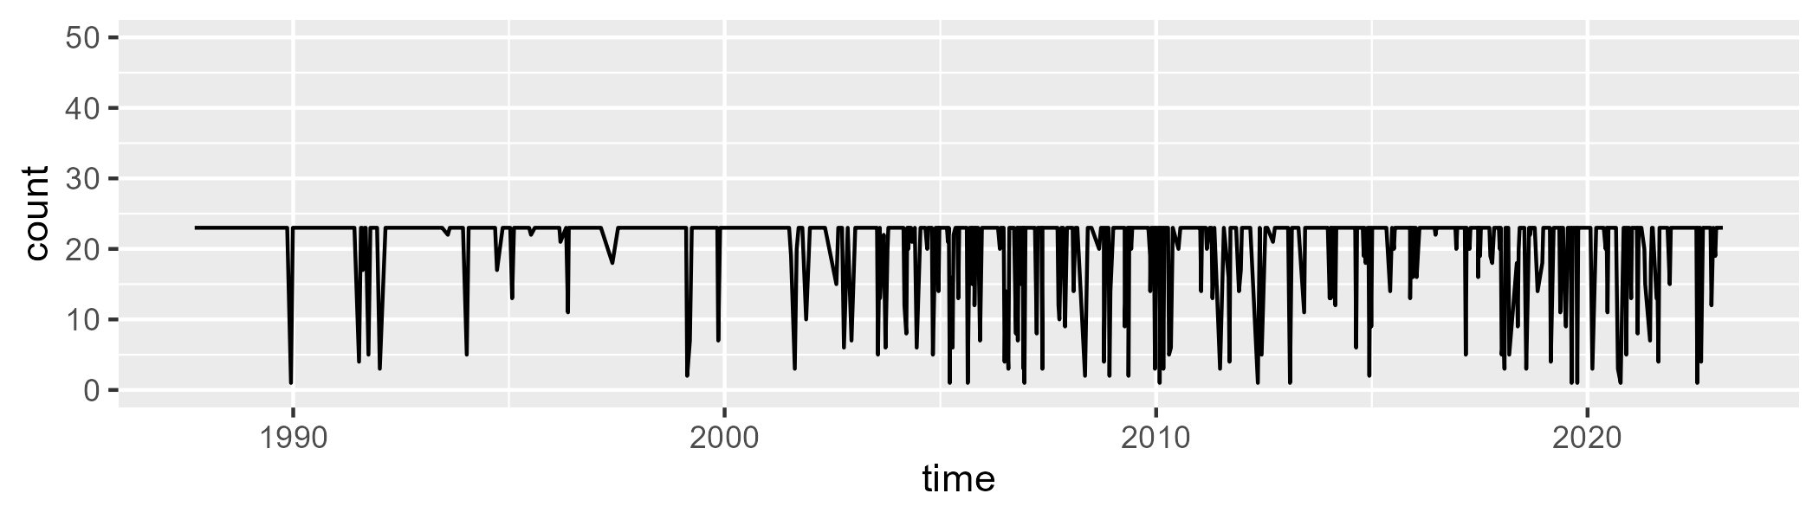

Min. : 1.00 1st Qu.:23.00 Median :23.00 Mean :20.47 3rd Qu.:23.00 Max. :23.00

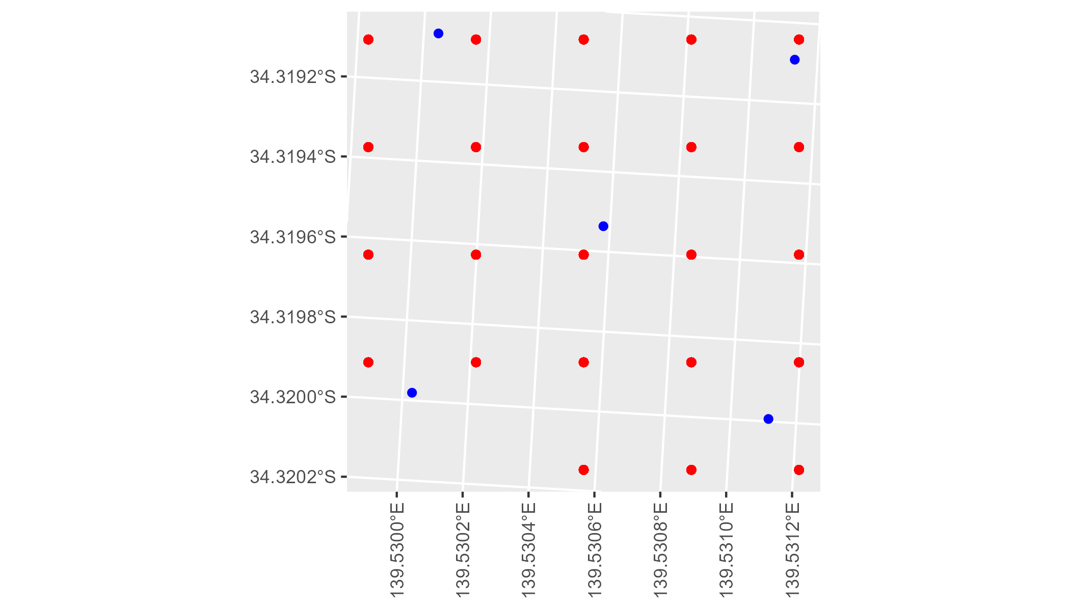

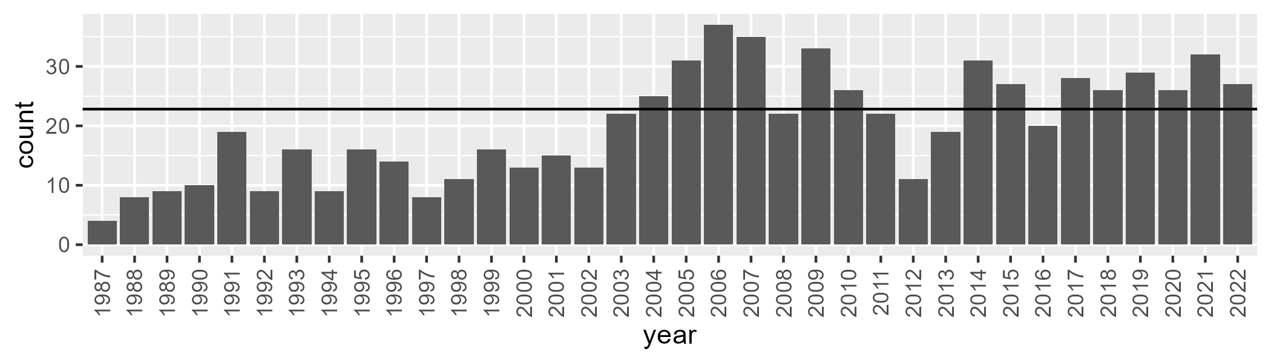

Number of samples: 719

# SAANUL0001

| Min. | 1st Qu. | Median | Mean | 3rd Qu. | Max. |
| --- | --- | --- | --- | --- | --- |
| 0 | 3.570308 | 7.378801 | 9.328669 | 12.99968 | 38.24319 |

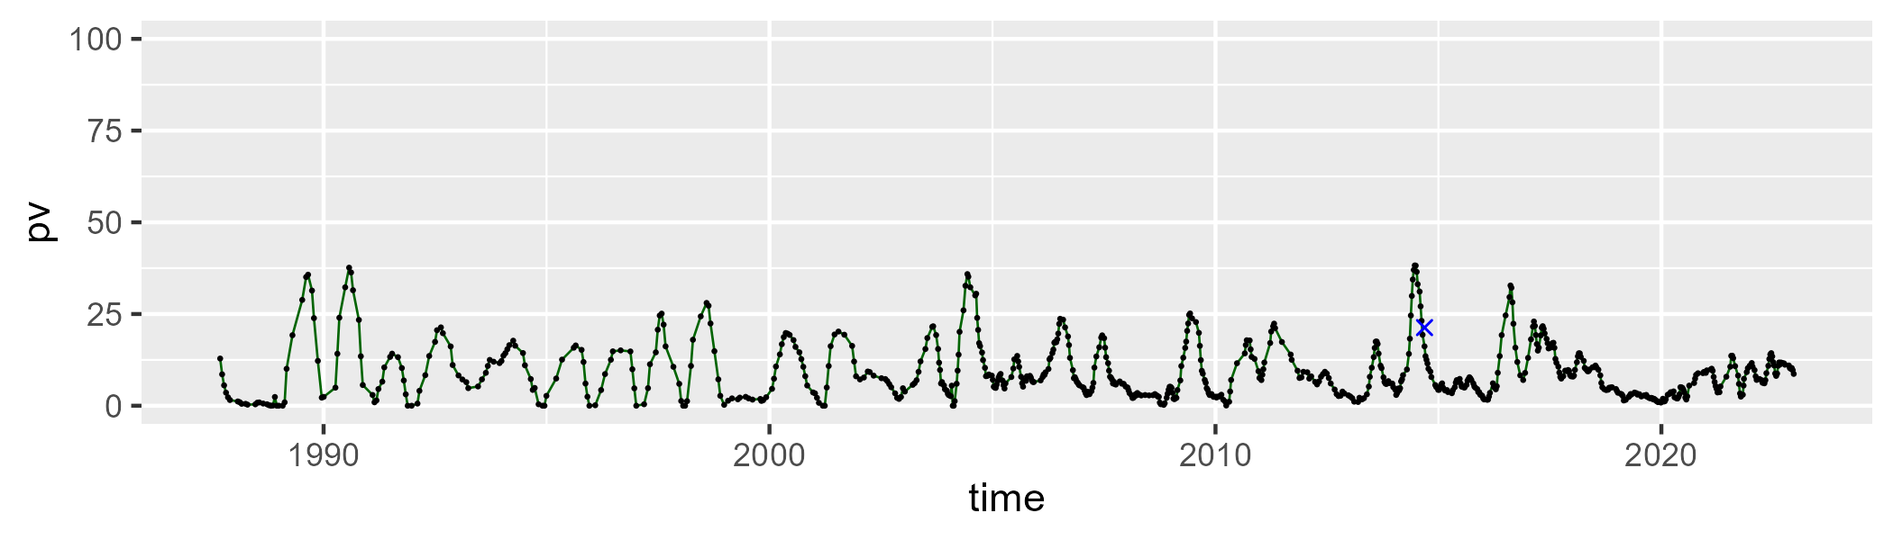

| Min. | 1st Qu. | Median | Mean | 3rd Qu. | Max. |
| --- | --- | --- | --- | --- | --- |
| 31.24737 | 47.0689 | 52.50169 | 52.40766 | 57.55014 | 74.64651 |

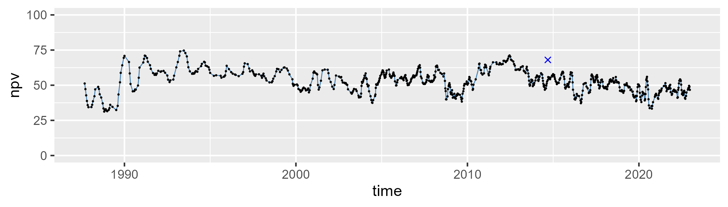

| Min. | 1st Qu. | Median | Mean | 3rd Qu. | Max. |
| --- | --- | --- | --- | --- | --- |
| 10.57842 | 30.16268 | 36.50169 | 36.89442 | 43.31442 | 71.19828 |

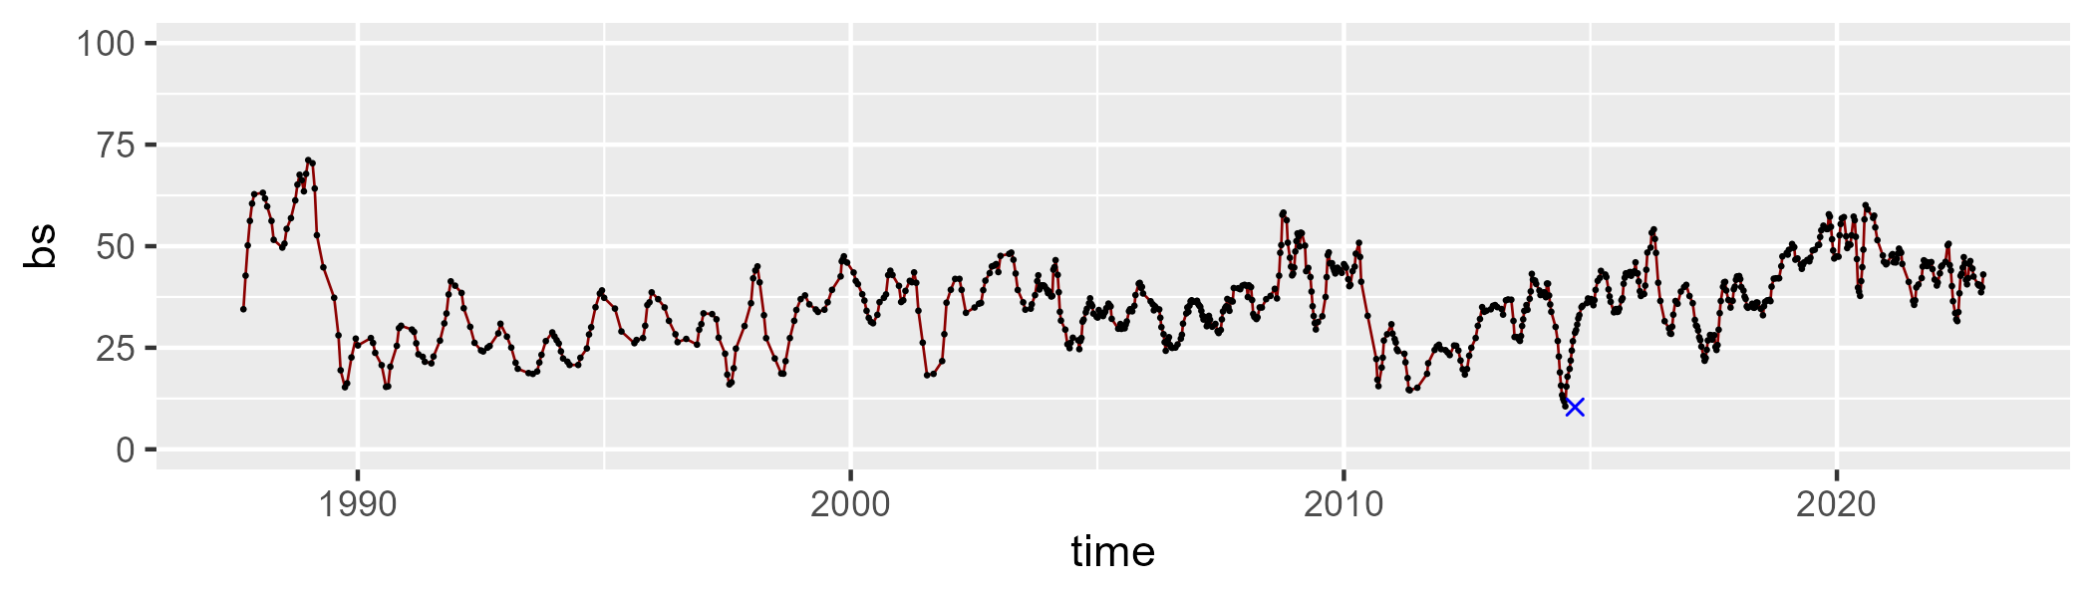

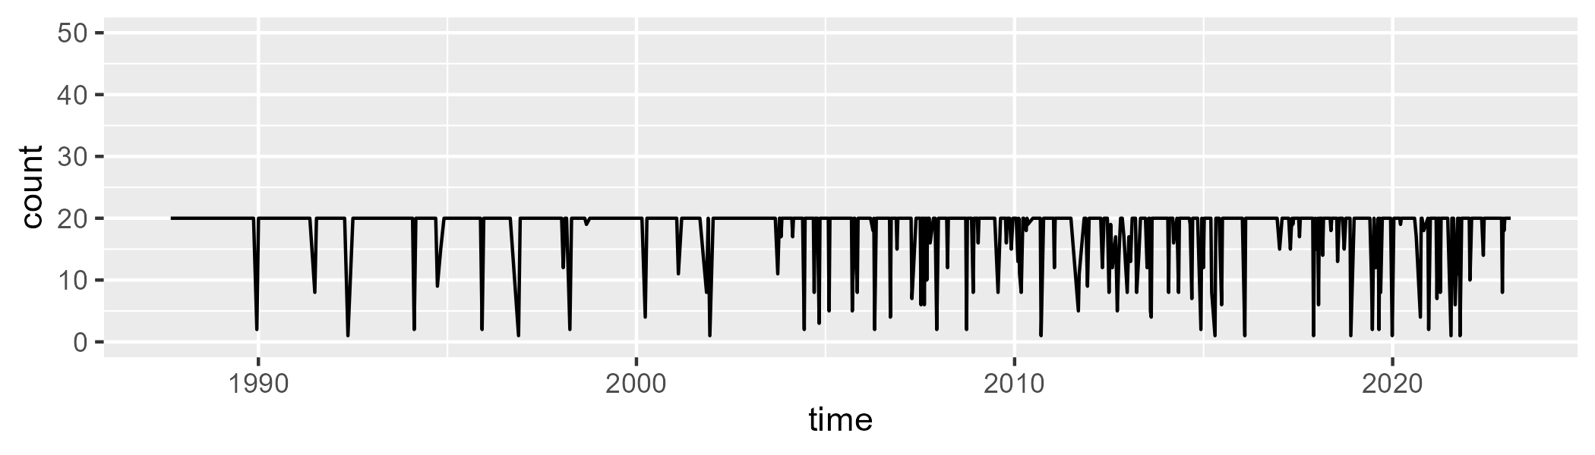

Min. : 1.00 1st Qu.:20.00 Median :20.00 Mean :18.45 3rd Qu.:20.00 Max. :20.00

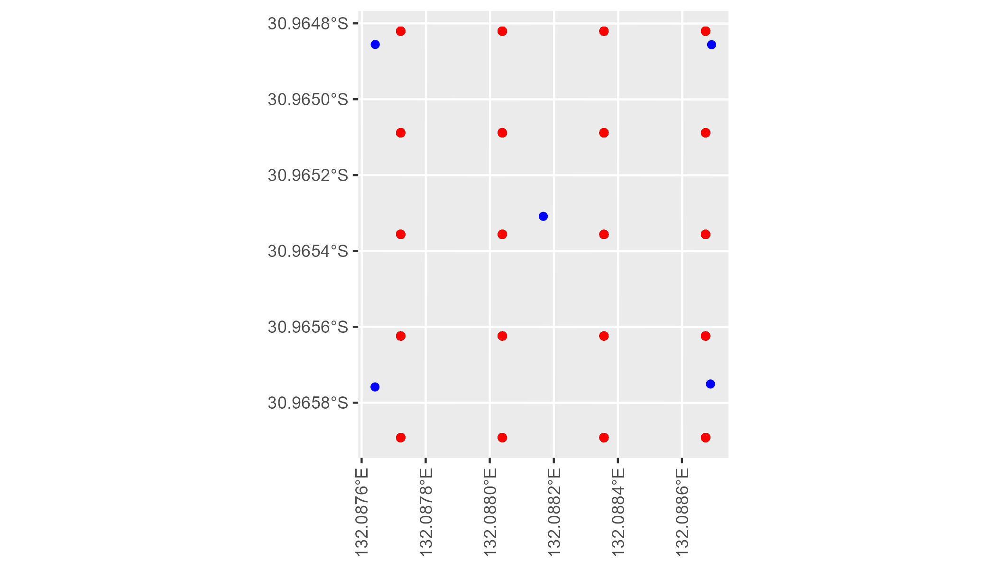

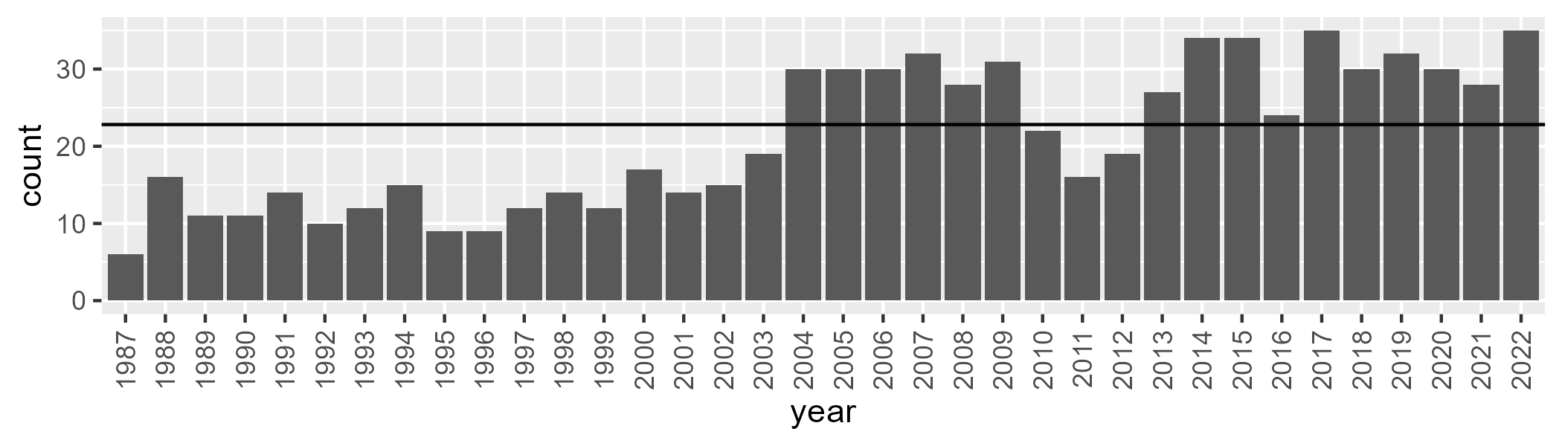

Number of samples: 763

# SAANUL0002

| Min. | 1st Qu. | Median | Mean | 3rd Qu. | Max. |
| --- | --- | --- | --- | --- | --- |
| 4.618295 | 13.52754 | 17.37359 | 19.22027 | 24.09761 | 51.10553 |

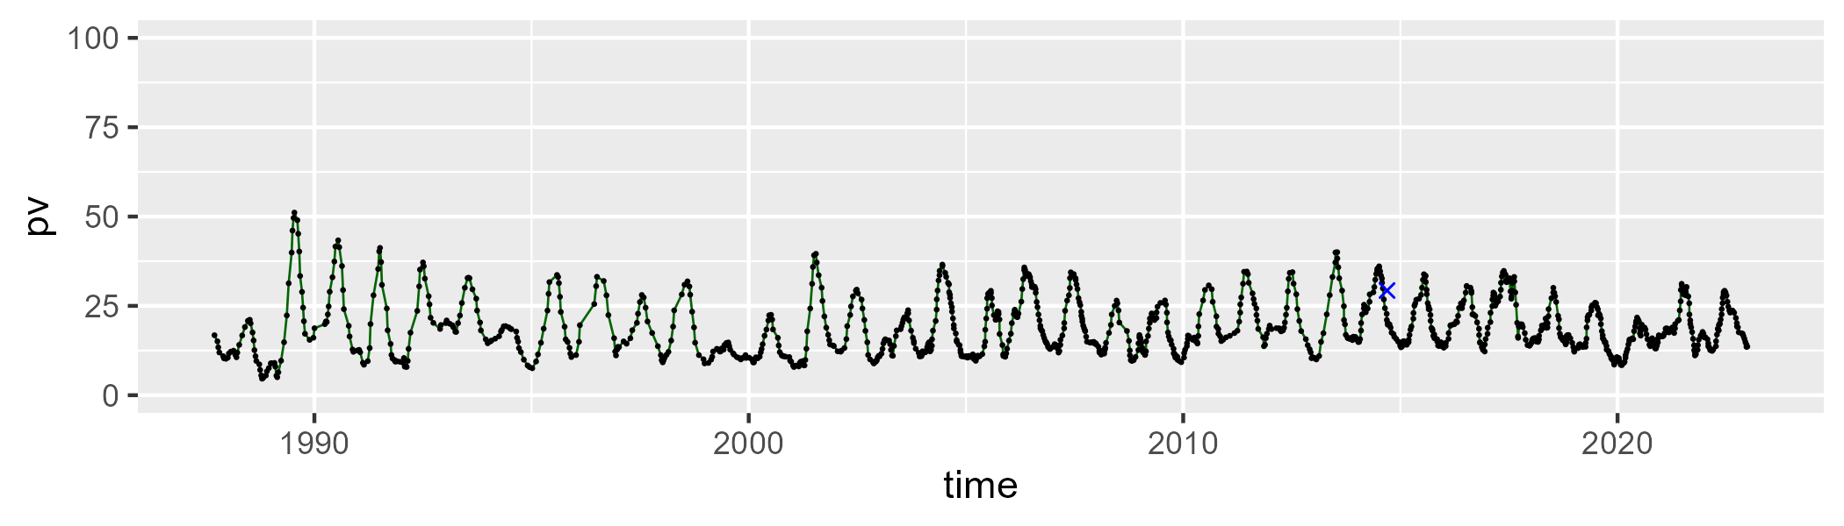

| Min. | 1st Qu. | Median | Mean | 3rd Qu. | Max. |
| --- | --- | --- | --- | --- | --- |
| 27.5759 | 44.85418 | 49.13742 | 49.21421 | 53.89043 | 65.04674 |

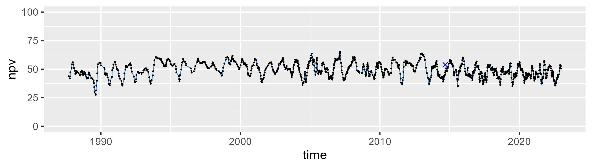

| Min. | 1st Qu. | Median | Mean | 3rd Qu. | Max. |
| --- | --- | --- | --- | --- | --- |
| 13.03385 | 26.36773 | 29.92902 | 30.22328 | 34.11759 | 47.91763 |

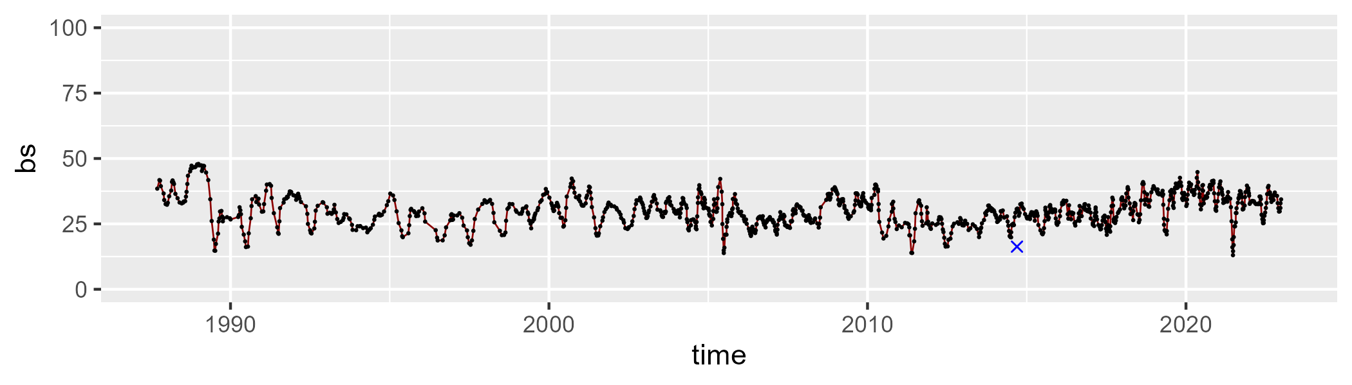

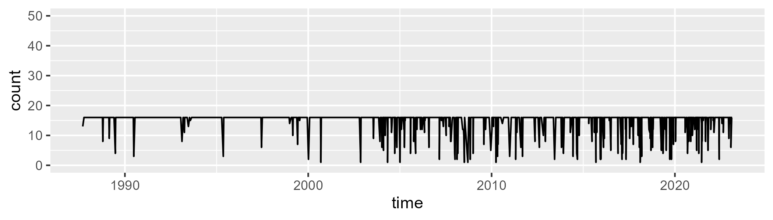

Min. : 1.00 1st Qu.:16.00 Median :16.00 Mean :14.88 3rd Qu.:16.00 Max. :16.00

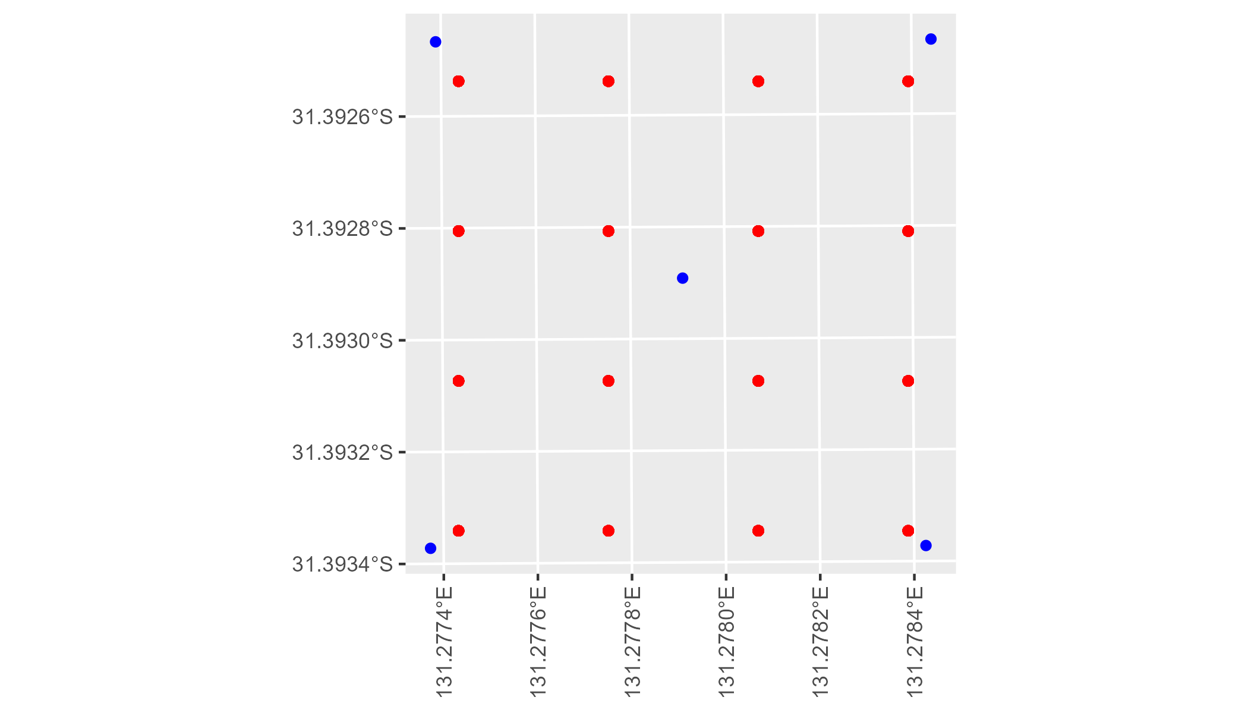

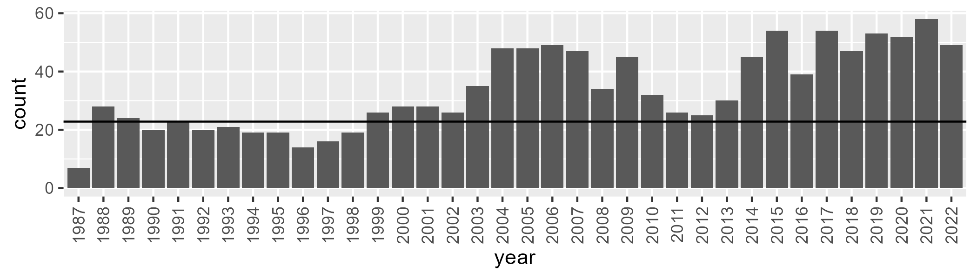

Number of samples: 1208

# SAANUL0003

| Min. | 1st Qu. | Median | Mean | 3rd Qu. | Max. |
| --- | --- | --- | --- | --- | --- |
| 0 | 5.517107 | 9.181534 | 10.96941 | 15.41675 | 42.80061 |

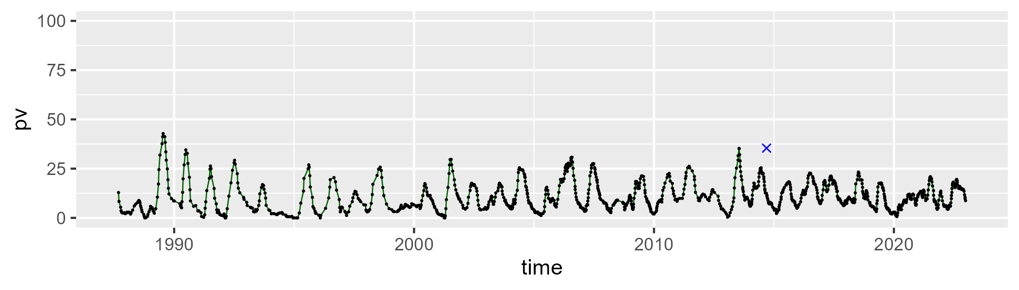

| Min. | 1st Qu. | Median | Mean | 3rd Qu. | Max. |
| --- | --- | --- | --- | --- | --- |
| 31.74256 | 46.96604 | 51.59952 | 51.54648 | 55.9335 | 73.37625 |

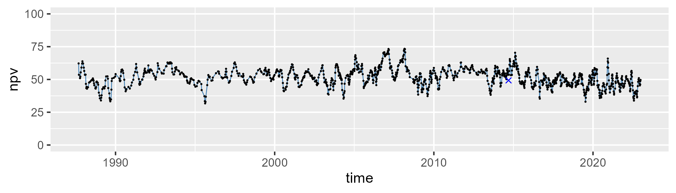

| Min. | 1st Qu. | Median | Mean | 3rd Qu. | Max. |
| --- | --- | --- | --- | --- | --- |
| 7.108612 | 30.84404 | 36.95662 | 36.10145 | 41.80679 | 59.41636 |

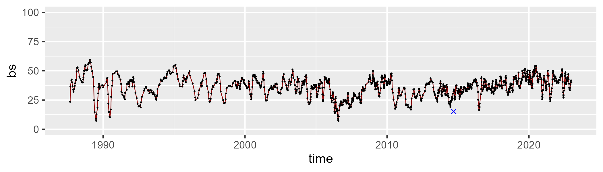

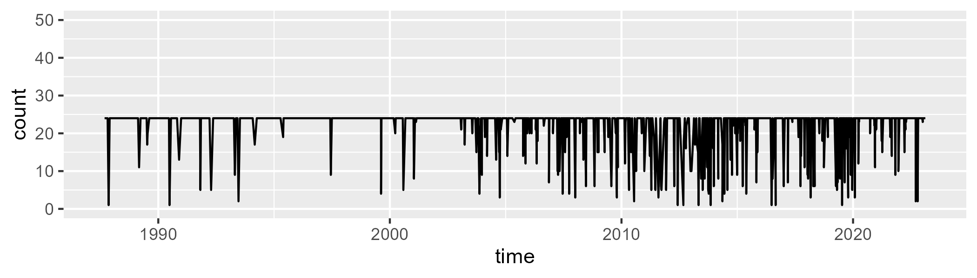

Min. : 1.00 1st Qu.:24.00 Median :24.00 Mean :22.19 3rd Qu.:24.00 Max. :24.00

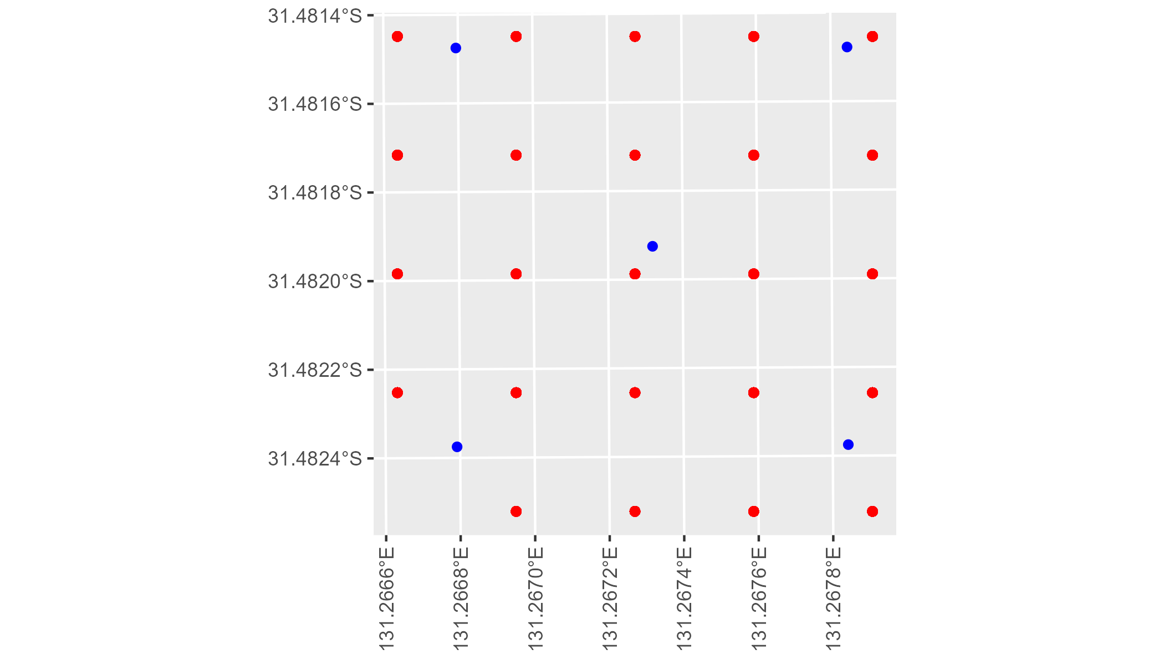

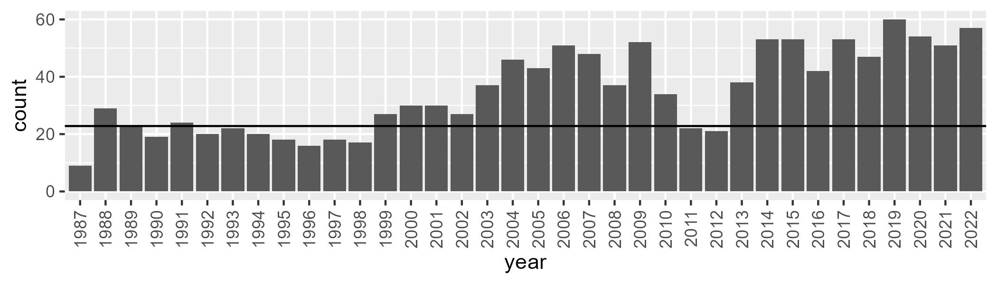

Number of samples: 1248

# SAANUL0004

| Min. | 1st Qu. | Median | Mean | 3rd Qu. | Max. |
| --- | --- | --- | --- | --- | --- |
| 0 | 5.810554 | 9.73012 | 10.95687 | 15.27898 | 37.12471 |

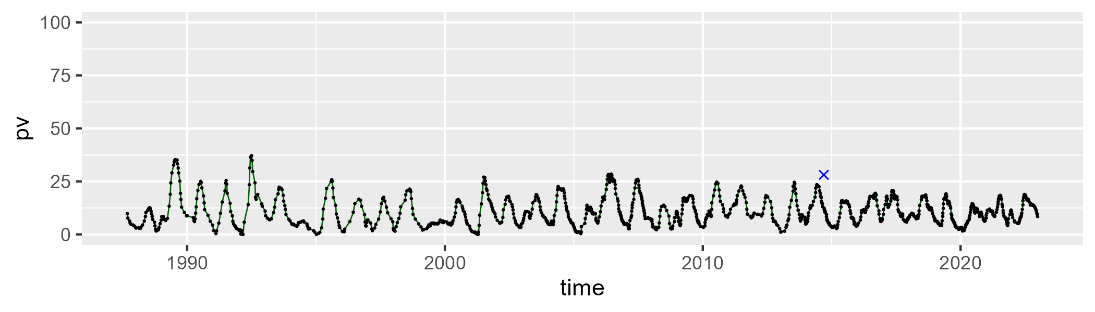

| Min. | 1st Qu. | Median | Mean | 3rd Qu. | Max. |
| --- | --- | --- | --- | --- | --- |
| 27.28986 | 46.53049 | 51.69994 | 51.7019 | 56.79481 | 74.73771 |

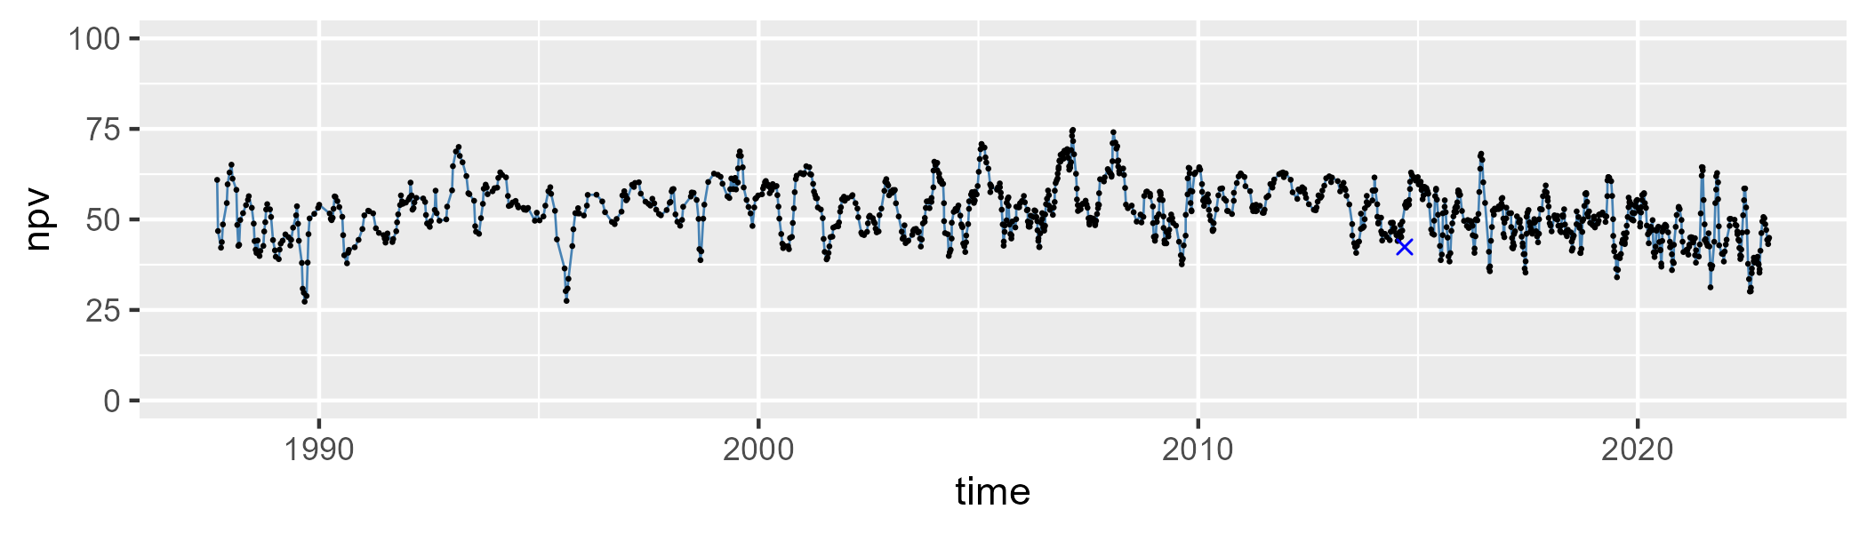

| Min. | 1st Qu. | Median | Mean | 3rd Qu. | Max. |
| --- | --- | --- | --- | --- | --- |
| 10.94143 | 31.23164 | 36.17698 | 35.99151 | 41.54029 | 57.01925 |

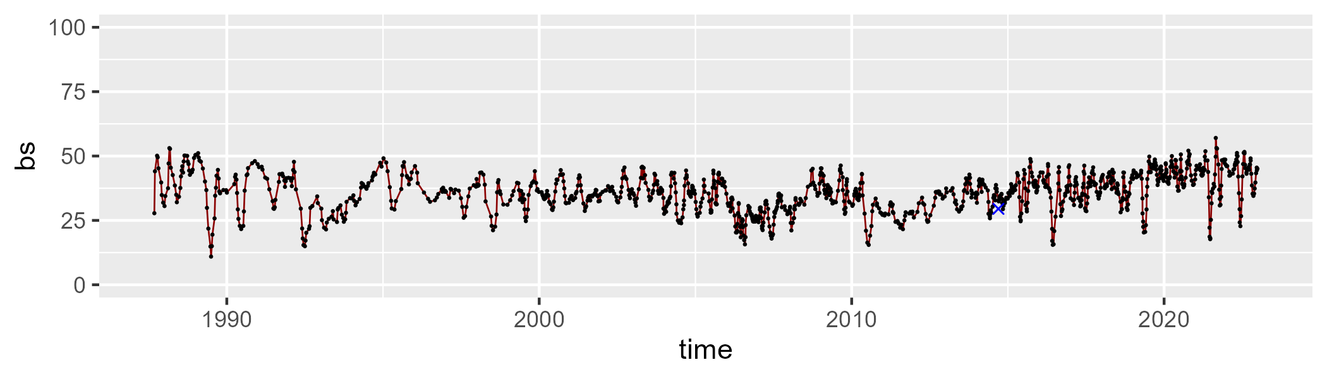

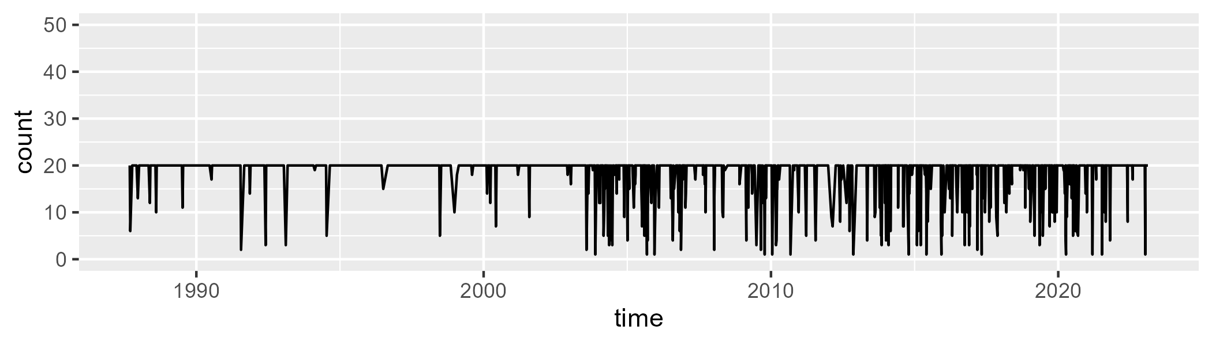

Min. : 1.00 1st Qu.:20.00 Median :20.00 Mean :18.29 3rd Qu.:20.00 Max. :20.00

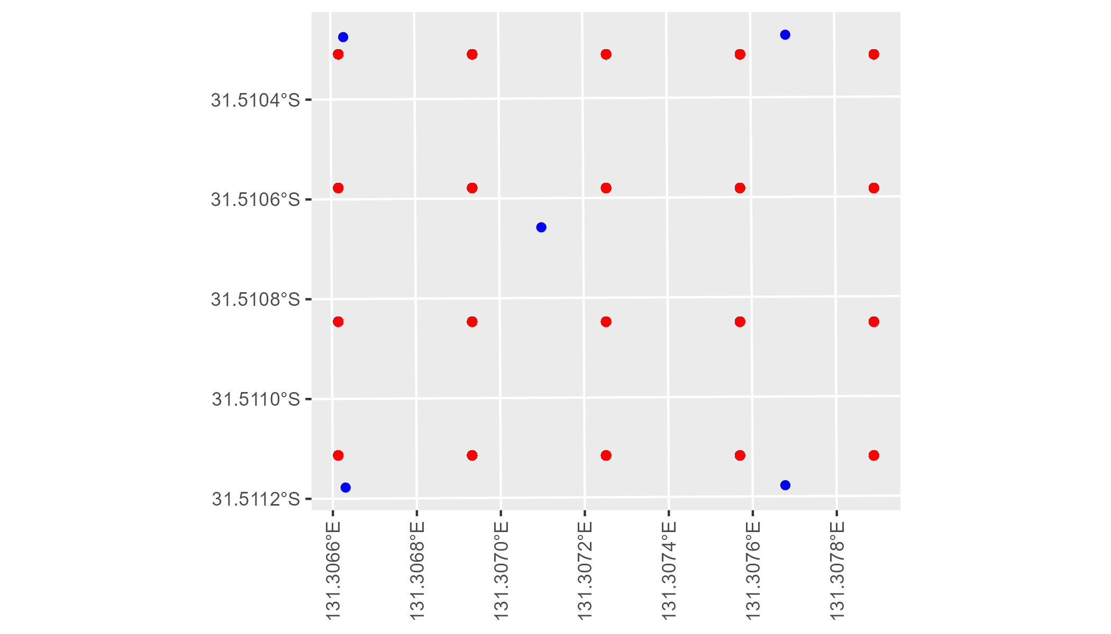

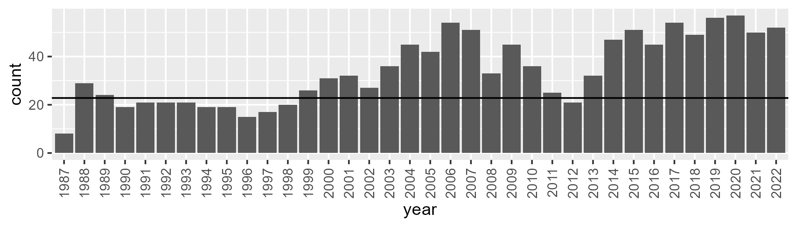

Number of samples: 1230

# SAARIV0001

| Min. | 1st Qu. | Median | Mean | 3rd Qu. | Max. |
| --- | --- | --- | --- | --- | --- |
| 31.91591 | 41.86553 | 45.98063 | 46.44463 | 50.66589 | 64.54483 |

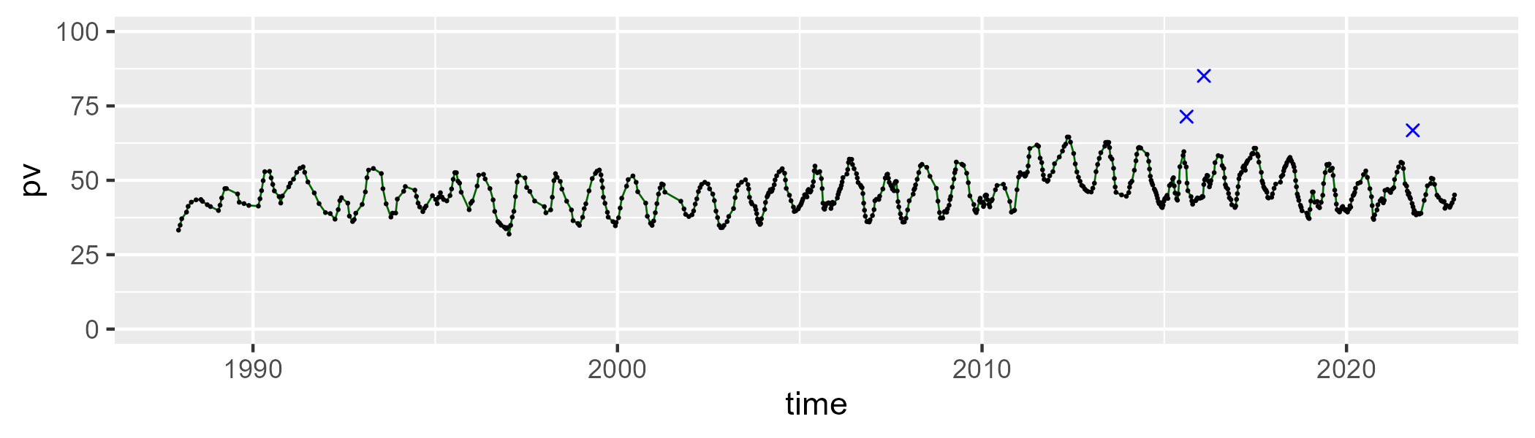

| Min. | 1st Qu. | Median | Mean | 3rd Qu. | Max. |
| --- | --- | --- | --- | --- | --- |
| 17.4997 | 31.79058 | 36.41535 | 36.35465 | 40.86443 | 56.86299 |

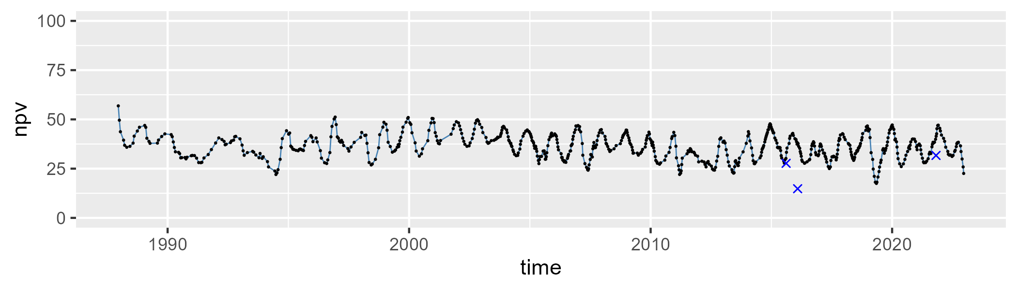

| Min. | 1st Qu. | Median | Mean | 3rd Qu. | Max. |
| --- | --- | --- | --- | --- | --- |
| 2.818675 | 12.14793 | 14.83326 | 15.75798 | 18.42038 | 37.91938 |

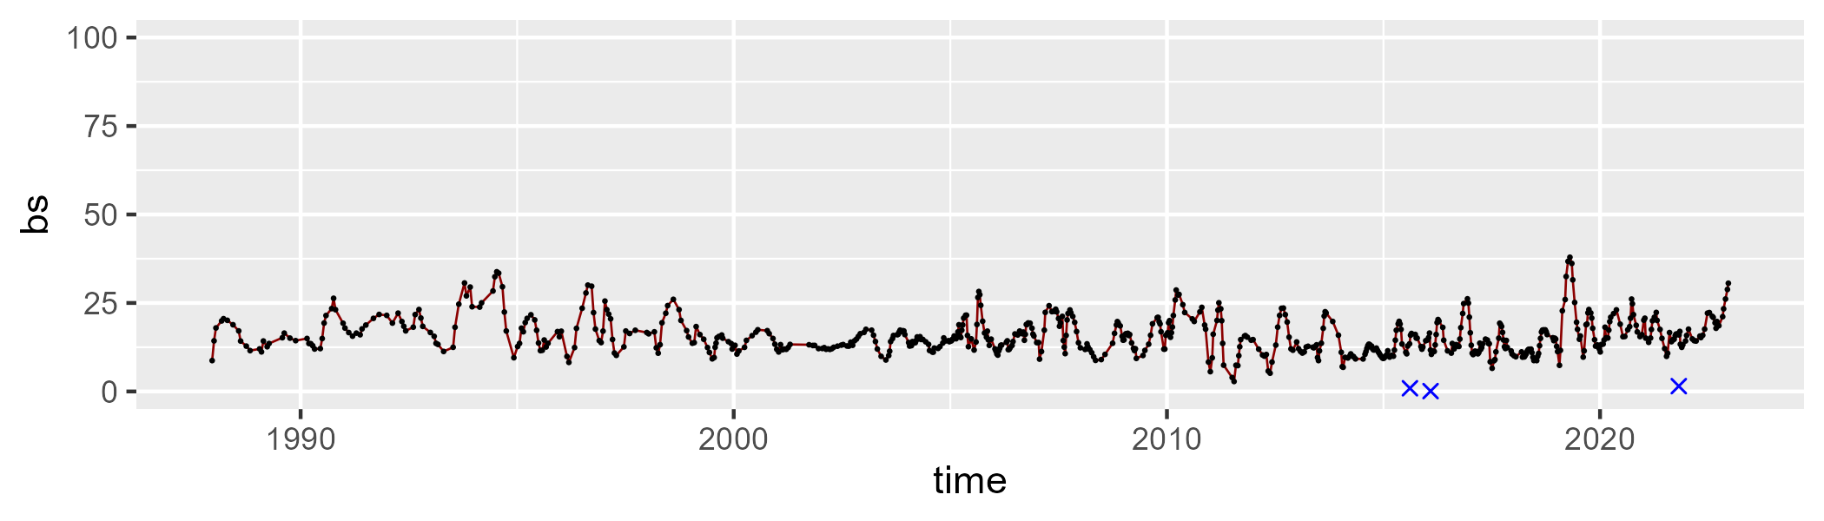

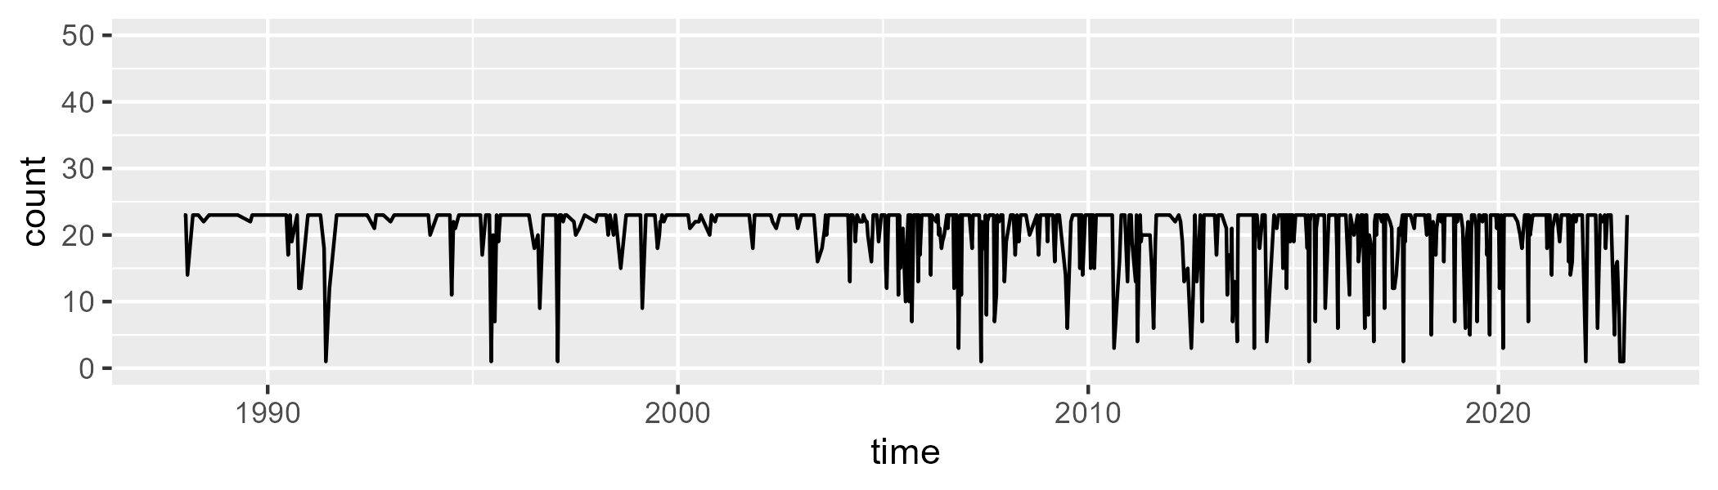

Min. : 1.00 1st Qu.:21.00 Median :23.00 Mean :20.54 3rd Qu.:23.00 Max. :23.00

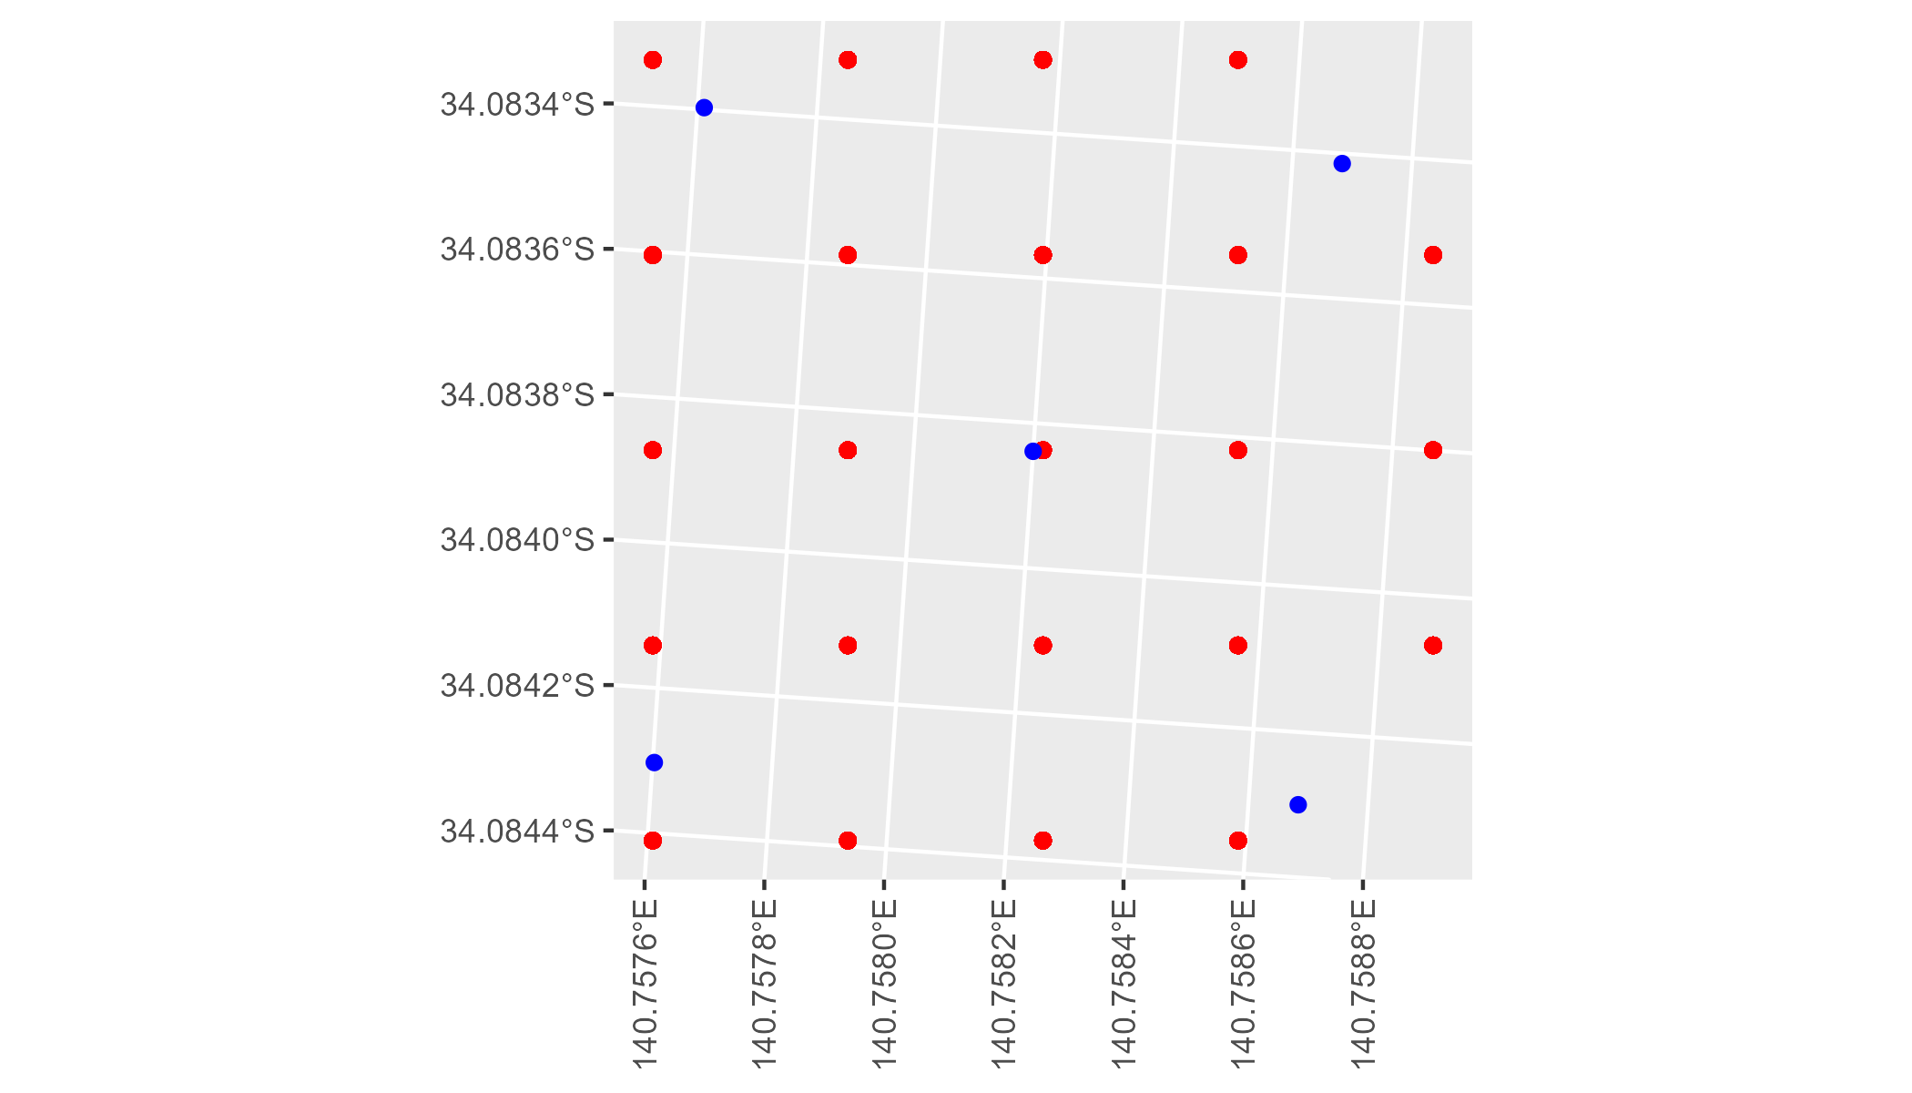

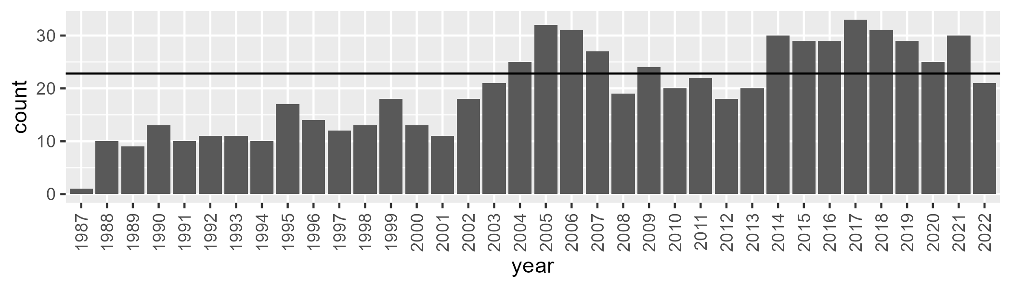

Number of samples: 707

# SAARIV0002

| Min. | 1st Qu. | Median | Mean | 3rd Qu. | Max. |
| --- | --- | --- | --- | --- | --- |
| 32.46669 | 40.85248 | 44.52721 | 44.9866 | 48.90307 | 61.13137 |

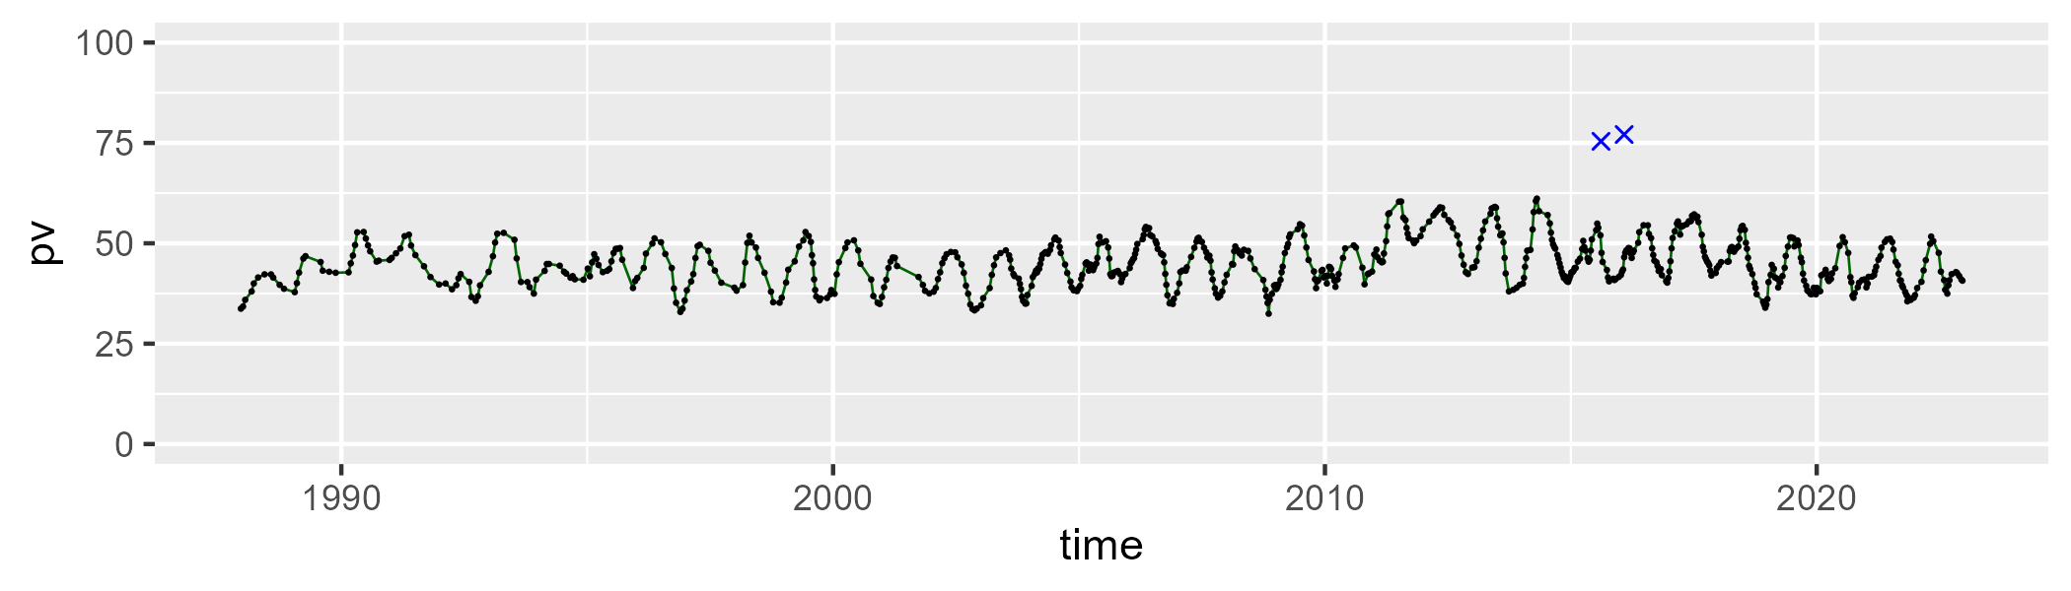

| Min. | 1st Qu. | Median | Mean | 3rd Qu. | Max. |
| --- | --- | --- | --- | --- | --- |
| 19.82446 | 34.92819 | 38.84407 | 38.57458 | 42.4115 | 56.08372 |

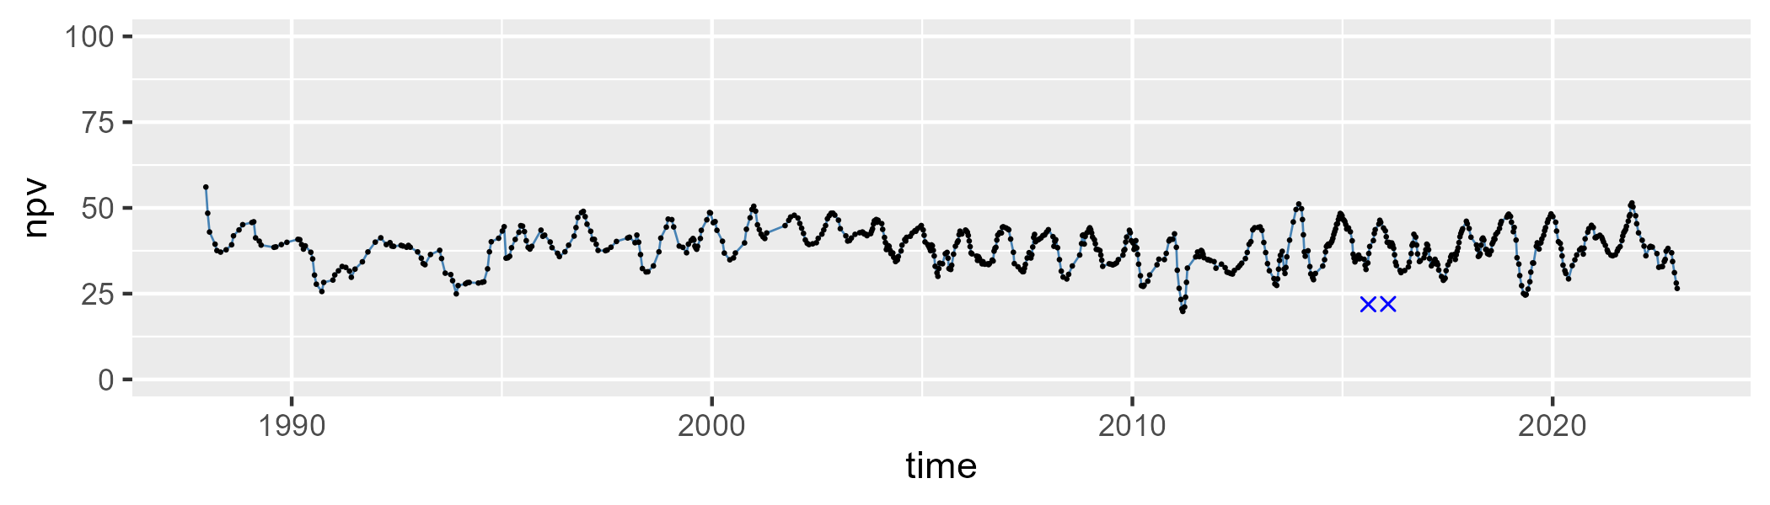

| Min. | 1st Qu. | Median | Mean | 3rd Qu. | Max. |
| --- | --- | --- | --- | --- | --- |
| 1.030088 | 11.54902 | 14.36434 | 15.0069 | 17.22143 | 36.40385 |

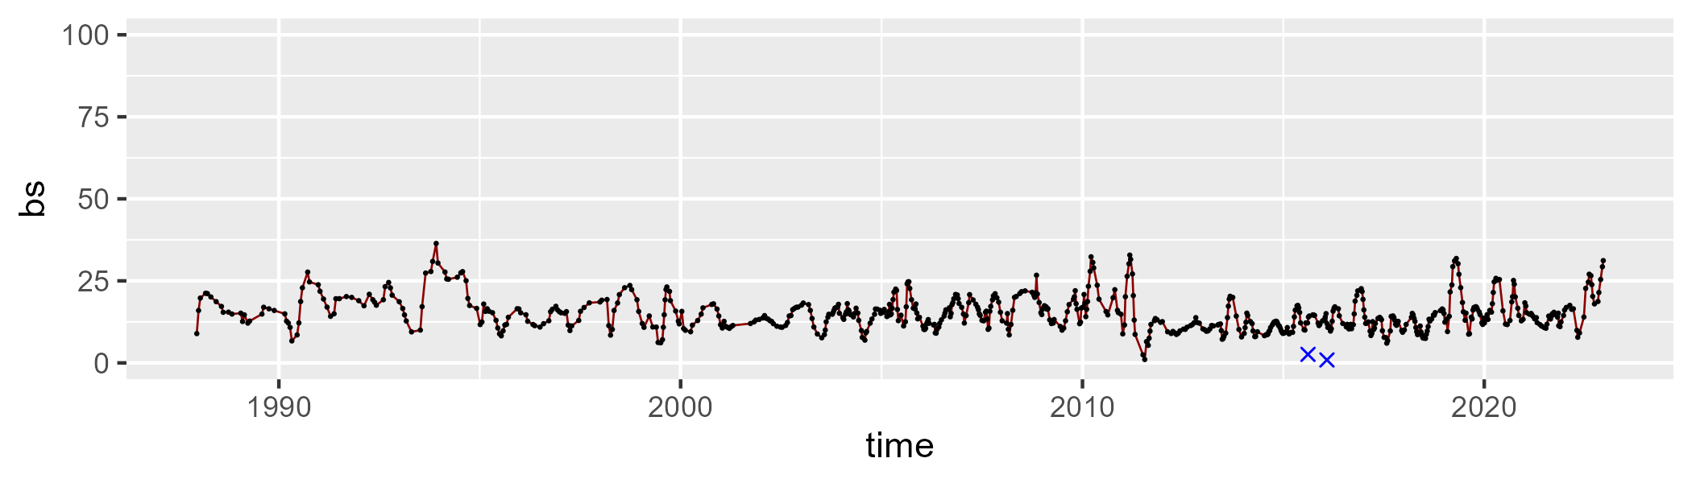

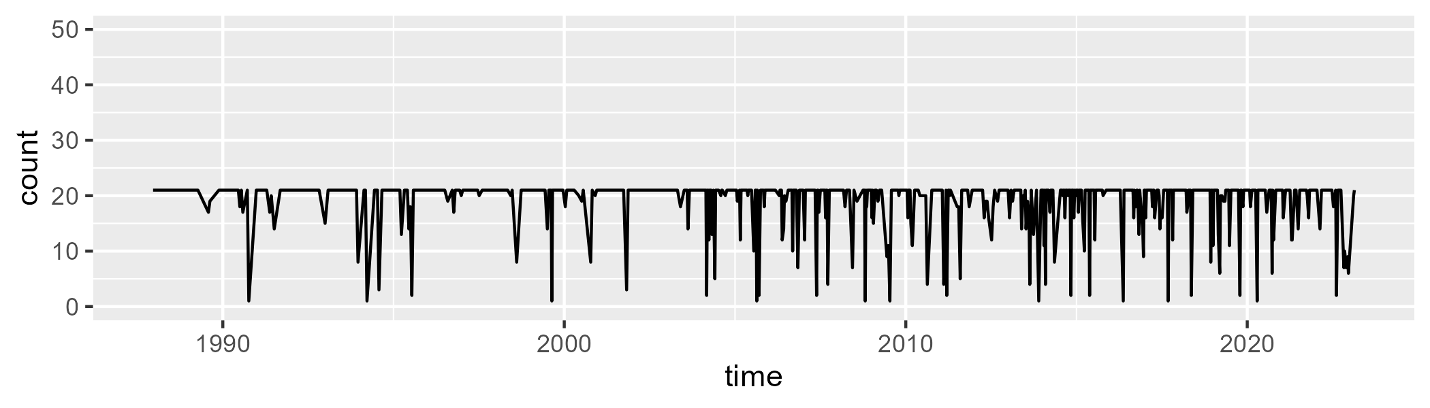

Min. : 1.00 1st Qu.:21.00 Median :21.00 Mean :19.14 3rd Qu.:21.00 Max. :21.00

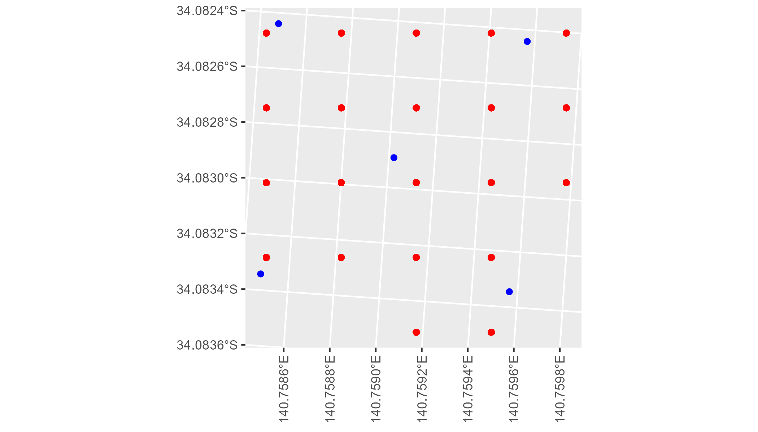

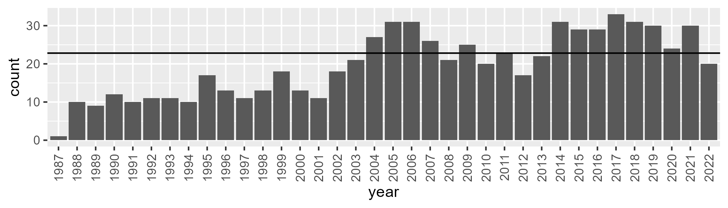

Number of samples: 709

# SAARIV0003

| Min. | 1st Qu. | Median | Mean | 3rd Qu. | Max. |
| --- | --- | --- | --- | --- | --- |
| 21.82716 | 31.88495 | 36.19782 | 36.38811 | 40.47257 | 49.69385 |

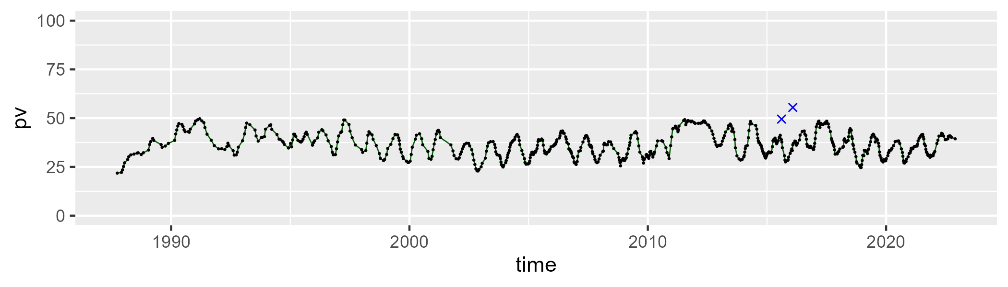

| Min. | 1st Qu. | Median | Mean | 3rd Qu. | Max. |
| --- | --- | --- | --- | --- | --- |
| 18.04332 | 39.33603 | 44.1111 | 43.35191 | 48.28946 | 59.08703 |

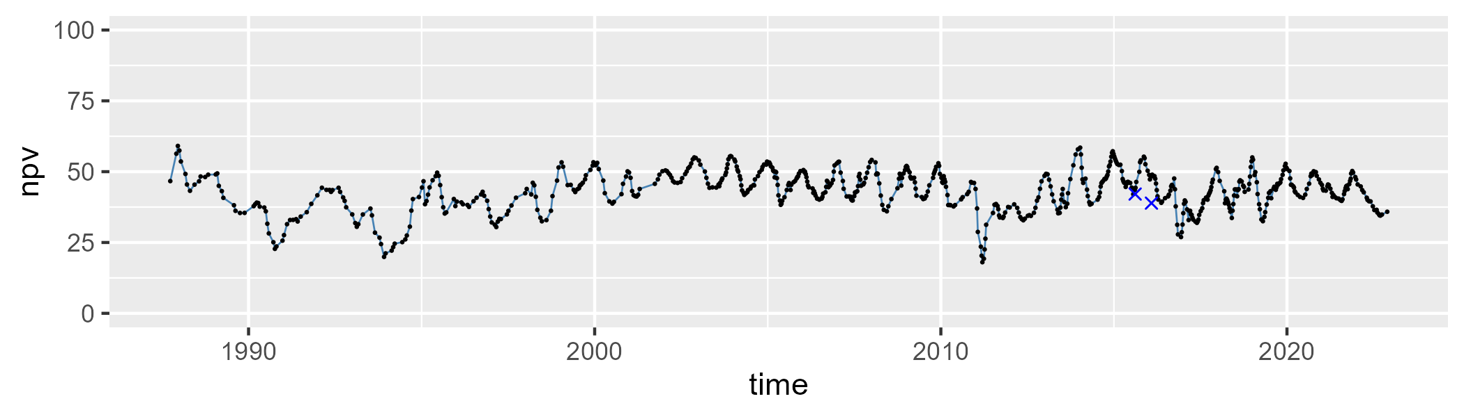

| Min. | 1st Qu. | Median | Mean | 3rd Qu. | Max. |
| --- | --- | --- | --- | --- | --- |
| 10.09423 | 15.57533 | 18.28828 | 18.95835 | 21.24368 | 38.63632 |

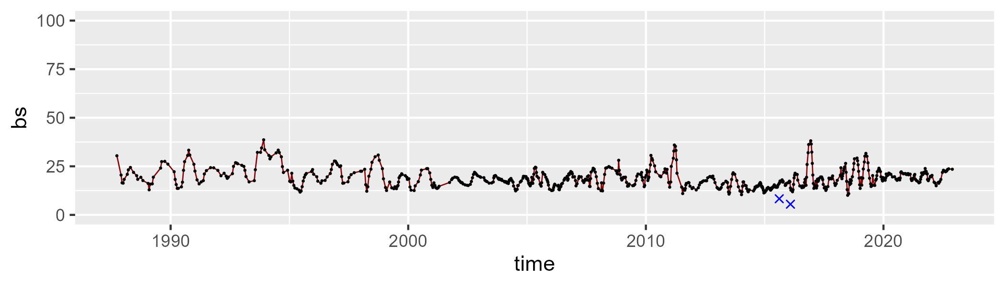

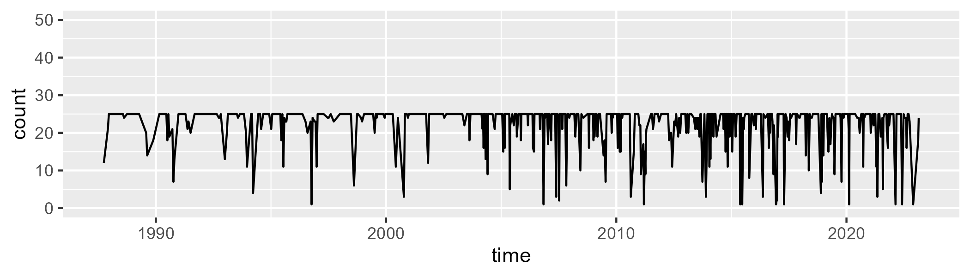

Min. : 1.00 1st Qu.:23.00 Median :25.00 Mean :22.55 3rd Qu.:25.00 Max. :25.00

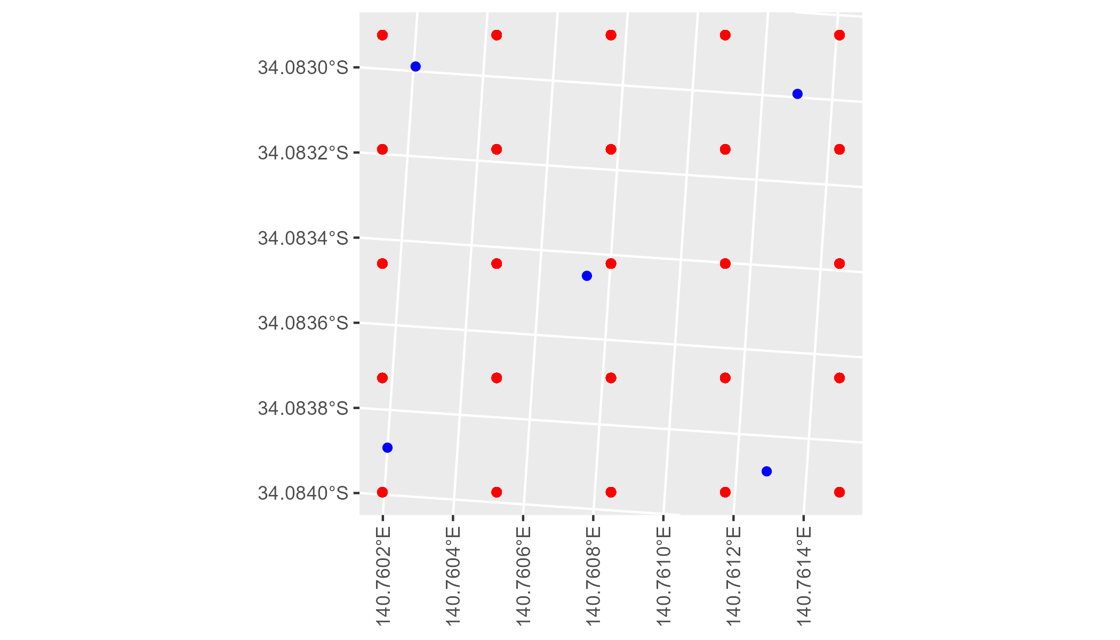

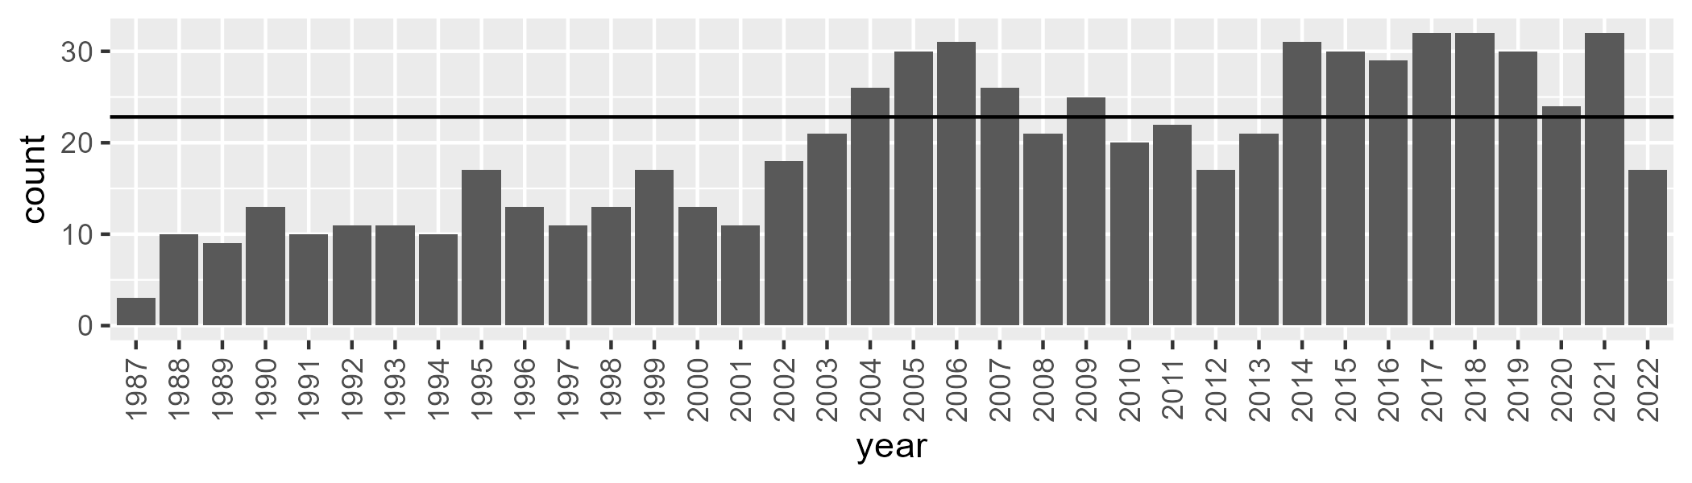

Number of samples: 707

# SAARIV0004

| Min. | 1st Qu. | Median | Mean | 3rd Qu. | Max. |
| --- | --- | --- | --- | --- | --- |
| 9.702346 | 27.40792 | 33.06602 | 32.76786 | 38.01668 | 56.0058 |

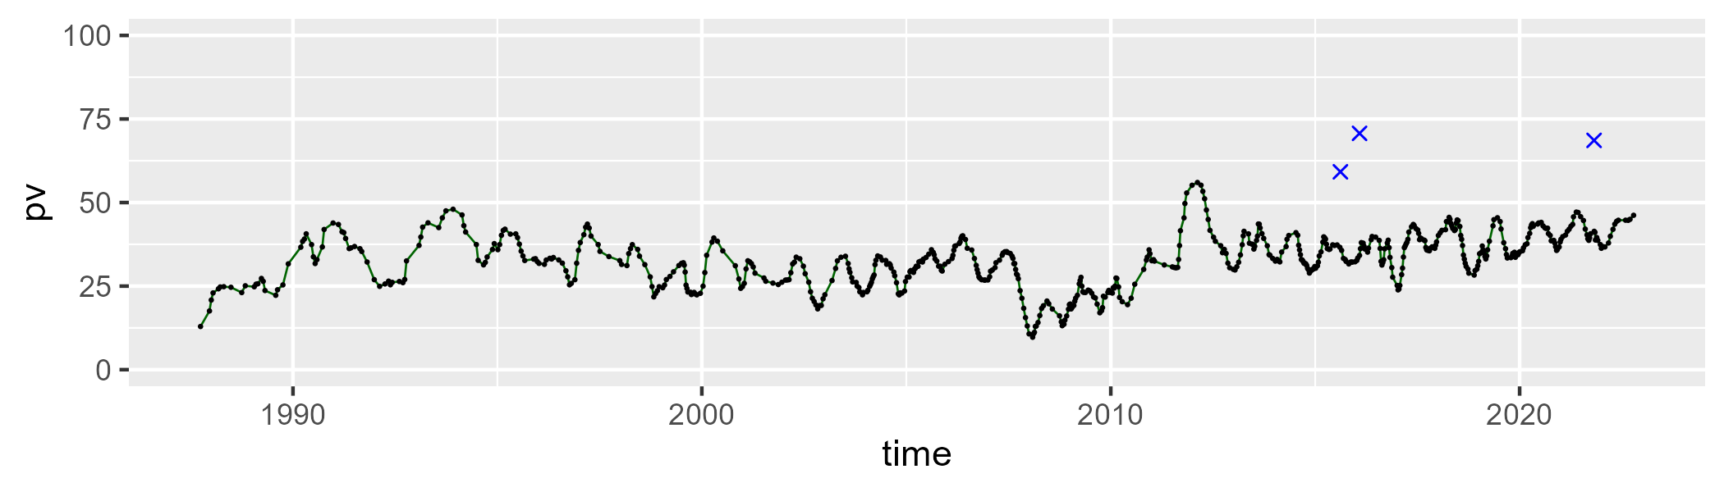

| Min. | 1st Qu. | Median | Mean | 3rd Qu. | Max. |
| --- | --- | --- | --- | --- | --- |
| 25.1779 | 39.046 | 45.73886 | 46.03513 | 52.11094 | 67.20684 |

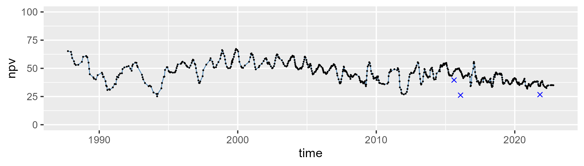

| Min. | 1st Qu. | Median | Mean | 3rd Qu. | Max. |
| --- | --- | --- | --- | --- | --- |
| 6.522634 | 15.11197 | 18.09394 | 19.89808 | 22.38331 | 46.75942 |

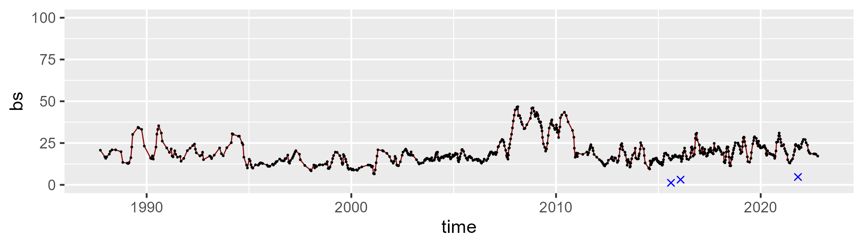

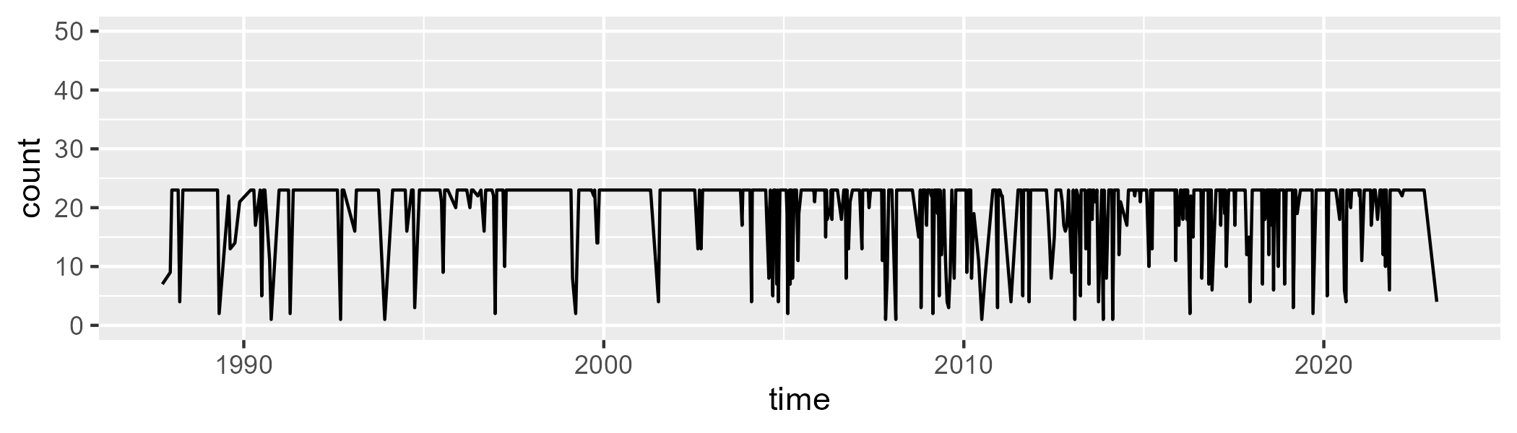

Min. : 1.0 1st Qu.:22.0 Median :23.0 Mean :20.2 3rd Qu.:23.0 Max. :23.0

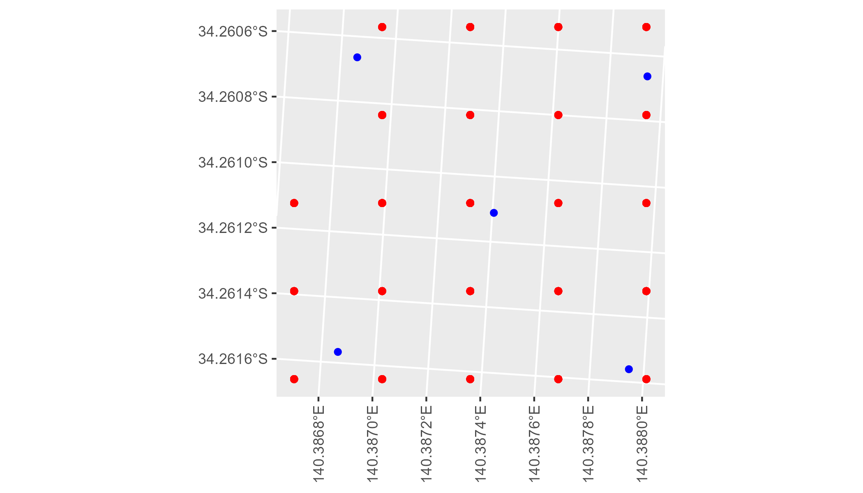

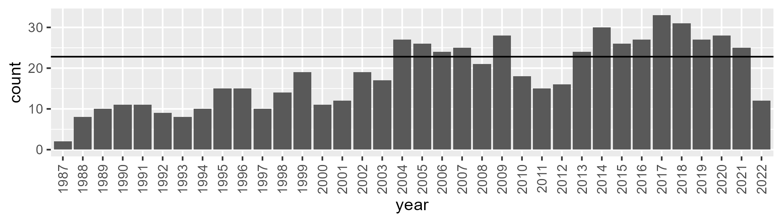

Number of samples: 664

# SAARIV0005

| Min. | 1st Qu. | Median | Mean | 3rd Qu. | Max. |
| --- | --- | --- | --- | --- | --- |
| 20.13739 | 35.58391 | 41.05949 | 41.39224 | 47.91781 | 59.75193 |

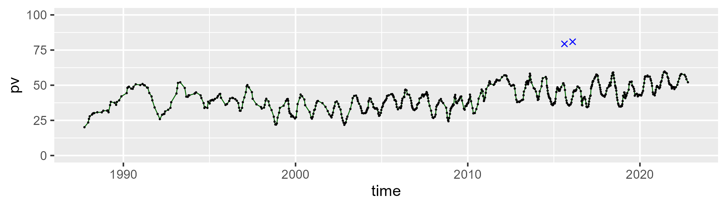

| Min. | 1st Qu. | Median | Mean | 3rd Qu. | Max. |
| --- | --- | --- | --- | --- | --- |
| 21.29343 | 35.42037 | 41.25354 | 42.58078 | 49.38855 | 68.33633 |

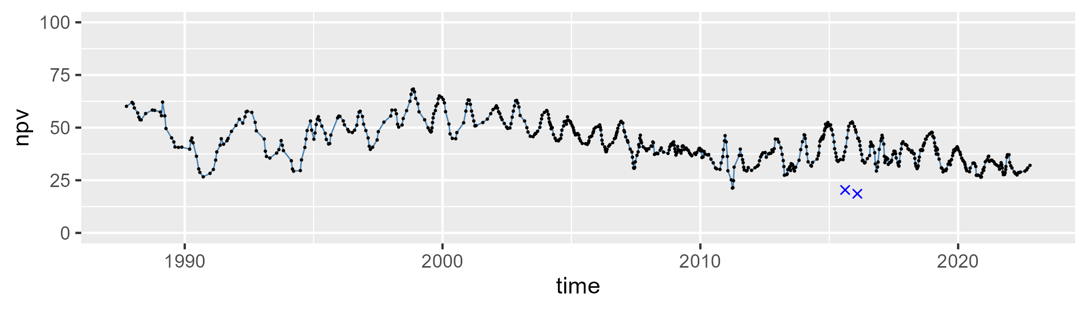

| Min. | 1st Qu. | Median | Mean | 3rd Qu. | Max. |
| --- | --- | --- | --- | --- | --- |
| 2.362527 | 10.71195 | 13.52041 | 14.68855 | 17.69182 | 33.73366 |

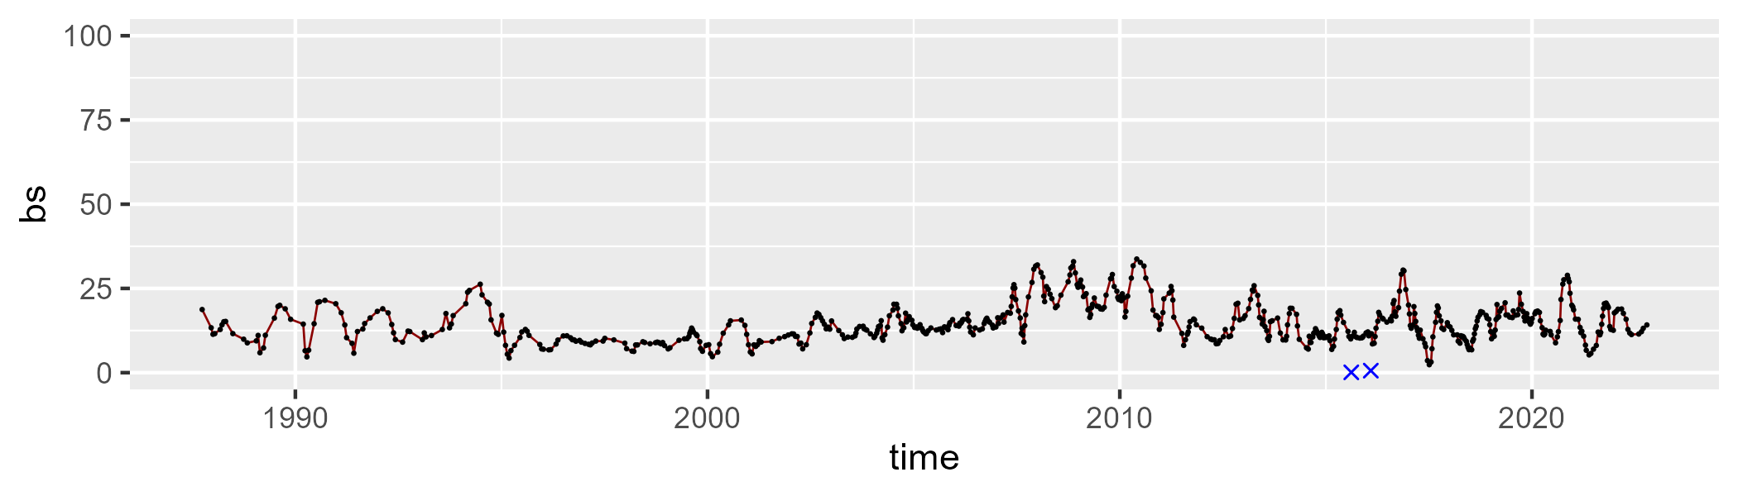

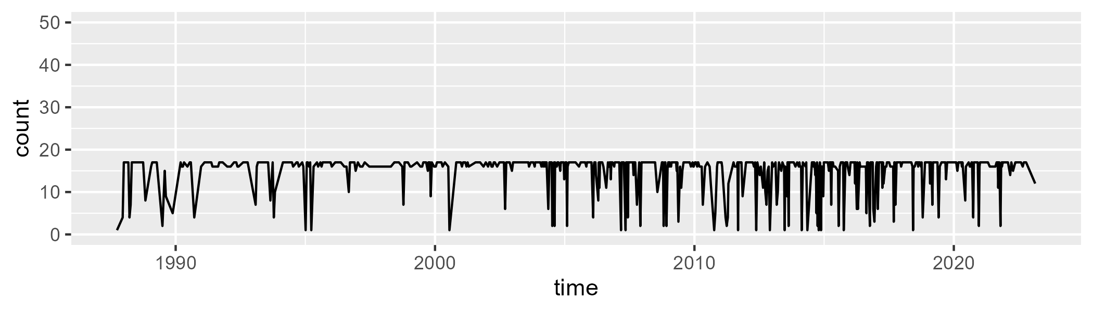

Min. : 1.00 1st Qu.:16.00 Median :17.00 Mean :15.03 3rd Qu.:17.00 Max. :17.00

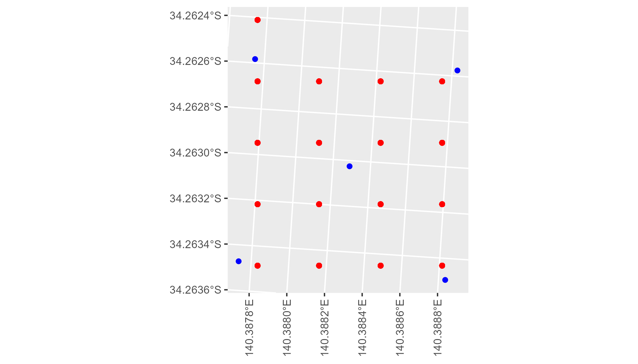

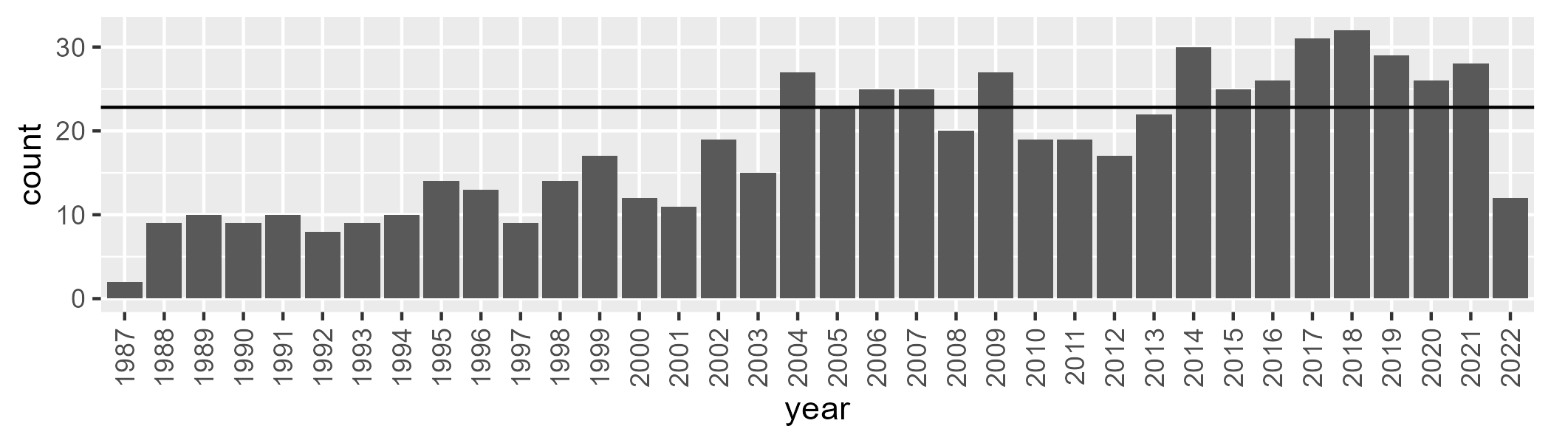

Number of samples: 654

# SAARIV0006

| Min. | 1st Qu. | Median | Mean | 3rd Qu. | Max. |
| --- | --- | --- | --- | --- | --- |
| 10.81976 | 28.75972 | 34.02647 | 33.46246 | 38.08894 | 56.74842 |

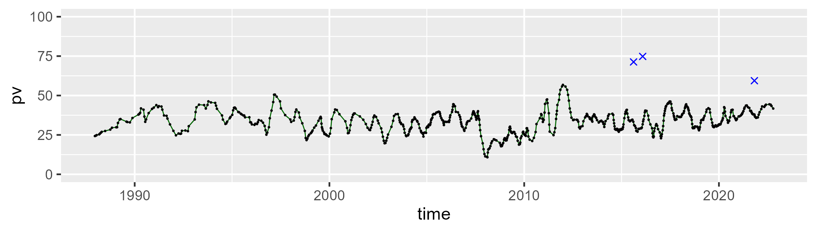

| Min. | 1st Qu. | Median | Mean | 3rd Qu. | Max. |
| --- | --- | --- | --- | --- | --- |
| 13.08062 | 41.29065 | 47.32726 | 47.55515 | 53.80219 | 71.11302 |

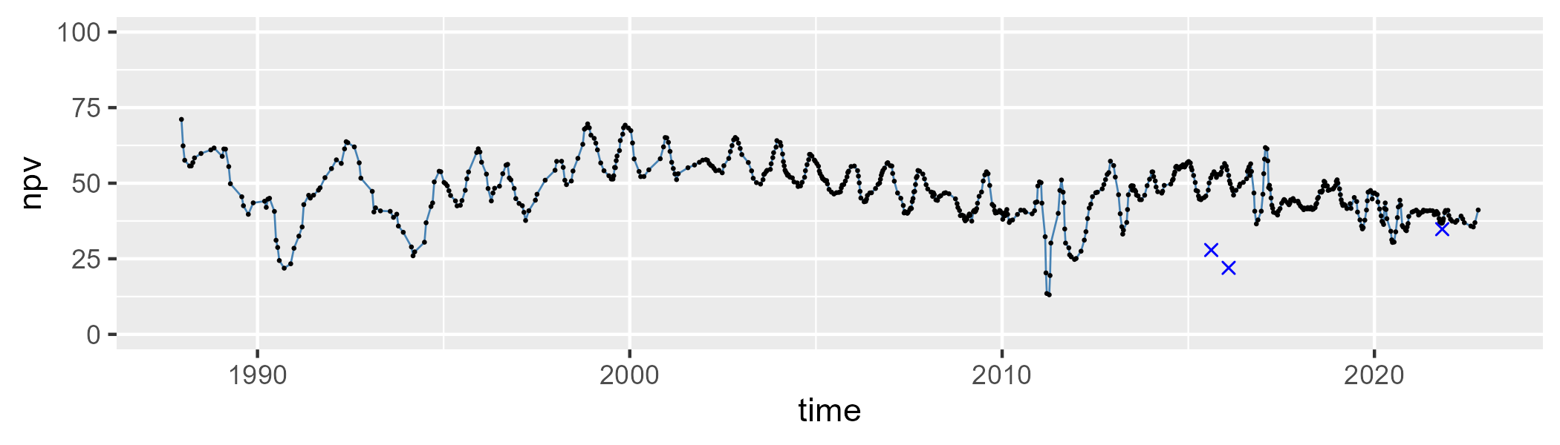

| Min. | 1st Qu. | Median | Mean | 3rd Qu. | Max. |
| --- | --- | --- | --- | --- | --- |
| 2.538371 | 12.45118 | 15.43395 | 17.71153 | 20.6565 | 48.37483 |

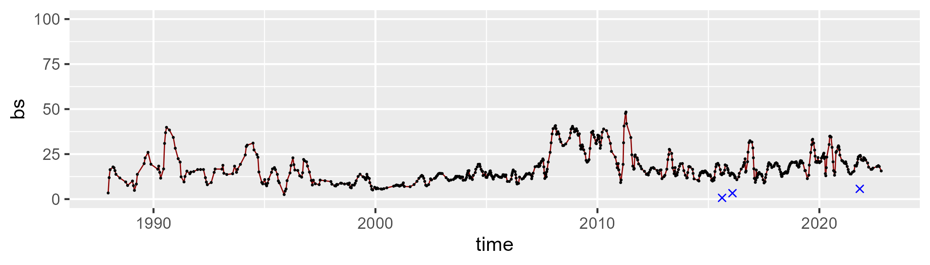

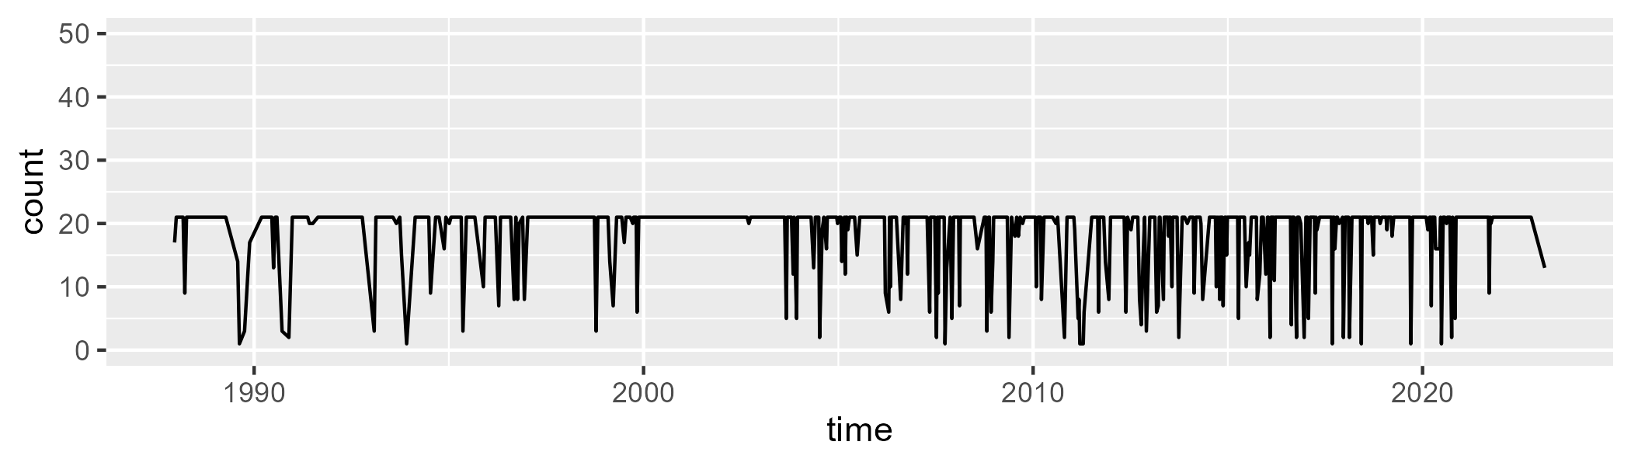

Min. : 1.00 1st Qu.:21.00 Median :21.00 Mean :18.78 3rd Qu.:21.00 Max. :21.00

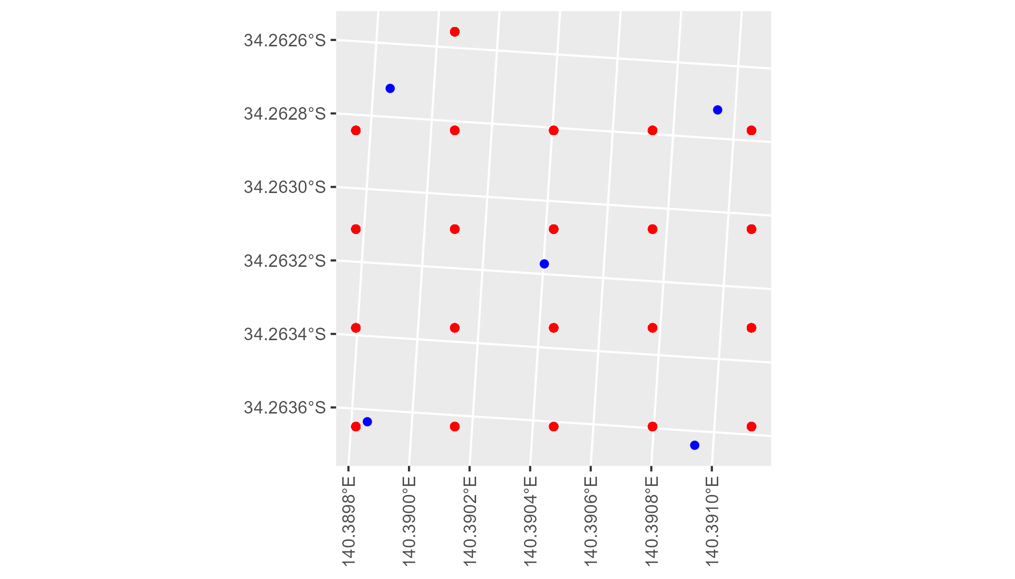

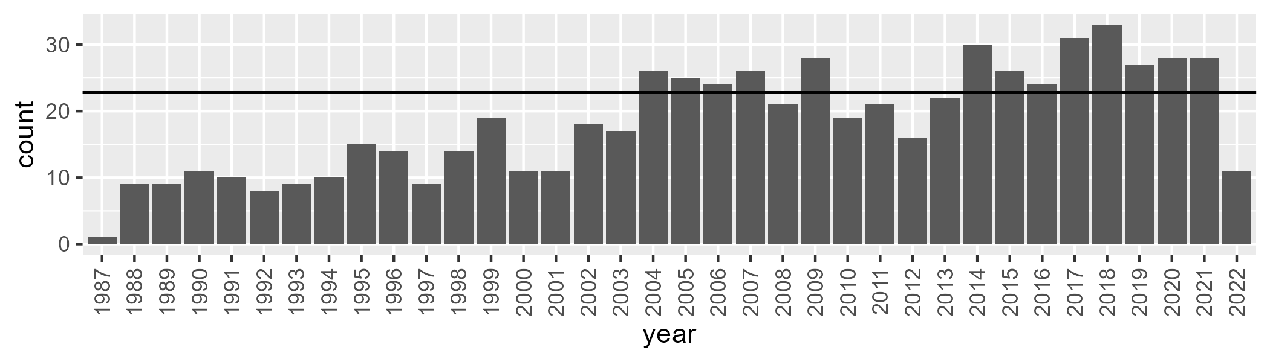

Number of samples: 661

# SAARIV0007

| Min. | 1st Qu. | Median | Mean | 3rd Qu. | Max. |
| --- | --- | --- | --- | --- | --- |
| 11.34731 | 19.49365 | 24.68727 | 25.59229 | 30.94606 | 50.85959 |

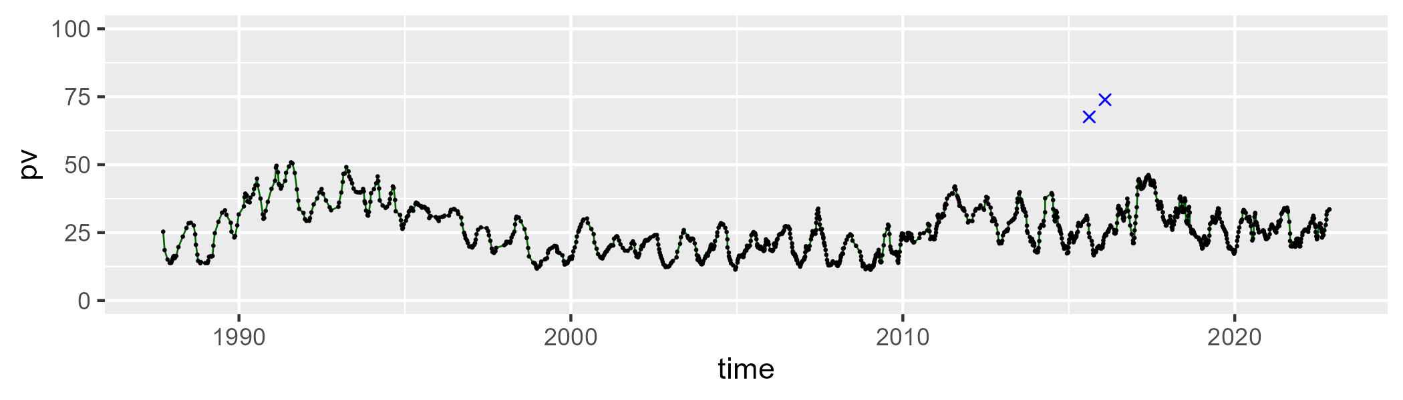

| Min. | 1st Qu. | Median | Mean | 3rd Qu. | Max. |
| --- | --- | --- | --- | --- | --- |
| 20.25014 | 48.02108 | 54.50109 | 52.94576 | 59.64581 | 70.19522 |

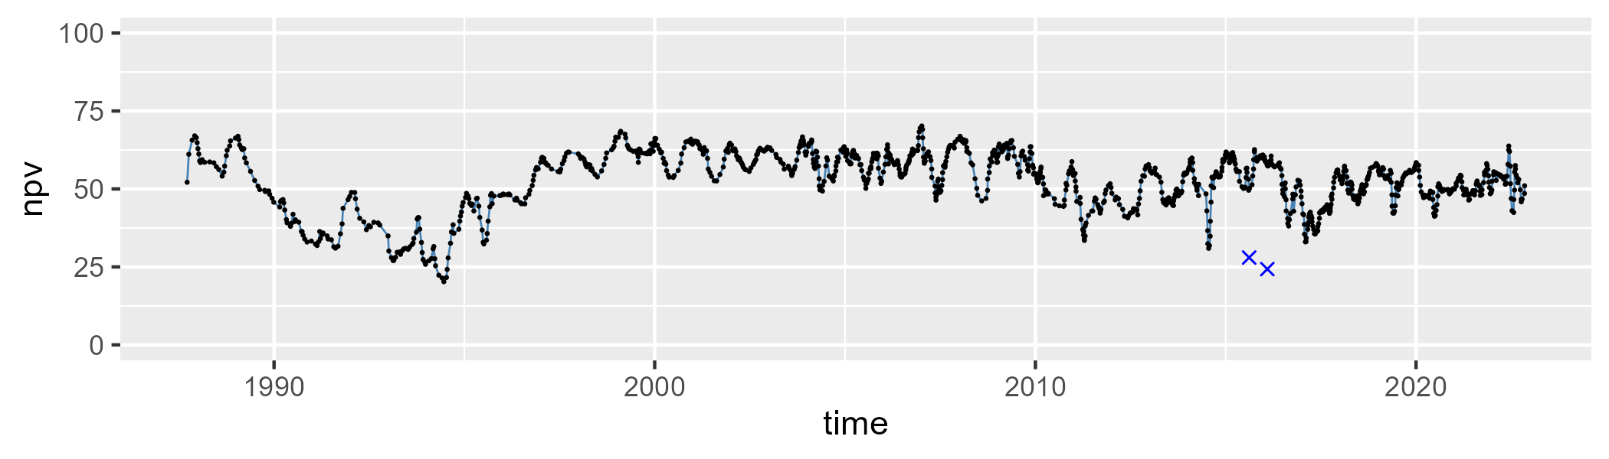

| Min. | 1st Qu. | Median | Mean | 3rd Qu. | Max. |
| --- | --- | --- | --- | --- | --- |
| 9.277137 | 17.08425 | 19.66267 | 20.20235 | 22.50038 | 44.02504 |

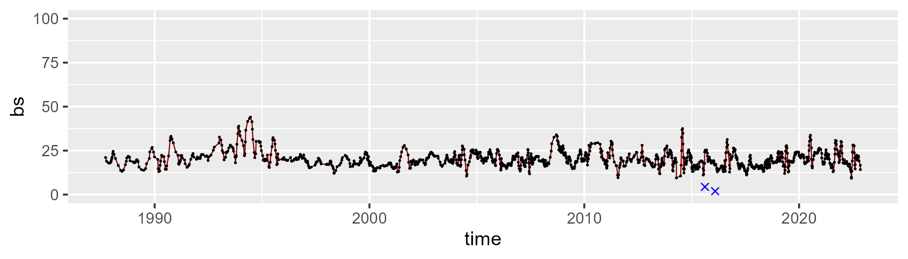

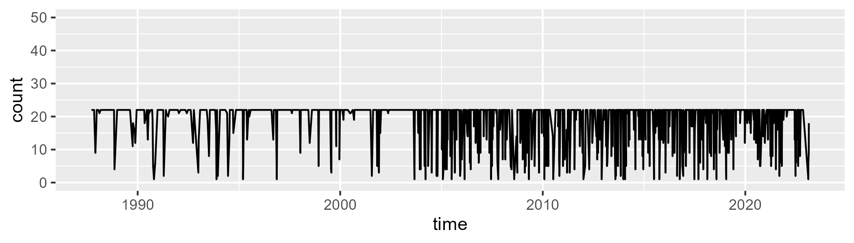

Min. : 1.00 1st Qu.:21.00 Median :22.00 Mean :19.13 3rd Qu.:22.00 Max. :22.00

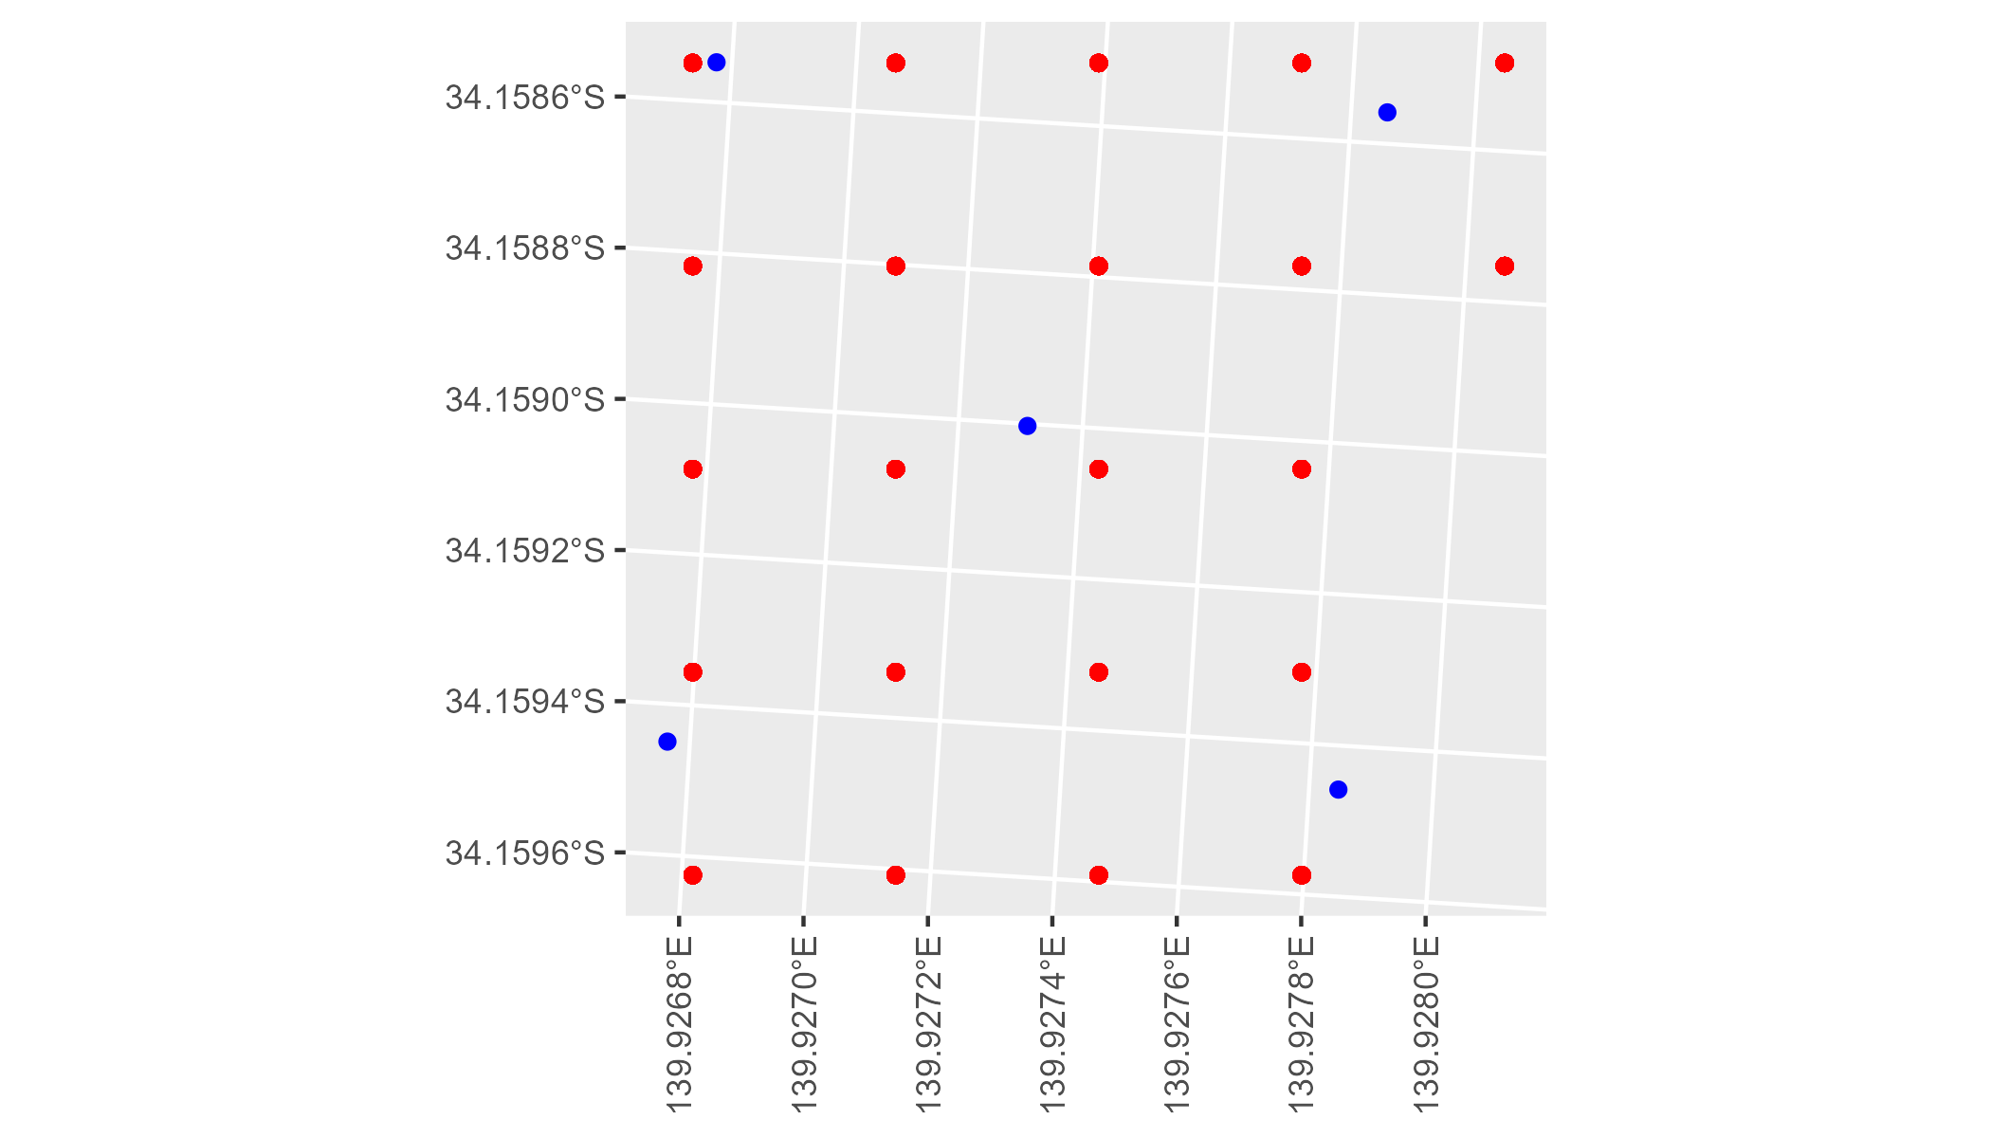

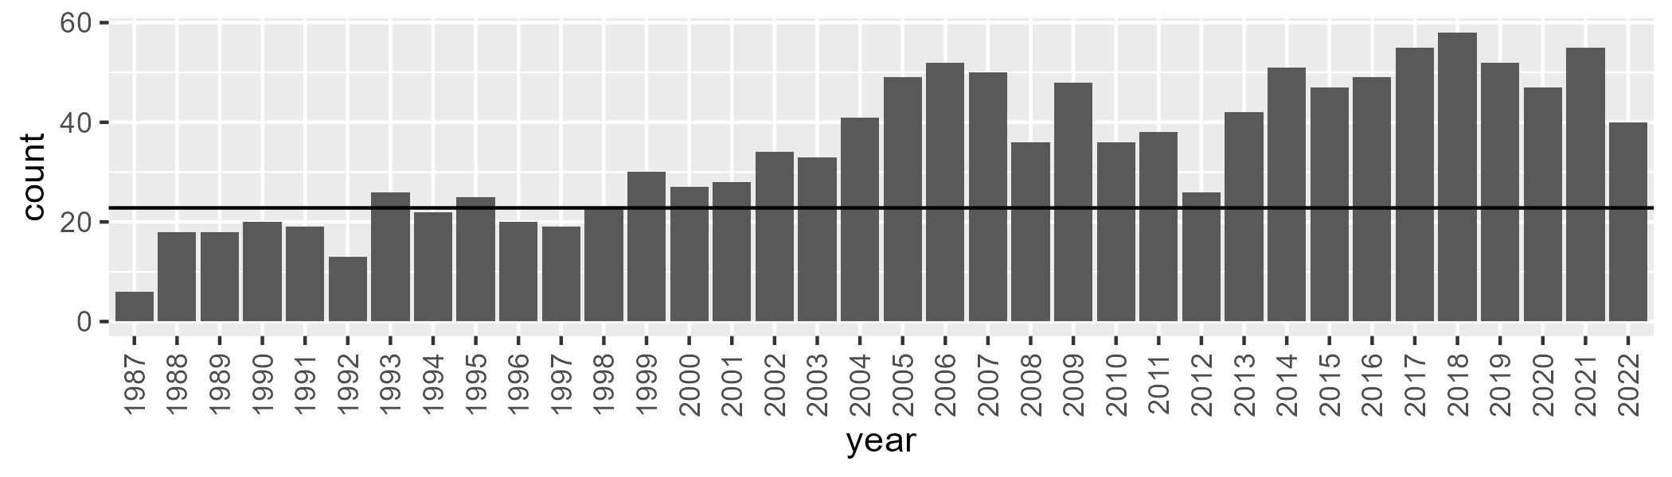

Number of samples: 1253

# SAARIV0008

| Min. | 1st Qu. | Median | Mean | 3rd Qu. | Max. |
| --- | --- | --- | --- | --- | --- |
| 11.49834 | 20.51288 | 25.27908 | 26.11185 | 31.07802 | 49.56365 |

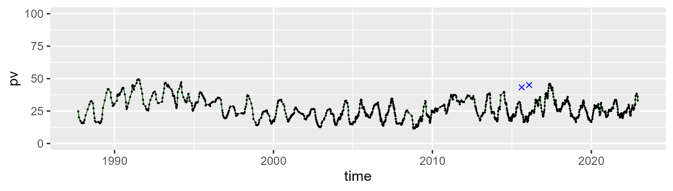

| Min. | 1st Qu. | Median | Mean | 3rd Qu. | Max. |
| --- | --- | --- | --- | --- | --- |
| 25.89719 | 48.19744 | 53.76448 | 53.2946 | 59.55536 | 71.1381 |

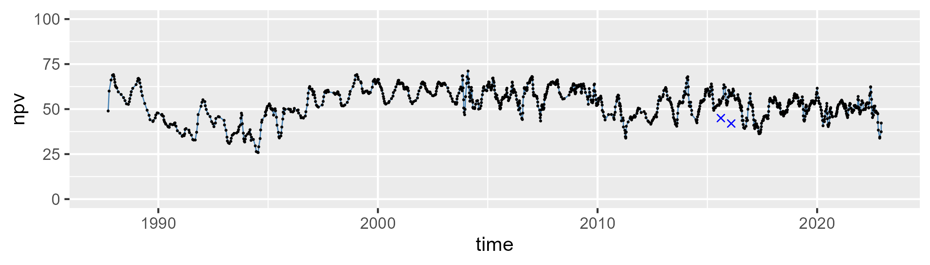

| Min. | 1st Qu. | Median | Mean | 3rd Qu. | Max. |
| --- | --- | --- | --- | --- | --- |
| 8.170275 | 16.33206 | 18.83169 | 19.34372 | 21.67509 | 41.3132 |

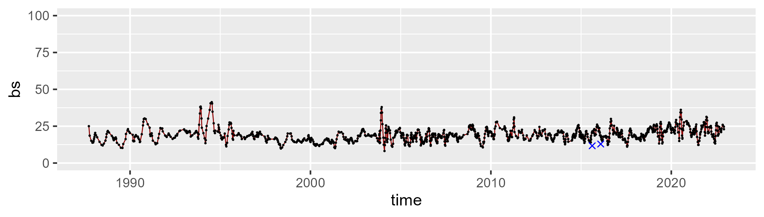

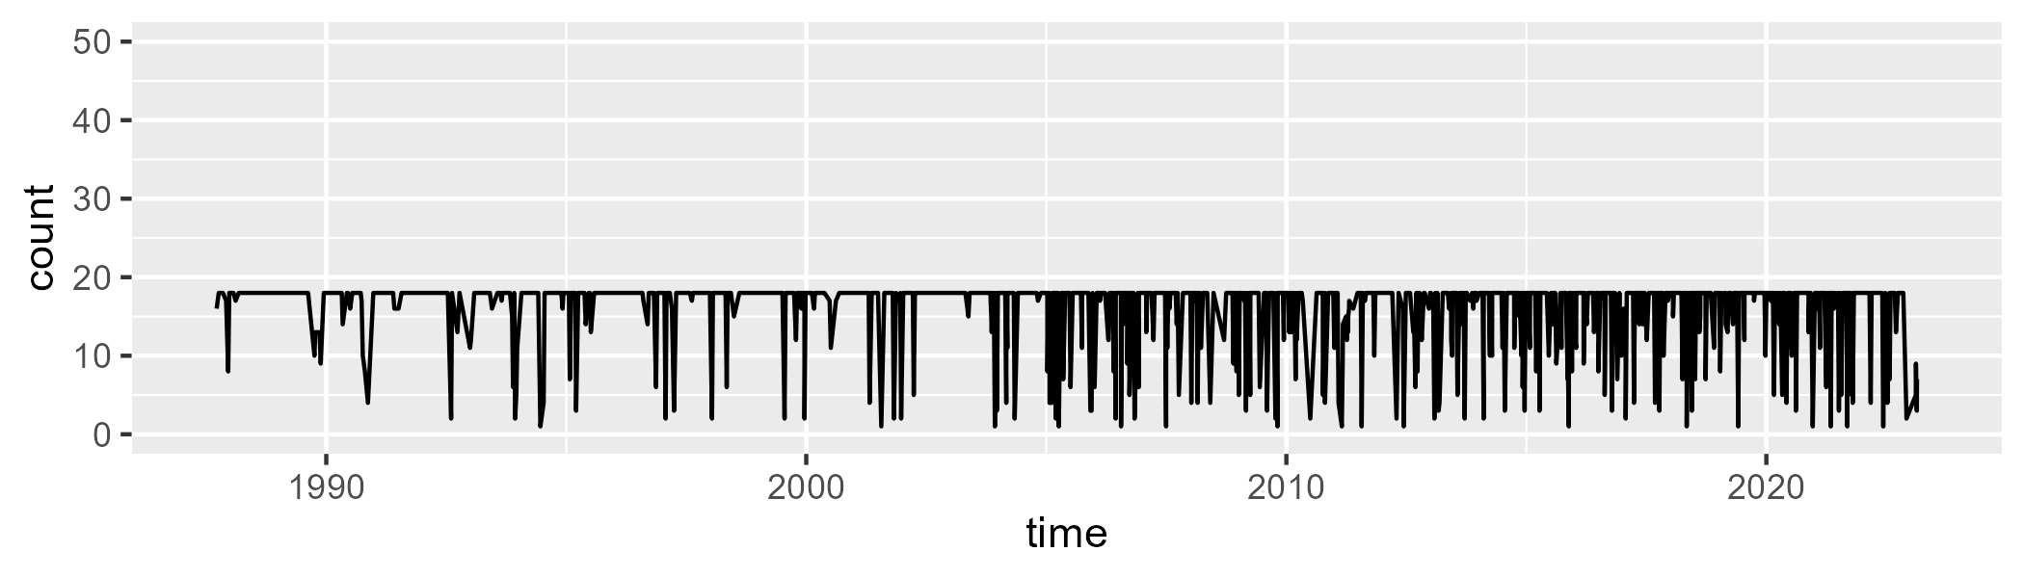

Min. : 1.00 1st Qu.:18.00 Median :18.00 Mean :16.03 3rd Qu.:18.00 Max. :18.00

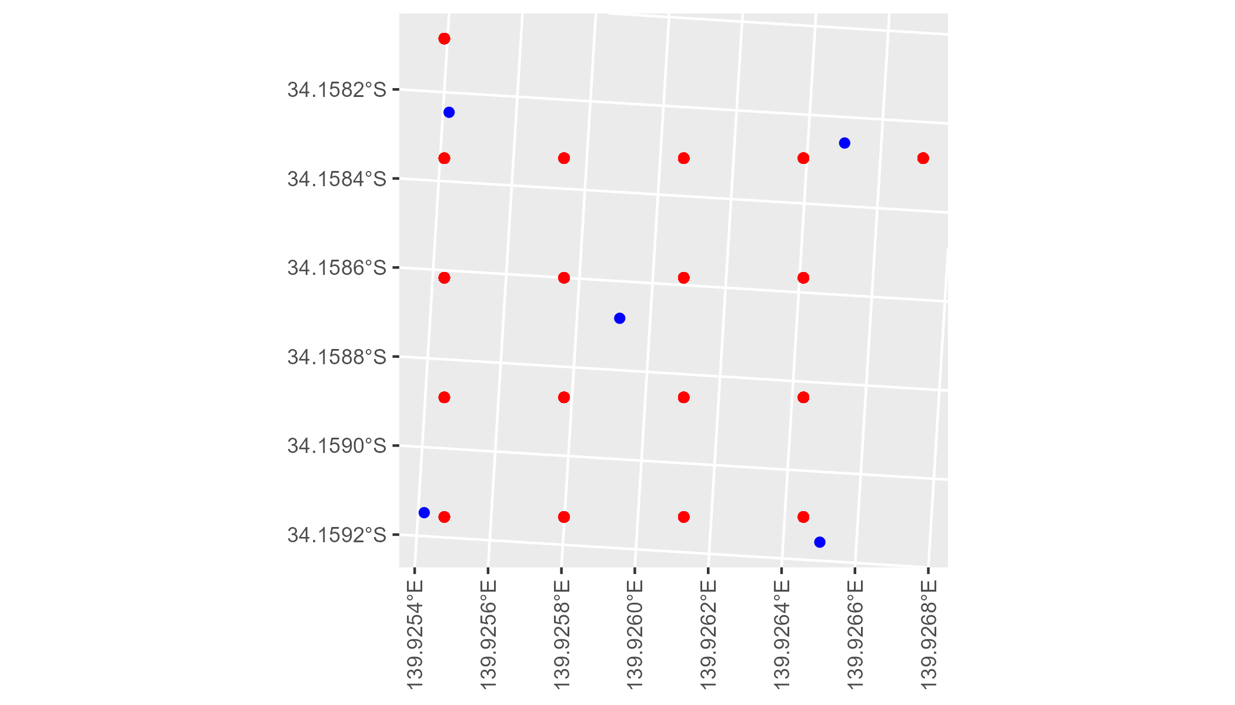

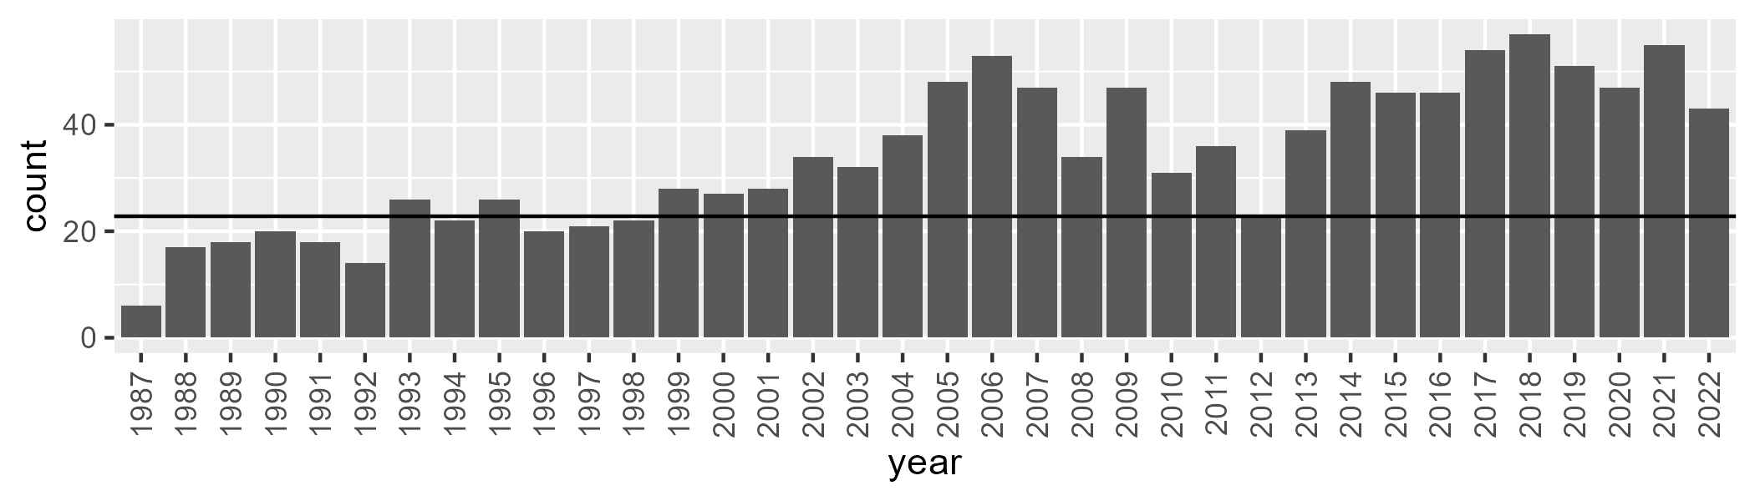

Number of samples: 1222

# SAARIV0009

| Min. | 1st Qu. | Median | Mean | 3rd Qu. | Max. |
| --- | --- | --- | --- | --- | --- |
| 13.00627 | 19.7876 | 23.76101 | 24.39498 | 28.28191 | 42.67048 |

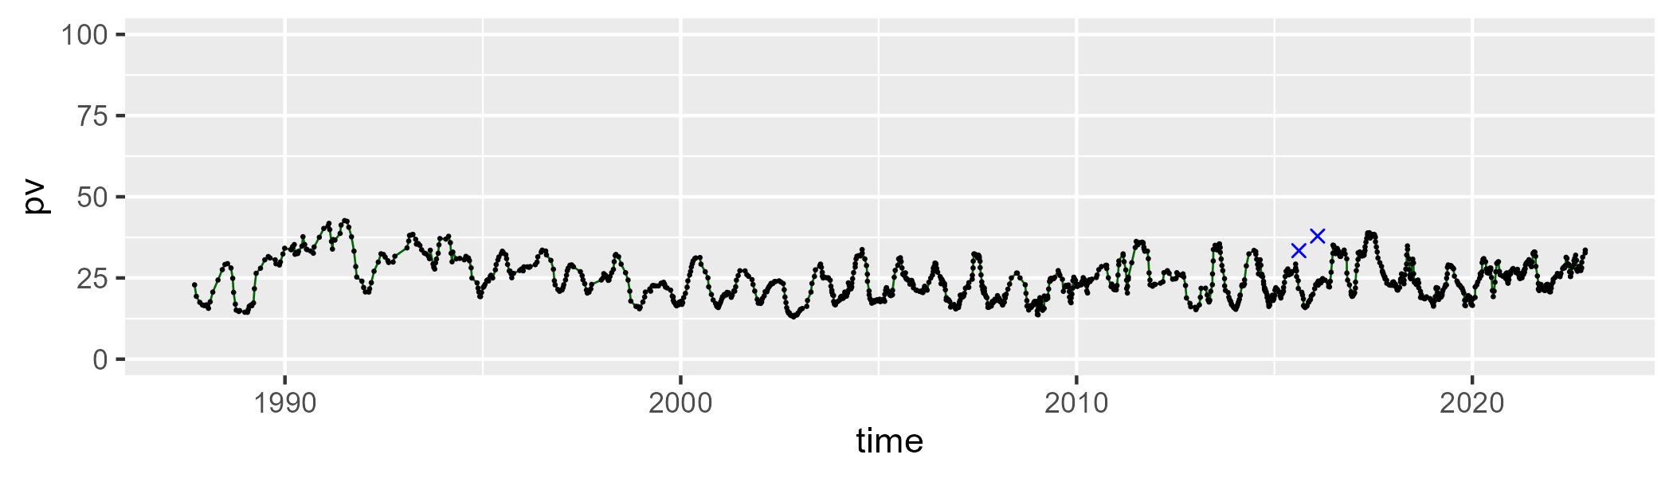

| Min. | 1st Qu. | Median | Mean | 3rd Qu. | Max. |
| --- | --- | --- | --- | --- | --- |
| 26.60447 | 43.66039 | 48.38742 | 47.77147 | 52.25588 | 63.55571 |

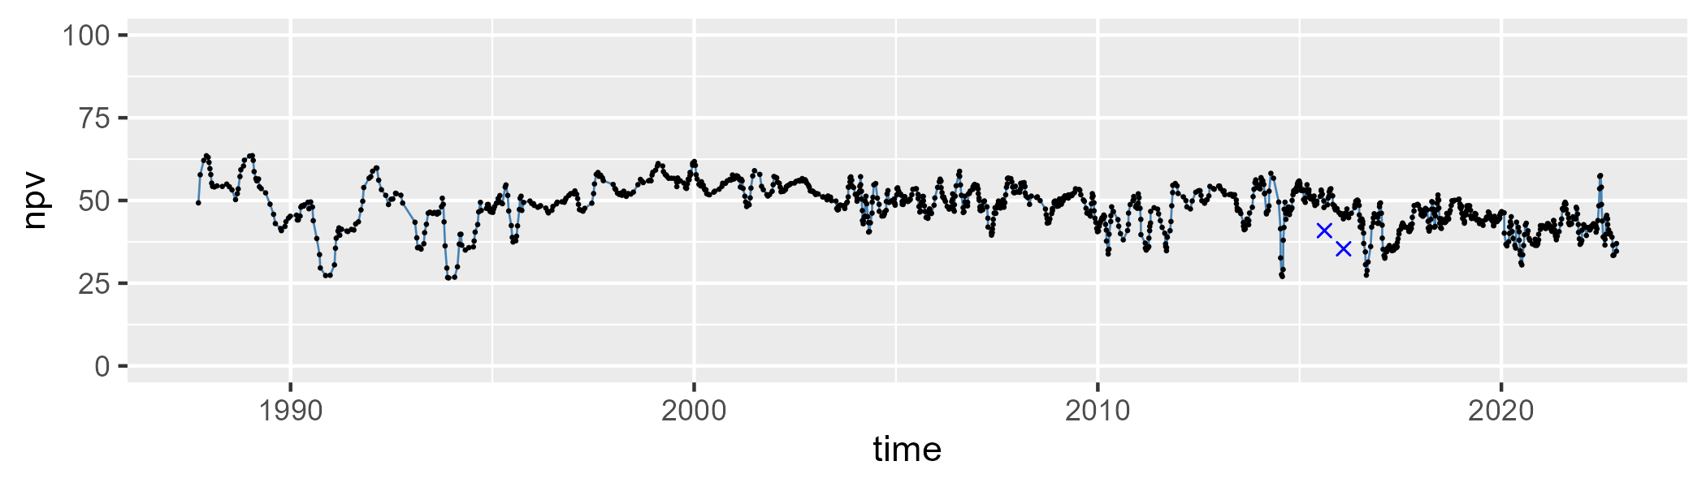

| Min. | 1st Qu. | Median | Mean | 3rd Qu. | Max. |
| --- | --- | --- | --- | --- | --- |
| 9.736947 | 22.31477 | 26.88765 | 26.54724 | 30.51234 | 47.34363 |

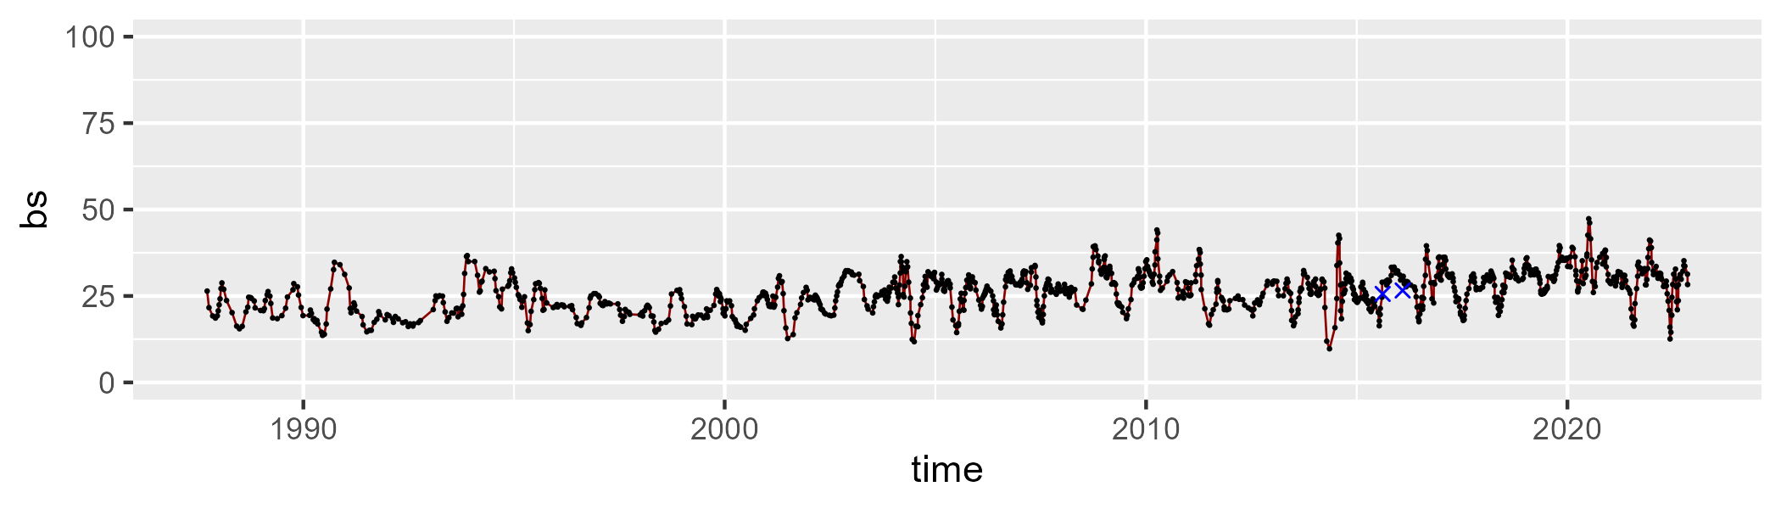

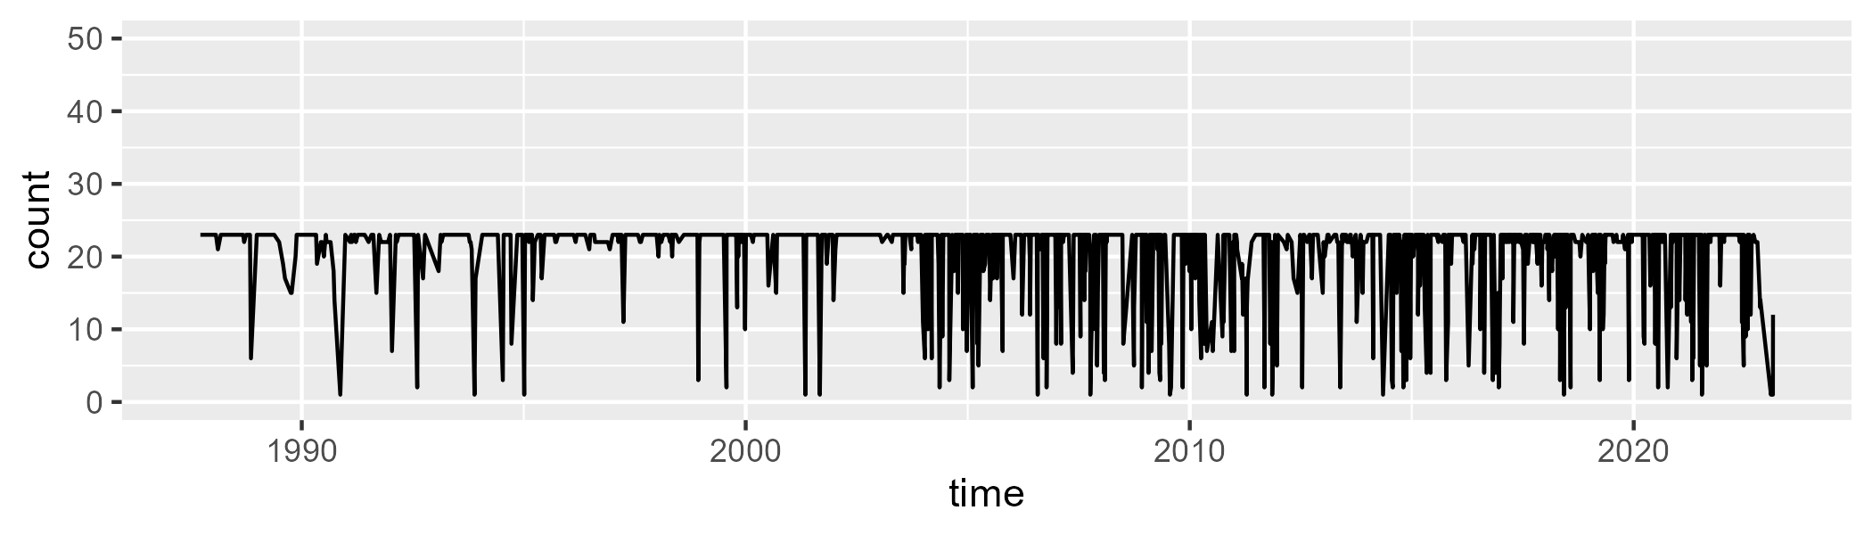

Min. : 1.00 1st Qu.:22.00 Median :23.00 Mean :20.41 3rd Qu.:23.00 Max. :23.00

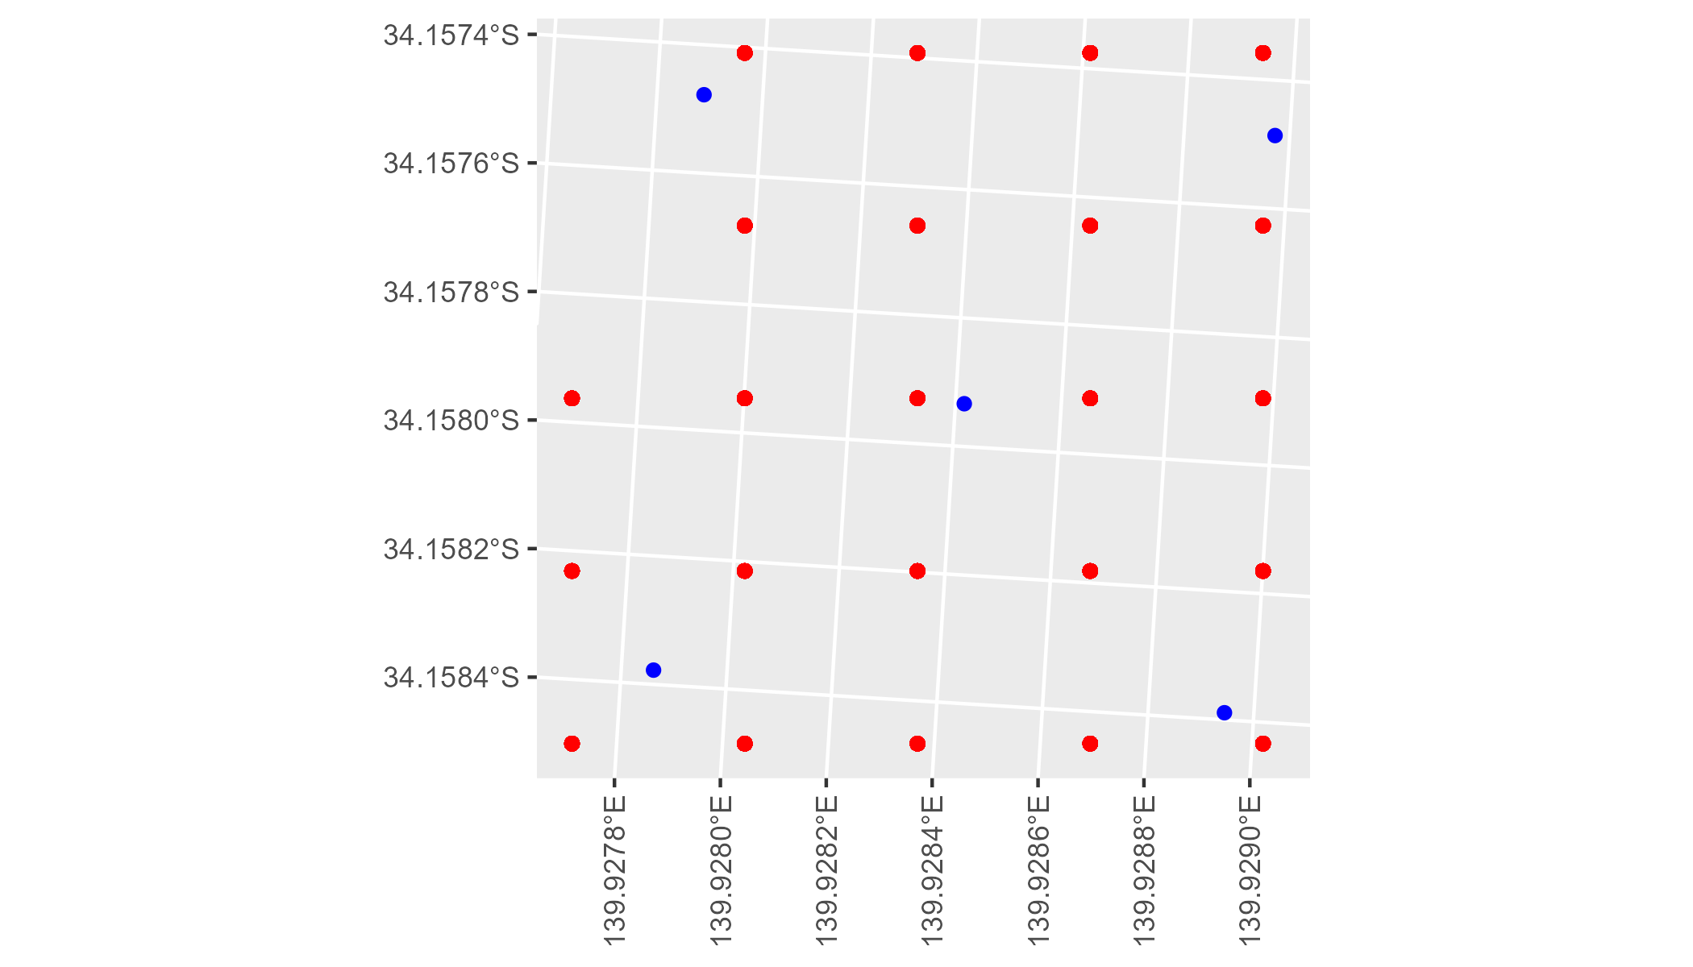

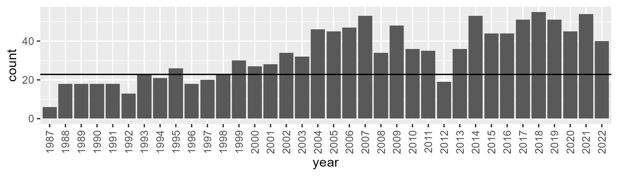

Number of samples: 1209

# SAASTP0001

| Min. | 1st Qu. | Median | Mean | 3rd Qu. | Max. |
| --- | --- | --- | --- | --- | --- |
| 0 | 0.5834924 | 1.597096 | 4.649936 | 6.119018 | 32.7573 |

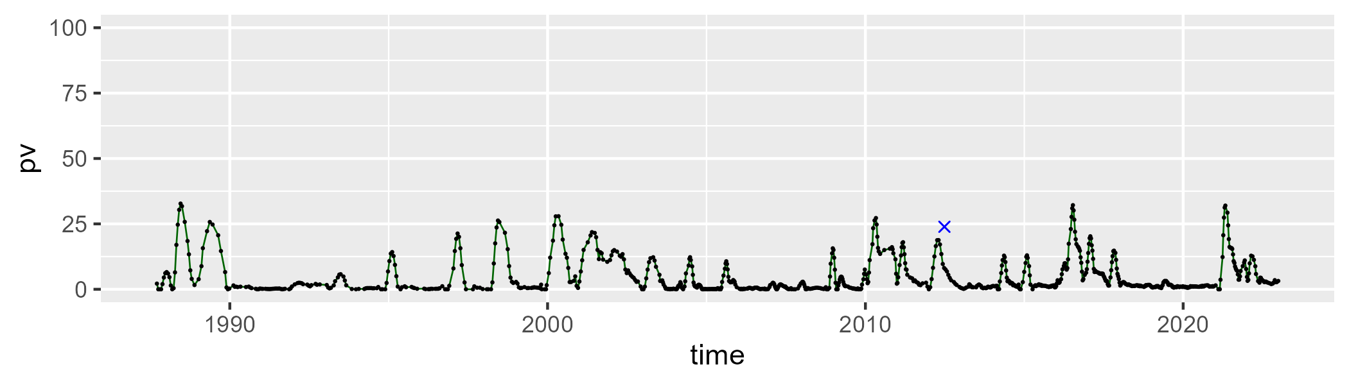

| Min. | 1st Qu. | Median | Mean | 3rd Qu. | Max. |
| --- | --- | --- | --- | --- | --- |
| 34.4802 | 52.5862 | 56.74978 | 57.31988 | 61.909 | 83.27387 |

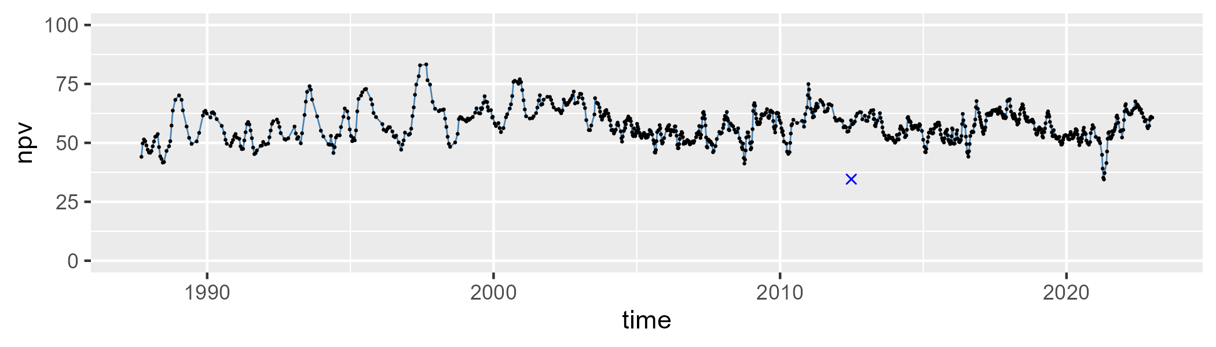

| Min. | 1st Qu. | Median | Mean | 3rd Qu. | Max. |
| --- | --- | --- | --- | --- | --- |
| 12.16377 | 30.89174 | 37.67517 | 36.83857 | 43.81104 | 57.15016 |

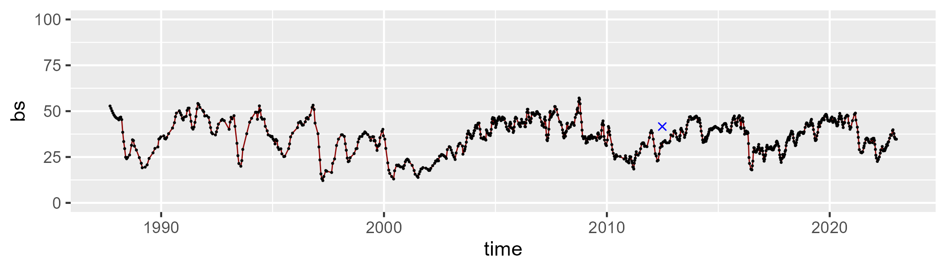

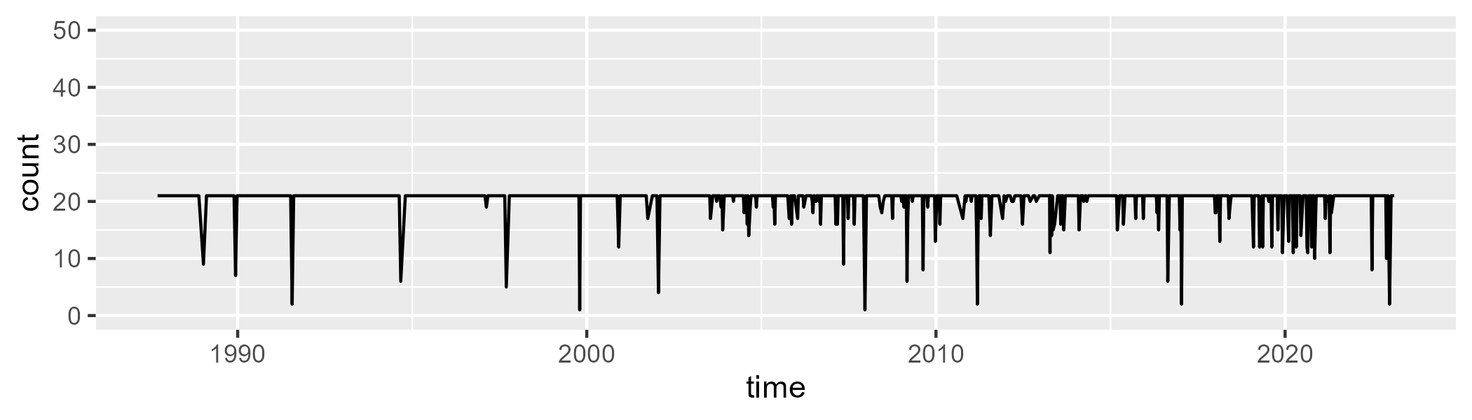

Min. : 1.00 1st Qu.:21.00 Median :21.00 Mean :20.25 3rd Qu.:21.00 Max. :21.00

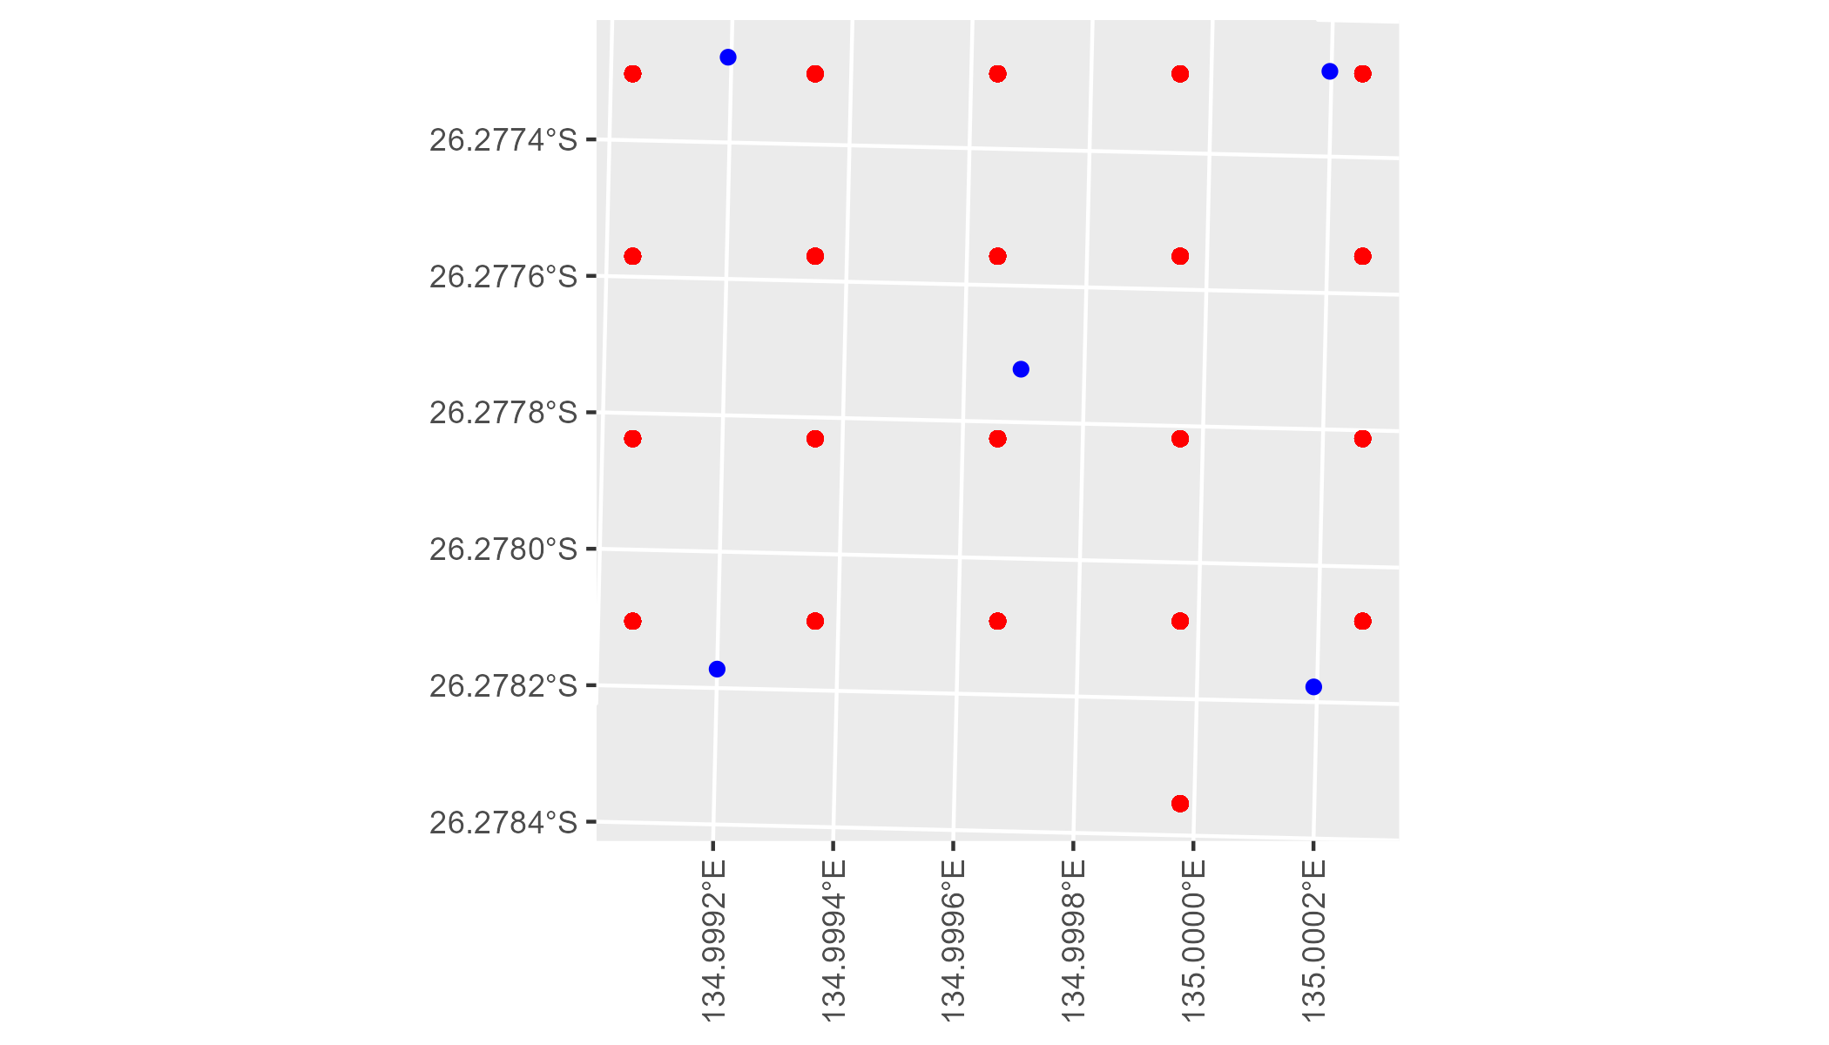

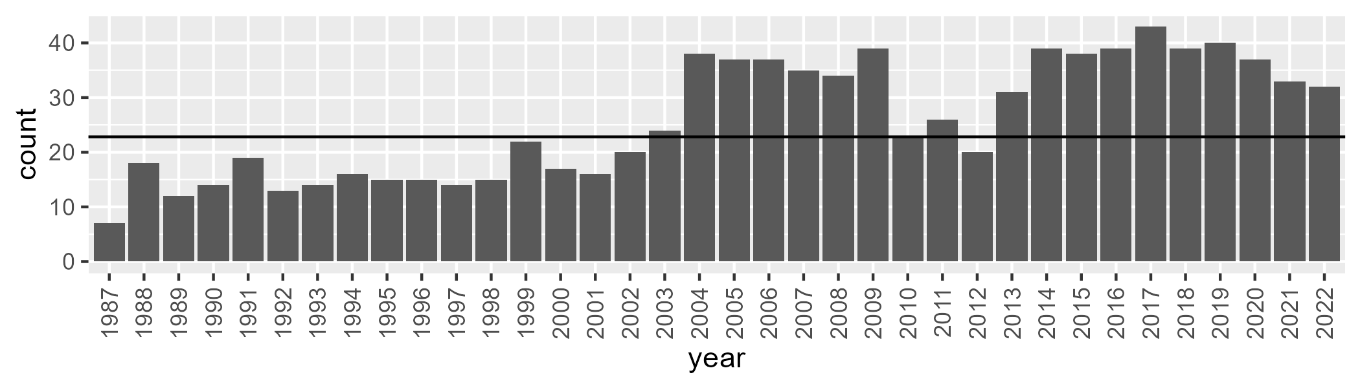

Number of samples: 931

# SAASTP0002

| Min. | 1st Qu. | Median | Mean | 3rd Qu. | Max. |
| --- | --- | --- | --- | --- | --- |
| 0 | 0.4424025 | 2.222435 | 6.35214 | 9.379981 | 38.8403 |

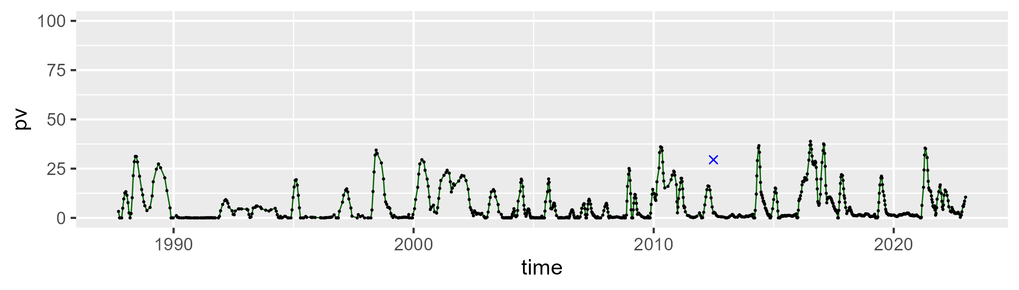

| Min. | 1st Qu. | Median | Mean | 3rd Qu. | Max. |
| --- | --- | --- | --- | --- | --- |
| 36.9688 | 58.47972 | 62.79426 | 63.31165 | 68.06276 | 81.36488 |

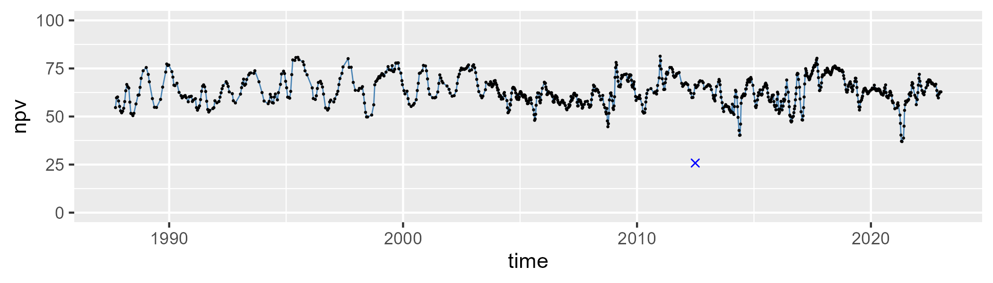

| Min. | 1st Qu. | Median | Mean | 3rd Qu. | Max. |
| --- | --- | --- | --- | --- | --- |
| 6.60335 | 22.35453 | 29.88552 | 29.25229 | 35.81446 | 53.70122 |

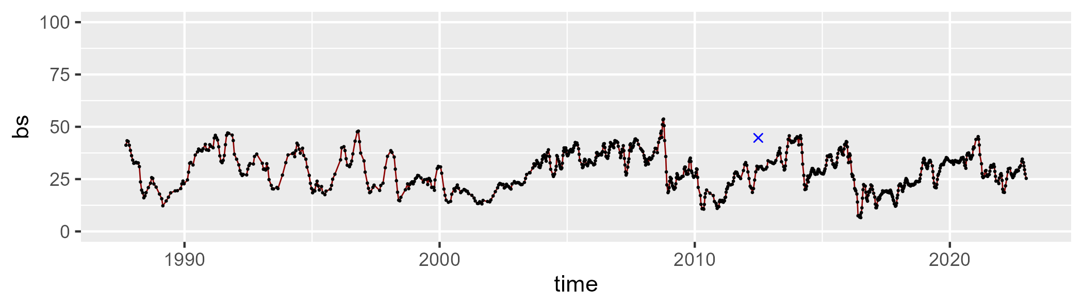

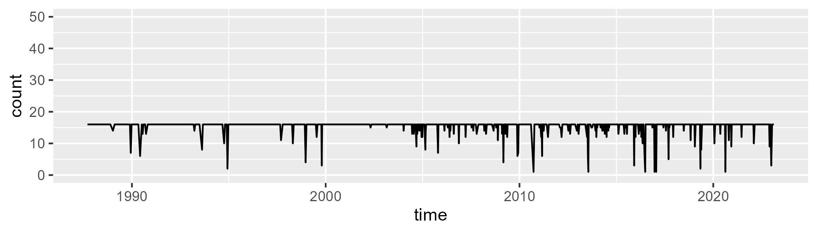

Min. : 1.00 1st Qu.:16.00 Median :16.00 Mean :15.39 3rd Qu.:16.00 Max. :16.00

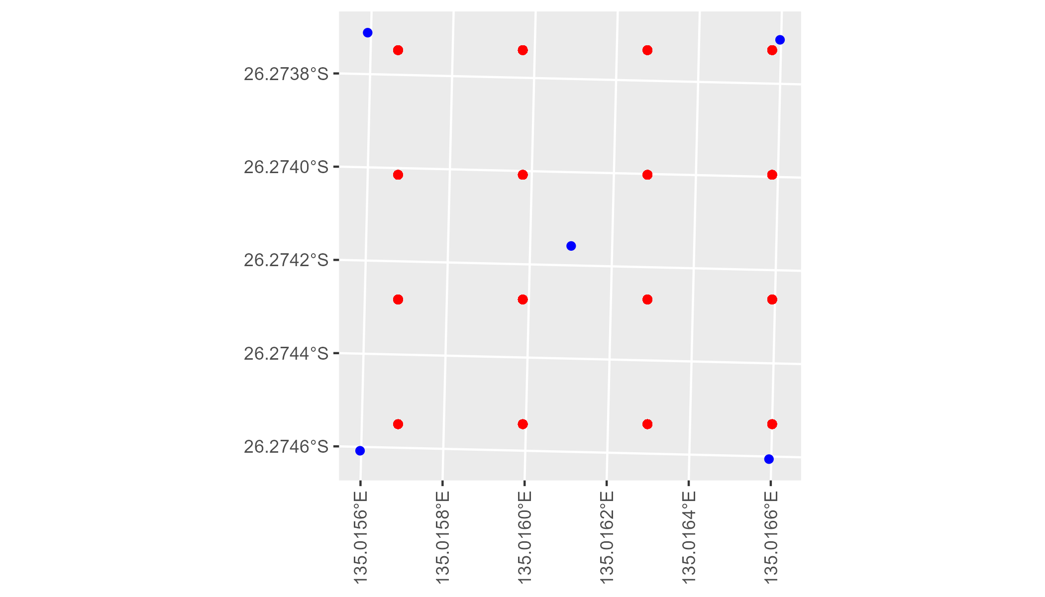

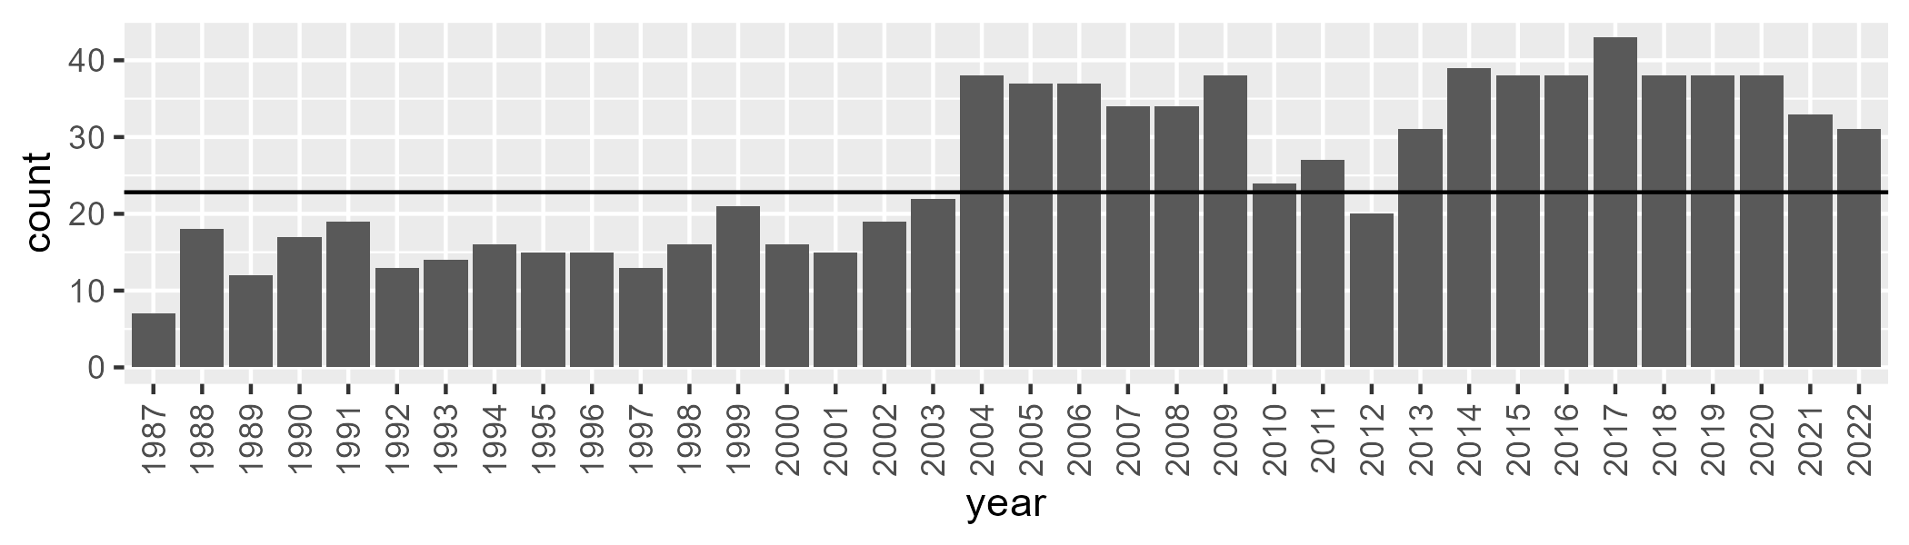

Number of samples: 924

# SAASTP0003

| Min. | 1st Qu. | Median | Mean | 3rd Qu. | Max. |
| --- | --- | --- | --- | --- | --- |
| 0 | 0 | 0.4988471 | 0.7040248 | 1.083288 | 9.142027 |

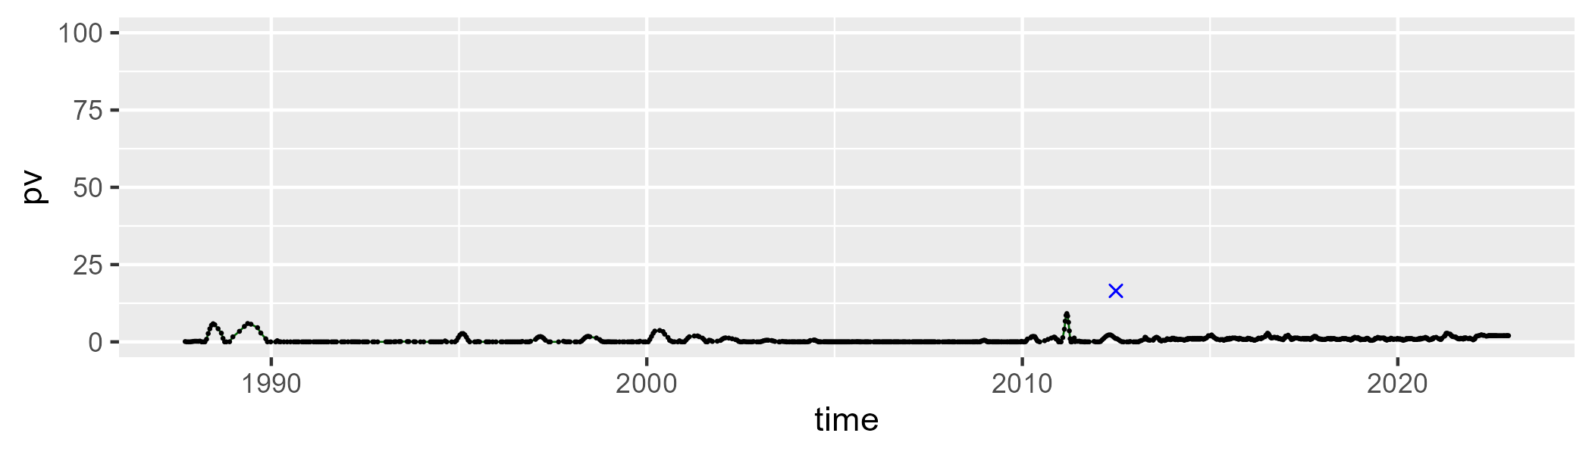

| Min. | 1st Qu. | Median | Mean | 3rd Qu. | Max. |
| --- | --- | --- | --- | --- | --- |
| 43.19157 | 52.77628 | 56.22808 | 56.97288 | 60.48951 | 73.37764 |

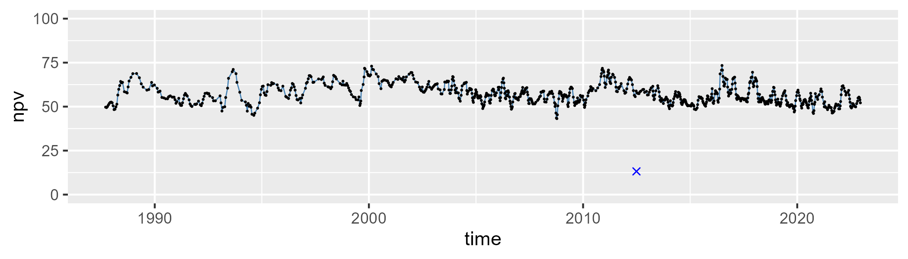

| Min. | 1st Qu. | Median | Mean | 3rd Qu. | Max. |
| --- | --- | --- | --- | --- | --- |
| 19.79317 | 38.34215 | 42.60981 | 41.56586 | 45.71741 | 56.1725 |

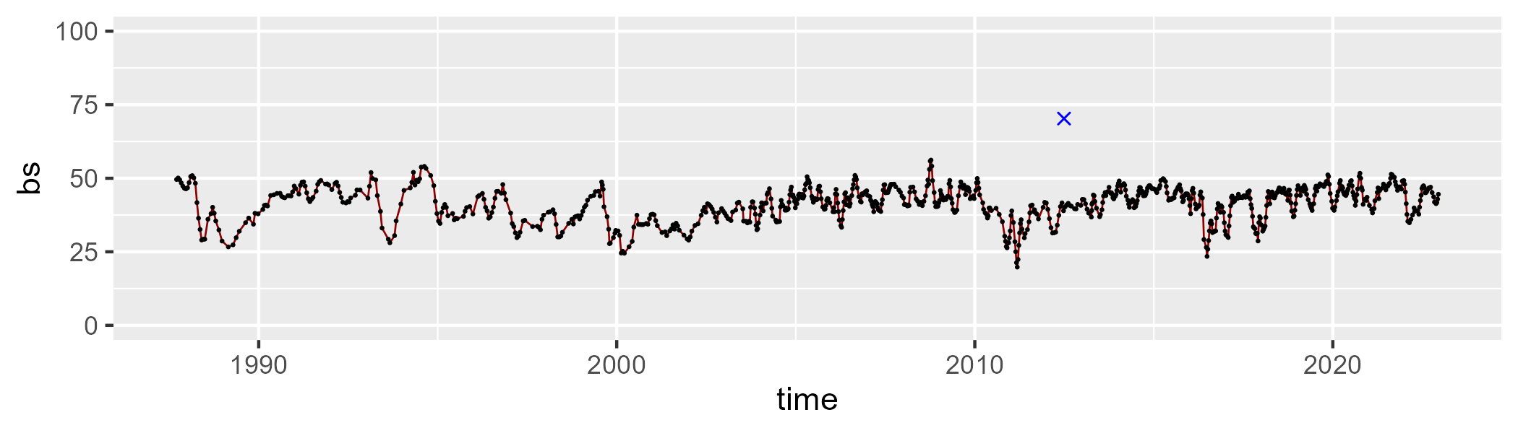

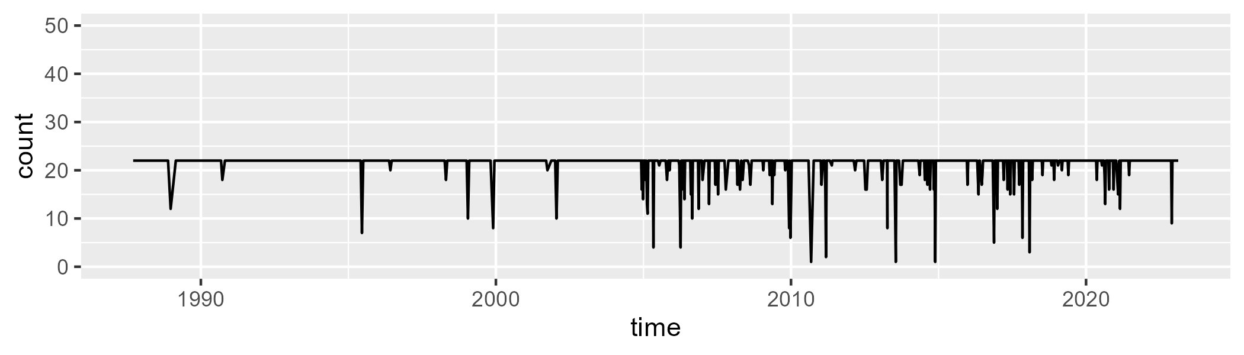

Min. : 1.0 1st Qu.:22.0 Median :22.0 Mean :21.3 3rd Qu.:22.0 Max. :22.0

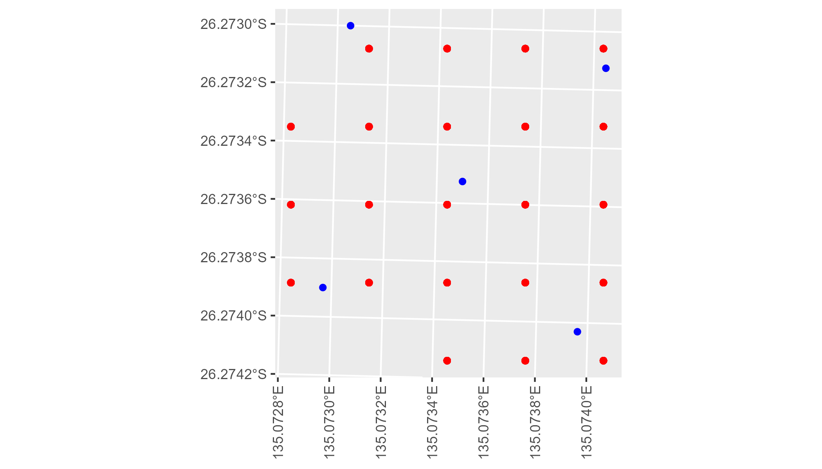

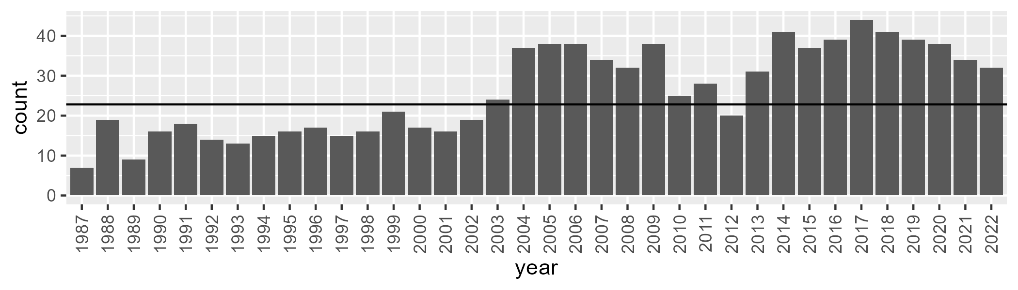

Number of samples: 938

# SAASTP0004

| Min. | 1st Qu. | Median | Mean | 3rd Qu. | Max. |
| --- | --- | --- | --- | --- | --- |
| 0 | 0.6701463 | 2.541359 | 7.618263 | 10.91349 | 63.45869 |

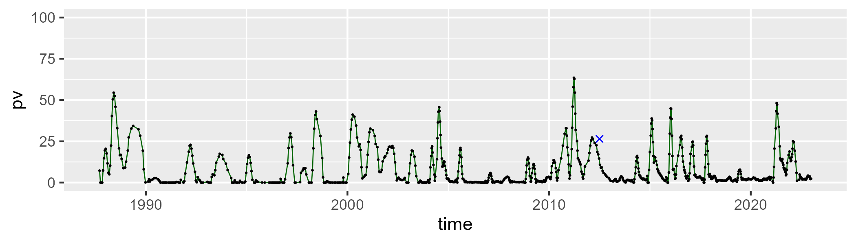

| Min. | 1st Qu. | Median | Mean | 3rd Qu. | Max. |
| --- | --- | --- | --- | --- | --- |
| 7.173873 | 26.30539 | 36.24117 | 36.75617 | 45.52825 | 77.12971 |

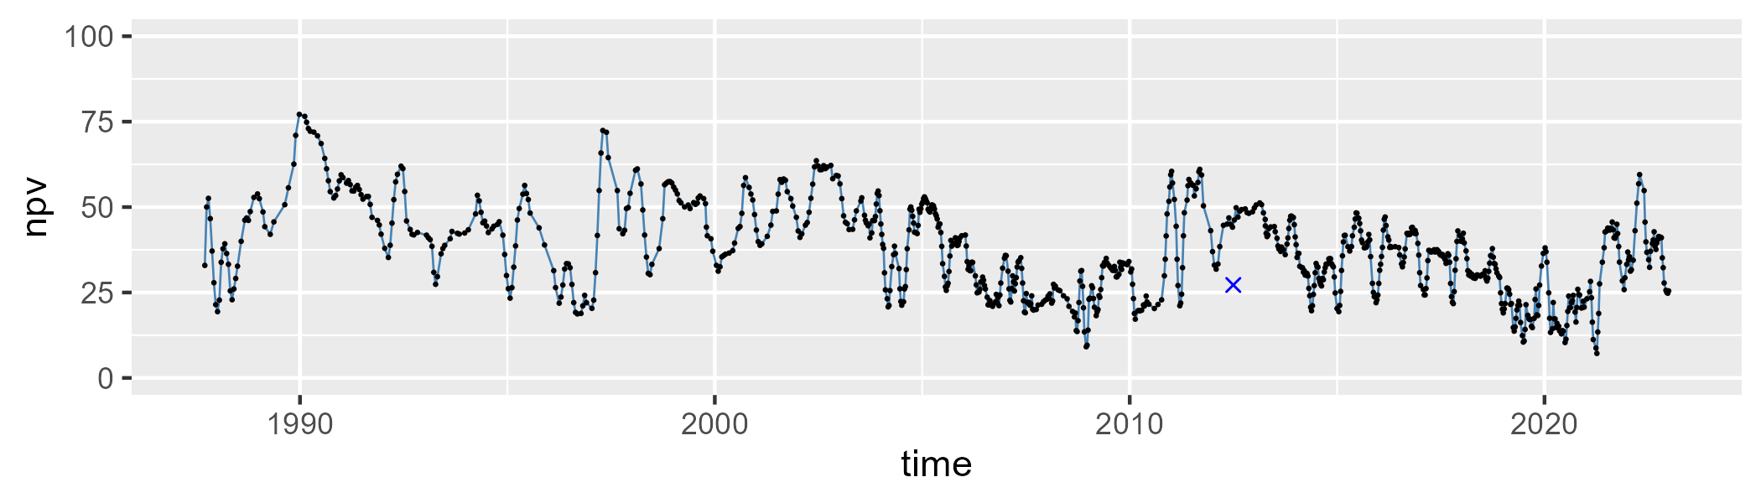

| Min. | 1st Qu. | Median | Mean | 3rd Qu. | Max. |
| --- | --- | --- | --- | --- | --- |
| 10.46193 | 43.35402 | 55.01656 | 54.33459 | 66.86128 | 86.78704 |

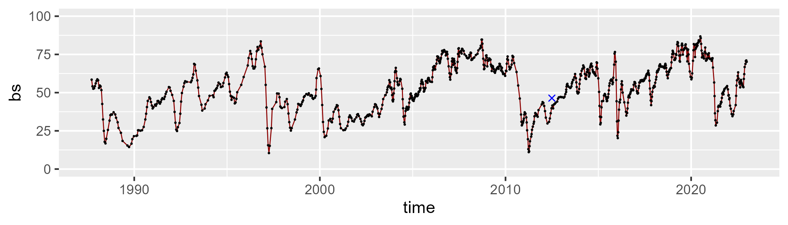

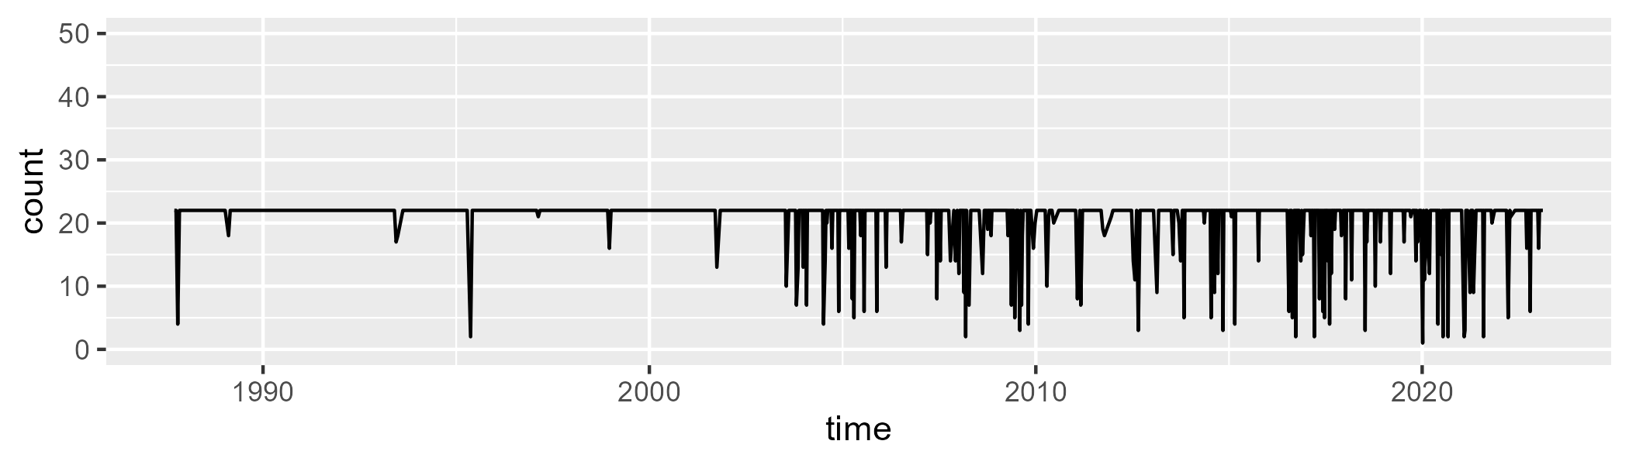

Min. : 1.00 1st Qu.:22.00 Median :22.00 Mean :20.65 3rd Qu.:22.00 Max. :22.00

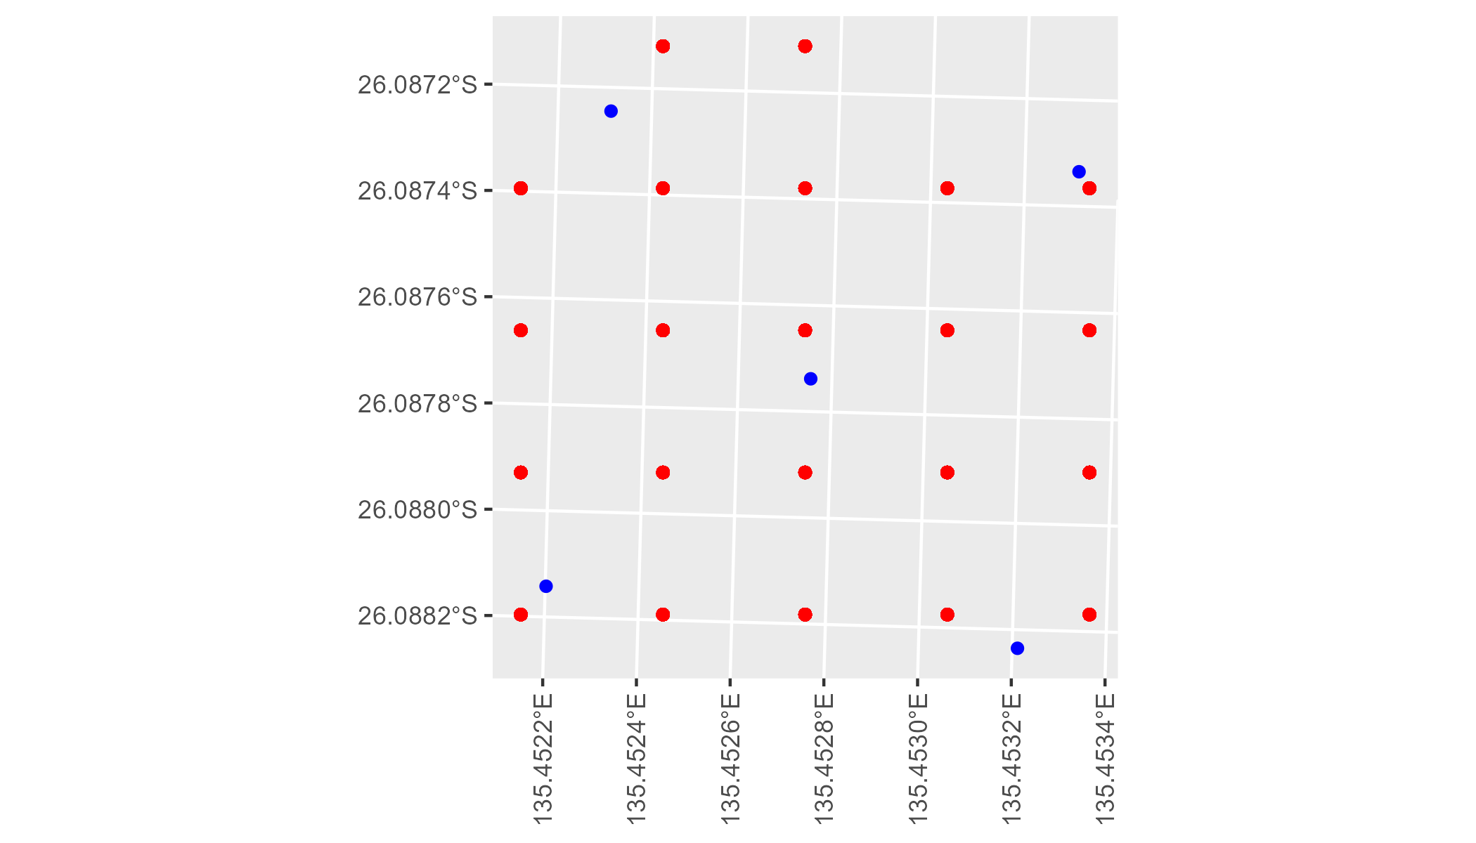

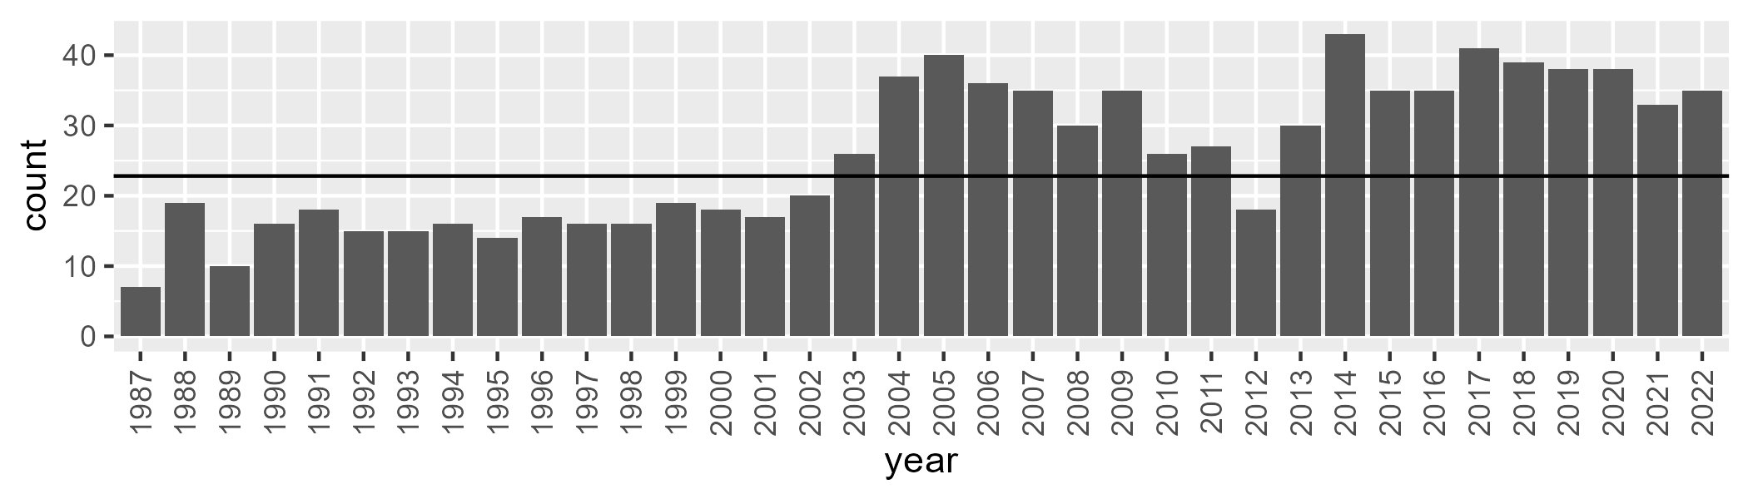

Number of samples: 930

# SAASTP0005

| Min. | 1st Qu. | Median | Mean | 3rd Qu. | Max. |
| --- | --- | --- | --- | --- | --- |
| 0 | 1.642722 | 3.614224 | 7.746726 | 8.465523 | 64.79227 |

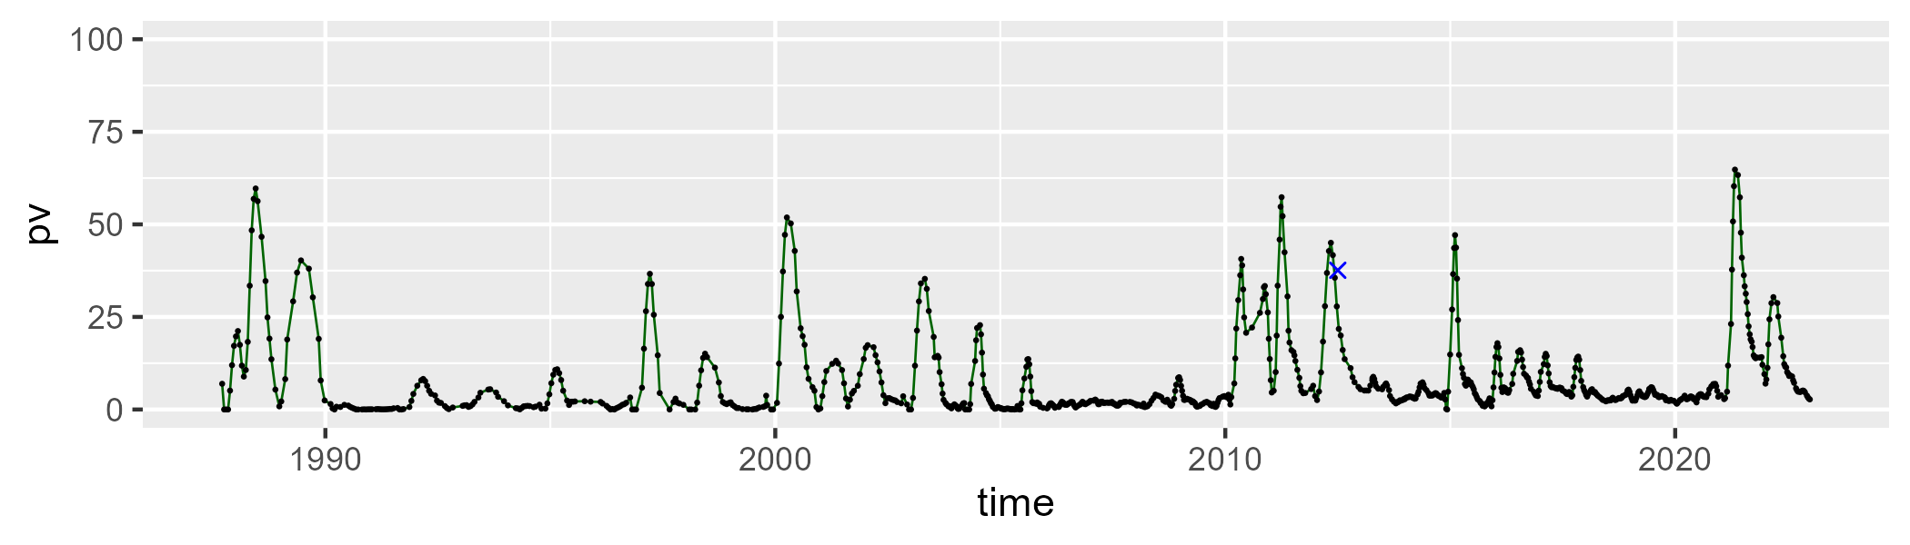

| Min. | 1st Qu. | Median | Mean | 3rd Qu. | Max. |
| --- | --- | --- | --- | --- | --- |
| 7.34012 | 24.7163 | 34.00739 | 36.05382 | 46.02014 | 74.55106 |

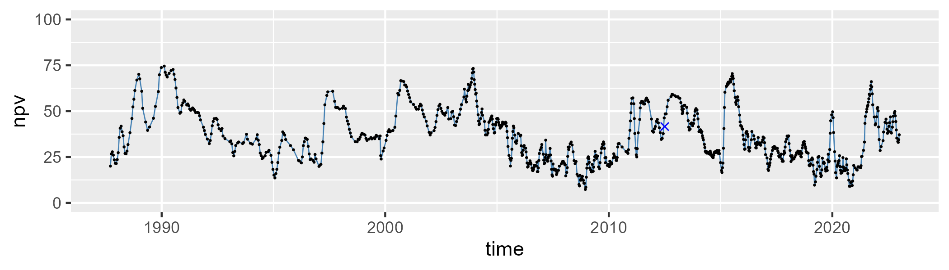

| Min. | 1st Qu. | Median | Mean | 3rd Qu. | Max. |
| --- | --- | --- | --- | --- | --- |
| 5.852221 | 42.07967 | 57.92415 | 54.77303 | 69.75331 | 87.20388 |

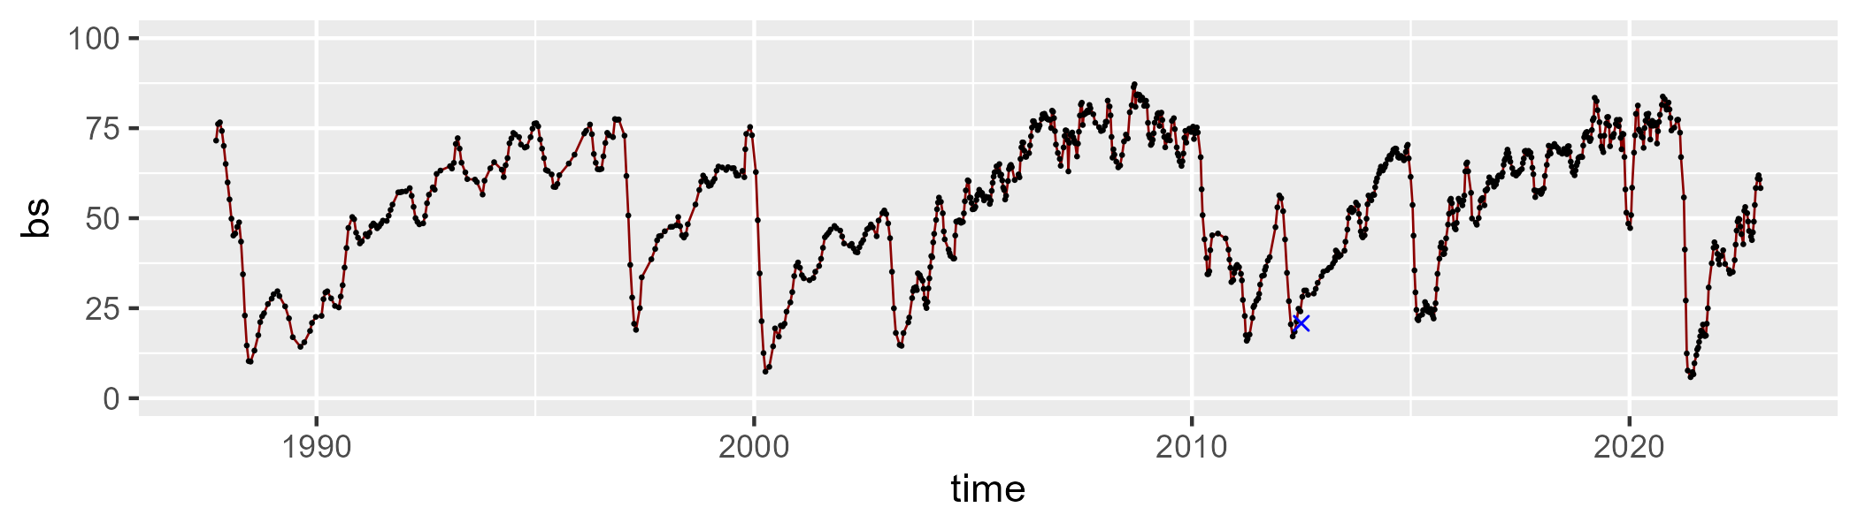

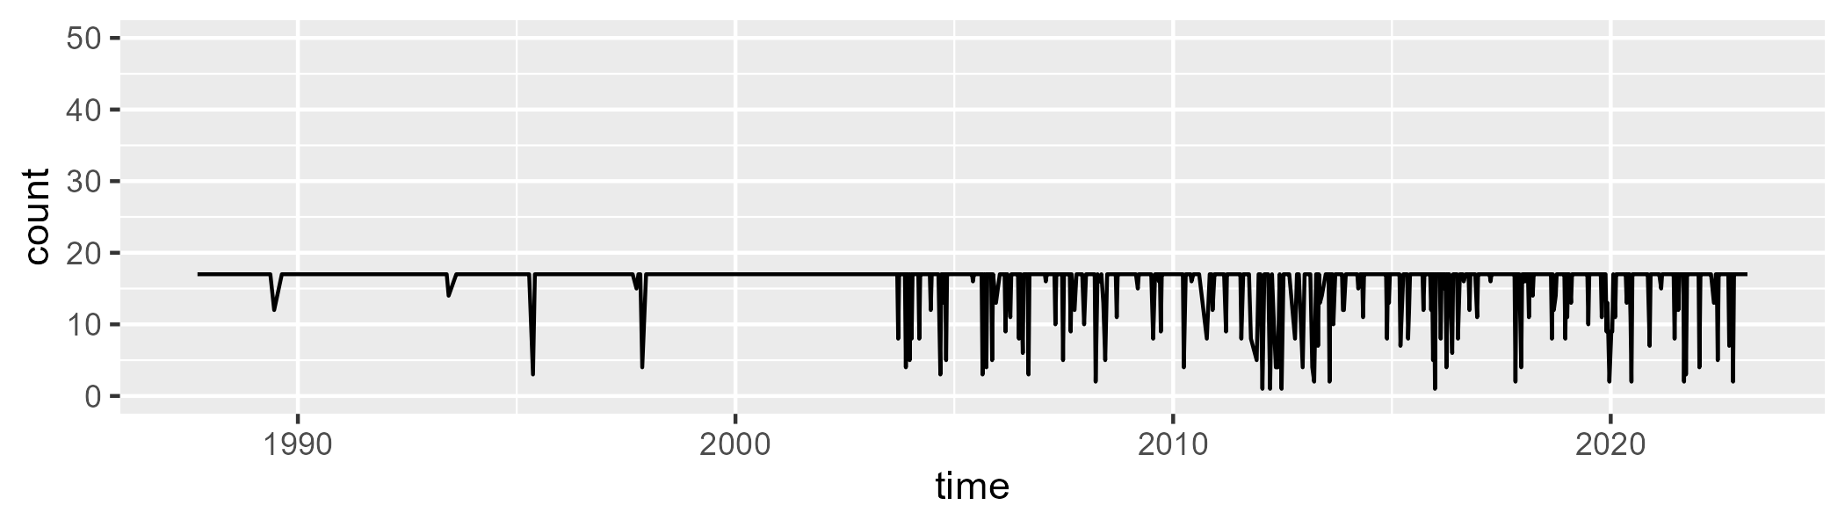

Min. : 1.00 1st Qu.:17.00 Median :17.00 Mean :15.95 3rd Qu.:17.00 Max. :17.00

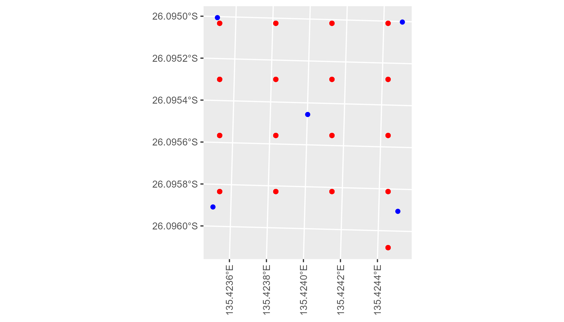

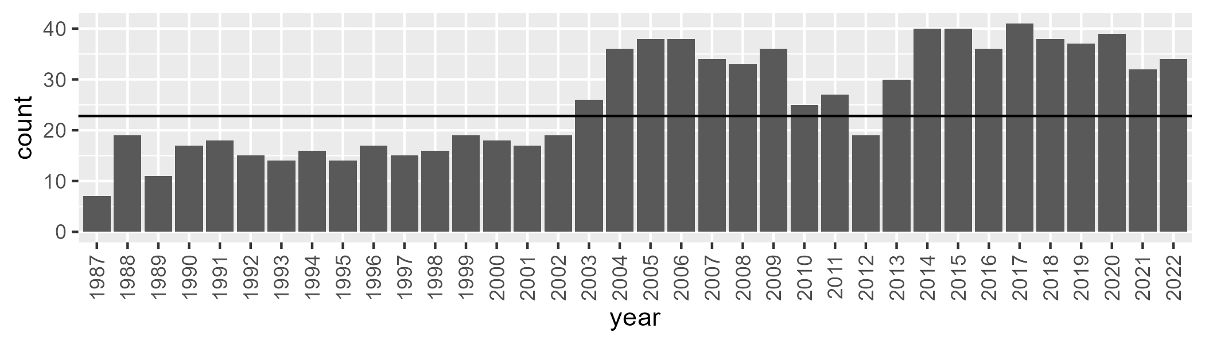

Number of samples: 931

# SAASTP0006

| Min. | 1st Qu. | Median | Mean | 3rd Qu. | Max. |
| --- | --- | --- | --- | --- | --- |
| 0 | 0.5372638 | 3.723762 | 11.46246 | 14.79765 | 77.08143 |

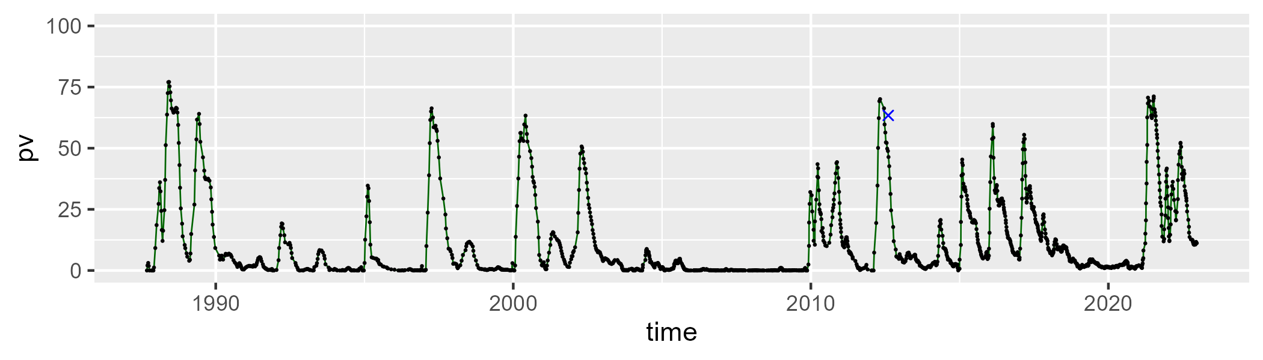

| Min. | 1st Qu. | Median | Mean | 3rd Qu. | Max. |
| --- | --- | --- | --- | --- | --- |
| 14.85871 | 46.35092 | 52.81477 | 52.13459 | 59.23831 | 83.17726 |

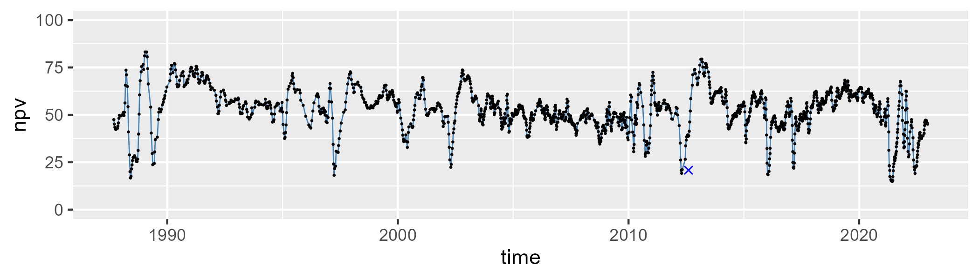

| Min. | 1st Qu. | Median | Mean | 3rd Qu. | Max. |
| --- | --- | --- | --- | --- | --- |
| 0 | 26.69805 | 36.38349 | 35.17207 | 44.78054 | 64.43675 |

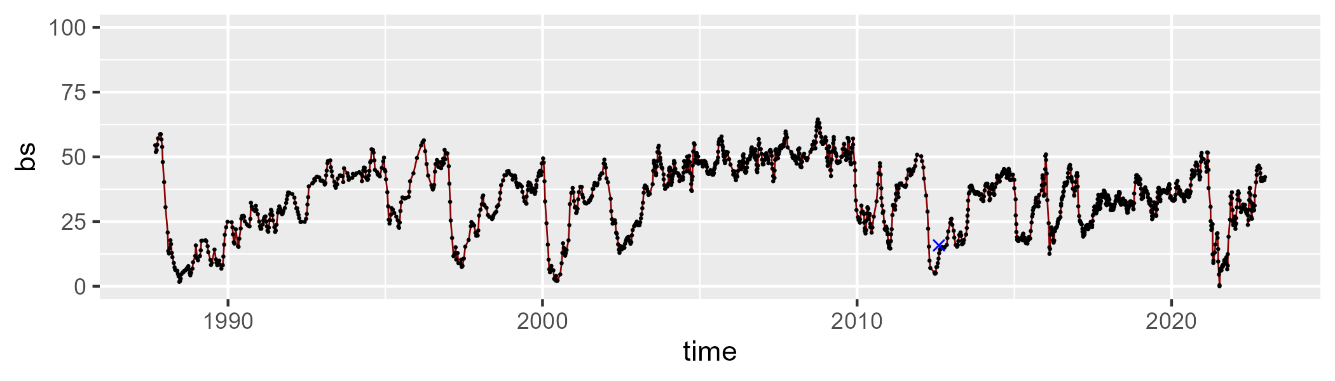

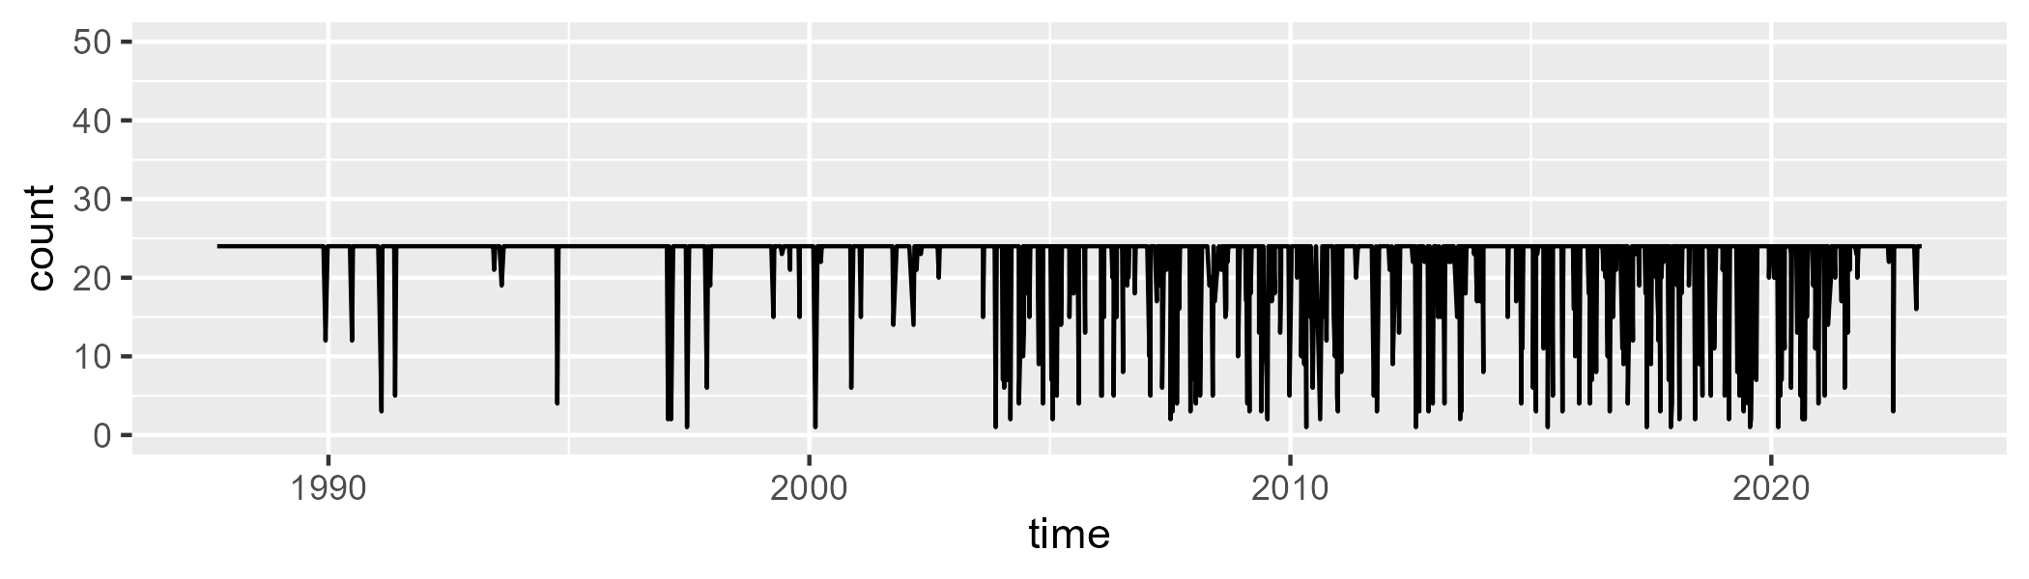

Min. : 1.00 1st Qu.:24.00 Median :24.00 Mean :22.12 3rd Qu.:24.00 Max. :24.00

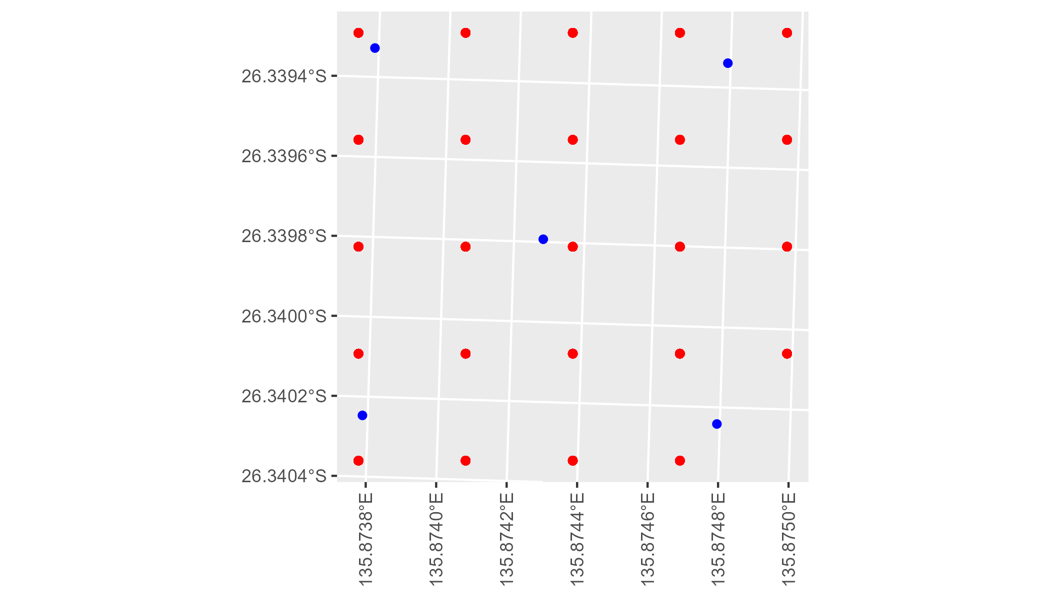

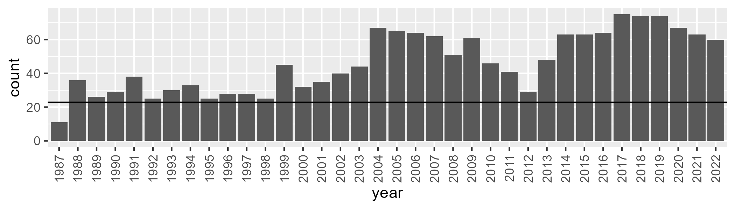

Number of samples: 1667

# SAASTP0007

| Min. | 1st Qu. | Median | Mean | 3rd Qu. | Max. |
| --- | --- | --- | --- | --- | --- |
| 0 | 0.4668785 | 2.65462 | 7.706583 | 9.272954 | 75.02515 |

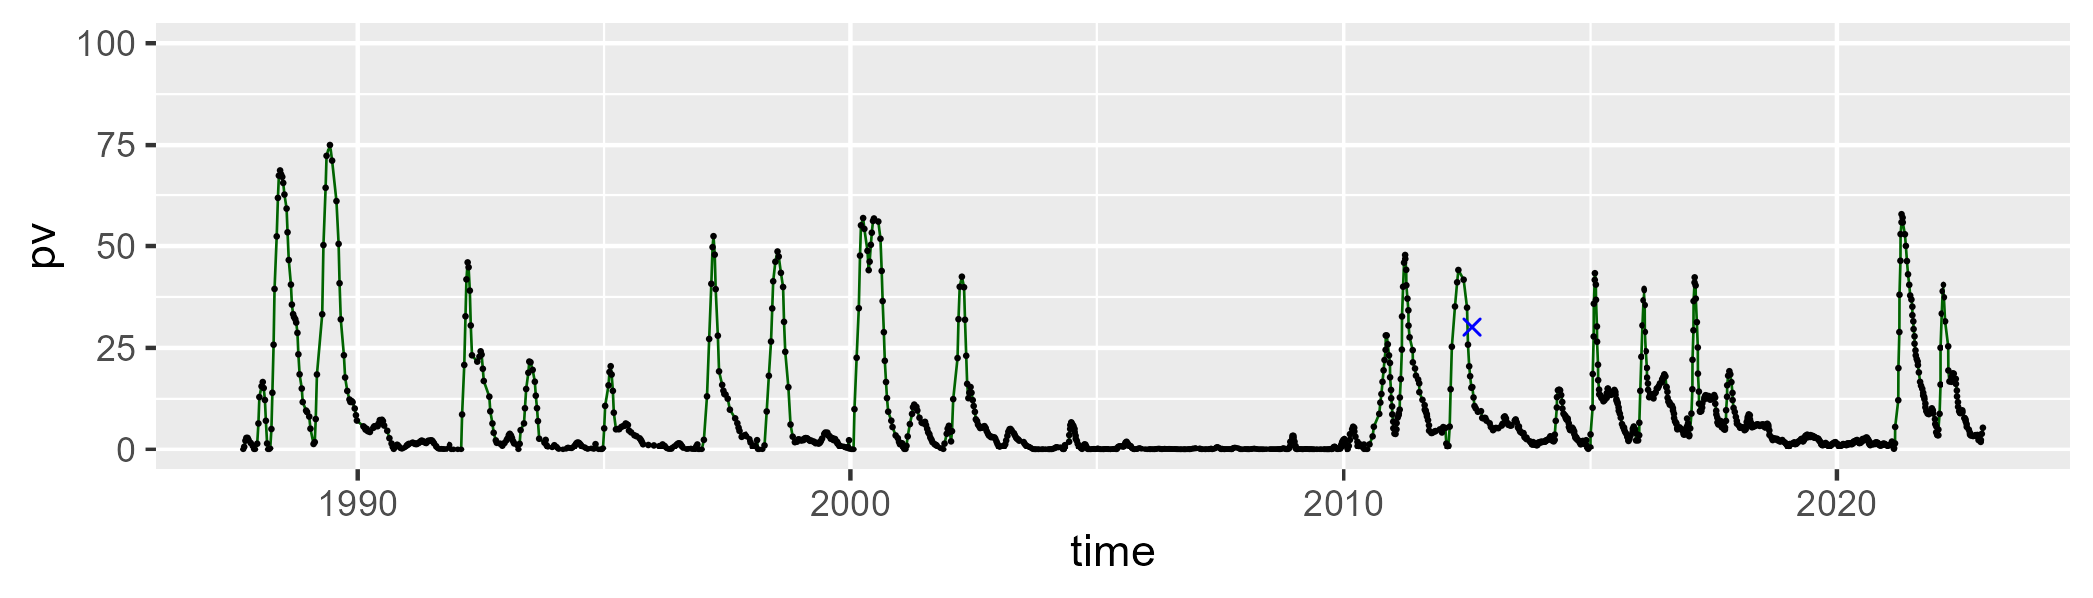

| Min. | 1st Qu. | Median | Mean | 3rd Qu. | Max. |
| --- | --- | --- | --- | --- | --- |
| 19.98286 | 45.68925 | 52.36945 | 52.98483 | 59.86491 | 83.59512 |

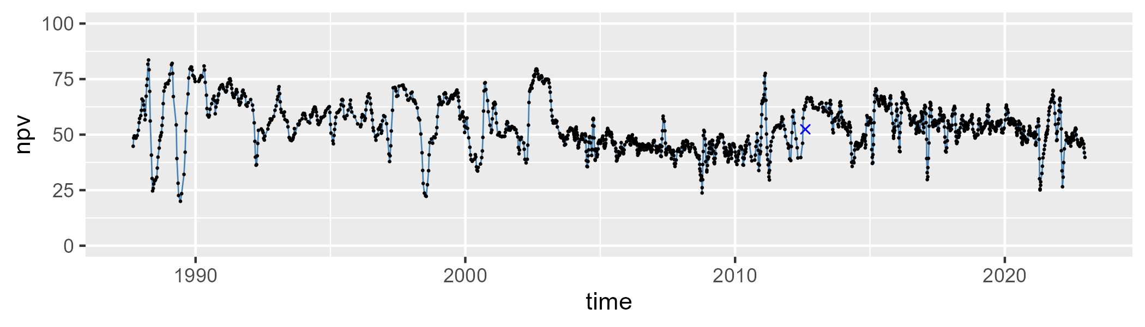

| Min. | 1st Qu. | Median | Mean | 3rd Qu. | Max. |
| --- | --- | --- | --- | --- | --- |
| 2.299786 | 28.86975 | 39.78447 | 38.10098 | 49.27848 | 75.02422 |

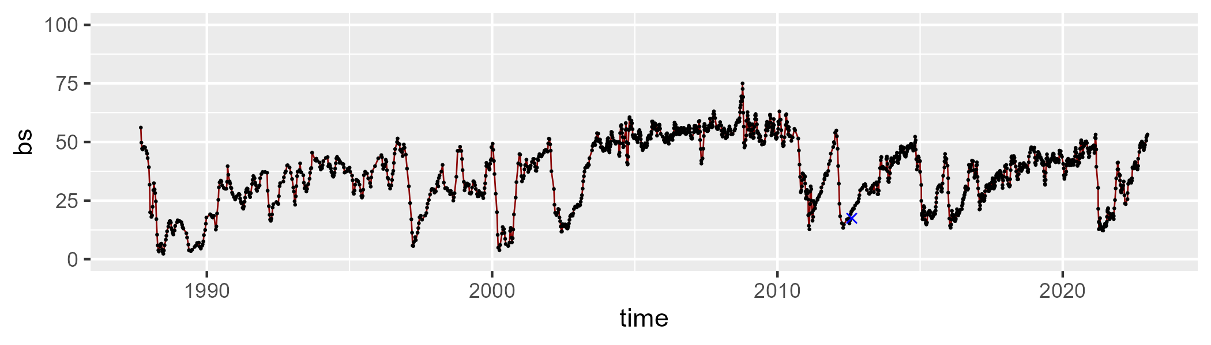

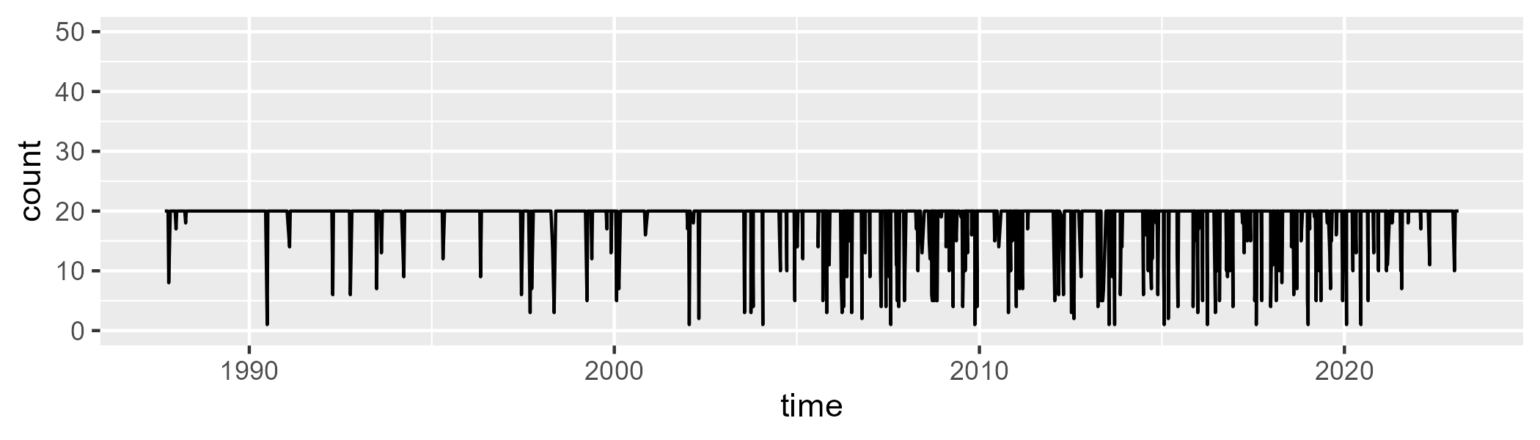

Min. : 1.00 1st Qu.:20.00 Median :20.00 Mean :18.78 3rd Qu.:20.00 Max. :20.00

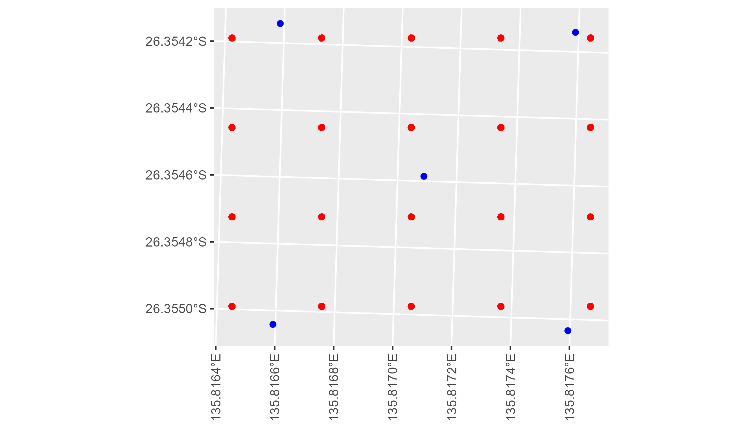

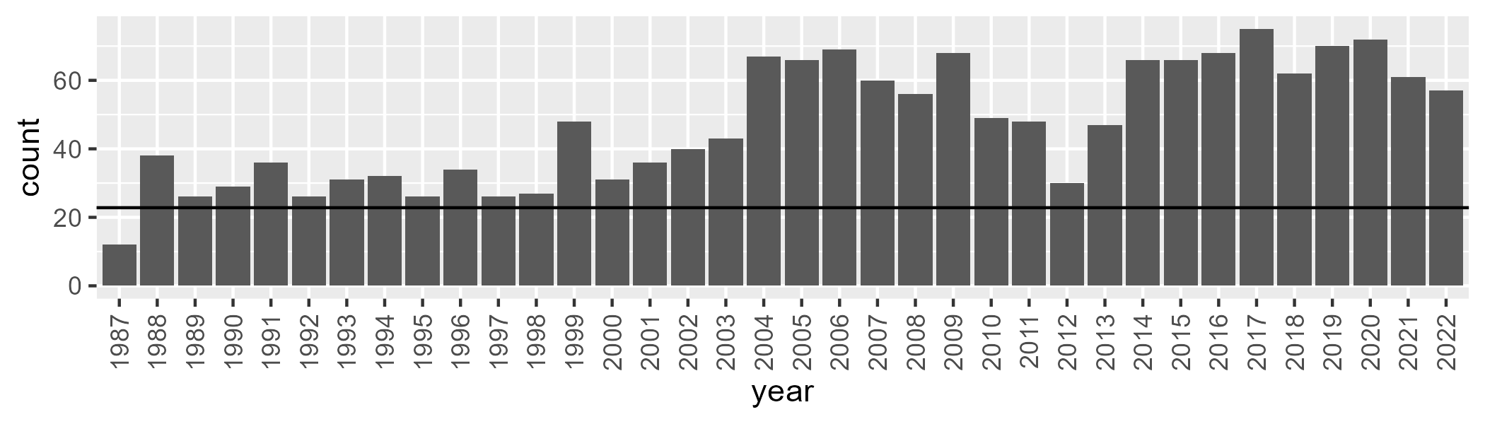

Number of samples: 1698

# SAASTP0008

| Min. | 1st Qu. | Median | Mean | 3rd Qu. | Max. |
| --- | --- | --- | --- | --- | --- |
| 0 | 0.8714609 | 1.970929 | 3.05034 | 4.052184 | 23.74175 |

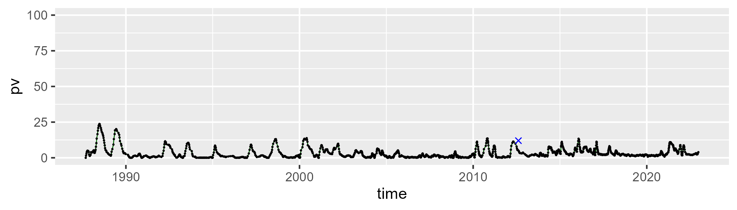

| Min. | 1st Qu. | Median | Mean | 3rd Qu. | Max. |
| --- | --- | --- | --- | --- | --- |
| 0.1451136 | 15.01314 | 20.38945 | 21.15928 | 26.01497 | 47.29537 |

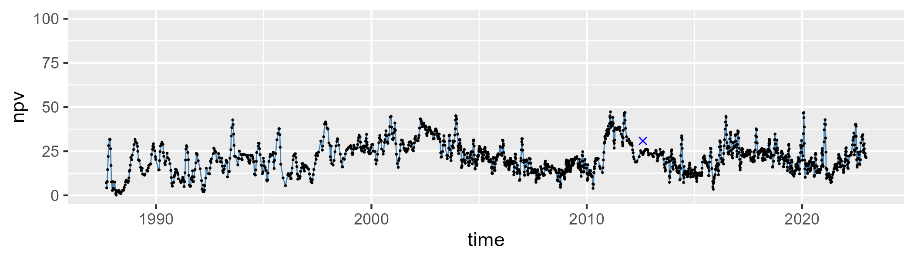

| Min. | 1st Qu. | Median | Mean | 3rd Qu. | Max. |
| --- | --- | --- | --- | --- | --- |
| 45.9734 | 69.51558 | 75.11415 | 74.36348 | 80.61791 | 93.93314 |

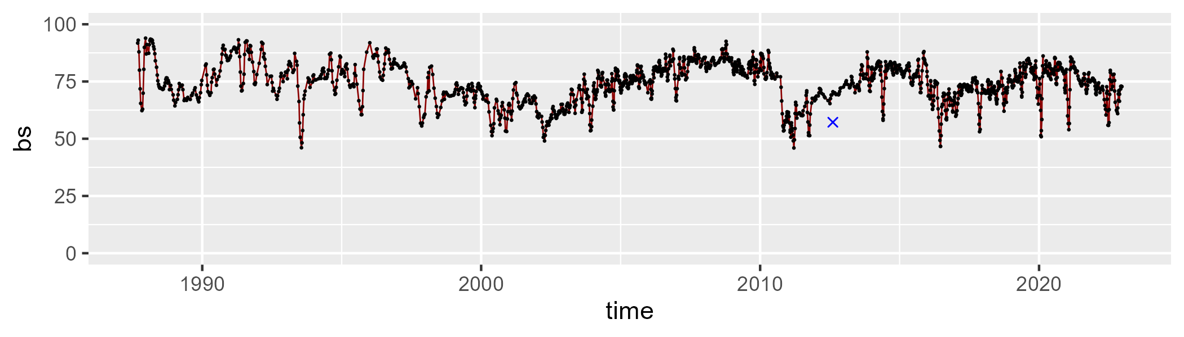

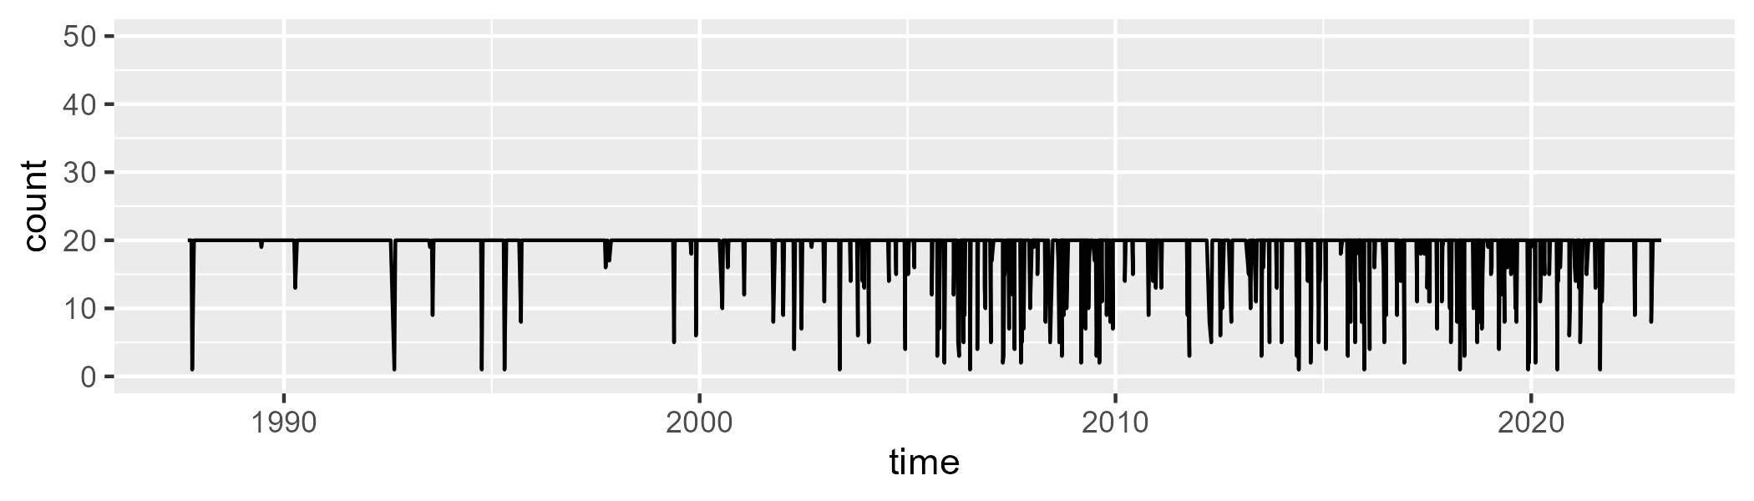

Min. : 1.00 1st Qu.:20.00 Median :20.00 Mean :18.91 3rd Qu.:20.00 Max. :20.00

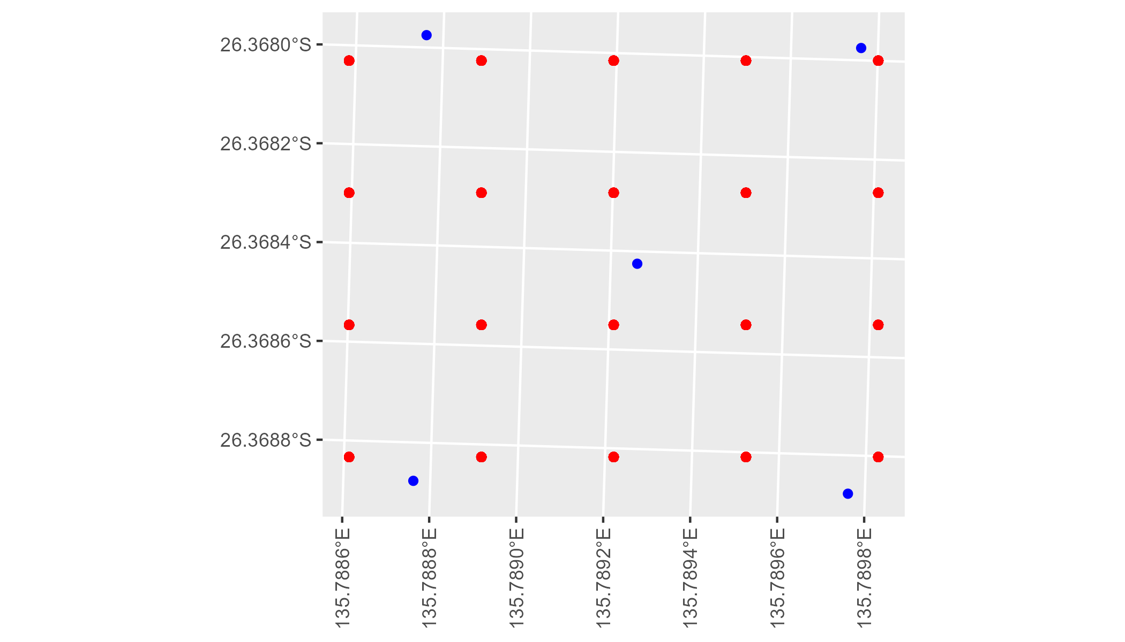

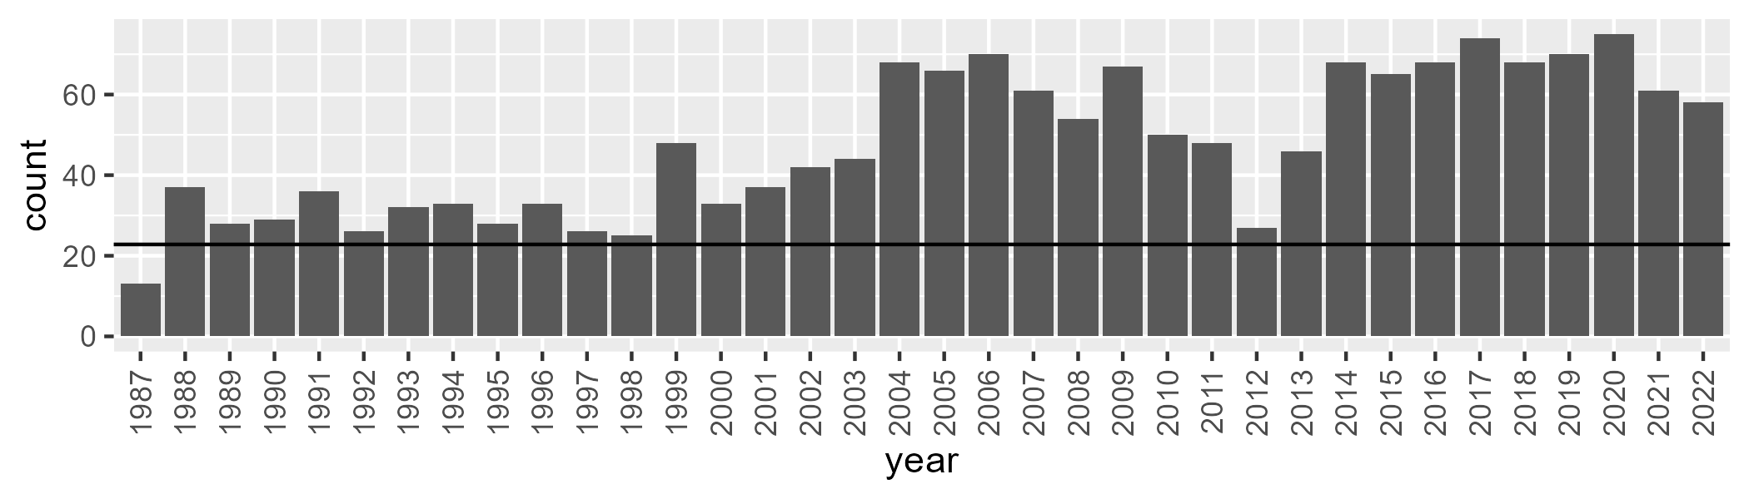

Number of samples: 1714

# SAASTP0009

| Min. | 1st Qu. | Median | Mean | 3rd Qu. | Max. |
| --- | --- | --- | --- | --- | --- |
| 0 | 1.401589 | 6.303121 | 12.18625 | 18.19412 | 61.83228 |

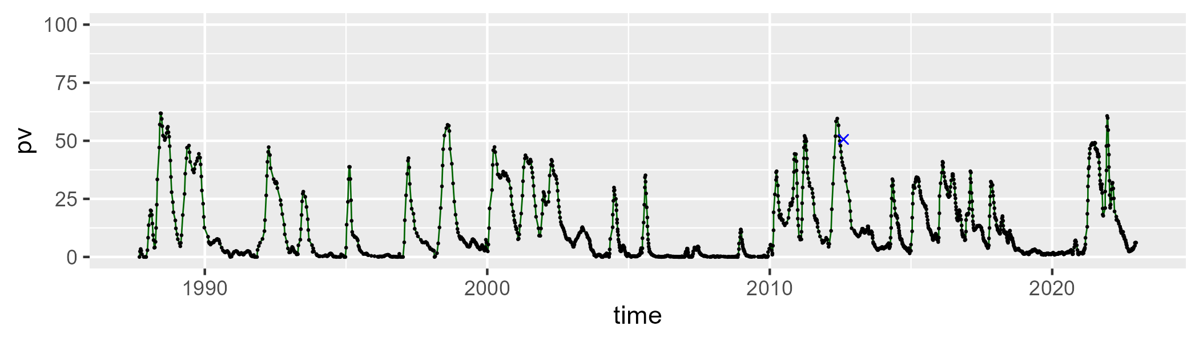

| Min. | 1st Qu. | Median | Mean | 3rd Qu. | Max. |
| --- | --- | --- | --- | --- | --- |
| 14.20949 | 38.22556 | 45.52054 | 44.48466 | 50.50853 | 67.0852 |

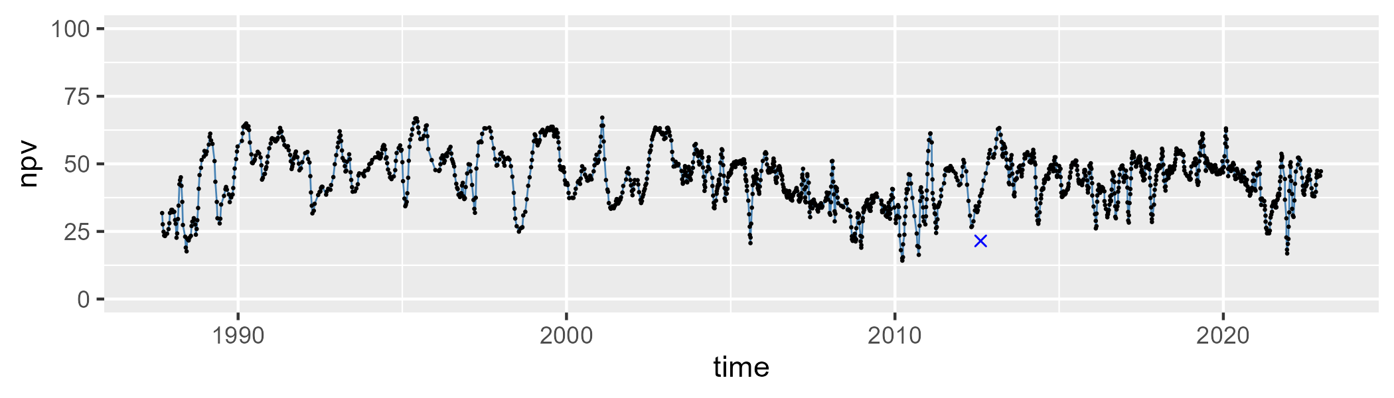

| Min. | 1st Qu. | Median | Mean | 3rd Qu. | Max. |
| --- | --- | --- | --- | --- | --- |
| 9.067529 | 32.5359 | 42.95774 | 41.9918 | 49.91132 | 77.6467 |

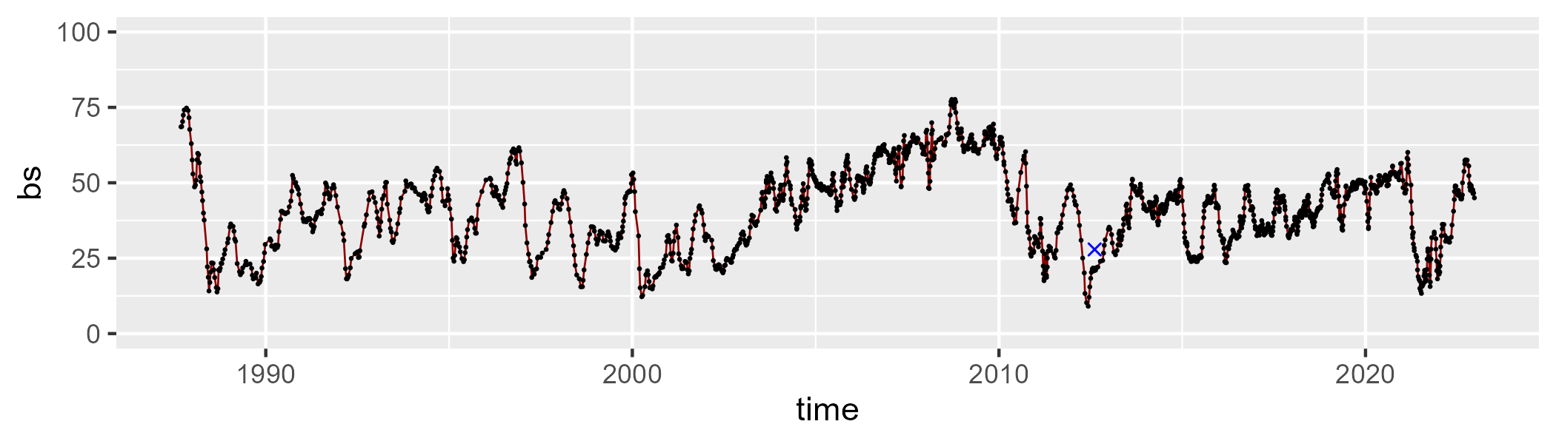

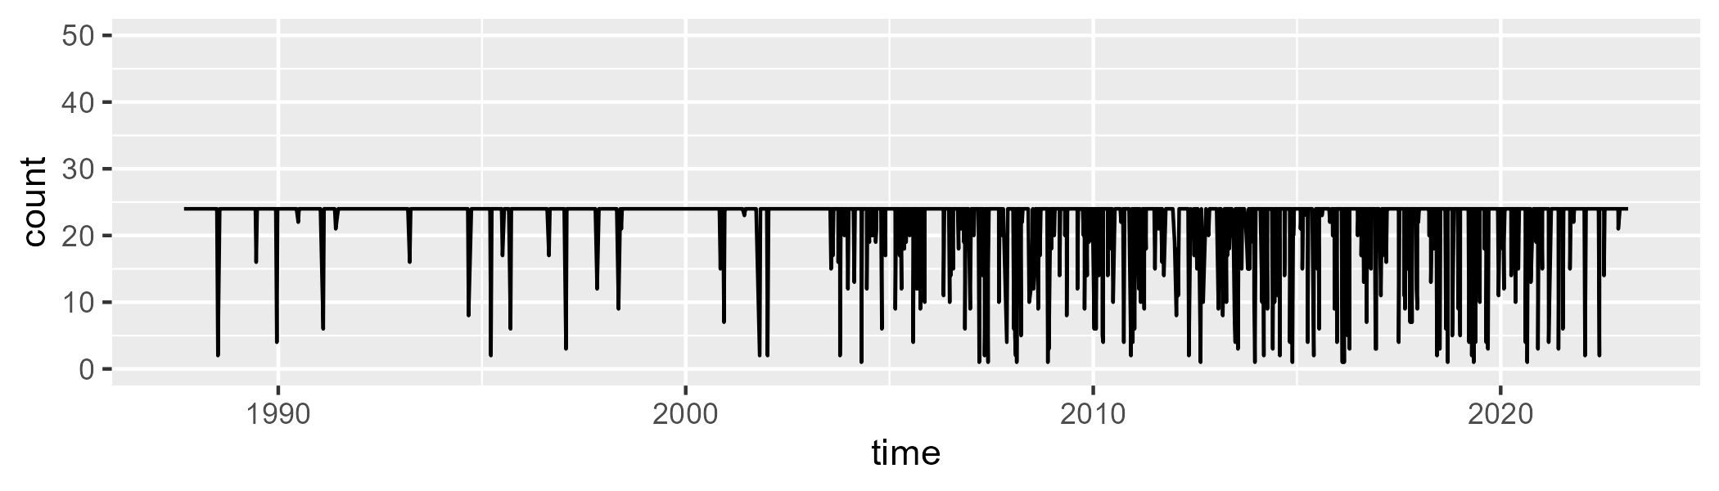

Min. : 1.0 1st Qu.:24.0 Median :24.0 Mean :22.2 3rd Qu.:24.0 Max. :24.0

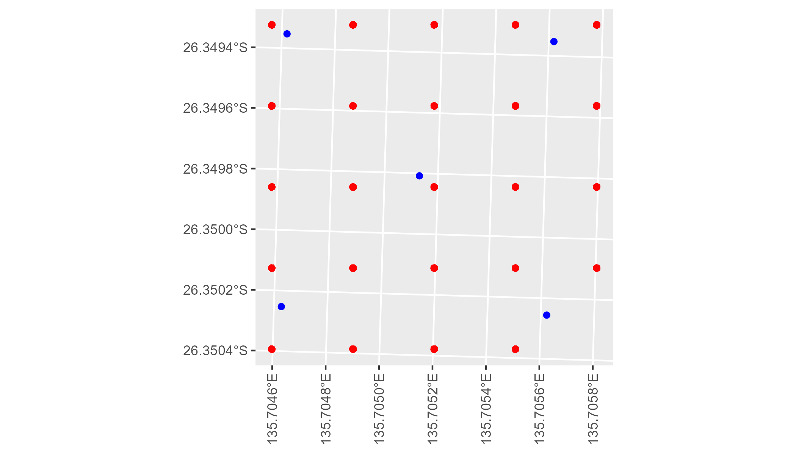

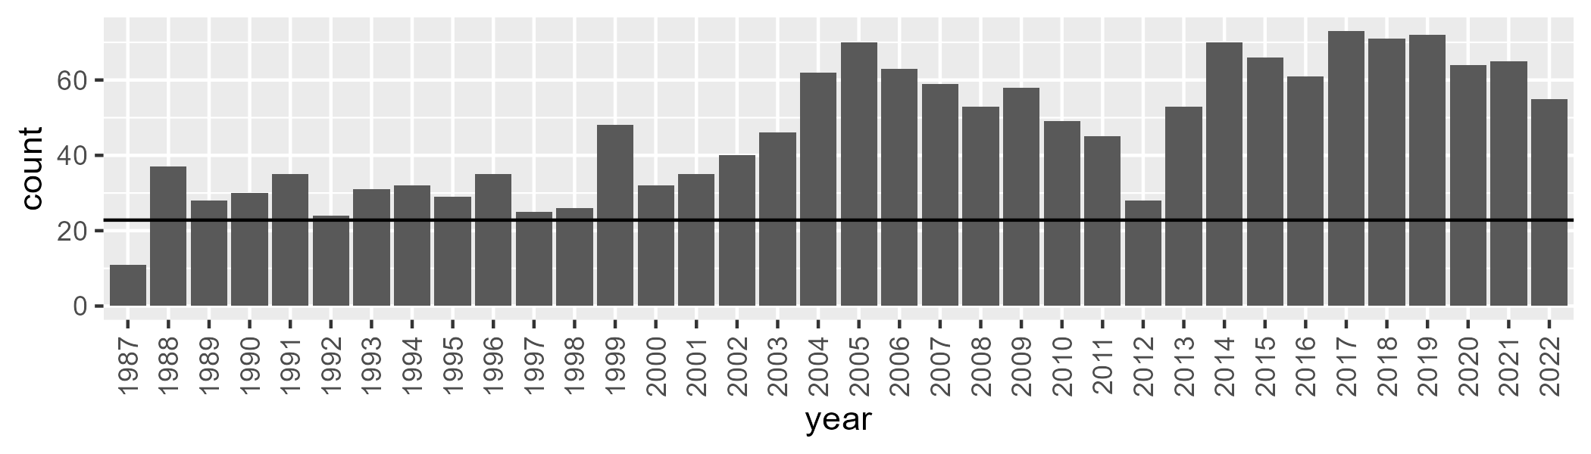

Number of samples: 1681

# SAASTP0010

| Min. | 1st Qu. | Median | Mean | 3rd Qu. | Max. |
| --- | --- | --- | --- | --- | --- |
| 0 | 0.02503591 | 0.412011 | 0.9489911 | 1.230622 | 12.06061 |

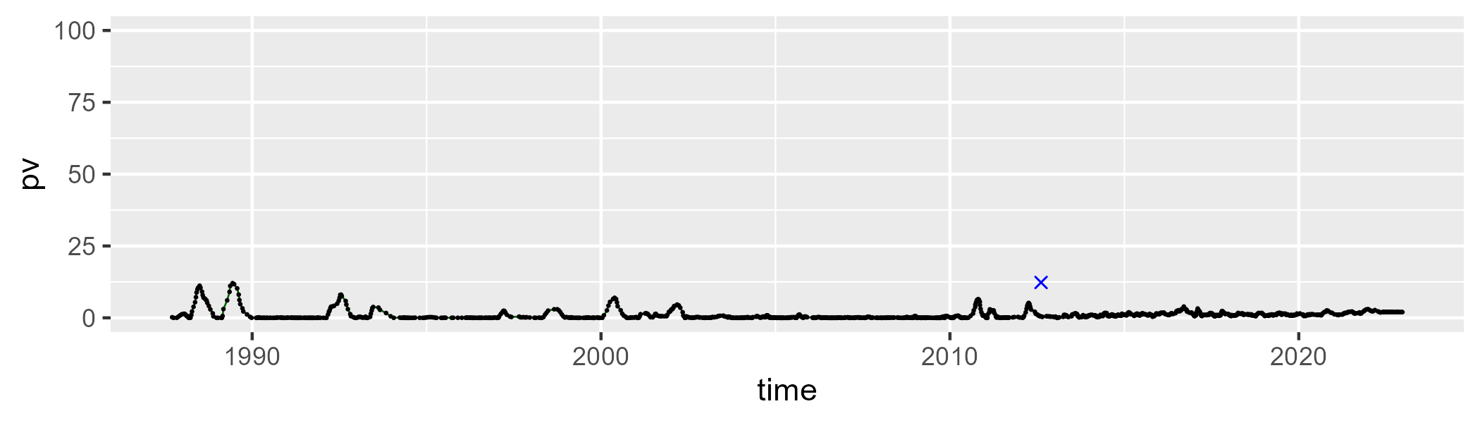

| Min. | 1st Qu. | Median | Mean | 3rd Qu. | Max. |
| --- | --- | --- | --- | --- | --- |
| 12.72314 | 26.38907 | 30.28022 | 31.01642 | 35.12291 | 51.17239 |

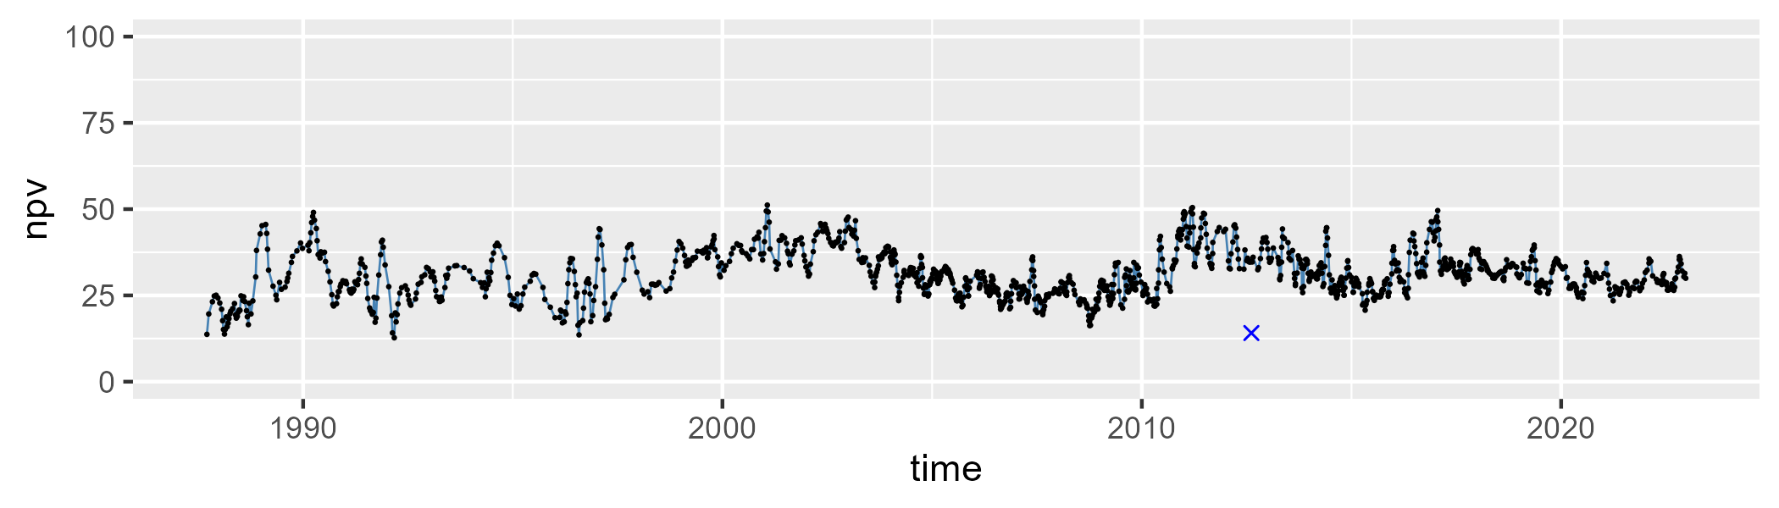

| Min. | 1st Qu. | Median | Mean | 3rd Qu. | Max. |
| --- | --- | --- | --- | --- | --- |
| 45.69074 | 62.77945 | 67.36885 | 66.90502 | 71.7808 | 85.64986 |

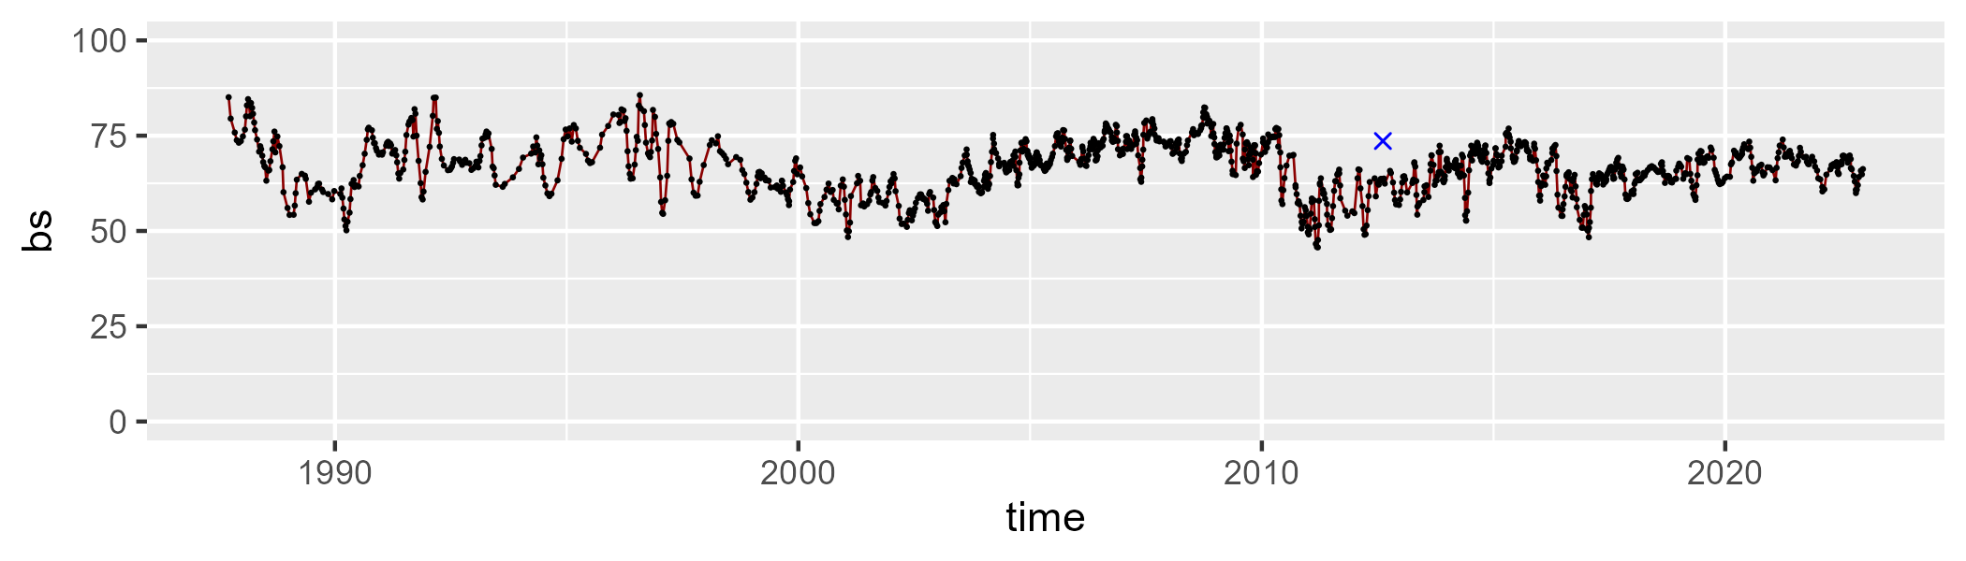

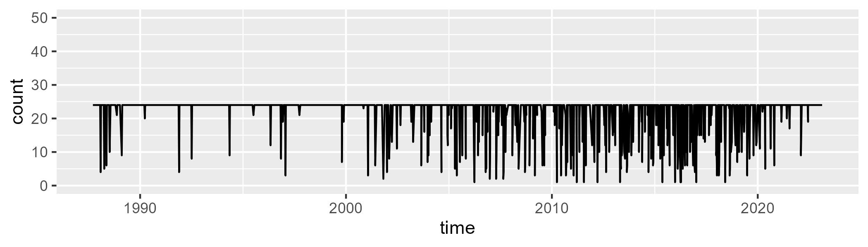

Min. : 1.00 1st Qu.:24.00 Median :24.00 Mean :21.85 3rd Qu.:24.00 Max. :24.00

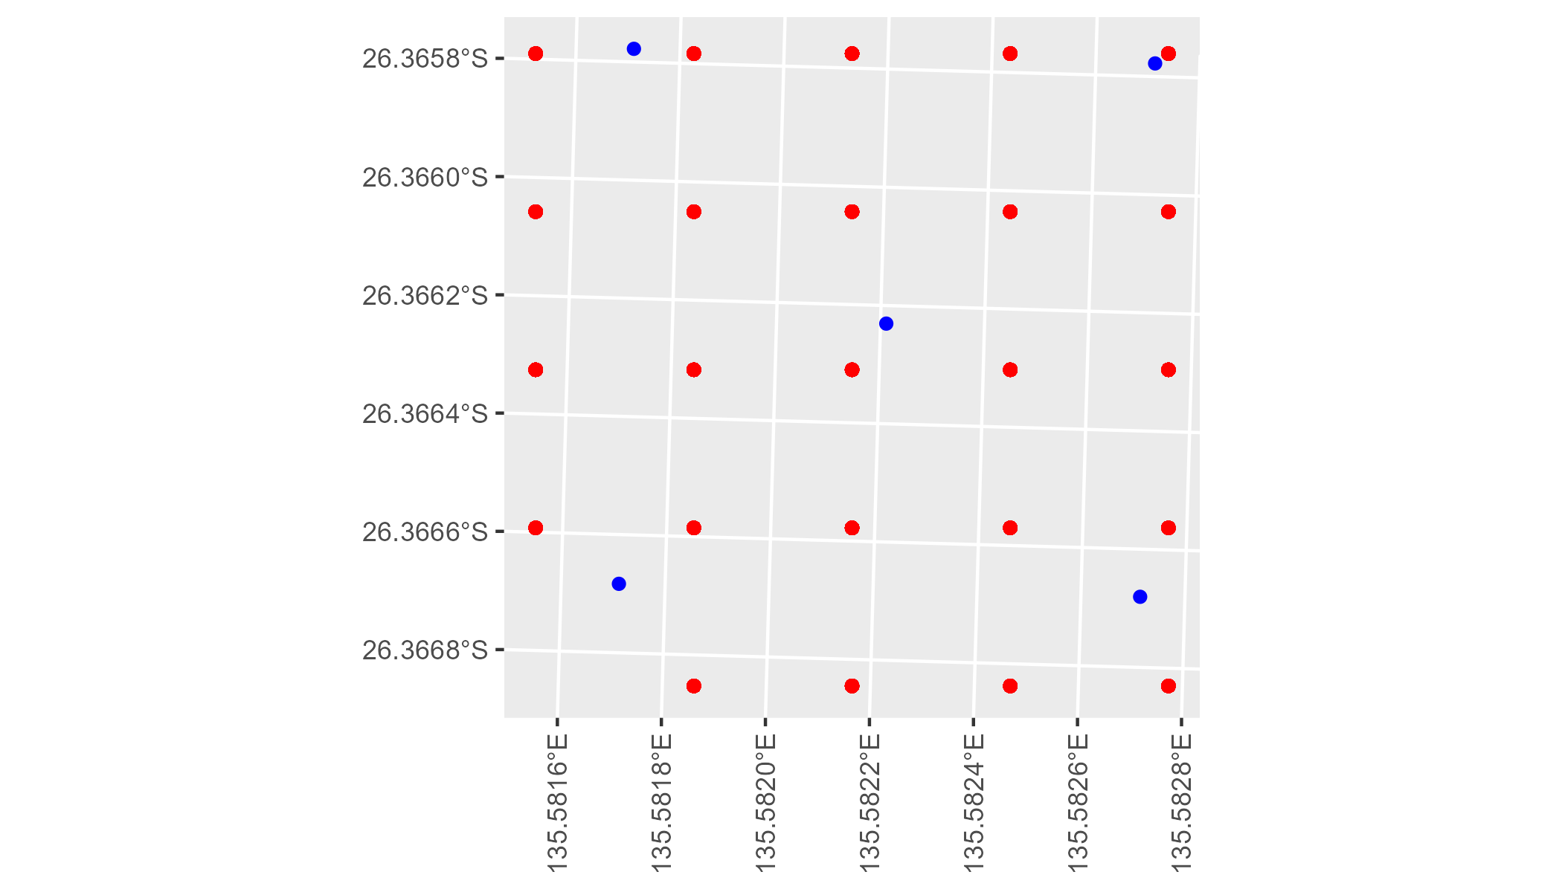

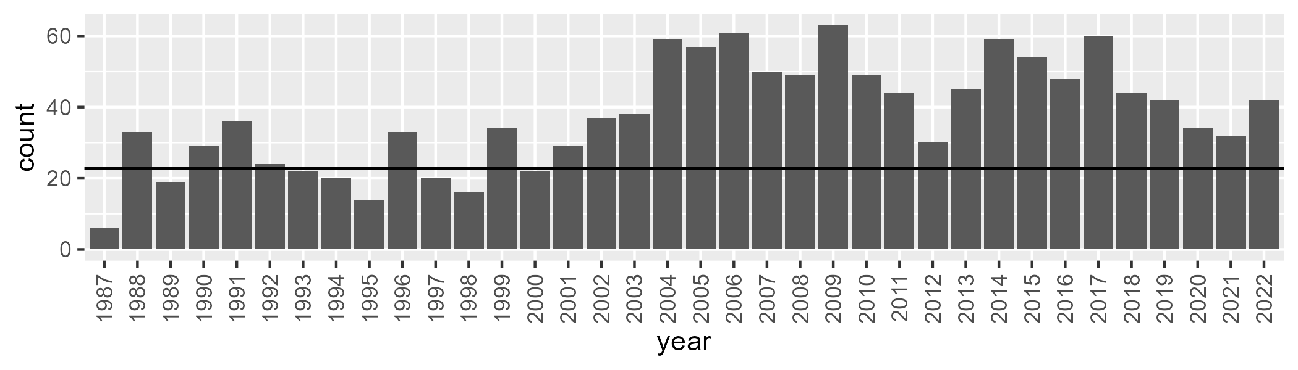

Number of samples: 1354

# SAASTP0011

| Min. | 1st Qu. | Median | Mean | 3rd Qu. | Max. |
| --- | --- | --- | --- | --- | --- |
| 0 | 0.1068044 | 0.926319 | 1.178633 | 1.589173 | 7.414616 |

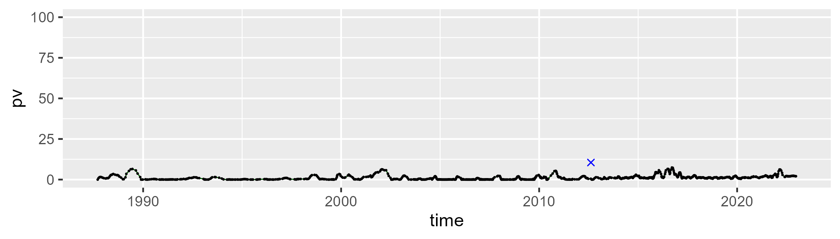

| Min. | 1st Qu. | Median | Mean | 3rd Qu. | Max. |
| --- | --- | --- | --- | --- | --- |
| 17.16668 | 33.88166 | 38.58844 | 38.78411 | 43.89368 | 60.89418 |

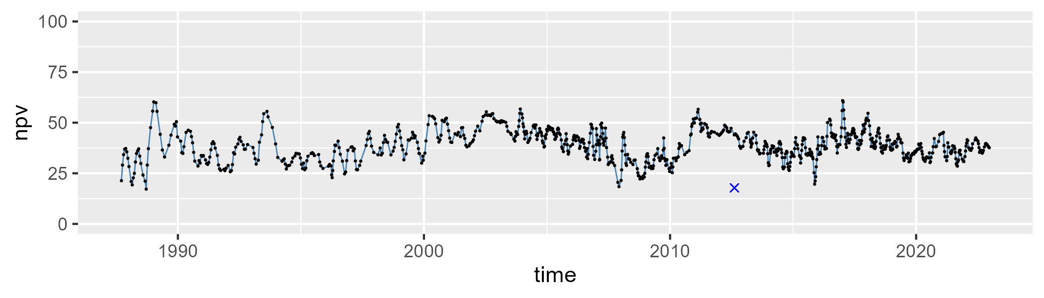

| Min. | 1st Qu. | Median | Mean | 3rd Qu. | Max. |
| --- | --- | --- | --- | --- | --- |
| 35.61808 | 53.94529 | 58.61198 | 58.7187 | 63.9531 | 78.53562 |

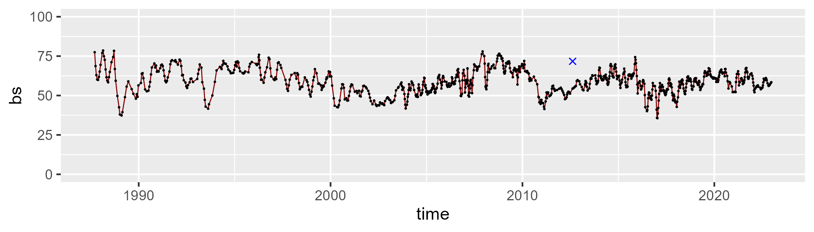

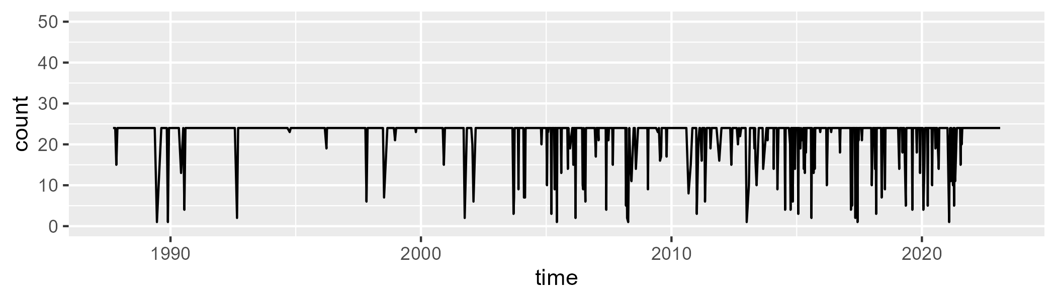

Min. : 1.00 1st Qu.:24.00 Median :24.00 Mean :22.38 3rd Qu.:24.00 Max. :24.00

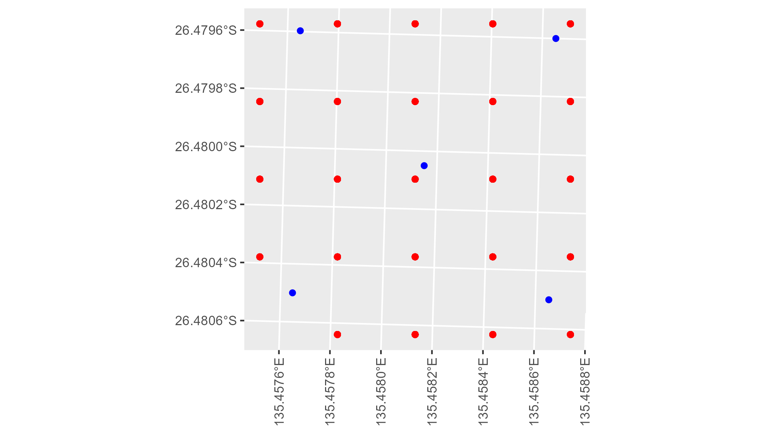

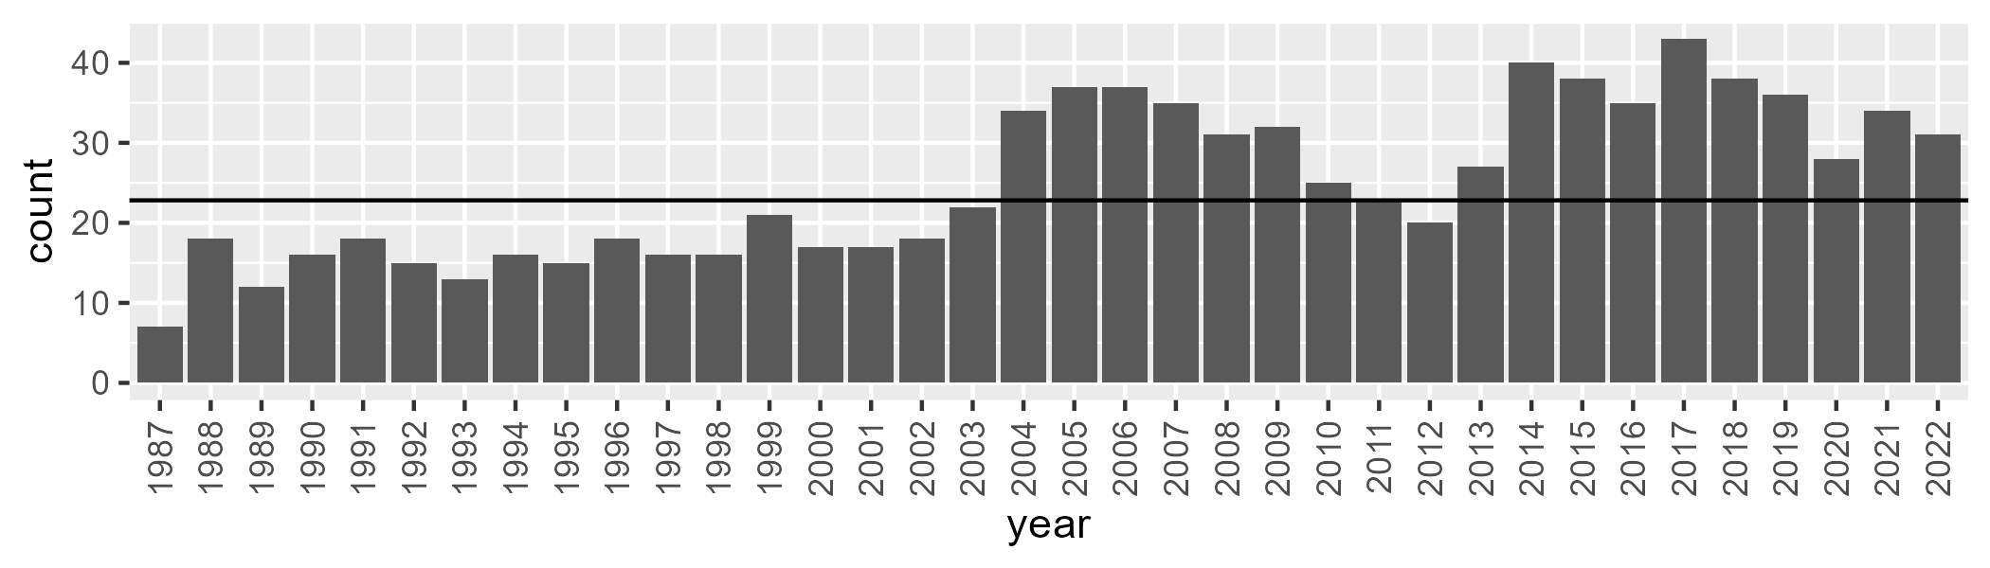

Number of samples: 899

# SAASTP0012

| Min. | 1st Qu. | Median | Mean | 3rd Qu. | Max. |
| --- | --- | --- | --- | --- | --- |
| 0 | 0.08559518 | 1.053201 | 2.488134 | 2.908524 | 21.81782 |

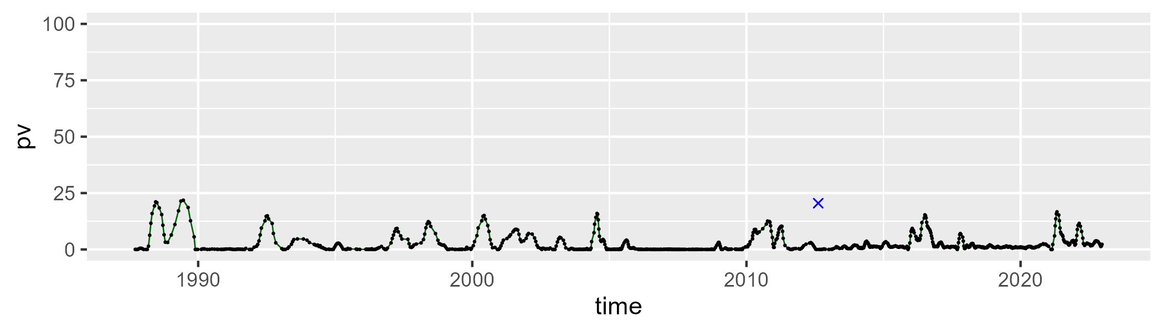

| Min. | 1st Qu. | Median | Mean | 3rd Qu. | Max. |
| --- | --- | --- | --- | --- | --- |
| 25.79311 | 39.51922 | 43.35134 | 43.30091 | 46.7686 | 60.46911 |

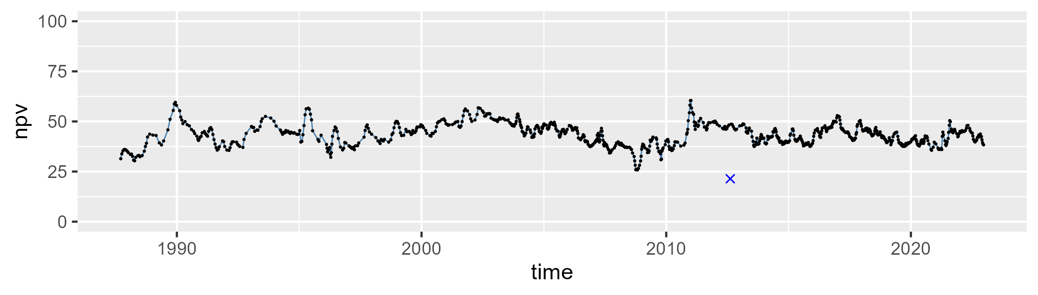

| Min. | 1st Qu. | Median | Mean | 3rd Qu. | Max. |
| --- | --- | --- | --- | --- | --- |
| 34.17171 | 49.31982 | 53.18193 | 53.00135 | 57.74858 | 73.52026 |

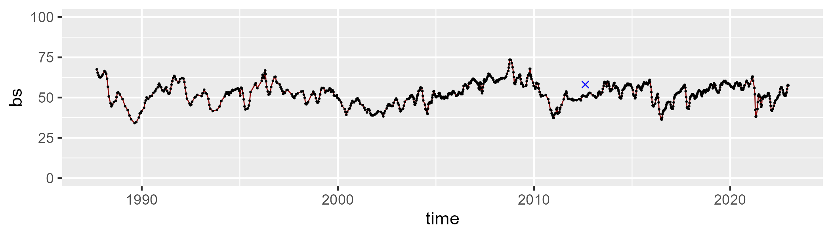

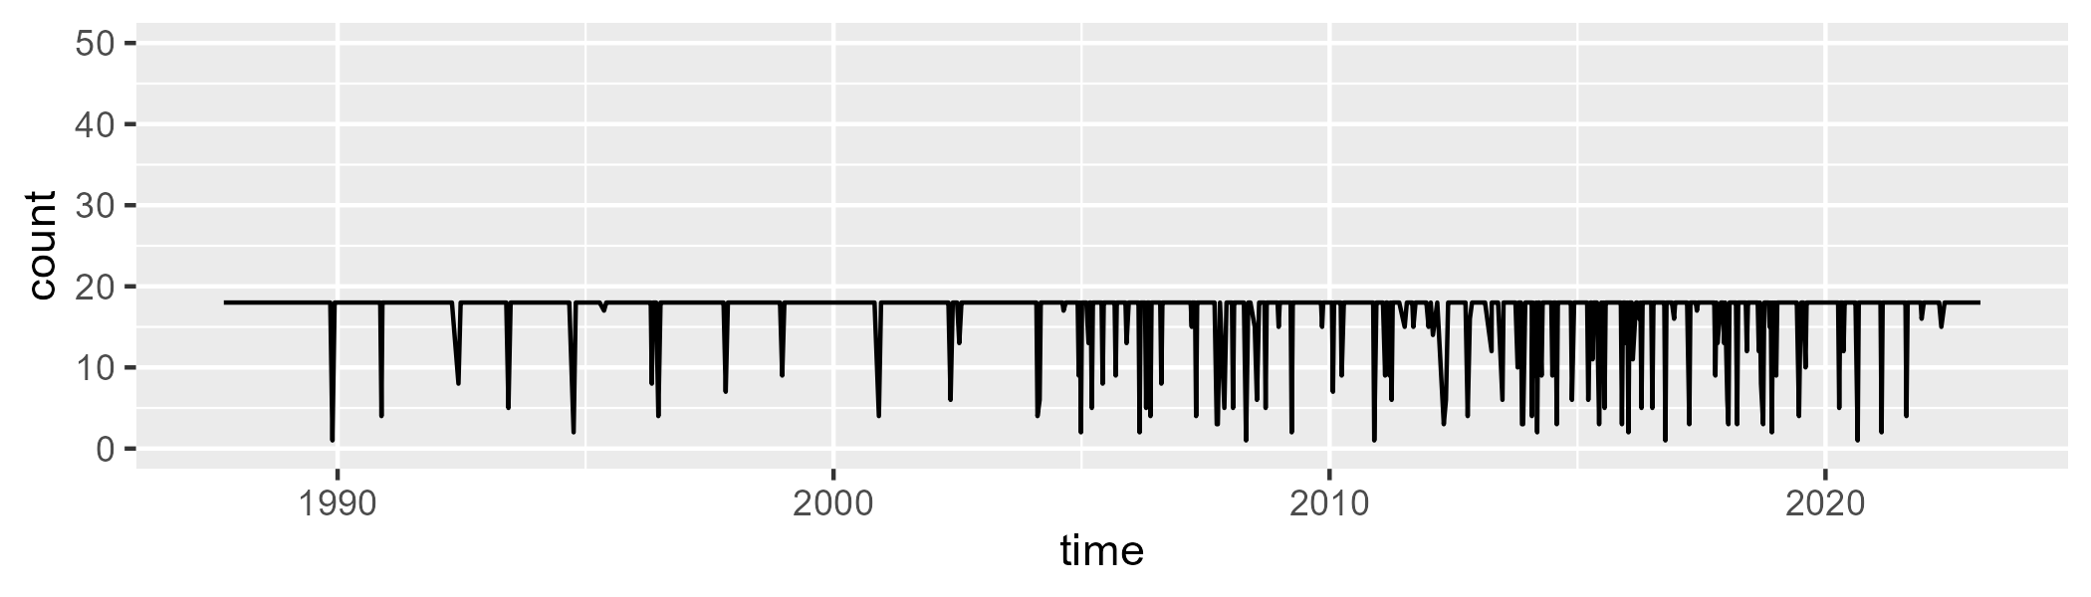

Min. : 1.00 1st Qu.:18.00 Median :18.00 Mean :16.79 3rd Qu.:18.00 Max. :18.00

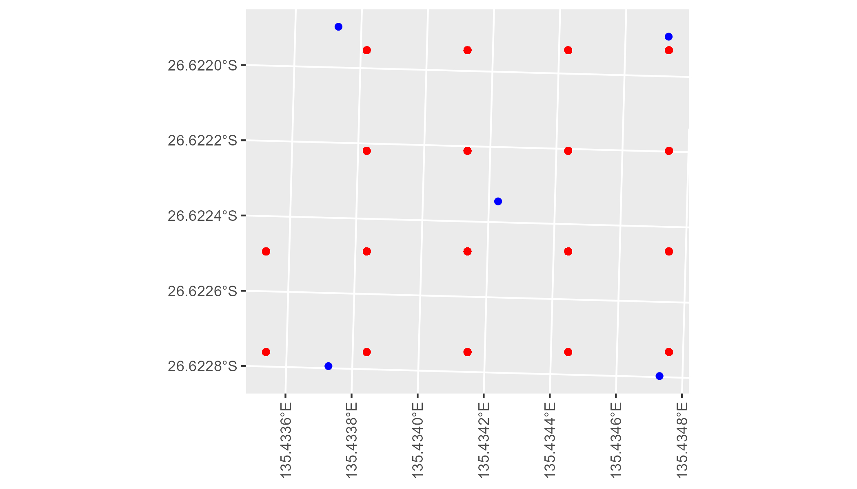

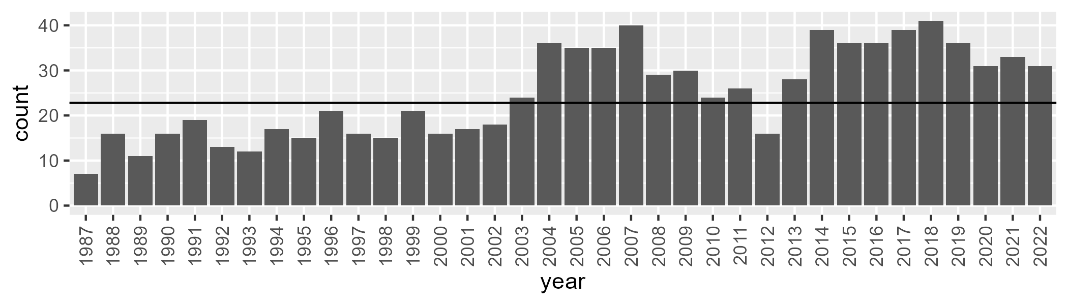

Number of samples: 895

# SAASTP0013

| Min. | 1st Qu. | Median | Mean | 3rd Qu. | Max. |
| --- | --- | --- | --- | --- | --- |
| 0 | 0.2256325 | 1.022639 | 1.7316 | 2.332248 | 14.03144 |

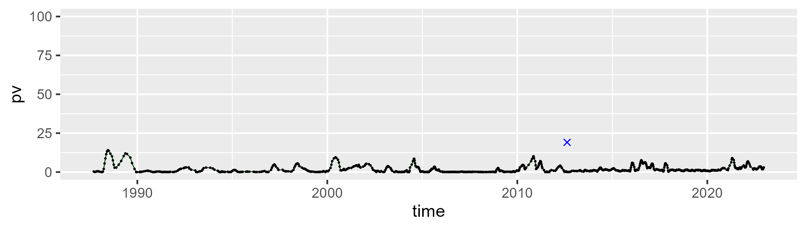

| Min. | 1st Qu. | Median | Mean | 3rd Qu. | Max. |
| --- | --- | --- | --- | --- | --- |
| 22.41771 | 34.07013 | 37.70282 | 38.1449 | 42.28952 | 56.56796 |

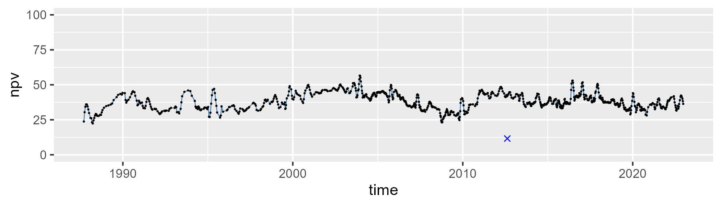

| Min. | 1st Qu. | Median | Mean | 3rd Qu. | Max. |
| --- | --- | --- | --- | --- | --- |
| 40.34818 | 54.28274 | 59.14674 | 58.81631 | 63.47424 | 75.73911 |

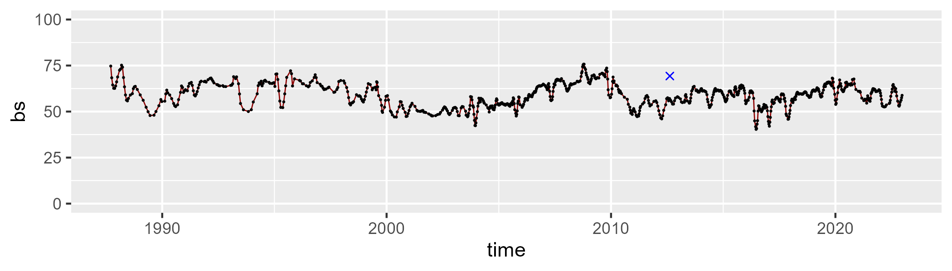

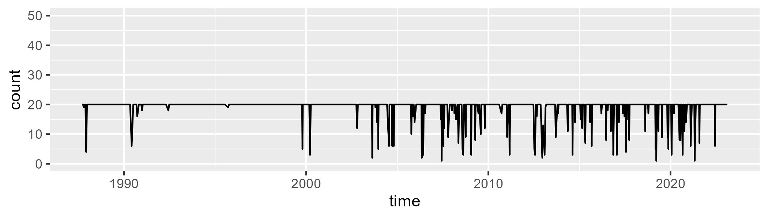

Min. : 1.00 1st Qu.:20.00 Median :20.00 Mean :18.93 3rd Qu.:20.00 Max. :20.00

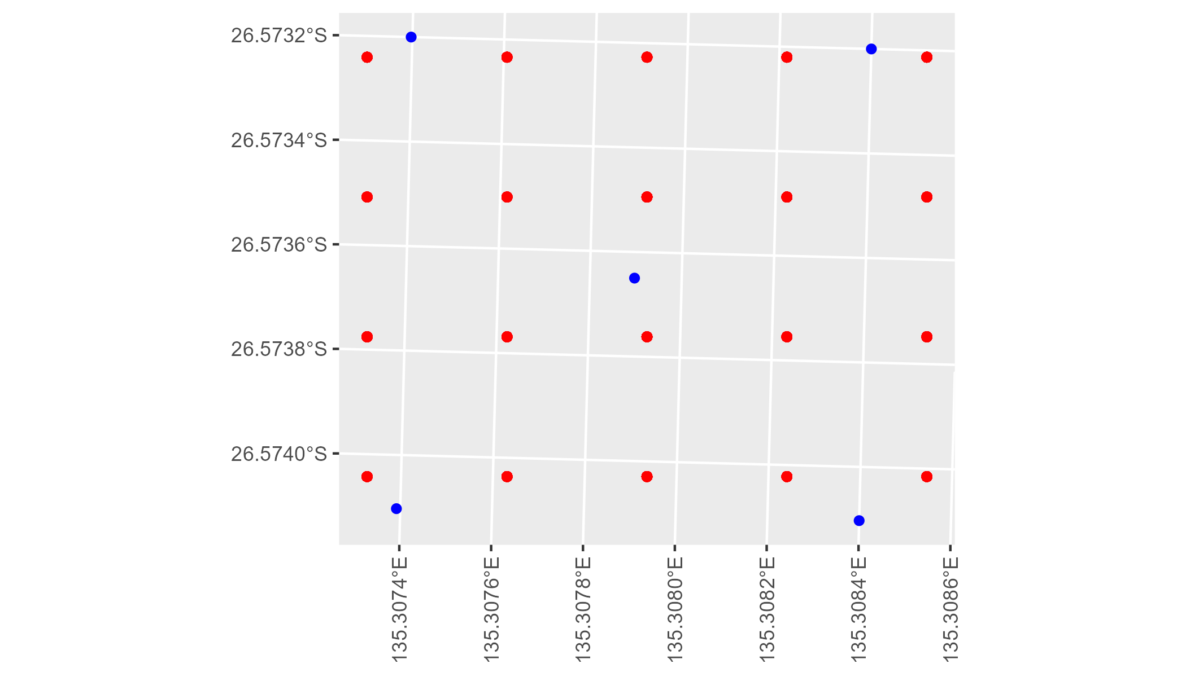

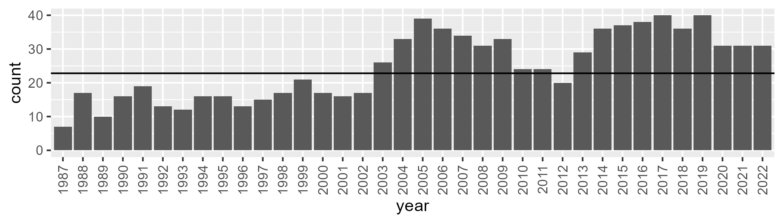

Number of samples: 891

# SAASTP0014

| Min. | 1st Qu. | Median | Mean | 3rd Qu. | Max. |
| --- | --- | --- | --- | --- | --- |
| 0 | 1.11782 | 1.927703 | 2.854 | 3.628591 | 16.72183 |

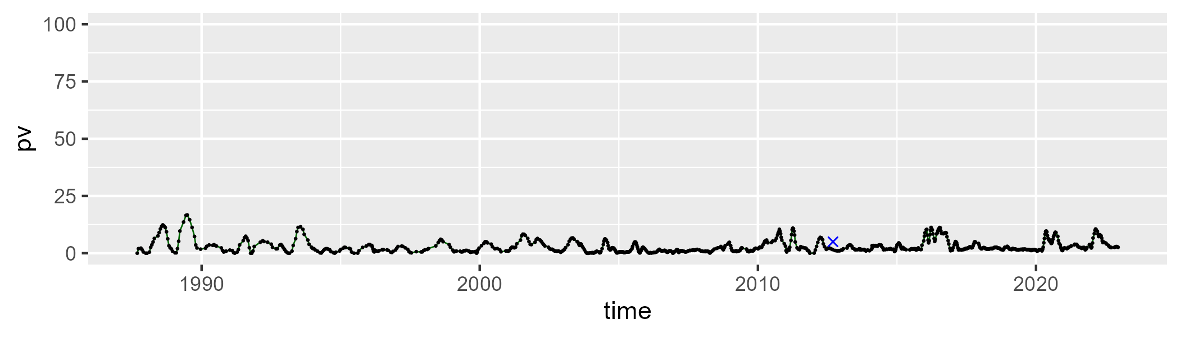

| Min. | 1st Qu. | Median | Mean | 3rd Qu. | Max. |
| --- | --- | --- | --- | --- | --- |
| 18.36581 | 26.39745 | 28.66308 | 28.91197 | 30.75915 | 54.23066 |

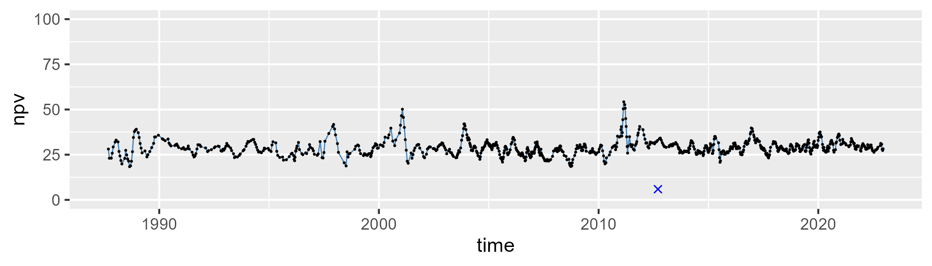

| Min. | 1st Qu. | Median | Mean | 3rd Qu. | Max. |
| --- | --- | --- | --- | --- | --- |
| 39.32394 | 64.24325 | 67.42601 | 66.76794 | 69.87172 | 78.18184 |

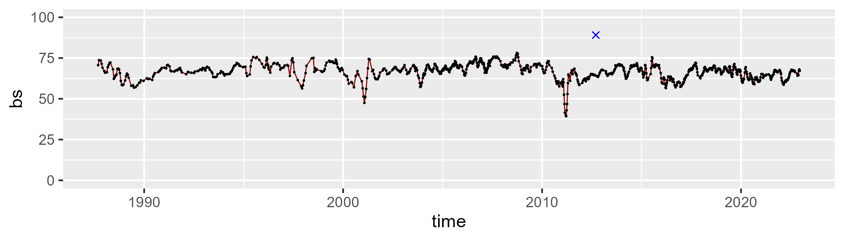

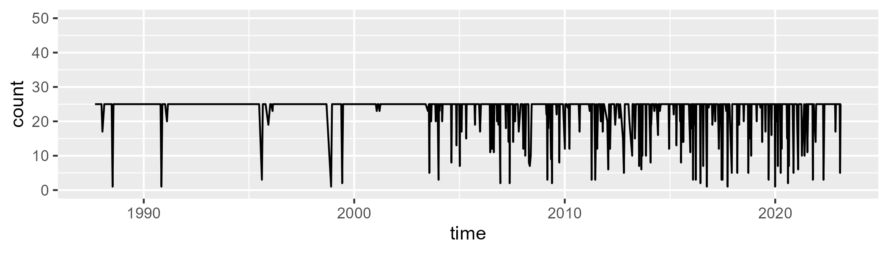

Min. : 1.00 1st Qu.:25.00 Median :25.00 Mean :23.19 3rd Qu.:25.00 Max. :25.00

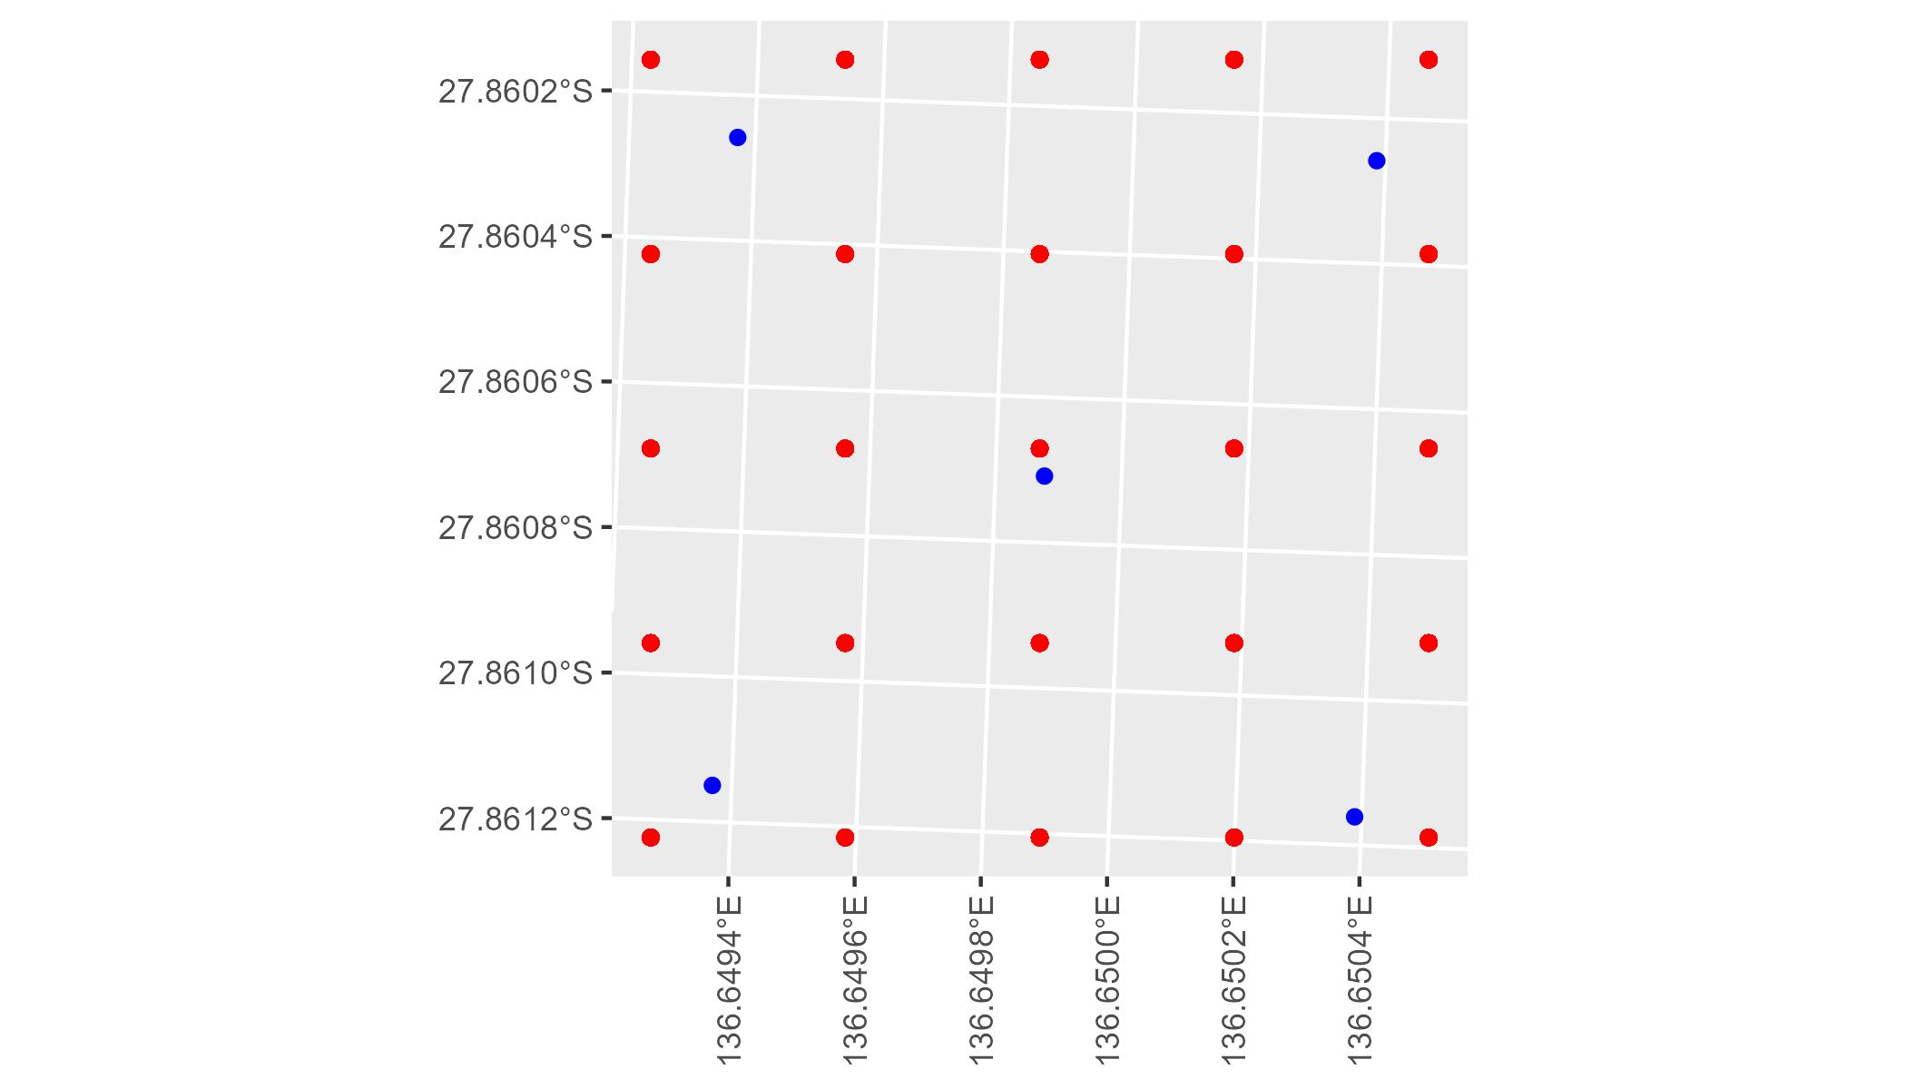

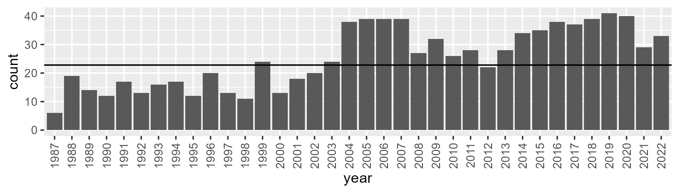

Number of samples: 913

# SAASTP0015

| Min. | 1st Qu. | Median | Mean | 3rd Qu. | Max. |
| --- | --- | --- | --- | --- | --- |
| 0 | 0.7863647 | 1.599953 | 2.614924 | 3.336564 | 15.87071 |

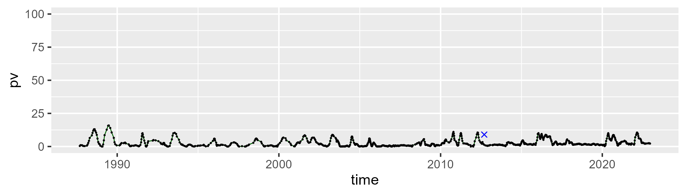

| Min. | 1st Qu. | Median | Mean | 3rd Qu. | Max. |
| --- | --- | --- | --- | --- | --- |
| 17.11975 | 26.04971 | 28.57916 | 28.99089 | 31.3432 | 50.59821 |

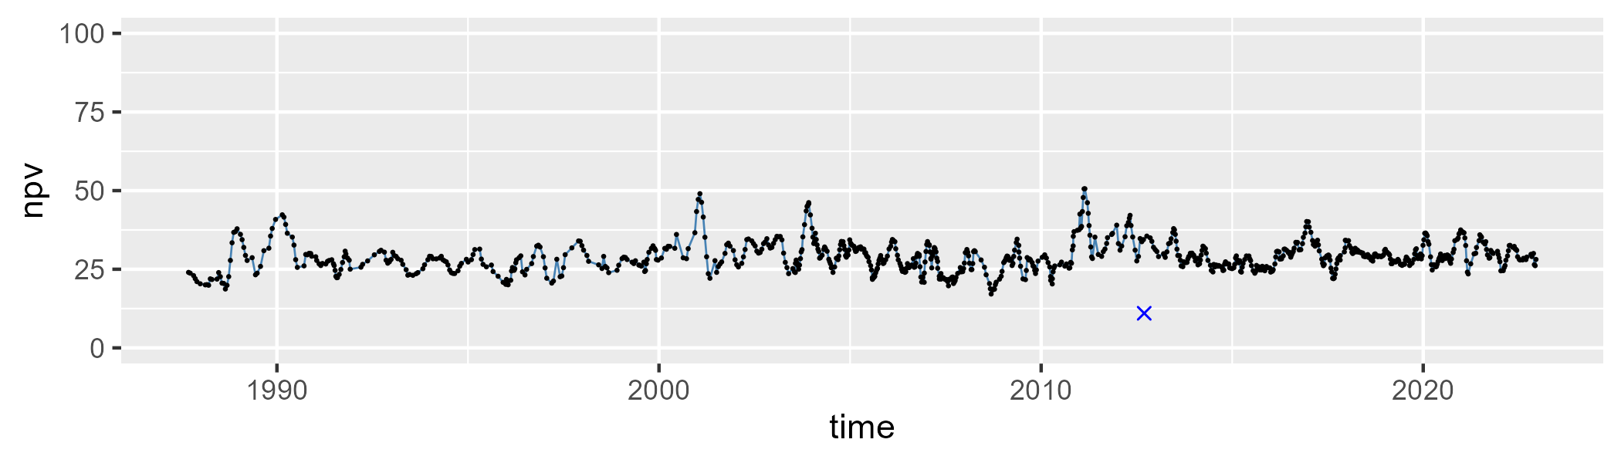

| Min. | 1st Qu. | Median | Mean | 3rd Qu. | Max. |
| --- | --- | --- | --- | --- | --- |
| 42.95698 | 64.26106 | 67.65663 | 66.98477 | 70.10454 | 79.05642 |

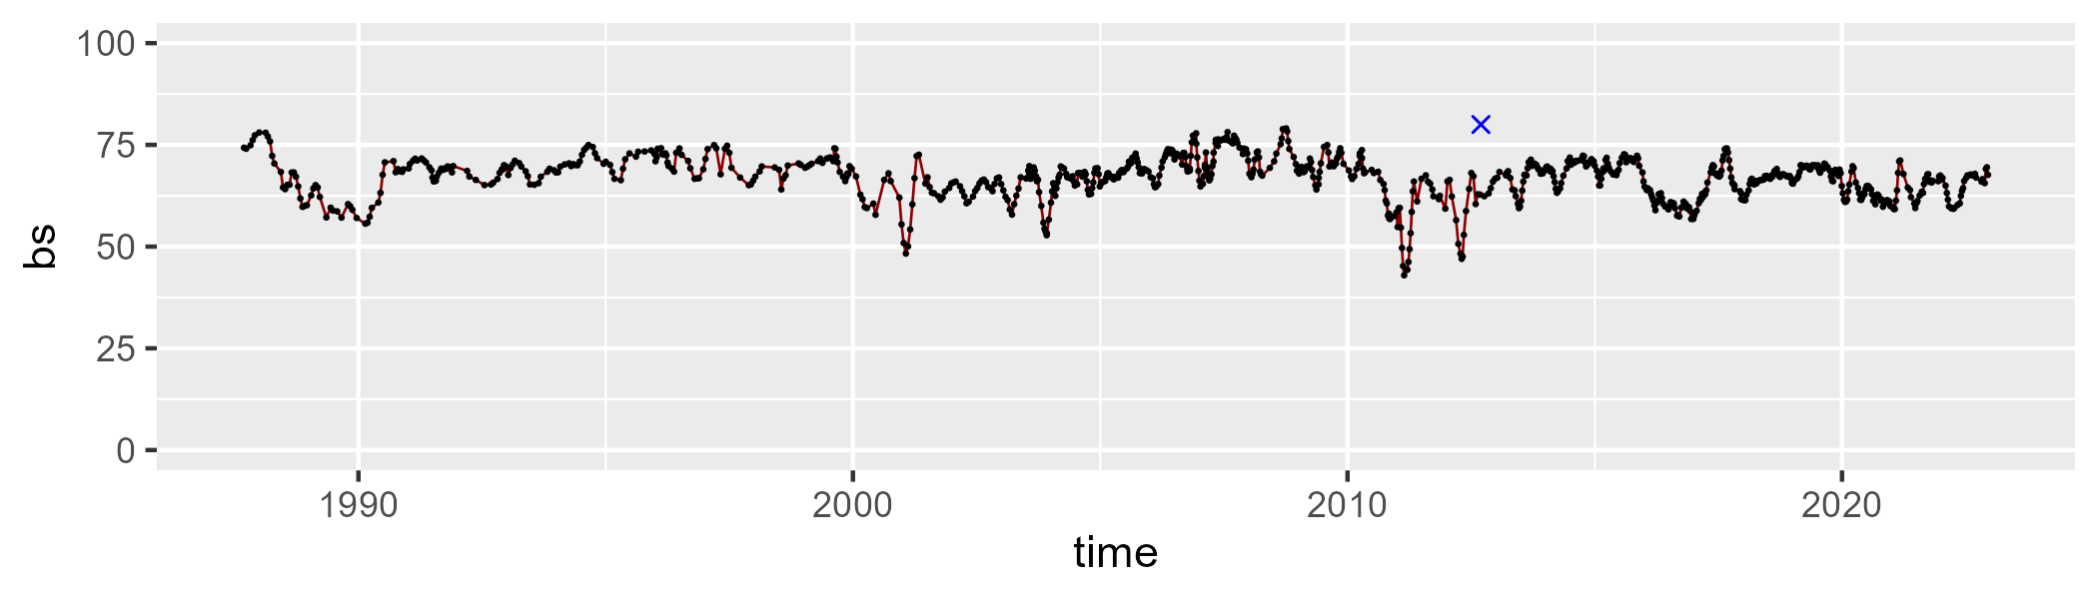

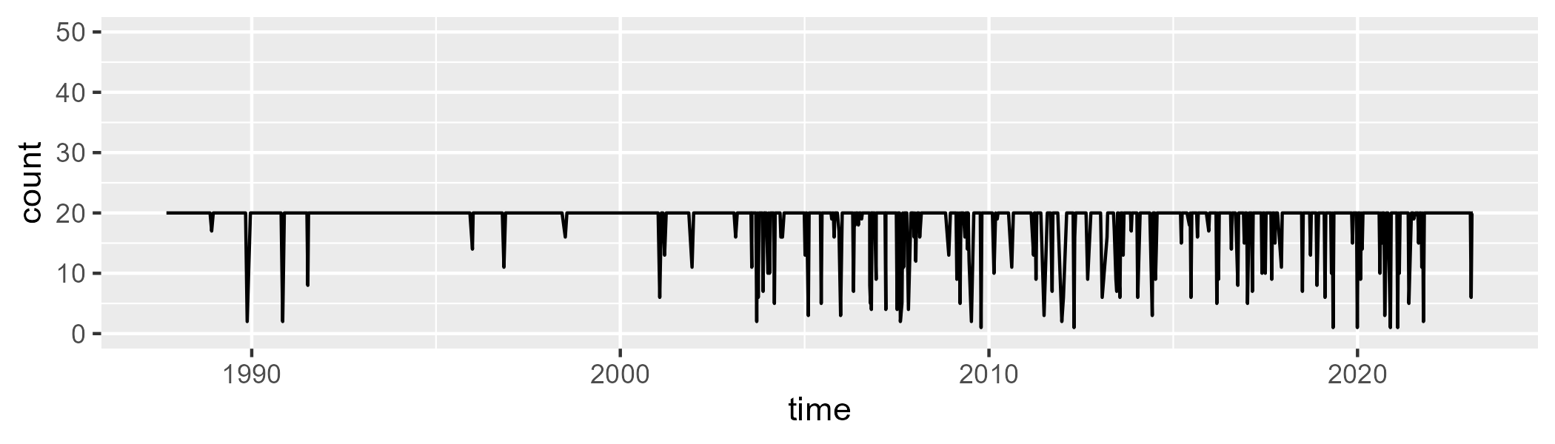

Min. : 1.00 1st Qu.:20.00 Median :20.00 Mean :18.69 3rd Qu.:20.00 Max. :20.00

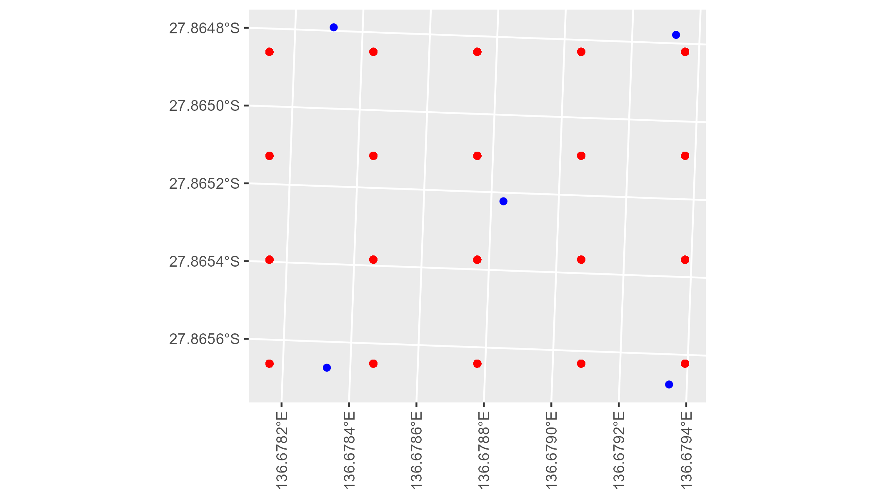

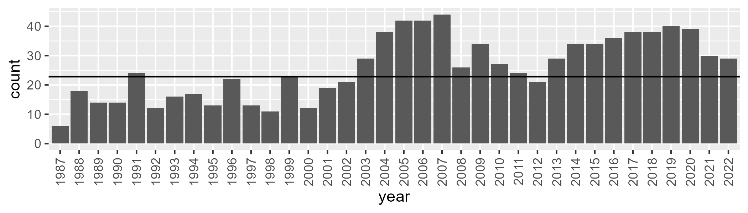

Number of samples: 929

# SAASTP0016

| Min. | 1st Qu. | Median | Mean | 3rd Qu. | Max. |
| --- | --- | --- | --- | --- | --- |
| 0 | 1.897638 | 4.585976 | 7.67282 | 11.22909 | 34.99597 |

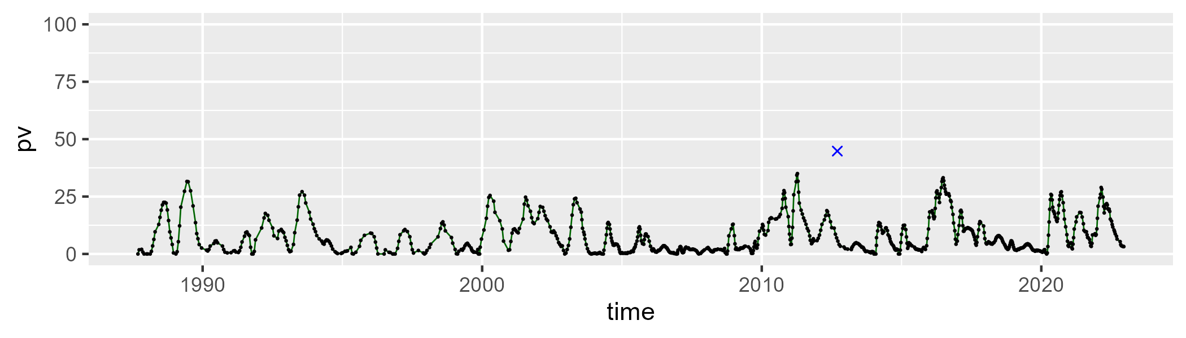

| Min. | 1st Qu. | Median | Mean | 3rd Qu. | Max. |
| --- | --- | --- | --- | --- | --- |
| 17.45623 | 39.24211 | 44.9511 | 44.17984 | 49.14847 | 65.89967 |

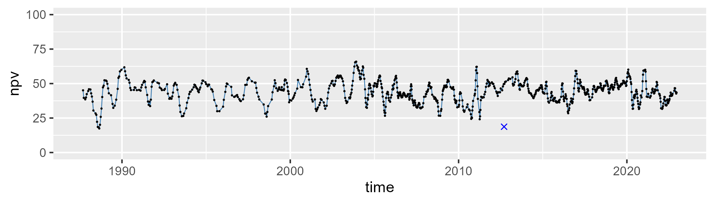

| Min. | 1st Qu. | Median | Mean | 3rd Qu. | Max. |
| --- | --- | --- | --- | --- | --- |
| 27.86724 | 41.77944 | 46.75023 | 46.88849 | 51.13863 | 67.24497 |

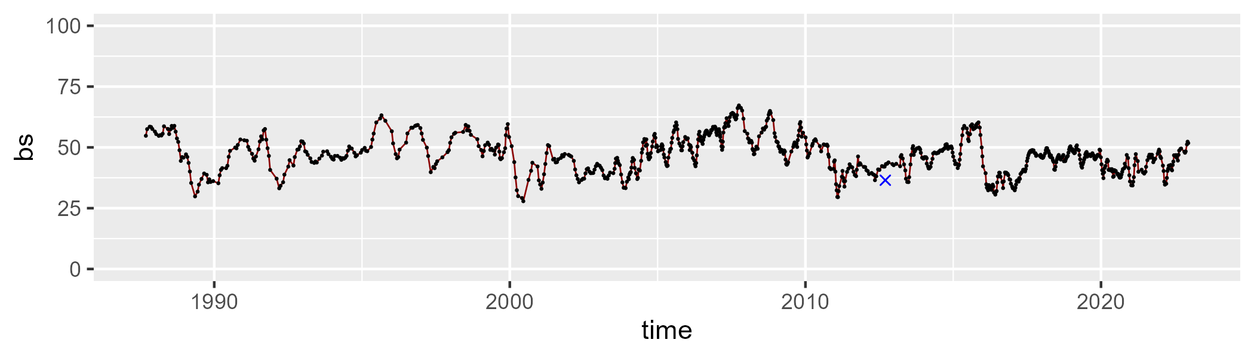

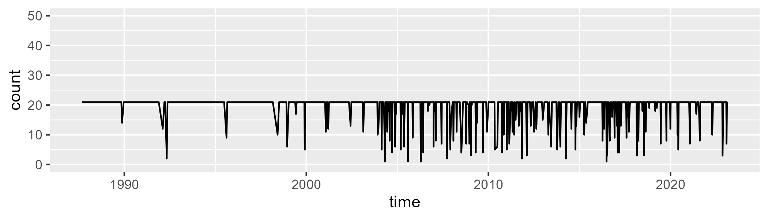

Min. : 1.00 1st Qu.:21.00 Median :21.00 Mean :19.52 3rd Qu.:21.00 Max. :21.00

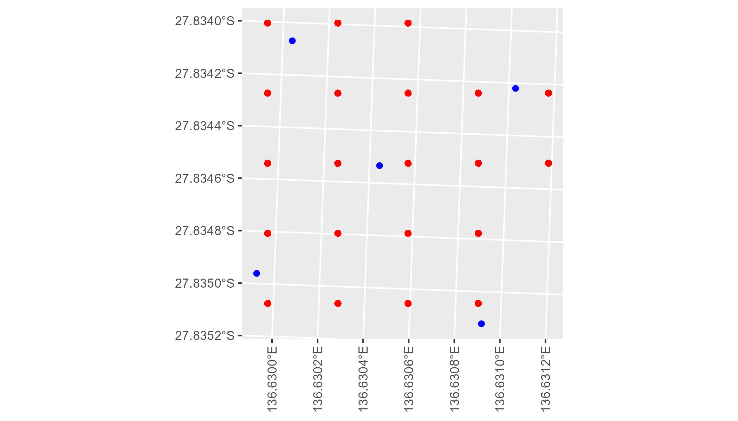

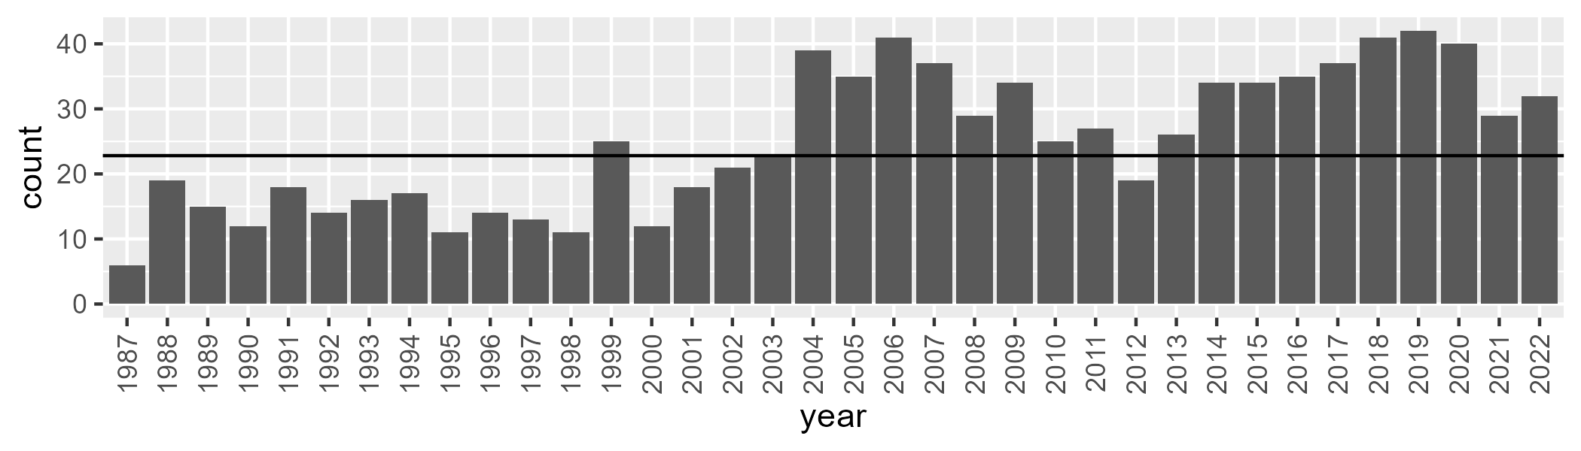

Number of samples: 901

# SAASTP0017

| Min. | 1st Qu. | Median | Mean | 3rd Qu. | Max. |
| --- | --- | --- | --- | --- | --- |
| 0 | 6.435596 | 11.46902 | 13.88042 | 19.41419 | 41.95548 |

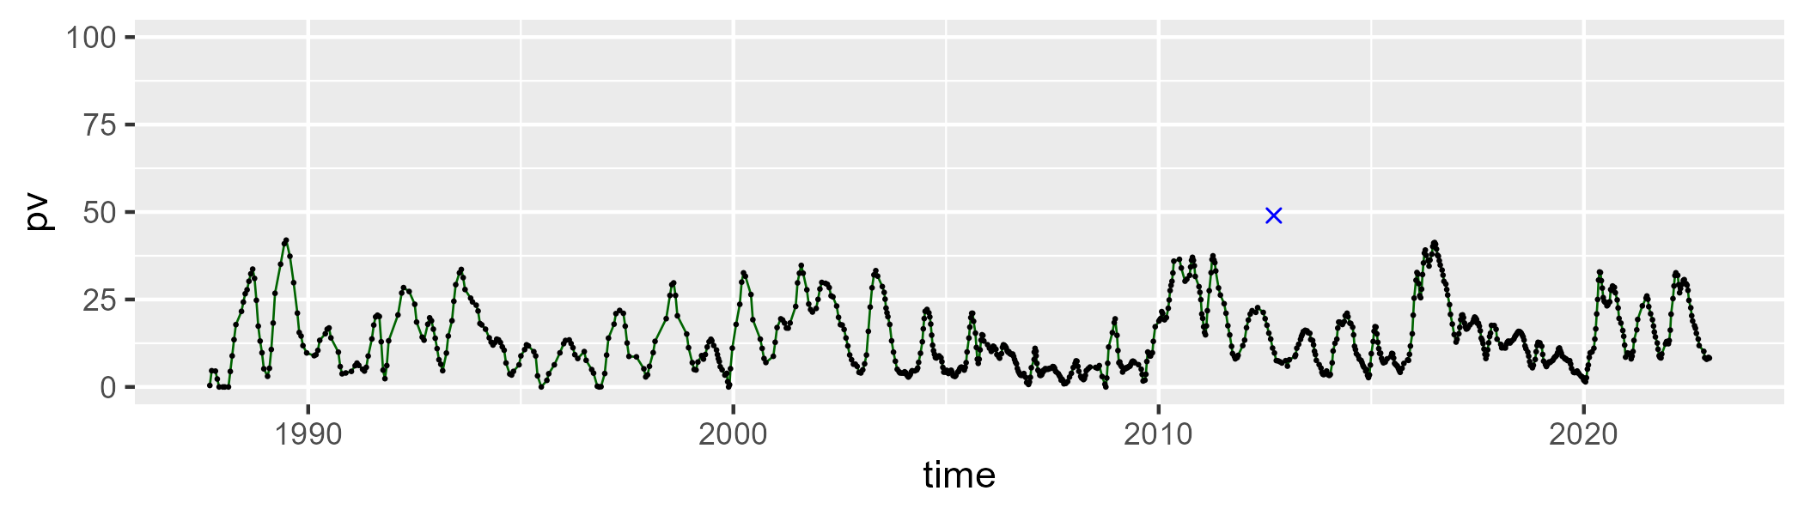

| Min. | 1st Qu. | Median | Mean | 3rd Qu. | Max. |
| --- | --- | --- | --- | --- | --- |
| 24.1281 | 42.83119 | 49.05819 | 48.66542 | 54.77477 | 68.90979 |

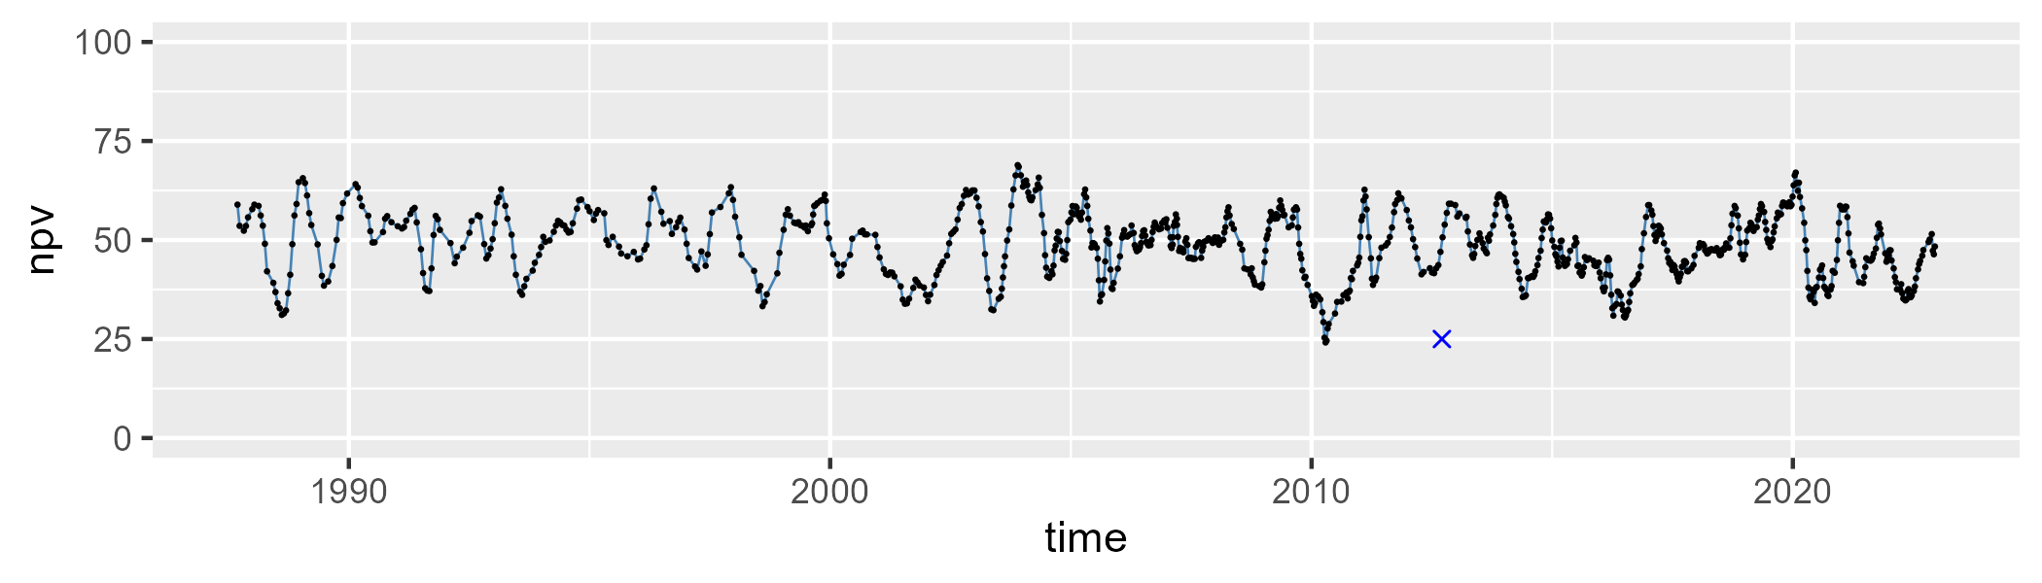

| Min. | 1st Qu. | Median | Mean | 3rd Qu. | Max. |
| --- | --- | --- | --- | --- | --- |
| 14.75635 | 31.60867 | 36.47665 | 36.13584 | 39.86048 | 56.88217 |

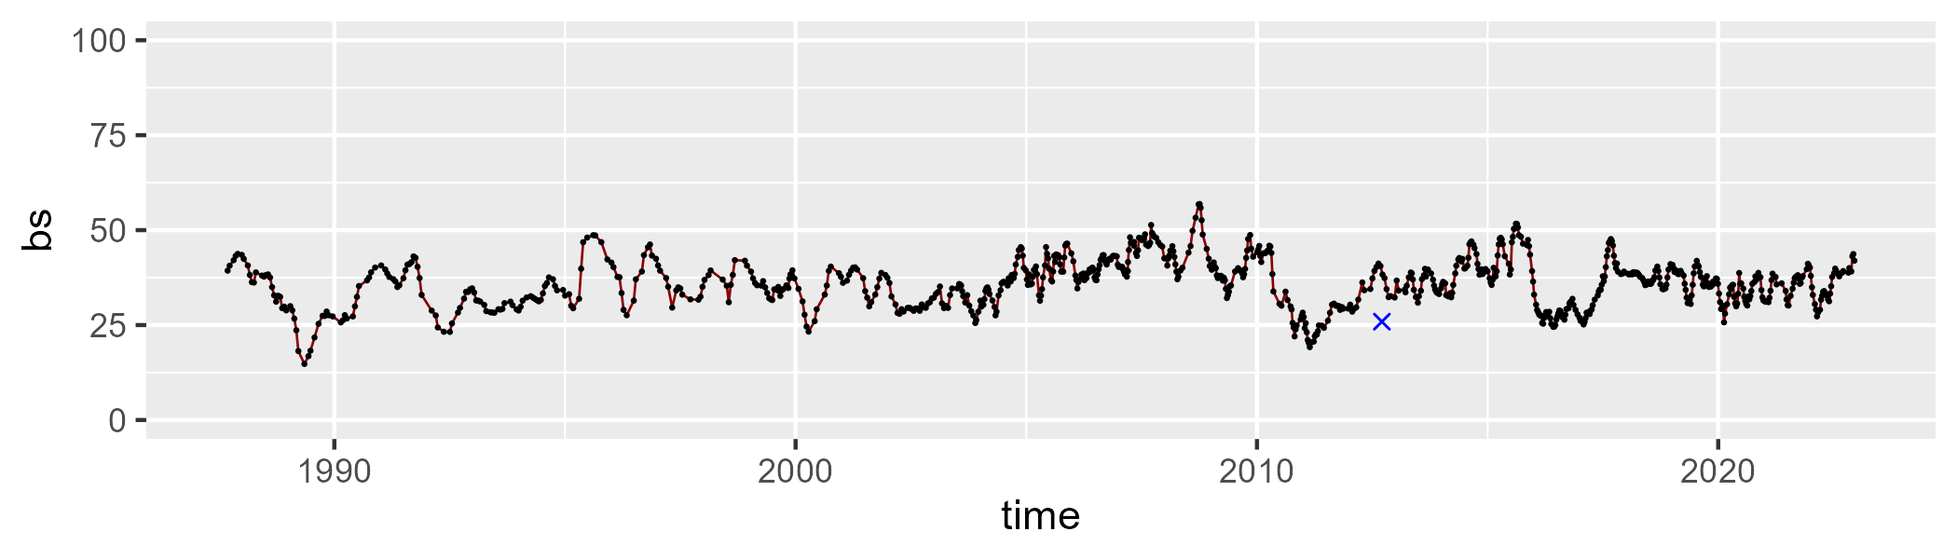

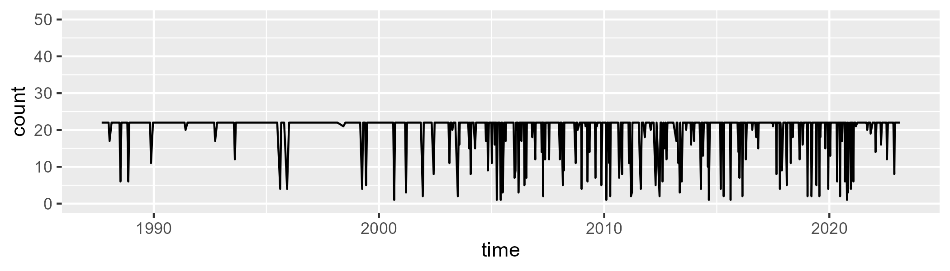

Min. : 1.00 1st Qu.:22.00 Median :22.00 Mean :20.24 3rd Qu.:22.00 Max. :22.00

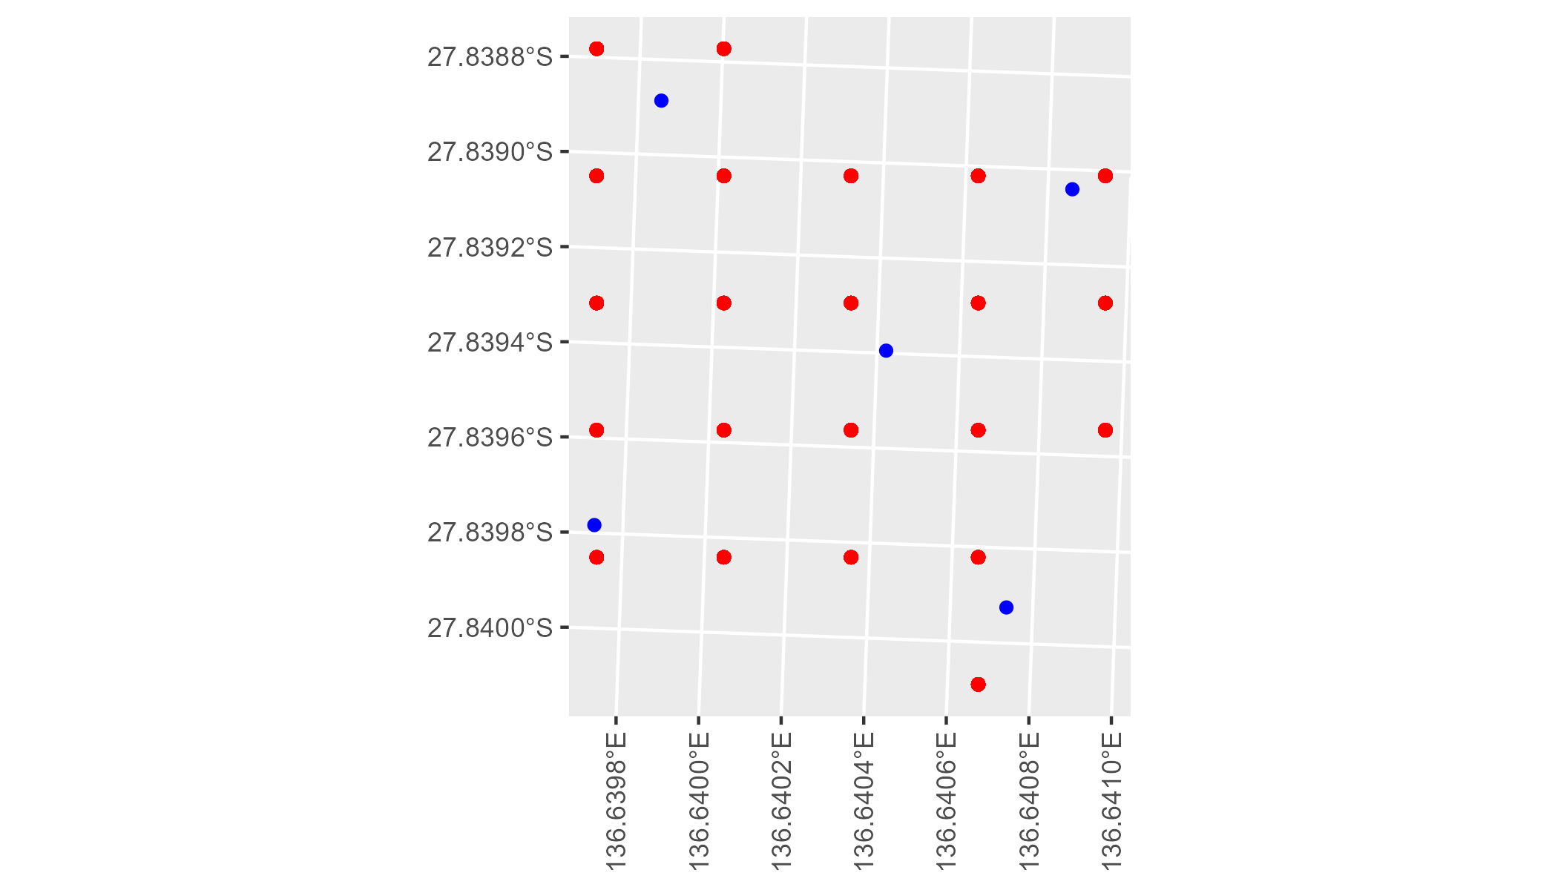

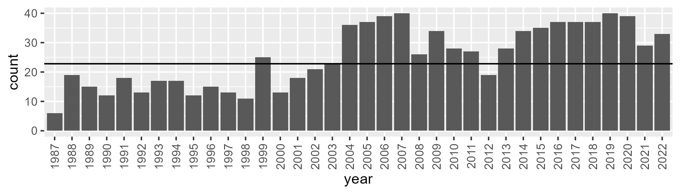

Number of samples: 903

# SAASTP0018

| Min. | 1st Qu. | Median | Mean | 3rd Qu. | Max. |
| --- | --- | --- | --- | --- | --- |
| 0 | 0.08279484 | 1.060463 | 2.764452 | 3.077808 | 29.47966 |

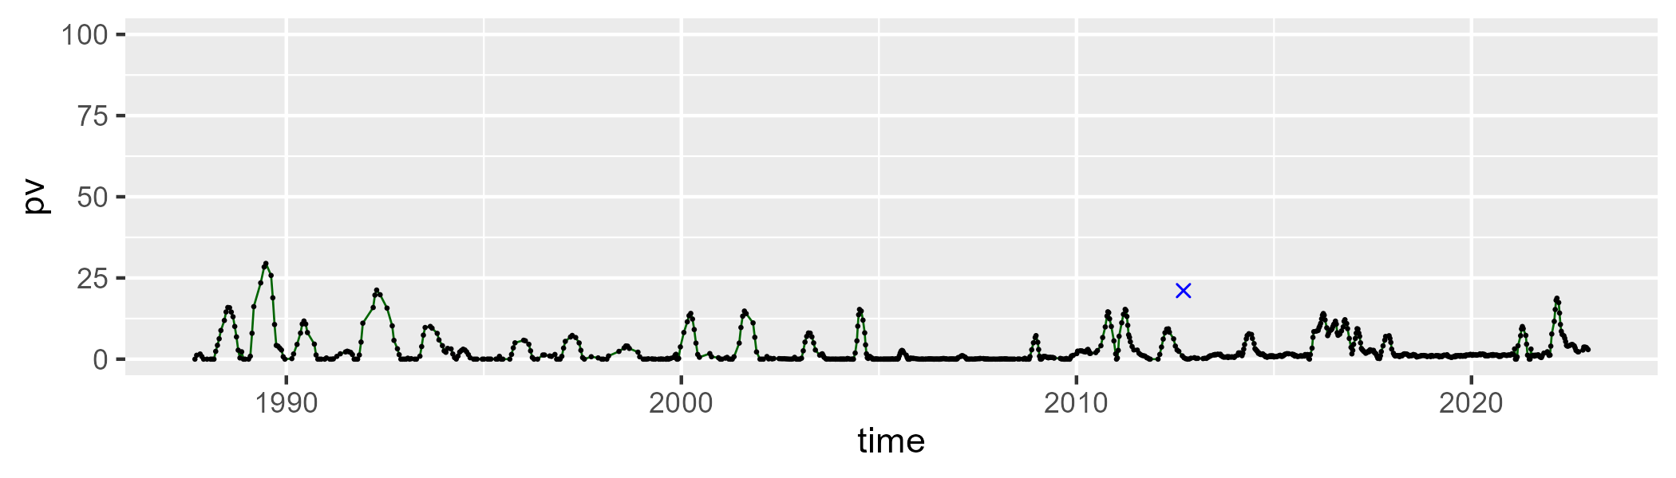

| Min. | 1st Qu. | Median | Mean | 3rd Qu. | Max. |
| --- | --- | --- | --- | --- | --- |
| 21.41501 | 32.22877 | 35.90755 | 36.6465 | 40.69353 | 58.43384 |

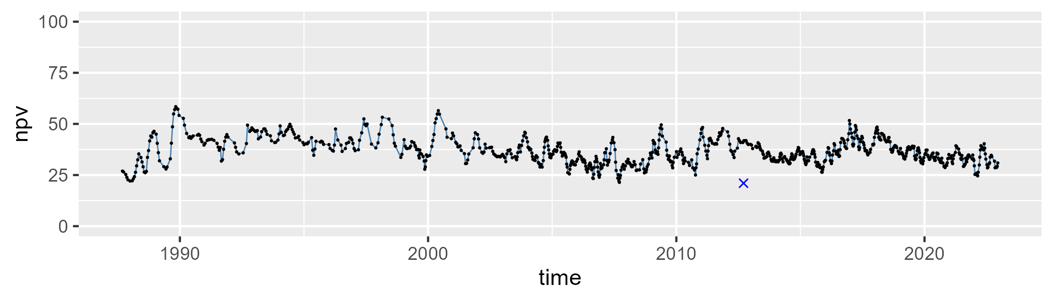

| Min. | 1st Qu. | Median | Mean | 3rd Qu. | Max. |
| --- | --- | --- | --- | --- | --- |
| 35.67877 | 54.28341 | 60.48815 | 59.49395 | 64.64732 | 78.76473 |

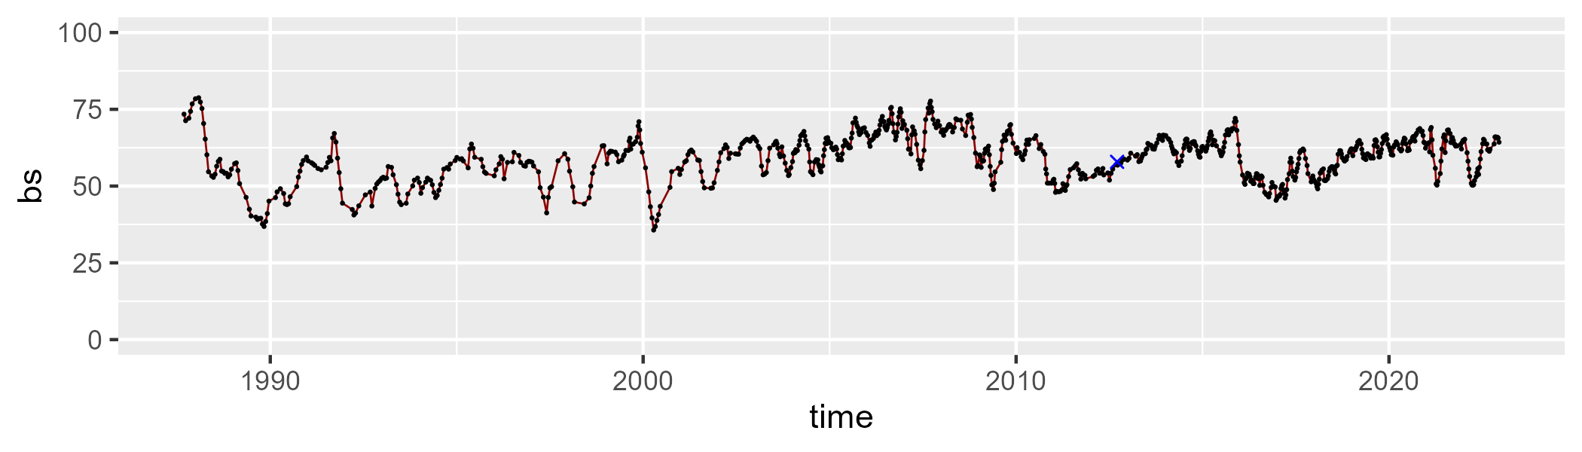

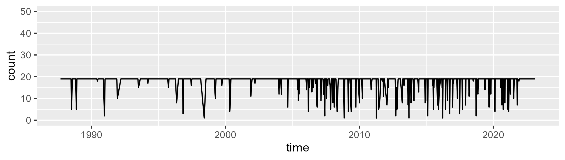

Min. : 1.00 1st Qu.:19.00 Median :19.00 Mean :17.79 3rd Qu.:19.00 Max. :19.00

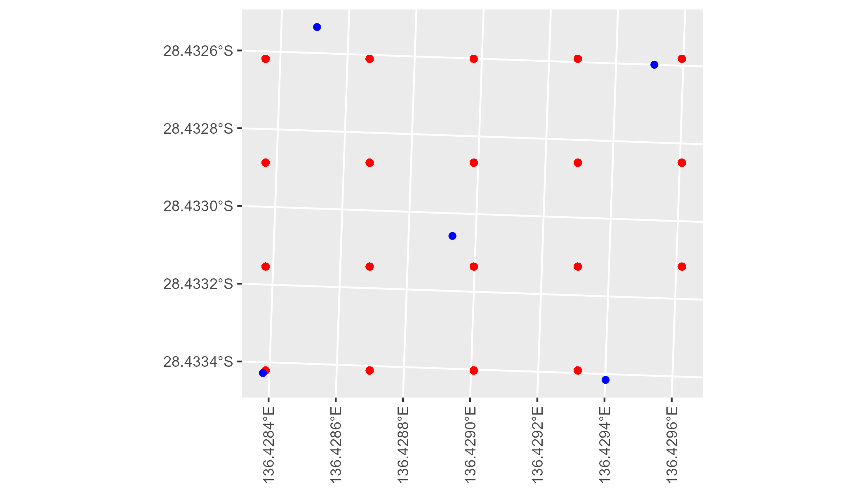

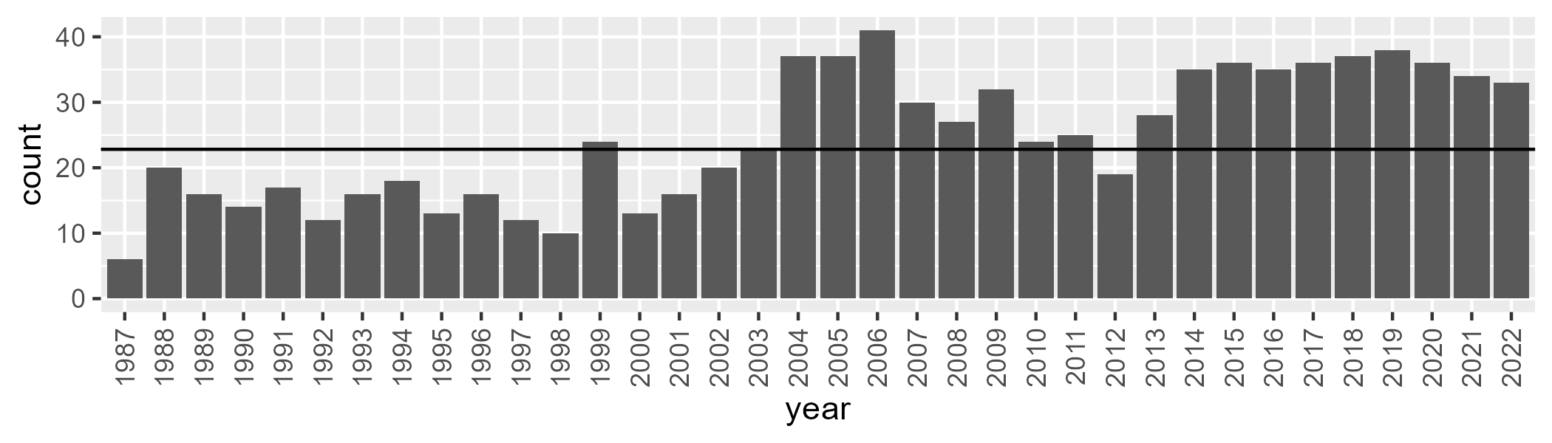

Number of samples: 886

# SAASTP0019

| Min. | 1st Qu. | Median | Mean | 3rd Qu. | Max. |
| --- | --- | --- | --- | --- | --- |
| 0 | 0.05207993 | 0.9557384 | 1.619613 | 1.822482 | 20.29929 |

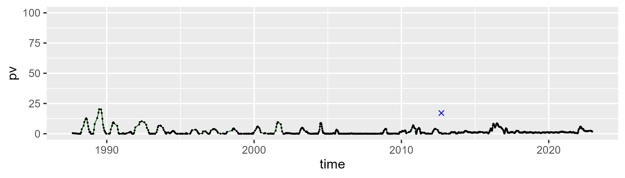

| Min. | 1st Qu. | Median | Mean | 3rd Qu. | Max. |
| --- | --- | --- | --- | --- | --- |
| 15.29058 | 32.34038 | 35.69208 | 35.89335 | 38.95273 | 54.82722 |

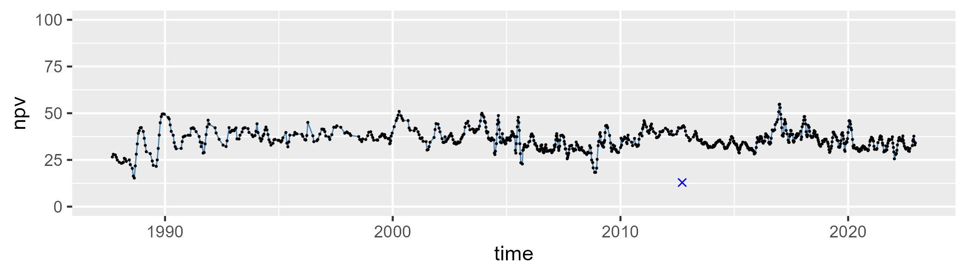

| Min. | 1st Qu. | Median | Mean | 3rd Qu. | Max. |
| --- | --- | --- | --- | --- | --- |
| 42.00208 | 57.91448 | 61.65249 | 61.39966 | 65.39884 | 77.35602 |

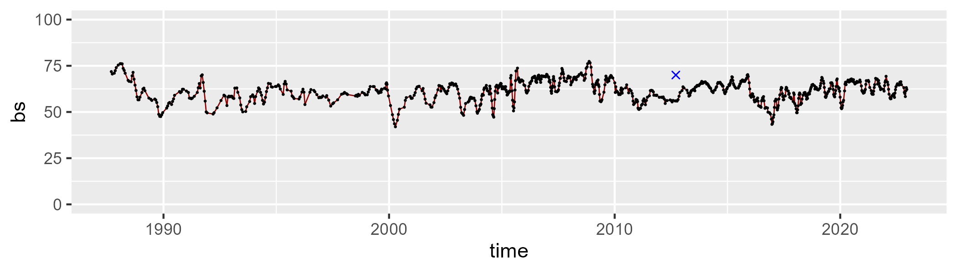

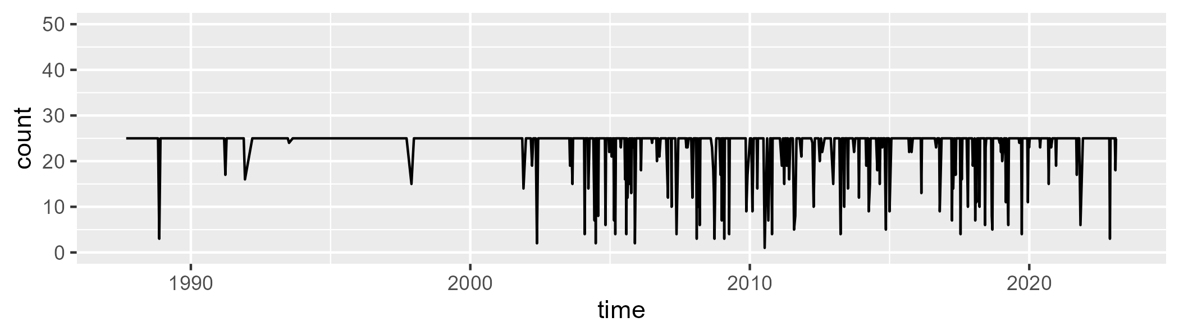

Min. : 1.00 1st Qu.:25.00 Median :25.00 Mean :23.46 3rd Qu.:25.00 Max. :25.00

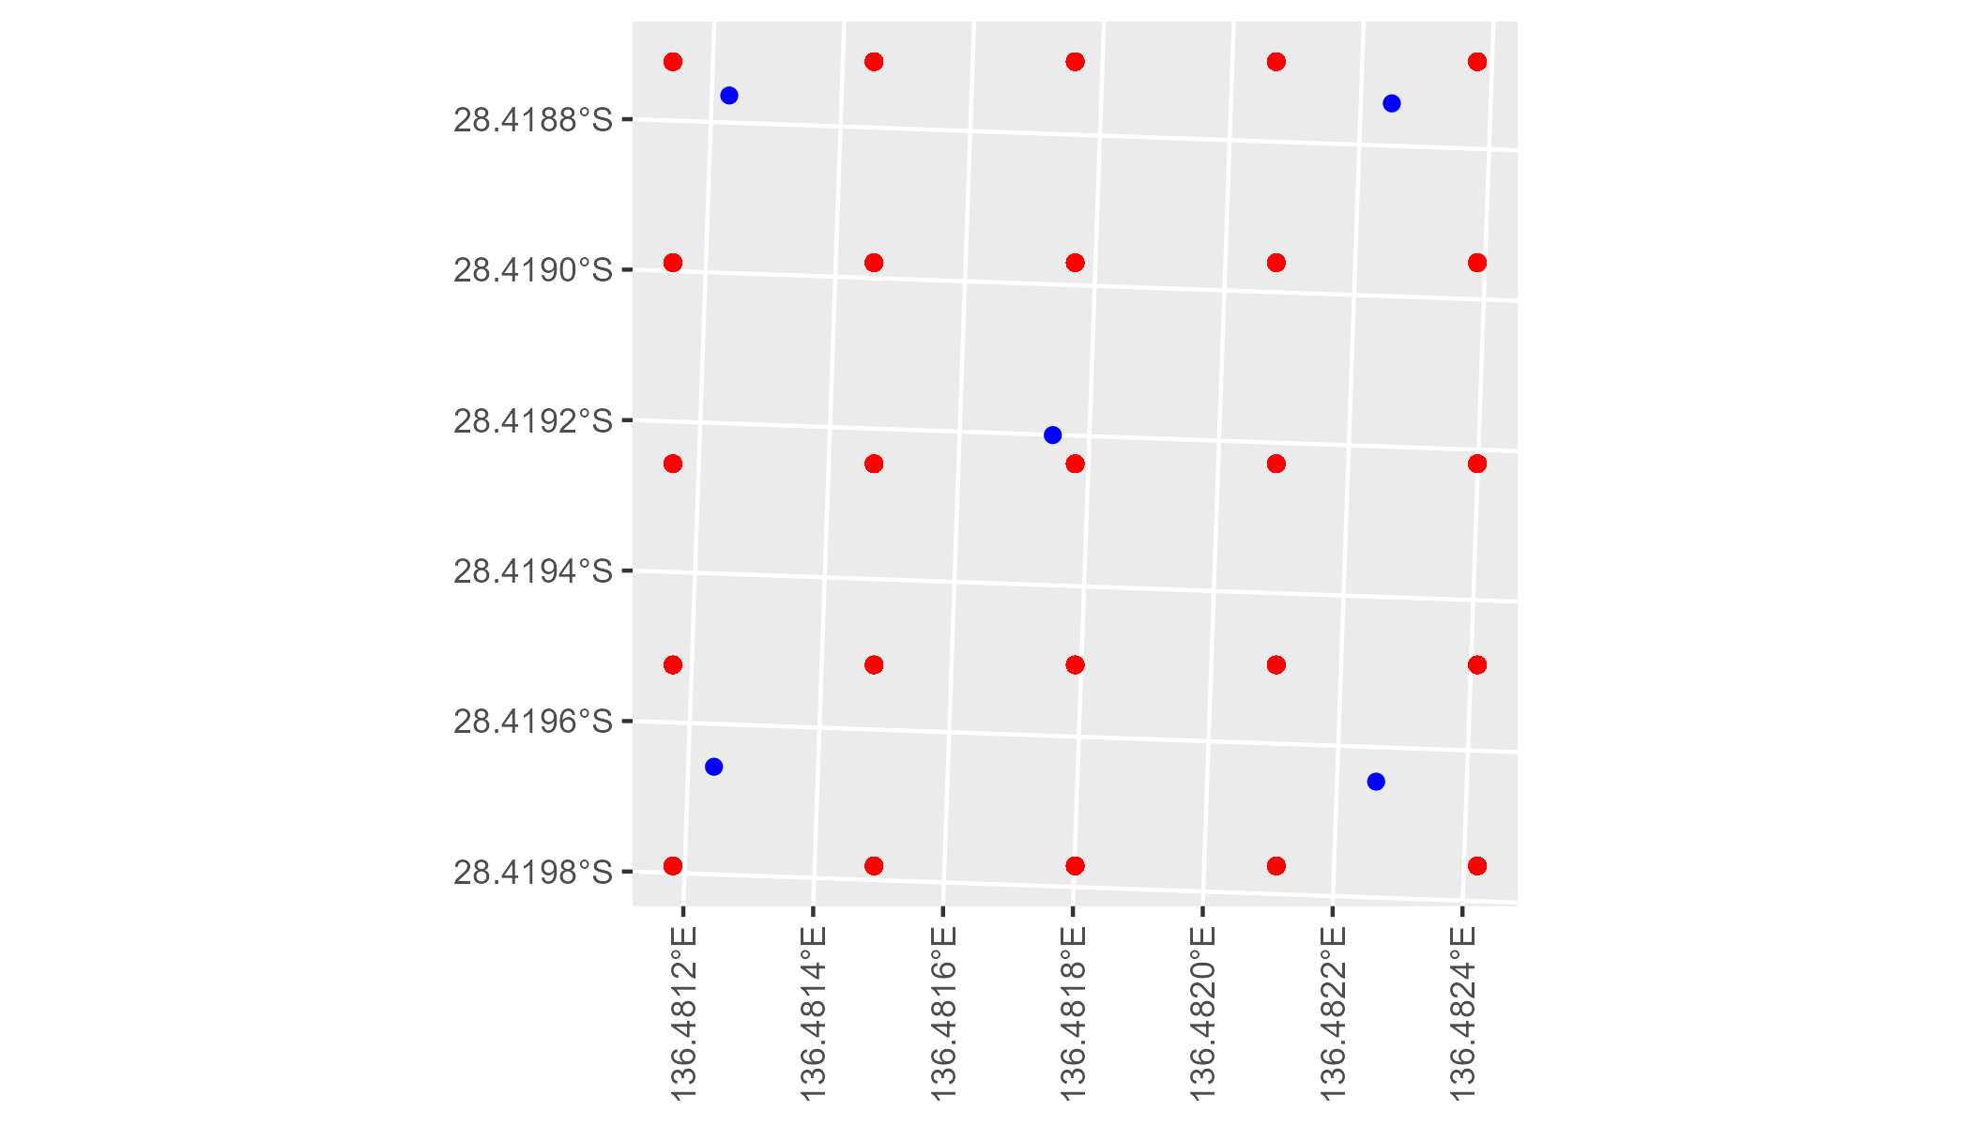

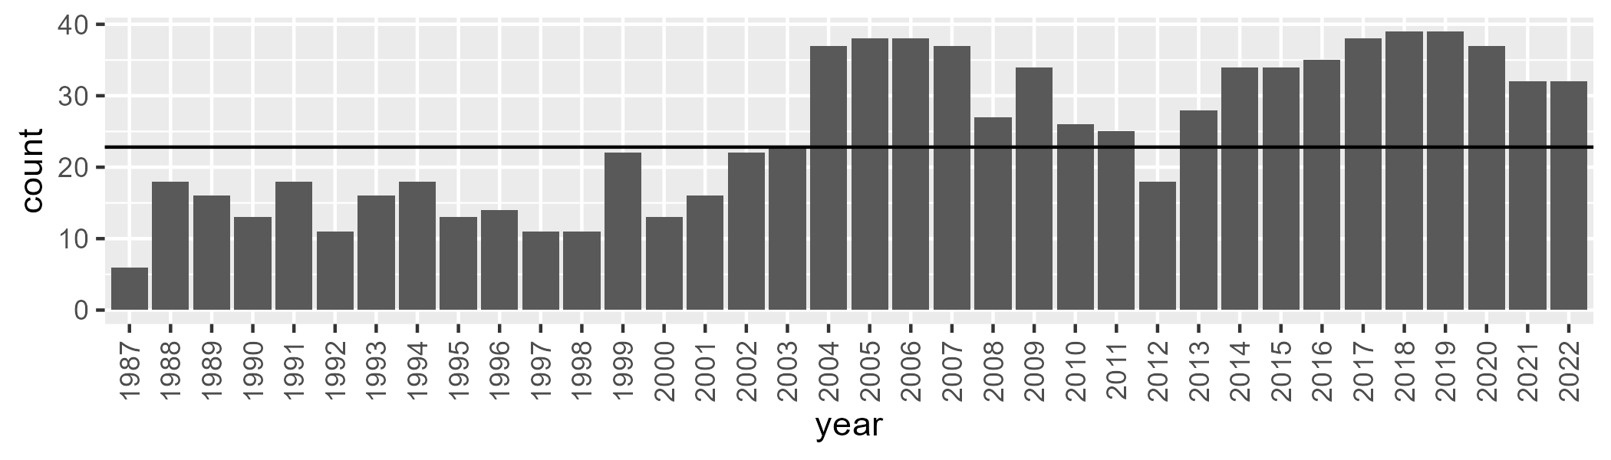

Number of samples: 889

# SAASTP0020

| Min. | 1st Qu. | Median | Mean | 3rd Qu. | Max. |
| --- | --- | --- | --- | --- | --- |
| 0 | 0.1574109 | 0.8955906 | 1.120661 | 1.466444 | 8.280413 |

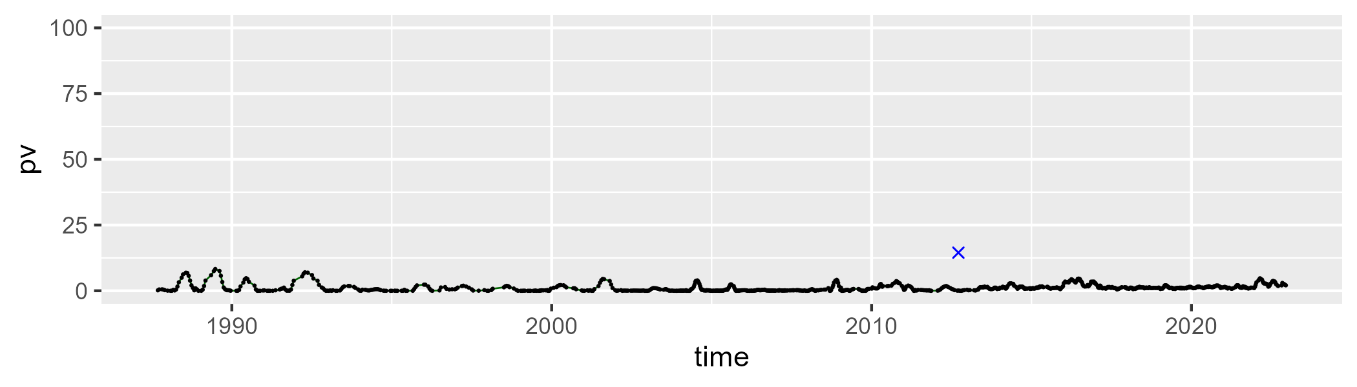

| Min. | 1st Qu. | Median | Mean | 3rd Qu. | Max. |
| --- | --- | --- | --- | --- | --- |
| 9.730743 | 22.1798 | 25.57626 | 26.06015 | 29.74568 | 48.92015 |

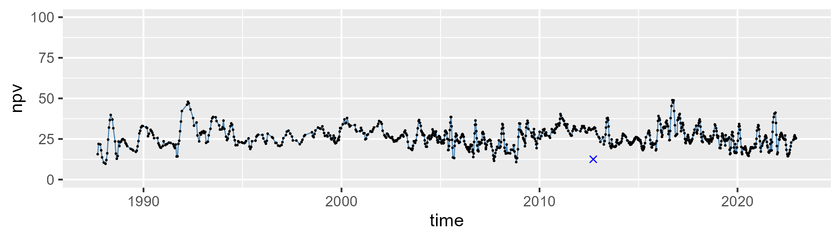

| Min. | 1st Qu. | Median | Mean | 3rd Qu. | Max. |
| --- | --- | --- | --- | --- | --- |
| 44.33639 | 67.79556 | 72.19201 | 71.64339 | 75.96012 | 89.47551 |

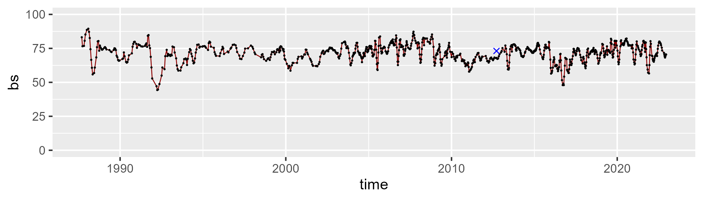

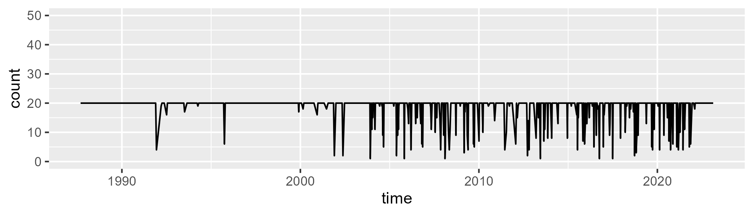

Min. : 1.00 1st Qu.:20.00 Median :20.00 Mean :18.63 3rd Qu.:20.00 Max. :20.00

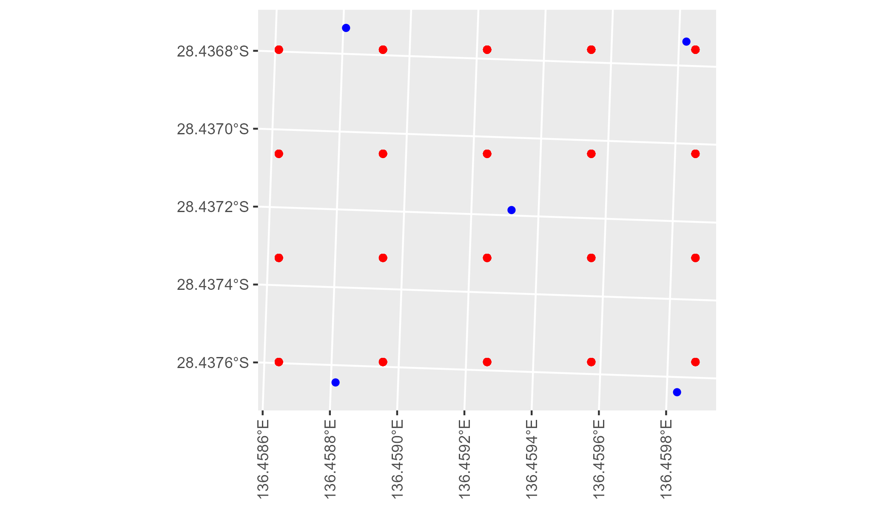

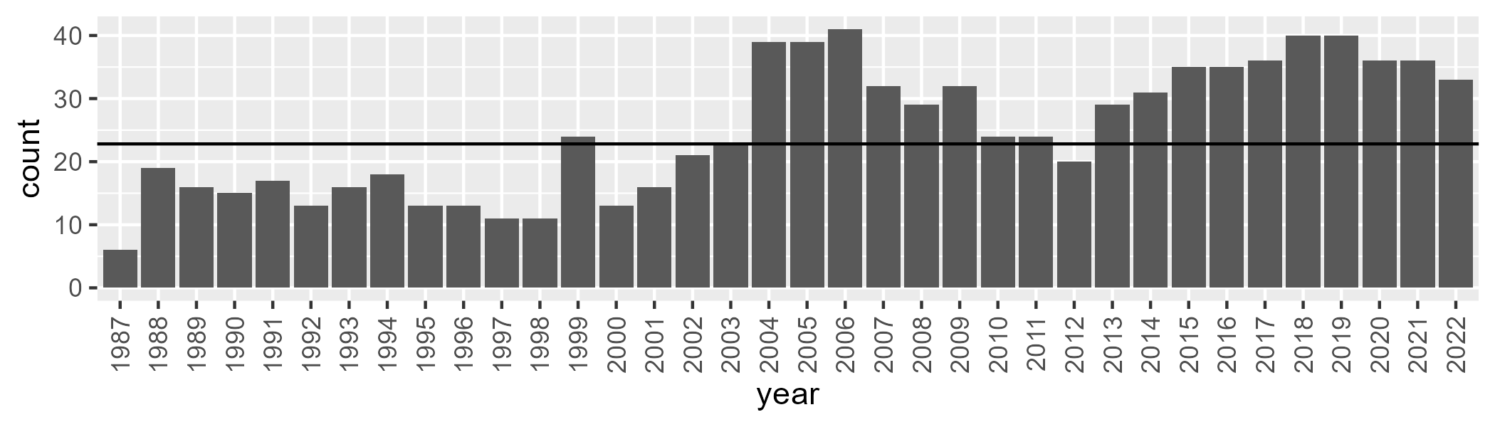

Number of samples: 896

# SAASTP0021

| Min. | 1st Qu. | Median | Mean | 3rd Qu. | Max. |
| --- | --- | --- | --- | --- | --- |
| 0 | 0.3717437 | 1.260902 | 2.227115 | 2.63017 | 25.80271 |

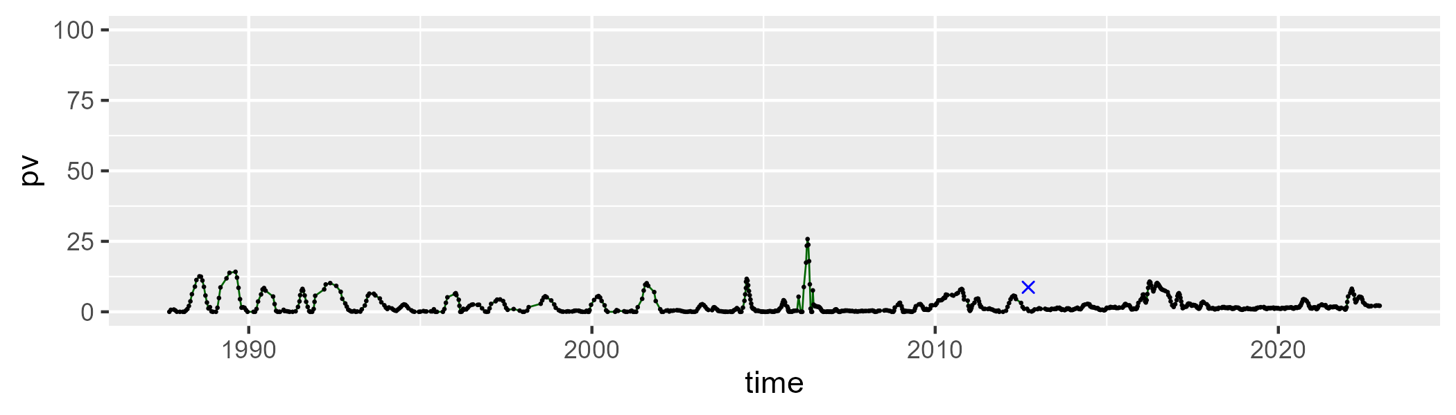

| Min. | 1st Qu. | Median | Mean | 3rd Qu. | Max. |
| --- | --- | --- | --- | --- | --- |
| 24.62565 | 32.49371 | 34.23005 | 34.52299 | 36.3896 | 46.40212 |

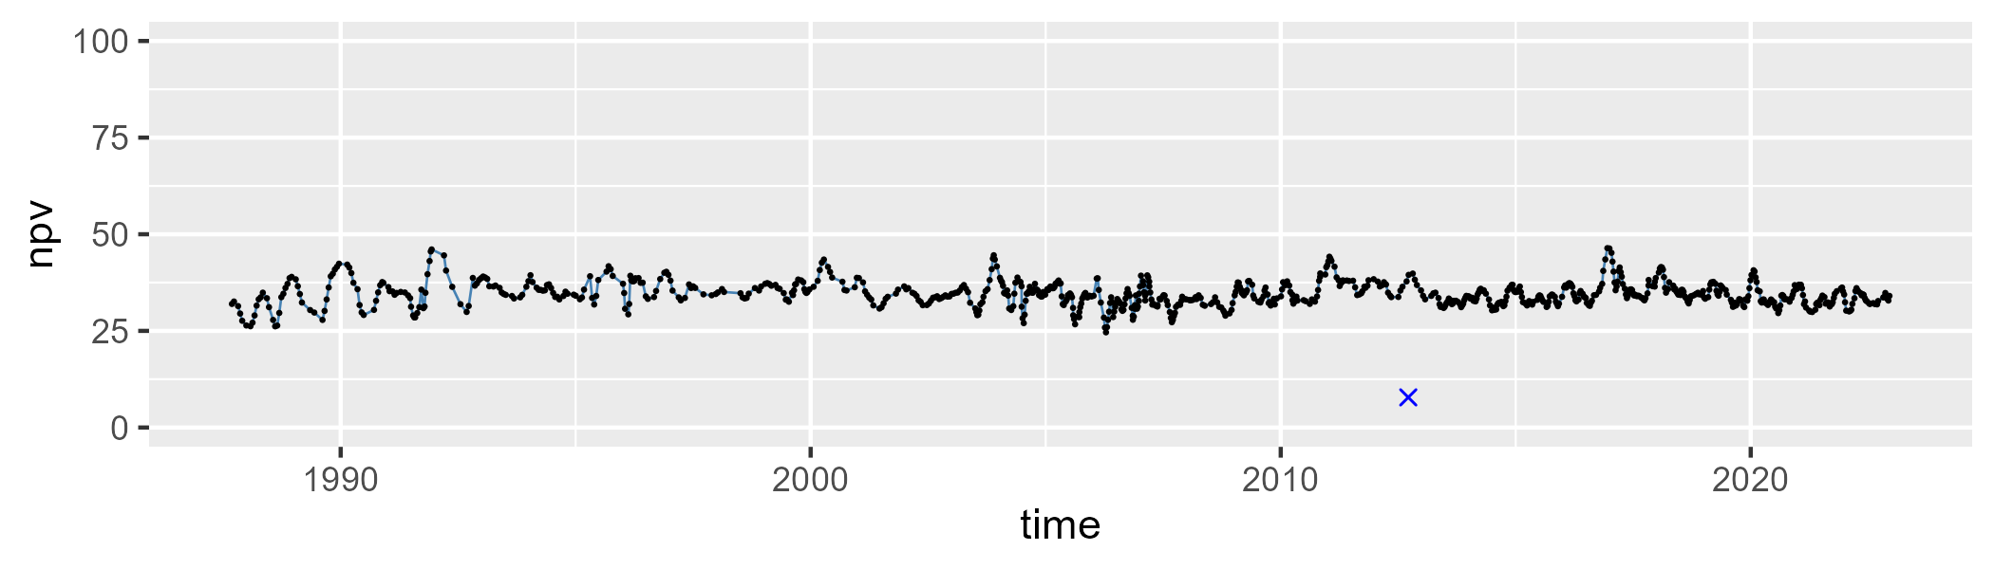

| Min. | 1st Qu. | Median | Mean | 3rd Qu. | Max. |
| --- | --- | --- | --- | --- | --- |
| 46.10593 | 59.84386 | 62.36765 | 61.93227 | 64.54872 | 73.13564 |

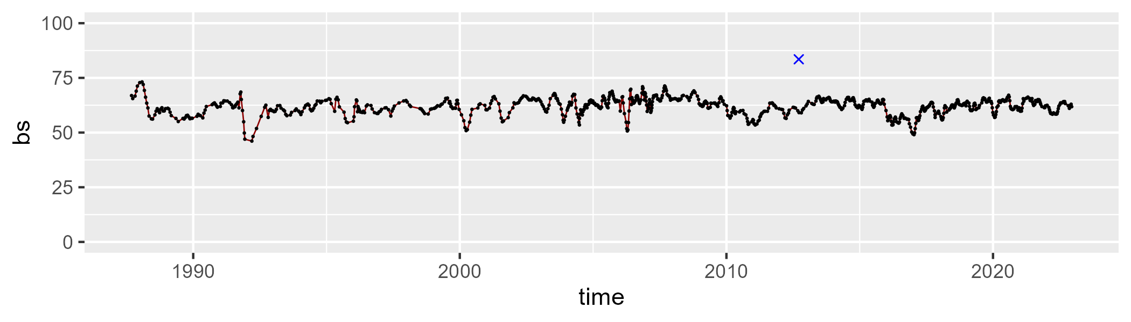

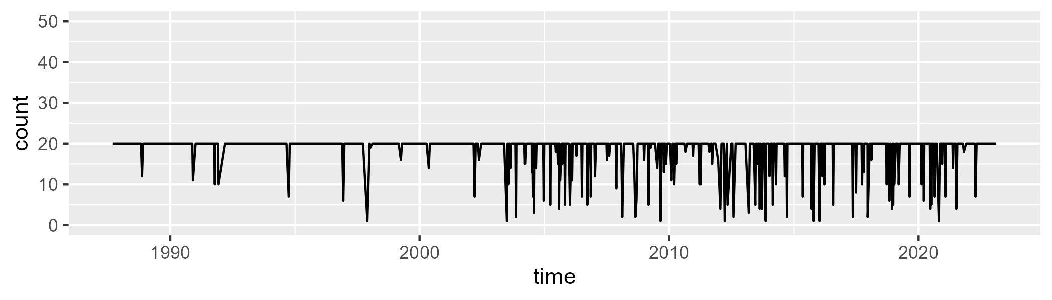

Min. : 1.00 1st Qu.:20.00 Median :20.00 Mean :18.61 3rd Qu.:20.00 Max. :20.00

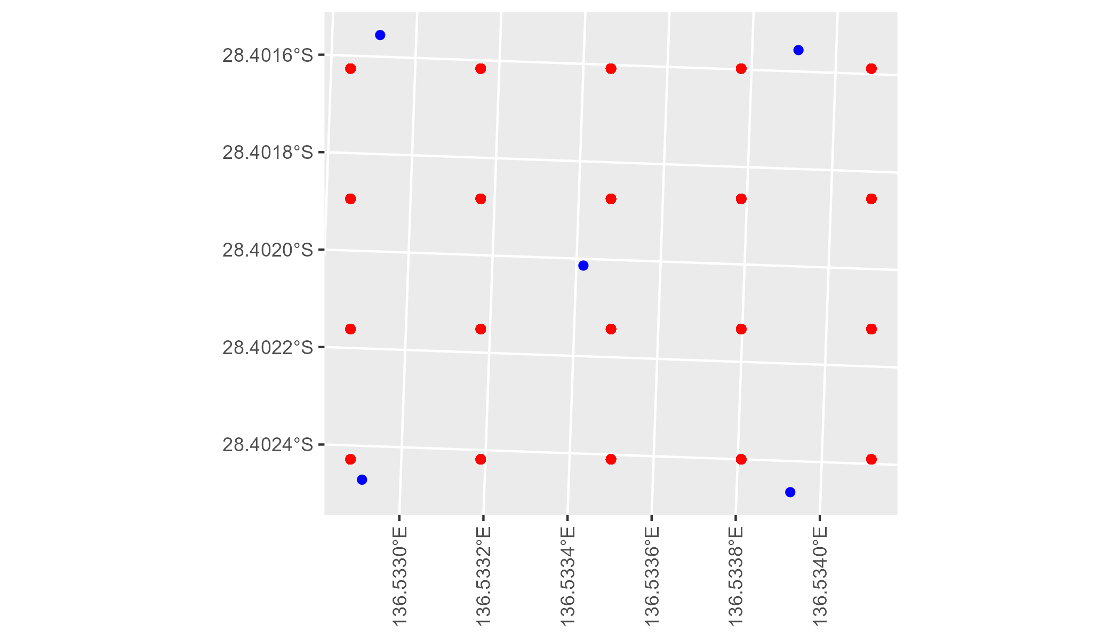

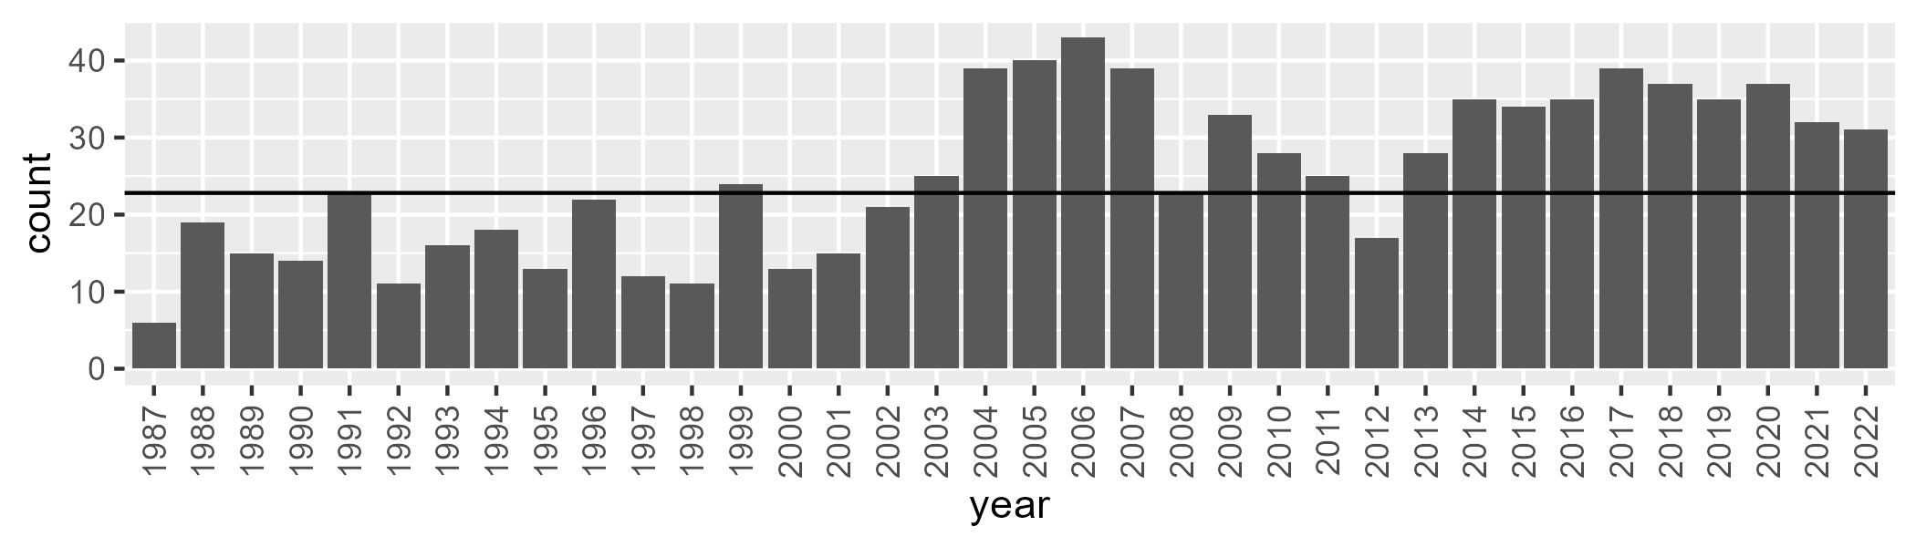

Number of samples: 908

# SAASTP0022

| Min. | 1st Qu. | Median | Mean | 3rd Qu. | Max. |
| --- | --- | --- | --- | --- | --- |
| 0 | 0.1076555 | 1.213189 | 2.829089 | 3.151865 | 32.04528 |

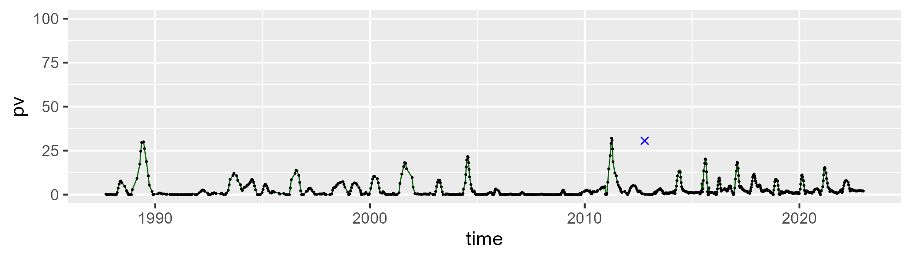

| Min. | 1st Qu. | Median | Mean | 3rd Qu. | Max. |
| --- | --- | --- | --- | --- | --- |
| 37.80169 | 55.71642 | 59.12763 | 58.78876 | 62.26893 | 71.92847 |

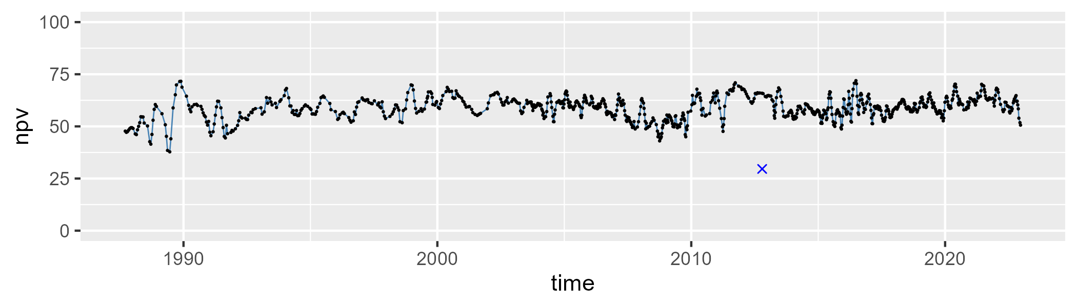

| Min. | 1st Qu. | Median | Mean | 3rd Qu. | Max. |
| --- | --- | --- | --- | --- | --- |
| 16.99993 | 33.36213 | 37.09211 | 37.42143 | 41.47567 | 56.63867 |

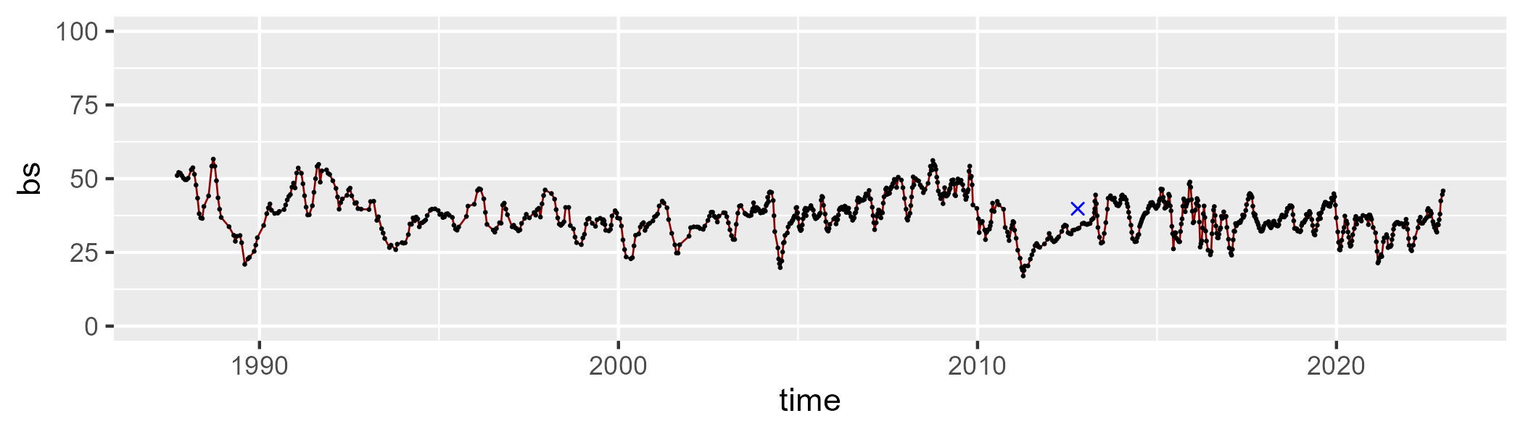

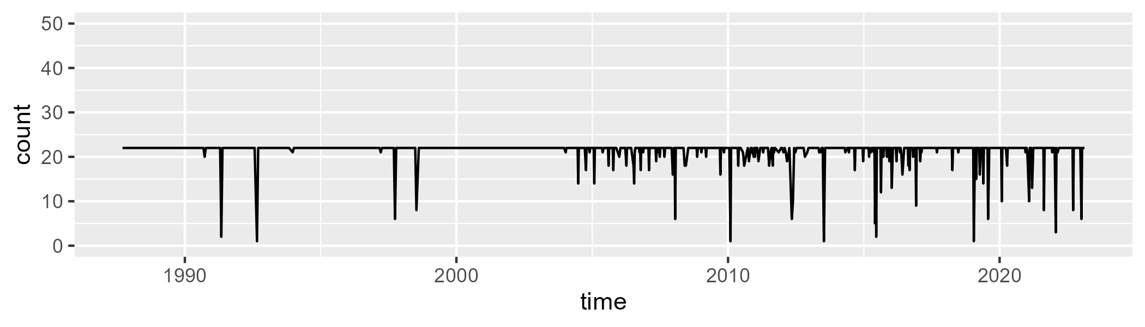

Min. : 1.00 1st Qu.:22.00 Median :22.00 Mean :21.36 3rd Qu.:22.00 Max. :22.00

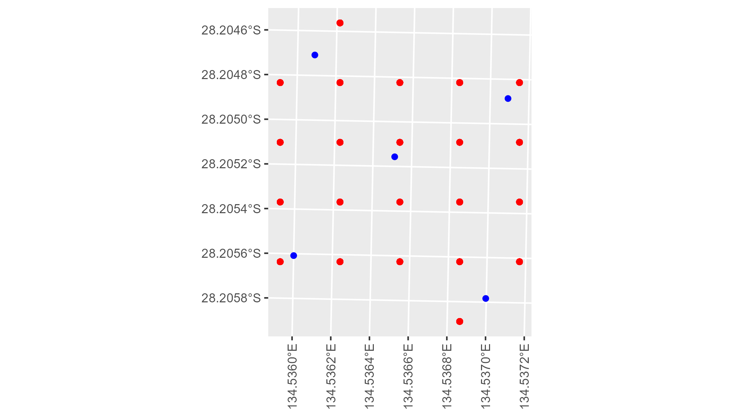

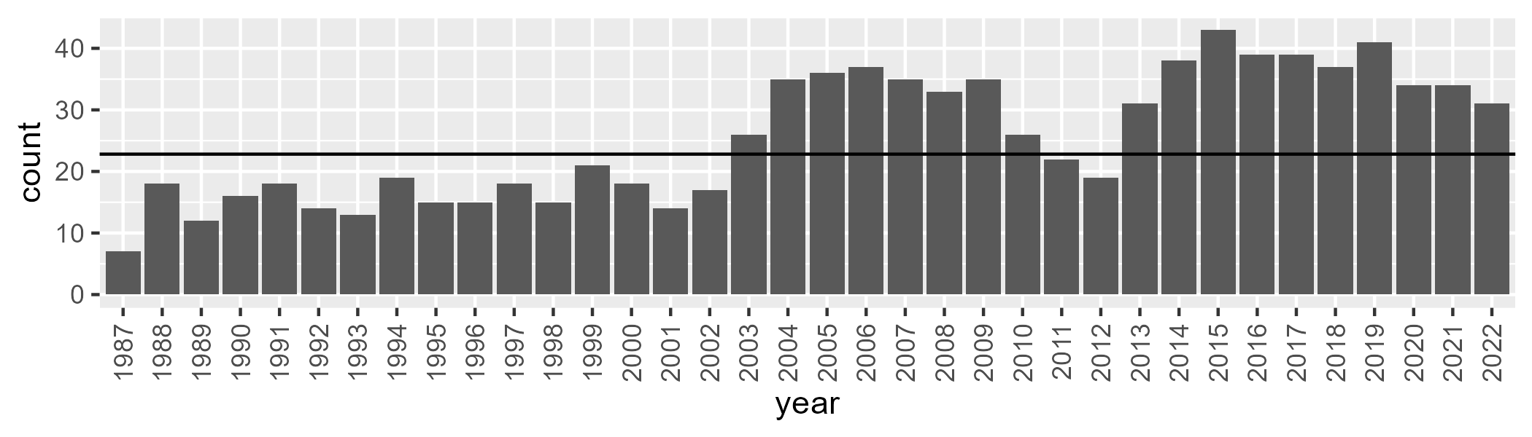

Number of samples: 921

# SAASTP0023

| Min. | 1st Qu. | Median | Mean | 3rd Qu. | Max. |
| --- | --- | --- | --- | --- | --- |
| 0 | 0.1272534 | 1.279839 | 3.966347 | 5.63587 | 44.48737 |

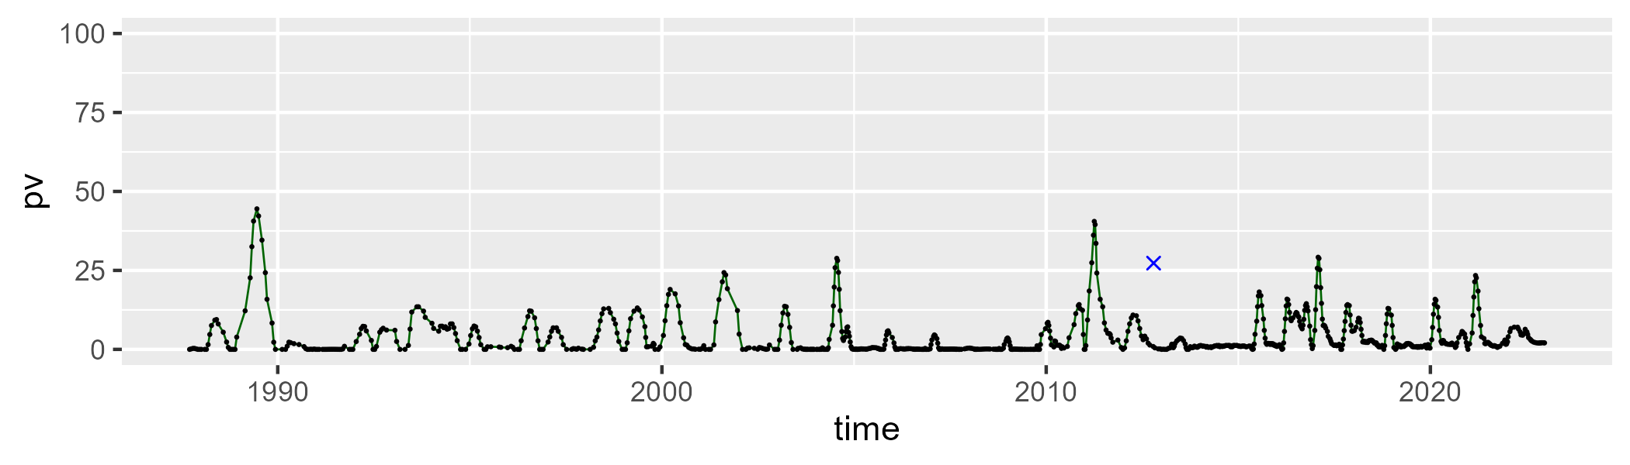

| Min. | 1st Qu. | Median | Mean | 3rd Qu. | Max. |
| --- | --- | --- | --- | --- | --- |
| 34.15208 | 53.13069 | 57.36517 | 57.3725 | 61.50222 | 77.25506 |

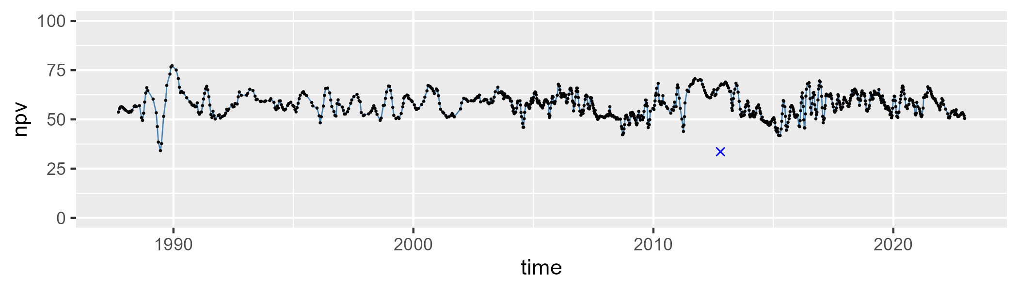

| Min. | 1st Qu. | Median | Mean | 3rd Qu. | Max. |
| --- | --- | --- | --- | --- | --- |
| 11.86777 | 33.063 | 37.53633 | 37.68134 | 42.81734 | 57.08232 |

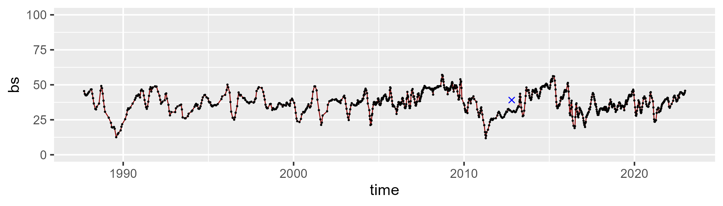

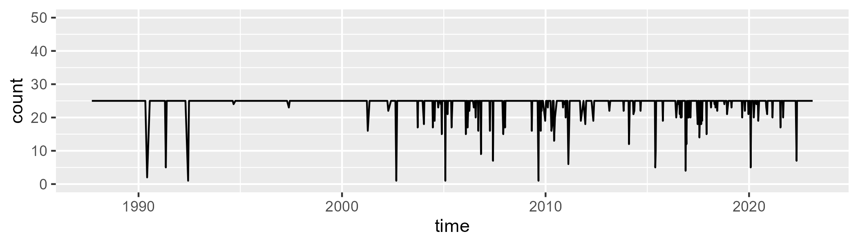

Min. : 1.00 1st Qu.:25.00 Median :25.00 Mean :24.23 3rd Qu.:25.00 Max. :25.00

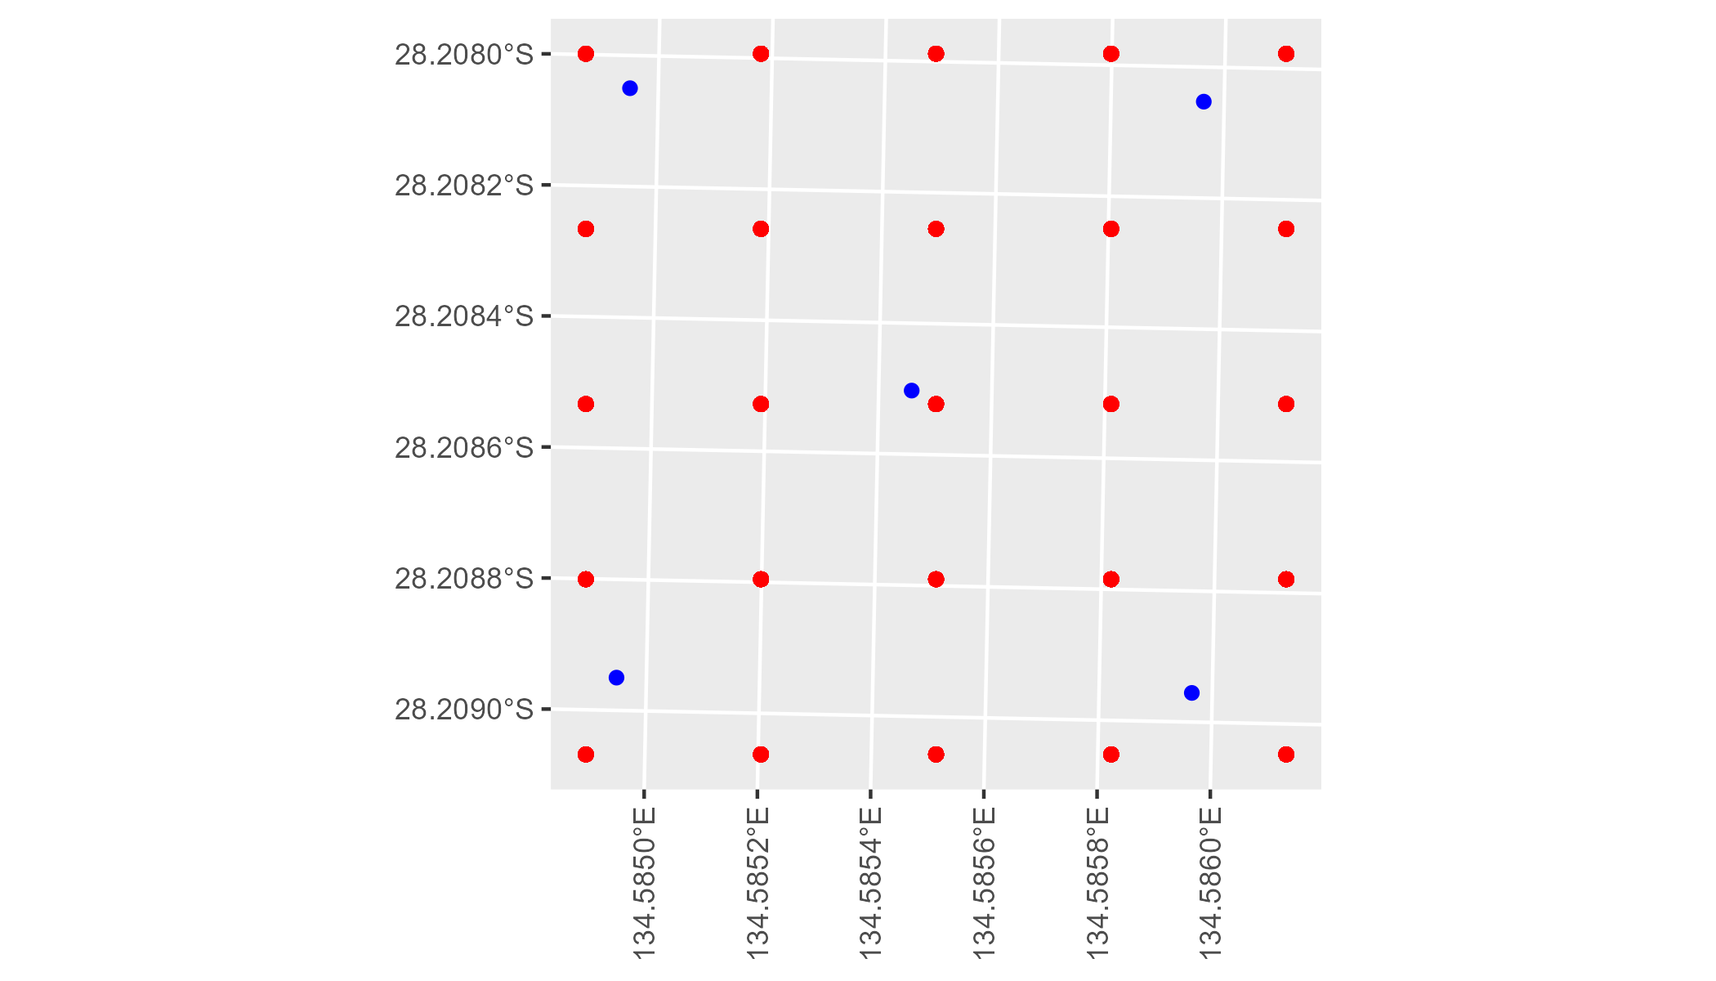

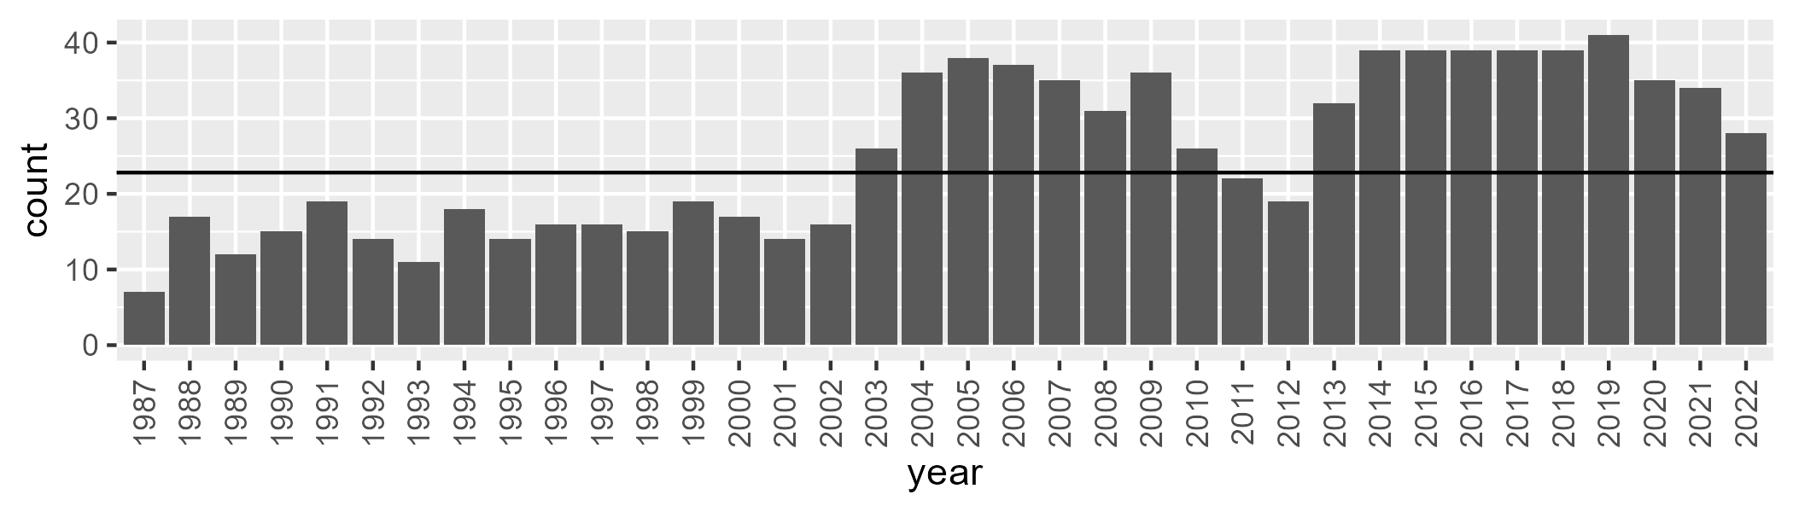

Number of samples: 911

# SAASTP0024

| Min. | 1st Qu. | Median | Mean | 3rd Qu. | Max. |
| --- | --- | --- | --- | --- | --- |
| 0 | 0.02471435 | 0.8336223 | 1.710189 | 1.36304 | 34.6633 |

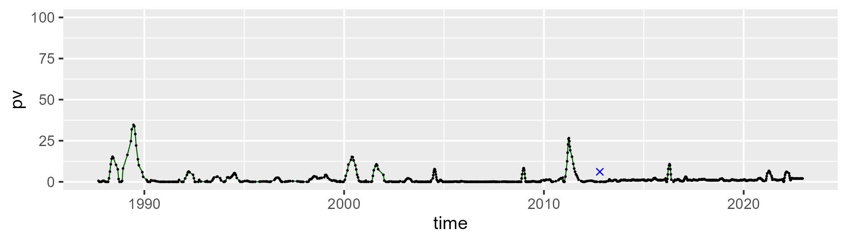

| Min. | 1st Qu. | Median | Mean | 3rd Qu. | Max. |
| --- | --- | --- | --- | --- | --- |
| 32.84719 | 47.17321 | 49.32876 | 49.52281 | 51.47223 | 64.5514 |

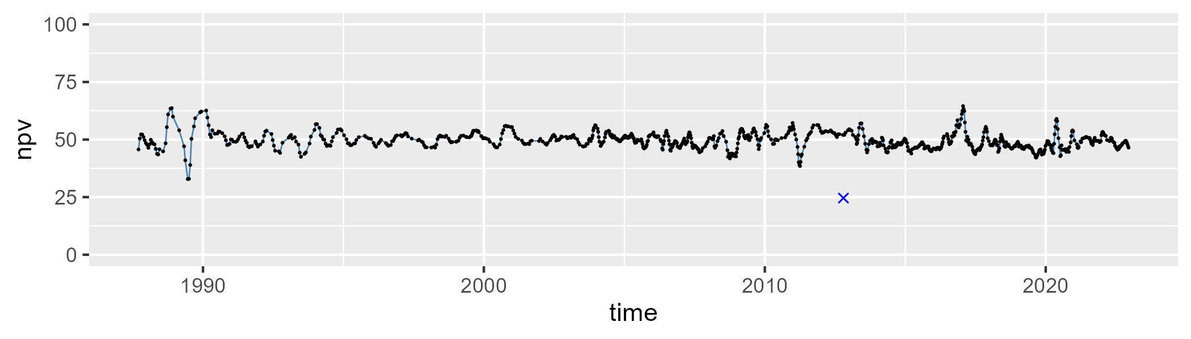

| Min. | 1st Qu. | Median | Mean | 3rd Qu. | Max. |
| --- | --- | --- | --- | --- | --- |
| 25.56084 | 45.86647 | 48.48679 | 47.7622 | 50.70919 | 57.26541 |

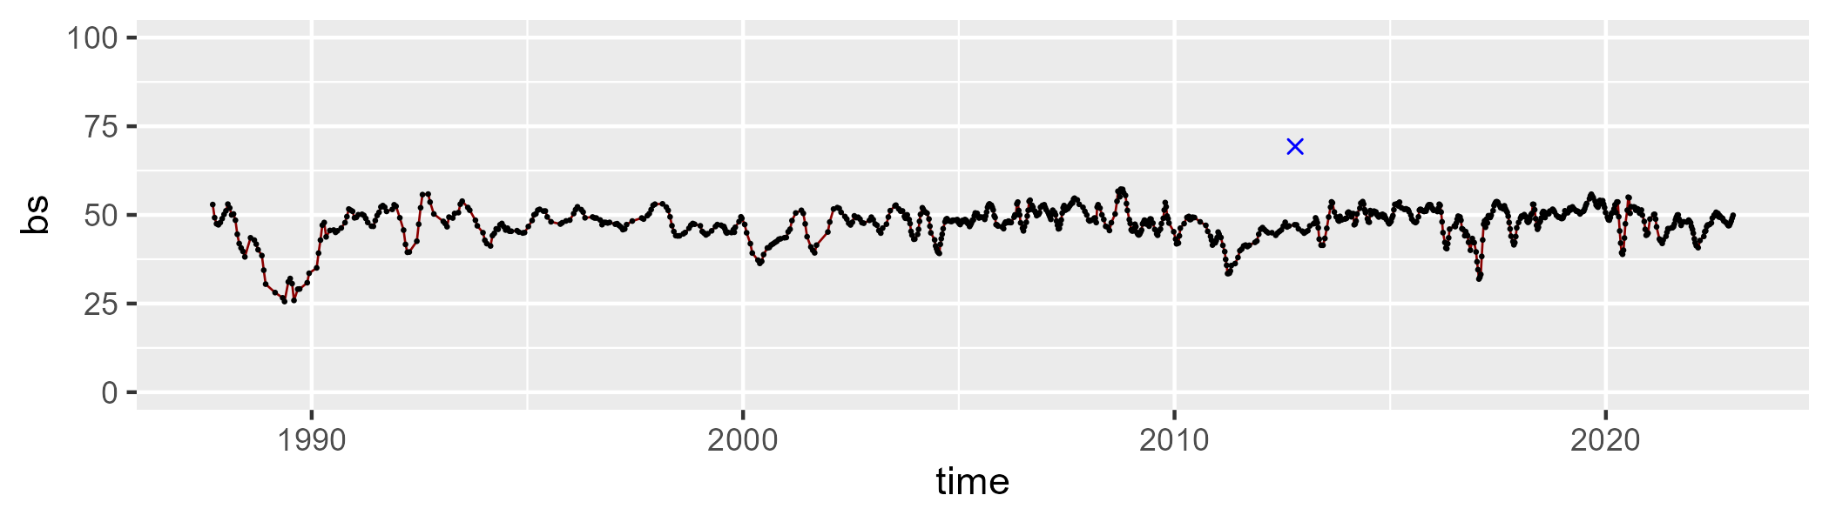

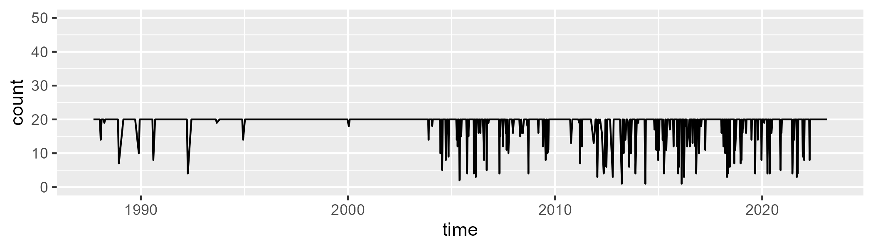

Min. : 1.00 1st Qu.:20.00 Median :20.00 Mean :18.75 3rd Qu.:20.00 Max. :20.00

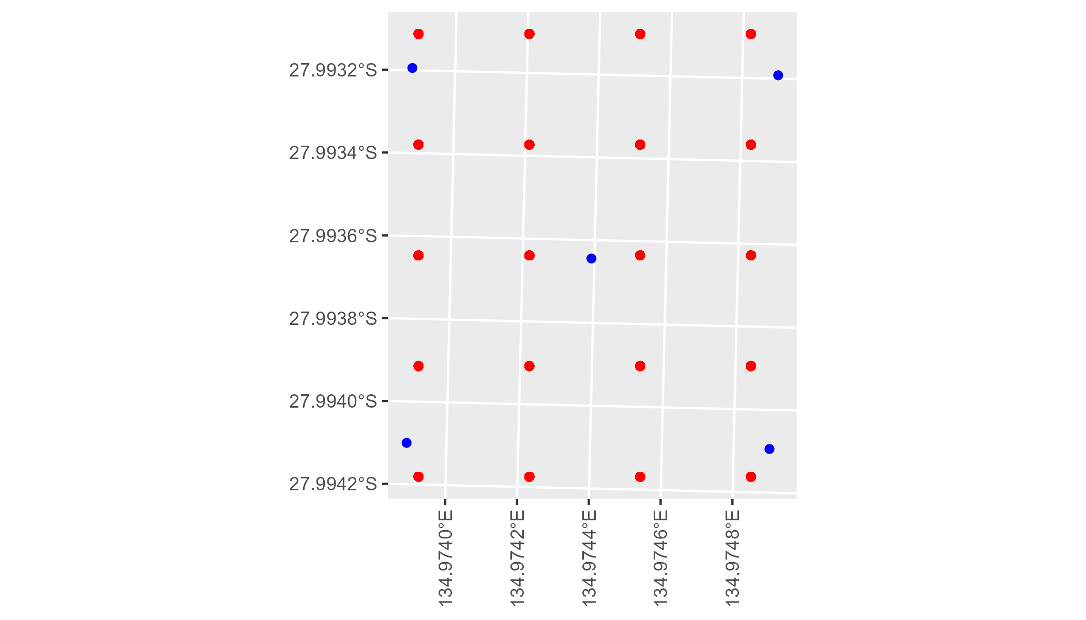

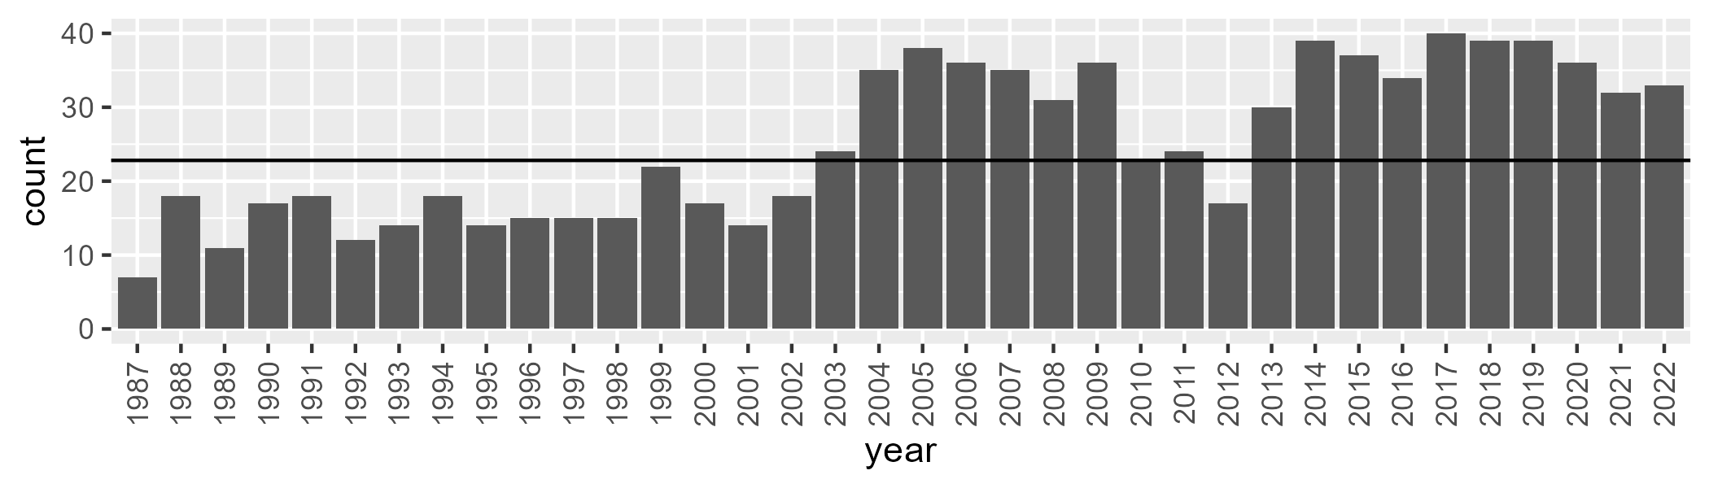

Number of samples: 903

# SAASTP0025

| Min. | 1st Qu. | Median | Mean | 3rd Qu. | Max. |
| --- | --- | --- | --- | --- | --- |
| 0 | 0.03873028 | 0.7913469 | 1.281906 | 1.334308 | 24.90548 |

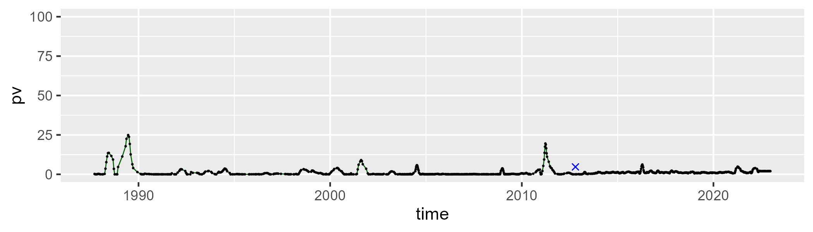

| Min. | 1st Qu. | Median | Mean | 3rd Qu. | Max. |
| --- | --- | --- | --- | --- | --- |
| 39.49787 | 47.78876 | 49.72859 | 50.04058 | 51.85906 | 65.66182 |

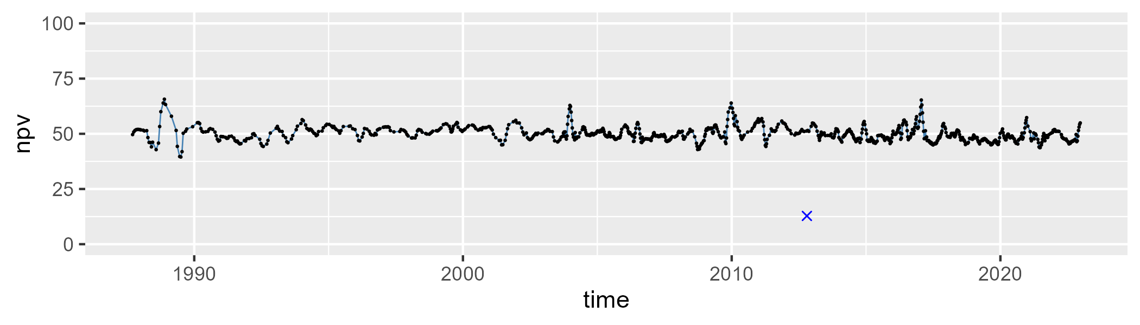

| Min. | 1st Qu. | Median | Mean | 3rd Qu. | Max. |
| --- | --- | --- | --- | --- | --- |
| 29.62947 | 45.80084 | 48.27698 | 47.62435 | 50.25953 | 56.28793 |

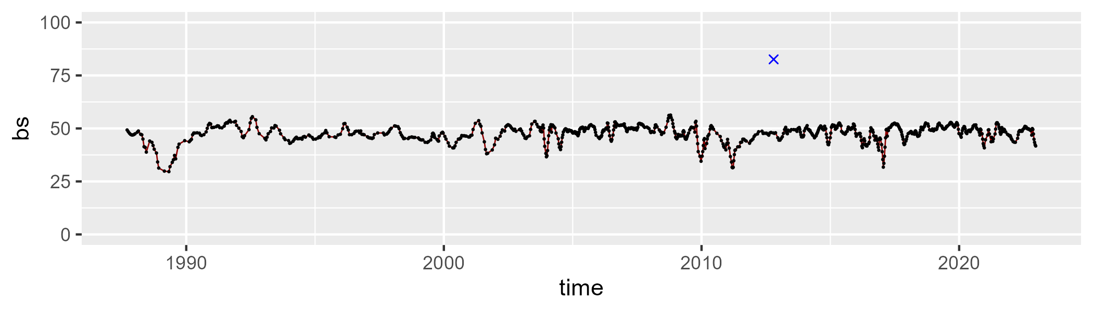

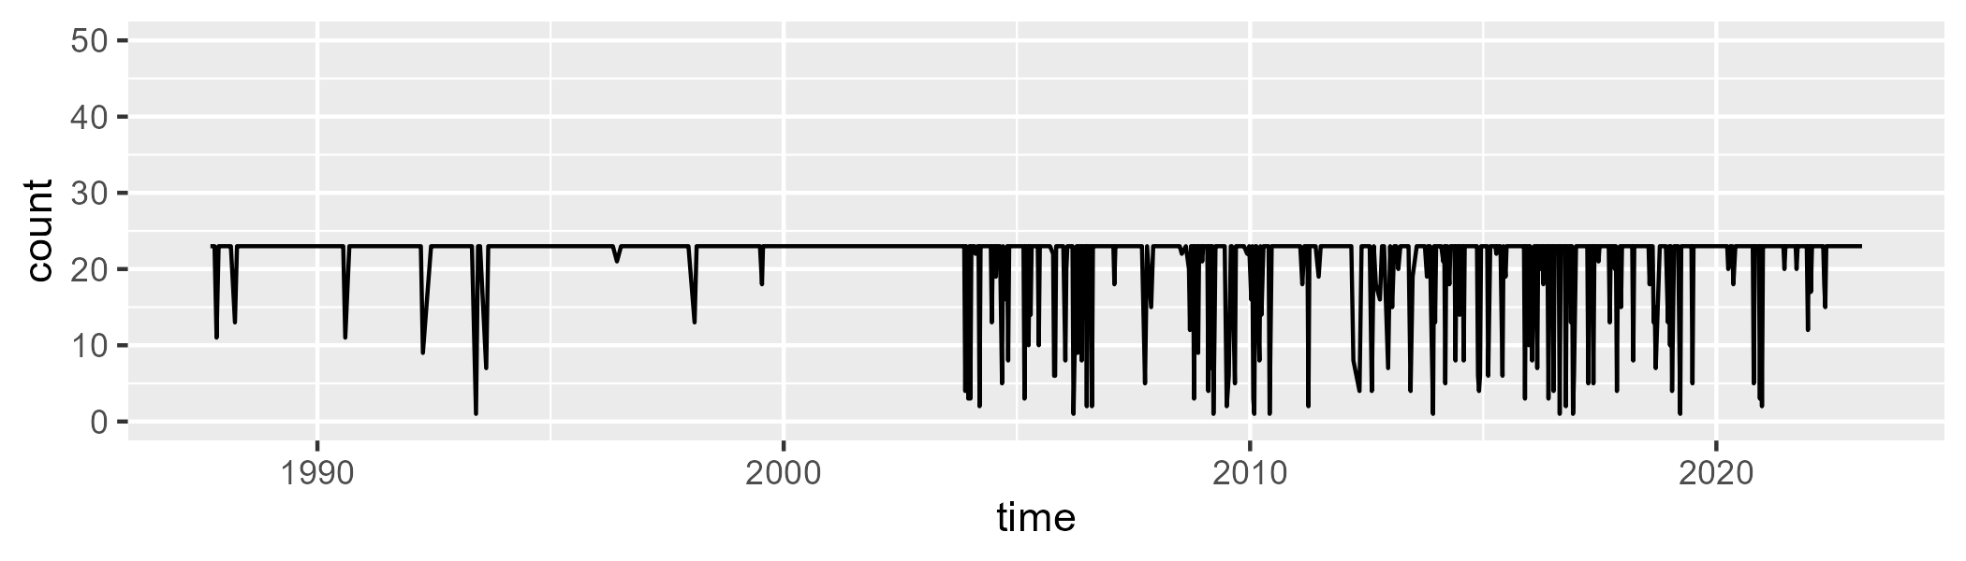

Min. : 1.0 1st Qu.:23.0 Median :23.0 Mean :21.2 3rd Qu.:23.0 Max. :23.0

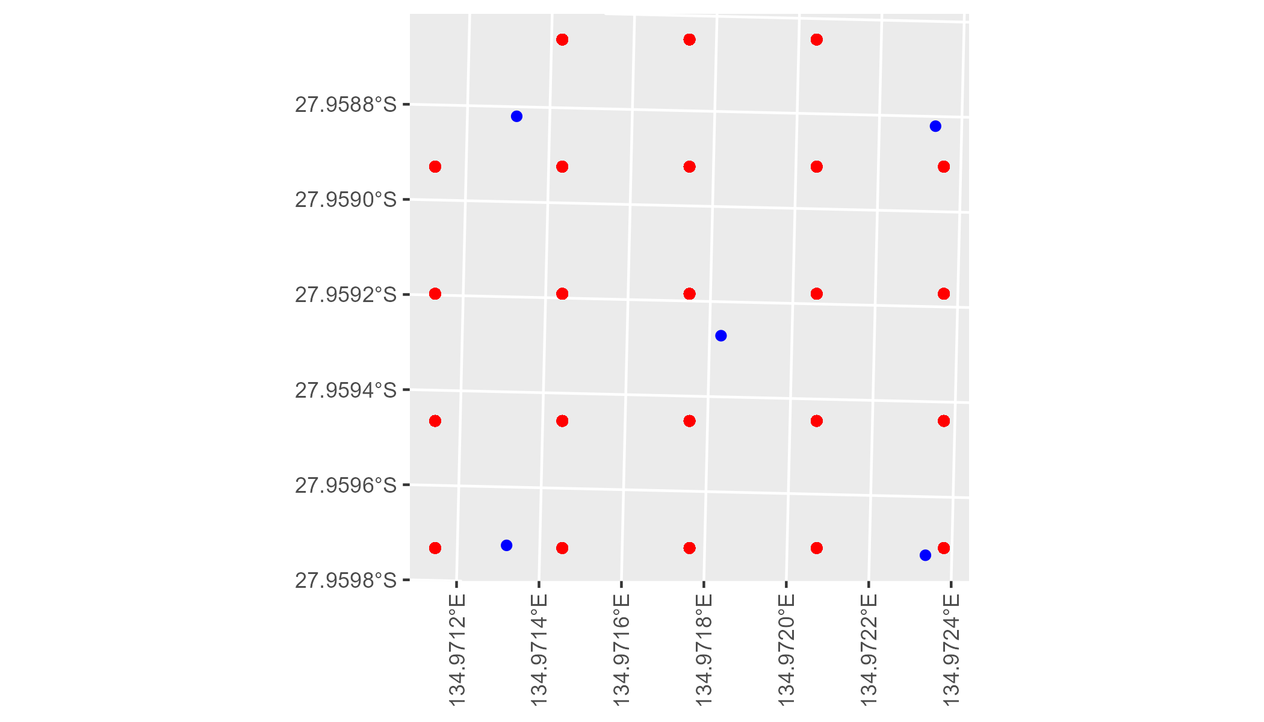

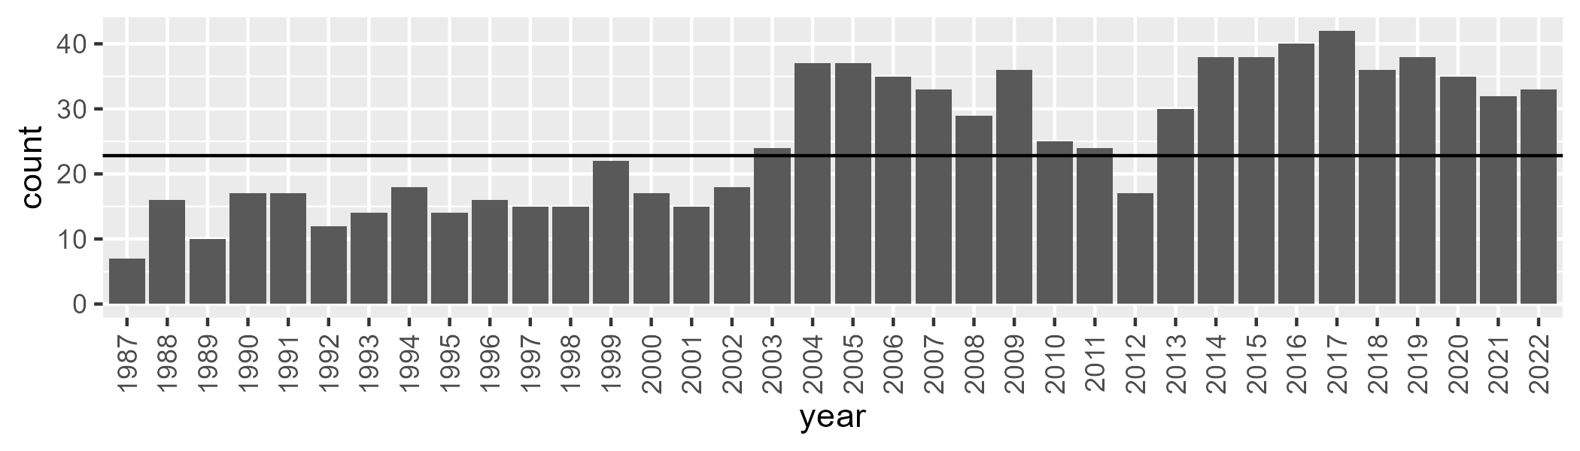

Number of samples: 902

# SAASTP0026

| Min. | 1st Qu. | Median | Mean | 3rd Qu. | Max. |
| --- | --- | --- | --- | --- | --- |
| 0 | 0.2915806 | 1.255346 | 3.530635 | 3.966863 | 39.55484 |

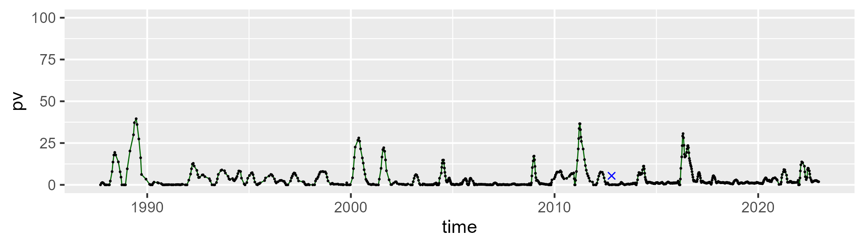

| Min. | 1st Qu. | Median | Mean | 3rd Qu. | Max. |
| --- | --- | --- | --- | --- | --- |
| 26.30773 | 40.6369 | 43.42078 | 43.8837 | 46.75872 | 71.04045 |

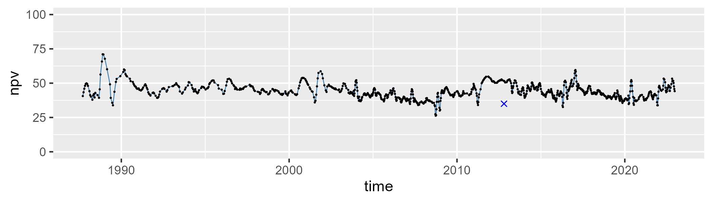

| Min. | 1st Qu. | Median | Mean | 3rd Qu. | Max. |
| --- | --- | --- | --- | --- | --- |
| 18.71671 | 47.251 | 52.67598 | 51.3682 | 56.62249 | 72.35396 |

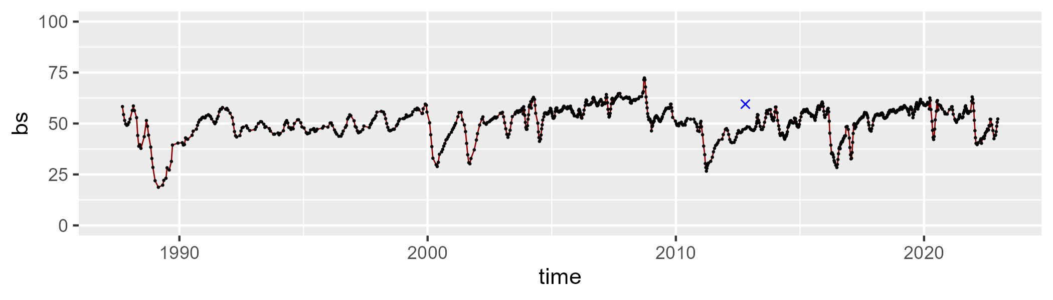

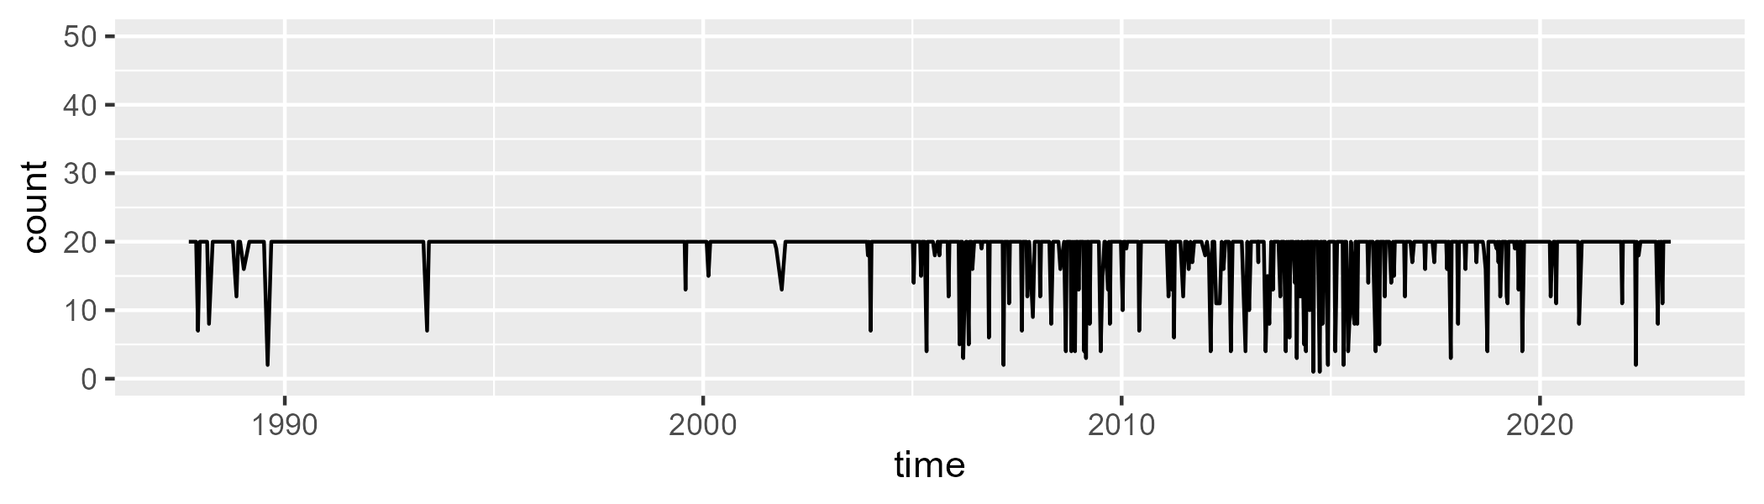

Min. : 1.00 1st Qu.:20.00 Median :20.00 Mean :18.68 3rd Qu.:20.00 Max. :20.00

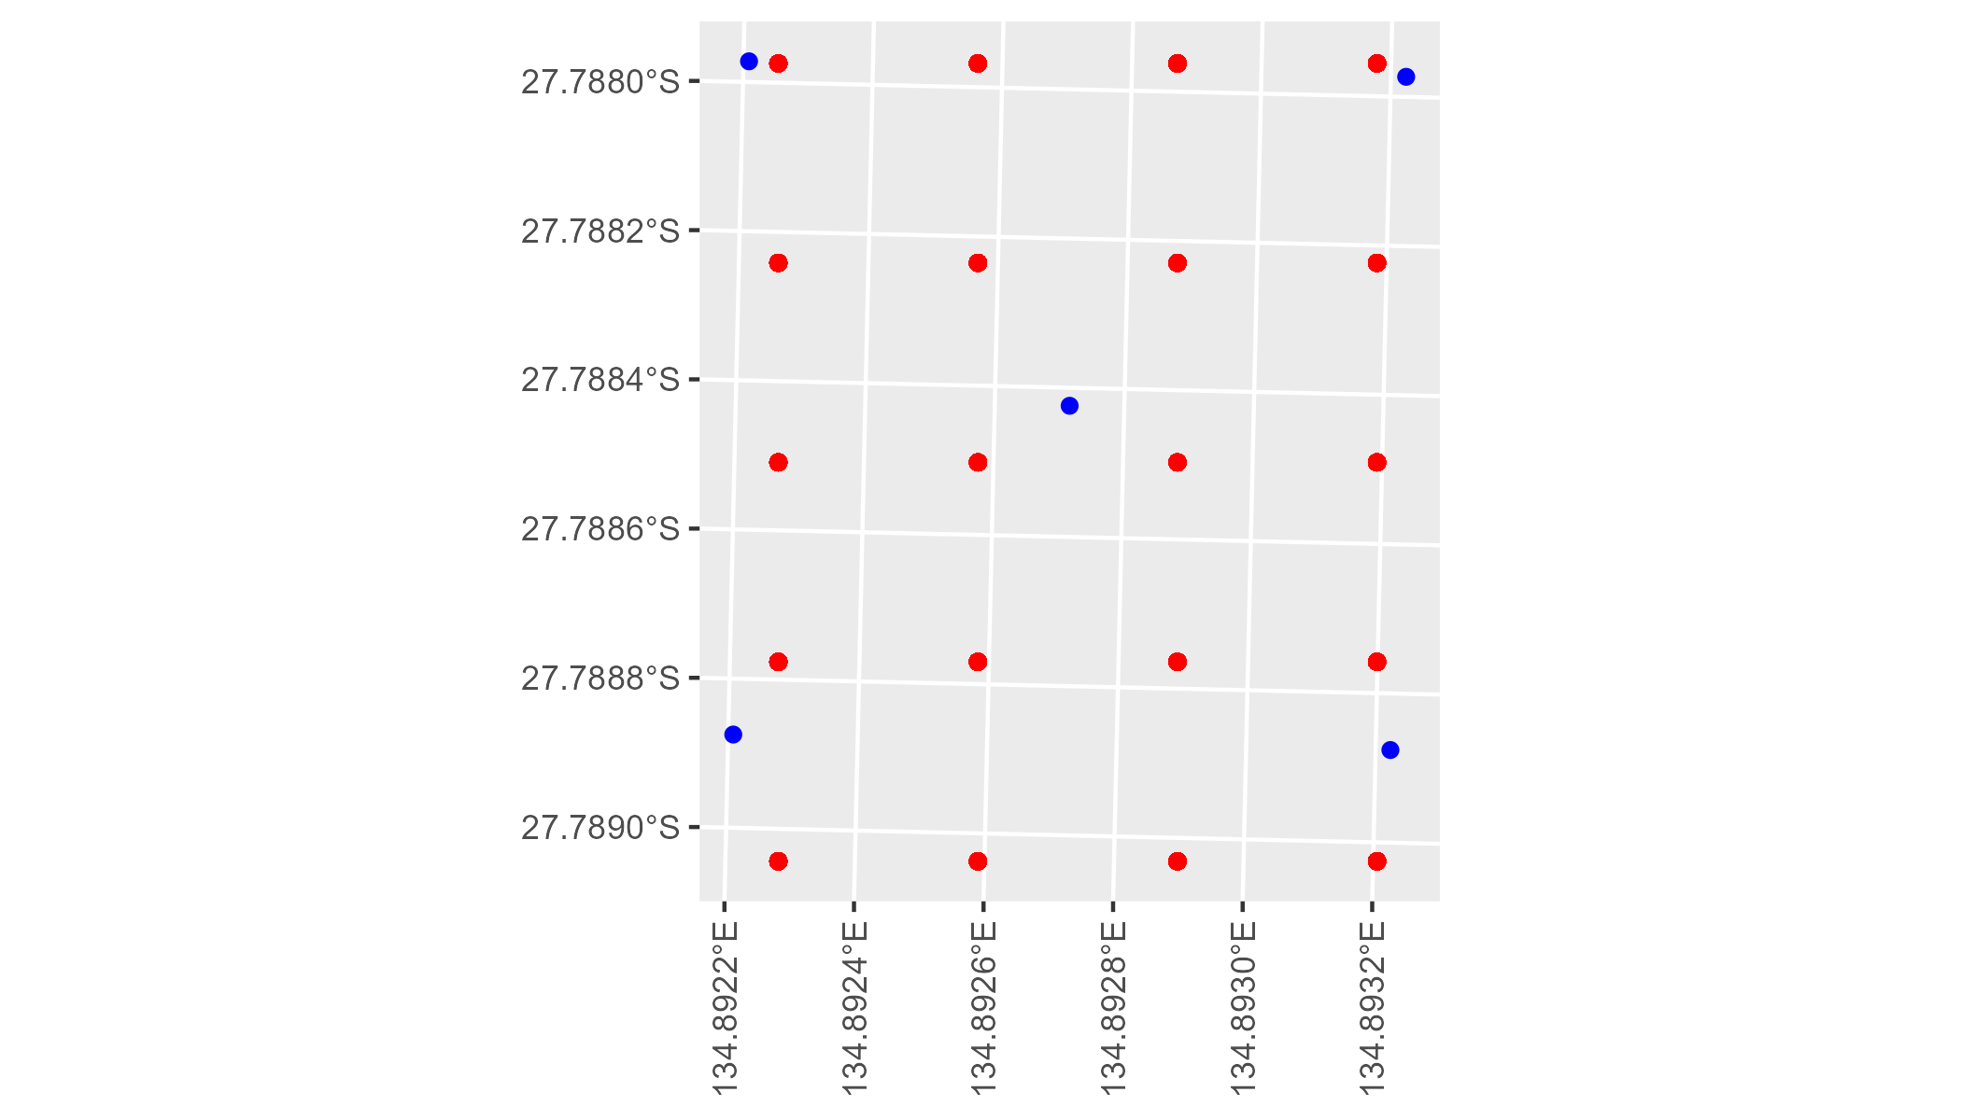

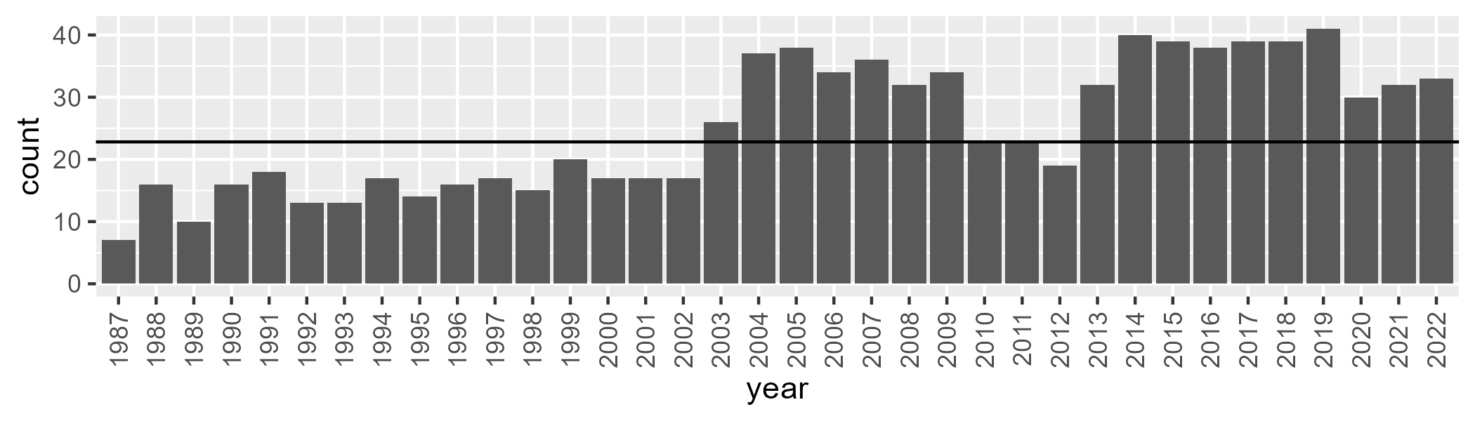

Number of samples: 908

# SAASTP0027

| Min. | 1st Qu. | Median | Mean | 3rd Qu. | Max. |
| --- | --- | --- | --- | --- | --- |
| 0 | 0.1911689 | 1.108991 | 2.884805 | 2.83717 | 33.41861 |

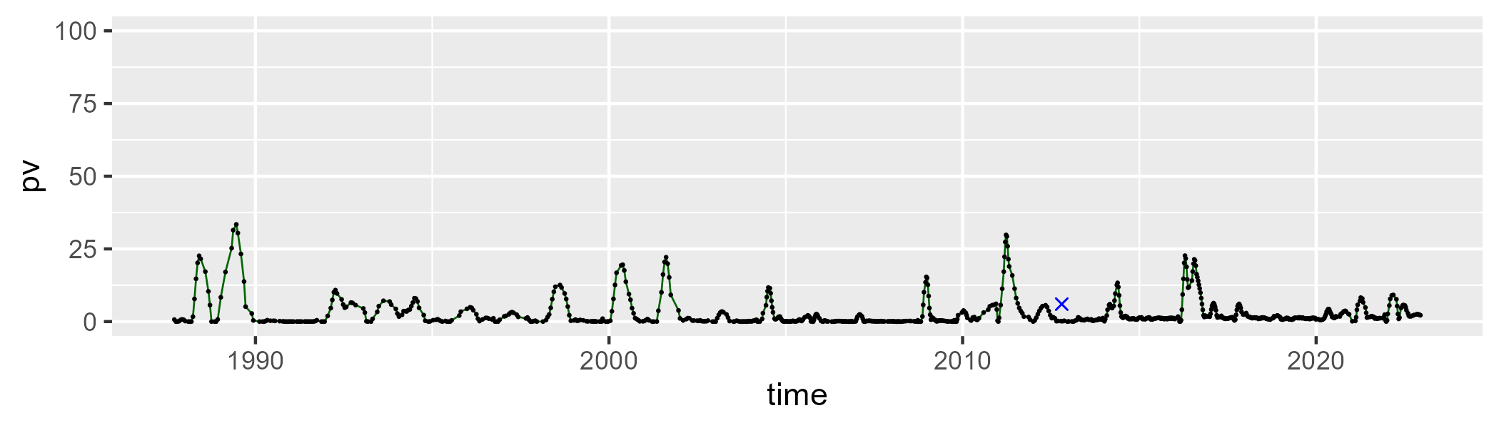

| Min. | 1st Qu. | Median | Mean | 3rd Qu. | Max. |
| --- | --- | --- | --- | --- | --- |
| 30.62168 | 41.31007 | 43.53216 | 44.20856 | 46.70771 | 71.63139 |

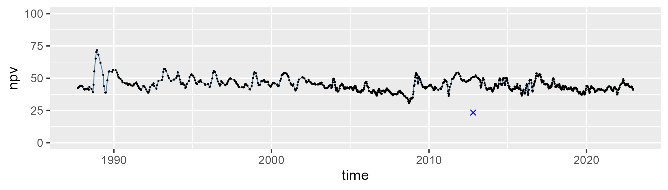

| Min. | 1st Qu. | Median | Mean | 3rd Qu. | Max. |
| --- | --- | --- | --- | --- | --- |
| 19.83566 | 48.1112 | 53.1141 | 51.70197 | 56.1569 | 68.25539 |

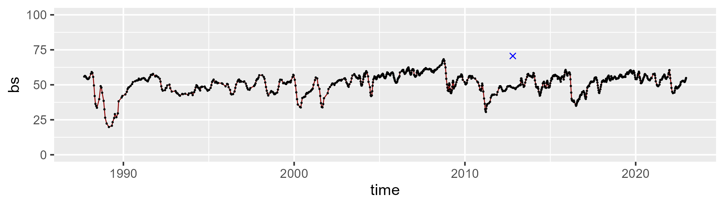

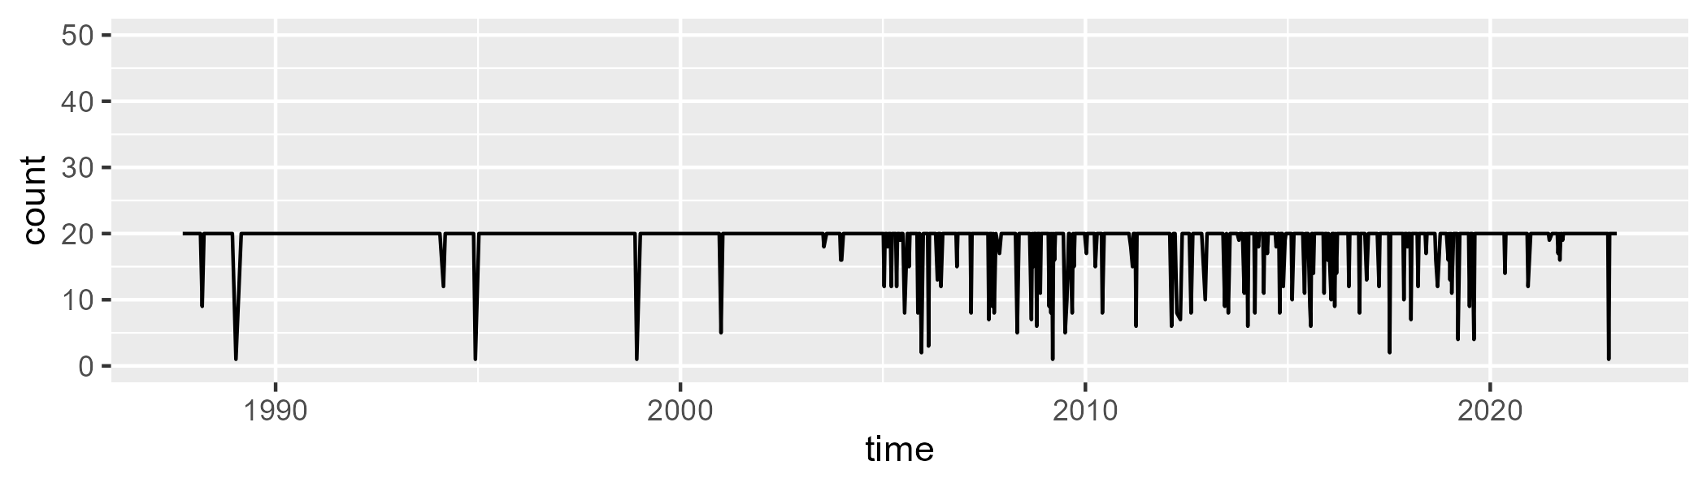

Min. : 1.00 1st Qu.:20.00 Median :20.00 Mean :18.99 3rd Qu.:20.00 Max. :20.00

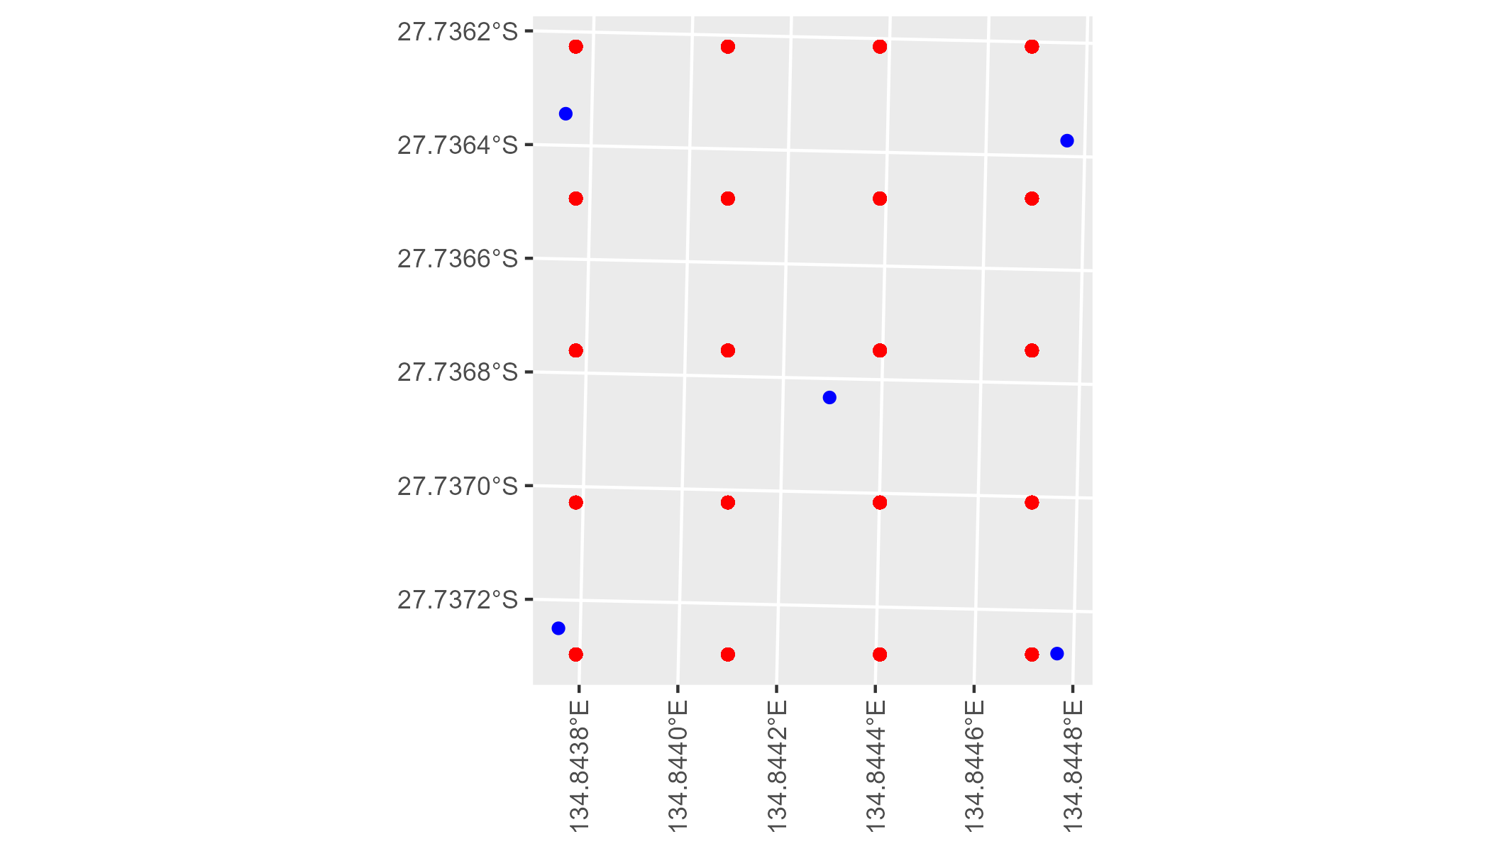

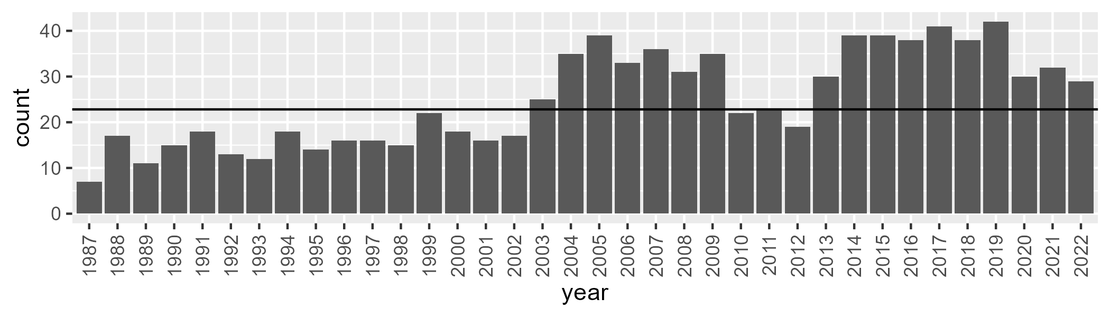

Number of samples: 901

# SAASTP0028

| Min. | 1st Qu. | Median | Mean | 3rd Qu. | Max. |
| --- | --- | --- | --- | --- | --- |
| 0 | 0.5554369 | 1.437016 | 3.565828 | 3.739576 | 39.77628 |

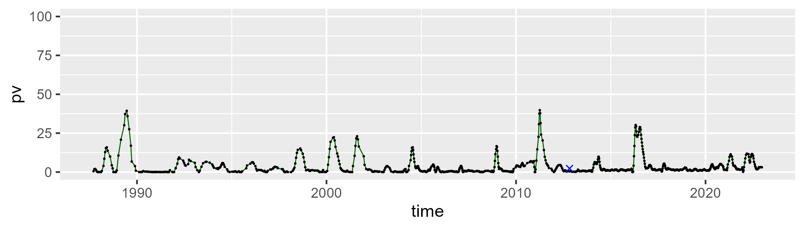

| Min. | 1st Qu. | Median | Mean | 3rd Qu. | Max. |
| --- | --- | --- | --- | --- | --- |
| 24.90034 | 37.52695 | 40.05844 | 40.66608 | 43.35368 | 64.5612 |

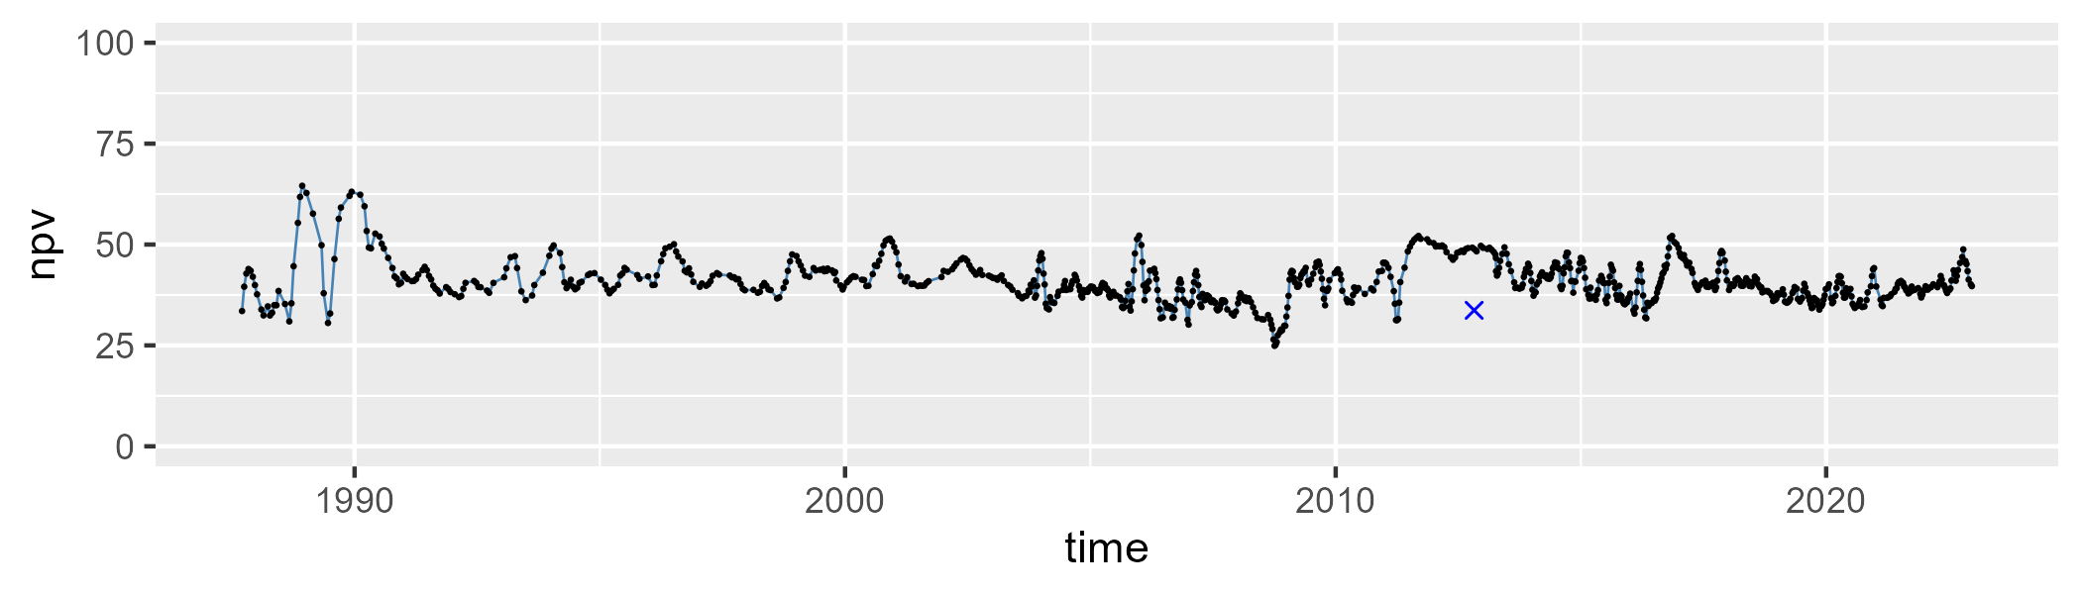

| Min. | 1st Qu. | Median | Mean | 3rd Qu. | Max. |
| --- | --- | --- | --- | --- | --- |
| 18.723 | 50.74614 | 55.81238 | 54.43977 | 59.20143 | 73.15129 |

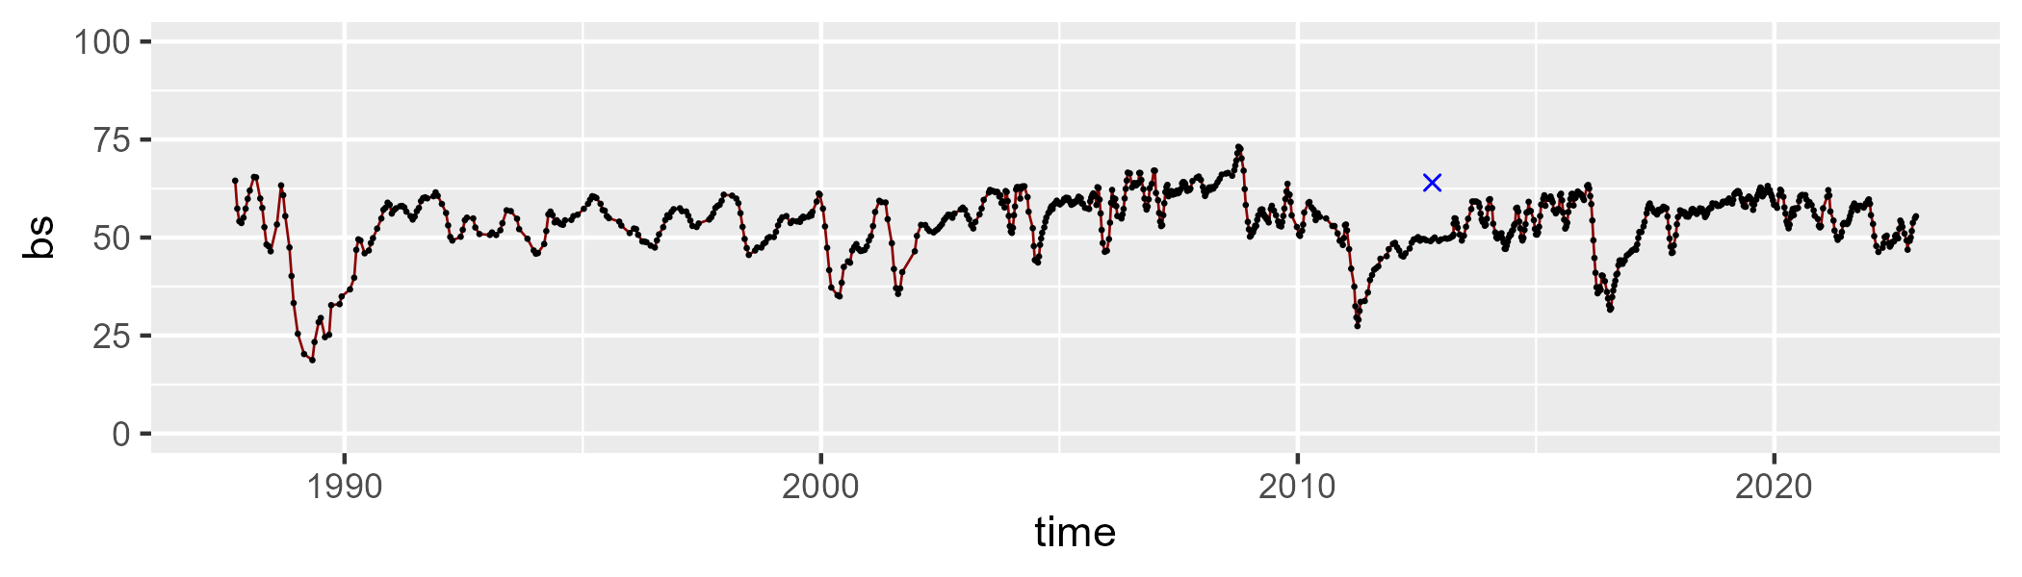

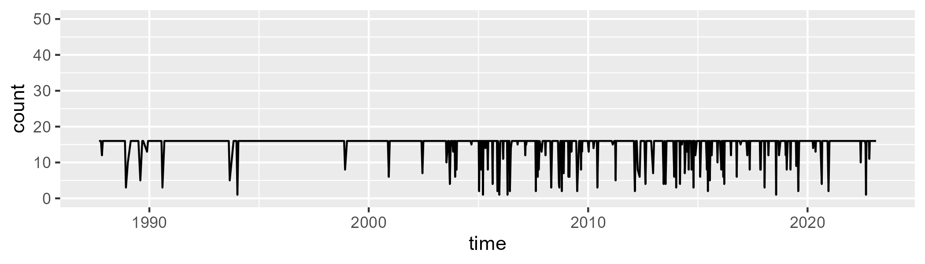

Min. : 1 1st Qu.:16 Median :16 Mean :15 3rd Qu.:16 Max. :16

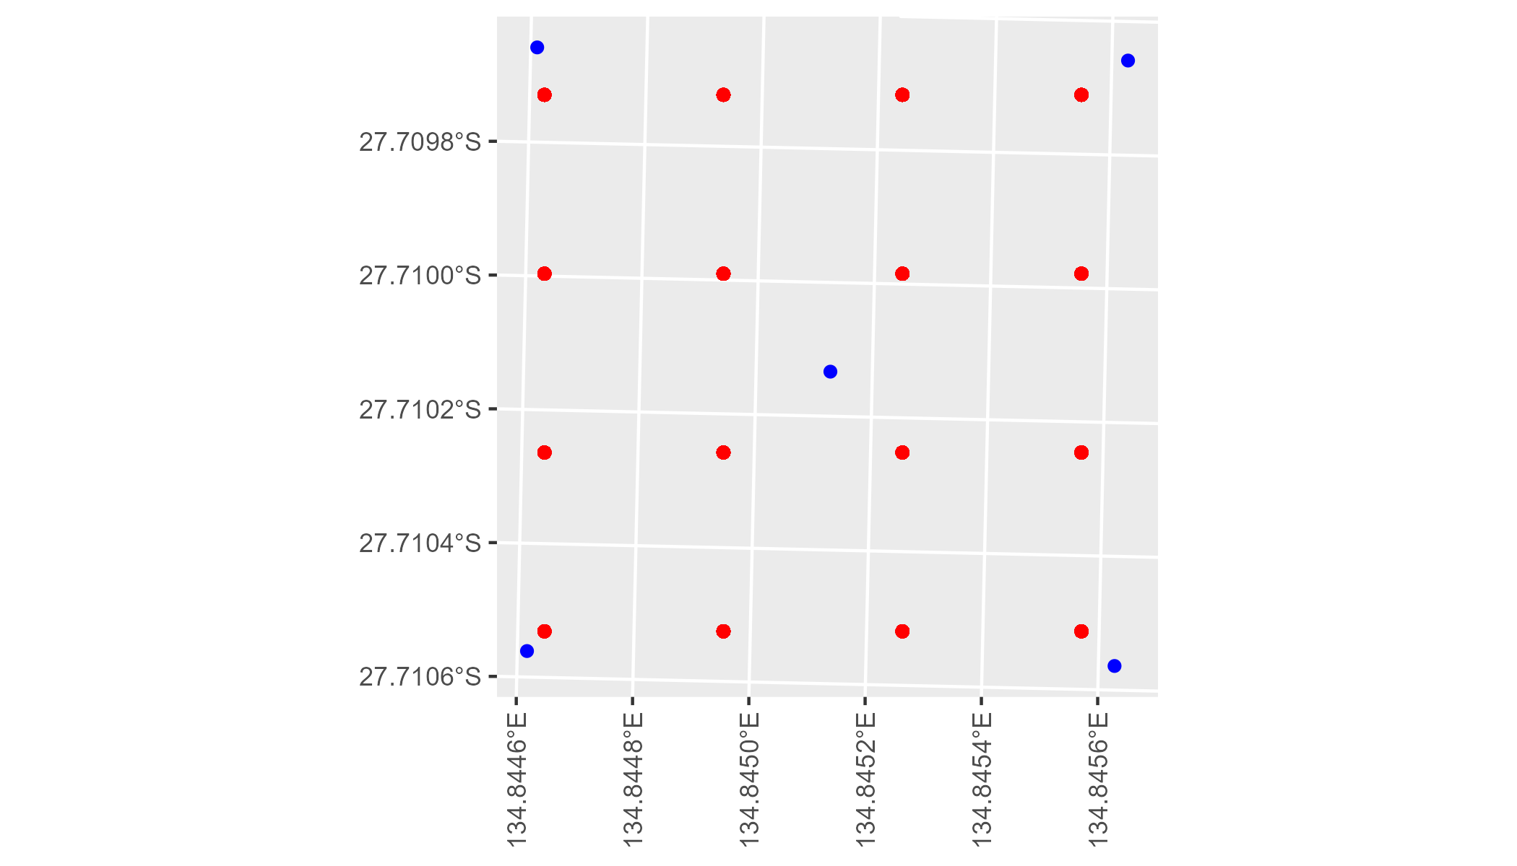

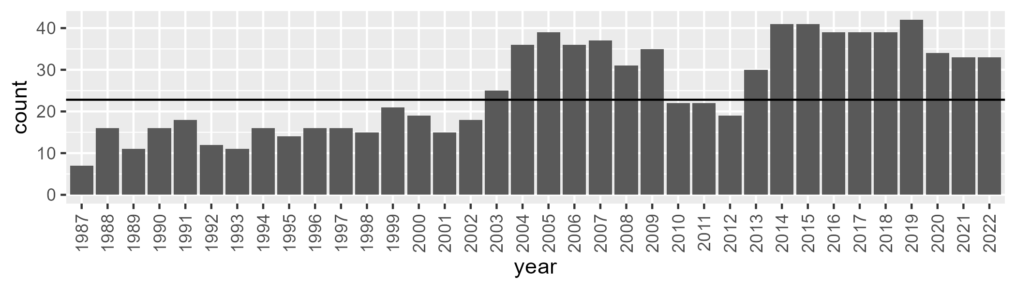

Number of samples: 914

# SAASTP0029

| Min. | 1st Qu. | Median | Mean | 3rd Qu. | Max. |
| --- | --- | --- | --- | --- | --- |
| 0 | 0.004516768 | 0.3490604 | 0.7085818 | 1.056649 | 16.71999 |

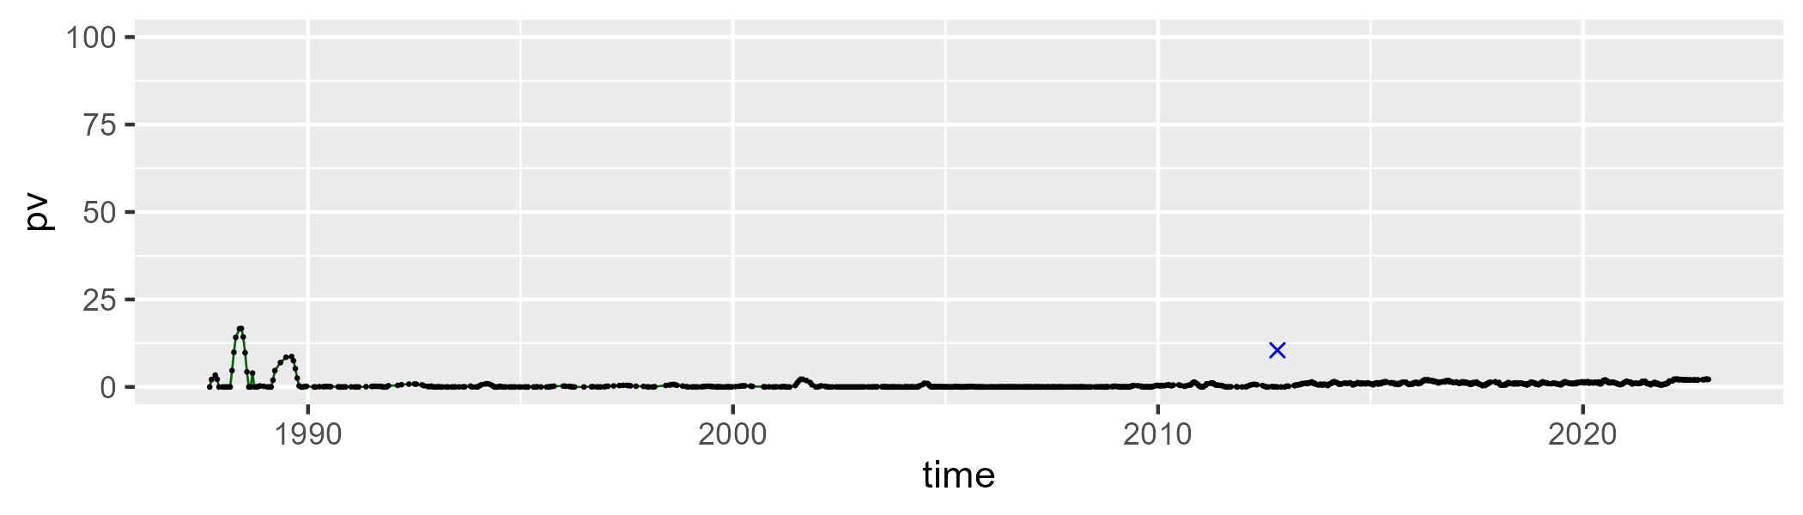

| Min. | 1st Qu. | Median | Mean | 3rd Qu. | Max. |
| --- | --- | --- | --- | --- | --- |
| 30.13587 | 37.8136 | 39.81854 | 40.57528 | 42.47931 | 57.76306 |

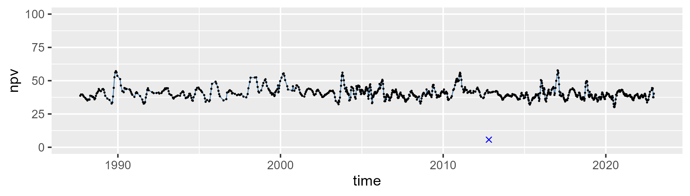

| Min. | 1st Qu. | Median | Mean | 3rd Qu. | Max. |
| --- | --- | --- | --- | --- | --- |
| 39.80359 | 56.14559 | 58.40218 | 57.84478 | 60.54588 | 67.86581 |

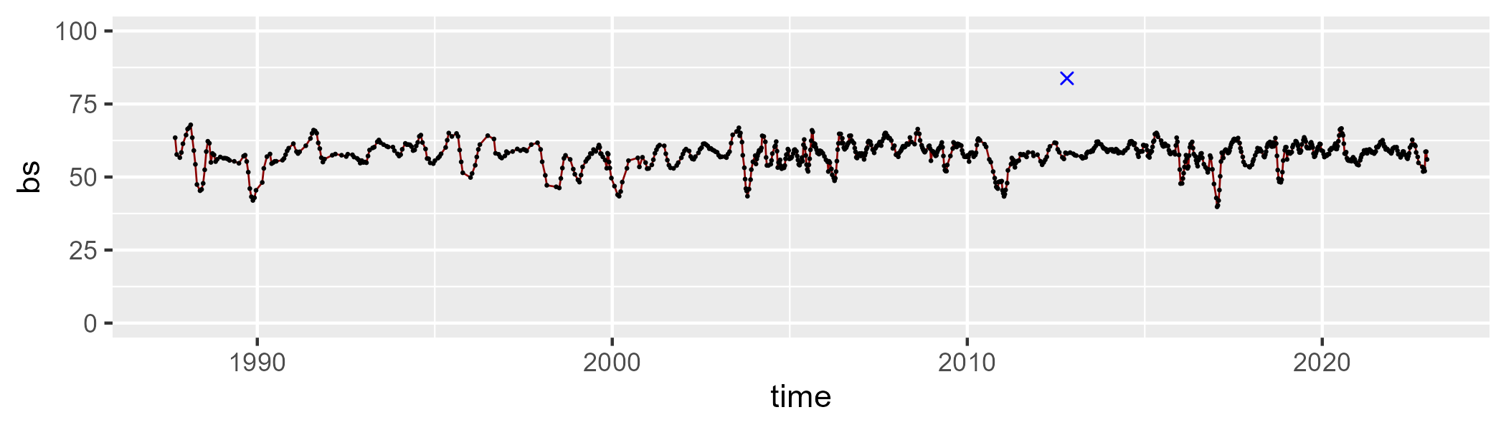

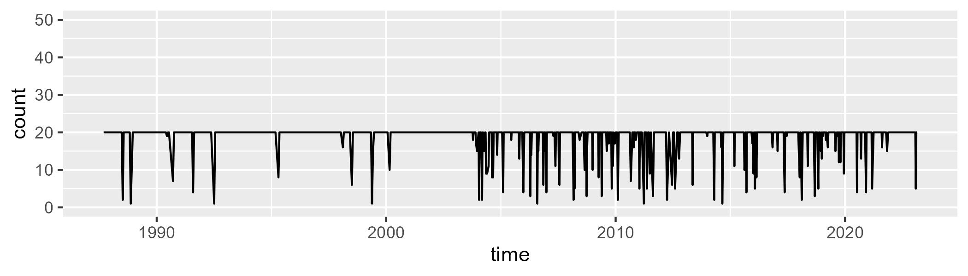

Min. : 1.00 1st Qu.:20.00 Median :20.00 Mean :18.76 3rd Qu.:20.00 Max. :20.00

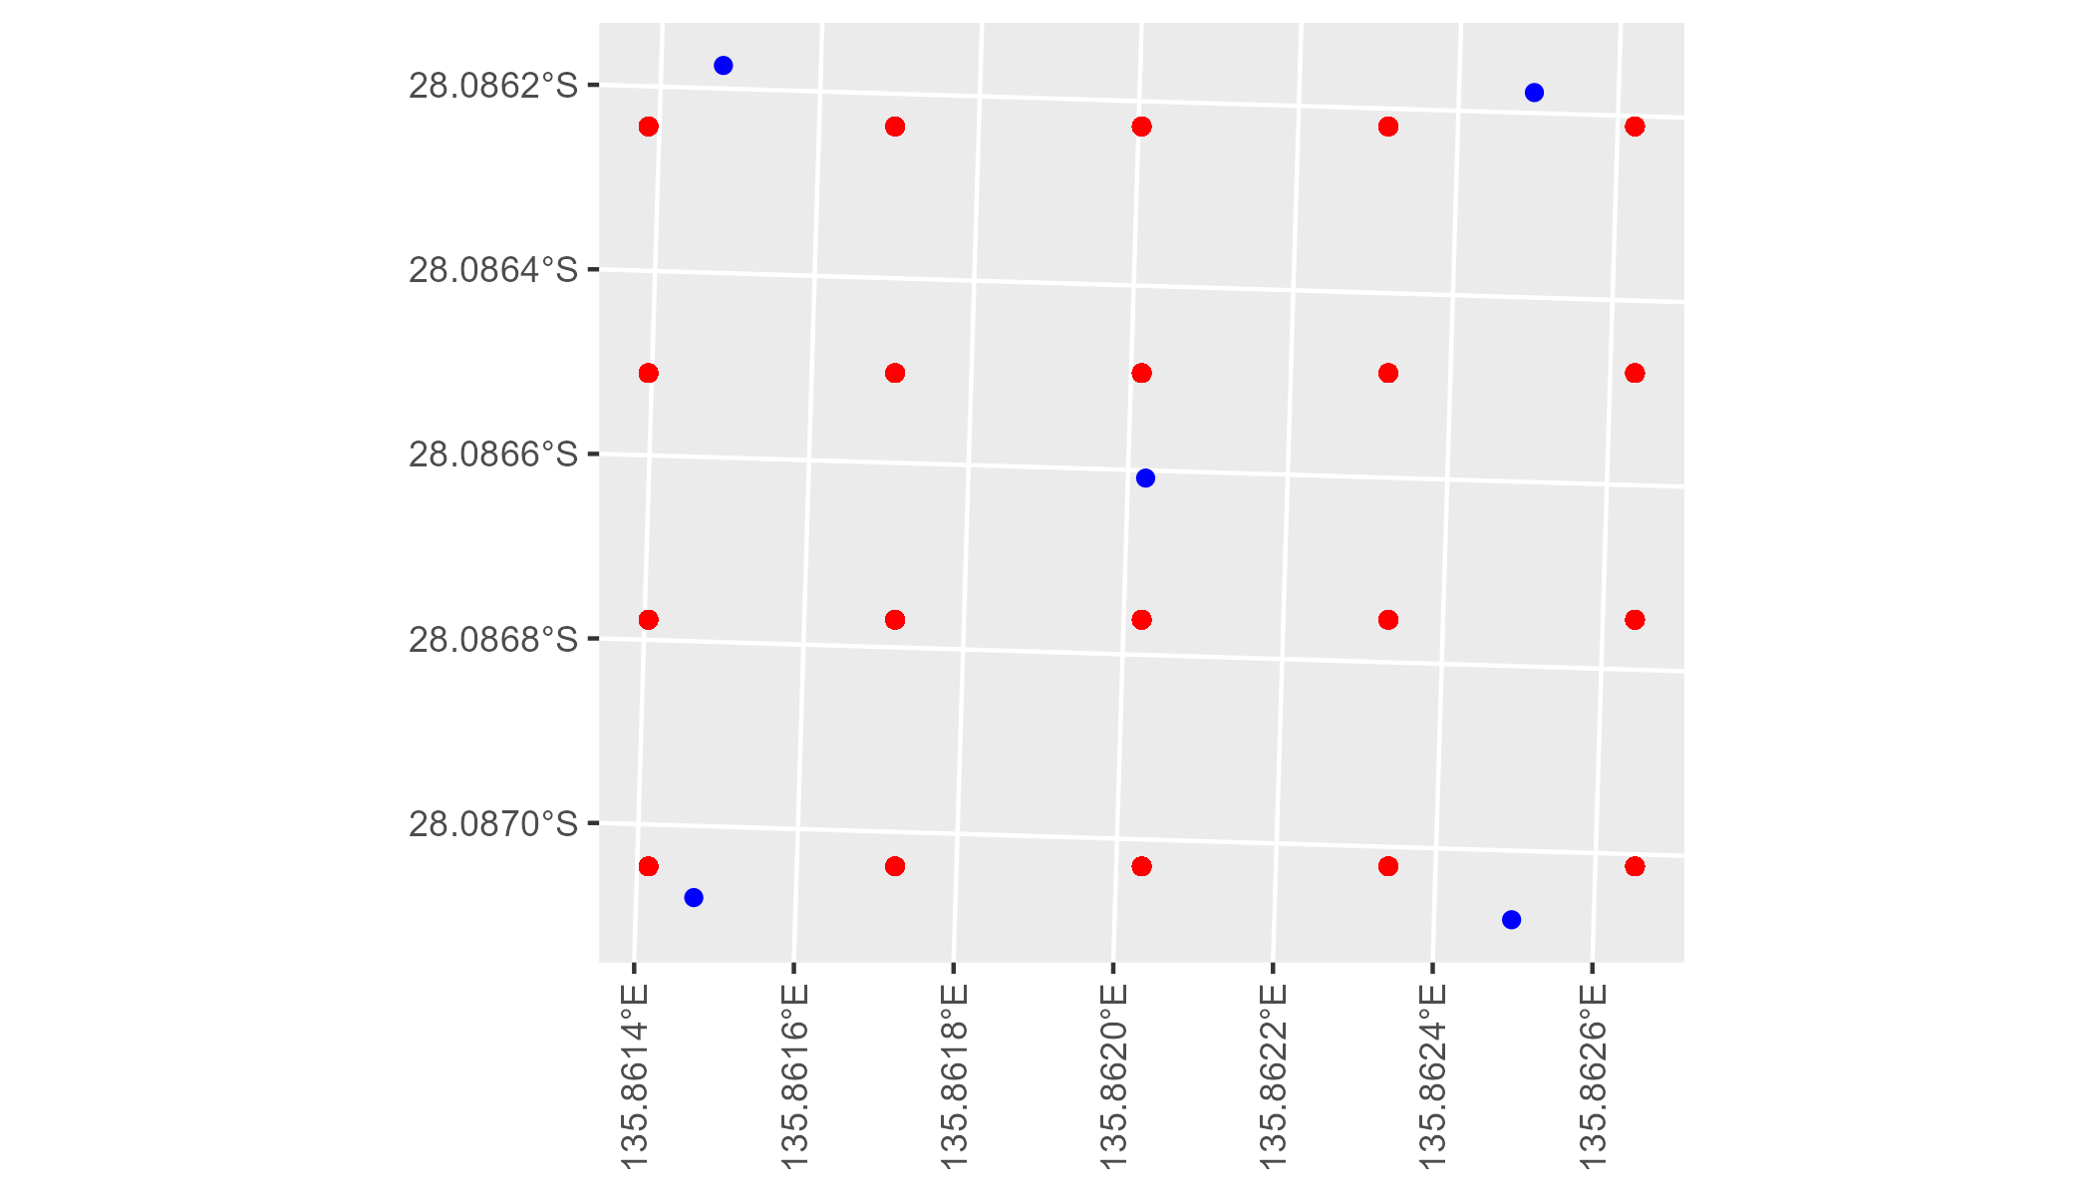

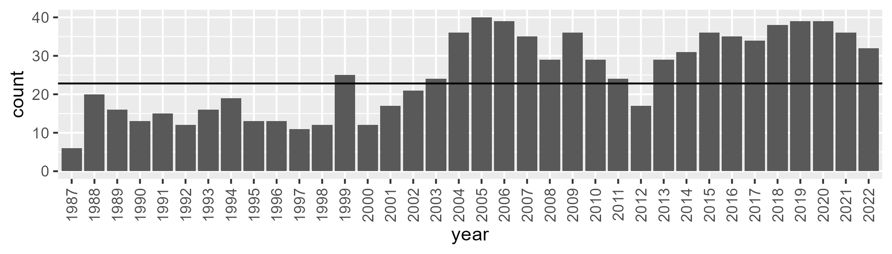

Number of samples: 899

# SAASTP0030

| Min. | 1st Qu. | Median | Mean | 3rd Qu. | Max. |
| --- | --- | --- | --- | --- | --- |
| 0 | 2.568352 | 4.493303 | 5.931903 | 8.283478 | 24.23585 |

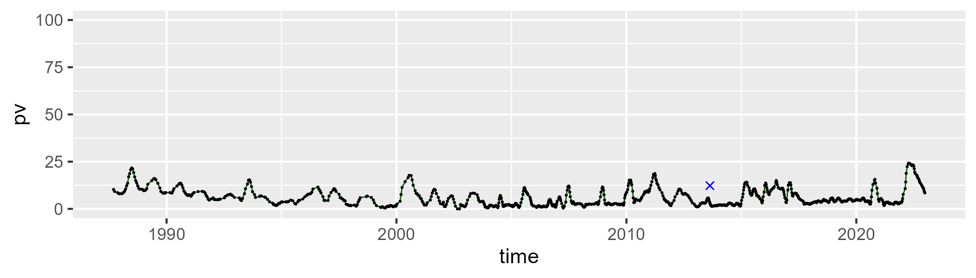

| Min. | 1st Qu. | Median | Mean | 3rd Qu. | Max. |
| --- | --- | --- | --- | --- | --- |
| 0 | 14.77183 | 22.00078 | 22.89528 | 30.0737 | 56.2352 |

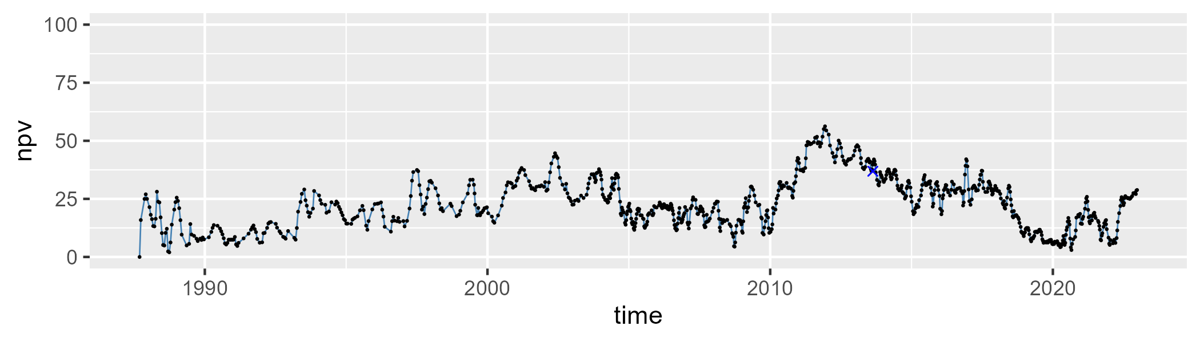

| Min. | 1st Qu. | Median | Mean | 3rd Qu. | Max. |
| --- | --- | --- | --- | --- | --- |
| 34.80879 | 61.52028 | 71.31684 | 69.65827 | 78.50385 | 92.41362 |

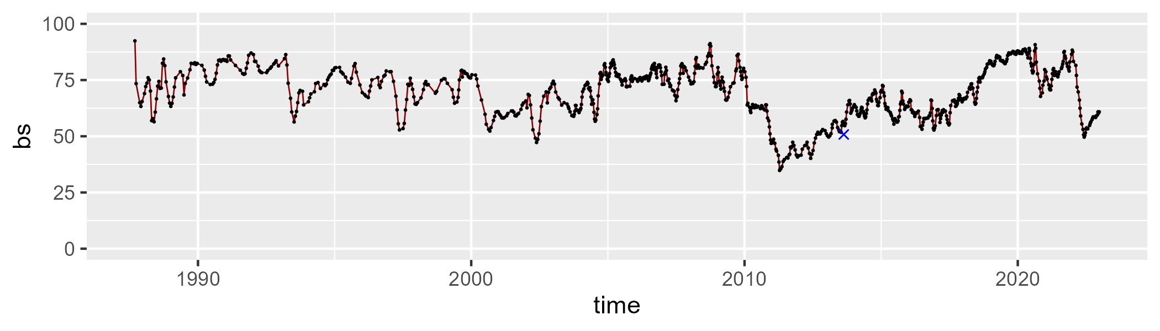

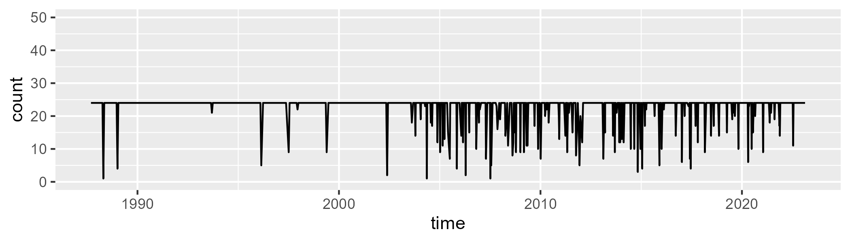

Min. : 1.00 1st Qu.:24.00 Median :24.00 Mean :22.62 3rd Qu.:24.00 Max. :24.00

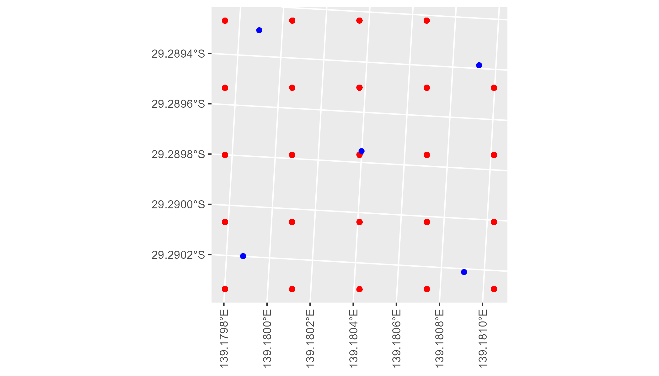

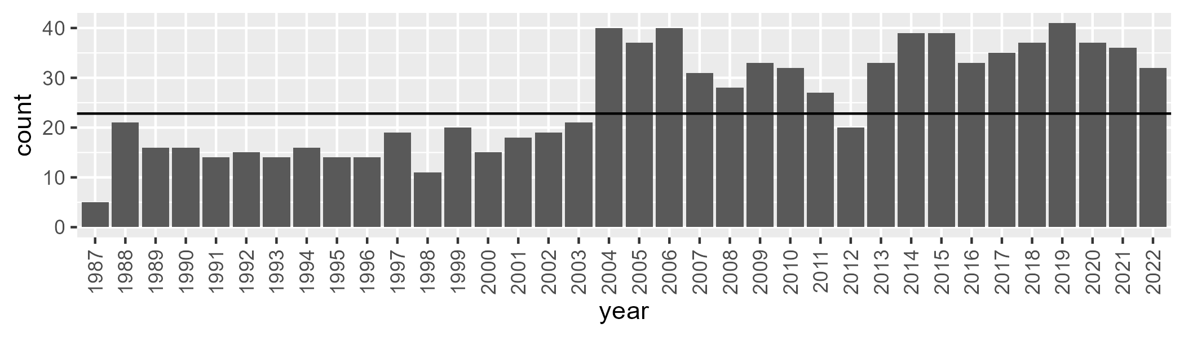

Number of samples: 918

# SAASTP0031

| Min. | 1st Qu. | Median | Mean | 3rd Qu. | Max. |
| --- | --- | --- | --- | --- | --- |
| 0 | 1.010902 | 2.848273 | 4.371865 | 5.997896 | 26.19203 |

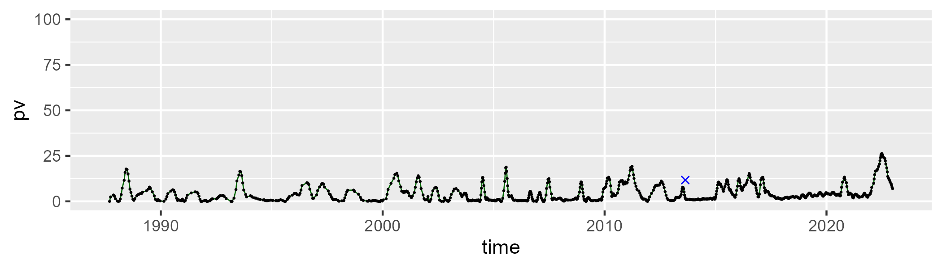

| Min. | 1st Qu. | Median | Mean | 3rd Qu. | Max. |
| --- | --- | --- | --- | --- | --- |
| 2.056 | 22.13406 | 28.00865 | 27.75625 | 34.05706 | 58.48932 |

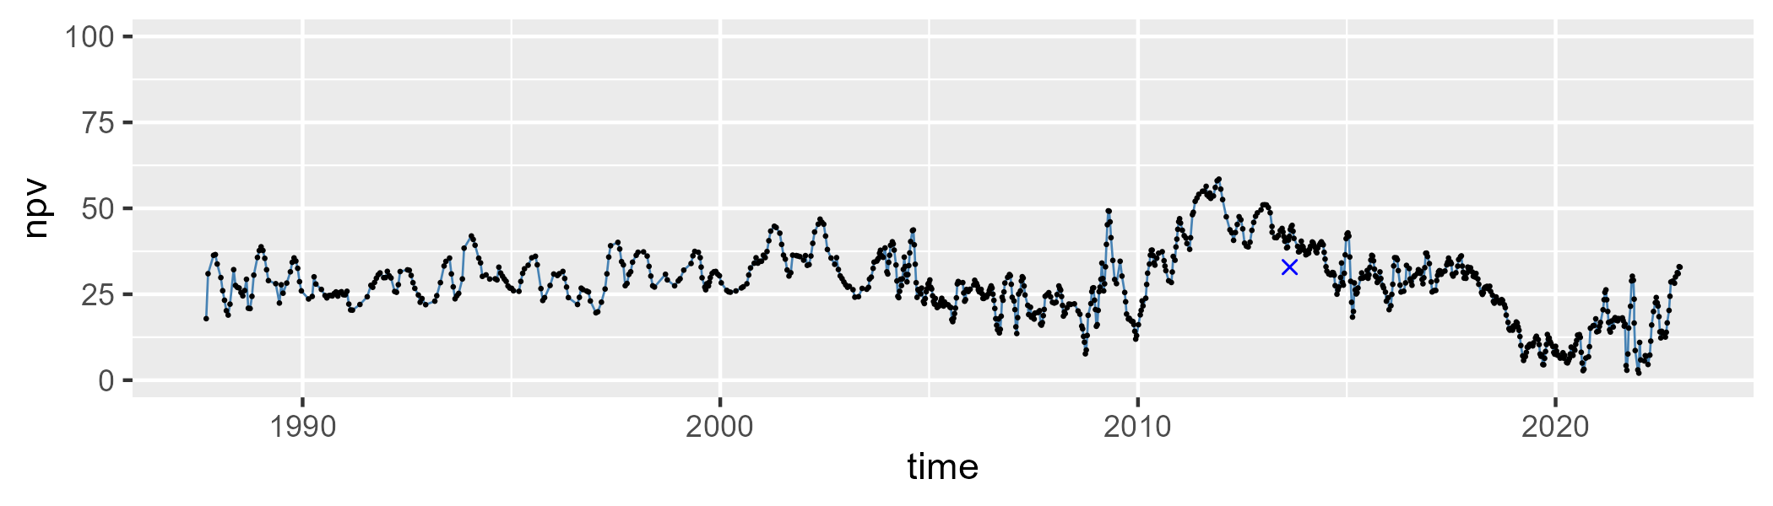

| Min. | 1st Qu. | Median | Mean | 3rd Qu. | Max. |
| --- | --- | --- | --- | --- | --- |
| 35.85944 | 59.12841 | 66.73135 | 66.41688 | 73.30621 | 91.31073 |

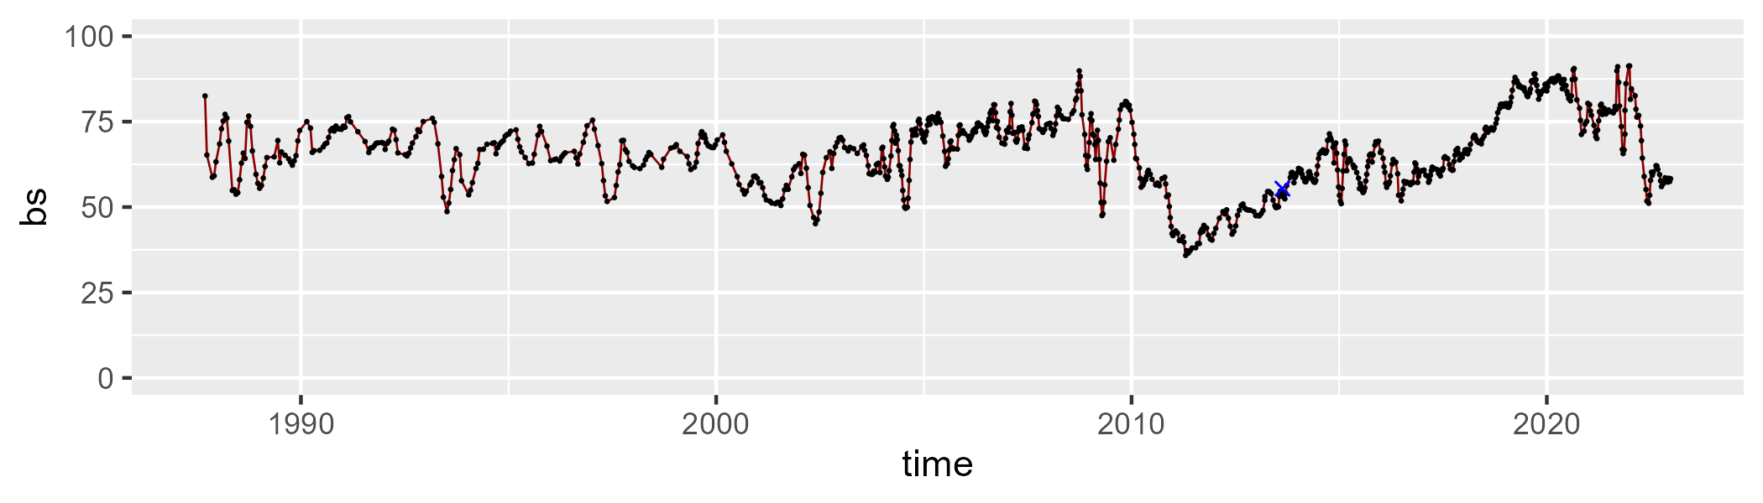

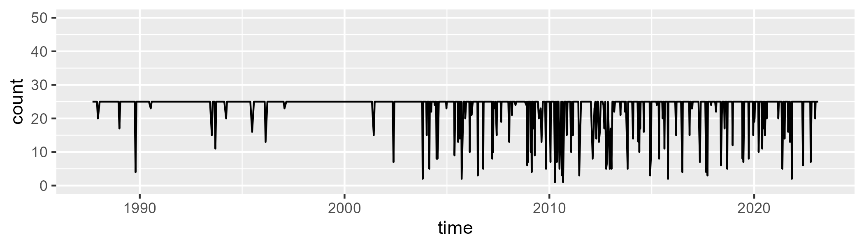

Min. : 1.00 1st Qu.:25.00 Median :25.00 Mean :23.33 3rd Qu.:25.00 Max. :25.00

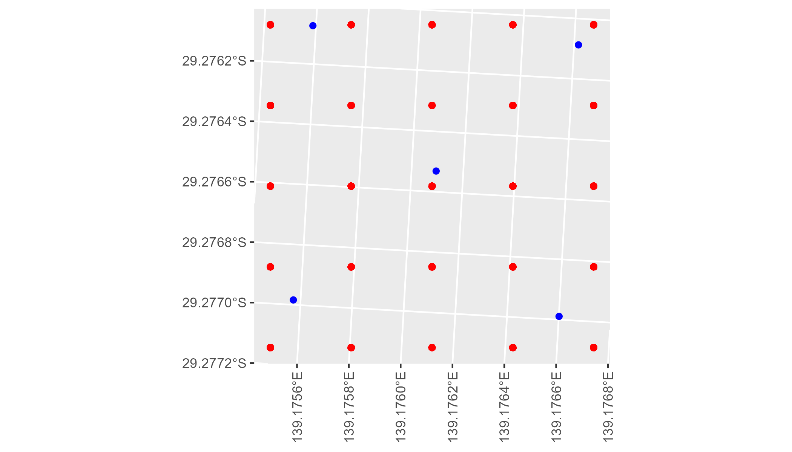

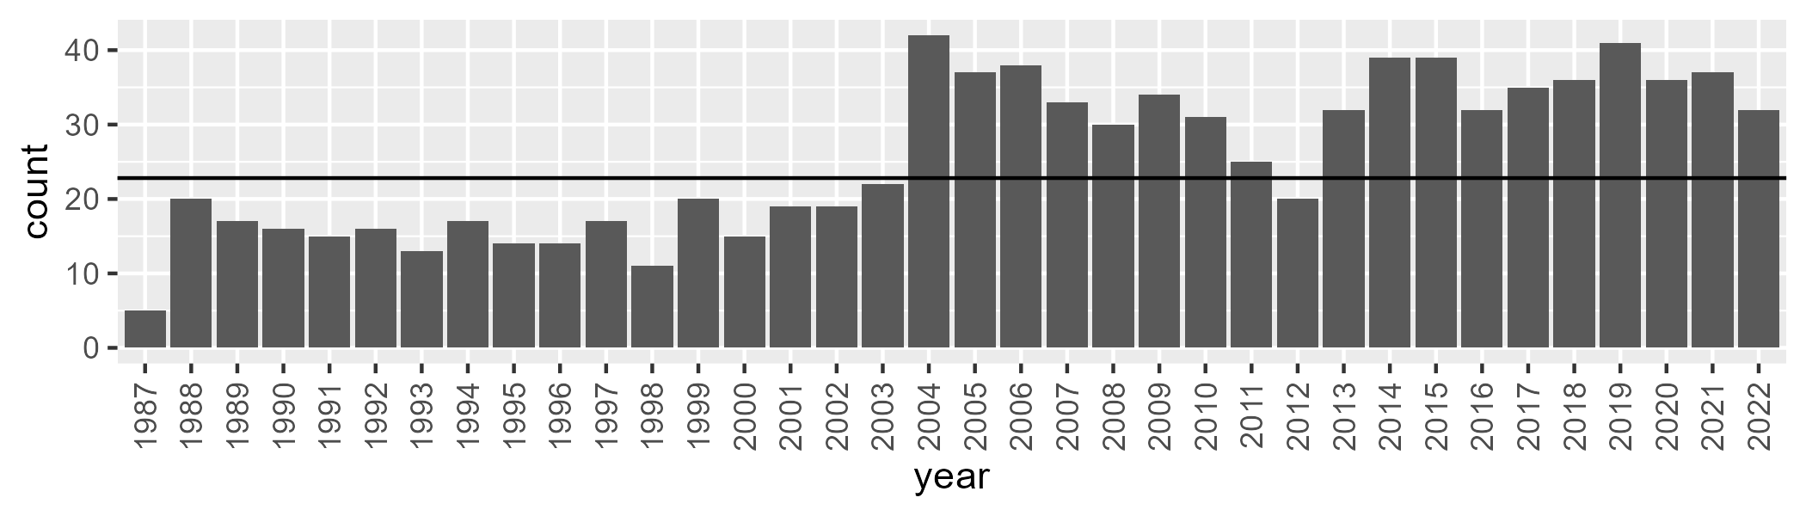

Number of samples: 919

# SAASTP0032

| Min. | 1st Qu. | Median | Mean | 3rd Qu. | Max. |
| --- | --- | --- | --- | --- | --- |
| 0 | 0.2586736 | 1.175989 | 2.974715 | 3.456204 | 24.23924 |

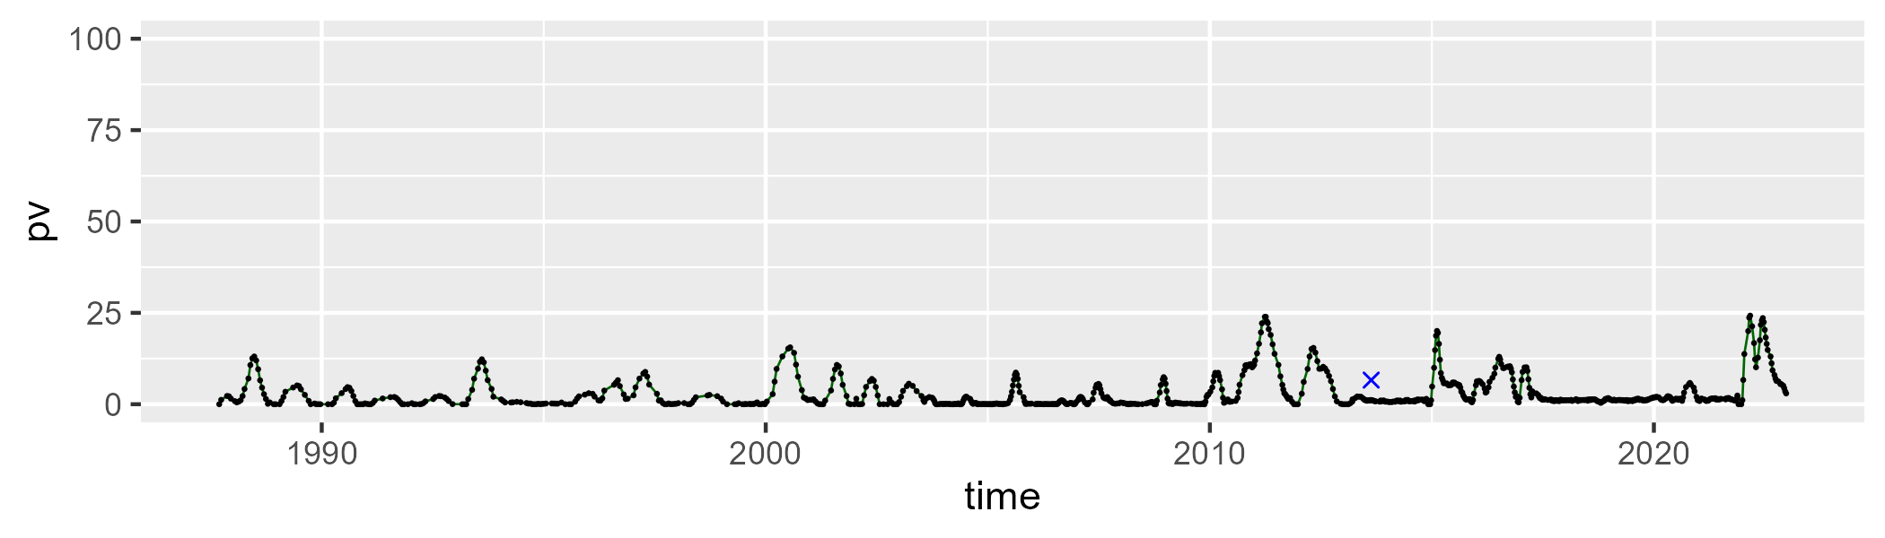

| Min. | 1st Qu. | Median | Mean | 3rd Qu. | Max. |
| --- | --- | --- | --- | --- | --- |
| 7.658355 | 24.66306 | 32.21006 | 33.19872 | 40.42817 | 68.30541 |

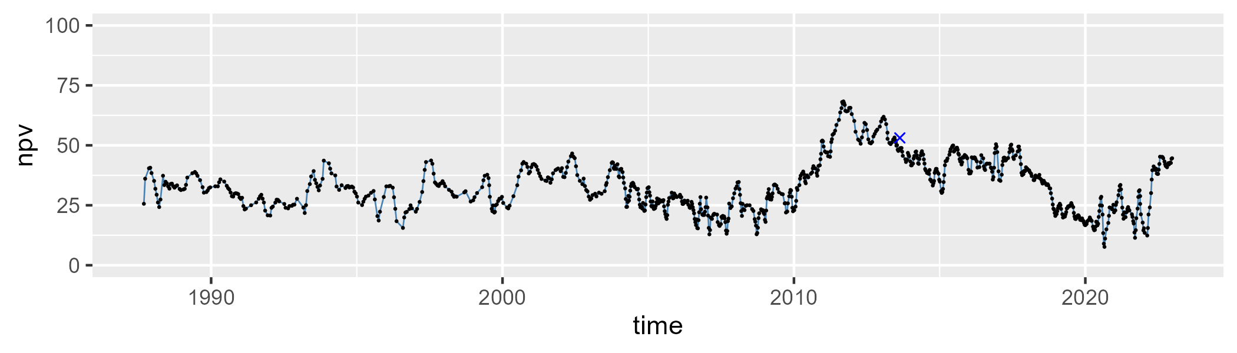

| Min. | 1st Qu. | Median | Mean | 3rd Qu. | Max. |
| --- | --- | --- | --- | --- | --- |
| 23.68278 | 53.0825 | 65.3687 | 62.52086 | 72.63916 | 88.60669 |

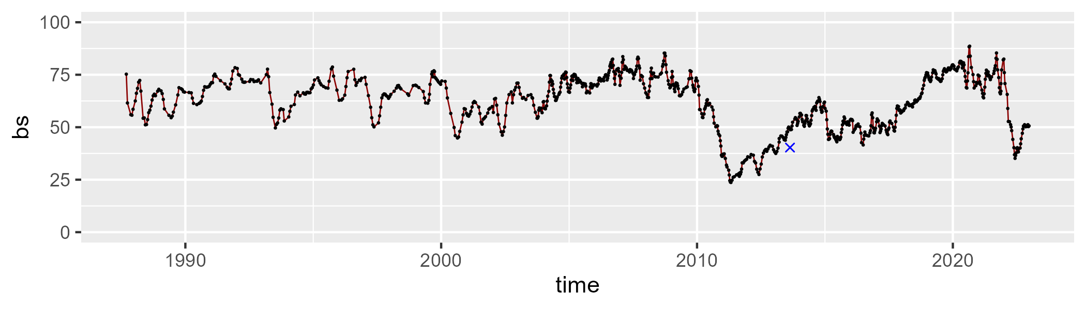

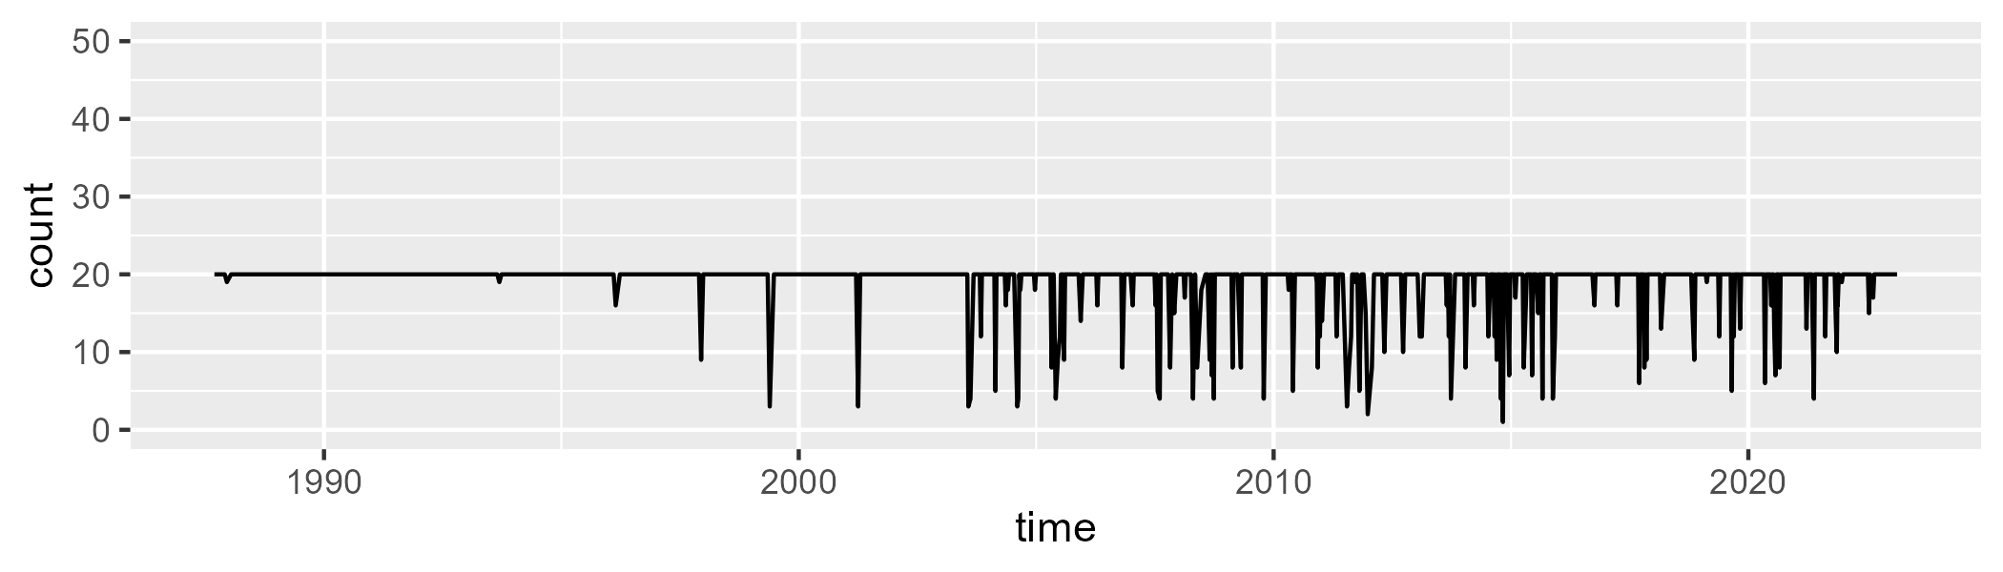

Min. : 1.00 1st Qu.:20.00 Median :20.00 Mean :18.92 3rd Qu.:20.00 Max. :20.00

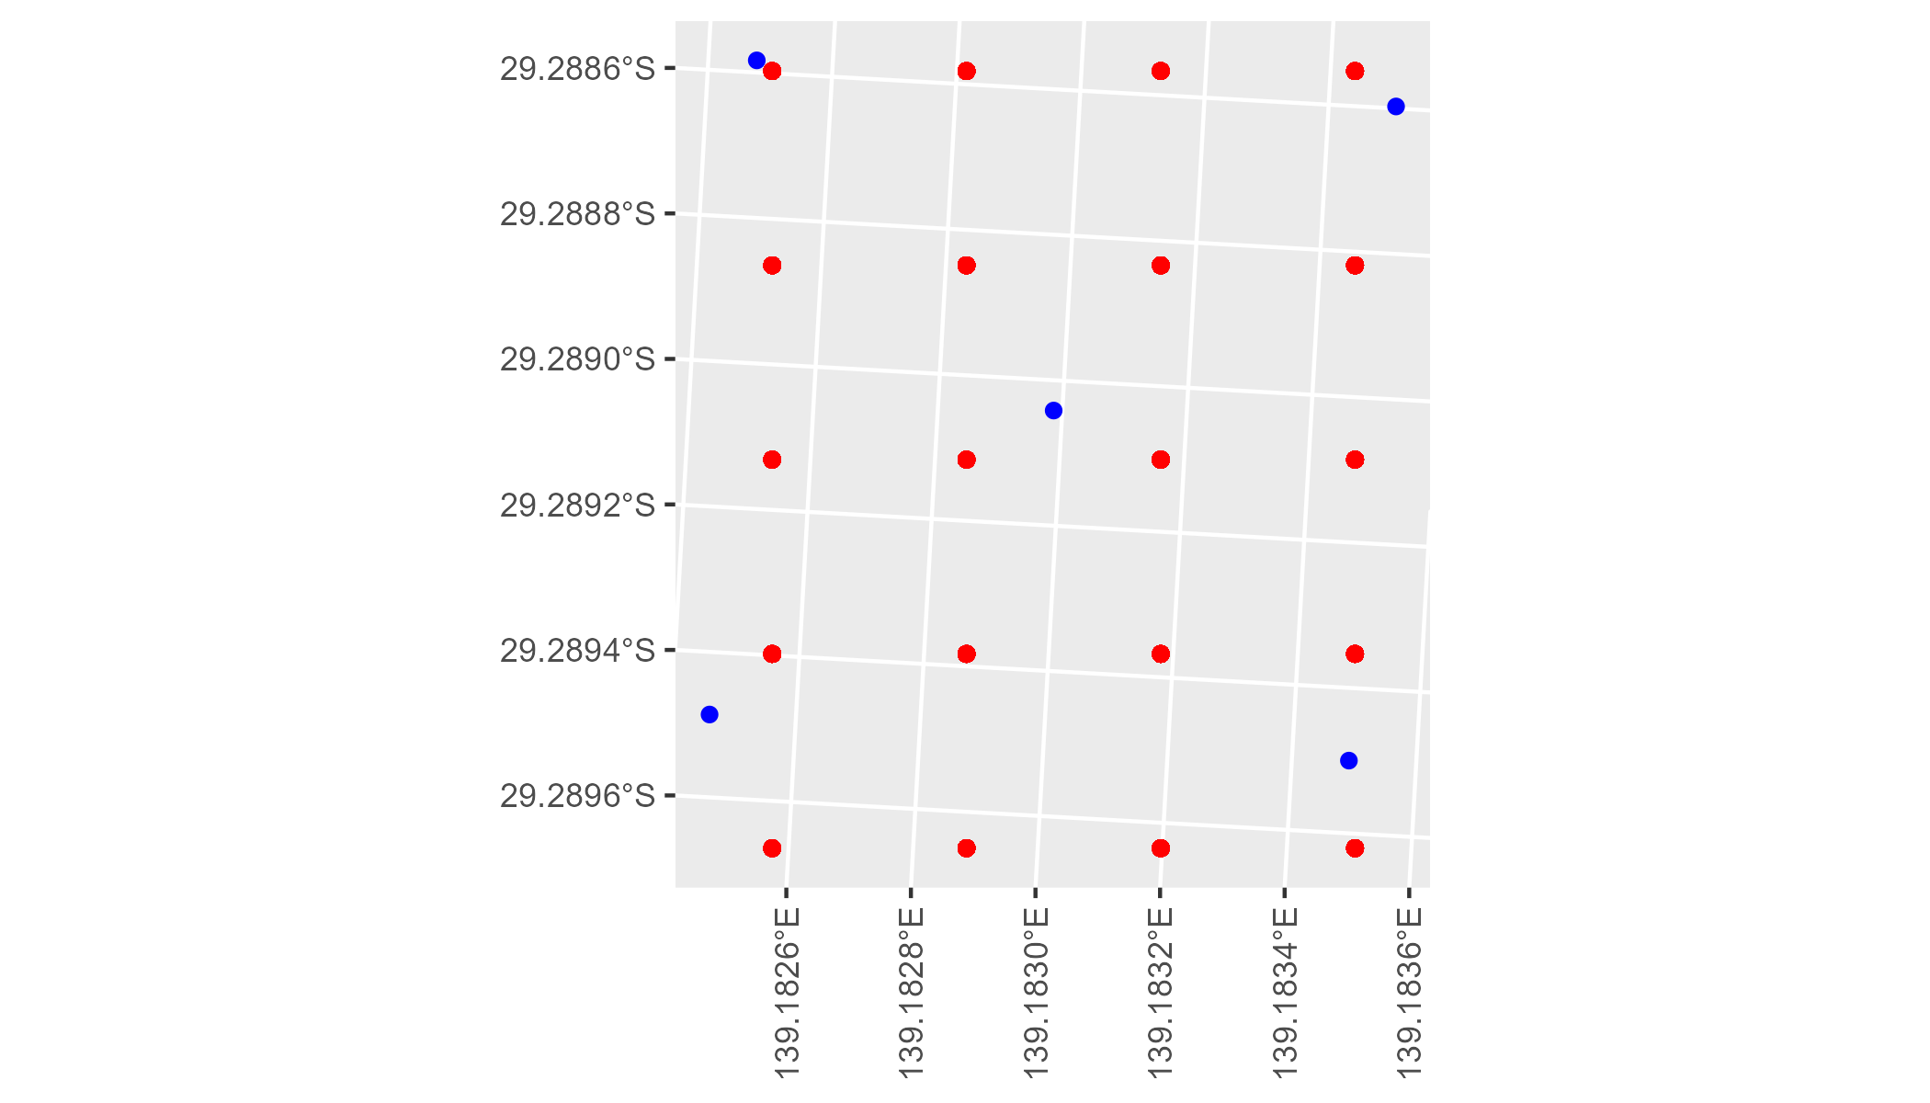

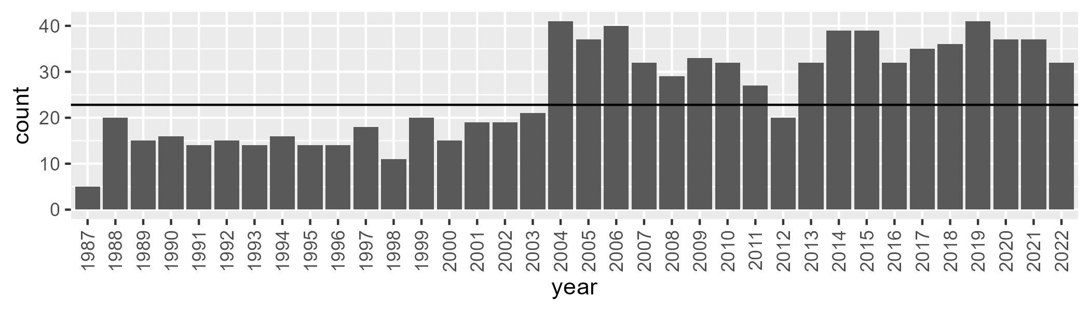

Number of samples: 917

# SAASTP0033

| Min. | 1st Qu. | Median | Mean | 3rd Qu. | Max. |
| --- | --- | --- | --- | --- | --- |
| 0 | 0.8855893 | 1.53171 | 2.344983 | 2.972526 | 26.09101 |

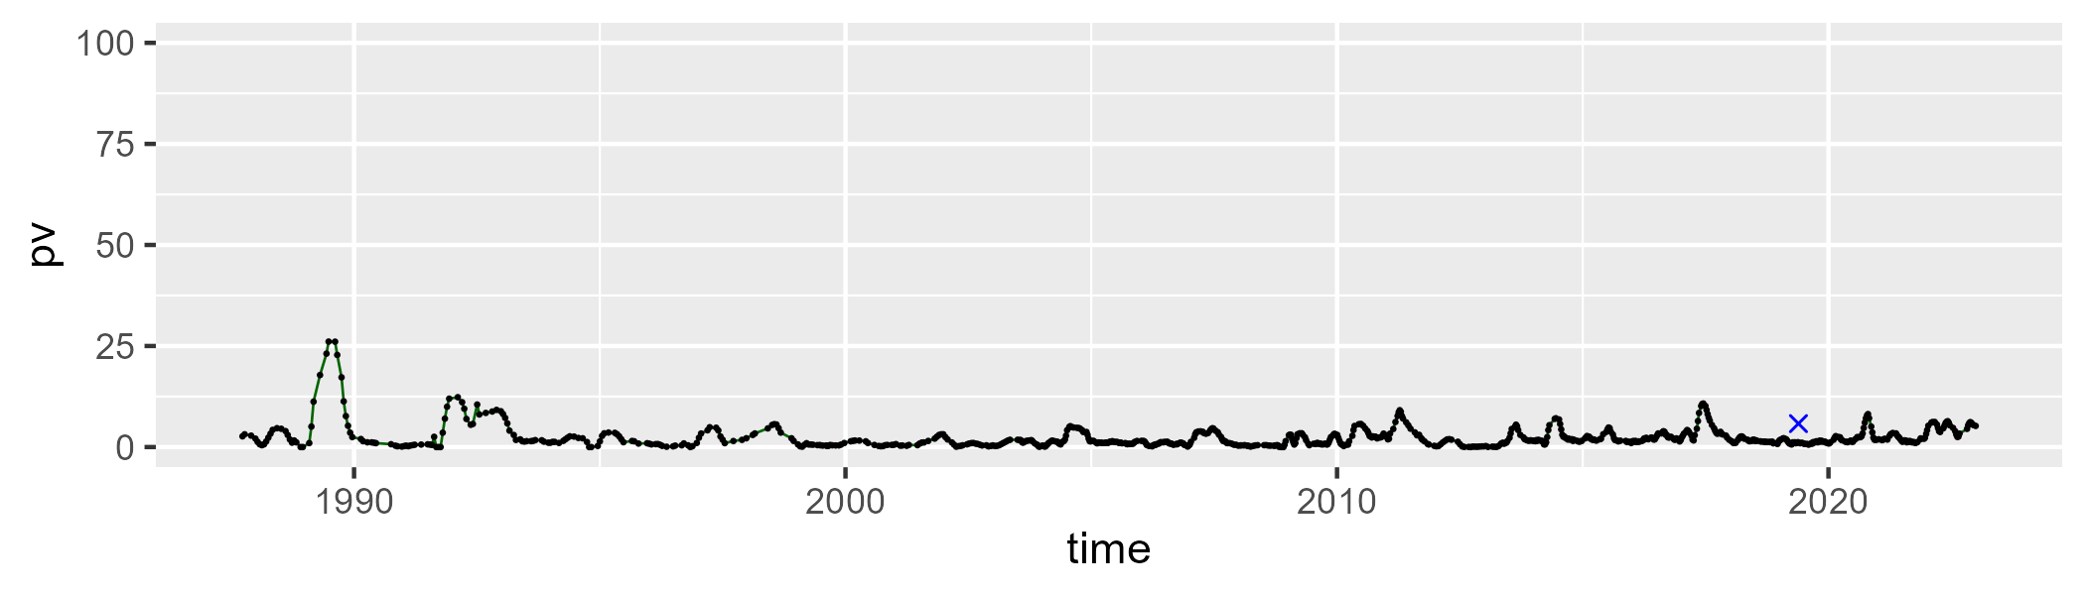

| Min. | 1st Qu. | Median | Mean | 3rd Qu. | Max. |
| --- | --- | --- | --- | --- | --- |
| 27.63415 | 34.96414 | 37.59079 | 37.8761 | 40.64237 | 56.11853 |

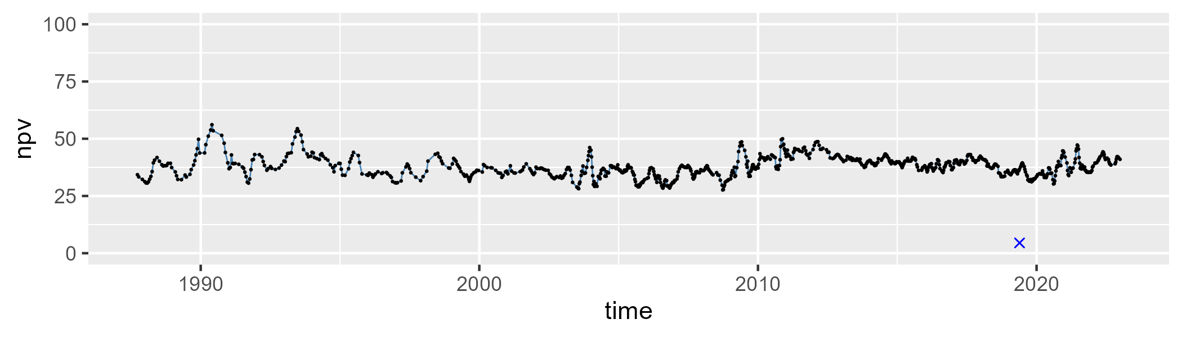

| Min. | 1st Qu. | Median | Mean | 3rd Qu. | Max. |
| --- | --- | --- | --- | --- | --- |
| 37.83611 | 54.89114 | 59.08679 | 58.48094 | 62.42588 | 70.89347 |

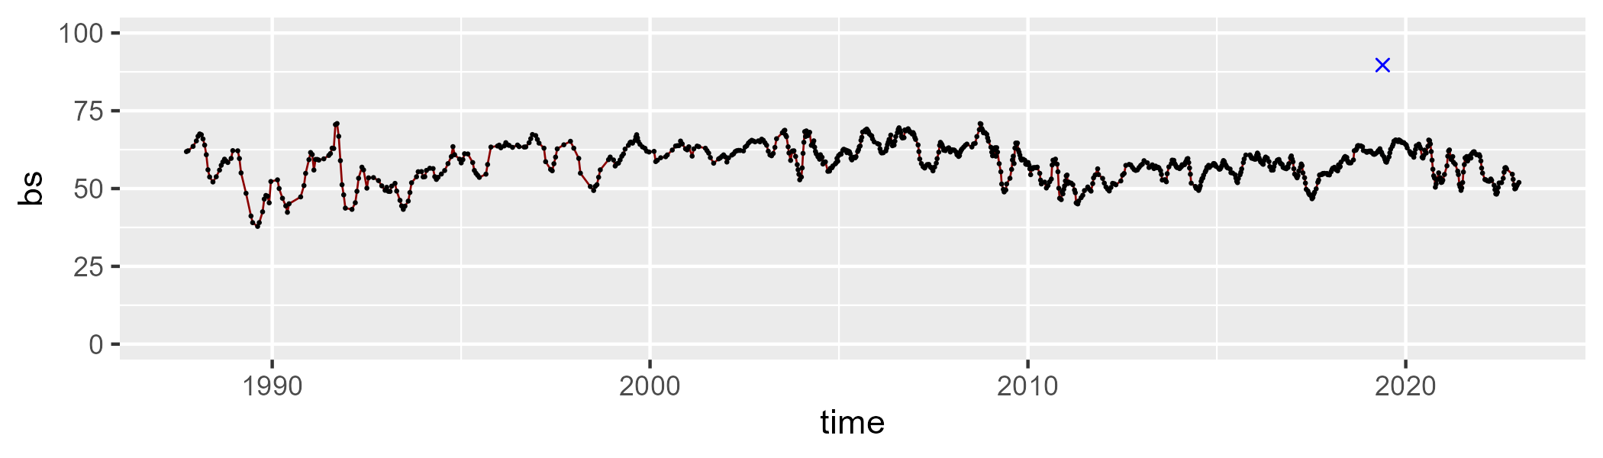

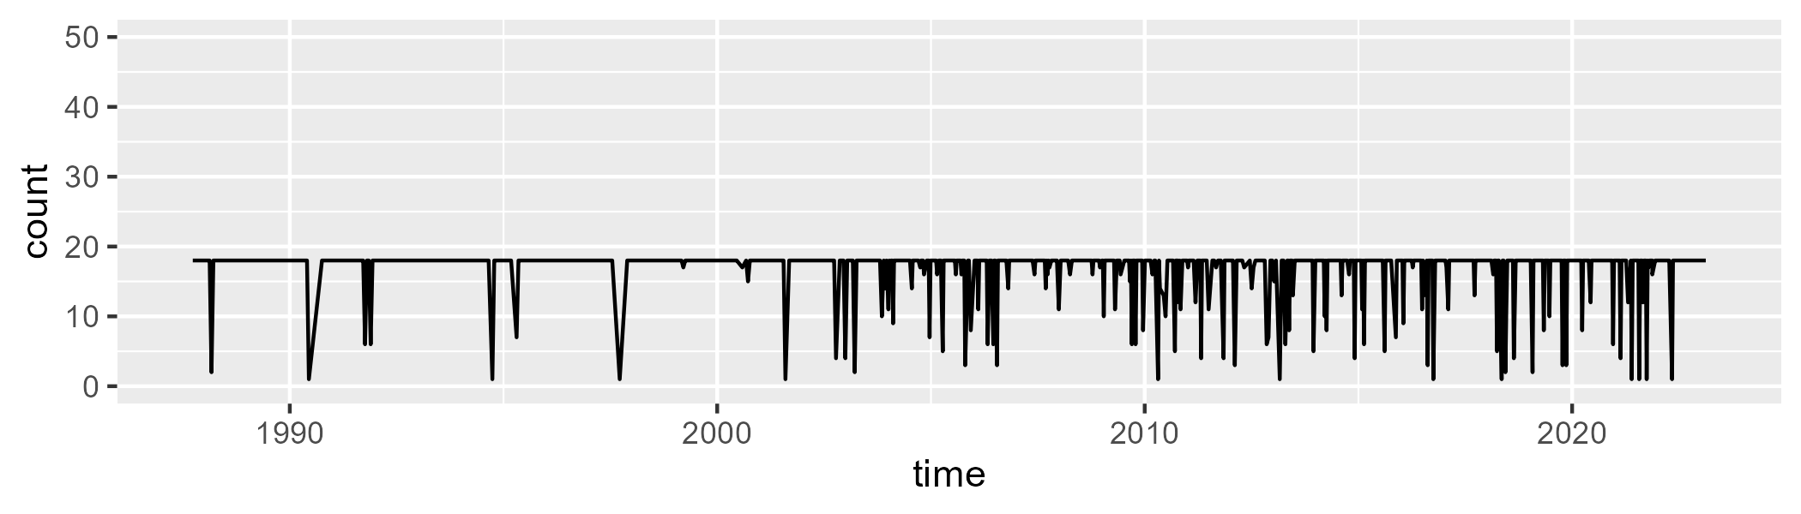

Min. : 1.00 1st Qu.:18.00 Median :18.00 Mean :16.83 3rd Qu.:18.00 Max. :18.00

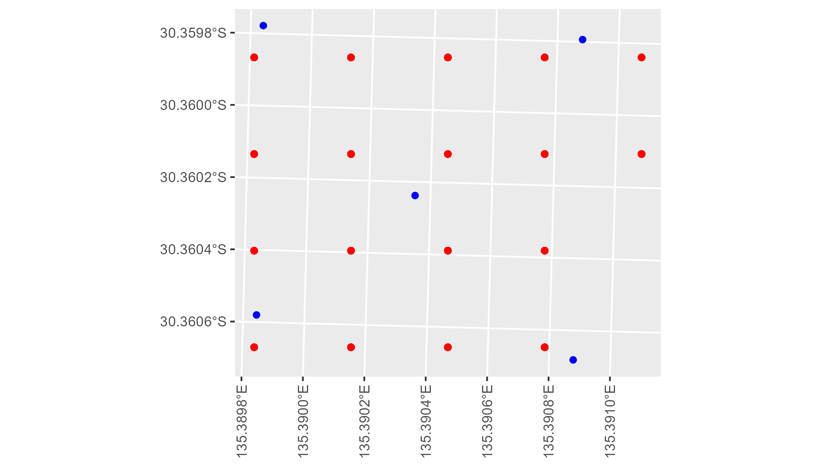

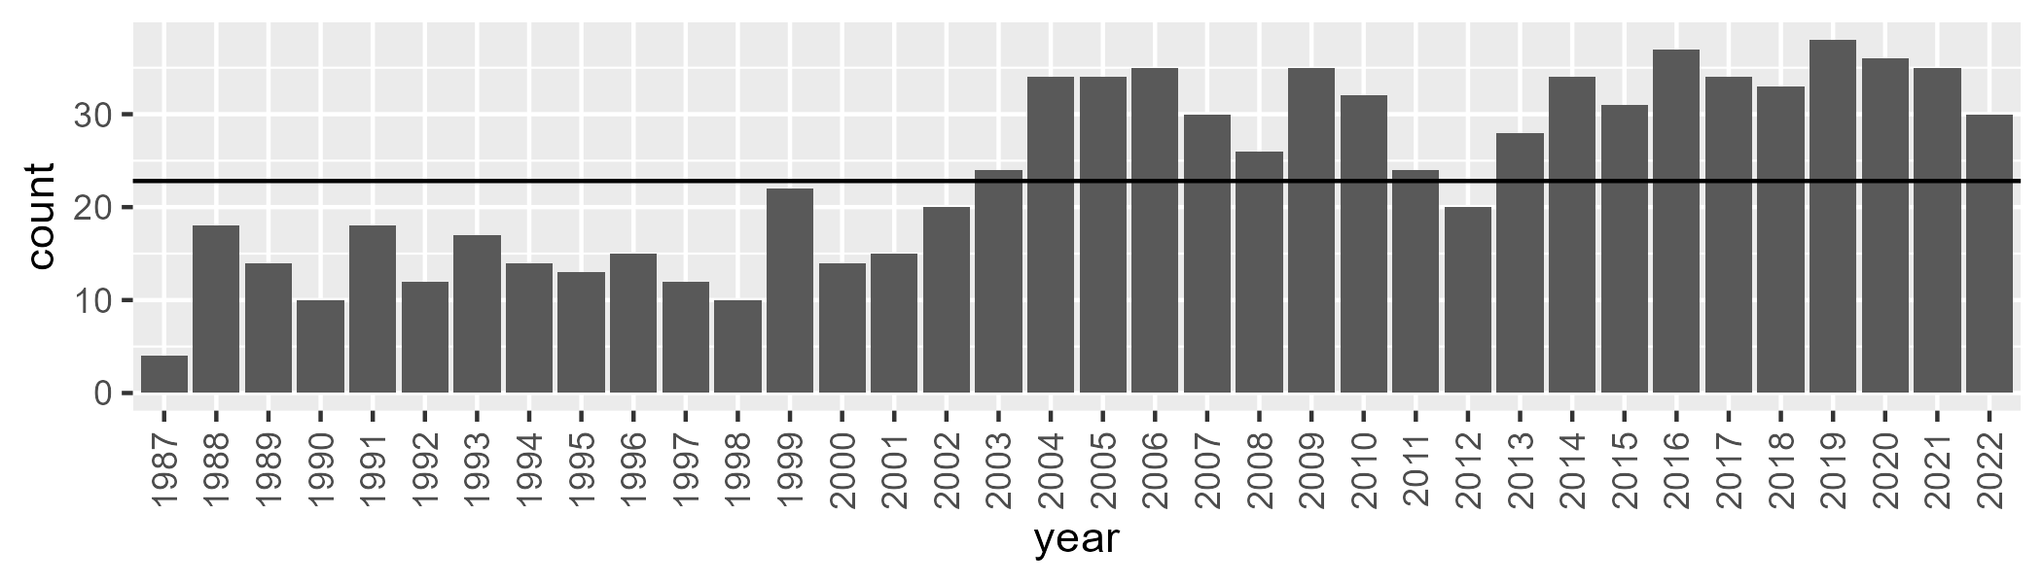

Number of samples: 858

# SAASTP0034

| Min. | 1st Qu. | Median | Mean | 3rd Qu. | Max. |
| --- | --- | --- | --- | --- | --- |
| 0 | 0.6970422 | 1.487926 | 1.991404 | 2.768784 | 14.8617 |

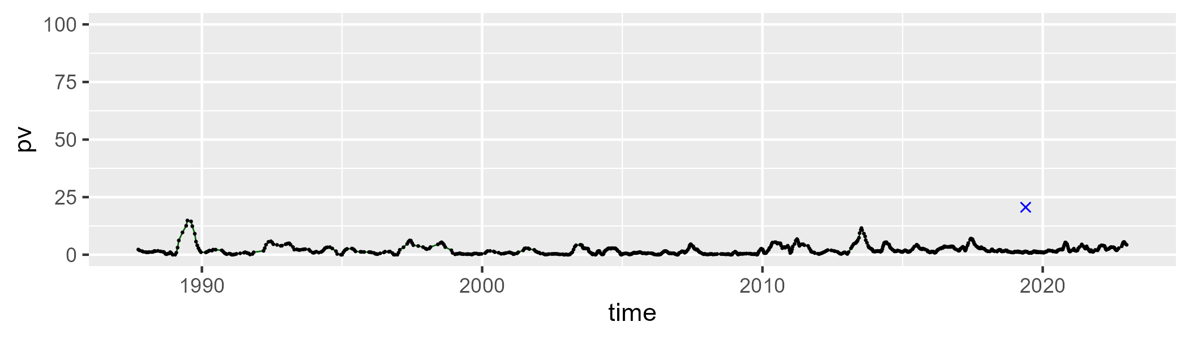

| Min. | 1st Qu. | Median | Mean | 3rd Qu. | Max. |
| --- | --- | --- | --- | --- | --- |
| 23.08972 | 30.41229 | 32.78091 | 33.19136 | 35.64052 | 54.62188 |

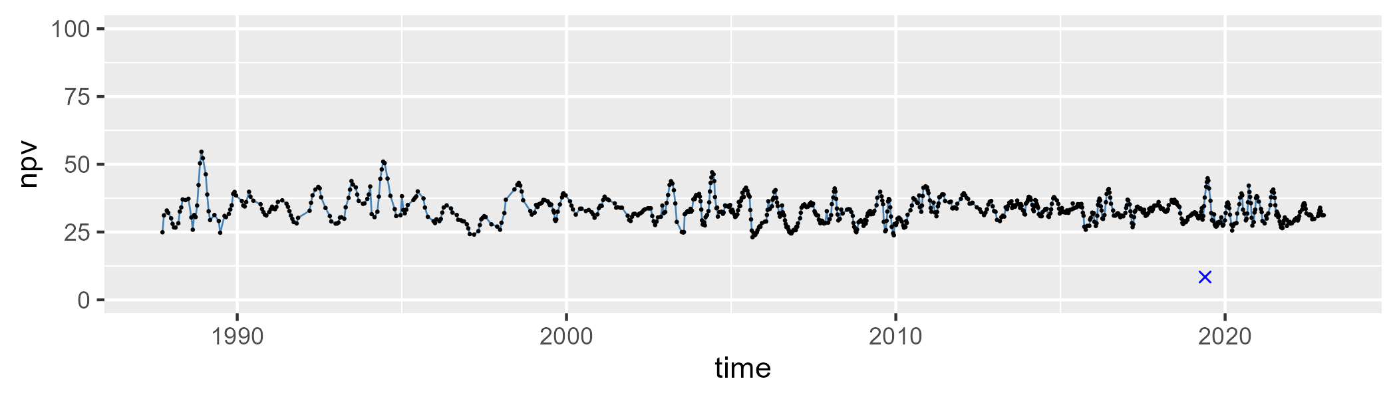

| Min. | 1st Qu. | Median | Mean | 3rd Qu. | Max. |
| --- | --- | --- | --- | --- | --- |
| 43.8401 | 60.40963 | 63.60799 | 63.41208 | 66.65411 | 74.58331 |

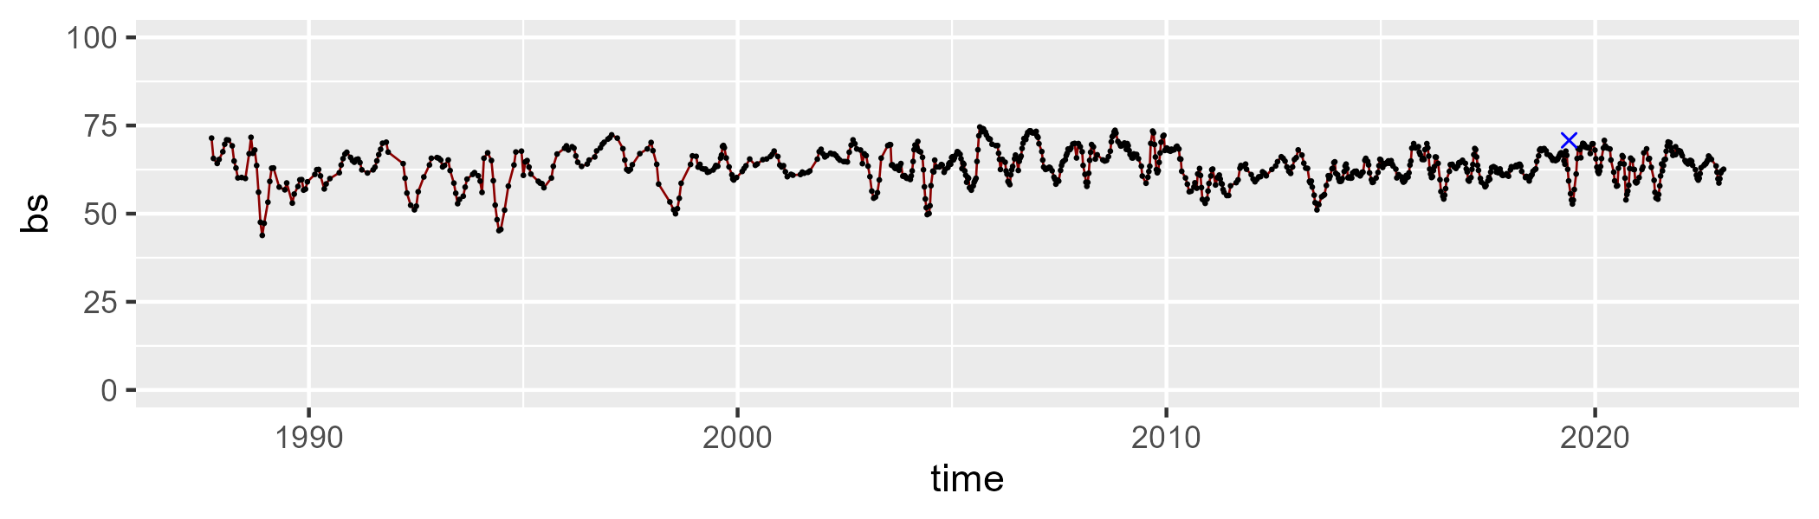

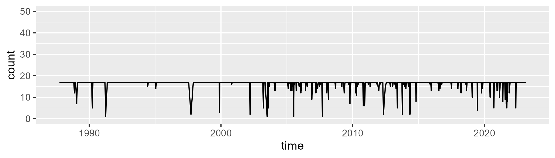

Min. : 1.00 1st Qu.:17.00 Median :17.00 Mean :16.35 3rd Qu.:17.00 Max. :17.00

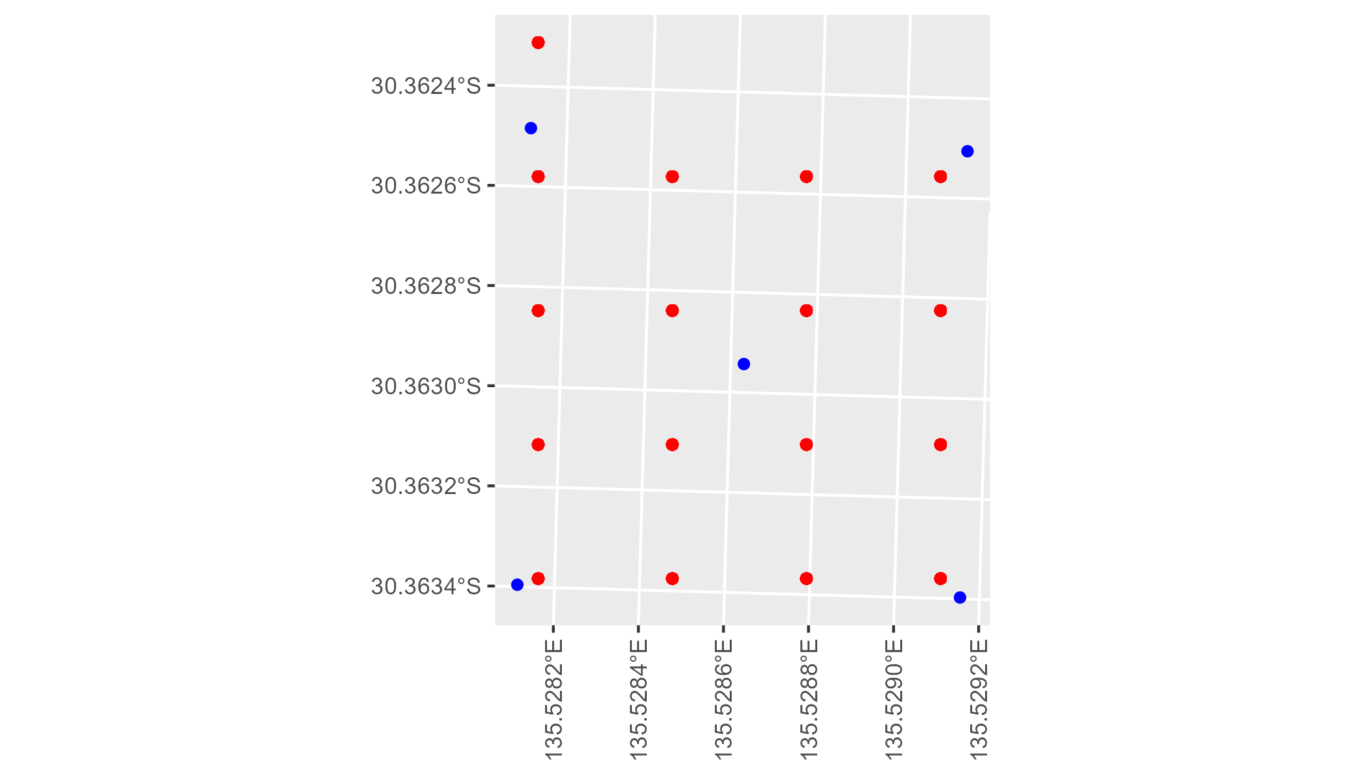

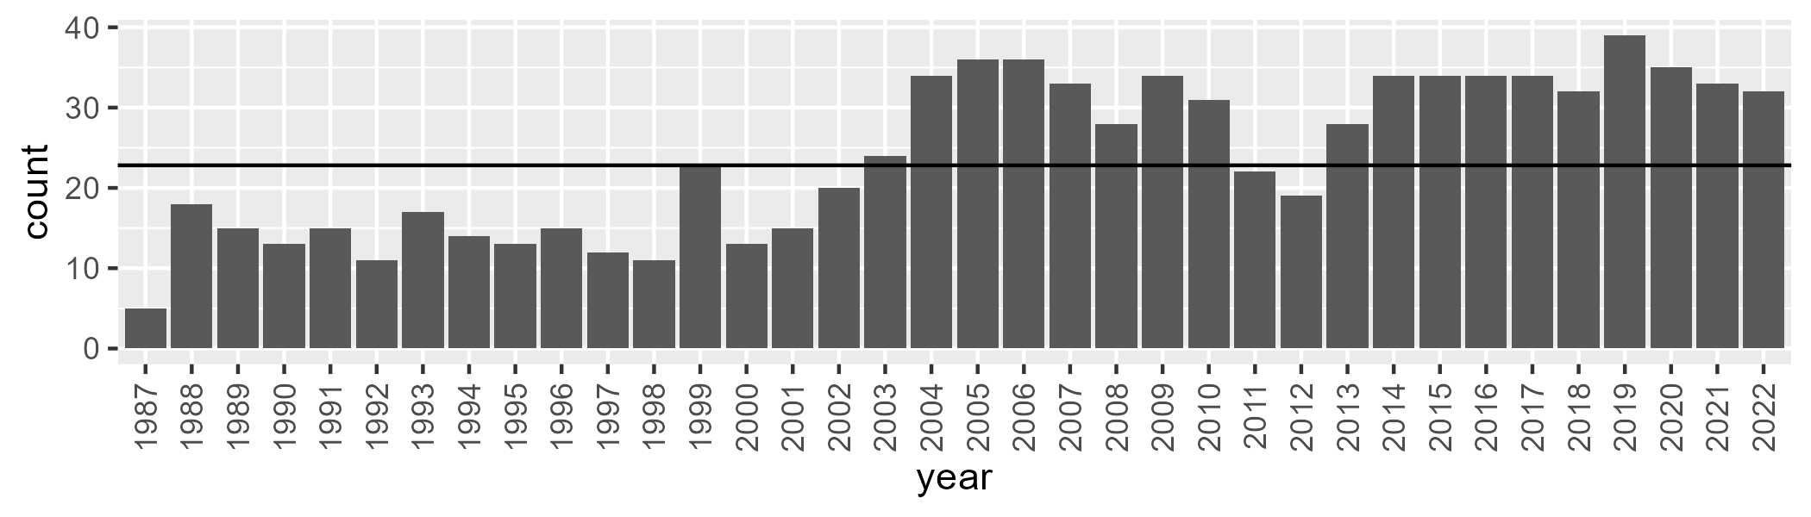

Number of samples: 862

# SASMDD0001

| Min. | 1st Qu. | Median | Mean | 3rd Qu. | Max. |
| --- | --- | --- | --- | --- | --- |
| 3.35581 | 15.84233 | 18.94659 | 19.55662 | 23.00355 | 35.32969 |

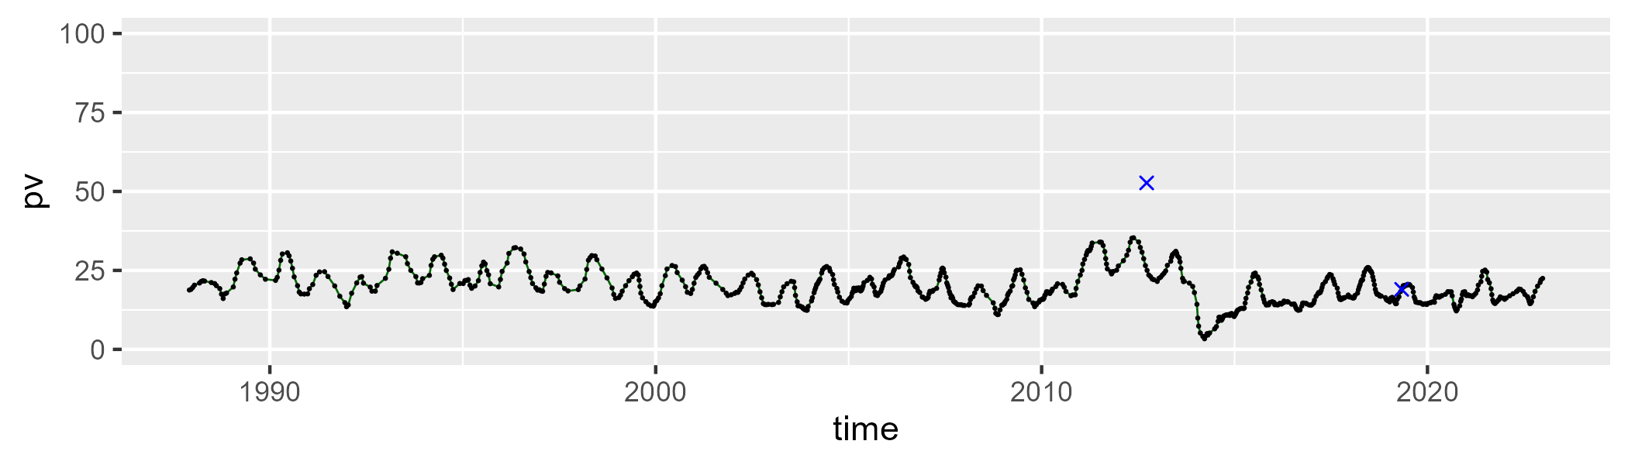

| Min. | 1st Qu. | Median | Mean | 3rd Qu. | Max. |
| --- | --- | --- | --- | --- | --- |
| 16.37317 | 26.75206 | 39.30039 | 35.99008 | 44.23396 | 49.84446 |

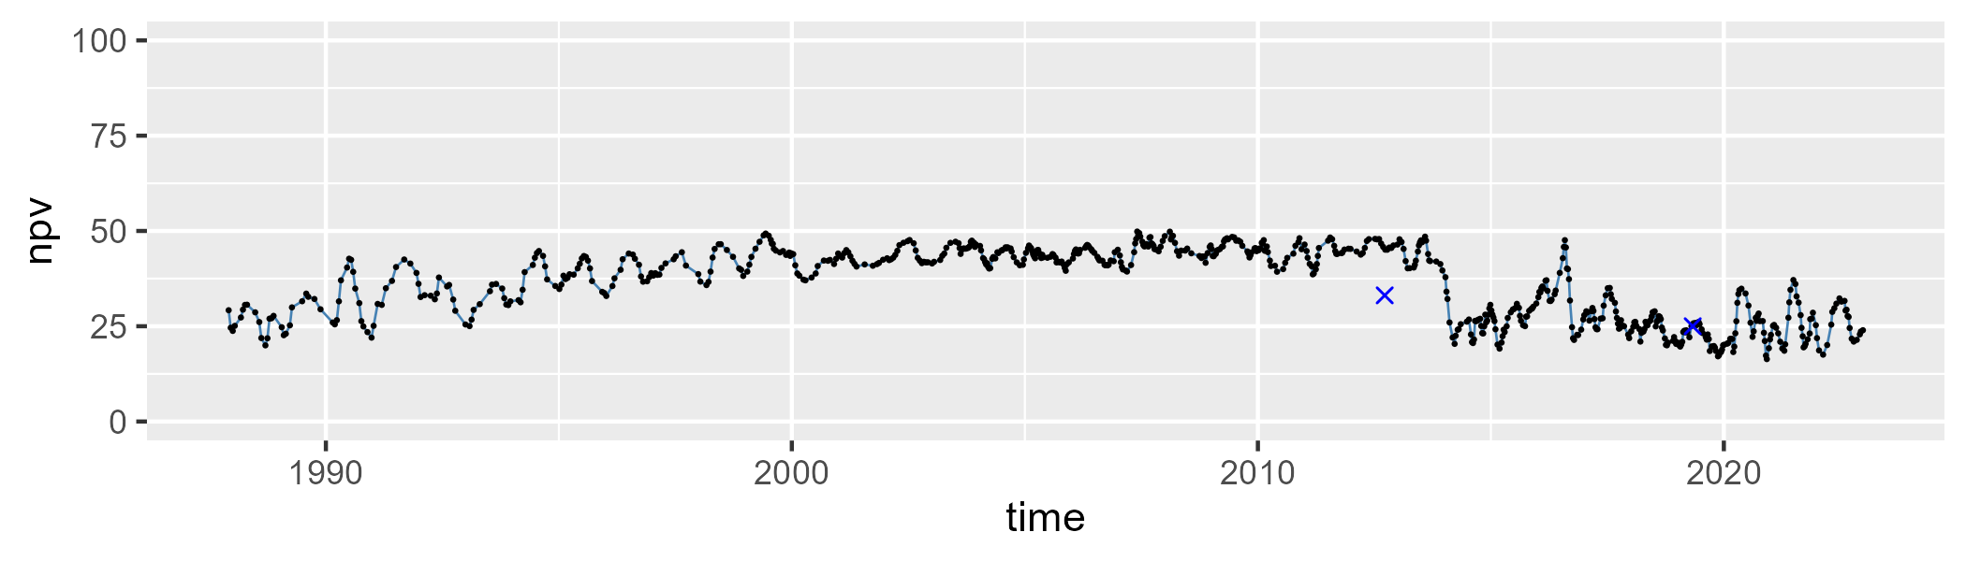

| Min. | 1st Qu. | Median | Mean | 3rd Qu. | Max. |
| --- | --- | --- | --- | --- | --- |
| 15.37352 | 34.04214 | 40.35066 | 42.98202 | 53.7643 | 74.53744 |

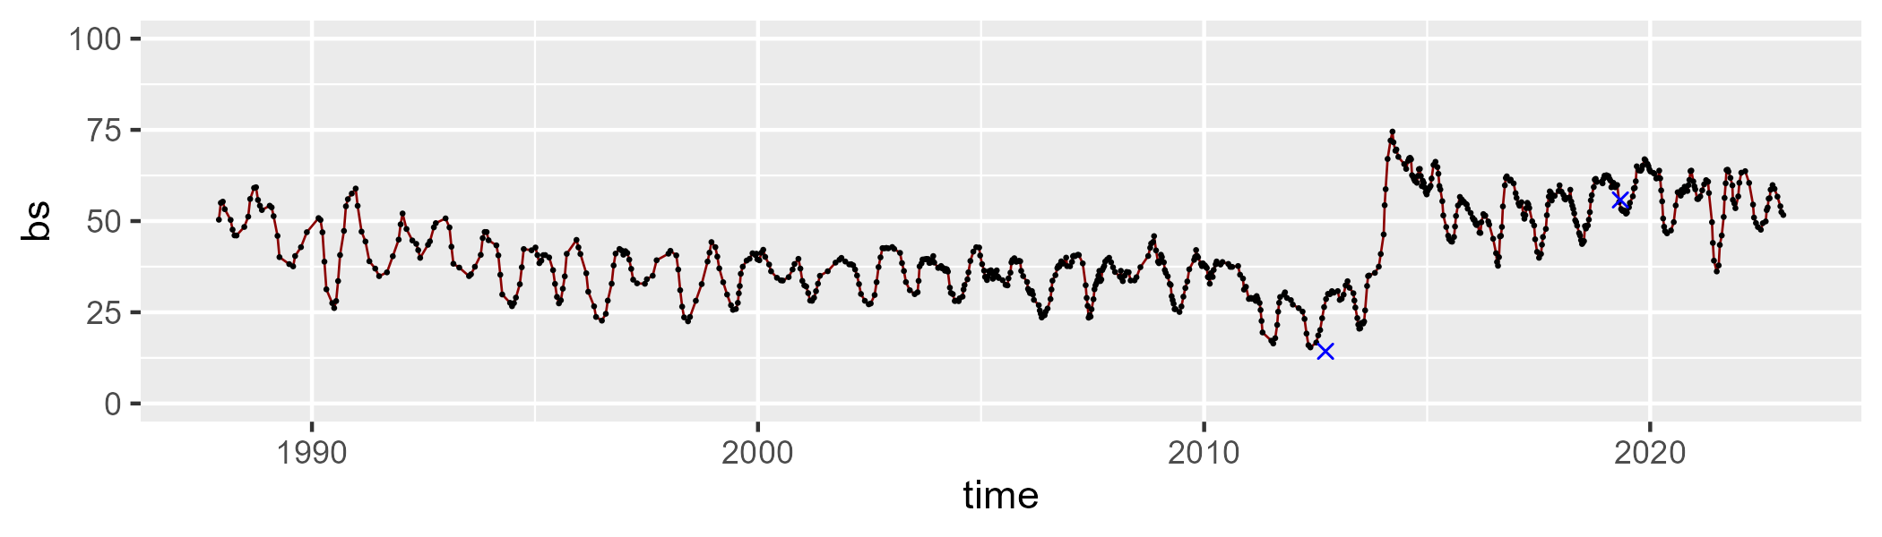

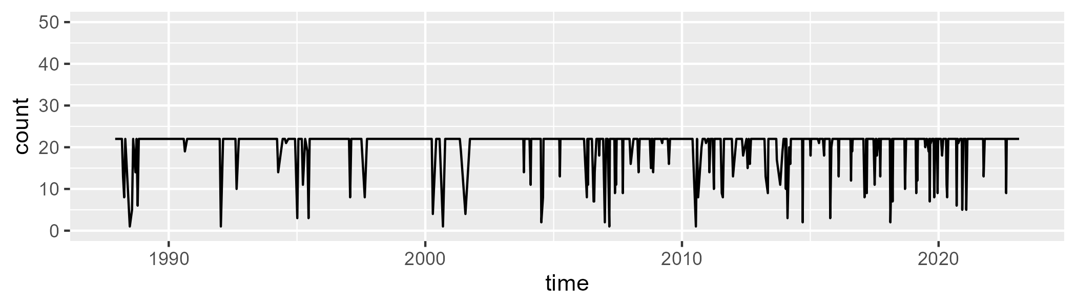

Min. : 1.0 1st Qu.:22.0 Median :22.0 Mean :20.6 3rd Qu.:22.0 Max. :22.0

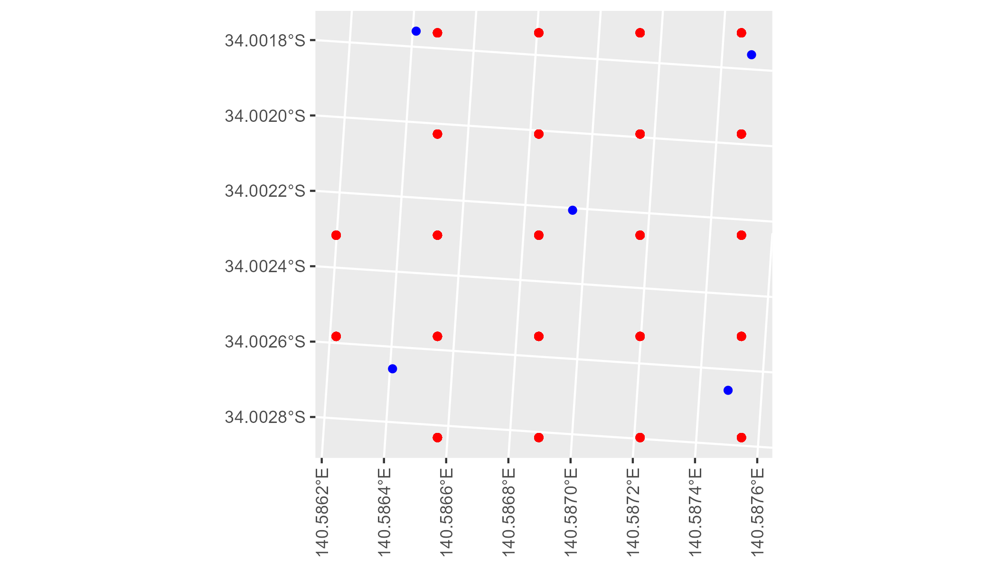

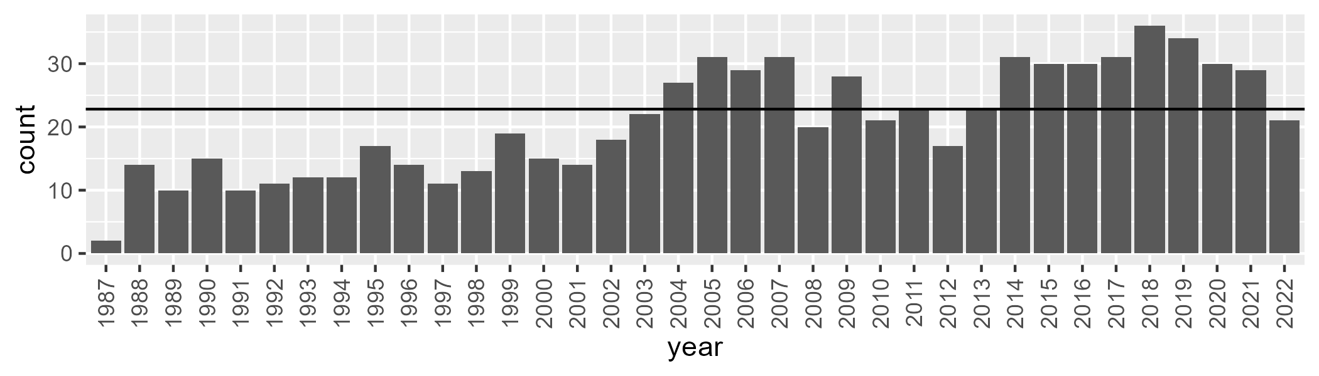

Number of samples: 751

# SASMDD0002

| Min. | 1st Qu. | Median | Mean | 3rd Qu. | Max. |
| --- | --- | --- | --- | --- | --- |
| 9.388643 | 18.41918 | 25.03224 | 25.17034 | 30.85894 | 45.37575 |

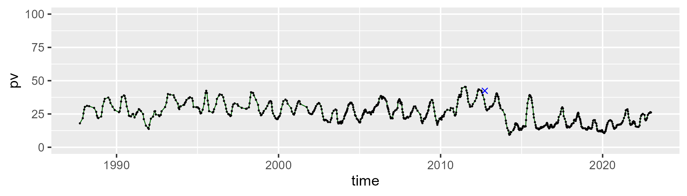

| Min. | 1st Qu. | Median | Mean | 3rd Qu. | Max. |
| --- | --- | --- | --- | --- | --- |
| 28.66225 | 43.26944 | 46.8463 | 46.00977 | 48.89076 | 59.44462 |

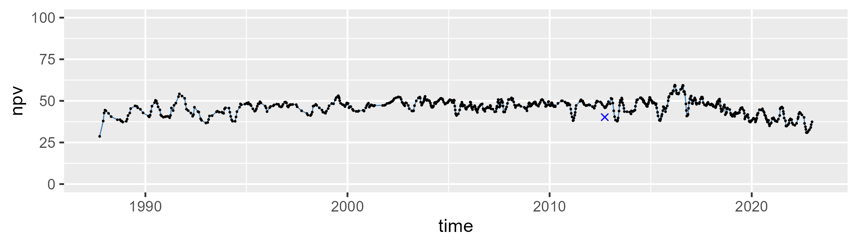

| Min. | 1st Qu. | Median | Mean | 3rd Qu. | Max. |
| --- | --- | --- | --- | --- | --- |
| 2.890738 | 20.93981 | 27.06551 | 27.49682 | 33.2118 | 52.01672 |

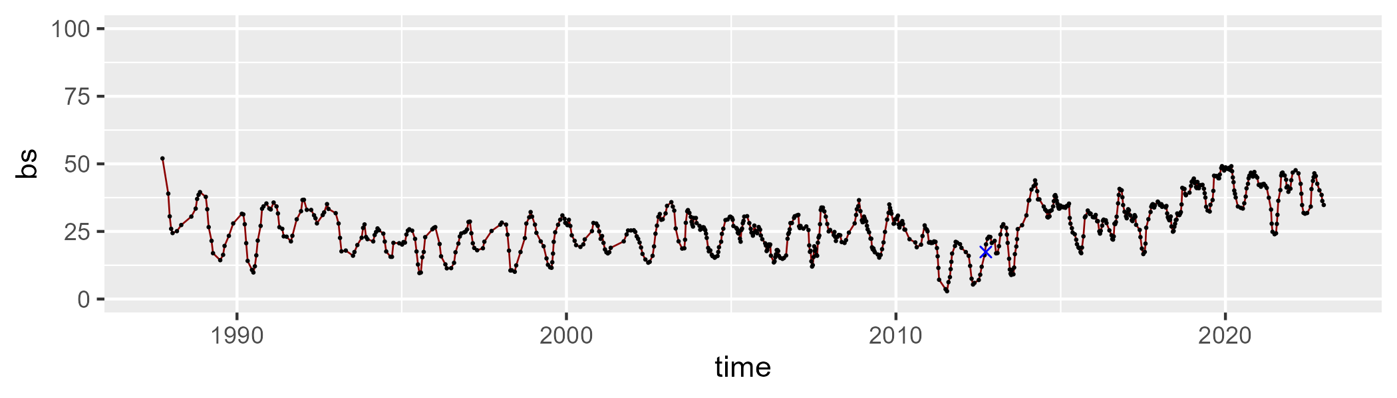

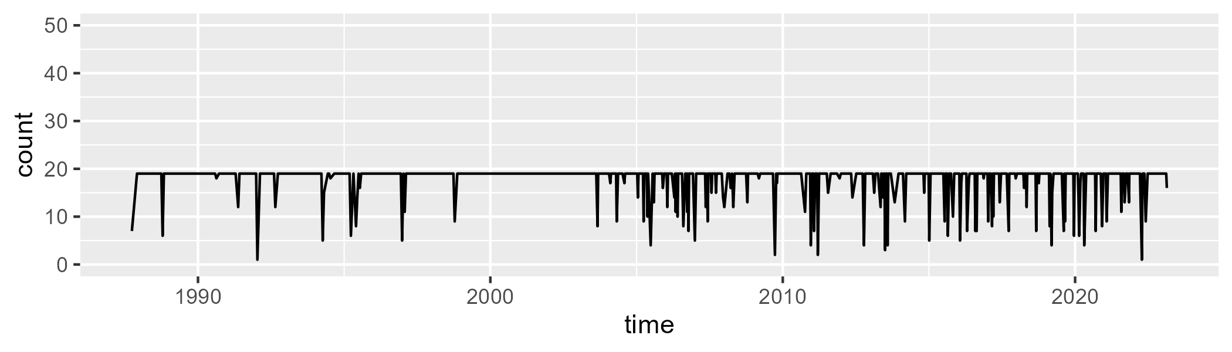

Min. : 1.00 1st Qu.:19.00 Median :19.00 Mean :17.81 3rd Qu.:19.00 Max. :19.00

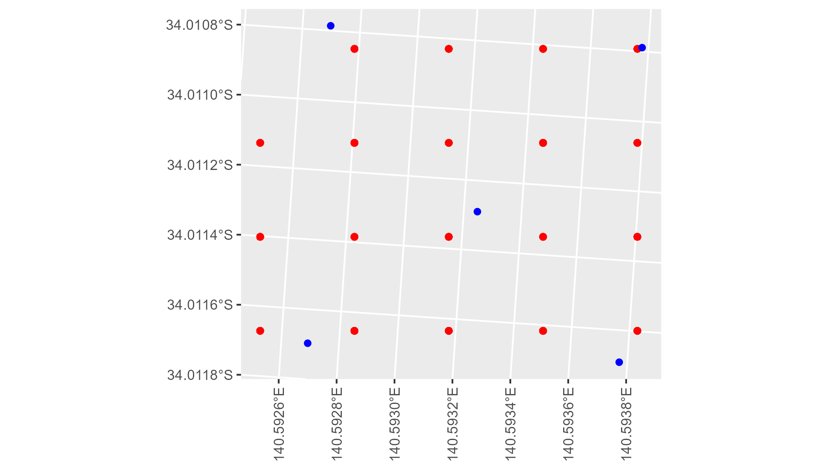

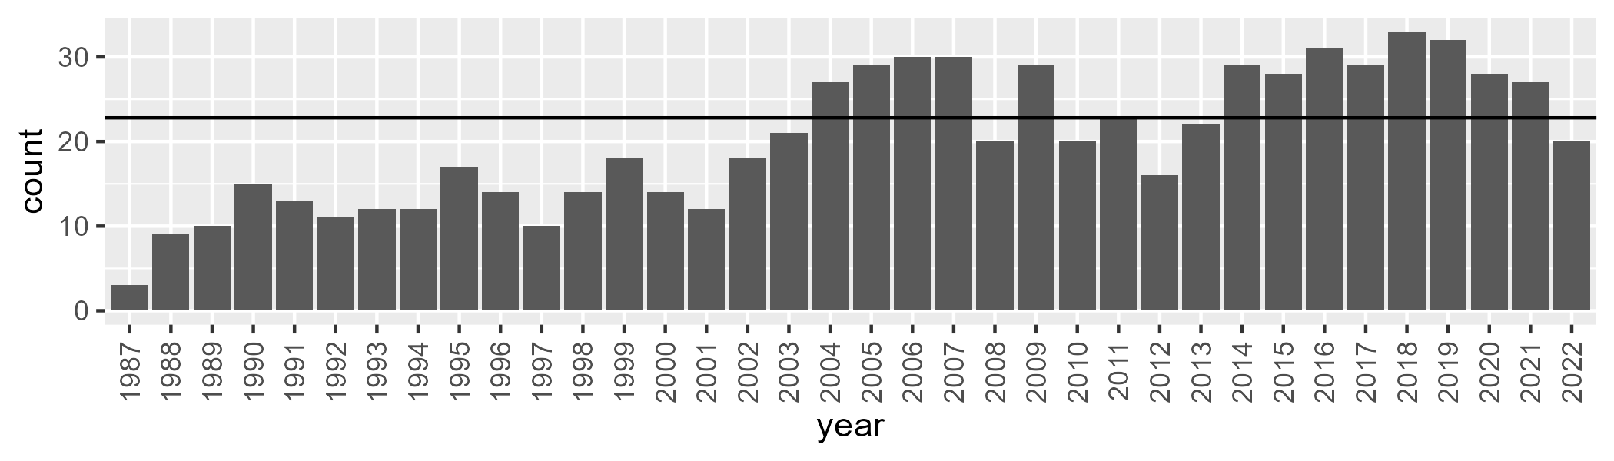

Number of samples: 726

# SASMDD0003

| Min. | 1st Qu. | Median | Mean | 3rd Qu. | Max. |
| --- | --- | --- | --- | --- | --- |
| 4.173922 | 18.03425 | 23.25097 | 23.32738 | 27.72947 | 39.45893 |

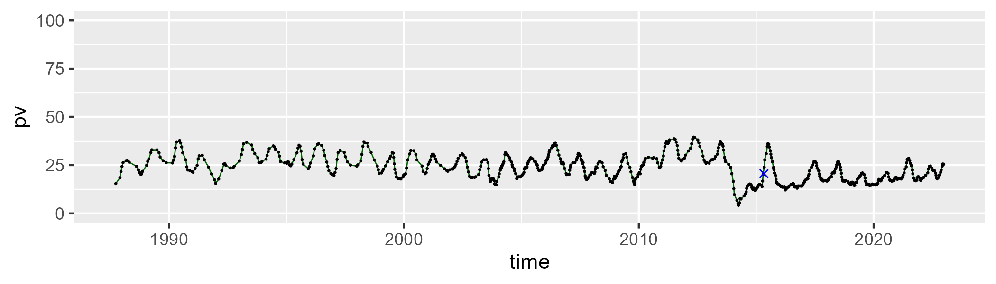

| Min. | 1st Qu. | Median | Mean | 3rd Qu. | Max. |
| --- | --- | --- | --- | --- | --- |
| 23.11032 | 37.71839 | 45.10172 | 42.73293 | 48.23714 | 55.11216 |

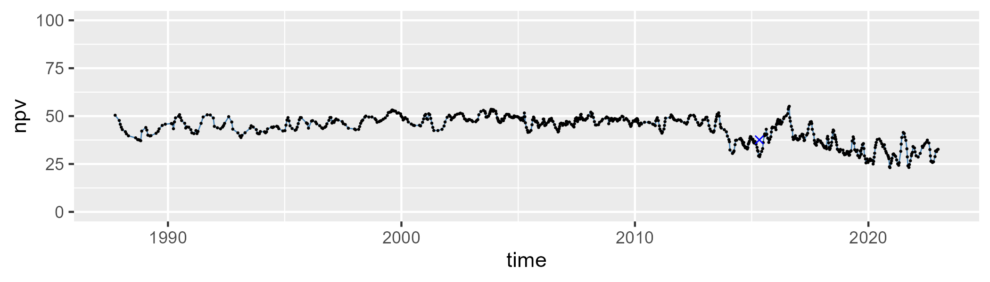

| Min. | 1st Qu. | Median | Mean | 3rd Qu. | Max. |
| --- | --- | --- | --- | --- | --- |
| 9.098353 | 24.55994 | 29.64542 | 32.56487 | 40.91945 | 62.32232 |

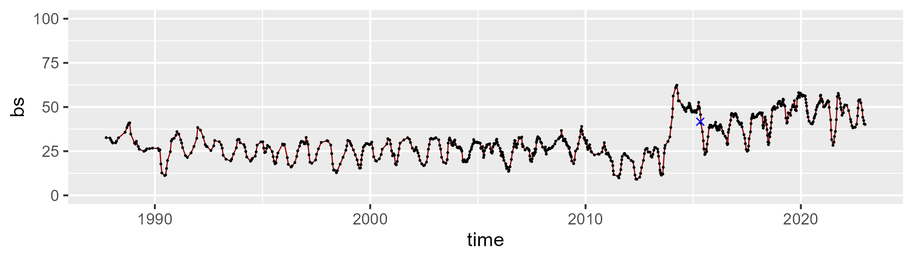

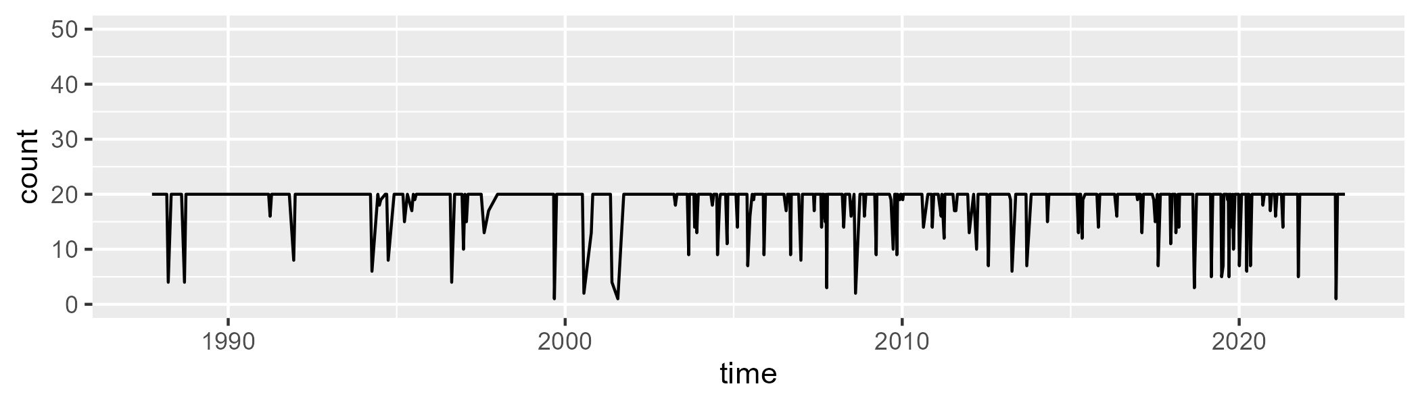

Min. : 1.00 1st Qu.:20.00 Median :20.00 Mean :18.92 3rd Qu.:20.00 Max. :20.00

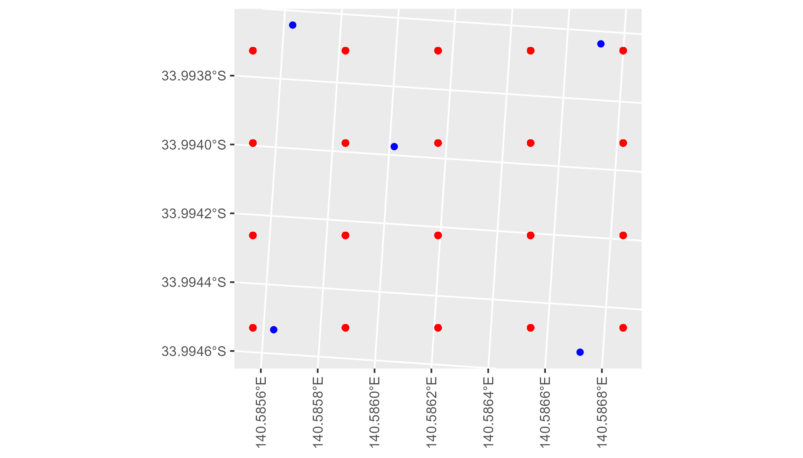

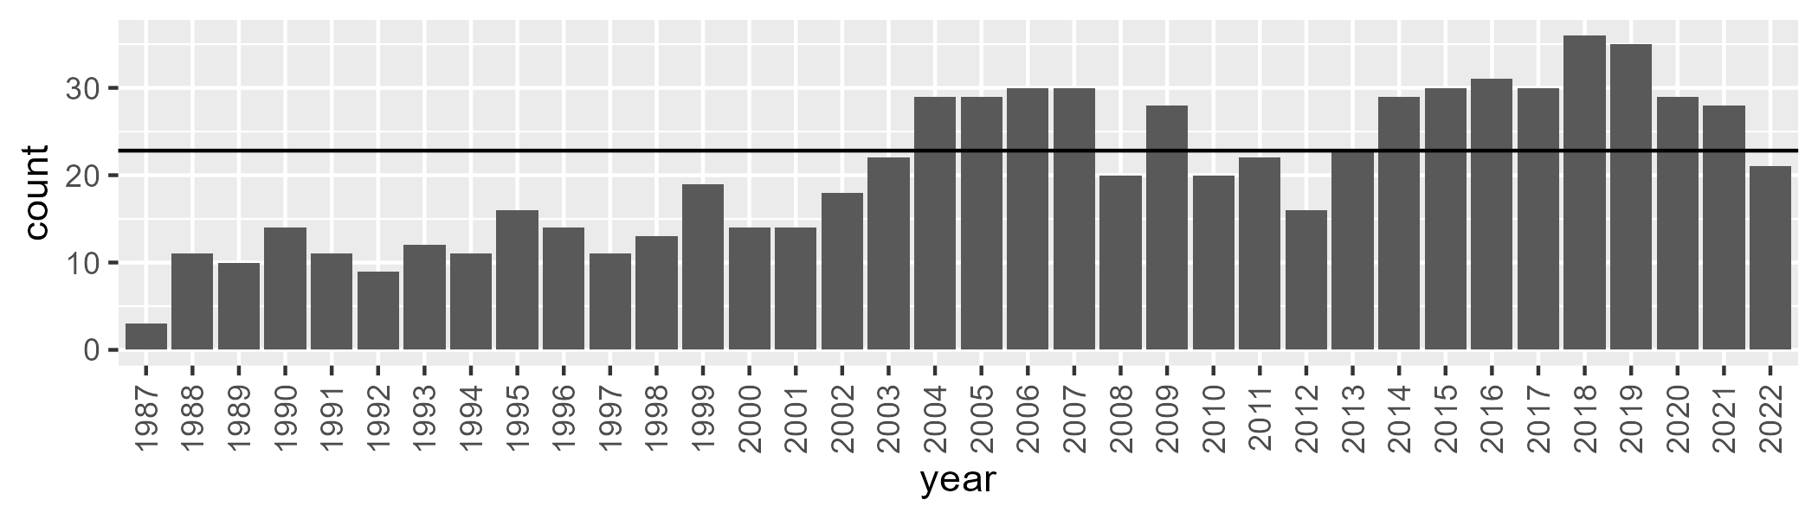

Number of samples: 738

# SASMDD0004

| Min. | 1st Qu. | Median | Mean | 3rd Qu. | Max. |
| --- | --- | --- | --- | --- | --- |
| 0 | 5.961927 | 11.24203 | 15.64092 | 23.51516 | 58.10778 |

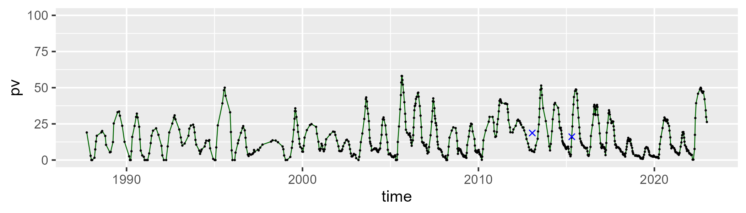

| Min. | 1st Qu. | Median | Mean | 3rd Qu. | Max. |
| --- | --- | --- | --- | --- | --- |
| 21.87972 | 43.57454 | 50.3382 | 49.48591 | 55.67861 | 66.55132 |

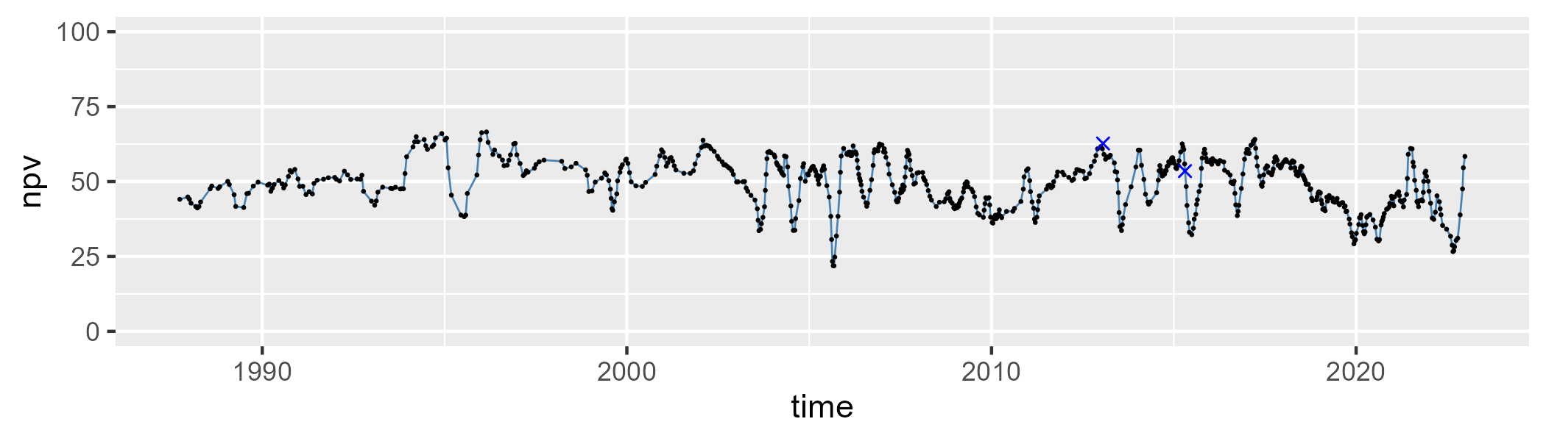

| Min. | 1st Qu. | Median | Mean | 3rd Qu. | Max. |
| --- | --- | --- | --- | --- | --- |
| 8.402614 | 25.48946 | 32.29289 | 33.5485 | 41.62314 | 66.72936 |

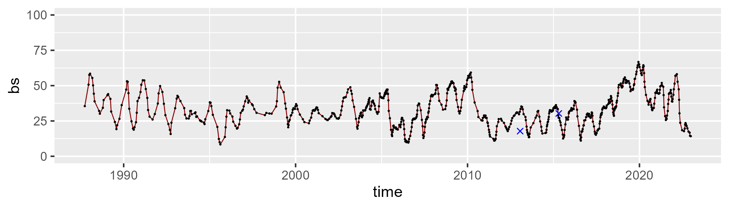

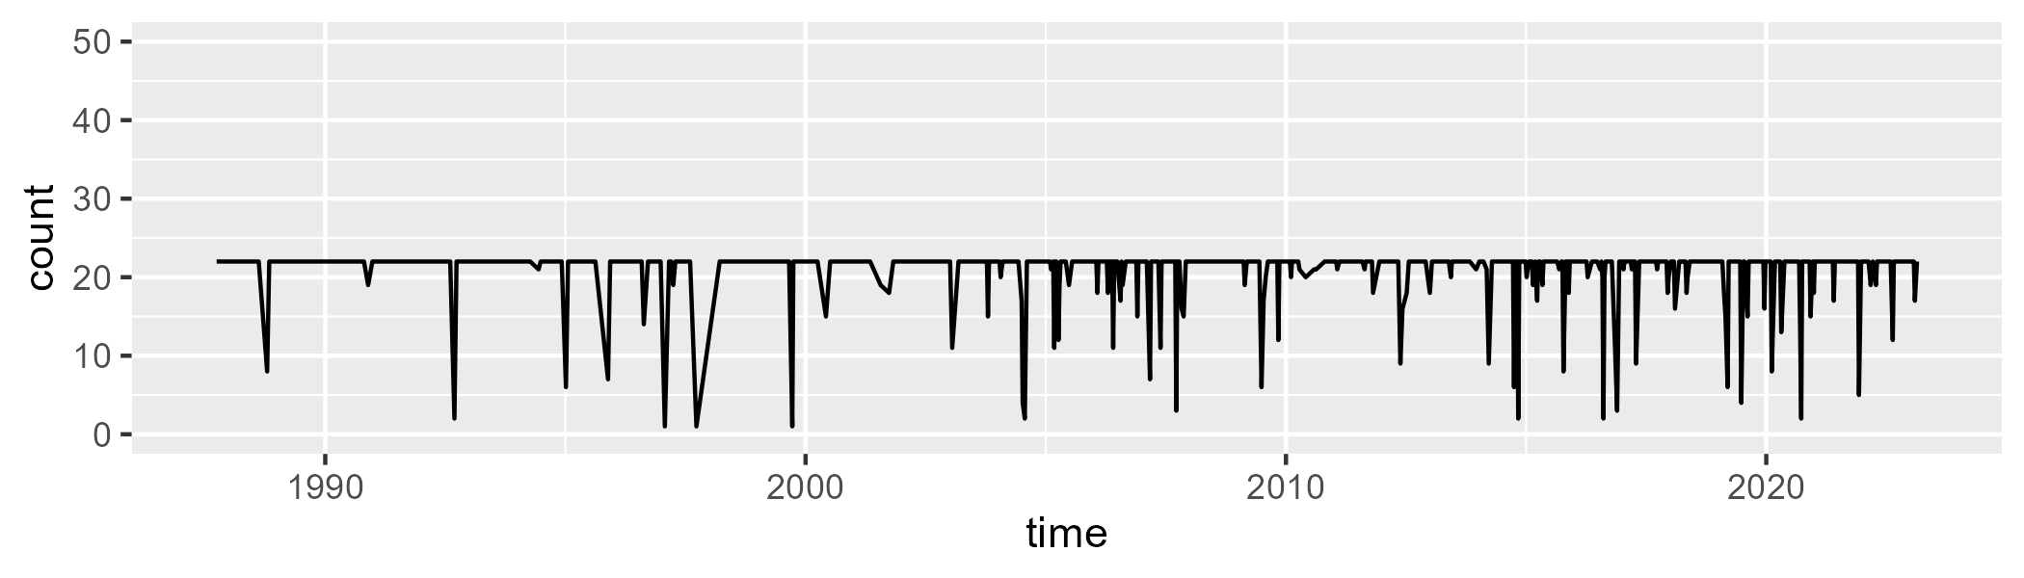

Min. : 1.00 1st Qu.:22.00 Median :22.00 Mean :20.93 3rd Qu.:22.00 Max. :22.00

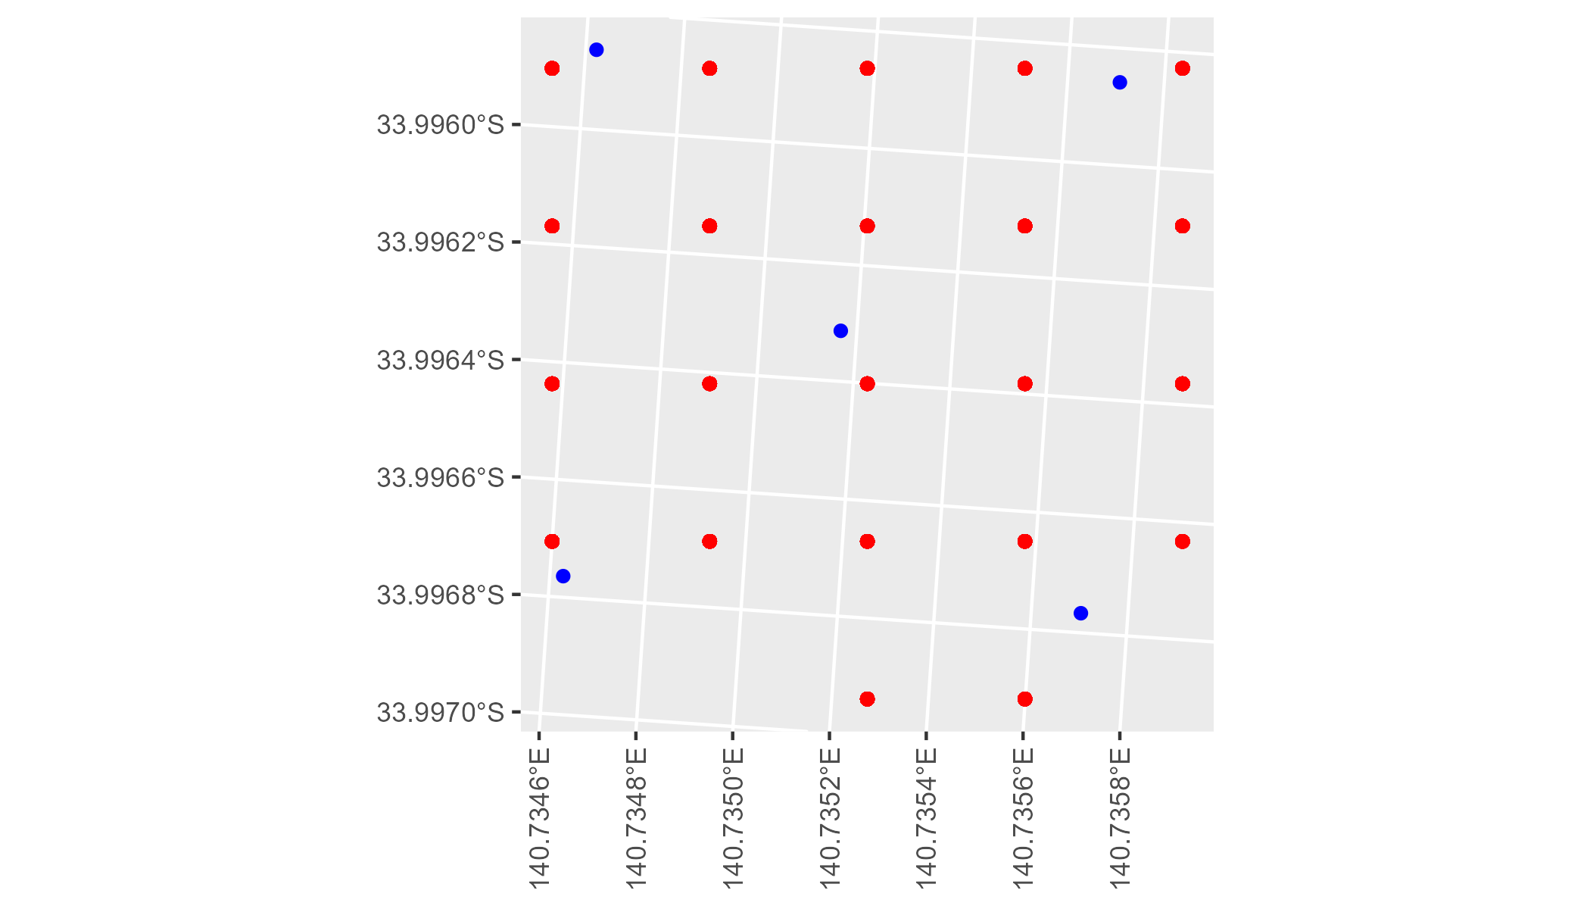

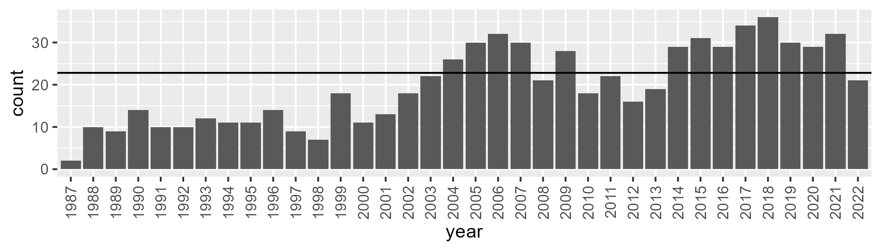

Number of samples: 714

# SASMDD0005

| Min. | 1st Qu. | Median | Mean | 3rd Qu. | Max. |
| --- | --- | --- | --- | --- | --- |
| 0 | 6.369876 | 12.14531 | 17.1201 | 26.16943 | 72.53339 |

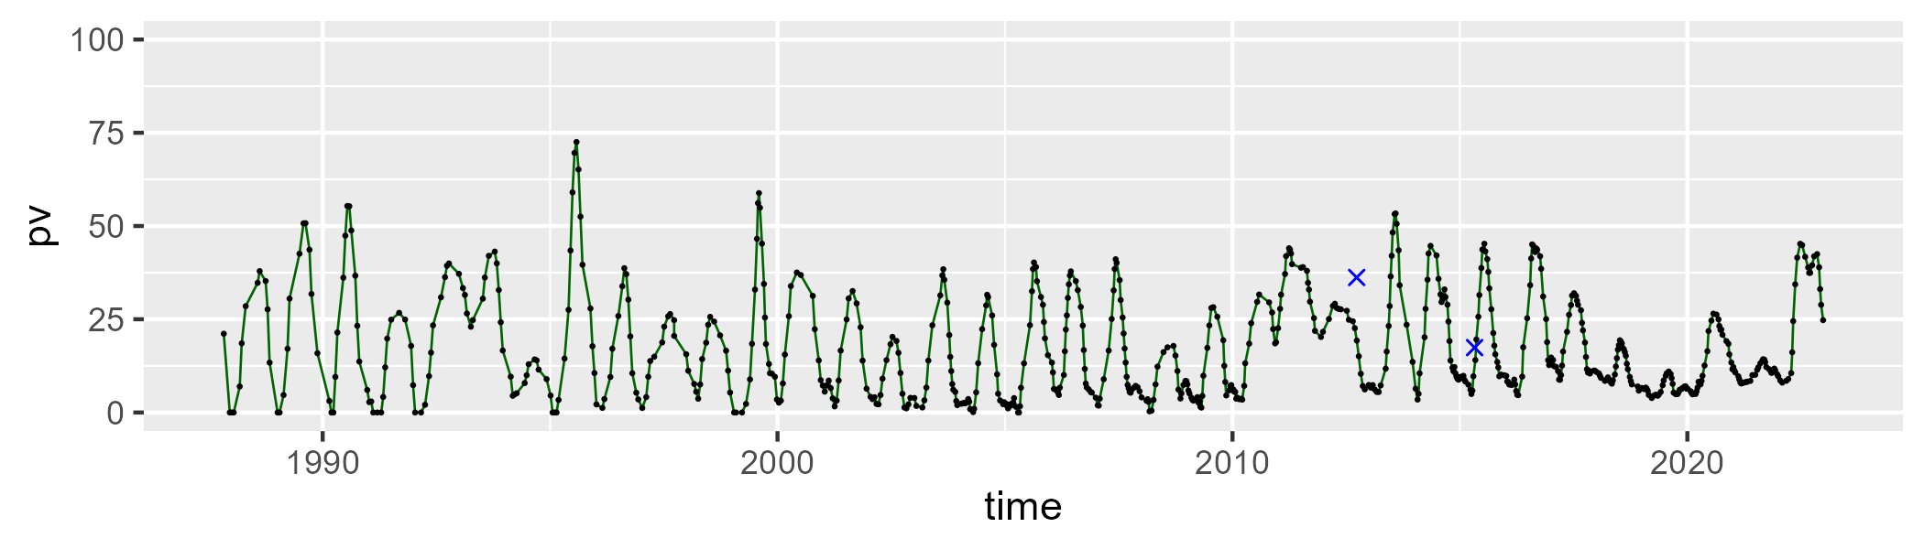

| Min. | 1st Qu. | Median | Mean | 3rd Qu. | Max. |
| --- | --- | --- | --- | --- | --- |
| 20.36621 | 40.24971 | 47.43983 | 47.34099 | 53.75501 | 86.35548 |

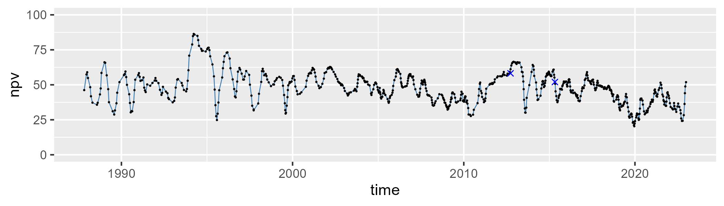

| Min. | 1st Qu. | Median | Mean | 3rd Qu. | Max. |
| --- | --- | --- | --- | --- | --- |
| 1.479268 | 23.1144 | 33.3344 | 34.25318 | 44.88324 | 70.68736 |

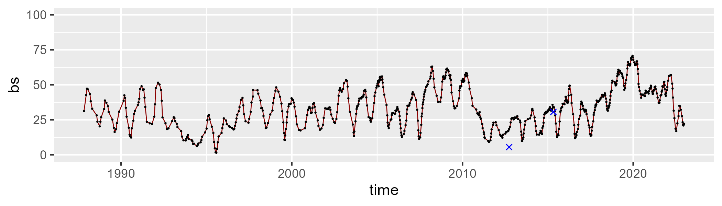

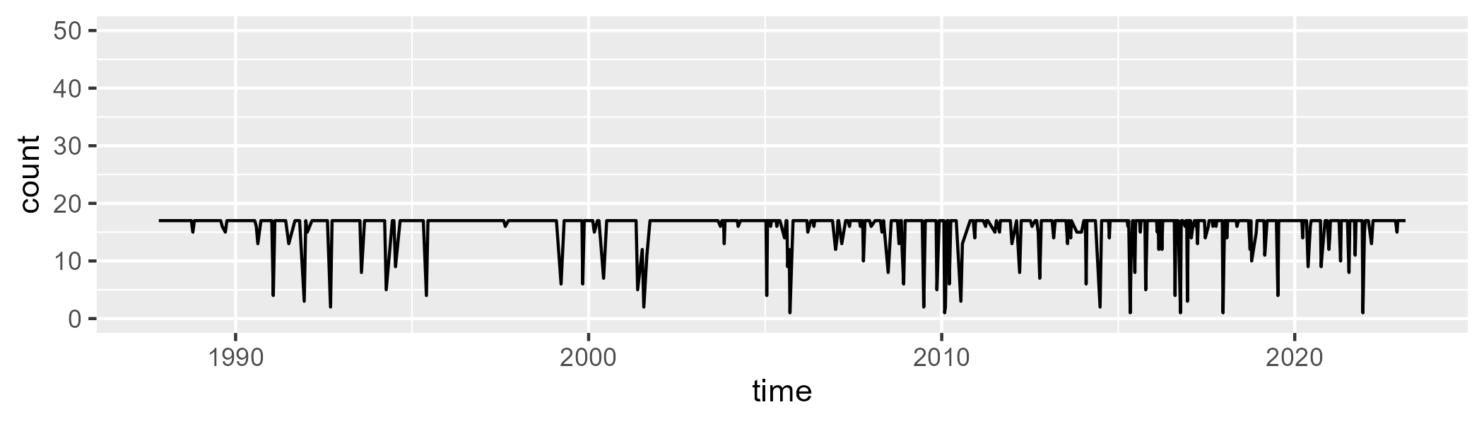

Min. : 1.00 1st Qu.:17.00 Median :17.00 Mean :16.03 3rd Qu.:17.00 Max. :17.00

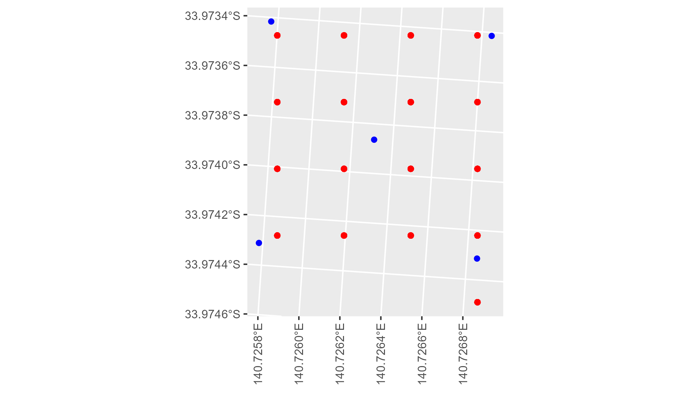

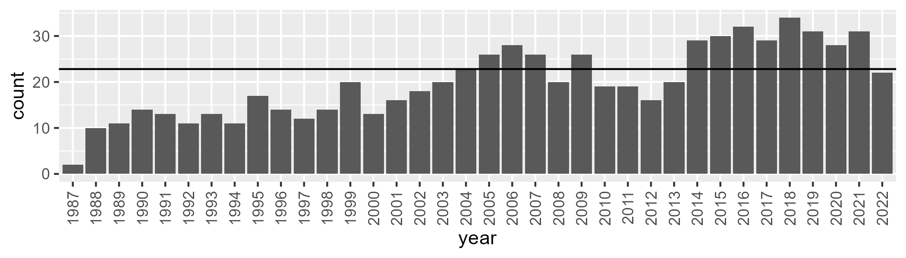

Number of samples: 718

# SASMDD0006

| Min. | 1st Qu. | Median | Mean | 3rd Qu. | Max. |
| --- | --- | --- | --- | --- | --- |
| 4.105386 | 15.82155 | 19.74878 | 20.39143 | 24.3458 | 41.35352 |

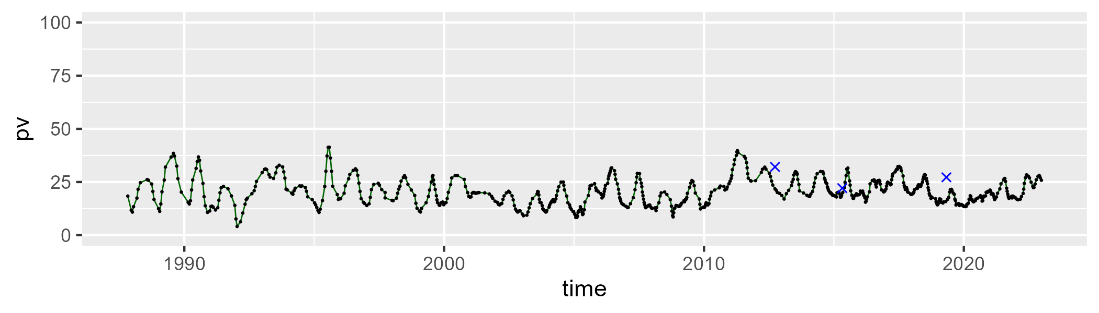

| Min. | 1st Qu. | Median | Mean | 3rd Qu. | Max. |
| --- | --- | --- | --- | --- | --- |
| 31.05796 | 40.3968 | 42.87174 | 42.93096 | 45.35574 | 58.06776 |

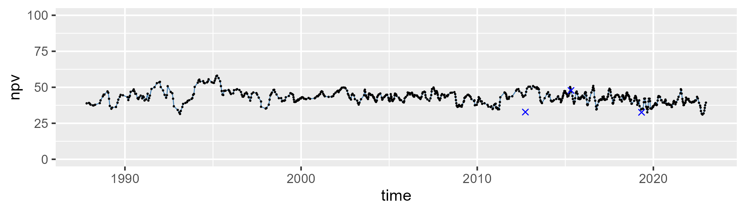

| Min. | 1st Qu. | Median | Mean | 3rd Qu. | Max. |
| --- | --- | --- | --- | --- | --- |
| 12.6593 | 30.53251 | 35.6176 | 35.28169 | 41.02301 | 51.03324 |

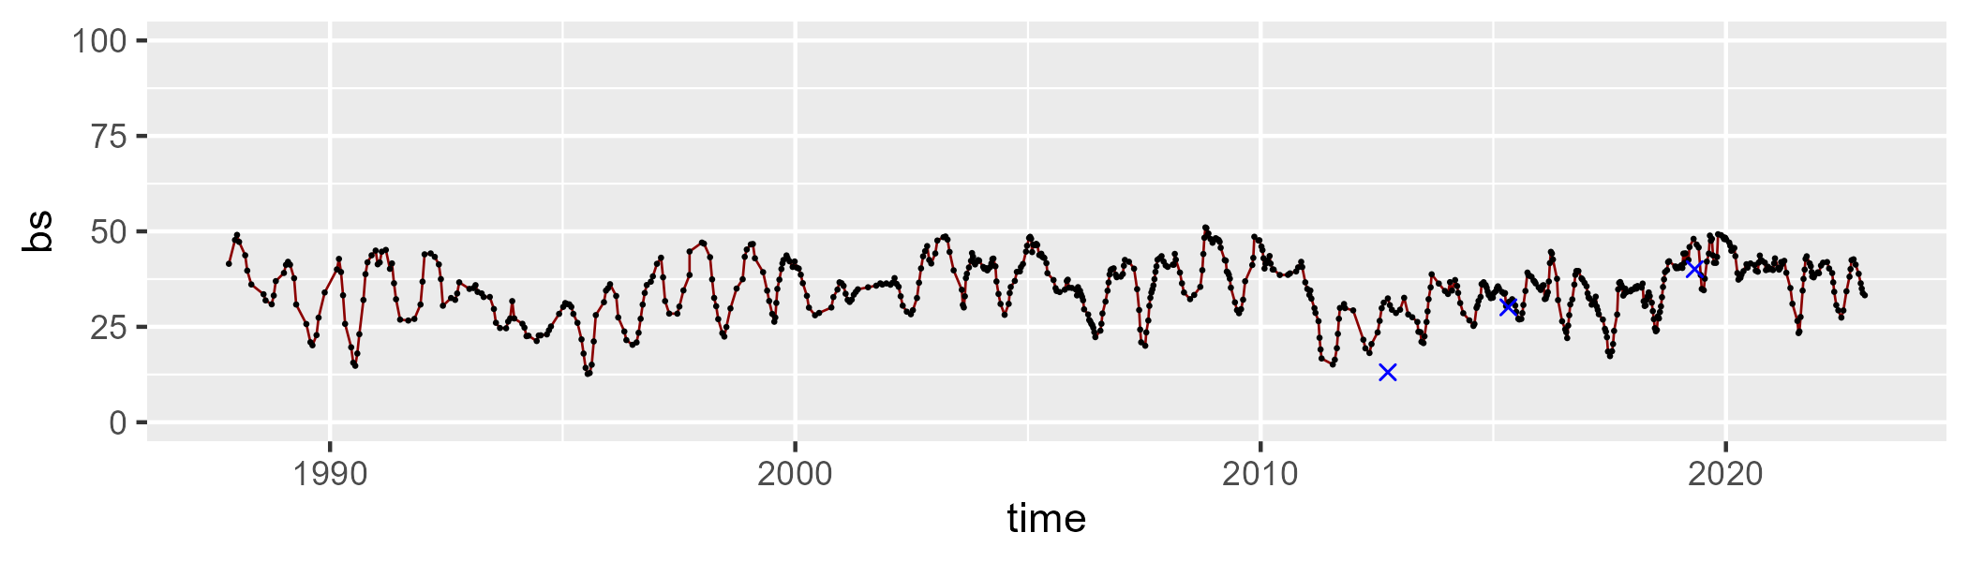

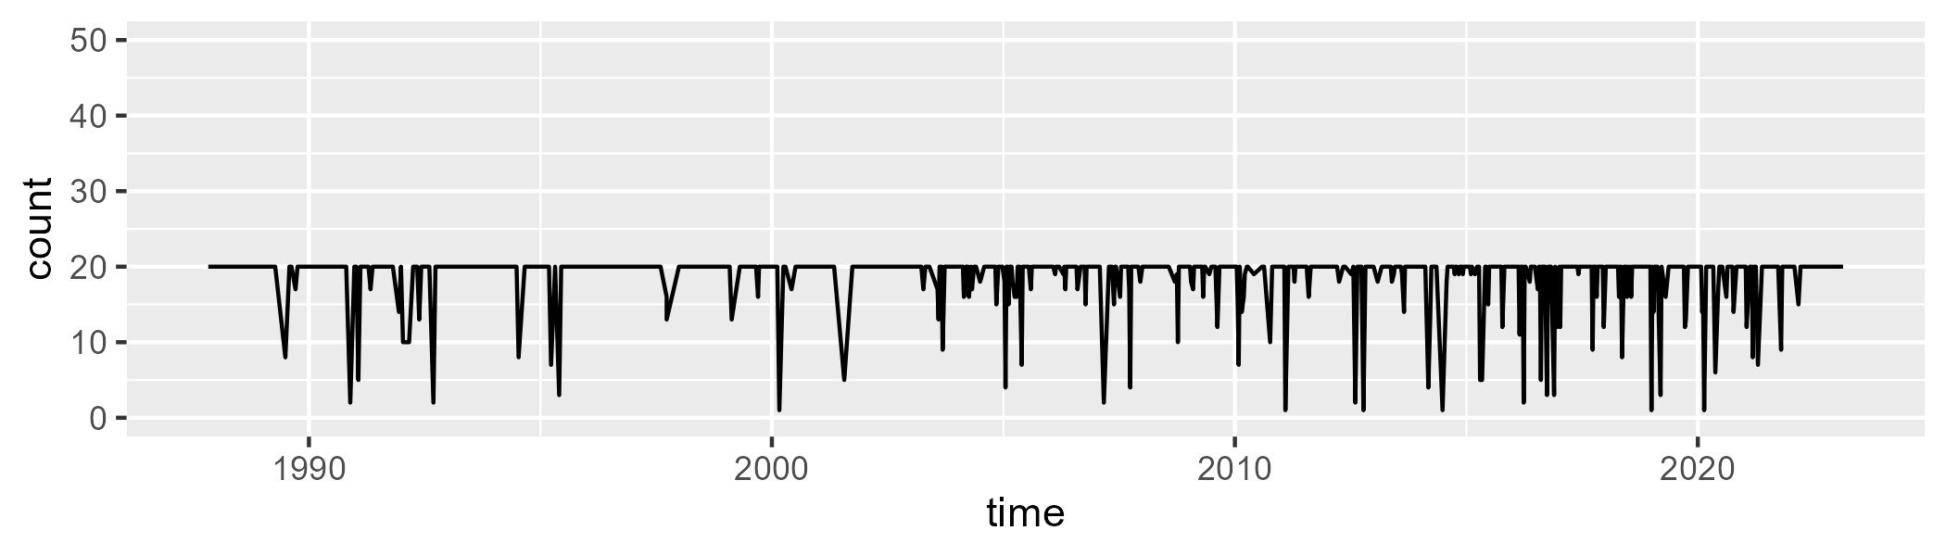

Min. : 1.00 1st Qu.:20.00 Median :20.00 Mean :18.72 3rd Qu.:20.00 Max. :20.00

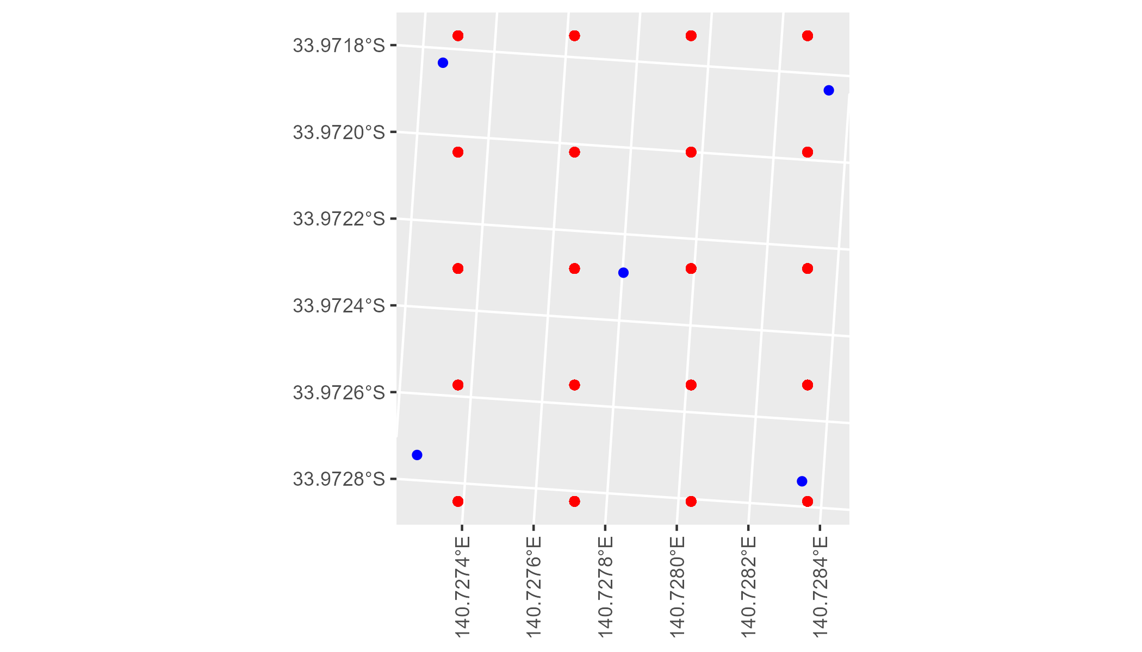

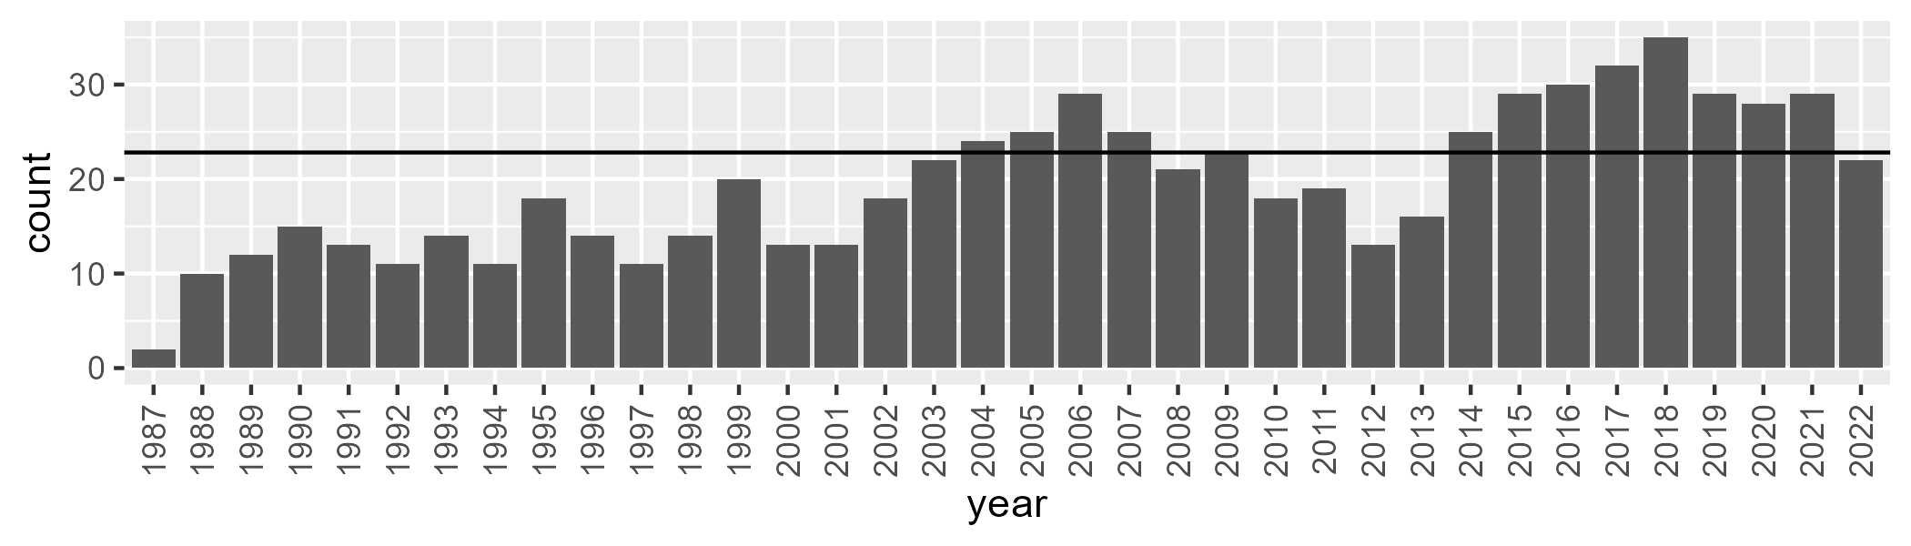

Number of samples: 703

# SASMDD0008

| Min. | 1st Qu. | Median | Mean | 3rd Qu. | Max. |
| --- | --- | --- | --- | --- | --- |
| 18.91933 | 27.55925 | 31.87077 | 32.26742 | 36.44844 | 46.84899 |

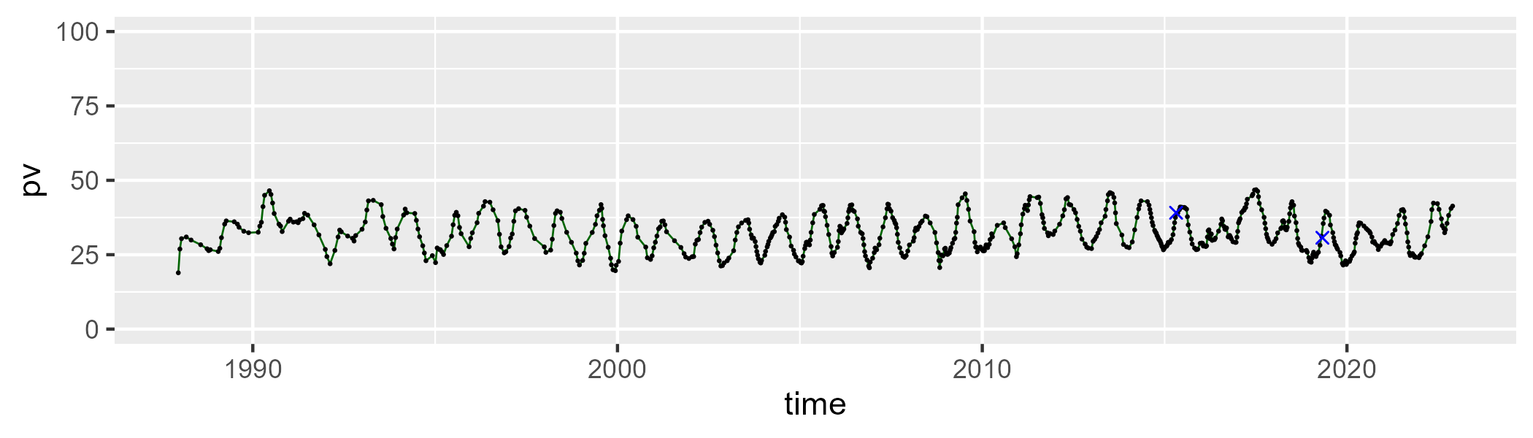

| Min. | 1st Qu. | Median | Mean | 3rd Qu. | Max. |
| --- | --- | --- | --- | --- | --- |
| 32.59867 | 42.33028 | 46.16048 | 45.70905 | 49.14295 | 59.30581 |

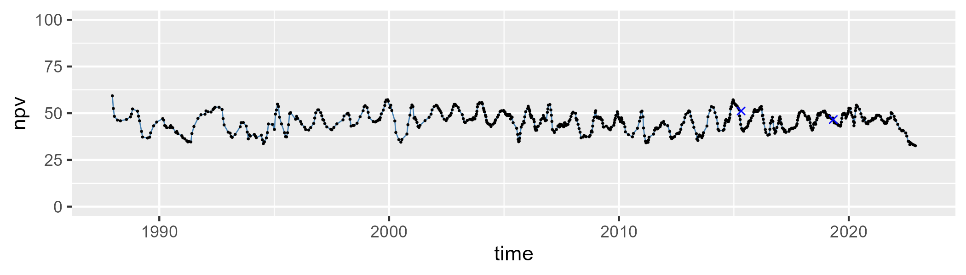

| Min. | 1st Qu. | Median | Mean | 3rd Qu. | Max. |
| --- | --- | --- | --- | --- | --- |
| 9.759655 | 17.2887 | 20.65915 | 20.74997 | 23.83106 | 38.26953 |

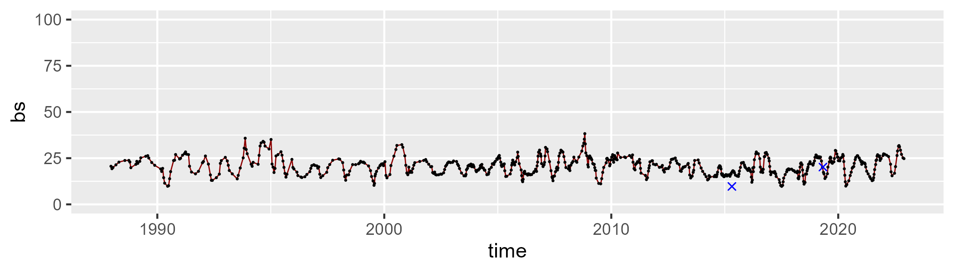

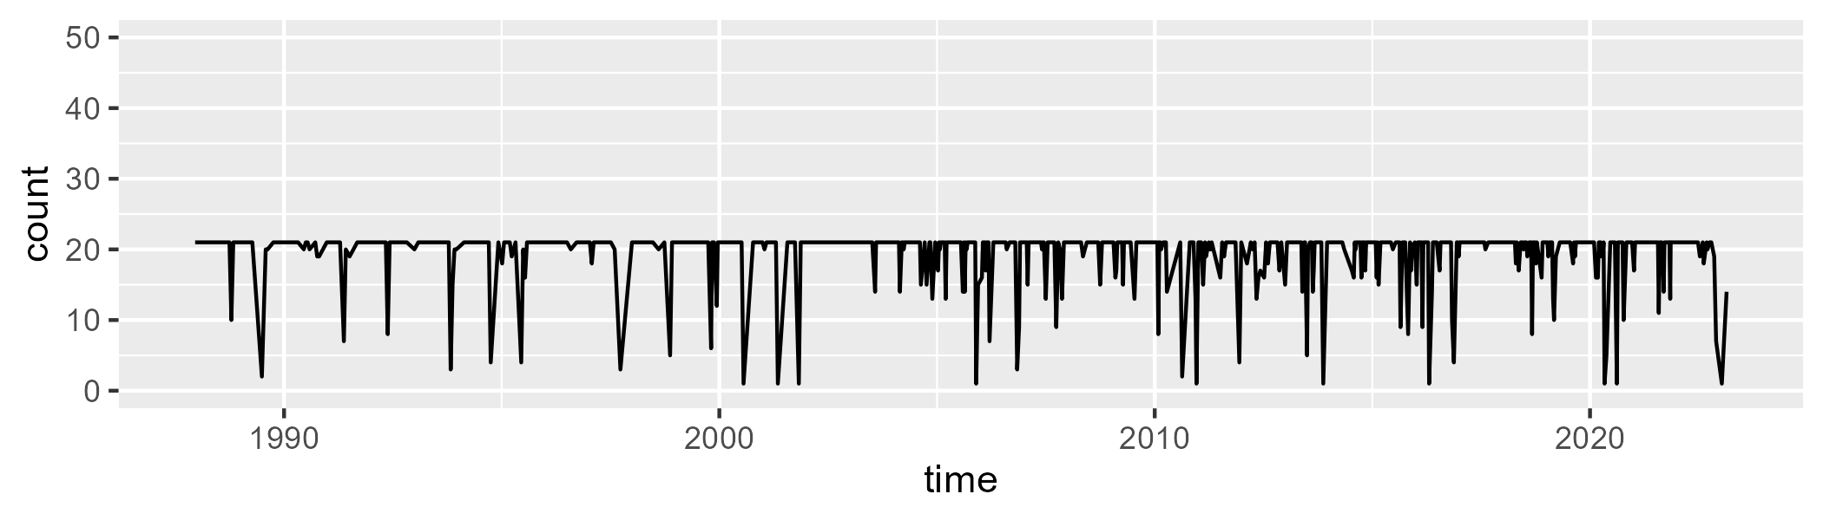

Min. : 1.00 1st Qu.:21.00 Median :21.00 Mean :19.51 3rd Qu.:21.00 Max. :21.00

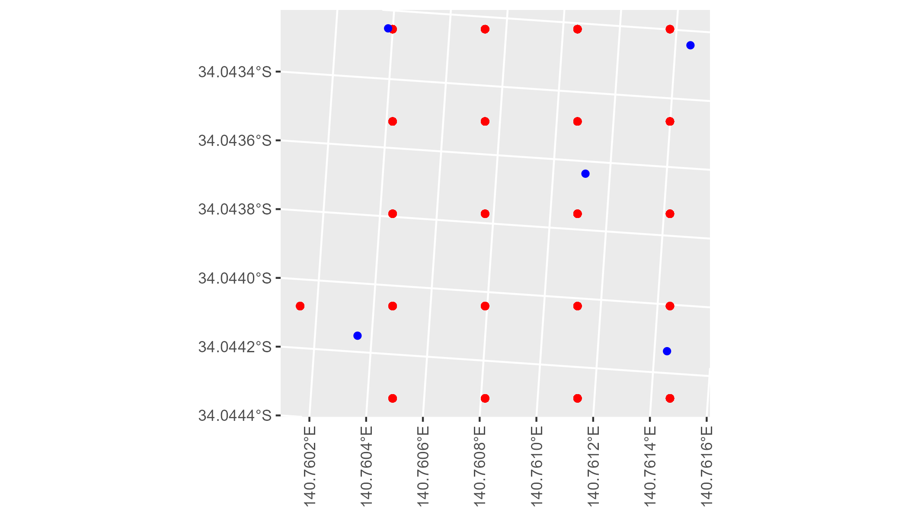

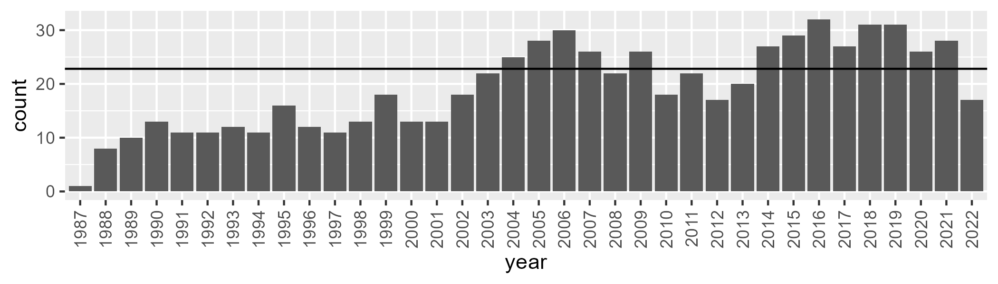

Number of samples: 695

# SASMDD0009

| Min. | 1st Qu. | Median | Mean | 3rd Qu. | Max. |
| --- | --- | --- | --- | --- | --- |
| 3.701499 | 12.21416 | 16.5141 | 18.17507 | 22.54657 | 42.37445 |

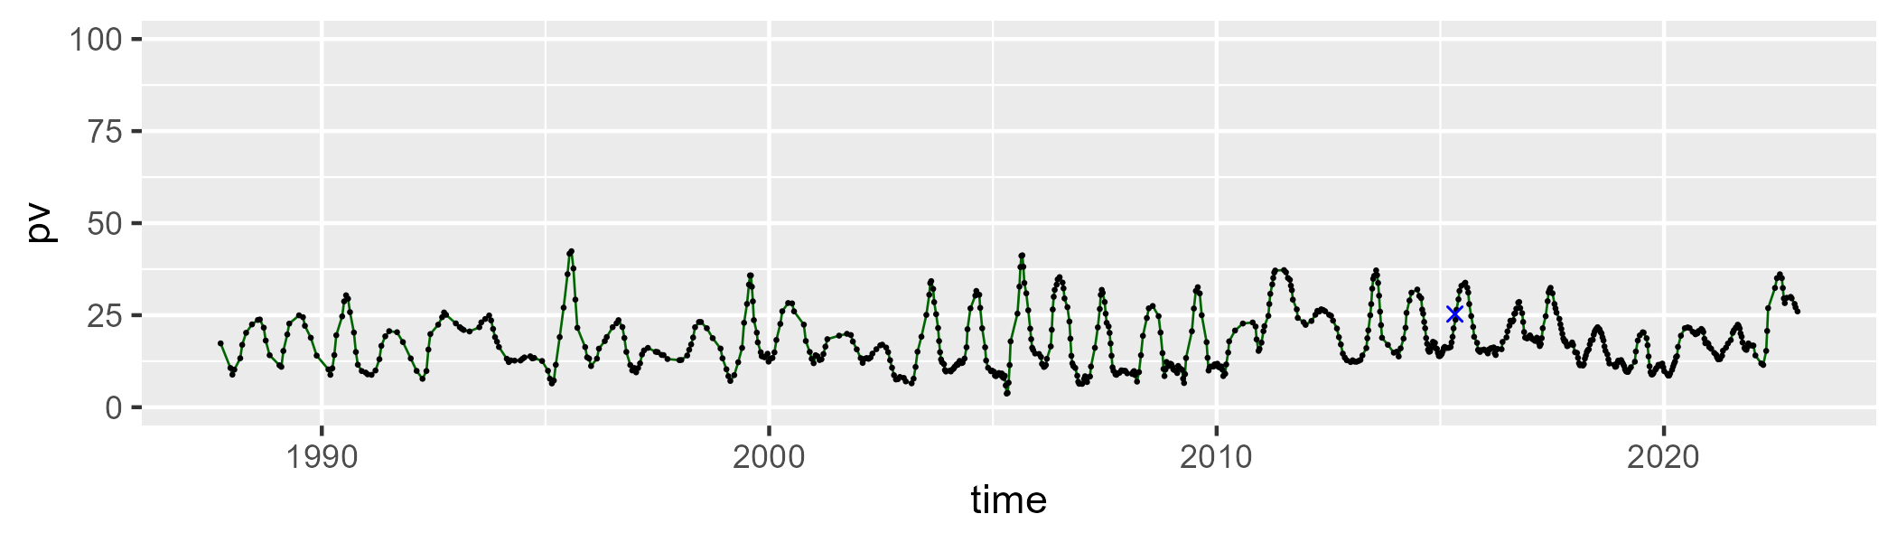

| Min. | 1st Qu. | Median | Mean | 3rd Qu. | Max. |
| --- | --- | --- | --- | --- | --- |
| 31.62918 | 44.12739 | 47.51305 | 47.22803 | 50.8842 | 61.30874 |

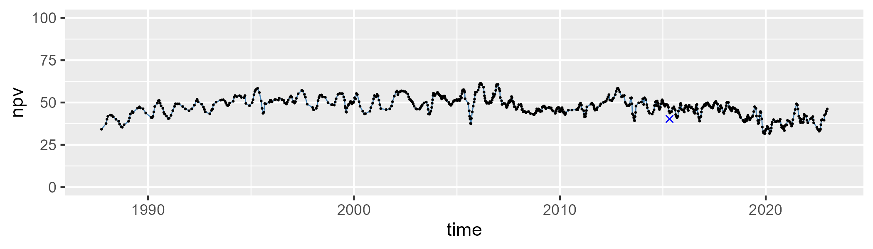

| Min. | 1st Qu. | Median | Mean | 3rd Qu. | Max. |
| --- | --- | --- | --- | --- | --- |
| 10.62187 | 27.78448 | 33.11627 | 33.25915 | 38.80074 | 56.54588 |

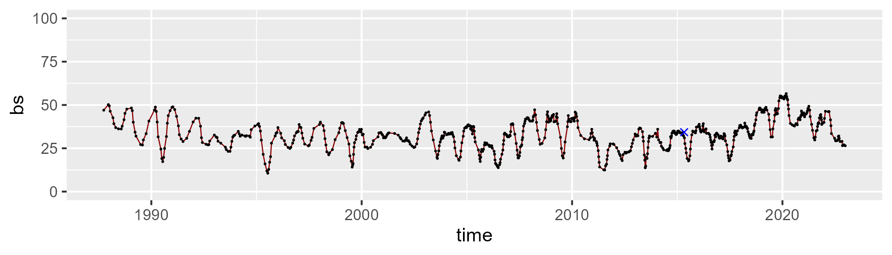

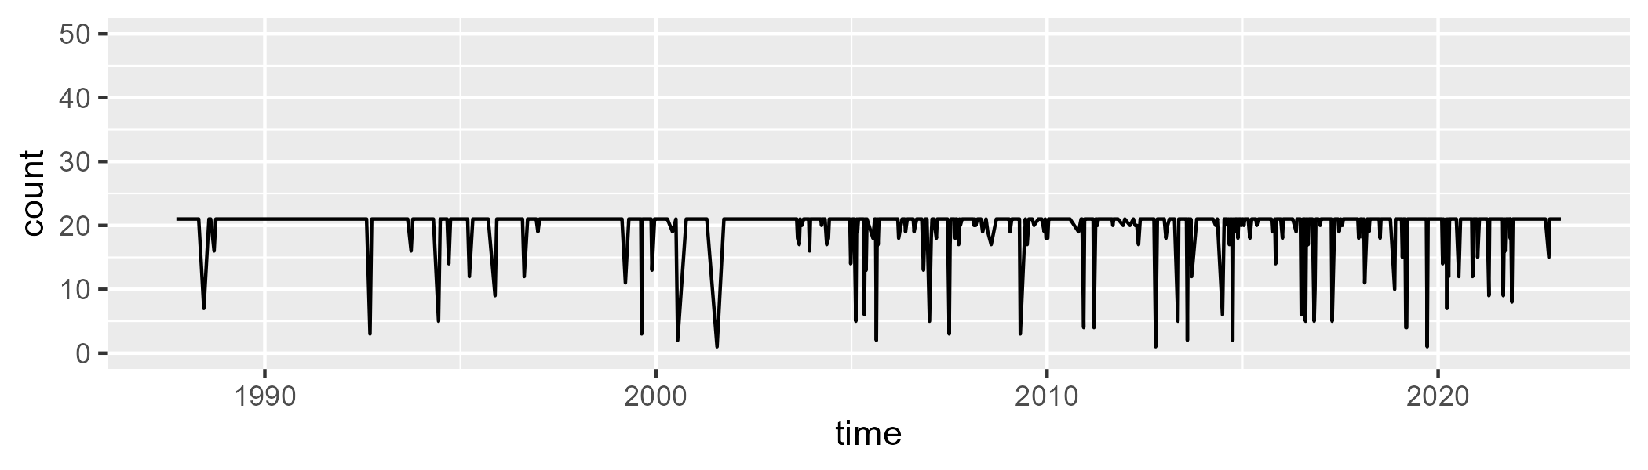

Min. : 1.00 1st Qu.:21.00 Median :21.00 Mean :19.85 3rd Qu.:21.00 Max. :21.00

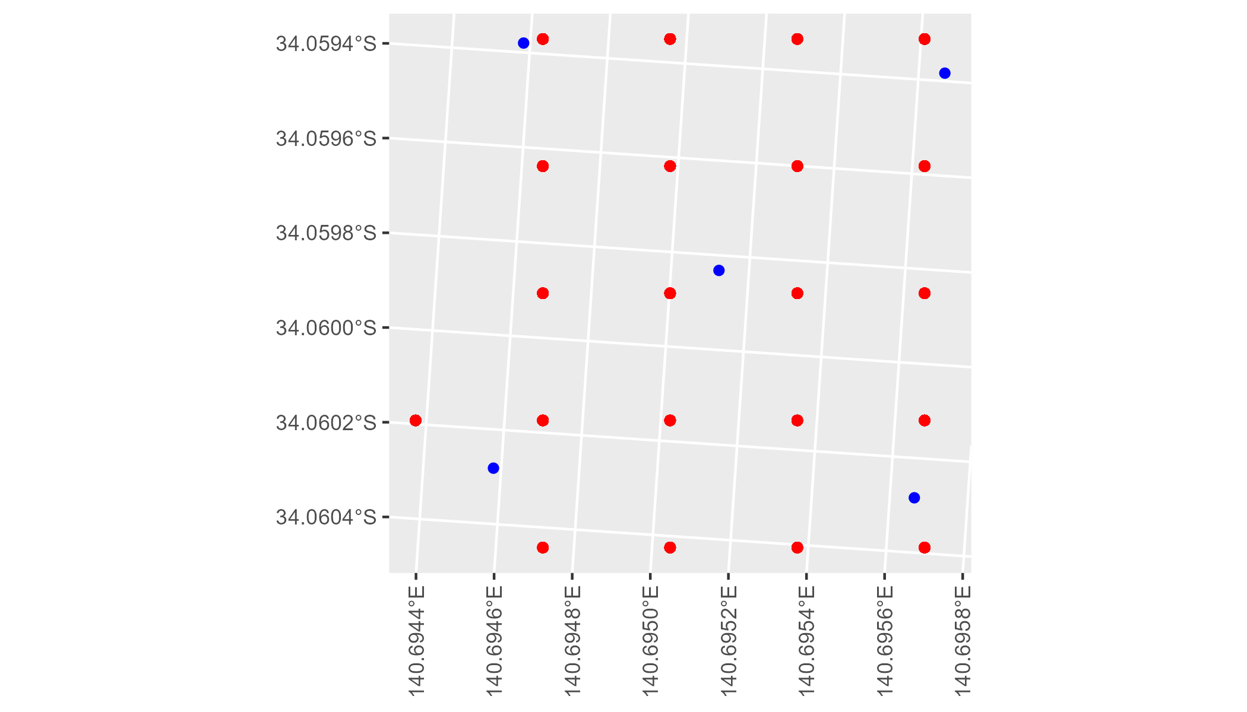

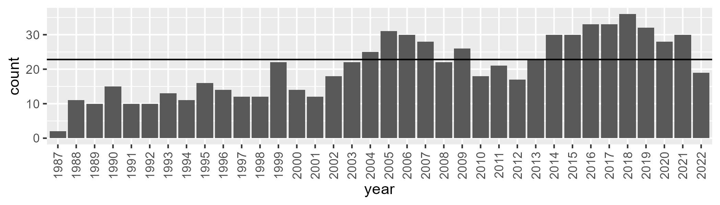

Number of samples: 736

# SASMDD0011

| Min. | 1st Qu. | Median | Mean | 3rd Qu. | Max. |
| --- | --- | --- | --- | --- | --- |
| 0 | 6.066148 | 11.8322 | 17.93001 | 27.42258 | 73.21297 |

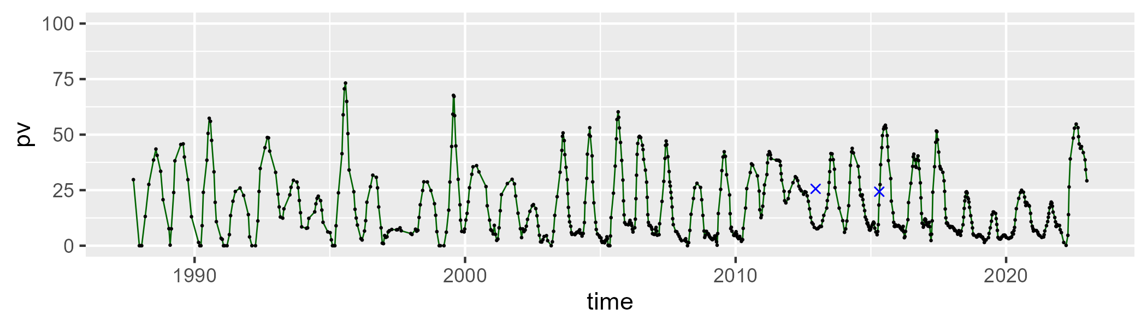

| Min. | 1st Qu. | Median | Mean | 3rd Qu. | Max. |
| --- | --- | --- | --- | --- | --- |
| 18.6377 | 45.57367 | 52.13644 | 51.25645 | 58.46064 | 84.95596 |

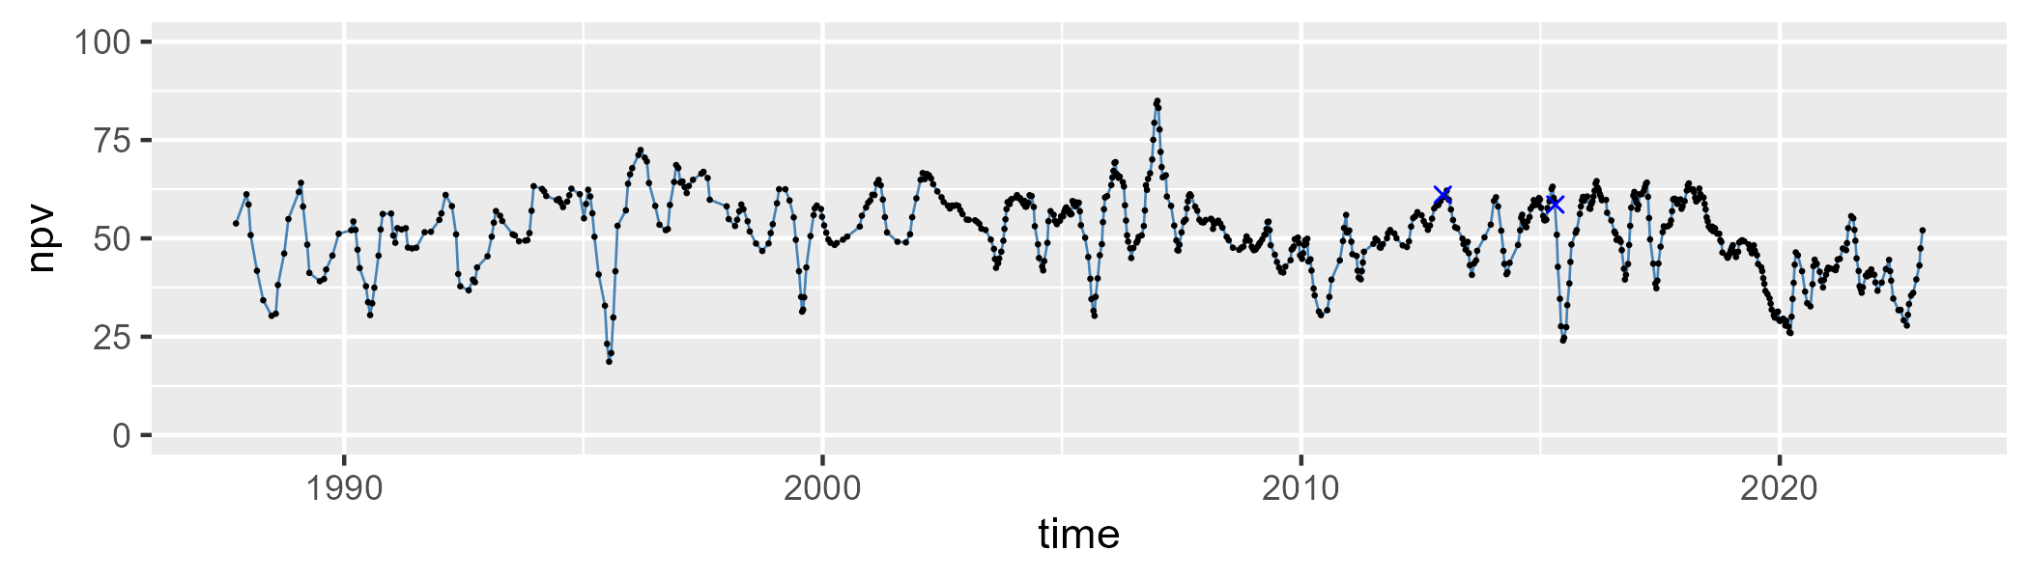

| Min. | 1st Qu. | Median | Mean | 3rd Qu. | Max. |
| --- | --- | --- | --- | --- | --- |
| 0 | 20.07927 | 28.77194 | 29.55002 | 38.17534 | 68.2509 |

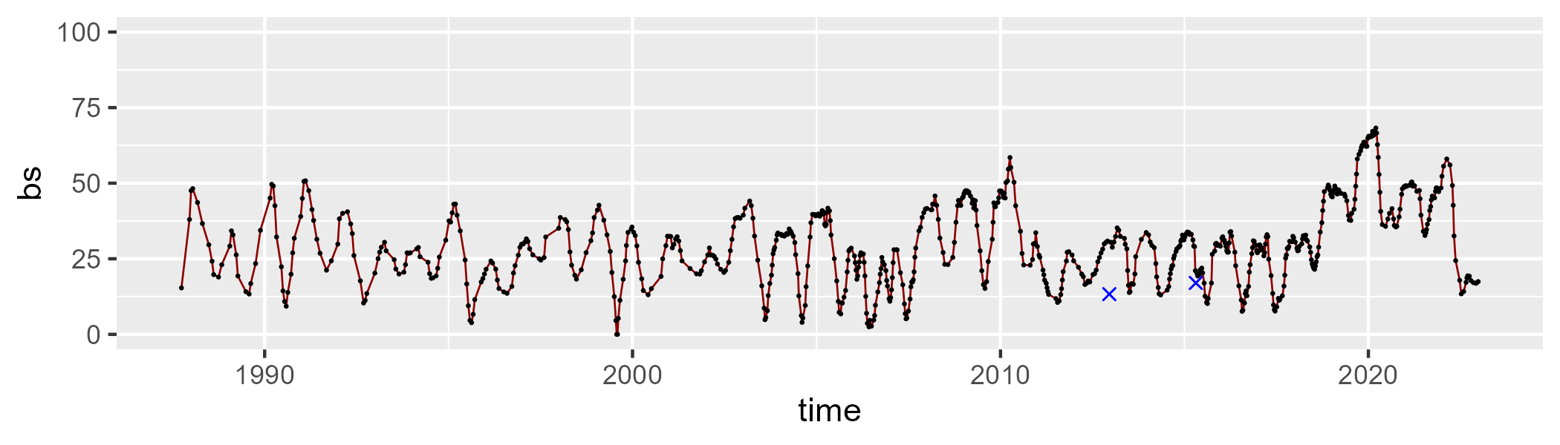

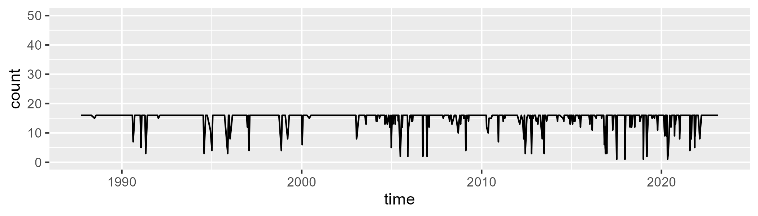

Min. : 1.00 1st Qu.:16.00 Median :16.00 Mean :15.06 3rd Qu.:16.00 Max. :16.00

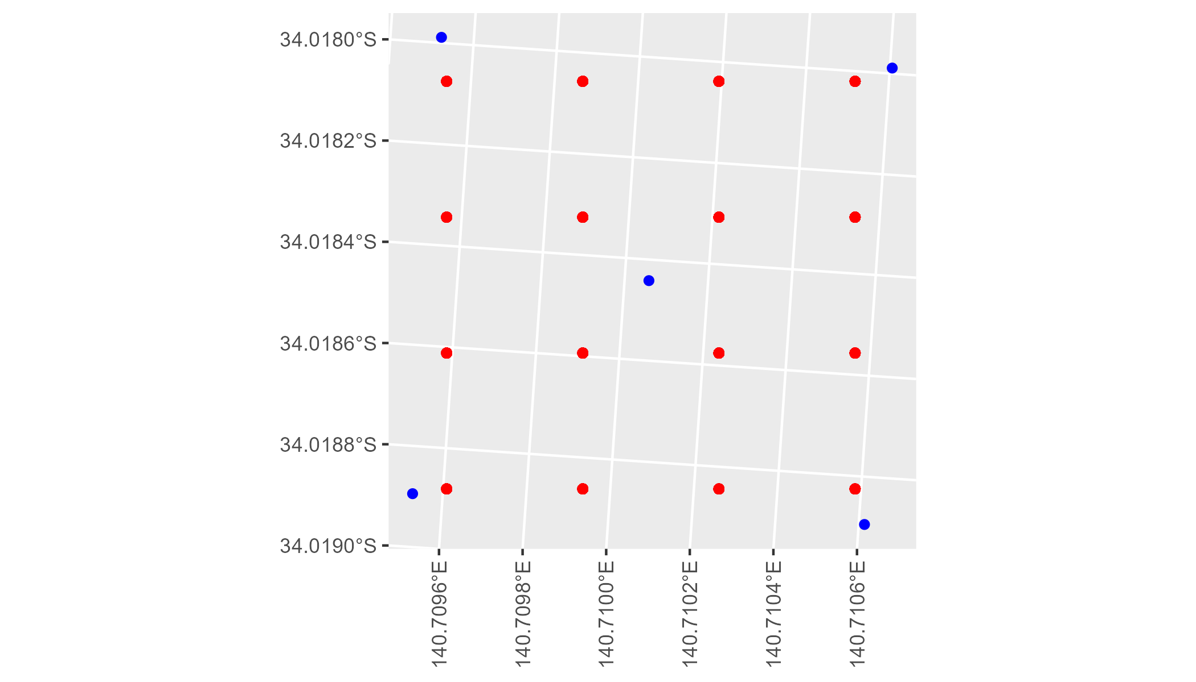

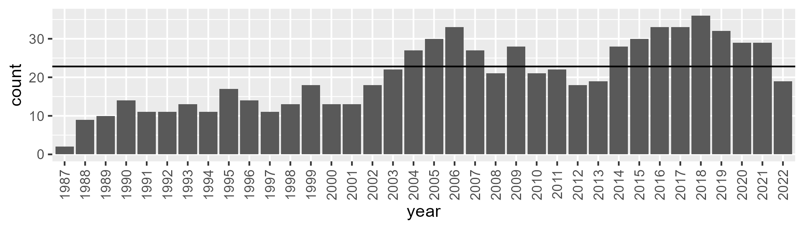

Number of samples: 735

# SASMDD0012

| Min. | 1st Qu. | Median | Mean | 3rd Qu. | Max. |
| --- | --- | --- | --- | --- | --- |
| 13.59112 | 28.91942 | 33.06284 | 33.27523 | 37.47343 | 47.46248 |

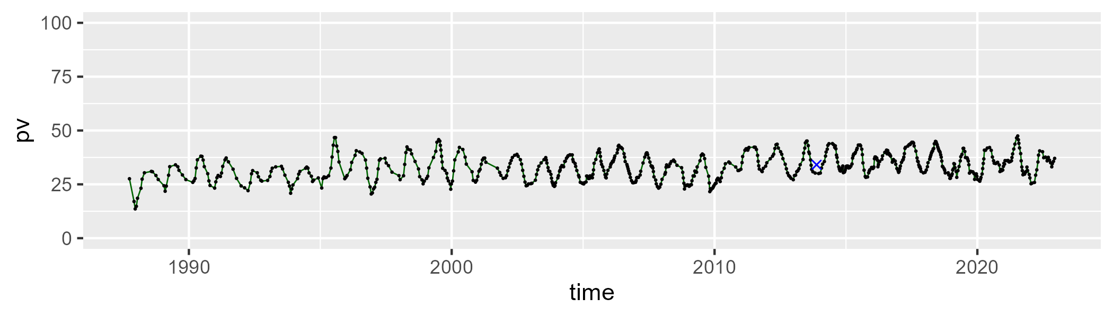

| Min. | 1st Qu. | Median | Mean | 3rd Qu. | Max. |
| --- | --- | --- | --- | --- | --- |
| 29.80684 | 43.59645 | 48.01483 | 47.61141 | 51.92014 | 72.89257 |

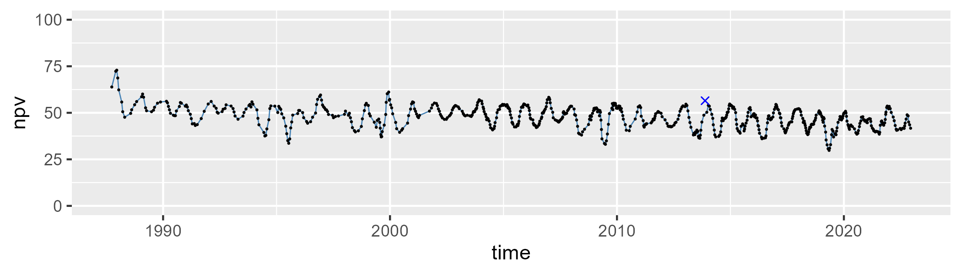

| Min. | 1st Qu. | Median | Mean | 3rd Qu. | Max. |
| --- | --- | --- | --- | --- | --- |
| 6.362823 | 14.87615 | 17.4085 | 17.81915 | 20.5123 | 35.04749 |

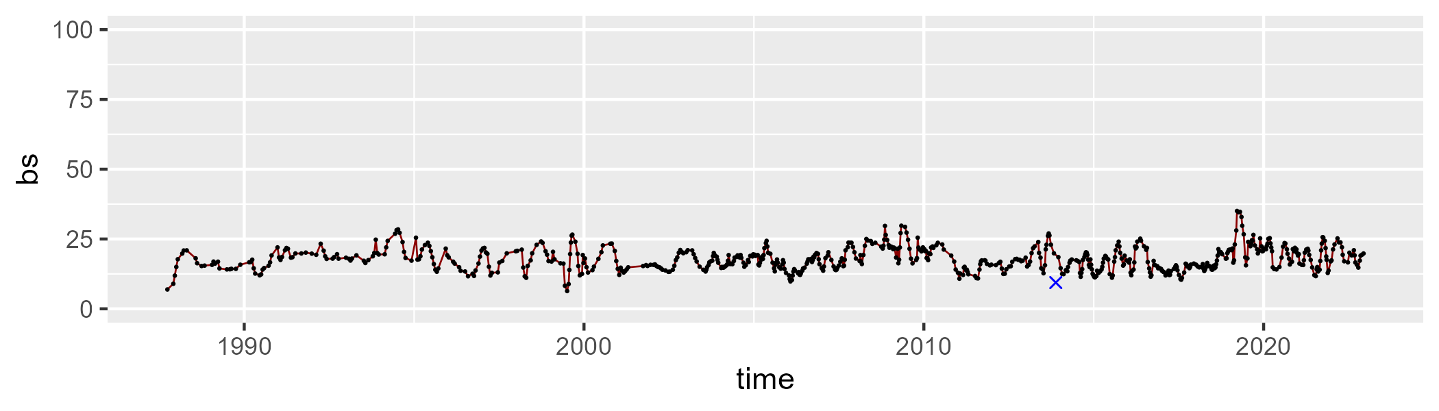

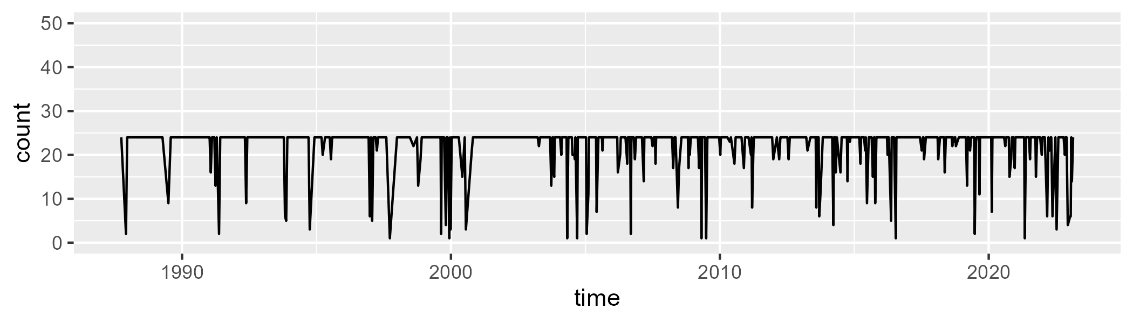

Min. : 1.00 1st Qu.:24.00 Median :24.00 Mean :22.35 3rd Qu.:24.00 Max. :24.00

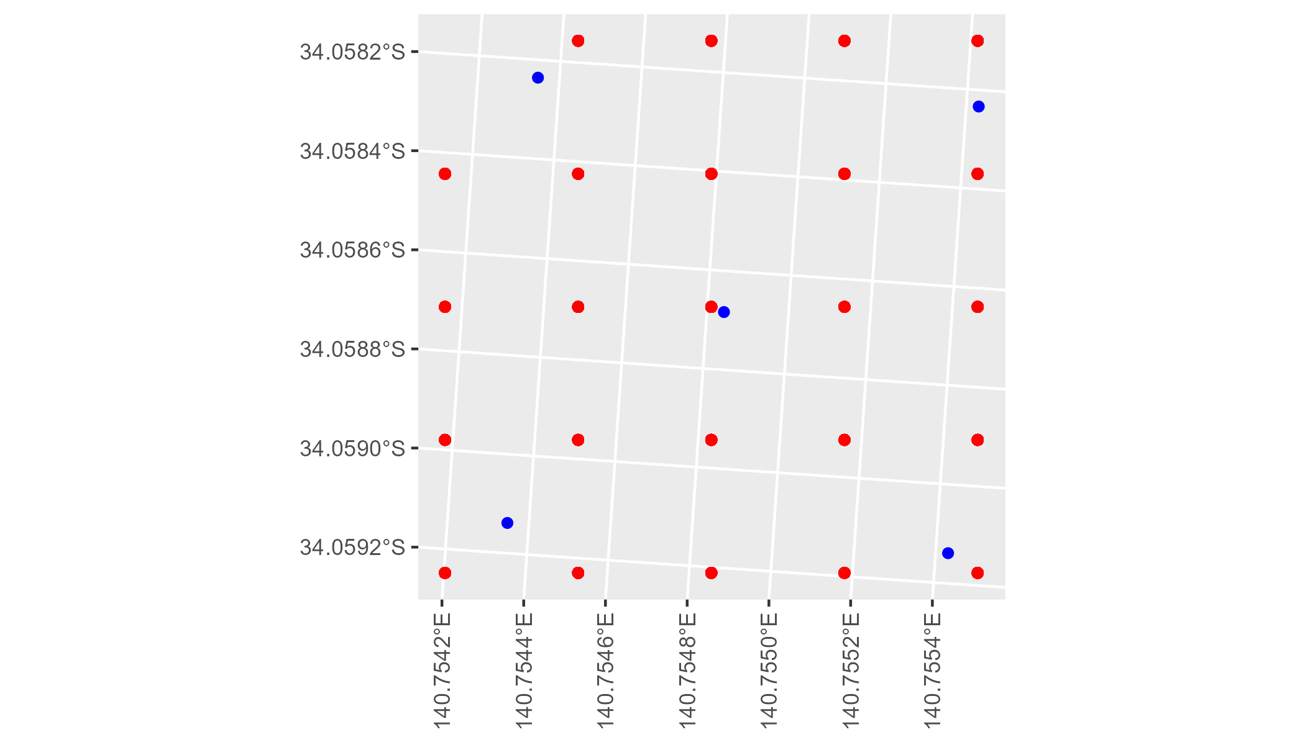

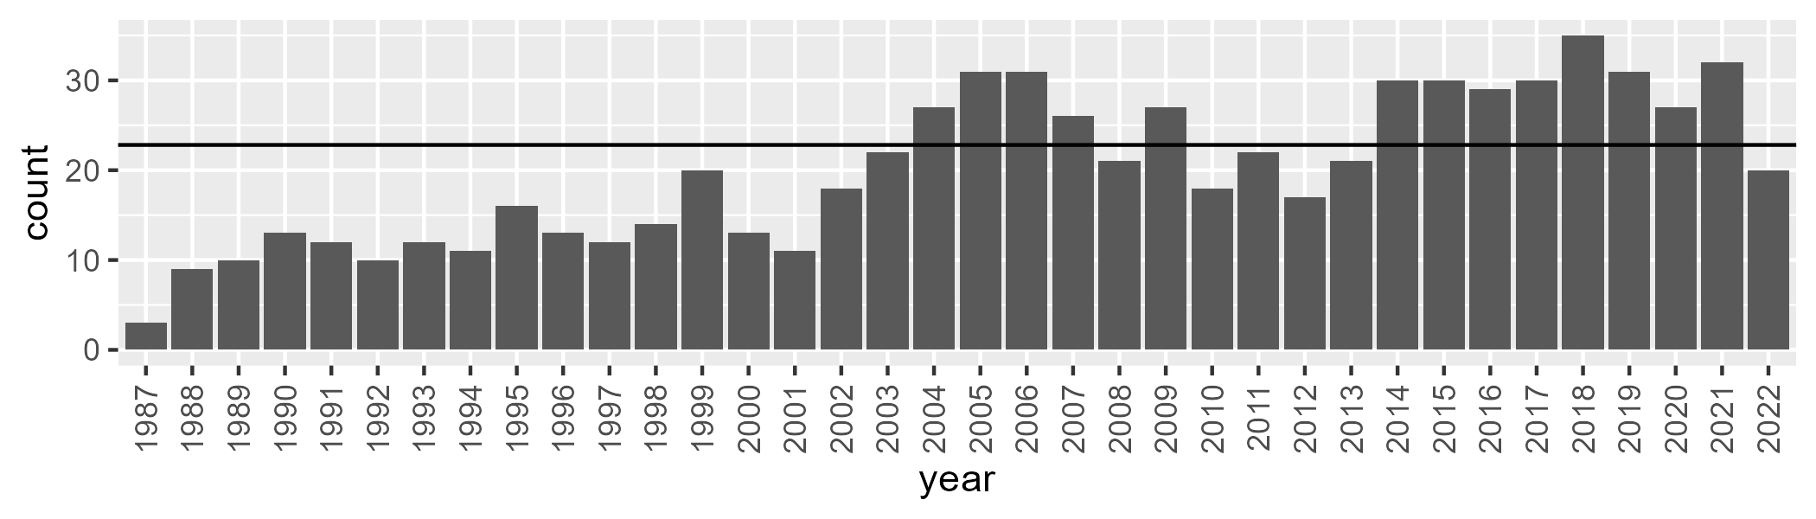

Number of samples: 724

# SASMDD0013

| Min. | 1st Qu. | Median | Mean | 3rd Qu. | Max. |
| --- | --- | --- | --- | --- | --- |
| 4.372605 | 13.50167 | 19.17493 | 20.63213 | 27.03806 | 50.62926 |

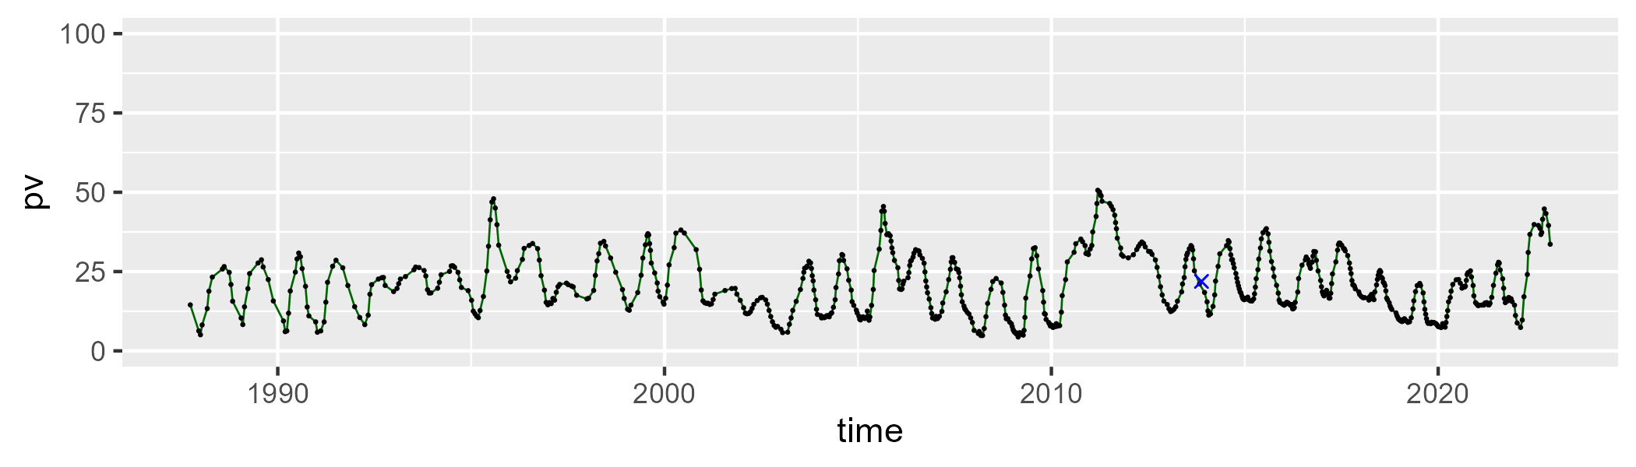

| Min. | 1st Qu. | Median | Mean | 3rd Qu. | Max. |
| --- | --- | --- | --- | --- | --- |
| 1.771792 | 36.39043 | 41.87683 | 40.73621 | 46.74201 | 60.22084 |

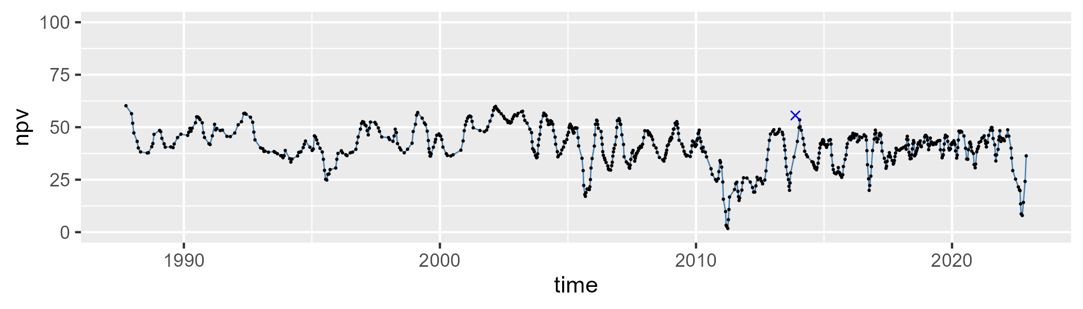

| Min. | 1st Qu. | Median | Mean | 3rd Qu. | Max. |
| --- | --- | --- | --- | --- | --- |
| 13.1004 | 32.82545 | 37.61379 | 37.32005 | 42.04081 | 55.72082 |

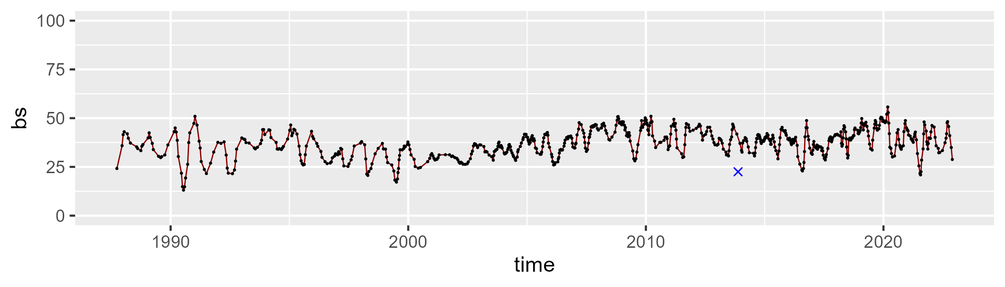

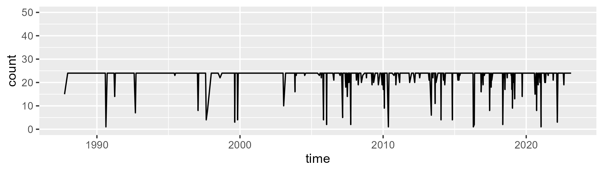

Min. : 1.00 1st Qu.:24.00 Median :24.00 Mean :22.95 3rd Qu.:24.00 Max. :24.00

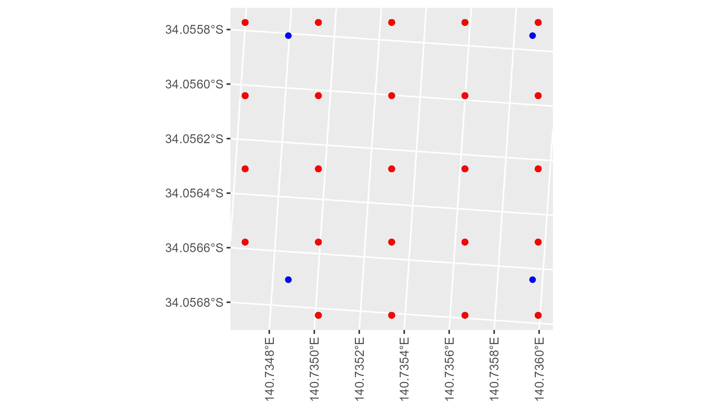

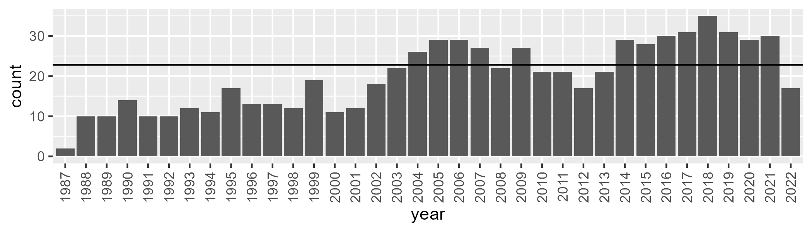

Number of samples: 716

# SASMDD0014

| Min. | 1st Qu. | Median | Mean | 3rd Qu. | Max. |
| --- | --- | --- | --- | --- | --- |
| 4.019567 | 11.73475 | 14.59879 | 15.4542 | 18.65011 | 33.79607 |

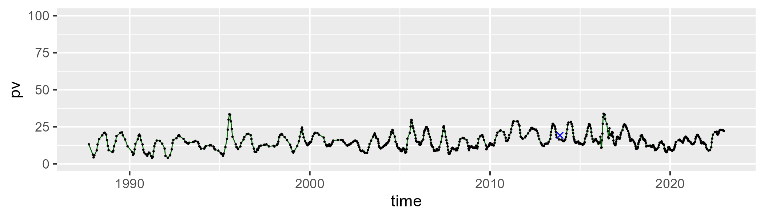

| Min. | 1st Qu. | Median | Mean | 3rd Qu. | Max. |
| --- | --- | --- | --- | --- | --- |
| 26.13338 | 41.13756 | 44.78963 | 44.12364 | 47.37319 | 55.10475 |

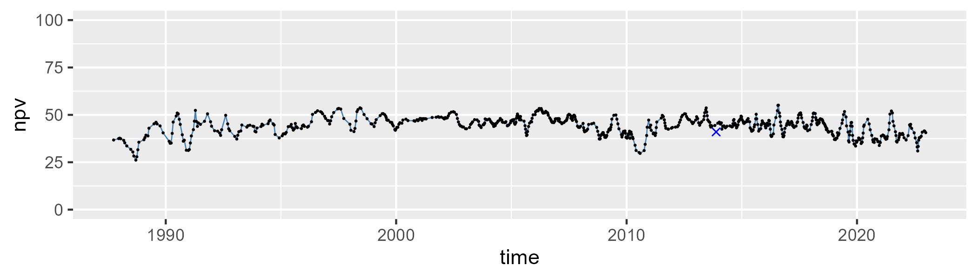

| Min. | 1st Qu. | Median | Mean | 3rd Qu. | Max. |
| --- | --- | --- | --- | --- | --- |
| 19.68704 | 34.15797 | 39.13895 | 39.0402 | 44.36358 | 61.94621 |

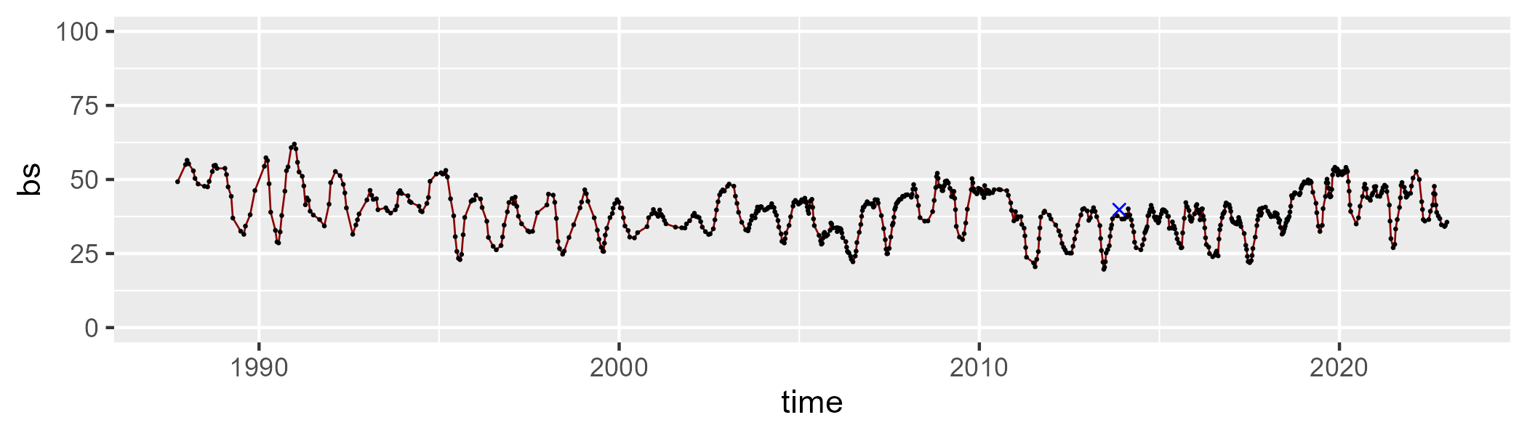

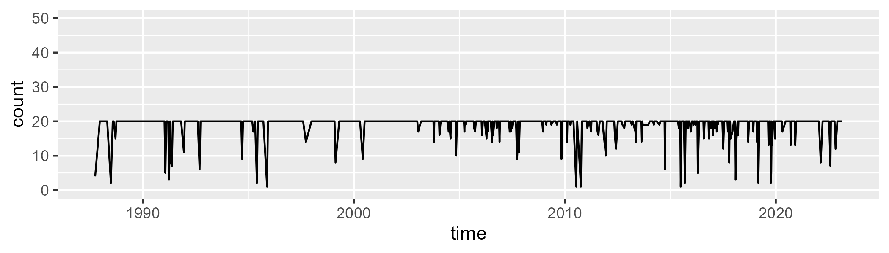

Min. : 1.00 1st Qu.:20.00 Median :20.00 Mean :18.98 3rd Qu.:20.00 Max. :20.00

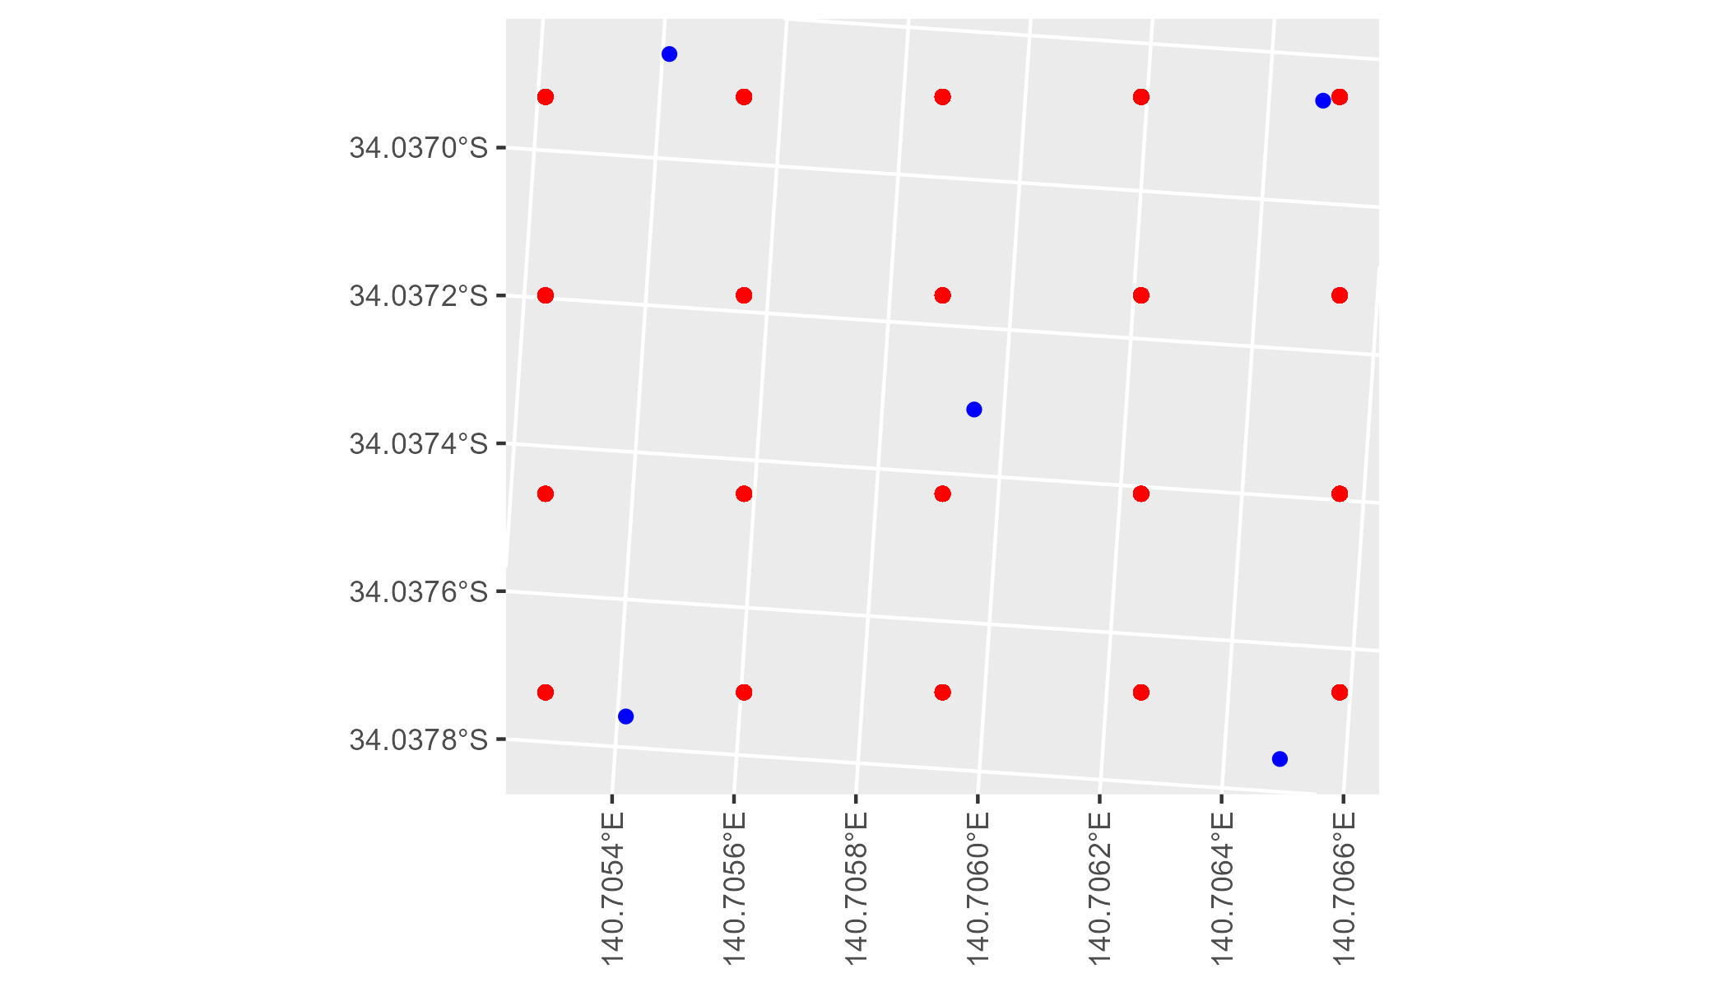

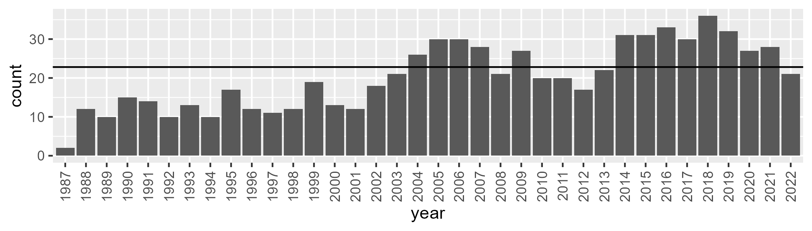

Number of samples: 731

# SASMDD0016

| Min. | 1st Qu. | Median | Mean | 3rd Qu. | Max. |
| --- | --- | --- | --- | --- | --- |
| 14.68295 | 22.48142 | 26.52299 | 27.1375 | 30.96712 | 45.18219 |

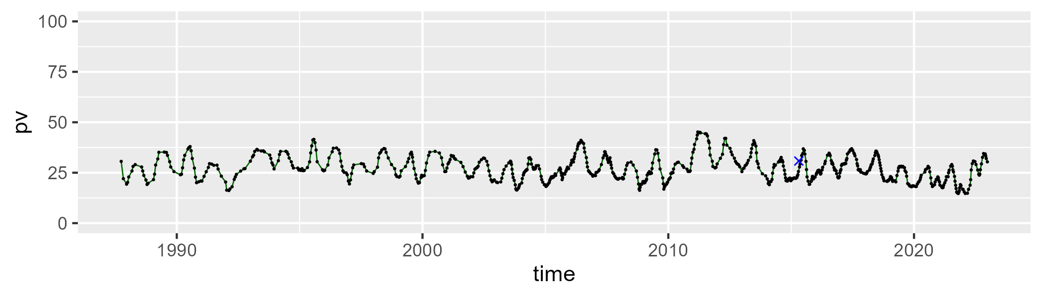

| Min. | 1st Qu. | Median | Mean | 3rd Qu. | Max. |
| --- | --- | --- | --- | --- | --- |
| 29.52857 | 43.06845 | 45.73835 | 45.01933 | 48.10317 | 53.50243 |

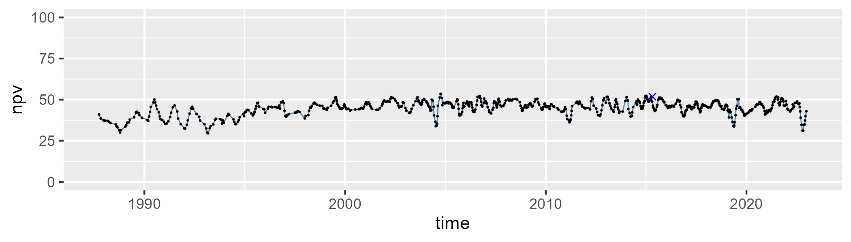

| Min. | 1st Qu. | Median | Mean | 3rd Qu. | Max. |
| --- | --- | --- | --- | --- | --- |
| 5.551839 | 21.37646 | 27.17035 | 26.52406 | 31.50077 | 49.69186 |

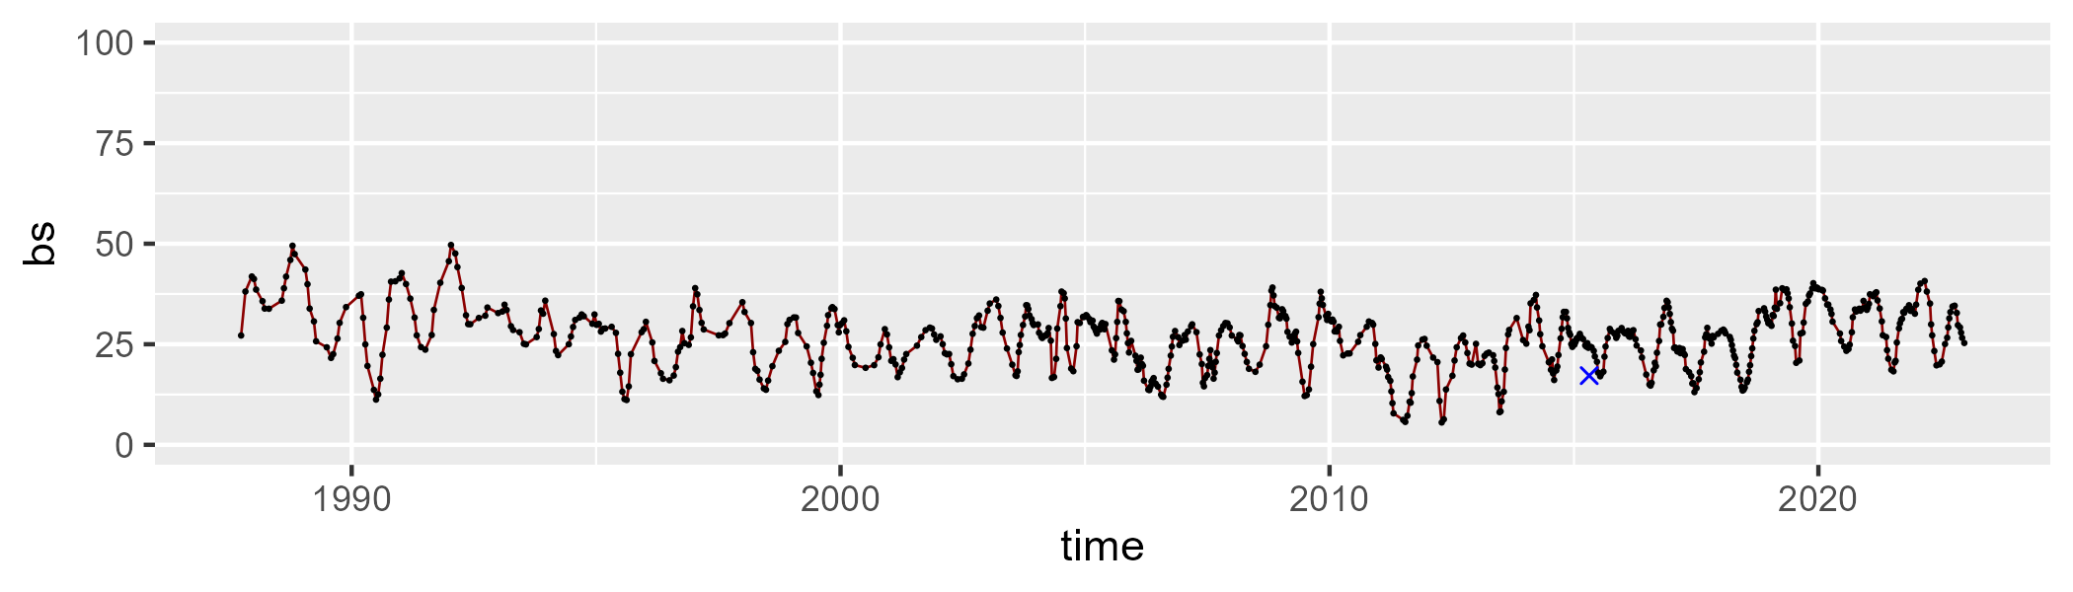

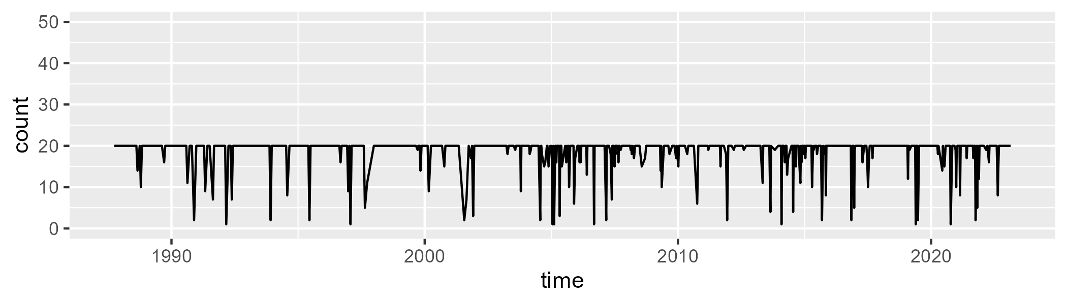

Min. : 1.0 1st Qu.:20.0 Median :20.0 Mean :18.7 3rd Qu.:20.0 Max. :20.0

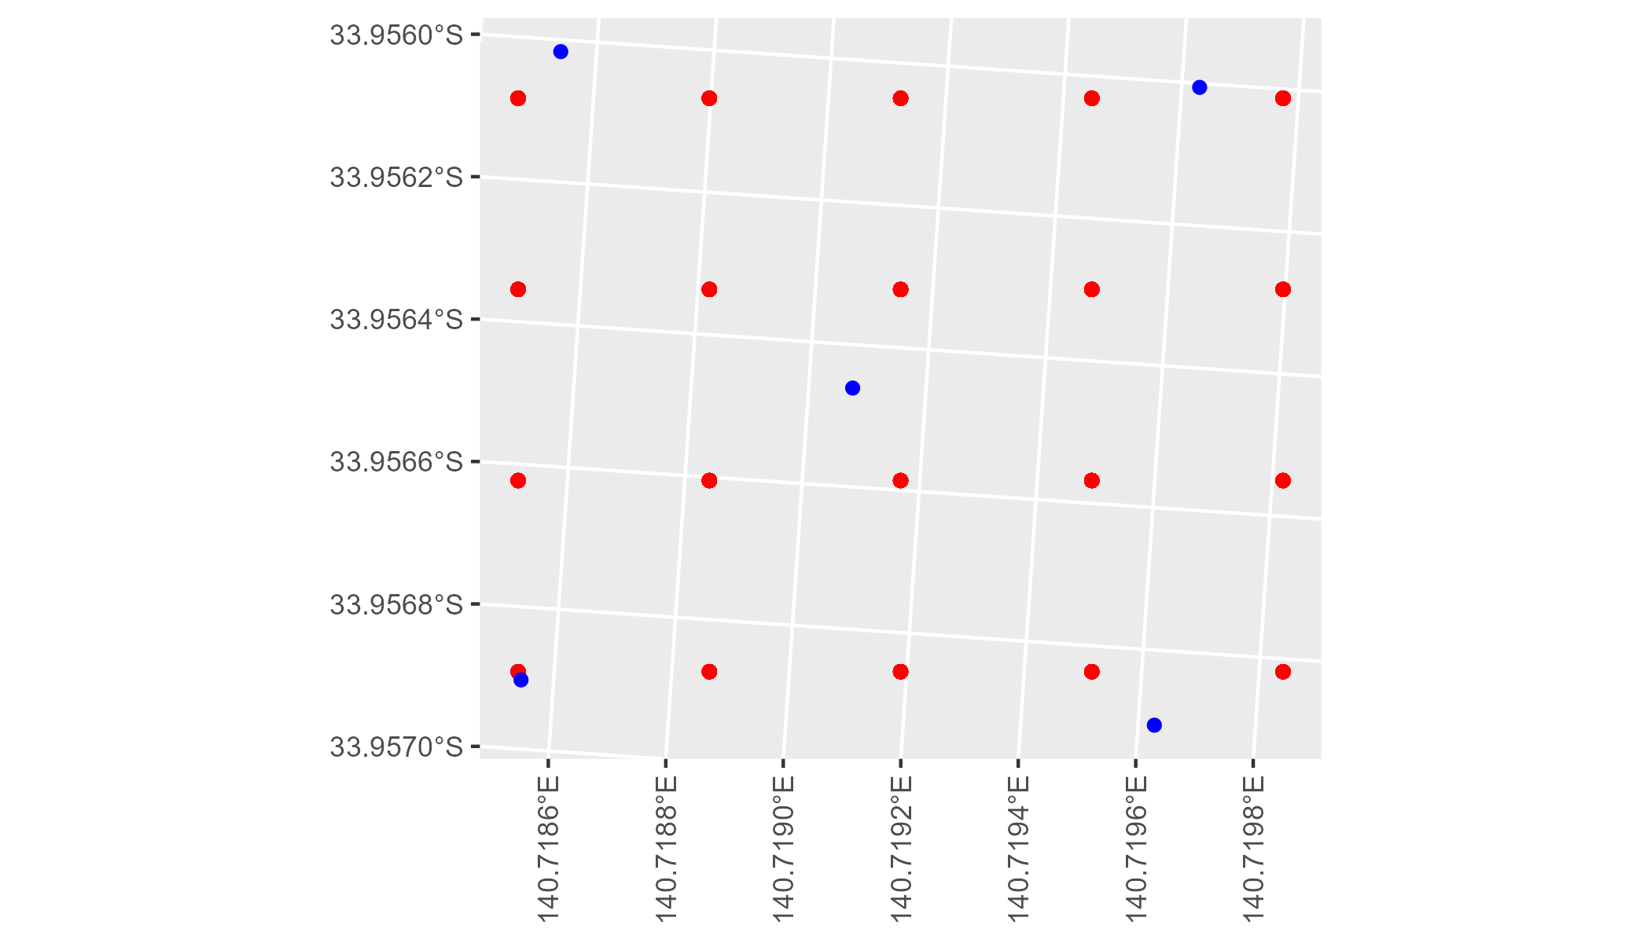

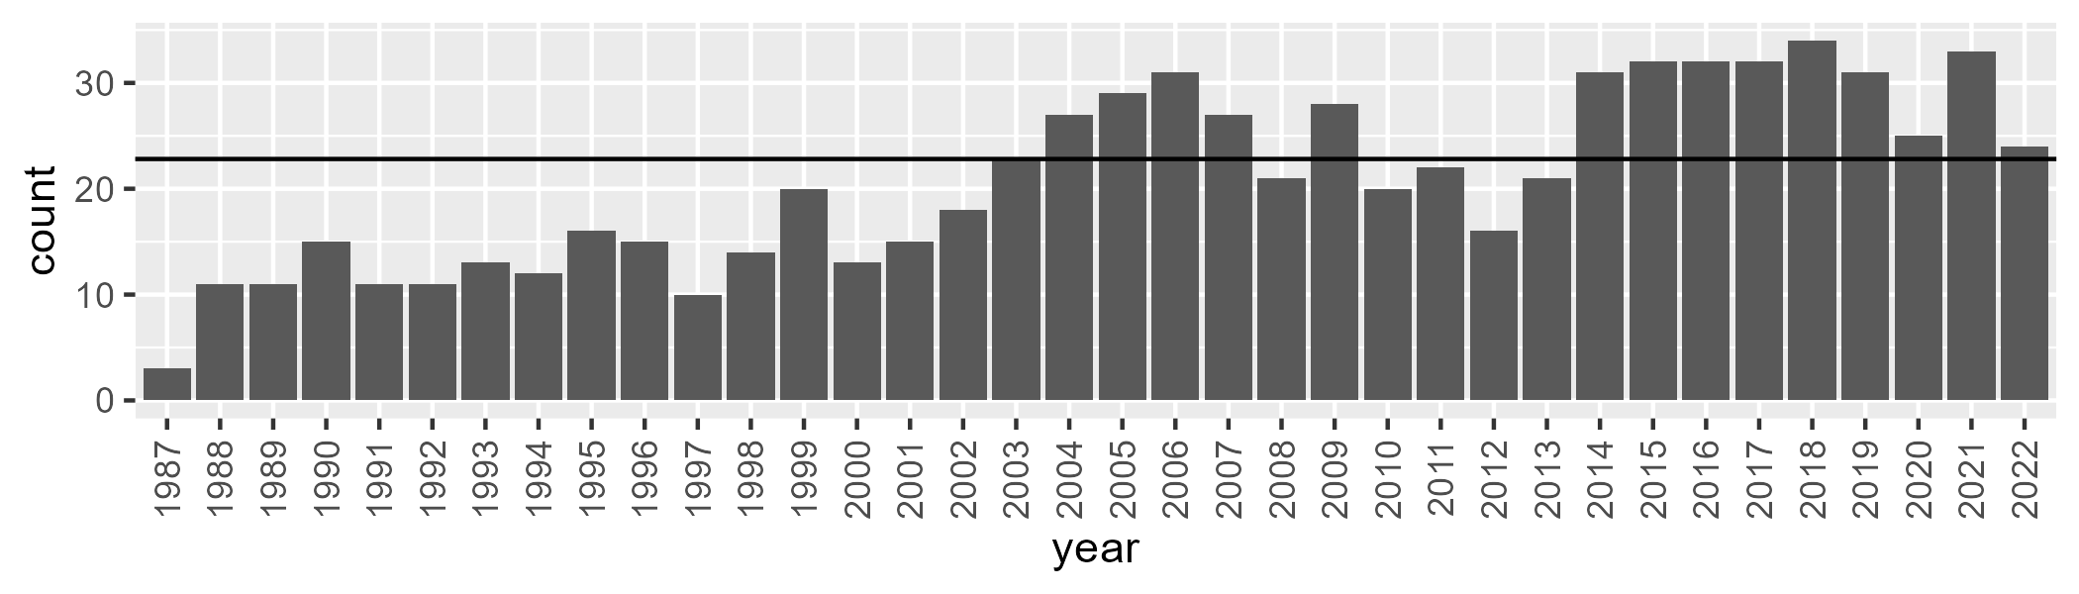

Number of samples: 747

# SASMDD0017

| Min. | 1st Qu. | Median | Mean | 3rd Qu. | Max. |
| --- | --- | --- | --- | --- | --- |
| 12.34103 | 18.87421 | 21.99362 | 22.40041 | 25.73304 | 35.60351 |

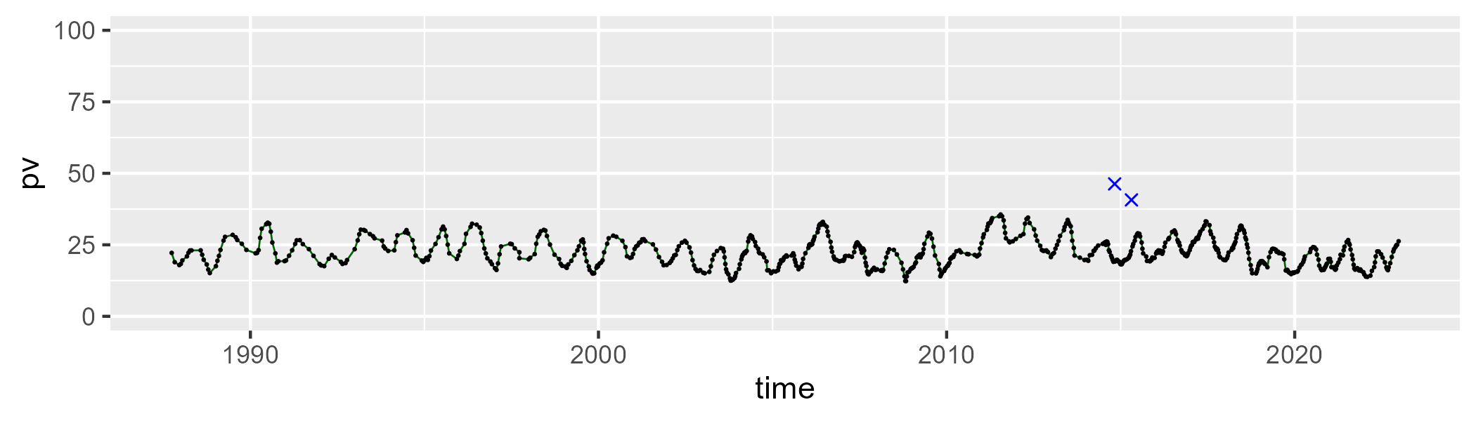

| Min. | 1st Qu. | Median | Mean | 3rd Qu. | Max. |
| --- | --- | --- | --- | --- | --- |
| 24.24267 | 40.52495 | 42.99259 | 42.3096 | 45.15986 | 52.685 |

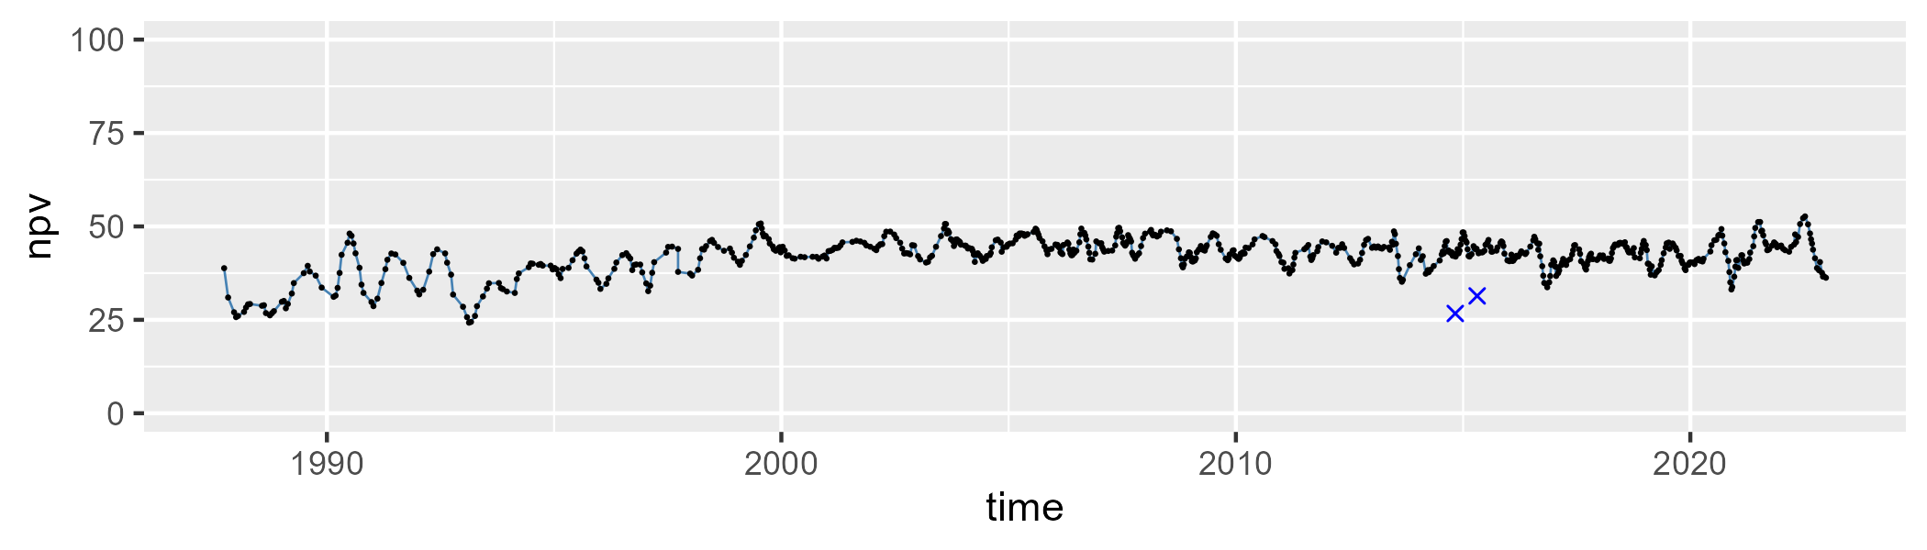

| Min. | 1st Qu. | Median | Mean | 3rd Qu. | Max. |
| --- | --- | --- | --- | --- | --- |
| 16.07894 | 29.33326 | 33.86544 | 33.87975 | 38.26931 | 56.17115 |

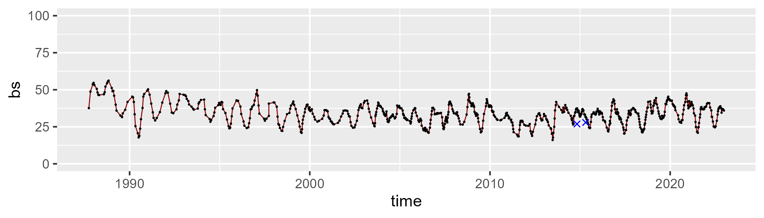

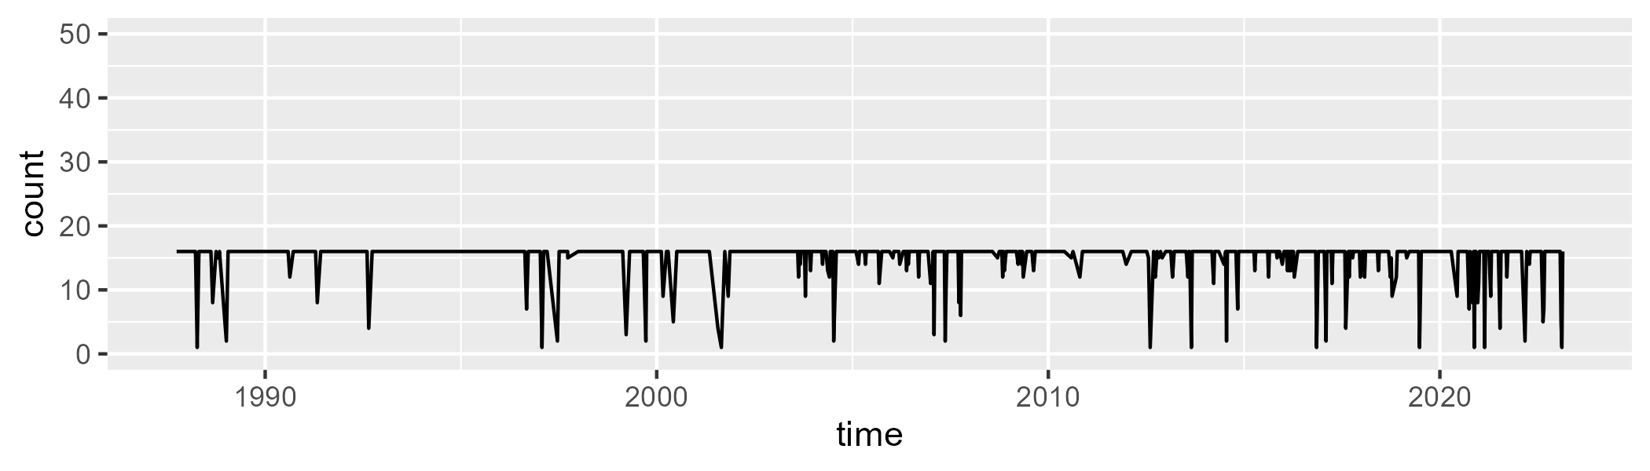

Min. : 1.00 1st Qu.:16.00 Median :16.00 Mean :15.09 3rd Qu.:16.00 Max. :16.00

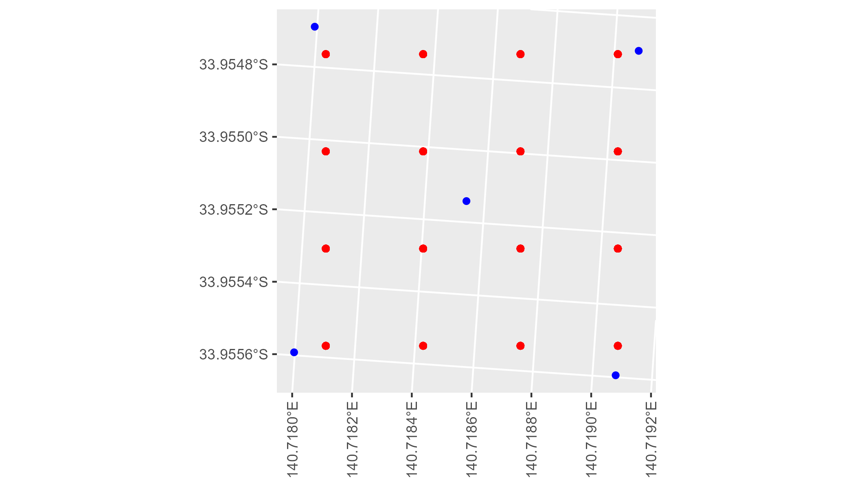

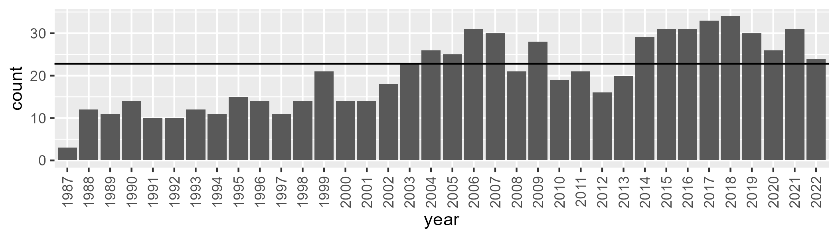

Number of samples: 733

# SASMDD0018

| Min. | 1st Qu. | Median | Mean | 3rd Qu. | Max. |
| --- | --- | --- | --- | --- | --- |
| 6.339512 | 16.43917 | 20.33399 | 20.64444 | 24.51041 | 34.49129 |

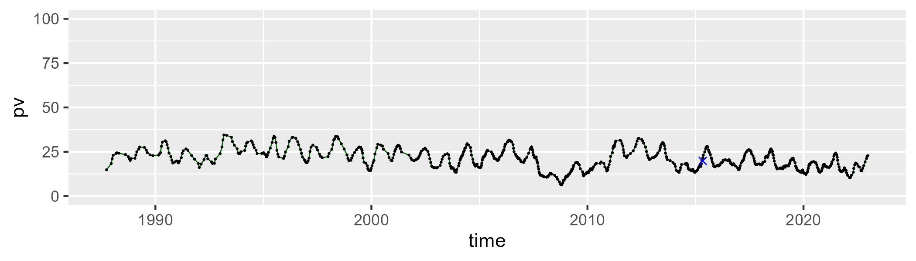

| Min. | 1st Qu. | Median | Mean | 3rd Qu. | Max. |
| --- | --- | --- | --- | --- | --- |
| 25.55576 | 36.50078 | 40.05873 | 40.02796 | 43.93572 | 50.8333 |

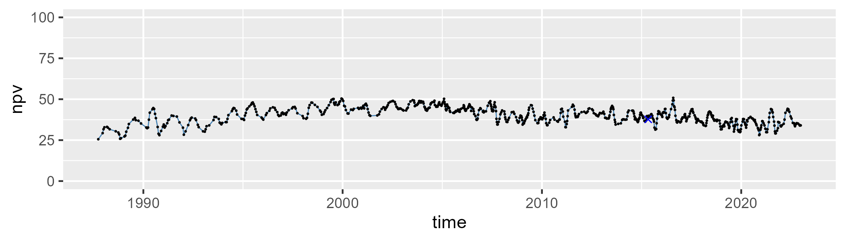

| Min. | 1st Qu. | Median | Mean | 3rd Qu. | Max. |
| --- | --- | --- | --- | --- | --- |
| 17.01703 | 32.11365 | 37.45323 | 37.89855 | 45.11112 | 58.33901 |

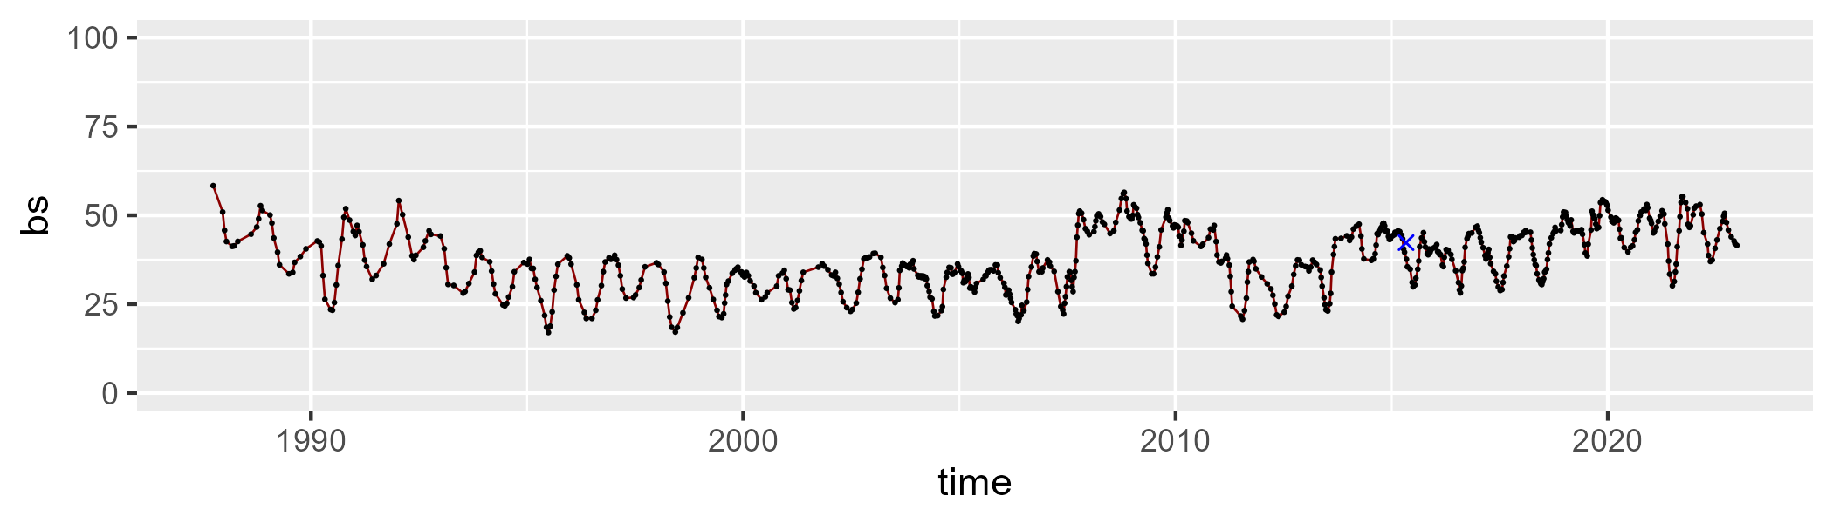

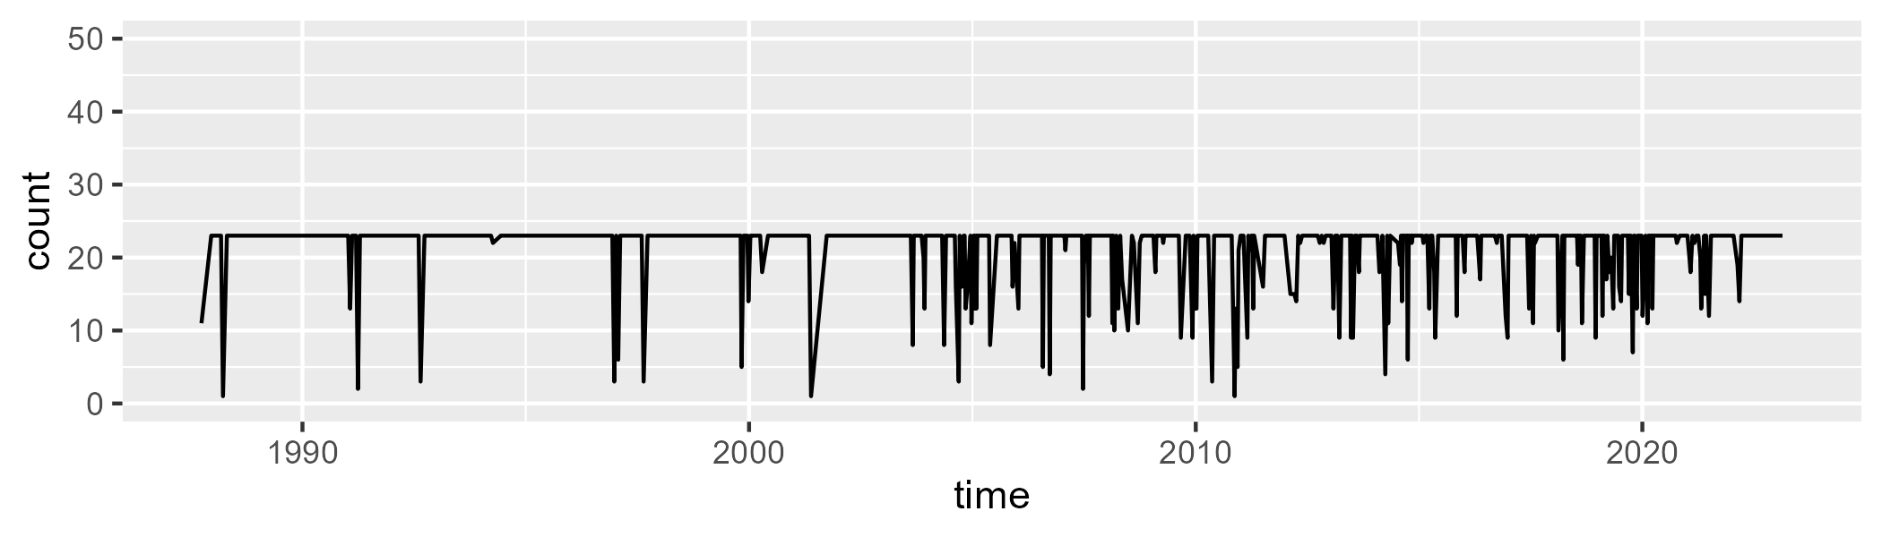

Min. : 1.00 1st Qu.:23.00 Median :23.00 Mean :21.45 3rd Qu.:23.00 Max. :23.00

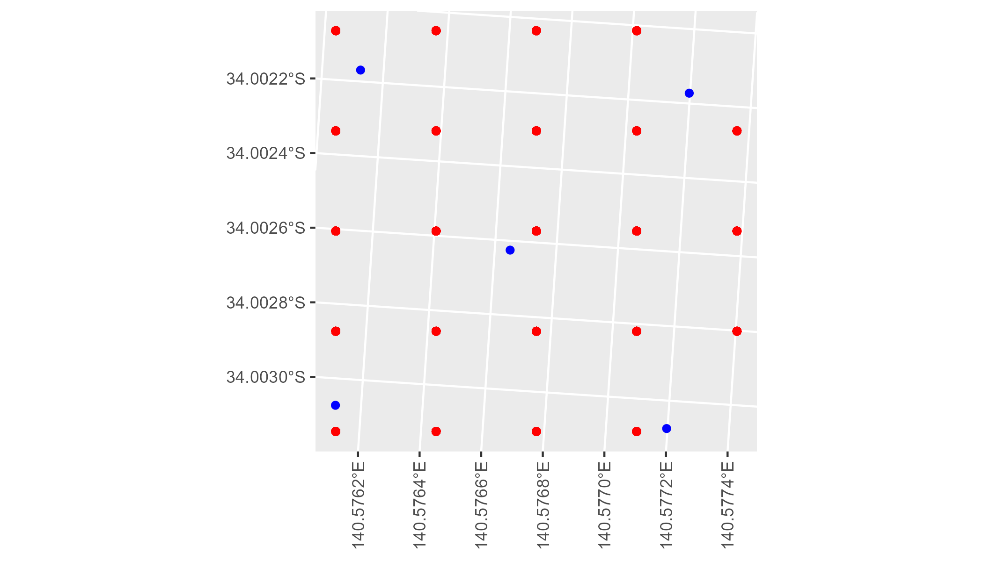

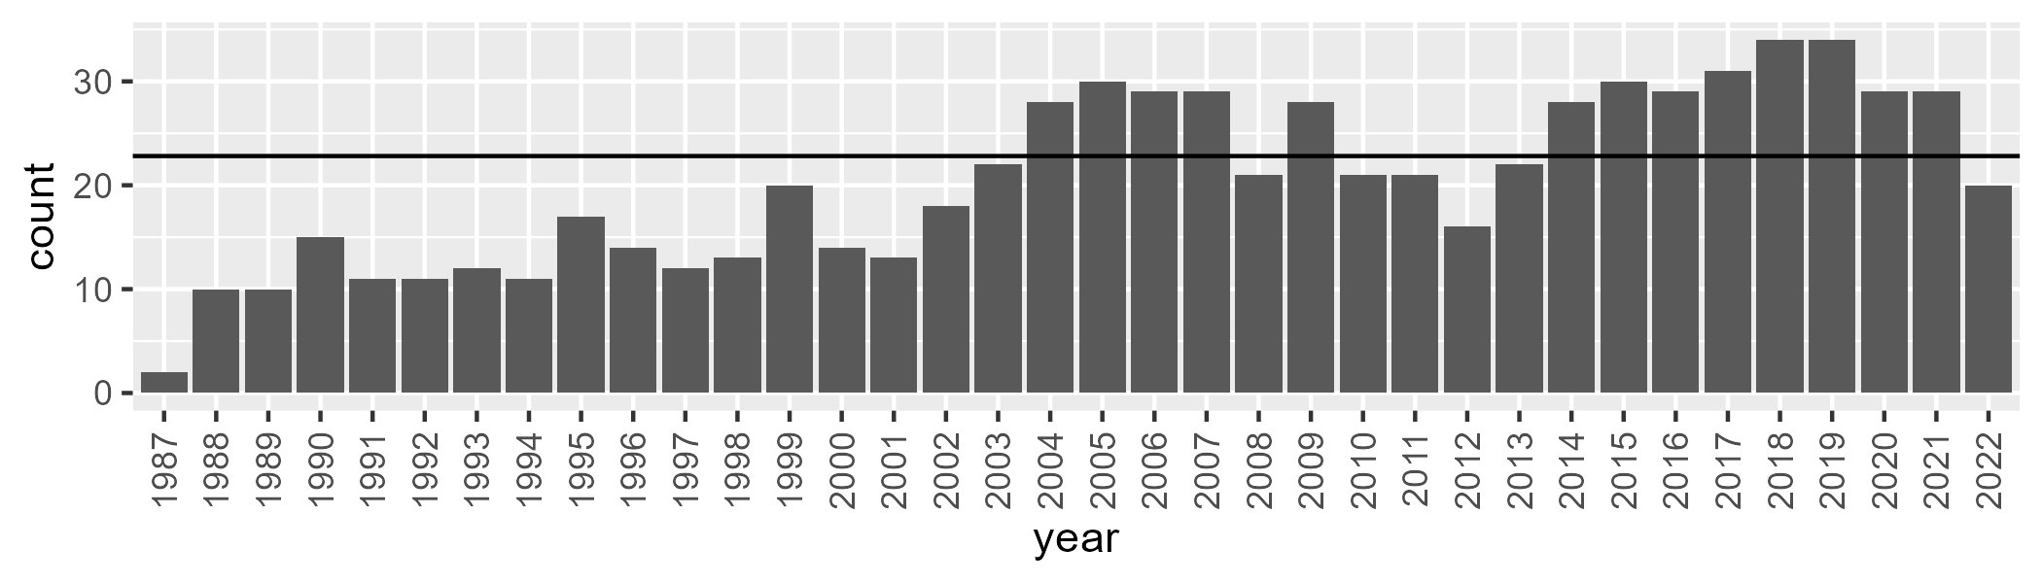

Number of samples: 734

# SASRIV0001

| Min. | 1st Qu. | Median | Mean | 3rd Qu. | Max. |
| --- | --- | --- | --- | --- | --- |
| 0 | 4.241674 | 9.172272 | 12.66573 | 18.97772 | 73.89036 |

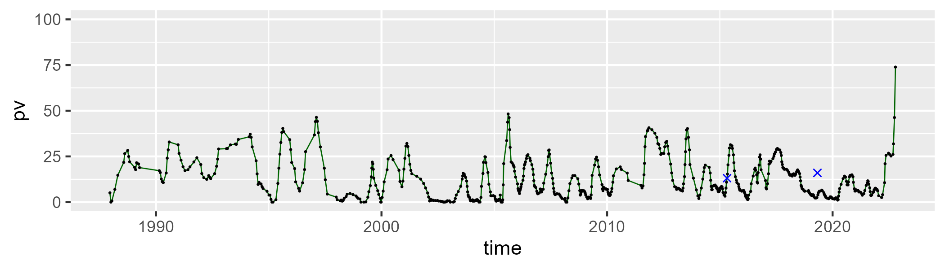

| Min. | 1st Qu. | Median | Mean | 3rd Qu. | Max. |
| --- | --- | --- | --- | --- | --- |
| 16.04356 | 36.88043 | 43.26081 | 44.53043 | 50.88903 | 84.85311 |

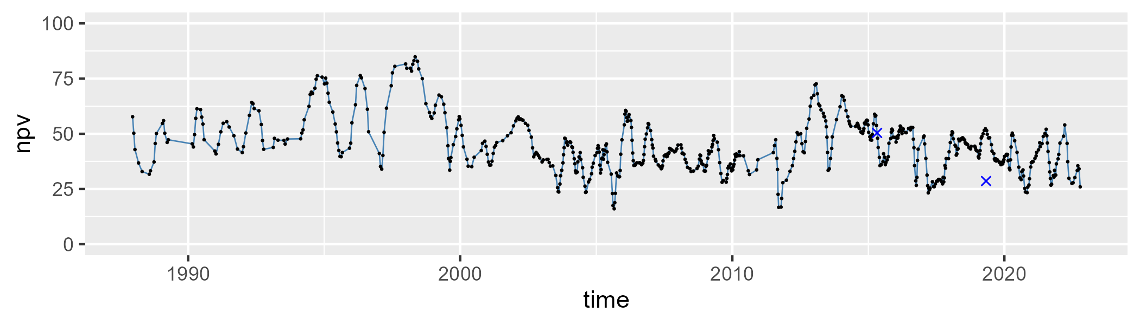

| Min. | 1st Qu. | Median | Mean | 3rd Qu. | Max. |
| --- | --- | --- | --- | --- | --- |
| 0 | 32.99709 | 42.41655 | 41.56165 | 52.00705 | 68.32966 |

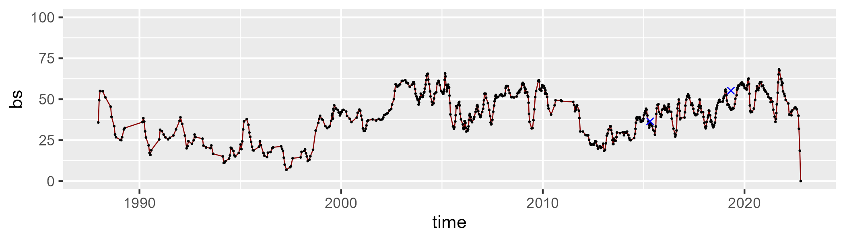

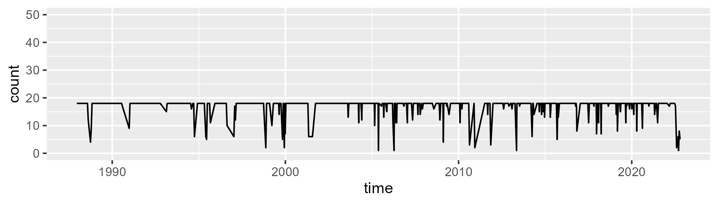

Min. : 1.00 1st Qu.:18.00 Median :18.00 Mean :16.99 3rd Qu.:18.00 Max. :18.00

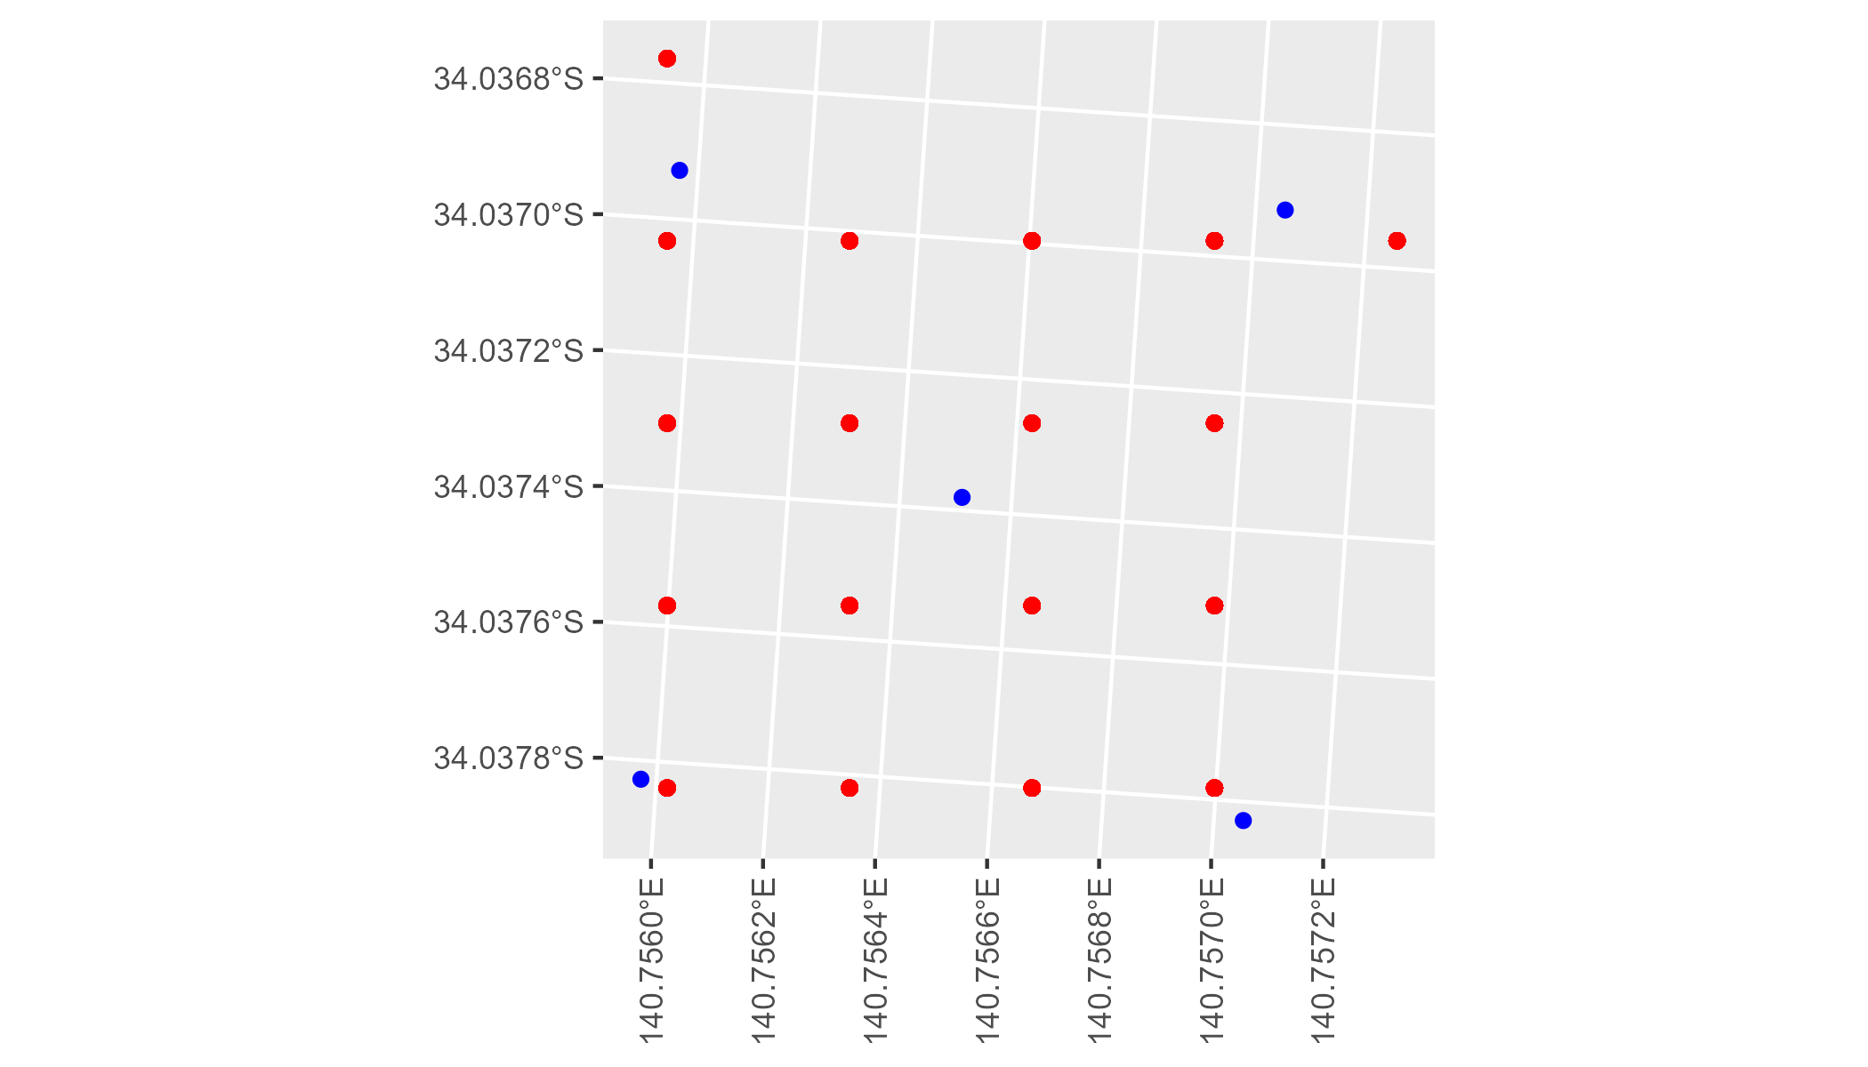

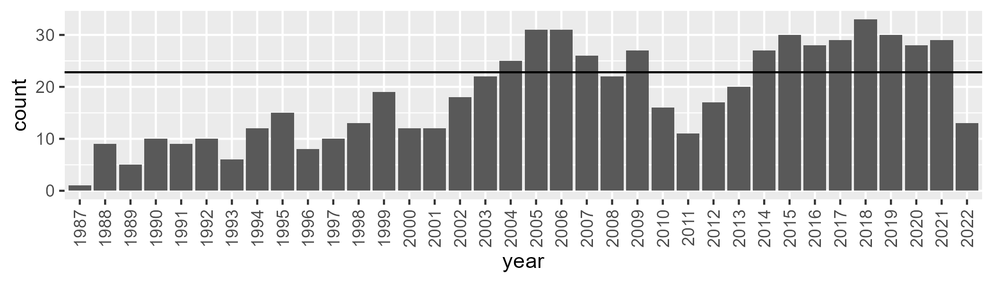

Number of samples: 664

# SASRIV0002

| Min. | 1st Qu. | Median | Mean | 3rd Qu. | Max. |
| --- | --- | --- | --- | --- | --- |
| 0 | 6.419103 | 11.60996 | 13.88236 | 20.9313 | 43.19308 |

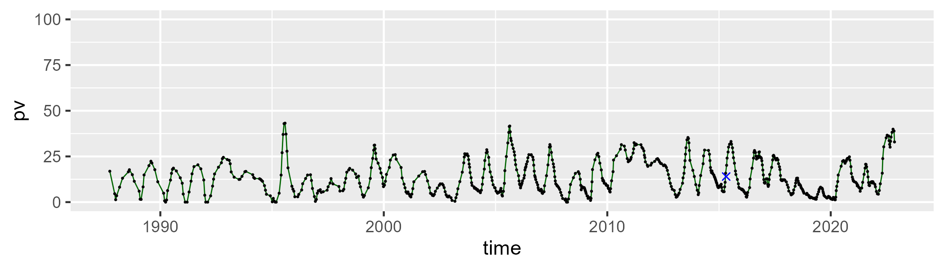

| Min. | 1st Qu. | Median | Mean | 3rd Qu. | Max. |
| --- | --- | --- | --- | --- | --- |
| 0.8153762 | 25.42795 | 31.77367 | 30.86075 | 37.79269 | 51.88954 |

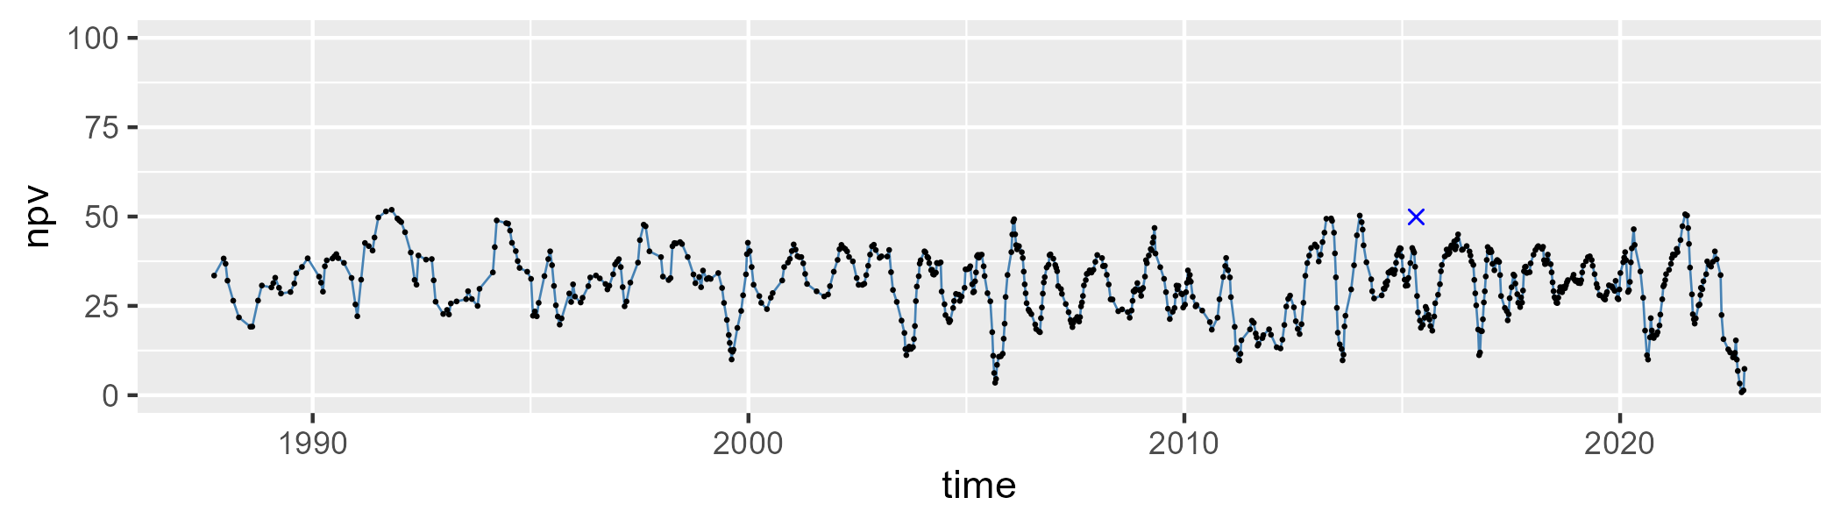

| Min. | 1st Qu. | Median | Mean | 3rd Qu. | Max. |
| --- | --- | --- | --- | --- | --- |
| 25.50376 | 49.77541 | 54.92736 | 54.06079 | 59.42249 | 79.06332 |

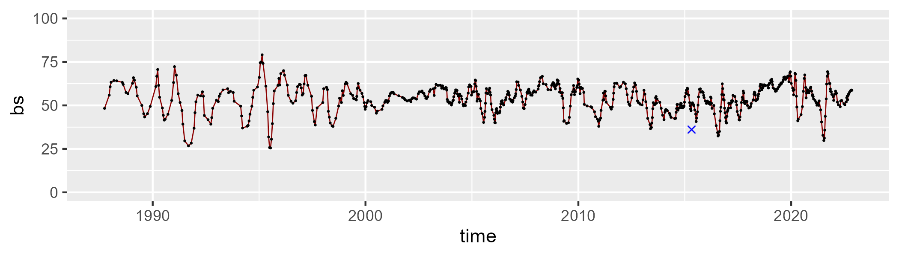

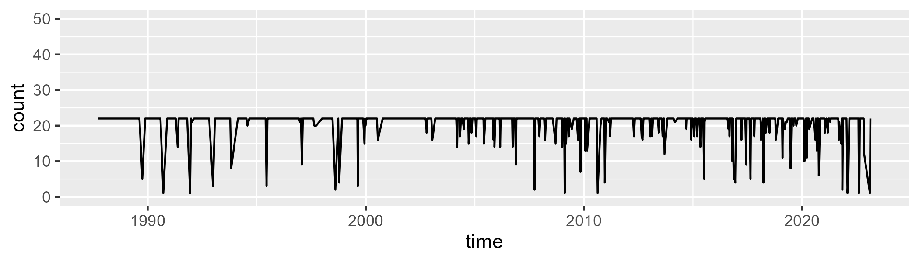

Min. : 1.00 1st Qu.:22.00 Median :22.00 Mean :20.57 3rd Qu.:22.00 Max. :22.00

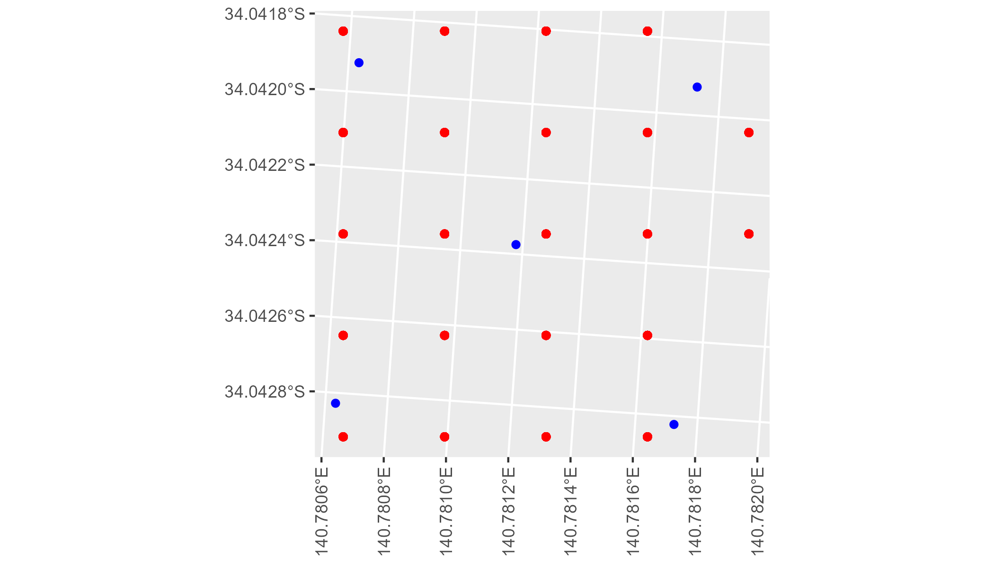

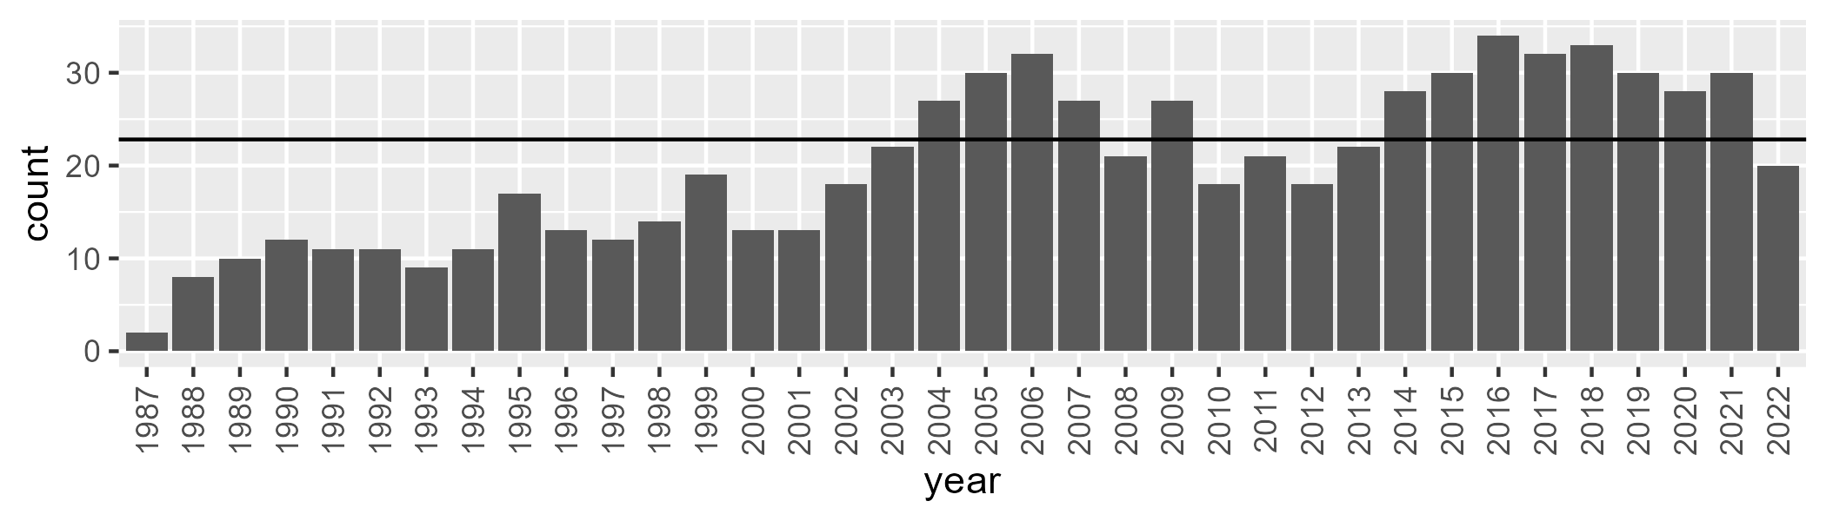

Number of samples: 723

# SATEYB0001

| Min. | 1st Qu. | Median | Mean | 3rd Qu. | Max. |
| --- | --- | --- | --- | --- | --- |
| 8.495082 | 28.97269 | 37.67794 | 40.64903 | 52.68129 | 78.50001 |

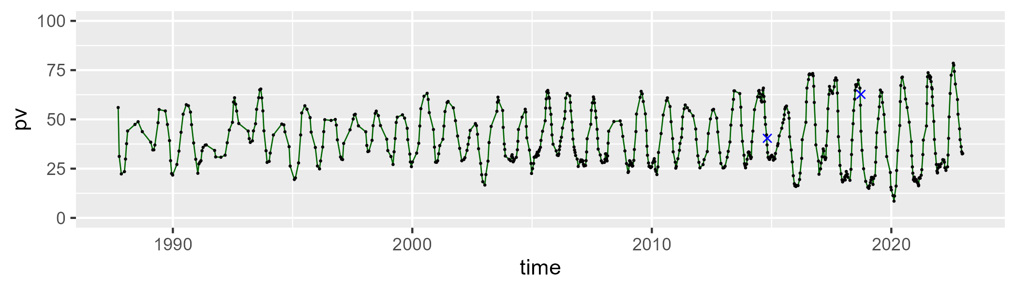

| Min. | 1st Qu. | Median | Mean | 3rd Qu. | Max. |
| --- | --- | --- | --- | --- | --- |
| 5.885184 | 34.70956 | 47.24027 | 43.86047 | 55.1184 | 64.8439 |

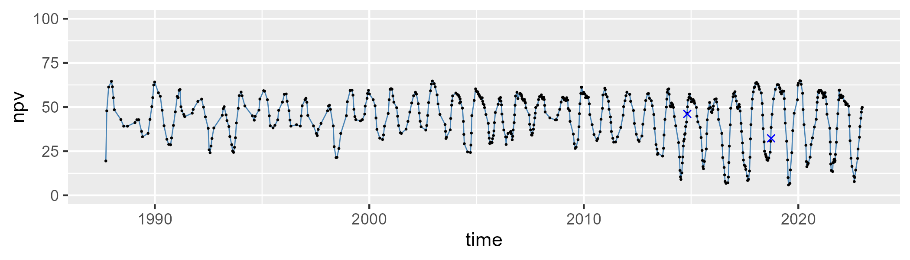

| Min. | 1st Qu. | Median | Mean | 3rd Qu. | Max. |
| --- | --- | --- | --- | --- | --- |
| 0.645166 | 10.68924 | 14.05967 | 14.24449 | 17.61506 | 35.3996 |

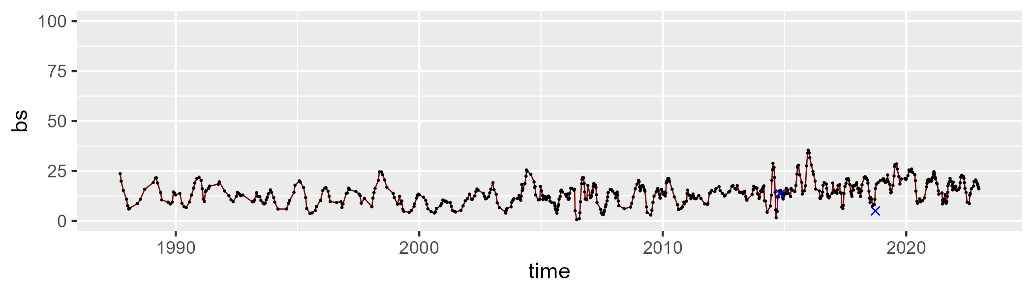

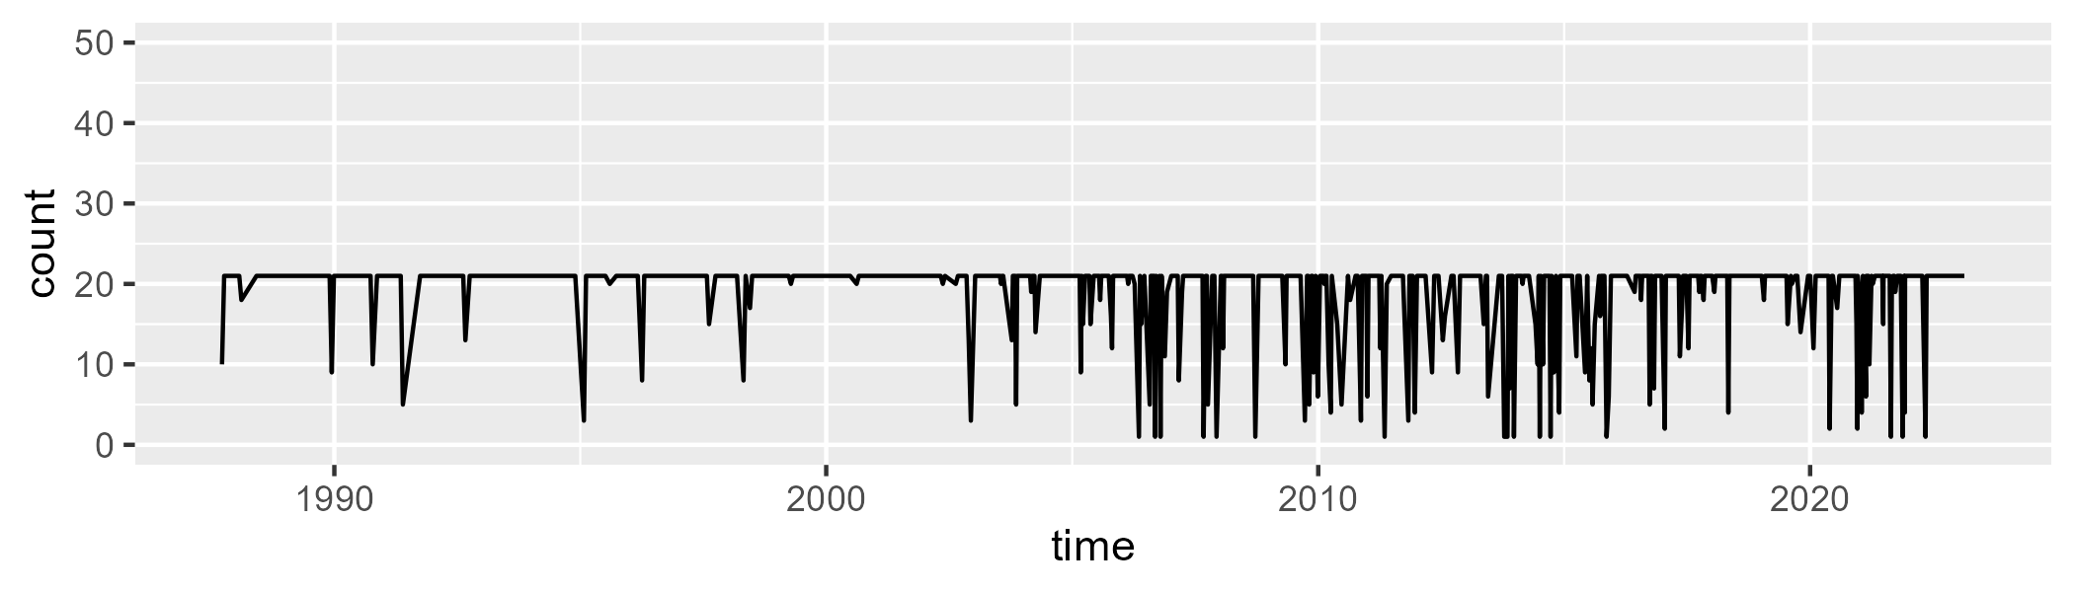

Min. : 1.00 1st Qu.:21.00 Median :21.00 Mean :18.93 3rd Qu.:21.00 Max. :21.00

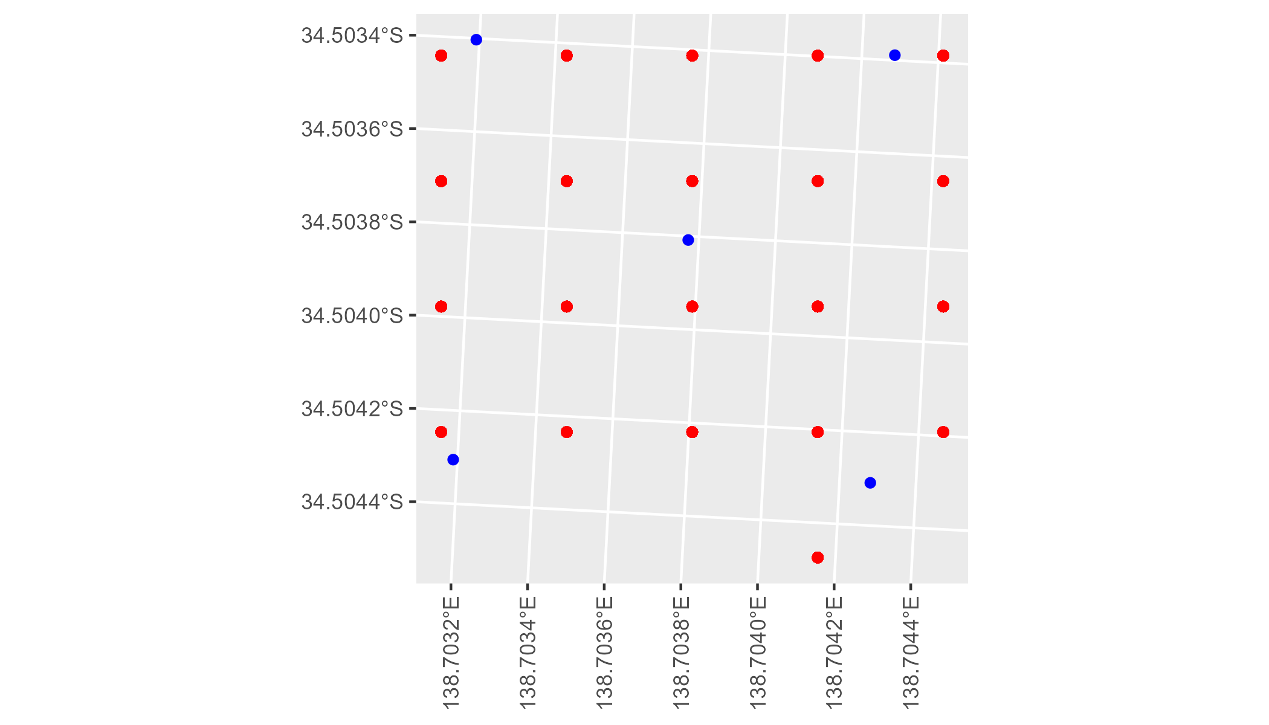

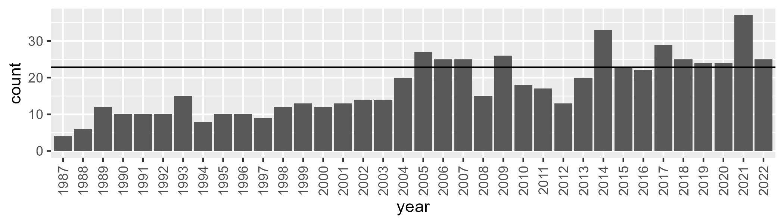

Number of samples: 630

# SATEYB0002

| Min. | 1st Qu. | Median | Mean | 3rd Qu. | Max. |
| --- | --- | --- | --- | --- | --- |
| 21.63098 | 31.74251 | 35.89995 | 36.11406 | 40.82262 | 50.57498 |

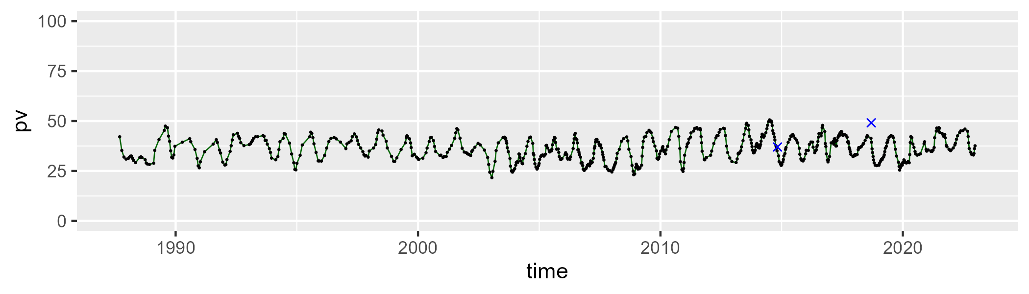

| Min. | 1st Qu. | Median | Mean | 3rd Qu. | Max. |
| --- | --- | --- | --- | --- | --- |
| 27.93015 | 43.78798 | 47.35282 | 46.71507 | 50.4985 | 58.33853 |

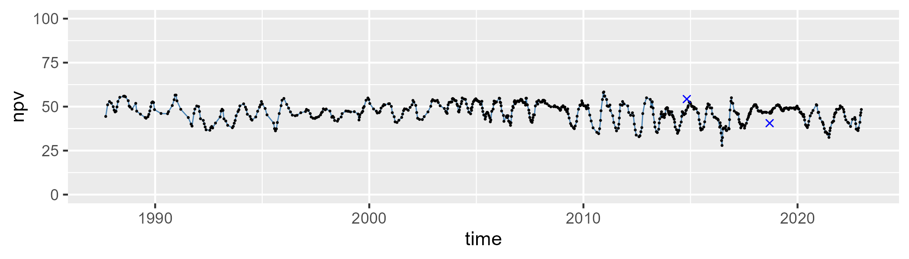

| Min. | 1st Qu. | Median | Mean | 3rd Qu. | Max. |
| --- | --- | --- | --- | --- | --- |
| 3.831106 | 13.06317 | 15.77106 | 15.91968 | 18.76599 | 32.77434 |

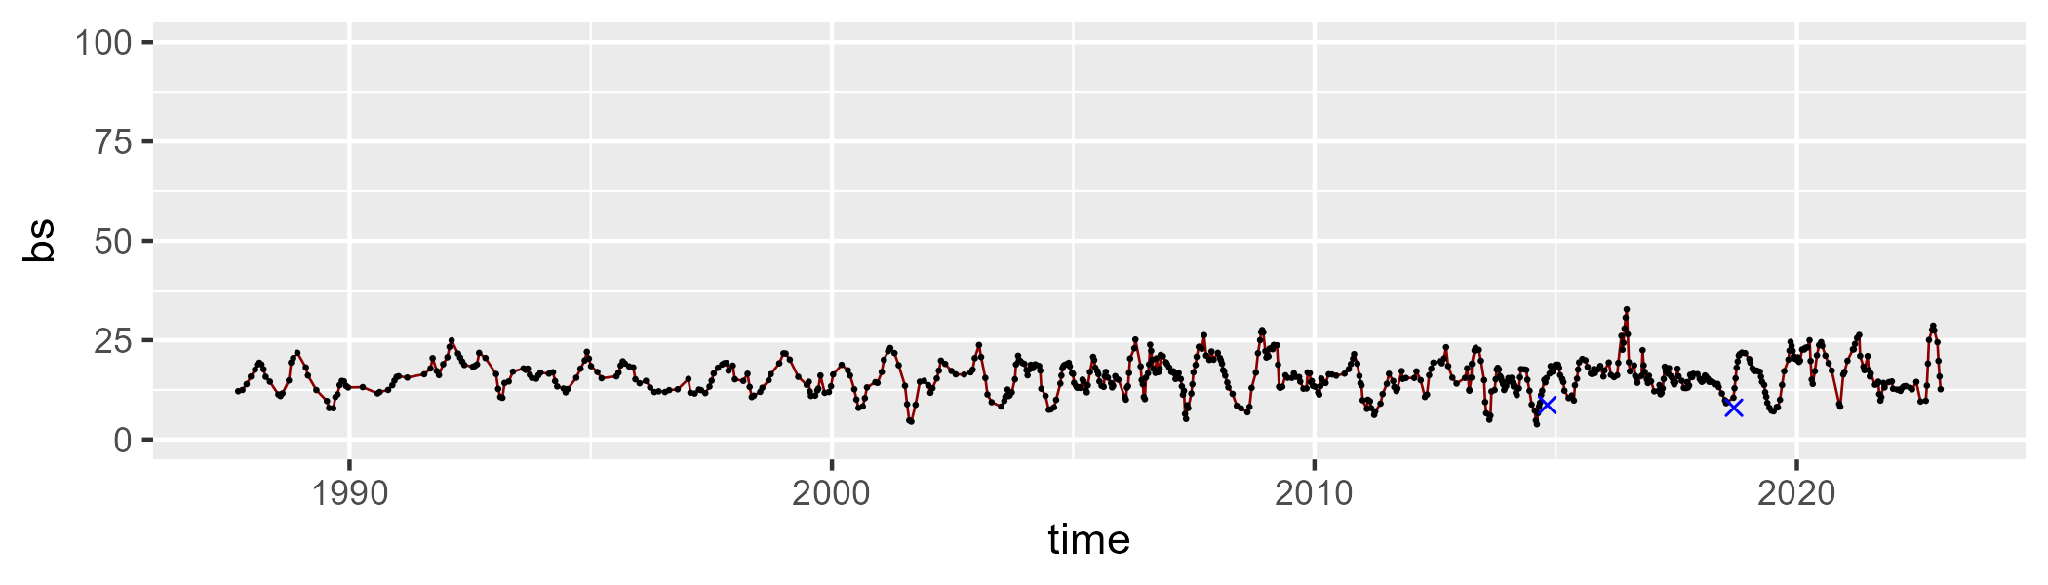

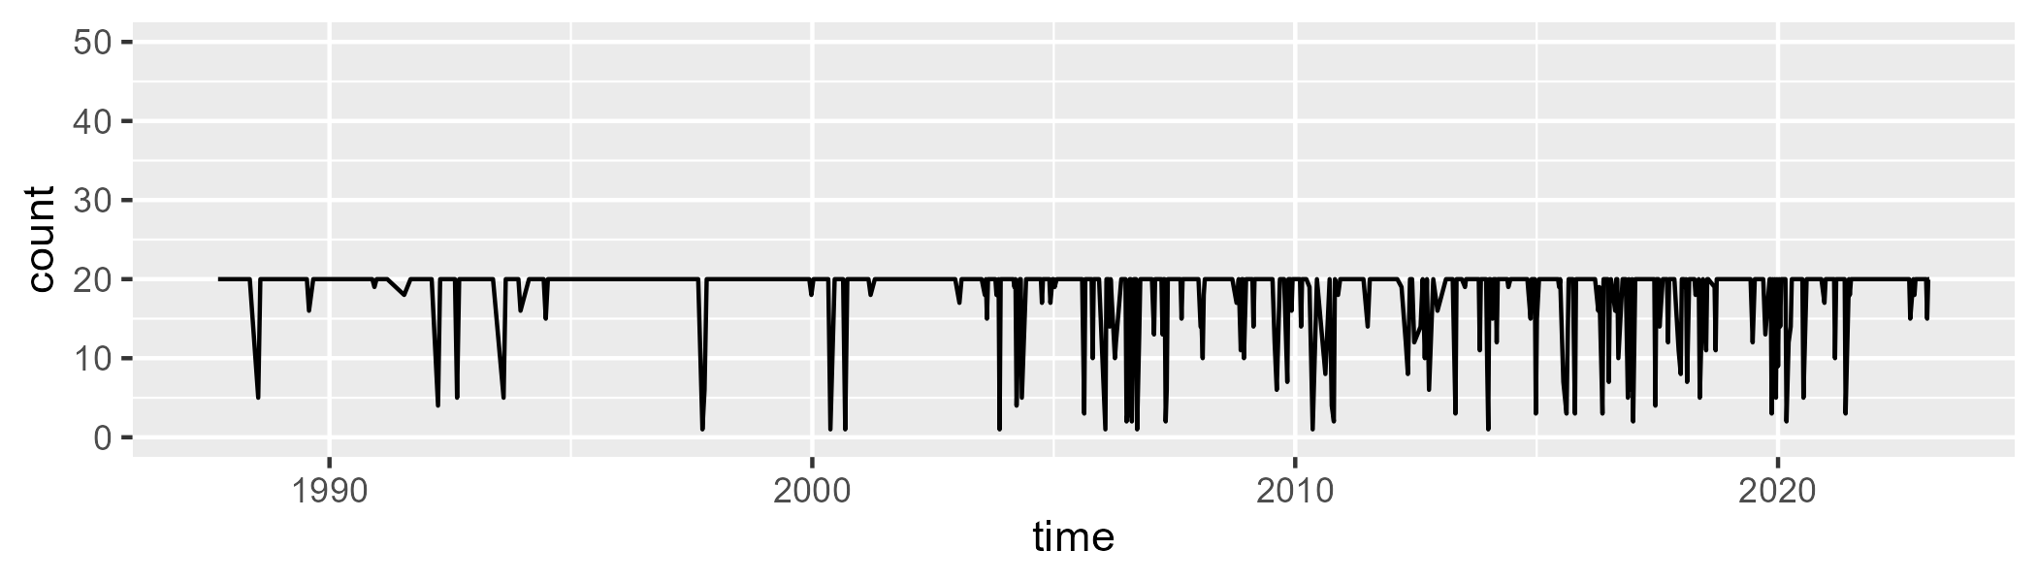

Min. : 1.0 1st Qu.:20.0 Median :20.0 Mean :18.3 3rd Qu.:20.0 Max. :20.0

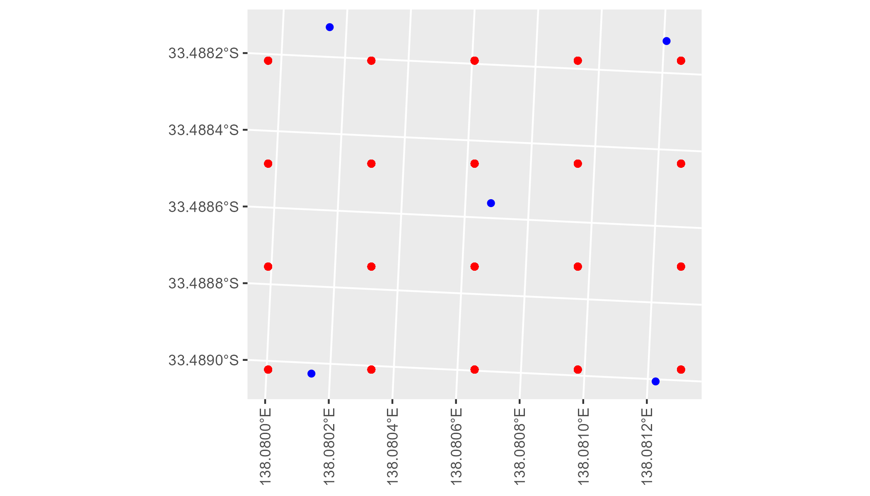

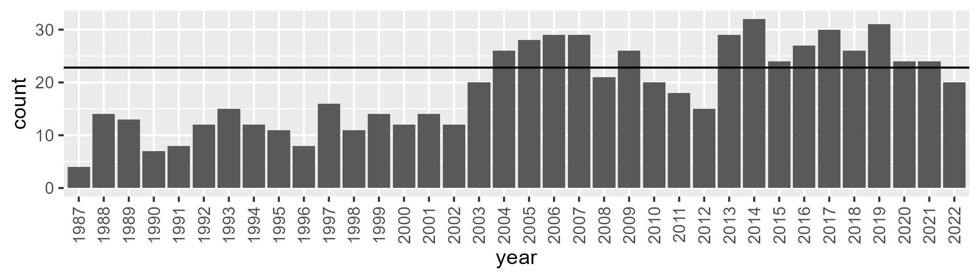

Number of samples: 682

# SATFLB0001

| Min. | 1st Qu. | Median | Mean | 3rd Qu. | Max. |
| --- | --- | --- | --- | --- | --- |
| 26.13417 | 34.27957 | 37.33692 | 38.05446 | 41.59565 | 60.25166 |

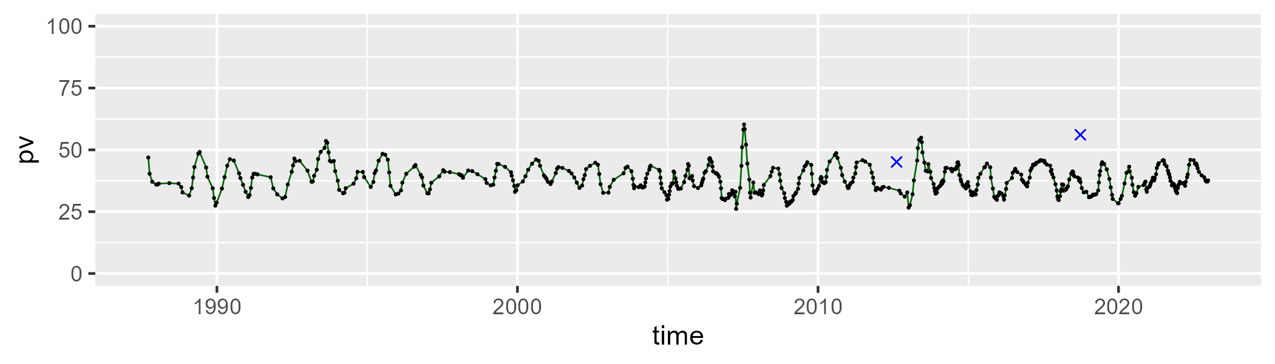

| Min. | 1st Qu. | Median | Mean | 3rd Qu. | Max. |
| --- | --- | --- | --- | --- | --- |
| 31.88199 | 45.33575 | 49.60709 | 49.03119 | 53.45458 | 63.71672 |

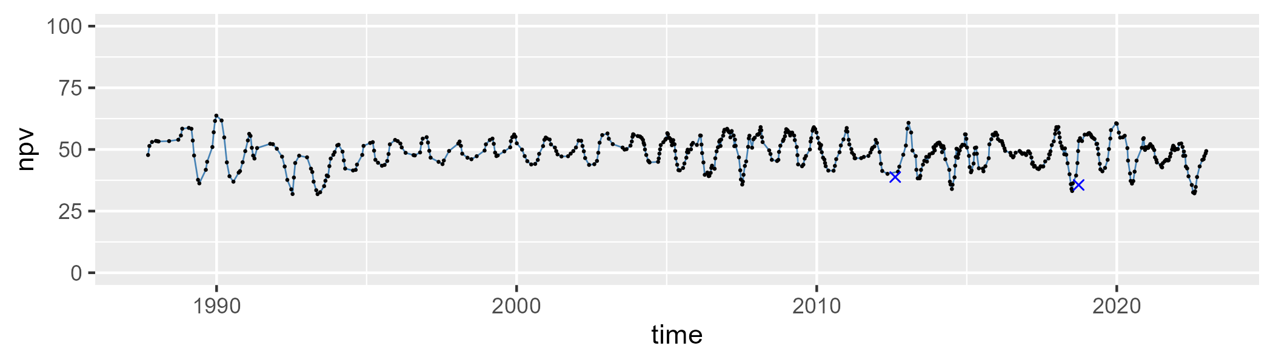

| Min. | 1st Qu. | Median | Mean | 3rd Qu. | Max. |
| --- | --- | --- | --- | --- | --- |
| 2.34242 | 8.961694 | 10.93381 | 11.7648 | 13.41515 | 30.68924 |

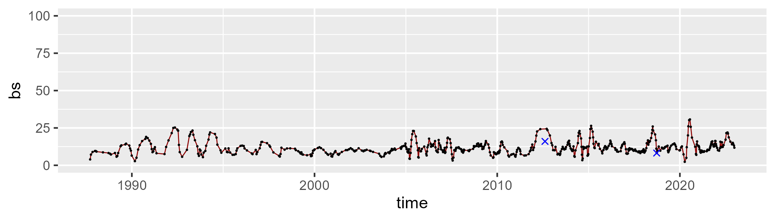

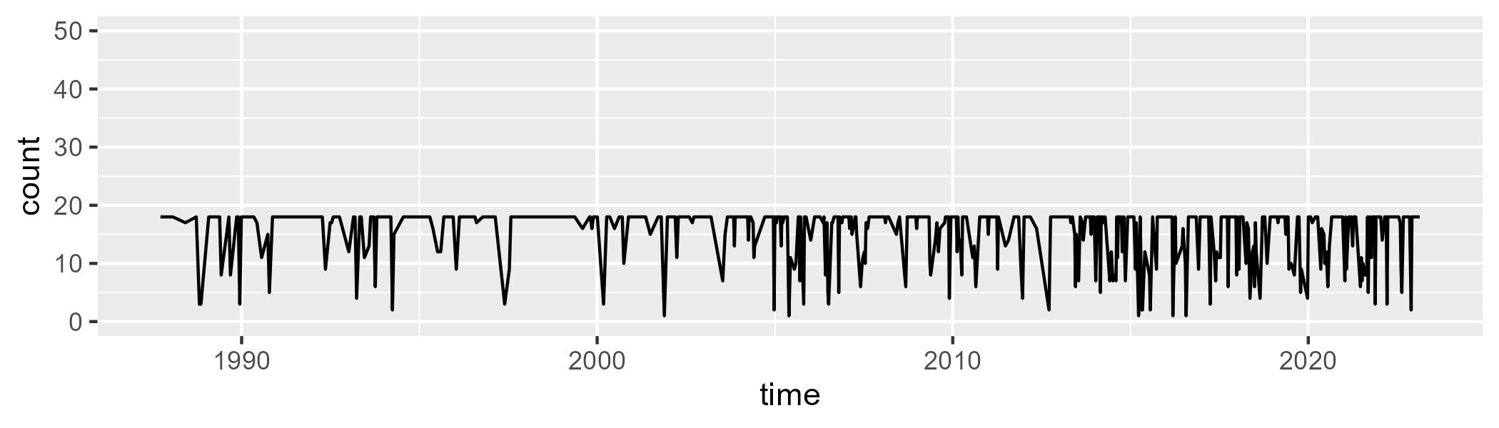

Min. : 1.00 1st Qu.:15.00 Median :18.00 Mean :15.51 3rd Qu.:18.00 Max. :18.00

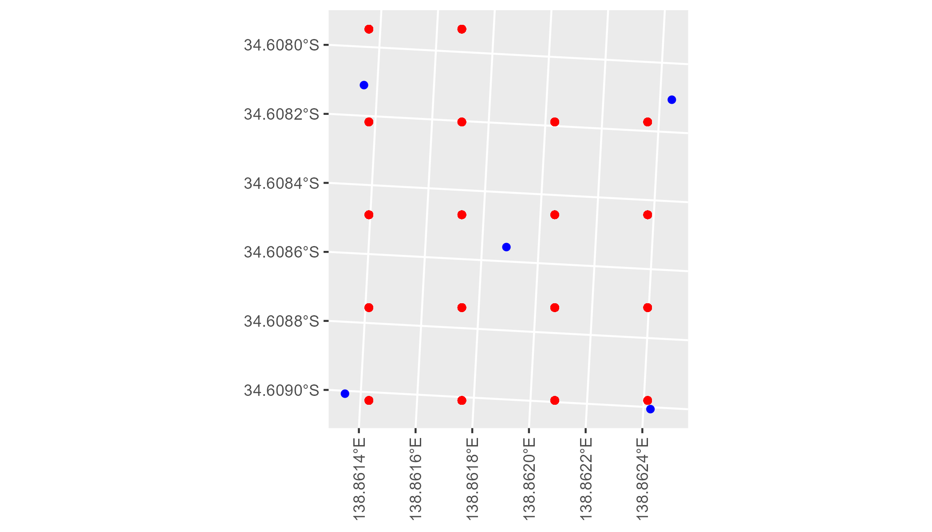

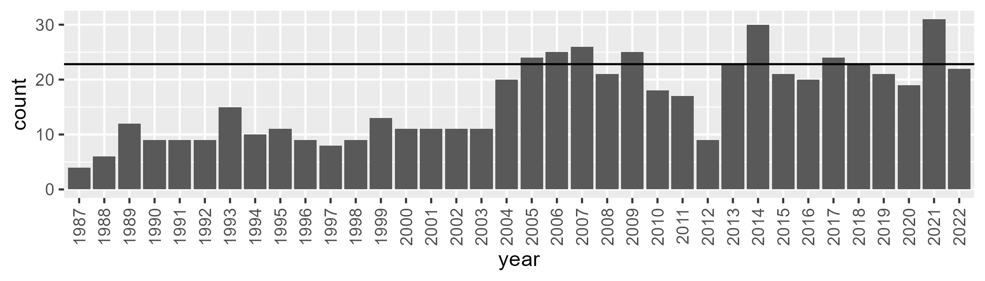

Number of samples: 587

# SATFLB0002

| Min. | 1st Qu. | Median | Mean | 3rd Qu. | Max. |
| --- | --- | --- | --- | --- | --- |
| 39.07374 | 47.98888 | 50.58303 | 50.37135 | 52.82806 | 59.42651 |

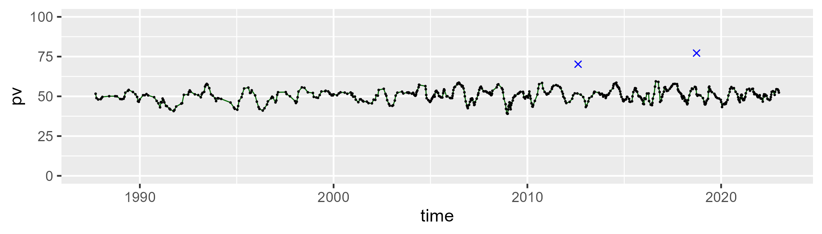

| Min. | 1st Qu. | Median | Mean | 3rd Qu. | Max. |
| --- | --- | --- | --- | --- | --- |
| 21.85693 | 38.43249 | 41.23815 | 40.89001 | 44.36671 | 51.99444 |

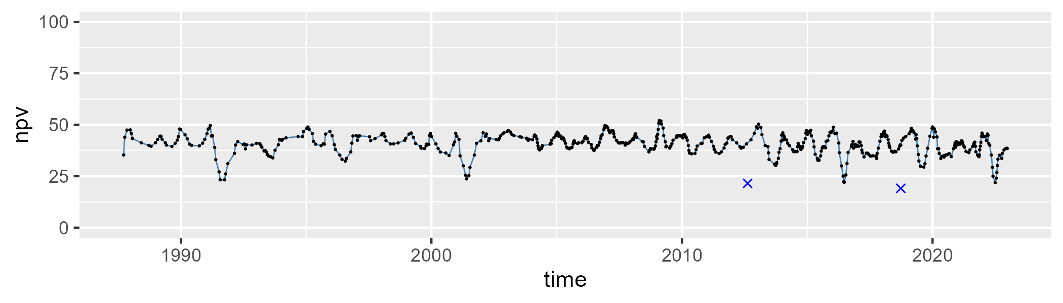

| Min. | 1st Qu. | Median | Mean | 3rd Qu. | Max. |
| --- | --- | --- | --- | --- | --- |
| 0 | 4.020966 | 6.165593 | 7.482495 | 9.084717 | 35.27254 |

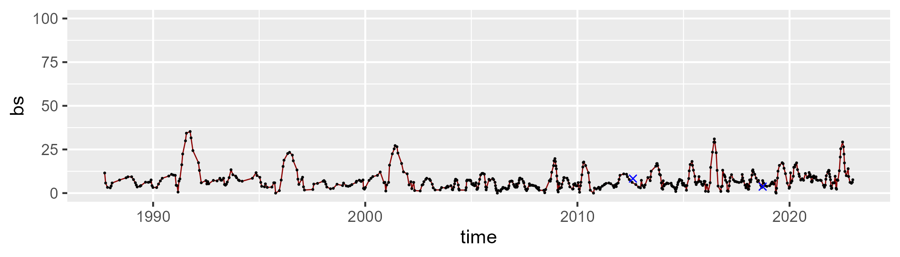

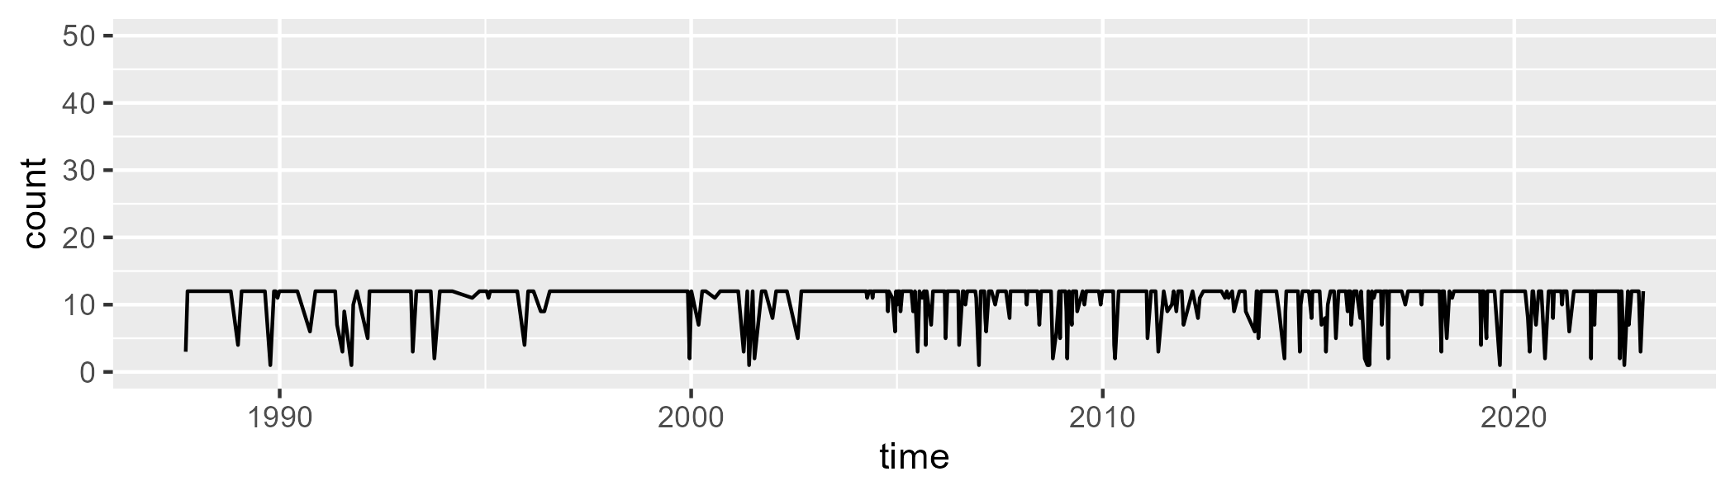

Min. : 1.00 1st Qu.:12.00 Median :12.00 Mean :10.87 3rd Qu.:12.00 Max. :12.00

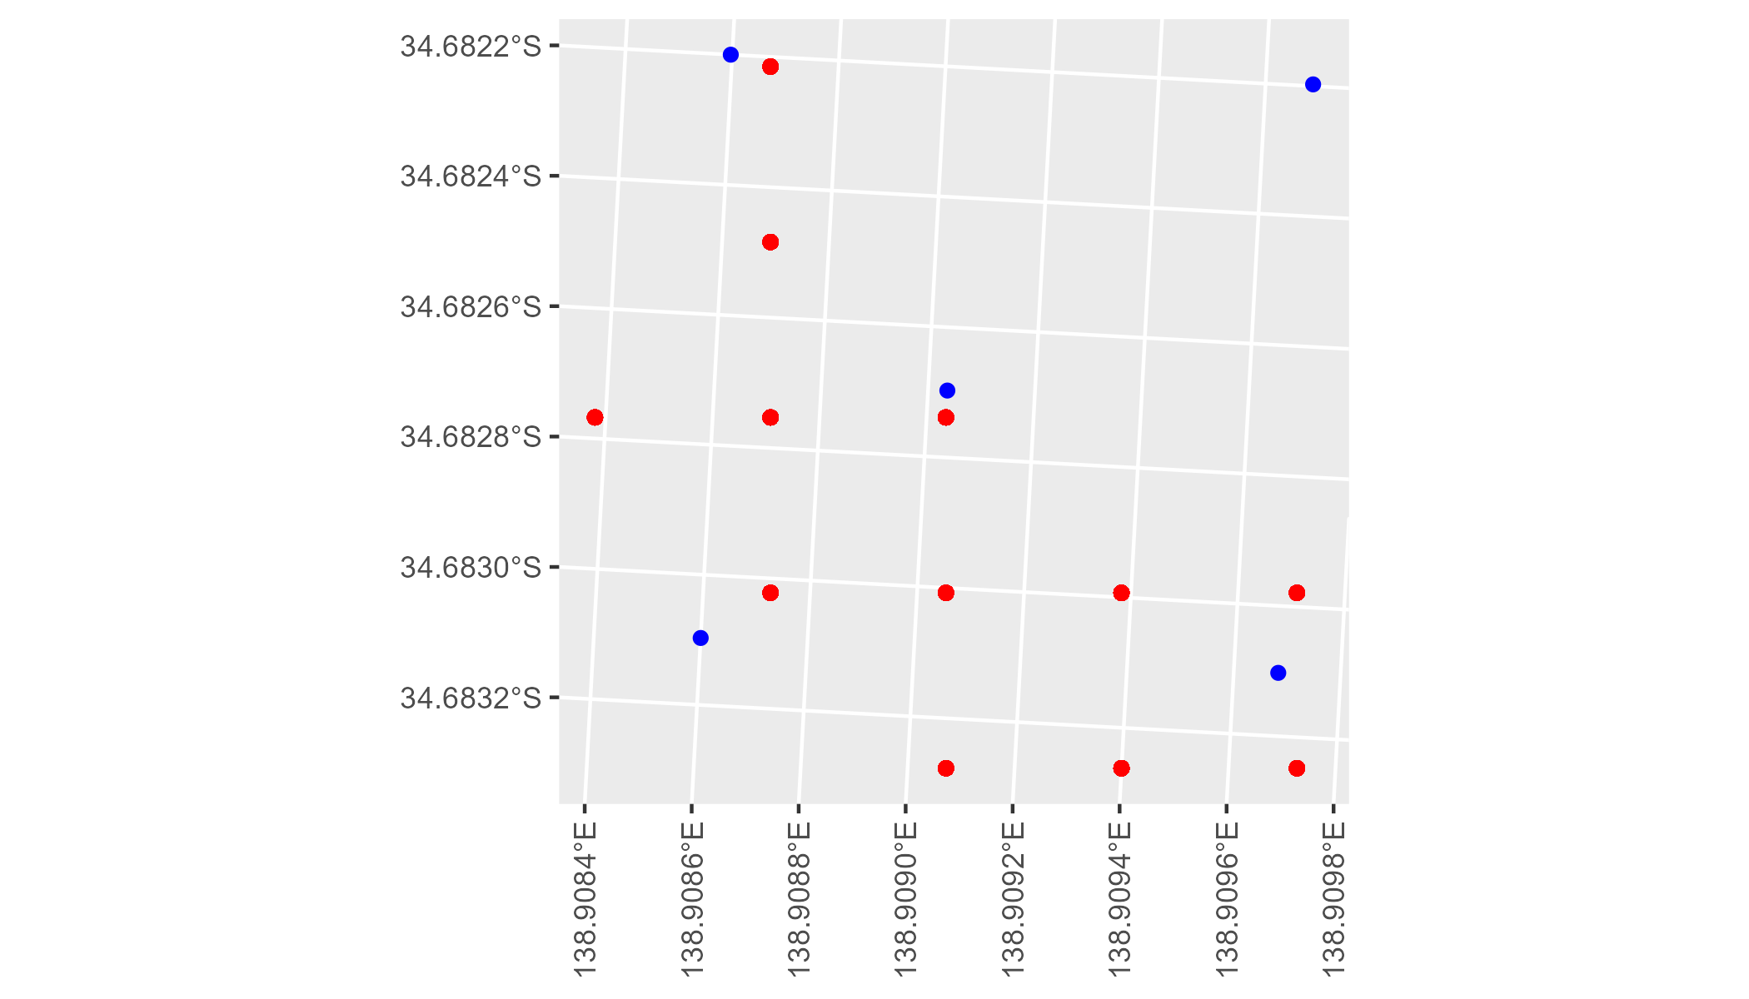

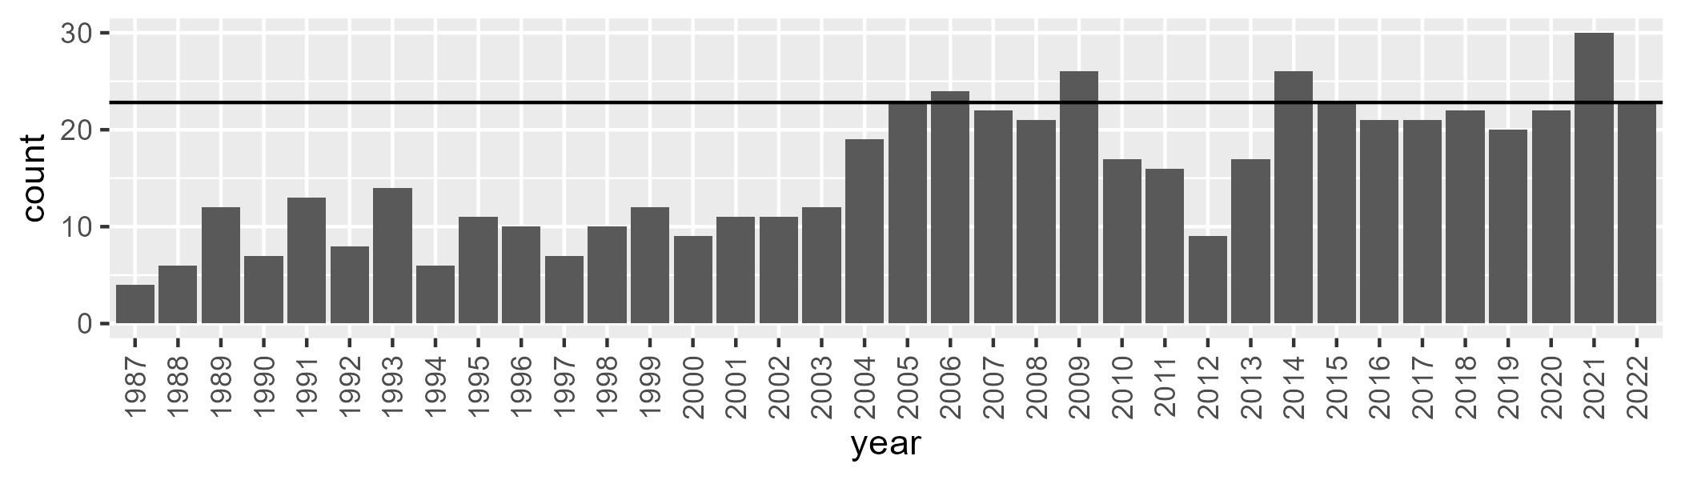

Number of samples: 565

# SATFLB0003

| Min. | 1st Qu. | Median | Mean | 3rd Qu. | Max. |
| --- | --- | --- | --- | --- | --- |
| 39.64603 | 49.08399 | 51.25453 | 51.13673 | 53.60505 | 59.9061 |

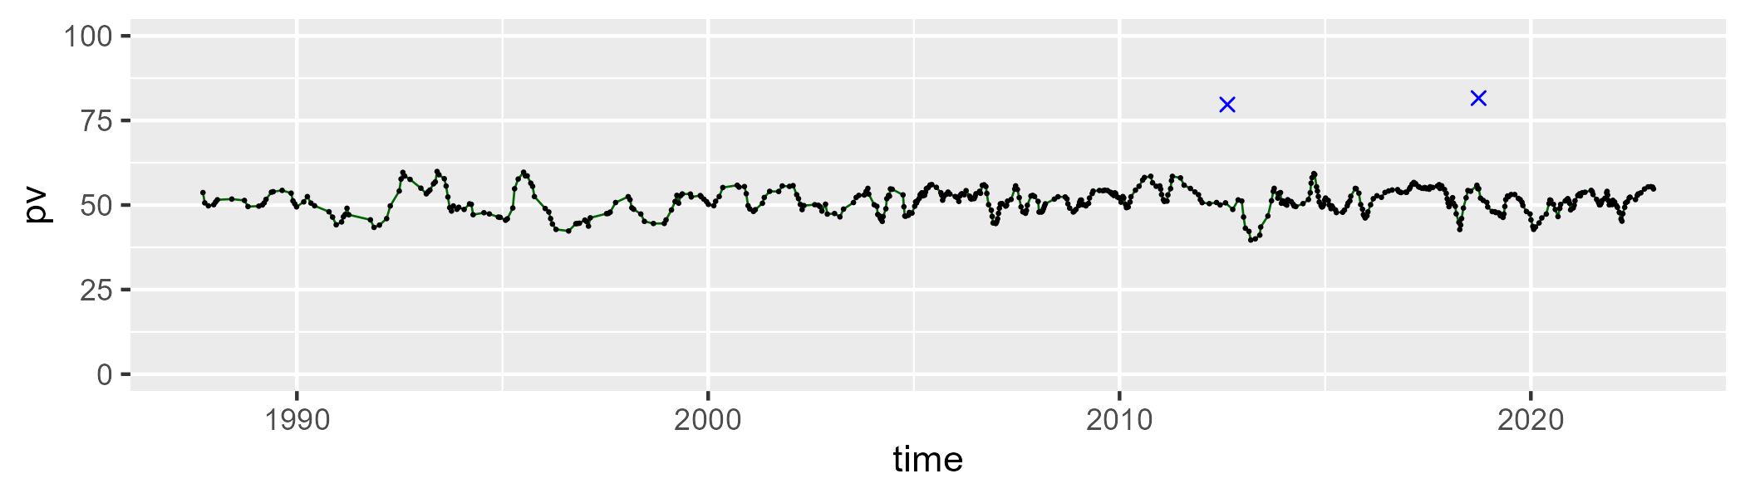

| Min. | 1st Qu. | Median | Mean | 3rd Qu. | Max. |
| --- | --- | --- | --- | --- | --- |
| 27.20483 | 37.74764 | 40.14595 | 39.90044 | 42.4017 | 48.65521 |

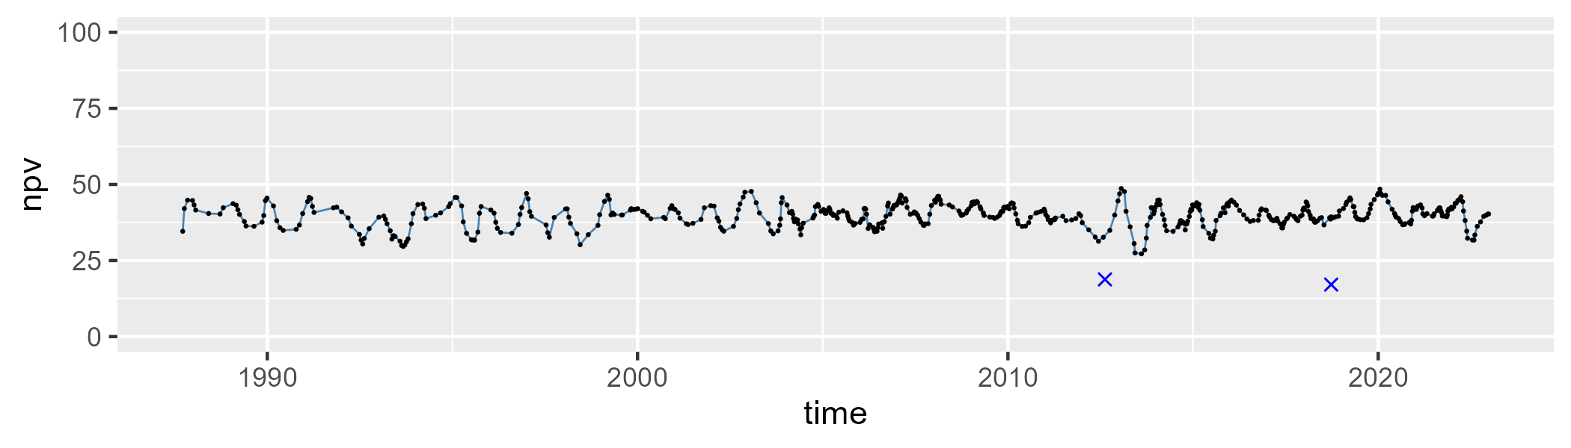

| Min. | 1st Qu. | Median | Mean | 3rd Qu. | Max. |
| --- | --- | --- | --- | --- | --- |
| 0 | 4.716253 | 6.808017 | 7.629313 | 9.425426 | 27.35811 |

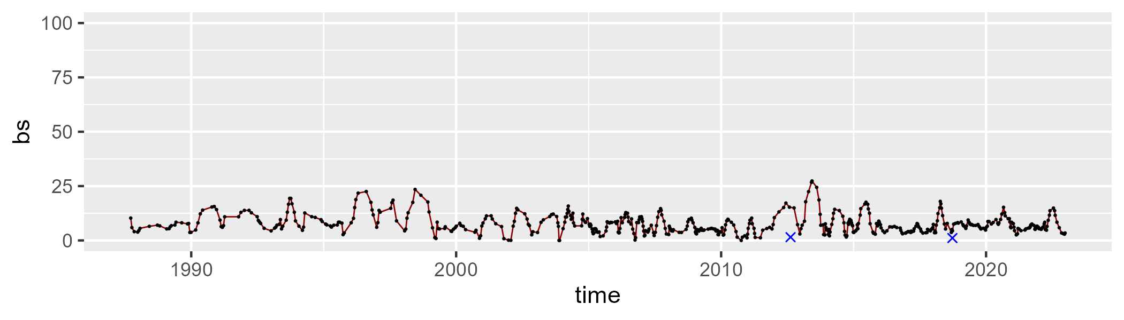

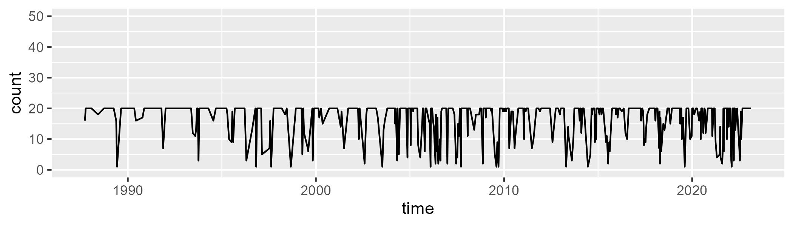

Min. : 1.00 1st Qu.:16.00 Median :20.00 Mean :16.96 3rd Qu.:20.00 Max. :20.00

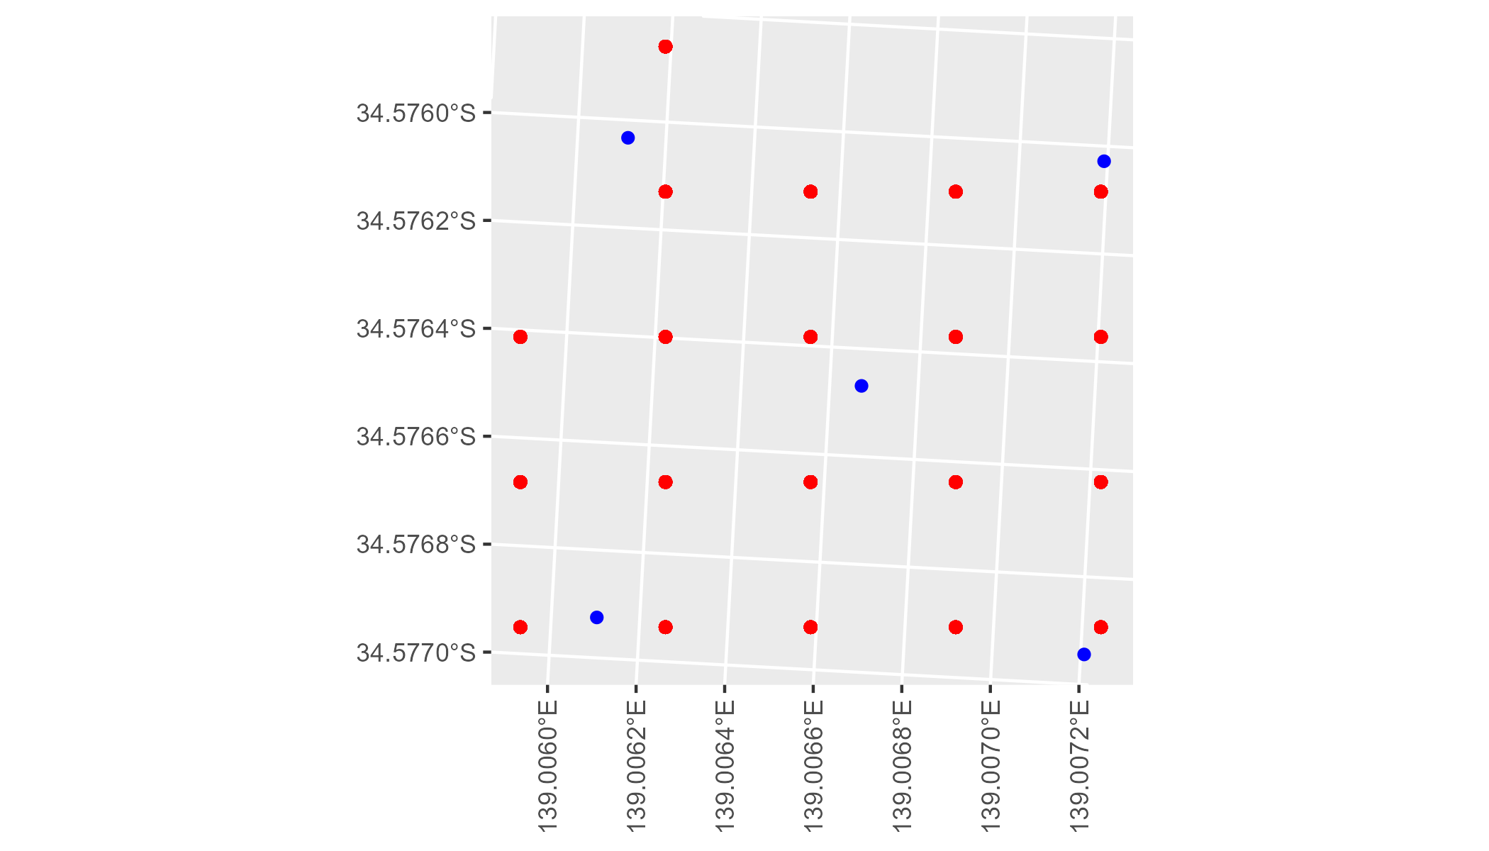

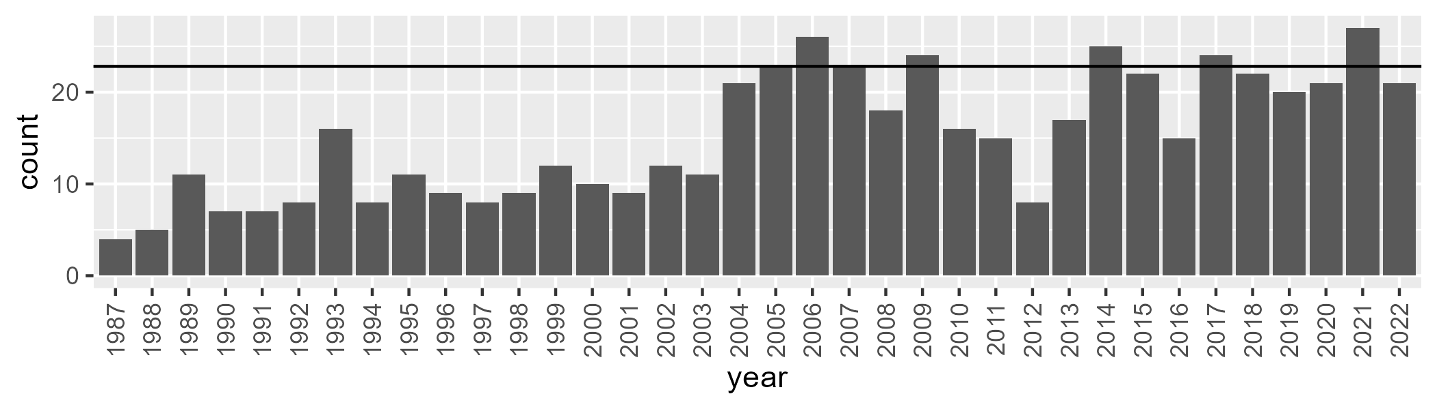

Number of samples: 545

# SATFLB0004

| Min. | 1st Qu. | Median | Mean | 3rd Qu. | Max. |
| --- | --- | --- | --- | --- | --- |
| 15.72446 | 21.6742 | 24.9013 | 25.64161 | 29.13469 | 40.1859 |

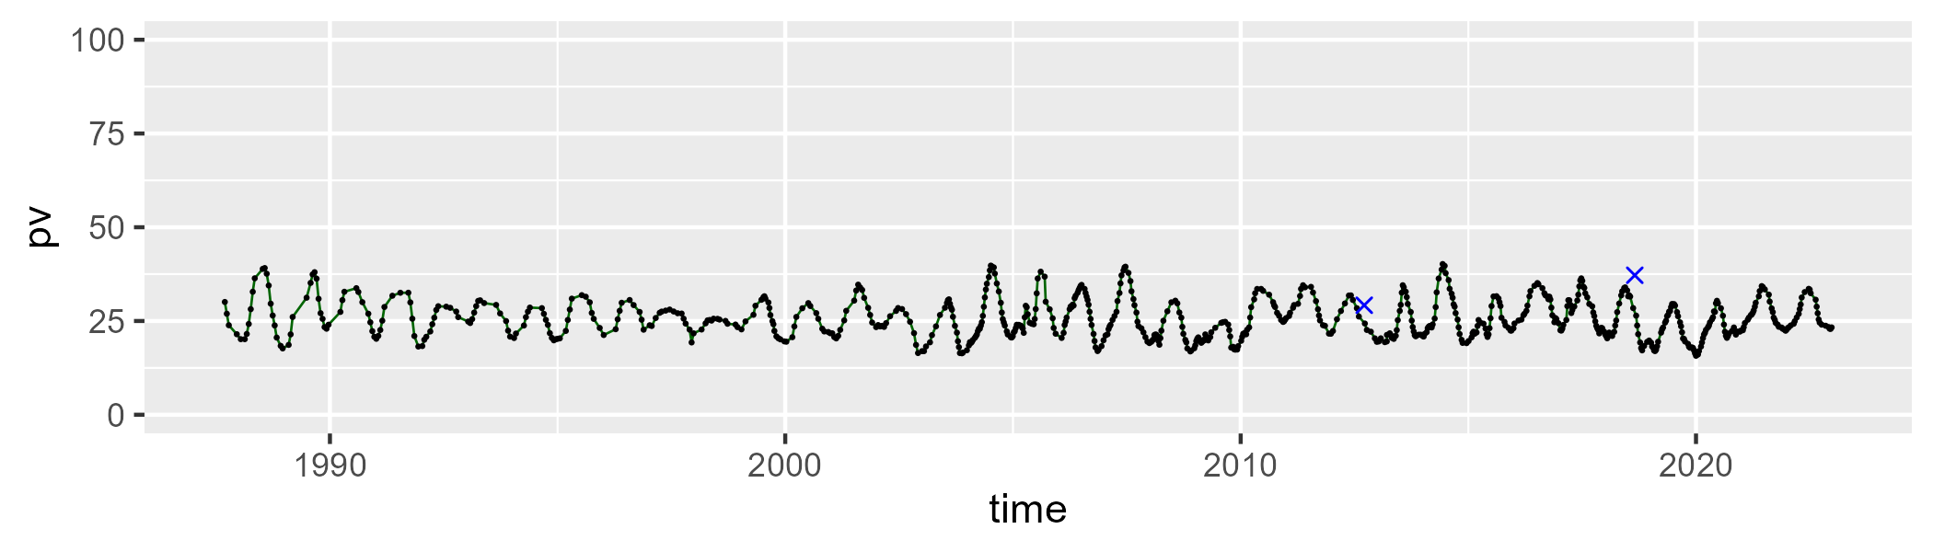

| Min. | 1st Qu. | Median | Mean | 3rd Qu. | Max. |
| --- | --- | --- | --- | --- | --- |
| 22.42075 | 31.603 | 34.98783 | 34.56758 | 37.3047 | 49.34209 |

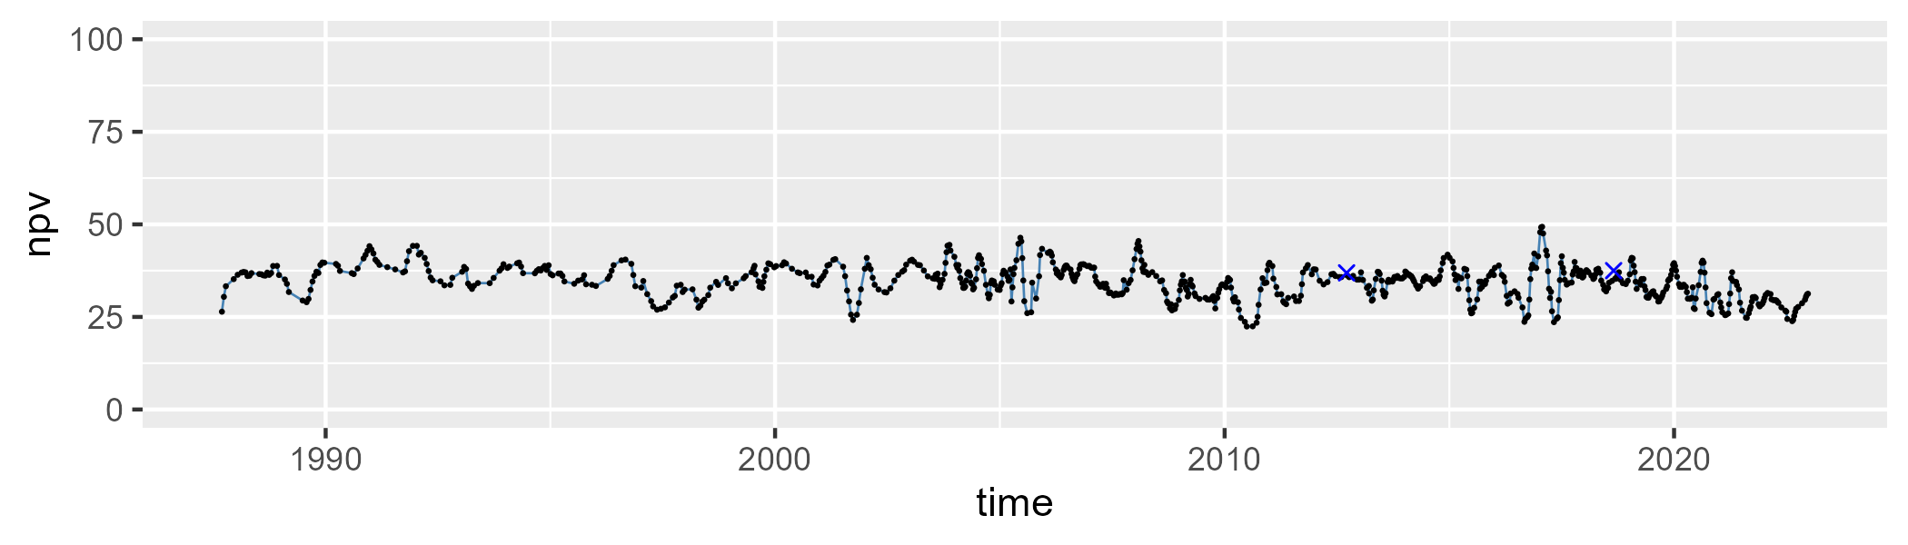

| Min. | 1st Qu. | Median | Mean | 3rd Qu. | Max. |
| --- | --- | --- | --- | --- | --- |
| 17.11756 | 34.35582 | 38.80579 | 38.20177 | 42.07712 | 54.76358 |

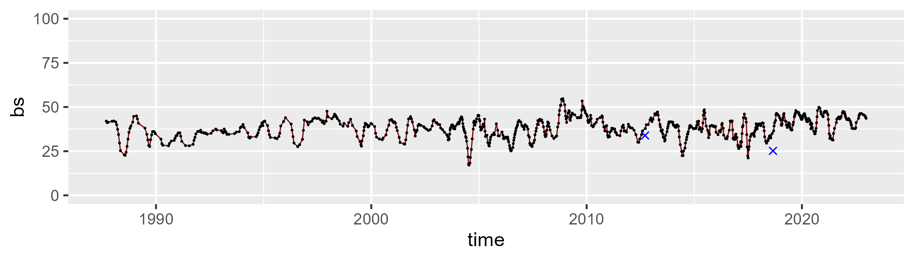

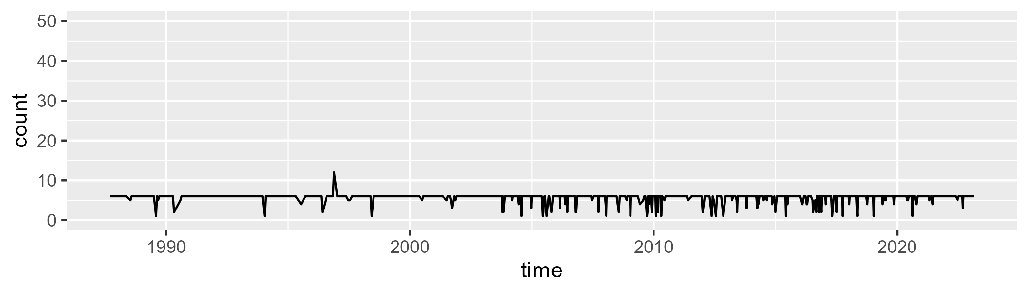

Min. : 1.000 1st Qu.: 6.000 Median : 6.000 Mean : 5.652 3rd Qu.: 6.000 Max. :12.000

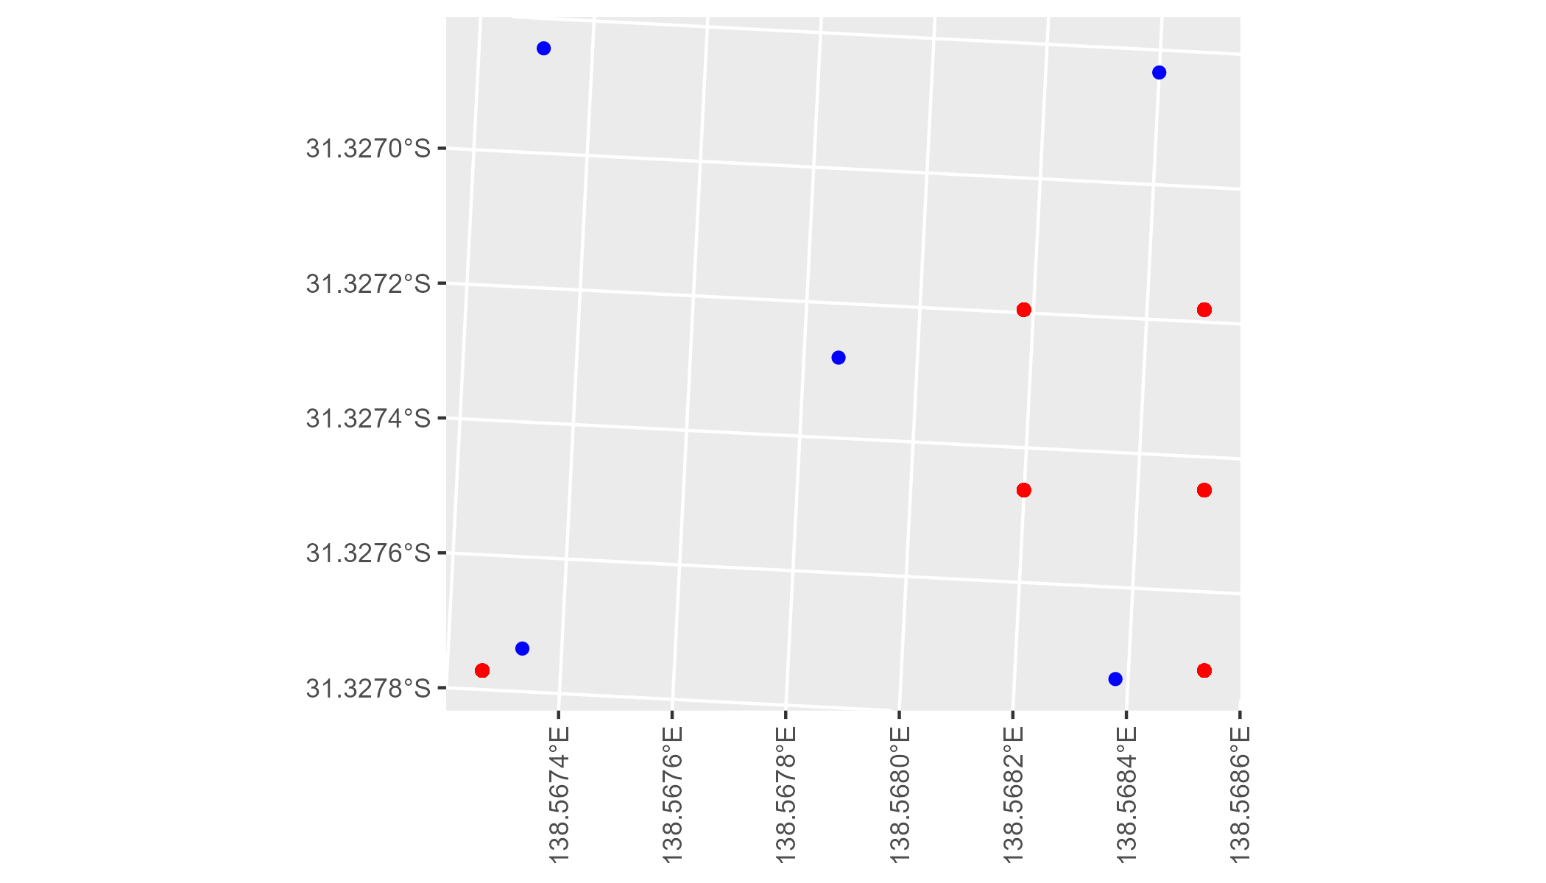

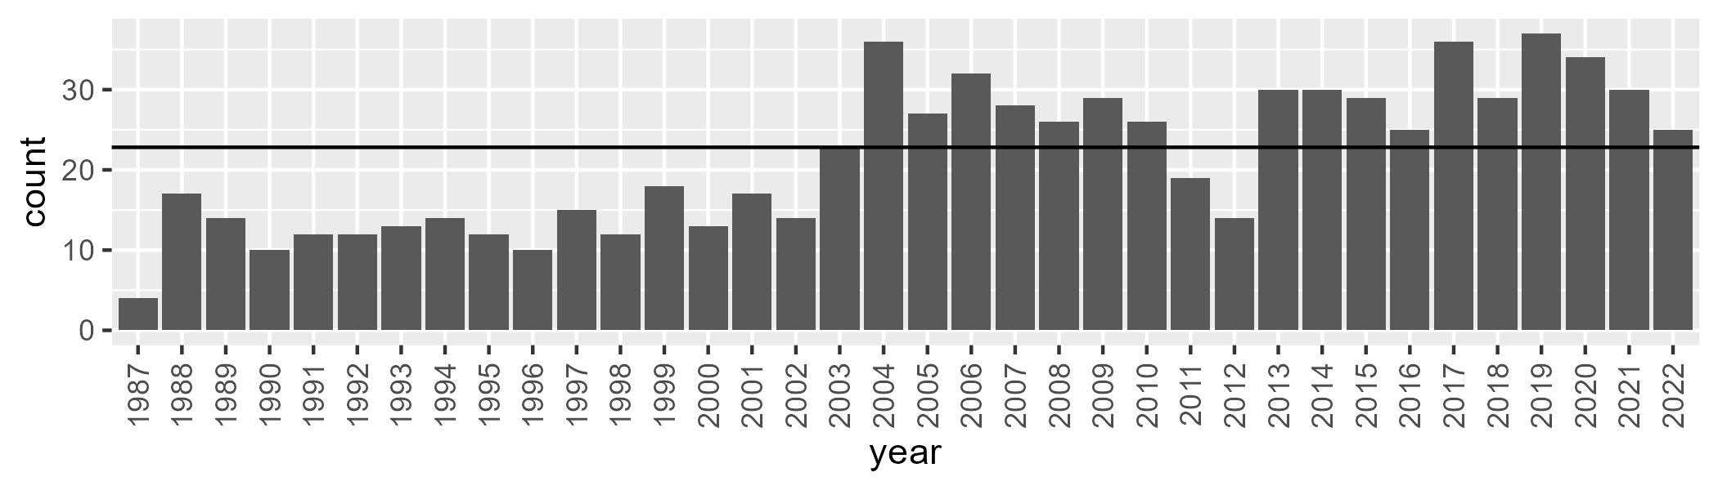

Number of samples: 772

# SATFLB0005

| Min. | 1st Qu. | Median | Mean | 3rd Qu. | Max. |
| --- | --- | --- | --- | --- | --- |
| 15.00581 | 29.30343 | 34.62607 | 34.13095 | 39.19808 | 49.59082 |

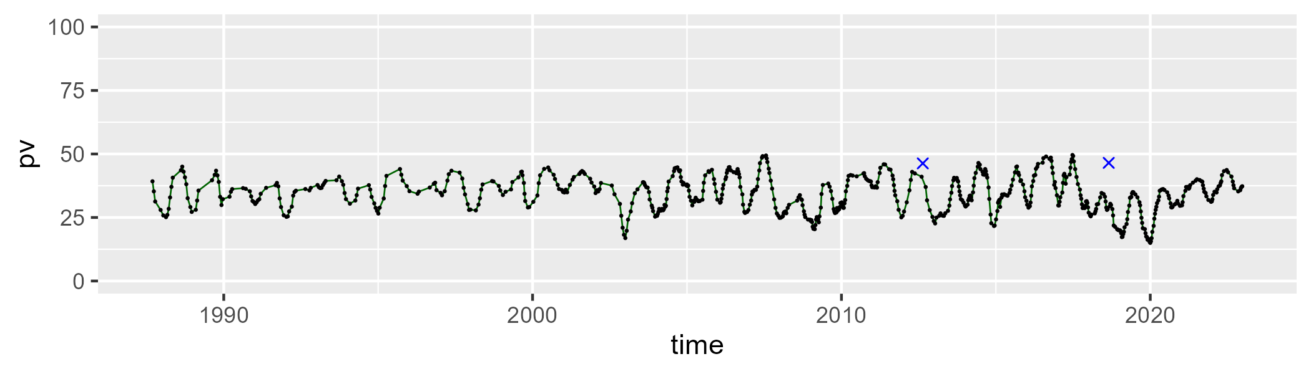

| Min. | 1st Qu. | Median | Mean | 3rd Qu. | Max. |
| --- | --- | --- | --- | --- | --- |
| 39.33471 | 47.41267 | 51.23948 | 51.25264 | 54.84586 | 64.44095 |

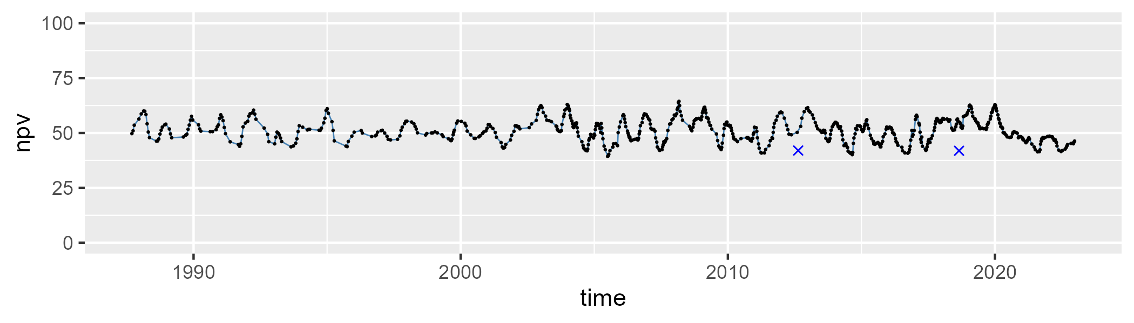

| Min. | 1st Qu. | Median | Mean | 3rd Qu. | Max. |
| --- | --- | --- | --- | --- | --- |
| 3.698009 | 10.82075 | 13.0968 | 13.41062 | 15.85851 | 28.02096 |

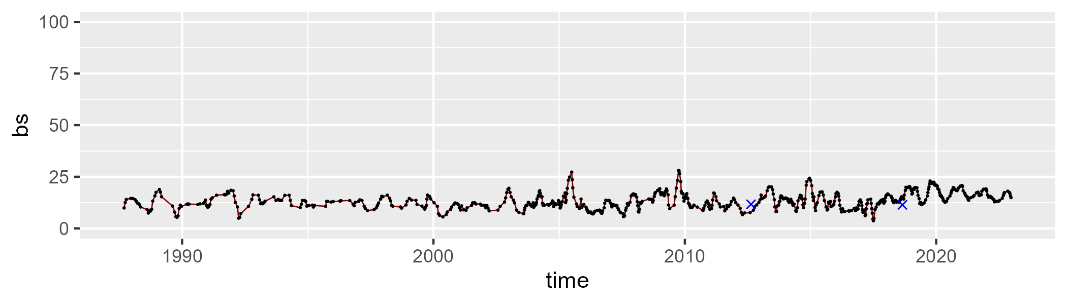

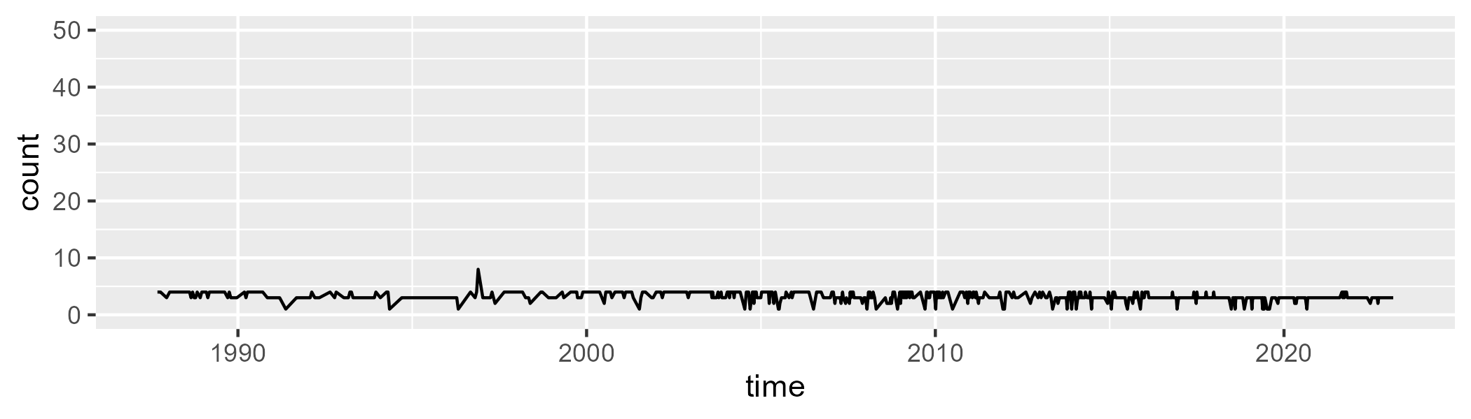

Min. :1.000 1st Qu.:3.000 Median :3.000 Mean :3.193 3rd Qu.:4.000 Max. :8.000

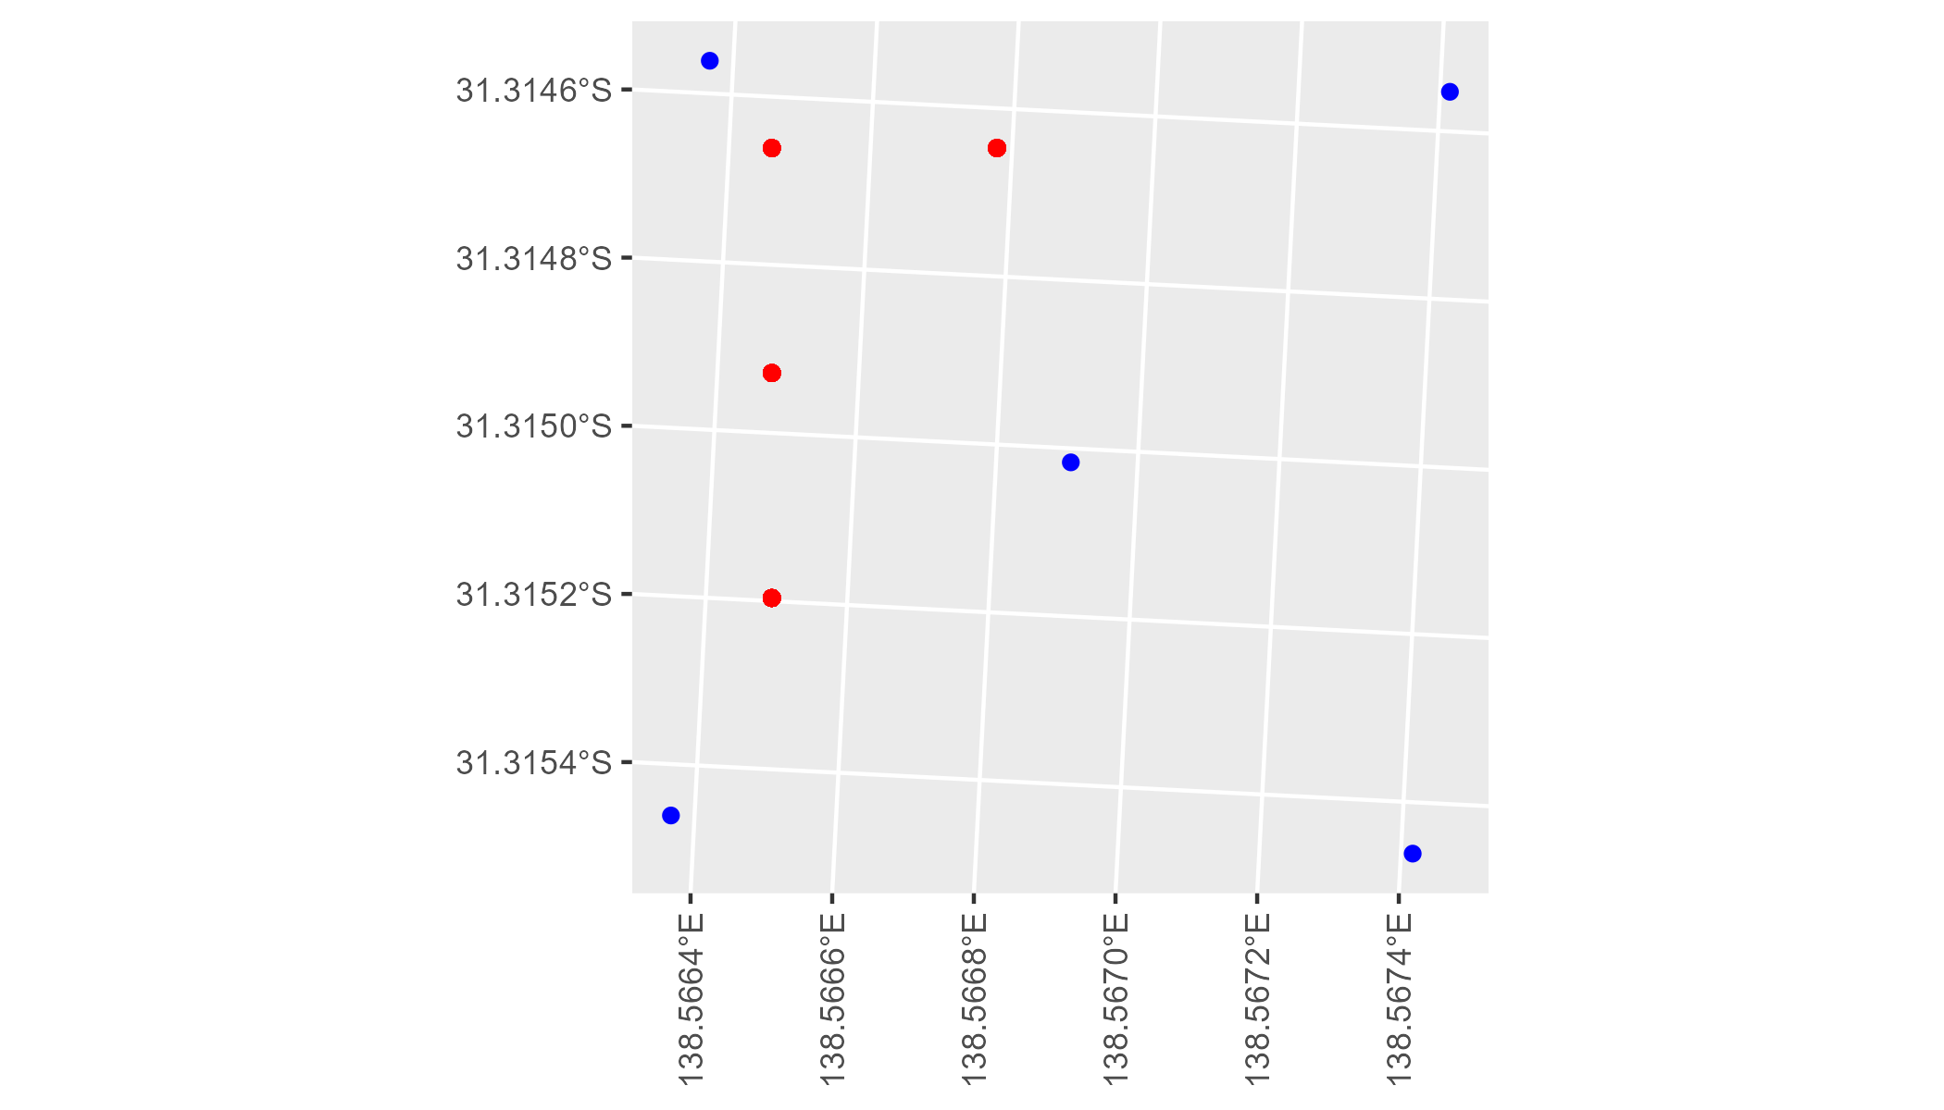

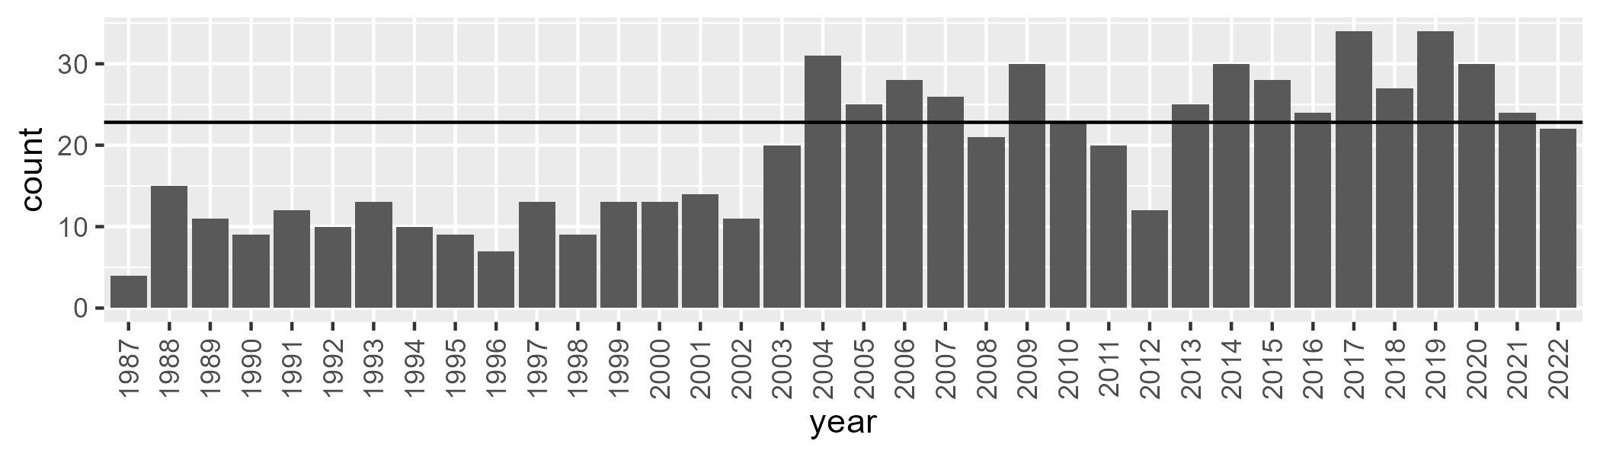

Number of samples: 687

# SATFLB0006

| Min. | 1st Qu. | Median | Mean | 3rd Qu. | Max. |
| --- | --- | --- | --- | --- | --- |
| 11.83215 | 21.09781 | 26.15934 | 26.85342 | 32.4598 | 47.21268 |

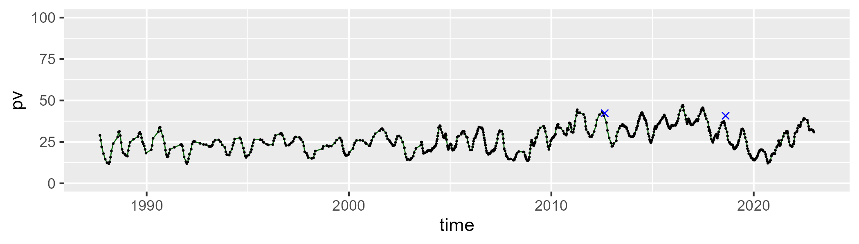

| Min. | 1st Qu. | Median | Mean | 3rd Qu. | Max. |
| --- | --- | --- | --- | --- | --- |
| 28.19647 | 40.97315 | 44.07328 | 43.83581 | 46.69234 | 53.86075 |

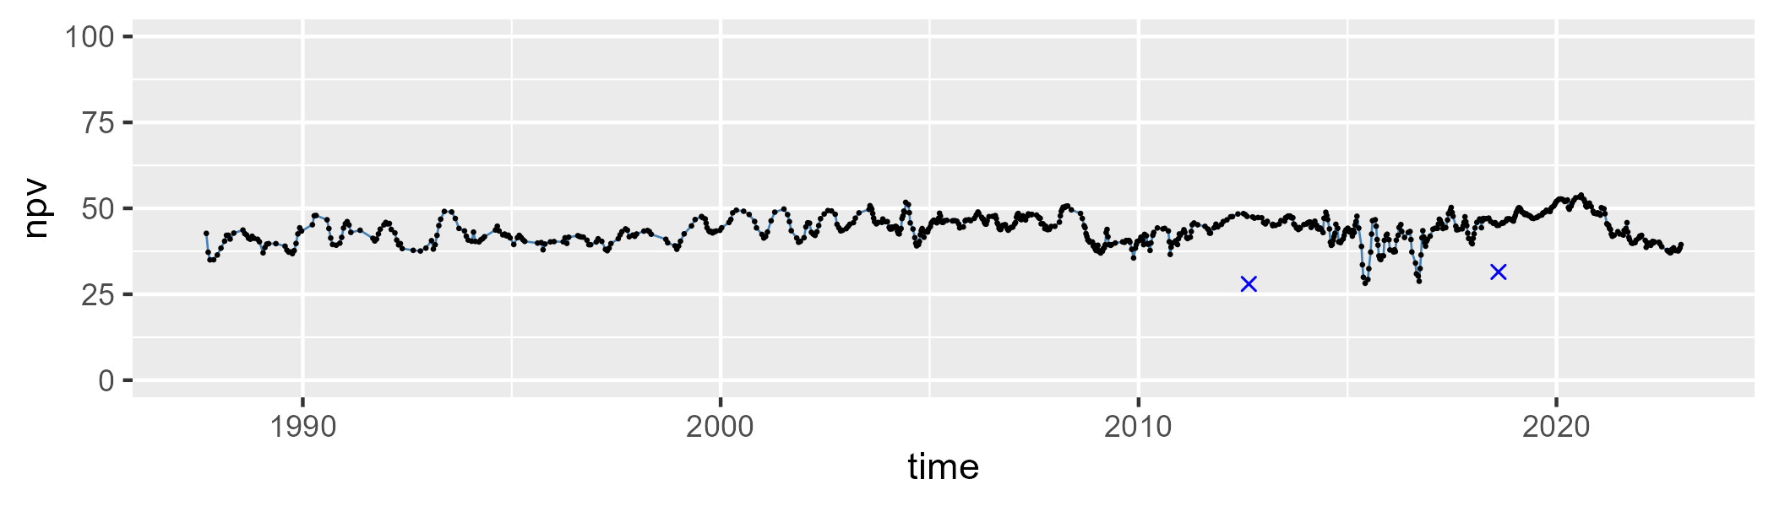

| Min. | 1st Qu. | Median | Mean | 3rd Qu. | Max. |
| --- | --- | --- | --- | --- | --- |
| 2.87184 | 22.96232 | 28.51198 | 27.89673 | 33.41351 | 47.57972 |

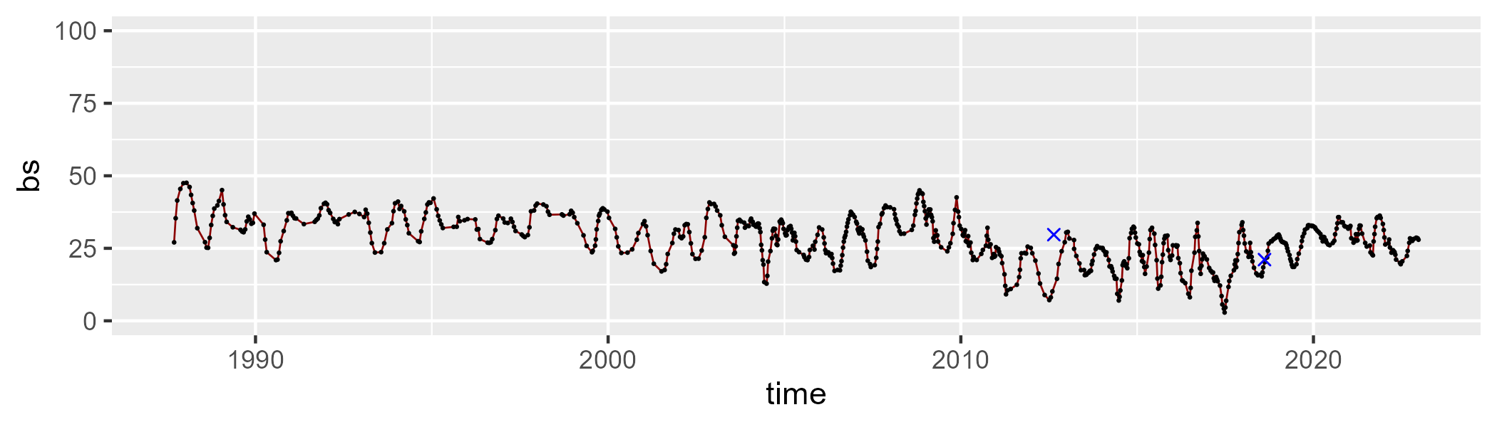

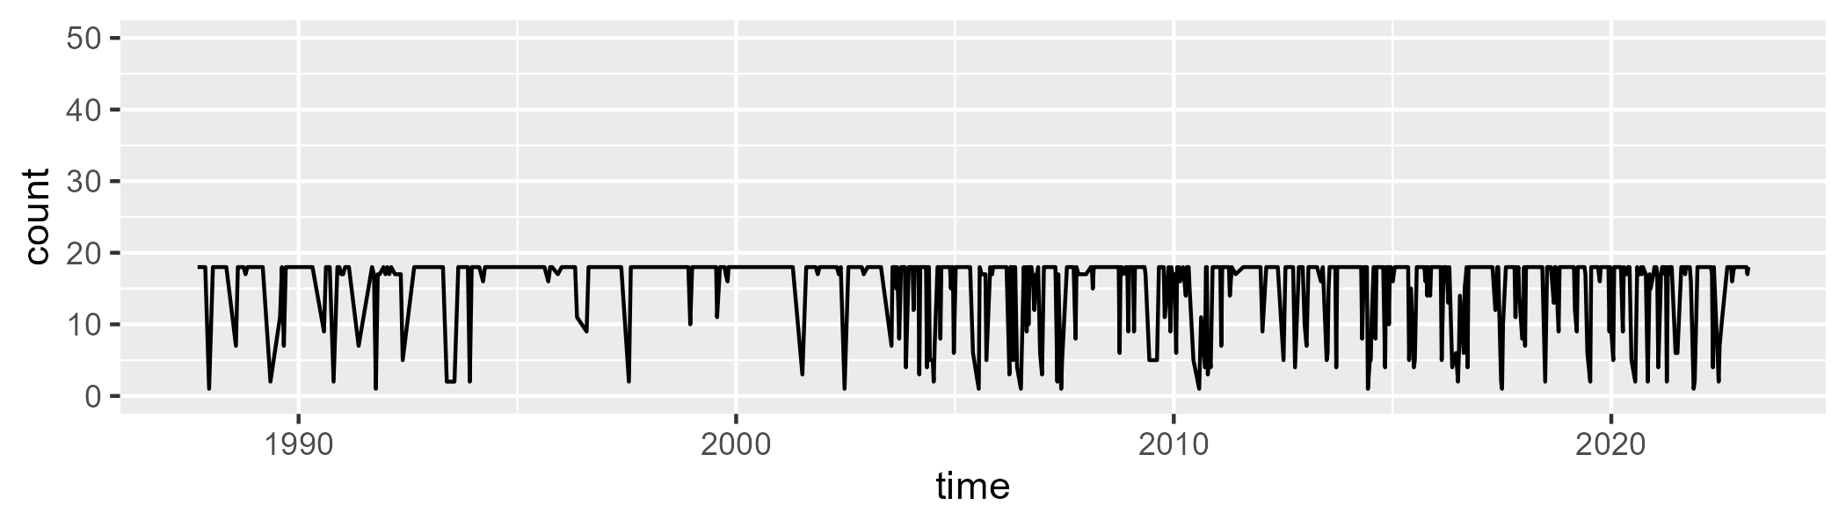

Min. : 1.0 1st Qu.:17.0 Median :18.0 Mean :15.8 3rd Qu.:18.0 Max. :18.0

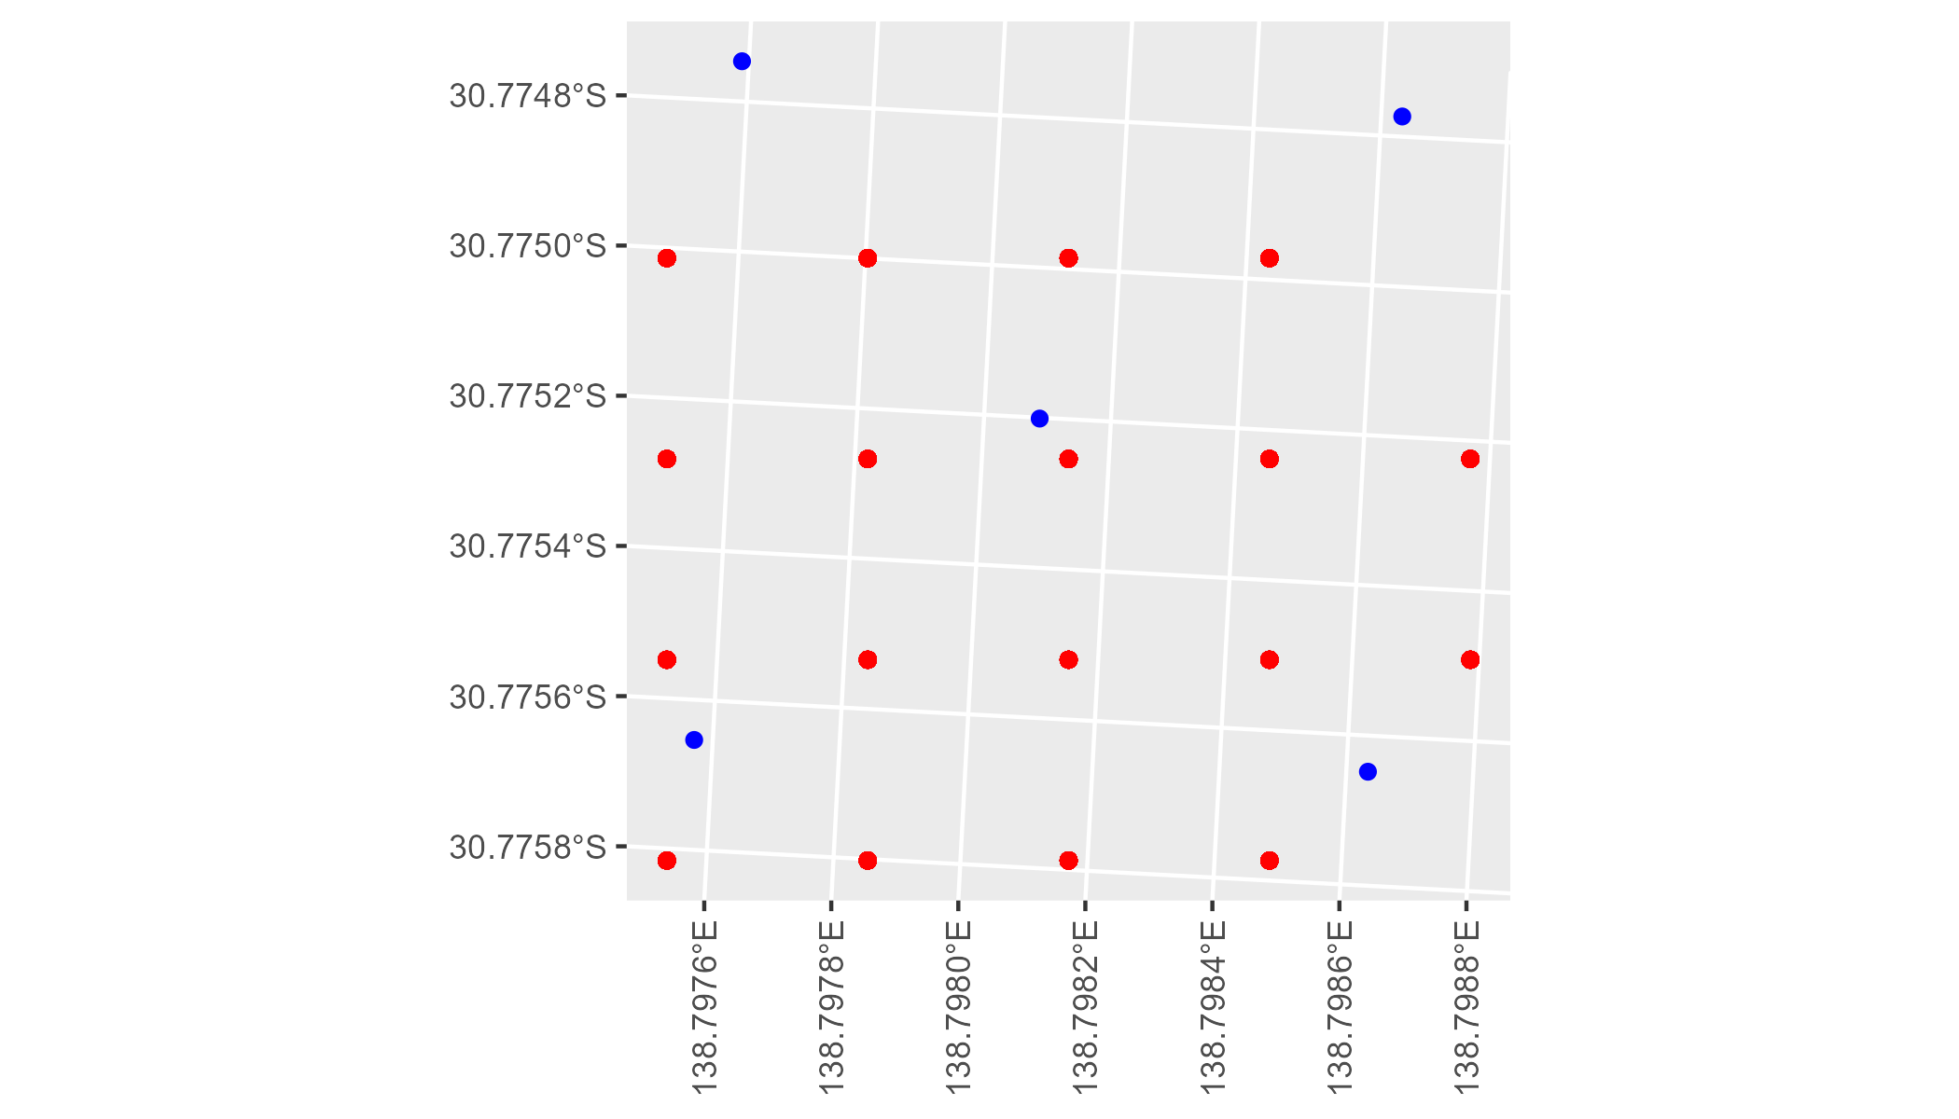

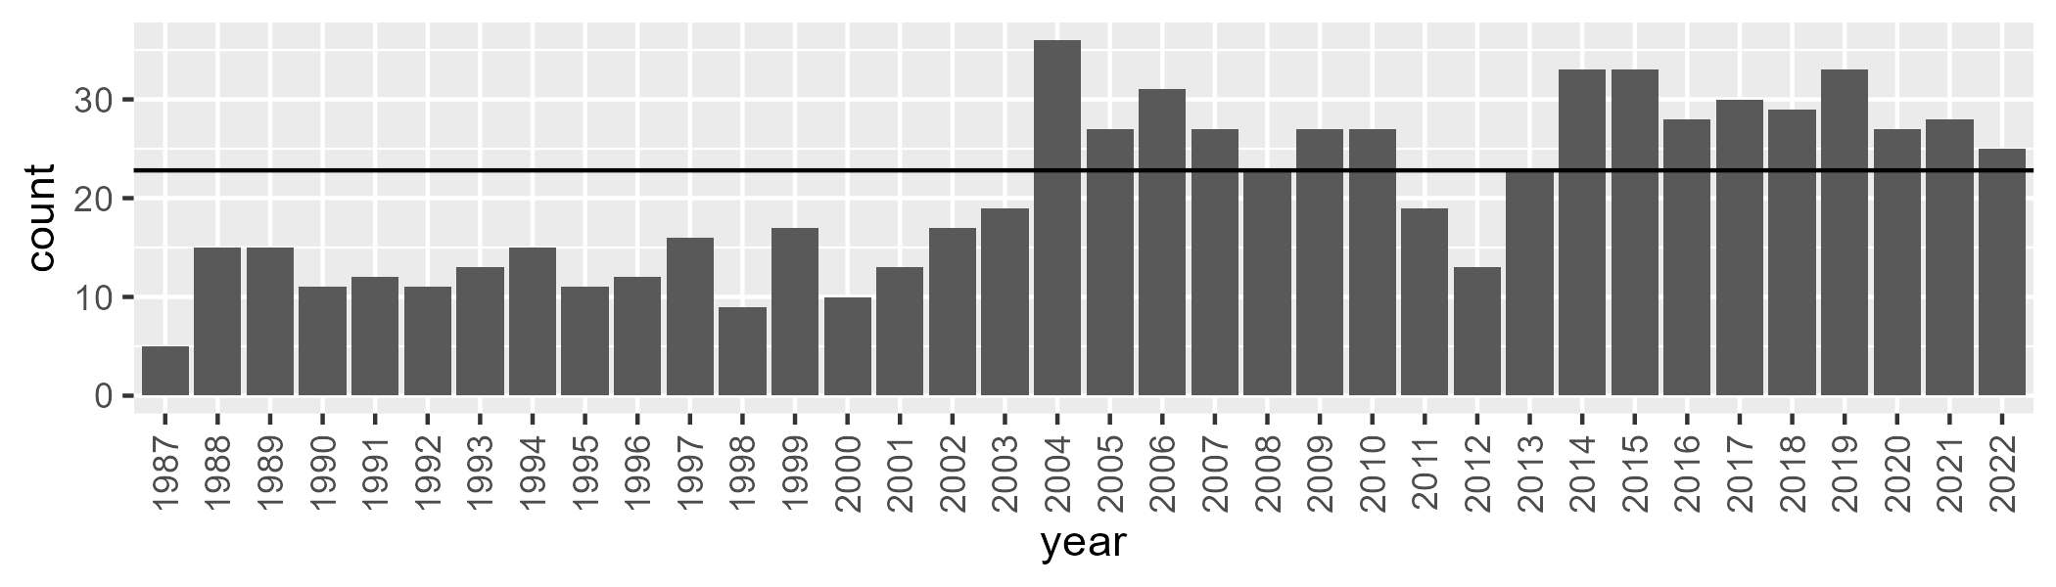

Number of samples: 740

# SATFLB0008

| Min. | 1st Qu. | Median | Mean | 3rd Qu. | Max. |
| --- | --- | --- | --- | --- | --- |
| 11.87632 | 21.55632 | 27.25036 | 28.4726 | 35.21282 | 50.14076 |

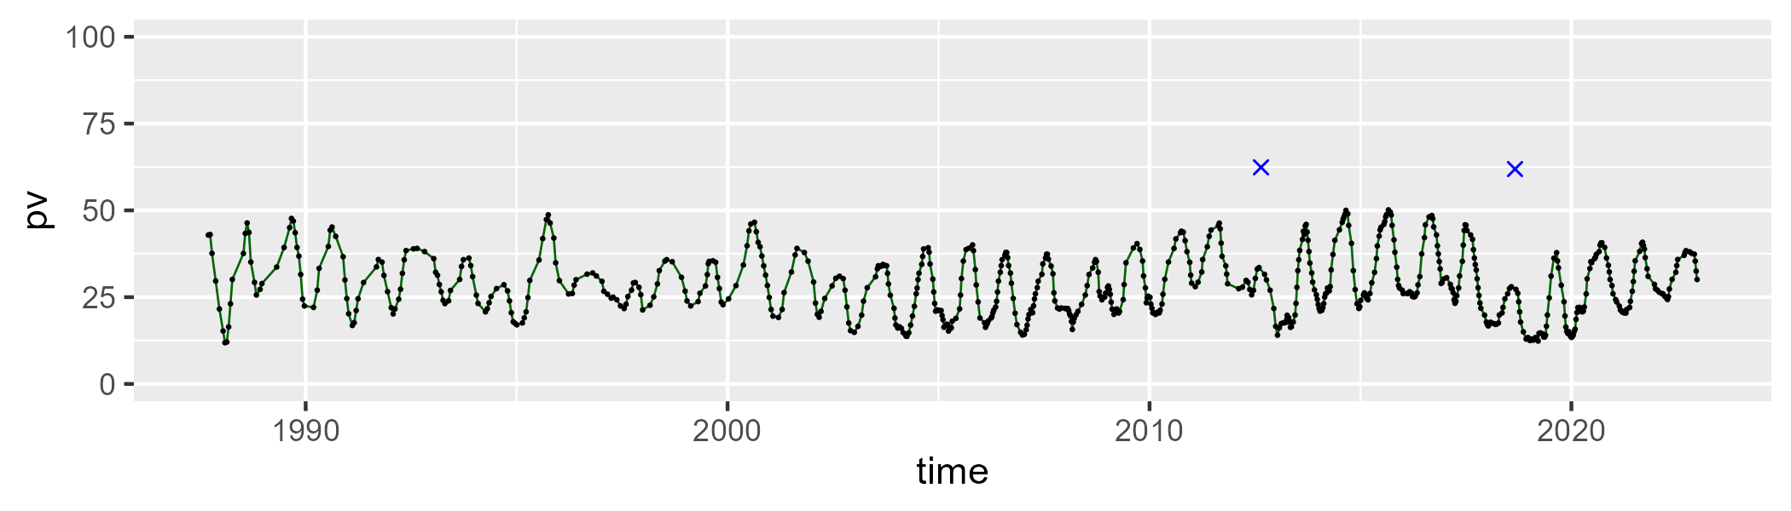

| Min. | 1st Qu. | Median | Mean | 3rd Qu. | Max. |
| --- | --- | --- | --- | --- | --- |
| 35.82297 | 48.95382 | 54.18585 | 53.40565 | 58.14963 | 71.17303 |

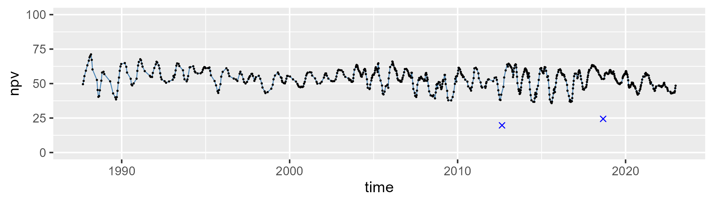

| Min. | 1st Qu. | Median | Mean | 3rd Qu. | Max. |
| --- | --- | --- | --- | --- | --- |
| 3.720958 | 12.54089 | 16.57687 | 16.87365 | 20.88011 | 34.40402 |

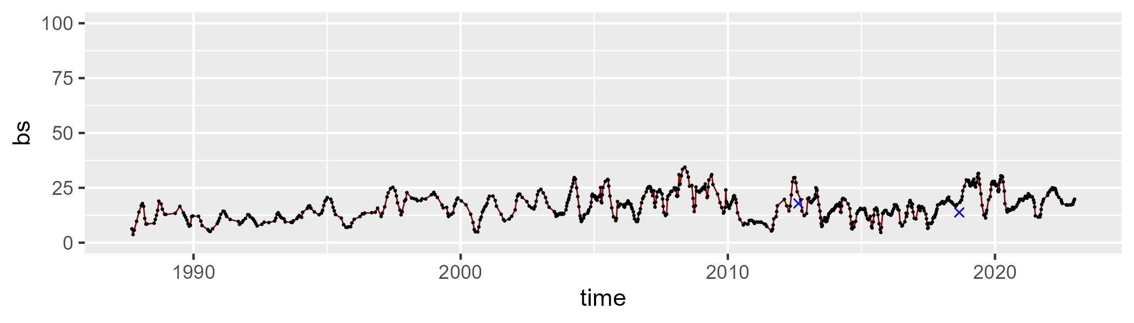

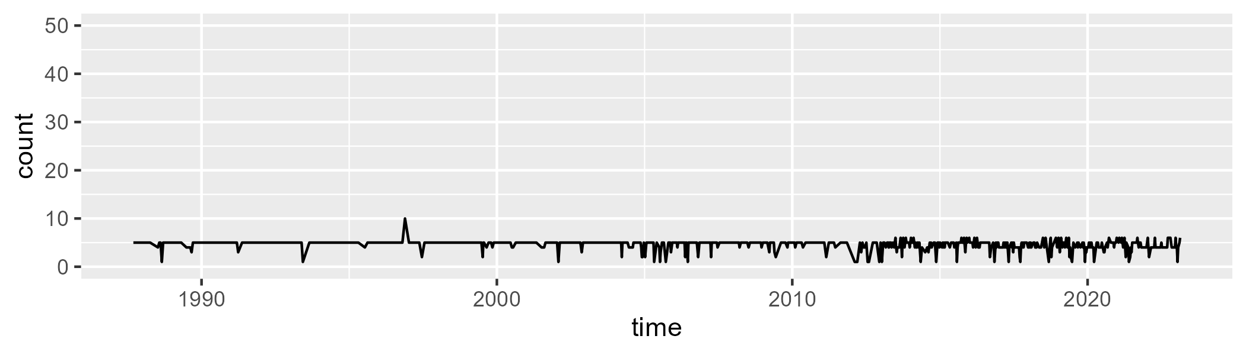

Min. : 1.000 1st Qu.: 4.000 Median : 5.000 Mean : 4.575 3rd Qu.: 5.000 Max. :10.000

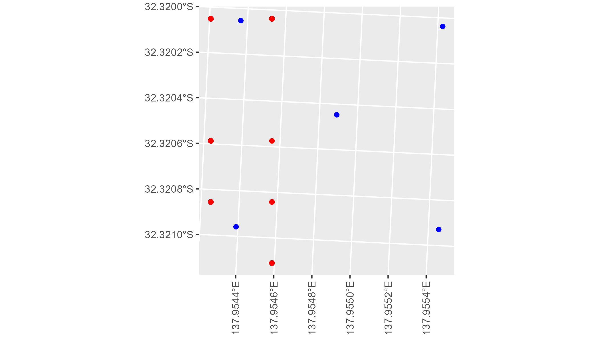

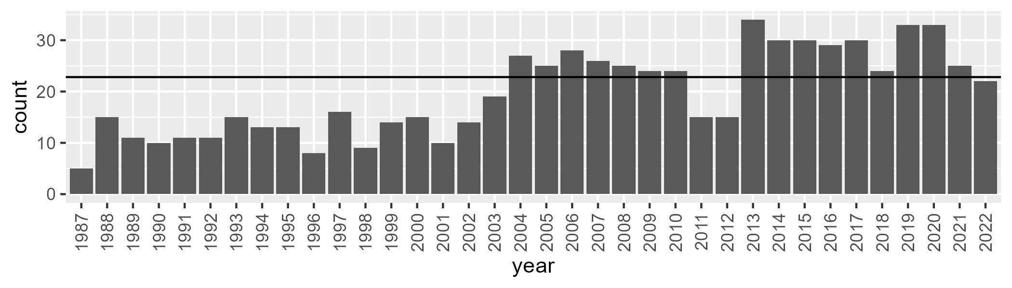

Number of samples: 708

# SATFLB0009

| Min. | 1st Qu. | Median | Mean | 3rd Qu. | Max. |
| --- | --- | --- | --- | --- | --- |
| 30.20154 | 41.46127 | 45.19522 | 44.82563 | 48.41003 | 56.22512 |

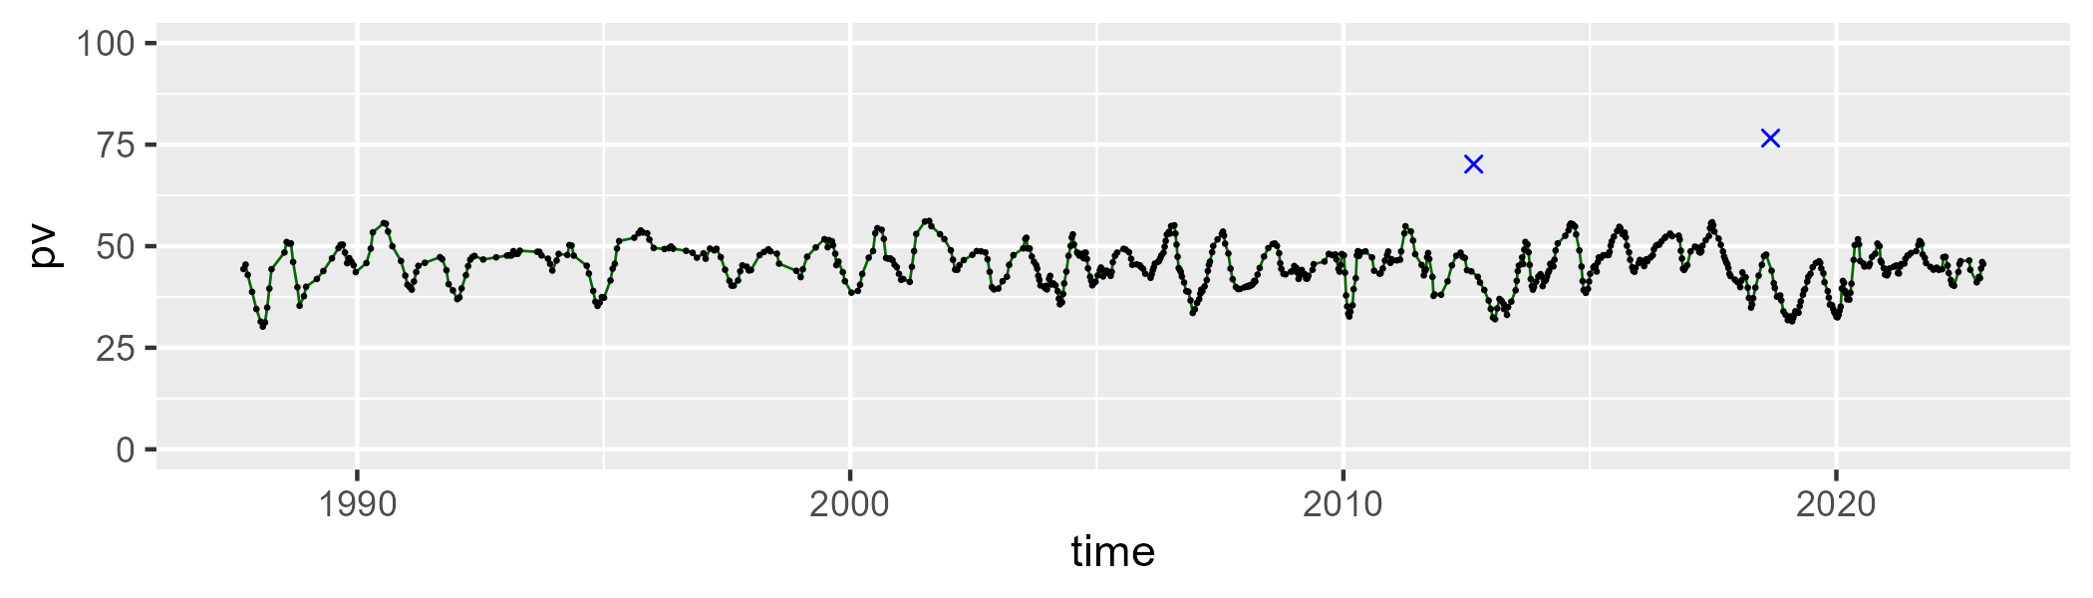

| Min. | 1st Qu. | Median | Mean | 3rd Qu. | Max. |
| --- | --- | --- | --- | --- | --- |
| 32.69795 | 42.25525 | 44.99492 | 44.88441 | 47.61111 | 54.04462 |

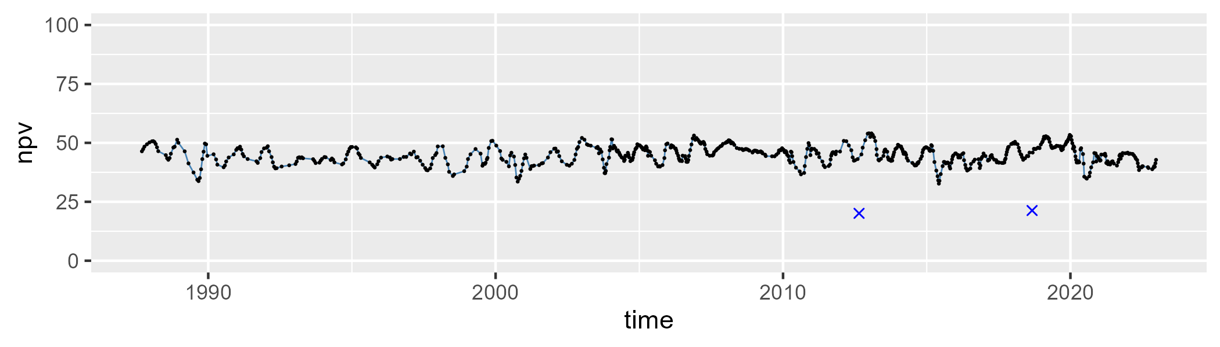

| Min. | 1st Qu. | Median | Mean | 3rd Qu. | Max. |
| --- | --- | --- | --- | --- | --- |
| 0 | 5.899916 | 8.613001 | 9.072202 | 11.94143 | 22.62453 |

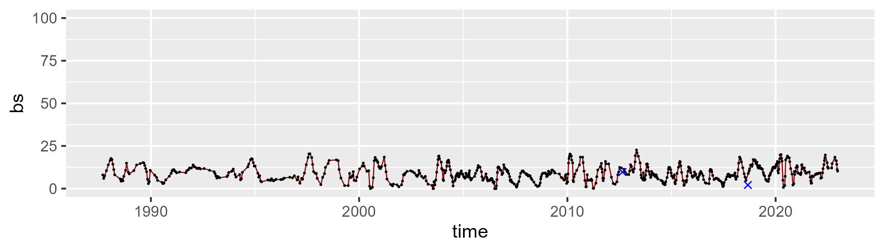

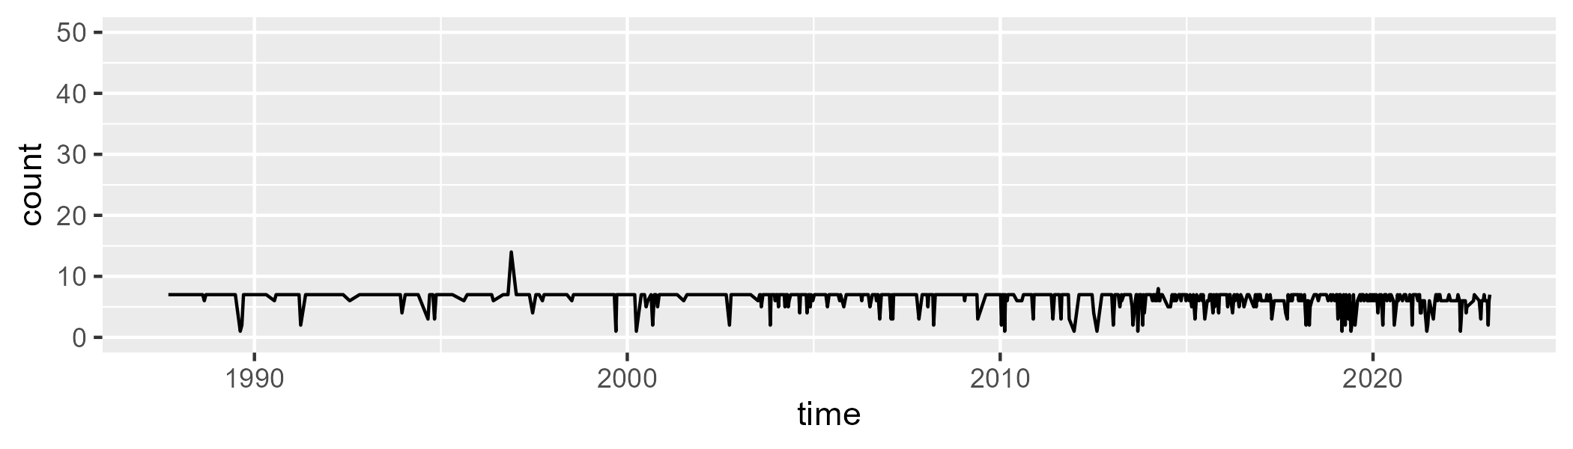

Min. : 1.000 1st Qu.: 6.000 Median : 7.000 Mean : 6.338 3rd Qu.: 7.000 Max. :14.000

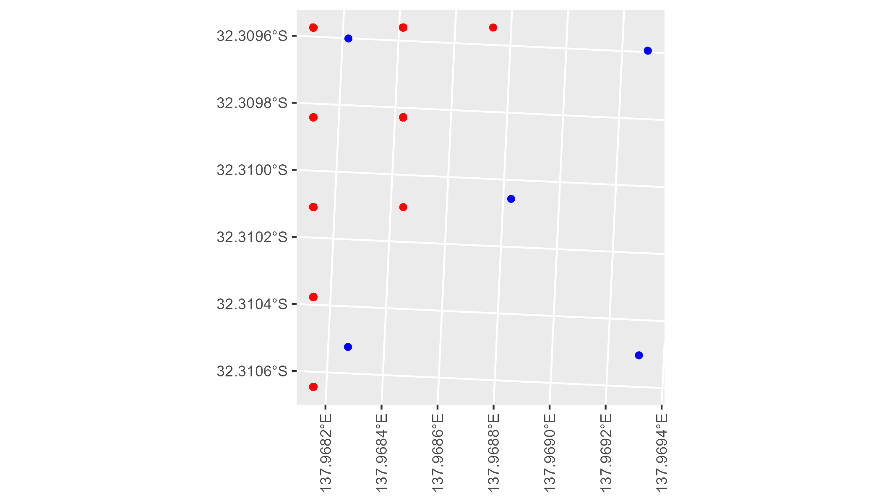

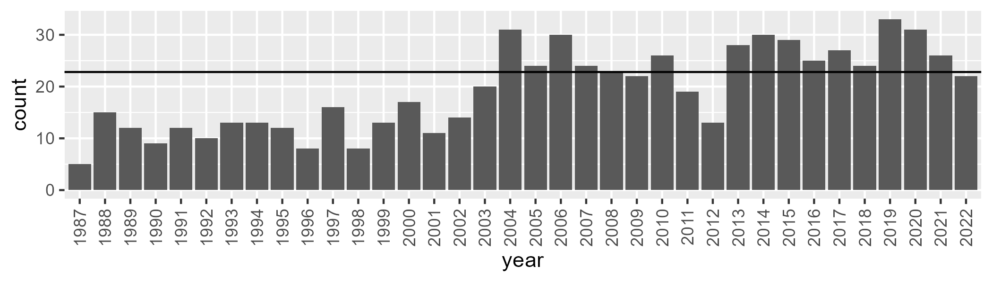

Number of samples: 695

# SATFLB0010

| Min. | 1st Qu. | Median | Mean | 3rd Qu. | Max. |
| --- | --- | --- | --- | --- | --- |
| 12.77018 | 35.97183 | 40.8821 | 40.66169 | 45.97455 | 59.30793 |

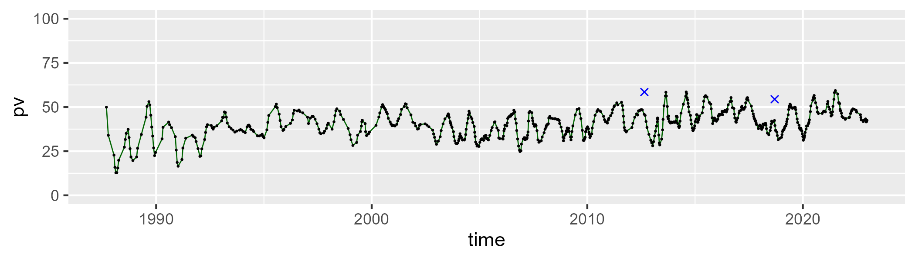

| Min. | 1st Qu. | Median | Mean | 3rd Qu. | Max. |
| --- | --- | --- | --- | --- | --- |
| 21.8446 | 38.2734 | 43.46845 | 42.96223 | 47.92157 | 71.01486 |

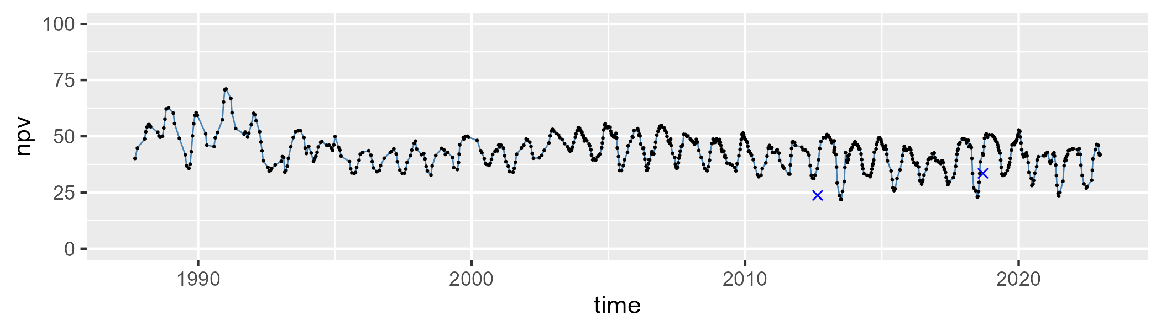

| Min. | 1st Qu. | Median | Mean | 3rd Qu. | Max. |
| --- | --- | --- | --- | --- | --- |
| 0 | 11.67333 | 14.2052 | 15.02201 | 17.16922 | 43.75841 |

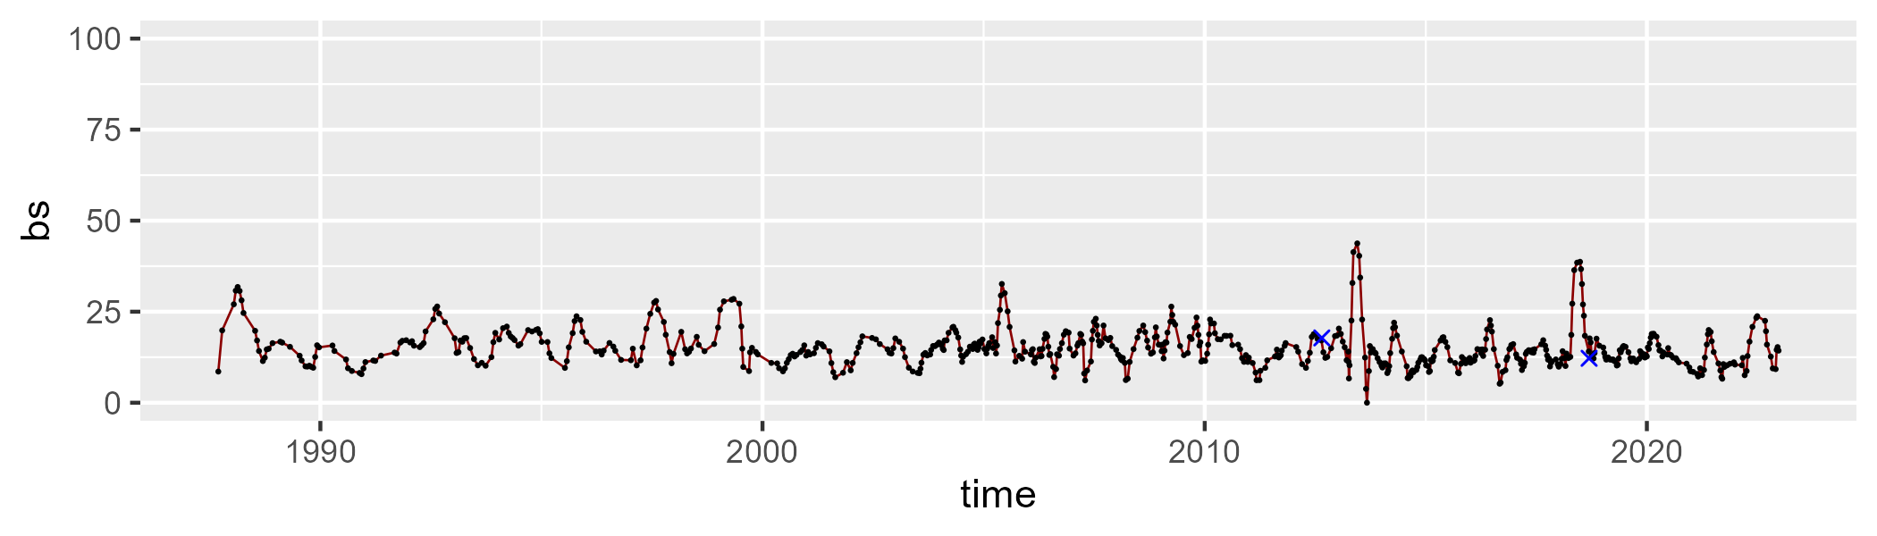

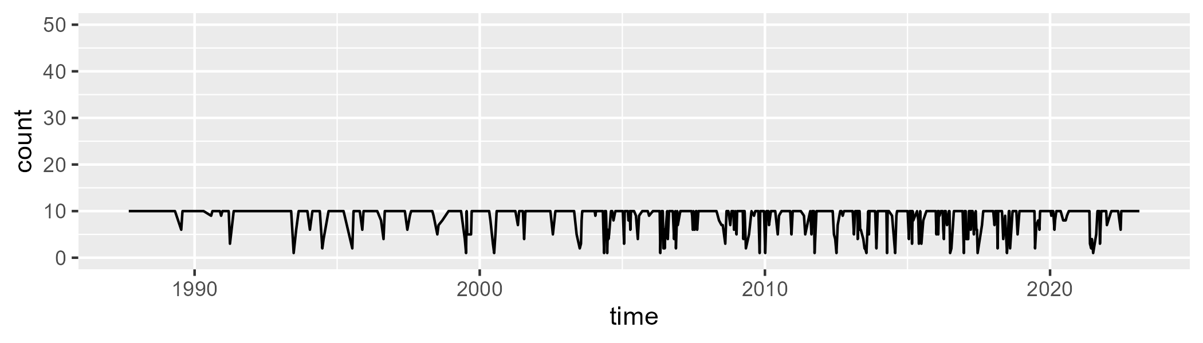

Min. : 1.000 1st Qu.:10.000 Median :10.000 Mean : 8.892 3rd Qu.:10.000 Max. :10.000

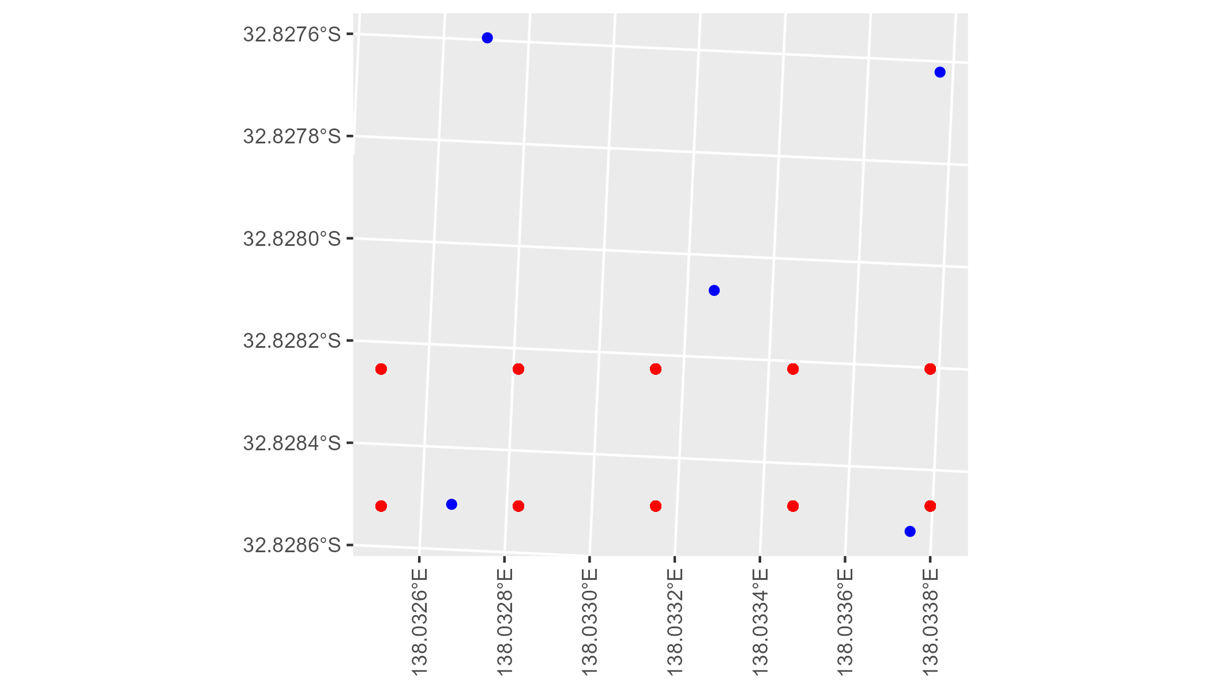

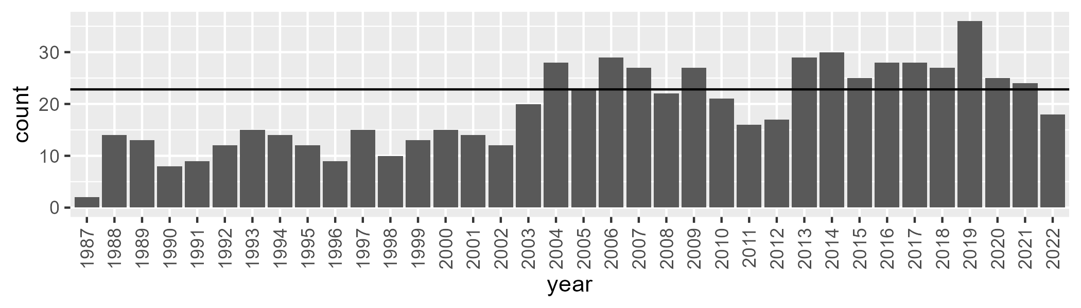

Number of samples: 687

# SATFLB0011

| Min. | 1st Qu. | Median | Mean | 3rd Qu. | Max. |
| --- | --- | --- | --- | --- | --- |
| 5.41376 | 47.72731 | 51.03128 | 50.47557 | 54.36007 | 63.91715 |

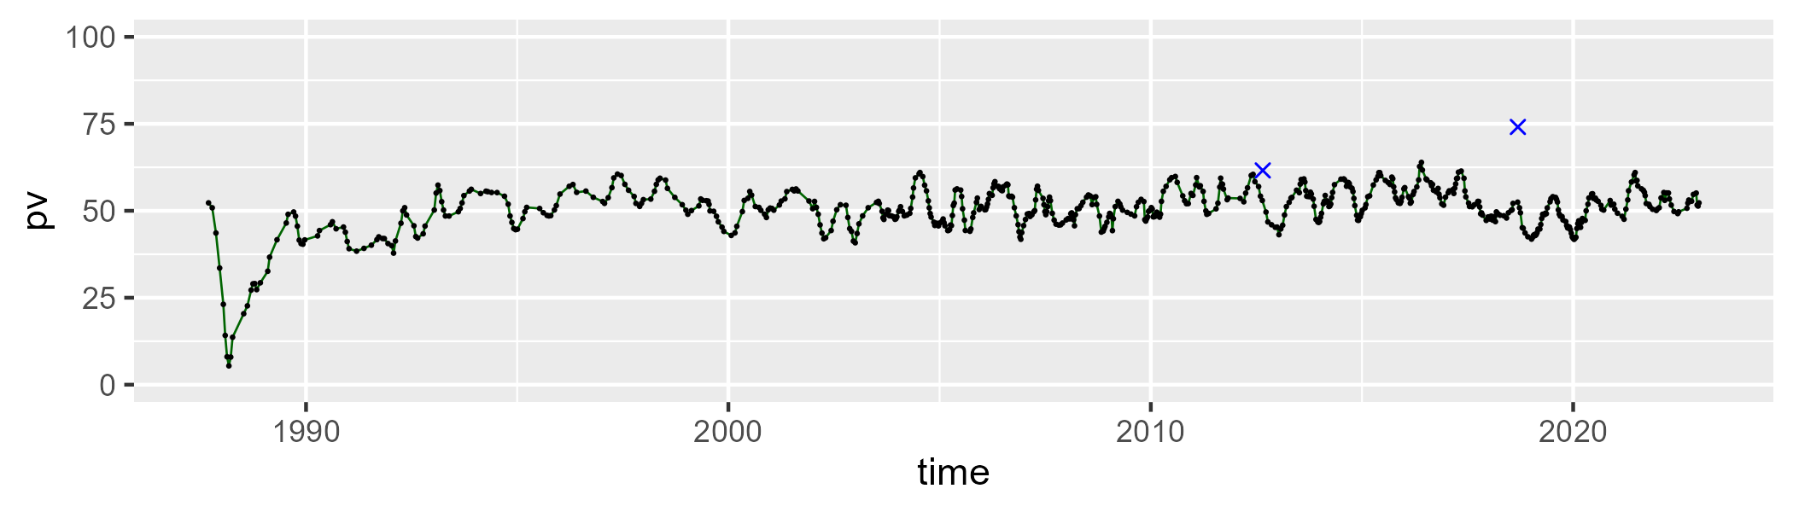

| Min. | 1st Qu. | Median | Mean | 3rd Qu. | Max. |
| --- | --- | --- | --- | --- | --- |
| 20.26697 | 36.95572 | 40.39729 | 39.60219 | 43.15629 | 51.88955 |

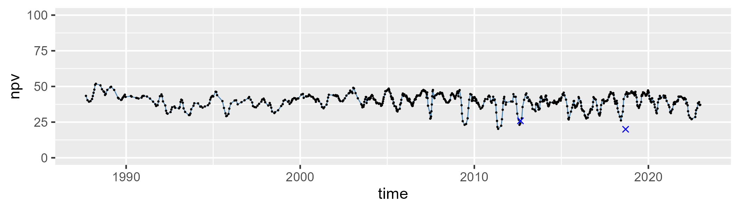

| Min. | 1st Qu. | Median | Mean | 3rd Qu. | Max. |
| --- | --- | --- | --- | --- | --- |
| 0 | 4.461894 | 7.515379 | 8.58384 | 10.96069 | 45.44748 |

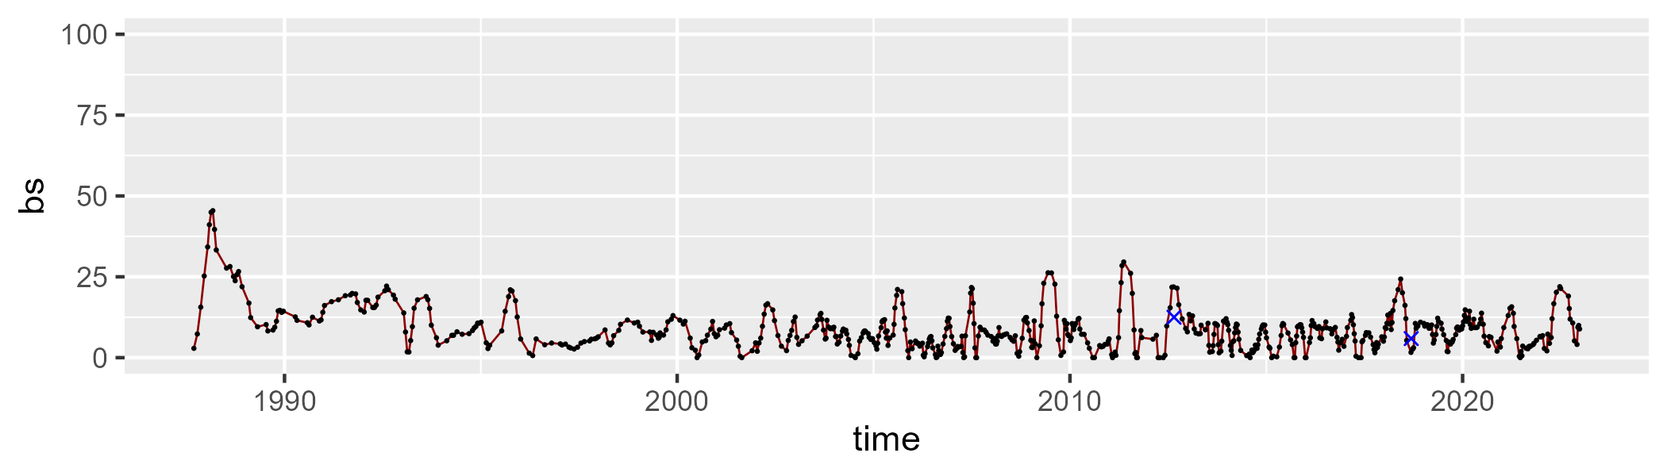

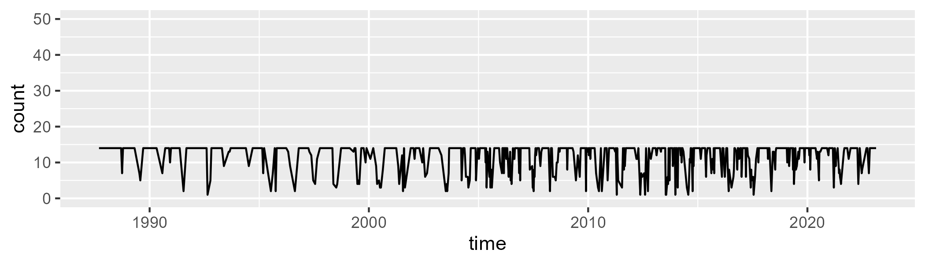

Min. : 1.00 1st Qu.:11.00 Median :14.00 Mean :11.83 3rd Qu.:14.00 Max. :14.00

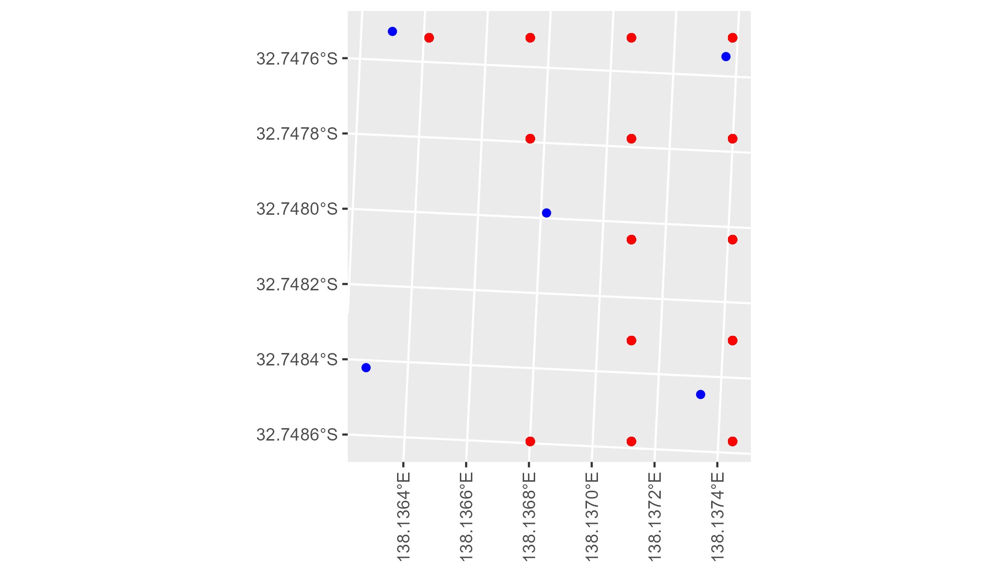

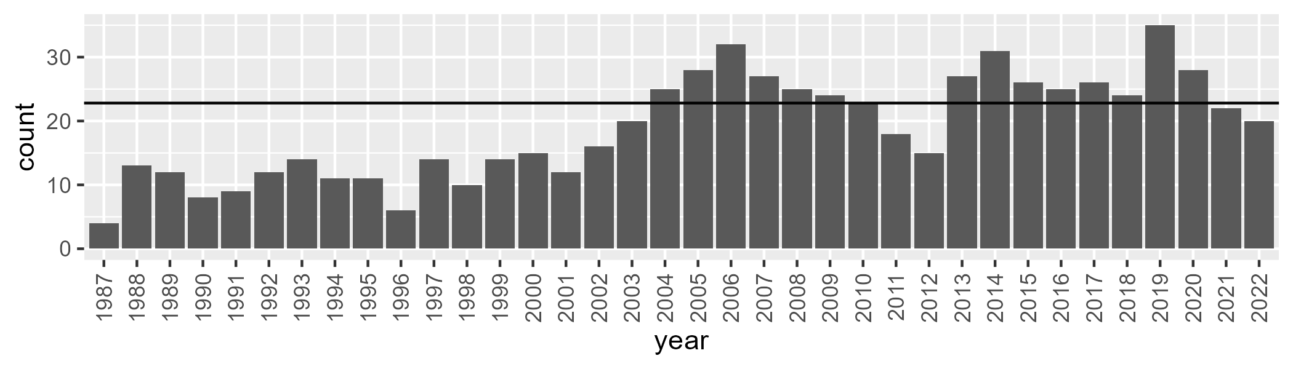

Number of samples: 682

# SATFLB0013

| Min. | 1st Qu. | Median | Mean | 3rd Qu. | Max. |
| --- | --- | --- | --- | --- | --- |
| 27.10512 | 46.74827 | 50.96864 | 50.61047 | 54.81454 | 67.61492 |

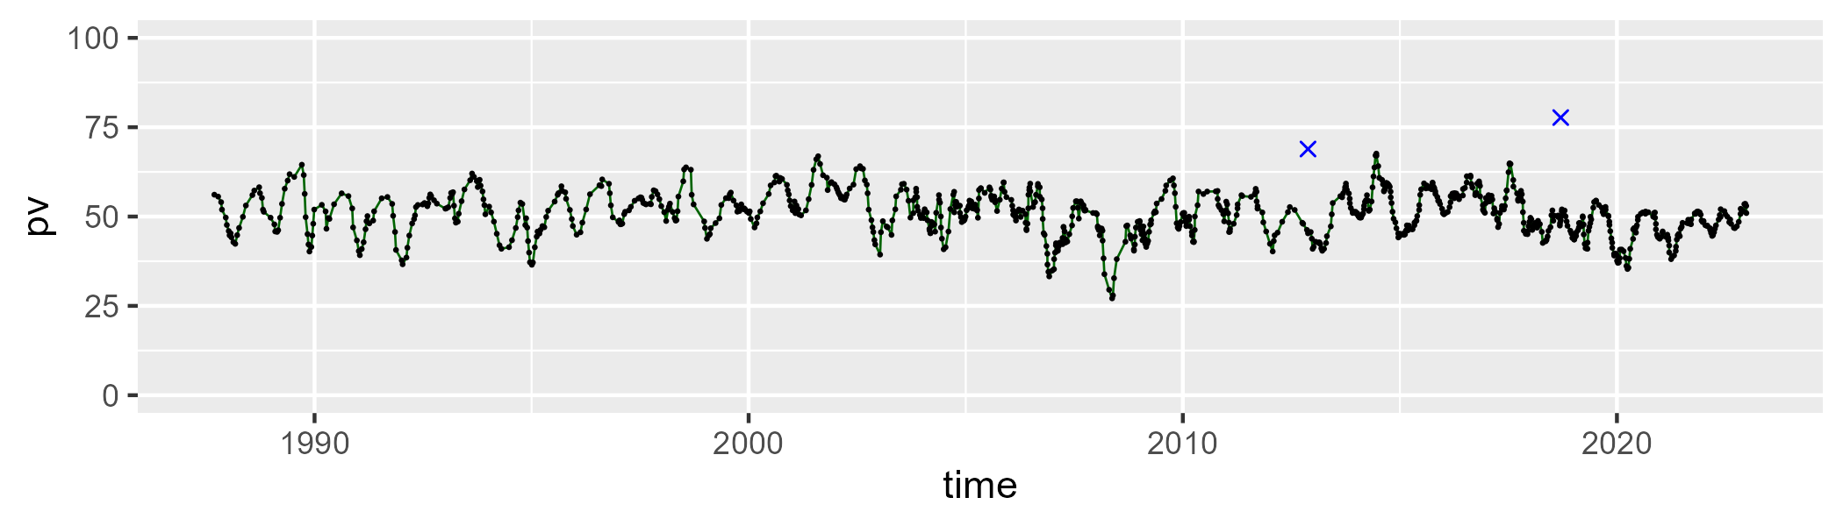

| Min. | 1st Qu. | Median | Mean | 3rd Qu. | Max. |
| --- | --- | --- | --- | --- | --- |
| 18.28446 | 35.71249 | 40.1026 | 40.1158 | 44.54938 | 58.8256 |

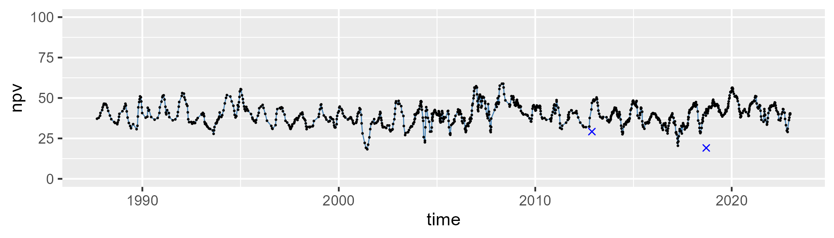

| Min. | 1st Qu. | Median | Mean | 3rd Qu. | Max. |
| --- | --- | --- | --- | --- | --- |
| 0 | 5.30095 | 6.948024 | 7.918315 | 9.665152 | 31.25992 |

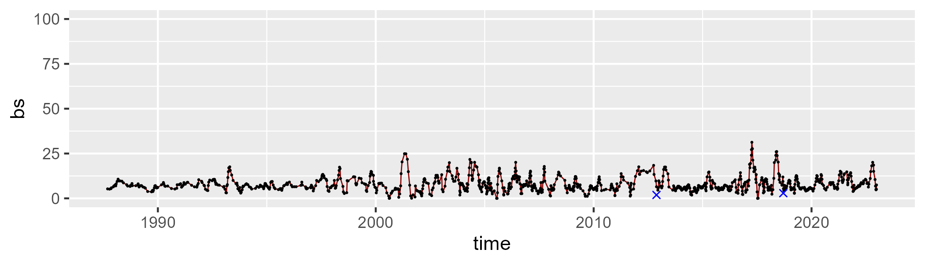

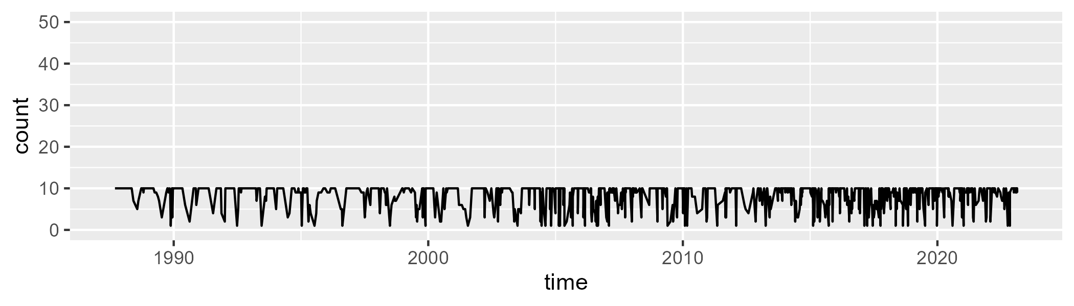

Min. : 1.000 1st Qu.: 7.000 Median :10.000 Mean : 8.336 3rd Qu.:10.000 Max. :10.000

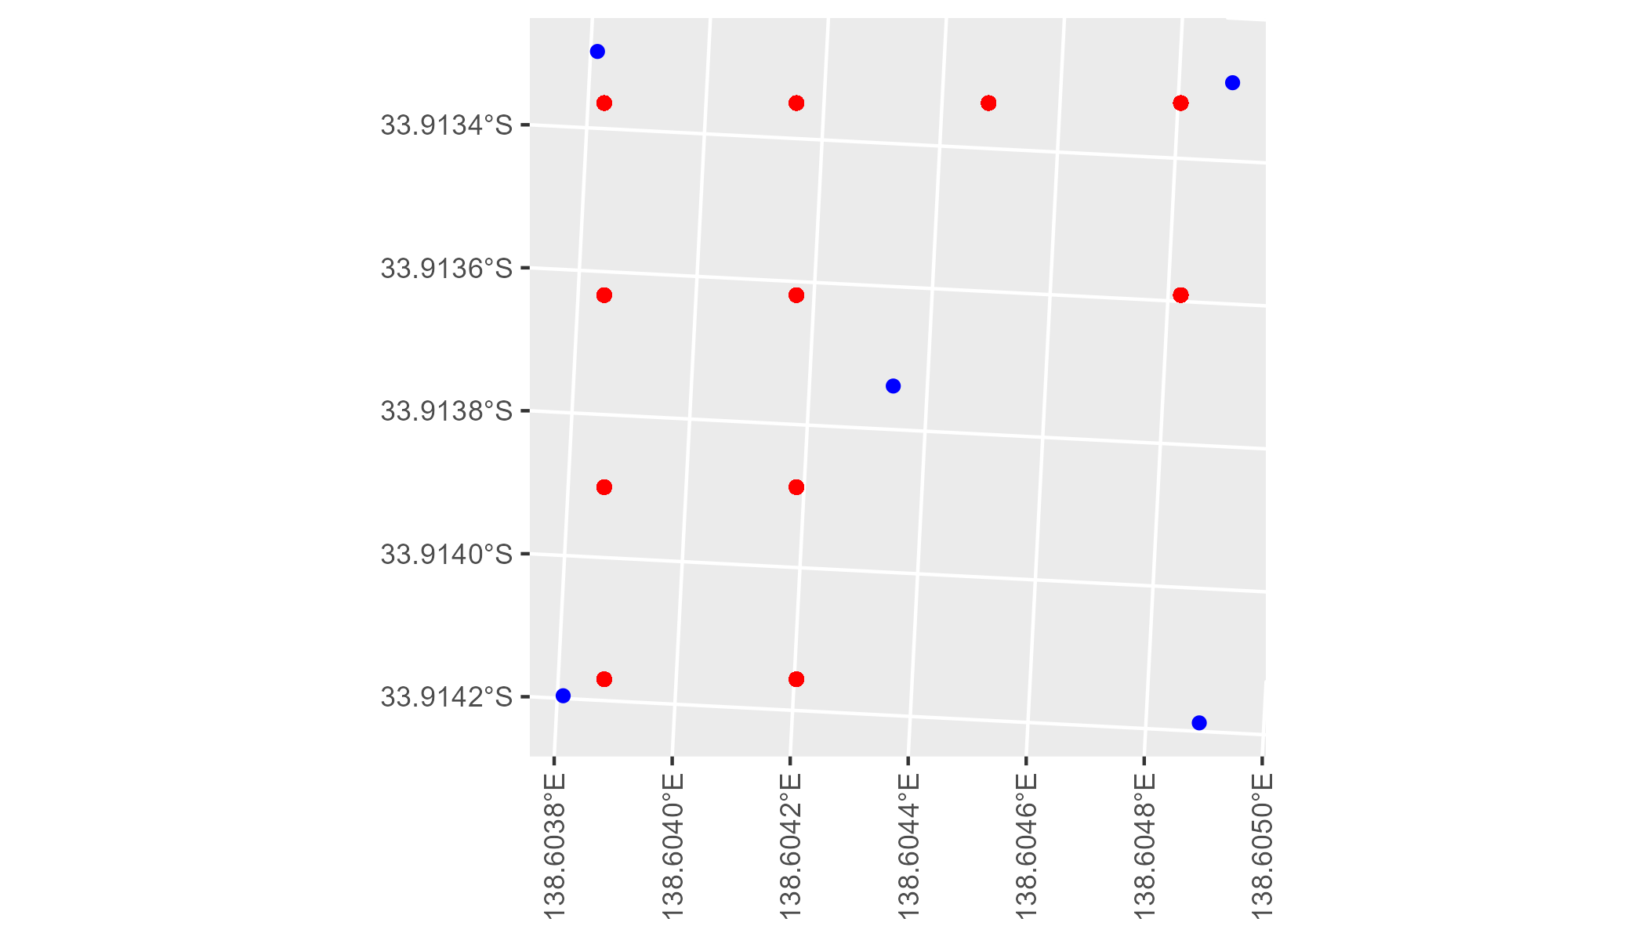

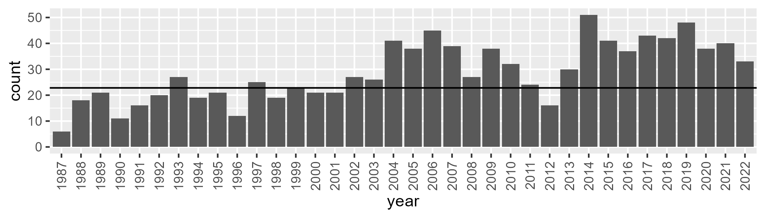

Number of samples: 1036

# SATFLB0015

| Min. | 1st Qu. | Median | Mean | 3rd Qu. | Max. |
| --- | --- | --- | --- | --- | --- |
| 43.20056 | 58.64816 | 61.44799 | 61.08845 | 64.2995 | 75.53696 |

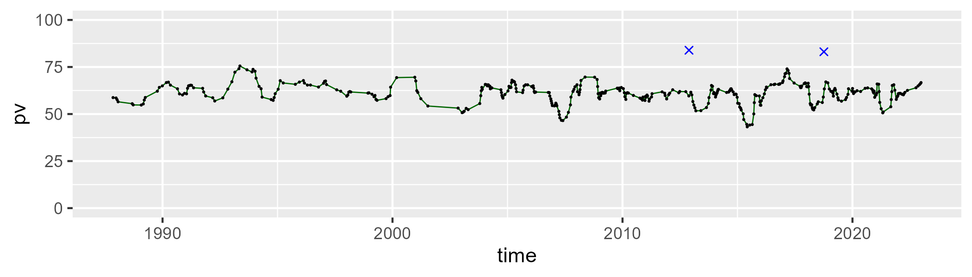

| Min. | 1st Qu. | Median | Mean | 3rd Qu. | Max. |
| --- | --- | --- | --- | --- | --- |
| 16.09408 | 27.15099 | 30.7645 | 30.1979 | 33.27285 | 50.13001 |

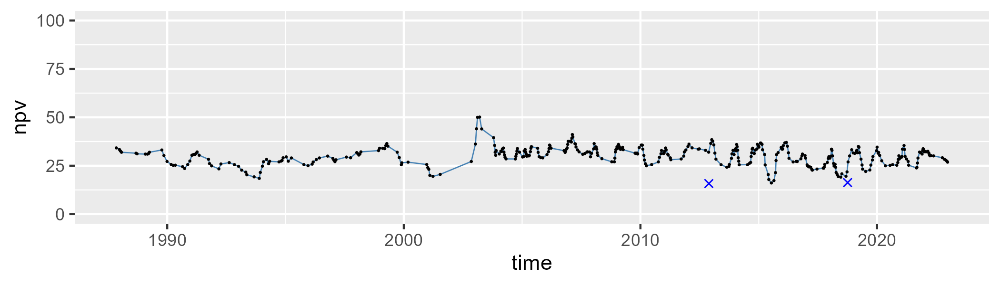

| Min. | 1st Qu. | Median | Mean | 3rd Qu. | Max. |
| --- | --- | --- | --- | --- | --- |
| 0 | 3.180974 | 5.604766 | 7.250385 | 9.607449 | 38.1478 |

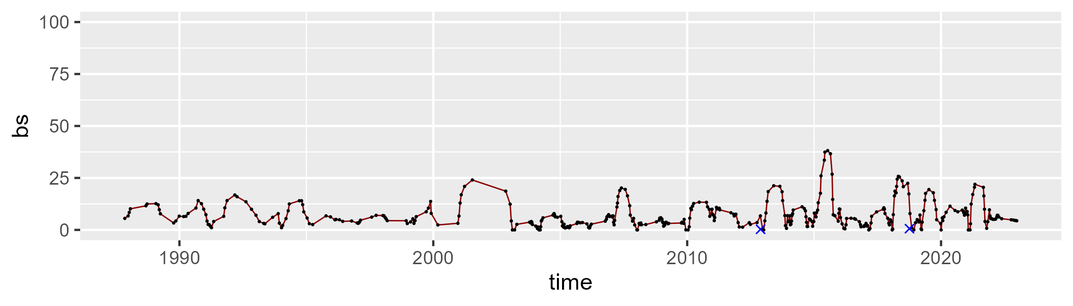

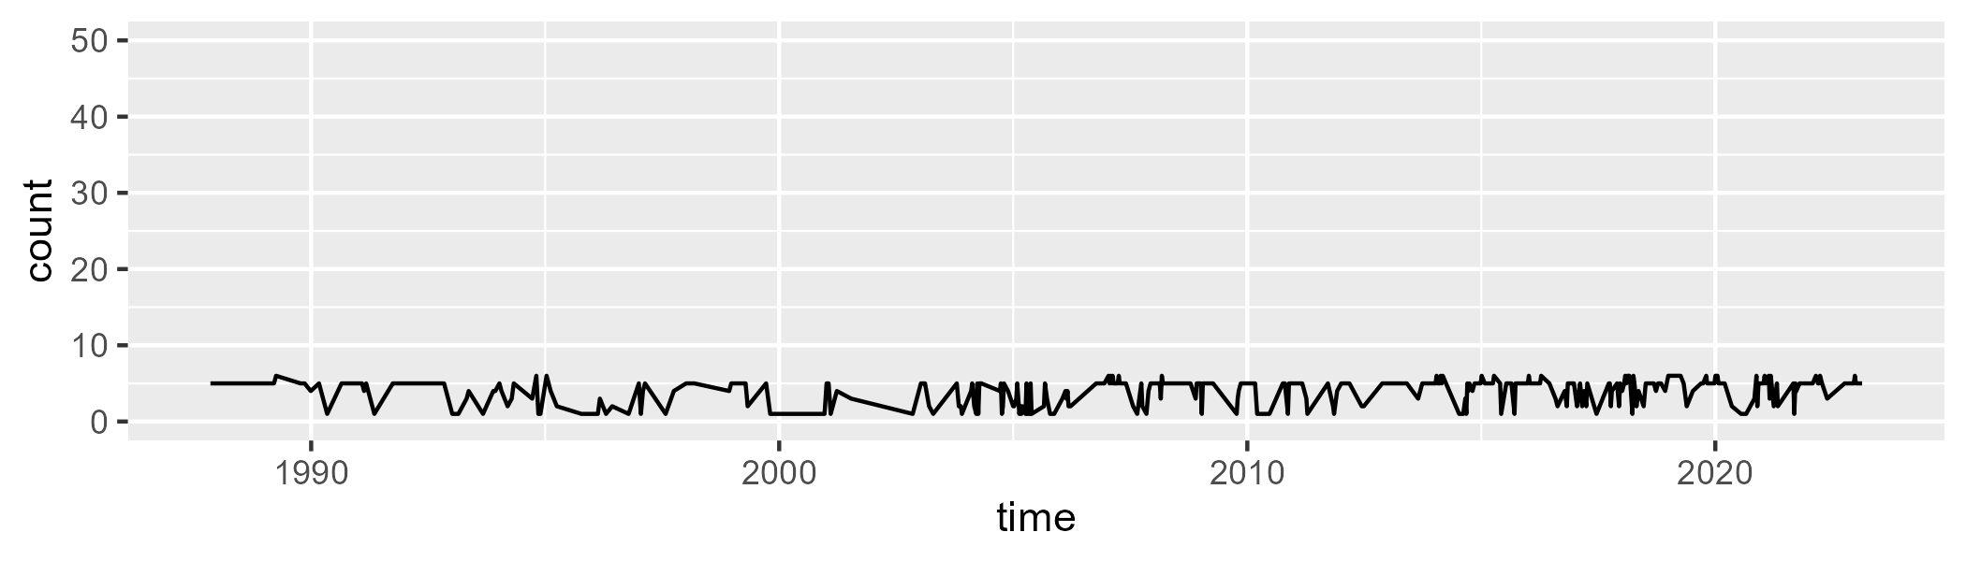

Min. :1.000 1st Qu.:3.000 Median :5.000 Mean :4.073 3rd Qu.:5.000 Max. :6.000

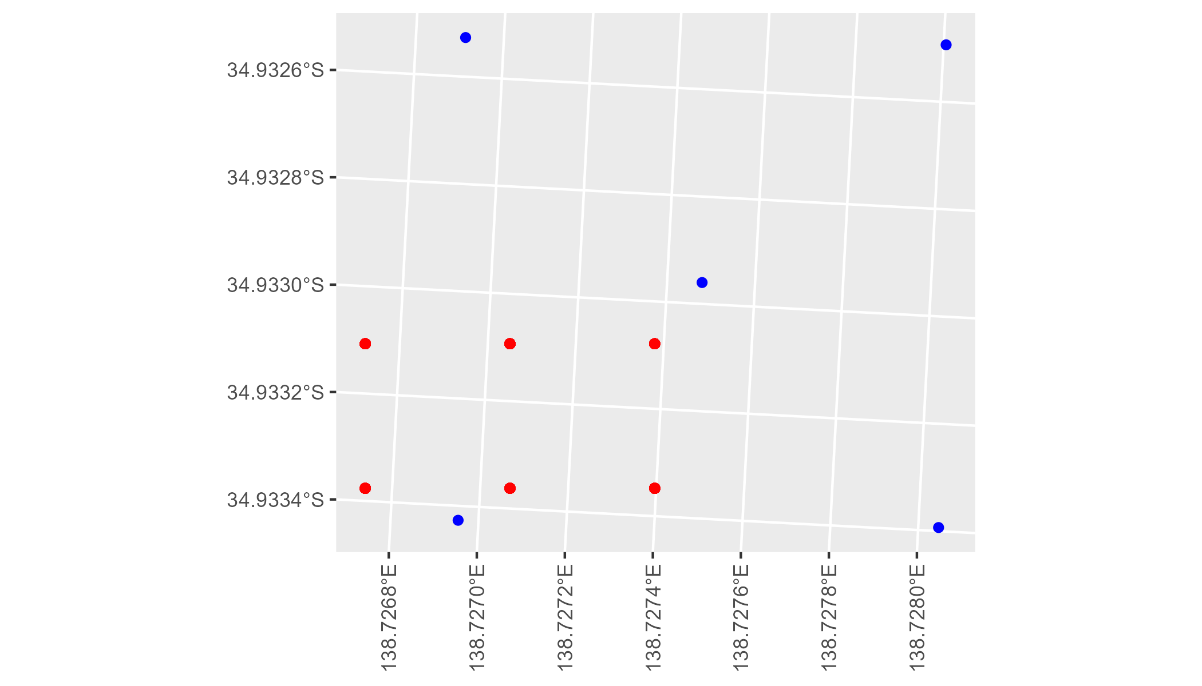

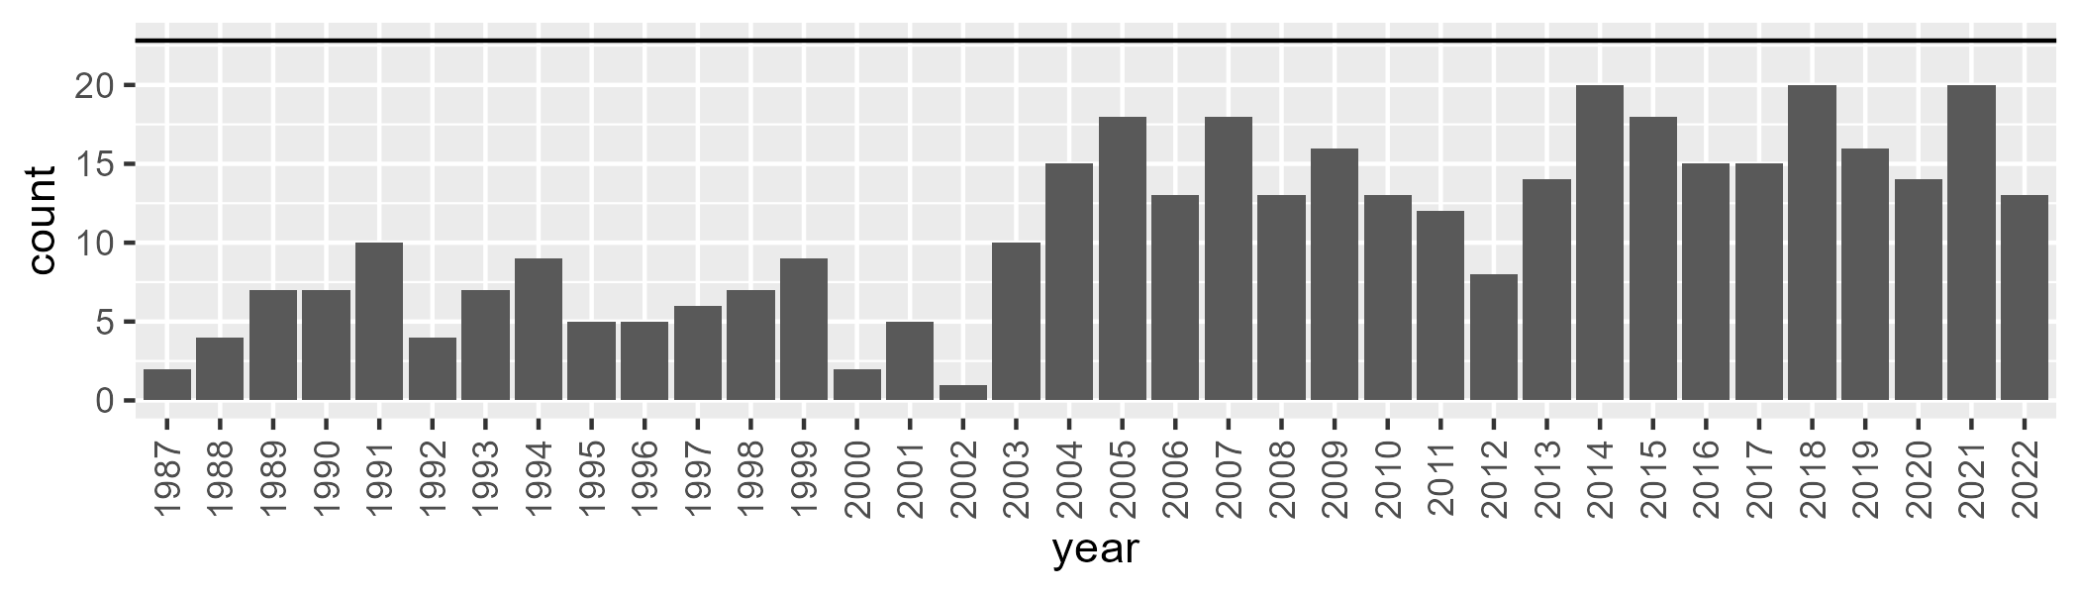

Number of samples: 391

# SATFLB0016

| Min. | 1st Qu. | Median | Mean | 3rd Qu. | Max. |
| --- | --- | --- | --- | --- | --- |
| 1.875667 | 9.026682 | 14.46873 | 14.59626 | 18.88944 | 32.05879 |

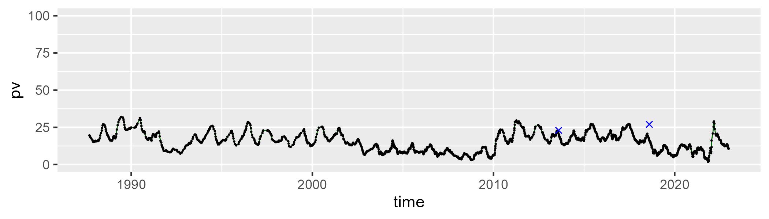

| Min. | 1st Qu. | Median | Mean | 3rd Qu. | Max. |
| --- | --- | --- | --- | --- | --- |
| 30.15139 | 39.55916 | 42.80391 | 42.71291 | 45.86537 | 56.46202 |

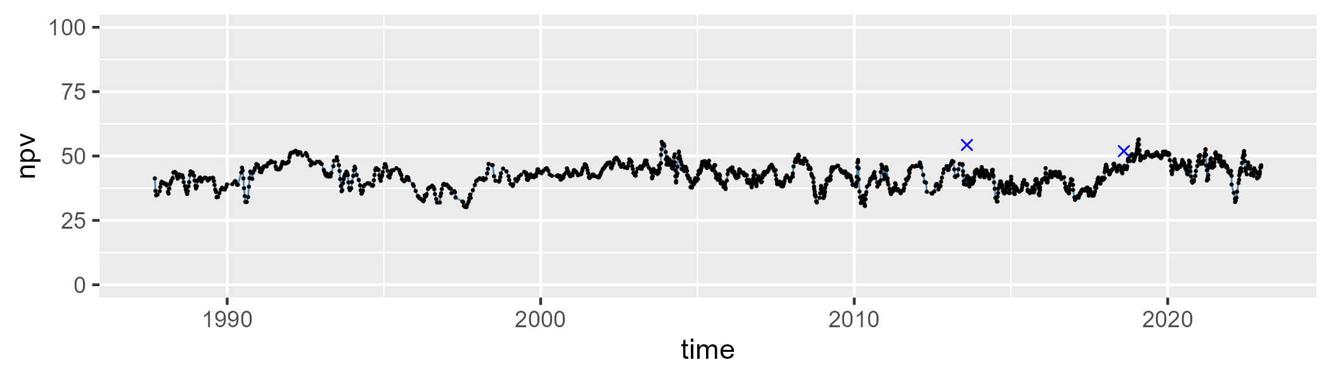

| Min. | 1st Qu. | Median | Mean | 3rd Qu. | Max. |
| --- | --- | --- | --- | --- | --- |
| 21.96378 | 37.76115 | 41.06713 | 41.30732 | 44.51817 | 63.65682 |

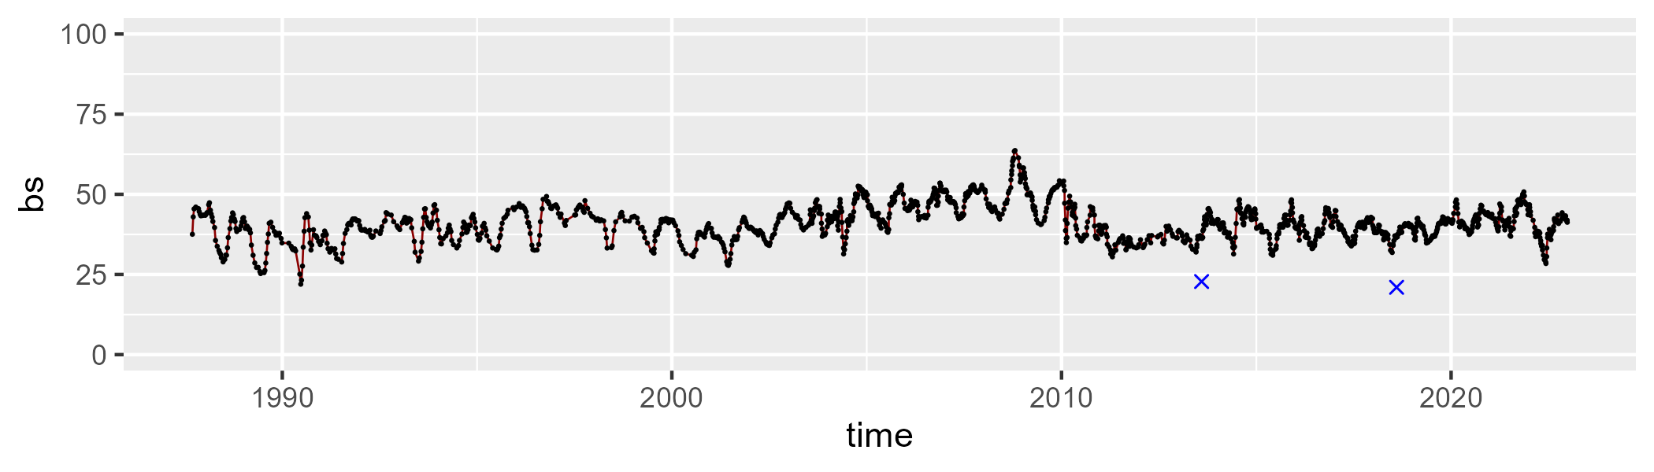

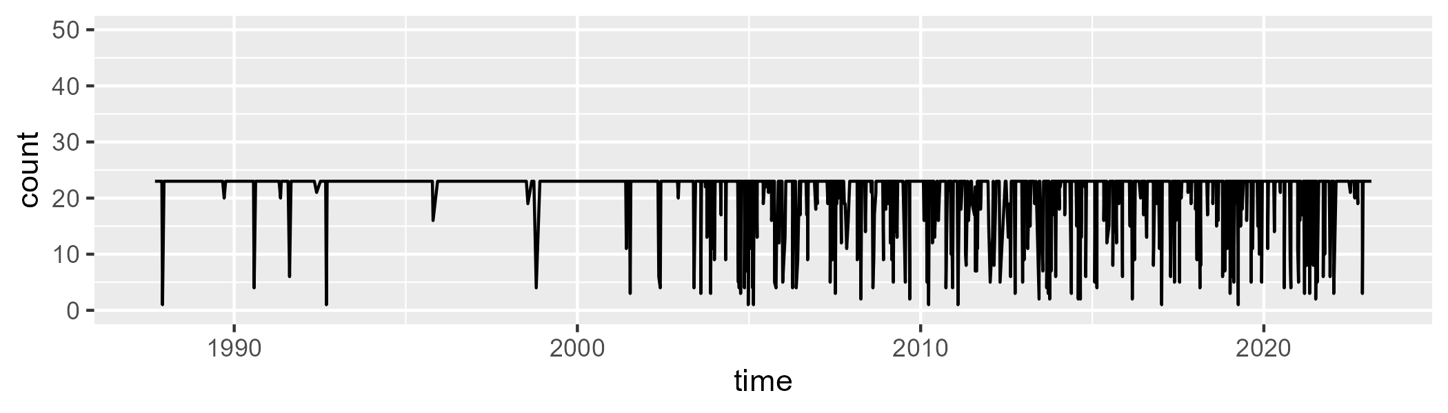

Min. : 1.00 1st Qu.:23.00 Median :23.00 Mean :21.26 3rd Qu.:23.00 Max. :23.00

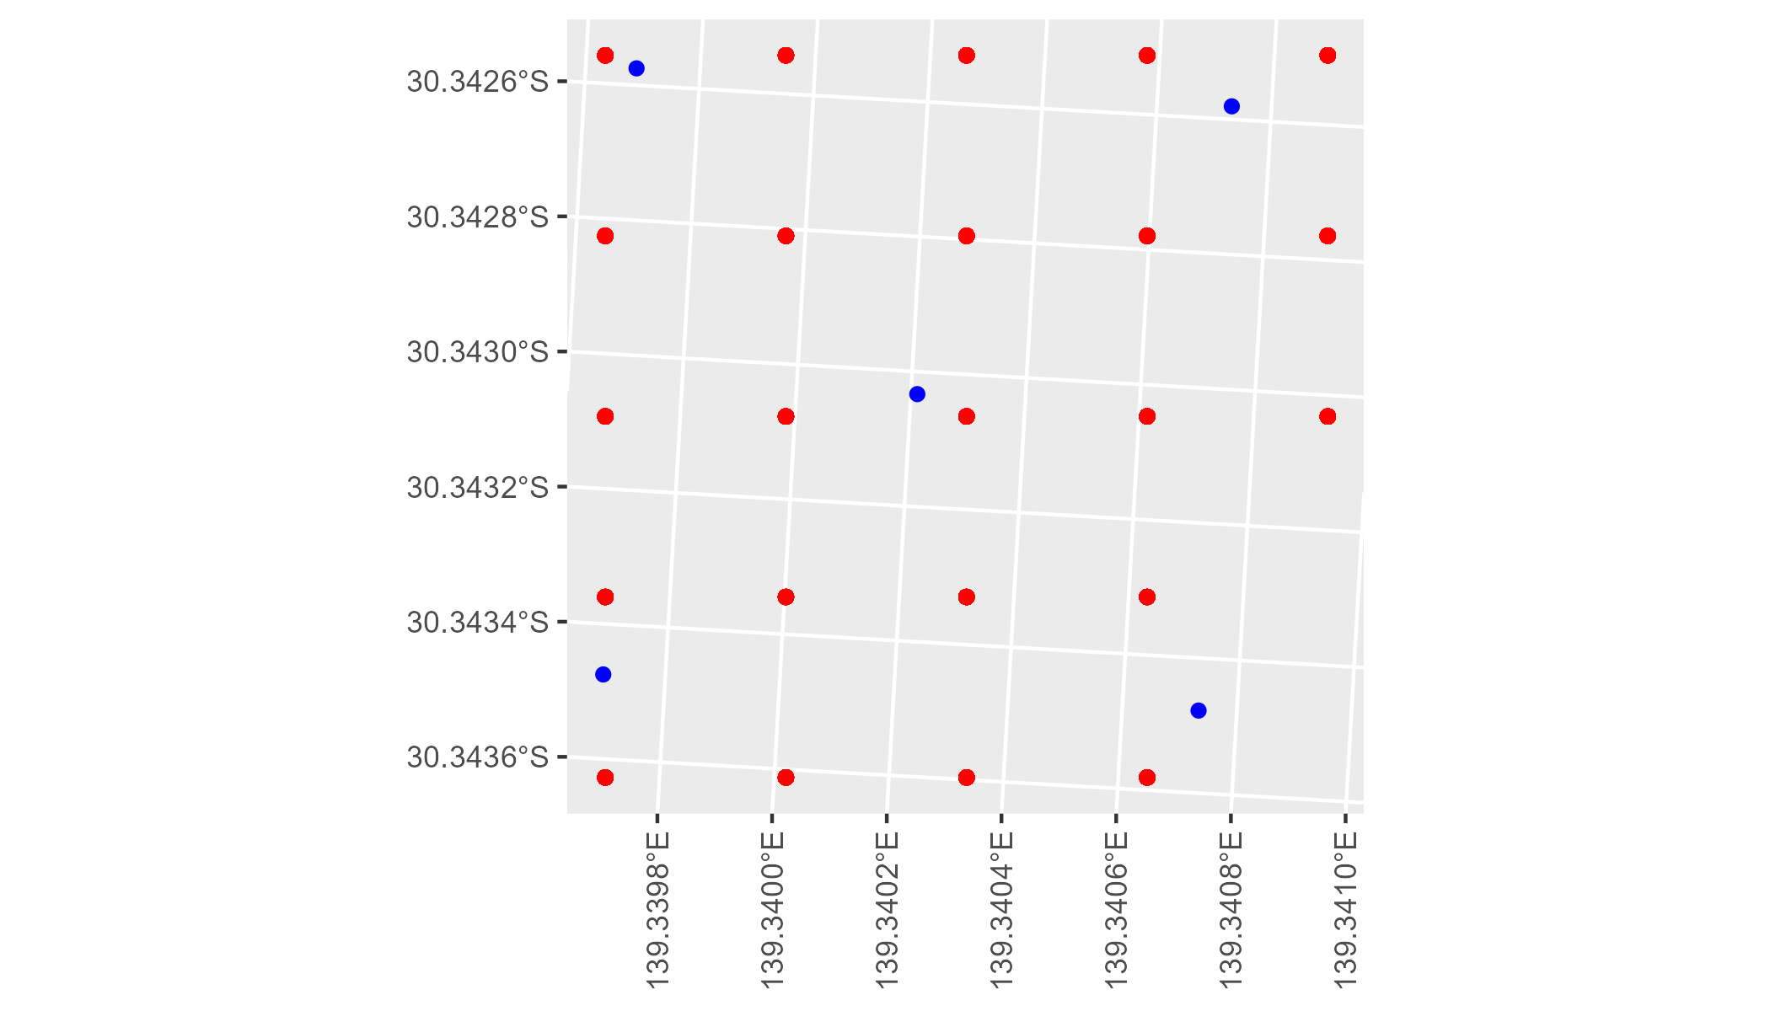

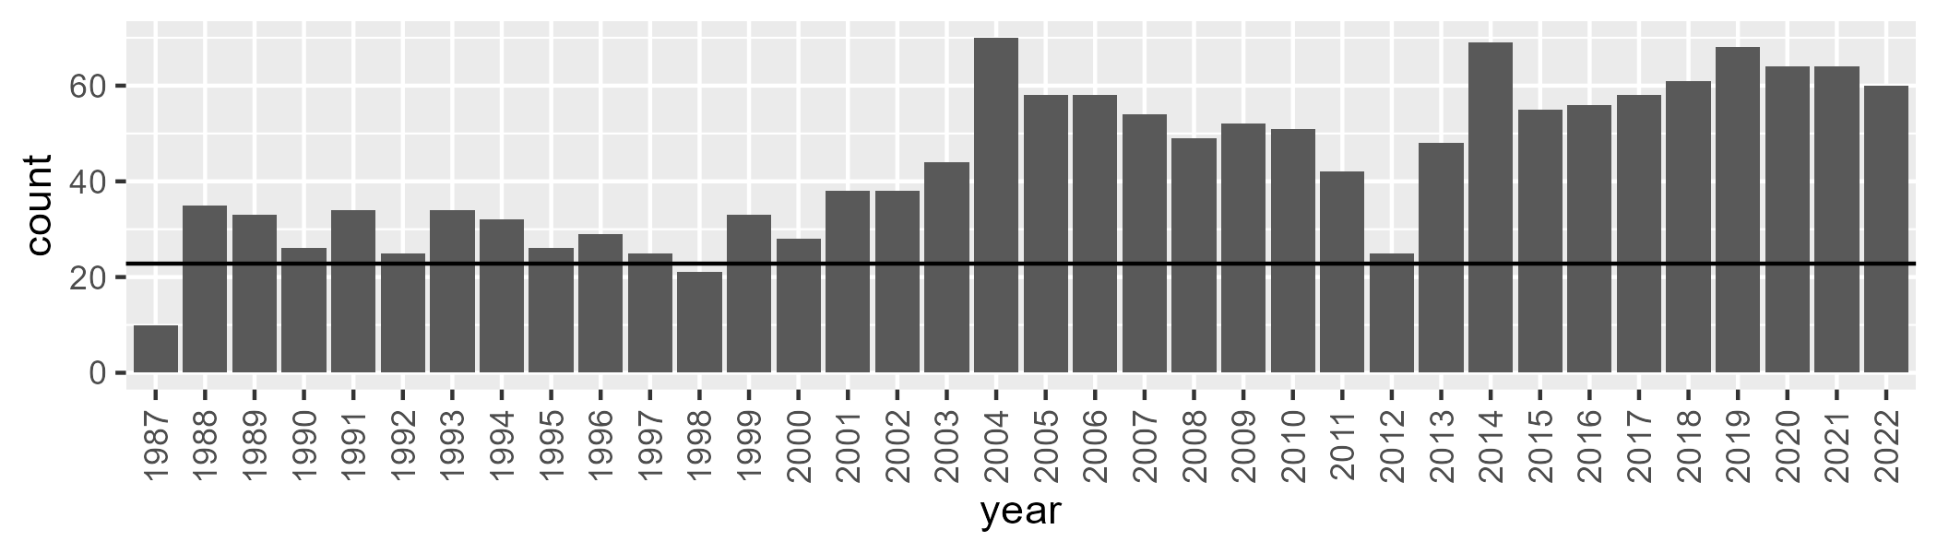

Number of samples: 1573

# SATFLB0017

| Min. | 1st Qu. | Median | Mean | 3rd Qu. | Max. |
| --- | --- | --- | --- | --- | --- |
| 0.1732662 | 4.089097 | 7.866197 | 9.123794 | 12.38844 | 33.90731 |

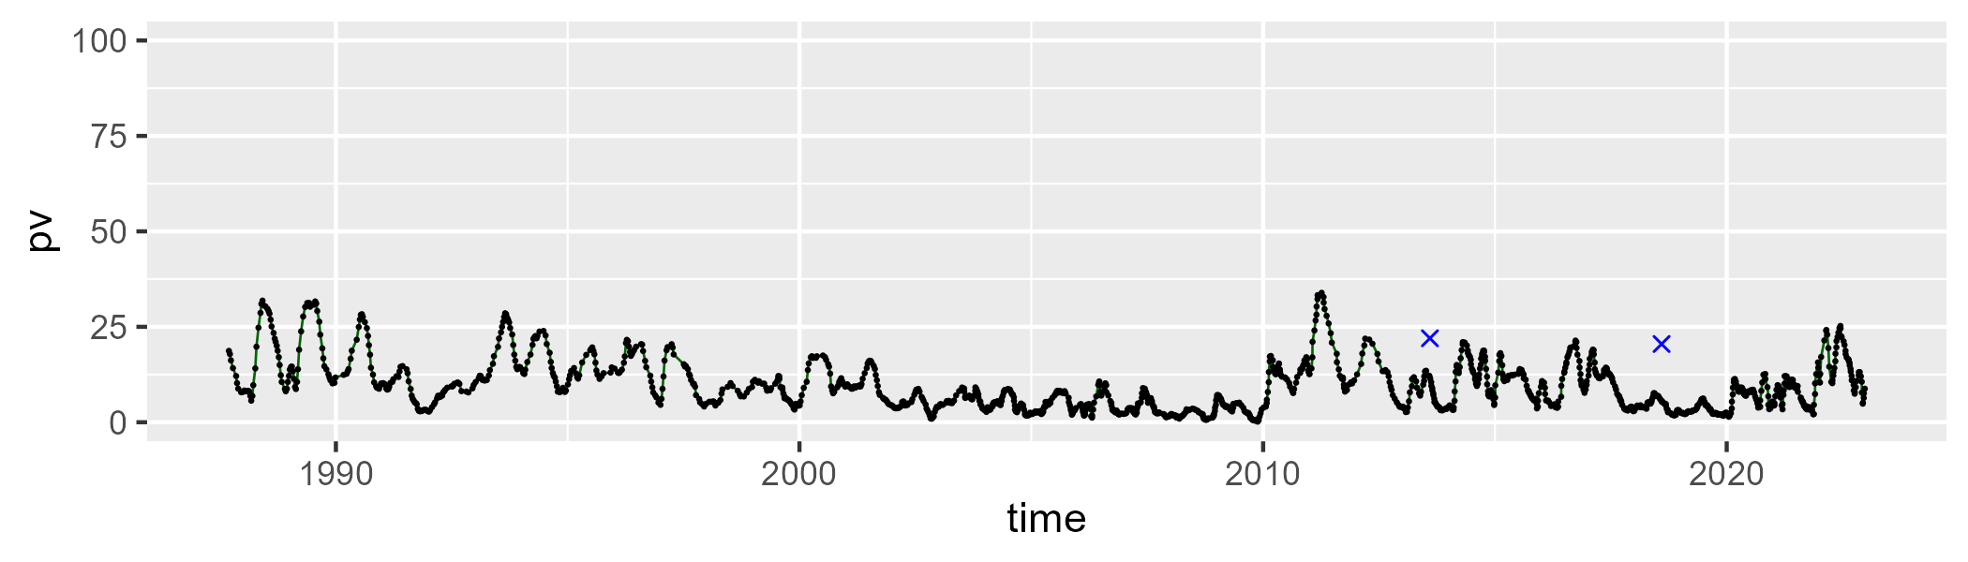

| Min. | 1st Qu. | Median | Mean | 3rd Qu. | Max. |
| --- | --- | --- | --- | --- | --- |
| 30.52429 | 42.00211 | 44.27086 | 43.93604 | 45.99358 | 55.19756 |

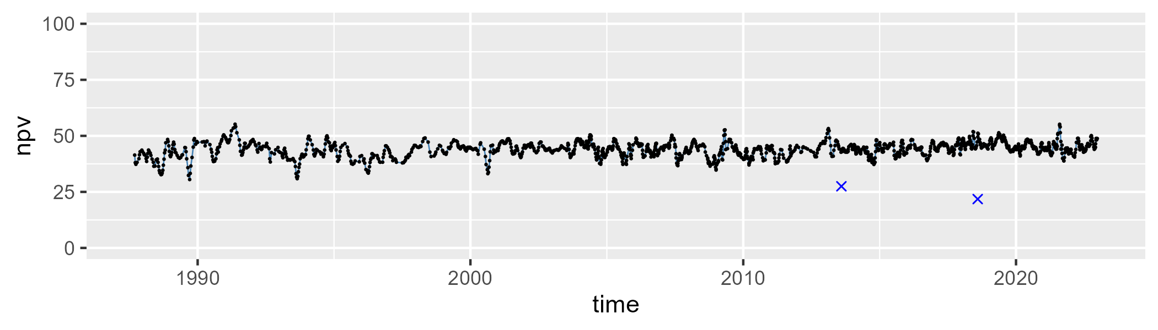

| Min. | 1st Qu. | Median | Mean | 3rd Qu. | Max. |
| --- | --- | --- | --- | --- | --- |
| 22.44967 | 41.83562 | 46.02174 | 45.47706 | 49.56458 | 61.66242 |

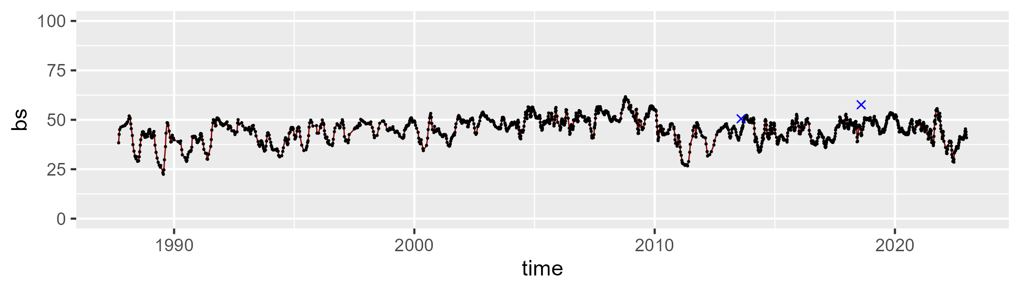

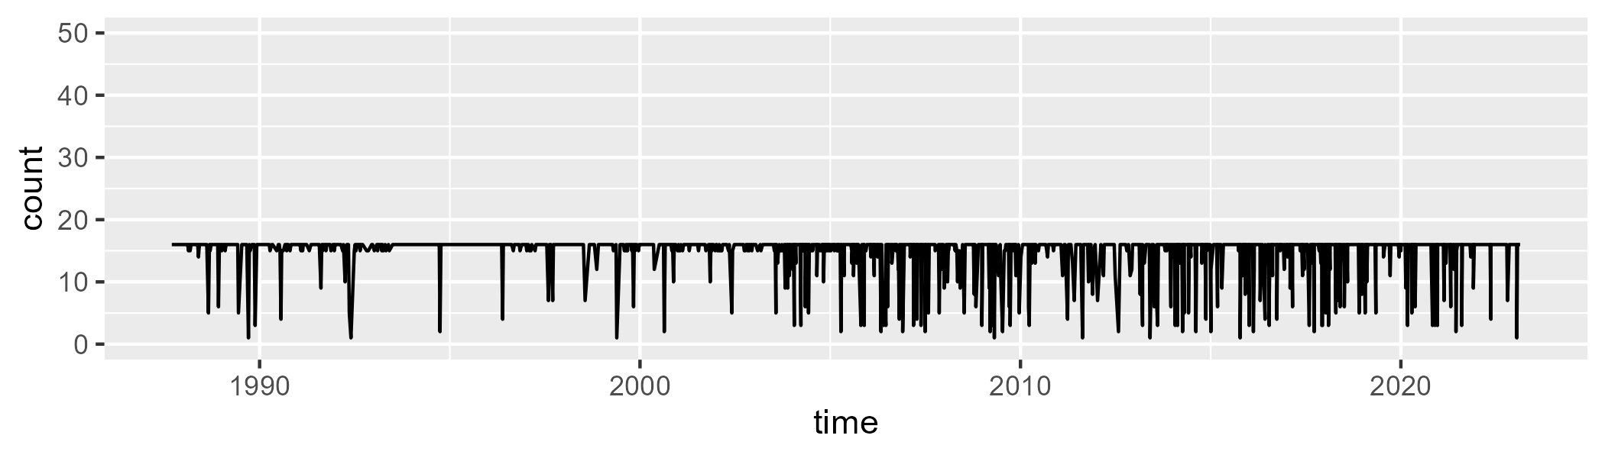

Min. : 1.0 1st Qu.:16.0 Median :16.0 Mean :14.8 3rd Qu.:16.0 Max. :16.0

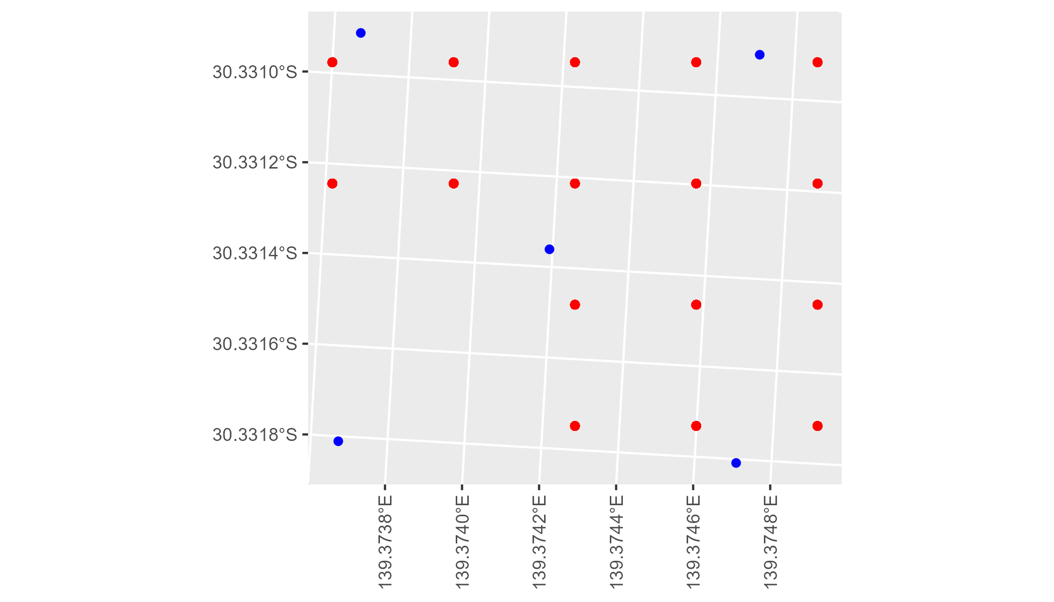

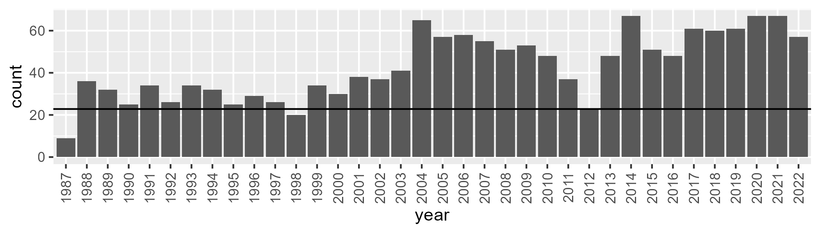

Number of samples: 1542

# SATFLB0018

| Min. | 1st Qu. | Median | Mean | 3rd Qu. | Max. |
| --- | --- | --- | --- | --- | --- |
| 0 | 3.363771 | 7.437313 | 8.797477 | 13.72611 | 26.07579 |

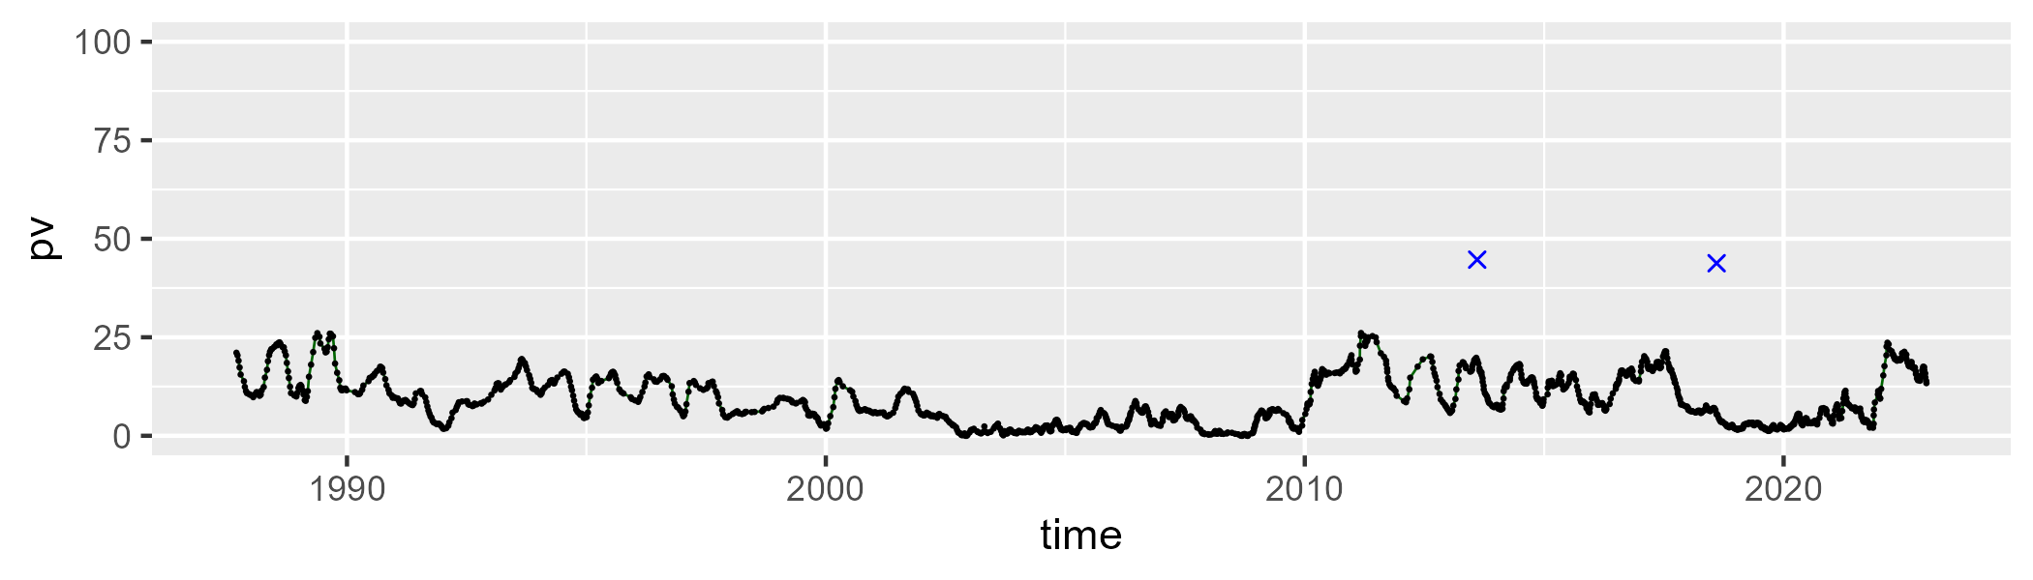

| Min. | 1st Qu. | Median | Mean | 3rd Qu. | Max. |
| --- | --- | --- | --- | --- | --- |
| 34.48508 | 47.60268 | 51.09197 | 50.48636 | 53.72818 | 62.74327 |

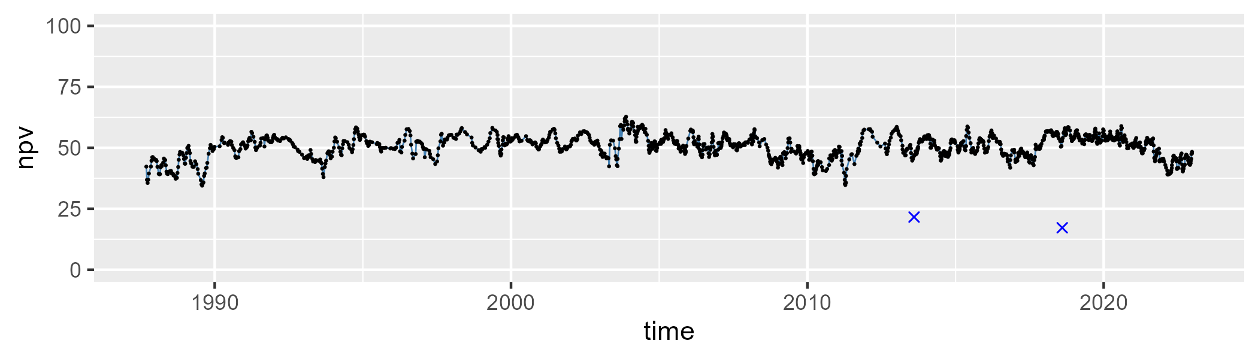

| Min. | 1st Qu. | Median | Mean | 3rd Qu. | Max. |
| --- | --- | --- | --- | --- | --- |
| 26.48062 | 35.90903 | 39.17756 | 39.30715 | 42.45289 | 55.49046 |

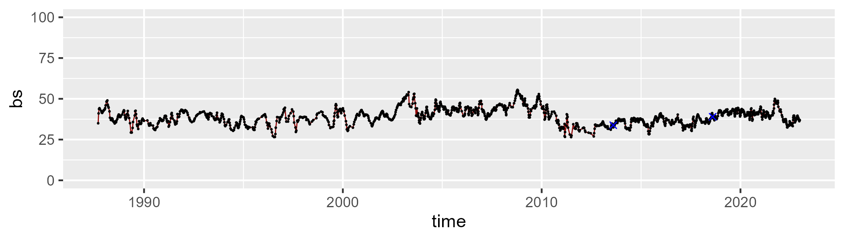

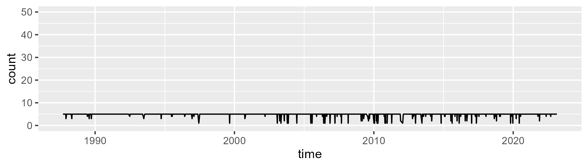

Min. :1.000 1st Qu.:5.000 Median :5.000 Mean :4.829 3rd Qu.:5.000 Max. :5.000

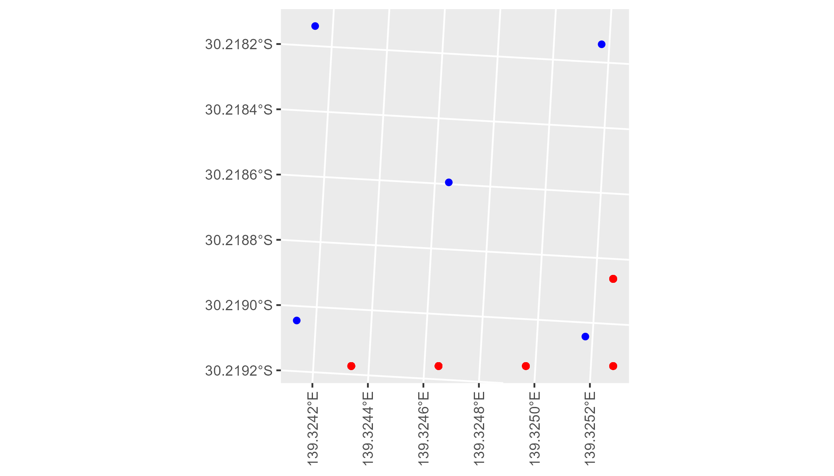

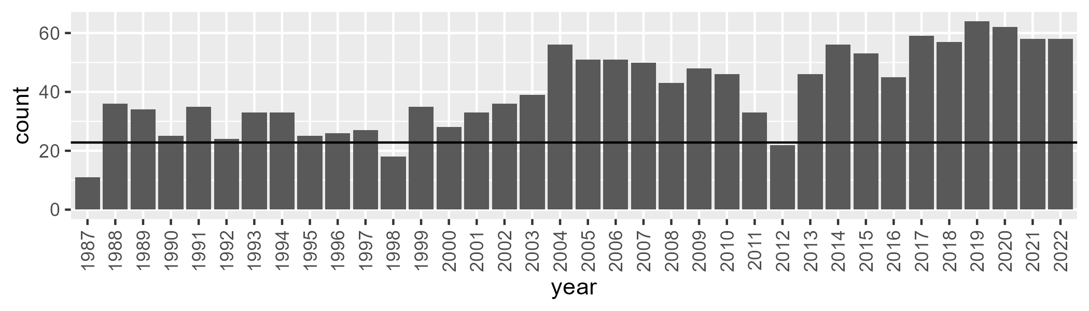

Number of samples: 1456

# SATFLB0019

| Min. | 1st Qu. | Median | Mean | 3rd Qu. | Max. |
| --- | --- | --- | --- | --- | --- |
| 1.089567 | 8.441562 | 12.47251 | 12.84603 | 16.73401 | 32.56541 |

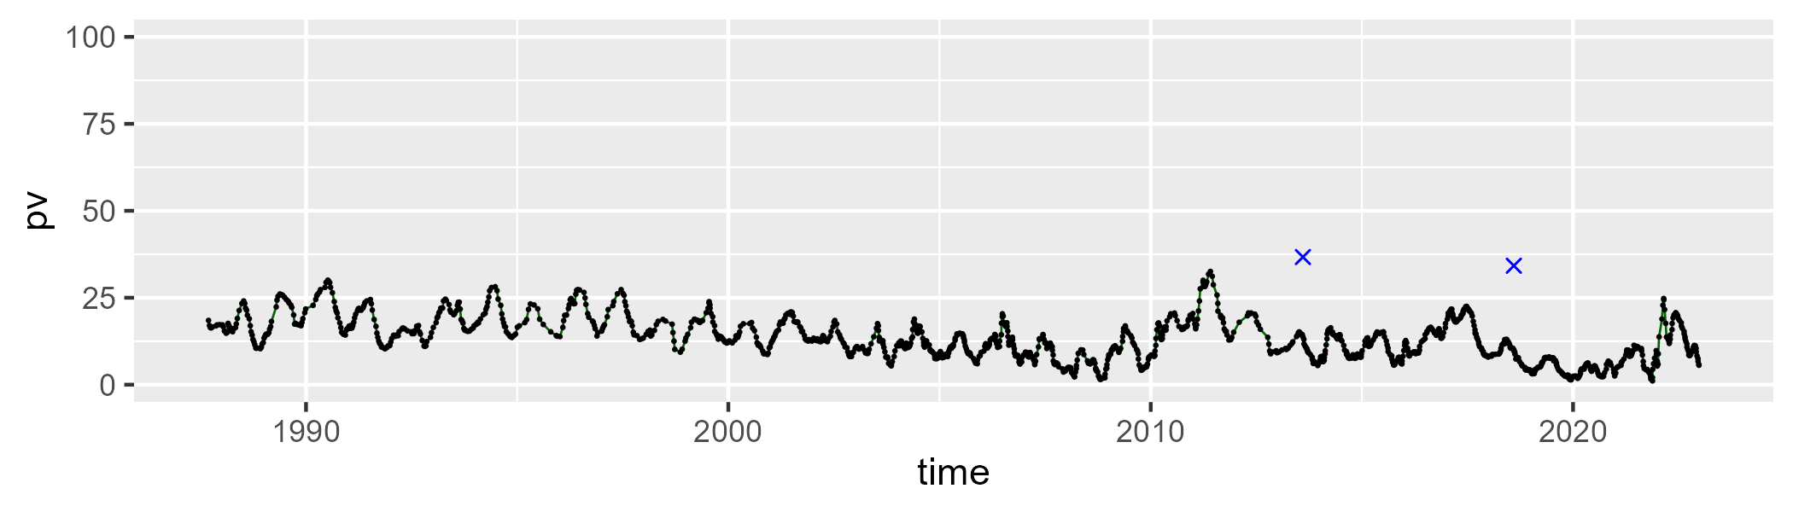

| Min. | 1st Qu. | Median | Mean | 3rd Qu. | Max. |
| --- | --- | --- | --- | --- | --- |
| 32.61822 | 42.90602 | 45.42637 | 45.023 | 47.57527 | 61.40814 |

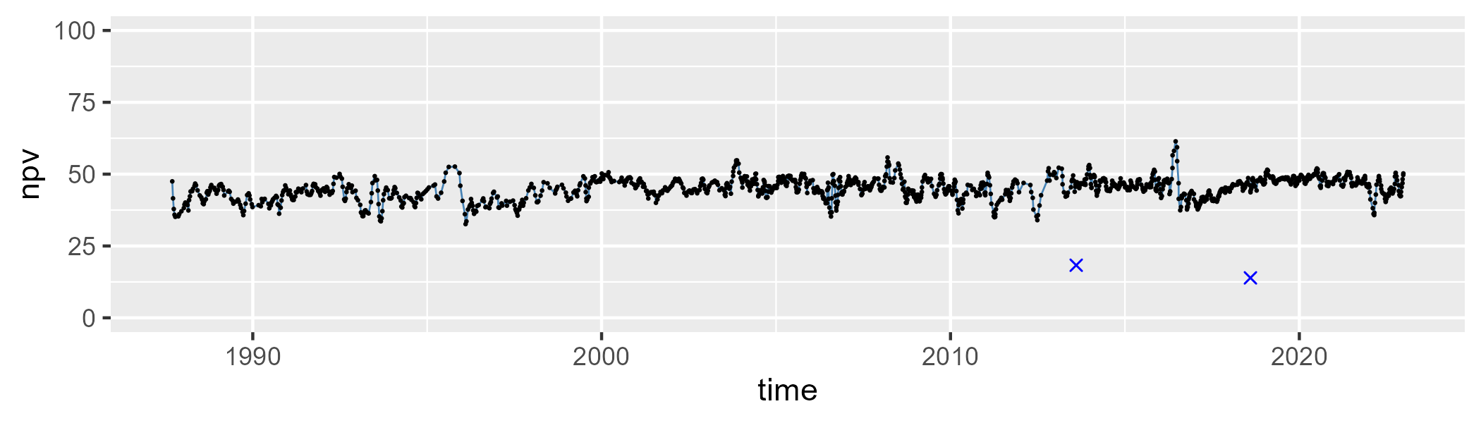

| Min. | 1st Qu. | Median | Mean | 3rd Qu. | Max. |
| --- | --- | --- | --- | --- | --- |
| 24.22048 | 37.97428 | 41.05267 | 40.70309 | 43.78268 | 55.04767 |

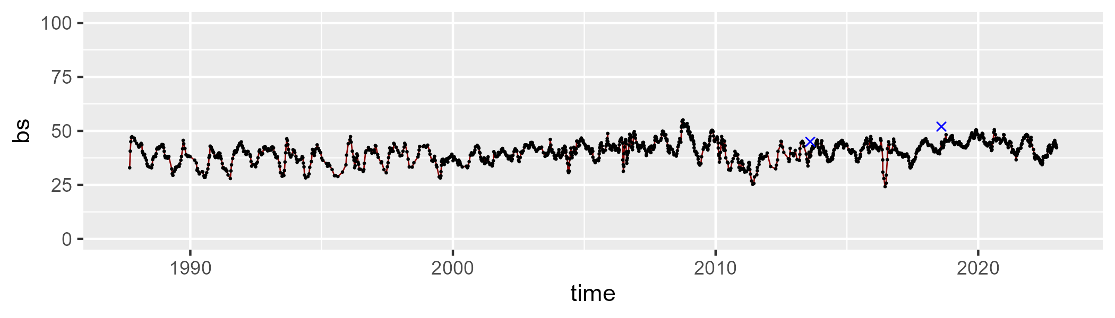

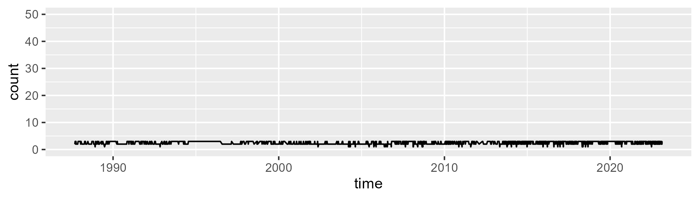

Min. :1.000 1st Qu.:2.000 Median :2.000 Mean :2.424 3rd Qu.:3.000 Max. :3.000

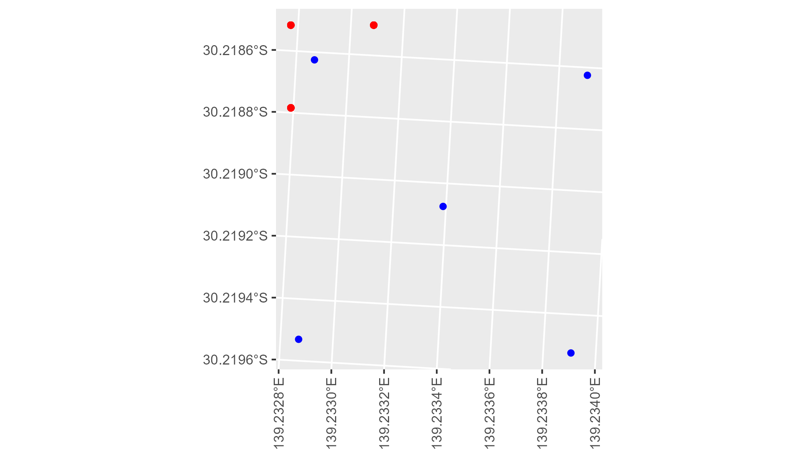

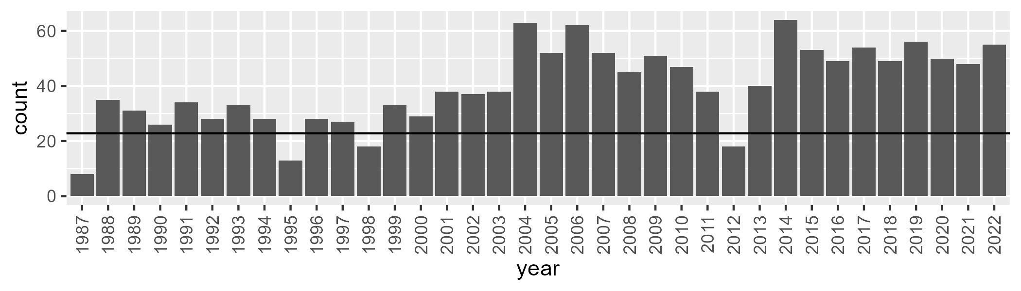

Number of samples: 1430

# SATFLB0020

| Min. | 1st Qu. | Median | Mean | 3rd Qu. | Max. |
| --- | --- | --- | --- | --- | --- |
| 4.124743 | 14.79625 | 18.97566 | 19.44107 | 23.46505 | 40.39314 |

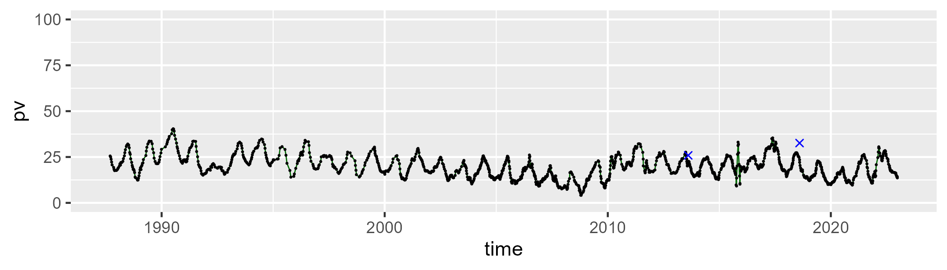

| Min. | 1st Qu. | Median | Mean | 3rd Qu. | Max. |
| --- | --- | --- | --- | --- | --- |
| 30.88286 | 44.56841 | 46.90403 | 46.65861 | 49.32666 | 62.76094 |

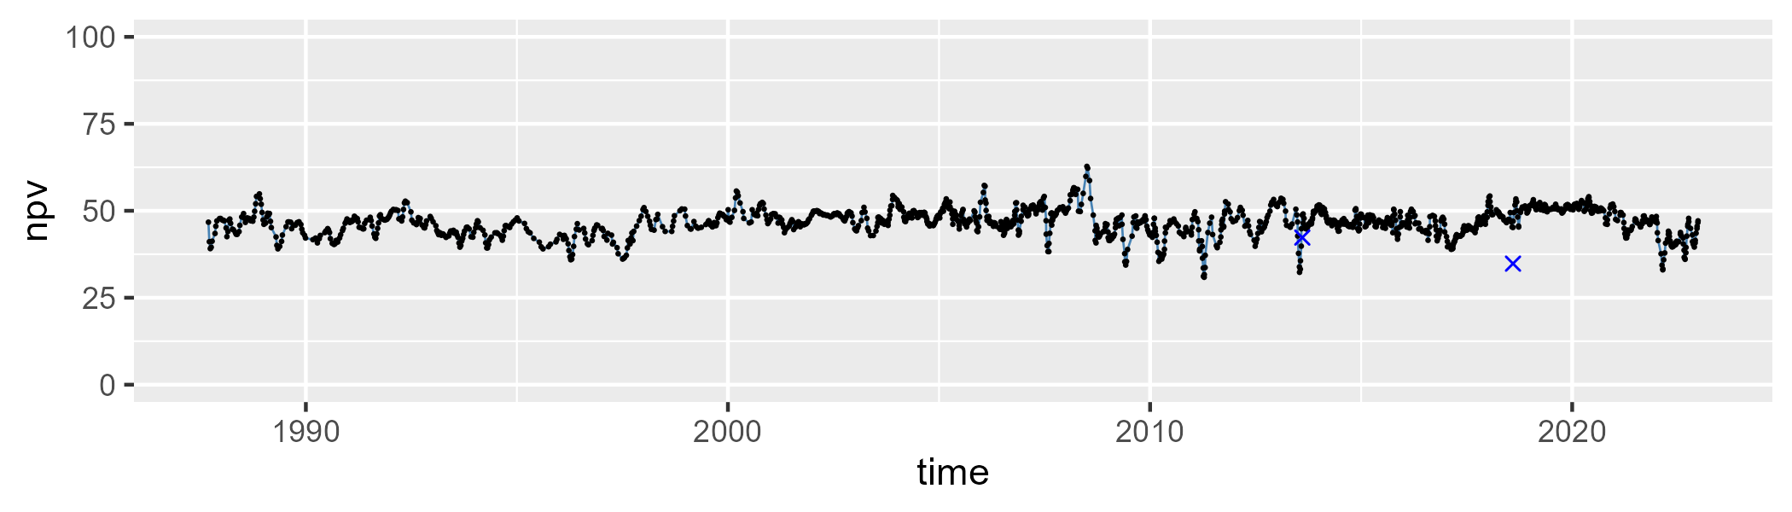

| Min. | 1st Qu. | Median | Mean | 3rd Qu. | Max. |
| --- | --- | --- | --- | --- | --- |
| 13.3922 | 29.33117 | 32.44801 | 32.53245 | 35.64059 | 51.92505 |

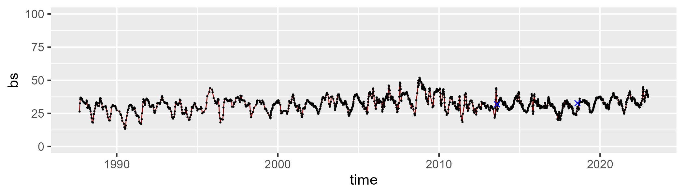

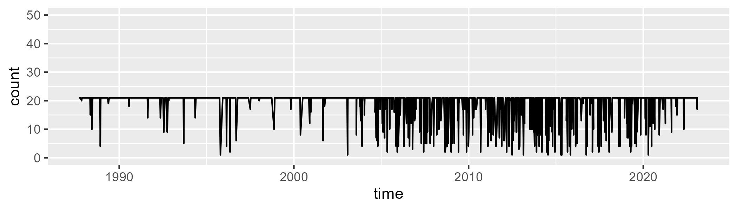

Min. : 1.00 1st Qu.:21.00 Median :21.00 Mean :19.17 3rd Qu.:21.00 Max. :21.00

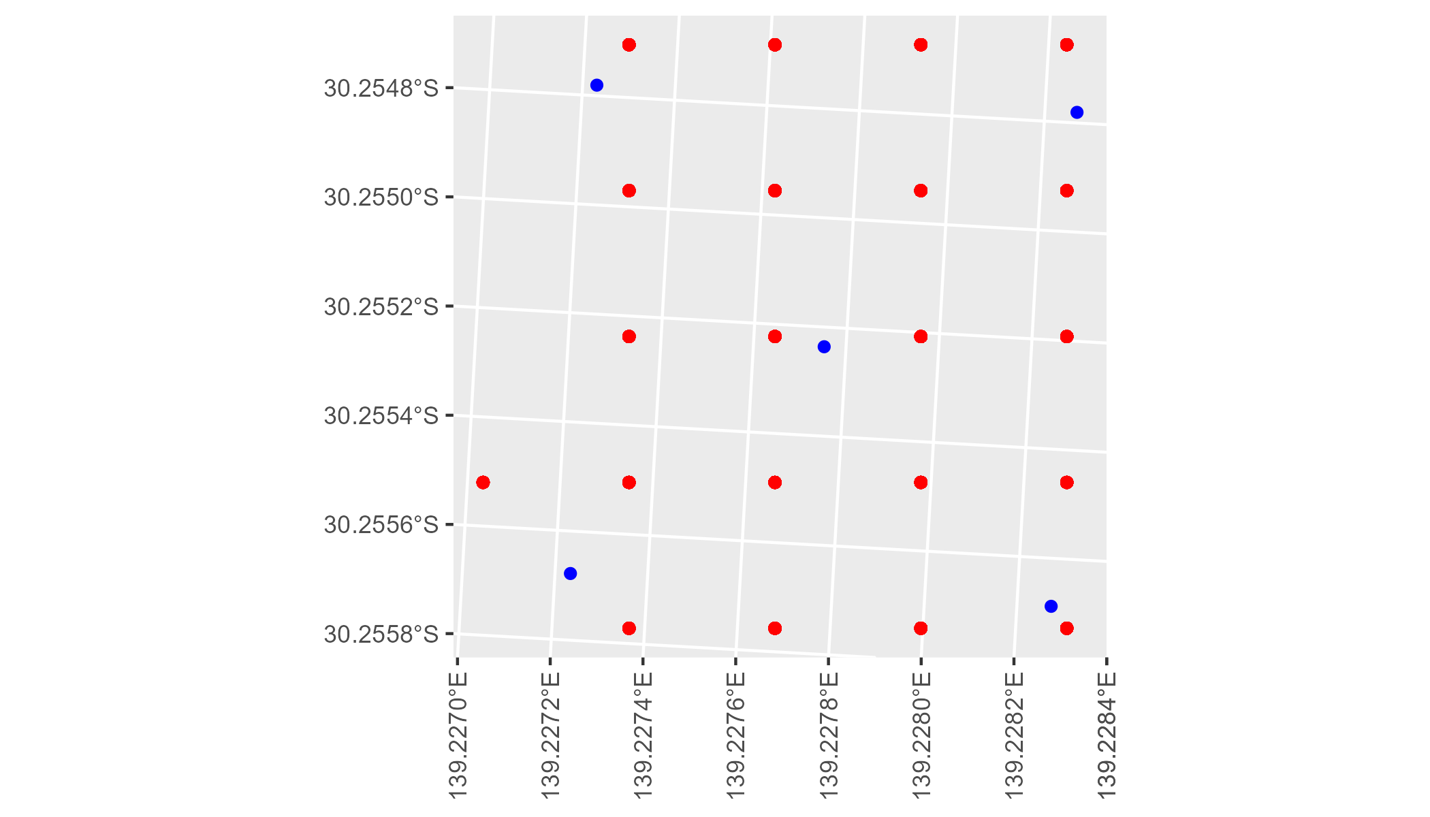

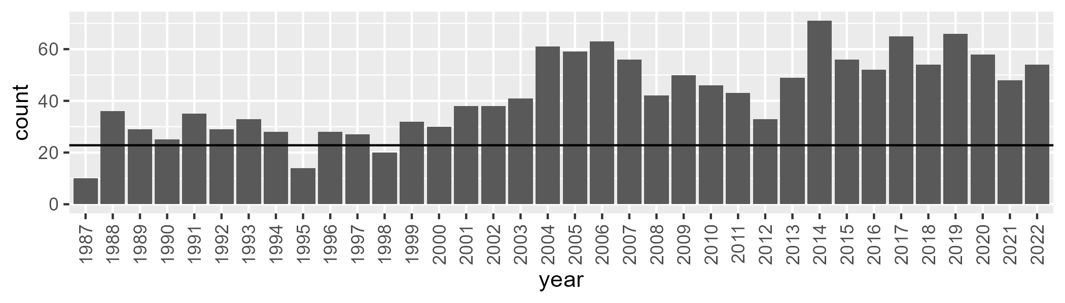

Number of samples: 1519

# SATFLB0021

| Min. | 1st Qu. | Median | Mean | 3rd Qu. | Max. |
| --- | --- | --- | --- | --- | --- |
| 1.66402 | 12.24236 | 17.62188 | 17.39648 | 22.34855 | 37.44241 |

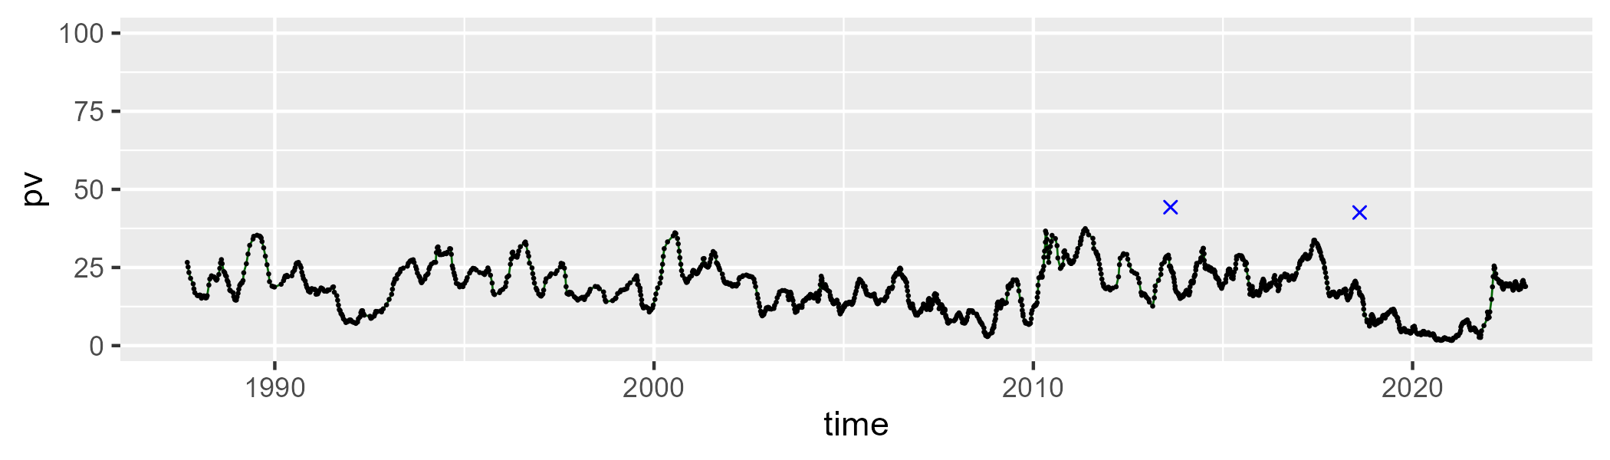

| Min. | 1st Qu. | Median | Mean | 3rd Qu. | Max. |
| --- | --- | --- | --- | --- | --- |
| 36.49722 | 53.06421 | 56.76156 | 56.39489 | 59.99224 | 70.62851 |

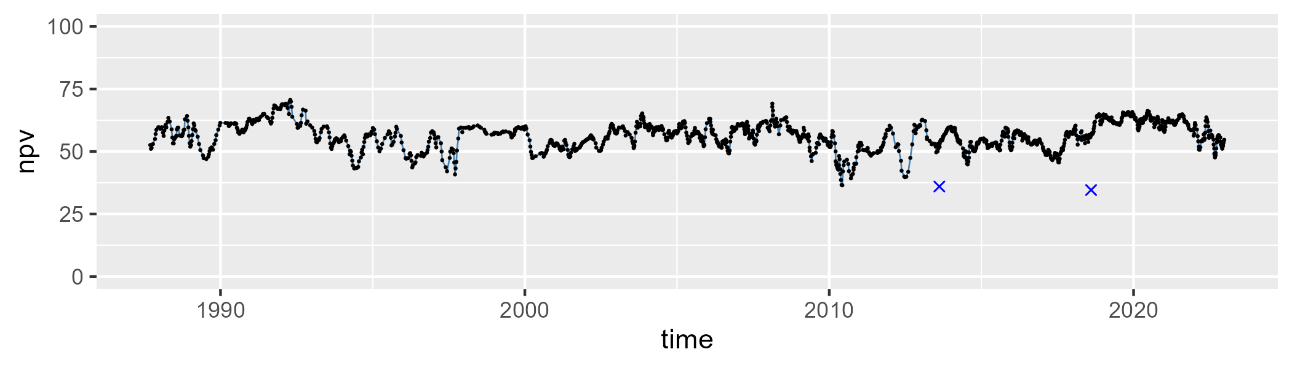

| Min. | 1st Qu. | Median | Mean | 3rd Qu. | Max. |
| --- | --- | --- | --- | --- | --- |
| 11.92247 | 21.94931 | 24.31824 | 24.92404 | 27.94238 | 41.02897 |

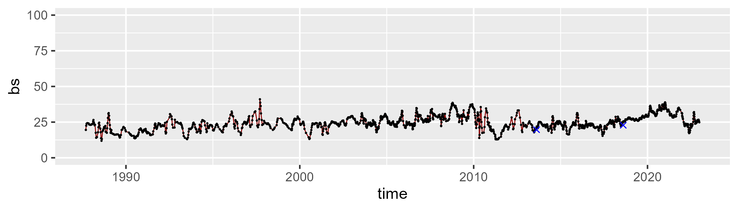

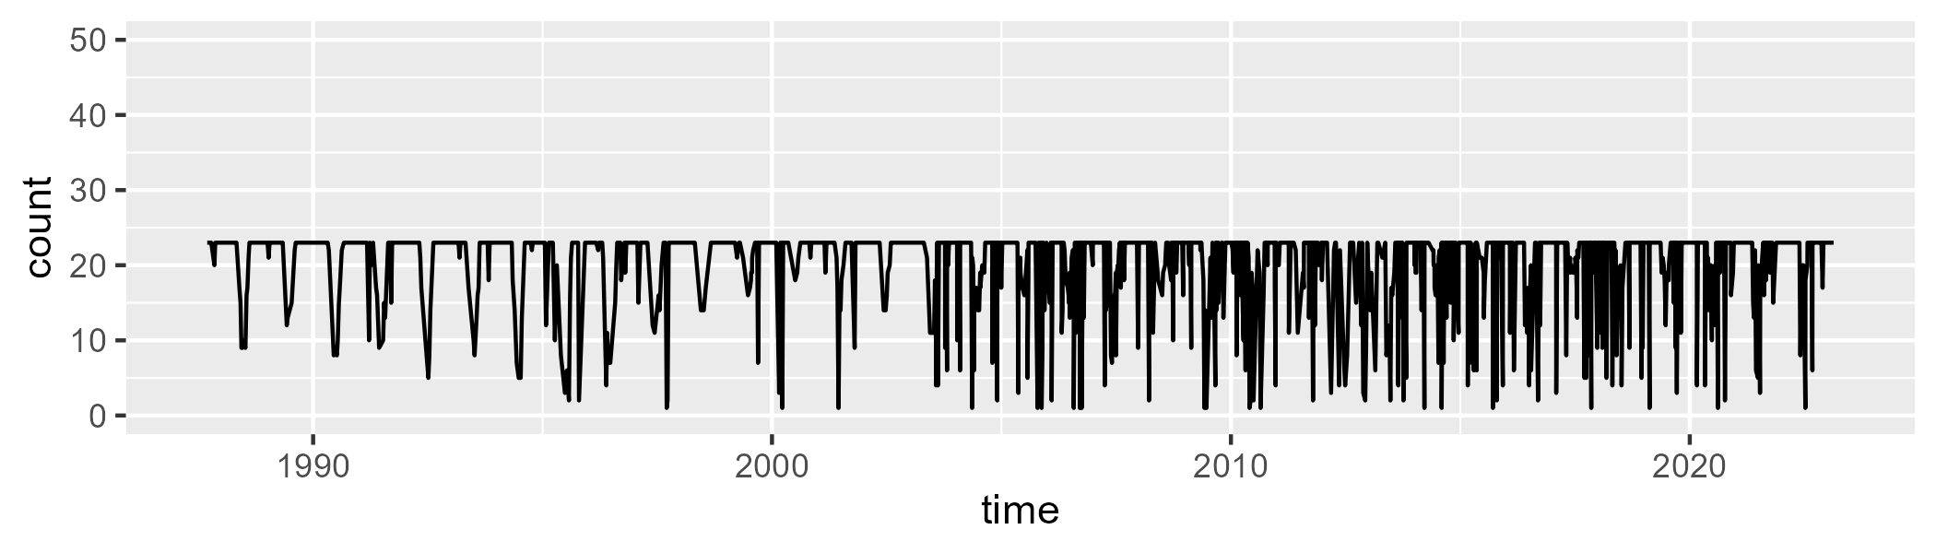

Min. : 1.00 1st Qu.:20.00 Median :23.00 Mean :20.25 3rd Qu.:23.00 Max. :23.00

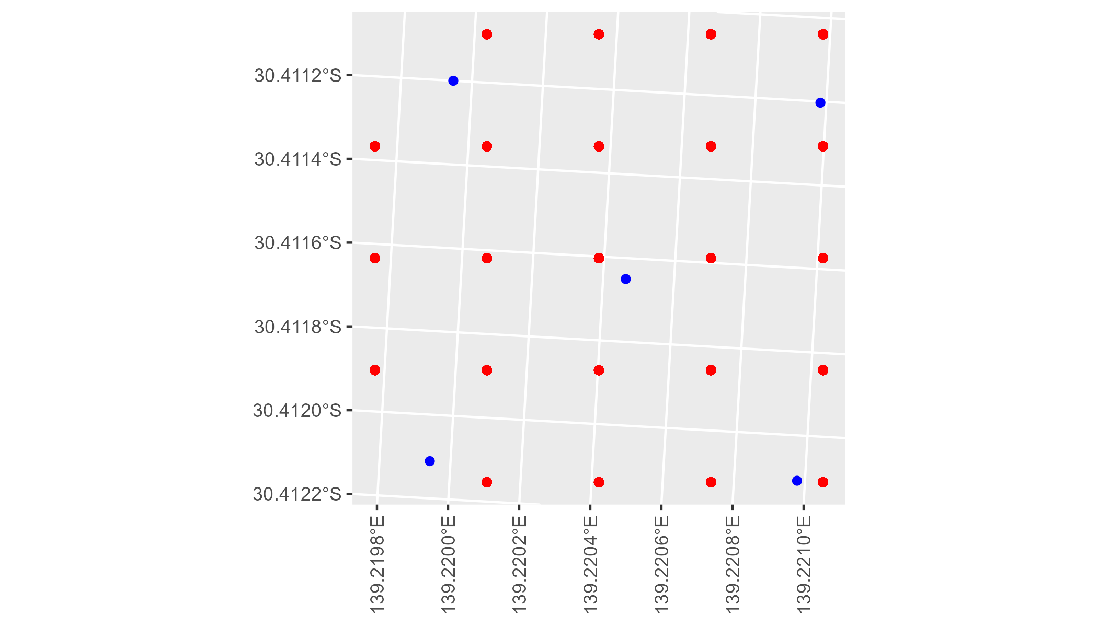

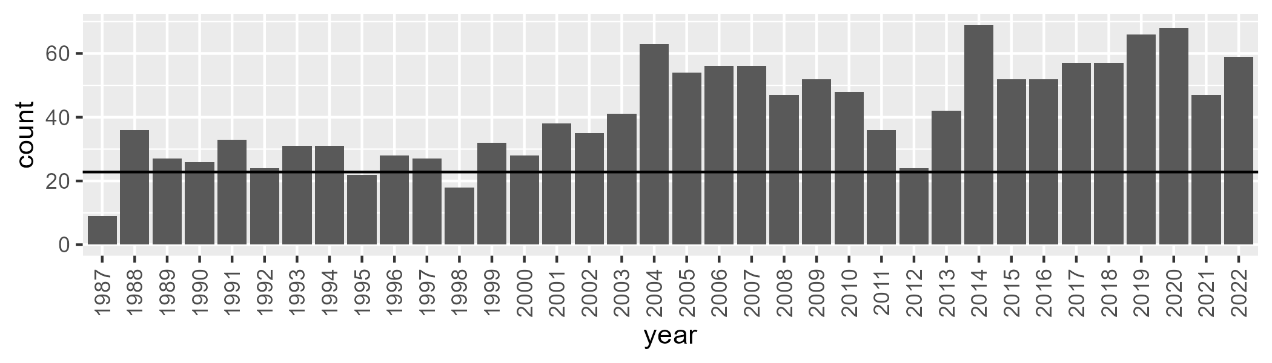

Number of samples: 1491

# SATFLB0022

| Min. | 1st Qu. | Median | Mean | 3rd Qu. | Max. |
| --- | --- | --- | --- | --- | --- |
| 4.284485 | 17.52105 | 21.78895 | 21.89691 | 26.7157 | 40.85267 |

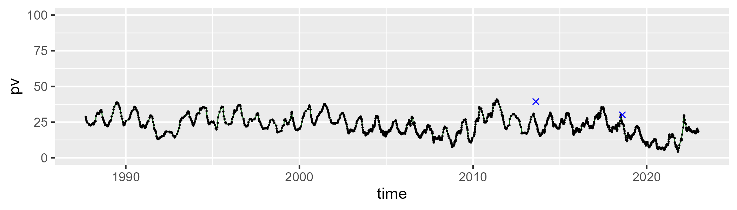

| Min. | 1st Qu. | Median | Mean | 3rd Qu. | Max. |
| --- | --- | --- | --- | --- | --- |
| 34.92788 | 49.06247 | 51.97446 | 51.76762 | 54.56576 | 63.348 |

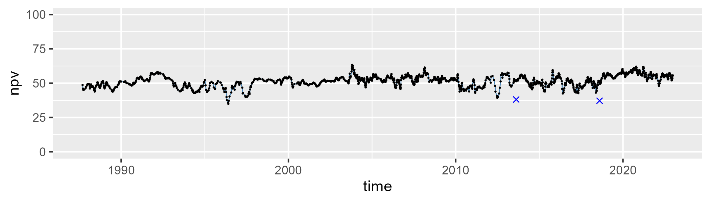

| Min. | 1st Qu. | Median | Mean | 3rd Qu. | Max. |
| --- | --- | --- | --- | --- | --- |
| 10.3027 | 22.30417 | 25.17611 | 25.03103 | 27.88996 | 38.81132 |

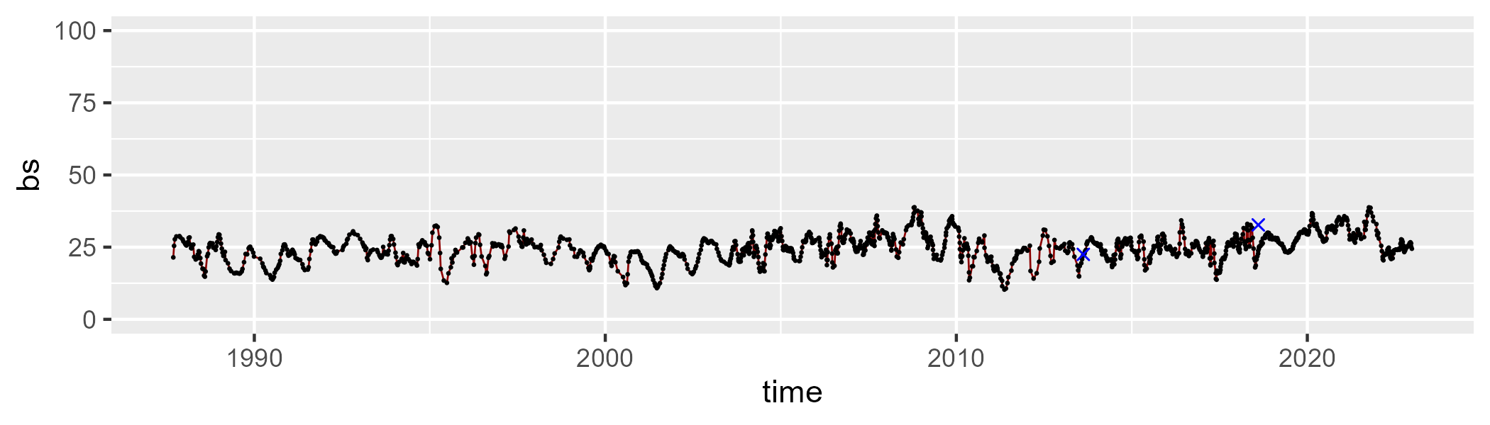

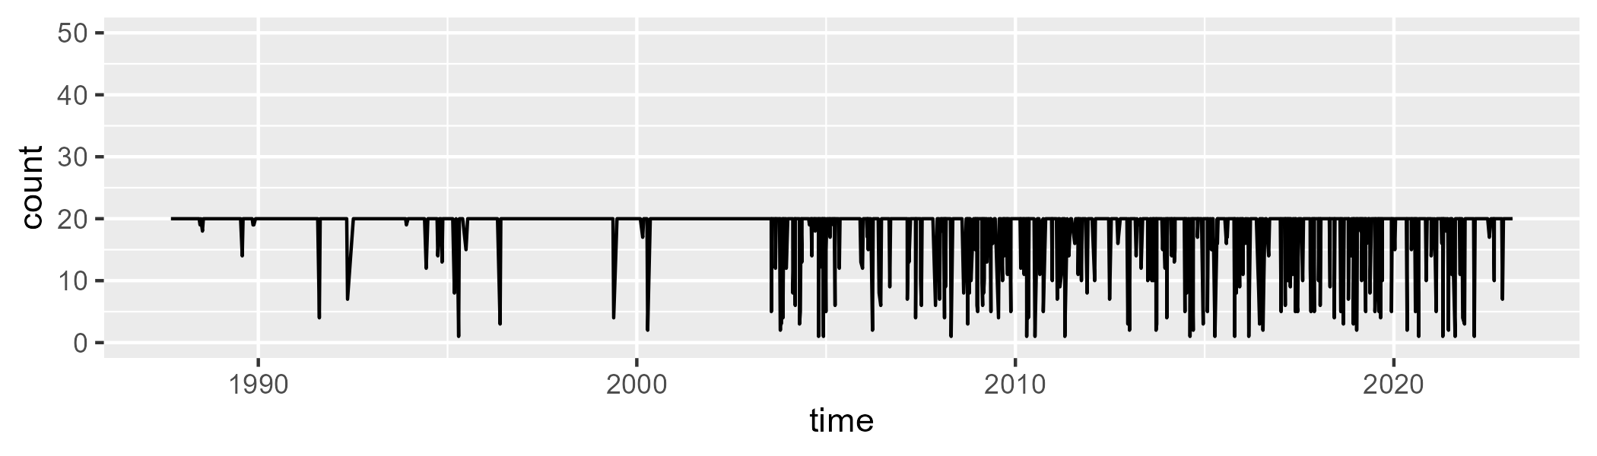

Min. : 1.00 1st Qu.:20.00 Median :20.00 Mean :18.46 3rd Qu.:20.00 Max. :20.00

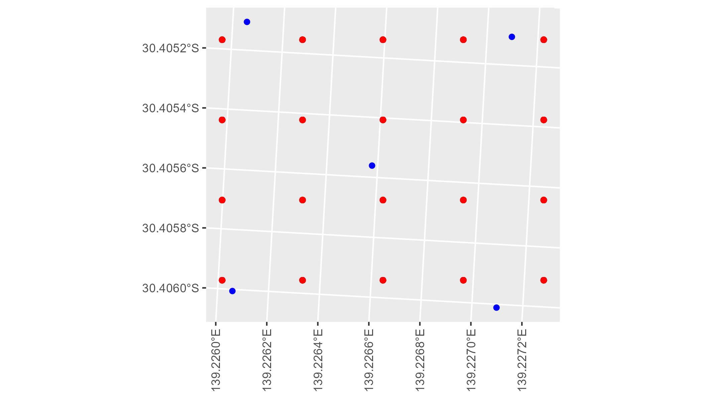

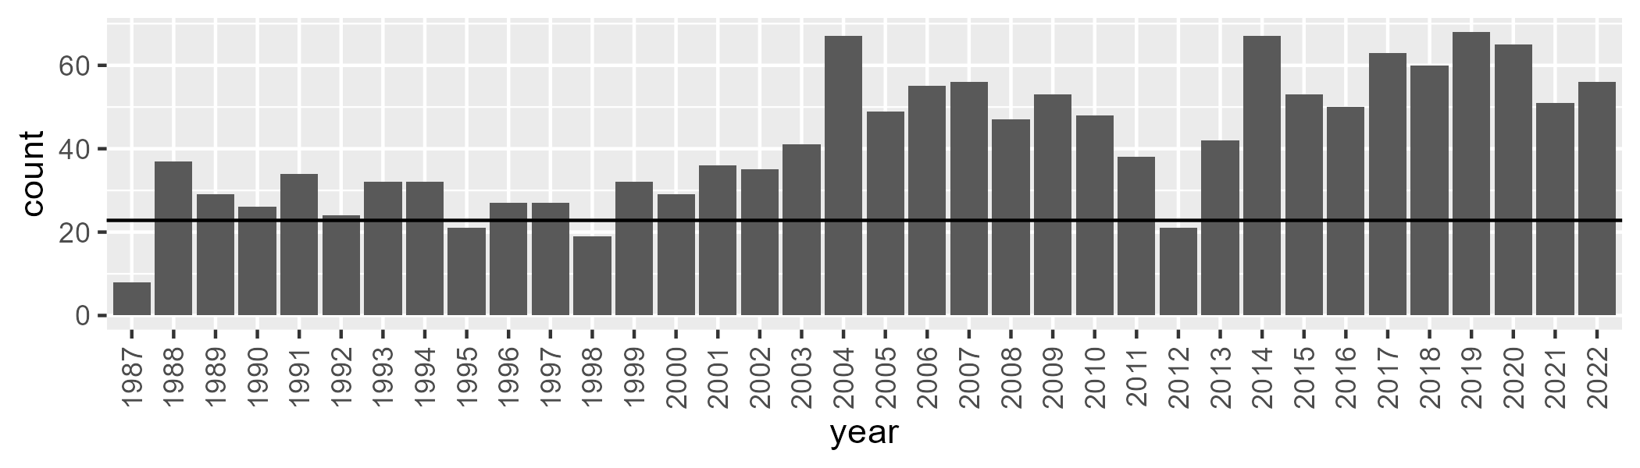

Number of samples: 1498

# SATFLB0023

| Min. | 1st Qu. | Median | Mean | 3rd Qu. | Max. |
| --- | --- | --- | --- | --- | --- |
| 0 | 2.544396 | 5.314509 | 7.651949 | 11.62883 | 54.64565 |

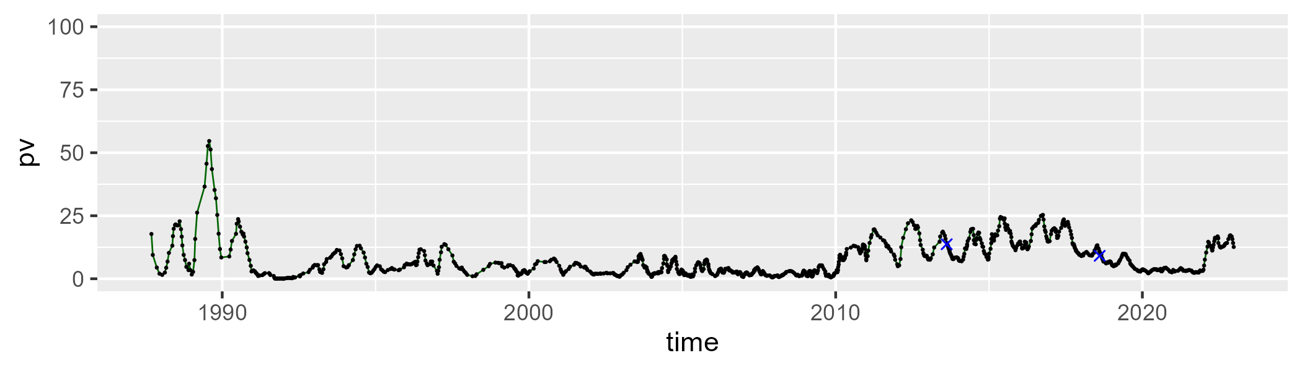

| Min. | 1st Qu. | Median | Mean | 3rd Qu. | Max. |
| --- | --- | --- | --- | --- | --- |
| 24.36086 | 37.69301 | 41.54775 | 41.77391 | 45.16981 | 73.67274 |

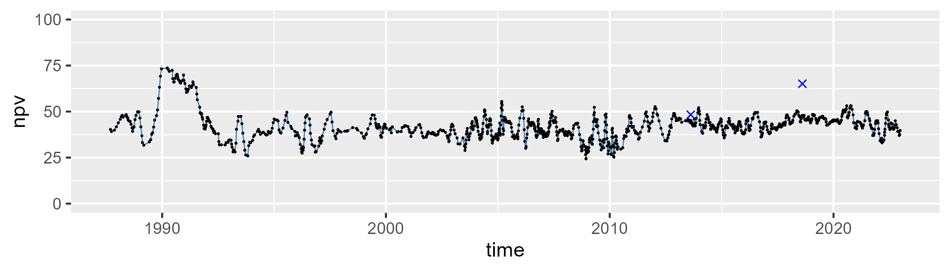

| Min. | 1st Qu. | Median | Mean | 3rd Qu. | Max. |
| --- | --- | --- | --- | --- | --- |
| 5.754592 | 42.68212 | 50.46951 | 49.21241 | 56.98189 | 71.92959 |

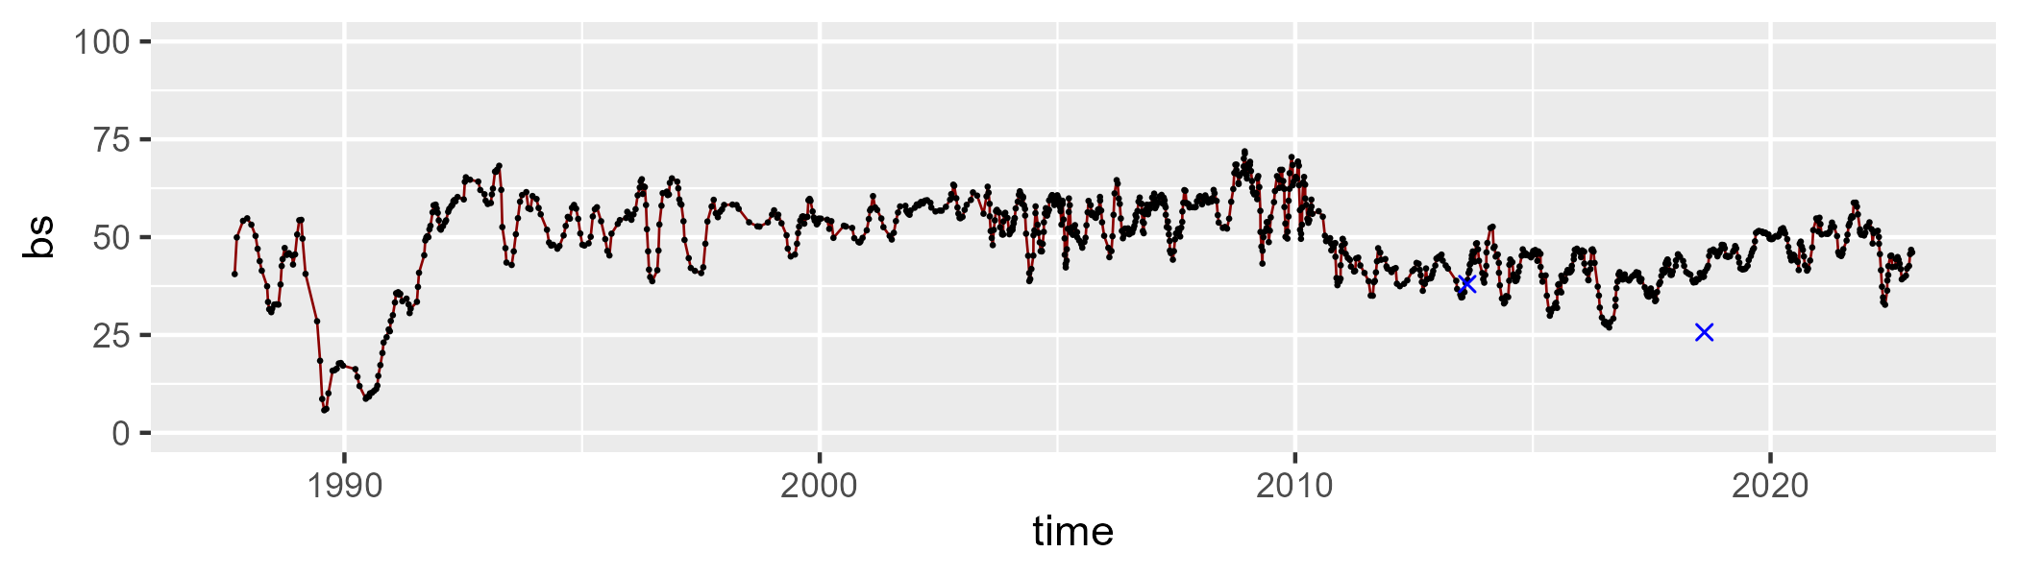

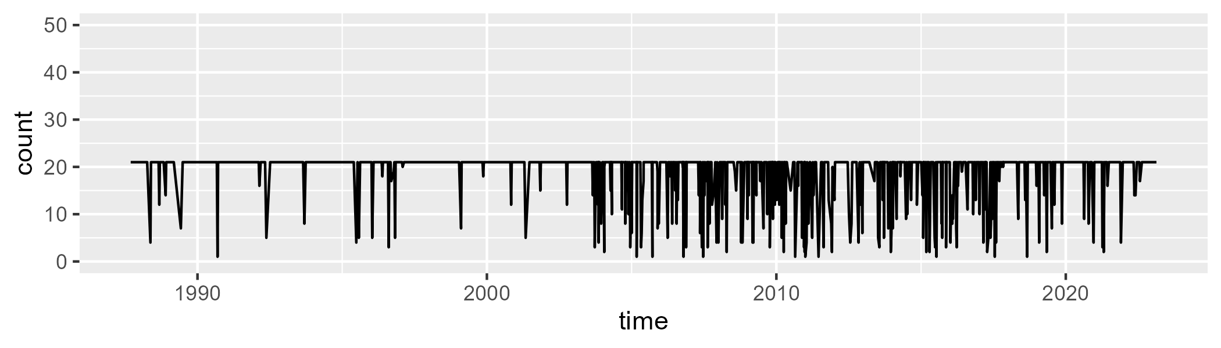

Min. : 1.00 1st Qu.:21.00 Median :21.00 Mean :18.89 3rd Qu.:21.00 Max. :21.00

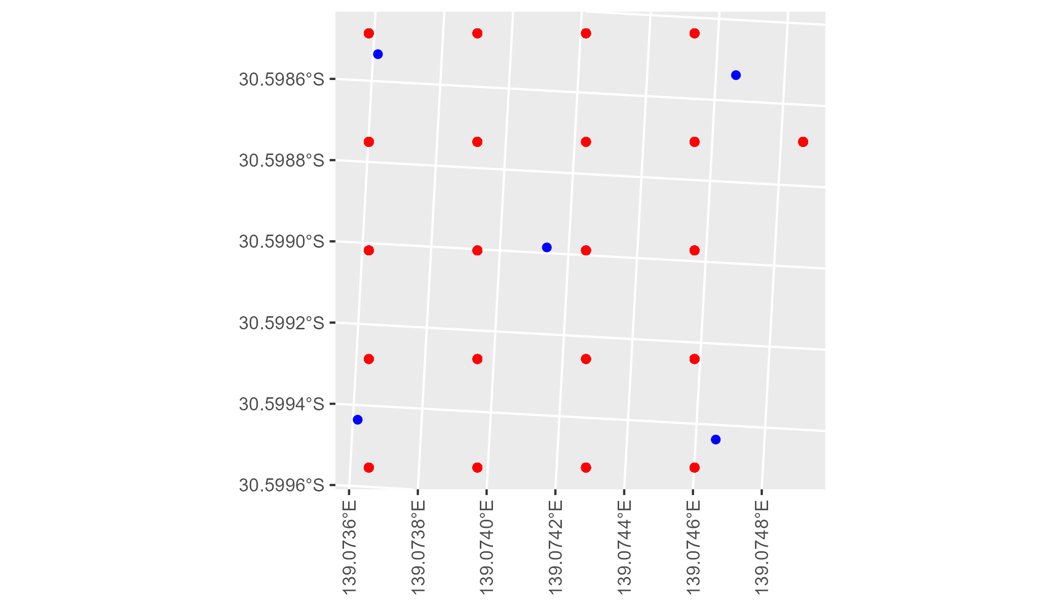

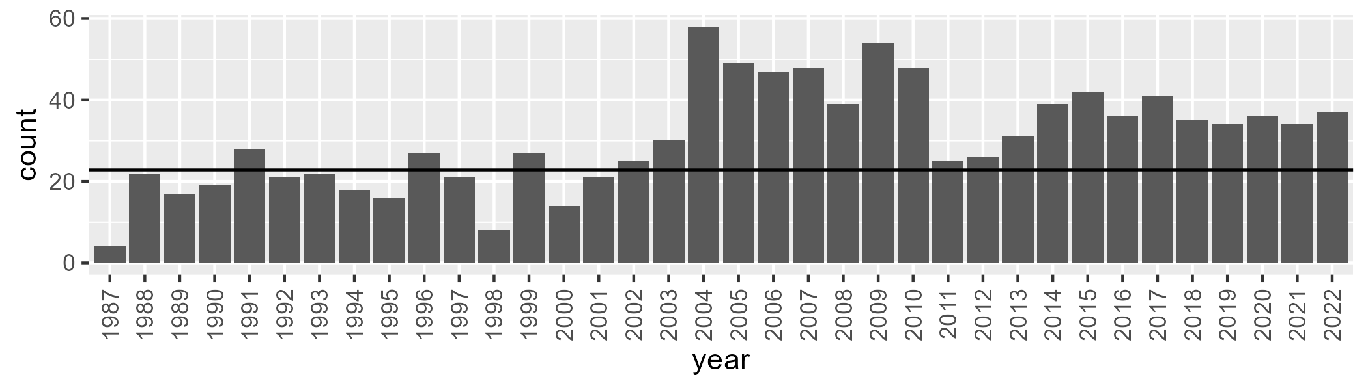

Number of samples: 1099

# SATFLB0024

| Min. | 1st Qu. | Median | Mean | 3rd Qu. | Max. |
| --- | --- | --- | --- | --- | --- |
| 3.022634 | 6.959668 | 8.897414 | 9.806538 | 11.86154 | 25.24586 |

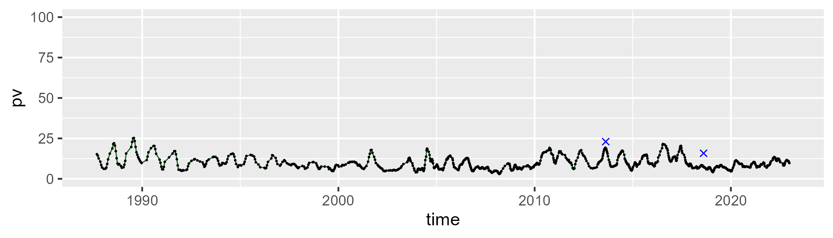

| Min. | 1st Qu. | Median | Mean | 3rd Qu. | Max. |
| --- | --- | --- | --- | --- | --- |
| 19.56958 | 29.87463 | 32.64219 | 32.71944 | 35.51107 | 49.72399 |

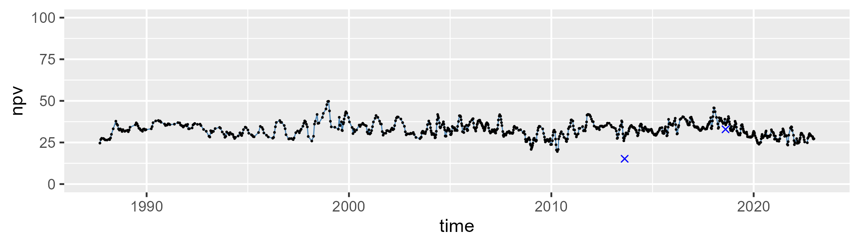

| Min. | 1st Qu. | Median | Mean | 3rd Qu. | Max. |
| --- | --- | --- | --- | --- | --- |
| 36.77589 | 52.10647 | 56.64372 | 55.91841 | 59.99795 | 68.8664 |

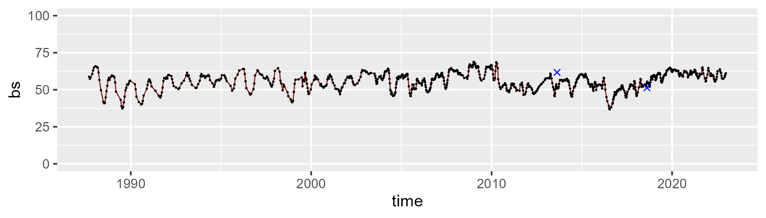

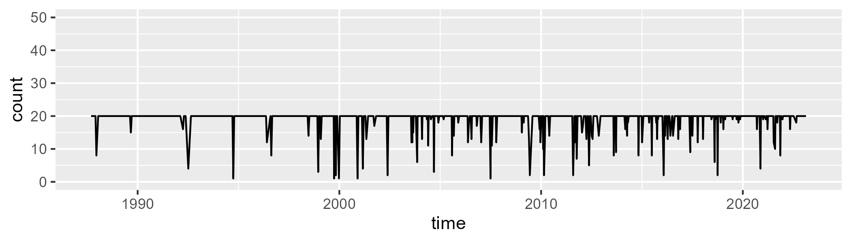

Min. : 1.00 1st Qu.:20.00 Median :20.00 Mean :19.02 3rd Qu.:20.00 Max. :20.00

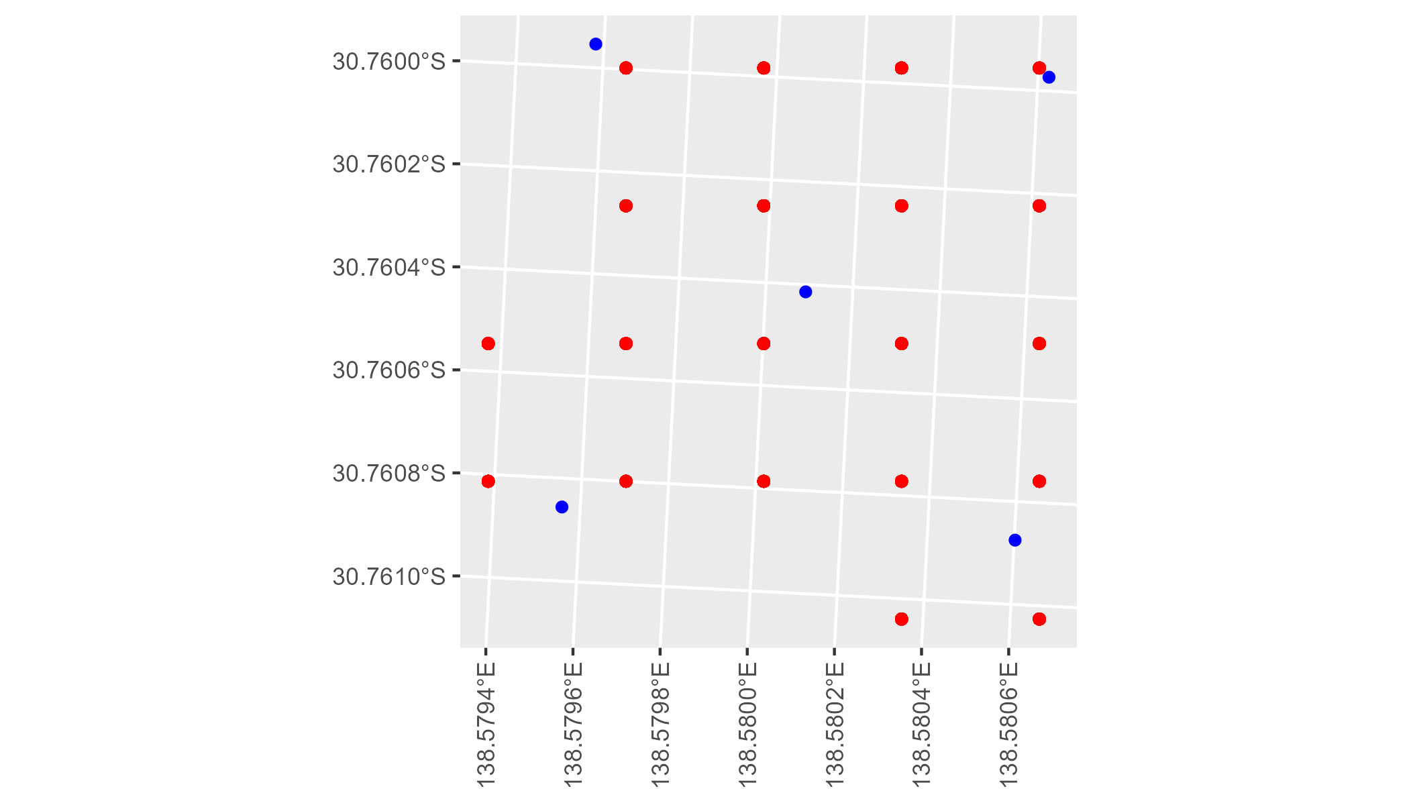

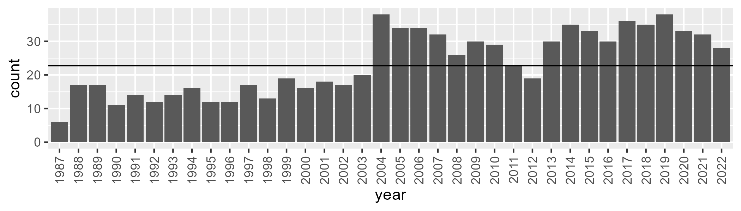

Number of samples: 846

# SATFLB0025

| Min. | 1st Qu. | Median | Mean | 3rd Qu. | Max. |
| --- | --- | --- | --- | --- | --- |
| 7.541716 | 13.77553 | 16.12168 | 16.58425 | 19.216 | 29.56798 |

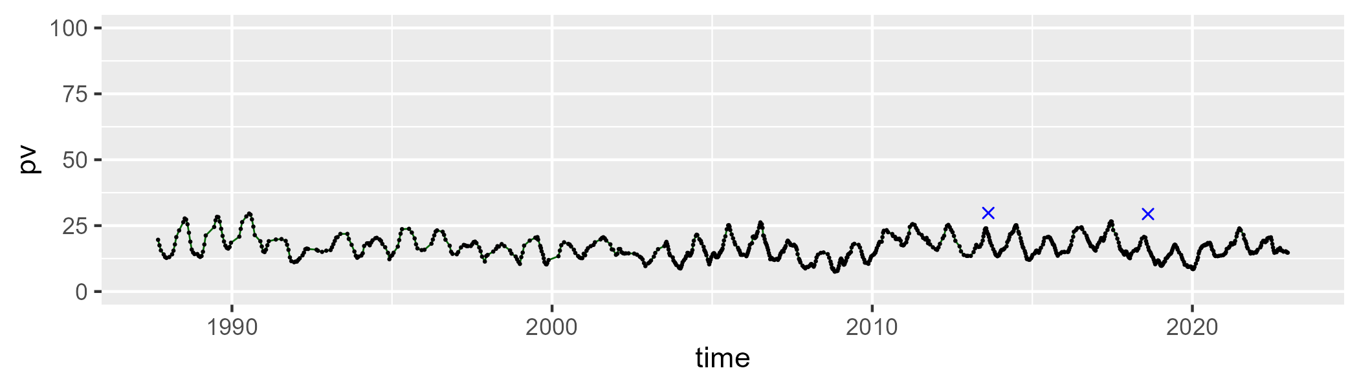

| Min. | 1st Qu. | Median | Mean | 3rd Qu. | Max. |
| --- | --- | --- | --- | --- | --- |
| 29.30688 | 39.40042 | 41.30272 | 41.33268 | 43.58047 | 49.65928 |

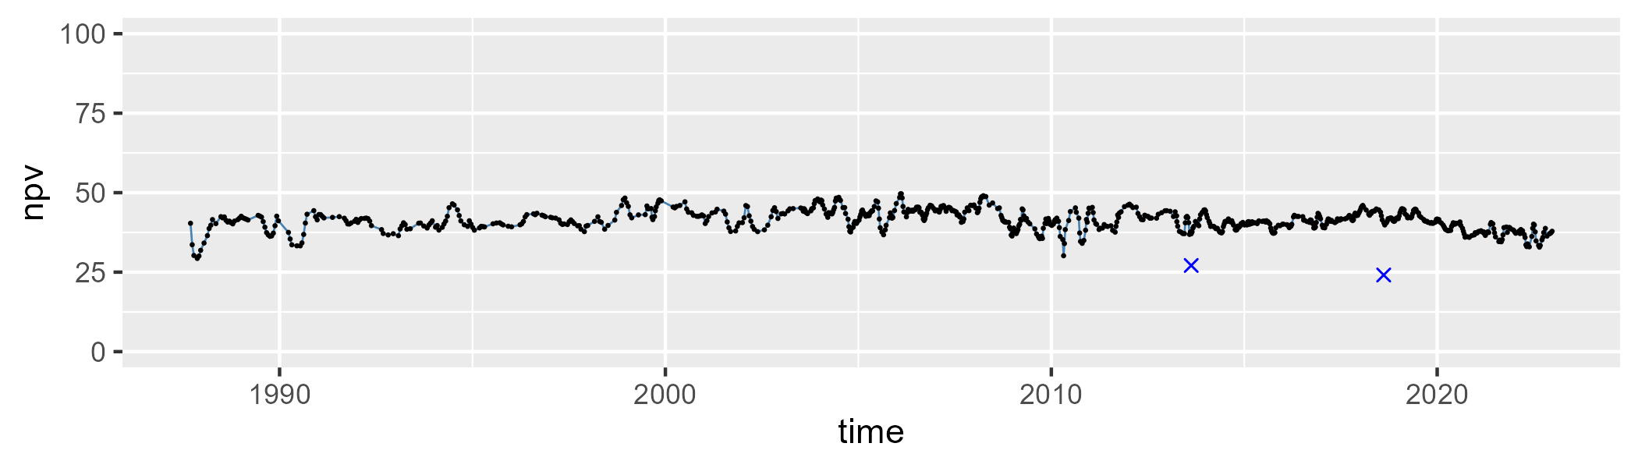

| Min. | 1st Qu. | Median | Mean | 3rd Qu. | Max. |
| --- | --- | --- | --- | --- | --- |
| 26.56646 | 37.41879 | 40.92453 | 40.60825 | 43.67303 | 55.49215 |

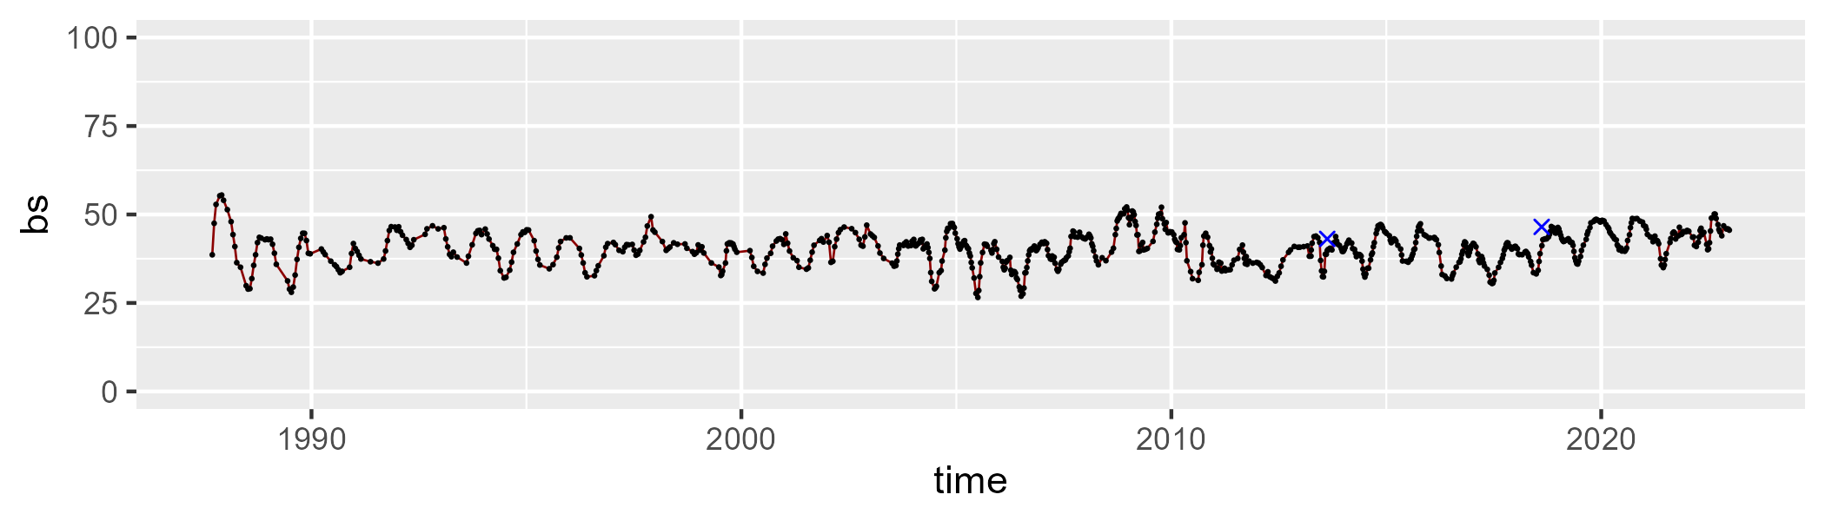

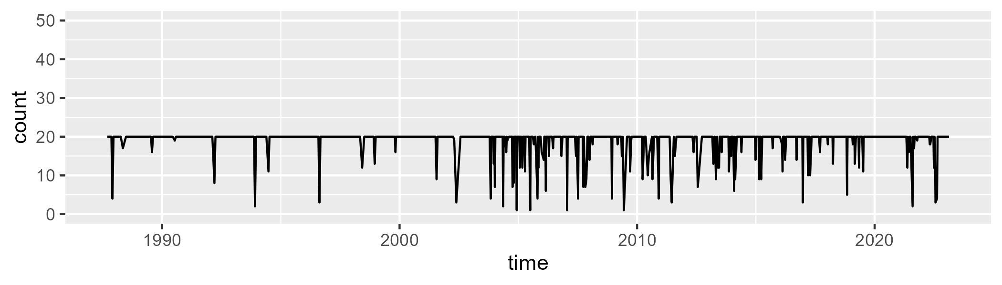

Min. : 1.00 1st Qu.:20.00 Median :20.00 Mean :18.91 3rd Qu.:20.00 Max. :20.00

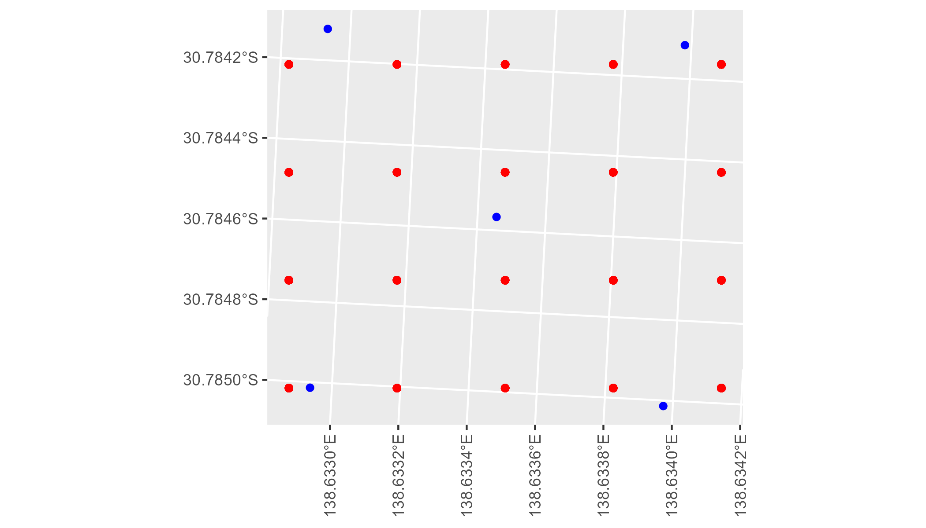

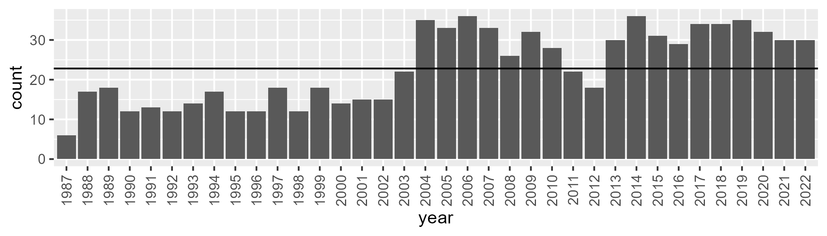

Number of samples: 831

# SATFLB0026

| Min. | 1st Qu. | Median | Mean | 3rd Qu. | Max. |
| --- | --- | --- | --- | --- | --- |
| 42.00316 | 50.37009 | 52.30136 | 52.53484 | 54.9255 | 63.33155 |

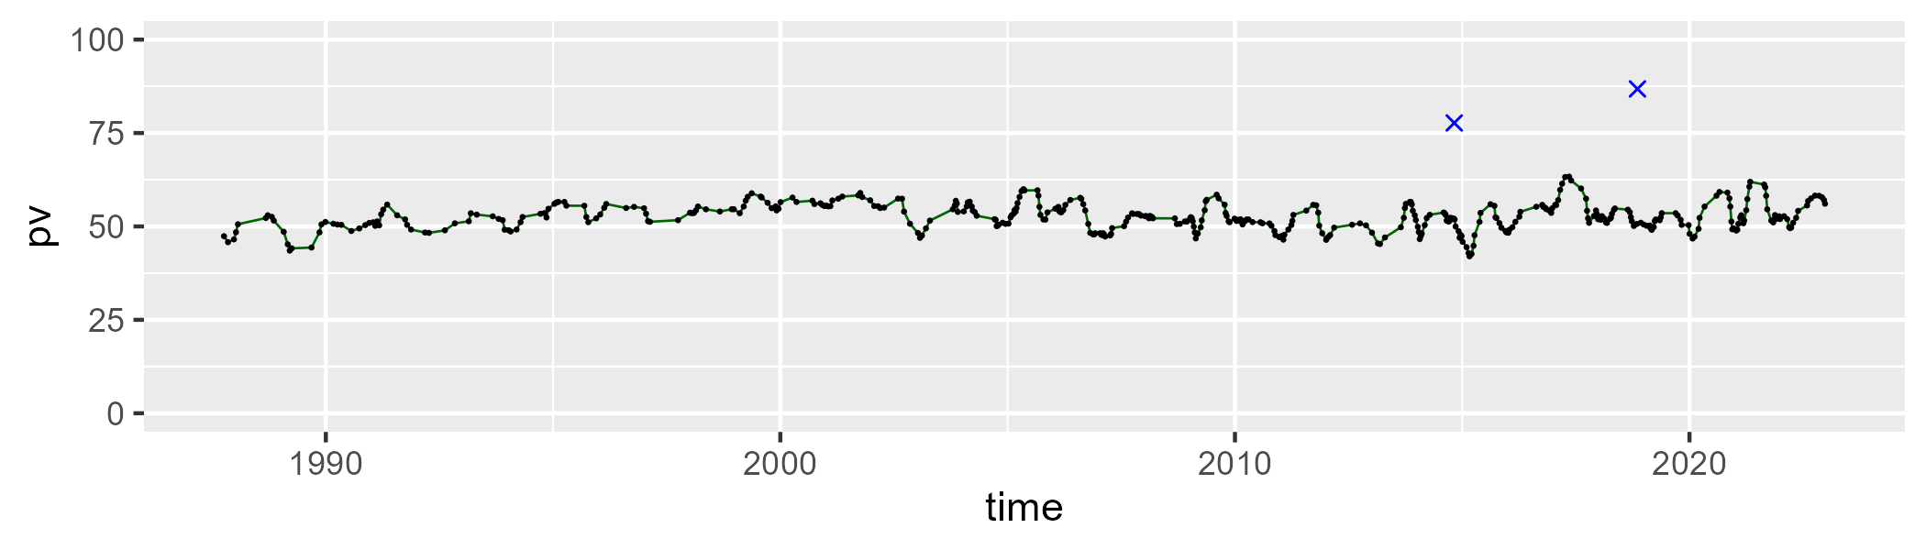

| Min. | 1st Qu. | Median | Mean | 3rd Qu. | Max. |
| --- | --- | --- | --- | --- | --- |
| 23.37877 | 37.31382 | 41.02735 | 40.10994 | 43.3236 | 51.8609 |

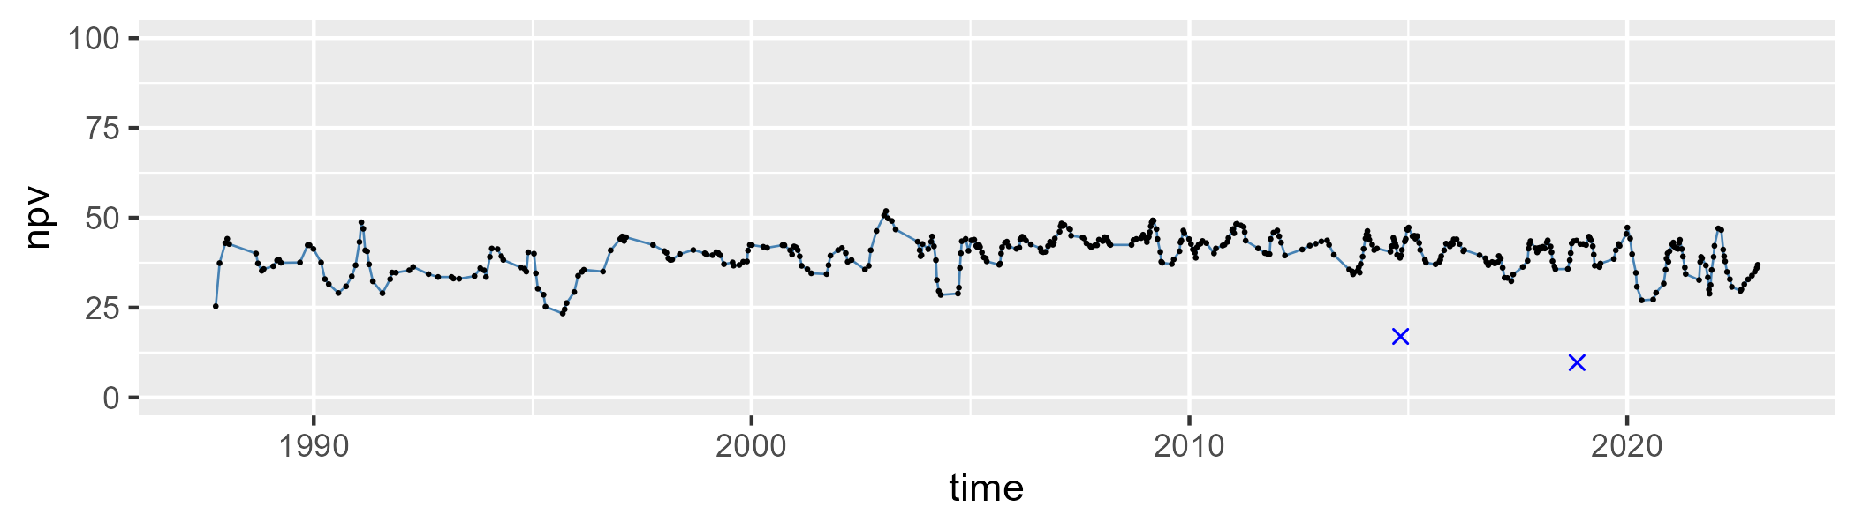

| Min. | 1st Qu. | Median | Mean | 3rd Qu. | Max. |
| --- | --- | --- | --- | --- | --- |
| 0 | 3.091965 | 5.025536 | 6.043861 | 7.704854 | 25.10664 |

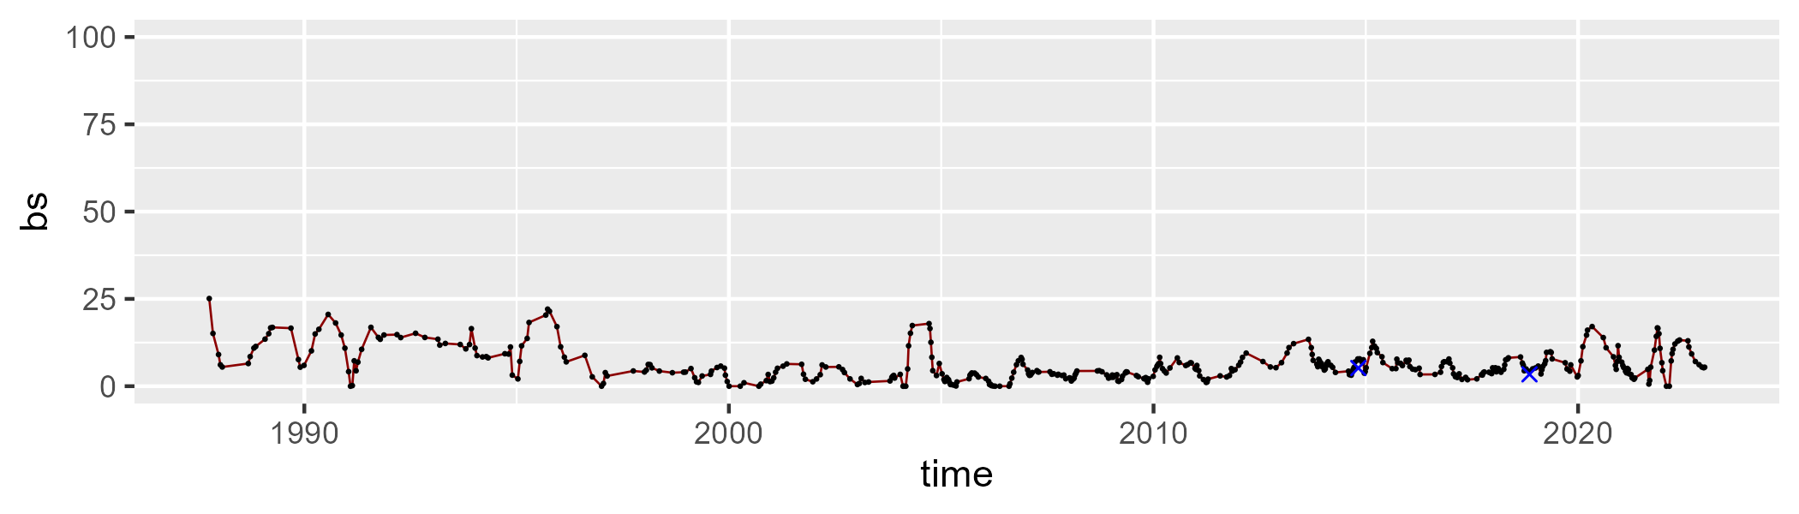

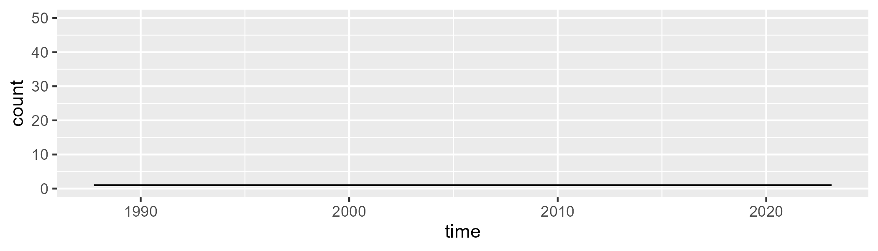

Min. :1 1st Qu.:1 Median :1 Mean :1 3rd Qu.:1 Max. :1

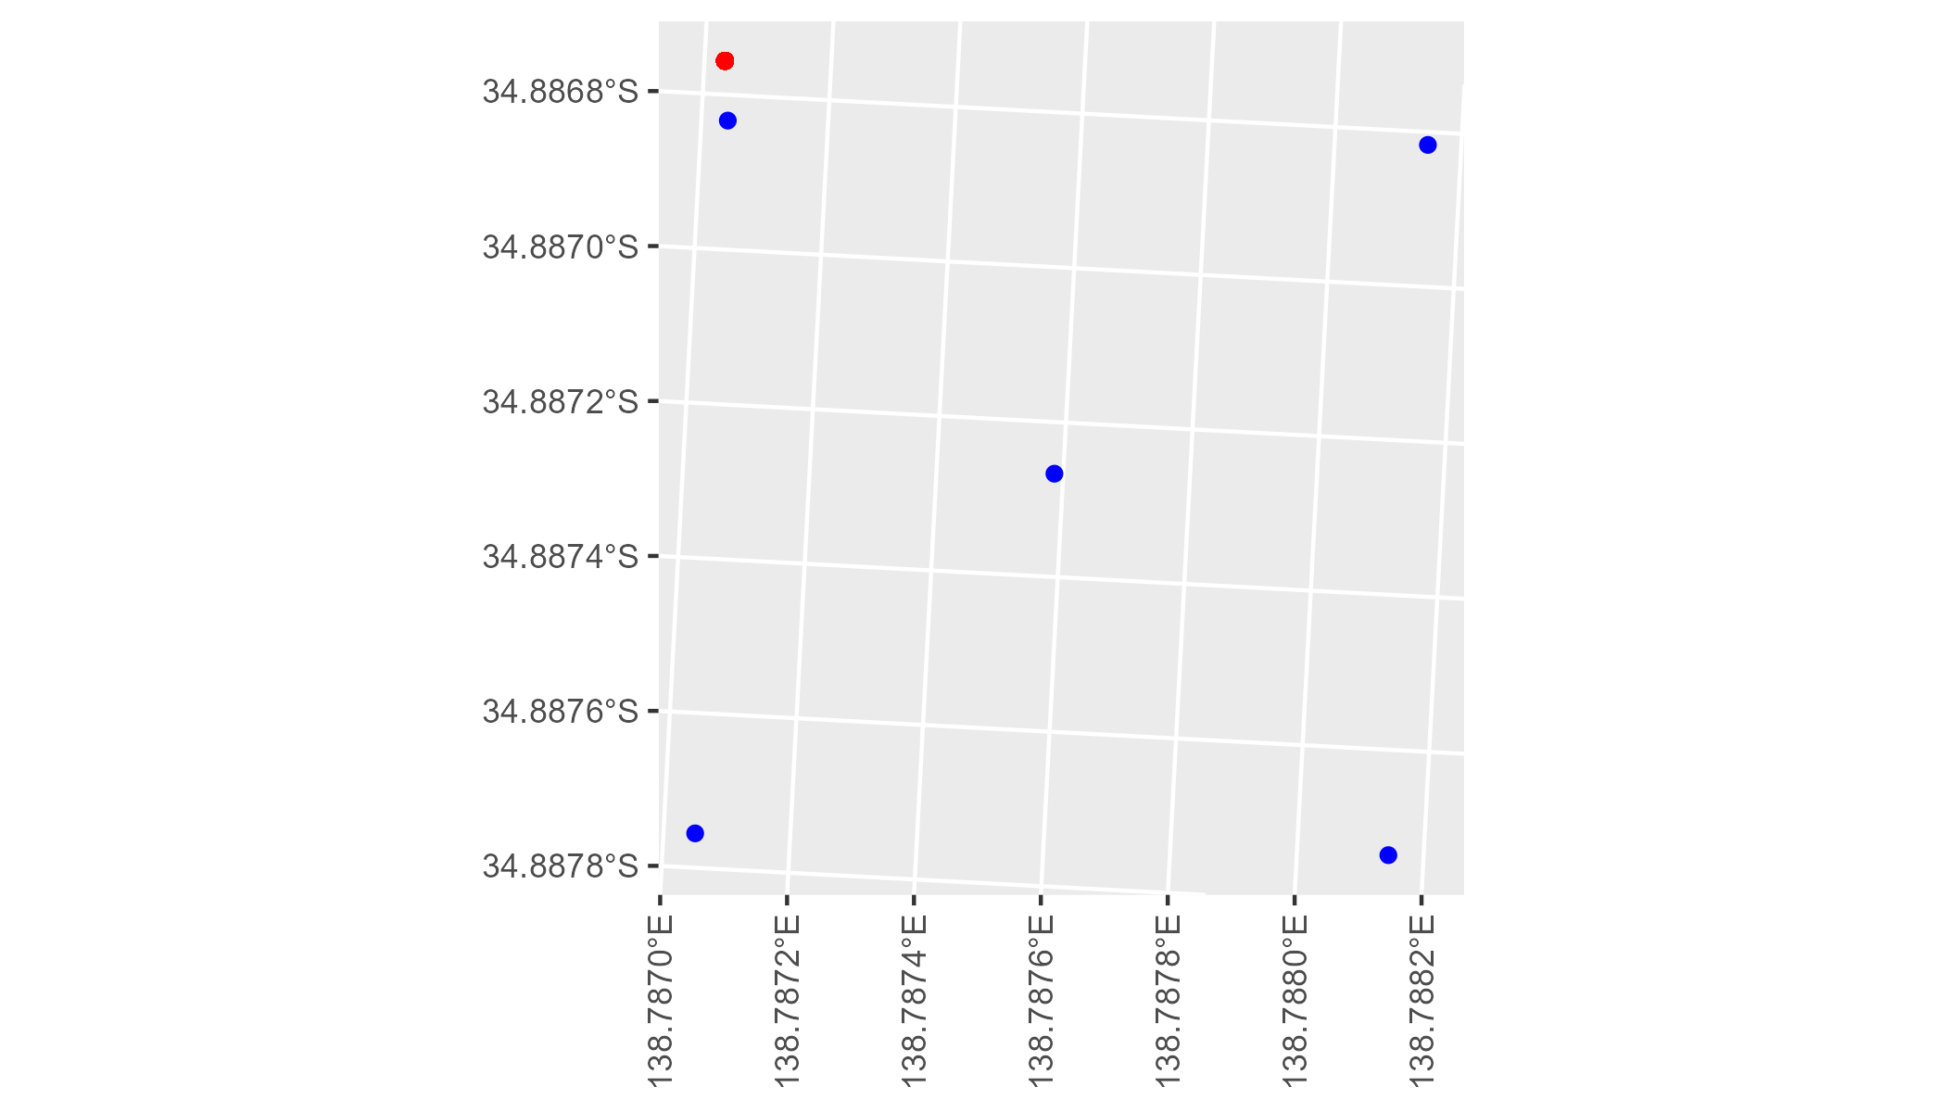

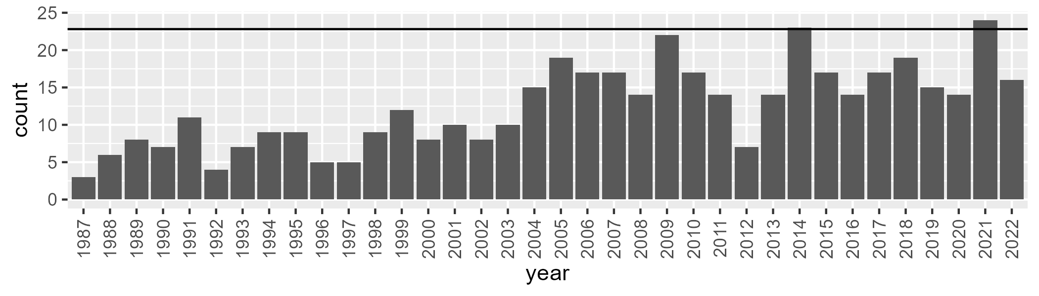

Number of samples: 446

# SATFLB0027

| Min. | 1st Qu. | Median | Mean | 3rd Qu. | Max. |
| --- | --- | --- | --- | --- | --- |
| 32.35166 | 50.35386 | 53.09461 | 52.72362 | 56.57661 | 66.34761 |

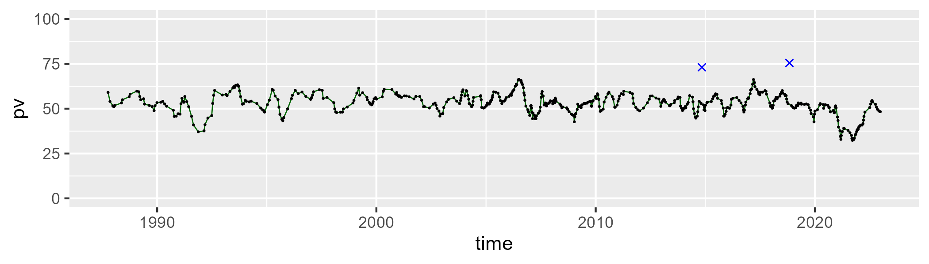

| Min. | 1st Qu. | Median | Mean | 3rd Qu. | Max. |
| --- | --- | --- | --- | --- | --- |
| 21.73506 | 34.2996 | 38.6795 | 38.24369 | 41.79289 | 52.45749 |

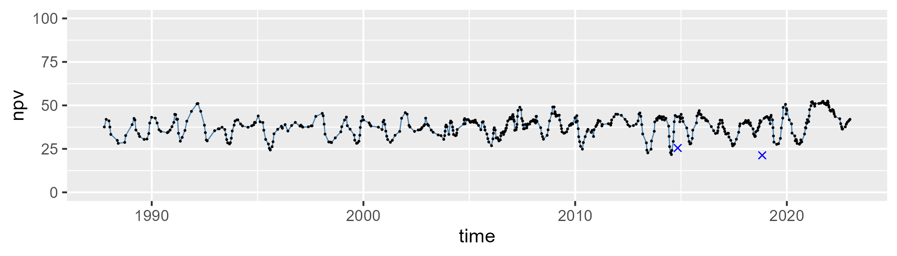

| Min. | 1st Qu. | Median | Mean | 3rd Qu. | Max. |
| --- | --- | --- | --- | --- | --- |
| 0 | 3.434248 | 6.689343 | 7.807063 | 11.3614 | 32.01732 |

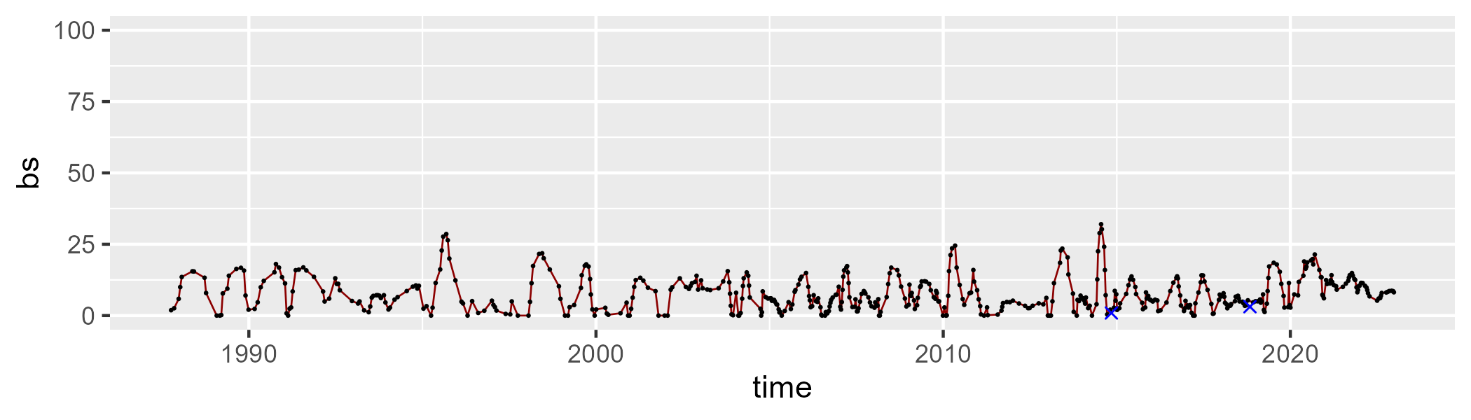

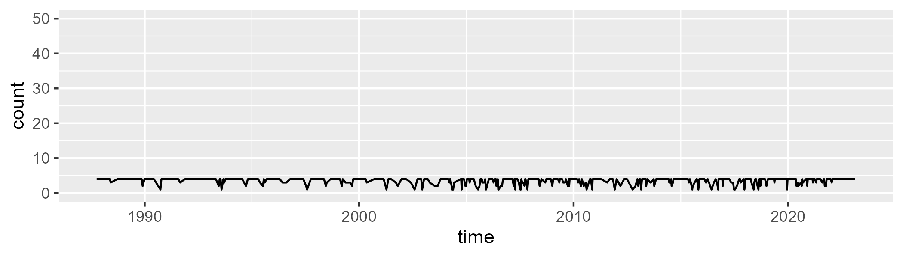

Min. :1.000 1st Qu.:3.000 Median :4.000 Mean :3.516 3rd Qu.:4.000 Max. :4.000

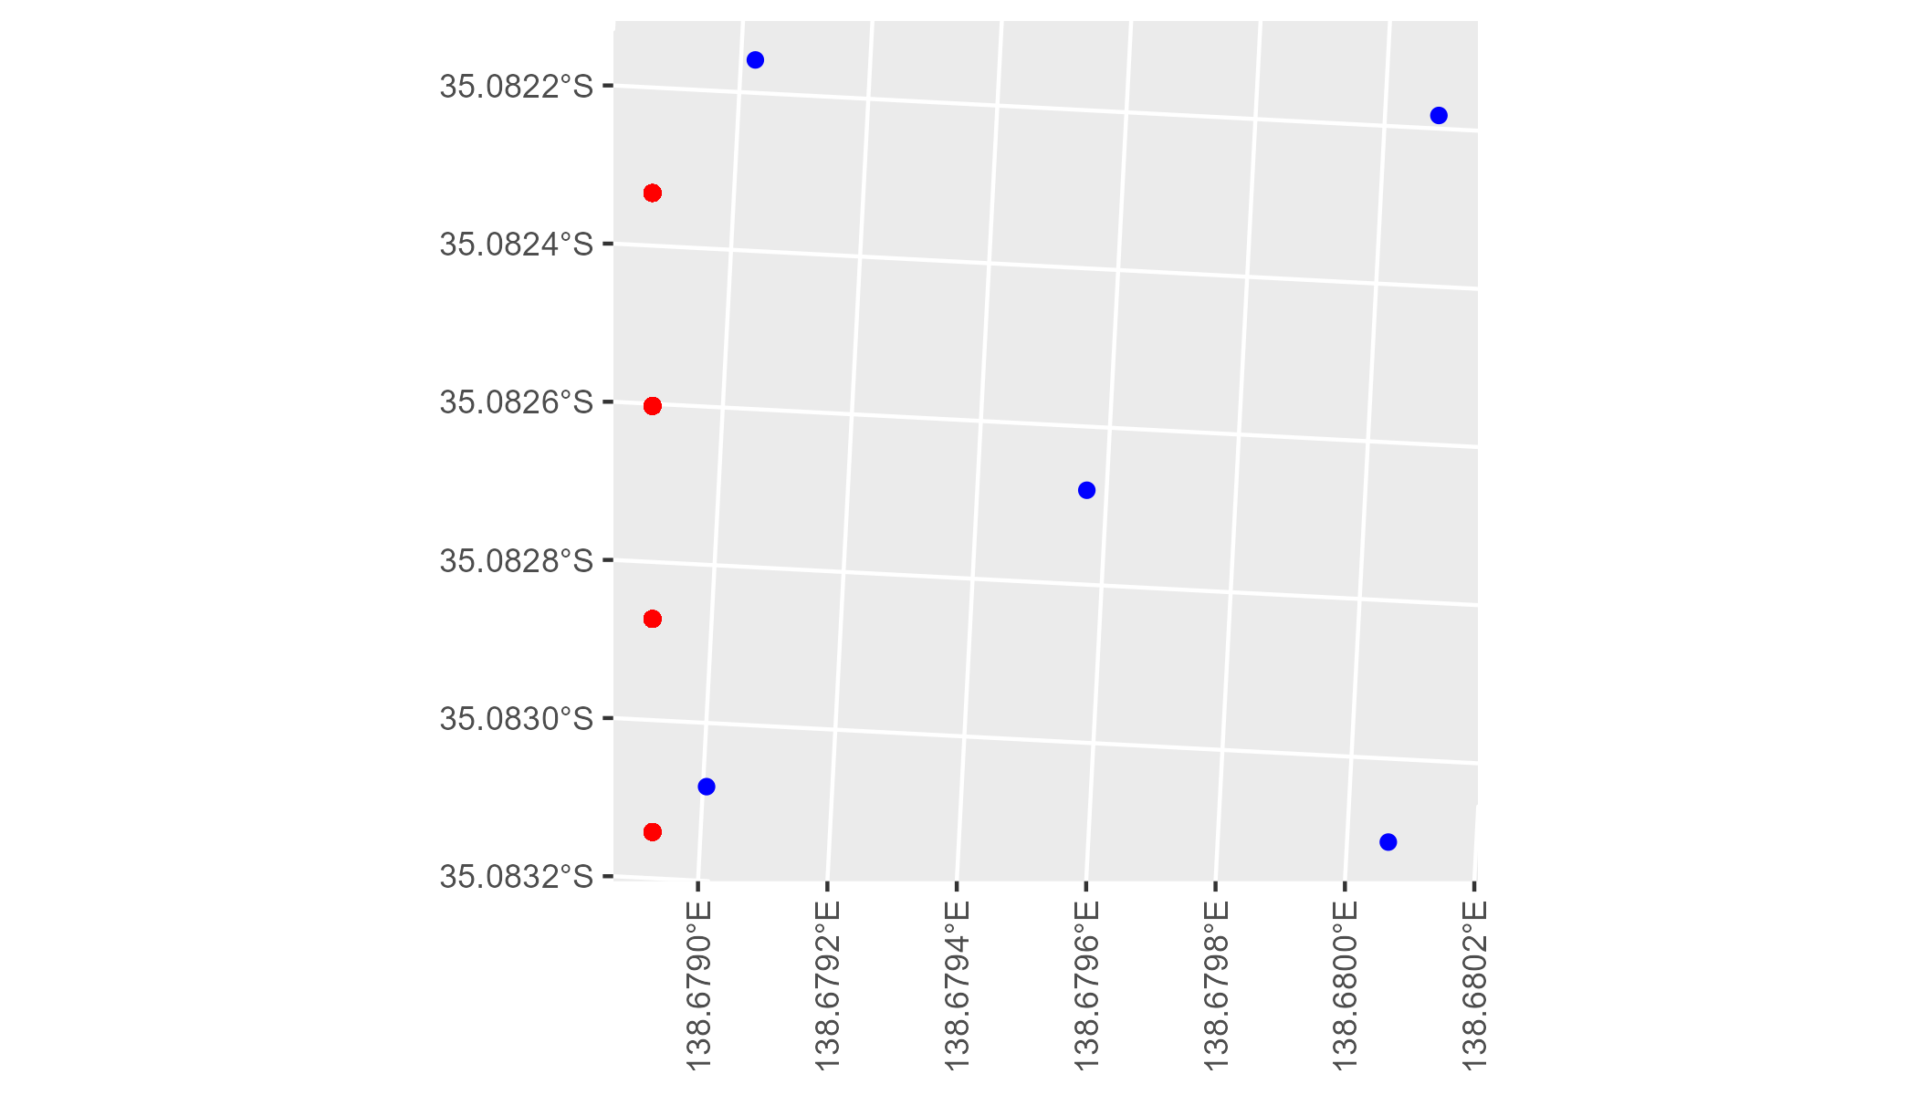

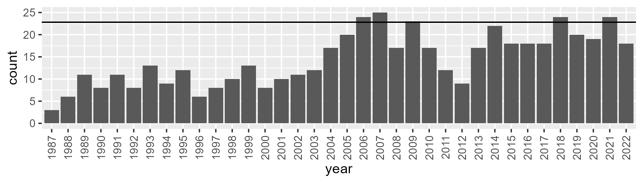

Number of samples: 521

# SATFLB0028

| Min. | 1st Qu. | Median | Mean | 3rd Qu. | Max. |
| --- | --- | --- | --- | --- | --- |
| 0.2609358 | 17.68833 | 27.78709 | 32.42346 | 48.03769 | 65.86148 |

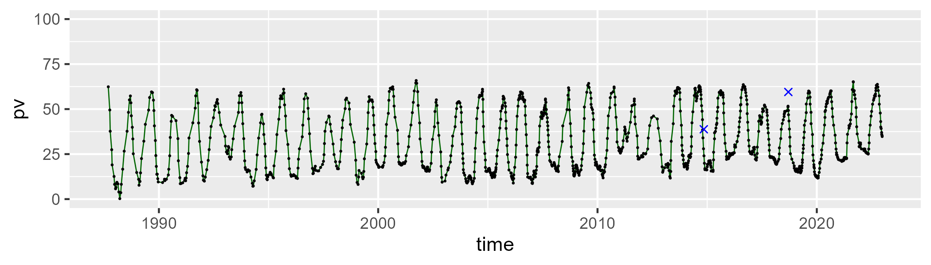

| Min. | 1st Qu. | Median | Mean | 3rd Qu. | Max. |
| --- | --- | --- | --- | --- | --- |
| 14.55715 | 41.78276 | 58.01775 | 54.8674 | 67.4505 | 88.65216 |

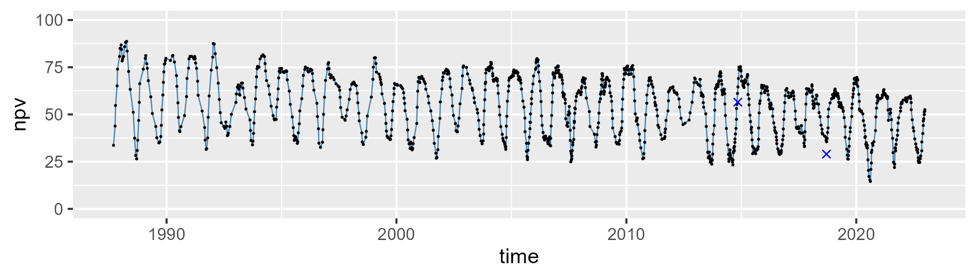

| Min. | 1st Qu. | Median | Mean | 3rd Qu. | Max. |
| --- | --- | --- | --- | --- | --- |
| 0 | 8.035076 | 11.12885 | 11.49686 | 14.24907 | 29.81425 |

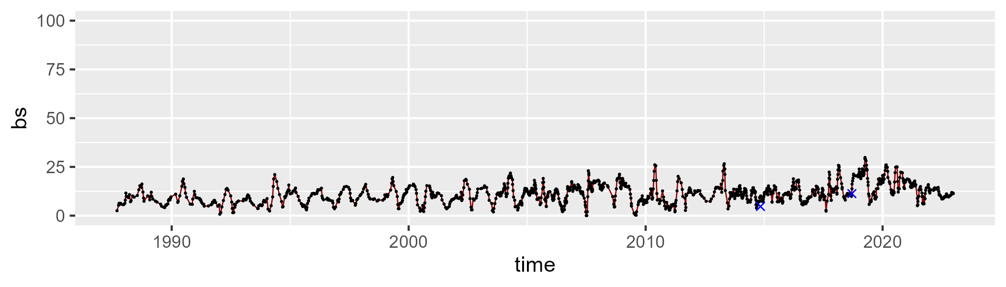

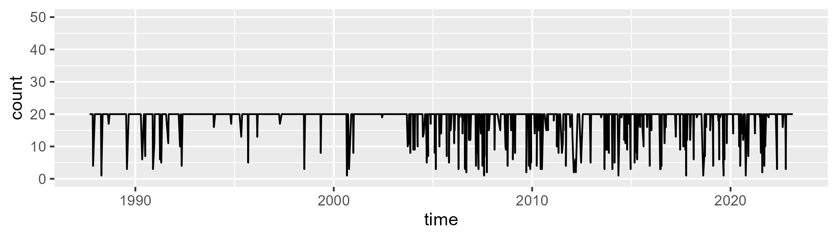

Min. : 1.00 1st Qu.:20.00 Median :20.00 Mean :18.43 3rd Qu.:20.00 Max. :20.00

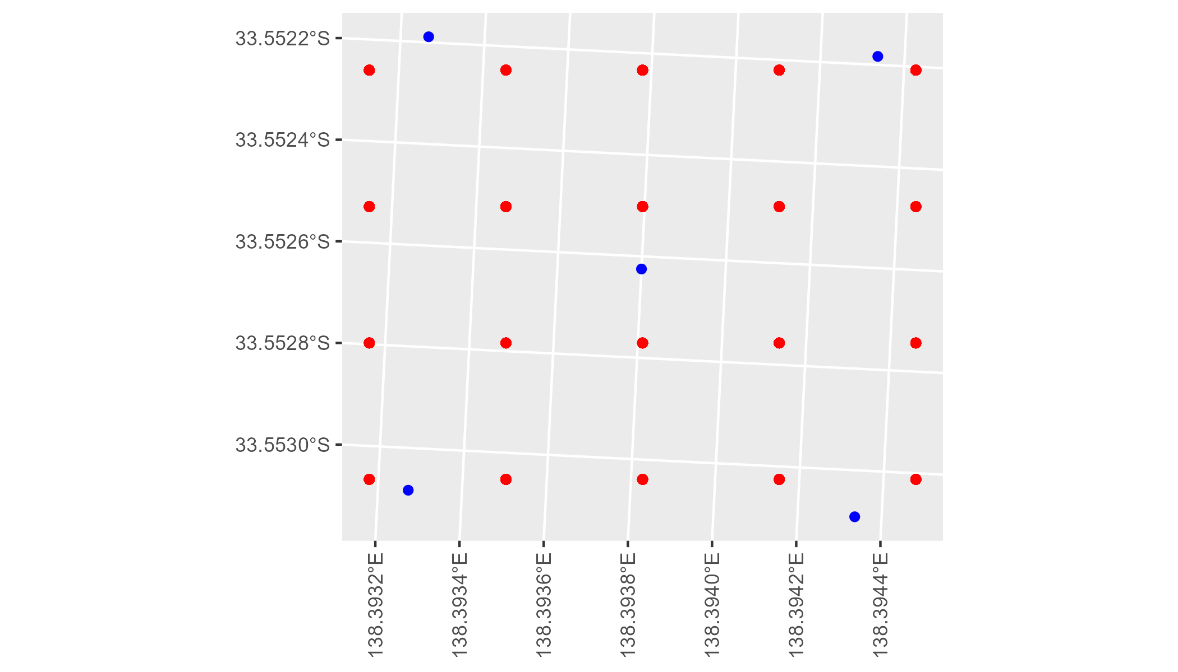

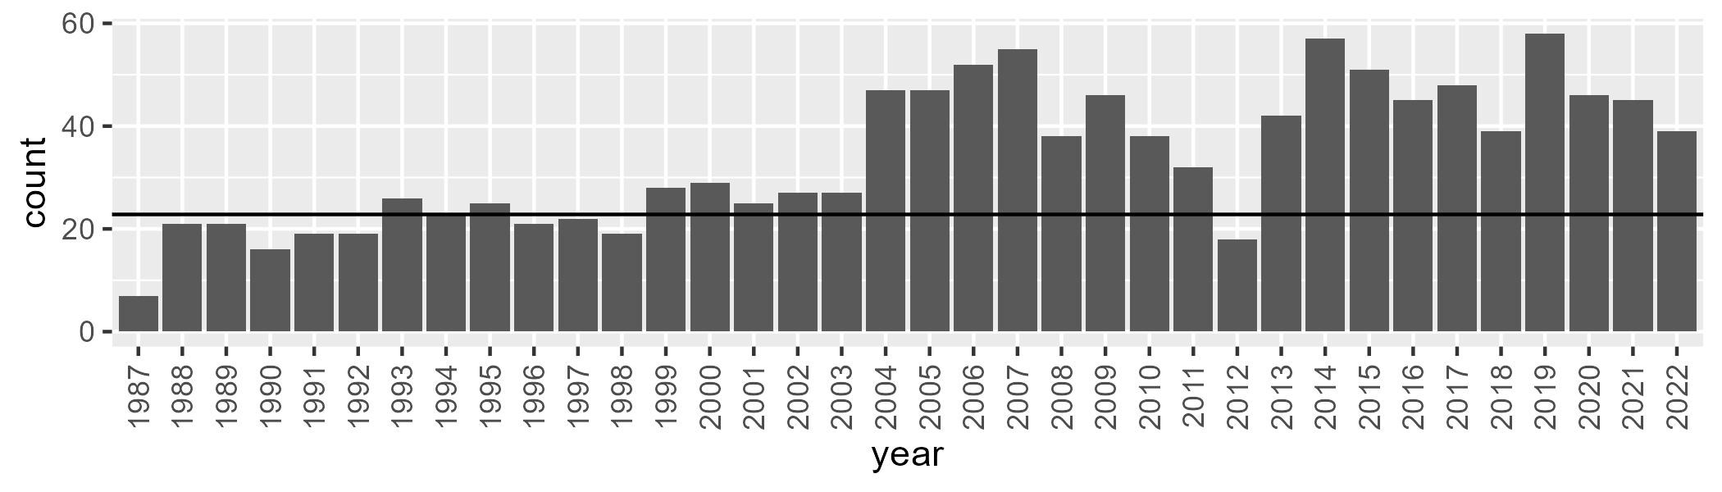

Number of samples: 1218

# SATKAN0001

| Min. | 1st Qu. | Median | Mean | 3rd Qu. | Max. |
| --- | --- | --- | --- | --- | --- |
| 47.32975 | 59.05089 | 61.67225 | 61.30316 | 64.30083 | 76.86684 |

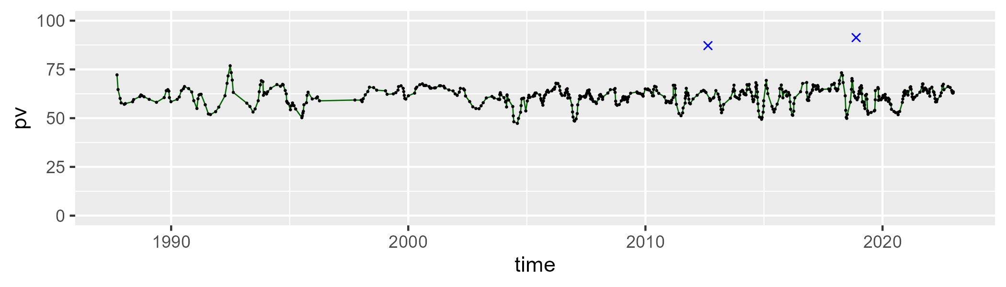

| Min. | 1st Qu. | Median | Mean | 3rd Qu. | Max. |
| --- | --- | --- | --- | --- | --- |
| 13.72649 | 27.52306 | 30.60598 | 30.24231 | 33.03314 | 46.3185 |

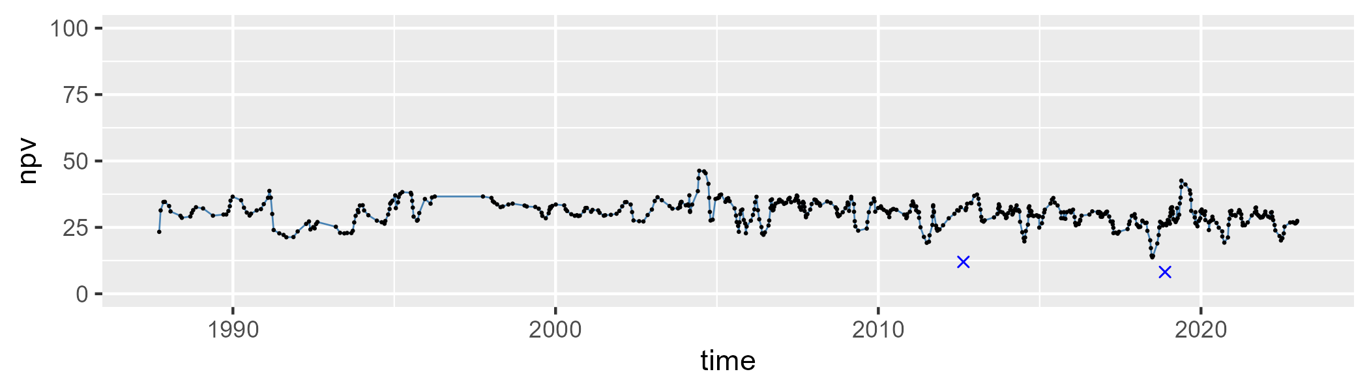

| Min. | 1st Qu. | Median | Mean | 3rd Qu. | Max. |
| --- | --- | --- | --- | --- | --- |
| 0 | 3.051246 | 5.785926 | 7.139385 | 10.0258 | 35.37792 |

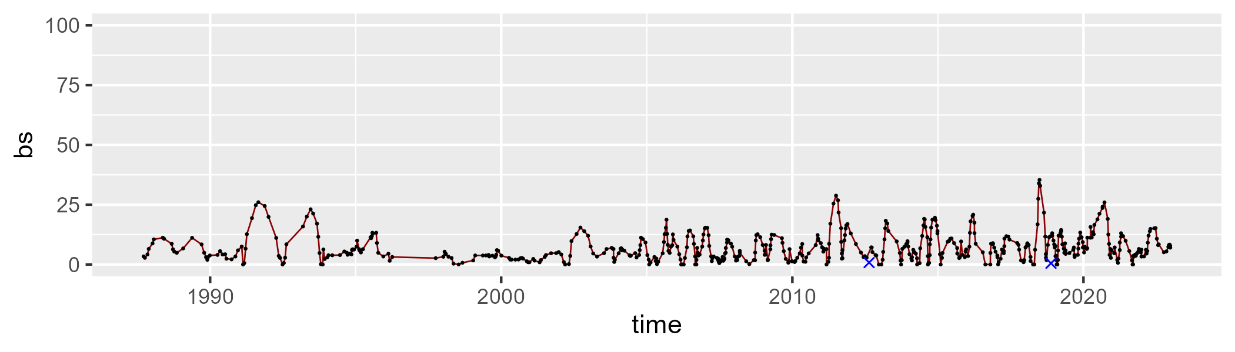

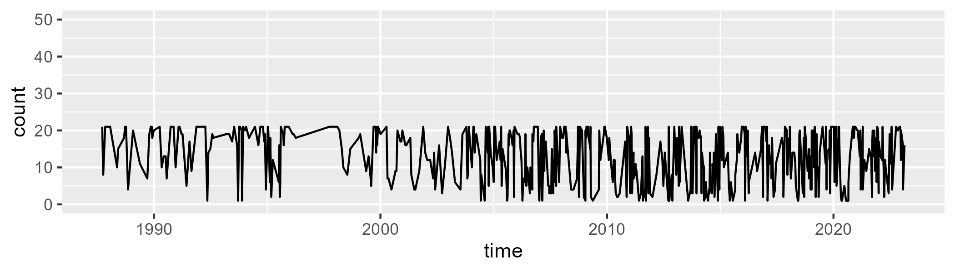

Min. : 1.00 1st Qu.: 7.00 Median :15.00 Mean :13.19 3rd Qu.:20.00 Max. :21.00

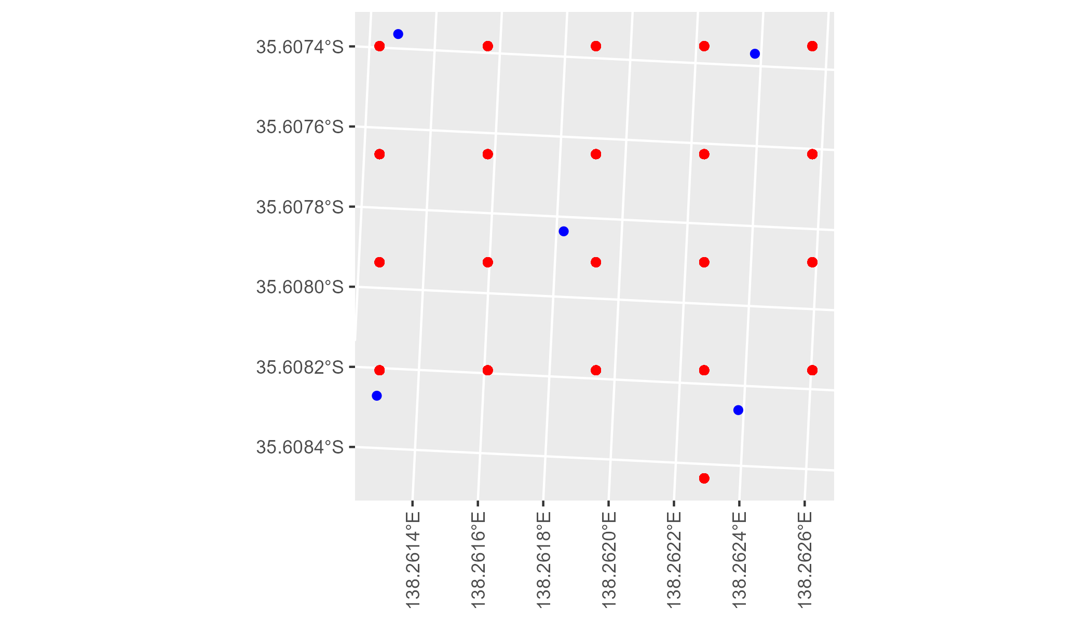

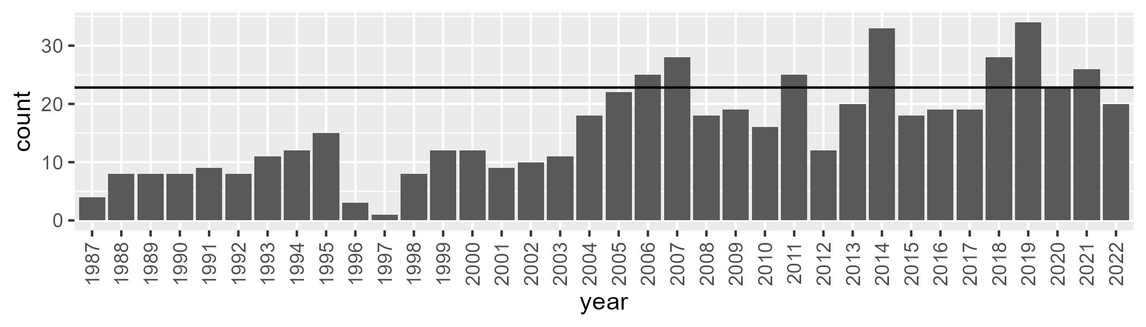

Number of samples: 572

# SATKAN0002

| Min. | 1st Qu. | Median | Mean | 3rd Qu. | Max. |
| --- | --- | --- | --- | --- | --- |
| 45.26219 | 56.15094 | 59.6917 | 59.37201 | 62.78337 | 76.19285 |

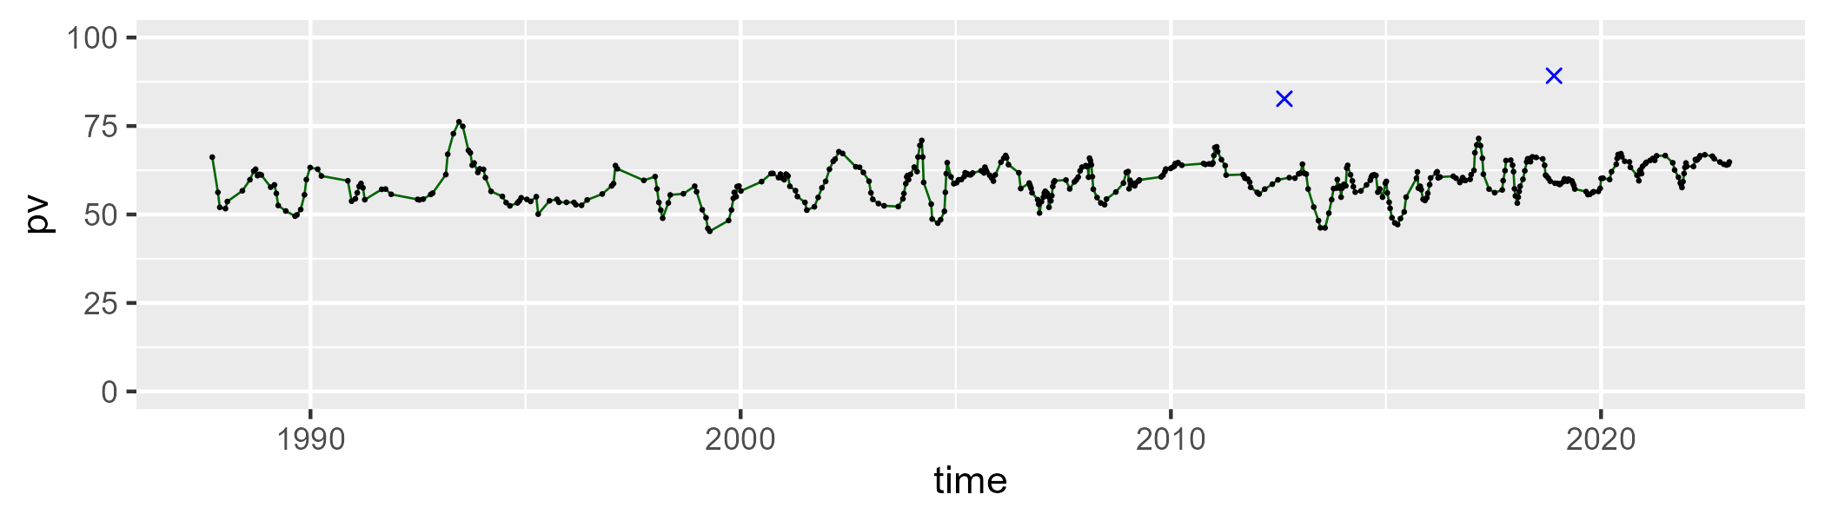

| Min. | 1st Qu. | Median | Mean | 3rd Qu. | Max. |
| --- | --- | --- | --- | --- | --- |
| 13.32854 | 28.596 | 31.90221 | 30.90824 | 34.17289 | 42.08364 |

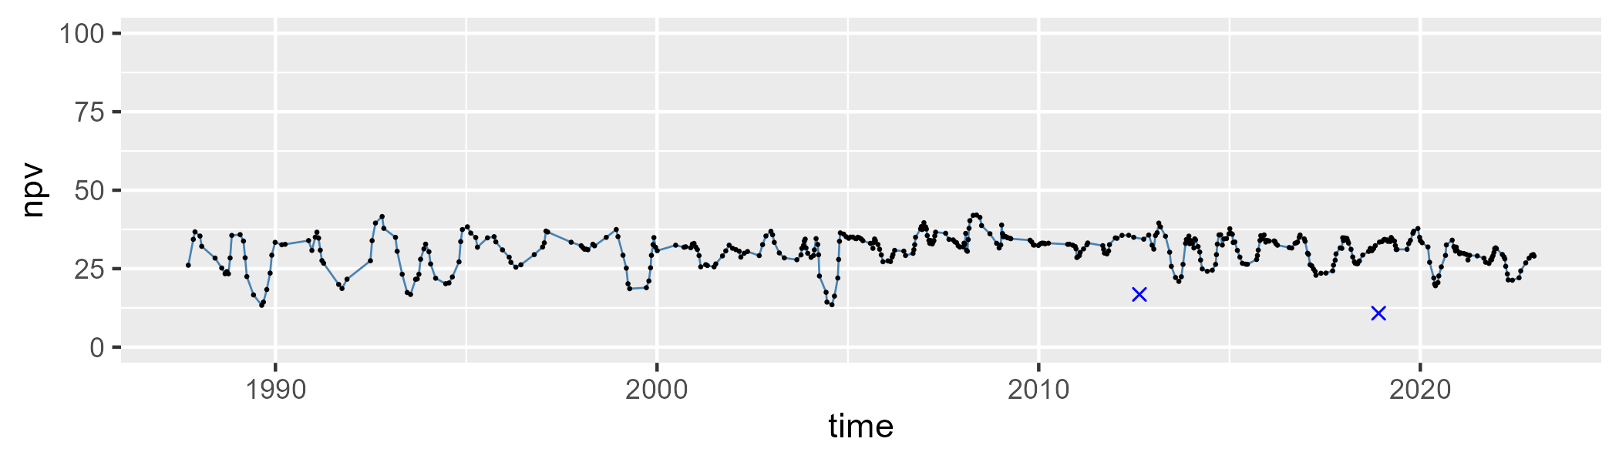

| Min. | 1st Qu. | Median | Mean | 3rd Qu. | Max. |
| --- | --- | --- | --- | --- | --- |
| 0 | 3.692212 | 6.380531 | 8.293164 | 10.39197 | 37.60298 |

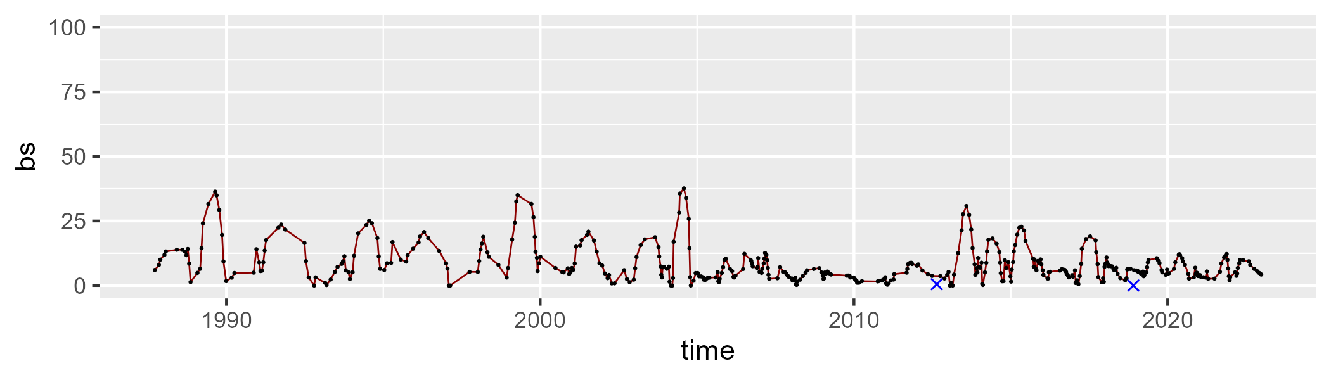

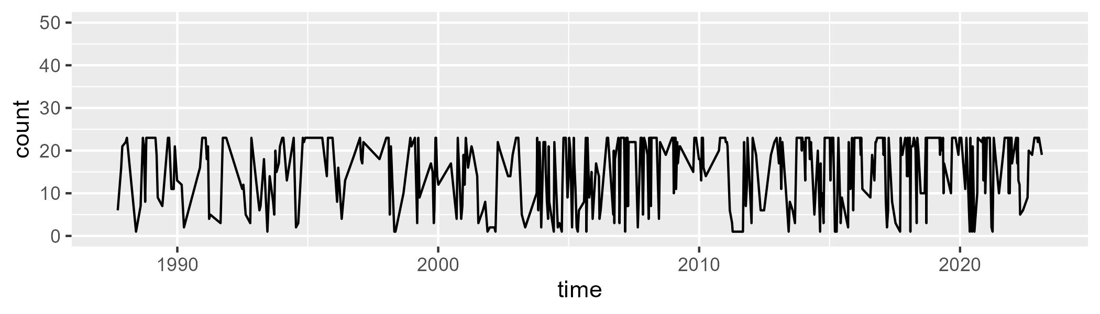

Min. : 1.00 1st Qu.: 9.00 Median :20.00 Mean :16.01 3rd Qu.:23.00 Max. :23.00

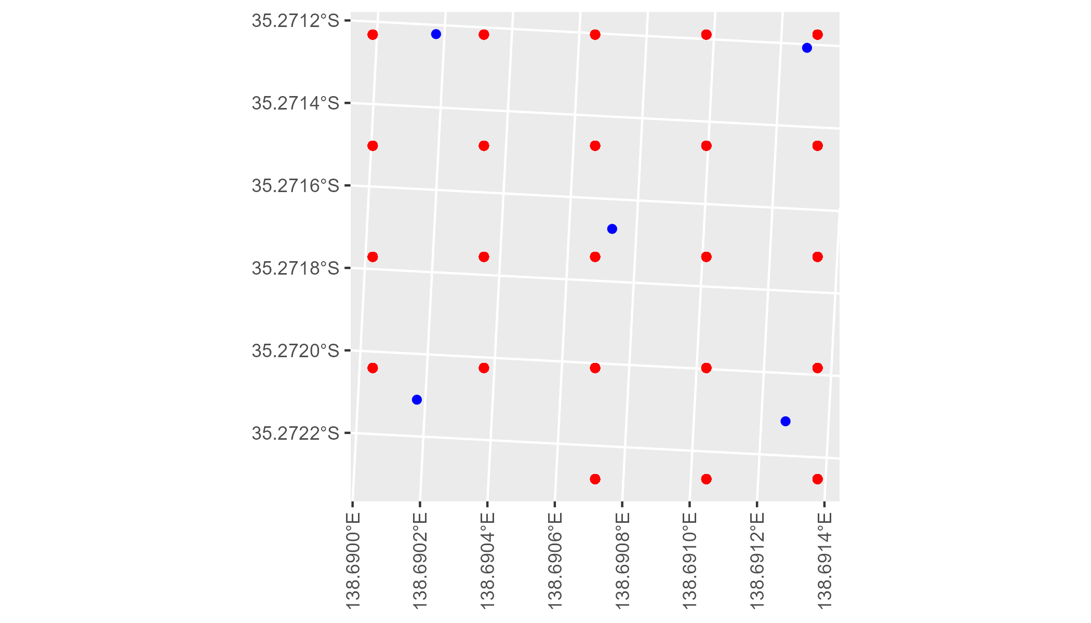

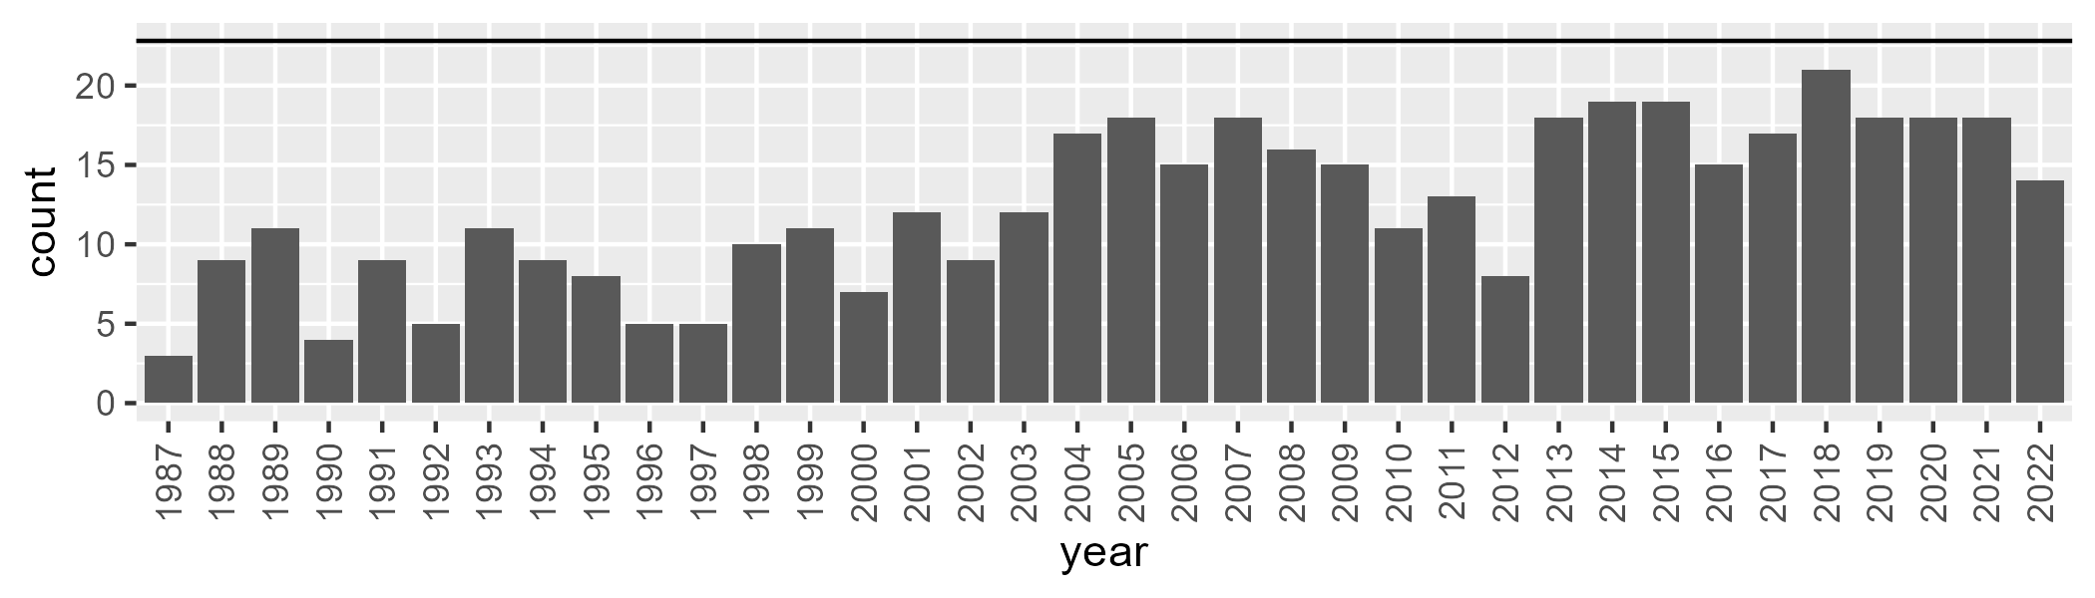

Number of samples: 448

# SATKAN0003

| Min. | 1st Qu. | Median | Mean | 3rd Qu. | Max. |
| --- | --- | --- | --- | --- | --- |
| 41.59261 | 52.90753 | 58.00324 | 57.41562 | 61.69027 | 70.79841 |

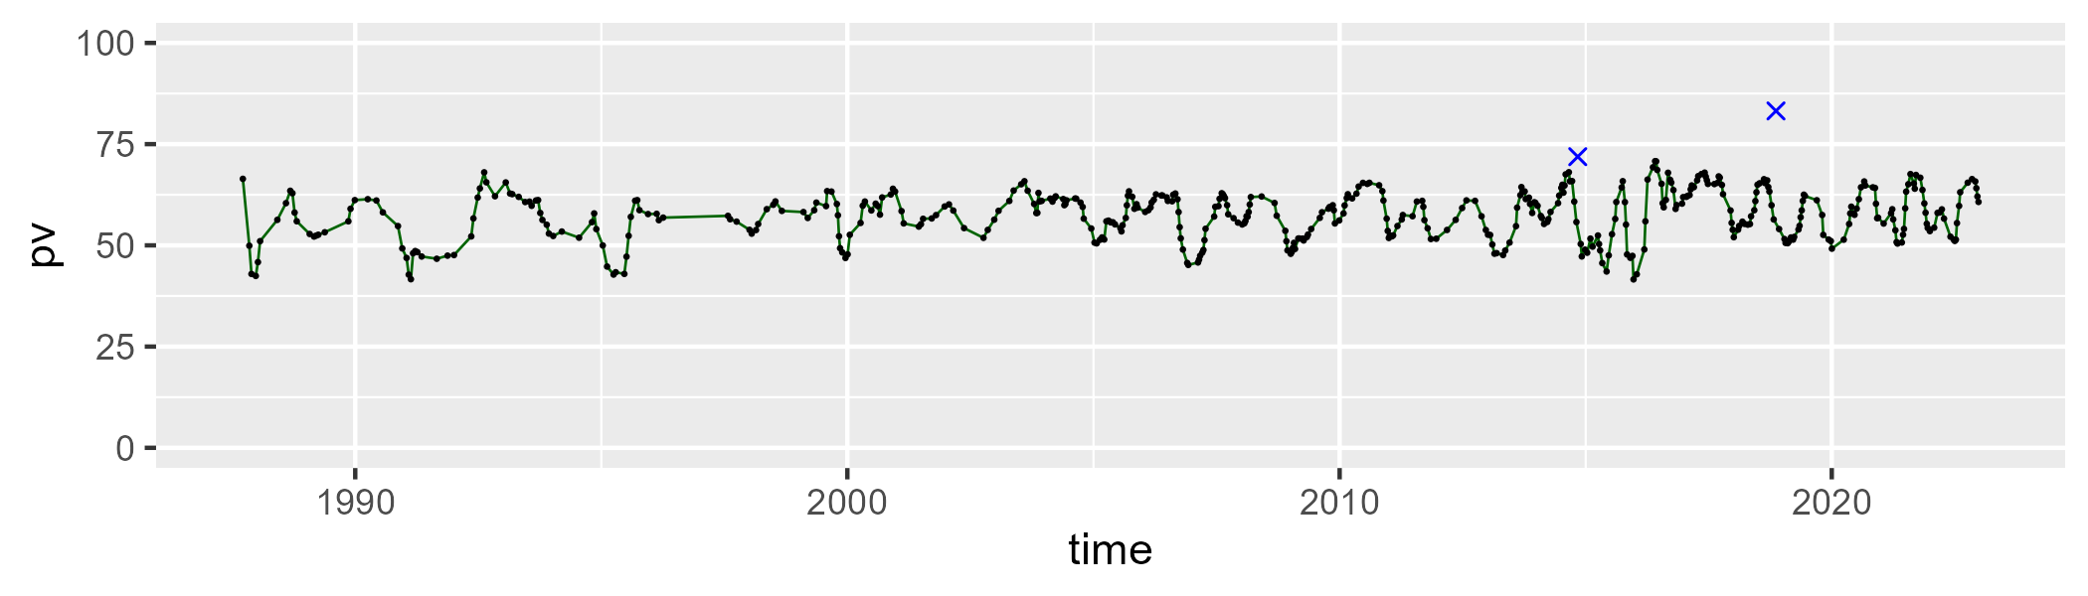

| Min. | 1st Qu. | Median | Mean | 3rd Qu. | Max. |
| --- | --- | --- | --- | --- | --- |
| 20.83151 | 30.51336 | 34.57883 | 34.47365 | 38.22695 | 45.18224 |

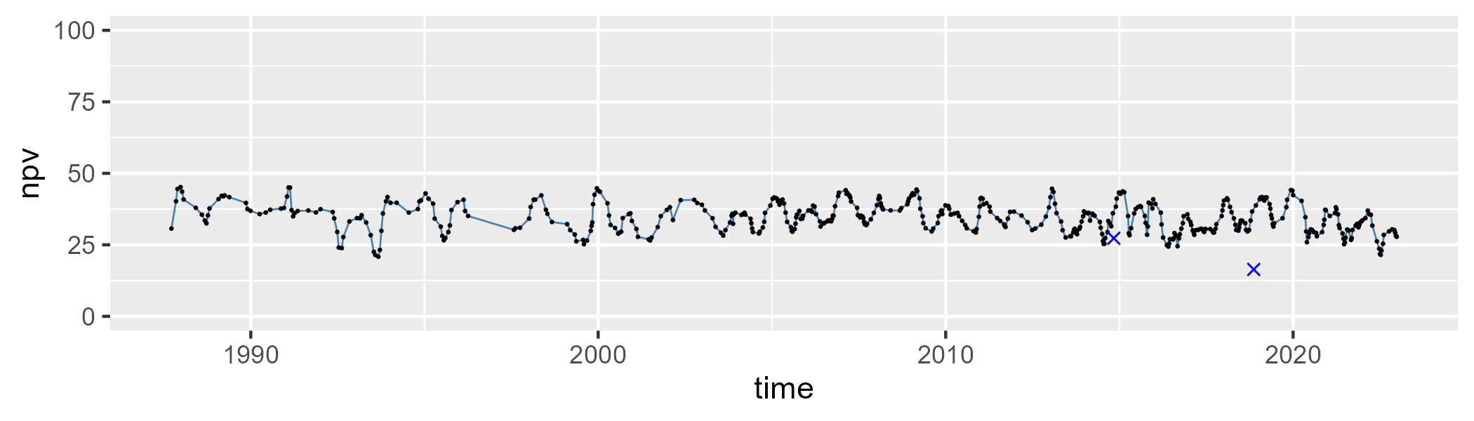

| Min. | 1st Qu. | Median | Mean | 3rd Qu. | Max. |
| --- | --- | --- | --- | --- | --- |
| 0 | 3.346587 | 5.901897 | 6.825575 | 9.389498 | 25.72662 |

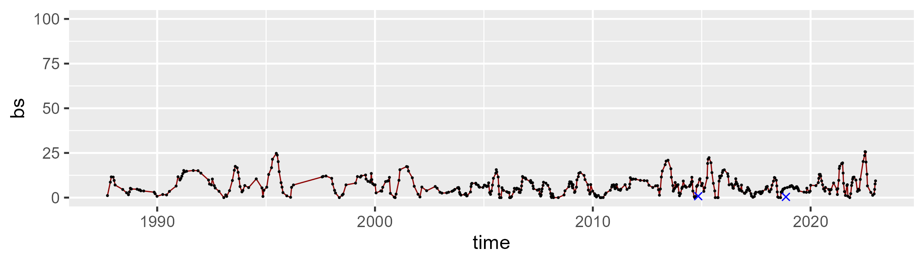

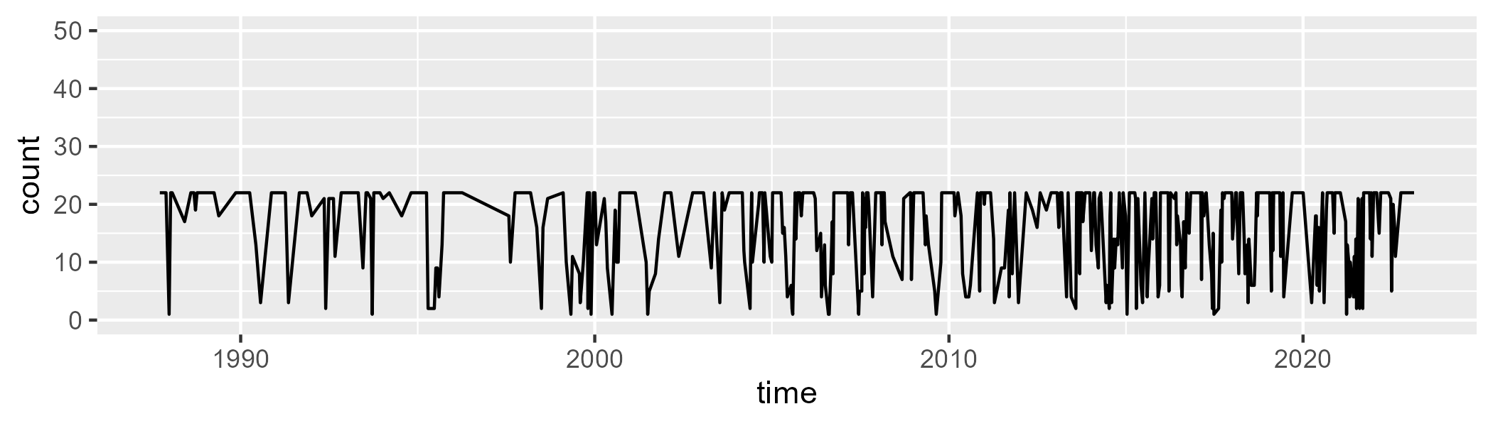

Min. : 1.00 1st Qu.:11.00 Median :22.00 Mean :16.63 3rd Qu.:22.00 Max. :22.00

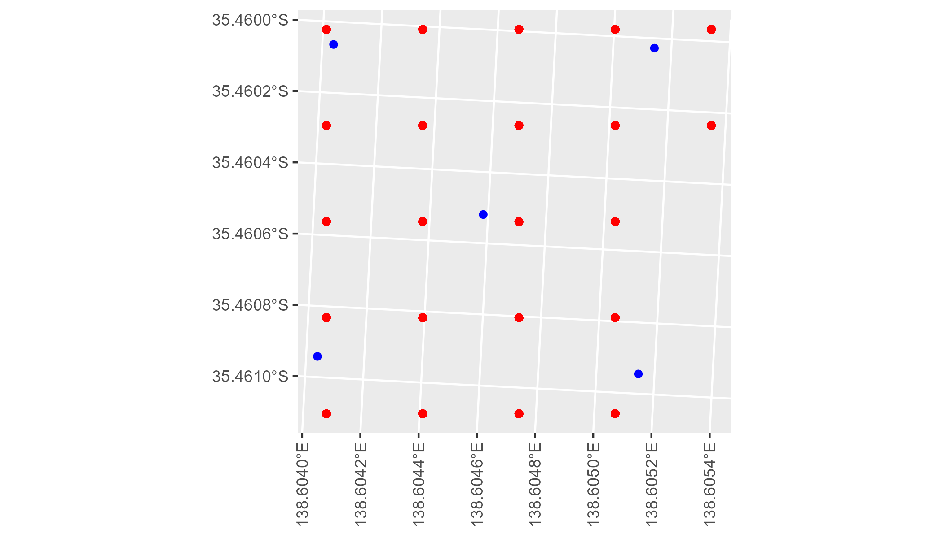

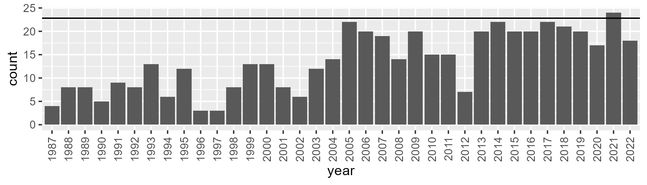

Number of samples: 489

# SATKAN0004

| Min. | 1st Qu. | Median | Mean | 3rd Qu. | Max. |
| --- | --- | --- | --- | --- | --- |
| 11.37243 | 38.13429 | 43.6113 | 43.11733 | 50.12433 | 60.28575 |

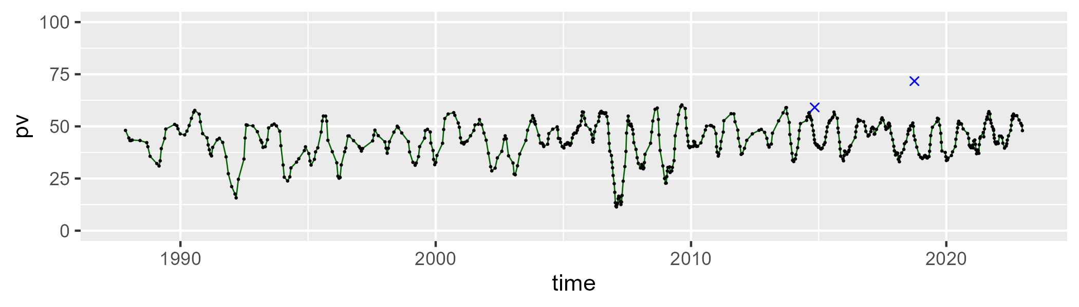

| Min. | 1st Qu. | Median | Mean | 3rd Qu. | Max. |
| --- | --- | --- | --- | --- | --- |
| 27.63864 | 41.76877 | 47.60643 | 47.37968 | 52.71047 | 72.93463 |

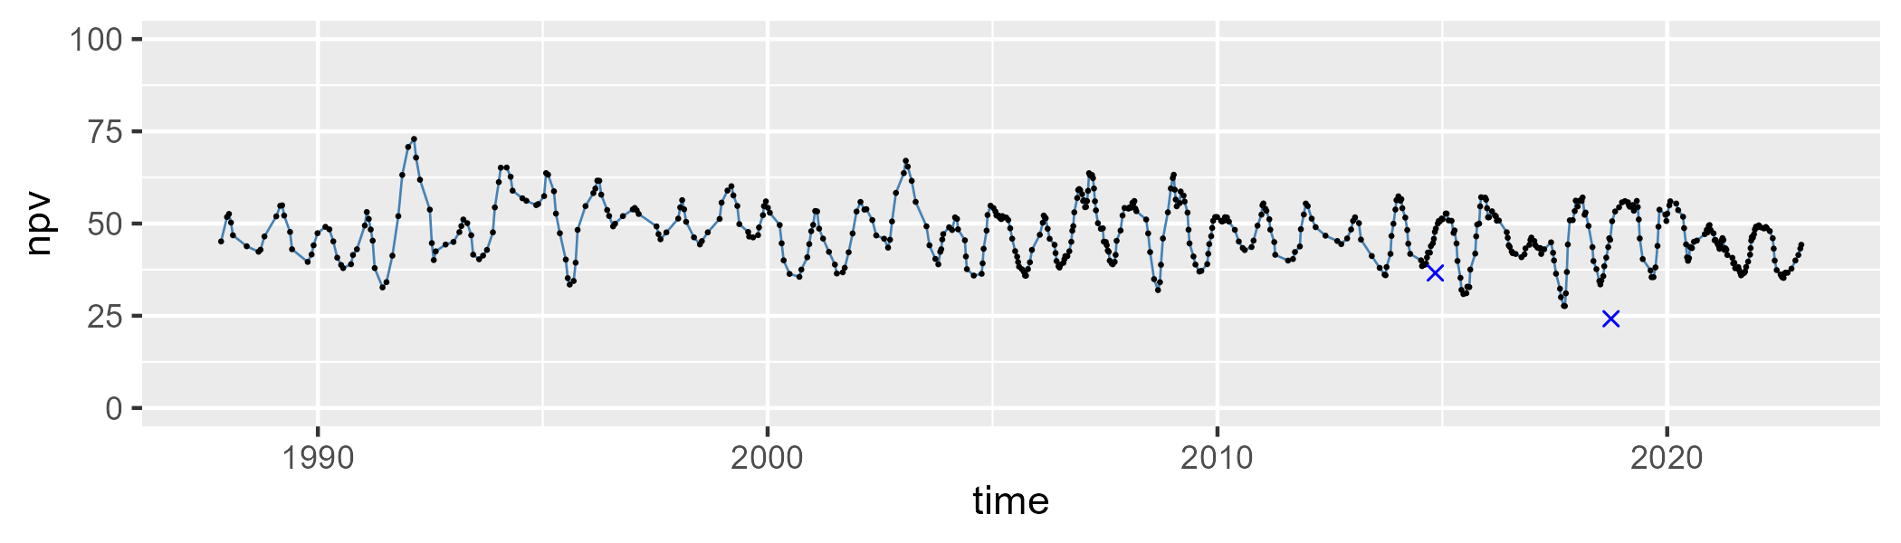

| Min. | 1st Qu. | Median | Mean | 3rd Qu. | Max. |
| --- | --- | --- | --- | --- | --- |
| 0 | 5.288146 | 7.290744 | 8.342999 | 10.18706 | 32.6282 |

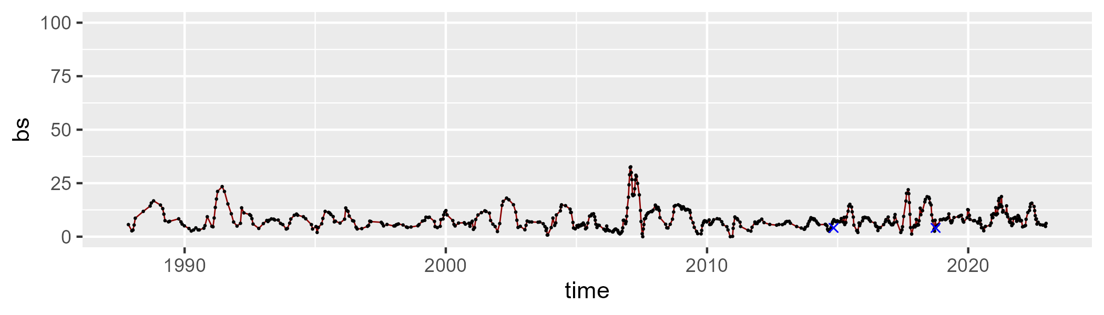

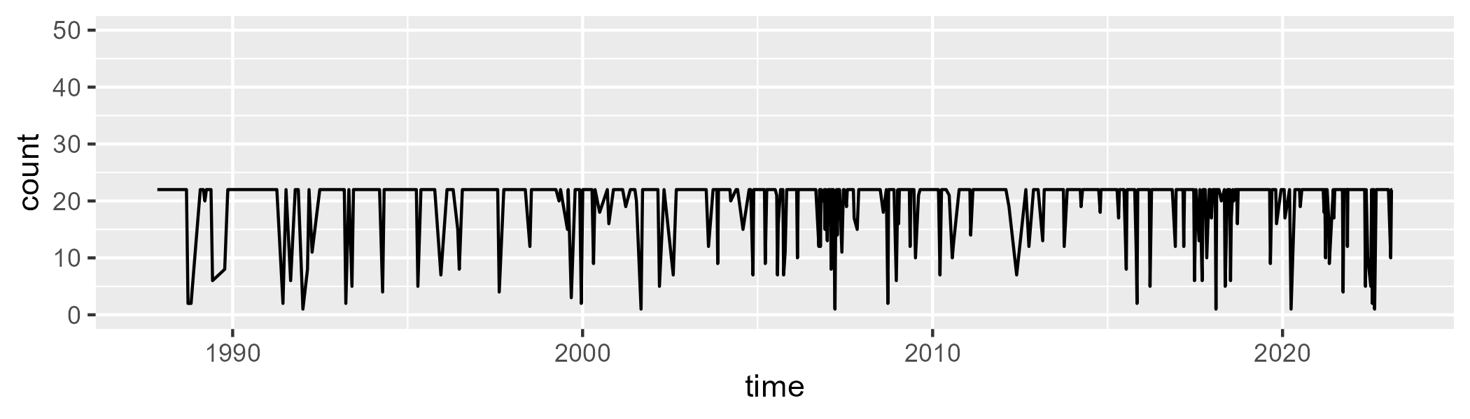

Min. : 1.00 1st Qu.:22.00 Median :22.00 Mean :19.82 3rd Qu.:22.00 Max. :22.00

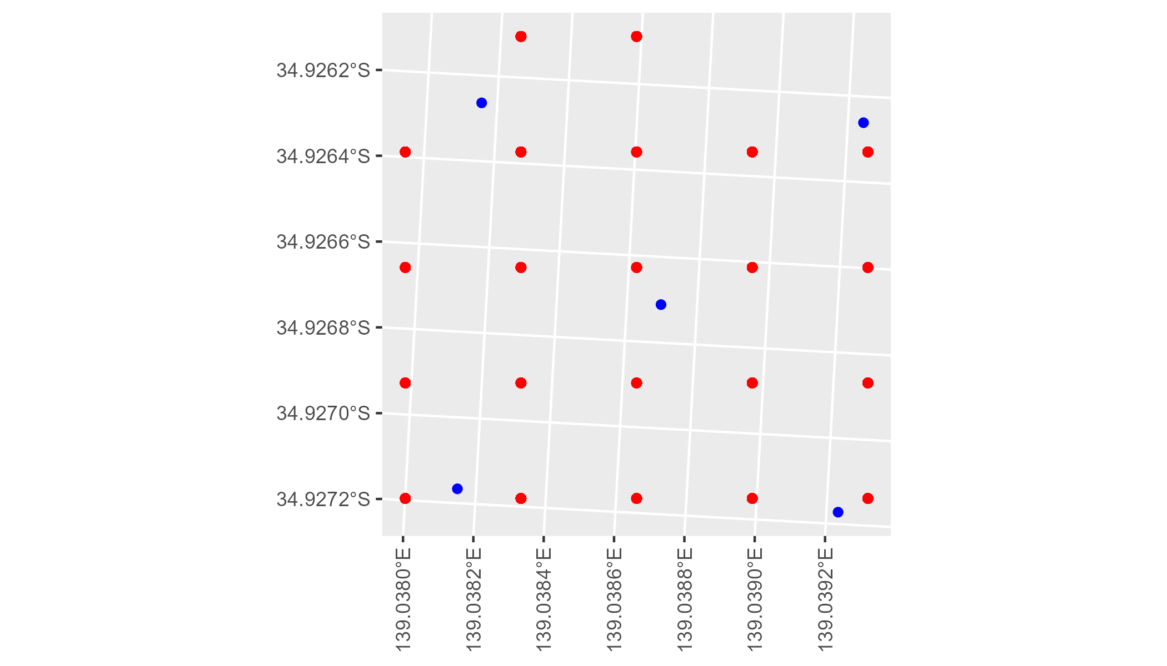

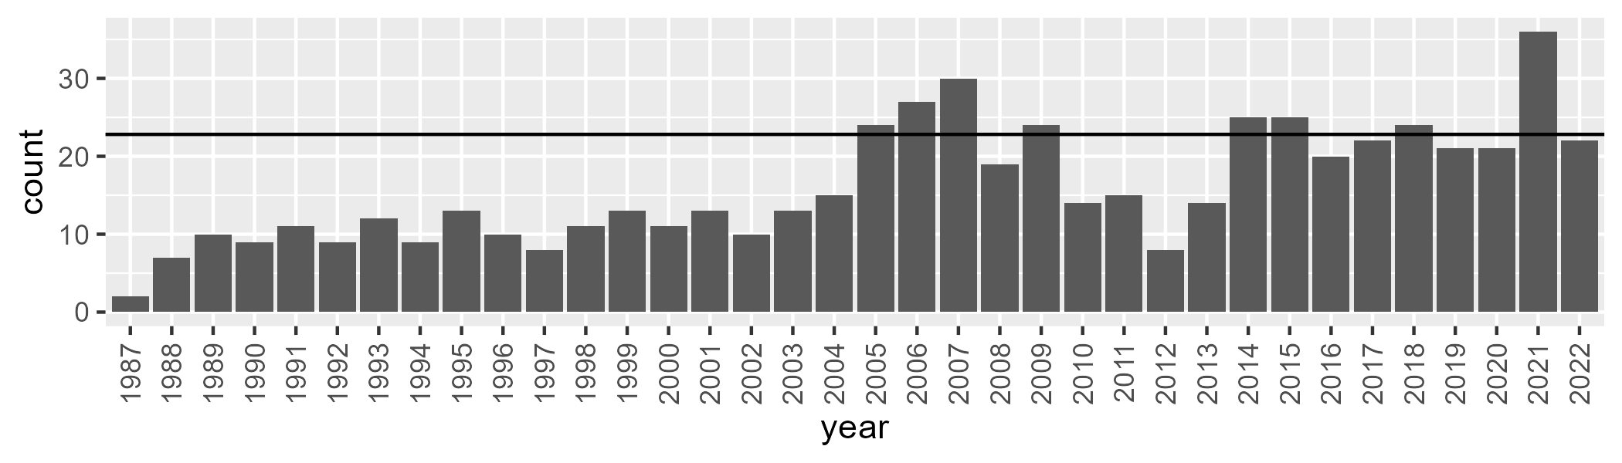

Number of samples: 577

# SATSTP0001

| Min. | 1st Qu. | Median | Mean | 3rd Qu. | Max. |
| --- | --- | --- | --- | --- | --- |
| 0 | 0.9951787 | 1.953507 | 4.530202 | 5.434089 | 52.45818 |

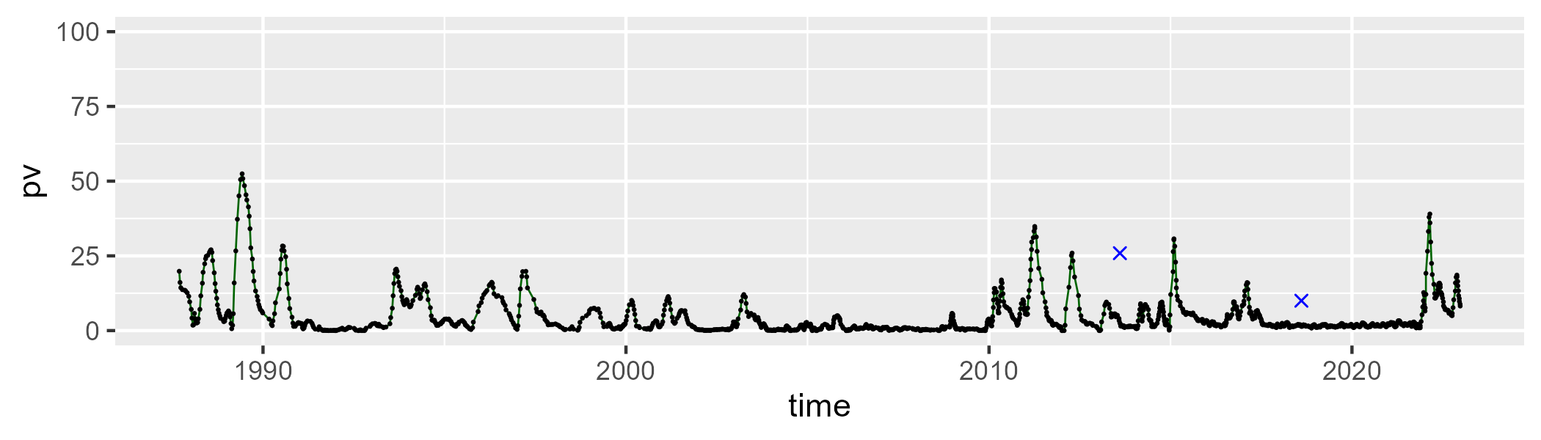

| Min. | 1st Qu. | Median | Mean | 3rd Qu. | Max. |
| --- | --- | --- | --- | --- | --- |
| 17.54459 | 31.93187 | 40.10908 | 40.43554 | 47.22067 | 71.59836 |

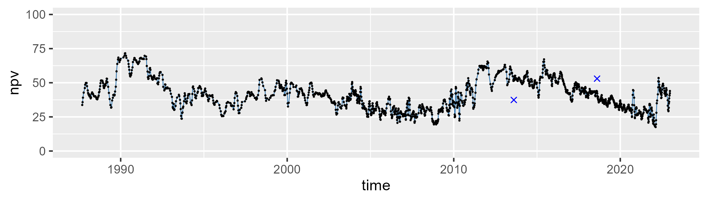

| Min. | 1st Qu. | Median | Mean | 3rd Qu. | Max. |
| --- | --- | --- | --- | --- | --- |
| 12.43729 | 45.18171 | 54.46507 | 53.62559 | 64.16991 | 77.98522 |

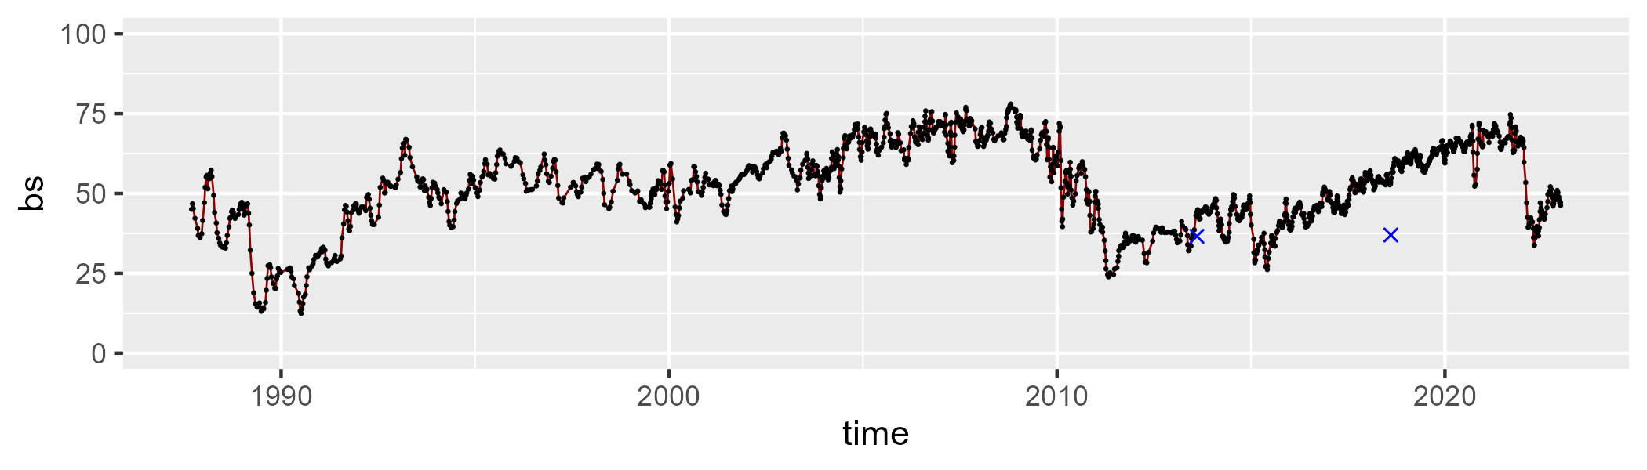

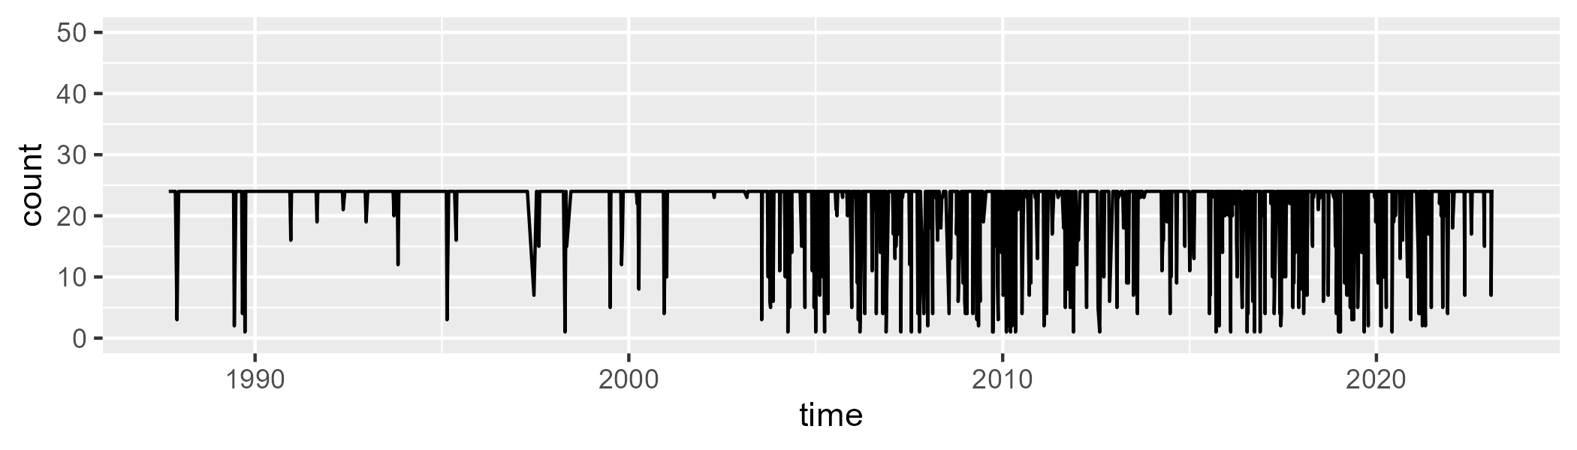

Min. : 1.00 1st Qu.:24.00 Median :24.00 Mean :21.76 3rd Qu.:24.00 Max. :24.00

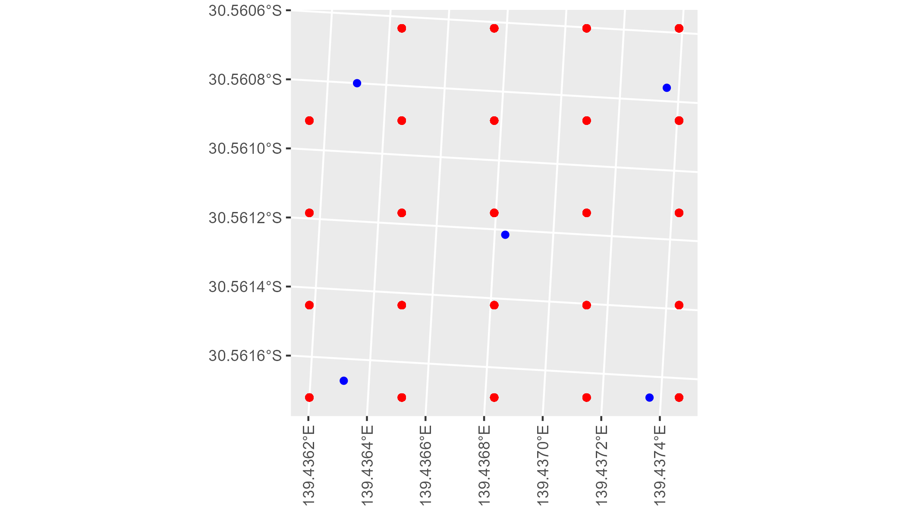

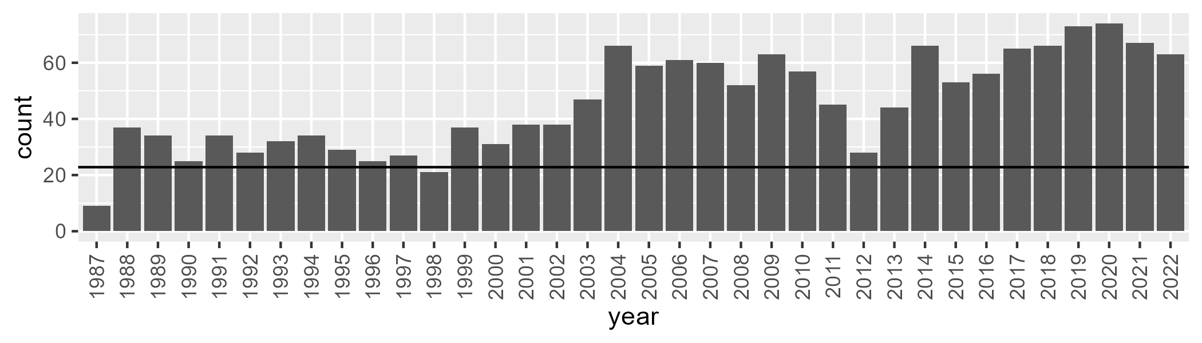

Number of samples: 1644

# SATSTP0002

| Min. | 1st Qu. | Median | Mean | 3rd Qu. | Max. |
| --- | --- | --- | --- | --- | --- |
| 3.267028 | 6.557848 | 8.410939 | 8.875449 | 10.46613 | 25.33213 |

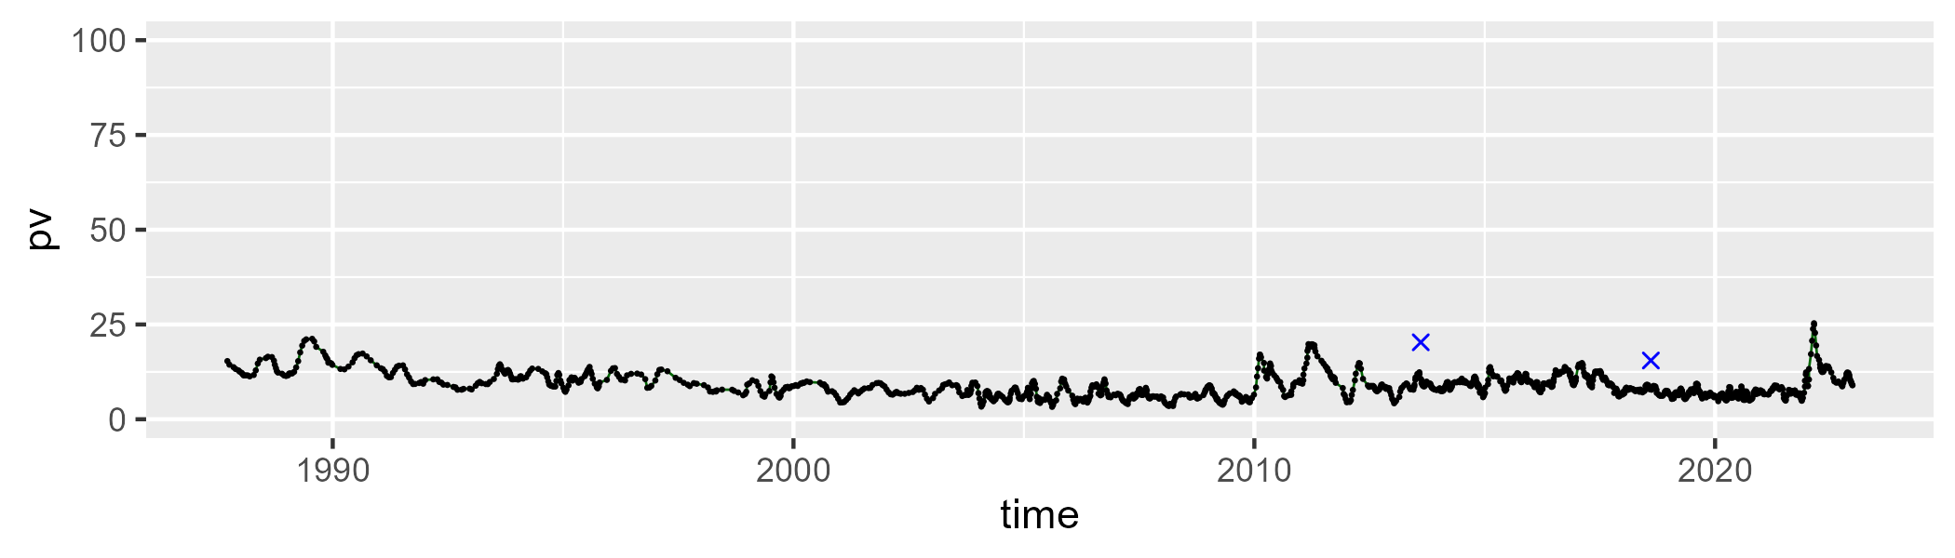

| Min. | 1st Qu. | Median | Mean | 3rd Qu. | Max. |
| --- | --- | --- | --- | --- | --- |
| 6.443705 | 18.96419 | 22.69373 | 22.64514 | 26.37837 | 44.1638 |

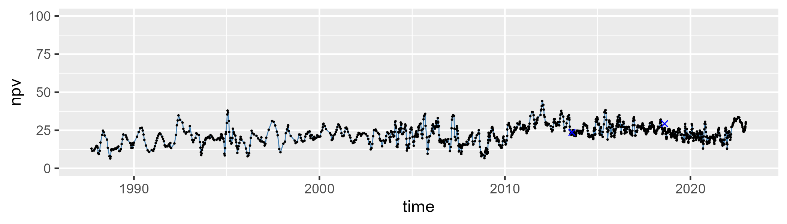

| Min. | 1st Qu. | Median | Mean | 3rd Qu. | Max. |
| --- | --- | --- | --- | --- | --- |
| 45.90274 | 62.6267 | 67.35874 | 66.88999 | 71.33654 | 85.45742 |

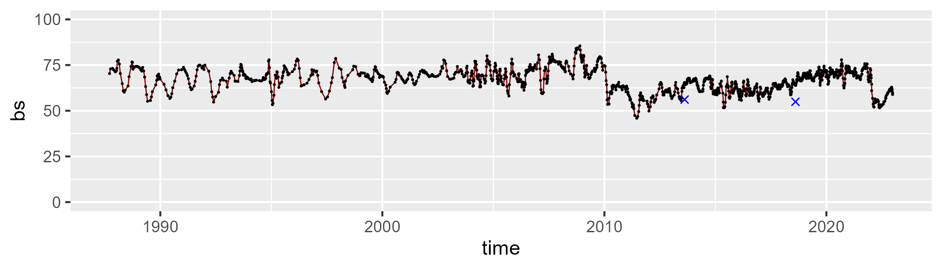

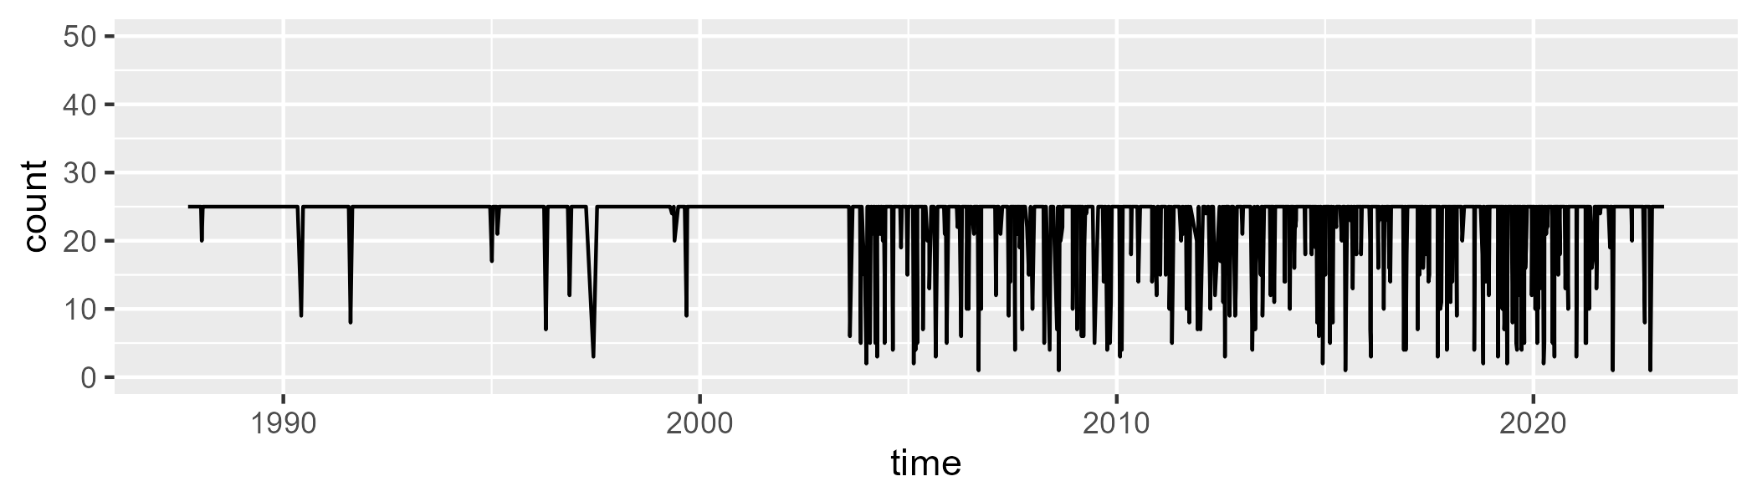

Min. : 1.00 1st Qu.:25.00 Median :25.00 Mean :22.77 3rd Qu.:25.00 Max. :25.00

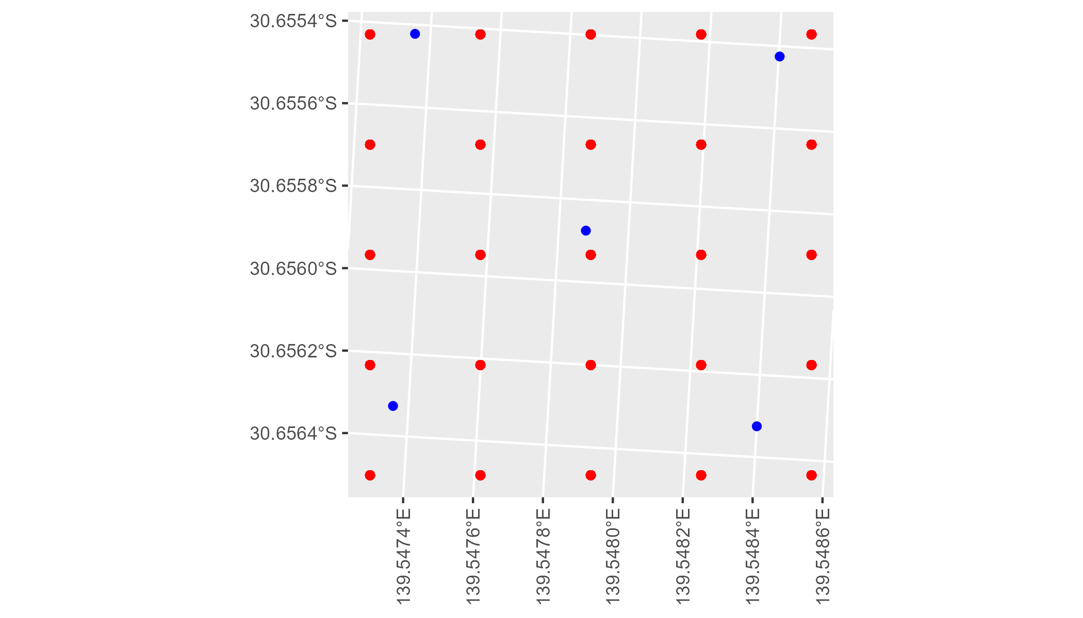

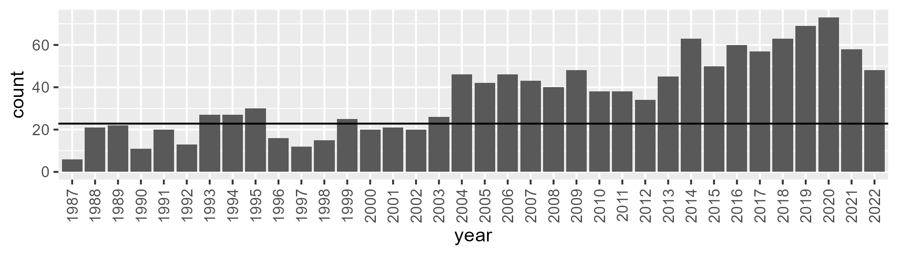

Number of samples: 1293

# SATSTP0003

| Min. | 1st Qu. | Median | Mean | 3rd Qu. | Max. |
| --- | --- | --- | --- | --- | --- |
| 0 | 0.5770719 | 1.364181 | 2.341394 | 2.76445 | 20.11466 |

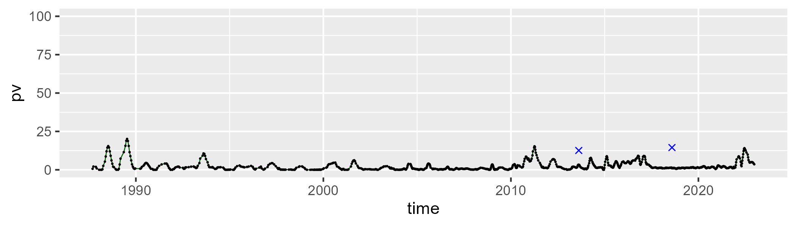

| Min. | 1st Qu. | Median | Mean | 3rd Qu. | Max. |
| --- | --- | --- | --- | --- | --- |
| 13.46721 | 27.2218 | 31.4621 | 31.69695 | 35.92806 | 58.62192 |

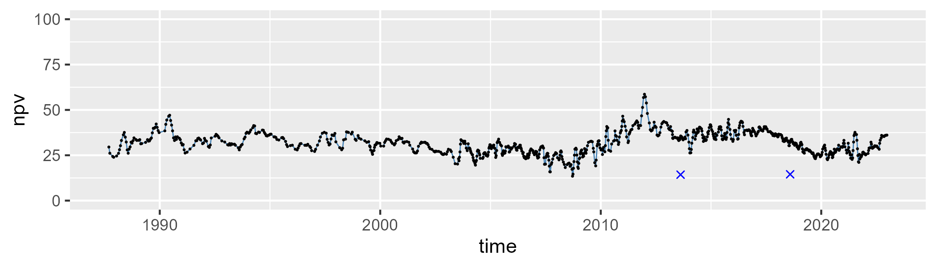

| Min. | 1st Qu. | Median | Mean | 3rd Qu. | Max. |
| --- | --- | --- | --- | --- | --- |
| 38.95183 | 59.45809 | 65.57831 | 64.57417 | 70.36228 | 84.82666 |

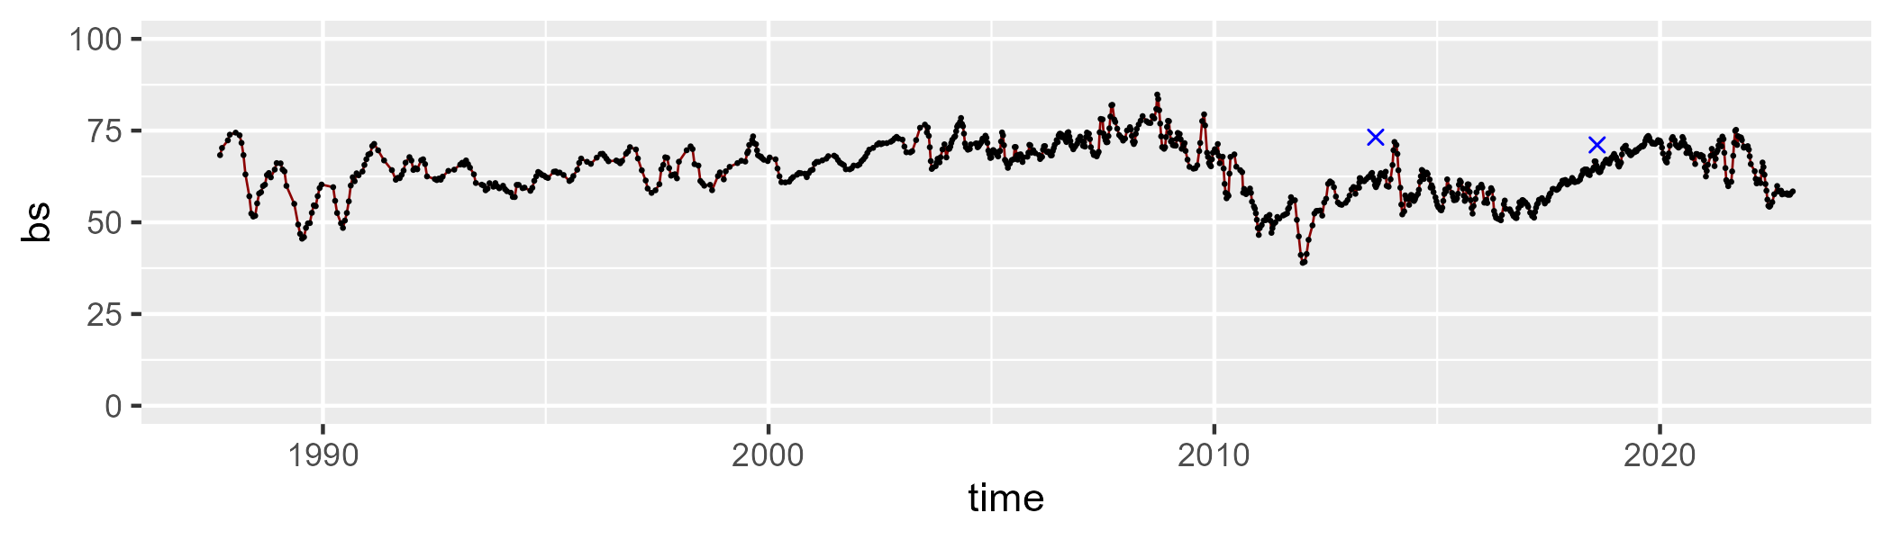

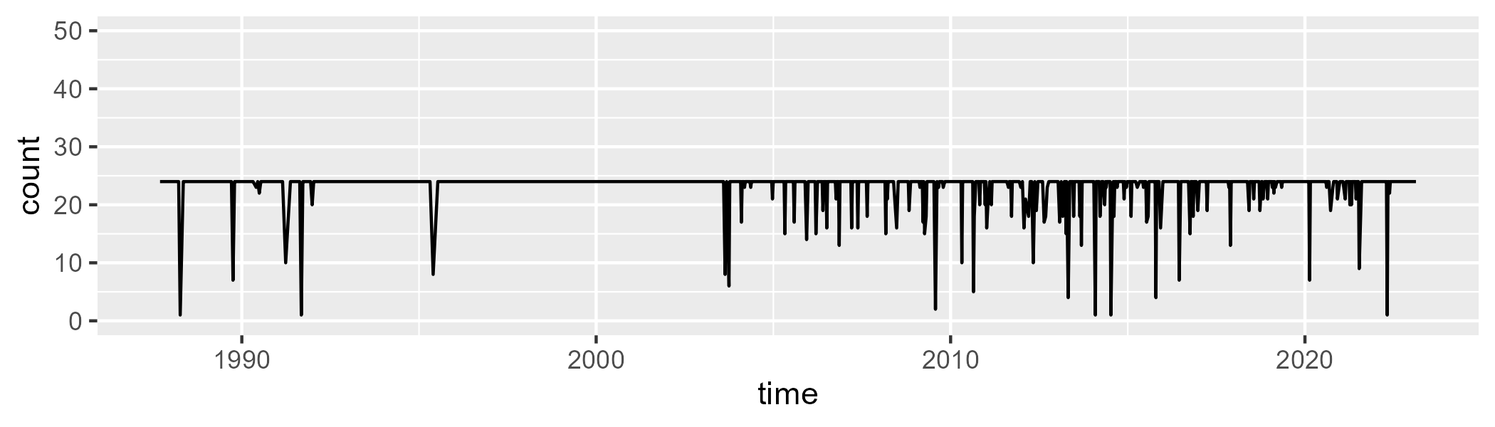

Min. : 1.00 1st Qu.:24.00 Median :24.00 Mean :23.15 3rd Qu.:24.00 Max. :24.00

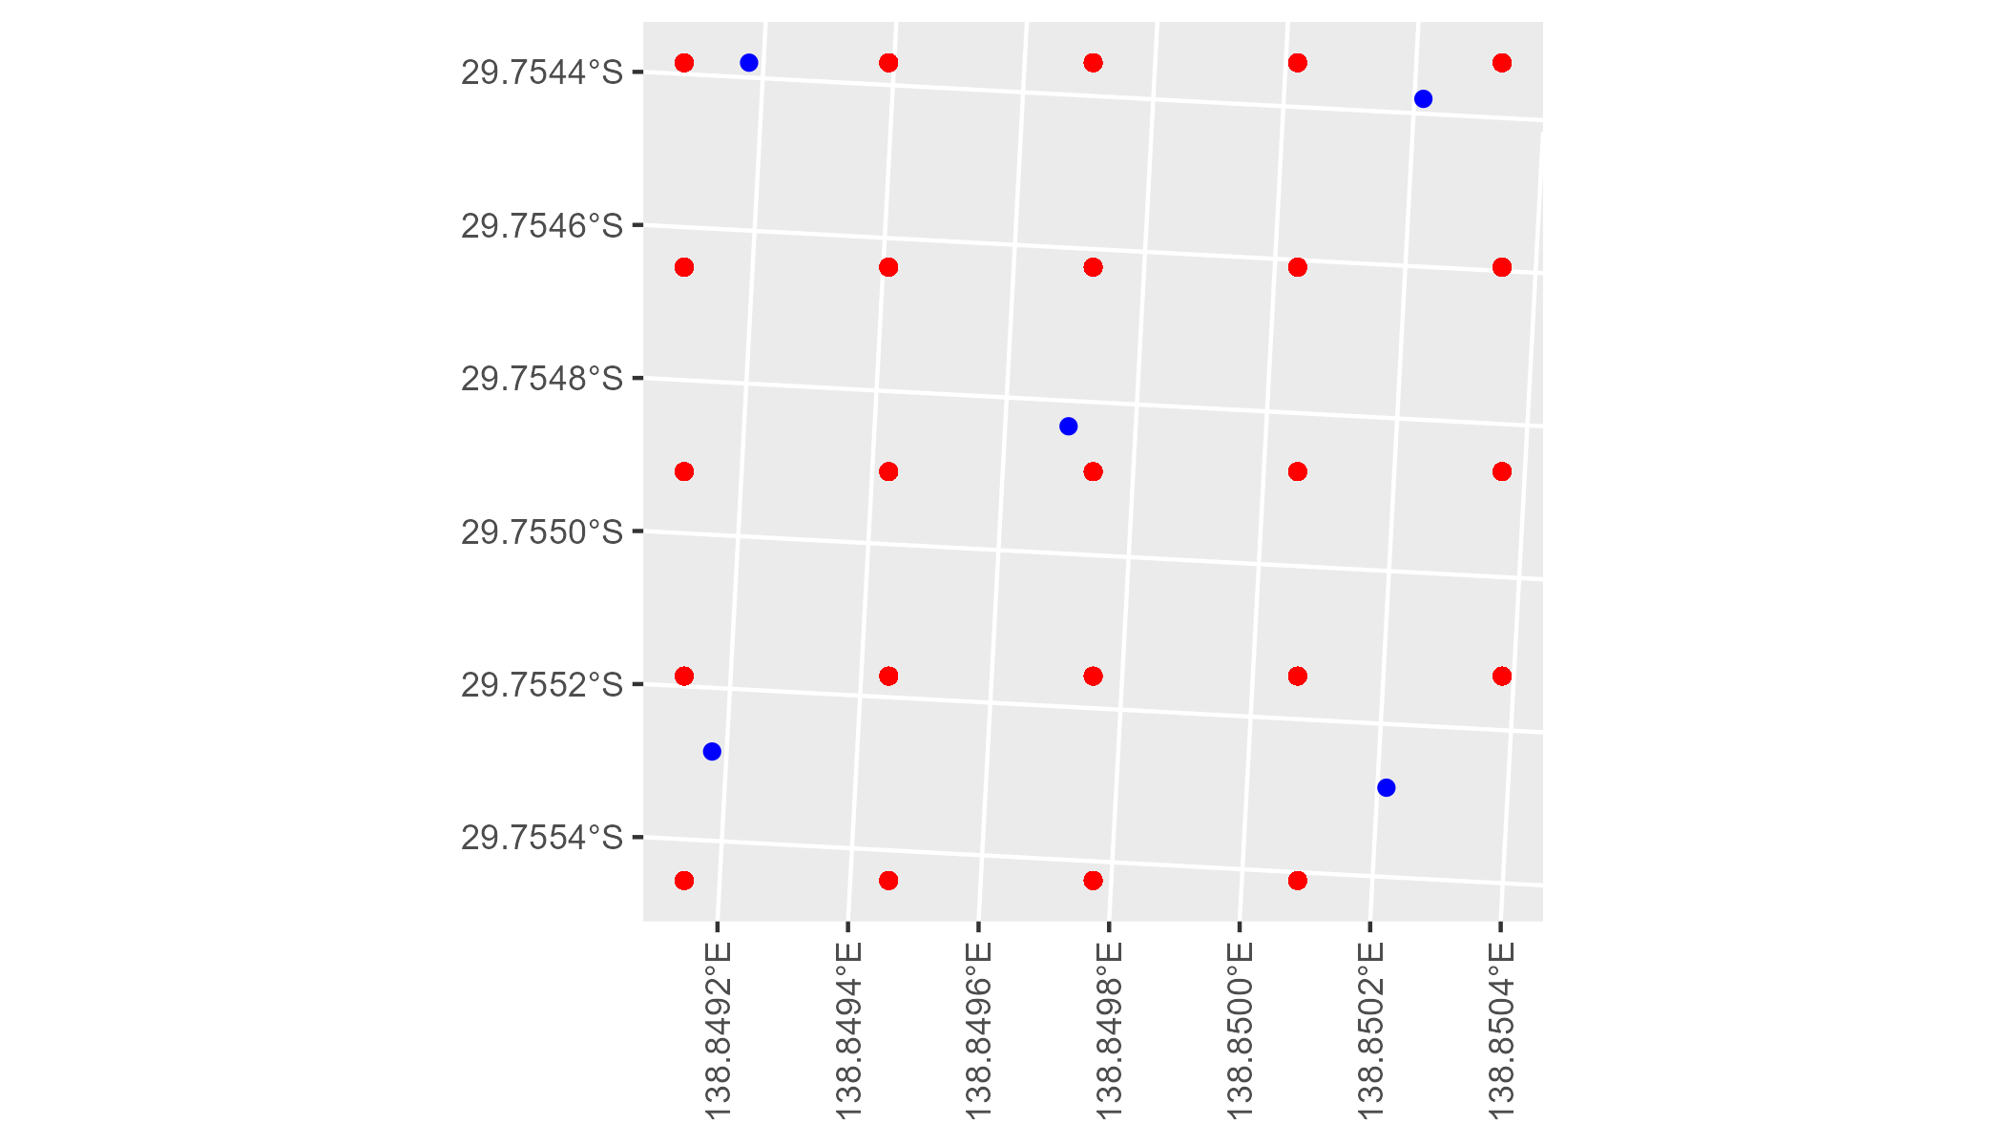

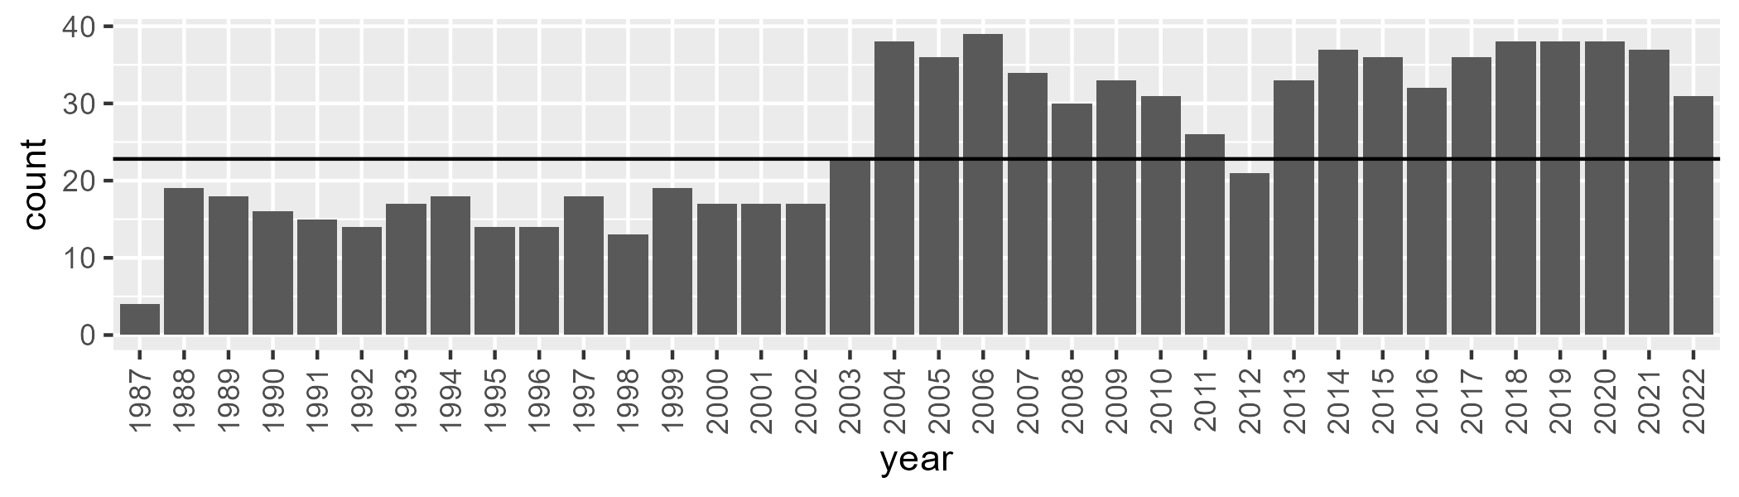

Number of samples: 917

# SATSTP0004

| Min. | 1st Qu. | Median | Mean | 3rd Qu. | Max. |
| --- | --- | --- | --- | --- | --- |
| 0 | 1.113628 | 5.092726 | 8.577347 | 13.59693 | 46.33876 |

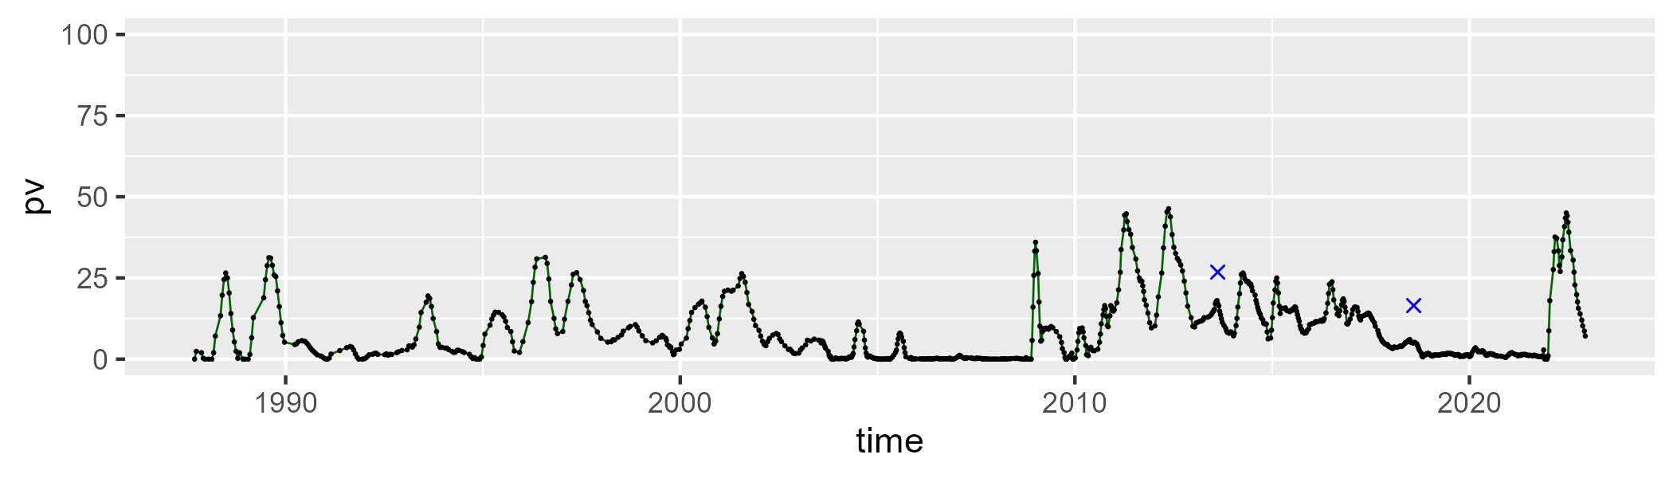

| Min. | 1st Qu. | Median | Mean | 3rd Qu. | Max. |
| --- | --- | --- | --- | --- | --- |
| 22.71688 | 39.64801 | 44.06949 | 43.93542 | 47.68846 | 67.84151 |

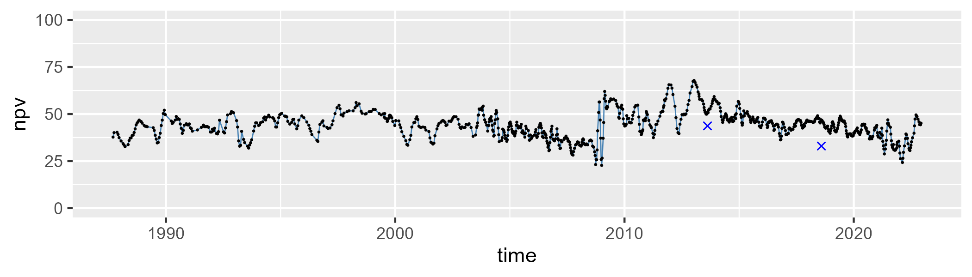

| Min. | 1st Qu. | Median | Mean | 3rd Qu. | Max. |
| --- | --- | --- | --- | --- | --- |
| 10.24904 | 38.01665 | 47.47587 | 46.22283 | 55.5216 | 75.99199 |

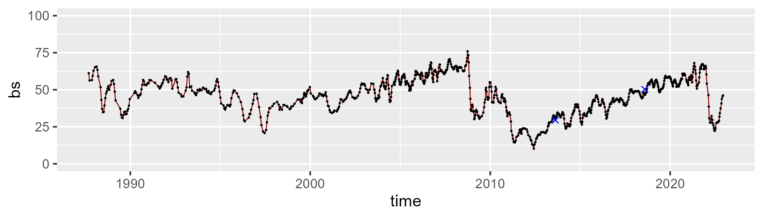

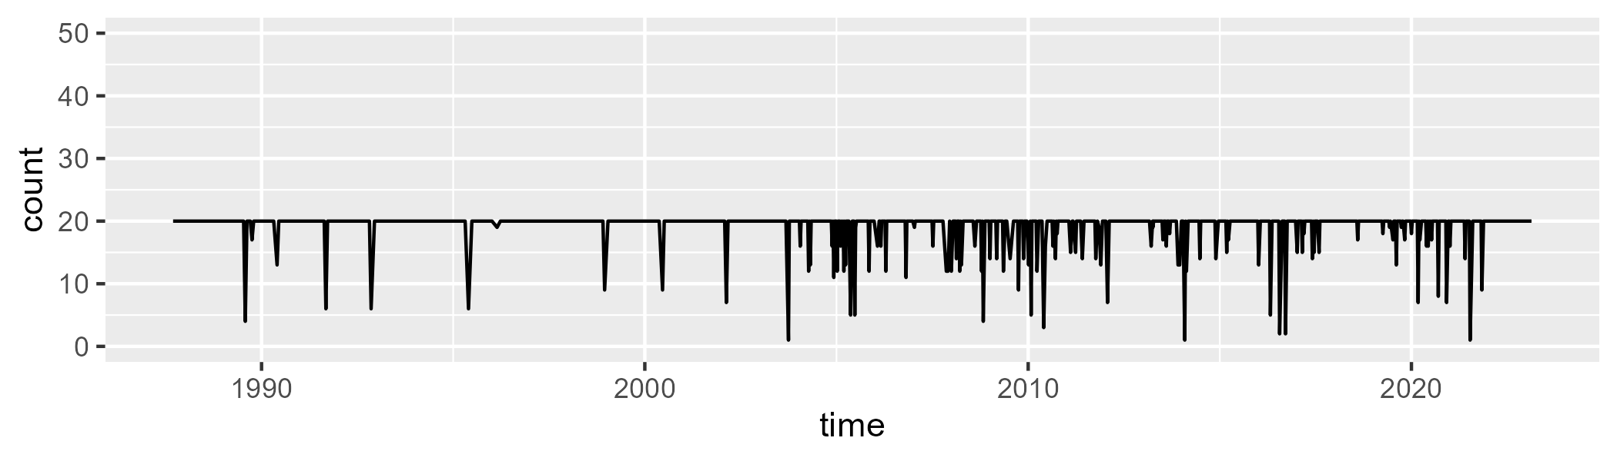

Min. : 1.00 1st Qu.:20.00 Median :20.00 Mean :19.16 3rd Qu.:20.00 Max. :20.00

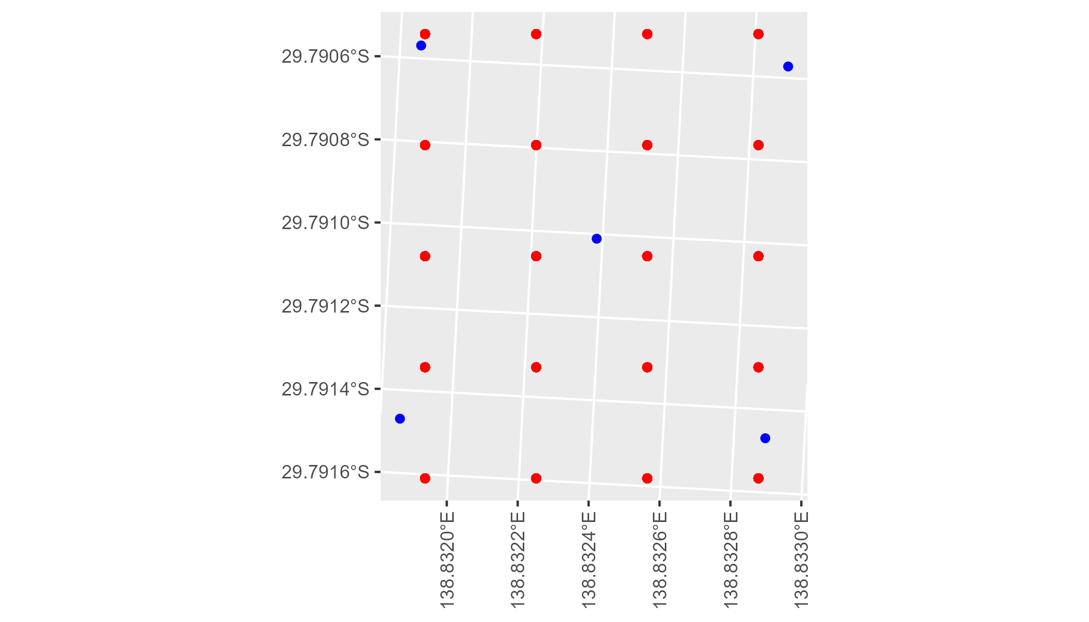

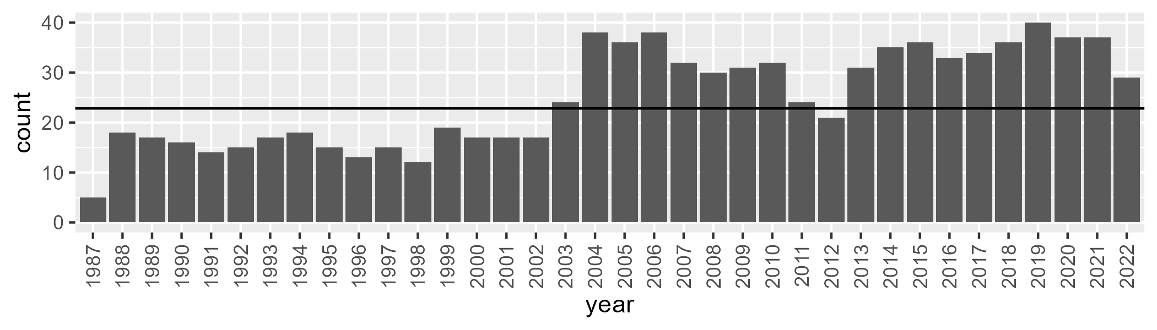

Number of samples: 899

# SATSTP0005

| Min. | 1st Qu. | Median | Mean | 3rd Qu. | Max. |
| --- | --- | --- | --- | --- | --- |
| 1.42261 | 5.285695 | 7.120509 | 7.827635 | 9.514575 | 24.62983 |

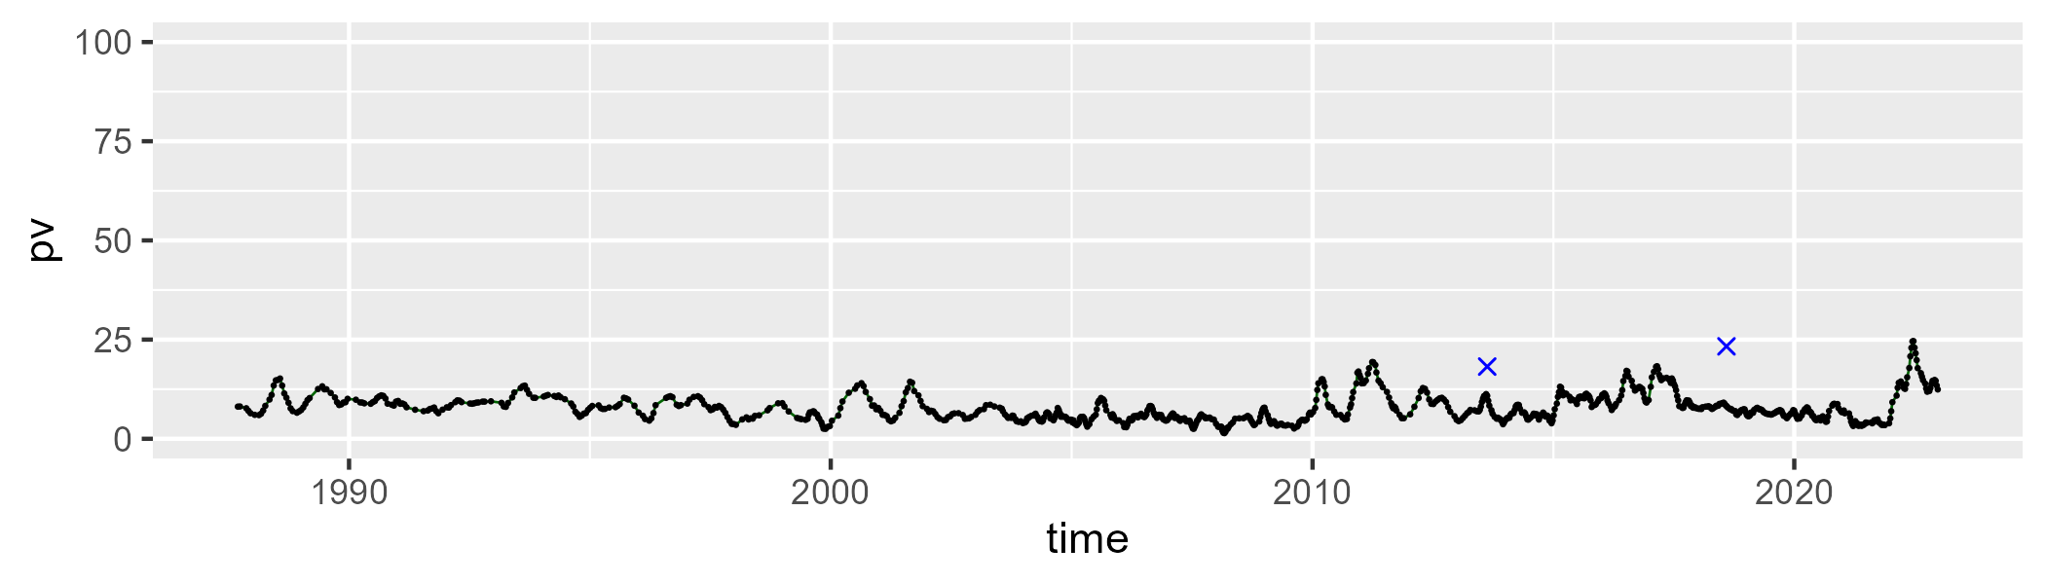

| Min. | 1st Qu. | Median | Mean | 3rd Qu. | Max. |
| --- | --- | --- | --- | --- | --- |
| 0 | 10.10582 | 15.47946 | 15.48793 | 20.23325 | 39.31918 |

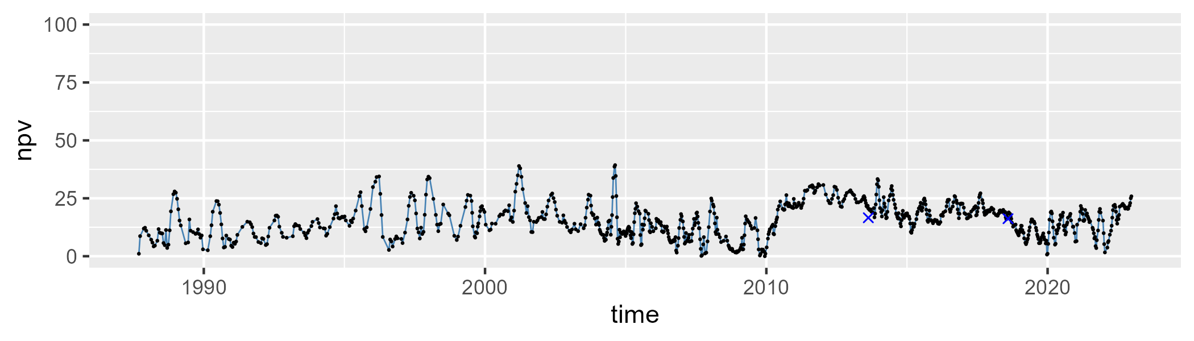

| Min. | 1st Qu. | Median | Mean | 3rd Qu. | Max. |
| --- | --- | --- | --- | --- | --- |
| 54.64681 | 69.20624 | 75.55533 | 75.14467 | 81.64667 | 93.62612 |

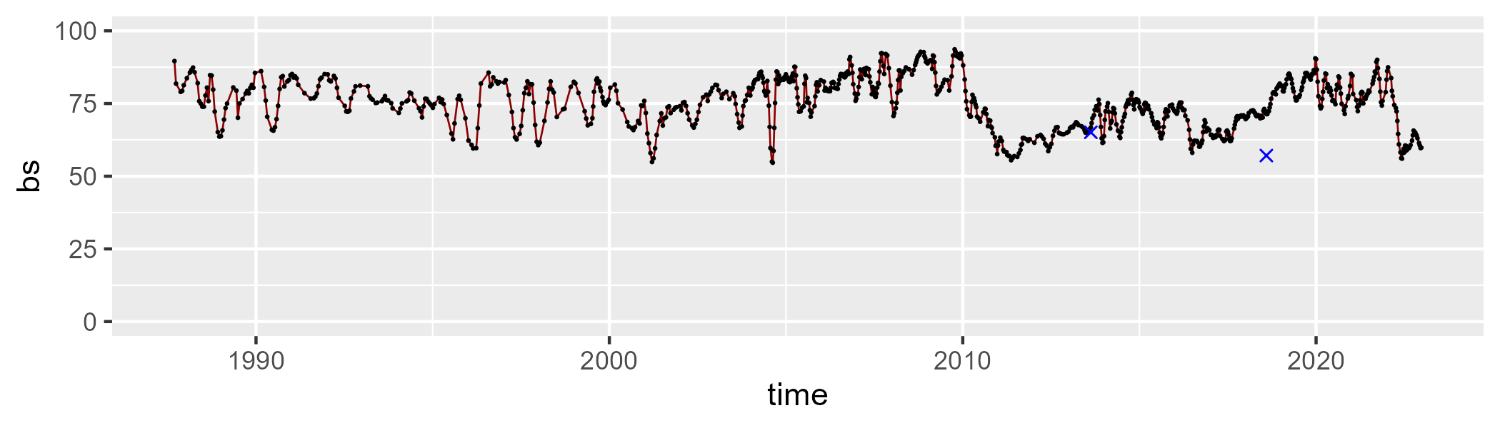

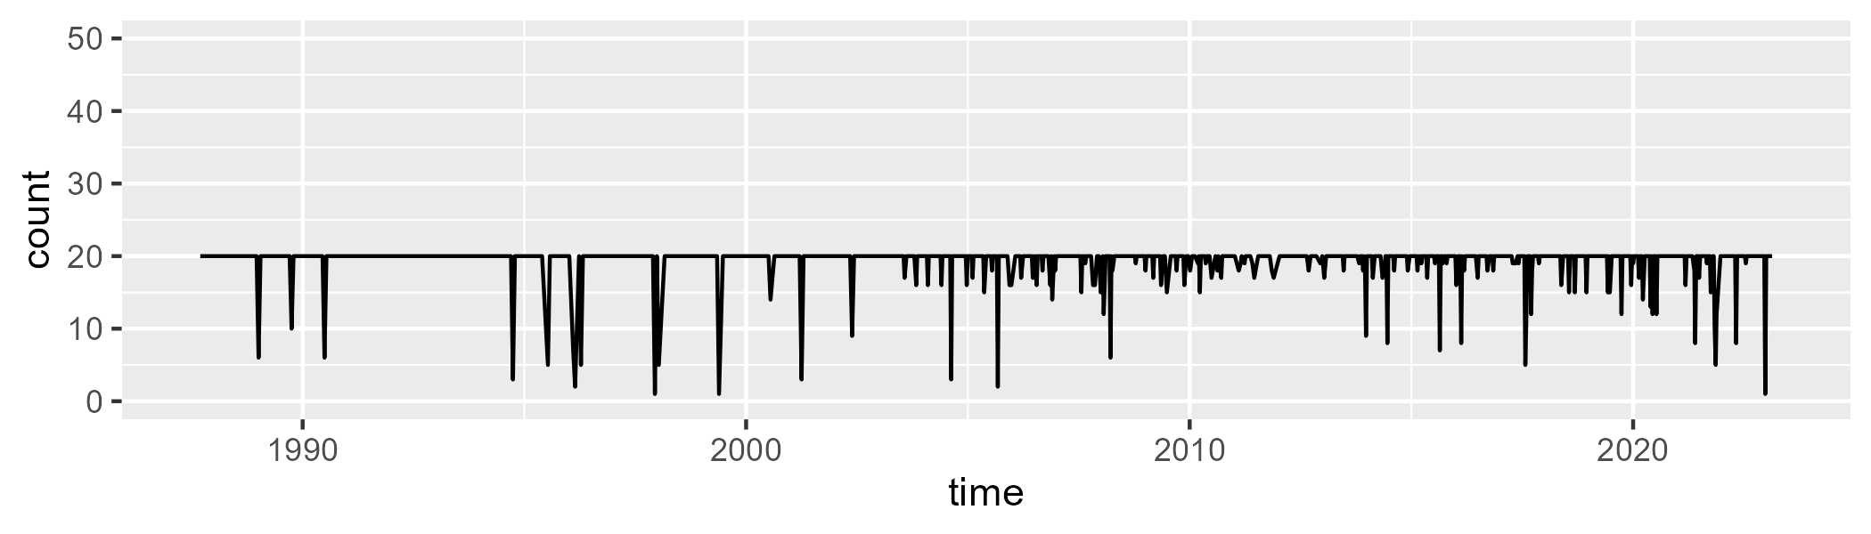

Min. : 1.00 1st Qu.:20.00 Median :20.00 Mean :19.24 3rd Qu.:20.00 Max. :20.00

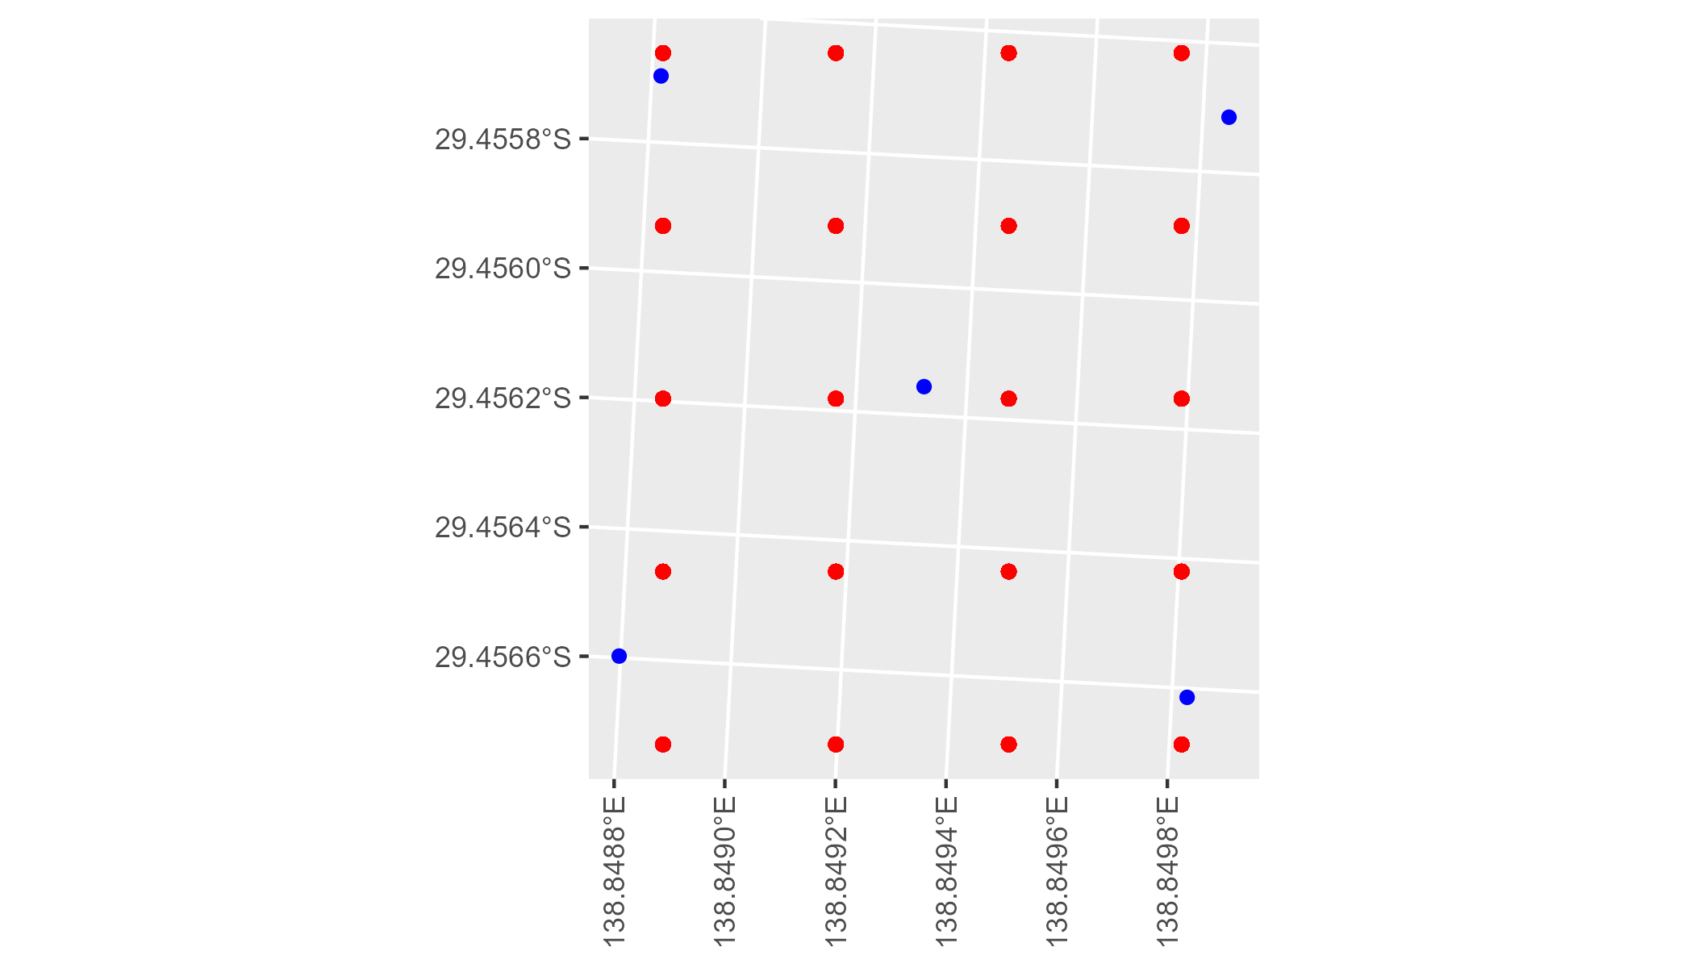

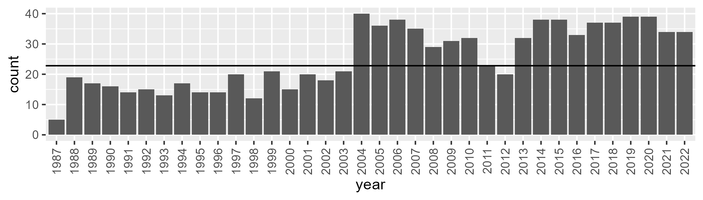

Number of samples: 916

# SATSTP0006

| Min. | 1st Qu. | Median | Mean | 3rd Qu. | Max. |
| --- | --- | --- | --- | --- | --- |
| 0 | 3.723721 | 8.237347 | 11.19918 | 14.83302 | 52.74962 |

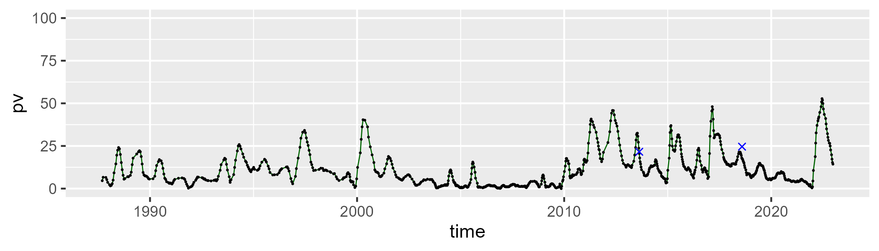

| Min. | 1st Qu. | Median | Mean | 3rd Qu. | Max. |
| --- | --- | --- | --- | --- | --- |
| 22.8111 | 40.03621 | 43.24378 | 43.13483 | 46.62713 | 58.87049 |

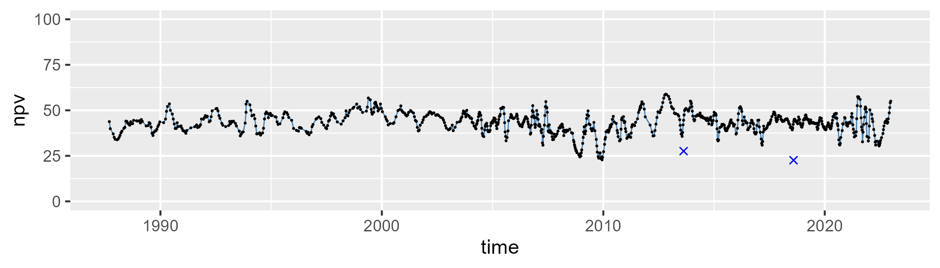

| Min. | 1st Qu. | Median | Mean | 3rd Qu. | Max. |
| --- | --- | --- | --- | --- | --- |
| 9.575113 | 37.79158 | 45.16479 | 44.23522 | 52.2372 | 73.74135 |

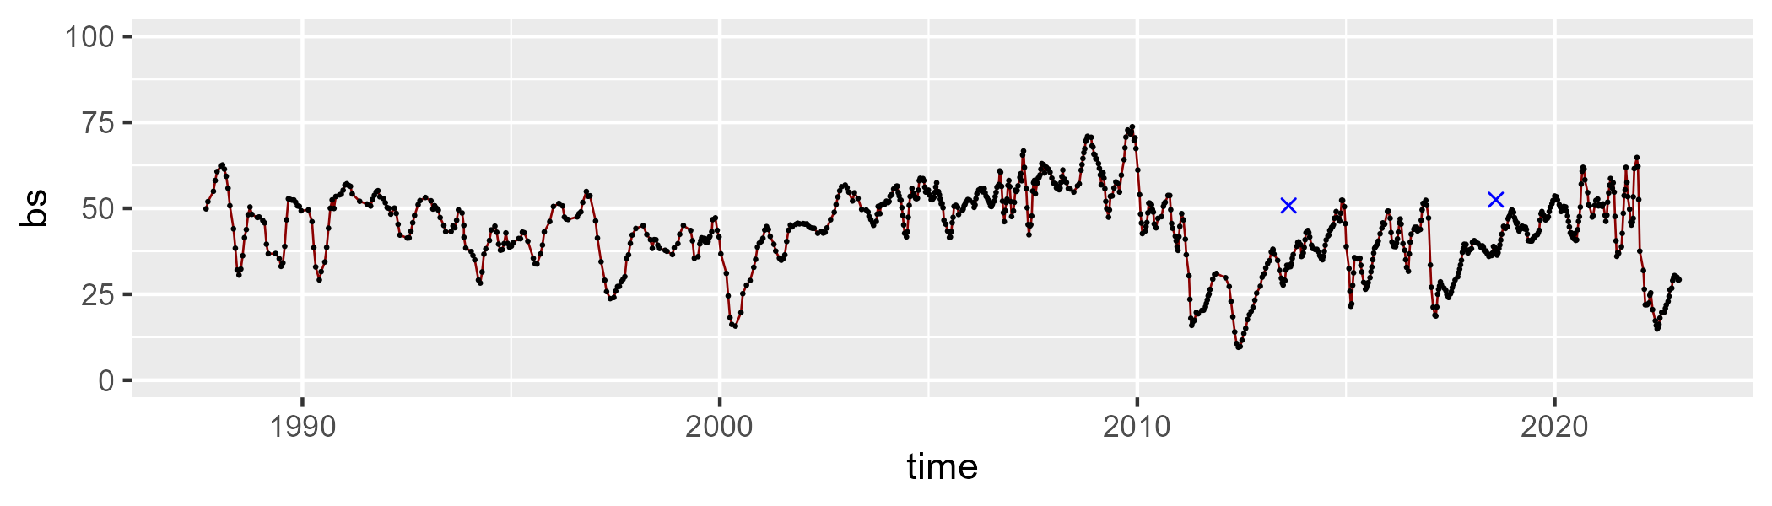

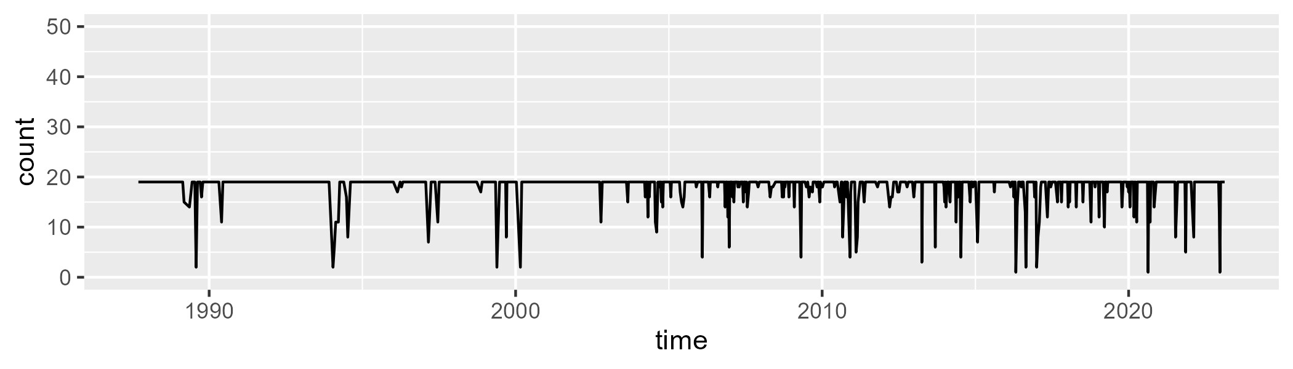

Min. : 1.00 1st Qu.:19.00 Median :19.00 Mean :18.11 3rd Qu.:19.00 Max. :19.00

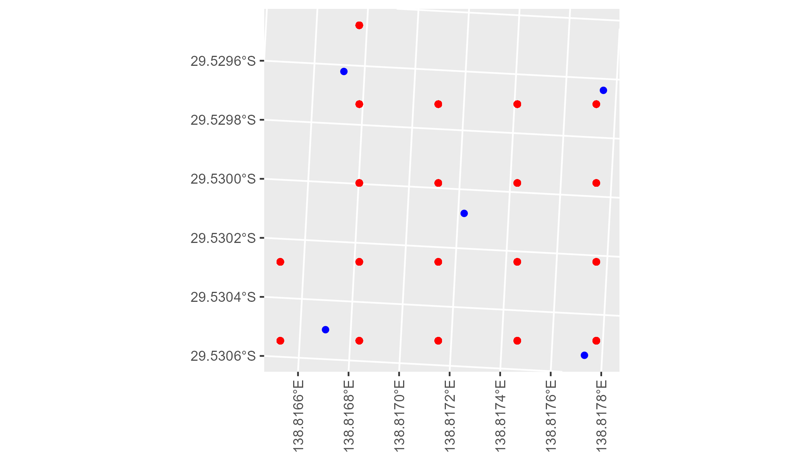

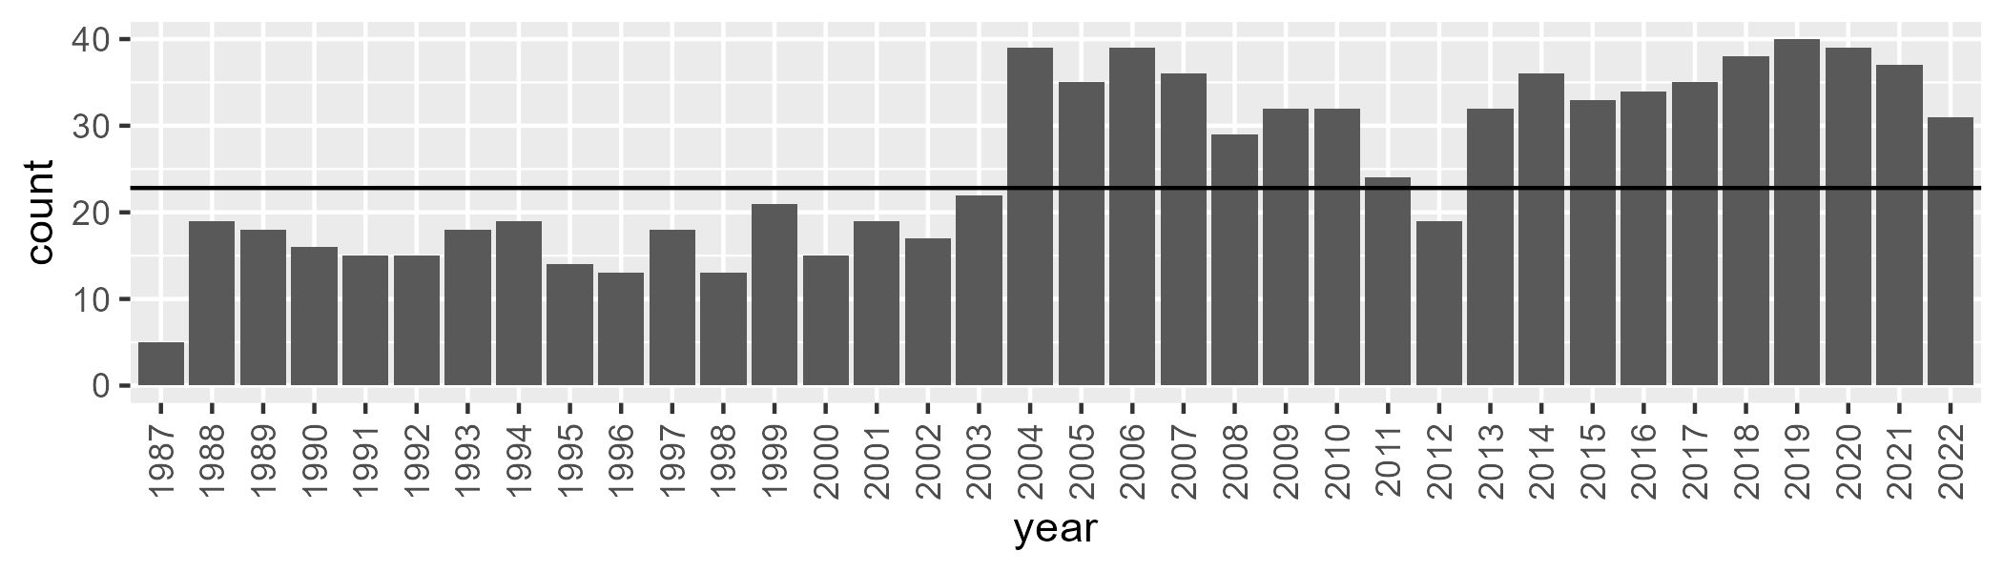

Number of samples: 917

# SATSTP0007

| Min. | 1st Qu. | Median | Mean | 3rd Qu. | Max. |
| --- | --- | --- | --- | --- | --- |
| 0 | 4.055759 | 8.565773 | 13.20301 | 17.09755 | 76.24989 |

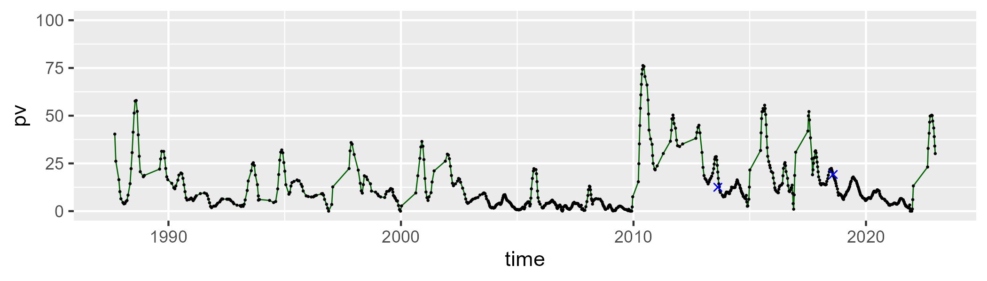

| Min. | 1st Qu. | Median | Mean | 3rd Qu. | Max. |
| --- | --- | --- | --- | --- | --- |
| 19.95076 | 59.30821 | 64.89255 | 62.78108 | 69.2209 | 90.32979 |

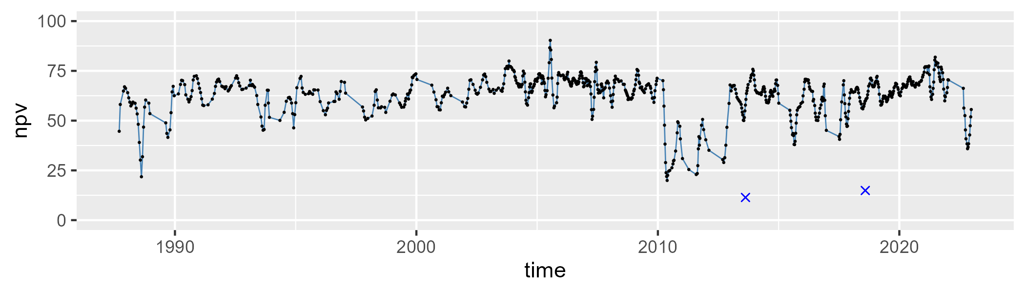

| Min. | 1st Qu. | Median | Mean | 3rd Qu. | Max. |
| --- | --- | --- | --- | --- | --- |
| 0 | 18.60446 | 23.08438 | 22.72973 | 27.4727 | 46.69249 |

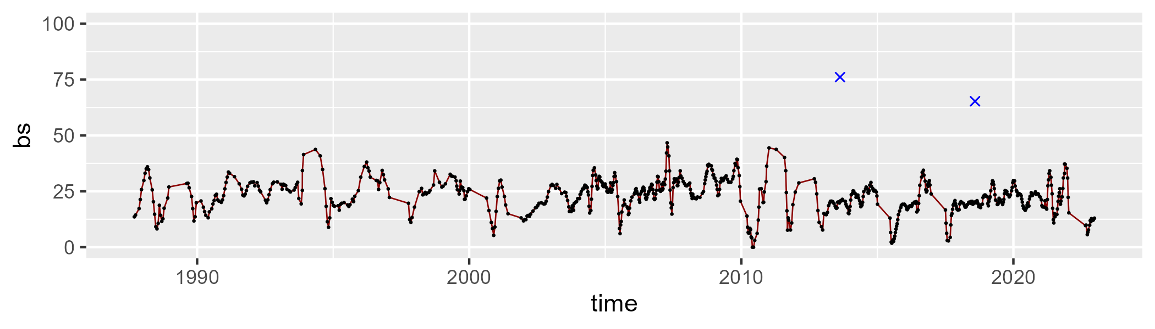

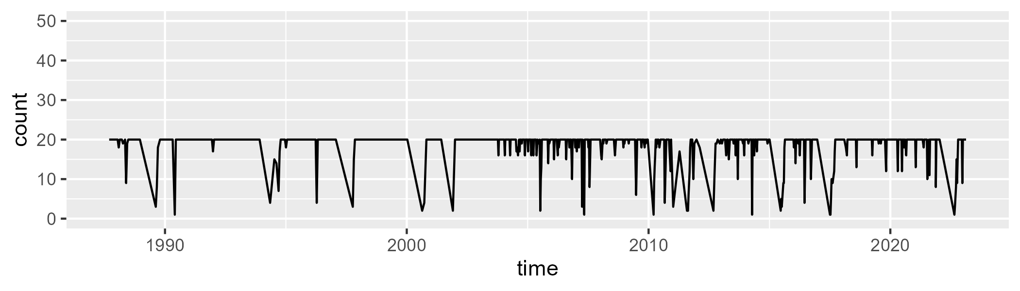

Min. : 1.00 1st Qu.:20.00 Median :20.00 Mean :18.66 3rd Qu.:20.00 Max. :20.00

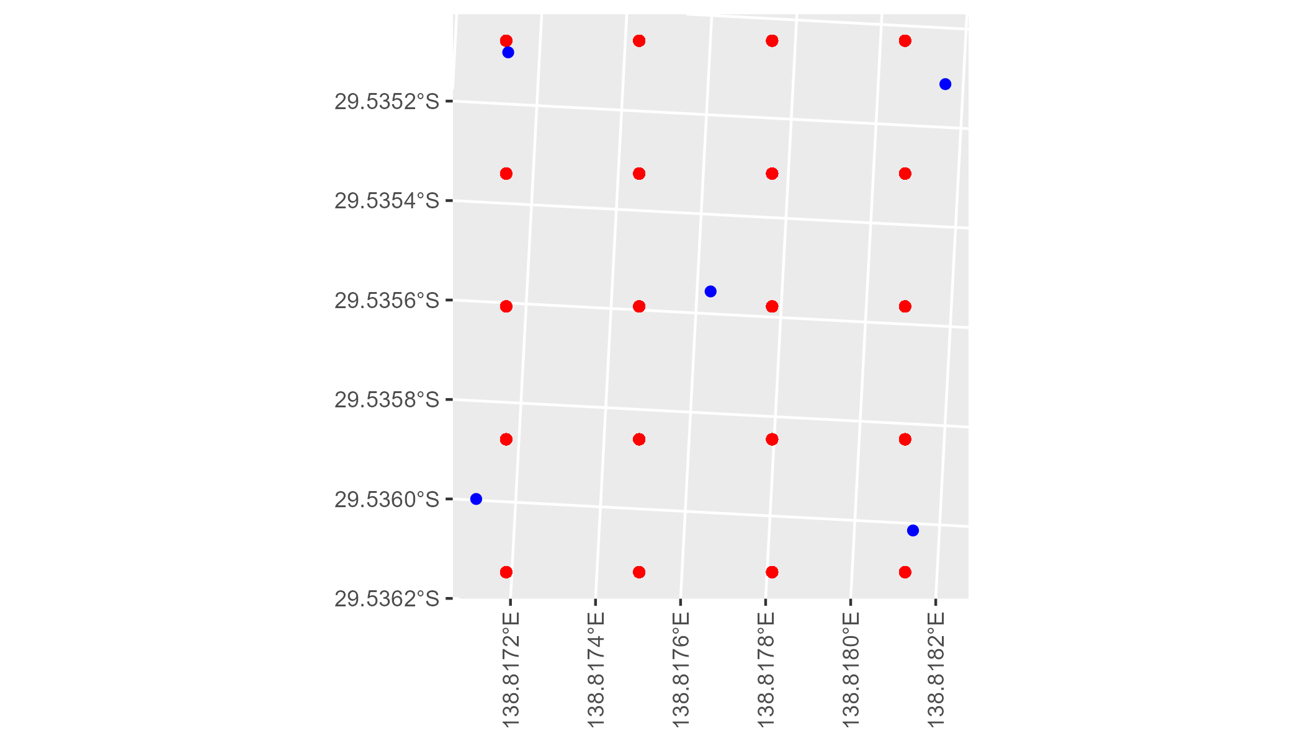

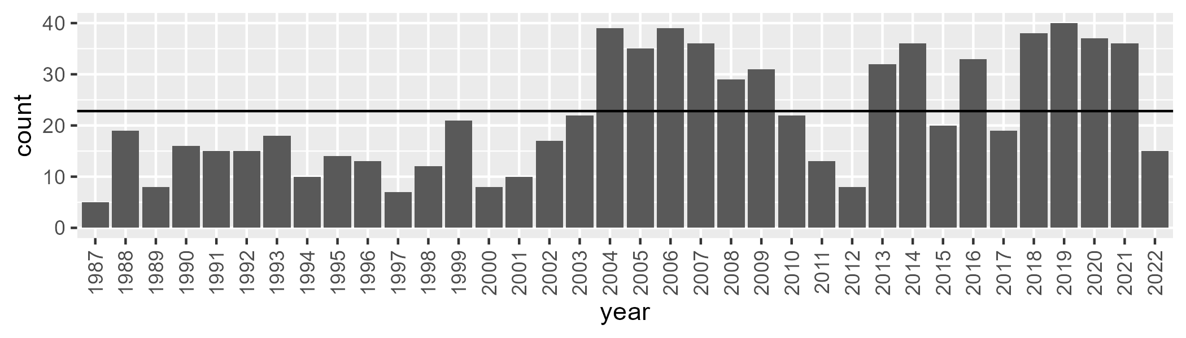

Number of samples: 788

# SATSTP0008

| Min. | 1st Qu. | Median | Mean | 3rd Qu. | Max. |
| --- | --- | --- | --- | --- | --- |
| 0 | 0.800921 | 1.670283 | 3.669851 | 4.741109 | 27.95147 |

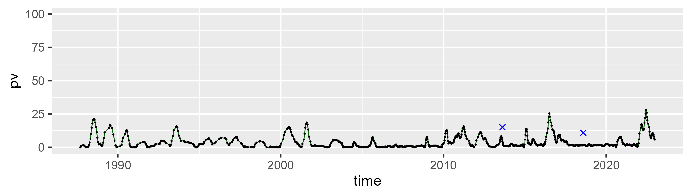

| Min. | 1st Qu. | Median | Mean | 3rd Qu. | Max. |
| --- | --- | --- | --- | --- | --- |
| 10.79447 | 29.97598 | 35.54233 | 34.74953 | 39.90013 | 52.64811 |

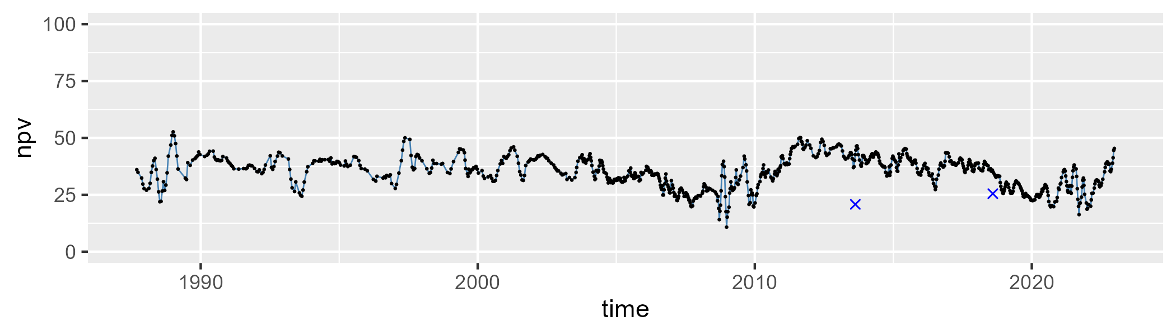

| Min. | 1st Qu. | Median | Mean | 3rd Qu. | Max. |
| --- | --- | --- | --- | --- | --- |
| 41.17279 | 54.23214 | 59.61017 | 60.14829 | 66.68661 | 83.41205 |

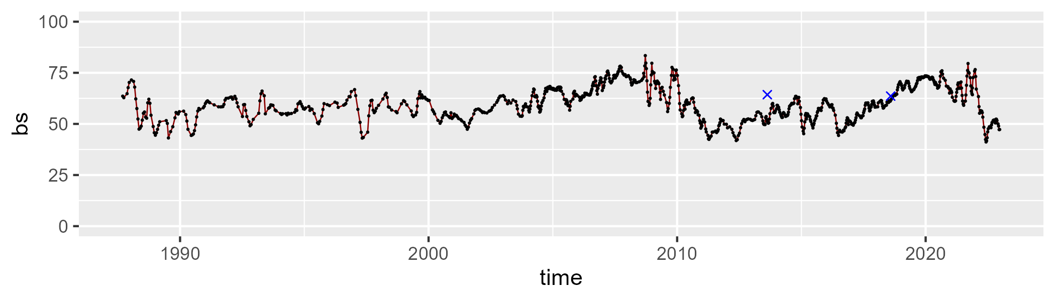

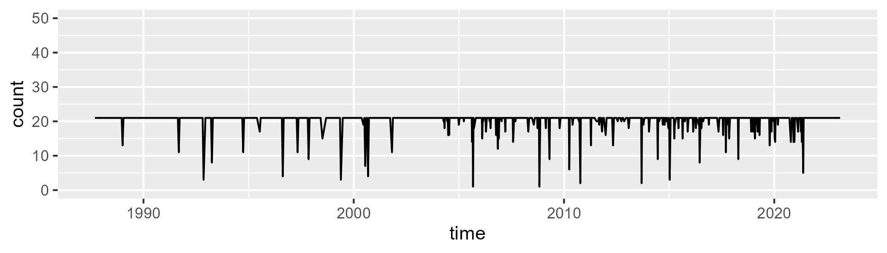

Min. : 1.00 1st Qu.:21.00 Median :21.00 Mean :20.29 3rd Qu.:21.00 Max. :21.00

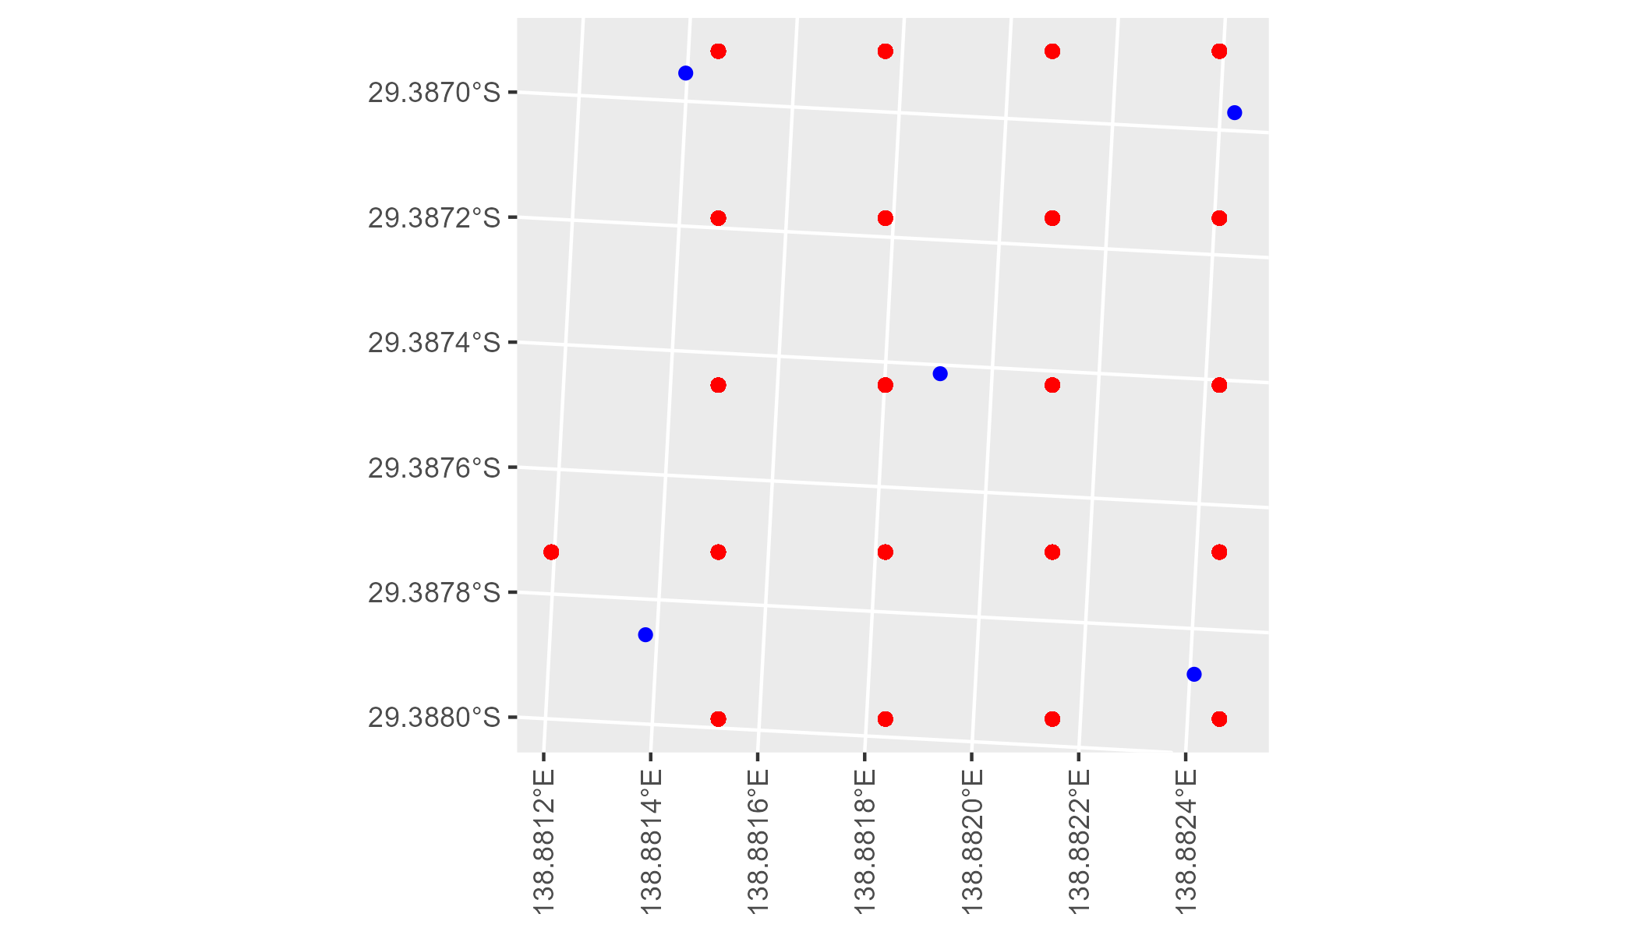

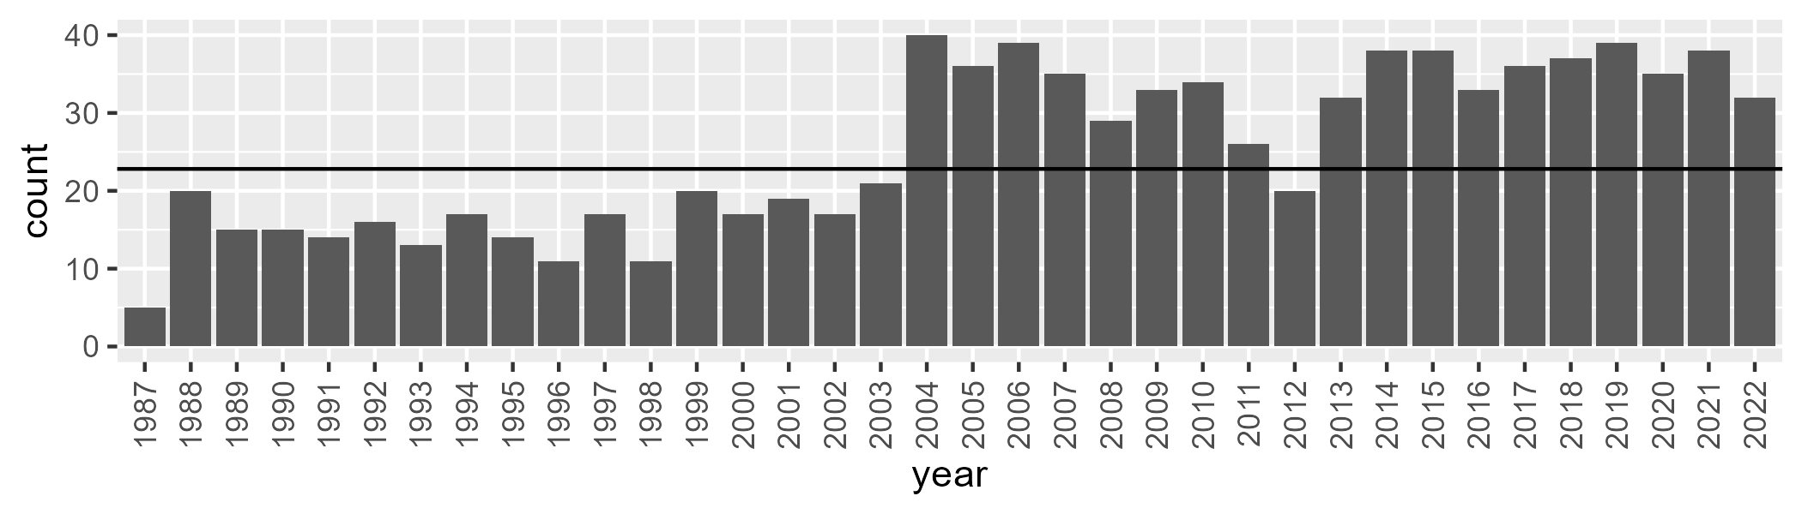

Number of samples: 912